***PAAREES PERFUMES***

***DAVIDOFF***

***FOR UNISEX***

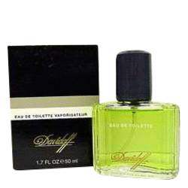

# *Davidoff*

***Description:***

Davidoff by Davidoff Cologne. For something decidedly different, give Davidoff a try. A predominance of citrus notes makes it surprisingly fresh, with top notes of lemon, lime and bergamot. Jasmine and basil round out the fruity notes to create a men's fragrance that turns heads. This blend first arrived on the market in 1984 from the Davidoff brand. Whether you are a young man or just young at heart, the combination of green and citrus hints at your dynamic personality before you say a word.