***PAAREES PERFUMES***

***DAVIDOFF***

***FOR WOMEN***

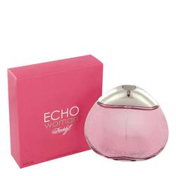

# *Echo*

***Description:***

Echo by Davidoff Perfume. Dare to be different with a splash of Echo by Davidoff. Introduced in 2004, this modern and unconventional scent was created for women who love a fragrance with a twist. Echo blends sweet violet and peony notes with the fruity scent of osmanthus and slightly green iris tones. Hints of rich musk add warmth and depth to this enticing combination. Fresh, soft and perfect for all-day wear, this fragrance lingers on your skin, ethereal and illusive as an echo.