Miqueas Herrera Assignment Module 2.3

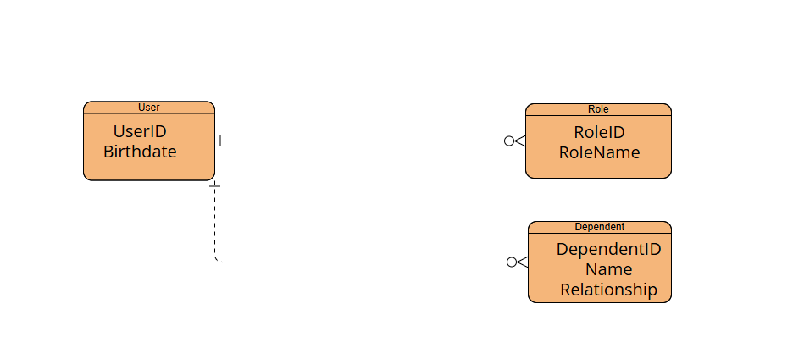

NoSQL structure

{

"UserID": "user123",

"Birthdate": "1990-01-01",

"Roles": [

{"RoleID": "role1", "RoleName": "Admin"},

{"RoleID": "role2", "RoleName": "User"}

],

"Dependents": [

{"DependentID": "dep1", "Name": "John Doe", "Relationship": "Child"},

{"DependentID": "dep2", "Name": "Jane Doe", "Relationship": "Spouse"}

]

}