Miqueas Herrera Assignment Module 5.2

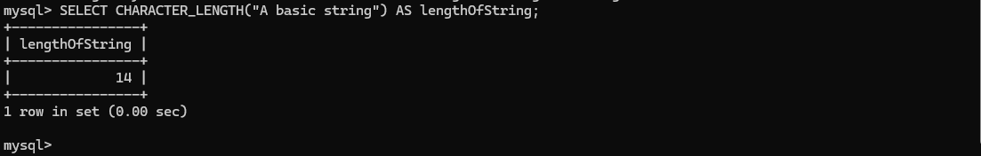This could be used when a program needs to operate at a certain speed and needs to keep a minimum or maximum # of characters in all strings.

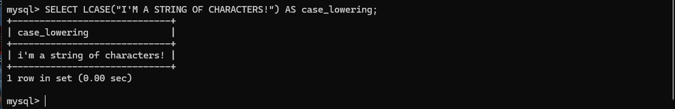This could be used for quick clean up in case camel casing isn’t used uniformly.

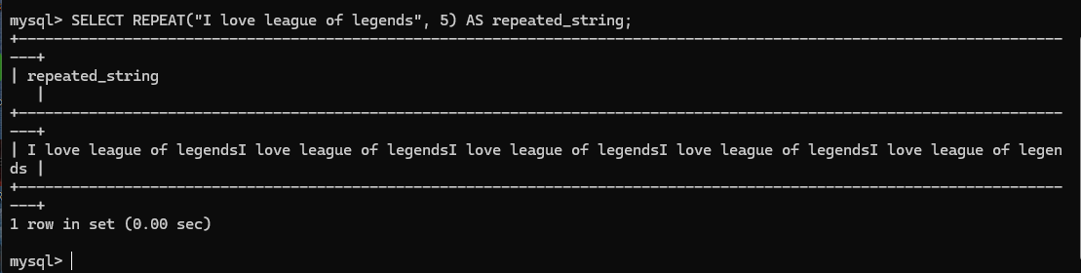This could be used in a video game to create a dialog of a manic villain while keeping clean and concise code.