Named Entity Recognition
Natural Language Processing — Deliverable 2
Team members
Jose Calatayud
Lluc Segura
Miquel Àngel Llauger

Table of Contents
- Introduction
- Exploratory Data Analysis
- Methodology
- Experimental Setup
- Results
- Conclusions
- Team members contributions
- Use of AI

1. Introduction
This project is about Named Entity Recognition (NER). NER is the task of finding and labelling the names that appear in a text, for example people, places or organizations. It is a useful first step in many systems, such as information retrieval, question answering or text summarization, because a lot of the meaning of a sentence is carried by these entities.
We work at the word (token) level. Each word in a sentence gets a tag, and the tags follow the IOB scheme: a tag that starts with B- marks the first word of an entity, a tag that starts with I- marks a word inside the same entity, and the tag O is used for words that are not part of any entity. So the goal is to predict the correct tag for every word.
Following the deliverable, we compare two ways of solving the task. The first one is the classical machine learning approach, where we design the features by hand and feed them to a model. For this we use Conditional Random Fields (CRF) with three different feature sets. The second one is the modern approach, where the model learns the features by itself from the data. For this we use two deep learning models: a BiLSTM trained from scratch and a pretrained transformer (DistilBERT) that we fine-tune for the task.
The data is a corpus of English sentences already annotated with entity tags, split into a training file and a test file. There is also a small TINY TEST file with 13 sentences that is used to inspect the predictions by hand. The whole pipeline (training and evaluation) is reproducible from the notebooks included in the delivery.

2. Exploratory Data Analysis
The data comes in CSV files with three columns: sentence_id, words and tags. Each row is one word together with its tag, and all the rows that share the same sentence_id form one sentence. To build the inputs for the models we group the rows by sentence_id and keep the order of the words.
The sizes of the three files (as reported by the loading code) are:
- Training set: 38,366 sentences.
- Test set: 38,367 sentences.
- Tiny test: 13 sentences.
The tag set has 17 different tags: the tag O plus 8 entity types, each one with a B- and an I- version. The 8 entity types are the following:
Type | Meaning | Examples
geo | Geographical entity | Barcelona, Paris, New York
org | Organization | Microsoft, Apple
per | Person | Jack London, Bill Gates
gpe | Geopolitical entity | United States, Saudi Arabia
tim | Time expression | Monday, 2021, summer
art | Artifact | named objects, works
eve | Event | named events
nat | Natural phenomenon | named natural events

One important point of the data is that it is very unbalanced. Most of the words are tagged as O, because in a normal sentence only a few words are real entities. Inside the entities the classes are also unbalanced: geo, org, per and tim are very frequent, while art, eve and nat appear only a few times. This imbalance has a clear effect on the results, as we will see later: the frequent classes are learned well and the rare ones are almost always missed. Because of this, the deliverable asks us to measure accuracy only on the positions where the true tag is not O, so that the huge amount of O tags does not hide the real performance.

3. Methodology

3.1. Classical approach: CRF
A Conditional Random Field is a model made for sequence labelling. Instead of classifying each word on its own, it looks at the whole sentence and takes into account the tags of the neighbour words, which is useful for the B-/I- structure of the tags. The CRF does not learn the features by itself; we have to give them. So the key part here is the feature template, which says what information we extract from each word and its context.
We tried three feature templates of growing complexity, to see how much the features matter:
- CRF v1 (basic): only features of the current word — the word in lowercase and simple flags like is it upper case, is it title case, is it a digit. No context is used.
- CRF v2 (medium): adds prefixes and suffixes of the word (last 2 and 3 letters, first 3 letters), a word shape feature, and the same kind of flags for the previous and the next word. It also marks the beginning and the end of the sentence (BOS/EOS).
- CRF v3 (rich): the most complete one. It adds more prefixes and suffixes, the length of the word, and flags like has a hyphen, has a digit, is punctuation. The context window is wider, using the two previous and the two next words together with their word shape.
The word shape feature replaces every upper case letter by X, every lower case letter by x and every digit by d (for example “Barcelona” becomes “Xxxxxxxxx”). It is a cheap way to tell the model about capitalization patterns, which are very informative for names.

3.2. Deep learning approach 1: BiLSTM from scratch
The first deep learning model is a Bidirectional LSTM tagger written in PyTorch and trained from scratch, with no handcrafted features. Each word first goes through an embedding layer that turns it into a vector; these embeddings are learned only from the training data. Then a bidirectional LSTM reads the sentence in both directions, so for every word it has information from the left and from the right context. Finally a linear layer maps the LSTM output of each word to the tag scores. A dropout layer is used to reduce overfitting. Words that were not seen during training are mapped to a special <UNK> token.

3.3. Deep learning approach 2: DistilBERT fine-tuned
The second deep learning model is DistilBERT (distilbert-base-cased), a smaller and faster version of BERT. The difference with the BiLSTM is that this model is already pretrained on a large amount of text, so it starts with a lot of language knowledge and we only fine-tune it for our NER task. We add a token classification head on top and train it on our sentences.
One technical detail is that BERT tokenizers split words into sub-words (pieces of words). Because of this, the tags, which are at the word level, have to be aligned to the sub-words. We put the real tag on the first sub-word of each word and a special value (-100) on the rest of the sub-words and on the special tokens, so that the loss function ignores them. This is the standard recipe for token classification with transformers.

4. Experimental Setup

4.1. Training configuration
The three CRF models were trained with the sklearn-crfsuite library, each one with its own feature template (v1, v2, v3) described above. The only thing that changes between them is the set of features, so the comparison is fair and shows the effect of the feature engineering.
The BiLSTM was trained with the following configuration:
- Embedding dimension: 100. Hidden dimension of the LSTM: 128 (bidirectional). Dropout: 0.3.
- Maximum sentence length: 60. Batch size: 64. Epochs: 5.
- Optimizer: Adam with learning rate 1e-3. Loss: cross entropy, ignoring the padding positions.
DistilBERT was fine-tuned with these settings:
- Model: distilbert-base-cased, maximum length 64, batch size 16.
- Optimizer: AdamW with learning rate 3e-5.
- Epochs: 3 when a GPU is available (full training). On CPU the notebook falls back to a smaller subset of the data and 1 epoch, just so that everything still runs end to end; the final model is meant to be trained on GPU.
All notebooks detect automatically if there is a GPU (cuda), an Apple GPU (mps) or only CPU, and run on whatever is available. The trained models are saved in the folder fitted_models, and the notebook 05_reproduce_results.ipynb loads them from there and evaluates them, without training anything again.

4.2. Evaluation metrics
We use the metrics asked in the deliverable:
- Non-O accuracy: accuracy computed only on the words whose true tag is not O. This way the many O tags do not inflate the score and we really measure how good the model is on the entities.
- Weighted F1: the F1-score (from sklearn.metrics.f1_score) averaged over the non-O classes, weighted by how many examples each class has. It is a more balanced measure than plain accuracy because it considers precision and recall together.
- Confusion matrix: on train and on test, excluding O, to see which tags get confused with which.
- Tiny test: the predictions on the 13 small sentences are printed in the word/tag format and we also report their non-O accuracy.

5. Results
The table below shows, for every model, the non-O accuracy and the weighted F1 on the training set and on the test set. These numbers are produced by the reproduce_results notebook by loading the saved models.
Model | Train acc (non-O) | Test acc (non-O) | Train F1 | Test F1
CRF v1 | 0.8645 | 0.4774 | 0.8764 | 0.4770
CRF v2 | 0.9306 | 0.7051 | 0.9339 | 0.7271
CRF v3 | 0.9630 | 0.7316 | 0.9649 | 0.7531
BiLSTM | 0.8335 | 0.4598 | 0.8467 | 0.4774
DistilBERT | 0.7587 | 0.5852 | 0.7617 | 0.5901

The best model on the test set is CRF v3, with a test weighted F1 of 0.7531 and a test non-O accuracy of 0.7316 (its row is highlighted). A few things can be seen in the table:
- For the CRF, more features clearly help: v1 is much worse than v2, and v2 is worse than v3. Adding context and richer word features makes a big difference, especially on the test set.
- There is a gap between train and test for the CRF (for v3, 0.96 on train against 0.75 on test). This means there is some overfitting, but v3 is still the model that generalizes best.
- The BiLSTM trained from scratch is the weakest on the test set (test F1 0.4774), at the same level as the basic CRF v1. With only 5 epochs, no pretrained embeddings and a limited vocabulary, it does not have enough to learn good representations.
- DistilBERT generalizes better than the BiLSTM (test F1 0.5901 against 0.4774), which is expected because it is pretrained. However, in this run it does not beat CRF v3. A likely reason is the limited fine-tuning; with more epochs on GPU it should improve.

5.1. Confusion matrices (best model)
The confusion matrices of CRF v3 are shown below, on the training set and on the test set, excluding the O tag. The diagonal is where the prediction is correct.
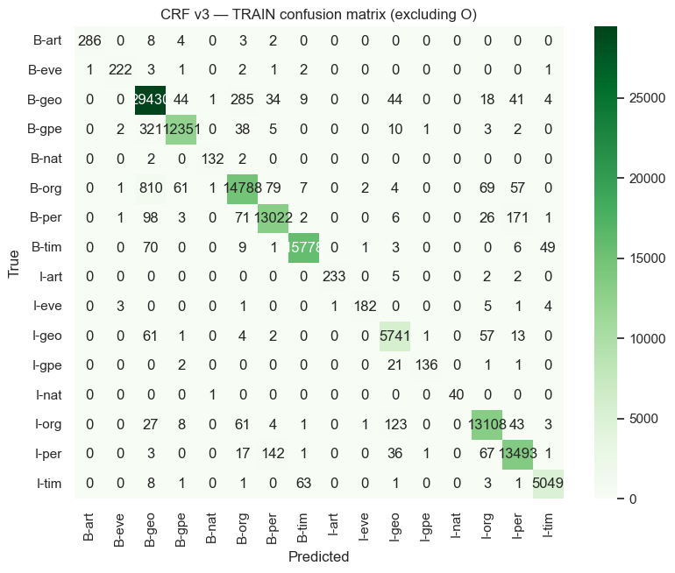
Figure 1. CRF v3 — confusion matrix on the training set (excluding O).
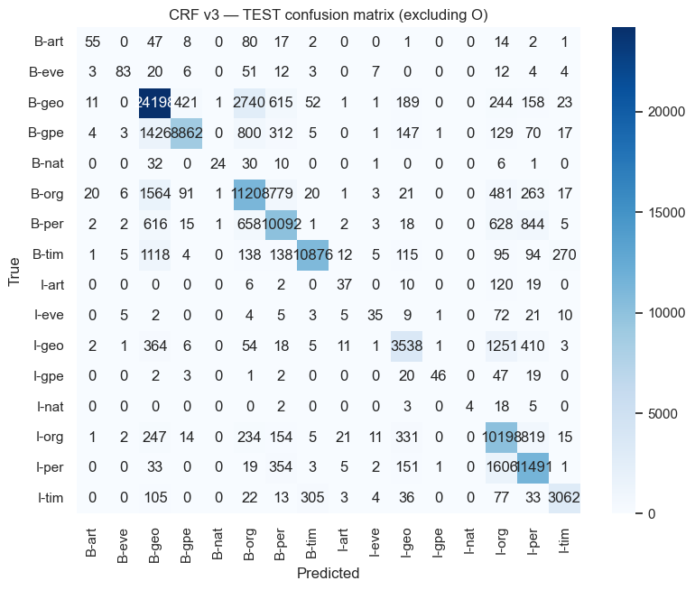
Figure 2. CRF v3 — confusion matrix on the test set (excluding O).
The matrices confirm the effect of the class imbalance. The frequent classes (geo, org, per, tim) are on the diagonal most of the time. The most common mistakes are between related classes, for example B-org confused with B-geo, or B-per confused with B-org, and the begin/inside confusions inside the same entity type (for example I-per predicted as I-org). The rare classes (art, eve, nat) have very few examples and are almost always missed, which pulls the test scores down.

5.2. Tiny test
The non-O accuracy on the tiny test for each model is:
Model | Tiny test acc (non-O)
CRF v1 | 0.7647
CRF v2 | 0.8824
CRF v3 | 0.7647
BiLSTM | 0.7647
DistilBERT | 0.8824

The tiny test is only 13 sentences, so these numbers are noisy and should not be over-interpreted. It is interesting that here CRF v2 and DistilBERT get the highest accuracy (0.8824), while CRF v3, which is the best on the real test set, gets 0.7647. With so few sentences, a couple of words changing tag already moves the score a lot.
Below are the predictions of the best model (CRF v3) on the tiny test, in the word/tag format requested by the deliverable:
The/O programmers/O from/O Barcelona/B-geo might/O write/O a/O sentence/O without/O a/O spell/O checker/O ./O
The/O programmers/O from/O Barchelona/B-geo cannot/O write/O a/O sentence/O without/O a/O spell/O checker/O ./O
Jack/O London/B-geo went/O to/O Parris/B-geo ./O
Jack/O London/B-geo went/O to/O Paris/B-geo ./O
Bill/B-per gates/O and/O Steve/B-per jobs/O never/O thought/O Microsoft/B-org would/O become/O such/O a/O big/O company/O ./O
Bill/B-per Gates/I-per and/O Steve/B-per Jobs/I-per never/O thought/O Microsoft/B-org would/O become/O such/O a/O big/O company/O ./O
The/O president/O of/O U.S.A/B-org thought/O they/O could/O win/O the/O war/O ./O
The/O president/O of/O the/O United/B-geo States/I-geo of/I-geo America/I-geo thought/O they/O could/O win/O the/O war/O ./O
The/O king/O of/O Saudi/B-geo Arabia/I-geo wanted/O total/O control/O ./O
Robin/B-per does/O not/O want/O to/O go/O to/O Saudi/B-geo Arabia/I-geo ./O
Apple/B-org is/O a/O great/O company/O ./O
I/O really/O love/O apples/O and/O oranges/O ./O
Alice/O and/O Henry/B-per went/O to/O the/O Microsoft/B-org store/O to/O buy/O a/O new/O computer/O during/O their/O trip/O to/O New/B-geo York/I-geo ./O

Looking at the predictions by hand is useful. The model finds Barcelona and even the misspelled “Barchelona” as geo, and it detects Microsoft and Apple as org and Bill Gates / Steve Jobs as per. It also makes understandable mistakes: it tags “London” as a place (geo) instead of part of the person “Jack London”, and it labels “Paris” and “Parris” as geo, which is correct. Multi-word entities like “United States of America” and “New York” are mostly captured with the right B-/I- structure.

6. Conclusions
In this project we compared a classical approach (CRF with handcrafted features) against two deep learning approaches (a BiLSTM from scratch and a fine-tuned DistilBERT) on a Named Entity Recognition task. The main conclusions are:
- The best model on the test set was the CRF with the richest feature set (CRF v3), with a test weighted F1 of 0.7531. On this dataset, good feature engineering plus the sequence structure of the CRF was very competitive.
- The quality of the features is decisive for the CRF. Going from v1 to v3 improved the test F1 from 0.48 to 0.75 just by adding affixes, word shape and a wider context window.
- The BiLSTM trained from scratch was the weakest model. Without pretrained embeddings and with only a few epochs, it cannot learn strong word representations from this amount of data.
- DistilBERT generalized better than the BiLSTM thanks to its pretraining, but in our run it did not reach the CRF v3. We think it is mostly a matter of limited fine-tuning, and with full GPU training and more epochs it has room to improve and could become the best model.
- The class imbalance is the main difficulty of the dataset. The rare entity types (art, eve, nat) have very few examples and are almost always missed, which lowers the global scores for every model.
As future work we would train the BiLSTM with pretrained word embeddings (for example GloVe) and for more epochs, fine-tune DistilBERT fully on GPU, and try to handle the class imbalance, for example with class weights or by gathering more examples of the rare entities. Combining the strong features of the CRF with a neural model (a BiLSTM-CRF) would also be a natural next step.

7. Team Member Contributions
The work was shared between the three members, and all of us took part in the discussions, the testing and the writing of this report. The main responsibilities were distributed as follows:
- Jose Calatayud: data loading and exploratory data analysis, and the classical approach — the CRF models and the design of the three feature templates (v1, v2, v3).
- Lluc Segura: the BiLSTM model from scratch (architecture, embeddings, training loop) and its evaluation.
- MiquelAngel Llauger: the DistilBERT fine-tuning (sub-word alignment and training) and the reproduce_results notebook that loads every model and computes the final metrics.
The report, the environment file and the final review of the deliverable were done by the three members together.

8. Use of AI
We used AI assistants (large language model based tools) as a support during the project. They helped us mainly to speed up the writing of boilerplate code, to debug errors, to remember library details (for example the sub-word alignment in transformers) and to improve the wording of this report. All the design decisions, the choice of models and features were done and checked by us.

