Three class classification was tried with same pipeline but metrics showed extreme failure and over fitting particularly because of cell-type effect on signal, even after controlling for it, and overlapping ES and HC classes.
After literature review, decision was made to do hierarchical classification predicting PD vs HC samples and gene subset, then ES vs LS [ref: Machine Learning Analysis of RNA-seq Data for Diagnostic and Prognostic Prediction of Colon Cancer].
Dataset with 155 x 28844 was used for processing
- PD Vs HC
- Data-Preprocessing
- Quality Control (QC) - Gene Level
- Log10 mean distribution to remove genes with near zero and noisy mean across all 155 samples
- Zero count distribution to differentiate between genes with zero and non-zero expression.
- Filter by Expression using edgeR library
To determine whether a gene is measurable or predictive as technical QC. This was computed on the full dataset because it uses only marginal expression information and remove genes that are silent, not learning which genes discriminate.
Two types of filters were applied: class-aware filter and stratum-aware filter. Class-aware keeps a gene that's expressed in 70% of LS (minority class) overall, even if all the detections come from one cell_type or one sex. While stratum-aware require the gene to be detectable across every cell_type × sex sub-stratum with ≥ 70% detection rate.
- Before Vs After filter zero count distribution was plotted.
Output was class-aware and stratum aware
- Variance Stabilizing Transformation (VST)
VST was applied on both types of datasets and before-after VST comparison was performed on each using log2(count+1) scale for attaining normalized before-VST values. Following plots were generated:
- Mean-Variance
- Per-gene skewness histogram
- Box plot per sample
- Normality analysis using histograms and scatter plot.

- Principal Component Analysis (Visualization Only)
It was performed to evaluate if expected biology (disease stage prediction through expression data) is stronger than noise.
Following plots were used for visualization:
- Per-stratum elliptic envelope plot that detects outliers
- Per cell-type Mahala Nobis plot that accounts for the correlation between genes and the shape of the data distribution for each cell type.
- PC1 and PC2 plot per condition/cell-type/sex
- Scree plot that explains how much variance is explained by how many PCs
- PC1-PC50 structure using Silhouette plot and Adjusted Rand Index (ARI)
Results: Both in stratum- and class-aware, features were driving condition equally, but in stratum-aware dataset cell-type identity dominated transcriptomic variance structure.
So, I proceeded with comparison of both with strong literature hold that stratum-aware filtering may erase genes crucial for producing PD vs HC signal.
No flagged outliers were removed because they showed diverse range indicating biological heterogeneity rather than noise.

- Train-Test Split
Stratum-aware dataset (155 x 7488 genes)
Class-aware dataset (155 x 12103 genes)
- 70-30 train test split; 108 samples (train) and 47 (test).
- Primary stratification on condition x cell type and composite augmentation with sex (as it contributes to least variance as defined by silhouette plot)
- Per-cell type chi squared test for train-test compositional analysis.
- KS test on top-5 train-fit PCs to check whether train and test are statistically similar in structure.
- Mirror Ordinary Least Squares (OLS) residualisation on sex and cell type confounders on train fit only to remove / regress the effects of confounders as observed in silhouette and ARI plots in PC structure step.
- Variance partitioning plot with median partial R² computation across genes to visualize before vs after residualisation.

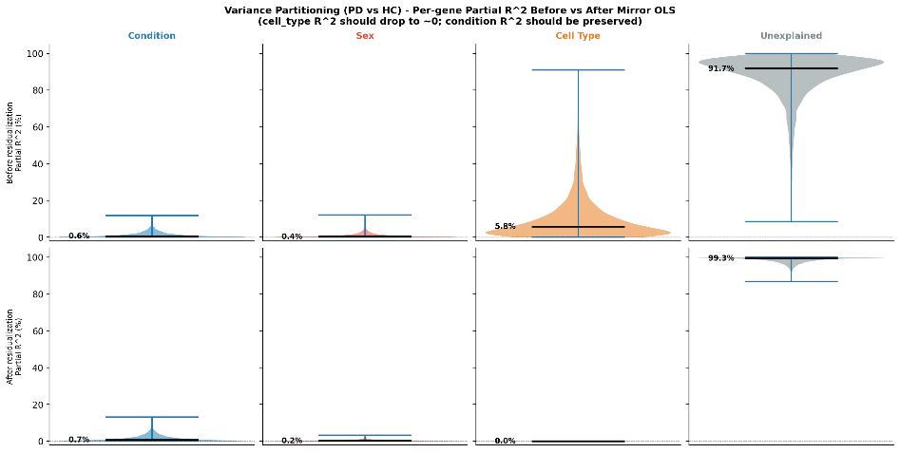
Figure 1: Stratum-aware
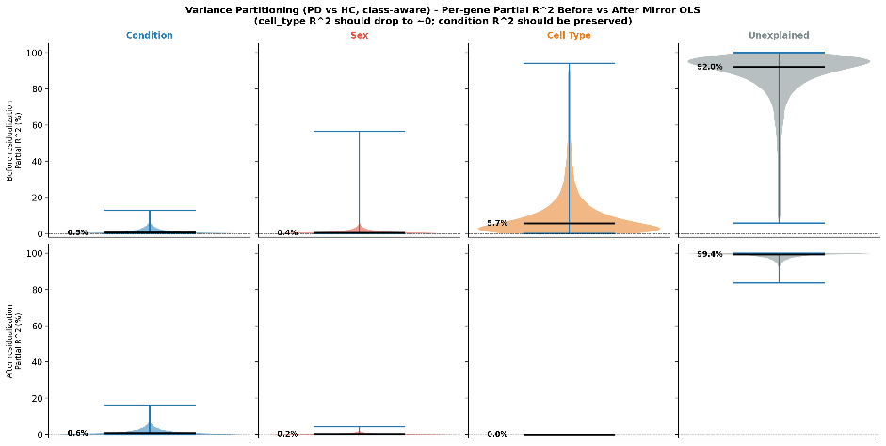
Figure 2: Class-aware

- Feature Selection
For FS I wanted to test both no-smote and smote feature selection as train sample size was low.
Phase 1 — Pre-fold
1. Drop strict zero-variance genes (var = 0 across train samples).
2. Round VST values to 4 decimal places.
Phase 2 — Outer CV (10 outer x 3 seeds = 30 outer folds)
Outer-fold seeds: 42, 123, 256
For each outer fold:
- Mirror OLS residualisation on (sex + cell_type), fit-and-transform.
For SMOTE script: Applied SMOTE on outer-TRAIN folds
(post-residualization, pre-MI) before bagged LASSO stability selection.
Two SMOTE strategies run sequentially:
BALANCED — minority class raised to majority class count
(sampling_strategy='auto')
IMBALANCED — both classes oversampled 2x while preserving the
original inter-class ratio
(sampling_strategy={0: 2*n_LS, 1: 2*n_ES})
b. Variance pre-screen: keep top-V genes by variance on outer-train.
c. MI ranking: keep top-K of those by mutual_info_classif vs class.
d. Bagged LASSO stability selection on the top-K:
- B bootstrap subsamples of 50% size, multinomial L1 over a
small lambda grid, warm-started from sparser to denser.
- Per-gene selection frequency = MAX over lambda of fraction of
bootstraps where any class coef != 0.
- Selected = freq >= pi_b.
Phase 3 — Consensus panel
Final panel: fold_inclusion >= 0.80
Stability path saved at thresholds [0.60, 0.70, 0.80, 0.90, 0.95].
Results: From consensus panel of genes by fold inclusion and stability path, a panel was decided for hyper-parameter tuning and test set evaluation keeping in mind literature thresholds of p ≤ 0.1 x n.
Stratum-aware panel size for all three scripts: [5,7,10,16]
Class-aware panel size for all three scripts: [5,10,15, 25, 41]

- Hyper-parameter Tuning of Classifiers
For each panel size:
Phase 0: Subset train/test to top-K consensus genes
Phase 1: Nested CV on the train half:
Outer = 9 stratified folds x 3 seeds (42, 123, 256) = 27 folds
Inner = 4 stratified folds, GridSearchCV with RobustScaler
INSIDE the pipeline (refit per inner fold).
SMOTE applied inside each INNER CV fold via a custom SMOTEWeightedPipeline wrapper.
Inner-CV scoring metric: balanced_accuracy.
Sample weighting: composite (sex x cell_type) stratum balance
multiplied by class balance (HC vs PD inverse frequency),
applied to RBF, Linear, GaussianNB, ElasticNet (the classifiers
whose fit() supports sample_weight).
Class encoding: NEG=HC=0 (minority, ~37 train), POS=PD=1 (majority, ~71 train).

- Evaluation
Best hyper-parameters for each panel size were stored by stage 4 and applied to full train set and evaluated on test set. Performance metrics generated were
Balanced accuracy
Macro-precision
Macro-recall
Macro-F1
AUROC
PR-AUC
Specificity
MCC
Brier score
Cohen’s kappa
Per-class F1, Precision, Recall
Results: For PD vs HC prediction Imbalanced SMOTE with 25 gene panel turned out to be most stable.
- ES Vs LS
- For prediction of ES vs LS within PD patients, HC were dropped from meta-data and dataset. Same pipeline was repeated for this classification.
Class aware dataset = 108 x 11456 genes
Stratum aware = 108 x 7446 genes
- Silhouette plot showed that features in stratum-aware were more discriminated by condition than in class-aware, so only stratum-aware was proceeded for stage 2 split. This also abides by literature that classes with over-lapping boundaries need more refined features.
- For ES vs LS, NO-SMOTE with 10 gene panel was most stable in prediction.
- Below train-test gap criteria was used for best pipeline selection in both:
<0.05 gap (5% gap) = excellent
0.05 - 0.1 (5-10% gap) = acceptable, mild optimisim
0.1- 0.15 (10 -15% gap) = borderline = needs justification
>0.15 (>15%-25) = over-fitting
>0.25 (> 25%) = pipeline failure

