1.Singleton class

**package** com.cap;

**public** **class** App {

**private** **static** App *app*;

**private** App() {

}

**public** **static** App getInstance() {

**if**(**null**==*app*) {

*app*=**new** App();

}

**return** *app*;

}

}

**package** com.cap;

**public** **class** Main {

**public** **static** **void** main(String[] args) {

App app=App.*getInstance*();

App app1=App.*getInstance*();

}

}

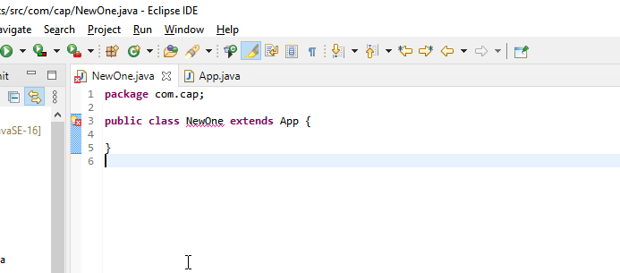

Shows that the singleton class cannot be inherited