**Flights Project Structure**

Users:

* Administrator
* Airline
* Customer
* Anonymous (Unlogged)

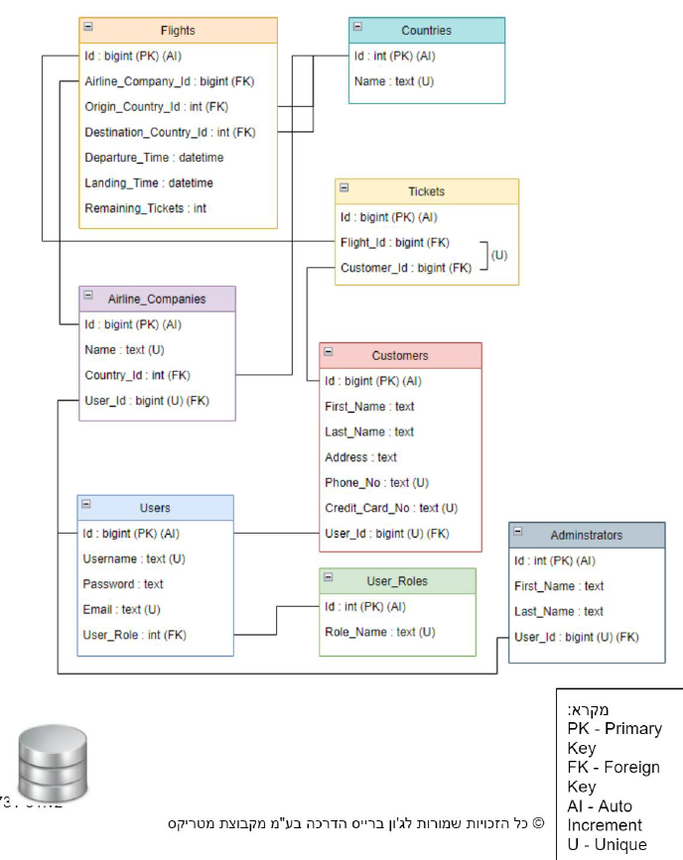Database Structure:

DB stored procedures:

* **get_airline_by_username(_username text)**
* **get_customer_by_username(_username text)**
* **get_user_by_username(_username tex)**
* **get_flights_by_parameters(_origin_country_id int, _destination_country_id int,_date date)**
* **get_flights_by_airline_ID(_airline_id bigint)**
* **get_arrival_flights_12hours(_country_id int)**
* **get_departure_flights_12hours(_country_id int)**
* **get_tickets_by_customer(_customer_id int)**
* **getFlightsByOriginCountryId(country_id)**
* **getFlightsByDestinationCountryId(country_id)**
* **getFlightsByDepartureDate(date)**
* **getFlightsByLandingDate(date)**
* **getFlightsByCustomer(customer)**
* **getAirlinesByCountry(country_id)**

Directory:

* .config- Connection String
* requirements.txt- שמות הספריות שהשתמשתם בהם
* **Logger**
  + **Logger class-singleton. Activation of every function from *Repository Class***
* **Modules (folder):**
* **Flight**
  + **class(dbmodel)**
* **AirlineCompany**
  + **class(dbmodel)**
* **Customer**
  + **class(dbmodel)**
* **Administrator**
  + **class(dbmodel)**
* **User**
  + **class(dbmodel)**
* **Country**
  + **class(dbmodel)**
* **Ticket**
  + **class(dbmodel)**
* **Repository**
  + **Repository(class)**
    - **Get by id, Get All, Add, Update, Add All, Remove**
    - **Mega-Func for all SP**
      * **getFlightsByOriginCountryId(country_id)**
      * **getFlightsByDestinationCountryId(country_id)**
      * **getFlightsByDepartureDate(date)**
      * **getFlightsByLandingDate(date)**
      * **SP: get_flights_by_parameters(_origin_country_id int, _destination_country_id int,_date date)**
      * **SP: get_flights_by_airline_ID(_airline_id bigint)**
      * **SP: get_arrival_flights_12hours(_country_id int)**
      * **SP: get_departure_flights_12hours(_country_id int)**
      * **getFlightsByCustomer(customer)**
      * **SP: get_tickets_by_customer(_customer_id int)**
      * **SP: get_user_by_username(_username tex)**
      * **getAirlinesByCountry(country_id)**
      * **SP: get_airline_by_username(_username text)**
      * **SP: get_customer_by_username(_username text)**

[SP, CRUD]

* FacadeBase
  + FacadeBase (parent class)
    - **get_all_flights()**
    - **get_flight_by_id(flightid)**
    - get_flights_by_parameters(origin_country_id, destination_country_id, date)
    - **get_all_airlines()**
    - **get_airline_by_id(airlineid)**
    - **get_airline_by_parameters( … )**
      * **userID**
      * **countryID**
    - **get_all_countries()**
    - **get_country_by_id(countryid)**
    - create_new_user ( user ) - for internal usage
* AnonymousFacade
* AnonymousFacade class(inherits façade base)
  + - login ( username, password )

After a successful login the function will return the ***correct facade*** [customer, airline or admin] and a ***login-token*** member inside (@getter)

Upon failure will return None or raise an error (i.e. WrongPasswordError)

* + - add_customer ( … )
* CustomerFacade
* CustomerFacade class(inherits façade base)
  + update_customer (customer)
  + add_ticket (ticket)
  + remove_ticket (ticket)
  + get_my_tickets ()
* AirlineFacade
* AirlineFacade class(inherits façade base)
  + get_my_flights ()
  + update_airline (airline)
  + add_flight (flight)
  + update_flight (flight)
  + remove_flight (flight)
* AdministratorFacade
* AdministratorFacade class(inherits façade base)
  + get_all_customers()
  + add_airline (...)
  + add_customer (...)
  + add_administrator (...)
  + remove_airline (airline)
  + remove_customer (customer)
  + remove_administrator (administrator)
* Login Token
  + Login token class
    - Parameters: ID, name, role (customer/airline/administrator)
* Testings unit-pytest