Setting Up Branch-to-Bench on Retool

- Go to https://github.com/MirBarnes/Forest-Entomology-Database-Project and download the folder “setupRETOOL”.

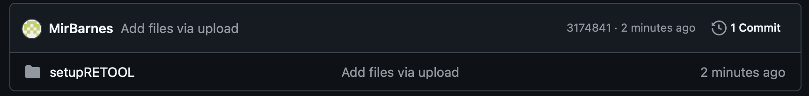
- If you don’t already have a Retool account, go to https://retool.com and click “Start for free” at the upper right-hand corner (at the time of this writing, June 2025). Set up a new account with your email or Google account.

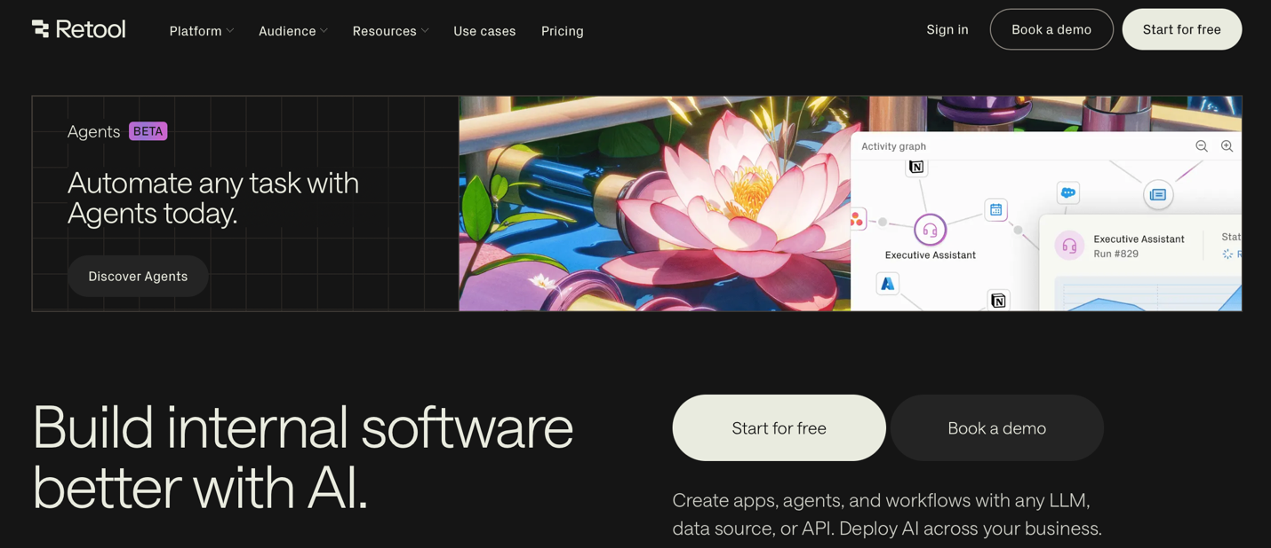

- During the account generation process, you will be asked whether you want to join a new organization or create a new organization. You will probably want to create a new organization. You’ll be asked a series of questions about your organization name, coding proficiency, and what applications you hope to build.

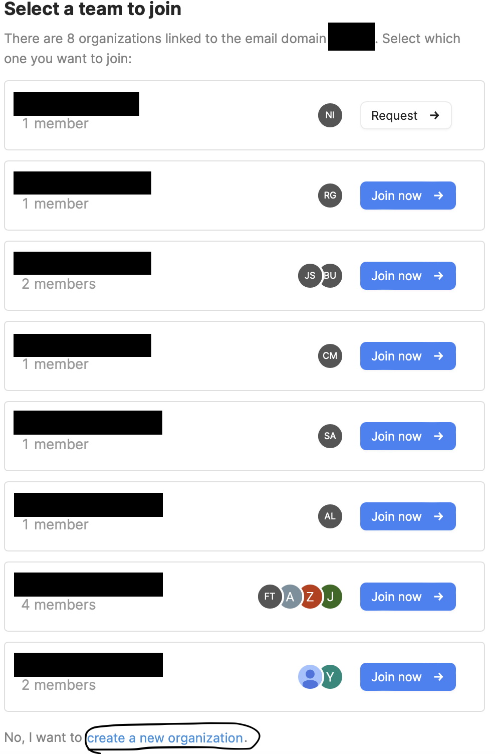

- After you have set up your new organization, Retool will take you directly to an app creation page. Immediately leave this setup by clicking the icon in the upper right hand corner and selecting “Back to home”.
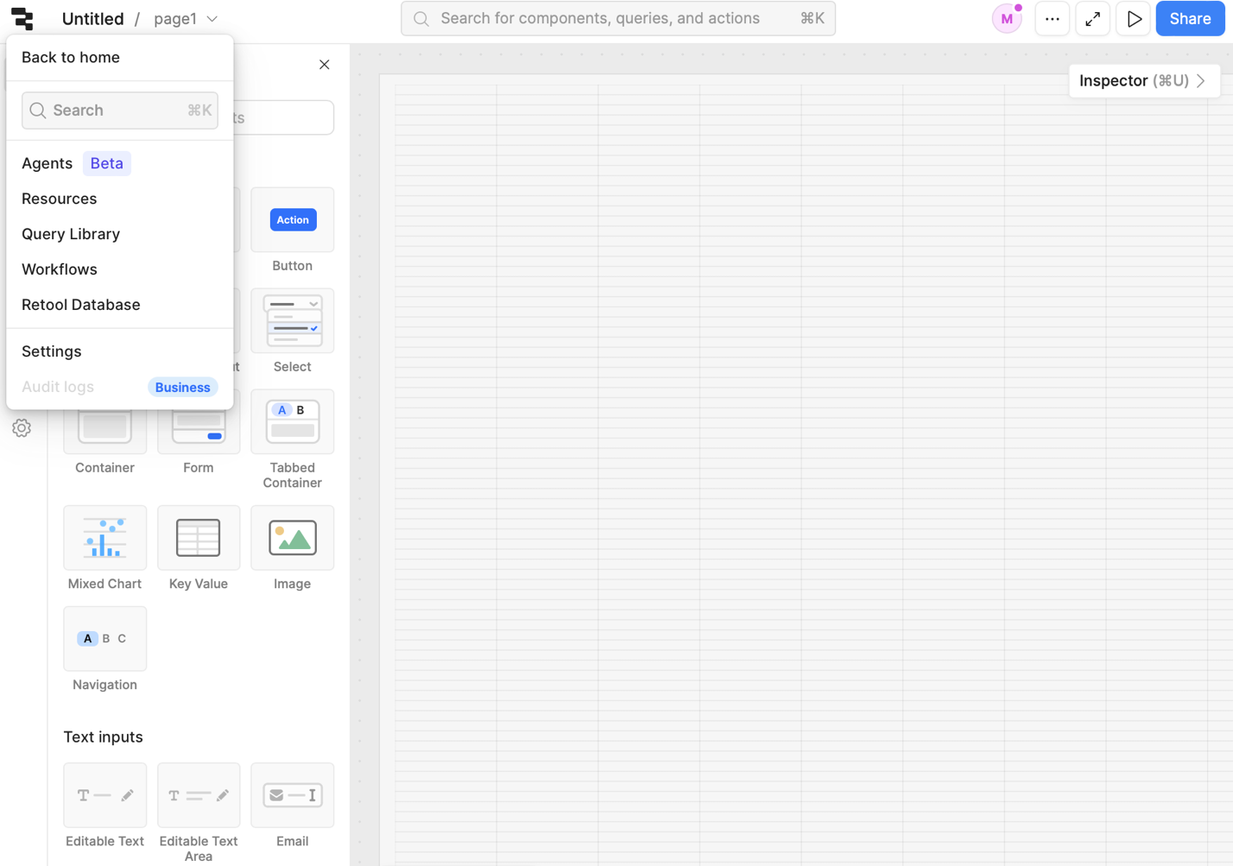

- Once you are on the home page, click on “Resource”. 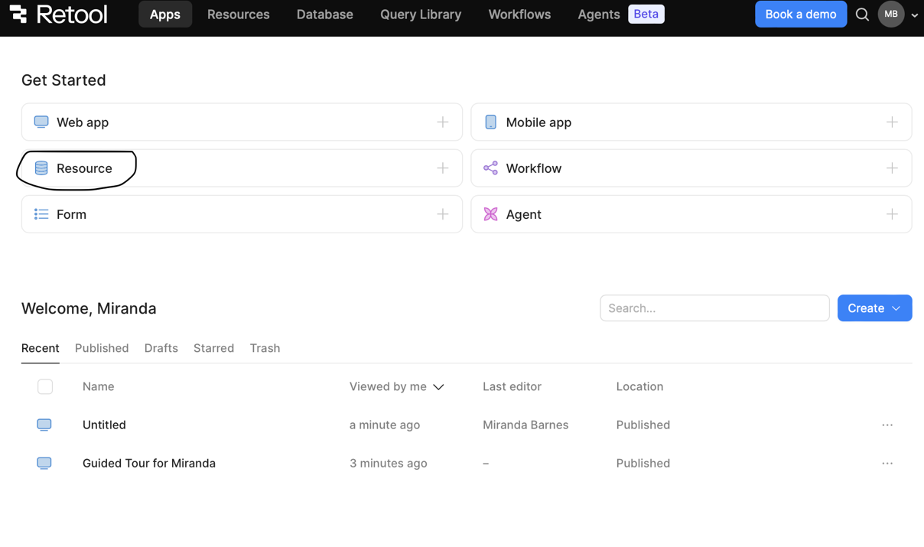

- Select “Retool Database”.

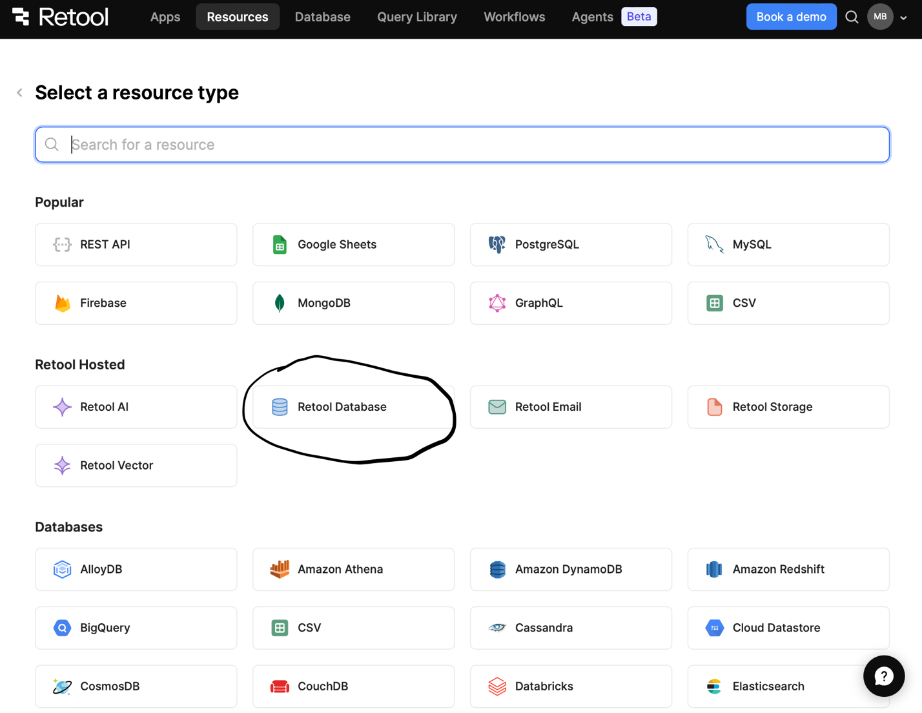

- It will take you to this page. Click “Import csv to a new table”. You will want to start by importing “Codebook.csv” in the retoolCSV folder.

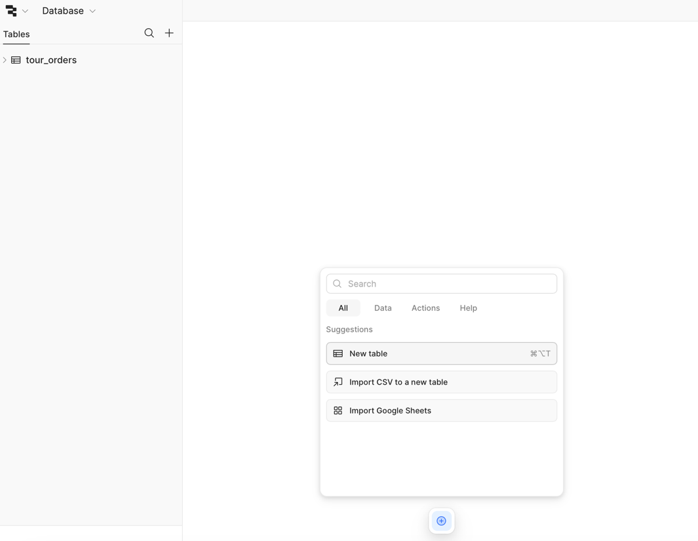

- You will be presented with something that looks like this.
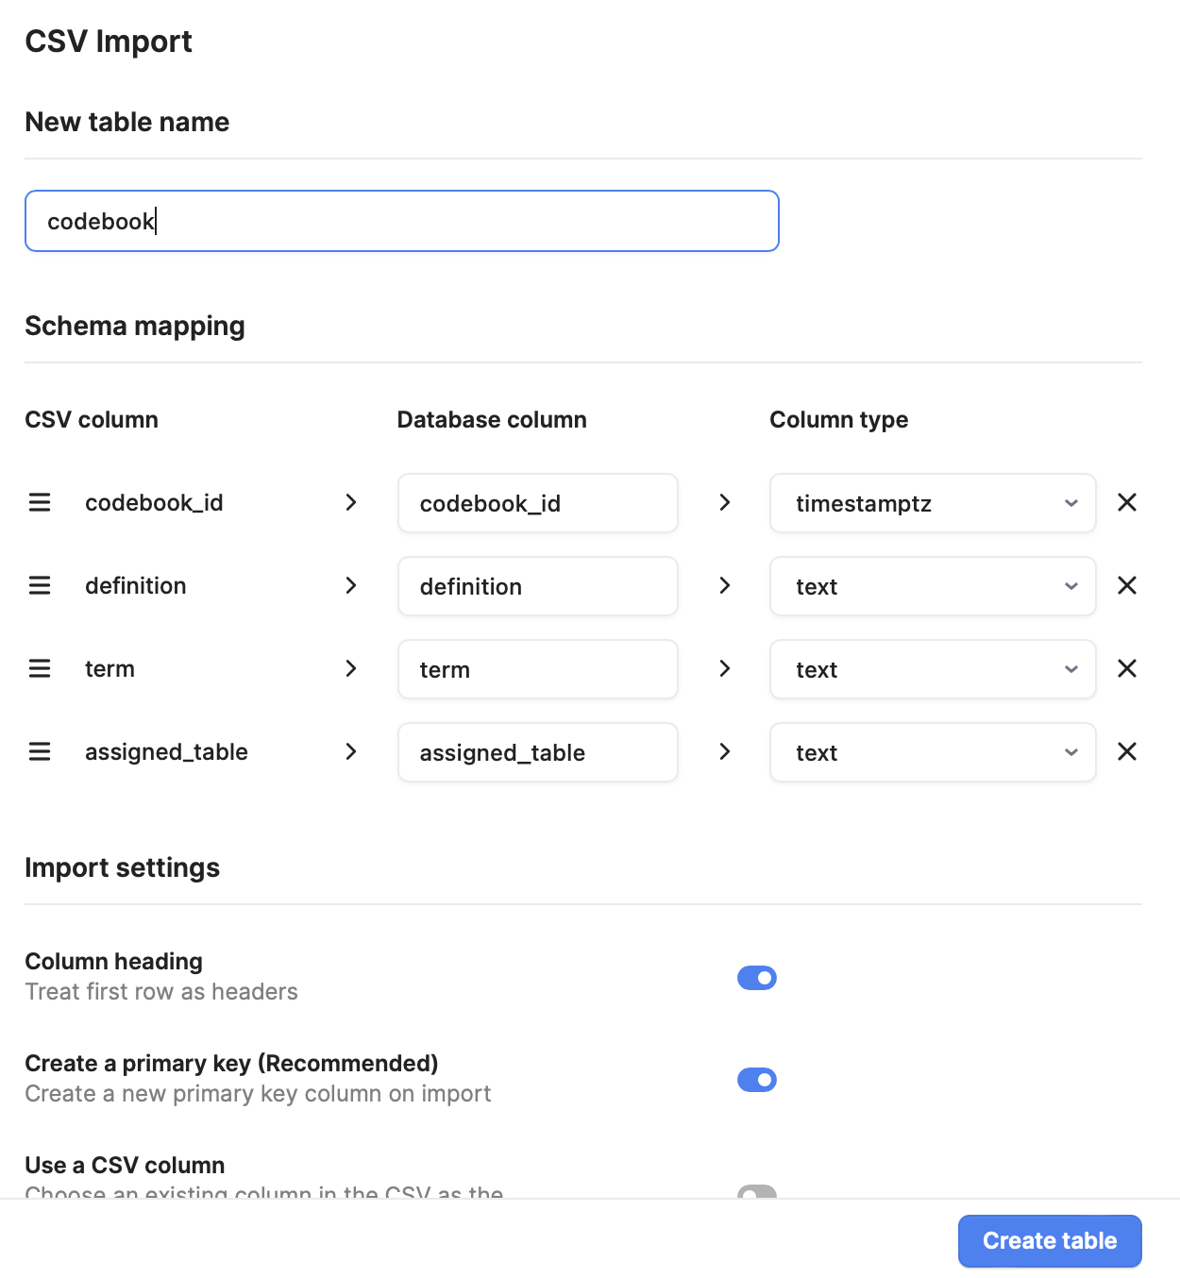

You will need to do the following for each table.
- Change the “New table name” to the original name of the .csv file, minus the file extension (i.e., capital letters for the start of each word, no spaces). So in this example, change “codebook” to “Codebook”. Retool will try to discourage from doing this by asking you to convert the title to snake case – ignore it or the application will not recognize the database.
- Change the data types to accurately reflect what we want each column to represent (in this case, alter the column type of “codebook_id” to int4.)
- Toggle on “Use a csv column” under Import Settings (it should automatically select “codebook_id” as the primary key in this case.)

For “Codebook”, the csv import should look like this:

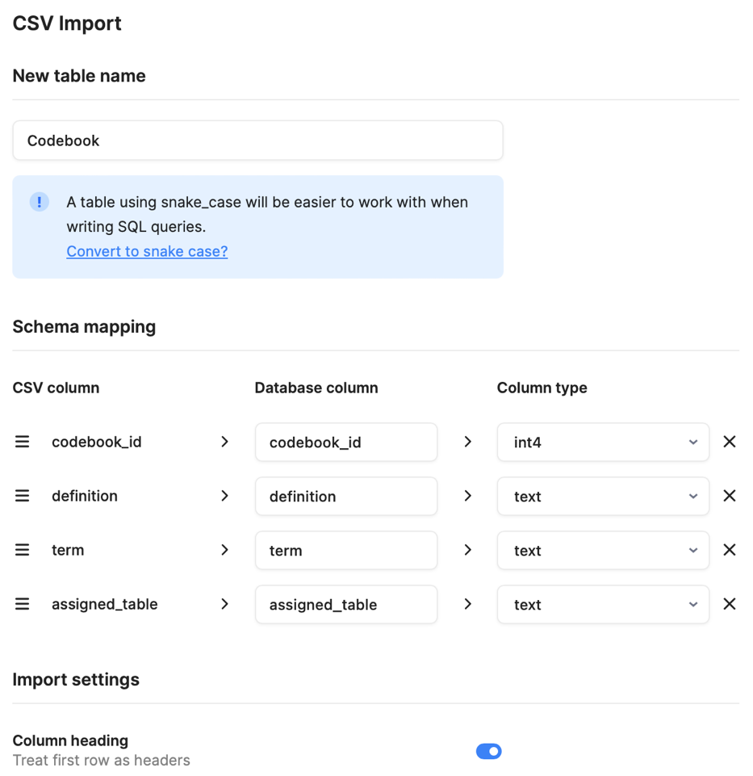
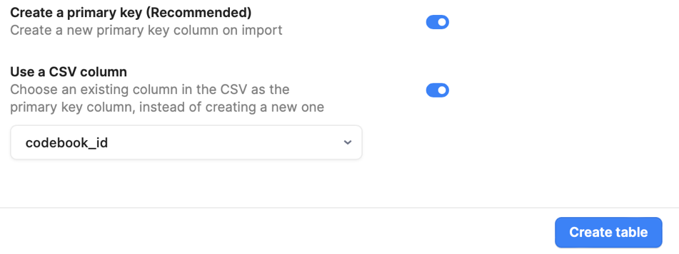

Click “Create table”.

- Go back to the actions menu at the bottom of the page and click the plus button. Select “New table” and import “Projects.csv”.
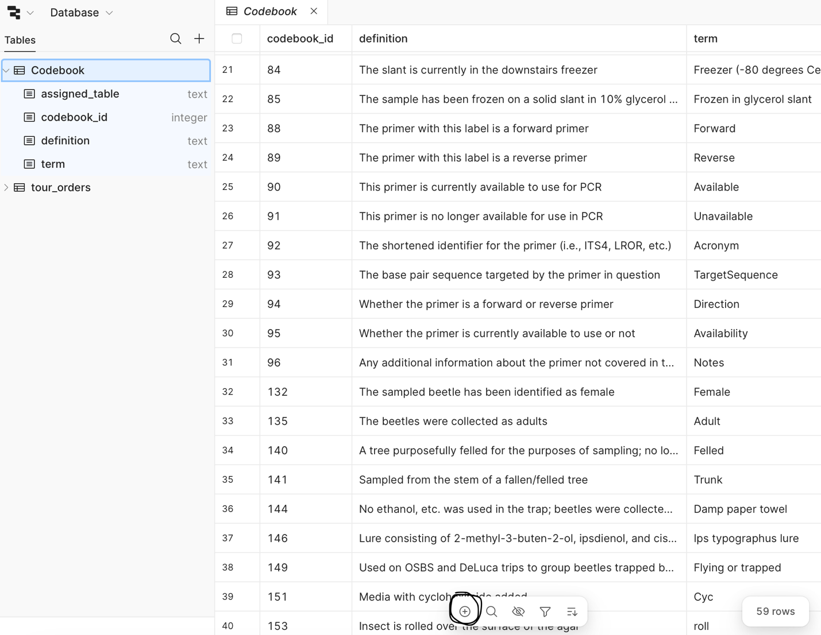

- Again, you will need to convert the title, data types, and the csv column as you did for Codebook.
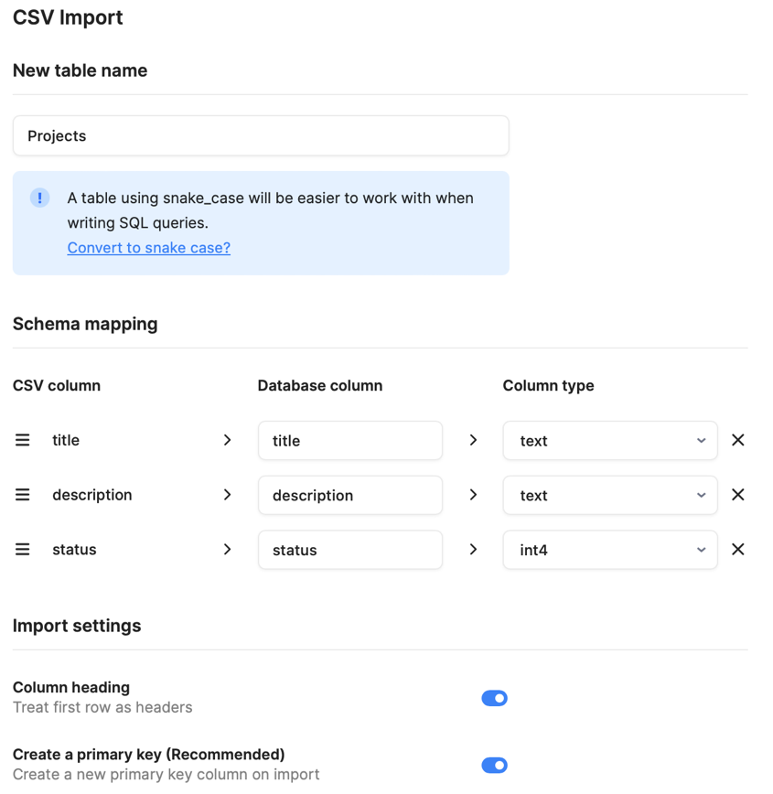
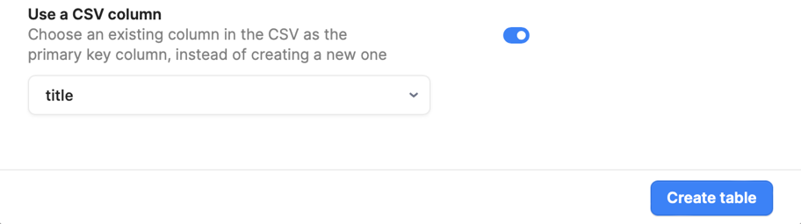

- Once you create this table, click on the “status” column heading, and select “Settings”.

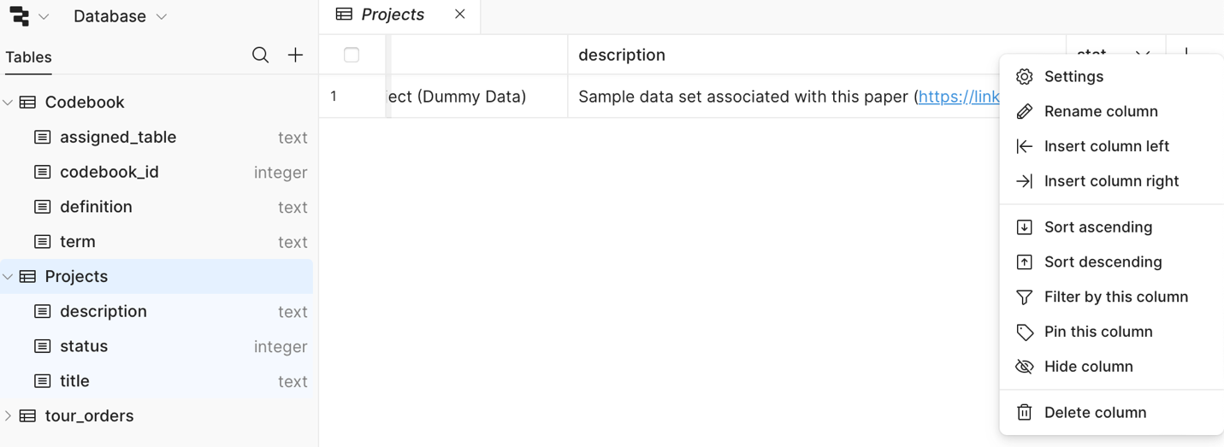

You will want to change the “Column type” of status to “Foreign key” and adjust the resulting settings to as follows:
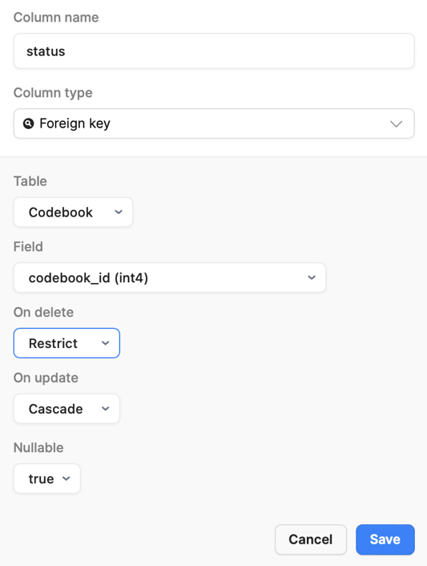

- You will now want to repeat these steps (9-11) for each table in the database. Shown below are the correct settings configurations for each table as well as the foreign key adjustments made after table creation. Again, make sure to double check the data type and the capitalization in each table. If these are not input correctly, many of the queries will not work.

For “LabMembers.csv”:
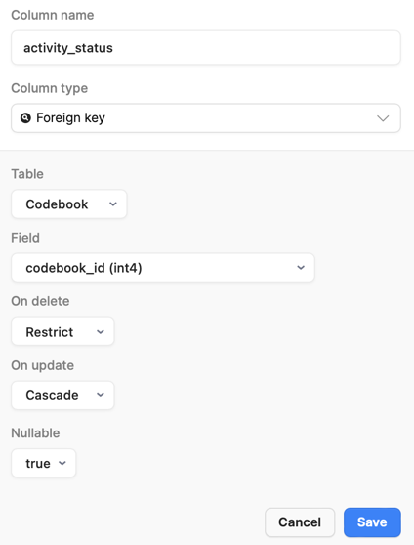
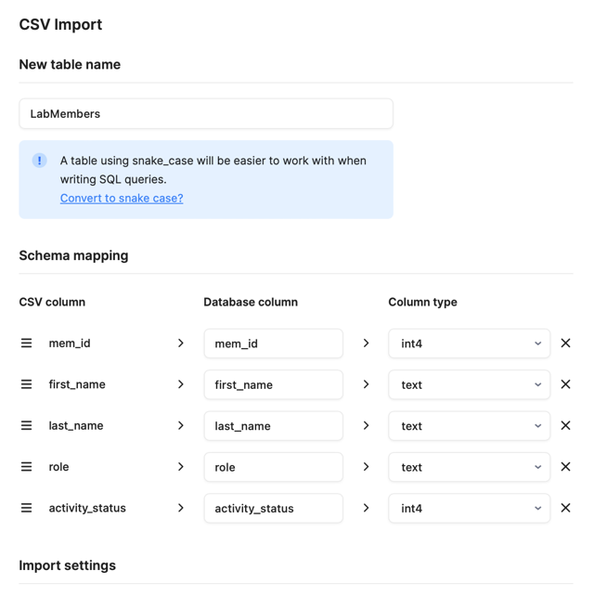
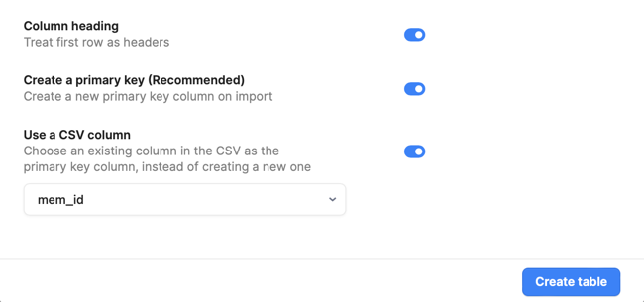

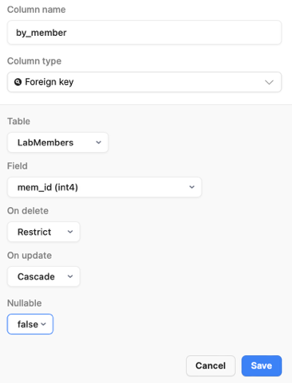
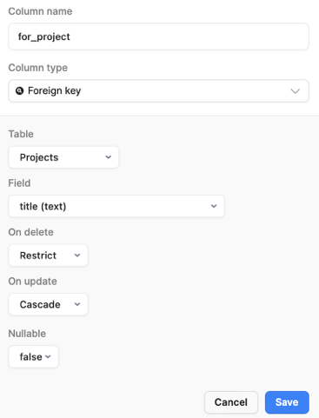
For “GeneratedObjects.csv”:
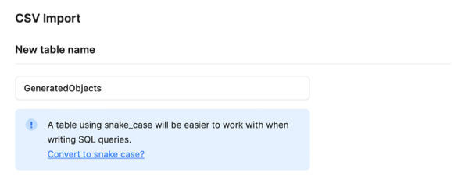
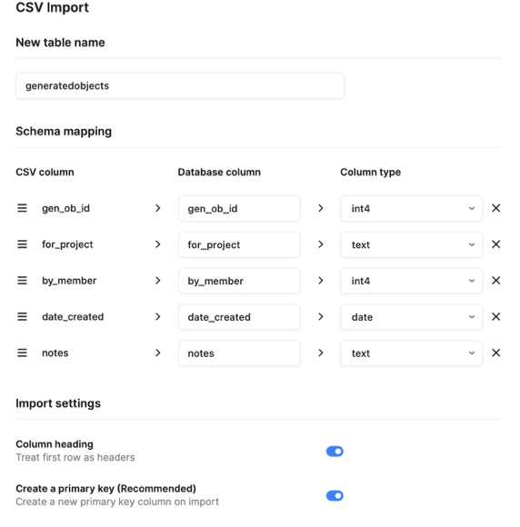
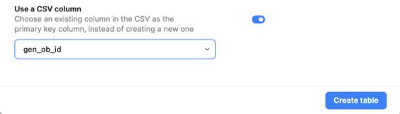

For “SampleDerivations.csv”:
Note for this one that we don’t want to create a primary key when we import it because we will want to designate a composite primary key consisting of both sample_object and comes_from.
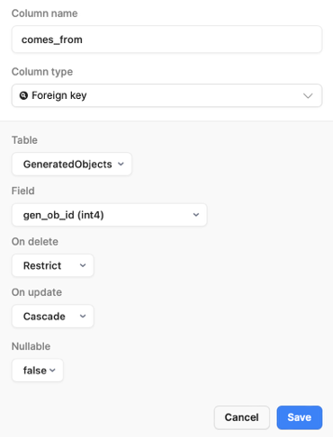
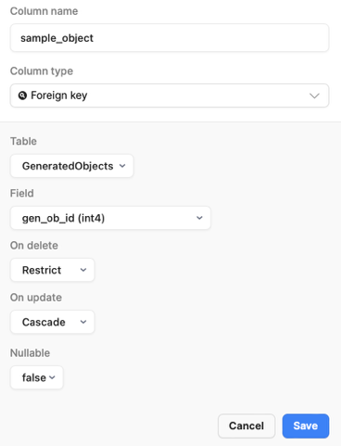
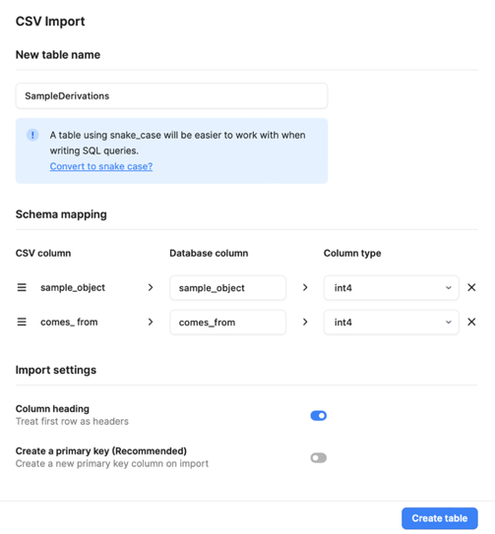
Once you’ve added in the foreign keys, go to the “Add key” button at the upper right and indicate “From existing column.”

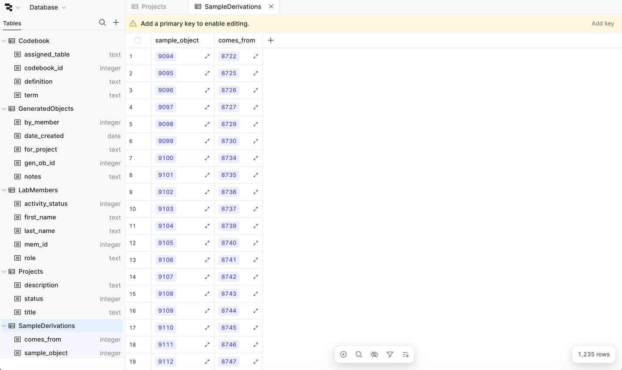

Select “Use a composite key” and select both “comes_from” and “sample_object”, then click “Set new”.

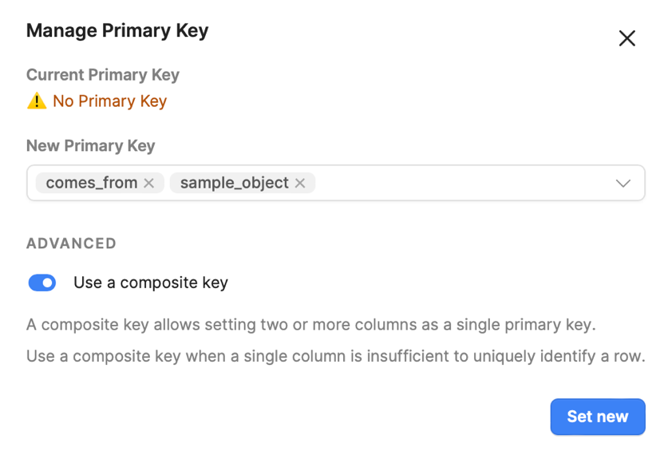

From “PrimerStocks.csv”:
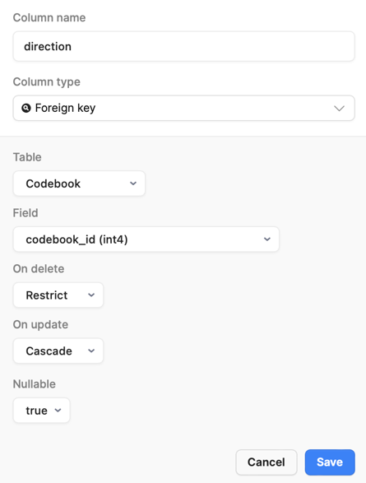
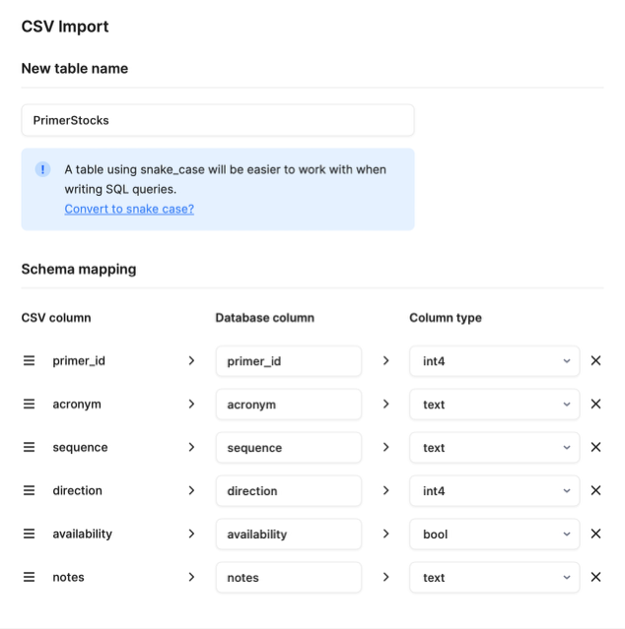
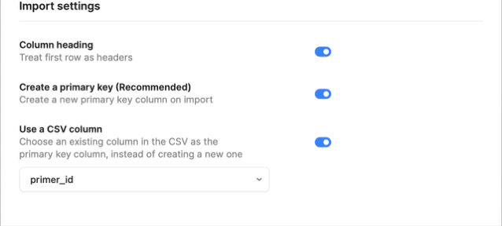

From “MediaPrepBatches.csv”:
From here on out (including for MediaPrepBatches”, you’re going to need to wait to designate a primary key until you have specified all of your foreign keys, as we did for “SampleDerivations”. This is because most of the primary keys will be foreign keys representing “GeneratedObjects”, and Retool will not you designate a foreign key if it has already been specified as a primary key, only the other way around.

For “MediaPrepBatches”, you will also need to go into the settings for “prep_id” and ensure it is unique (under “Unique”, select “true”) and not nullable (under “Nullable”, select “false”).
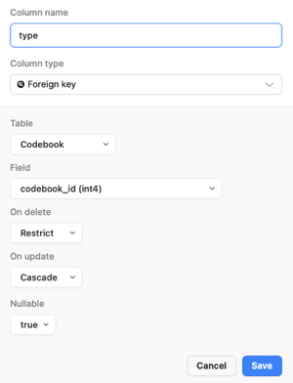
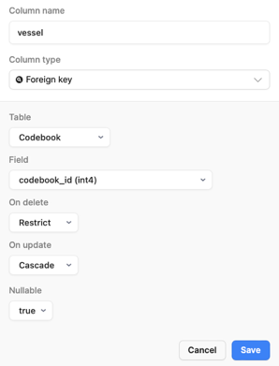
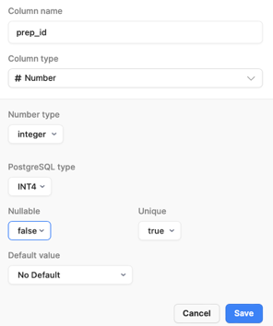
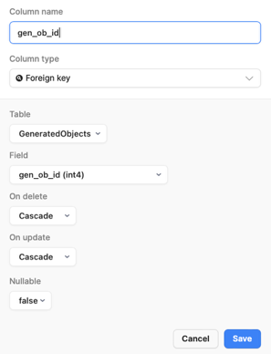
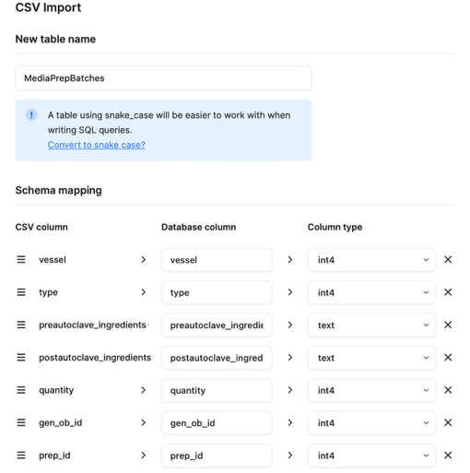
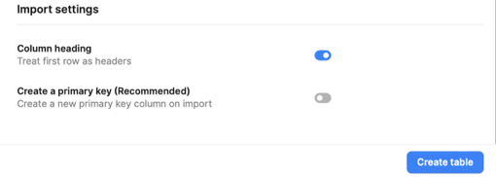

From “login.csv”:
Leave this table’s title all in lowercase and designate “mem_id” as a primary key after making it a foreign key.
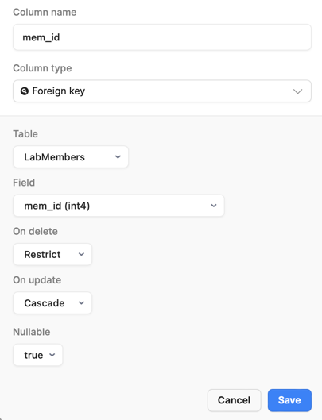
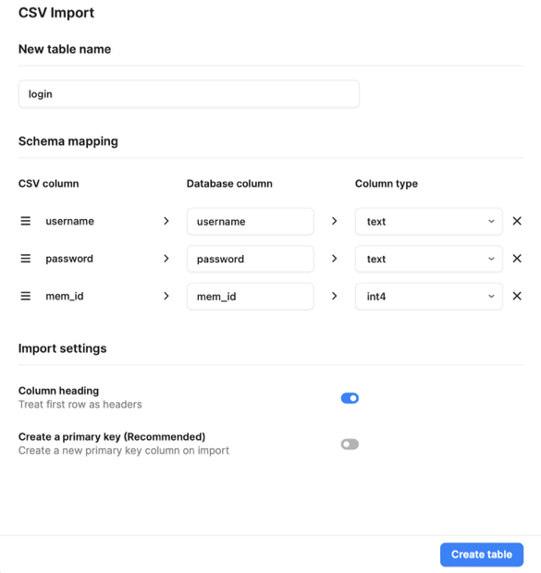

From “Trees.csv”:
Designate “gen_ob_id” as a primary key after making it a foreign key.
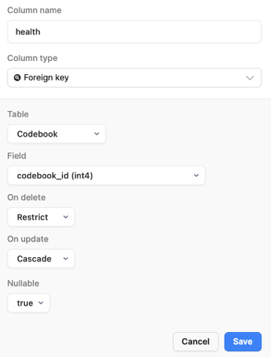
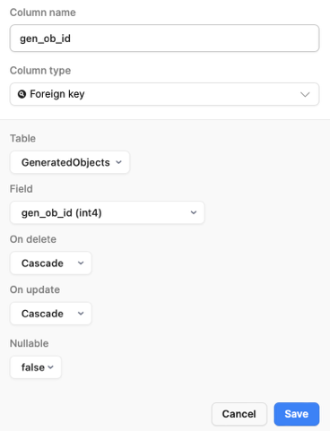
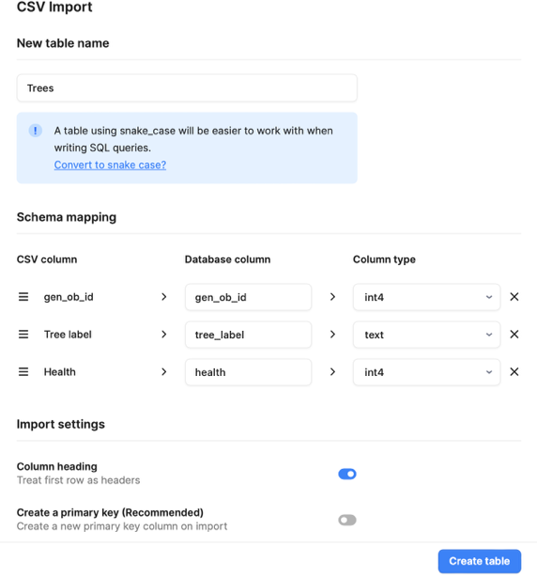

From “Traps.csv”:
Designate “gen_ob_id” as a primary key after making it a foreign key.
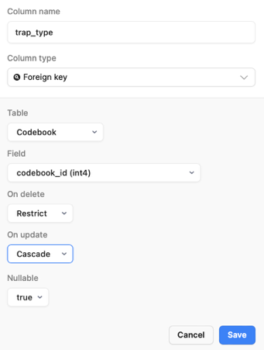
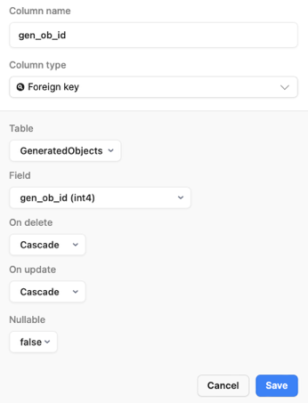
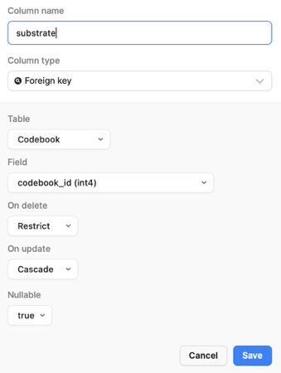
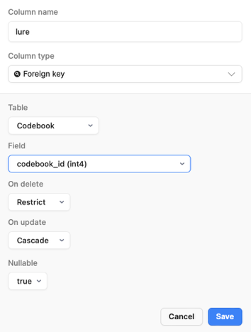
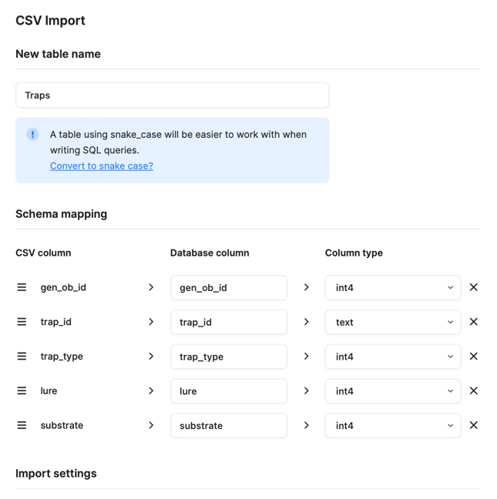
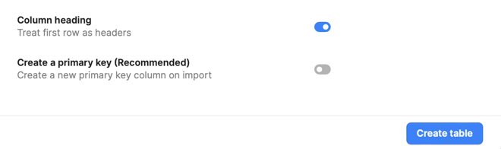

From “Galleries.csv”:
Designate “gen_ob_id” as a primary key after making it a foreign key.
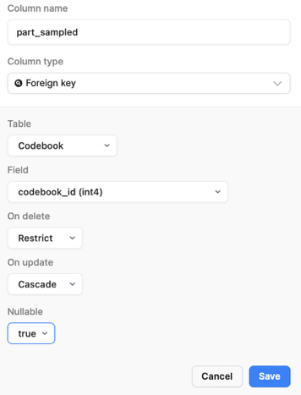
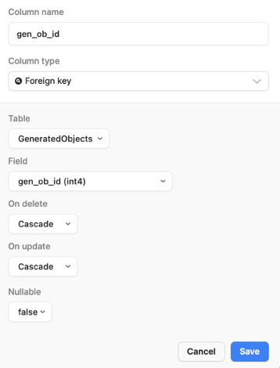
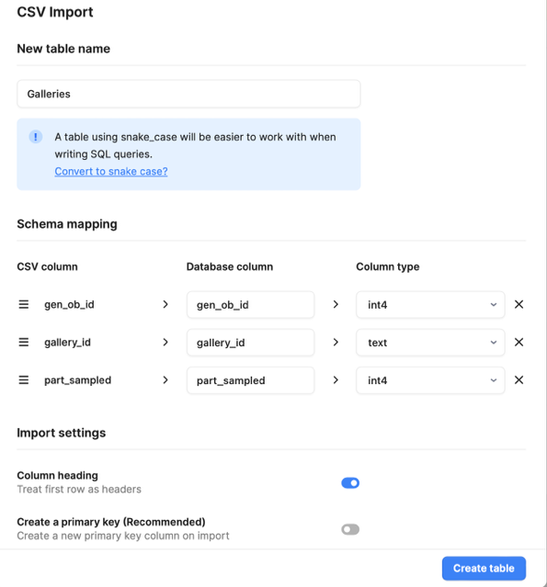

From “Beetles.csv”:
Designate “gen_ob_id” as a primary key after making it a foreign key.
Make sure that beetle_identifier is specified as text!!
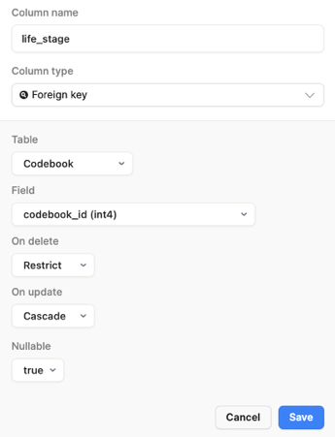
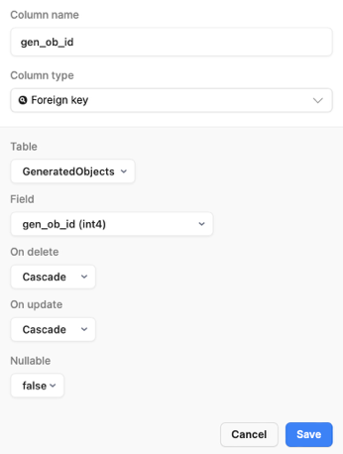
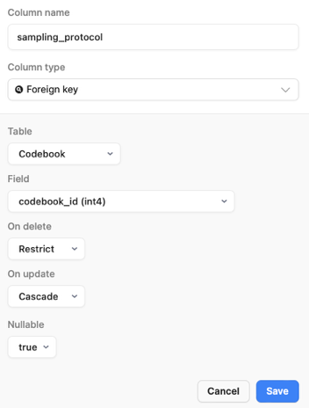
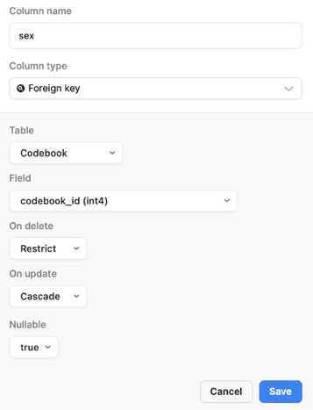
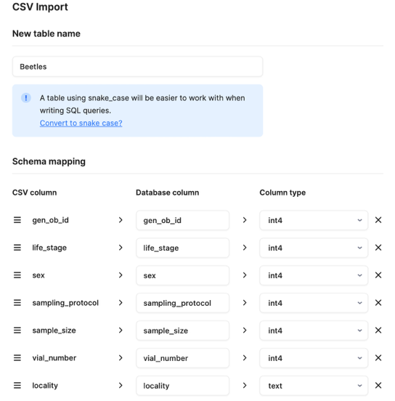
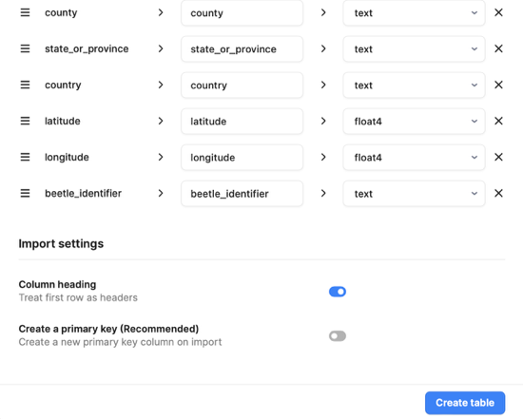

From “Cultures.csv”:
Designate “gen_ob_id” as a primary key after making it a foreign key. You will also need to go into the settings for “physical_label” and ensure it is unique (under “Unique”, select “true”) and not nullable (under “Nullable”, select “false”).
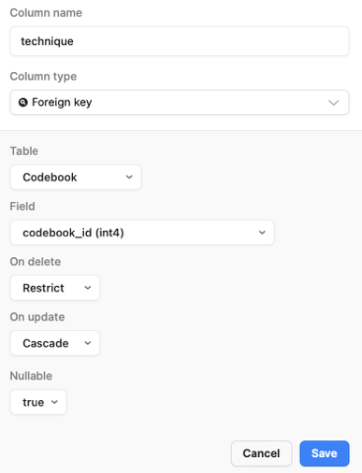
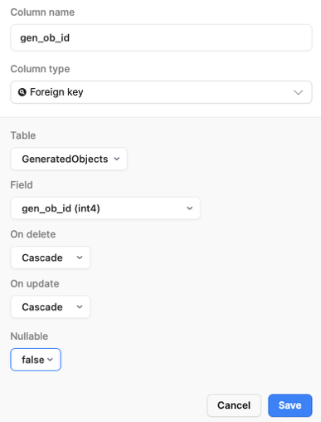
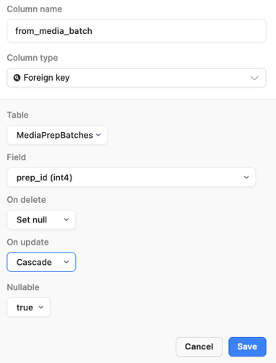
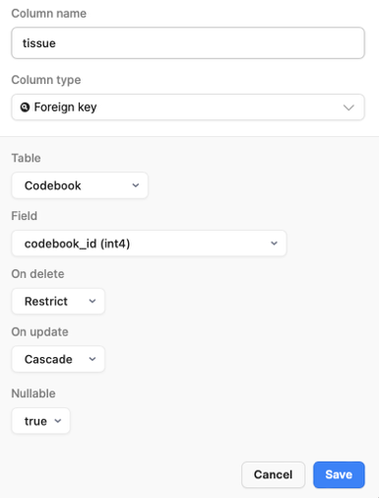
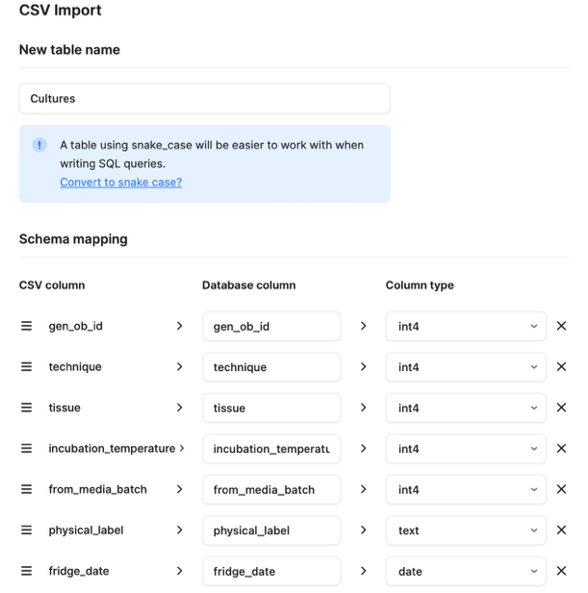
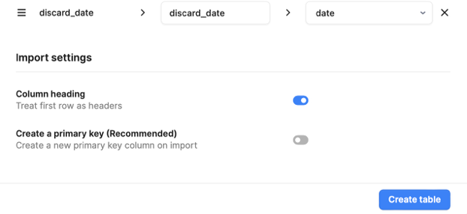

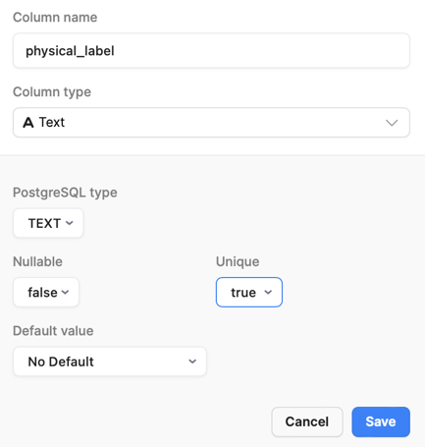

From “Morphotypes.csv”:
Designate “gen_ob_id” as a primary key after making it a foreign key.
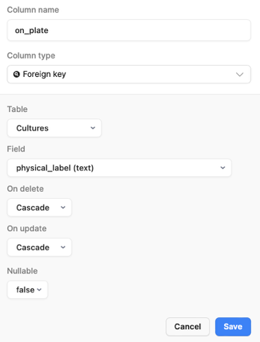
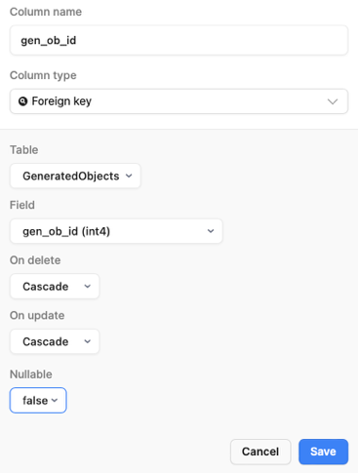
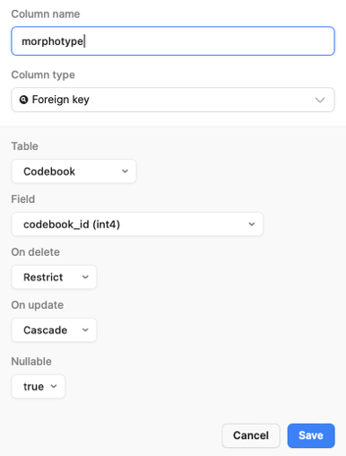
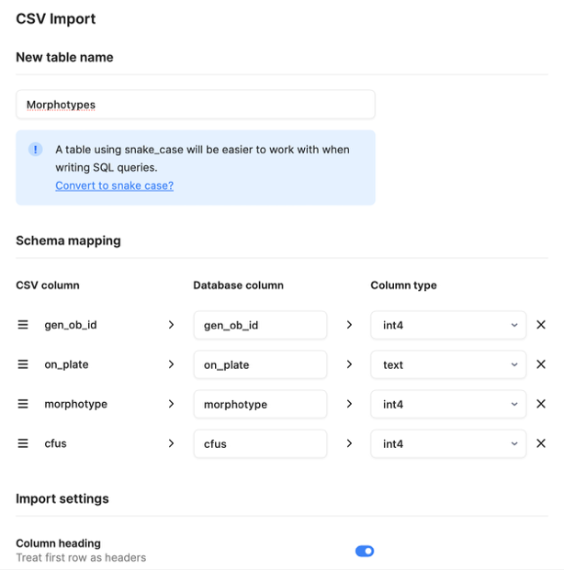
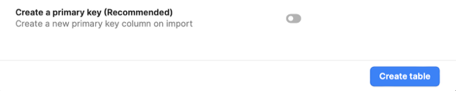

From “Slants.csv”:
Designate “gen_ob_id” as a primary key after making it a foreign key.
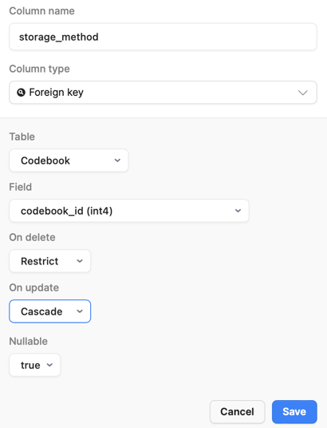
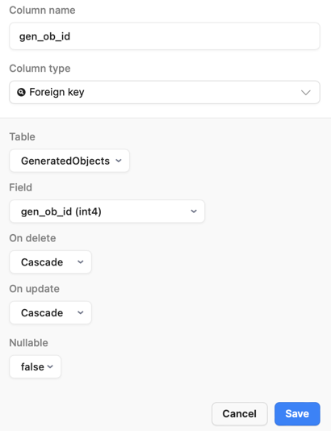
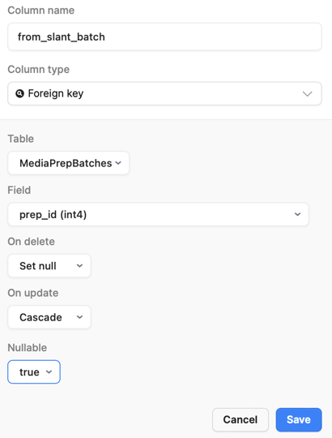
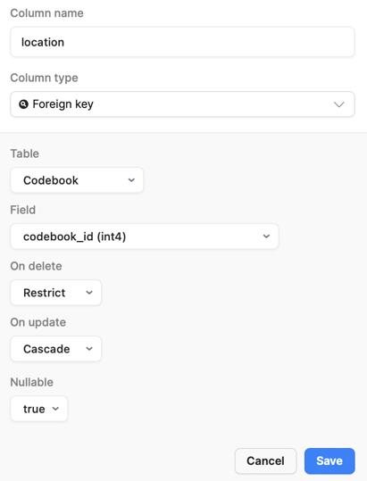
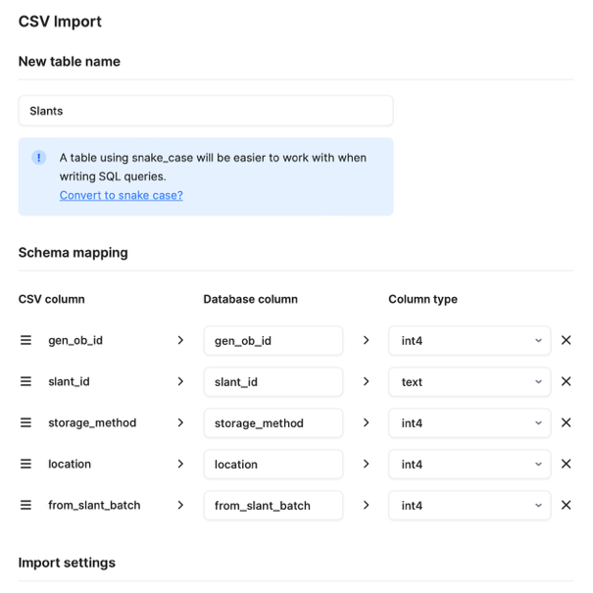
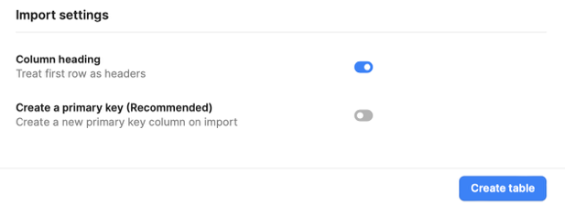

From “Extractions.csv”:
Designate “gen_ob_id” as a primary key after making it a foreign key.
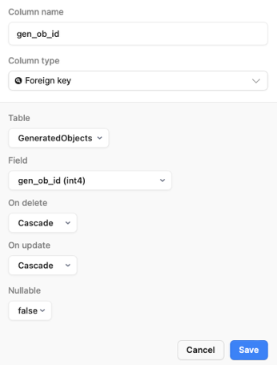
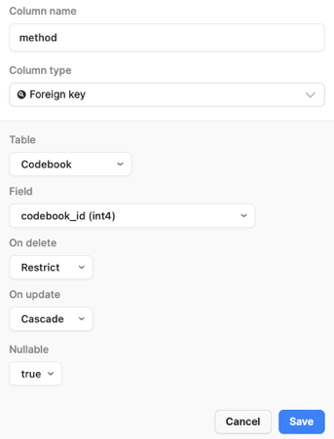
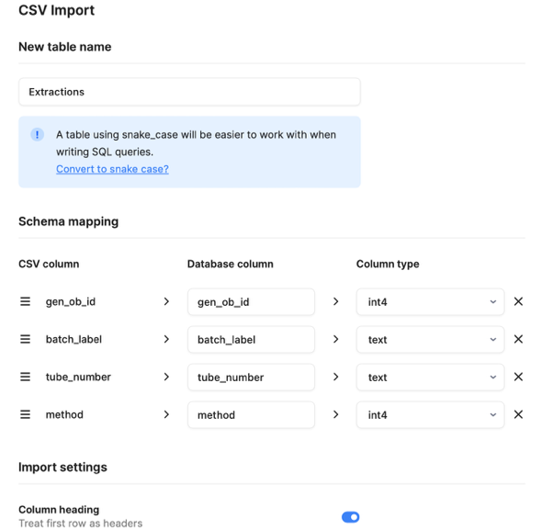
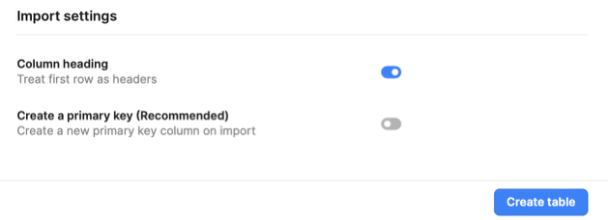

From “PCRProducts.csv”:
Designate “gen_ob_id” as a primary key after making it a foreign key.
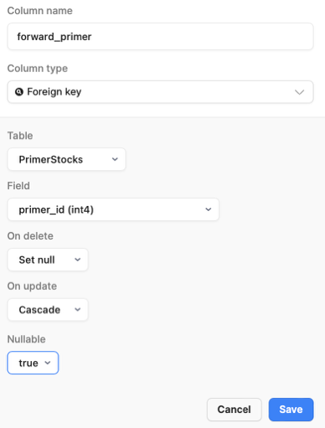
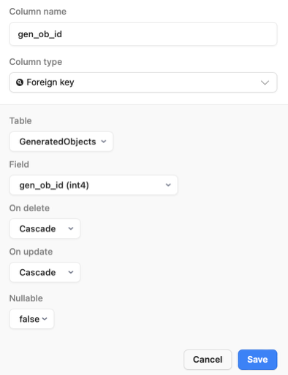
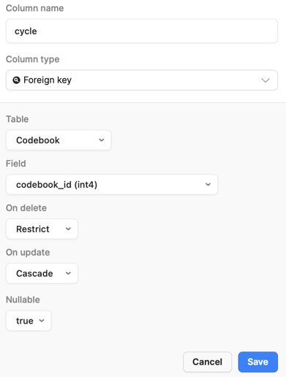
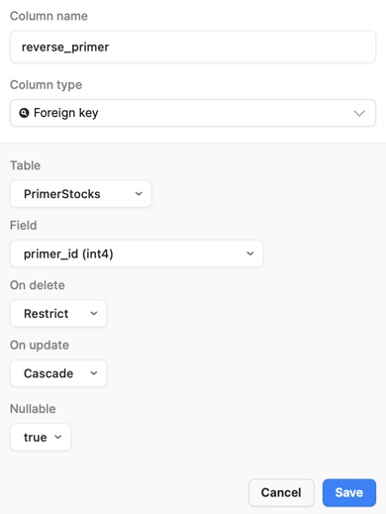
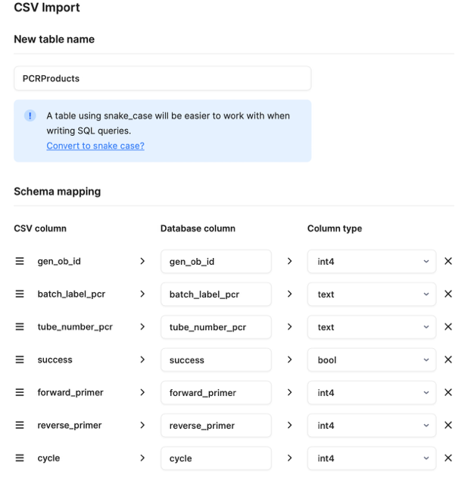
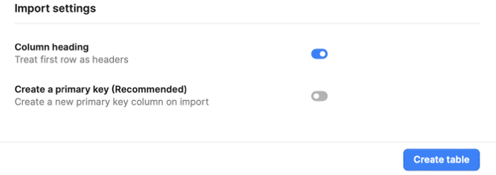

From “Sequences.csv”:
Designate “gen_ob_id” as a primary key after making it a foreign key.
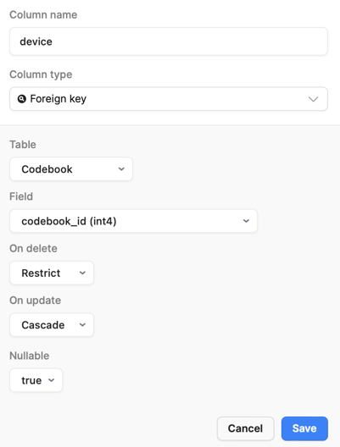
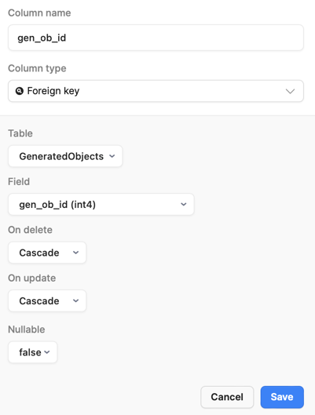
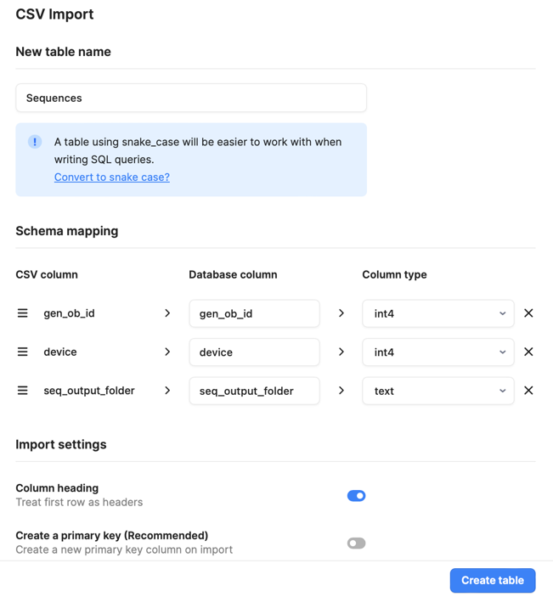

From “Computations.csv”:
Designate “gen_ob_id” as a primary key after making it a foreign key.
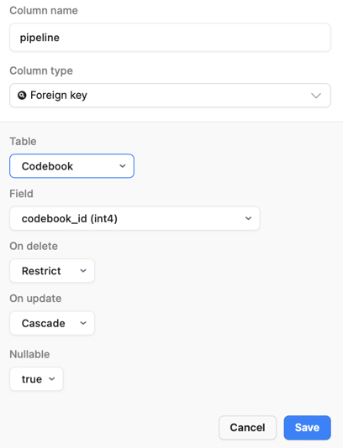
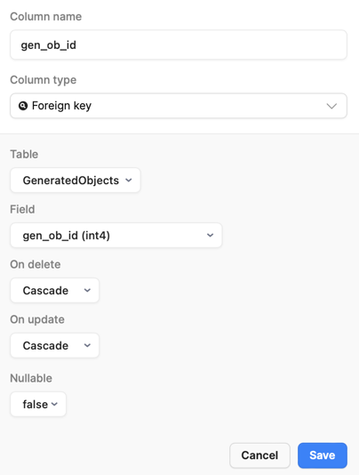
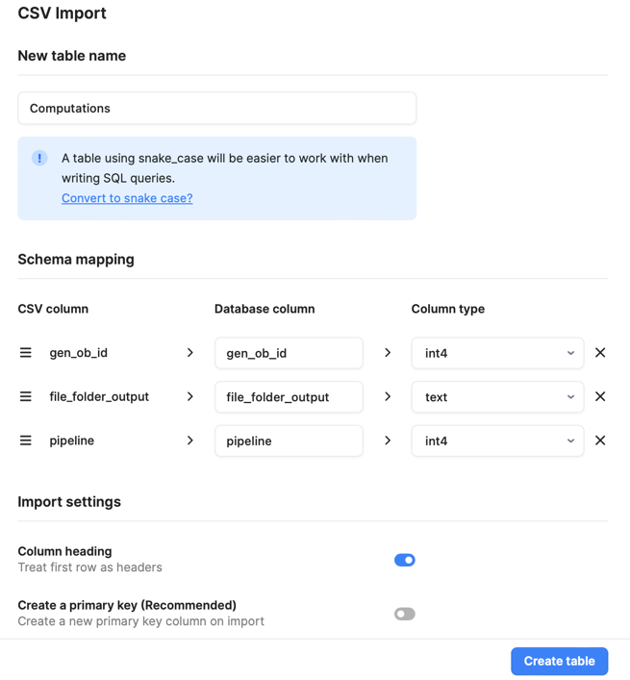

From “Identifications.csv”:
Designate “ided_ob_id”, “id_by”, and “date_identified” as a composite primary key after designating appropriate foreign keys.
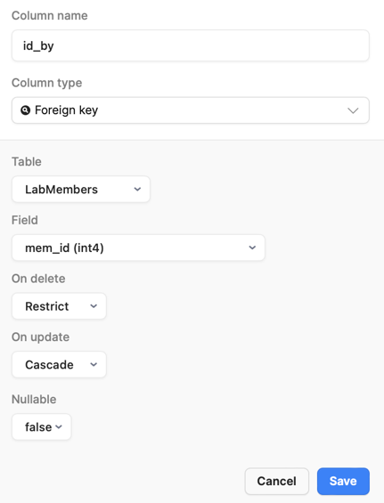
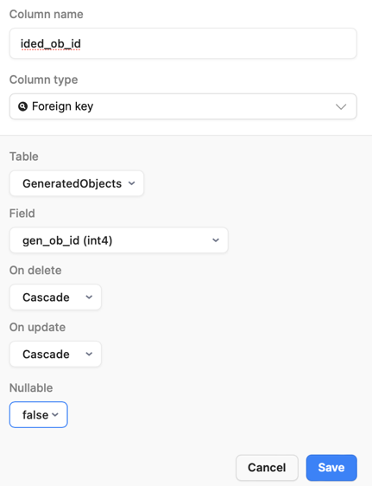
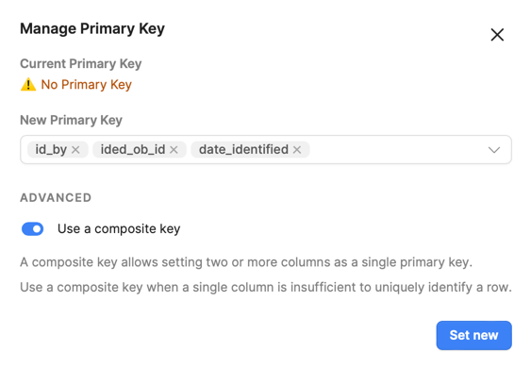
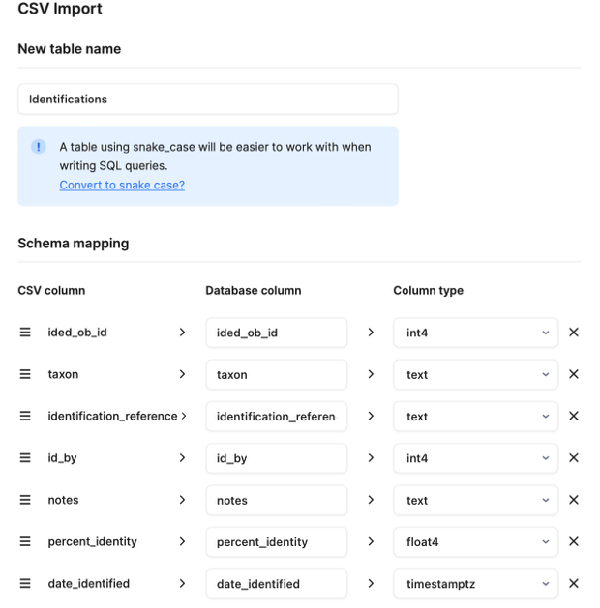
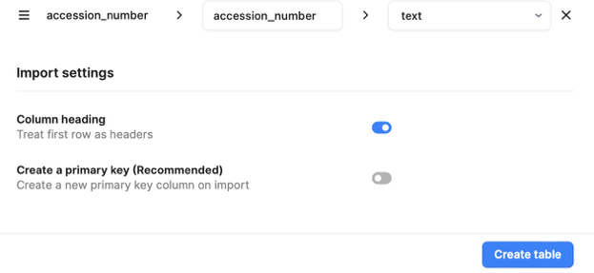

From “idCounter.csv”:
For this table, go ahead and designate table_name as the primary id during the table creation step.

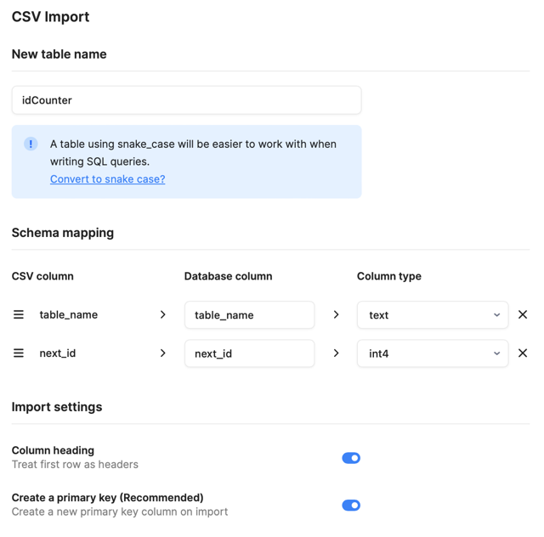
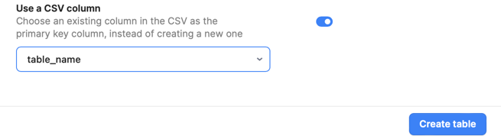

- Now that the database backend is constructed, all we need to do is upload the application files for the user interface! Leave the database by clicking the icon at the upper left-hand corner of the screen and selecting “Back to Resources.”

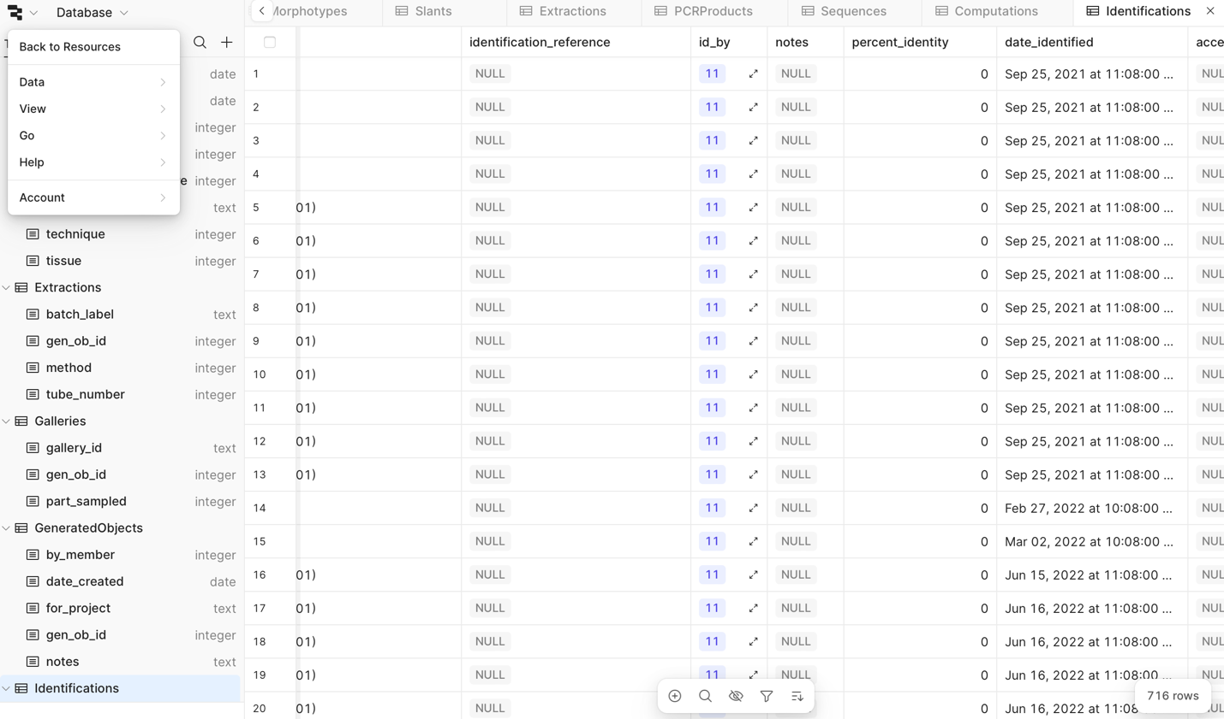

Then navigate back to “Apps”.

- Click on “Published”.

- Click on “Create” and select “Create a Folder”. Give it a name.
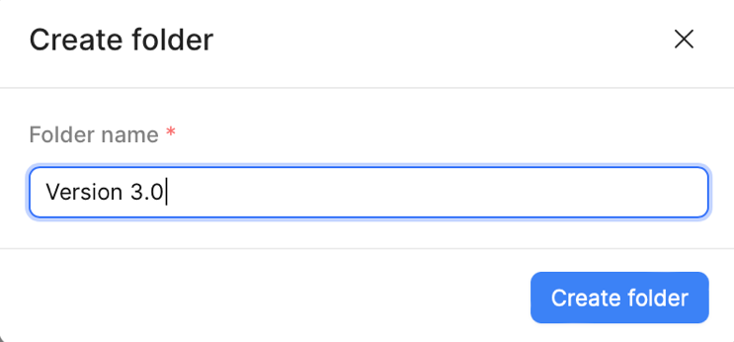

- Click on “Create” again and select “From JSON/ZIP”.

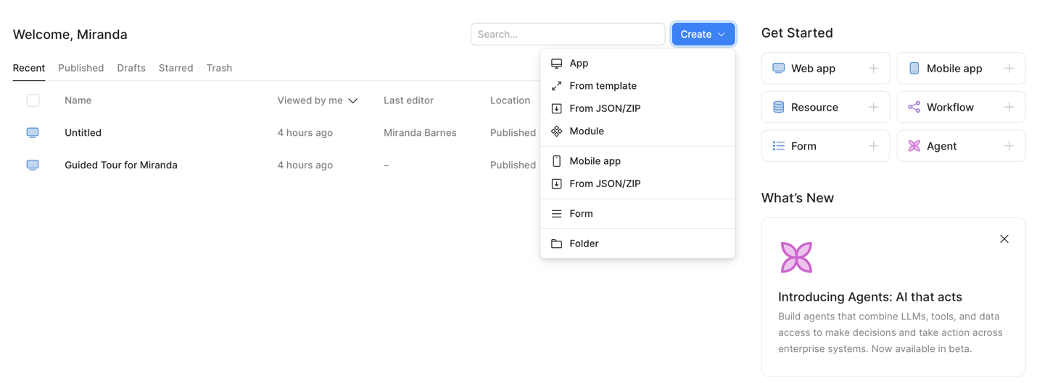

- You will be presented with an option to upload a file. Note that when you click on this to upload the page, Retool may open a new tab. When you upload the file on this new tab, it will appear as if nothing has happened. Return to the original tab and you will see that the file has been uploaded. Select the folder you created. Then click “Create app”.

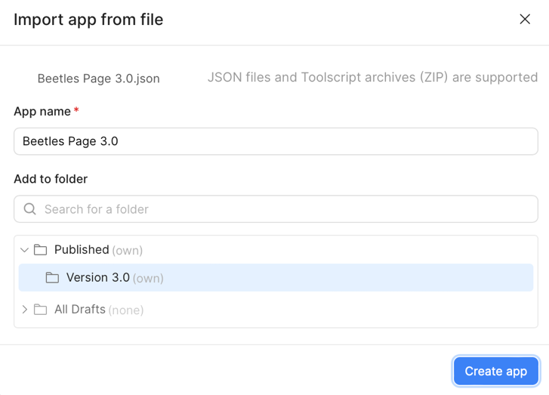

It will take you to the editor for that page. Leave the editor by navigating back to the icon at the upper left-hand corner and clicking “Back to home”.

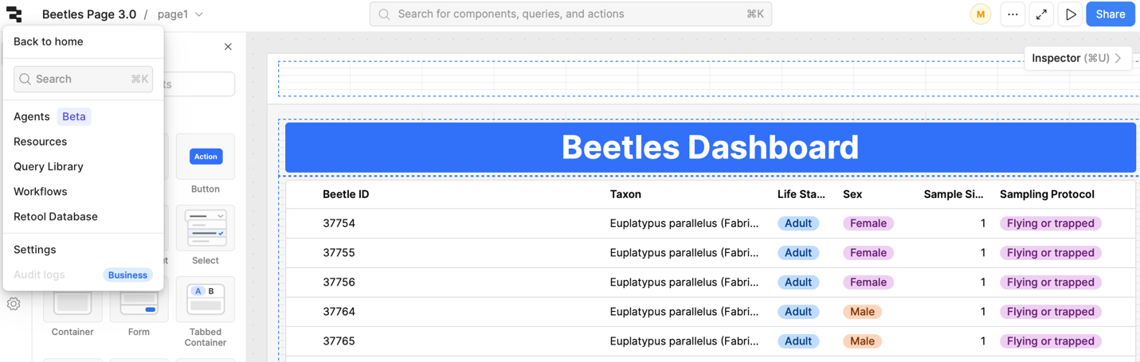

- Return to published, then the “Version 3.0” folder, then repeat this process for all of the .json files in the user interface. Make sure you are creating all of them in the “Version 3.0” folder.

- The last task is to connect each interface via the navigation bar at the top of the page. This is technically optional if you’d prefer to access the applications via the Retool home page, but it’s more convenient to be able to move from application page to application page.

To do this, click the big white empty bar at the top of the page and open the “Inspector” tab.

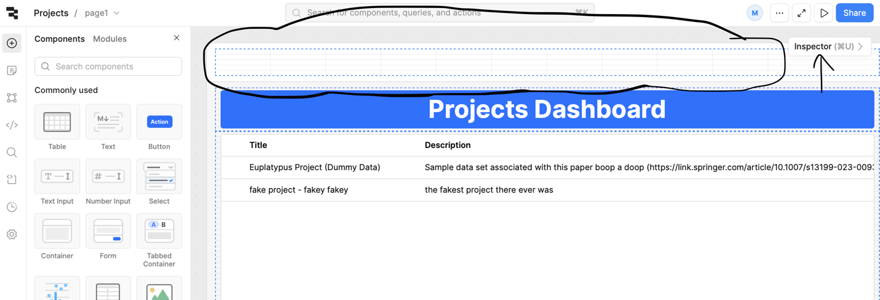

The following menu should appear. Click on one of the menu items and find the “App” option under “Edit menu item”.

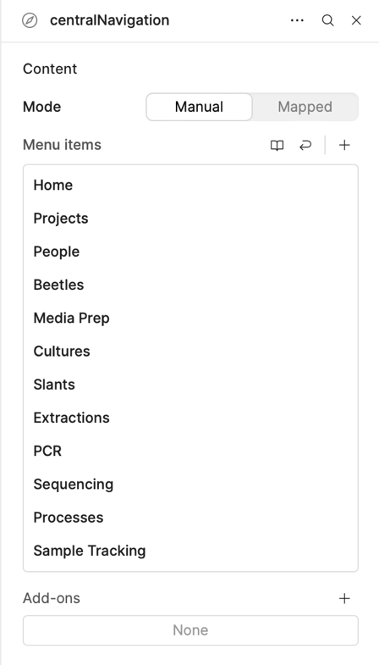
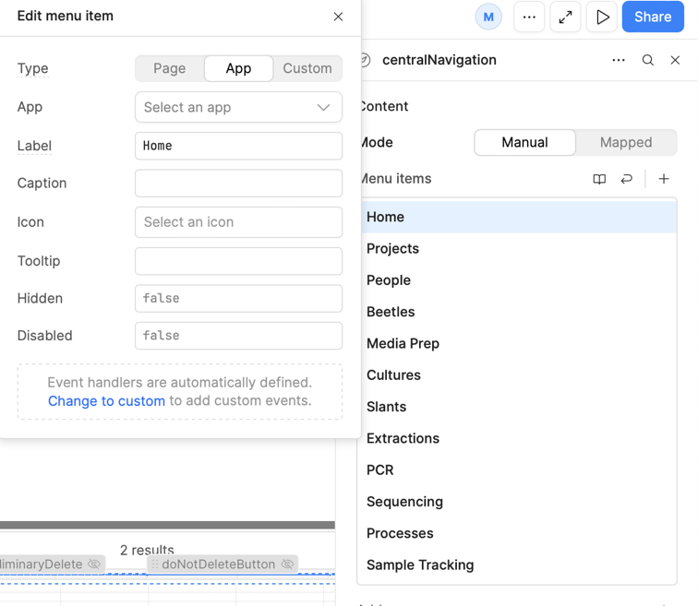
Select the name of the app corresponding to that menu item in the dropdown list (it should be nested in the folder you put it in earlier). Repeat this for each of the menu items, then repeat on each of the pages.

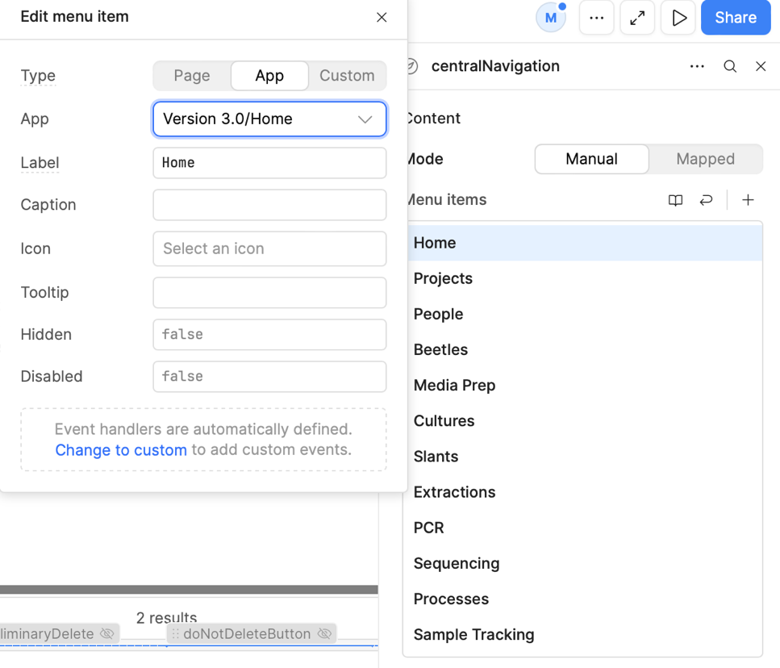

- The first thing you should do once you have your application officially set up is navigate to the “People” Page and log in as Username: sample.user, Password: sample.pass. This will allow you to make additional users who can then add, edit and delete entries on the other pages.

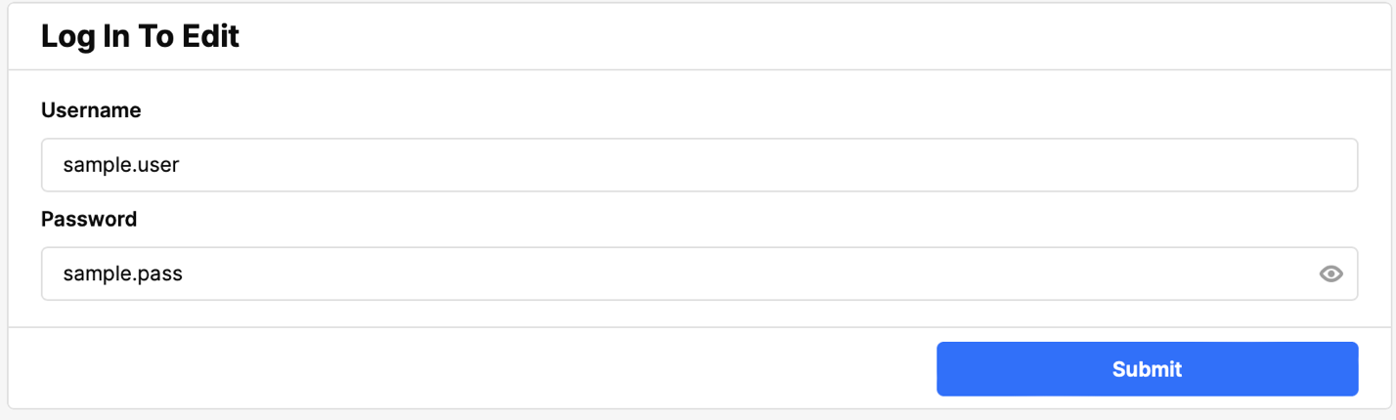

We recommend keeping the sample dataset in place until you’ve filled all of the tables with your own information (both to check that the database is fully functional and because terms in “Codebook” will only appear if they are actively being used), but then you are more than welcome to log in as sample.user and delete the sample data as described in the user manual. You can also hide them from the default table views by changing the activity statuses of “Andre Rodrigues” to “Inactive” on the People page and “Euplatypus Project (Dummy Data)” to “Published” on the Projects Page. Remember to back up your data regularly!

