**Home page  
LOGO**  

**Main Menu**

**HOW IT WORKS? FOR INDIVIDUALS FOR BUSINESSES WHY US? CONTACT**

**We offer**

* ***Door-to-door transport*** - **Auto *dealerships - Reviews***
* ***Open car transport - Auto auctions - About us***
* ***Enclosed auto transport - Car rental companies - Our team***
* ***Expedited transport - Vision and Mission***
* ***Motorcycle shipping***

**We serve**

* ***Online car buyers***
* ***College students***
* ***Snowbirds***
* ***Car collectors***
* ***Car resellers***
* ***Military***

**Background picture**Rasm bo’lishi kerak va qoramtir fon bilan. Tiniq variant faylni ichida. Rasm uzgarishi shart emas.

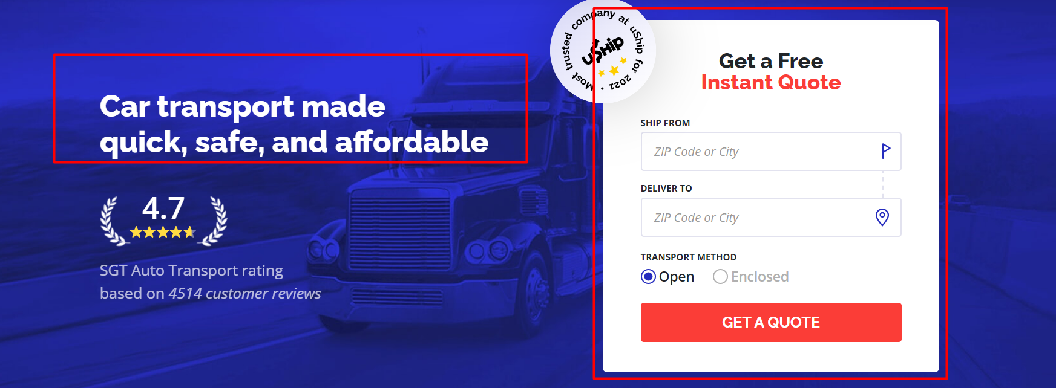

Motto miz manashunday kata shriftda bulishi kerak va pastidan WE DELIVER “CARS, SUVS, RVS, MOTORCYCLES, HEAVY EQUIPMENT, BOATS, PEACE OF MIND” degan qushtirnoq ichidagi qismi aylanib turishi kerak. Manashu linkdagidek. <https://www.usstartruckingllc.com/>.

Yonboshida quote oladigan qismi bulishi kerak

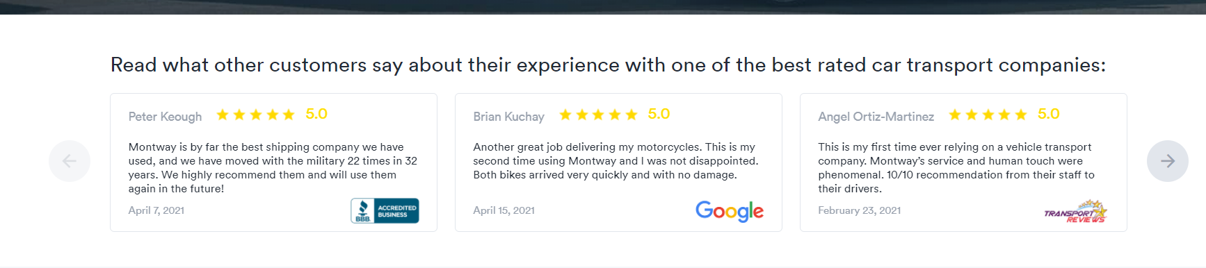

Pastida 5-star-reviews turishi kerak.

“How do I book with an auto transport company?”  
“United Freeway is here to help you in 3 simple steps”. Faqat “We pick up your vehicle” ni o’rniga “Your vehicle is picked up” bo’lishi kerak.

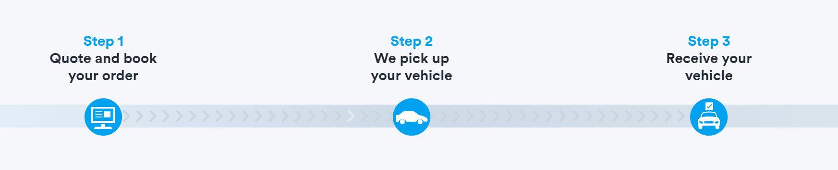

Shuning pastidan “Get a quote” va “Learn more” degan qismi turishi kerak. 

**Why you should book with one of the top-rated auto transport companies:**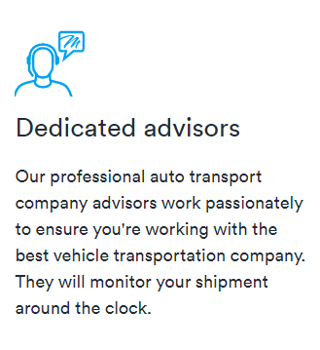  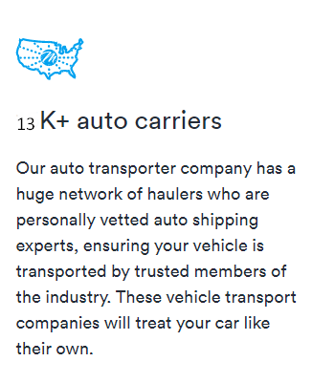

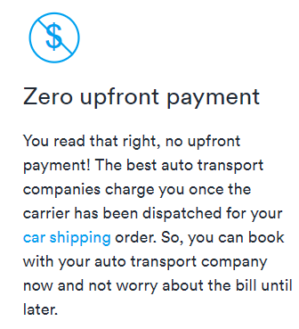 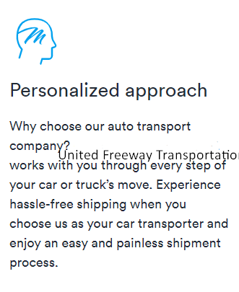

We're a top-rated auto transport company, so your car will get from point A to point B without you having to break a single sweat. By having your car delivered straight to your door, you’re allowing the experts to handle every step of the process and ensure there are no speed bumps along the way.

Top-rated company

Keyin esa manashu qism:

Central Dispatch Logo

13,000+ carrier network

Rating ni “4.8” qilib ikkala rasmni ham pastda manashu raqamlarni 0 dan kupayib kelishi kurinishida animatsiya qilish kk.

Va pastidan manabu qism quyiladi. montway.com nikidek. Review platformani ichiga birdan utib ketmasin.



Undak keying qism: faqat dizaynini saytni uziga moslab qilaverasiz

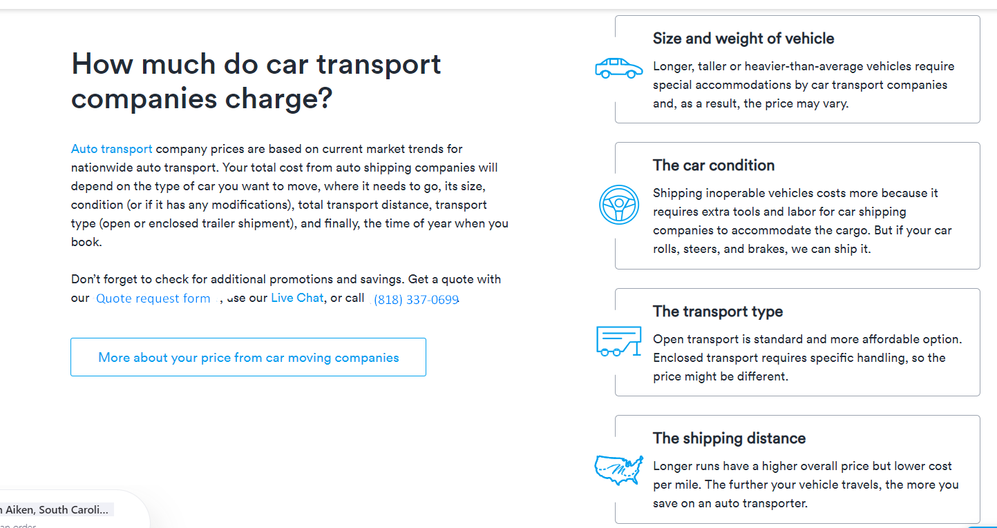

OUR PARTNERS:  
 

     

Keyingi qism FAQ bo’ladi. FAQ uzimizni website dagi bilan bir xil bo’ladi. Yonboshida rasm ham bulsin. 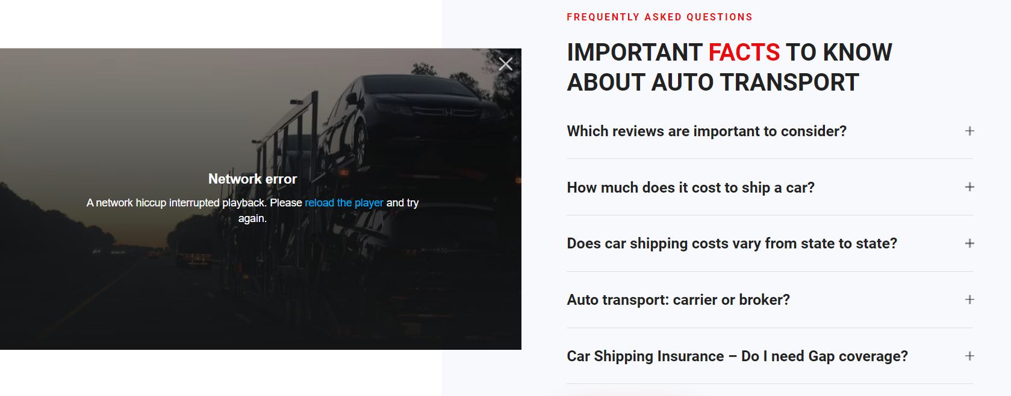shunga uxshash