1 2 3 4 5 6 7 8

预留5V输入接口，连接器间距2.54mm

**SWD**调试编程接口

J1

1

2

3

4

5

###### SDI

GND PB15/MOSI

3V3 J4

GND

10

11

|  |  |  |
| --- | --- | --- |
| BOOT0 | BOOT1 | 启动方式 |
| 0 | 无关 | 用户闪存 |
| 1 | 0 | ISP下载模式 |
| 1 | 1 | 内部RAM |

U5

MiniSD

DAT3 CMD

Vss Vcc CLK

Css2 DAT0 DAT1 DAT2

1 SDIO_D2 PC10

5V

C5

A 106

3

C3 104

U1

AMS1117-3.3V

VCCOUT

2

C2

1

GND

106

3V3

C4 104

1 K A 2

GD GD

D3 5V1

STM32工作模式已经默认接地：BOOT0通过R7接地

GND

GD GD

C1

3V3

104

BOOT0

3V3 GND

R1

10K PA13_SWDIO

PA14_SWCLK

R4 10K

SPI_1X5

SCL

###### CS SDO

D/C BLK

PB13/SCK

PB12/CS PB14/MISO

###### PB1/RS

PB0/BLK

SIP8-2.54mm

1

2

3

4

5

6

7

8

2 SDIO_D3 PC11

3 SDIO_CMD PD2 3V3 4

5 SDIO_SCK PC12

6

7 SDIO_D0 PC8

8 SDIO_D1 PC9

9 SD_NC

C19 104

A

GND

**ST****M32**工作模式选择

GND

**TFT**液晶屏接口

GND

## 供电稳压供电

DevEBox 大越创新

GND

12

13

DevEBox大越电子mcudev.taobao.com 大越电子出品

可以接本店：0.96寸、1.3寸OLED液晶屏 1.3寸、2.0寸TFT 高清液晶屏

1.44寸、1.8寸TFT液晶屏 2.4寸、2.8寸TFT液晶屏

**SD/TF**卡接口**(**小卡座，自弹**)**

##### 大越电子出品: shop389957290.taobao.com

大越电子出品: shop389957290.taobao.com

##### 还有其他规格，欢迎到店咨询

店铺：mcudev.taobao.com

3V3

R5 510R

1

D1 LED

2 1

##### STM32H750VB /H743VI核心板

内 核 ：Cortex-M7 (H750VB) FLASH：128K

(H743VI) FLASH：2048K (2M)

QUADSPI_BK1_IO2 PE2

U2

##### STM32H750VB /H743VI

1. PE2/SPI4_SCK

VDD 100

3V3

GND

3V3

GND

PB11 PB10

PC4

J6

1

1

2

3

4

5

6

7

8

9

10

11

12

13

14

15

16

17

18

19

20

21

22

23

24

2

3

4

5

DCMI_SDA 6

DCMI_SCL 7

8

DCMI_RESET 9

##### 可以接本店摄像头模块：

OV2640-200 万像素

OV5640-500 万像素(自动对焦)

##### RAM：1024K

2

C8 10P

PE3 DCMI_D4 PE4 DCMI_D6 PE5 DCMI_D7 PE6

1. PE3
2. PE4/SPI4_NSS/DCMI_D4
3. PE5/SPI4_MISO/DCMI_D6
4. PE6/SPI4_MOSI/DCMI_D7

VSS 99

PE1/UART8_TX/DCMI_D3 98

PE0/UART8_RX/DCMI_D2 97

PB9/I2C1_SDA/UART4_TX/FDCAN1_TX 96

PE1 DCMI_D3 PE0 DCMI_D2 PB9

GND

PA5 PA7 PA4 PB7

DCMI_CH1 10

DCMI_PWDN 11

DCMI_HREF 12

DCMI_VSYNC 13

此处为FPC插座（翻盖式）

GND

VBAT 6

Y1

VBAT

PB8/I2C1_SCL/UART4_RX/FDCAN1_RX 95

PB8 R7

PC6

DCMI_D0 14

店铺可以选购FPC转接延长线

## 供电指示灯

B

GND

GND

C9

C10 20P

C11 20P

10P

Y2 25M

32.768K

GND

C6 104

GND 3V3

RST

GND

VREF+

PC13 7

PC14 8

PC15 9

10

11

12

13

14

PC0 15

PC1 16

PC2 17

PC3 18

19

20

PC13/RTC_TAMP_1/ RTC_TS PC14-OSC32_IN

PC15-OSC32_OUT VSS

VDD

PH0-OSC_IN PH1-OSC_OUT NRST

PC0 PC1

PC2_C/ADC3_INP0 PC3_C/ADC3_INP1 VSSA

VREF+

BOOT0 94

PB7/I2C4_SDA 93

PB6/I2C4_SCL 92

PB5/SPI1_MOSI 91

PB4/SPI1_MISO 90

PB3/SPI1_SCK 89

PD7 88

PD6/USART2_RX 87

PD5/USART2_TX 86

PD4 85

PD3 84

PD2/SDMMC1_CMD 83

PD1/UART4_TX/FDCAN1_TX 82

PD0/UART4_RX/FDCAN1_RX 81

PB7 PB6 PB5 PB4 PB3 PD7 PD6 PD5 PD4 PD3 PD2 PD1 PD0

BOOT0

DCMI_VSYNC 10K QSPI_BK1_NCS

SPI1_MOSI SPI1_MISO SPI1_SCK

DCMI_D5 SDIO_CMD

GND

GND

PC7 PE0 PE1 PE4 PD3 PE5 PE6 PA6 PA8

DCMI_D1 DCMI_D2 DCMI_D3 DCMI_D4 DCMI_D5 DCMI_D6 DCMI_D7 DCMI_PCLK DCMI_XCLK

15

16

17

18

19

20

21

22

23

24

FPC-24P

25

26

##### 店铺1：mcudev.taobao.com B

店铺2: shop389957290.taobao.com

GD GD

3V3

GND

Key RST GND

C17

VDDA

PA0

PA1 PA2 PA3

1. VDDA
2. PA0/TIM2_CH1/TIM5_CH1/UART4_TX

PC12/SDMMC1_CK 80

PC11/SDMMC1_D3 79

PC12 SDIO_SCK

PC11 SDIO_D3

PC10 SDIO_D2 PA15

PA14_SWCLK

GND

# mcudev.taobao.com

C22

1 2

3 4

5 6

7 8

9 10

11 12

13 14

15 16

17 18

19 20

21 22

23 24

25 26

27 28

29 30

31 32

33 34

35 36

37 38

39 40

41 42

43 44

PA1

R14 2 D2

1

3V3

R34

0R

R11

0R

104

23

24

25

26

PA1/TIM2_CH2/TIM5_CH2/UART4_RX PA2/TIM2_CH3/TIM5_CH3/USART2_TX PA3/TIM2_CH4/TIM5_CH4/USART2_RX

PC10/SDMMC1_D2

PA15 PA14 /SWCLK

78

77

76

75

**DCMI**接口**-**摄像头插座

510R

2 1 LED

GND

C23 104

GND

3V3 DCMI_HREF PA4

27

28

VSS VDD

VDD VSS

74

73

3V3 GND

DCMI_CH1

PA5

29

PA4/SPI6_NSS/DCMI_HSYNC

VCAP

72 2.2uF

PA13_SWDIO

DCMI_PCLK PA6 DCMI_PWDN PA7 DCMI_RESET PC4

PC5

30

31

32

33

PA5/SPI6_SCK PA6/SPI6_MISO/DCMI_PIXCLK PA7/SPI6_MOSI

PC4

PA13 /SWDIO PA12/OTG_FS_DP PA11/OTG_FS_DM PA10/USART1_RX

71

70

69

68

PA12/USB_DP PA11/USB_DM

PA10/RXD1

PA9/TXD1

5V

J2

5V

**LED**指示灯

PB0/BLK

PB1/RS

PB0 PB1

34

35

PC5 PB0/TIM3_CH3

PA9/USART1_TX PA8/MCO1

67

66

PA8 PC9

DCMI_XCLK SDIO_D1

3V3

3V3

PE7/UART7_RX PE8/UART7_TX

PC7/TIM3_CH2/USART6_RX/DCMI_D1 PC6/TIM3_CH1/USART6_TX/DCMI_D0

QUADSPI_CLK PB2

PD9

PD11 PD13

PD10 PD12

1. PB1/TIM3_CH4

PC9/SDMMC1_D1 65

PC8

SDIO_D0

PE7

1. PB2

PC8/SDMMC1_D0 64 PC7 DCMI_D1

GND

PD8

GND

PE9/TIM1_CH1/UART7_RTS PE10/TIM1_CH2N/UART7_CTS PE11/TIM1_CH2/SPI4_NSS PE12/TIM1_CH3N/SPI4_SCK PE13/TIM1_CH3/SPI4_MISO PE14/TIM1_CH4/SPI4_MOSI PE15/FMC_D12/LCD_R7

PD15/TIM4_CH4 PD14/TIM4_CH3 PD13/I2C4_SDA PD12/I2C4_SCL

PD11 PD10 PD9/USART3_RX

PD14

PD13 QUADSPI_BK1_IO3 PD12 QUADSPI_BK1_IO1 PD11 QUADSPI_BK1_IO0 PD10

PD9 PD8

PD15 PC7 PC9

PA9/TXD1 PA11/USB_DM PA15

PC11

PE8 PE9

38

39

63

62

PC6 PD15

DCMI_D0

GND

C

GND

K1

Key K2

Key

## 按键

PE3

PC5

STM32H750VB /H743VI核心板（M版）

DevEBox大越电子 嵌入式开发网精品店

mcudev.taobao.com 大越电子出品

GND 3V3

DCMI_SCL

DCMI_SDA

C21

PB11 47

48

PE10 40

PE11 41

PE12 42

PE13 43

PE14 44

PE15 45

PB10 46

2.2uF 49

50

PB10/TIM2_CH3/I2C2_SCL/USART3_TX PB11/TIM2_CH4/I2C2_SDA/USART3_RX VCAP

VSS VDD

STM32H7xx

C12

C16

C15

C14

C13

104 104 104

104

104

PD8/USART3_TX PB15/SPI2_MOSI

PB14/SPI2_MISO 53

61

60

59

58

57

56

55

54

PB13/SPI2_SCK/FDCAN2_TX 52

PB12/SPI2_NSS/FDCAN2_RX 51

3V3 C18

106

PB15 PB14 PB13 PB12

PB15/MOSI PB14/MISO PB13/SCK PB12/CS

3V3

PD0 PD2 PD4 PD6 PB3 PB5 PB7 PB9 PE1

Header 22X2

J3

1 2

3 4

5 6

7 8

9 10

11 12

13 14

15 16

17 18

19 20

21 22

23 24

25 26

27 28

29 30

31 32

33 34

35 36

37 38

39 40

41 42

43 44

PC12 PD1 PD3 PD5 PD7 PB4 PB6 PB8 PE0

C

PD14 PC6 PC8 PA8

PA10/RXD1 PA12/USB_DP PC10

3V3

##### 大越电子出品: shop389957290.taobao.com

接口支持**QSPI**接口模式

GND

5V

嵌入式开发网

标准MicroUSB接口

L1

GND

VDDA

PB15 PB13 PB11 PE15 PE13 PE11 PE9 PE7 PB1

VREF+ PB14 PB12 PB10 PE14 PE12 PE10 PE8 PB2 PB0

GND

C20 3V3

即常见安卓手机供电接口

J5

VCC 1

500mA

PC5

PA7 PA5 PA3

PC4

PA6 PA4 PA2

PB6 PD12

U3

QSPI_BK1_NCS 1

CS

QUADSPI_BK1_IO1 2

DO (IO1) HOLD(IO3) WP(IO2) CLK

GND DI (IO0)

GND

104

8

VCC

7 QUADSPI_BK1_IO3 PD13

D- D+ ID GND

1. R2 0R
2. R3 0R

4

5

###### PA11/USB_DM

PA12/USB_DP

VBAT

Q1 3V3

1

1

3

2 1

3

PA1 PC3 PC1 PC13 PE5

PA0 PC2 PC0 PE6 PE4

PE2

NC NC NC NC

QUADSPI_BK1_IO2 3

6 QUADSPI_CLK

PB2

Micro_USB

2 PE3

PE2

4

D GND W25QXX

5 QUADSPI_BK1_IO0 PD11

GND

GND

C7 104

GND

2

BAT54C

9

8

7

6

BAT

B1

GND

Header 22X2

扩展**I/O**接口

D

外部存储**FLASH**

**USB** 供电接口

**(STM32 USB Slave)**

## 实时时钟备用电池接口**B1**（预留）

Title

STM32H750VB /H743VI核心板（M版）

Size

Number DevEBox大越电子

嵌R入evisi式on 开发网

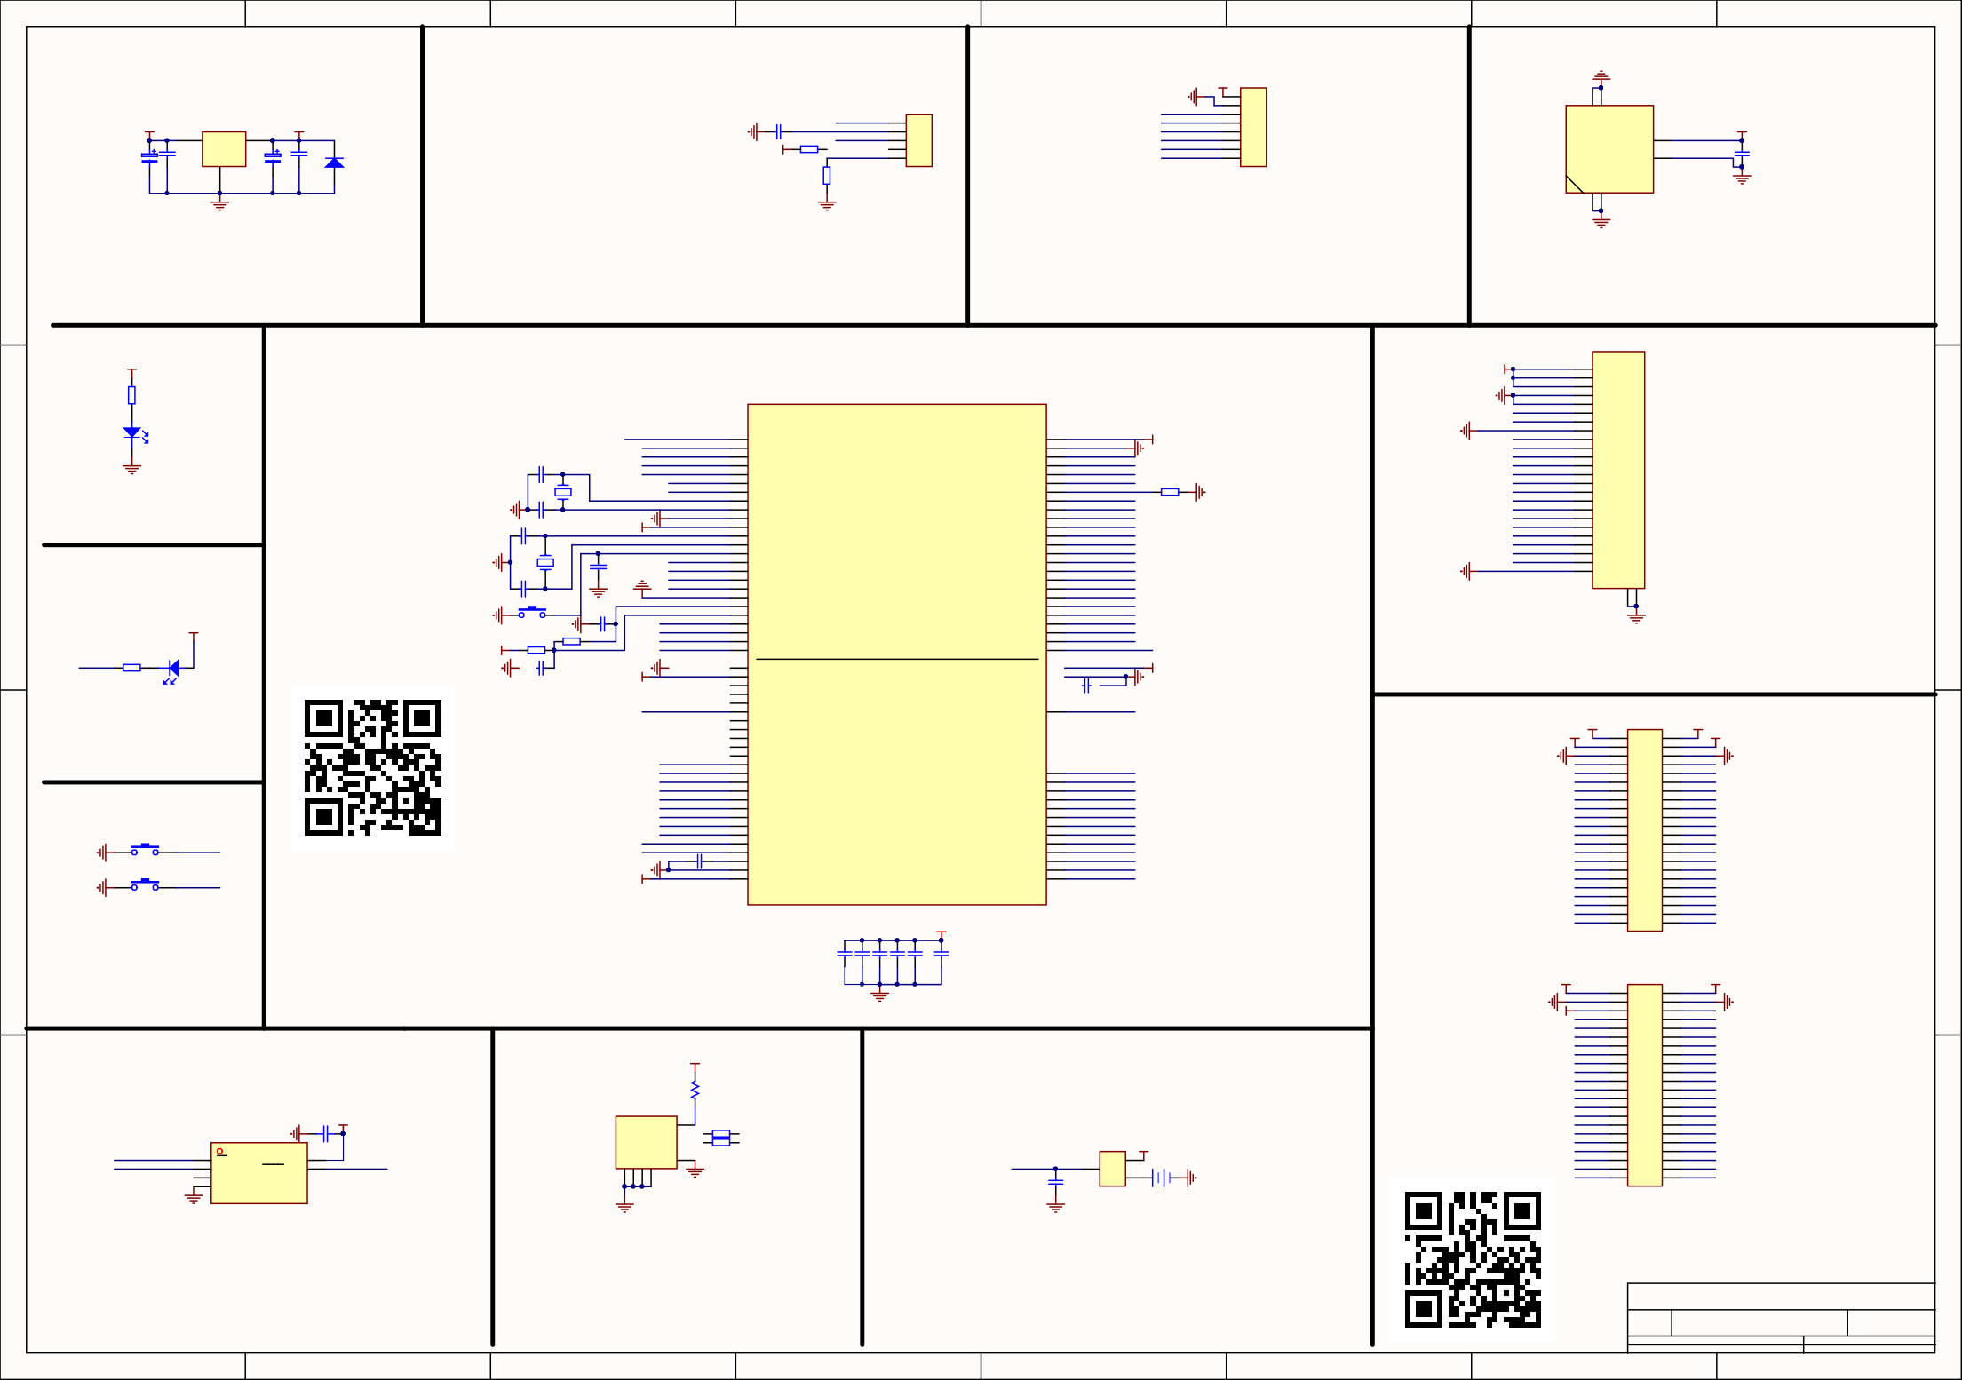

1 2 3 4 5 6

A2

Date: File:

7

mcudev.taobao.com 大越电子出品

2019-11-23 Sheet of

Z:\VMDOC\..\STM32_H7XX_M.SchDoc Drawn By:

8

# DevEBox 大越创新

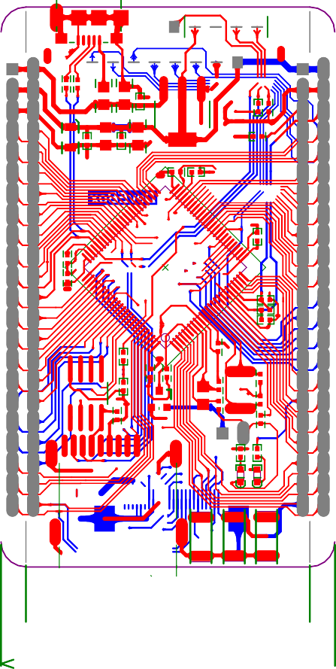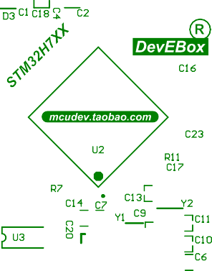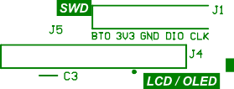

mcudev.taobao.com

嵌入~~式~~开发网

**Bill of Materials <Parameter Title not found>**

### Source Data From: STM32_H7XX_M.PrjPcb Project: STM32_H7XX_M.PrjPcb

**Variant: None**

DevE

Creation Date: 2019-11-23 下午 01:44:44

#### Print Date: 43792 43792.57279

Box 大越创新

C1, C3, C4, C6, C7, C12, C13, C14, C15, C16, C17, C19, C20, C23

2.2umF

SIP5-2.54mm SPI_1X5

cCuap

Header 5H

deC21, vC22

J1

.taobCapacaitor

Header, 5-Pin, Right Angle

# o.com 2

#### IDE2X22 HDR1X8

|  |  |  |  |  |  |
| --- | --- | --- | --- | --- | --- |
| **Footprint** | **Comment** | **LibRef** | **Designator** | **Description** | **Quantity** |
| SIP2-2.54mm | BAT | BATTERY | B1 |  | 1 |
| RC0402 | 104 | Cap, CAP, CAP, CAP,  Cap, Cap, Cap, Cap, Cap, Cap, Cap, Cap Semi,  CAP, Cap |  | Capacitor, Capacitor, Capacitor, Capacitor, Capacitor, Capacitor, Capacitor, Capacitor, Capacitor, Capacitor, Capacitor, Capacitor (Semiconductor SIM Model), [NoValue], Capacitor | 14 |
| RC0805 | 106 | ELECTRO2, ELECTRO2,  Cap | C2, C5, C18 | [NoValue], [NoValue], Capacitor | 3 |
| RC0402 | 10P | CAP | C8, C9 |  | 2 |
| RC0402 | 20P | CAP | C10, C11 | Capacitor | 2 |
| RC0603 |  |  |  |  |  |
| LED-0603 | LED | LED | D1, D2 |  | 2 |
| SOD_323 | 5V1 | Diode | D3 | Default Diode | 1 |

Header 22X2 SIP8-2.54mm

Header 22X2 Header 8

J2, J3 J4

J5

|  |  |  |  |  |  |
| --- | --- | --- | --- | --- | --- |
| micro_USB | Micro_USB | MiniUSB |  | 1 | |
| FPC24-  05MM | FPC-24P | FPC-24P | J6 | 1 | |
| SW-SPST | Key | SW-PB | K1, K2, RST | 3 | |
| RC0805 | 500mA | RES | L1 | 1 | |
| SOT-23- | BAT54C | BAT54C | Q1 1 | | |
| BAT54C |  |  |  |  |  |
| RC0402 | 10K | Res2 | R1, R4, R7 | Resistor | 3 |
| RC0402 | 0R | Res2 | R2, R3, R11, R34 | Resistor | 4 |
| RC0402 | 510R | Res2 | R5, R14 | Resistor | 2 |
| SOT-223 | AMS1117-3.3V | 11 | U1 |  | 1 |
|  | STM32H7xx | STM32H750V | U2 |  | 1 |
| SOP8L | W25QXX |  |  |  |  |
|  | MiniSD | MiniSD | U5 |  | 1 |
| JZ3215-32K | 32.768K | CRYSTAL | Y1 | 晶振 | 1 |
| JZ5032-8M 25M CRYSTAL Y2 Crystal | | | | | 1 |

Header, 22-Pin, Dual row 2

Header, 8-Pin 1

1

**Approved**

53

W25嵌QXX U3

**Notes**

入

式开发网 1