

|  |
| --- |
| Business Template  **Subject areas** |
| **Logo / Image** |

Contents

1 Business Description 3

1.1 Business background 3

1.2 Problems. Current Situation 3

1.3 The benefits of implementing a database. Project Vision 3

2 Model description 3

2.1 Definitions & Acronyms 3

2.2 Logical Scheme 3

2.3 Objects 3

# 

# Business Description

## Business background

A recruitment agency serves as an intermediary between job seekers (candidates) and employers looking for talent. It streamlines the hiring process by maintaining a structured database of job postings, applications, interviews, and employment offers.

## Problems. Current Situation

Many recruitment agencies rely on spreadsheets or unstructured data storage, leading to inefficiencies such as duplicate records, difficulty tracking applications, and slow communication between candidates and employers. Without a well-structured database, agencies struggle with scalability and effective data retrieval.

## the Benefits of implementing a database. Project Vision

A centralized database improves efficiency by:

* Structuring job postings, applications, and interviews systematically.
* Enhancing data integrity through relationships and constraints.
* Reducing redundancy and ensuring consistency.
* Providing easy search and reporting features for job matching.

# Model description

## Definitions & Acronyms

**Candidate**: A job seeker registered in the agency’s system.

**Employer**: A company posting job vacancies.

**Application**: A job application submitted by a candidate.

**Interview**: A scheduled meeting between a candidate and an employer.

**Skill**: A specific ability or expertise possessed by candidates.

**Job Category**: A classification of job positions based on industry.

## Logical Scheme

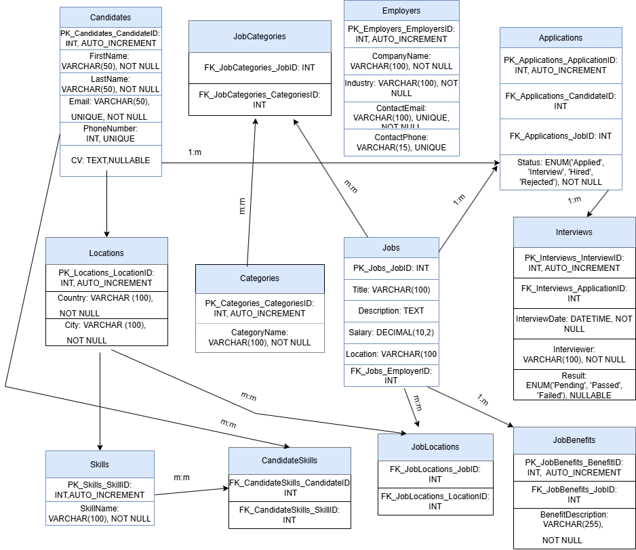

## Objects

Candidates

Holds personal and contact details of job seekers.

|  |  |  |  |
| --- | --- | --- | --- |
| Table 1 | Field name | Field Description | Data Type |
| Candidates | CandidateID | PRIMARY KEY, AUTO_INCREMENT | INT |
| FirstName | NOT NULL | VARCHAR(50) |
|  | LastName | NOT NULL | VARCHAR(50) |
|  | Email | UNIQUE, NOT NULL | VARCHAR(50) |
|  | PhoneNumber | UNIQUE | INT |
|  | CV | NULLABLE | TEXT |

Comments on table relationships:

· A candidate can apply for multiple jobs (one-to-many with **Applications**).

· A candidate can have multiple skills (many-to-many with **Skills** through **CandidateSkills**).

Example with data

|  |  |  |  |  |  |
| --- | --- | --- | --- | --- | --- |
| CandidateID | FirstName | LastName | Email | PhoneNumber | CV |
| 1 | John | Doe | johndoe@gmail.com | 2398474879 | NULL |

Employers

Stores information about companies that offer jobs.

|  |  |  |  |
| --- | --- | --- | --- |
| Table 2 | Field name | Field Description | Data Type |
| Employers | EmployerID | PRIMARY KEY, AUTO_INCREMENT | INT |
| CompanyName | NOT NULL | VARCHAR(100) |
|  | Industry | NOT NULL | VARCHAR(100) |
|  | ContactEmail | UNIQUE, NOT NULL | VARCHAR(100) |
|  | ContactPhone | UNIQUE | VARCHAR(15) |

Example with data

|  |  |  |  |  |
| --- | --- | --- | --- | --- |
| EmployerID | CompanyName | Industry | ContactEmail | ContactPhone |
| 1 | Tech | IT | techIT@gmail.com | 2398474879 |

**Relationships:**

* An employer can post multiple jobs (one-to-many with **Jobs**).

JOBS

Contains job postings.

|  |  |  |  |
| --- | --- | --- | --- |
| Table 3 | Field name | Field Description | Data Type |
| Jobs | JobID | PRIMARY KEY, AUTO_INCREMENT | INT |
| Title | NOT NULL | VARCHAR(100) |
|  | Description | NULLABLE | TEXT |
|  | Salary | NULLABLE | DECIMAL(10,2) |
|  | LocationID | FOREIGN KEY REFERENCES Locations(LocationID) | INT |
|  | EmployerID | FOREIGN KEY REFERENCES Employers(EmployerID) | INT |

Example with data

|  |  |  |  |  |  |
| --- | --- | --- | --- | --- | --- |
| JobID | Title | Description | Salary | LocationID | EmployerID |
| 1 | Software Engineer | Develops applications | 1213897 | 1 | 1 |

**Relationships:**

* A job belongs to one employer but can receive multiple applications (one-to-many with **Applications**).
* A job can be categorized into multiple categories (many-to-many with **Categories** through **JobCategories**).
* A job can have multiple locations (many-to-many with **Locations** through **JobLocations**).
* A job can have multiple benefits (one-to-many with **JobBenefits**).

Locations

Stores job location details.

|  |  |  |  |
| --- | --- | --- | --- |
| Table 4 | Field name | Field Description | Data Type |
| Location | LocationID | PRIMARY KEY, AUTO_INCREMENT | INT |
| Country | NOT NULL | VARCHAR(100) |
|  | City | NOT NULL | VARCHAR(100) |

Example with data

|  |  |  |
| --- | --- | --- |
| LocationID | Country | City |
| 1 | Kazakhstan | Almaty |

**Relationships:**

* A job can be offered in multiple locations (many-to-many with **Jobs** through **JobLocations**).

CATEGORIES

Defines different job categories.

|  |  |  |  |
| --- | --- | --- | --- |
| Table 5 | Field name | Field Description | Data Type |
| CATEGORIES | CategoryID | PRIMARY KEY, AUTO_INCREMENT | INT |
| CategoryName | NOT NULL | VARCHAR(100) |

Example with data

|  |  |
| --- | --- |
| CategoryID | CategoryName |
| 1 | IT |

* **Relationships:**
  + A job can belong to multiple categories (many-to-many with **Jobs** through **JobCategories**).

JobCategories

Links jobs and categories.

|  |  |  |  |
| --- | --- | --- | --- |
| Table 6 | Field name | Field Description | Data Type |
| JobCategories | JobID | PRIMARY KEY, FOREIGN KEY REFERENCES Jobs(JobID) | INT |
| CategoryID | PRIMARY KEY, FOREIGN KEY REFERENCES Categories(CategoryID) | INT |

Example with data

|  |  |
| --- | --- |
| JobID | CategoryID |
| 1 | 1 |

* **Relationships:**
* Serves as a junction table linking **Jobs** and **Categories** in a many-to-many relationship.

Applications

Records job applications submitted by candidates.

|  |  |  |  |
| --- | --- | --- | --- |
| Table 7 | Field name | Field Description | Data Type |
| Applications | ApplicationID | PRIMARY KEY, AUTO_INCREMENT | INT |
| CandidateID | FOREIGN KEY REFERENCES Candidates(CandidateID) | INT |
|  | JobID | FOREIGN KEY REFERENCES Jobs(JobID) | INT |
|  | Status | NOT NULL | ENUM('Applied', 'Interview', 'Hired', 'Rejected') |

Example with data

|  |  |  |  |
| --- | --- | --- | --- |
| ApplicationID | CandidateID | JobID | Status |
| 1 | 1 | 1 | Applied |

**Relationships:**

* An application belongs to one candidate and one job (many-to-one with **Candidates** and **Jobs**).
* An application can result in an interview (one-to-one with **Interviews**).

Interviews

Tracks interview details.

|  |  |  |  |
| --- | --- | --- | --- |
| Table 8 | Field name | Field Description | Data Type |
| Interviews | InterviewID | PRIMARY KEY, AUTO_INCREMENT | INT |
| ApplicationID | FOREIGN KEY REFERENCES Applications(ApplicationID) | INT |
|  | InterviewDate | NOT NULL | DATETIME |
|  | Interviewer | NOT NULL | VARCHAR(100) |
|  | Result | NULLABLE | ENUM('Pending', 'Passed', 'Failed') |

Example with data

|  |  |  |  |  |
| --- | --- | --- | --- | --- |
| InterviewID | ApplicationID | InterviewDate | Interviewer | Result |
| 1 | 1 | 1 | Maria | Passed |

**Relationships:**

* Each interview is associated with one application (one-to-one with **Applications**).

Skills

Defines candidate skills.

|  |  |  |  |
| --- | --- | --- | --- |
| Table 9 | Field name | Field Description | Data Type |
| Interviews | SkillID | PRIMARY KEY, AUTO_INCREMENT | INT |
| SkillName | NOT NULL | VARCHAR(100) |

|  |  |
| --- | --- |
| SkillID | SkillName |
| 1 | Python |

**Relationships:**

* Candidates can have multiple skills (many-to-many with **Candidates** through **CandidateSkills**).

CandidateSkills

Links candidates and skills.

|  |  |  |  |
| --- | --- | --- | --- |
| Table 10 | Field name | Field Description | Data Type |
| CandidateSkills | CandidateID | PRIMARY KEY, FOREIGN KEY REFERENCES Candidates(CandidateID) | INT |
| SkillID | PRIMARY KEY, FOREIGN KEY REFERENCES Skills(SkillID) | INT |

Example with data

|  |  |
| --- | --- |
| CandidateID | SkillID |
|  |  |
| 1 | 1 |

Serves as a junction table linking Candidates and Skills in a many-to-many relationship.

JobLocations

Links jobs and locations.

|  |  |  |  |
| --- | --- | --- | --- |
| Table 11 | Field name | Field Description | Data Type |
| JobLocations | JobID | PRIMARY KEY, FOREIGN KEY REFERENCES Jobs(JobID) | INT |
| LocationID | PRIMARY KEY, FOREIGN KEY REFERENCES Locations(LocationID) | INT |

Example with data

|  |  |
| --- | --- |
| JobID | LocationID |
|  |  |
| 1 | 1 |

Serves as a junction table linking Jobs and Locations in a many-to-many relationship.

JobBenefits

Stores additional benefits for jobs.

|  |  |  |  |
| --- | --- | --- | --- |
| Table 12 | Field name | Field Description | Data Type |
| JobBenefits | BenefitID | PRIMARY KEY, AUTO_INCREMENT | INT |
| JobID | FOREIGN KEY REFERENCES Jobs(JobID) | INT |
|  | BenefitDescription | NOT NULL | VARCHAR(255) |

Example with data

|  |  |  |
| --- | --- | --- |
| BenefitID | JobID | BenefitDescription |
|  |  |  |
| 1 | 1 | Health Insurance |