

CSF3133
Web-Based Interface Design
Lab Module 3
Name | Sarah Amira Heri
Matric No | S75812
Date | 5 November 2025
Venue | MP2

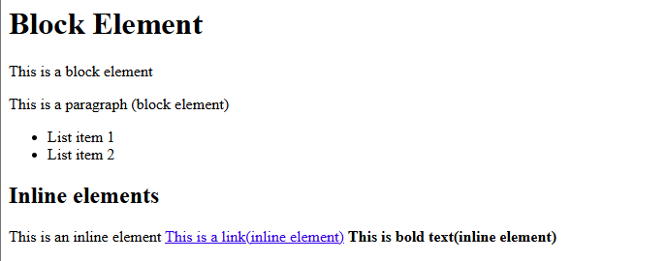
3.2

3.3
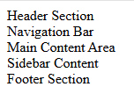

3.4
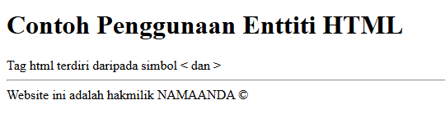

3.5
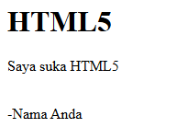

3.6.1
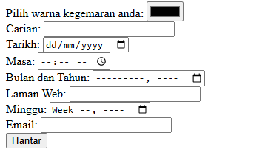

3.6.2
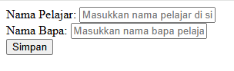

3.6.3
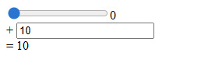

Lab Exercise (output)
