Sex-specific and lineage-specific alternative splicing in primates

Ran Blekhman^{1*}, John C. Marioni^{1*}, Paul Zumbo², Matthew Stephens^{1,3}, Yoav Gilad¹

¹Department of Human Genetics, University of Chicago, Chicago, Illinois 60637, USA;
²Keck Biotechnology Laboratory, New Haven, Connecticut 06511, USA;
³Department of Statistics, University of Chicago, Chicago, Illinois 60637, USA

*These authors contributed equally to this work

Correspondence should be addressed to Ran Blekhman (blekhman@uchicago.edu), John Marioni (marioni@uchicago.edu), Matthew Stephens (stephens@uchicago.edu), or Yoav Gilad (gilad@uchicago.edu).

Supplementary Tables and Figures

Available as a separate file:

Supplementary Table 1 (Table S1: the genes included in the study and their classifications).

In Table S1, the following information is provided:

Column Description
------------------------------------------------------------------------
1 EnsemblGeneID Ensembl Gene ID (ENSG...)
2 GeneSymbol Official gene symbol (where found)
3 numExons Number of exons included in analysis
4 deHC Is the gene DE between humans and chimpanzees?
5 deHR Is the gene DE between humans and rhesus macaques?
6 deCR Is the gene DE between chimpanzee and rhesus macaques?
7 deHC.m Is the gene DE between humans and chimpanzees in males?
8 deHC.f Is the gene DE between humans and chimpanzees in females?
9 deHR.m Is the gene DE between humans and rhesus macaques in males?
10 deHR.f Is the gene DE between humans and rhesus macaques in females?
11 deCR.m Is the gene DE between chimpanzees and rhesus macaques in males?
12 deCR.f Is the gene DE between chimpanzees and rhesus macaques in females?
13 Stabilizing Gene's regulation likely evolves under stabilizing selection
14 DirectionalHuman Gene's regulation likely evolves under directional selection in human
15 DirectionalChimp Gene's regulation likely evolves under directional selection in chimpanzee
16 SexDimorphic Gene shows a sexually dimorphic expression pattern
17 SexDimorphic.HighMales Gene shows a sexually dimorphic expression pattern, with expression level higher in males
18 SexDimorphic.HighFemales Gene shows a sexually dimorphic expression pattern, with expression level higher in females
19 ExonDimorphic Gene shows a sexually dimorphic expression pattern in at least one exon
20 HumanSpecificExonUsage Gene shows a signature of human-specific exon usage in at least one exon
21-56 These columns give the number of reads in each of the 36 lanes of data. The column header is in the form "RxLy.SpeciesSexSample", where Rx is the run number (R1-R8), Ly is the lane number (L1-L8), Species are designated as either "HS" (human), "PT" (chimpanzee), or "RM" (rhesus macaque), Sex is either "M" (male) of "F" (female), and Sample is the sample number (1-3).
Table S2. Information on the 18 liver tissue samples used in the study.

 | Species | Sex | Study-design ID | Sample ID | Source
1 | human | male | HSM1 | 56295 | NDRI
2 | human | male | HSM2 | 58876 | NDRI
3 | human | male | HSM3 | humYale2 | Yale
4 | human | female | HSF1 | 53355 | NDRI
5 | human | female | HSF2 | 56720 | NDRI
6 | human | female | HSF3 | 60504 | NDRI
7 | chimpanzee | male | PTM1 | YN97-139 | A. Stone
8 | chimpanzee | male | PTM2 | YN07-147 | Yerkes
9 | chimpanzee | male | PTM3 | c0433 | SFBR
10 | chimpanzee | female | PTF1 | YN06-108 | Yerkes
11 | chimpanzee | female | PTF2 | 40191 | SFBR
12 | chimpanzee | female | PTF3 | YN05-400 | Yerkes
13 | rhesus macaque | male | RMM1 | 17602 | Yerkes
14 | rhesus macaque | male | RMM2 | 13330-305 | A. Stone
15 | rhesus macaque | male | RMM3 | YN06-52 | Yerkes
16 | rhesus macaque | female | RMF1 | 17550 | SFBR
17 | rhesus macaque | female | RMF2 | YN05-349 | Yerkes
18 | rhesus macaque | female | RMF3 | YN05-115 | Yerkes

Table S3. Summary of sequencing data.

Sample | Run | Lane | Total reads in lane | Total reads mapped to the genome | Low mapping quality (excluded) | Not exonic (excluded) | Ambiguous mapping (excluded) | Mapped to unique, orthologous exons | %highQ mapped to the genome /total | %mapped to orthologous exons /highQ
HSF1 | 1 | 4 | 5225421 | 4630714 | 940647 | 2011194 | 1119 | 1677754 | 70.62% | 45.47%
HSF1 | 4 | 2 | 5378161 | 4776758 | 969626 | 2074776 | 1145 | 1731211 | 70.79% | 45.47%
HSF2 | 2 | 7 | 4983423 | 4377924 | 866082 | 1880422 | 1035 | 1630385 | 70.47% | 46.43%
HSF2 | 3 | 2 | 5477129 | 4844386 | 923649 | 2107266 | 1164 | 1812307 | 71.58% | 46.22%
HSF3 | 8 | 1 | 6592168 | 5786387 | 1734533 | 2646310 | 1011 | 1404533 | 61.46% | 34.66%
HSF3 | 8 | 2 | 6820205 | 6014108 | 1761438 | 2790068 | 957 | 1461645 | 62.35% | 34.37%
HSM1 | 1 | 1 | 4430094 | 3811556 | 695631 | 1759758 | 919 | 1355248 | 70.34% | 43.49%
HSM1 | 5 | 2 | 4934824 | 4243716 | 769575 | 1965624 | 960 | 1507557 | 70.40% | 43.39%
HSM2 | 2 | 3 | 7163392 | 6377324 | 1404567 | 2737987 | 1493 | 2233277 | 69.42% | 44.91%
HSM2 | 4 | 8 | 6945518 | 6213693 | 1344719 | 2683804 | 1377 | 2183793 | 70.10% | 44.85%
HSM3 | 3 | 6 | 7116535 | 6431378 | 1417732 | 3025554 | 1187 | 1986905 | 70.45% | 39.63%
HSM3 | 4 | 1 | 6588978 | 5942132 | 1319507 | 2784386 | 1191 | 1837048 | 70.16% | 39.74%
PTF1 | 1 | 2 | 8033773 | 6777231 | 1421372 | 2666018 | 4098 | 2685743 | 66.67% | 50.15%
PTF1 | 4 | 4 | 7961190 | 6778944 | 1399178 | 2679424 | 4048 | 2696294 | 67.57% | 50.12%
PTF2 | 2 | 4 | 6196219 | 5353004 | 1063461 | 2364339 | 2140 | 1923064 | 69.23% | 44.83%
PTF2 | 6 | 6 | 6056206 | 5249458 | 1023407 | 2329970 | 2113 | 1893968 | 69.78% | 44.82%
PTF3 | 3 | 7 | 5668150 | 4784111 | 1025732 | 1903628 | 2765 | 1851986 | 66.31% | 49.28%
PTF3 | 5 | 3 | 5694753 | 4769812 | 1067158 | 1872547 | 2705 | 1827402 | 65.02% | 49.35%
PTM1 | 1 | 6 | 6566806 | 5524233 | 1396197 | 2632937 | 2241 | 1492858 | 62.86% | 36.16%
PTM1 | 3 | 3 | 7458554 | 6324089 | 1562475 | 3051504 | 2557 | 1707553 | 63.84% | 35.86%
PTM2 | 2 | 8 | 5957980 | 5004024 | 1238000 | 2141504 | 2307 | 1622213 | 63.21% | 43.07%
PTM2 | 4 | 6 | 6965495 | 5927759 | 1353334 | 2607491 | 2731 | 1964203 | 65.67% | 42.94%
PTM3 | 6 | 2 | 6234221 | 5361258 | 1294352 | 2308192 | 2297 | 1756417 | 65.24% | 43.19%
PTM3 | 6 | 4 | 6433433 | 5533712 | 1332887 | 2383115 | 2409 | 1815301 | 65.30% | 43.21%
RMF1 | 1 | 7 | 7419416 | 6169840 | 1332365 | 2418600 | 1460 | 2417415 | 65.20% | 49.97%
RMF1 | 5 | 1 | 6551838 | 5448353 | 1202490 | 2119014 | 1283 | 2125566 | 64.80% | 50.06%
RMF2 | 2 | 2 | 6972886 | 5773699 | 1236935 | 2179695 | 1527 | 2355542 | 65.06% | 51.92%
RMF2 | 5 | 8 | 4818067 | 3886408 | 910825 | 1429261 | 929 | 1545393 | 61.76% | 51.94%
RMF3 | 3 | 4 | 8254319 | 7022077 | 1564763 | 2751856 | 1804 | 2703654 | 66.11% | 49.54%
RMF3 | 4 | 7 | 7759692 | 6594227 | 1463650 | 2577131 | 1793 | 2551653 | 66.12% | 49.73%

Table S3. (Continued)

Sample | Run | Lane | Total reads in lane | Total reads mapped to the genome | Low mapping quality (excluded) | Not exonic (excluded) | Ambiguous mapping (excluded) | Mapped to unique, orthologous exons | %mapped/ total | %mapped to orthologous exons /highQ
RMM1 | 1 | 3 | 8027380 | 6638969 | 1447705 | 2515779 | 1428 | 2674057 | 64.67% | 51.51%
RMM1 | 3 | 8 | 7472185 | 6230492 | 1331614 | 2375815 | 1376 | 2521687 | 65.56% | 51.47%
RMM2 | 2 | 6 | 7419941 | 6244477 | 1600585 | 2689930 | 1139 | 1952823 | 62.59% | 42.05%
RMM2 | 5 | 4 | 7533197 | 6350391 | 1634835 | 2729048 | 1143 | 1985365 | 62.60% | 42.10%
RMM3 | 3 | 1 | 6437039 | 5304440 | 1157409 | 2015999 | 1300 | 2129732 | 64.42% | 51.36%
RMM3 | 4 | 3 | 7154944 | 6025747 | 1306574 | 2294278 | 1408 | 2423487 | 65.96% | 51.35%
Table S4. Analysis of the proportion of lineage-specific up- and down- regulated genes using different cutoffs to define orthologous exons. The different cutoffs are shown in the first column, and for each cutoff the proportion of genes that were found to be highly expressed in the first species (high) or the second species (low) are given.

H-R cutoff, H-C cutoff |  | Human-Chimp | Human-Rhesus | Chimp-Rhesus
0.9, 0.95 | High | 0.532252 | 0.5826212 | 0.562491
 | Low | 0.467748 | 0.4173788 | 0.437509
0.91, 0.96 | High | 0.527105 | 0.5709695 | 0.55413
 | Low | 0.472895 | 0.4290305 | 0.44587
0.92, 0.96 | High | 0.510945 | 0.5710942 | 0.56466
 | Low | 0.489055 | 0.4289058 | 0.43534
0.93, 0.96 | High | 0.507701 | 0.5696046 | 0.568407
 | Low | 0.492299 | 0.4303954 | 0.431593
0.93, 0.97 | High | 0.506654 | 0.5698596 | 0.568441
 | Low | 0.493346 | 0.4301404 | 0.431559
0.94, 0.97 | High | 0.500304 | 0.5662379 | 0.569691
 | Low | 0.499696 | 0.4337621 | 0.430309
0.95, 0.98 | High | 0.486318 | 0.5598067 | 0.574102
 | Low | 0.513682 | 0.4401933 | 0.425898

Table S5. Functional categories enriched among genes whose regulation likely evolves under stabilizing selection.

DB | Category | Expected | Observed | Pval
GO | Nucleus | 361.594 | 437 | 4.25E-07
GO | nucleic acid binding | 231.884 | 296 | 7.76E-07
GO | DNA binding | 162.441 | 218 | 9.91E-07
GO | nucleobase, nucleoside, nucleotide and nucleic acid metabolic process | 279.876 | 347 | 1.16E-06
GO | biopolymer metabolic process | 394.436 | 468 | 1.27E-06
GO | cellular biopolymer metabolic process | 286.4 | 353 | 1.64E-06
GO | membrane-bounded organelle | 562.405 | 633 | 8.80E-06
GO | intracellular membrane-bounded organelle | 562.405 | 633 | 8.80E-06
GO | cellular biopolymer biosynthetic process | 228.346 | 285 | 9.48E-06
GO | biopolymer biosynthetic process | 228.346 | 285 | 9.48E-06
GO | cellular macromolecule biosynthetic process | 243.274 | 299 | 1.92E-05
GO | macromolecule biosynthetic process | 243.606 | 299 | 2.15E-05
GO | gene expression | 254.332 | 310 | 2.56E-05
GO | regulation of cellular metabolic process | 210.1 | 262 | 2.66E-05
GO | regulation of gene expression | 192.961 | 243 | 2.88E-05
GO | regulation of metabolic process | 215.076 | 267 | 3.05E-05
GO | RNA metabolic process | 221.932 | 274 | 3.51E-05
GO | regulation of macromolecule metabolic process | 205.124 | 254 | 6.08E-05
GO | regulation of RNA metabolic process | 169.85 | 215 | 6.78E-05
GO | regulation of macromolecule biosynthetic process | 189.864 | 237 | 6.78E-05
GO | regulation of transcription, DNA-dependent | 168.965 | 214 | 6.83E-05
GO | macromolecule metabolic process | 453.706 | 515 | 6.88E-05
GO | transcription, DNA-dependent | 173.72 | 219 | 7.42E-05
GO | primary metabolic process | 528.9 | 591 | 7.63E-05
GO | regulation of nucleobase, nucleoside, nucleotide and nucleic acid metabolic process | 184.004 | 230 | 8.18E-05
GO | cellular macromolecule metabolic process | 444.749 | 505 | 8.47E-05
GO | RNA biosynthetic process | 174.162 | 219 | 8.71E-05
GO | regulation of biosynthetic process | 191.744 | 238 | 9.50E-05
GO | intracellular organelle | 620.902 | 681 | 0.000128613
GO | regulation of transcription | 179.028 | 223 | 0.000134328
GO | Organelle | 621.123 | 681 | 0.000135558
GO | metabolic process | 584.3 | 644 | 0.000145165
GO | Transcription | 185.773 | 230 | 0.000151099
GO | Binding | 879.878 | 931 | 0.000191753
GO | cellular metabolic process | 540.179 | 597 | 0.000272803
GO | intracellular part | 753.929 | 808 | 0.000318468
GO | cellular biosynthetic process | 283.525 | 332 | 0.000328352
GO | biosynthetic process | 287.948 | 336 | 0.000388676
GO | Intracellular | 786.328 | 837 | 0.000566012
GO | molecular_function | 1059.24 | 1091 | 0.00115685

Table S6. Functional categories enriched among genes whose regulation likely evolves under directional selection in humans.

DB | Category | Expected | Observed | Pval
GO | endoplasmic reticulum lumen | 4.5543 | 11 | 0.00495079
GO | cellular homeostasis | 14.1183 | 24 | 0.00714996
GO | monoamine transmembrane transporter activity | 0.45543 | 3 | 0.00731945
GO | glycosaminoglycan binding | 5.54106 | 12 | 0.00838891
GO | pattern binding | 6.30011 | 13 | 0.00933245
GO | polysaccharide binding | 5.69287 | 12 | 0.0103788
GO | cellular cation homeostasis | 7.97002 | 15 | 0.0126222
GO | cation homeostasis | 8.72907 | 16 | 0.0129985
GO | amine transport | 4.02296 | 9 | 0.0172198
GO | protein disulfide isomerase activity | 0.60724 | 3 | 0.0182662
GO | intramolecular oxidoreductase activity, transposing S-S bonds | 0.60724 | 3 | 0.0182662
GO | intramolecular oxidoreductase activity, interconverting keto- and enol-groups | 0.60724 | 3 | 0.0182662
GO | protein phosphatase type 2A complex | 1.13857 | 4 | 0.0228782
GO | protein amino acid dephosphorylation | 7.05916 | 13 | 0.0228916
KEGG | Tight junction | 5.69964 | 11 | 0.0230599
GO | sphingoid metabolic process | 2.27715 | 6 | 0.0231083
GO | soluble fraction | 9.33631 | 16 | 0.0234313
GO | endoplasmic reticulum | 43.949 | 57 | 0.0241855
KEGG | Cell adhesion molecules (CAMs) | 5.01568 | 10 | 0.0242026
GO | non-membrane spanning protein tyrosine phosphatase activity | 0.683144 | 3 | 0.0258766
GO | ceramide biosynthetic process | 0.683144 | 3 | 0.0258766
GO | neurotransmitter uptake | 0.683144 | 3 | 0.0258766
GO | homeostatic process | 23.3028 | 33 | 0.0262481
GO | heparin binding | 4.32658 | 9 | 0.0267258
GO | platelet alpha granule | 2.35305 | 6 | 0.0268741
GO | protein phosphatase type 2A regulator activity | 1.21448 | 4 | 0.0287175
GO | fibroblast proliferation | 1.21448 | 4 | 0.0287175
GO | regulation of fibroblast proliferation | 1.21448 | 4 | 0.0287175
GO | ER-Golgi intermediate compartment | 3.0362 | 7 | 0.029121
GO | cobalt ion transport | 0.30362 | 2 | 0.0311402
GO | L-amino acid import | 0.30362 | 2 | 0.0311402
GO | positive regulation of epidermal growth factor receptor signaling pathway | 0.30362 | 2 | 0.0311402
GO | amino acid import | 0.30362 | 2 | 0.0311402
GO | cysteine-tRNA ligase activity | 0.30362 | 2 | 0.0311402
GO | UDP-galactose transmembrane transporter activity | 0.30362 | 2 | 0.0311402
GO | defense response to Gram-positive bacterium | 0.30362 | 2 | 0.0311402
GO | glutamate uptake during transmission of nerve impulse | 0.30362 | 2 | 0.0311402
GO | amino acid uptake during transmission of nerve impulse | 0.30362 | 2 | 0.0311402
GO | L-glutamate import | 0.30362 | 2 | 0.0311402
GO | cysteinyl-tRNA aminoacylation | 0.30362 | 2 | 0.0311402
Table S7. Functional categories enriched among genes whose regulation likely evolves under directional selection in chimpanzee.
DB | Category | Expected | Observed | Pval
GO | Endosome | 16.3909 | 29 | 0.001812
GO | negative regulation of response to stimulus | 2.91053 | 8 | 0.00709997
GO | UDP-glucosyltransferase activity | 0.84252 | 4 | 0.00728519
GO | zinc ion transport | 1.83823 | 6 | 0.00805841
GO | glucosyltransferase activity | 0.919113 | 4 | 0.0102742
GO | sterol catabolic process | 0.919113 | 4 | 0.0102742
GO | cholesterol catabolic process | 0.919113 | 4 | 0.0102742
GO | anti-apoptosis | 10.7996 | 19 | 0.011024
GO | regulation of autophagy | 0.536149 | 3 | 0.0123967
GO | negative regulation of defense response | 0.995706 | 4 | 0.0139555
GO | Cytoplasm | 354.625 | 383 | 0.0179183
GO | cellular response to starvation | 1.60845 | 5 | 0.0188701
GO | cellular response to nutrient levels | 2.22119 | 6 | 0.020526
GO | peptidase inhibitor activity | 5.59127 | 11 | 0.0223437
GO | electron transport chain | 4.97853 | 10 | 0.0251309
GO | carboxylic acid transmembrane transporter activity | 4.2892 | 9 | 0.0253458
GO | transmembrane receptor protein tyrosine kinase signaling protein activity | 0.689335 | 3 | 0.0265024
GO | response to starvation | 1.76163 | 5 | 0.0274964
GO | regulation of cellular catabolic process | 2.37438 | 6 | 0.0279492
GO | structural constituent of cytoskeleton | 3.67645 | 8 | 0.0279614
GO | organic acid transmembrane transporter activity | 4.36579 | 9 | 0.0281308
GO | transferase activity, transferring glycosyl groups | 12.7144 | 20 | 0.0285777
GO | cellular response to extracellular stimulus | 3.06371 | 7 | 0.030404
GO | bile acid:sodium symporter activity | 0.306371 | 2 | 0.0316772
GO | shikimate kinase activity | 0.306371 | 2 | 0.0316772
GO | L-cystine transport | 0.306371 | 2 | 0.0316772
GO | maternal process involved in female pregnancy | 0.306371 | 2 | 0.0316772
GO | glycogen (starch) synthase activity | 0.306371 | 2 | 0.0316772
GO | organophosphate catabolic process | 0.306371 | 2 | 0.0316772
GO | potassium channel inhibitor activity | 0.306371 | 2 | 0.0316772
GO | growth factor receptor binding | 2.45097 | 6 | 0.0322477
KEGG | Vibrio cholerae infection | 3.11847 | 7 | 0.0324534
GO | generation of precursor metabolites and energy | 16.1611 | 24 | 0.0326729
GO | endopeptidase inhibitor activity | 5.20831 | 10 | 0.0332682
GO | negative regulation of apoptosis | 15.3951 | 23 | 0.0338872
GO | energy derivation by oxidation of organic compounds | 7.50609 | 13 | 0.0357463
GO | acyl-CoA metabolic process | 0.765928 | 3 | 0.0357469
GO | oxidoreductase activity, acting on the CH-CH group of donors, NAD or NADP as acceptor | 1.30208 | 4 | 0.0363951
GO | negative regulation of cell death | 15.7015 | 23 | 0.0410961

Table S8. Functional categories enriched among genes with conserved sexually dimorphic gene expression patterns, showing a higher expression level in females.

DB | Category | Expected | Observed | Pval
GO | integral to membrane | 108.858 | 151 | 1.62E-06
GO | intrinsic to membrane | 111.366 | 153 | 2.40E-06
GO | membrane part | 126.081 | 165 | 1.61E-05
GO | lipid metabolic process | 20.066 | 39 | 4.74E-05
GO | cellular lipid metabolic process | 16.5962 | 34 | 5.22E-05
GO | Membrane | 152.919 | 188 | 0.000147018
GO | extracellular region | 36.3695 | 57 | 0.000377538
KEGG | Pyruvate metabolism | 1.09317 | 6 | 0.000468967
GO | sterol biosynthetic process | 1.08691 | 6 | 0.000579983
GO | Vacuole | 6.43783 | 16 | 0.000693785
GO | Lysosome | 5.85257 | 15 | 0.000734165
GO | lytic vacuole | 5.85257 | 15 | 0.000734165
GO | cholesterol biosynthetic process | 0.794277 | 5 | 0.000890028
GO | lipid biosynthetic process | 8.06818 | 18 | 0.00118253
GO | sterol metabolic process | 2.71726 | 9 | 0.00142573
GO | steroid metabolic process | 5.01649 | 13 | 0.00147292
GO | NLS-bearing substrate import into nucleus | 0.543453 | 4 | 0.00159185
GO | cell adhesion molecule binding | 0.543453 | 4 | 0.00159185
GO | Sphingolipid metabolic process | 1.79757 | 7 | 0.00185116
GO | Phospholipids transport | 0.961493 | 5 | 0.0022438
GO | monocarboxylic acid metabolic process | 6.64685 | 15 | 0.00265388
GO | cholesterol metabolic process | 2.42464 | 8 | 0.00266204
GO | regulation of JNK activity | 1.0033 | 5 | 0.00273849
GO | positive regulation of lipid biosynthetic process | 0.334433 | 3 | 0.00346969
GO | transferase activity, transferring acyl groups, acyl groups converted into alkyl on transfer | 0.334433 | 3 | 0.00346969
GO | carboxylic acid metabolic process | 13.2937 | 24 | 0.00366405
GO | organic acid metabolic process | 13.3773 | 24 | 0.00396665
KEGG | Glycolysis / Gluconeogenesis | 1.14783 | 5 | 0.00441732
GO | hydrolase activity, acting on carbon-nitrogen (but not peptide) bonds, in linear amides | 1.58855 | 6 | 0.0045556
GO | ATPase activity, coupled to transmembrane movement of substances | 3.21891 | 9 | 0.0046366
GO | Wnt receptor signaling pathway | 3.21891 | 9 | 0.0046366
GO | cellular alcohol metabolic process | 8.44442 | 17 | 0.00470037
GO | ATPase activity, coupled to movement of substances | 3.26072 | 9 | 0.00505352
GO | hydrolase activity, acting on acid anhydrides, catalyzing transmembrane movement of substances | 3.26072 | 9 | 0.00505352
GO | membrane lipid catabolic process | 0.752473 | 4 | 0.00577205
GO | cellular_component | 352.366 | 367 | 0.00604945
GO | primary active transmembrane transporter activity | 3.38613 | 9 | 0.0064804
GO | P-P-bond-hydrolysis-driven transmembrane transporter activity | 3.38613 | 9 | 0.0064804
GO | ATPase activity, coupled to transmembrane movement of ions | 2.25742 | 7 | 0.00686825
Table S9. Functional categories enriched among genes with conserved sexually dimorphic gene expression patterns, showing a higher expression level in males.

DB | Category | Expected | Observed | Pval
GO | DNA packaging | 0.86818 | 5 | 1.68E-03
GO | grooming behavior | 0.068093 | 2 | 1.69E-03
TRANSFAC | T08571 (GATA-2) | 0.077348 | 2 | 1.89E-03
GO | reproductive behavior | 0.085116 | 2 | 2.78E-03
GO | Mating | 0.085116 | 2 | 2.78E-03
GO | mating behavior | 0.085116 | 2 | 2.78E-03
GO | RNA splicing | 3.06416 | 9 | 3.58E-03
GO | positive regulation of cell cycle | 0.32344 | 3 | 0.00383803
GO | RNA binding | 6.63902 | 14 | 0.00660594
GO | dopamine metabolic process | 0.136185 | 2 | 0.00753748
GO | positive regulation of cell size | 0.136185 | 2 | 0.00753748
GO | behavioral interaction between organisms | 0.136185 | 2 | 0.00753748
GO | neurotransmitter receptor activity | 0.425578 | 3 | 0.00845563
GO | RNA processing | 5.48145 | 12 | 0.00880256
GO | neurotransmitter binding | 0.442601 | 3 | 0.00944088
GO | glycolipid biosynthetic process | 0.153208 | 2 | 0.00958333
GO | platelet alpha granule | 0.459625 | 3 | 0.0104904
GO | nuclear part | 12.3928 | 21 | 0.0116136
GO | positive regulation of mitosis | 0.187254 | 2 | 0.0143182
GO | mRNA processing | 3.18333 | 8 | 0.0144725
GO | response to inorganic substance | 0.527717 | 3 | 0.0153441
GO | nuclear periphery | 0.54474 | 3 | 0.0167241
GO | negative regulation of response to stimulus | 0.204278 | 2 | 0.0169916
GO | mitotic chromosome condensation | 0.204278 | 2 | 0.0169916
GO | chromosome condensation | 0.221301 | 2 | 0.019859
GO | nuclear inner membrane | 0.221301 | 2 | 0.019859
GO | RNA splicing, via transesterification reactions with bulged adenosine as nucleophile | 1.58315 | 5 | 0.0210172
GO | nuclear mRNA splicing, via spliceosome | 1.58315 | 5 | 0.0210172
GO | RNA splicing, via transesterification reactions | 1.58315 | 5 | 0.0210172
GO | cytosolic calcium ion homeostasis | 0.59581 | 3 | 0.0212688
GO | elevation of cytosolic calcium ion concentration | 0.59581 | 3 | 0.0212688
GO | biogenic amine metabolic process | 0.59581 | 3 | 0.0212688
GO | chromatin assembly | 0.612833 | 3 | 0.0229192
GO | mRNA metabolic process | 3.48974 | 8 | 0.0237452
GO | purine NTP-dependent helicase activity | 1.12353 | 4 | 0.0257721
GO | ATP-dependent helicase activity | 1.12353 | 4 | 0.0257721
GO | nucleobase metabolic process | 0.255347 | 2 | 0.0261468
GO | ATP-dependent RNA helicase activity | 0.255347 | 2 | 0.0261468
GO | peptide receptor activity, G-protein coupled | 0.646879 | 3 | 0.0264232
GO | peptide receptor activity | 0.663902 | 3 | 0.0282767

Table S10. Functional categories enriched among genes with conserved sexually dimorphic exon usage.

DB | Category | Expected | Observed | Pval
GO | positive regulation of immune system process | 1.17899 | 8 | 2.28E-05
GO | peptidase activity | 4.30388 | 14 | 0.000101211
GO | peptidase activity, acting on L-amino acid peptides | 3.86892 | 13 | 0.000131292
GO | regulation of immune system process | 1.54528 | 8 | 0.000156667
GO | hydrolase activity | 18.1084 | 34 | 0.000163001
GO | immunoglobulin mediated immune response | 0.537985 | 5 | 0.000190243
GO | B cell mediated immunity | 0.549432 | 5 | 0.00021043
GO | regulation of immune response | 0.869934 | 6 | 0.000228122
GO | complement activation, classical pathway | 0.331948 | 4 | 0.000312279
GO | humoral immune response mediated by circulating immunoglobulin | 0.343395 | 4 | 0.000357144
GO | activation of immune response | 0.618111 | 5 | 0.000367898
GO | Proteolysis | 6.15822 | 16 | 0.000424003
GO | cytoplasmic part | 35.0721 | 53 | 0.0004664
GO | COPI-coated vesicle | 0.160251 | 3 | 0.000486788
GO | complement activation | 0.389181 | 4 | 0.000583353
GO | activation of plasma proteins during acute inflammatory response | 0.389181 | 4 | 0.000583353
GO | vesicle targeting, to, from or within Golgi | 0.171697 | 3 | 0.000603404
GO | acute inflammatory response | 0.721129 | 5 | 0.000753175
GO | propionyl-CoA carboxylase activity | 0.045786 | 2 | 0.00076869
GO | lymphocyte mediated immunity | 0.732576 | 5 | 0.000809587
GO | positive regulation of immune response | 0.732576 | 5 | 0.000809587
GO | adaptive immune response based on somatic recombination of immune receptors built from immunoglobulin superfamily domains | 0.766915 | 5 | 0.000997808
GO | adaptive immune response | 0.766915 | 5 | 0.000997808
GO | leukocyte mediated immunity | 0.801255 | 5 | 0.00121675
GO | vesicle-mediated transport | 4.93344 | 13 | 0.00131952
GO | vesicle targeting | 0.22893 | 3 | 0.00144985
GO | hydrolase activity, hydrolyzing O-glycosyl compounds | 0.835594 | 5 | 0.00146936
GO | catalytic activity | 44.2064 | 61 | 0.00163639
GO | ligase activity, forming carbon-sulfur bonds | 0.240376 | 3 | 0.00167741
GO | aminoacylase activity | 0.068679 | 2 | 0.001893
GO | establishment of vesicle localization | 0.251823 | 3 | 0.00192611
GO | endoplasmic reticulum | 7.80651 | 17 | 0.00198351
GO | organelle membrane | 13.6442 | 25 | 0.00201516
GO | vesicle localization | 0.263269 | 3 | 0.0021966
GO | metallopeptidase activity | 1.35069 | 6 | 0.00232643
GO | regulation of response to stimulus | 1.37358 | 6 | 0.00253155
GO | Golgi-associated vesicle | 0.595218 | 4 | 0.00290557
GO | Membrane | 51.9213 | 68 | 0.00307677
GO | positive regulation of response to stimulus | 0.995845 | 5 | 0.00318298

Table S11. Functional categories enriched among genes with human-specific differences in exon usage. To ensure that our inference is robust with respect to arbitrary decisions, we provide p-values indicating the enrichment of GO categories in two sets of candidate genes (i) using a more liberal threshold, which increases the number of genes in the test set and (ii) using the threshold described in the main text. The expected and observed numbers of genes are taken from test set (i), and the table is ordered by the p-values obtained when this test set is used.

DB | Category | Expected(1) | Observed(1) | Pval(1) | Pval(2)
GO | cytoplasm | 349.221 | 415 | 6.54E-07 | 0.0035881
GO | cytoskeletal protein binding | 25.1133 | 46 | 4.45E-05 | 0.00209142
GO | biological_process | 640.285 | 680 | 5.96E-05 | 0.00480622
GO | metabolic process | 391.1 | 439 | 0.000227208 | 0.0425175
GO | cytoplasmic part | 214.889 | 254 | 0.00079586 | 0.0453272
GO | anatomical structure morphogenesis | 120.001 | 151 | 0.00112742 | 0.0281379
GO | actin cytoskeleton | 12.3132 | 24 | 0.00122828 | 0.000256321
GO | negative regulation of blood coagulation | 1.32175 | 6 | 0.0013751 | 0.00186569
GO | actin binding | 16.835 | 30 | 0.00142545 | 0.000816309
GO | wound healing | 7.79139 | 17 | 0.00181981 | 0.0011391
GO | regulation of blood coagulation | 1.39132 | 6 | 0.00185014 | 0.00223935
GO | negative regulation of coagulation | 1.39132 | 6 | 0.00185014 | 0.00223935
GO | regulation of coagulation | 1.46089 | 6 | 0.00243972 | 0.00265625
GO | actin filament binding | 2.57394 | 8 | 0.00334816 | 0.00172193
GO | cell fraction | 38.957 | 56 | 0.00357348 | 0.017378
GO | actin filament bundle formation | 1.60002 | 6 | 0.00402771 | 0.0355944
GO | proteolysis | 36.8004 | 53 | 0.00435973 | 0.0231848
GO | endocytosis | 12.1045 | 22 | 0.00460473 | 0.0130564
GO | membrane invagination | 12.1045 | 22 | 0.00460473 | 0.0130564
GO | coagulation | 6.05224 | 13 | 0.00686664 | 0.0348013
GO | blood coagulation | 6.05224 | 13 | 0.00686664 | 0.0348013
GO | response to wounding | 22.1915 | 34 | 0.00836365 | 0.0186516
GO | hemostasis | 6.3305 | 13 | 0.00997448 | 0.0406815
GO | coenzyme biosynthetic process | 3.75656 | 9 | 0.0114511 | 0.0399307
GO | cellular process | 547.902 | 576 | 0.0126502 | 0.028655
GO | ER-Golgi intermediate compartment | 3.2696 | 8 | 0.0147811 | 0.00459545
GO | structural constituent of cytoskeleton | 3.2696 | 8 | 0.0147811 | 0.0283699
GO | gene silencing | 2.08698 | 6 | 0.0156453 | 0.00858154
GO | actin cytoskeleton organization | 12.7306 | 21 | 0.0160313 | 0.00155248
GO | vesicle-mediated transport | 30.0525 | 42 | 0.0168489 | 0.0256333
GO | multi-organism process | 24.2785 | 35 | 0.018121 | 0.0140681
GO | ligase activity, forming carbon-sulfur bonds | 1.60002 | 5 | 0.0189272 | 0.0391464
GO | Ras GTPase activator activity | 6.19137 | 12 | 0.0199507 | 0.0391617
GO | interspecies interaction between organisms | 14.8176 | 23 | 0.0234111 | 0.0367626
GO | actin filament-based process | 13.2175 | 21 | 0.0234228 | 0.00204593
GO | regulation of actin filament-based process | 3.687 | 8 | 0.028952 | 0.0399307
GO | regulation of actin cytoskeleton organization and biogenesis | 3.687 | 8 | 0.028952 | 0.0399307
GO | cofactor biosynthetic process | 5.07832 | 10 | 0.0290119 | 0.021339

Table S12. Biological inference is robust to the choice of statistical cutoffs. Here we repeat the analysis of enrichment of specific functional categories discussed in the main text using two additional arbitrary cutoffs, one below the original cutoff, and one above it. For each category found using the original cutoff, the highest ranking similar category is shown.

 | Category found in original test | Lower cutoff matching category | P | Higher cutoff matching category | P
Stabilizing | transcriptional regulation | regulation of gene expression | <10⁻⁵ | regulation of transcription, DNA-dependant | <10⁻³
Stabilizing | metabolic pathways | biopolymer metabolic process | <10⁻⁹ | biopolymer metabolic process | <10⁻⁵
Dimorphic - all | X chromosome | X chrom over-representation | 0.015 | X chrom over-representation | 0.009
Dimorphic - female higher | metabolism and catabolism of lipids | lipid metabolic process | <10⁻³ | cellular lipid metabolic process | <10⁻³
Dimorphic - female higher | ATPase activity | ATPase activity, coupled to transmembrane movement of substances | 0.026 | ATPase activity, coupled to transmembrane movement of substances | 0.001
Dimorphic - male higher | RNA splicing, binding, and processing | RNA splicing factor activity | 0.022 | RNA splicing | 0.002
Dimorphic - male higher | grooming and mating behavior | mating behavior | 0.001 | grooming behavior | 0.003

Table S13. Species-specific patterns of alternative exon-usage

 | All Exons |  | Excluding first and last exons
 | No. of Exons | No. of Genes | No. of Exons | No. of Genes
Human | 307 | 256 | 203 | 180
Chimpanzee | 695 | 565 | 401 | 339
Rhesus macaque | 1146 | 837 | 798 | 612

Table S14. Inter-species differences in exon usage confirmed by quantitative RT-PCR. The first column in this table provides the Ensembl ID of each tested gene, and the second and third columns indicate the test and control exon from this gene for which expression levels were measured using RT-PCR. The fourth column indicates the species in which the test exon was used more frequently, based on the RNAseq data. In the fifth column the difference in expression of the test versus the control exon is reported for chimpanzee. To obtain this value we first took all three measurements from the test exon in one individual and divided this by the mean expression of the control exon in that individual. We then repeated this for the second tested individual and took the average of the six values obtained. The sixth column shows the equivalent value for the human samples. Finally, in the last column we report a p-value calculated using a one-sided t-test where the six normalized chimpanzee measurements were compared with the six normalized human measurements. The direction of the change expected under the alternative hypothesis was obtained using the RNAseq data. p-values in red indicate that the difference in exon usage was in the direction expected based on the RNAseq data, and an asterisk indicates cases where the null hypothesis was rejected at a p-value cutoff of 0.05.

Gene | Ortho Exon # |  | The species in which the test exon is used more often based on the RNAseq data | RT-PCR mean estimate of expression level of test/control exons |  | P-value
 | Test | Control |  | Chimpanzee | Human
ENSG00000055211 | 7 | 2 | Chimpanzee | 4.789961779 | 2.076147034 | 0.008 (*)
ENSG00000089127 | 6 | 3 | Chimpanzee | 1.543734482 | 1.021181636 | 0.033 (*)
ENSG00000105676 | 2 | 5 | Chimpanzee | 16.32701386 | 1.39267725 | 2.68E-04 (*)
ENSG00000116209 | 2 | 4 | Chimpanzee | 0.794398401 | 0.69798316 | 0.197
ENSG00000125826 | 10 | 3 | Chimpanzee | 9.994197017 | 0.659510502 | 3.13E-07 (*)
ENSG00000136052 | 5 | 8 | Human | 1.258208622 | 0.732886419 | 1
ENSG00000136930 | 2 | 5 | Human | 6.985792606 | 2.633226081 | 1
ENSG00000139631 | 3 | 10 | Human | 0.647060074 | 1.50254354 | 0.0016 (*)
ENSG00000155666 | 2 | 4 | Chimpanzee | 5.068388198 | 0.38662623 | 1.57E-04 (*)
ENSG00000171793 | 2 | 5 | Chimpanzee | 0.698734864 | 0.905524338 | 0.21

Table S15. Summary of exon-exon junction reads.

 | Junctions between adjacent exons |  |  | Junction reads where one exon is skipped |  |  | Junction reads where more than one exon is skipped
 | Number of unique junctions | Number of reads (across all 12 lanes) | Number of genes with junction reads | Number of unique junctions | Number of reads (across all 12 lanes) | Number of genes with junction reads | Number of unique junctions | Number of reads (across all 12 lanes) | Number of genes with junction reads
Humans | 65,243 | 1,389,788 | 10,120 | 1,649 | 12,799 | 1,412 | 310 | 1,047 | 275
Chimpanzees | 62,514 | 1,308,535 | 9,966 | 1,512 | 11,359 | 1,309 | 332 | 1,146 | 289
Rhesus Macaques | 58,223 | 1,481,188 | 9,569 | 1,342 | 13,547 | 1,157 | 243 | 1,194 | 200

Figure S1: An illustration of the study design.

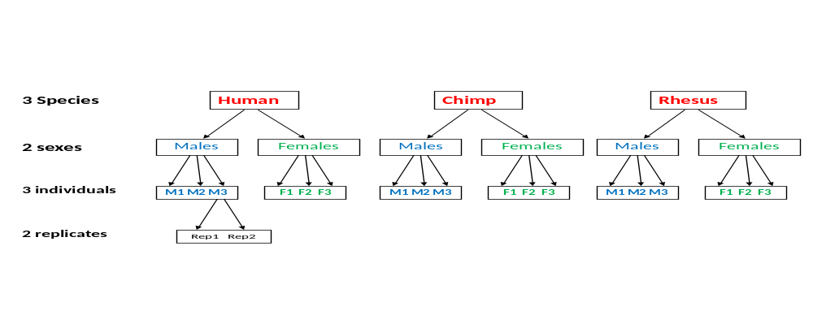

Figure S2. Histograms showing the distribution of median normalized expression levels across all genes in each species.

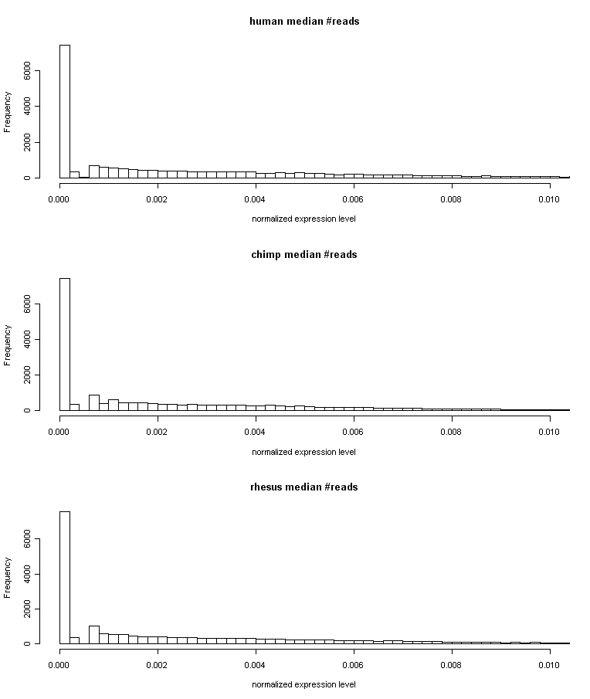
Figure S3. Heatmap of pairwise (Spearman) correlations of gene expression levels between all lanes. Colors represent different R² values as indicated in the color key at the bottom. The dendrogram, which was used to order the rows and columns of the heatmap, was generated by clustering the pairwise correlation matrix using a Euclidean distance metric and complete agglomeration.

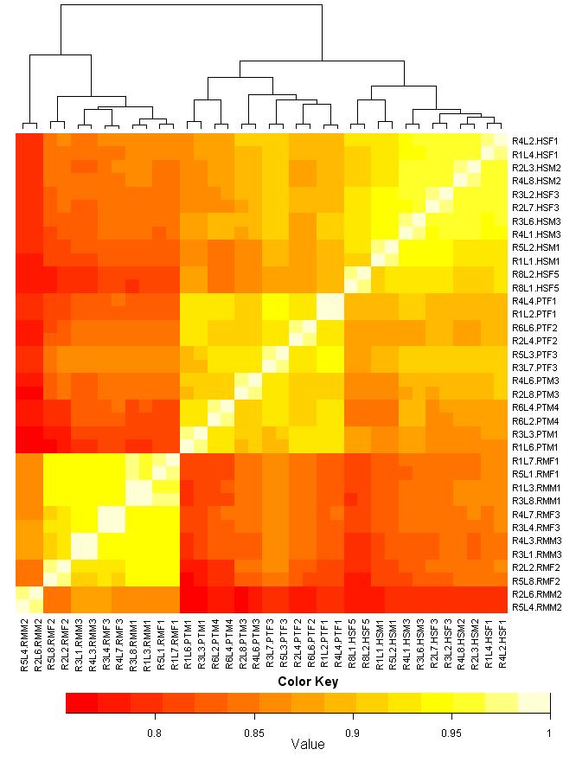
Figure S4. Histograms of the pairwise Spearman correlations between different subsets of lanes are shown. On the left, the correlations between pairs of lanes in which the same sample was sequenced are shown. In the second column, correlations of all lanes in which individuals of the same species and sex are shown. In the third column, correlations of all lanes in which individuals of the same species and different sex are shown. In the fourth column, correlations between individuals of the same sex but in different species are shown and, in the fifth column, correlations across all individuals of different species or sex, are shown.

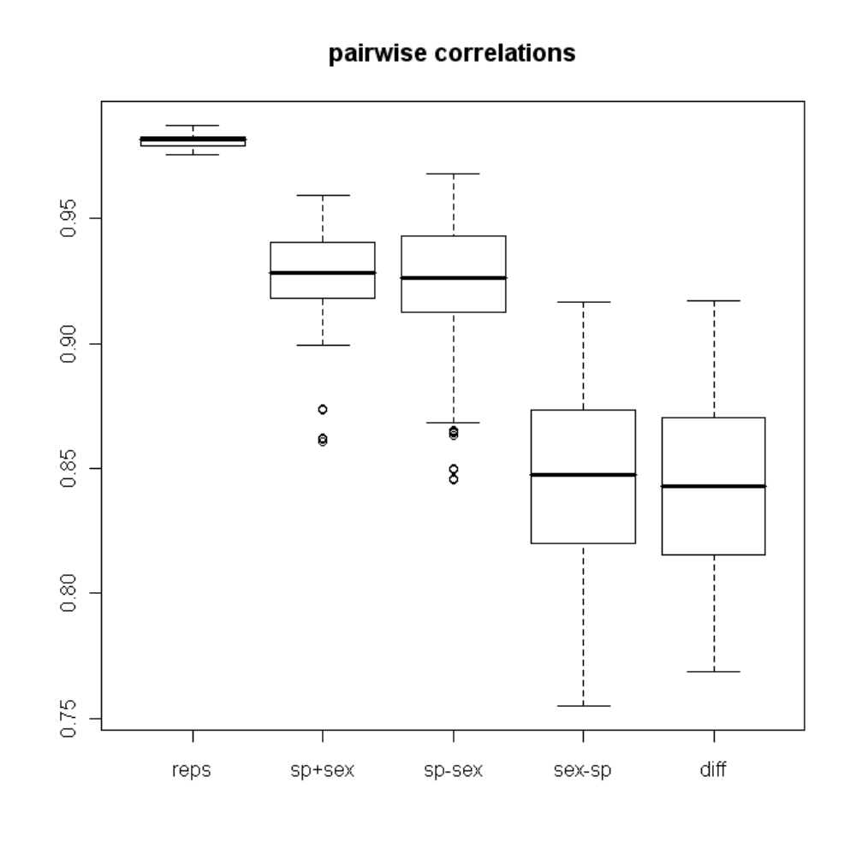
Figure S5. Sample plots showing the correlation between different pairs of lanes. First row shows correlation between lanes sequencing the same individual (replicates): HSM1, PTF1, RMF1. Second row shows correlation between lanes from the same species and sex, but not the same individual: (left to right) HSM1 vs HSM2; PTF1 vs PTF2; RMF1 vs RMF2. Third row shows correlation between lanes from the same species, different sex: HSM1 vs HSF1; PTM1 vs PTF1; RMM1 vs RMF1. Fourth row shows correlation between lanes from different species, same sex: HSM1 vs PTM1; HSM2 vs RMM2; PTM3 vs RMM3.

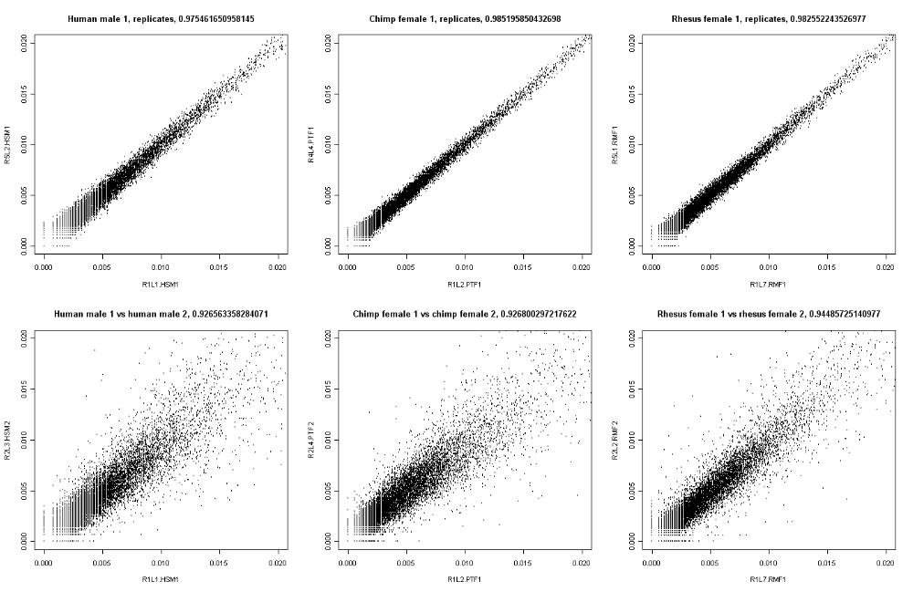

Figure S5 (continued)

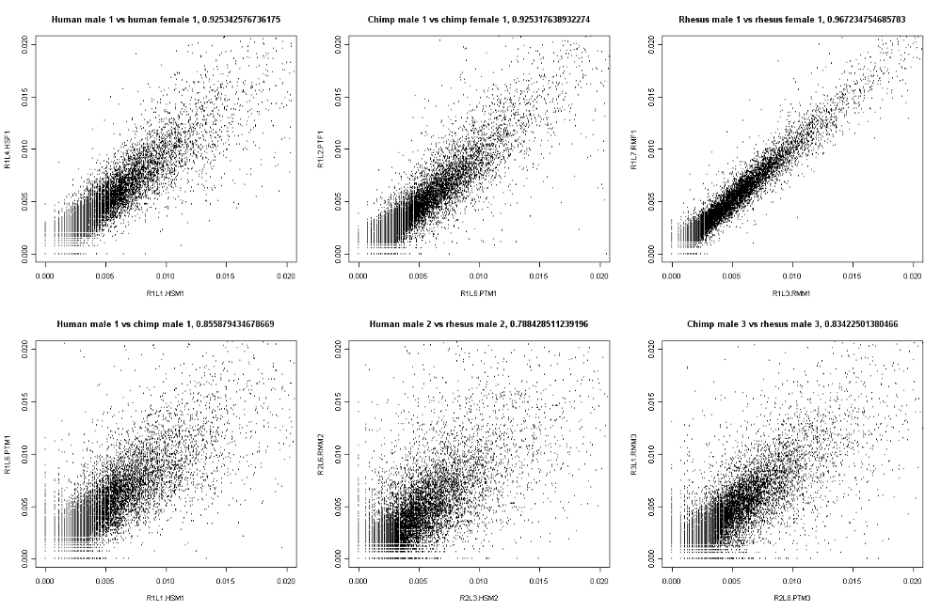

Figure S6. No sex-specific or species-specific RNA degradation bias. Expression levels in 5’ and 3’ exons across the different species and sexes are plotted. In each panel, the three boxplots show the normalized, per bp median expression level in the two most 5’ exons (left), the two most 3’ exons (right), and all the other exons (middle), including only genes with at least 6 exons. For each gene, we calculated the mean over all exons in each of the three categories.

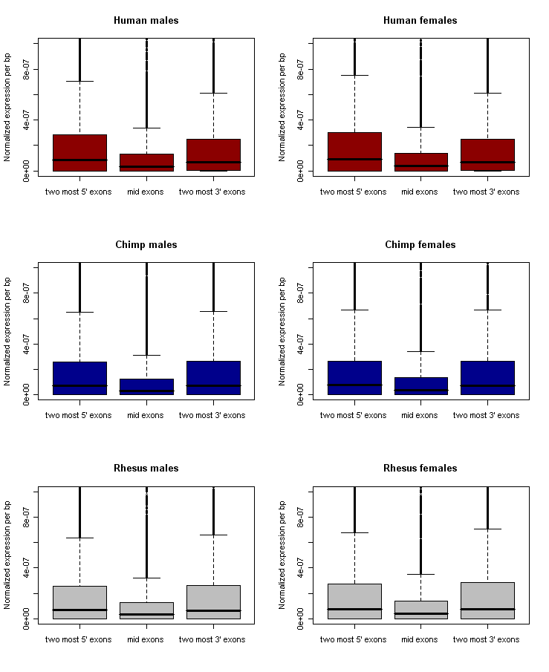
Figure S7 Correlation of measurements of gene expression levels from the multi-species array from Blekhman et al., 2008, and the RNAseq data for human liver samples. On the y-axis, expression estimates from the multi-species microarray for each gene are shown and, on the x-axis, the median normalized expression values from the RNAseq data (for the same set of genes) are shown. The correlation was calculated using Spearman’s rank test.

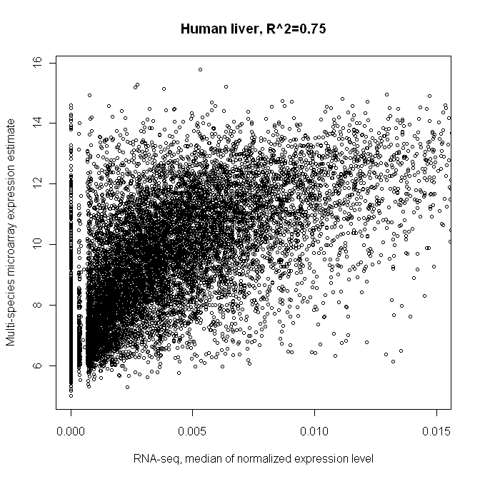
Figure S8. Correlation of measurements of gene expression levels from the multi-species array from Blekhman et al., 2008, and the RNAseq data for chimpanzee liver samples. On the y-axis, expression estimates from the multi-species microarray for each gene are shown and, on the x-axis, the median normalized expression values from the RNAseq data (for the same set of genes) are shown. The correlation was calculated using Spearman’s rank test.

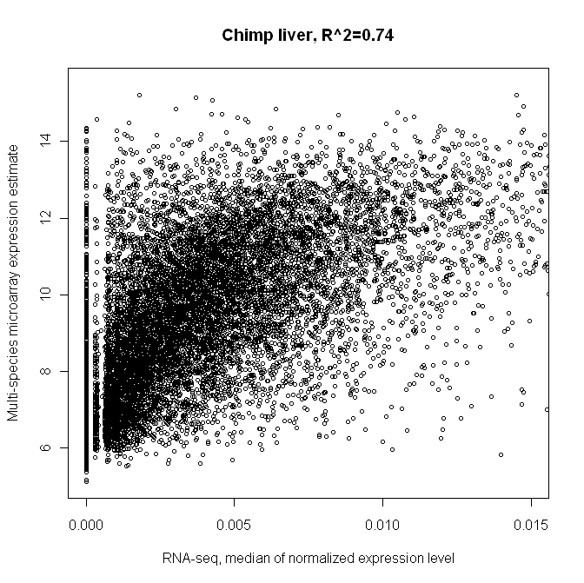
Figure S9. Correlation of measurements of gene expression levels from the multi-species array from Blekhman et al., 2008, and the RNAseq data for rhesus macaque liver samples. On the y-axis, expression estimates from the multi-species microarray for each gene are shown and, on the x-axis, the median normalized expression values from the RNAseq data (for the same set of genes) are shown. The correlation was calculated using Spearman’s rank test.

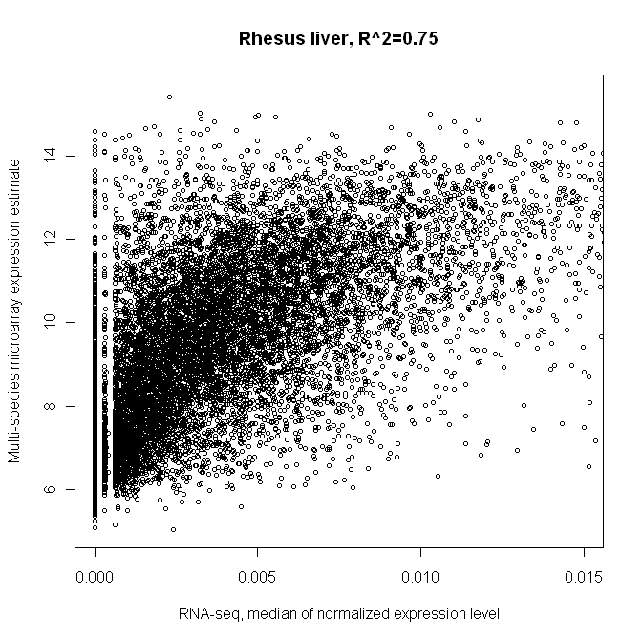
Figure S10. Examples of strong concordance between expression levels measured using the multi-species arrays from Blekhman et al., 2008 and the RNAseq data from the current study. Six genes are displayed; for each, the expression estimate (mean±s.e.m) from the multispecies array (left) and normalized expression level (mean±s.e.m) from the RNAseq data (right) are shown for each species (H:human, C:chimpanzee, R:rhesus macaque).

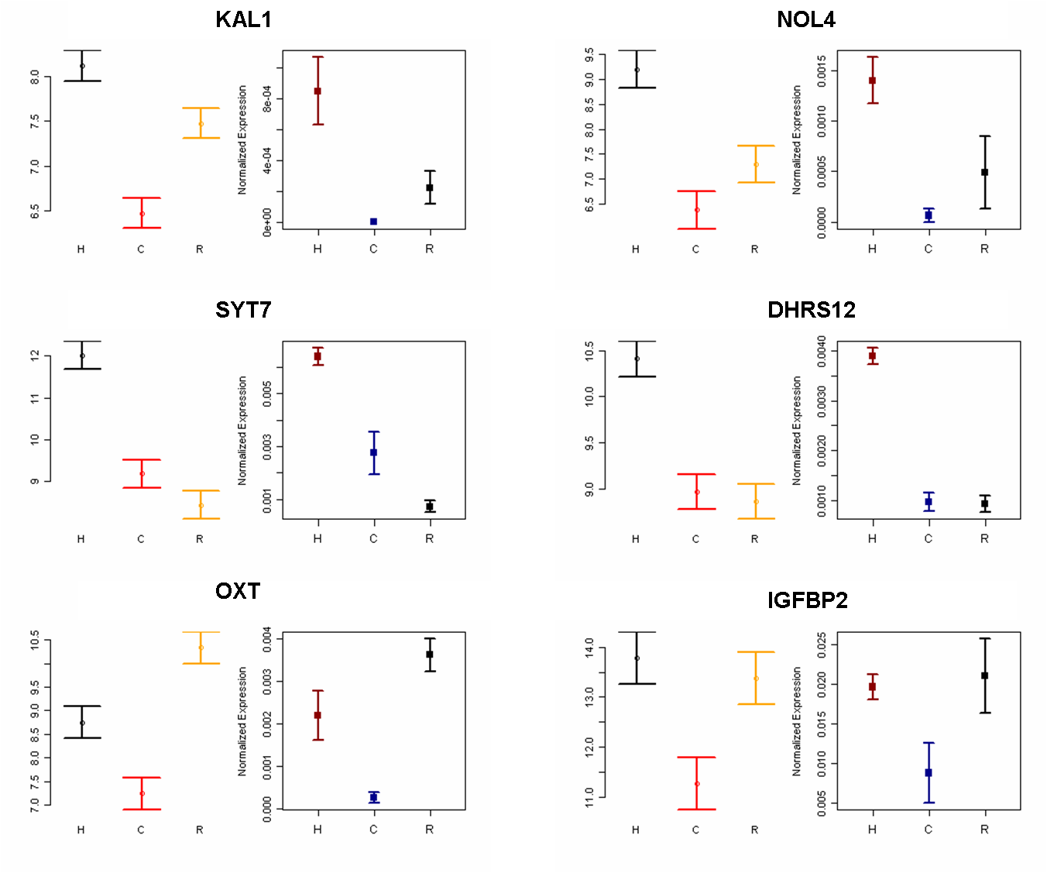
Figure S11. Scatterplot of the difference in gene expression levels between humans and chimpanzees estimated using the RNAseq data (y-axis) or using the multi-species microarray data from Blekhman et al., 2008 (x-axis). The Pearson correlation between estimates from the two platforms (considering all genes – including those that are not differentially expressed between the two species) is 0.58. The gene VNN3 is highlighted (see Figure S12 for an explanation of the poor concordance between the array and sequencing platforms for this gene).

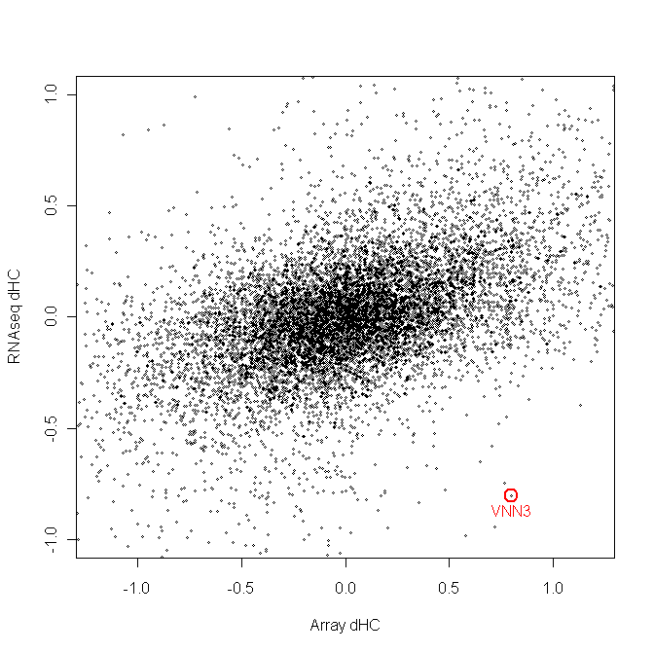
Figure S12. Expression differences between humans and chimpanzees along the VNN3 gene region. (A) The total number of reads (across all lanes) mapped to the region of the genome including the VNN3 gene in human and chimpanzee. The x-axis represents the genomic position on chromosome 6 in each species, and the black boxes above the axis represent the orthologous exons in VNN3. The red lines represent the positions of the array probes (6 total, 60bp each) for this gene in the multi-species microarray. (B) A larger image of the relevant section of the gene.

A
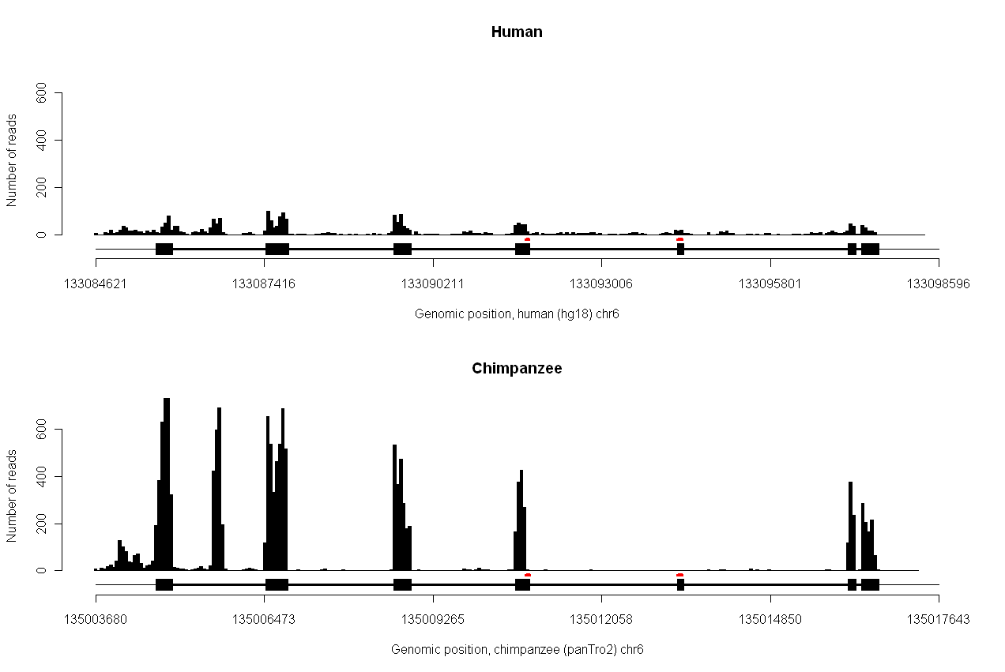
B
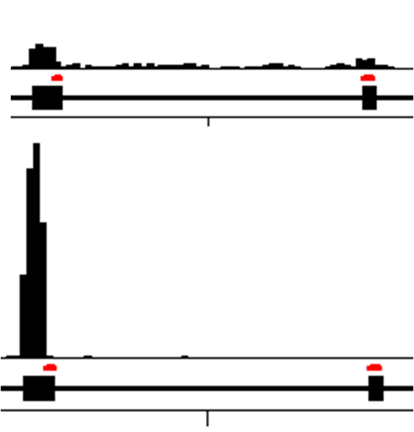
Figure S13. Expression levels in humans (red) and chimpanzees (blue) for random genes found to be differentially expressed between the species. The gene name is indicated at the top of each plot. Each dot represents the normalized expression level in one individual (calculated as a mean of the two lanes).

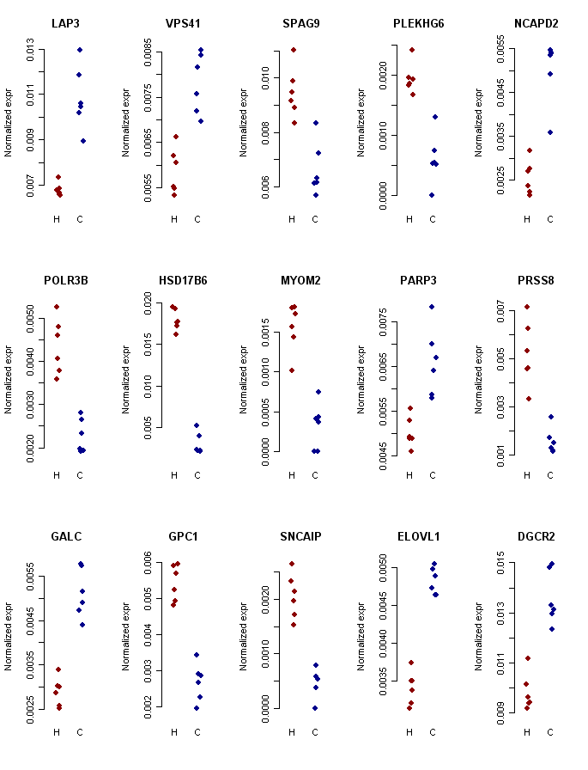
Figure S14. Overlap of genes differentially expressed between species.

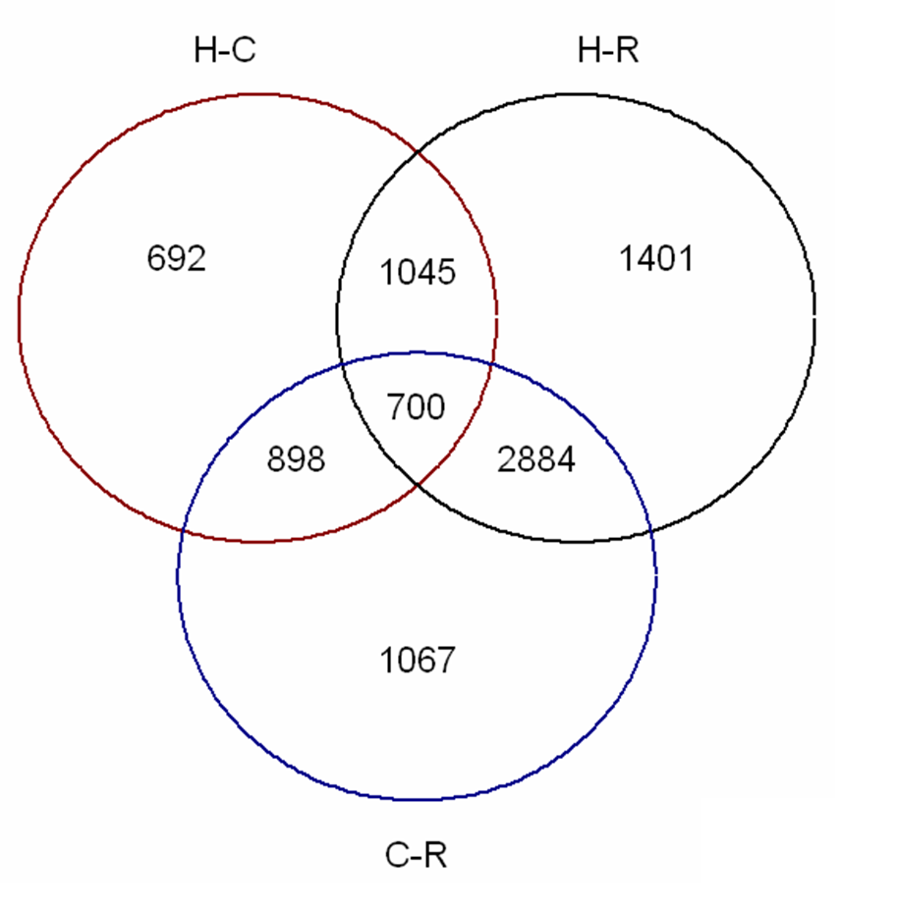

Figure S15. Gene expression levels evolve under evolutionary constraint. Box plots of absolute expression differences (y-axis) between pairs of individuals are shown for comparisons across different time scales (x-axis). We set comparisons of individuals from the same species to 1M years (a conservative estimate for the time to the most recent common ancestor within populations), comparisons between humans and chimpanzees to 6MY, and comparisons between either human or chimpanzee and rhesus macaque to 25MY.
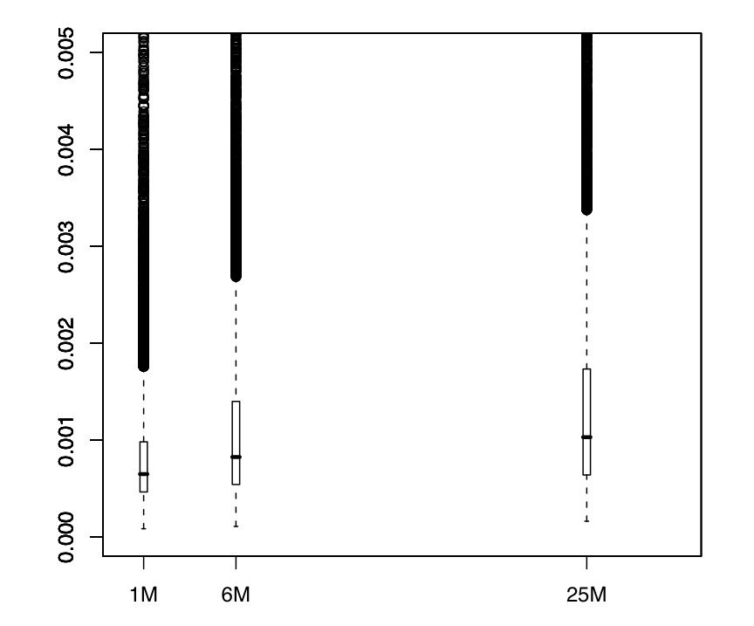
Figure S16. The distribution of between-individual variance. The variance values (y-axis) are plotted against the ranks (x-axis). The dotted line represents the chosen cutoff, based on a shift in the slope of the distribution (0.8).

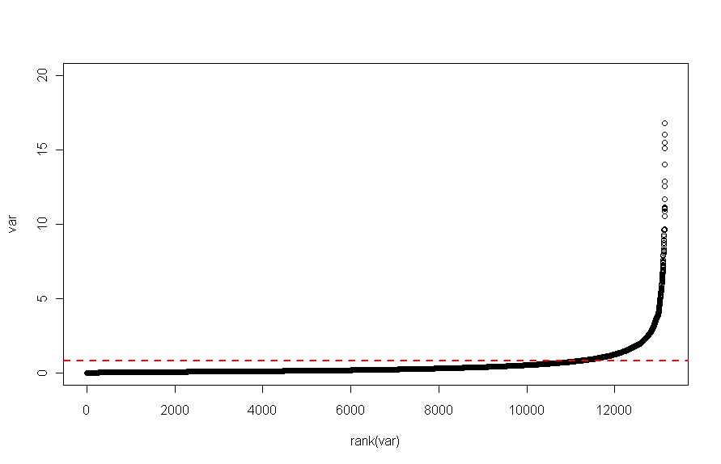

Figure S17. Examples of two genes whose regulation likely evolved under relaxation of selective constraint exclusively in the human lineage. For each species, the mean (±s.e.m) normalized expression level is shown.

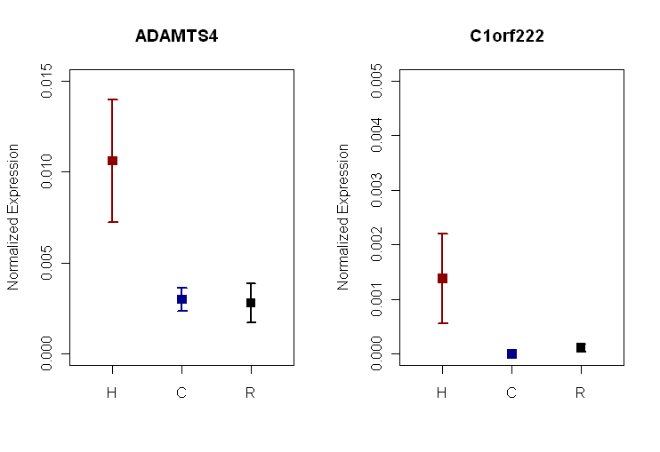

Figure S18. The distribution of the Wald statistic associated with the human-specific effect in model 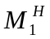 (see Supplementary Methods). The statistic values (y-axis) are plotted against the ranks (x-axis). The dotted line represents the chosen cutoff, based on a shift in the slope of the distribution (0.03).

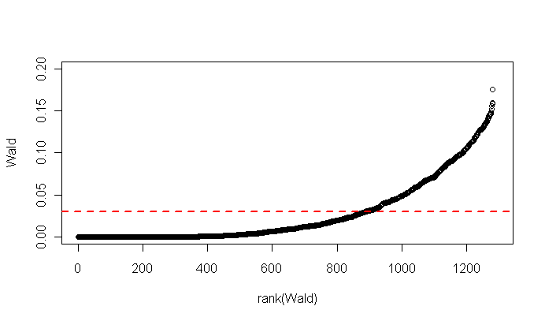
Figure S19. Mean (±s.e.m) normalized expression levels in humans (red), chimpanzees (blue), and rhesus macaques (black) for genes with different Wald statistic values (including only genes that are expressed, have low levels of between-individual variance, and for which the best fitting model is). The gene name and Wald statistic rank are indicated at the top of each plot. The final cutoff (0.03) maintained the top 887 genes in this ranking.

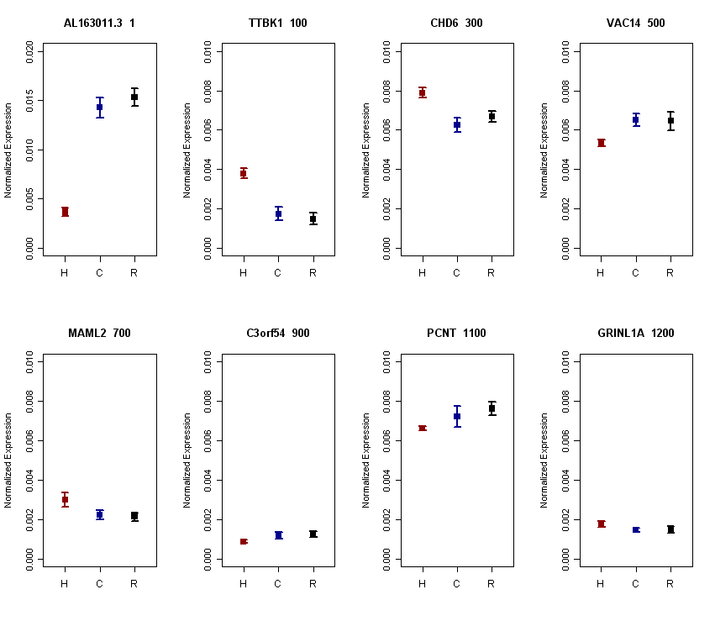

Figure S20. Conserved sexually dimorphic exon usage. Each panel is showing data for one gene. Mean (±s.e.m) relative exon expression levels (y-axis) are plotted separately for females (green) and males (blue). The gene structure appears above the x-axis, which denotes the genomic coordinates in human. Splice junctions identified for each sex are shown as triangles connecting pairs of exons. In each gene, a difference in exon usage between males and females is circled.

