Name

Online Shopping API

Description

API Features:

#### User is able to sign up by providing username, email, password, birthdate, gender, mobile number and address.

#### User can choose their type (Shop owner, Normal).

#### User is able to login into the online market by providing username/email and password.

#### API provide authorization and authentication.

Main components and used libraries:

#### The coding language used is java.

#### The project management tool used is Maven.

#### The framework used is spring boot.

#### JDBC library (for further reading: https://www.javatpoint.com/java-jdbc).

#### The relational database used is MySQL.

Badges

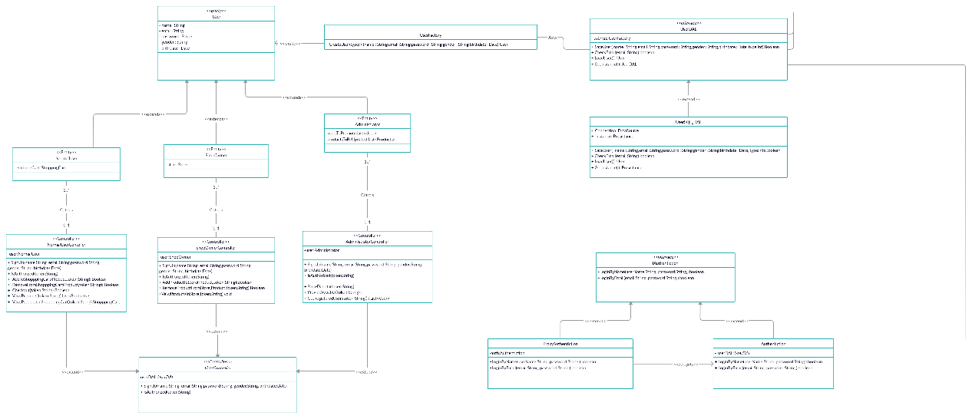

Figure 1 Class Diagram

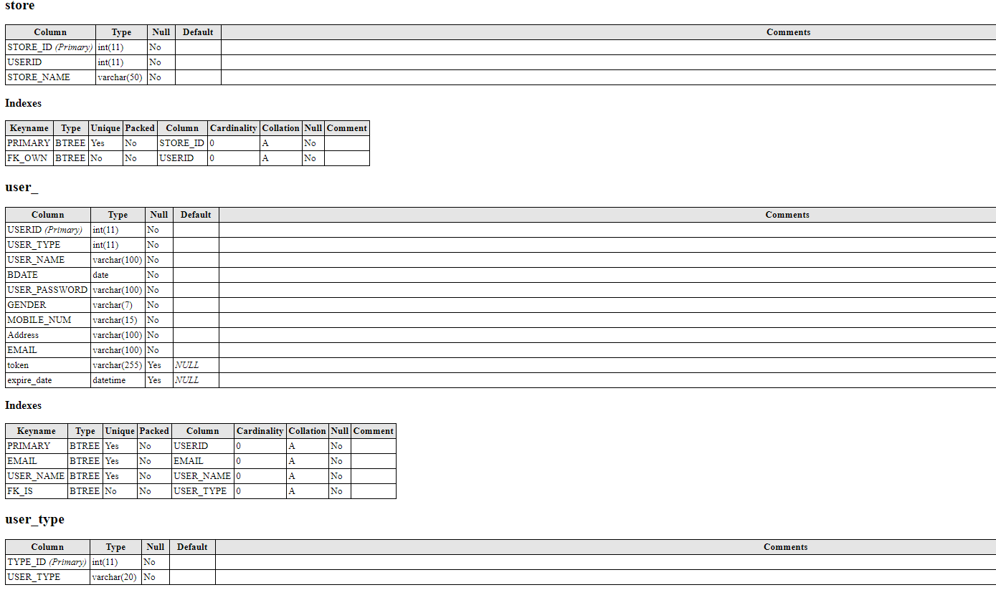

Figure 2 Database tables

Visuals and Usages

1. Log in by name

URL: http:// localhost:8081/LoginByName/name/password

input: User name and their password

Output: A token which the user will use to navigate the site.

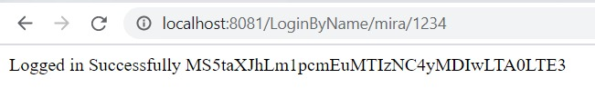

1. Log in by Email

URL: http:// localhost:8081/LoginByEmail/email/password

input: User email and their password

Output: A token which the user will use to navigate the site.

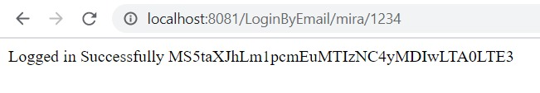

1. Sign Up as Normal User

URL:<http://localhost:8081/SignupAsNormal/Name/Email/Password/Gender/Birthdate/Mobilenum/Address>

input: Name, Email, Password, Gender, Birthdate, Mobile num, Address

Output: A token which the user will use to navigate the site.

1. Sign Up as Shop owner

URL:[http://localhost:8081/SignupAsShopOwner/Name/Email/Password/Gender/Birthdate/Mobilenum/Address](http://localhost:8081/SignupAsShopOwner/Name/Email/Password/Gender/Birthdate/Mobilenum/Address%20)

input: Name, Email, Password, Gender, Birthdate, Mobile num, Address

Output: A token which the user will use to navigate the site.

1. Sign Up as Administrator

URL:[http://localhost:8081/SignUpAsAdmin/Name/Email/Password/Gender/Birthdate/Mobilenum/Address](http://localhost:8081/SignUpAsAdmin/Name/Email/Password/Gender/Birthdate/Mobilenum/Address%20)

input: Name, Email, Password, Gender, Birthdate, Mobile num, Address

Output: A token which the user will use to navigate the site.

1. Get Registered Users

URL:<http://localhost:8081/GetRegisteredUsers/token>

input: Administrator token

Output: List of all Registered users.



Support

For support please contact the contributors at these gmails:

* [Miramohamedraheem@gmail.com](mailto:Miramohamedraheem@gmail.com)
* [nehaletafa99@gmail.com](mailto:nehaletafa99@gmail.com)
* [noura.ihab@gmail.com](mailto:noura.ihab@gmail.com)
* [nouran.qassem98@gmail.com](mailto:nouran.qassem98@gmail.com)

Contributing

Sadly, we are not open for external contributors yet.

Project status

The project is divided into 5 to 8 sprints so far we have implements only two so it’s a work in progress.