*Supporting Information for the Journal of Cleaner Production*

Modelling global material stocks and flows for residential and service sector buildings towards 2050

Sebastiaan Deetman1,3, Sylvia Marinova1, Ester van der Voet1, Detlef P. van Vuuren2,3, Oreane Edelenbosch4 & Reinout Heijungs1,5

1 Institute of Environmental Sciences, Leiden University, Leiden, the Netherlands  
2 PBL Netherlands Environmental Assessment Agency, The Hague, The Netherlands  
3 Copernicus Institute for Sustainable Development, Utrecht University, Utrecht, The Netherlands

4 Department of Management and Economics, Politecnico di Milan, Via Lambruschini 4/B, Milan, Italy  
5 Department of Econometrics and OR, Vrije Universiteit Amsterdam, Amsterdam, The Netherlands

Number of pages: 25

Number of figures: 14

Number of tables: 5

1. IMAGE Region definitions 2

2. Regression Analysis for Service Sector Floorspace 3

2.1 Weighted regression 6

2.2. Reflection on model specification 8

3. Dynamic Stock modelling for Service Sector Floorspace 9

3.1 Lifetime assumptions 9

3.2 Historic stock development 11

3.3 Lifetime verification 12

4. Material Assumptions 13

5. Detailed results 15

5.1 Per capita floorspace demand 15

5.2 Detailed model outcomes 17

6. Sensitivity Analysis 19

6.1. Description of Four Sensitivity Variants 19

6.2 Outcomes of the Sensitivity Analysis 21

6.3 Discussion on the Sensitivity Analysis 24

7. Model Code 27

7.1 Code for the regression analysis for service sector floorspace 27

7.2. Code of the main model 29

8. References (as used in the SI) 30

## IMAGE Region definitions

The regional classification used in the main text and the underlying model distinguish 26 global regions, which can be seen in in Figure S.1, below. We’ve also indicated which regions are grouped under ‘fast developing’ with a 1, and ‘steady developed’ regions with a 2, according to the identified regional typologies used in the main text. Buildings in Greenland & Antarctica are not taken into account.



2

2

2

1

11

1

2

2

2

2

2

2

2

2

1

1

1

1

1

1

1

1

1

1

3

3

Figure S.1. The 26 world regions in IMAGE 3.0. *Source: Stehfest et al.*1*, reproduced with permission of the editor. Regions tagged with a 1 are part of the group classified as ‘fast developing’ regions in the main text. Regions with a 2 represent the ‘steady developed’ region & group 3 indicates China & Japan.*

## Regression Analysis for Service Sector Floorspace

As indicated in the main text, the starting point for our analysis is the 2017 data on service-related floor space in 231 countries, according to the Navigant Global Building Stock Database2. Because this is a commercial database, we cannot provide the original data. This section just explains the steps taken in the regression analysis, while providing additional detail.

First, we excluded countries for which we could not find the Gross Domestic Product (GDP) in Purchasing Power Parity (PPP) or the Service Value Added (SVA) fraction in the United Nation statistics3,4. The following countries were excluded for this reason:

*Greenland, Andorra, Faeroe Islands, Gibraltar, Holy See, Isle of Man, Liechtenstein, Monaco, American Samoa, Cook Islands, French Polynesia, Guam, North-Korea, Mayotte, New Caledonia, Niue, Northern Mariana Islands, Taiwan, Tokelau, Wallis and Futuna Islands, Anguilla, Aruba, Belize, Cuba, Falkland Islands, French Guiana, Guadeloupe, Martinique, Montserrat, Saint Helena, Saint Kitts and Nevis, Saint Lucia, Saint Pierre and Miquelon, Saint Vincent and the Grenadines, Sint Maarten (Dutch part), Suriname, Turks and Caicos Islands, Venezuela, British & US Virgin Islands, Bahrain, Oman, Syrian Arab Republic, Djibouti, Eritrea, Libya, Rwanda, Somalia, Sudan, Western Sahara.*

Secondly, we excluded another group of countries which represented outliers in terms of per capita service sector floorspace, because they are island states, or typical city states. Because the model resulting from the regression is applied to 26 large global regions, we feel that calibrating a model to such atypical cases should be avoided. For this reason, the following countries were omitted in the regression analysis:

*Cyprus, Bhutan, Brunei Darussalam, Comoros, Fiji, Hong-Kong, Kiribati, Macau, Maldives, Marshall Islands, Micronesia, Nauru, Palau, Samoa, Singapore, Solomon Islands, Tonga, Tuvalu, Vanatu, Antigua and Barbuda, Bahamas, Barbados, Caribbean Netherlands, Cayman Islands, Grenada, Puerto Rico, Trinidad & Tobago, Kuwait, Qatar, United Arab Emirates, Cabo Verde, Mauritius, Sao Tome and Principe, Seychelles*

The remaining 147 countries yield data points which are used in the regression analysis, for which the results are shown in Figure S.2. These figures show the resulting unweighted models as well as the population weighted model, using a Gompertz function (also see the main text):

*y* being the service sector floor space demand in square meter per capita, and *x* the Service Value Added per capita in 2016-US$ for a particular country/yr, in Purchasing Power Parity. The coefficients α, β and γ were estimated using the Sequential Least Squares Programming (SLSQP) algorithm from the scipy package implemented in a python script (See Section S.6). We choose the SLSQP routine because as a sequential quadratic programming routine it has been shown to perform well (in terms of both efficiency and accuracy) for constrained non-linear optimization problems, such as ours5,6. The model is used to project the global floor space demand by applying the SVA for 26 IMAGE regions. As the SVA in IMAGE is expressed in 2005 US$ (PPP), we correct for inflation based on the inflation calculator of the United States Bureau of Labor Statistics7.

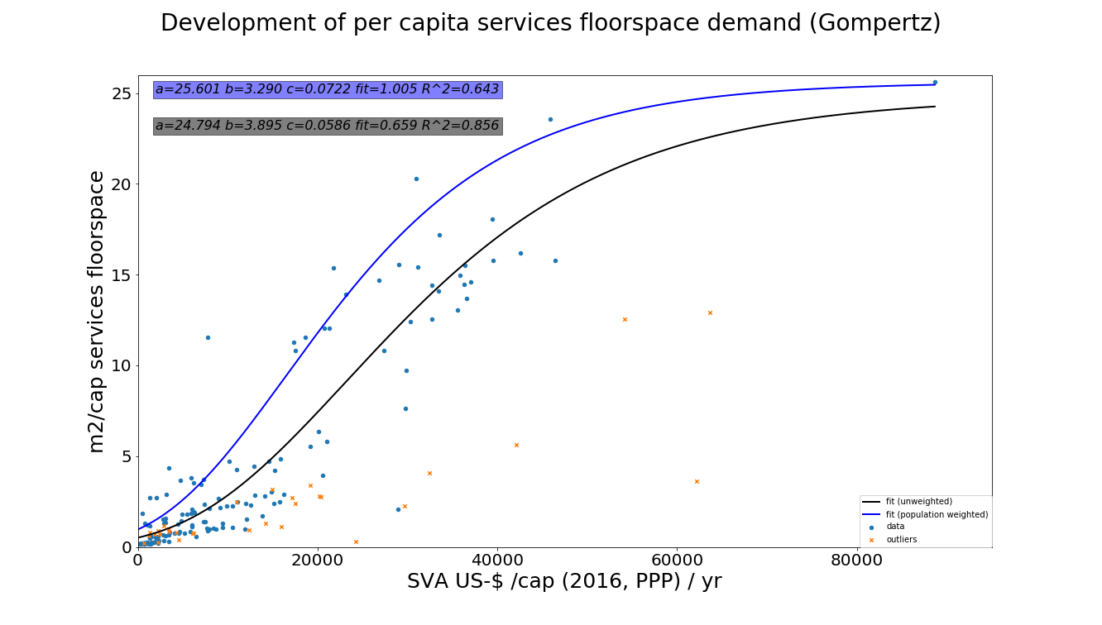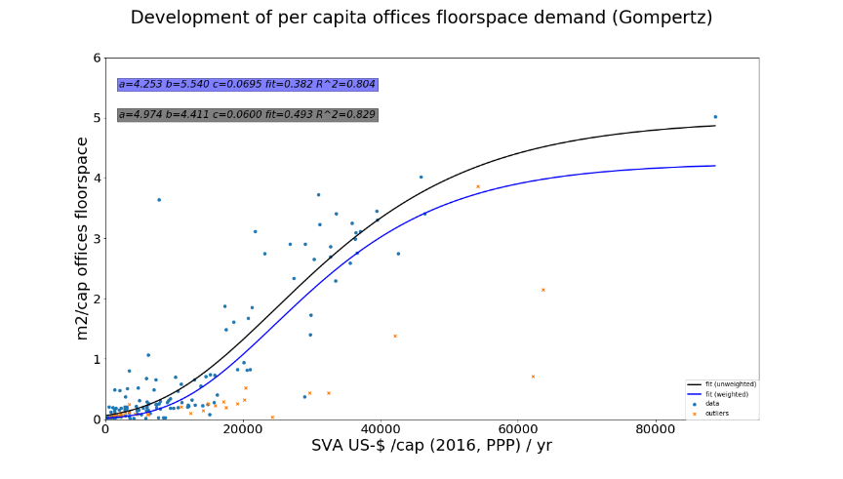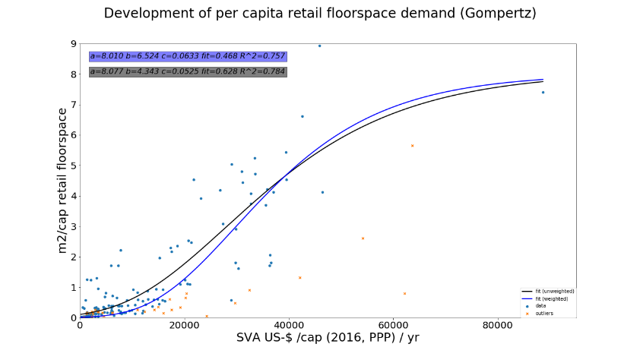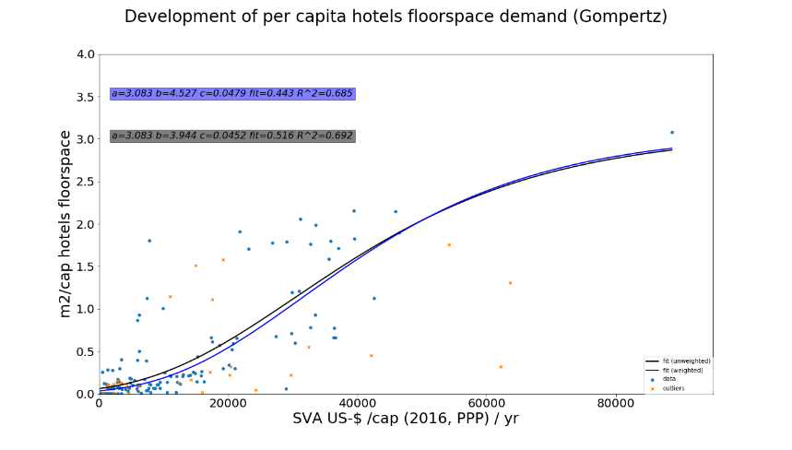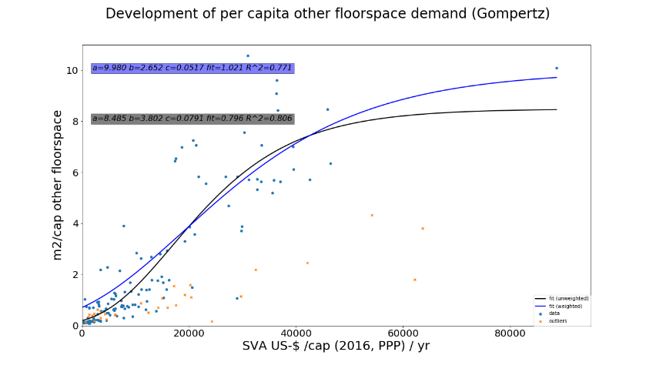

b

a

d

c

e

*Figure S.2. Development of per capita service sector floorspace demand, according to the unweighted regression (black) and a population weighted regression (blue). a) represents the total service sector floorspace (data points represent the sum of the data points in panel b-e). b) shows the office space, c) shows the floorspace for retail, shops & warehouses, d) shows hotels & restaurants & e) shows the per capita demand for other buildings (educational buildings, hospitals, governmental buildings, buildings for assembly and public transportation).*

### 2.1 Weighted regression

As explained in the main text, the model validation based on unweighted regression did not lead to a suitable fit with the 2017 data. The unweighted model (black line) would underestimate the known total global floorspace for 2017. This mismatch is addressed by means of a ‘fit’ indicator, , which represents the total modelled floor space over the total observed floor space in 2017, when multiplied with the population size for the 147 countries used in the regression:

Here, is the modelled per capita floor space, for country *i*, as derived from the estimated regression model, and using information on the Service Value Added per capita, per country. is the per capita floor space according to the data and is the population in a country, according to the data.

As indicated in Figure S.2a, the total service-related floor space demand based on unweighted regression analysis would have a fit of . In other words, the model predicts a total service sector floor space demand that would be off by 33% in 2017. This is caused by the fact that many countries with a large population size lie above the unweighted curve, while many countries with a small population size are below the curve. It was thus decided to use a population weighted regression model for the floor space demand from the service sector as a whole (blue line in Figure S.2a). This was done by minimizing the goodness-of-fit parameter, or the , according to Bevington & Robinson 8:

Here, is the Service Value Added in US$ (2016, PPP) and is the uncertainty of the , so of the per capita floor space of country , measured in terms of a standard deviation. An unweighted model assumes an equal (but possibly unknown) for all countries. There is no information on the value of these -values. We decided to construct them based on the (population or GDP per capita weighted) per capita floorspace and a country-specific uncertainty weight as follows:

Here the uncertainty weight is assumed to decrease linearly (with population size or GDP/cap) until a maximum reached (200 million people or $40,000 GDP/cap, see Figure S.3):

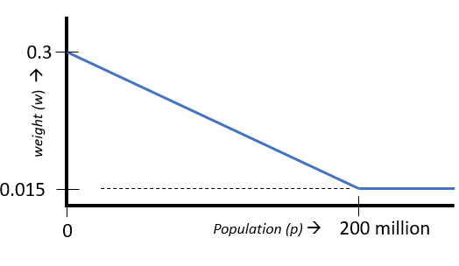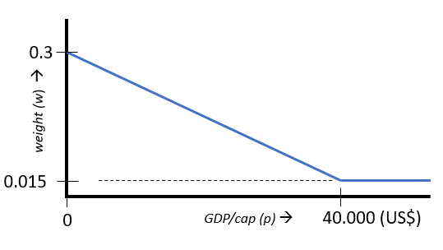

*Figure S.3. Graphical representation of the uncertainty weighting factors (w) used in the weighted regression analysis. Left: population weighted regression; Right: regression weighted by GDP per capita.*

This means that we introduce a relatively large uncertainty weight (), and resulting relative standard deviation of the service-related floor space (of 30%) for countries with a small population size (), while countries with a population size beyond 200 million people are assumed to have a smaller relative standard deviation of the service-related floor space (of 1.5%). When implemented, these settings ensure that the model fit becomes more accurate, because it allocates more weight to data points representing countries with a larger population (since these have a lower uncertainty weight). Using the estimated Gompertz parameters resulting from the weighted regression leads to a much better fit of for the year 2017, representing a mismatch of total global floor space of only 0.5%. A more accurate model verification in the year 2017, however, comes at the cost of lower values as can be seen from Figure S.2.

While the total service-sector floorspace is represented using a population weighted regression, thus ensuring an appropriate model fit, it was decided to follow a different approach regarding the disaggregation of floorspace demand across the four service building types (Figure S.2b-c). One reason being the lower resulting values from a population weighted regression. Another reason is that if the total service floorspace ensures a proper representation of the current situation, the need for population-based weighting diminishes for the specific building types. Instead we applied a more common weighting approach based on the reliability of the data. Here, we assume that reported data from countries with a higher per capita income have a higher reliability than data from countries with a lower income per capita. This could be defended by the common view that affluent countries tend to have better statistical offices for example. To translate a countries affluence into a proxy for the data reliability we used the per capita GDP (2016 US$/cap, PPP). Similar to the population weighted approach we use a high uncertainty weight of 30% at low income levels, and assume a linear decrease to 1.5% at high levels of GDP per capita (beyond 40.000 US$/capita yr-1), as shown in Figure S.3.

The disaggregation of the total commercial floor space demand (based on the weighted regression) was done based on the relative contribution according to the GDP/cap weighted regression fits for the four service-related building types, as can be found in Figure S.4 a&b.

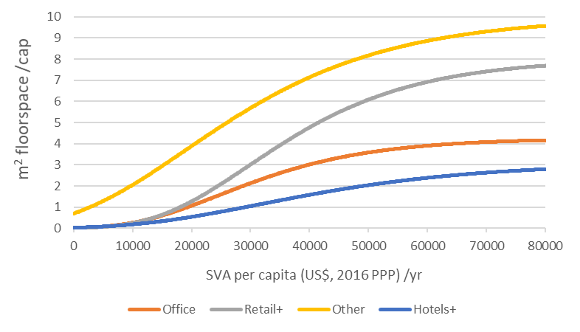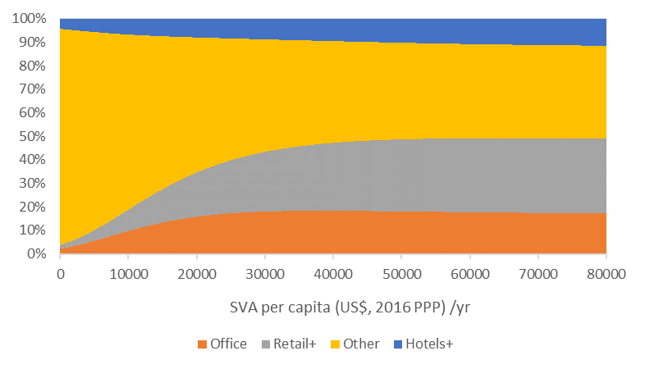

b

a

*Figure S.4. Per capita floor space demand for four service sector building types, used to disaggregate the total service-related floorspace demand (blue line in Figure S.2a). a) Four regression models used for the four commercial building types (the corresponding Gompertz parameters for these curves can be found in Table 1 of the main text). b) Relative contribution of the four service building types to the total service sector floorspace demand, at different levels of Service Value Added (in US$/capita yr-1).*

## 2.2. Reflection on model specification

In the current model specification, we use national data on per capita service value added to derive the development of the per capita floorspace for non-residential buildings. However, this does not mean that service value added is the only possible independent variable to explain the development of non-residential floorspace demand. From literature we know, for example, that the amount of some shops seems to be correlated with population density at the local level9. To see if this is true for our data, we displayed the per capita floorspace demand for four non-residential building types in relation to the population density in Figure S.5. Using the figure one can identify some of the city-states, but other than that, the figures do not suggest any clear relationship between non-residential floorspace demand and population density.

That does not mean, however, that such relationship does not exist. If data on non-residential floorspace demand would be specified for smaller regions, or if it would distinguish between urban and rural areas, one may expect to find not only a better regression, but perhaps a better model by incorporating a second independent variable such as population density. The current model specification is therefore chosen based on data-availability, given the global scope of our research.

Furthermore, in the definition of a global model describing a generic development path we inevitably lose sight of exceptional regional factors such as culture and lifestyle, which surely play a role in floorspace demand. We would like to emphasize that therefore careful interpretation is required when using regional model outcomes. For this exact reason we provide both the data and the model used, which should make it easy to build and improve upon our work, for example by improving the regional representation.

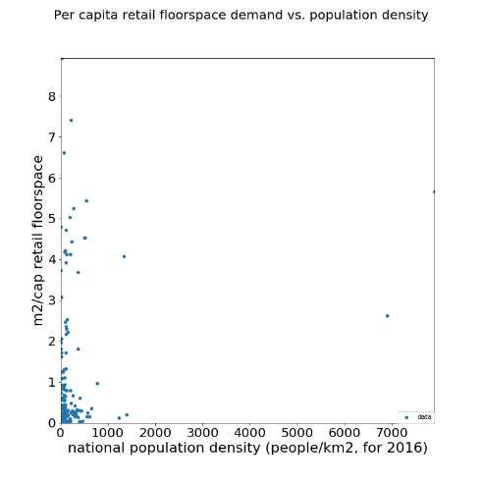 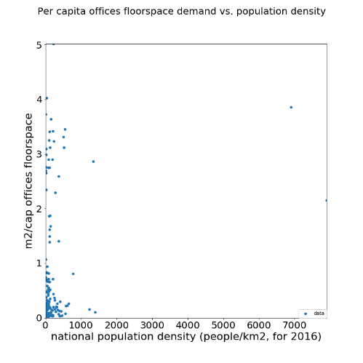

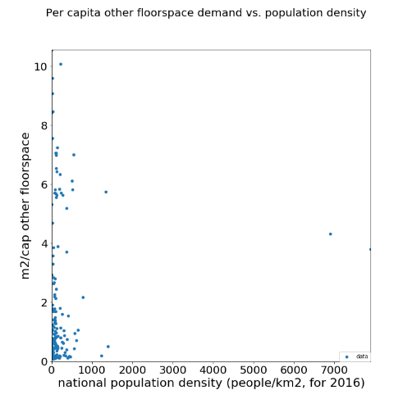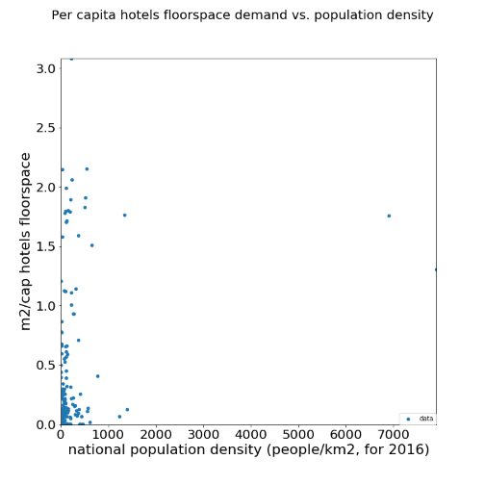

*Figure S.5. Per capita floorspace demand in 4 non-residential building types (top-left: offices; top-right: retail+; bottom-left: hotels+; bottom-right: other) versus the population density. Data points represent countries, including outliers (N=176).*

Finally, the assumption of a fixed relation between demand (floor-space) and income (SVA) is only valid under a presumption of a ‘business as usual’ development. This is a legitimate assumption under the SSP2 scenario, as it explicitly assumes a “path in which social, economic, and technological trends do not shift markedly from historical patterns” according to Riahi et al.10. However, implementation of our model under different scenarios (SSP or other) could mean that this relation between service sector floorspace demand and SVA needs to be revisited.

## Dynamic Stock modelling for Service Sector Floorspace

### 3.1 Lifetime assumptions

The dynamic stock model used was originally developed by Pauliuk and co-contributors11, and was applied in this study using a stock-driven approach. This requires lifetime assumptions for the buildings in our model, which were based on the Weibull distribution parameters as found in literature. Table 3 in the main text shows the averaged Weibull parameters used, but as indicated in the main text, we used building-specific Weibull parameters where possible. Table S.2 shows the parameters used.

Averaging lifetime distributions based on given Weibull parameters cannot simply be done by averaging the available shape parameters and the available scale parameters. Therefore, we used a python least squares optimization routine to find the closest representation of the average, given multiple Weibull curves. In case we used an average to represent the multiple Weibull parameters found in literature, we indicate the coefficient of determination for the fitted curve with respect to the average of multiple curves (2 to maximum 5 curves) in brackets. Thus, representing how well our parameter settings matches the average of the lifetimes found in literature. For an example, please see Figure S.6.

|  |  |  |  |  |
| --- | --- | --- | --- | --- |
| **Region** | **Building type** | **shape** | **scale** | **Comment** |
| Japan | Detached | 1.88 | 41.23 | Building Specific Weibull parameters according to the average found in two studies 12,13 (R2 = 0.99) |
|  | Semi-detached | 1.89 | 42.58 |
|  | Apartments | 1.90 | 43.95 |
|  | High-rise | 2.56 | 34.05 |
| China | Urban: detached | 2 | 33.85 | Region specific shape parameter and building specific scale parameter according to the mean indicated in Wang et al.14 |
|  | Urban: semi-detached | 2 | 39.49 |
|  | Rural: (semi)-detached | 2 | 31.03 |
|  | Apartments | 2 | 53.60 |
|  | High-rise | 2 | 56.42 |
| Eastern Europe | (semi)-detached | 2.5 | 73.26 | Region specific shape parameter according to Novikova et al.15,16 |
|  | Appartments | 2.5 | 101.43 |
|  | High-rise | 1.97 | 67.36 | Global Average (see below) |
| United States | All | 4.16 | 85.19 | Region specific parameters according to average 17–19 (R2 = 0.951) |
| Western Europe | All | 2.95 | 70.82 | Region specific parameters according to average 19–21 (R2 = 0.965) |
| Canada | All | 1.97 | 57.53 | Global shape, regional mean 22,23 |
| Mexico | All | 1.97 | 63.17 | Global shape, regional mean 23,24 |
| Brazil | All | 1.97 | 112.80 | Global shape, regional mean 25 |
| Rest of South Amerika | All | 1.97 | 68.24 | Global shape, regional mean according to the average of Argentine, Chile, and South-Amerika in 22–24,26 |
| Southeastern Asia | All | 1.97 | 56.40 | Global shape, regional mean 22 |
| Oceania | All | 1.97 | 94.00 | Global shape, regional mean according to Buyle et al. 22 and Stephan et al.27 |
| Global Average | All | 1.97 | 67.34 | These lifetime parameters are applied when no information is available, it is a constructed average of parameters from 5 regions, being Japan, China, US, East & Western Europe. (R2 = 0.994) |

*Table S.1. Weibull parameters describing the lifetime distributions used. Where possible, we used lifetime estimates specific to the building type.*

*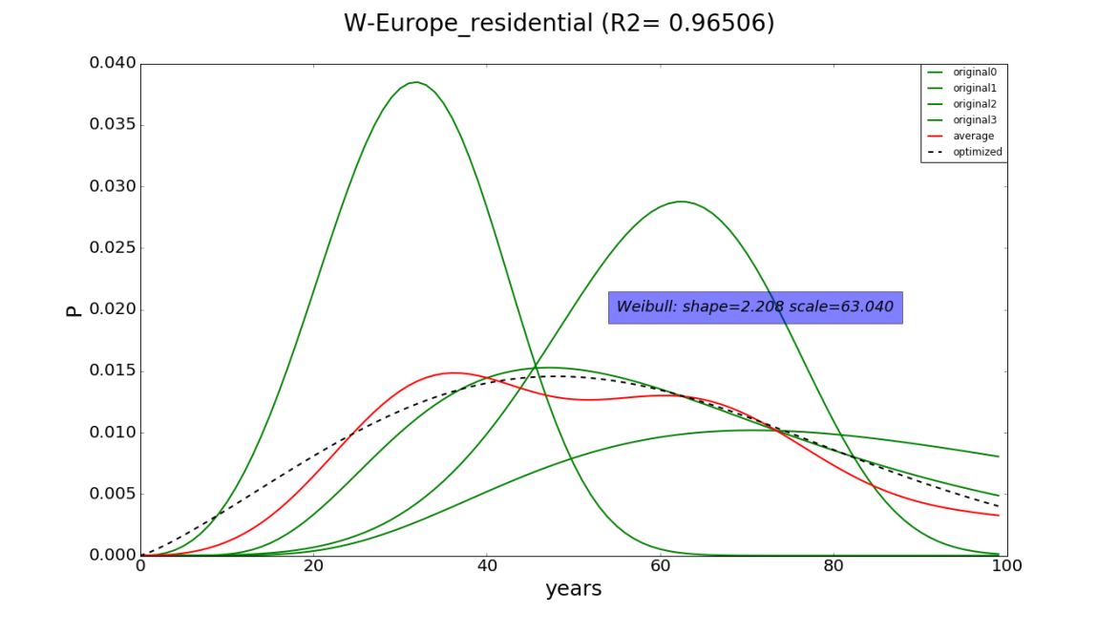Figure S.6. Example of fitting a Weibull distribution to an average of multiple Weibull curves found in literature. This example shows the four literature-based Weibull curves for Western Europe in green, the red line is the resulting average for the 4 curves, and the dotted line is the fitted curve used in our model, which fits the average with an R 2* of *0.965.*

## 3.2 Historic stock development

Since we have no data on the age distribution of the initial stock, we needed to extend the historic time series to derive the age-distribution of buildings based on historic inflow. We did so using the historic population dating back to 1820 based on Bolt et al. 28, and an additional 100 years of linear increase in population from 0 in 1720. During this model-setup period, we also assumed that the per capita floor space increased at the average global rate found in the first ten years of the IMAGE data (about 1% per year). For the development of the share of urban population before 1971 a similar approach was used, but based on regionally specific annual growth-rate. Both for the per capita floor space and the urban population fraction a minimum was maintained based on the lowest regional value in 1971. To assess the viability of these historic model assumptions, we checked whether our model was able to re-create the known age-distribution of the building stock in two European test-cases (See SI for an elaboration). The model managed successfully, but to ensure a proper fit, both test-cases required relatively high lifetimes, compared to those found in Table 3 in the main text. This suggests that some of the mean building lifetimes found in literature could be rather low.

## 3.3 Lifetime verification

We performed a model verification exercise, in which we tested assumptions on the historical model setup (Section 2.2.2 of the main text) as well as the lifetime assumptions for residential buildings. We were able to find two sources describing the age distribution of residential buildings in great detail. One for the Netherlands in the year 2018 29 and the other for Western Europe as a whole in the year 2010 30. Given the age-structure of the building stock for these regions and years, we were able to see whether the model is able to re-create these numbers. We thus run our model given the historic assumptions as described in the main text , lifetimes as found in the literature and historic population development based on Bolt et al. 28 . The Weibull parameters for Western Europe are the same as used in the main model (see Table 3 in the main text), while for the Netherlands we used the same shape parameter, but an adjusted scale parameter, corresponding to an average lifetime of 120 years for residential building, based on Sandberg et al. 31. Furthermore, in this test-case, we assume the historic development of per capita floorspace to be similar to that of Western Europe. Figure S.7 shows the resulting model outcomes, compared to the available statistics. It shows that for the Netherlands the model is able to re-create the age-structure of the residential building stock quite well, based only on GDP and Population as a driver. Perhaps with the exception of historical artefacts such as a relatively high share of remaining houses from before 1900 (which could be explained by policies aimed at preservation of historical & monumental buildings in the Netherlands) and some noticeable historic abnormalities, such as the effect of the second world war on housing construction activities.

However, using the regular lifetime assumptions for Western Europe (i.e. a Weibull distribution with a mean lifetime of 63 years) seems to lead to an over-estimation of recent building activities (Figure S.7b), because the model projects the demolition of buildings that in reality have remained in stock. Only when we assume a much higher average lifetime of 130 years, the model is able to match the known age-distribution of the stock in the year 2010 (Figure S.7c). This suggests that the literature-based lifetimes of Western European residential buildings could be lower than in reality. Another factor that may explain the mismatch between our model and the available statistics for these two test-cases is the fact that we do not account for the lifetime dynamics of monumental buildings. The latter may be quite relevant for Western Europe, given the fact that historic and monumental buildings make up a large part of the (urban) building stock 32.

Though this highlights two important paths for future research and model improvement (introducing more realistic lifetime distributions and accounting for stock dynamics for monumental buildings specifically), we are currently unable to adjust our model for these findings. Given that we aim to develop a global model we currently lack the data and the time to perform a similar verification for all 26 regions in our model.

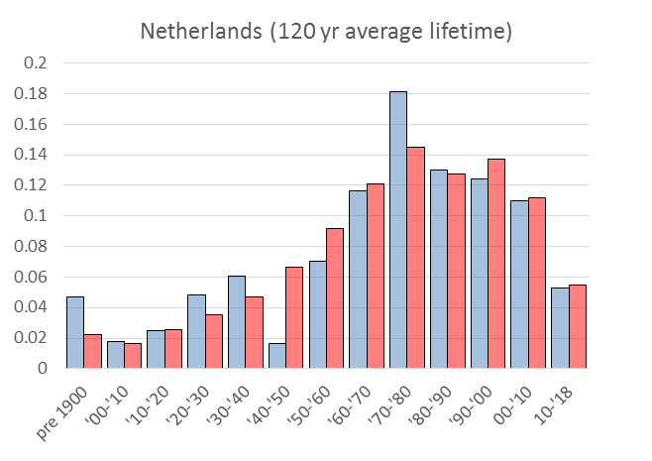

a

Statistics

Model

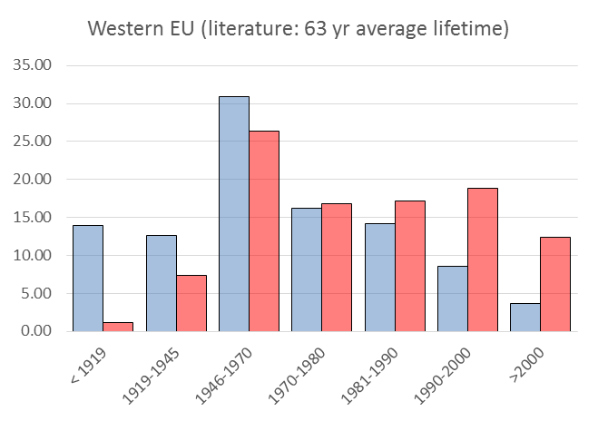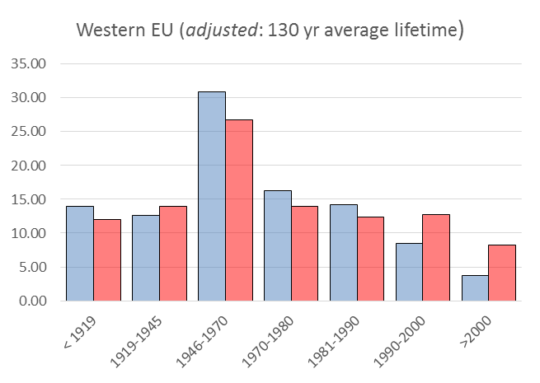

b

c

*Figure S.7. Model verification results. Showing the fraction of residential buildings by age-cohort on the y-axis, according to the available statistics (blue), and according to our model (red). Data for the Netherlands (a) represents the year 2018 based on* 29*, while data for Western Europe (b&c) represents the year 2010 based on* 30*.*

## Material Assumptions

All of the assumptions on material content of residential buildings (in kg per m2) is described by Marinova et al. 33. The material content estimates for service-related buildings applied in our calculations are summarized in Table 2 of the main text. Table S.2 below, shows how these averages were derived from the individual sources.

|  |  |  |  |  |  |  |  |  |  |
| --- | --- | --- | --- | --- | --- | --- | --- | --- | --- |
|  | **Source** | **Description** | **Region** | **Steel** | **Concrete** | **Aluminium** | **Copper** | **Wood** | **Glass** |
| **Offices** | Ecoinvent 34 | Multi-storey building | - | 24 | 393 | 8.5 | 8.5 | 24.7 | 3.1 |
| Kashkooli 35 | High-rise office building | Mexico | 124 | 425 |  | 2.7 | 3.0 | 1.0 |
| Kofoworola 36 | Typical office building | Thailand | 256 | 2118 | 0.3 |  | 1.5 | 9.6 |
| Oka 37 | Offices | Japan | 158 |  |  |  |  |  |
| Reyna 38 | Offices (low & high) | USA | 42 | 533 | 9.7 |  | 0.2 | 4.6 |
| Schebek 39 | Offices | - | 87 | 1057 | 0.6 | 0.7 | 4.2 | 13.9 |
| **Retail+** | Ecoinvent 34 | Hall-type building | - | 26 | 785 | 1.2 |  | 18.2 | 1.8 |
| Reyna 38 | Warehouse, department store & small store | USA | 83 | 658 | 2.1 |  |  | 1.9 |
| Schebek 39 | Warehouse | - | 85 | 349 | 1.1 | 0.7 | 4.2 | 13.9 |
| Gruhler* 40 | Wholesale &  Car-shop | Germany | 121 | 1009 | 5.2 | 3.9 | 11.0 |  |
| **Hotels+** | Reyna 38 | Hotel | USA | 89 | 93 | 5.2 |  |  | 2.7 |
| Rossello-Batle 41 | Hotel | Spain | 51 | 1007 | 3.0 | 3.3 | 12.0 | 5.1 |
| Gruhler* 40 | Hotel/  guesthouse | Germany | 113 | 1073 | 4.9 | 3.7 | 25.0 |  |
| **Other** | Kumanayake 42 | University | Sri Lanka | 132 | 1543 | 5.0 |  |  | 7.6 |
| Reyna 38 | School & Hospital | USA | 132 | 835 | 7.9 |  |  | 4.9 |
| Gruhler* 40 | Nursing-home & Emergency services | Germany | 104 | 1037 | 4.5 | 3.4 | 25.5 |  |
| Marcellus‐Zamora 43 | Civic/  Institutional | USA | 40 | 702 |  |  |  | 31.0 |
| **Average** |  | | | **97.9** | **850.9** | **4.2** | **3.3** | **11.8** | **7.8** |

*Table S.2. Material content of service-related building types in kg/m2. Corresponding to the use in the main text, ‘Retail+’ refers to the combination of retail, shops and warehouses, ‘Hotels+’ refers to hotels and restaurants and ‘Other’ refers to other buildings such as hospitals, educational buildings, governmental buildings, buildings for assembly and transport-related buildings. *The study by Gruhler reports metals as a single category, we used an assumption on the share of 93% steel, 4% aluminium and 3% copper to disaggregate the three metals.*

The Ecoinvent database gives the material use during the assumed lifetime of a building, and thus incorporates the replacement of some building elements with shorter lifetimes, such as the window-frames for example. As indicated in the main text, we adjusted the material use per m2 to reflect the materials contained in the building, so not accounting for the maintenance & refurbishment. We adjusted for this using the indicated lifetimes of the building components which are replaced during the lifetime of the entire building. To give an example; if the Ecoinvent database indicated 3 kgs of Aluminium window-frame, with an expected service life of 25 years, per square meter of a hall-type building with an expected 50 yr lifetime, we assumed a 1,5 kg/m2 Aluminium demand based on our ‘one-time-built’ approach.

Other conversion factors used to derive the material content for service sector buildings as displayed in Table S.2 are shown in Table S.3. Figure S.8 shows the distribution of the data on material intensities for buildings in the service sector as a whole (4 building types combined). The mean values displayed in this figure are used in the sensitivity analysis, where they are applied to all 4 building service-related types.

|  |  |  |
| --- | --- | --- |
| **Conversion factor** | **value** | **source** |
| kg per m2 glass | 10 | 44 |
| kg per m2 corrugated steel roof plate | 10 | Appendix 1 in 45 |
| kg per cement block | 12.25 | ‘standard’ according to 46 |
| kg per m2 steel cladding | 3.66 | 26 Gauge according to 47 |
| kg per ft2 of concrete brick | 18.07 | * 1. kg per brick acc. to 48 |

*Table S.3. Conversion factors used in calculating the material intensities of service sector buildings.*

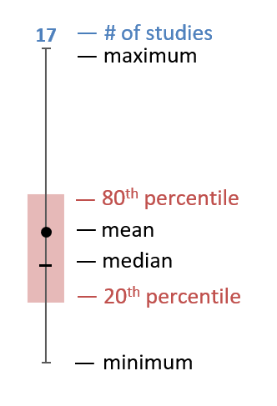

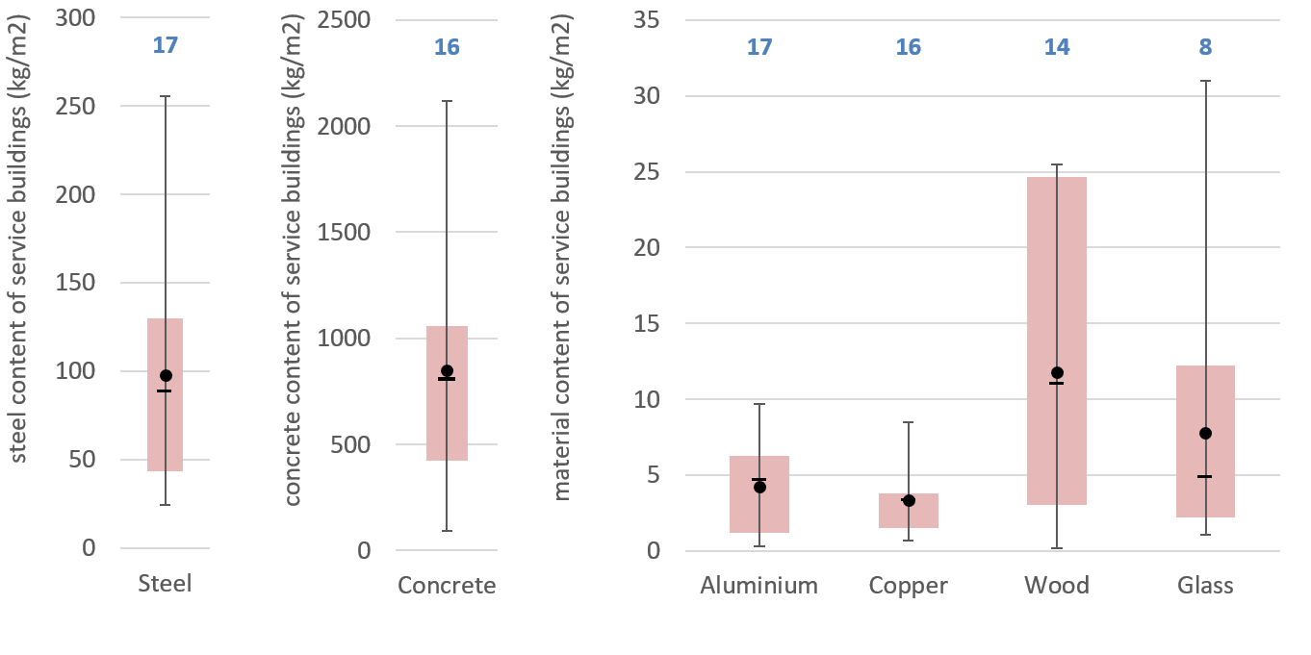  
*Figure S.8. Distribution of the data points on material intensity for buildings in the service sector. The boxes represent the 20th to 80 percentile interval range, while the whisker indicate the maximum and minimum values for each of the six materials. Numbers above the plots indicate the number of data points. Though our analysis applies average material intensities per service sector building type based on Table S.2 (not shown here), these graphs are meant to give an impression of the overall data variability. Furthermore, the mean values displayed here are used in the sensitivity analysis.*

## Detailed results

### 5.1 Per capita floorspace demand

Figure 2 in the main text shows the development of the global building stock in terms of floor space (in m2) as a consequence of the development of population as well as affluence. To show the effect of increased affluence only, Figure S.9 shows the development of the average per capita floor space (in-use stock) between 2000-2015 and 2035-2050, for both rural and urban residential purposes and for service-related purposes. The per capita floorspace demand in the service sector remains well below the residential floor space demand. It can also be seen that the per capita floor space for urban housing is slightly lower than the per capita floor space in rural areas, as elaborated by Daioglou et al.49. Though this seems to be a logical consequence of compact urban living, driven by scarcity of space in areas with a high population density, the available data on per capita floor space in our database for materials in residential buildings seems to suggest the opposite. For a more elaborate discussion about this interesting finding and possible future model improvements, please see Marinova et al.33.

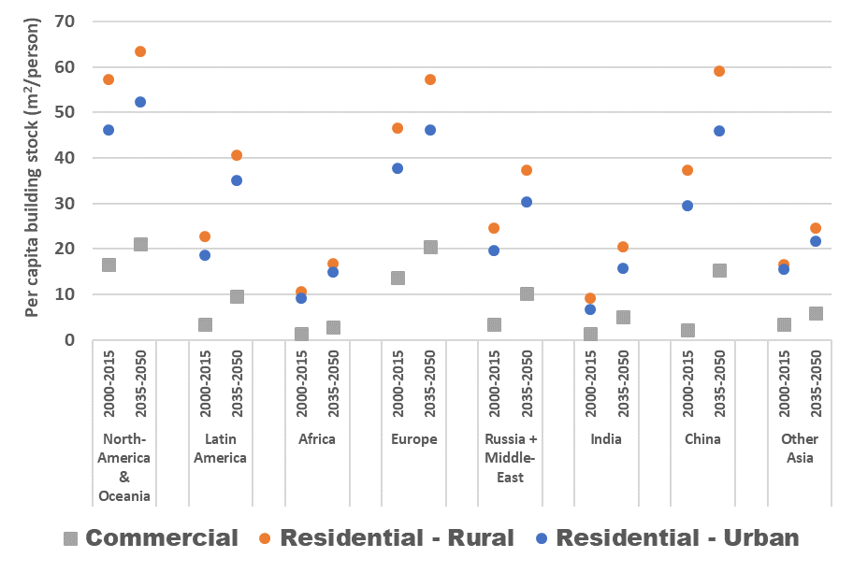  
*Figure S.9. Development of the average per capita floor space stock by region, for the period 2000-2015 and 2035-2050. Urban residential buildings are shown in blue, rural residential buildings in orange and service sector floor space in grey.*

Figure S.9 shows the growth of the residential and service-related per capita floor space demand. As discussed in the main text, the latter grows more rapidly. As a consequence of the regression analysis and the resulting demand curves as shown in Figure S.4a, some service sector building types grow more rapidly than others. Table S.4 provides the relative contribution of each building type to the total commercial building stock and the resulting growth factors between 2018 and 2050. It shows that demand for retail and offices is expected to grow faster than the demand for other service-related building types.

|  |  |  |  |
| --- | --- | --- | --- |
|  | Share | |  |
|  | 2018 | 2050 | Growth |
| Hotels+ | 8% | 9% | 2.71 |
| Offices | 13% | 16% | 2.96 |
| Other | 63% | 54% | 2.10 |
| Retail+ | 17% | 22% | 3.15 |

*Table S.4. The share of service sector building types in the total service-related building stock, and the resulting growth factors per building type. Using the same definition of building types as in Table S.2.*

### 5.2 Detailed model outcomes

The full set of model outcomes is available from the Supplementary Data, which provides data for the entire modelling period (1970-2050), for all 26 IMAGE regions, for 4 residential building types as well as 4 service sector building types, and for floorspace (in m2) as well as material demand (in kgs), it contains the model outcomes for the building stock, but also for the inflow and outflow as derived from the stock. As discussed in the main text, it is not advisable to use detailed regional outcomes without critical reflection. We present a first attempt to model the global building stock, with regional detail. All assumptions are listed transparently where possible, but we cannot guarantee that the results make sense at the highest level of detail. We decided to provide the detailed results so that priorities for model improvement can be identified. We encourage people to use and expand this model as they see fit. Therefore, the model and the associated data are made available on Github, under a creative commons license50.

To show the contribution of different building types on the demand of construction materials and the consequential outflow of scrap building materials, Figure S.10 below shows the material flows by the end of the modelling period (average of 2045-2050) for each building type, and for all six materials.

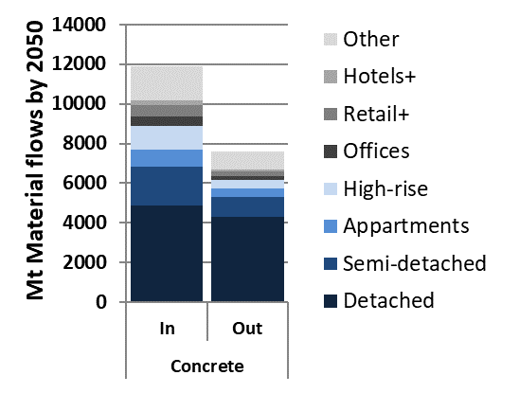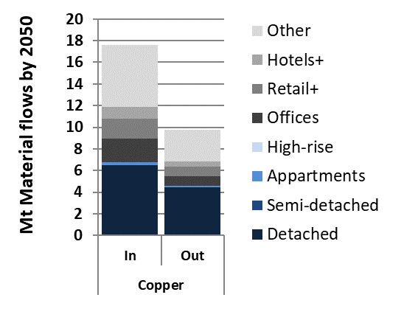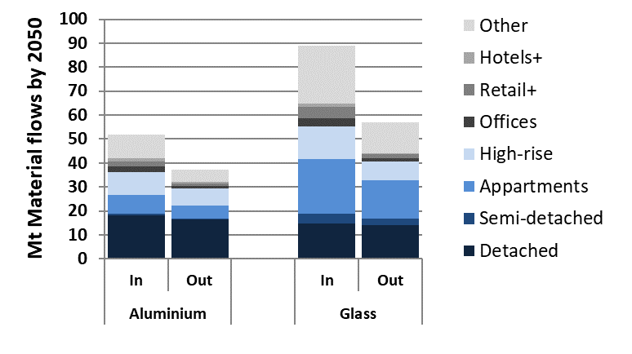

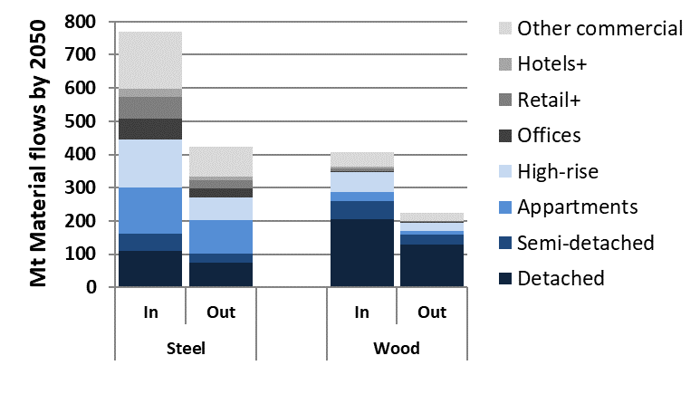

*Figure S.10. Ratio between the total inflow and outflow of building materials by the end of the modelling period (average of the period 2045-2050). The contribution of service sector building types (in grey) and residential building types (in blue) is shown. For the definition of residential building types, please see* 33*. The definition of service building types is similar to Table S.2.*

## Sensitivity Analysis

### 6.1. Description of Four Sensitivity Variants

1. Mean Material Intensity (Mean MI)

Based on the material intensity database as described by Marinova et al.33 we defined a sensitivity variant in which we ignore the regional detail on material intensities of residential buildings, but instead assume a global mean material intensity for each of the four residential building types and the six materials, based on all available studies. Here, we further explore the effects on inflow and outflow related indicators. Please note that when no literature was available on the residential material intensities of a particular region, a global average was already used in the default analysis (main text). This means that for the residential buildings, this alternative assumption can be used to identify the sensitivity of overall outcomes to the regional assumptions on material intensities.

Material intensities in service sector buildings, however, are not regionally specified to begin with. So, to come up with a sensitivity variant based on the material intensities described in this paper, we defined the mean material intensities for service sector buildings based on all available studies describing the service-related building types. The mean values used are shown in Figure S.8 and represent the assumption that all service-related building types would have a similar material demand.

1. Normal distribution for building lifetimes

Stock dynamics in both residential and service sector buildings are based on the assumed Weibull lifetime distributions. To see the effect of different lifetime profiles, we defined a sensitivity variant based on a normal distribution.

We assumed the same mean lifetimes as in the regular analysis, but defined the normal lifetime distribution using a standard-deviation that would make sure that the distribution would be above zero (as opposed to the Weibull distribution, the normal distribution continues below zero, leading to unrealistic assumptions). To this end we linearly increased the standard deviation from 10 at a mean lifetime of 35 years to 20 at a mean lifetime of 60 years, leading to an increasing spread of the lifetime distribution at higher expected lifetimes (based on literature, see Table S.1). The resulting lifetimes can be seen in Figure S.11. To avoid disregarding the mass balance by any remaining ‘tail’ of the distribution before the building’s actual lifetime, we actually deploy a folded normal distribution, which presents only a very slight deviation from the normal distribution during the first few years after construction. This method was applied for both residential and service sector buildings.

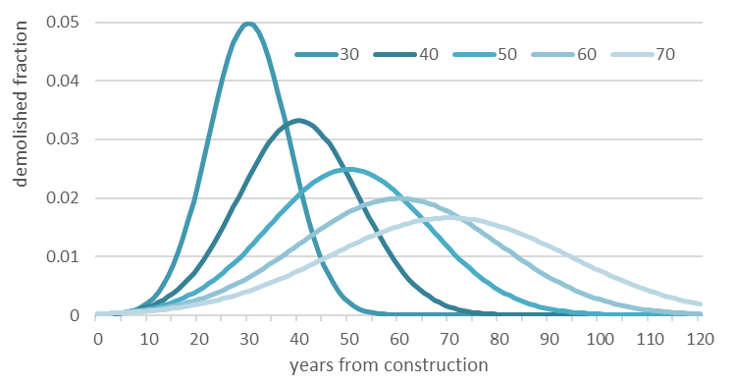*Figure S.11. Normal lifetime distributions used in the sensitivity variant. We assumed that an increasing mean lifetime leads to an increasing standard deviation as shown here.*

1. Increasing Alpha with 10%

The Gompertz parameters resulting from the regression analysis are key in determining the demand for service sector buildings. In particular the value of alpha, as it determines the maximum value for the per capita demand of service-related floor space. In the regular analysis the value of alpha was maximized to represent the highest value in the available data in the Global Building Stock Database by Navigant Research2. Our model thus assumes that demand for service sector buildings will grow towards what is currently known to be the highest value. However, wealthy regions like the United States seem to be approaching that maximum already51. To assess the effect of allowing a higher per capita service sector floorspace demand we defined a sensitivity variant that allows for a 10% higher value of alpha for the overall service sector. Mind that we only change the alpha for the total service sector, while keeping the original Gompertz parameters for the individual building types. As such, we assume that the sub-division of service-related building types remains the same.

If we only increase the value of alpha by 10%, the service-related building stock would simply increase by 10%, leading to a corresponding 10% increase in annual demand for each of the materials. This shows a high dependency of the outcomes on the value of alpha, but it does not make a very interesting sensitivity analysis. Therefore, we decided to change the assumptions in the regression by finding a new set of Gompertz parameters based on a regression in which alpha was maximized to the maximum in the data, plus 10%. This gives a slightly better population weighted R^2 of 0.685, based on the resulting parameters of alpha: 28.161, beta: 3.191 and gamma: 6.06*10^-5

1. Replacing the Gompertz model with an Exponential Decay function

Another key factor prescribing the development of service sector floorspace demand is the assumed Gompertz curve. To assess the effect of a different regression model, we implemented a sensitivity variant based on an Exponential Decay function:

Similar to the model described in the main text, y is the service floor space demand in square meter per capita, and x is the Service Value Added per capita in 2016-US$ for a particular country, in PPP. While α, β and γ are the regression parameters. The method performing the regression remained the same as described in the main text. Again, we only change the model describing the total service related floorspace demand, thus using a population weighted regression. The sub-division of the total floorspace across the 4 service-related building types was unaltered.

The regression leads to the following alpha: 25.601, beta: 28.431 and gamma: 4.15*10^-5. This leads to a somewhat lower R^2 of 0.514 at a fit () of 0.995, suggesting a somewhat inferior model than used in the regular calculations. Furthermore, the exponential decay function leads to negative values at lower levels of Service Value Added. To avoid this, we minimized the function below 0.542 m2/cap, which represents the 25th percentile of the original data.

To understand the effects of choosing an alternative model function, we plot the development of service sector floorspace demand based on the regular model as well as the two sensitivity variants in Figure S.12 below.

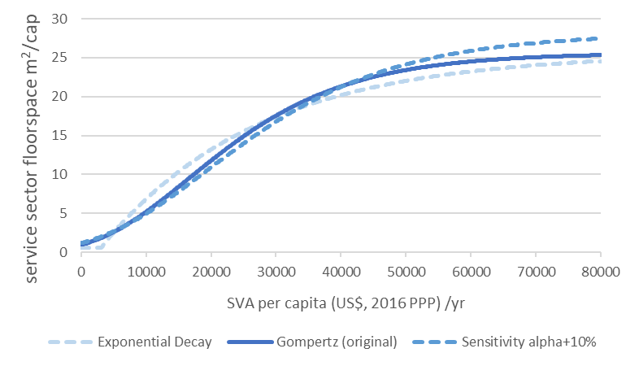  
*Figure S.12. Development of the service sector floorspace demand (expressed per capita).*

### 6.2 Outcomes of the Sensitivity Analysis

The outcomes of the sensitivity analysis are displayed in Table S.5 and Figure S.13. Table S.2 shows the changes in 3 different material demand indicators by 2045 (based on a 5-yr moving average) on 6 materials with regards to the regular analysis presented in the main manuscript. Two of the sensitivity variants only have an effect on the demand for materials in service-related buildings, while the other two sensitivity variants also affect the demand of materials in residential buildings.

Since the main text elaborates on the gap between inflow and outflow of construction materials by the end of the scenario period (2045-2050) in Figure 5, the sensitivity analysis also explores the effect of changing assumptions on the mismatch between inflow & outflow (thus, the potential for reaching a circular material flows). We do not display the ratio between inflow and outflow itself, but the extent by which this ratio changes. A positive number means that the mismatch between inflow and outflow becomes even larger, while a negative number means that the outflow of construction materials covers a larger fraction of the new demand for construction materials, compared to the analysis in the main text. Figure S.13 shows the development of the annual demand for the six materials under investigation for service sector buildings only.

|  |  |  |  |  |  |  |
| --- | --- | --- | --- | --- | --- | --- |
|  |  |  | **Mean MI** | **Normal distr. (lifetimes)** | **Alpha + 10%** | **Exponential Decay** |
|  |  |  | Mean of all service building types & Mean of all regions for residential buildings | For all buildings, including residential | Only affects  service sector floorspace  demand | Only affects service sector floorspace demand |
| **Sub selection** | **Indicator** | **year** |
| Service sector buildings | Steel demand | 2045-‘50 | 1% | -13% | -2% | 7% |
| Concrete demand | 2045-‘50 | -6% | 7% |
| Glass demand | 2045-‘50 | -23% | 9% |
| Wood dem. | 2045-‘50 | -35% | 9% |
| Aluminium demand | 2045-‘50 | -10% | 8% |
| Copper demand | 2045-‘50 | 2% | 7% |
| Residential | Steel demand | 2045-‘50 | -10% | 5% | 0% | 0% |
| Concrete demand | 2045-‘50 | -20% | -8% |
| Glass demand | 2045-‘50 | -2% | -9% |
| Wood dem. | 2045-‘50 | 2% | -5% |
| Aluminium demand | 2045-‘50 | -18% | -10% |
| Copper demand | 2045-‘50 | -0.3% | -8% |
| All (Services & Residential) | Steel I/O ratio | 2045-‘50 | 8% | 2% | 0.03% | 1% |
| Concrete I/O ratio | 2045-‘50 | 36% | 2% | -0.6% | 2% |
| Glass I/O ratio | 2045-‘50 | -1% | 1% | -1.0% | 3% |
| Wood I/O ratio | 2045-‘50 | -13% | 2% | -0.4% | 1% |
| Aluminium I/O ratio | 2045-‘50 | 23% | 1% | -0.7% | 2% |
| Copper I/O ratio | 2045-‘50 | 2% | -0.3% | -1.3% | 4% |

*Table S.5. Effects of the four sensitivity variants on selected material demand indicators. See text for a description of the sensitivity variants. ‘I/O ratio’ stands for the Inflow-to-Outflow ratio. Please note that the numbers indicate the change with respect to the same indicators under the regular analysis presented in the main document. Green numbers indicate an increase in demand or I/O ratio, while red numbers indicate a decrease.*

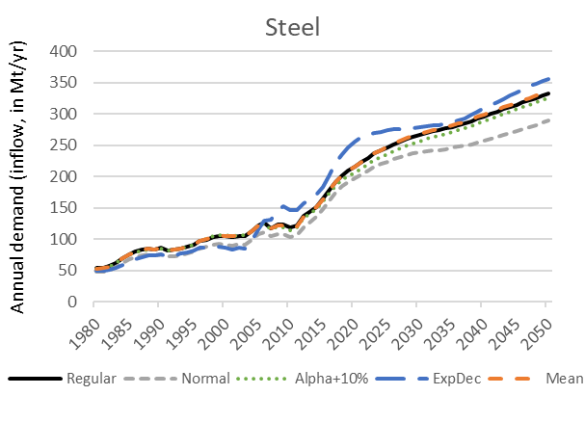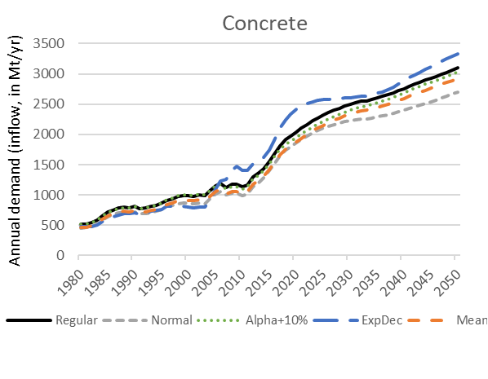

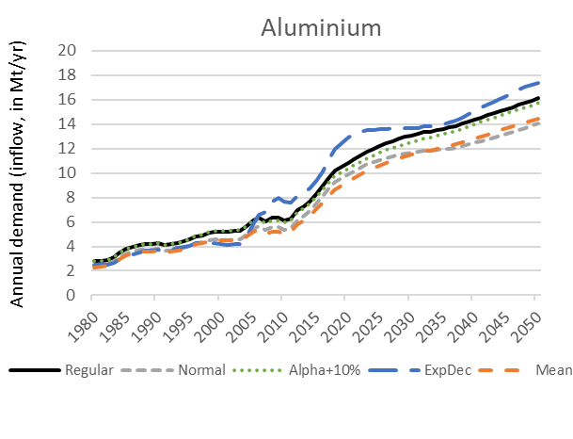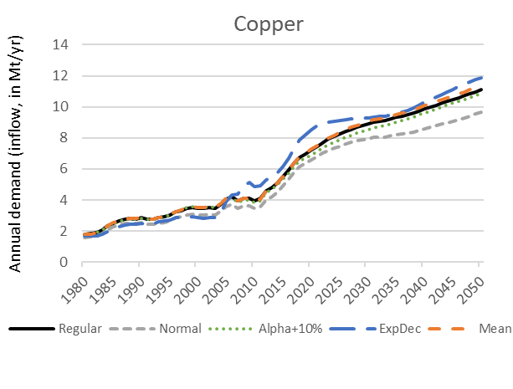

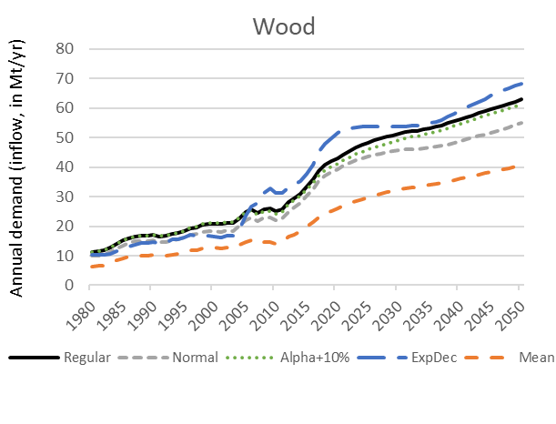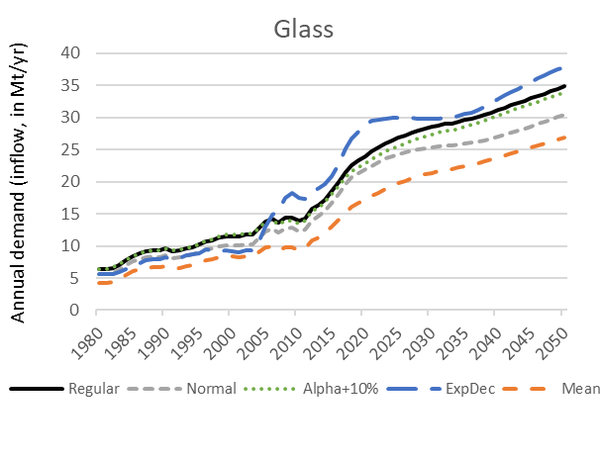

### 

*Figure S.13. Annual material demand in service sector buildings under the four sensitivity variants (5-yr moving average). ‘Regular’ indicates the regular (or default) assumptions as described in the main document. ‘Normal’ refers to the assumption of a normal lifetime distribution as opposed to a Weibull distribution. ‘Alpha+10%’ is the result of allowing a 10% higher maximum per capita floorspace demand in the regression describing the development of service sector building stock. ‘ExpDec’ refers to an alternative regression model for service-related floor space demand based on an Exponential Decay function as opposed to a Gompertz function. ‘Mean’ assumes global mean material intensities; the results for service-related buildings as shown here are the result of assuming a single global material intensity for all service sector buildings, based on the mean in the available data as shown in Figure S.8.*

### 6.3 Discussion on the Sensitivity Analysis

Looking at the outcomes of the sensitivity data in Table S.5 it seems that the largest deviations from the regular outcomes arise when assuming global mean material intensities (in kg/m2). This sensitivity variant can lead to both slightly higher or lower annual material demand by the end of the scenario period, depending on the material and the focus on either residential or service sector buildings.

For service sector buildings, the demand for glass and wood is most affected, given that the most important building type (being the ‘other’ service-related buildings, a.o. based on governmental and institutional buildings) has a relatively high material intensity for glass and wood according to the literature used (Table 2 in the main text, or Table S.2). Assuming a mean material intensity for all service-sector buildings leads to a lower value, and thus to a lower demand for wood and glass. On the one hand this may indicate that more data has to be acquired on the use of these materials, especially in service-related building types that are not offices, retail or catering related. However, building materials like wood and glass and aluminium are often non-structural and therefore their material intensities may simply have a wider range, leading to larger deviations based on alternative assumptions.

The effect of assuming a global mean material intensity for residential buildings is most noticeable for concrete and aluminium. This can be mostly explained the relatively high material intensities found for detached houses in China. Both aluminium and concrete intensities for detached houses in China are over 2 times the global mean, thus leading to a considerable drop in material demand in the sensitivity variant. As can be seen in Table S.5 this translates to a decrease in the global demand of around 18-20% for both materials. As mentioned before, this sensitivity analysis highlights the importance of proper material intensity data, especially for dominant regions like China.

Interestingly, Table S.5 also shows that a drop in the annual demand for concrete and aluminium in residential buildings under the assumption of a mean material intensity causes an increase of the Inflow-to-Outflow (I/O) ratio at the global level. So, even though material demand from construction of residential buildings is lower, the gap between inflow & outflow increases. This has to do with a combination of stock dynamics and regional material intensities. While the demand for concrete is lower in China under the mean material intensity assumptions, so is the Chinese outflow, which due to a relatively short lifetime is considerable towards 2050 as can be seen in Figure 4c of the main text. At the global level, the inflow (annual demand) of concrete towards 2050 is mostly determined by fast developing regions (see Figure 4b). Because the material intensities of most fast developing regions remain mostly the same as in the regular analysis, the inflow remains high in the sensitivity variant, while the outflow (mainly from China) is lower. Thus leading to an increase in the Inflow-to-Outflow Ratio.

Replacing the Weibull lifetime distribution with a normal distribution has a slightly smaller effect on the annual demand. For service sector buildings it consistently decreases the annual material demand by 13%. As a consequence of a skewed probability density function (PDF) of the Weibull distribution, which leads to faster building replacement and higher inflow, compared to the normal distribution (which therefore has the effect of lowering material demand). This effect is temporary, as we use the same mean lifetimes. The Weibull distribution has a higher spread and consequentially offsets this higher inflow rates due to early decommissioning by lower inflow rates due to a larger surviving fraction at higher building lifetimes, as can be seen in Figure S.14. A higher spread represents the real-life possibility that a building lasts longer than its envisioned service-life. However, in our model, the continuously expanding commercial stock leads to a larger emphasis on the short term effects than on the long term effects of considering a different lifetime distribution. Assuming a normal lifetime distribution thus causes less service sector buildings to be replaced in the short term.

The effect of implementing a normal lifetime distribution is similar for residential buildings, but there the regional stock dynamics also play a role. Global residential stock increases rapidly during the period 2000-2020, mostly as a consequence of Chinese stock expansion. Since Chinese buildings are assumed to have a relatively short lifetime, a large fraction of the residential cohorts built in this period is already demolished by the end of the scenario period (2045-2050), while most of these buildings are demolished a bit later under the assumption of a normal lifetime distribution, thus leading to an (additional) decrease in demand for most materials in residential buildings compared to the default model. Interestingly, the lower annual demand for materials in residential and service sector buildings does not translate to a smaller gap between inflow and outflow (I/O ratio), which actually increases slightly due to the same stock dynamics.

*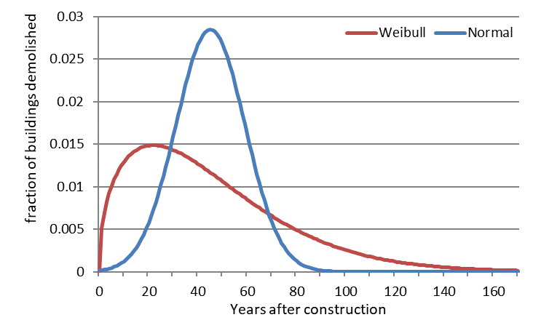Figure S.14. Comparison of building lifetimes in the service sector under two lifetime distributions. The default analysis uses the Weibull distribution, while the sensitivity variant uses the normal distribution.*

The effects of increasing the maximum per capita floorspace demand for service sector buildings may seem counter-intuitive at first sight. One would intuitively expect that a higher maximum floorspace demand would lead to a higher material demand for service sector buildings. However, because of the implementation of this sensitivity variant the entire regression was changed. This means that not only the maximum per capita floorspace demand was increased, but also the beta and gamma parameters of the Gompertz function were changed. Together they lead to a higher demand for service-related floorspace at higher levels of per capita Service Value Added, but to slightly lower demand for service-related floorspace at lower income levels (<40.000 US$ SVA/capita yr-1). Because most regions in the IMAGE model remain below that level, the overall effect is a slight decrease of annual demand for materials in service sector buildings by about 2%.

Finally, the effect of implementing a different regression model for the service sector floorspace demand can also be seen in the right-most column of Table S.5. Replacing the default Gompertz curve for an Exponential Decay function results in a slight (7-9%) increase in material demand for service sector buildings. This is a consequence of the fact that the Exponential Decay function behaves opposite to the sensitivity variant on increasing alpha. As can be seen from Figure S.12. This means that the function yields slightly higher per capita demand of floorspace for service sector buildings in the mid-range income regions (with an SVA between 5.000 to 30.000 US$/capita yr-1). As most regions are moving up within this range during the scenario period, the Exponential Decay function leads to slightly increased floorspace demand and a subsequent increase in the use of building materials for buildings in the service sector.

## Model Code

### 7.1 Code for the regression analysis for service sector floorspace

# The main stucture of this regression tool is based on https://stackoverflow.com/questions/44878372/how-can-i-apply-weights-in-this-scipy-least-squares-optimization-routine

import numpy as np

from scipy import optimize

import math

import os

# set an initial guess for the gompertz parameters alpha, beta and gamma

guess = [25, 3, 0.07]

name = 'services' # alternatively: hotels, offices, retail for regression on specific building types

alpha_fact = 1.1 # set to 1.1 for sensitivity variant (10% above max of y)

# FIT TO EQUATION OF GOMPERTZ CURVE

def fit_func(ps, xs):

result = []

for item in xs:

result.append(ps[0] * math.exp(-ps[1] * math.exp((-ps[2]/1000) * item)) )

return result

#error_function (used in unweighted optimisation)

def err_func(ps, xs, ys):

## GET FIT

ys_trial = fit_func(ps, xs)

## GET RESIDUALS

residuals = [(ys[idx] - ys_trial[idx])**2 for idx in range(len(ys))]

return sum(residuals)

# R-squared (used in unweighted optimisation)

def R2_coef_of_determination(xs,ys,ps):

ss_res = np.dot((ys - fit_func(ps,xs)),(ys - fit_func(ps,xs))) # sum of the squares of the residuals

ymean = np.mean(ys) # mean

ss_tot = np.dot((ys-ymean),(ys-ymean)) # total sum of the squares

r2 = 1-ss_res/ss_tot

return r2

# Chi-squared (used in weighted optimization)

def get_chi_squared(ps, xs, ys, wts):

ys_trial = fit_func(ps, xs)

resid = [(ys[idx] - ys_trial[idx]) **2 * (1 / wts[idx])**2 for idx in range(len(ys))]

ss_res = sum(resid) # sum of the weighted squares of the residuals

return ss_res

#Import data (x = SVA, y = m2/cap, pop=used in weighting & determination of the fit, phi, gdp=used in weigthing of regression of building types)

os.chdir("C:\\Users\\...")

csv = np.genfromtxt('files_commercial\\data_' + name + '_PPP.csv', delimiter=",")

csv_excl = np.genfromtxt('files_commercial\\outliers_' + name + '_PPP.csv', delimiter=",")

xdata = csv.transpose()[0]

ydata = csv.transpose()[1]

xexcl = csv_excl.transpose()[0]

yexcl = csv_excl.transpose()[1]

pop = csv.transpose()[2] # population in thousands

gdp = csv.transpose()[3] # GDP per capita in 2016 dollars (PPP)

# choice for sigma based on population (services all) or based on GDP/cap (all 4 sub-categories)

sigma_choice = pop if name == 'services' else gdp

# all ones for non-weighted Chi-squared calculation

non_weighted = np.ones(len(xdata))

# calculate mean y value (plain or population weighted)

y_mean_weighted = sum(sigma_choice * ydata) / sum(sigma_choice)

# Construct sigma manually based on population

sig_max = 0.3

sig_min = 0.015

sig_max_value = 200000 if name == 'services' else 40000

sig_perc = [max(sig_min, sig_max-((sig_max-sig_min)/sig_max_value)*sigma_choice[idx]) for idx in range(len(sigma_choice))]

sig_manual = y_mean_weighted * np.array(sig_perc)

# FIND FITS Using SLSQP routine (alternative routines: L-BFGS-B, Powell)

# Unweighted optimisation

ans1 = optimize.minimize(err_func, x0=guess, args=(xdata, ydata), method='SLSQP', bounds=[(0, max(ydata)),(0.00, 20.00),(0.01,1.00)], options={'maxiter': 10000, 'ftol': 1e-05, 'disp': False, 'eps': 1e-08})

[alpha, beta, gamma] = ans1.x[0], ans1.x[1], ans1.x[2]

# Weighted optimisation (either population, or gdp)

ans2 = optimize.minimize(get_chi_squared, x0=guess, args=(xdata, ydata, sig_manual), method='SLSQP', bounds=[(0.00, max(ydata)),(0.00,20.00),(0.01,1.00)], options={'maxiter': 10000, 'ftol': 1e-05, 'disp': False, 'eps': 1e-08})

[alpha_sig, beta_sig, gamma_sig] = ans2.x[0], ans2.x[1], ans2.x[2]

#Find R-squared or Goodness of fit parameters

rsquared = R2_coef_of_determination(xdata, ydata,[alpha, beta, gamma])

rsquared_sig = R2_coef_of_determination(xdata, ydata,[alpha_sig, beta_sig, gamma_sig])

#Goodness-of-fit parameter (Chi-squared)

chi_squared = get_chi_squared(xdata, ydata,[alpha_sig, beta_sig, gamma_sig], non_weighted) # non-Weighted Chi-squared

chi_squared_sig = get_chi_squared(xdata, ydata,[alpha_sig, beta_sig, gamma_sig], sig_manual) # Weighted Chi-squared

# find the total global square meters according to the data in 2017

data_sqr_meters = ydata * pop

sqr_meters_total_data = sum(data_sqr_meters)

# Find the resulting total global square meters according to the fitted function

# Wherever the function yields negative numbers (e.g. in case of a logarithmic model), we assume 0

def current_fit(xs, pop, par): # par = [alpha, beta]

optim_sqr_meters = []

for point in range(0,len(xs)):

if (fit_func(par, [xs[point]])[0] > 0):

optim_sqr_meters.append(fit_func(par, [xs[point]])[0] * pop[point])

else:

optim_sqr_meters.append(0)

return sum(optim_sqr_meters)

optim_sqr_meters_non = current_fit(xdata, pop, [alpha, beta, gamma])

optim_sqr_meters_sig = current_fit(xdata, pop, [alpha_sig, beta_sig, gamma_sig])

current_fit_non = optim_sqr_meters_non/sqr_meters_total_data # fit (phi) of the non-weighted parameterisation

current_fit_sig = optim_sqr_meters_sig/sqr_meters_total_data # fit (phi) of the weighted parameterisation

### 7.2. Code of the main model

The code of the main model is available from Github at

<https://github.com/SPDeetman/BUMA>

## References (as used in the SI)

1. Stehfest, E., van Vuuren, D., Bouwman, L. & Kram, T. *Integrated assessment of global environmental change with IMAGE 3.0: Model description and policy applications*. (Netherlands Environmental Assessment Agency (PBL), 2014).

2. Machinchick, T. & Freas, B. *Global Building Stock Database, Commercial and Residential Building Floor Space by Country and Building Type: 2017-2026*. (2018).

3. UNData. Per capita GDP at current prices. *National Accounts Estimates of Main Aggregates, United Nations Statistics Division* (2018). Available at: http://data.un.org/Data.aspx?q=GDP&d=SNAAMA&f=grID%3A101%3BcurrID%3AUSD%3BpcFlag%3A1#SNAAMA.

4. UNData. GVA by kind of economic activity. *National Accounts; United Nations Statistics Division* (2018). Available at: http://data.un.org/. (Accessed: 19th November 2018)

5. Kraft. A software package for sequential quadratic programming. (1988).

6. Perez, R. E., Jansen, P. W. & Martins, J. R. R. A. pyOpt: a Python-based object-oriented framework for nonlinear constrained optimization. *Struct. Multidiscip. Optim.* **45**, 101–118 (2012).

7. US Bureau of Labor Statistics. CPI Inflation Calculator. (2019). Available at: https://www.bls.gov/data/inflation_calculator.htm. (Accessed: 23rd January 2019)

8. Bevington, P. R. & Robinson, D. K. *Data Reduction and Error Analysis for the Physical Sciences*. *McGraw-Hill* (2003). doi:10.1063/1.4823194

9. Jensen, P. Network-based predictions of retail store commercial categories and optimal locations. *Phys. Rev. E* **74**, 035101 (2006).

10. Riahi, K. *et al.* The Shared Socioeconomic Pathways and their energy, land use, and greenhouse gas emissions implications: An overview. *Glob. Environ. Chang.* **42**, 153–168 (2017).

11. Pauliuk, S. & Heeren, N. Open Dynamic Material Systems Model. (2018).

12. Daigo, I., Iwata, K., Oguchi, M. & Goto, Y. Lifetime Distribution of Buildings Decided by Economic Situation at Demolition: D-based Lifetime Distribution. *Procedia CIRP* **61**, 146–151 (2017).

13. Nomura, K. & Suga, Y. *Asset Service Lives and Depreciation Rates bas ed on Disposal Data in Japan*. (2013).

14. Wang, T., Tian, X., Hashimoto, S. & Tanikawa, H. Concrete transformation of buildings in China and implications for the steel cycle. *Resour. Conserv. Recycl.* **103**, 205–215 (2015).

15. Novikova, A., Csoknyai, T. & Szalay, Z. Low carbon scenarios for higher thermal comfort in the residential building sector of South Eastern Europe. *Energy Effic.* **11**, 845–875 (2018).

16. Novikova, A. *et al.* *The typology of the residential building stock in Albania and the modelling of its low-carbon transformation*. (2015).

17. Olson, B. D. *Residential Building Material Reuse in Sustainable Construction*. (Washington State University, 2011).

18. Kapur, A., Keoleian, G., Kendall, A. & Kesler, S. E. Dynamic Modeling of In-Use Cement Stocks in the United States. *J. Ind. Ecol.* **12**, 539–556 (2008).

19. Hatayama, H., Daigo, I., Matsuno, Y. & Adachi, Y. Assessment of the Recycling Potential of Aluminum in Japan, the United States, Europe and China. *Mater. Trans.* **50**, 650–656 (2009).

20. Heeren, N. *et al.* Environmental Impact of Buildings—What Matters? *Environ. Sci. Technol.* **49**, 9832–9841 (2015).

21. Davis, J. *et al.* Time-dependent material flow analysis of iron and steel in the UK: Part 2. Scrap generation and recycling. *Resour. Conserv. Recycl.* **51**, 118–140 (2007).

22. Buyle, M., Braet, J. & Audenaert, A. Life cycle assessment in the construction sector: A review. *Renew. Sustain. Energy Rev.* **26**, 379–388 (2013).

23. Murakami, S., Oguchi, M., Tasaki, T., Daigo, I. & Hashimoto, S. Lifespan of Commodities, Part I. *J. Ind. Ecol.* **14**, 598–612 (2010).

24. OECD & Eurostat. *Eurostat-OECD Survey of National Practices in Estimating Net Stocks of Structures*. *OECD* (2015).

25. Condeixa, K., Haddad, A. & Boer, D. Material flow analysis of the residential building stock at the city of Rio de Janeiro. *J. Clean. Prod.* **149**, 1249–1267 (2017).

26. Olaya, Y., Vásquez, F. & Müller, D. B. Dwelling stock dynamics for addressing housing deficit. *Resour. Conserv. Recycl.* **123**, 187–199 (2017).

27. Stephan, A. & Athanassiadis, A. Quantifying and mapping embodied environmental requirements of urban building stocks. *Build. Environ.* **114**, 187–202 (2017).

28. Bolt, J., Inklaar, R., Jong, H. de & van Zanden, J. L. Maddison Project Database, version 2018. (2018). Available at: www.ggdc.net/maddison. (Accessed: 26th November 2018)

29. Kadaster. Basisadministratie Adressen en Gebouwen. (2018). Available at: https://zakelijk.kadaster.nl/basisregistratie-adressen-en-gebouwen. (Accessed: 23rd January 2019)

30. Dol, K. & Haffner, M. *Housing Statistics in the European Union 2010*. *Delft University of Technology* (2010). doi:10.1002/hep.21180

31. Sandberg, N. H., Sartori, I. & Brattebø, H. Sensitivity analysis in long-term dynamic building stock modeling—Exploring the importance of uncertainty of input parameters in Norwegian segmented dwelling stock model. *Energy Build.* **85**, 136–144 (2014).

32. Lodi, C., Magli, S., Contini, F. M., Muscio, A. & Tartarini, P. Improvement of thermal comfort and energy efficiency in historical and monumental buildings by means of localized heating based on non-invasive electric radiant panels. *Appl. Therm. Eng.* **126**, 276–289 (2017).

33. Marinova, S., Deetman, S. & Van der Voet, E. Construction materials database and stock analysis of the global residential built environment: 1970-2050. *J. Clean. Prod.* **in review**, (2019).

34. Kellenberger, D. *et al.* Life Cycle Inventories of Building Products. *ecoinvent report No. 7* (2007). doi:10.1109/SECON.2017.7925283

35. Kashkooli, A. M. S., Vargas, G. A. & Altan, H. A semi-quantitative framework of building lifecycle analysis: Demonstrated through a case study of a typical office building block in Mexico in warm and humid climate. *Sustain. Cities Soc.* **12**, 16–24 (2014).

36. Kofoworola, O. F. & Gheewala, S. H. Life cycle energy assessment of a typical office building in Thailand. *Energy Build.* **41**, 1076–1083 (2009).

37. Oka, T., Suzuki, M. & Konnya, T. The estimation of energy consumption and amount of pollutants due to the construction of buildings. *Energy Build.* **19**, 303–311 (1993).

38. Reyna, J. L. & Chester, M. V. The Growth of Urban Building Stock: Unintended Lock-in and Embedded Environmental Effects. *J. Ind. Ecol.* **19**, 524–537 (2015).

39. Schebek, L. *et al.* Material stocks of the non-residential building sector: the case of the Rhine-Main area. *Resour. Conserv. Recycl.* **123**, 24–36 (2017).

40. Gruhler, K. & Deilmannl, C. Materialaufwand von Nichtwohngebäuden – Teil II. in (Fraunhofer IRB Verlag, 2017).

41. Rosselló-Batle, B., Moià, A., Cladera, A. & Martínez, V. Energy use, CO2 emissions and waste throughout the life cycle of a sample of hotels in the Balearic Islands. *Energy Build.* **42**, 547–558 (2010).

42. Kumanayake, R., Luo, H. & Paulusz, N. Assessment of material related embodied carbon of an office building in Sri Lanka. *Energy Build.* **166**, 250–257 (2018).

43. Marcellus-Zamora, K. A., Gallagher, P. M., Spatari, S. & Tanikawa, H. Estimating Materials Stocked by Land-Use Type in Historic Urban Buildings Using Spatio-Temporal Analytical Tools. *J. Ind. Ecol.* **20**, 1025–1037 (2016).

44. Leadbitterglass. How To Calculate The Weight Of Glass. (2019). Available at: http://www.leadbitterglass.co.uk/glassroom/calculate-weight-of-glass/. (Accessed: 23rd January 2019)

45. Porteus, J. & Kermani, A. *Structural Timber Design to Eurocode 5*. (John Wiley & Sons, Ltd, 2007). doi:10.1002/9780470697818

46. Brown’s. Standard and Lightweight Concrete Block / Architectural Block Cube Sizes and Weights. (2019). Available at: https://www.brownsconcrete.com/images/Resources/Building/Product_Info/Block_Weight_Cube_Size.pdf. (Accessed: 23rd January 2019)

47. Ted Pella inc. Standard Gauge for Sheet and Plate Iron and Steel. (2019). Available at: https://www.tedpella.com/company_html/gauge.htm. (Accessed: 23rd January 2019)

48. National Masonry. Masonry Blocks & Bricks. (2019). Available at: https://www.nationalmasonry.com.au/wp-content/uploads/National_Masonry_Design_Guide_Book_2_SQLD.pdf. (Accessed: 23rd January 2019)

49. Daioglou, V., van Ruijven, B. J. & van Vuuren, D. P. Model projections for household energy use in developing countries. *Energy* **37**, 601–615 (2012).

50. Deetman, S. repository for the building materials model. (2019). Available at: https://github.com/SPDeetman/BUMA.

51. IEA. Commercial Buildings Energy Consumption Survey (CBECS). (2012). Available at: https://www.eia.gov/consumption/commercial/.