Appendix A. Supplementary information

Global construction materials database and stock analysis of the residential buildings between 1970-2050

Sylvia Marinovaa, Sebastiaan Deetmana, Ester van der Voeta, Vassilis Daiogloub,c

a*CML – Institute of Environmental Sciences, Leiden University, Einsteinweg 2, 2333 CC Leiden, The Netherlands*

b*PBL Netherlands Environmental Assessment Agency, PO Box 30314, 2500 GH, The Hague, the Netherlands*

c*Copernicus Institute of Sustainable Development, Utrecht University, Princetonlaan 8a, 3584 CB, Utrecht, the Netherlands*

*\* corresponding author: deetman@cml.leidenuniv.nl*

1. IMAGE Region definitions

The regional classification used in the main text and the underlying model distinguish 26 global regions, which can be seen in in Figure S.1, below.

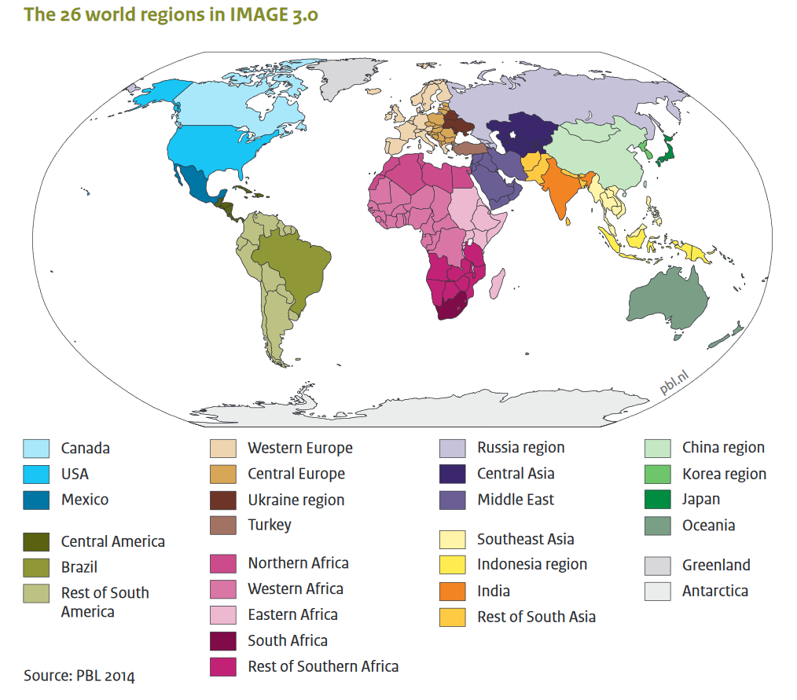

2

2

2

1

11

1

2

2

2

2

2

2

2

2

1

1

1

1

1

1

1

1

1

1

3

3

**Figure A.1.** The 26 world regions in IMAGE 3.0.Source: Stehfest et al.[1], reproduced with permission of the editor. Regions tagged with a 1 are part of the group classified as fast-developing regions in the main text. Regions with a 2 represent the steady developed regions and group 3 indicates China & Japan.

We have also indicated which regions are grouped under Fast developing regions with a 1, and Steady developed regions with a 2, according to the identified regional typologies used in the main text. Buildings in Greenland & Antarctica are not taken into account.

1. Usable floor area

In Table A.1 we present detailed information on the average per capita floor space disaggregated in four dwelling types: detached house, row house, apartment buildings, high-rise buildings. The data is based on all available studies reviewed and presented in Section 1.1 of the main text.

Due to lack of data we cannot provide accurate estimations of the average per capita square meters for certain regions and building types. In these cases, we apply global average values. The asterisk identifies the data directly available from the literature. The rest of the table is filled with the global average on all other available studies.

**Table A.1.** Average per capita floor space (m2/cap) (L). The asterisk (*) identifies the regional data directly available from the literature. The rest of the table is filled with the global average on all other available studies.

|  |  |  |  |  |  |
| --- | --- | --- | --- | --- | --- |
| Region | Area | Detached houses | Row  houses | Apartment  buildings | High-rise  buildings |
| 1 | Urban | 42.88* | 40.65 | 28.61 | 39.00* |
| 1 | Rural | 33.00 | 32.61 | 22.00 | 31.40 |
| 2 | Urban | 50.98* | 40.65 | 25.81* | 20.90* |
| 2 | Rural | 33.00 | 32.61 | 22.00 | 31.40 |
| 3 | Urban | 34.36 | 40.65 | 28.61 | 31.40 |
| 3 | Rural | 33.00 | 32.61 | 22.00 | 31.40 |
| 4 | Urban | 34.36 | 40.65 | 28.61 | 31.40 |
| 4 | Rural | 33.00 | 32.61 | 22.00 | 31.40 |
| 5 | Urban | 41.55* | 40.65 | 28.61 | 13.93* |
| 5 | Rural | 33.00 | 32.61 | 22.00 | 31.40 |
| 6 | Urban | 22.70* | 35.00* | 29.00* | 31.40 |
| 6 | Rural | 33.00 | 32.61 | 22.00 | 31.40 |
| 7 | Urban | 34.36 | 40.65 | 28.61 | 31.40 |
| 7 | Rural | 33.00 | 32.61 | 22.00 | 31.40 |
| 8 | Urban | 17.12* | 40.65 | 27.00* | 31.40 |
| 8 | Rural | 33.00 | 32.61 | 22.00 | 31.40 |
| 9 | Urban | 34.36 | 40.65 | 28.61 | 31.40 |
| 9 | Rural | 33.00 | 32.61 | 22.00 | 31.40 |
| 10 | Urban | 13.67 | 40.65 | 13.67* | 31.40 |
| 10 | Rural | 33.00 | 32.61 | 22.00 | 31.40 |
| 11 | Urban | 31.71* | 28.13* | 35.69* | 34.50* |
| 11 | Rural | 56.52* | 32.61* | 22.00 | 31.40 |
| 12 | Urban | 23.90* | 40.65 | 37.00* | 35.27* |
| 12 | Rural | 33.00 | 32.61 | 22.00 | 31.40 |
| 13 | Urban | 34.36 | 40.65 | 28.61 | 65.00* |
| 13 | Rural | 33.00 | 32.61 | 22.00* | 31.40 |
| 14 | Urban | 34.36 | 40.65 | 28.61 | 31.40 |
| 14 | Rural | 33.00 | 32.61 | 22.00 | 31.40 |
| 15 | Urban | 34.36 | 40.65 | 28.61 | 31.40 |
| 15 | Rural | 33.00 | 32.61 | 22.00 | 31.40 |
| 16 | Urban | 34.36 | 40.65 | 28.61 | 31.40 |
| 16 | Rural | 33.00 | 32.61 | 22.00 | 31.40 |
| 17 | Urban | 57.52* | 40.65 | 28.25* | 31.40 |
| 17 | Rural | 33.00 | 32.61 | 22.00 | 31.40 |
| 18 | Urban | 13.27* | 40.65 | 10.00* | 28.04* |
| 18 | Rural | 32.63* | 32.61 | 22.00 | 31.40 |
| 19 | Urban | 34.36 | 40.65 | 16.32* | 28.65* |
| 19 | Rural | 33.00 | 32.61 | 22.00 | 31.40 |
| 20 | Urban | 17.50* | 40.65 | 41.37 | 25.47* |
| 20 | Rural | 35.20* | 32.61 | 22.00 | 31.40 |
| 21 | Urban | 34.36 | 44.28* | 27.77* | 31.40 |
| 21 | Rural | 33.00 | 32.61 | 22.00 | 31.40 |
| 22 | Urban | 29.00 | 40.65 | 28.61 | 21.25* |
| 22 | Rural | 33.00 | 32.61 | 22.00 | 31.40 |
| 23 | Urban | 31.34* | 40.65 | 28.61 | 30.08* |
| 23 | Rural | 33.00 | 32.61 | 22.00 | 31.40 |
| 24 | Urban | 38.25* | 49.55* | 36.85* | 17.18* |
| 24 | Rural | 33.00 | 32.61 | 22.00 | 31.40 |
| 25 | Urban | 34.36 | 40.65 | 28.61 | 31.40 |
| 25 | Rural | 7.67* | 32.61 | 22.00 | 31.40 |
| 26 | Urban | 34.36 | 40.65 | 28.61 | 31.40 |
| 26 | Rural | 33.00 | 32.61 | 22.00 | 31.40 |

It is important to note that we use the global averages displayed in Table A.1. solely to allocate the IMAGE data to the four building types. This approach is not ideal since our data is based mostly on developed regions and therefore it could be considered biased when applied to less developed countries. However, given the experimental nature of our model we believe that for the time being the numbers which we obtained are suitable to distribute the IMAGE data across the different building types. It is important to mention that future development of the data is necessary in order to provide as accurate as possible predictions for the development of the building stock.

Interestingly, the static data on per capita floorspace in the four building types suggests that urban housing, on average, provides a larger per capita floorspace than rural housing. This is in contrast to the IMAGE data, which assumes rural houses to be larger (even at a per capita basis, see Table A.1). This difference is influenced by two data points from one individual study conducted by Bhochhibhoya et al. (2017)[2] included in the database. The paper focuses on the ﻿greenhouse gas emissions associated with three buildings located at rural area in Nepal. The data points display significantly lower value for per capita square meter (7.67 m2/cap) in comparison to per capita floorspace values for rural buildings located in Turkey (22 m2/cap) [3], India (32.63 m2/cap) [4] and China (63.51 m2/cap) [5]. Despite the fact that two data points are shifting the results, we decided to not exclude the study from the per capita floorspace calculations since Nepal is one of the few representatives for rural areas in Least Developed Countries (LDCs) [6]. In addition, we chose to not adjust our model for this discrepancy. However, we believe this issue should be explored and adjusted in future research, as elaborated in the discussion.

1. Material content

Table A.2 presents data on the material contents in each region across the four dwelling types. The building types are depicted by a code: 1 for detached houses, 2 for row houses, 3 for apartment buildings and 4 for high-rise buildings. The construction materials presented in this study we considered as commonly used in the built environment and are steel, cement, concrete, wood, copper, aluminium and glass.

**Table A.2.** Average material contents across the four different dwelling types and are separated into seven different construction materials: steel, cement, concrete, wood, copper, aluminium and glass. The asterisk (*) identifies the regional data directly available from the literature. The rest of the table is filled with the global average on all other available studies.

|  |  |  |  |  |  |  |  |
| --- | --- | --- | --- | --- | --- | --- | --- |
| Region | Building  types | Steel | Concrete | Wood | Copper | Aluminium | Glass |
| 1 | 1 | 32.31* | 876.71* | 48.75* | 1.73 | 9.27* | 2.68 |
| 1 | 2 | 32.89 | 1208.13 | 34.97 | 0.01 | 0.23 | 1.07 |
| 1 | 3 | 97.36 | 995.92 | 37.17 | 0.31 | 1.94 | 6.35 |
| 1 | 4 | 45.78* | 1040.35* | 28.66* | 0.01 | 2.20 | 1.20* |
| 2 | 1 | 7.26* | 472.10* | 48.45* | 0.80* | 1.84* | 3.32* |
| 2 | 2 | 32.89 | 1208.13 | 34.97 | 0.01 | 0.23 | 1.07 |
| 2 | 3 | 1.24* | 57.69* | 37.17 | 0.31 | 4.92* | 6.35 |
| 2 | 4 | 61.48* | 265.24* | 54.48 | 0.01 | 3.05* | 4.42 |
| 3 | 1 | 32.63 | 846.33 | 53.07 | 1.73 | 3.56 | 2.68 |
| 3 | 2 | 32.89 | 1208.13 | 34.97 | 0.01 | 0.23 | 1.07 |
| 3 | 3 | 97.36 | 995.92 | 37.17 | 0.31 | 1.94 | 6.35 |
| 3 | 4 | 116.98 | 910.21 | 54.48 | 0.01 | 2.20 | 4.42 |
| 4 | 1 | 35.50* | 735.00* | 90.00* | 1.73 | 3.56 | 2.68 |
| 4 | 2 | 27.00* | 1315.00* | 40.00* | 0.01 | 0.23 | 1.07 |
| 4 | 3 | 97.36 | 995.92 | 37.17 | 0.31 | 1.94 | 6.35 |
| 4 | 4 | 116.98 | 910.21 | 54.48 | 0.01 | 2.20 | 4.42 |
| 5 | 1 | 32.63 | 897.65* | 868.96* | 1.73 | 3.56 | 0.80* |
| 5 | 2 | 32.89 | 1208.13 | 34.97 | 0.01 | 0.23 | 1.07 |
| 5 | 3 | 97.36 | 995.92 | 37.17 | 0.31 | 1.94 | 6.35 |
| 5 | 4 | 116.98 | 611.19* | 20.63* | 0.01 | 2.20 | 0.66* |
| 6 | 1 | 35.15* | 607.64* | 19.78* | 1.73 | 3.56 | 1.18* |
| 6 | 2 | 39.29* | 894.86* | 17.68* | 0.01 | 0.23 | 1.07* |
| 6 | 3 | 37.50* | 933.00* | 2.70* | 0.31 | 1.94 | 1.80* |
| 6 | 4 | 116.98 | 910.21 | 54.48 | 0.01 | 2.20 | 4.42 |
| 7 | 1 | 32.63 | 846.33 | 53.07 | 1.73 | 3.56 | 2.68 |
| 7 | 2 | 32.89 | 1208.13 | 34.97 | 0.01 | 0.23 | 1.07 |
| 7 | 3 | 97.36 | 995.92 | 37.17 | 0.31 | 1.94 | 6.35 |
| 7 | 4 | 116.98 | 910.21 | 54.48 | 0.01 | 2.20 | 4.42 |
| 8 | 1 | 8.93* | 675.66* | 6.89* | 1.73 | 2.89* | 0.04* |
| 8 | 2 | 32.89 | 1208.13 | 34.97 | 0.01 | 0.23 | 1.07 |
| 8 | 3 | 26.73* | 995.92 | 42.06* | 0.31 | 1.94 | 6.35 |
| 8 | 4 | 116.98 | 910.21 | 54.48 | 0.01 | 2.20 | 4.42 |
| 9 | 1 | 32.63 | 846.33 | 53.07 | 1.73 | 3.56 | 2.68 |
| 9 | 2 | 32.89 | 1208.13 | 34.97 | 0.01 | 0.23 | 1.07 |
| 9 | 3 | 97.36 | 995.92 | 37.17 | 0.31 | 1.94 | 6.35 |
| 9 | 4 | 116.98 | 910.21 | 54.48 | 0.01 | 2.20 | 4.42 |
| 10 | 1 | 32.63 | 846.33 | 53.07 | 0.77* | 3.56 | 2.68 |
| 10 | 2 | 32.89 | 1208.13 | 34.97 | 0.01 | 0.23 | 1.07 |
| 10 | 3 | 97.36 | 995.92 | 37.17 | 0.39* | 1.94 | 6.35 |
| 10 | 4 | 116.98 | 910.21 | 54.48 | 0.01 | 2.20 | 4.42 |
| 11 | 1 | 47.90* | 1507.04* | 77.29* | 3.11* | 0.93* | 2.51* |
| 11 | 2 | 24.63* | 796.02* | 35.77* | 0.01 | 0.23* | 1.07 |
| 11 | 3 | 76.24* | 567.99* | 49.88* | 0.15* | 0.46 | 11.21* |
| 11 | 4 | 142.30* | 850.70* | 27.00* | 0.01* | 2.20 | 4.75* |
| 12 | 1 | 32.63 | 1892.83* | 99.36* | 1.73 | 3.56 | 33.54* |
| 12 | 2 | 32.89 | 1208.13 | 34.97 | 0.01 | 0.23 | 1.07 |
| 12 | 3 | 97.36 | 810.86* | 22.71* | 0.31 | 1.94 | 6.35 |
| 12 | 4 | 116.98 | 902.59* | 2.54* | 0.01 | 2.20 | 4.42 |
| 13 | 1 | 32.63 | 846.33 | 53.07 | 1.73 | 3.56 | 2.68 |
| 13 | 2 | 32.89 | 1208.13 | 34.97 | 0.01 | 0.23 | 1.07 |
| 13 | 3 | 75.50* | 1507.64* | 9.57* | 0.31 | 1.94 | 6.35 |
| 13 | 4 | 40.65* | 768.27* | 8.08* | 0.01 | 2.20 | 4.42 |
| 14 | 1 | 32.63 | 846.33 | 53.07 | 1.73 | 3.56 | 2.68 |
| 14 | 2 | 32.89 | 1208.13 | 34.97 | 0.01 | 0.23 | 1.07 |
| 14 | 3 | 97.36 | 995.92 | 37.17 | 0.31 | 1.94 | 6.35 |
| 14 | 4 | 116.98 | 910.21 | 54.48 | 0.01 | 2.20 | 4.42 |
| 15 | 1 | 32.63 | 846.33 | 53.07 | 1.73 | 3.56 | 2.68 |
| 15 | 2 | 32.89 | 1208.13 | 34.97 | 0.01 | 0.23 | 1.07 |
| 15 | 3 | 97.36 | 995.92 | 37.17 | 0.31 | 1.94 | 6.35 |
| 15 | 4 | 116.98 | 910.21 | 54.48 | 0.01 | 2.20 | 4.42 |
| 16 | 1 | 32.63 | 846.33 | 53.07 | 1.73 | 3.56 | 2.68 |
| 16 | 2 | 32.89 | 1208.13 | 34.97 | 0.01 | 0.23 | 1.07 |
| 16 | 3 | 97.36 | 995.92 | 37.17 | 0.31 | 1.94 | 6.35 |
| 16 | 4 | 116.98 | 910.21 | 54.48 | 0.01 | 2.20 | 4.42 |
| 17 | 1 | 102.55* | 1641.98* | 11.88* | 1.73 | 0.73* | 2.72* |
| 17 | 2 | 32.89 | 1208.13 | 34.97 | 0.01 | 0.23 | 1.07 |
| 17 | 3 | 335.19* | 1926.32* | 37.17 | 0.31 | 1.94 | 6.35 |
| 17 | 4 | 116.98 | 910.21 | 54.48 | 0.01 | 2.20 | 4.42 |
| 18 | 1 | 20.77* | 1069.50* | 17.41* | 2.02* | 3.56 | 2.60* |
| 18 | 2 | 32.89 | 1208.13 | 34.97 | 0.01 | 0.23 | 1.07 |
| 18 | 3 | 21.16* | 1005.80* | 37.17 | 0.31 | 1.94 | 6.35 |
| 18 | 4 | 121.21* | 1733.60* | 54.48 | 0.01 | 2.20 | 4.42 |
| 19 | 1 | 32.63 | 846.33 | 53.07 | 1.73 | 3.56 | 2.68 |
| 19 | 2 | 32.89 | 1208.13 | 34.97 | 0.01 | 0.23 | 1.07 |
| 19 | 3 | 106.51* | 2319.18* | 37.17 | 0.73* | 1.94 | 6.35 |
| 19 | 4 | 63.31* | 932.62* | 54.48 | 0.01 | 2.20 | 9.25* |
| 20 | 1 | 25.80* | 2613.94* | 36.92* | 1.73 | 10.21* | 7.82* |
| 20 | 2 | 32.89 | 1208.13 | 34.97 | 0.01 | 0.23 | 1.07 |
| 20 | 3 | 374.30* | 995.92 | 15.04* | 0.25* | 1.94 | 6.35 |
| 20 | 4 | 128.95* | 295.01* | 61.89* | 0.01 | 3.43* | 1.97* |
| 21 | 1 | 32.63 | 846.33 | 53.07 | 1.73 | 3.56 | 2.68 |
| 21 | 2 | 37.93 | 2729.51 | 54.65 | 0.01 | 0.23 | 1.07 |
| 21 | 3 | 33.95* | 1164.02* | 11.26* | 0.31 | 0.44* | 0.78* |
| 21 | 4 | 116.98 | 910.21 | 54.48 | 0.01 | 2.20 | 4.42 |
| 22 | 1 | 28.39* | 25.78* | 107.15* | 1.73 | 3.56 | 1.60* |
| 22 | 2 | 32.89 | 1208.13 | 34.97 | 0.01 | 0.23 | 1.07 |
| 22 | 3 | 97.36 | 995.92 | 37.17 | 0.31 | 1.94 | 6.35 |
| 22 | 4 | 116.98 | 910.21 | 54.48 | 0.01 | 0.33* | 0.73* |
| 23 | 1 | 57.22* | 224.67* | 76.00* | 1.73 | 1.50* | 4.00* |
| 23 | 2 | 32.89 | 1208.13 | 34.97 | 0.01 | 0.23 | 1.07 |
| 23 | 3 | 97.36 | 995.92 | 37.17 | 0.31 | 1.94 | 6.35 |
| 23 | 4 | 304.33* | 1871.00* | 18.00* | 0.01 | 2.00* | 2.00* |
| 24 | 1 | 21.05* | 627.84* | 67.25* | 1.14* | 1.90* | 1.06* |
| 24 | 2 | 35.58* | 795.98* | 29.49* | 0.01* | 0.23 | 1.07 |
| 24 | 3 | 49.41* | 701.25* | 37.17 | 0.01* | 1.94 | 6.35 |
| 24 | 4 | 120.72* | 1136.39* | 176.66* | 0.01 | 2.20 | 7.30* |
| 25 | 1 | 32.63 | 846.33 | 34.04* | 1.73 | 3.56 | 2.68 |
| 25 | 2 | 32.89 | 1208.13 | 34.97 | 0.01 | 0.23 | 1.07 |
| 25 | 3 | 97.36 | 995.92 | 37.17 | 0.31 | 1.94 | 6.35 |
| 25 | 4 | 116.98 | 910.21 | 54.48 | 0.01 | 2.20 | 4.42 |
| 26 | 1 | 32.63 | 846.33 | 53.07 | 1.73 | 3.56 | 2.68 |
| 26 | 2 | 32.89 | 1208.13 | 34.97 | 0.01 | 0.23 | 1.07 |
| 26 | 3 | 97.36 | 995.92 | 37.17 | 0.31 | 1.94 | 6.35 |
| 26 | 4 | 116.98 | 910.21 | 54.48 | 0.01 | 2.20 | 4.42 |



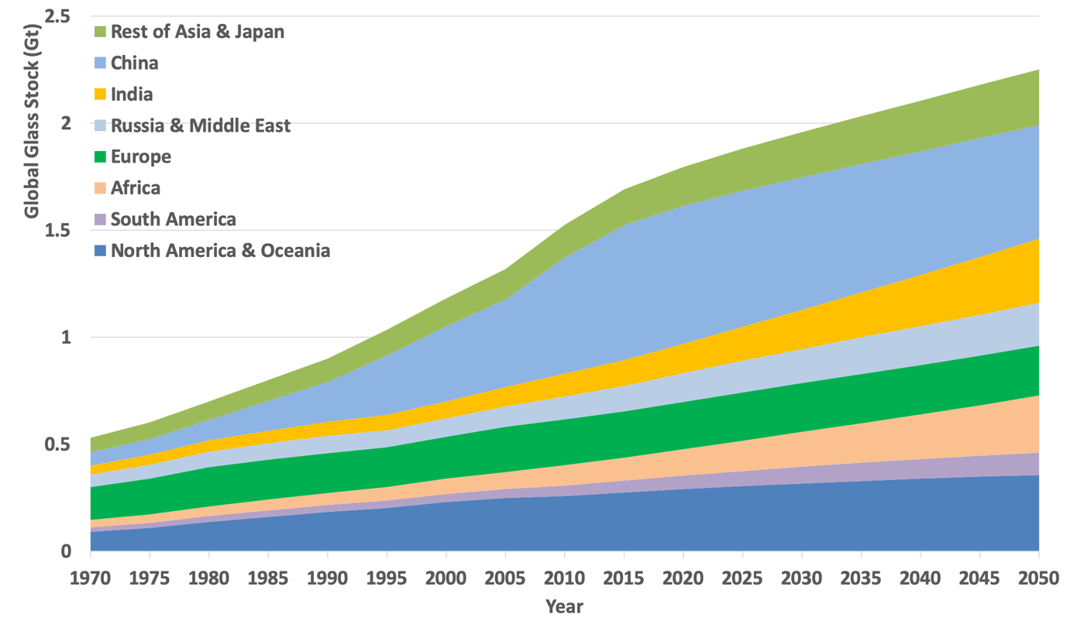

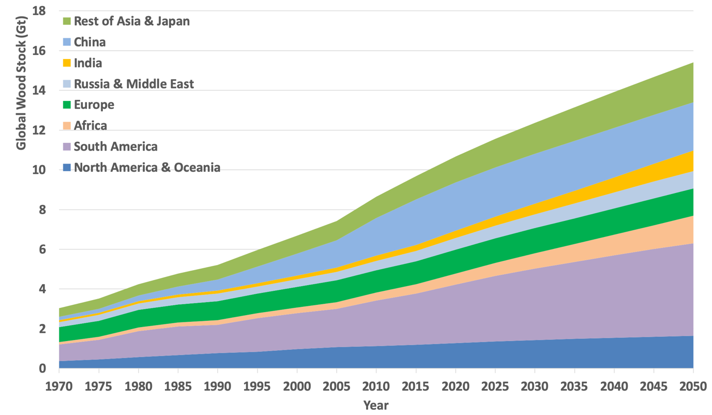

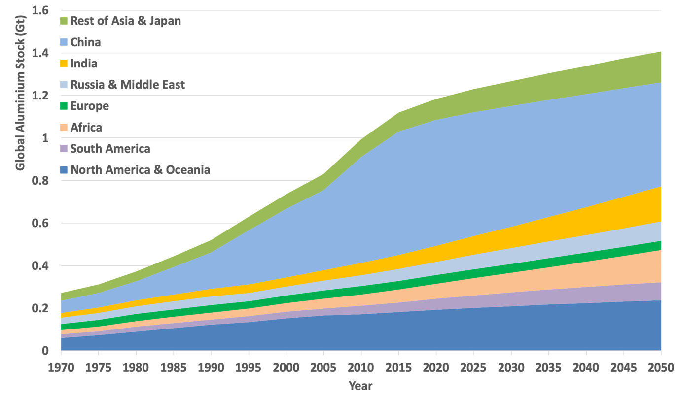

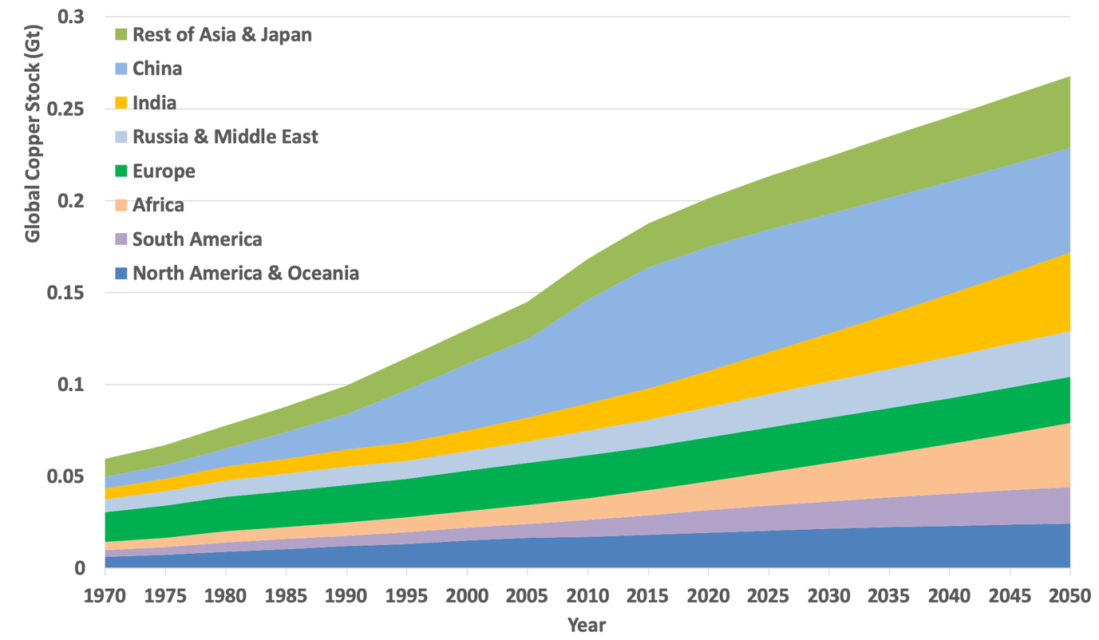

**Figure A.2.** Global material stock across ten regions for the period between 1970 and 2050

1. Steel in residential buildings in China: comparison with literature values

The Chinese in-use steel stock data coming from our model show very high values in comparison with the rest of the world regions. We therefore performed a sanity check of our results by comparing them with steel stock estimations from the literature (see Table A.3).

Pauliuk et al. (2013b) [7] developed a dynamic stock model to estimate the present in-use stock of the steel on a global level. The in-use stock is divided into four product categories (transportation, machinery, construction and products) within ten regions. In addition, Pauliuk et al. (2013a) [8] modeled the in-stock and future demand of the steel on a global level. Table 3 shows that our estimates are in the same order or magnitude as ours. Compared to our results Pauliuk et al. (2013a and b) [7,8] show a smaller initial steel stock, but a larger stock in 2050 compared to our estimates.

Hatayama et al. (2010) [9] analysed global steel use using a dynamic MFA. The steel in-use stock and future demand is estimated for three categories (buildings, civil engineering (infrastructure) and vehicles). The future building stock is modelled by a logistic function including parameters such as GDP, population density and saturation value per capita. Hatayama shows results for the whole of Asia, of which China is an important part. According to Hatayama et al. (2010) [9], Asia’s steel stock will be at the level of 35 Gt in 2050, 21 of which will reside in buildings. Our estimate for Asia as a whole is around 11 Gt. Note that our estimates include residential buildings only.

**Table A.3.** Comparison of steel in-use stock estimates for China.

|  |  |  |  |
| --- | --- | --- | --- |
|  | Pauliuk et al. (2013a), 2000-2005, China [8] | Pauliuk et al. (2013b), 2050, China [7] | Hatayama et al. (2010) 2050, Asia [9] |
| Steel stock from literature (Gt) | 2.6 in total, 1.6 in buildings* | 17 in total, 10 in buildings* | 35 for whole of Asia, 21 in buildings |
| Our estimated steel stock in residential buildings (Gt) | 2.2 | 7 | 11 for whole of Asia |

*calculated from Pauliuk et al. estimate of 2 tons/cap in the early 2000s and 13 ton/cap in 2050, and a population of 13 million in both 2000 and 2050 in accordance with SSP2.

1. Sensitivity analysis
   1. Description

In order to estimate the uncertainties related to the material intensity parameter and its influence on the model outcomes, we performed a sensitivity analysis using three different alternative values for the material content in terms of kg/m2 UFA. The effect on the modelled material stock development is estimated under these three “sensitivity scenarios”. As the number of measurements for the individual regions is often too low, we performed this analysis at the global level only and disregarded the regional specificity of the material intensities of residential buildings. In addition, we aggregated over the four different building types, for the same reason.

In sensitivity scenario 1, we estimate the global material stock considering the mean global value for each material. Sensitivity scenario 2 is based on the values representing the 20th percentile, and sensitivity scenario 3 considers the values depicting the 80th percentile. In that way, we have some idea of the variability of the results.

* 1. Outcomes and discussion

The outcomes from the sensitivity analysis are presented in Table A.4 and Figure A.3. Table A.4 displays the mean, the 80th percentile, 20th percentile and the median scenarios compared to the model outcome based on averages for the period between 2045-2050, as specified in the main text. The numbers in Table A.4 represent differences in the outcome compared to the modelling results in the main text in percentages. The red numbers represent lower modelling outcomes while the green numbers show an increase in the stock in relation to the original results.

**Table A.4.** Effects of the sensitivity variants on selected material demand indicators. The percentages indicate the change with respect to the same indicators under the analysis presented in the main document. The green numbers indicate an increase in the stock, while the red numbers indicate a decrease.

|  |  |  |  |  |  |
| --- | --- | --- | --- | --- | --- |
| **Indicator** | **Year** | **Mean MI** | **80th Percentile** | **20th Percentile** | **Median** |
| Steel stock | 2045 - ’50 | -14% | 8% | -67% | -35% |
| Concrete stock | 2045 - ‘50 | -16% | 4% | -60% | -22% |
| Glass stock | 2045 - ‘50 | -3% | 32% | -69% | -37% |
| Wood stock | 2045 - ‘50 | -10% | 34% | -64% | -34% |
| Aluminium stock | 2045 - ‘50 | -16% | 19% | -68% | -50% |
| Copper stock | 2045 - ‘50 | 2% | 35% | -86% | -53% |

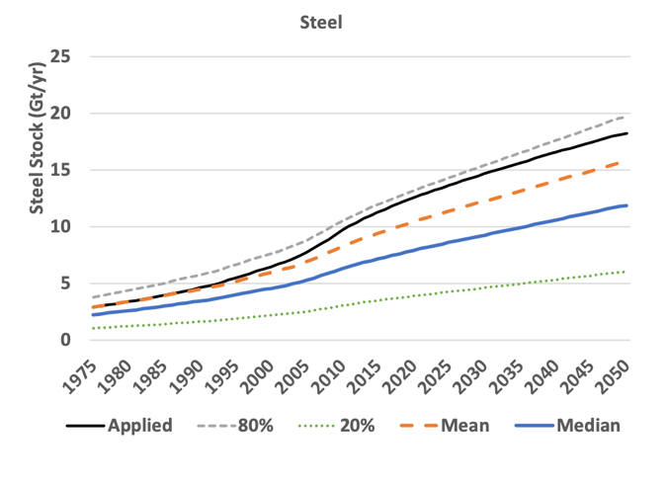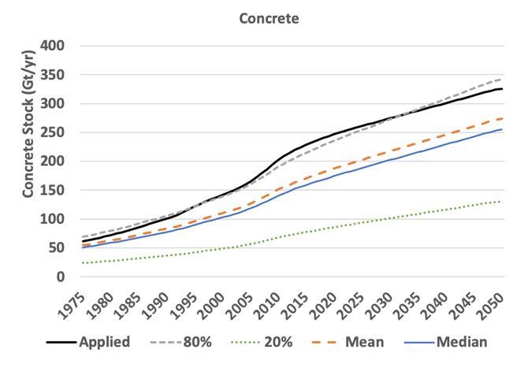

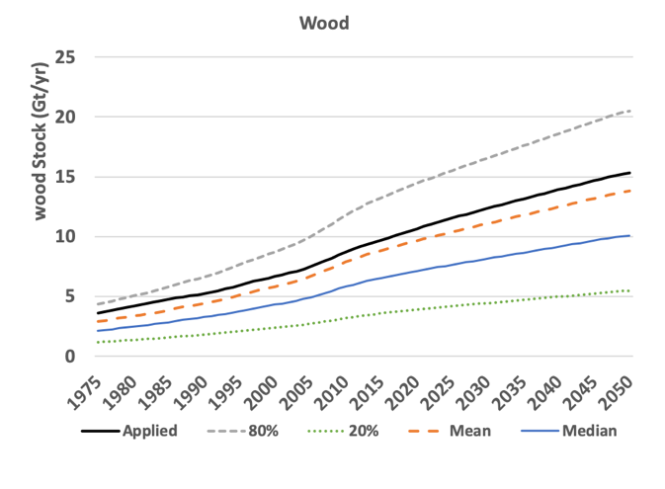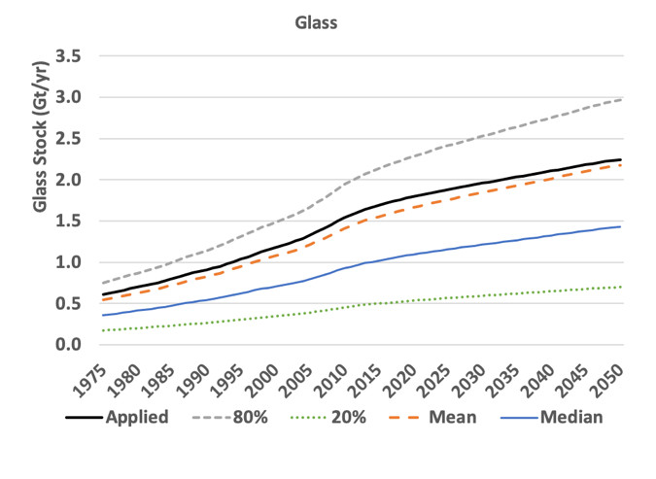

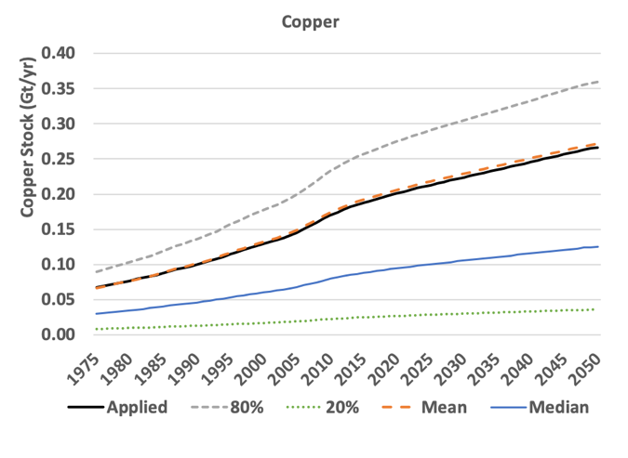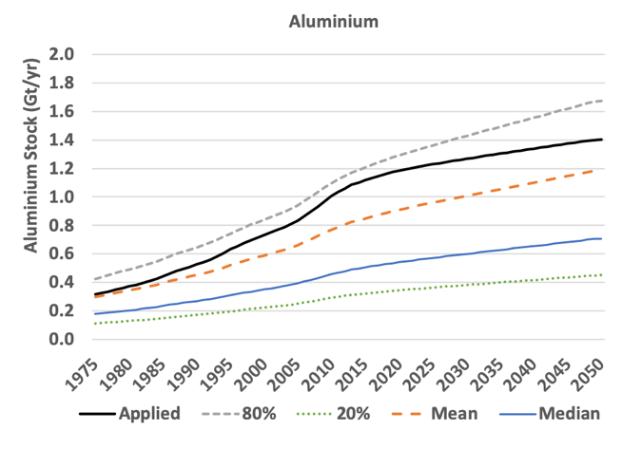

**Figure A.3.** Annual global stock development under four sensitivity variants. *“Applied”* shows the original data and the results as described in the main text. The *“Mean”* depicts the global mean material content. The “*Median*” shows the “middle” value for each material. The *“20%”* assumes the global values for 20th percentile and *“80%”* represents the global values for 80th percentile as identified in Figure 2 in the main document.

The outcomes presented in Table A.4 show that assuming a global mean material intensity does not lead to very different results for the materials stock estimates near the end of the modelled period. Only for copper, using mean values lead to slightly higher stock estimates while the other material stocks show lower values. This can be explained with the fact that the material content of copper for square meter for certain building types (e.g. copper in row houses and apartment buildings) is relatively low as shown in Table 2 in the main text. In addition, the same table shows that the global average of copper for detached houses is rather high in comparison with the rest of the dwelling types. Thus, applying the global mean and disregarding of the different regions results in a higher value for building types which in reality contain low amount of the material. Copper and glass are the construction materials showing the smallest difference between the applied and the mean scenario. This might indicate that the intensity of the materials is rather standard and the fluctuations in the data range are limited. The lower mean values for the stock of the rest of the materials might be explained by a very high values for material intensities, for instance the amount of concrete in detached houses in China. The value for concrete used for detached houses in this region are two times higher than the global mean value which could lead to decline in the mean variant compared to the applied scenario, as China represents an important share of the global stock. This outcome suggests the importance of using (and collecting) regional specific data.

The 80th percentile variant shows significantly higher stock estimations for the period between 2045-2050, as expected. The only exception is concrete (4%). This once again can be explained with the significantly higher mean value of the material intensity of the concrete in detached houses in China in relation to the global average, that contribute so much to the global stock.

The stock estimates based on the 20th percentile values for material content are much lower than either the applied, the mean or the median scenarios, by 60-70% for most materials and by over 80% for copper. We explain that with the wilder range of the data for copper resulted from the differences in the material intensity in the different regions and dwelling types. One reason could be the limited amount of data for copper, another could be the actual differences in the amount of copper used in buildings given that the material has a various purposes and the amount used could significantly vary across residential buildings [10,11].

The median scenario shows lower stock estimation in comparison with the applied, mean and 80th percentile scenarios. This can be explained with the fluctuation of the range of data and having extreme values for certain regions. This fact once again highlights the importance of the regional desegregation as the different regions are characterised by different architectural styles and preferred materials.

The 20th and 80th percentile values could be interpreted as the range of modelling outcomes based on data variability. The range is considerable: in most cases, a factor 4 difference between highest and lowest values is visible in the results, and a higher factor difference for materials with fewer data points. This indicates there is a high variability in the material content of dwellings. It also points to the need for a more consistent collection, as well as typology of buildings. Another interesting observation is that both the mean and the applied values are much closer to the 80th percentile values than to the 20th percentile values. Apparently, the bulk of the measurements are closer to the higher values, indicating the lower values might represent atypical situations.

In all, we can conclude that the database on material contents for doing such stock assessments is sufficient to arrive at order-of-magnitude credible values, but still is limited and lacks a lot of detail regarding regional differentiation and differentiation over the housing types. The sensitivity for reginal differentiation is large and the database not always allows regional differentiation. This is a challenge to be taken up by researchers, but especially by architects, construction companies and demolishers. We hope the database will be further developed to allow more robust outcomes.

**References**

[1] E. Stehfest, D. van Vuuren, L. Bouwman, T. Kram, Integrated assessment of global environmental change with IMAGE 3.0: Model description and policy applications, Netherlands Environmental Assessment Agency (PBL), 2014.

[2] S. Bhochhibhoya, M. Zanetti, F. Pierobon, P. Gatto, R.K. Maskey, R. Cavalli, The global warming potential of building materials: an application of life cycle analysis in Nepal, Mountain Research and Development. 37 (2017) 47–55. doi:10.1659/MRD-JOURNAL-D-15-00043.1.

[3] A. Atmaca, N. Atmaca, Life cycle energy (LCEA) and carbon dioxide emissions (LCCO2A) assessment of two residential buildings in Gaziantep, Turkey, Energy and Buildings. 102 (2015) 417–431. doi:10.1016/j.enbuild.2015.06.008.

[4] A. Sharma, B.M. Marwaha, A methodology for energy performance classification of residential building stock of Hamirpur, HBRC Journal. 13 (2015) 337–352. doi:10.1016/j.hbrcj.2015.11.003.

[5] X. Yang, M. Hu, J. Wu, B. Zhao, Building-information-modeling enabled life cycle assessment, a case study on carbon footprint accounting for a residential building in China, Journal of Cleaner Production. 183 (2018) 729–743. doi:10.1016/j.jclepro.2018.02.070.

[6] Least Developed Country Category: Nepal Profile | Economic Analysis & Policy Division, Nations, Development Policy & Analysis Division | Dept of Economic & Social Affairs | United. (2019).

[7] S. Pauliuk, T. Wang, D.B. Müller, Steel all over the world: Estimating in-use stocks of iron for 200 countries, Resources, Conservation and Recycling. 71 (2013) 22–30. doi:10.1016/j.resconrec.2012.11.008.

[8] S. Pauliuk, R.L. Milford, D.B. Mu, J.M. Allwood, The Steel Scrap Age, 47 (2013) 3448−3454. doi:10.1021/es303149z.

[9] H. Hatayama, I. Daigo, Y. Matsuno, Y. Adachi, Outlook of the World Steel Cycle Based on the Stock and Flow Dynamics, 44 (2010) 6457–6463. doi:10.1021/es100044n.

[10] M.K. Rathi, A.K. Patil, Use of Aluminium In Building Construction, (2013) 1–7. http://www.engineeringcivil.com/use-of-aluminium-in-building-construction.html.

[11] P. Gontia, C. Nägeli, L. Rosado, Y. Kalmykova, M. Österbring, Material-intensity database of residential buildings: A case-study of Sweden in the international context, Resources, Conservation and Recycling. 130 (2018) 228–239. doi:10.1016/j.resconrec.2017.11.022.