

Financial Risk Assessment and Micro-Lending System (FRAMS)

A Capstone Project Presented to the Faculty of
College Department of
West Prime Horizon Institute, Inc.
Pagadian City

In Partial Fulfilment
of the Requirements in Capstone Project
for the Degree of Bachelor of Science in Information Technology
Academic Year 2025-2026

by:
Cabaraban, John Lloyd M.
Mandawe, Mark Rexben S.
Andulog, Joann R.
Luy, Angel Ann S.

Mr. Antonio Llagas Jr.
Adviser
October 23, 2026
CHAPTER I
INTRODUCTION
Background of the Study
Many lending offices maintain borrower files, loan computations, and payment records using paper-based documents or separate spreadsheets. This practice makes it difficult to access and monitor essential information in one place, including borrower applications, declared income, existing financial obligations, loan amounts released, and outstanding balances. When these records are not properly integrated, lending offices may experience delays in processing transactions, inconsistencies in financial records, and difficulties monitoring overdue accounts and repayment activities.
Credit risk in micro-lending involves more than determining whether an individual qualifies for a loan. Local studies of lending institutions indicate that lending officers continue to rely on borrower interviews, business verification, and checks for existing unpaid loans when evaluating applications. These practices are particularly relevant because many micro-borrowers have limited income and little formal credit history (Mina, 2024; Juventud et al., 2023). Furthermore, studies on digital lending and microfinance indicate the growing role of web-based systems and structured risk assessment tools in improving lending operations (Santos, 2023; Campos, 2024). These studies, discussed in detail in Chapter 2, support the development of an integrated system that connects borrower information, loan processing, and financial risk assessment.
The system developed in this study is the Financial Risk Assessment and Micro-Lending System (FRAMS) for RJ and RR Finance Services, located at Purok San Francisco, Poblacion, Sominot, Zamboanga del Sur. The system registers borrowers, facilitates a five-step loan application process, and accepts supporting documents. It also computes an eligibility estimate based on the borrower's declared income, existing financial obligations, requested loan amount, loan term, and the lending office's configured limits. The final loan approval decision remains under the administrator's authority. Once the borrower accepts the loan agreement, the administrator assigns a collector and proceeds with the loan release. The system subsequently generates installment schedules, records repayments and applicable penalties, and produces financial reports to support monitoring and decision-making.

In addition to payments recorded at the lending office, FRAMS includes PayMongo Dynamic QR Ph. A collector starts the code for an assigned loan when the method is bank transfer or e-wallet. The borrower pays by scanning that code. The QR image is not a payment confirmation. While the QR payment page remains open, FRAMS polls the PayMongo Payment Intent API every five seconds and records the repayment only after the provider status is succeeded and the paid amount matches the pending transaction. If that page is closed while the attempt is still pending, expired, or failed, an authorized administrator or the assigned collector can select Check with PayMongo on the payments page. That staff action retrieves the same Payment Intent status and records the repayment only when the amount matches. Showing the code, returning to the browser, or waiting for a local timer does not, by itself, record the repayment. Cash is recorded directly by authorized staff. Bank transfer and e-wallet may also be recorded directly, without a QR code, by an administrator or the assigned collector.

Therefore, this study focuses on developing a practical web-based system that integrates borrower management, loan application processing, eligibility assessment, loan approval, loan release, online and recorded payments, collection monitoring, and financial reporting for RJ and RR Finance Services. The eligibility estimate serves as a decision-support tool rather than an automatic loan approval mechanism or a machine-learning prediction of default. Through these integrated features, FRAMS aims to support more organized lending operations, improve the monitoring of financial transactions, and assist the lending office in making informed lending decisions.

Statement of the Problem
The lending institution, RJ and RR Finance Services, faces challenges in managing borrower information, processing loan applications, monitoring repayments, and assessing borrower eligibility using manual records and separate files. These practices may make it difficult to maintain organized records, monitor outstanding balances, identify overdue accounts, and connect financial information with the corresponding loan applications.
To address these concerns, the study aims to develop the Financial Risk Assessment and Micro-Lending System (FRAMS), a web-based application designed to centralize borrower records, support loan processing and eligibility assessment, facilitate payment monitoring, and generate financial reports.

Specifically, the study seeks to answer the following questions:

- How can FRAMS improve the management of borrower information and loan applications?

- How can FRAMS assist in assessing borrower eligibility using declared income, existing financial obligations, requested loan amount, loan term, and configured lending criteria without treating the assessment as an automatic loan approval?

- How can FRAMS facilitate the monitoring of loan repayments, outstanding balances, installment schedules, and overdue accounts?

- How can FRAMS support the delivery of notifications concerning loan application decisions, agreement acceptance, loan releases, and payment transactions?

- How can FRAMS generate financial reports that support the monitoring of lending transactions and management decision-making?

- How acceptable is the developed system in terms of functionality, usability, reliability, security, and performance based on the evaluation of its intended users?
Objectives of the Study
The general objective of this study is to design, develop, and evaluate a secure web-based Financial Risk Assessment and Micro-Lending System (FRAMS) for RJ and RR Finance Services to support borrower management, loan processing, eligibility assessment, repayment monitoring, and financial reporting.
Specifically, the study aims to:
- Develop a borrower management module that supports borrower registration, administrator approval, client record management, online loan applications, and supporting document submission and review.
- Implement a rule-based eligibility assessment that evaluates borrower information, declared income, existing financial obligations, requested loan amount, loan term, and configured lending criteria to assist the administrator in reviewing loan applications.
- Develop loan processing and repayment monitoring functions that support interest computation, installment schedule generation, loan agreement acceptance, collector assignment, loan release, payment recording, penalty computation, and monitoring of outstanding balances.
- Implement notifications for relevant loan application decisions, agreement updates, loan releases, and payment transactions, consistent with the notification functions available in the developed system.
- Develop financial reporting functions that support the monitoring of loan releases, collections, outstanding balances, overdue accounts, and other relevant lending transactions.
- Evaluate the developed system in terms of functionality, usability, reliability, security, and performance using the evaluation instrument and verified responses of the intended users.

Scope and Delimitations
This study covers the design, development, and evaluation of the Financial Risk Assessment and Micro-Lending System (FRAMS) for RJ and RR Finance Services, located at Purok San Francisco, Poblacion, Sominot, Zamboanga del Sur. The system is designed to support borrower registration and approval, client record management, loan applications, supporting document review, eligibility assessment, loan agreement acceptance, loan release, collector assignment, installment scheduling, payment recording, penalty computation, notifications, contact inquiries, user management, and financial reporting.
The system is intended for three primary user roles: administrator, collector, and borrower. Borrowers can register, submit loan applications, and provide the required supporting documents. Administrators manage borrower records, review applications, assess eligibility results, make loan approval decisions, assign collectors, oversee loan releases, and access financial reports. Collectors manage assigned accounts and record authorized repayment transactions.
FRAMS provides a rule-based eligibility estimate using borrower information, declared monthly income, existing financial obligations, employment or business duration, requested loan amount, loan term, and the configured lending criteria. The program's documented default parameters include a maximum debt-to-income ratio of 40%, a minimum loan amount of PHP 3,000, a maximum loan amount of PHP 500,000, and a minimum employment or business duration of three months. The documented interest computation applies a flat monthly rate of 5% to the original principal for each month of the loan term. The configured penalty rates depend on the payment frequency. These parameters and computations must correspond to the actual program configuration and implemented formulas.
The loan-amount field on the application form uses an HTML minimum of PHP 1,000 so that the browser can reject nonnumeric or negative entry. The eligibility function, however, still applies the configured policy minimum of PHP 3,000 and blocks a requested amount below that limit. Appendix K, Figure K1, shows the frontend numeric-entry message and should not be read as a change to the policy minimum.
The eligibility estimate serves as a decision-support tool and does not automatically approve or reject a loan. The final approval decision remains under the administrator's authority. Dependents and collateral notes may be recorded, but they are not included as variables in the documented eligibility formula.
The system includes PayMongo Dynamic QR Ph for supported non-cash collection transactions. According to the selected implementation, an authorized collector initiates a QR payment for an assigned loan. The corresponding repayment is recorded after the Payment Intent status is confirmed as succeeded and the paid amount has been matched to the pending transaction. While the QR page is open, FRAMS polls the Payment Intent API for that confirmation. If the QR page is no longer open, authorized staff may start the same confirmation from the payments page using Check with PayMongo. Cash payments and other authorized payment records may be entered directly by authorized personnel. Successful QR Ph collection depends on valid PayMongo API credentials (PayMongo, n.d.) and network access to retrieve Payment Intent status.
The study does not include credit bureau integration, SMS integration, loan restructuring, deposits, savings, or investment accounts. Although the system records relevant lending transactions, this study does not establish that all recording errors have been eliminated or that the system has been deployed across multiple branches. The eligibility assessment is rule-based and is not a machine-learning model for predicting loan default.
The evaluation of FRAMS is limited to the respondents, evaluation instruments, testing procedures, and evidence documented in Chapter III and Chapter IV. The conclusions are therefore based on the verified implementation and evaluation results rather than on untested capabilities or assumptions about system performance.
Significance of the Study
Lending office. FRAMS gives RJ and RR Finance Services one application for applications, eligibility review, release, collection, and reports, in place of disconnected files.
Administrators. The system supports approval of borrowers, review of documents, release of loans, assignment of collectors, and reading of dashboards and period reports.
Collectors. The system limits collection work to assigned clients and loans and provides the schedule and payment form for those accounts.
Borrowers. An approved borrower can apply, upload requirements, accept or decline the agreement, and view the loan, the schedule, and the payment history.
Educational institutions. The project may be used in teaching systems analysis, database design, and web development.
Future researchers. The study may be a reference for later work on micro-lending systems and rule-based eligibility estimates.
The researchers. The project provides practice in analysis, web development, database design, and the implementation of a lending workflow.

Definition of Terms
Administrator. The staff role that approves borrowers, reviews applications, releases loans, manages users and collectors, and views expenses, penalties, and reports.
Borrower. The client who registers, applies after approval, responds to the agreement, and views that borrower's own loan and payments.
Collector. The staff role that views assigned clients and loans and records payments for those accounts.
Debt-to-income ratio. Existing monthly obligations, with or without the proposed loan payment, divided by monthly gross income. FRAMS uses this ratio in the eligibility estimate.
Eligibility estimate. The result—Eligible, Conditionally Eligible, or Not Eligible—produced from income, obligations, the requested loan amount, the loan term, and the configured limits. It is not a final approval.
FRAMS. The Financial Risk Assessment and Micro-Lending System developed in this study.
Installment schedule. The due amounts created when a loan is released, including the due date, principal, interest, and status.
Loan. The released amount recorded with its term, interest, schedule, and remaining balance.
Payment. An amount recorded against a loan, including the date, method, collector, and any penalty portion.
PayMongo Dynamic QR Ph. A collector-initiated QR payment for bank transfer or e-wallet. The repayment is recorded after PayMongo reports a succeeded Payment Intent for the matching amount, through status polling on the open QR page or through staff-initiated Check with PayMongo. Displaying the QR image is not confirmation of payment.
Penalty. The amount computed on an unpaid installment whose due date has passed, using the rate for that loan's payment frequency.
Role-based access. The restriction of pages and records according to the signed-in user's role.

CHAPTER II
REVIEW OF RELATED LITERATURE AND STUDIES

This chapter reviews literature and studies relevant to the Financial Risk Assessment and Micro-Lending System (FRAMS). It discusses local and foreign work on credit-risk management, microfinance, digital lending, repayment monitoring, and information-system use. The review identifies practices that inform the system’s design and distinguishes those practices from features that FRAMS does not implement. FRAMS uses configured rules to produce an eligibility estimate; it does not use machine learning to predict default or make the final lending decision.
Related Literature
Local Literature
Mina (2024) examined credit-risk management practices in microfinance lending institutions in Nueva Ecija. The descriptive study involved four lending officers from San Isidro and Cabiao. The institutions offered individual and group loans, often collected weekly, and used interviews and applicant checks to review creditworthiness. Checks included reviewing the applicant’s credit situation, confirming that the business existed, and determining whether the borrower had an outstanding loan with another institution. Mina also identified weaknesses in existing practices and proposed measures to manage remaining risks. This study is relevant to FRAMS because it highlights the importance of consistently recording borrower information and applying documented checks. FRAMS supports those tasks through borrower records, supporting documents, and a rule-based eligibility estimate; it does not independently verify external debts or business existence unless staff review the submitted information.

Juventud et al. (2023) discussed credit risk in microfinance lending to micro-enterprises. They described microfinance as a source of financial support for low-income households, while noting that limited credit data, limited credit histories, and over-indebtedness can increase lending risk. The authors also discussed group lending and selected forms of collateral as risk-management practices. These points establish why lenders need relevant borrower information and a consistent assessment process. FRAMS uses the income, obligations, loan amount, term, and other configured criteria available in its records; it does not rely on a credit-bureau score.

Estrellado (2024) studied financial-inclusion practices of lending institutions and the sustainability of micro-businesses in Sorsogon City. The descriptive study involved 15 micro-business owners and considered factors such as years in operation, initial capital, loan amount, and daily sales. The reported strategies included reducing loan-access barriers, using loans as business capital, offering repayment options, and providing financial-literacy education. Estrellado recommended improved credit-information sharing, borrower monitoring, need-based financial education, and access to credit. The study broadens the context of FRAMS by showing that loan management concerns extend beyond assessment to repayment and borrower support. FRAMS includes application processing and repayment records, but it does not provide a separate financial-literacy module.

In a related local study, Juventud et al. (2023) assessed perceived credit risk among micro-enterprise owners in Barangay Población, Iligan City. The descriptive-correlational study included 75 business owners. The authors described limited income and credit history as common concerns and discussed practices such as group lending, collateral, and cash-flow assessment. They also reported that age, business type, previous loan use, and loan experience did not significantly explain respondents’ perceptions of credit risk. For FRAMS, the study supports collecting financial information relevant to repayment capacity, while its findings do not establish that the system’s particular eligibility rules are predictive or validated for other populations.
Foreign Literature
Shi et al. (2022) reviewed machine-learning, statistical, and deep-learning methods for credit-risk estimation and reported that ensemble and deep-learning models often outperform traditional statistical approaches on public datasets. Kou (2022), in an editor’s introduction to Financial Innovation, surveyed current fintech and credit-assessment research, including work comparing fintech lenders with traditional banks. This literature provides context for automated risk assessment, but its methods should not be conflated with the approach used in FRAMS. FRAMS does not implement a machine-learning score; it applies configured eligibility rules and presents the result for review by the authorized administrator.

Bazarbash and Beaton (2020) examined fintech micro-lending in emerging economies and discussed how automated scoring and alternative data, including transaction-related information, may support financial inclusion while managing risk. The relevant implication for FRAMS is the value of a structured and consistently applied assessment process. FRAMS does not collect mobile-use data or implement the alternative-data scoring methods described in that work.

Guan et al. (2023) examined responsible credit-risk assessment that combines machine learning with human expert rules so that lending decisions remain explainable. Chen, Ye, and Ye (2023) proposed an interpretable selective-learning model that uses logistic regression for most cases and a neural network only where a linear model is insufficient. Huang et al. (2023) compared BigTech big-data and machine-learning default prediction for small and medium-sized enterprises with traditional bank scorecards. Cornelli et al. (2024) studied fintech small-business lending platforms in the United States and reported that those platforms’ internal credit scores predicted loan performance more accurately than traditional credit scores, particularly in high-unemployment areas. These sources describe predictive or data-driven scoring. FRAMS has a narrower scope: it records installment status, payment history, overdue penalties, and reports, but it does not use a predictive model to identify likely default or automatically revise repayment terms.

Taken together, the foreign literature describes approaches that may inform future development but are outside the current FRAMS implementation. The present study focuses on a locally hosted web application that keeps borrower information, applications, eligibility estimates, loan schedules, payments, and collection records within one system. This distinction is important when interpreting the project’s functionality and results.
Related Studies
Local Studies
Santos (2023) discussed changes in the Philippine financial landscape associated with digital payments and mobile banking and highlighted the relevance of online access to financial services. This work provides context for offering a borrower-facing portal and digital access to loan information in FRAMS. It does not, by itself, demonstrate that FRAMS improves trust or financial outcomes; those effects would require direct evaluation.
The Iligan City study by Juventud et al. (2023) is also relevant as an empirical local study because it examines perceived credit risk among micro-enterprise owners. Its discussion of limited credit history supports the practical value of recording declared income and existing obligations when a formal credit-bureau score is unavailable. However, the study’s findings should be treated as contextual support rather than validation of FRAMS’s eligibility formula.
Ramirez (2024) developed and validated a tool for assessing risk and return in the gross loan portfolio of microfinance institutions in Occidental Mindoro, illustrating the role of structured information in portfolio decisions. Campos (2024) described credit-analysis and collection practices of microfinance institutions in Nueva Ecija, including the growing use of digital tools. Penaso and Dagang (2025) examined loan-management practices and operational efficiency in microfinance institutions in Northern Mindanao. Collectively, these studies support attention to organized records, loan monitoring, and collection workflows. FRAMS applies these ideas through borrower and loan records, installment schedules, payment tracking, and period reports; it does not claim to reproduce the portfolio-risk tool evaluated by Ramirez.
Foreign Studies
LendStack (n.d.) and BlueOrchard (2025) are cited in the original draft for discussion of cloud-based lending platforms and infrastructure costs. These sources are treated here as industry-oriented background rather than as equivalent to peer-reviewed empirical studies. FRAMS is designed for local hosting using Apache, PHP, and MySQL. Accordingly, the comparison concerns the use of web-based lending software, not a claim that FRAMS is cloud-hosted or that it achieves a particular cost reduction.
Khandani et al. (2010) examined machine-learning models for consumer credit-risk assessment. The more recent studies reviewed above (Shi et al., 2022; Guan et al., 2023; Chen et al., 2023; Huang et al., 2023; Cornelli et al., 2024) likewise treat credit risk as a prediction problem using historical lending outcomes, alternative data, or internal fintech scores. These studies demonstrate approaches that differ from a fixed, rule-based assessment. They inform the broader research context, but their reported outcomes should not be presented as outcomes achieved by FRAMS.
The foreign studies also highlight the value of monitoring loans after release. In FRAMS, post-release monitoring is implemented through installment status, payment history, overdue-penalty records, and reports. These functions support staff review but do not constitute a machine-learning model, automated early-warning prediction, or continuous risk rescoring.
Synthesis
The local literature shows that microfinance lenders already practice credit checking, but much of it is manual, interview-based, and limited by the lack of a formal credit history (Mina, 2024; Juventud, Matigas, Himongala, & Galla, 2023; Juventud, Matigas, Himongala, Galla, & Abiol, 2023). Estrellado (2024) adds that access, repayment arrangements, and financial education matter to micro-business borrowers. Local studies then show the turn toward digital access and structured portfolio tools (Santos, 2023; Ramirez, 2024; Campos, 2024; Penaso & Dagang, 2025).
The foreign literature and studies go further. They describe machine learning, alternative data, and predictive scoring (Kou, 2022; Shi et al., 2022; Bazarbash & Beaton, 2020; Guan et al., 2023; Chen et al., 2023; Huang et al., 2023; Cornelli et al., 2024; Khandani et al., 2010). Those capabilities are a research direction. They are not features of the system built in this study.
The gap that FRAMS addresses is the absence of one web-based record that registers the borrower, stores the application and documents, applies a stated eligibility rule, releases the loan with a schedule, and tracks payments and penalties for a small lending office. FRAMS differs from the reviewed predictive systems because the eligibility result is explainable from income, debt, amount, term, and limits, and because the administrator remains the approving authority. Table 1 summarizes that comparison.

Area | Sources retained from the review | What those sources emphasize | What FRAMS implements
Credit checking | Mina (2024); Juventud et al. (2023) | Interviews, business checks, and limited credit history | Eligibility estimates from income, debt, amount, term, and limits
Financial inclusion | Estrellado (2024) | Loan access, repayment choice, and financial education | Online application and status viewing; no separate literacy module
Digital lending records | Santos (2023); Campos (2024); Penaso and Dagang (2025) | Web access and structured loan monitoring | Borrower portal, staff console, schedules, and reports
Portfolio tools | Ramirez (2024) | A structured risk-return instrument | Dashboard and period reports of loans, collections, and balances
Predictive scoring | Shi et al. (2022); Chen, Ye, and Ye (2023); Khandani et al. (2010) | Machine-learning credit scoring and interpretable selective models | Not implemented; the estimate is rule-based and is not an approval
Delinquency monitoring | Guan et al. (2023); Huang et al. (2023); Cornelli et al. (2024) | Explainable ML, BigTech/fintech scoring, and credit-access studies | Overdue status, frequency-based penalties, and payment history

Table 1 Comparison of the reviewed focus and the FRAMS implementation

Conceptual Framework
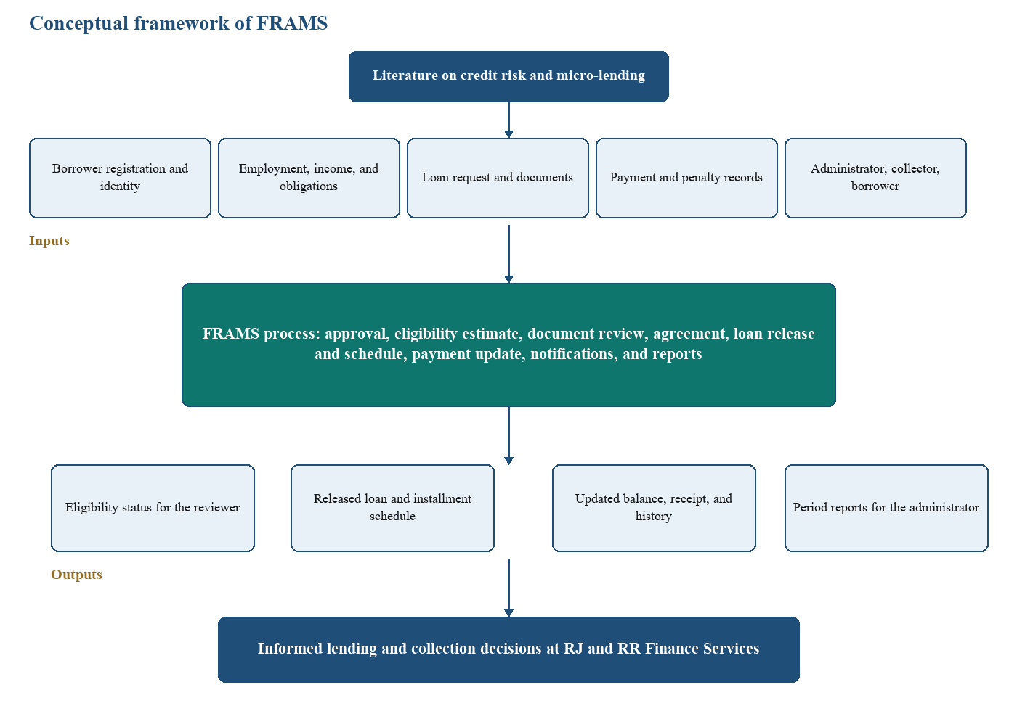
The conceptual framework of this study shows how FRAMS works. It explains how the system handles loan applications, loan release, and collection for RJ and RR Finance Services. The framework uses the Input–Process–Output (IPO) model, which shows how information flows from inputs, through the system, to outputs. The system takes information such as borrower registration and identity, employment, income, and obligations, the loan request and documents, and payment and penalty records from the administrator, collector, and borrower. FRAMS then uses this information to estimate eligibility, review documents, approve the loan, prepare the agreement, release the loan with a schedule, update payments, send notifications, and prepare reports. The outputs are the eligibility status for the reviewer, the released loan and installment schedule, the updated balance with its receipt and history, and period reports for the administrator. This helps the office make informed lending and collection decisions.
Figure 1 Conceptual framework of the FRAMS
Figure 1 presents the conceptual framework of the proposed FRAMS using the Input–Process–Output (IPO) model. The framework illustrates how data are collected as inputs, processed through the system, and transformed into meaningful outputs that support lending and collection. This framework is guided by literature on credit risk and micro-lending, which emphasizes the borrower’s identity, capacity to pay, supporting documents, and record of repayment.
The Input component consists of the necessary data and users required for system operation. These include borrower registration and identity, such as the borrower’s personal details and account information. Employment, income, and obligations describe the borrower’s work, earnings, existing debts, and other monthly obligations used in the eligibility estimate. The loan request and documents state the amount, term, and purpose of the loan and supply the files needed for review. Payment and penalty records show amounts collected, remaining balances, and overdue charges. The administrator, collector, and borrower are also part of the input, because they encode, review, release, collect, and pay through the system.
The Process component represents the operations performed by FRAMS. Approval covers the reviewer’s decision on the application. The eligibility estimate computes whether the requested loan fits the borrower’s income and existing obligations. Document review checks the files submitted with the application. The agreement records the approved terms accepted by the borrower. Loan release and schedule disburse the approved amount and set the installment plan. Payment update posts collections and penalty charges and refreshes the balance. Notifications inform the concerned users of application and payment events, and reports summarize lending and collection activity for a chosen period.
The Output component consists of the processed information generated by the system. These outputs include the eligibility status for the reviewer, the released loan and installment schedule, the updated balance together with the receipt and payment history, and period reports for the administrator. These outputs provide organized and timely information for reviewing applications, releasing loans, monitoring balances, and checking collections.
Overall, the conceptual framework demonstrates how FRAMS integrates input data, lending and collection processes, and informative outputs to support informed lending and collection decisions at RJ and RR Finance Services.
Theoretical Framework
The development of the Financial Risk Assessment and Micro-Lending System (FRAMS) is anchored on theories and models related to credit risk management, information system success, and technology acceptance. These foundations provide the basis for how FRAMS manages borrower information, evaluates loan requests, monitors repayment, and supports users in performing lending-related activities.
Credit Risk and Loan Management. Credit risk management focuses on identifying and managing the possibility that a borrower may be unable to fulfill loan obligations. In microfinance, creditworthiness appraisal, loan monitoring, risk handling, and loan recovery are important components of effective loan management. Penaso and Dagang (2025) examined these areas in microfinance institutions in Northern Mindanao and found that loan management practices are associated with operational efficiency, particularly in payment and recovery activities.
This concept is applied in FRAMS through the collection and evaluation of borrower information, income, existing obligations, requested loan amount, employment or business information, and supporting documents. The system provides an eligibility estimate based on defined lending criteria, such as the debt-to-income limit, minimum and maximum loan amount, and required employment or business duration. However, the system does not automatically reject applicants; the final decision remains with the authorized administrator. This allows FRAMS to function as a decision-support tool rather than replacing human judgment.
DeLone and McLean Information Systems Success Model. DeLone and McLean (2003) proposed an updated Information Systems Success Model that evaluates information systems through dimensions including system quality, information quality, service quality, use, user satisfaction, and net benefits.
The model is relevant to FRAMS because the system is designed to centralize loan and borrower information and make that information available for lending operations. In FRAMS, system quality is reflected in organized loan processing and monitoring functions, while information quality is supported by maintaining consistent borrower, loan, payment, and risk-assessment records. The resulting system is intended to improve the efficiency of loan processing, monitoring, reporting, and decision support.
Technology Acceptance Model. Davis (1989) introduced the Technology Acceptance Model (TAM), which identifies perceived usefulness and perceived ease of use as important factors influencing users' acceptance of information technology.
This model is applicable to FRAMS because the system must be usable by the personnel responsible for processing and managing loans. FRAMS provides centralized borrower records, loan applications, payment monitoring, notifications, and reports to reduce the need for separate manual records. Its usefulness is reflected in its ability to support lending activities, while its ease of use is addressed through organized interfaces and role-based functions for administrators and other authorized users.
These models also inform the User Acceptance Testing criteria used in Chapter IV. Functionality and reliability correspond to system quality in the DeLone and McLean model. Usability corresponds to perceived ease of use in the Technology Acceptance Model. Security corresponds to protected and role-restricted use. Performance corresponds to system quality as experienced during ordinary office use. The UAT ratings therefore represent user perceptions of these qualities. They are not independent laboratory measurements of response time or of residual security risk.

CHAPTER III
DESIGN AND METHODOLOGY
Research Design
This study used a developmental research design to plan, develop, and refine the Financial Risk Assessment and Micro-Lending System (FRAMS). An iterative development approach was used because the lending workflow consists of related modules, including registration, loan application, eligibility assessment, agreement acceptance, loan release, payment recording, and reporting. The modules were developed and reviewed in stages so that issues identified during development could be addressed. Claims about testing or evaluation in this manuscript are limited to activities supported by actual records.
The modules were developed in the order of the lending workflow. Registration, administrator approval, and role-based login were completed first and checked against the pre-development interview notes. The five-step loan application, document upload, and eligibility estimate were added next and reviewed against the documented lending criteria. Agreement acceptance, collector assignment, loan release, and installment generation followed. Payment recording, penalty computation, PayMongo QR Ph collection, notifications, and reports were then integrated. Each iteration used the same local PHP and MySQL environment. Revisions after testing are those documented in Chapter IV and Appendix K. A separate dated iteration log was not attached to this manuscript.
Respondents
The respondents were borrowers and personnel of RJ and RR Finance Services in Purok San Francisco, Poblacion, Sominot, Zamboanga del Sur. Purposive sampling was used because the study required feedback from people familiar with the lending operations addressed by FRAMS. The pre-development information-gathering activity and the post-development system evaluation are described separately; their respondent counts should not be assumed to be identical unless confirmed by the original records.
- Pre-development Data Gathering
Before coding and developing FRAMS, the researchers conducted pre-development data-gathering activities at RJ and RR Finance Services to understand the existing lending operations and identify the requirements of the proposed system. The activities involved twelve (12) participants: one (1) owner, one (1) collector, and ten (10) borrowers. These participants provided perspectives on management, collection activities, and borrower experiences. The pre-development participants are reported separately from the thirty-two (32) post-development system-evaluation respondents.
2. Software Evaluation Respondents
After the development of FRAMS, the system was evaluated by its intended users to assess its acceptability in terms of functionality, usability, reliability, security, and performance. The supplied User Acceptance Testing (UAT) response export contains 32 submissions. Based on the recorded user-role field, the respondents consisted of 30 borrowers, one administrator, and one collector.
The pre-development data-gathering participants are reported separately from the post-development software evaluation respondents. The post-development evaluation results were calculated from the individual responses to the 20-item questionnaire. The supplied response spreadsheet serves as the supporting source for the calculations presented in Chapter IV and Appendix J.
Sampling Technique
The study used purposive sampling to select respondents who were directly involved in or had experience with the lending operations addressed by the Financial Risk Assessment and Micro-Lending System (FRAMS). The respondents were selected based on their roles and their ability to provide relevant information about borrower registration, loan application processing, financial risk assessment, loan approval, loan release, payment collection, repayment monitoring, and report generation.
The post-development evaluation dataset contains 32 submissions, consisting of 30 borrowers, one administrator, and one collector. These respondents were selected using purposive sampling because they represented intended users with relevant experience or responsibilities related to the lending operations addressed by FRAMS. The evaluation results were calculated from their recorded responses to the 20-item questionnaire. The respondent-role distribution is based on the recorded user-role field in the supplied UAT response export.
Purposive sampling was appropriate because the study required feedback from individuals familiar with the lending process and the intended functions of FRAMS. Selecting respondents according to their roles enabled the researchers to obtain evaluations from the system's intended users and assess its acceptability.
Data-Gathering Instruments
The following instruments were used. Interviews, observation, and document review were conducted before coding. The user evaluation form was administered after development. Secondary sources were consulted during the review of literature.
1. Interview Guide
The interview guide was used to gather information from the owner, collector, and borrowers about the existing loan application process, interest rates, debt-to-income (DTI) limit, payment schedules, penalties, collection procedures, and reporting requirements. The interviews were conducted before coding began.
2. Observation
Observation was conducted before coding began to understand how lending activities were performed, particularly the handling of loan applications, borrower information, payment records, collection procedures, and reports.
3. Document Review
The researchers reviewed available lending forms, records, and other relevant documents before coding began. The review helped identify the information recorded during lending transactions and the data needed to support the system requirements.
4. User Evaluation Form
The user evaluation form gathered feedback on functionality, usability, reliability, security, and performance. The user evaluation form consisted of 20 statements grouped into five criteria: functionality, usability, reliability, security, and performance. Each criterion contained four statements. Respondents rated each statement using a five-point Likert scale: 5 for Strongly Agree, 4 for Agree, 3 for Neutral, 2 for Disagree, and 1 for Strongly Disagree.
The weighted means were calculated from the individual responses recorded in the supplied UAT response export. The blank questionnaire included in Appendix I documents the evaluation instrument, while the response spreadsheet serves as the supporting record for the recorded answers and resulting computations presented in Chapter IV and Appendix J.
5. Secondary Data Sources
Secondary sources consisted of the literature in Chapter II and the available lending records. These sources supplied additional information for the requirements and the design of FRAMS.
Data-Gathering Techniques
- The researchers conducted interviews with the owner, collector, and borrowers before coding began to understand existing lending procedures and operational requirements.
- The researchers observed the existing loan application, payment tracking, and collection processes before coding began.
- The researchers reviewed available lending forms, records, and related documents before coding began.
- Information obtained from interviews, observation, and document review was used to identify and define the functional requirements of FRAMS.
Procedures
- Obtaining consent before gathering data.
- Conducting the interviews and distributing the questionnaires.
- Analyzing the responses to identify problems and requirements.
- Designing and developing FRAMS from those requirements.
- Testing the developed system.
- Revising the system from feedback.
Statistical Treatment of Data
Descriptive statistics were used to analyze the respondents' evaluations of the Financial Risk Assessment and Micro-Lending System (FRAMS). The evaluation covered five criteria: functionality, usability, reliability, security, and performance. The weighted mean was used to determine the average rating for each criterion based on the responses of the 32 respondents, consisting of 30 borrowers, one administrator, and one collector.
The weighted mean was computed using the following formula:
$$WM=\frac{\sum{f}x}{N}$$
where WM represents the weighted mean, f represents the frequency of each response rating, x represents the numerical value assigned to the rating, and N represents the total number of valid individual ratings included in the calculation.
Each of the five criteria contained four statements answered by 32 respondents, producing 128 individual ratings per criterion. The overall evaluation included 640 individual ratings, calculated as 32 respondents multiplied by 20 questionnaire statements. The supplied workbook contains the individual answer to each of the 20 questions for every respondent. The analysis did not begin from five criterion-level scores per respondent.
The five-point Likert scale was interpreted using the following ranges:
Weighted Mean Range | Verbal Interpretation
4.21–5.00 | Strongly Agree
3.41–4.20 | Agree
2.61–3.40 | Neutral
1.81–2.60 | Disagree
1.00–1.80 | Strongly Disagree

The resulting criterion-level and overall weighted means are presented in Chapter IV. Appendix J provides the response-frequency summary and computations supporting these findings. The original UAT response spreadsheet should be retained as the source record for the calculations.
Requirements Analysis
Functional and non-functional requirements were written from the objectives in Chapter I and from the lending workflow the office needs.
Functional Requirements
FRAMS is required to perform the following functions. Loan restructuring, a separate risk-analyst role, and machine-learning scores are outside this system and are not listed.
Borrower and application. The system registers a borrower, keeps the account pending until an administrator approves or rejects it, and stores client identity and contact information. An approved borrower submits personal details, employment and income, the loan product, amount, term, purpose, and payment frequency, and uploads five required files: a valid government ID, proof of income, proof of billing, a selfie holding the ID, and an additional supporting document. The system computes an eligibility estimate and blocks an unaffordable request before documents are accepted as the next step. The administrator verifies documents and approves, rejects, or asks for more documents. The borrower sees the application status.
Loan computation and release. The system computes total interest as the original principal multiplied by the monthly rate and by the term in months, and total payable as principal plus that interest. The standard rate in the program is 5 percent per month. It generates the installment count from the payment frequency, divides principal and interest across the installments, and sets the due dates. It stores the agreement, the borrower’s acceptance or decline, the assigned collector, the loan number, and the schedule. Loan status reflects active, overdue, and paid conditions from the balance and the due dates.
Payments and penalties. The system records a payment with amount, date, method, collector, optional reference, and a penalty portion. It rejects a payment that exceeds the remaining balance plus the penalty still due. It recomputes the balance and the installment status. For an unpaid installment past its due date, it computes a penalty of 1 percent, 2 percent, 3 percent, or 5 percent of the installment amount for daily, weekly, semi-monthly, and monthly loans. Cash, bank transfer, and e-wallet can be recorded at once by an administrator or the assigned collector. For bank transfer or e-wallet, a collector may instead start PayMongo Dynamic QR Ph. That repayment is stored only after the Payment Intent is confirmed as succeeded, either through status polling on the open QR page or through staff-initiated Check with PayMongo.
Reports and notifications. The administrator dashboard summarizes loans, amounts released and collected, outstanding balance, and overdue loans. Reports cover loans, payments, borrowers, collector performance, and a financial summary for a daily, monthly, yearly, or custom period, with PDF export of the current view. The system stores a notification for the user who must act and shows the unread count.
Non-Functional Requirements
Security. Passwords are stored with a one-way hash. Pages require a session. The administrator, the collector, and the borrower reach only their own functions, and borrower and collector queries are limited to their own or assigned records. Forms that change data use a cross-site request token. Loan documents are limited to JPG, PNG, and PDF and to 8 MB.
Reliability. The eligibility result, the schedule, and the balance are computed by the shared functions rather than typed as finished totals, so that the review page, the borrower page, and the reports read the same stored figures.
Usability. Signed-in users share one sidebar and top bar. The application shows the step the borrower is on. A failed login, upload, eligibility check, or payment returns a message on the page.
Performance and availability. The system is intended for ordinary office use on the local network. The application is available when the local web server and database are running.
System Design Tools
The following system-design tools were used in the development of FRAMS.
Data Flow Diagram (DFD)
Figure 2 is the Level 1 data flow diagram, with processes 1.0 through 5.0. The borrower, the collector, and the administrator send data into those processes and receive the records that belong to their role. Process 4.0 is a payment recorded by the collector. An administrator can record cash, bank transfer, and e-wallet on the same payments store. A confirmed PayMongo Payment Intent, retrieved while the QR page is open or through staff-initiated Check with PayMongo, also writes that store, and it is not drawn as a separate process on this figure.
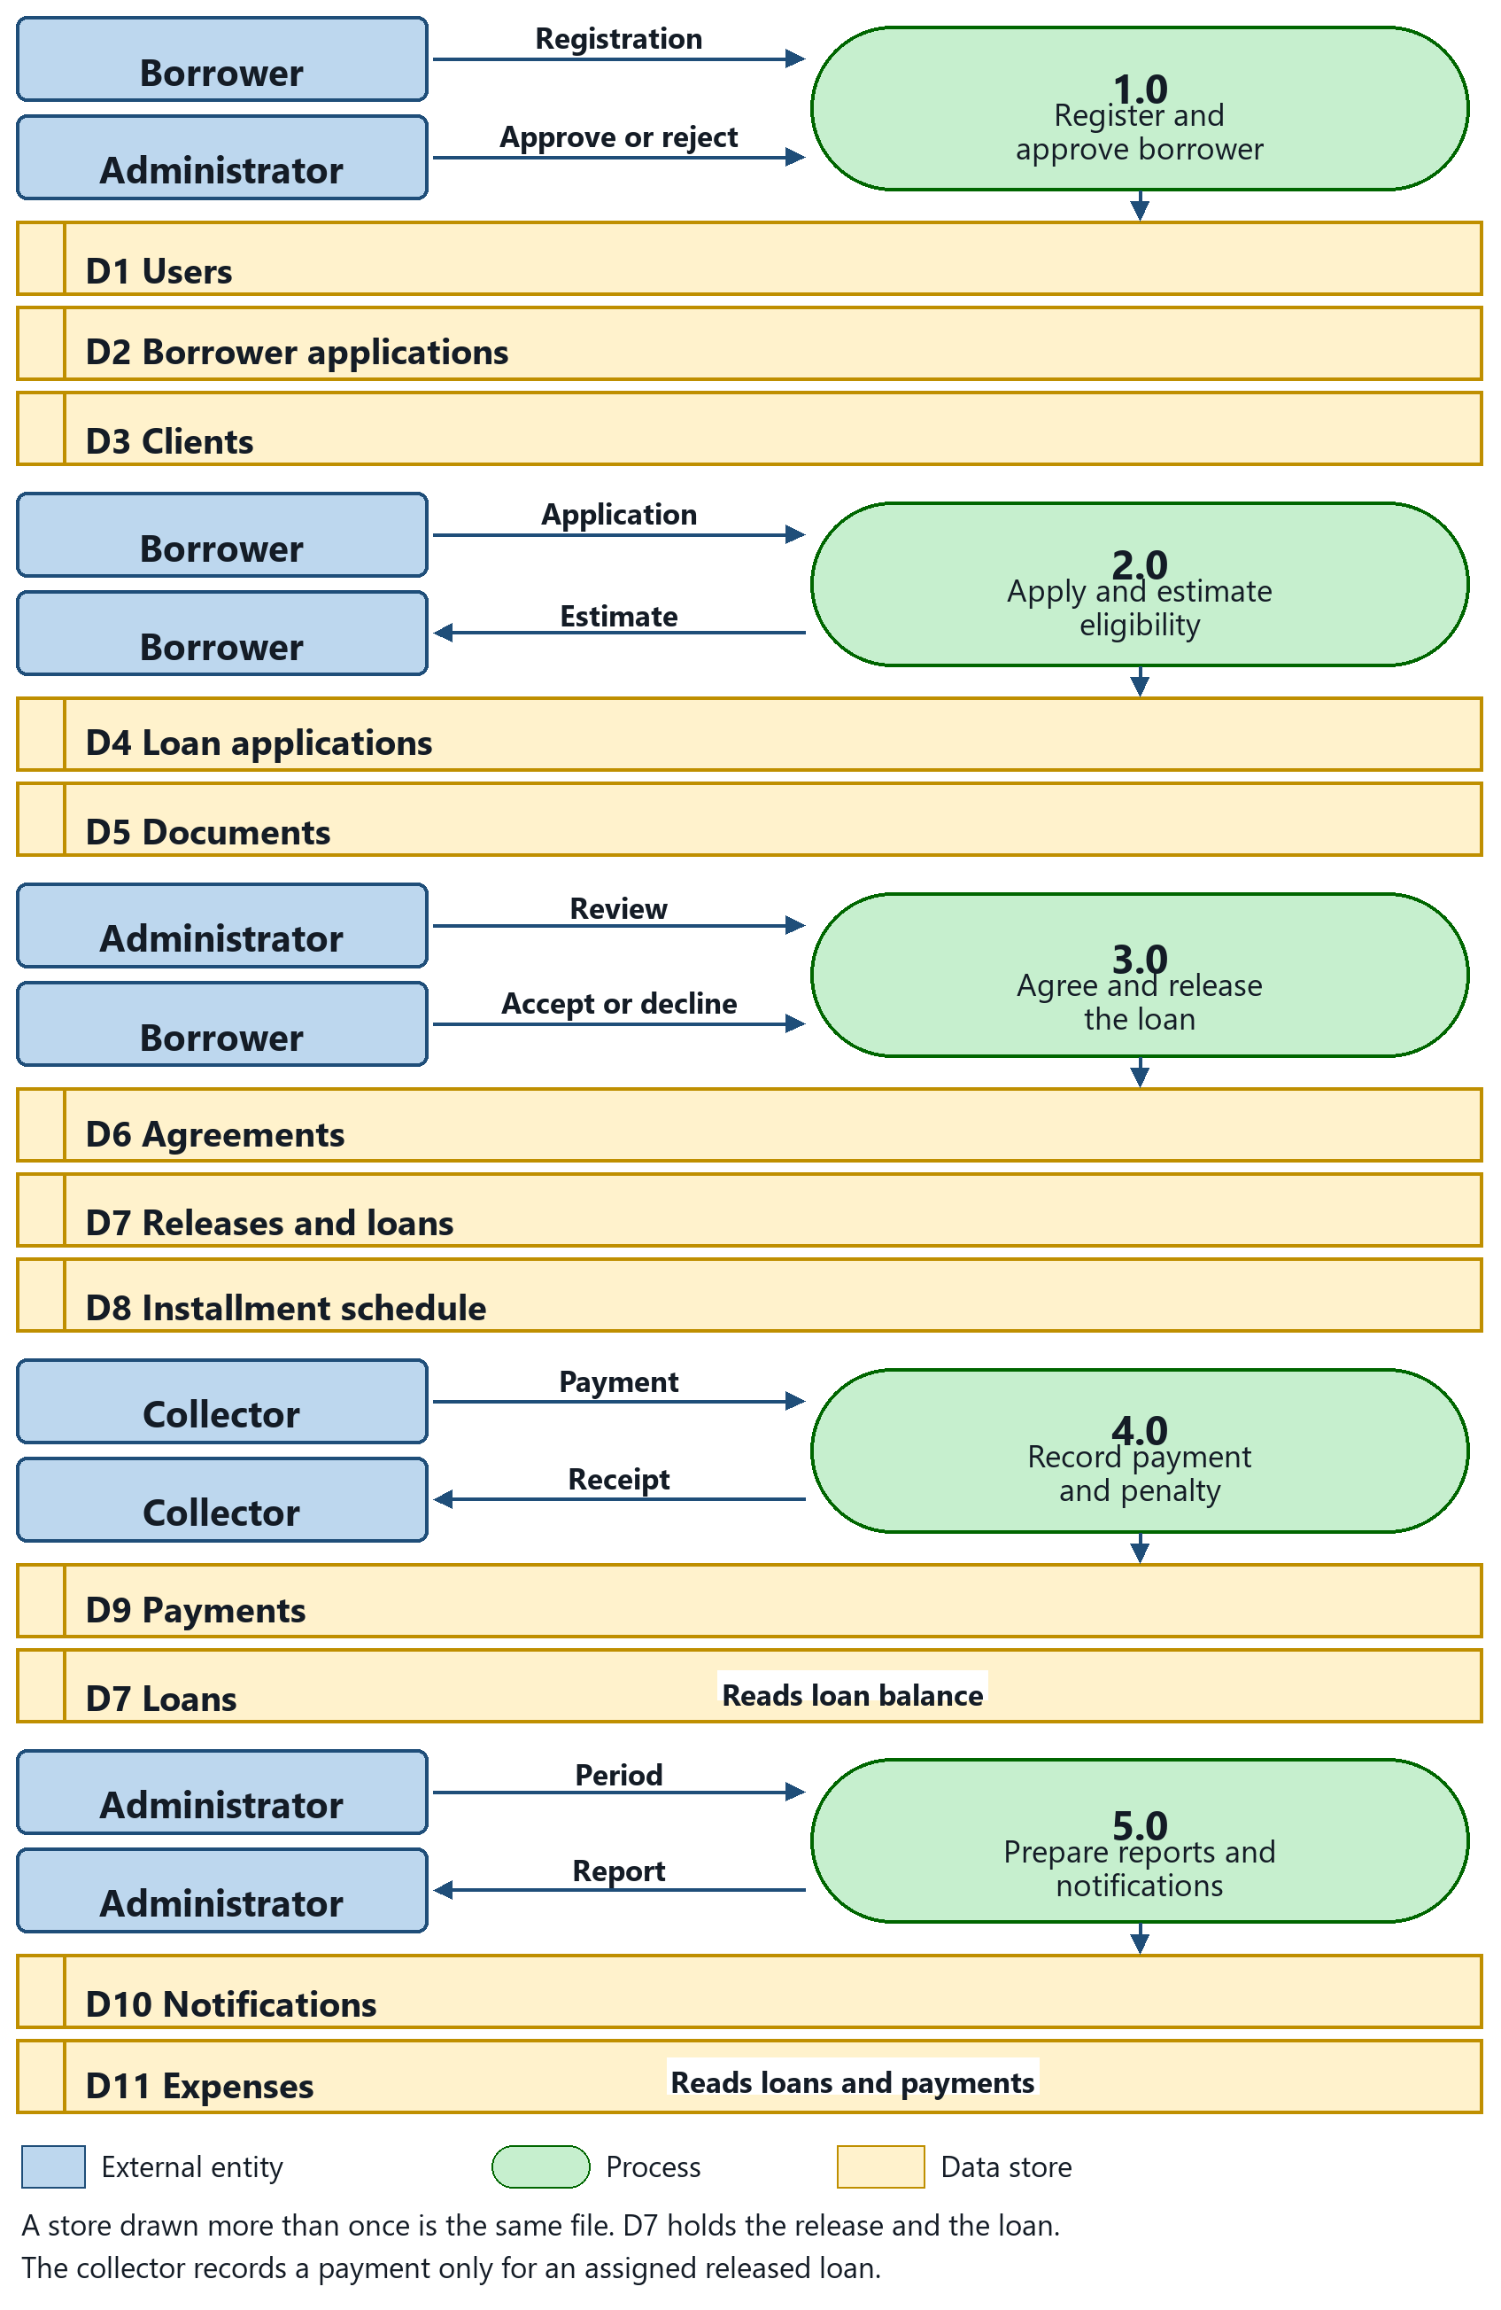

Figure 2 Level 1 Data Flow Diagram of FRAMS
Entity-Relationship Diagram (ERD)
Figure 3 is the entity-relationship diagram of FRAMS. A user account owns the borrower registration, the client record, password-reset tokens, and in-application notifications. A client is assigned to one collector through collector_id and may have many loans. A loan application belongs to the borrower's user account, stores the eligibility estimate, and links to its documents, reviews, one agreement, and one release. Releasing creates the loan and the installment rows. Installments are stored against the release through release_id. Payments belong to a loan. A PayMongo QR Ph attempt belongs to a loan and, after verification, to one payment. Contact messages from the public page are stored with their replies. Expenses and the email log are office records and are not required links to a loan.
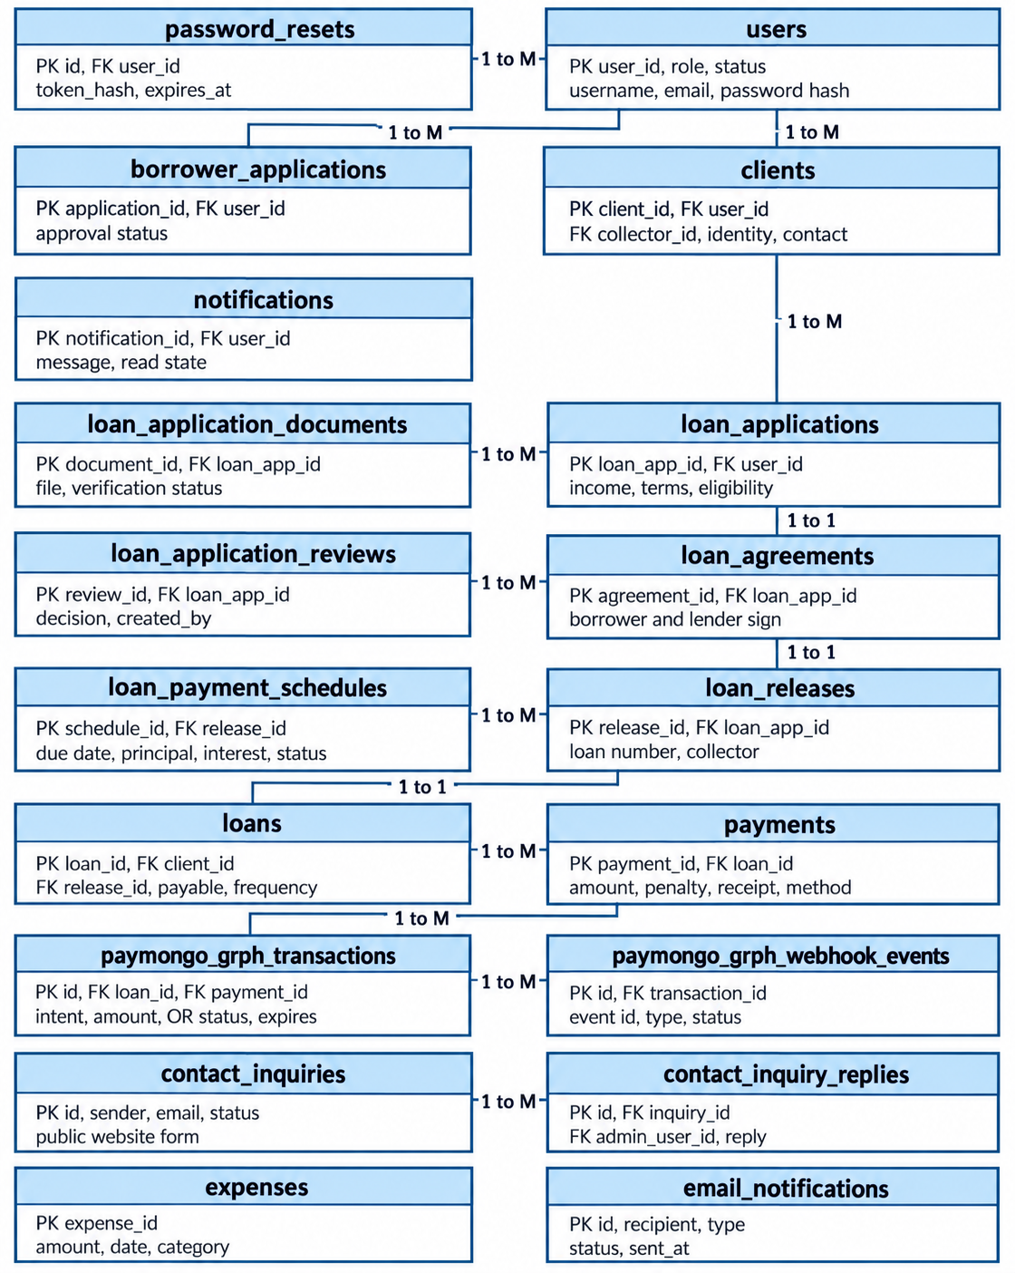
Figure 3 Entity-Relationship Diagram of FRAMS
users. Stores every account that can sign in. Each row holds the username, email, password hash, role (administrator, collector, or borrower), and account status. One user may be linked to many clients, borrower applications, and notifications.
borrower_applications. Stores a borrower’s request to open an account before that person becomes a client. It links to users through user_id and keeps the approval status of the registration.
clients. Stores the borrower profile used for lending. It links to the borrower’s user account and to the assigned collector through collector_id, and it keeps identity and contact details. One client may have many loans. Loan applications are stored on that borrower’s user account.
notifications. Stores messages sent to a user, such as application or payment updates. Each row links to users and records the message and whether it has been read.
loan_application_documents. Stores the files uploaded for a loan application, such as a valid ID, proof of income, proof of billing, a selfie holding the ID, and an additional supporting document. Each file links to loan_applications through application_id and keeps its verification status.
loan_applications. Stores a request for a loan. It links to the borrower’s user account through user_id and keeps the income, the requested terms, the eligibility status, and the assessment result. One application has many documents and, once approved, one agreement.
loan_agreements. Stores the borrower’s acceptance of the approved loan terms. It links one-to-one with loan_applications.
loan_releases. Stores the release of an approved loan, including the loan number. It links one-to-one with the agreement and with the loan record that follows.
loans. Stores the active loan after release. It links to the client and to loan_releases, and it keeps the total payable, payment frequency, and loan status. One loan has many schedule rows and many payments.
loan_payment_schedules. Stores each installment of a loan. A row links to the loan release through release_id and keeps the due date, principal, interest, amount due, and whether that installment is unpaid, paid, or overdue.
payments. Stores money collected for a loan. Each row links to loans and keeps the amount paid, any penalty included, the method, and the receipt number in the form RJRR-YYYYMMDD-######. A verified PayMongo QR Ph payment also stores the link to its QR Ph transaction.
expenses. Stores office expenses used in the financial report. Each row keeps the amount, date, and category. It is not linked to a borrower or a loan; it is read when the period report is prepared.
password_resets. Stores the expiring token used by the forgot-password page. Each row links to users.
email_notifications. Stores the result of selected email messages, including the recipient, message type, status, and send time. It is not required to link to a loan.
contact_inquiries. Stores the name, email, and message sent from the public page. An administrator reads and answers these records.
contact_inquiry_replies. Stores an administrator reply to one contact inquiry.
loan_application_reviews. Stores each administrator decision and review note for a loan application.
paymongo_qrph_transactions. Stores a collector-started Dynamic QR Ph attempt, including the loan, amount, payment-intent identifier, status, and expiry. A verified attempt links to one payment.
paymongo_qrph_webhook_events. This table exists in the operational schema and stores provider event rows when they are present. It is not part of the selected payment-confirmation workflow or of the official PayMongo evaluation scope. In the selected workflow, a repayment is posted after Payment Intent status polling or staff-initiated Check with PayMongo confirms success and the amount matches.
Process Design
The actors are the borrower, the collector, and the administrator. Figure 4 shows the activity those actors share. The borrower registers, applies, uploads documents, accepts or declines the agreement, and views the loan and receipts. The collector records payments for assigned loans. The administrator reviews, releases, assigns the collector, and opens users, expenses, penalties, and reports.
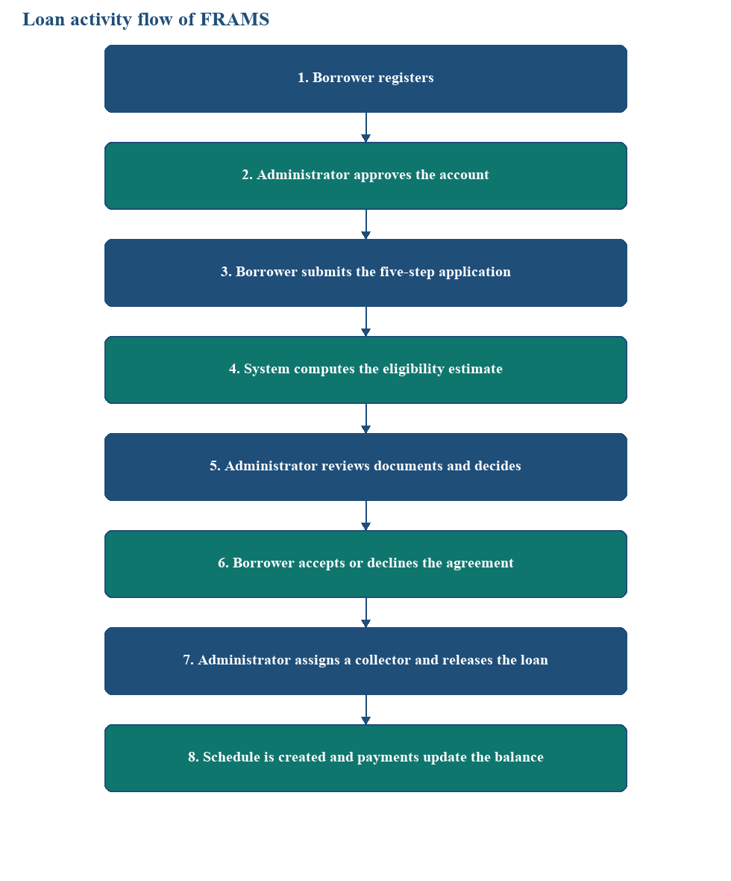
Figure 4 Loan activity flow of FRAMS
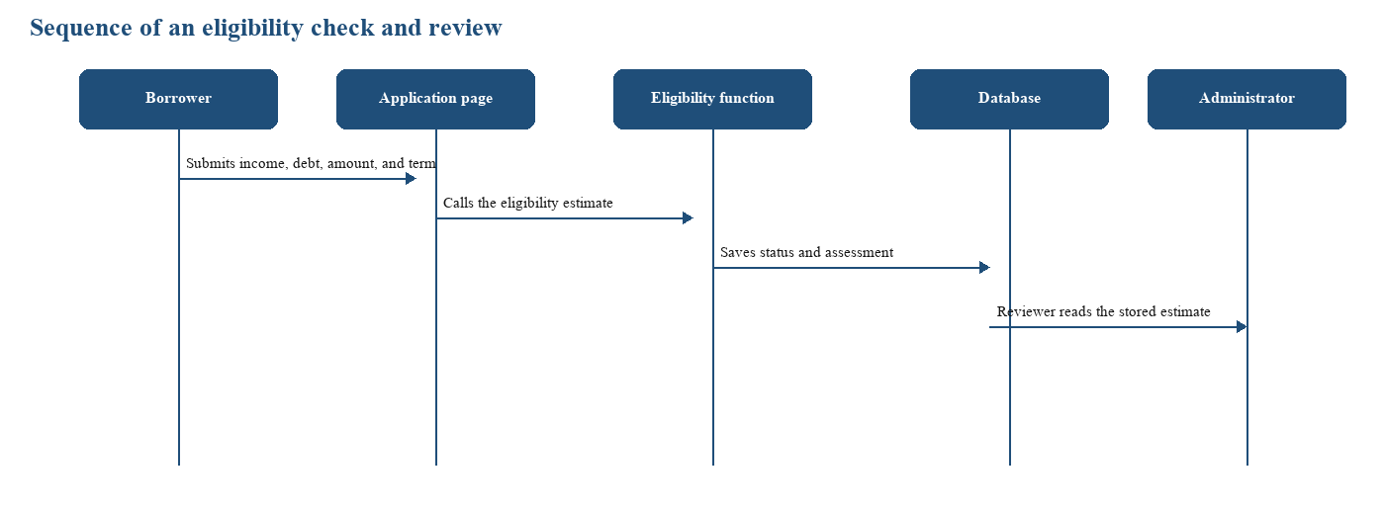
Figure 4 is the activity from registration through collection. The eligibility estimate sits before document review continues, and release sits only after the borrower accepts the agreement. Figure 5 is the sequence for that estimate. The borrower submits the figures, the application page calls the eligibility function, the result is saved, and the administrator reads the stored estimate on the review page. The administrator records the lending decision separately.
Figure 5 Sequence of an eligibility check and administrator review
System Process Flow
This section presents the operational flow of FRAMS with standard flowchart symbols. An oval marks the start or end. A rectangle marks a process. A diamond marks a decision, and its branches are labeled Yes and No. A parallelogram marks input or output. A cylinder marks a record read from or written to the database. A document symbol marks a file the system generates. Each chart follows the pages and rules in the implemented system.

Figure 5.1 presents the overall operational flow of FRAMS. The process begins when a user opens the staff login or borrower login page and enters a username or email address and password. FRAMS checks the credentials and account status. If access is denied, the system displays an appropriate message and returns the user to the login page. If authentication succeeds, the user is directed to the dashboard permitted by the assigned role.
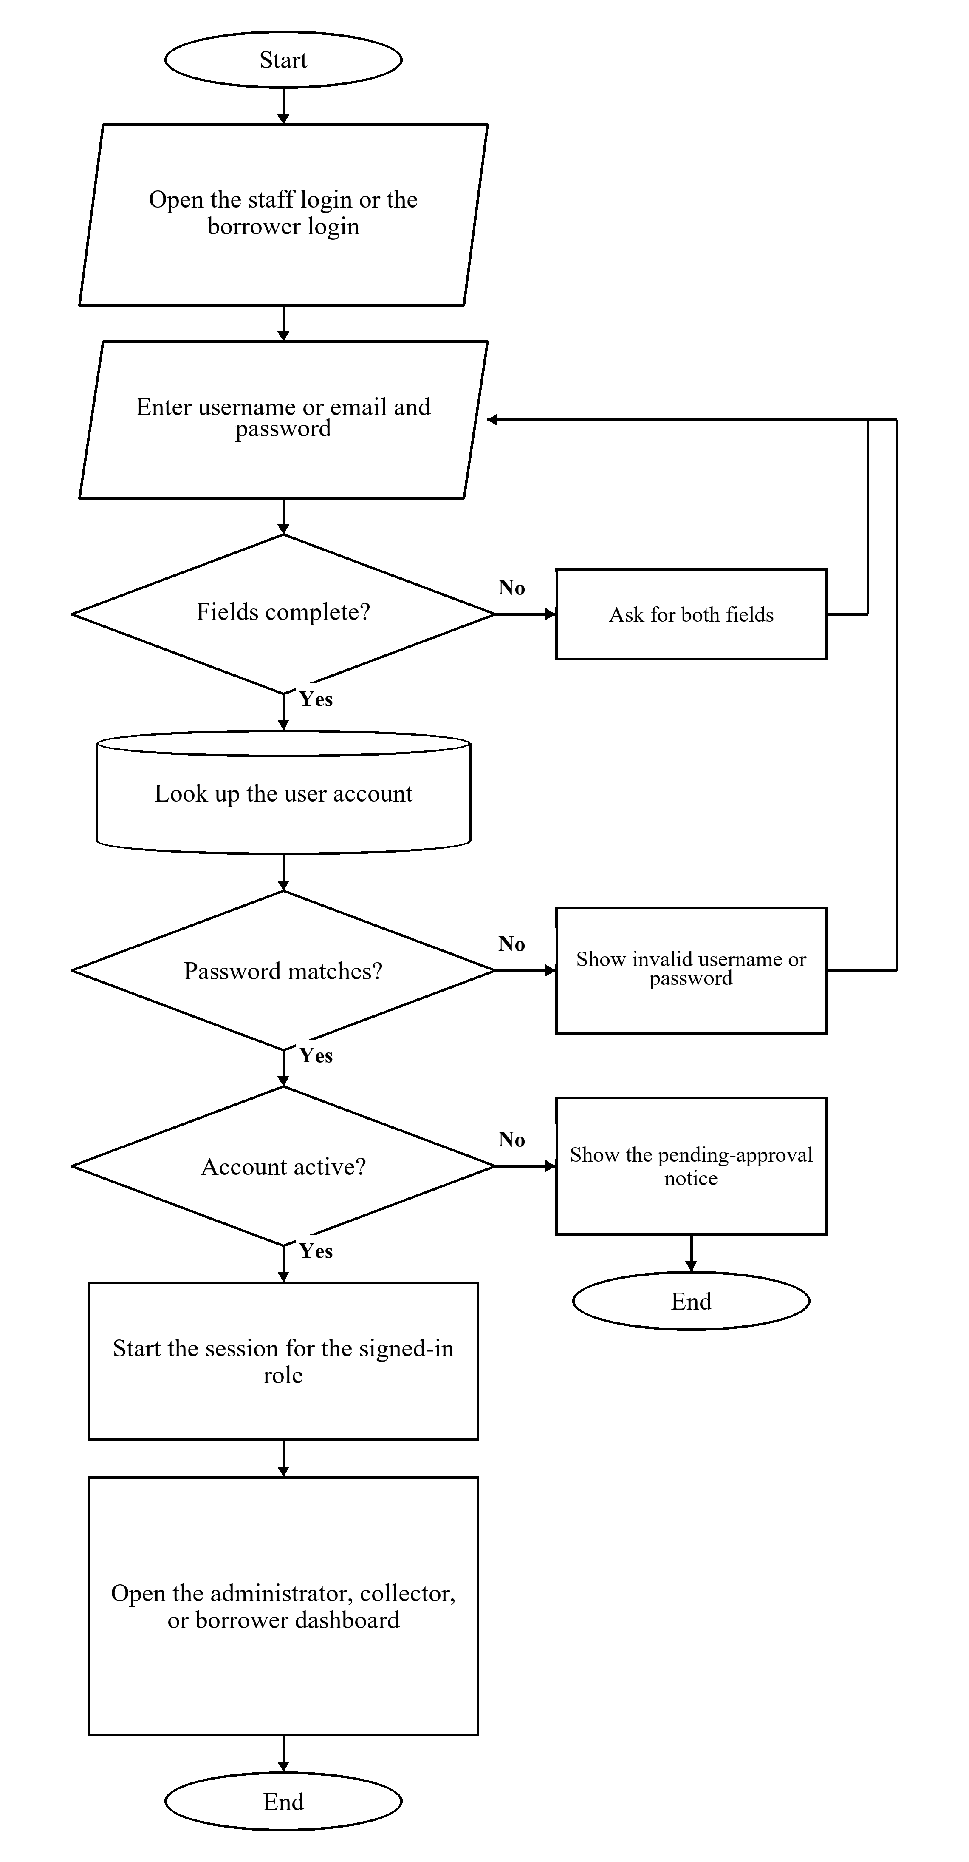
User Authentication Flow

Figure 5.2 FRAMS User Authentication Flowchart
Figure 5.2 shows how FRAMS authenticates a user. The process starts on the staff login page or the borrower login page. The user enters a username or email and password. If either field is empty, the page asks for both fields and returns to the form. If the fields are complete, FRAMS looks up the account. A password that does not match produces an invalid-login message and returns to the form. A matching password on an account that is not yet active, including a borrower registration that is still pending approval, produces a pending-approval notice and ends without a session. When the password matches and the account is active, FRAMS starts a session and opens the administrator dashboard, the collector dashboard, or the borrower dashboard according to the role.

Borrower Registration Flow
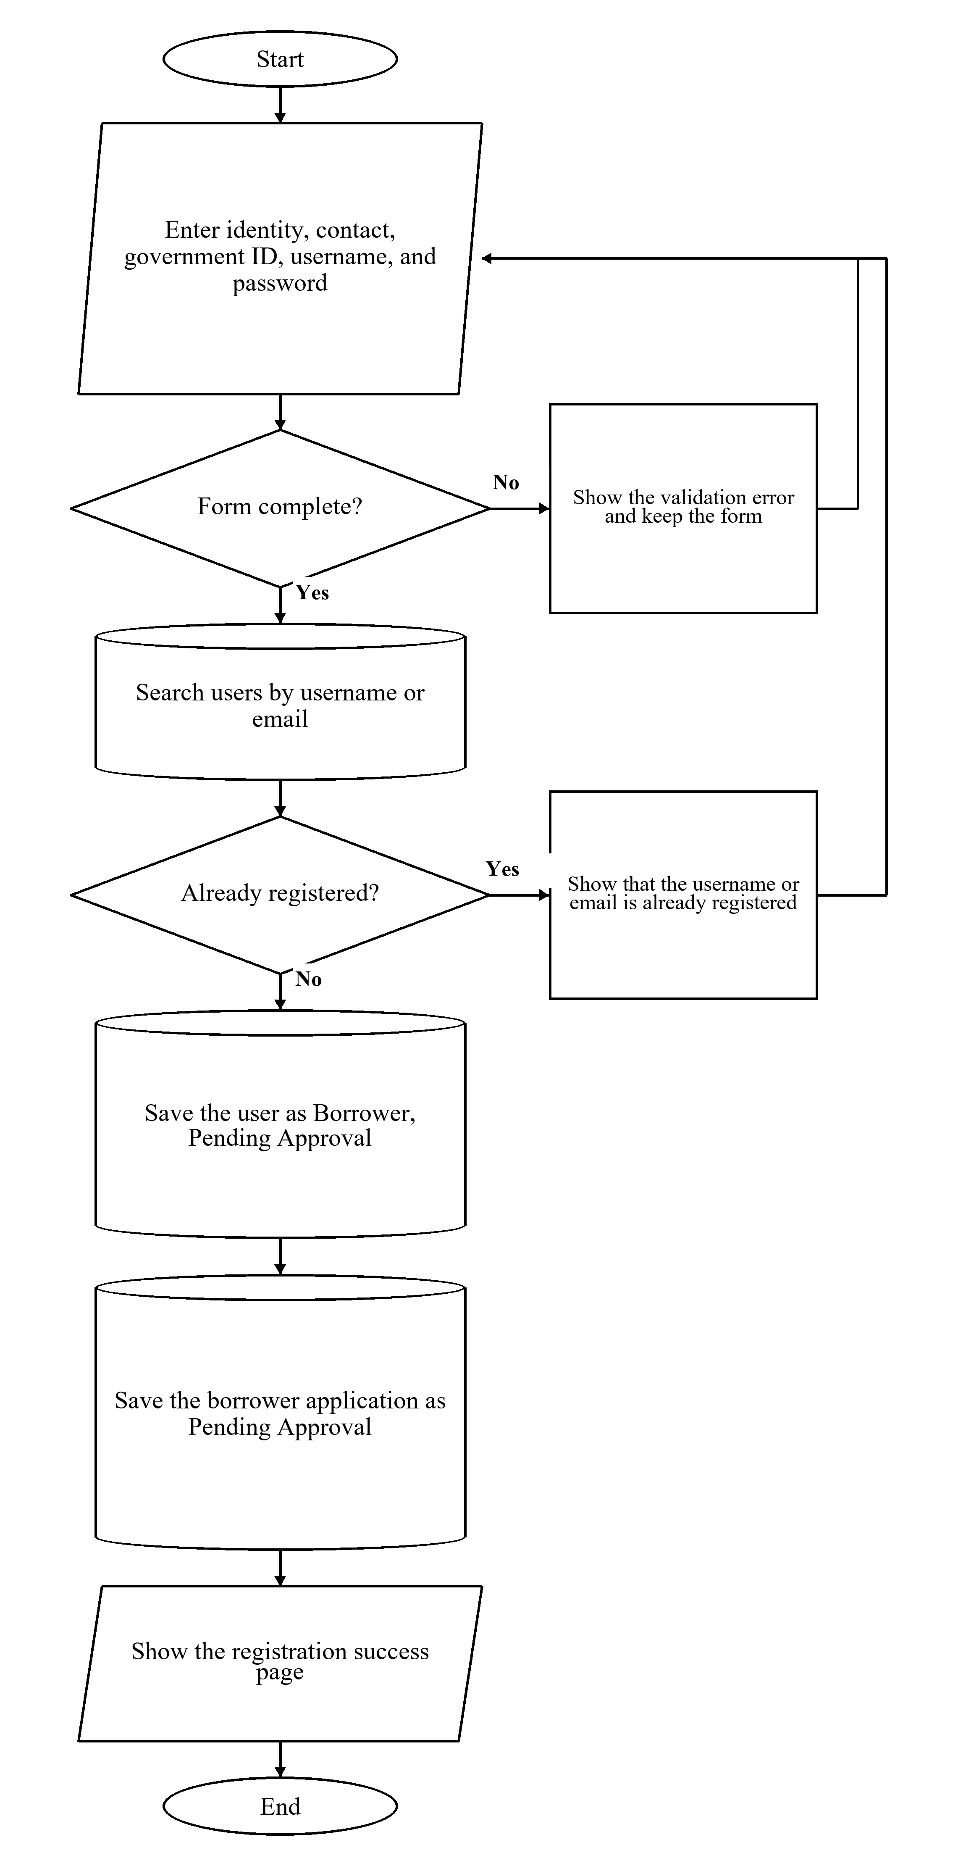

Figure 5.3 FRAMS Borrower Registration Flowchart
Figure 5.3 presents borrower registration. The applicant enters identity, contact, government identification, username, and password, and gives consent. If a required field is missing or the passwords do not match, the page shows a validation error and keeps the form. If the form is complete, FRAMS searches the user records by username or email. An existing username or email stops registration and shows that the account is already registered. When no matching record is found, the system stores the user with the role Borrower and the status Pending Approval and stores the borrower application with the same pending status. The registration success page is the result. The account can sign in after an administrator approves it.
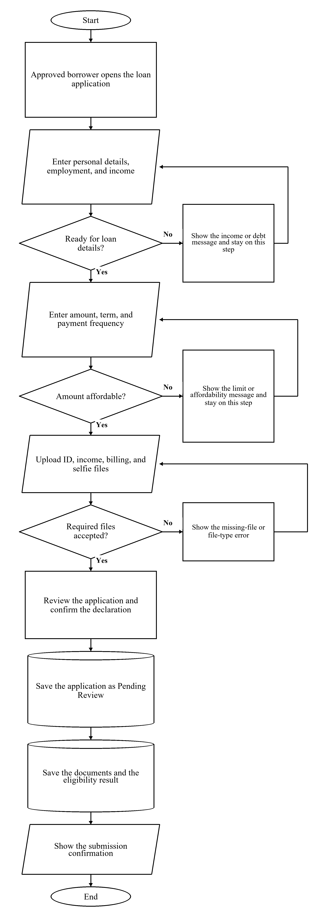
Loan Application Flow

Figure 5.4 FRAMS Loan Application Flowchart
Figure 5.4 traces the loan application completed by an approved borrower. The borrower enters personal details, employment, and income. FRAMS opens the loan-details step when employment status and income are present, existing debt is within the debt-to-income guidelines, and there is room for a new payment. Otherwise, the page shows the income or debt message and stays on that step. The borrower then enters the amount, term, and payment frequency. The wizard stays on that step when the amount is outside the configured loan limits, when debt-to-income after the proposed loan is over the limit, or when the requested amount is above the estimated affordable principal. The borrower uploads a valid government ID, proof of income, proof of billing, a selfie holding a valid ID, and an additional supporting document. All five files are required. Accepted files are JPG, PNG, or PDF and are limited to 8 MB. After the borrower reviews the application and confirms the declaration, FRAMS saves the application as Pending Review, saves the documents, and saves the eligibility result. The confirmation page is shown, and the application awaits administrator review.

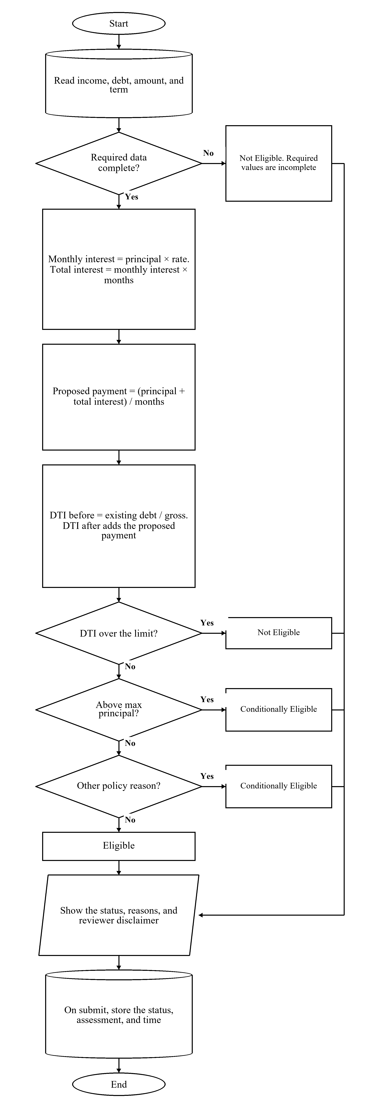

Figure 5.5 Financial Risk Assessment Flow

Figure 5.5 shows the eligibility estimate used during the application and again on the administrator review page. The process reads income, existing debt, the requested amount, and the term. If a required value is missing, the status is Not Eligible, and the page lists the missing information. When the data are complete, monthly interest equals the principal multiplied by the monthly rate, total interest equals that monthly interest multiplied by the term in months, and the proposed monthly payment equals the principal plus total interest, divided by the term. Debt-to-income before the loan exists monthly debt divided by gross income. Debt-to-income after the loan adds the proposed payment. The maximum affordable payment is gross income multiplied by the configured debt-to-income limit, minus existing debt. The maximum principal is that affordable payment multiplied by the term, divided by one plus the rate multiplied by the term, and then kept within the minimum and maximum loan amounts. The configured defaults are a 40 percent debt-to-income limit, a loan range of 3,000 to 500,000 pesos, a minimum employment length of three months, and a monthly interest rate of 5 percent. Debt-to-income after the loan above the limit produces Not Eligible. A requested amount above the maximum principal, or another policy reason such as employment shorter than the minimum or net income greater than gross income, produces Conditionally Eligible. The remaining complete applications are Eligible. The page shows the status, the reasons, and the reviewer disclaimer. When the application is submitted, FRAMS stores the status, the assessment, and the time on the loan application. The administrator records the lending decision separately.

Loan Approval and Release Flow

Figure 5.6 FRAMS Loan Approval, Agreement, and Release Flowchart

Figure 5.6 shows administrator review through release of funds. The process starts when the administrator opens the application, the documents, and the stored eligibility estimate, and marks each document verified or rejected. If the application is not approved, the administrator rejects it and records the reason or requests more documents and sets the status to Documents Incomplete. In either case the borrower is notified and that branch ends. Approval sets the status to Waiting for Loan Agreement, saves or updates the client, and saves a loan marked Pending Release. FRAMS then generates the agreement and records the lender’s acceptance. The borrower reviews the agreement and either types a name to accept it or enters a reason to decline it. A decline is stored, both sides are notified, and release stops. Release continues when both acceptances are on record, an active collector is assigned, the loan amount is valid, and the application has not already been released. That step saves the loan number, the release record, and the installment schedule, and notifies the borrower that the loan has been released.

Payment and Collection Flow

Figure 5.7 FRAMS Payment and Collection Flowchart

Figure 5.7 shows how an administrator or the assigned collector records a cash, bank transfer, or e-wallet payment on a released loan. A staff member selects the loan, and the page shows the remaining balance and the penalty due. Penalty due is computed from unpaid installments whose due date has passed, at 1 percent for a daily schedule, 2 percent for weekly, 3 percent for semi-monthly, and 5 percent for monthly, after penalty amounts already recorded on payments are applied. The staff member enters the amount received, the date, the method, and any penalty portion. The form is shown again when the amount is not greater than zero, when the penalty portion is larger than the amount received, or when the payment is larger than the remaining balance plus the penalty due. A valid payment is saved with a receipt number. The balance is recomputed from the total payable minus the payments on record, and the installment status is updated. The receipt can then be viewed, printed, or downloaded.
Figure 5.7 is the immediate recording path for cash, bank transfer, and e-wallet. An administrator or the assigned collector can save that payment as soon as the amount is valid. PayMongo Dynamic QR Ph waits for later confirmation. The Create Dynamic QR Ph action is shown only for bank transfer or e-wallet, and only a collector can start it. The page stores a pending QR Ph transaction and shows the code. While that page remains open, FRAMS polls the Payment Intent API. If the page is closed while the attempt is still pending, expired, or failed, authorized staff can select Check with PayMongo. The balance stays unchanged until the Payment Intent is confirmed as succeeded and the paid amount matches the pending transaction. Displaying the QR code does not record the repayment. A failed, expired, or mismatched attempt does not post a payment. A recorded QR Ph payment remains linked to the transaction.
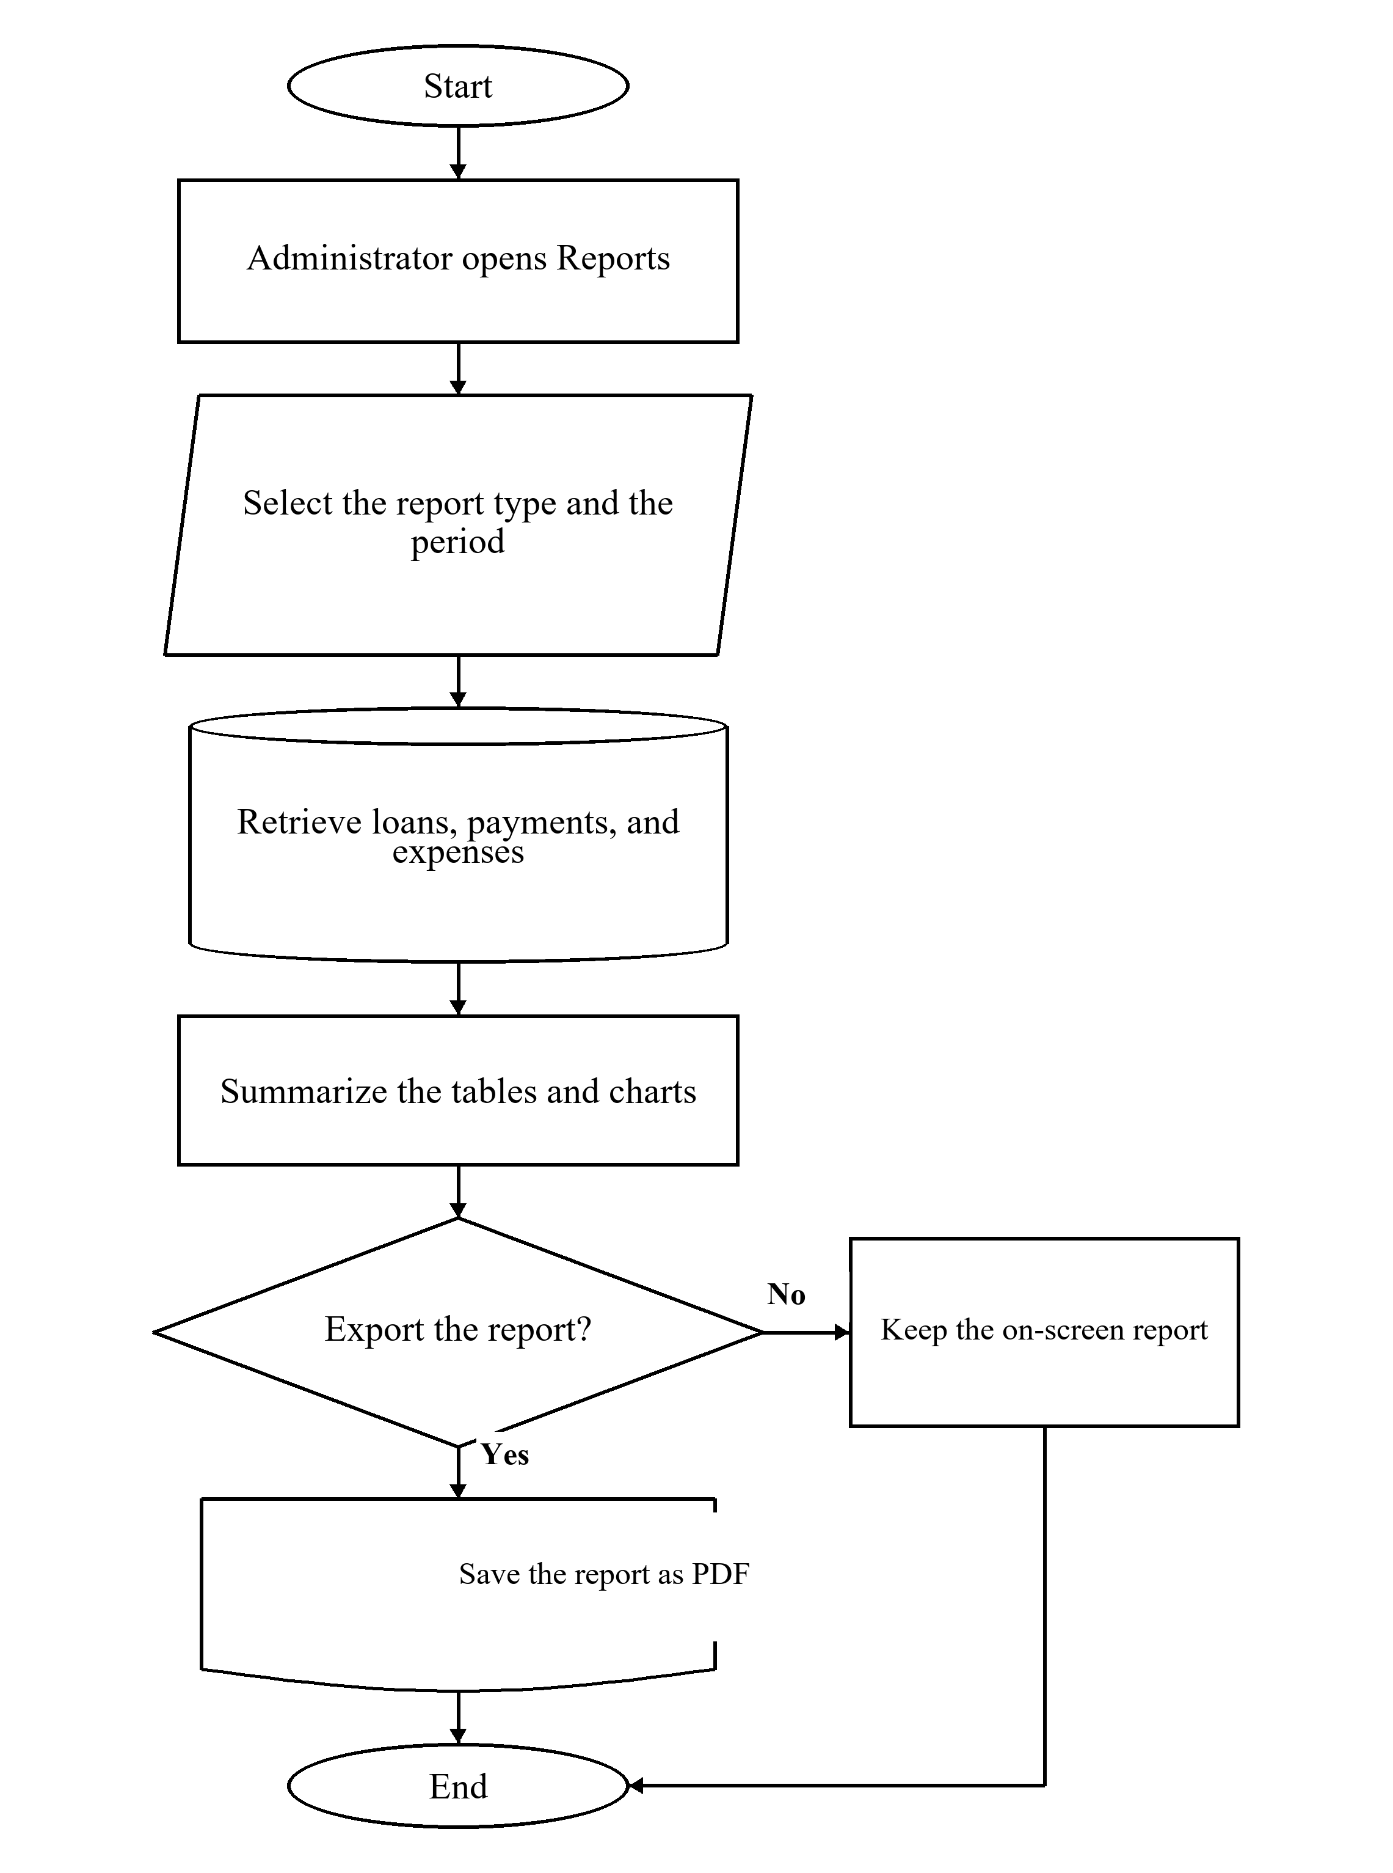
Report on Generation Flow

Figure 5.8 FRAMS Report Generation Flowchart
Figure 5.8 shows report generation, which is available to the administrator. The process starts when the administrator opens Reports and selects the report type and the period. The report types are dashboard analytics, loan reports, payment reports, borrower reports, collector performance, and the financial summary. The period may be daily, monthly, yearly, or a custom range. FRAMS retrieves the related loans, payments, and expenses and summarizes them as tables and charts. The administrator may keep the report on screen or export it. Exports are saved as PDF.
Technical Tools
Hardware Requirements
Equipment | Use
Computer running the local web server and MySQL | Hosts the application during development and office use
Staff computer with a current browser | Administrator and collector work
Borrower phone or computer with a browser | Registration, application, agreement, and loan viewing
Local network | Connects the browser to the office server

Table 2 Hardware used for FRAMS
Software Requirements
Component | Software
Server-side language | PHP 8.1 or newer
Database | MySQL through PDO
Web server | Apache; XAMPP is the documented local package
Browser interface | HTML, CSS, JavaScript, and Bootstrap
Charts and export | Chart.js for charts. The reports page exports the current view as PDF
Mail | PHPMailer for selected messages when mail is configured
Operating system | Windows for the development machine
Browsers | Google Chrome, Microsoft Edge, and Mozilla Firefox

Table 3 Software used for FRAMS
Development and Testing Environment
Development used a local XAMPP environment, MySQL, and a code editor, with the project files kept under version control. Testing follows the capstone requirement for unit testing, integration testing, and user acceptance testing.
Unit Testing
Unit testing evaluated individual functions and validation rules within FRAMS. The tests covered authentication, registration, loan eligibility validation, document uploads, and payment amount validation. Each function was assessed independently to determine whether it produced the expected result. The six test cases, identified as UT-01 to UT-06, are presented in Table 4.4.

Integration Testing
Integration testing evaluated whether connected modules worked together correctly. The tests covered the workflow from borrower approval and login to loan application submission, eligibility assessment, loan release, installment schedule generation, payment recording, balance updates, borrower payment history, and report generation. The seven integration test cases, identified as IT-01 to IT-07, are presented in Table 4.5.
System Testing
System testing evaluated FRAMS as a complete application to determine whether its major features and workflows operated according to their intended requirements. The evaluation covered borrower management, loan processing, repayment monitoring, notifications, and report generation. Twelve system test cases, identified as ST-01 to ST-12, were conducted to assess the specified system functions. The test cases and their corresponding results are presented in Table 4.6.
PayMongo QR Ph Testing
PayMongo QR Ph testing evaluated the integration between FRAMS and PayMongo's QR Ph payment processing. The tests covered QR code creation attempts, payment amount validation, cash-versus-QR controls, collector assignment restrictions, borrower access restrictions, unresolved pending payment attempts, unresolved pending payment attempts, receipt display, and payment-record listing. The procedure used an isolated FRAMS test server and disposable test records to assess the specified payment workflows. Payment Intent polling and staff-initiated Check with PayMongo are implemented on the payments page; they were not included as separately passed cases in Table 4.7 because no dedicated polling or staff-reconciliation screenshot series was supplied for those actions.
The testing evidence distinguishes provider rejection caused by an isolated invalid test key from successful QR code creation. The official PayMongo evaluation scope contains 11 test cases, PM-01 to PM-10 and PM-12, presented in Table 4.7, with supporting evidence in Figures B26–B35 and B37. The former local-endpoint signature case (Figure B36) is excluded from the official count because it is outside the selected Payment Intent polling and staff Check with PayMongo workflow. No live PayMongo charge is claimed.
Penetration and Security Testing
Penetration and security testing assessed selected FRAMS security controls through twelve controlled, non-destructive checks in the isolated test environment. The checks covered authentication, including signed-out access, incorrect-password handling, and inactive-account restrictions; role-based access control for borrowers and collectors; missing security tokens and cross-site request forgery (CSRF) protection; SQL injection probes; output encoding and cross-site scripting (XSS) protection; borrower-record ownership restrictions; collector assignment controls; file-upload validation; session behavior after logout; and password-reset-code validation.
The twelve penetration test cases, identified as PT-01 to PT-12, are presented in Table 4.8, with detailed results and supporting screenshots provided in Figures B38–B49. The findings are limited to the specific test cases and conditions examined. Passing these checks does not establish that the entire application is free of vulnerabilities.

CHAPTER IV
SYSTEM IMPLEMENTATION AND RESULTS
This chapter presents the implementation and observed testing results of the Financial Risk Assessment and Micro-Lending System (FRAMS) for RJ and RR Finance Services. In the running interface, the organization is identified as RJ and RR Finance Services, and some page titles use the label Lending Management System. The discussion is limited to functions and outcomes supported by the application, test records, and supplied evaluation data. The manuscript distinguishes documented functional test cases from repeated execution runs, and it identifies limitations where original questionnaire records or external-provider evidence are not available.
System Implementation
FRAMS was implemented as a browser-based application for a local Apache, PHP, and MySQL environment. The documented local setup is XAMPP, with the application placed under the web server document root. Authorized users open the pages in a web browser. The server renders each page, checks the signed-in role, reads and writes the database, and returns HTML. There is no separate mobile application and no separate public web service for the screens. The payments page uses two authenticated JSON lookups. One loads the selected loan and its remaining balance into the payment form. The other refreshes a pending PayMongo QR Ph transaction by retrieving its Payment Intent status and returns the stored result. Authorized staff can start the same retrieval from the payments list by selecting Check with PayMongo. A QR Ph repayment is posted only after that status is succeeded and the amount matches.
The user interface uses HTML, CSS, and JavaScript, with Bootstrap, Font Awesome, and Bootstrap Icons stored in the application assets. Chart.js renders dashboard and report charts, and the reporting page provides PDF export. Server-side processing is written in PHP, and MySQL is accessed through PHP Data Objects (PDO). The project dependency file specifies the PHP requirements and PHPMailer for selected email messages.
Table 4.1
Technologies used in the implementation of FRAMS
Component | Tool or technology | Purpose in the implemented system
Server-side language | PHP | Processes forms, roles, loan computations, and page output
User interface | HTML, CSS, JavaScript, Bootstrap | Renders forms, navigation, tables, and messages
Database | MySQL through PDO | Stores users, applications, loans, schedules, and payments
Charts | Chart.js | Displays dashboard and report charts from query results
Mail | PHPMailer and the project mail helpers | Sends selected account, application, release, and payment messages when mail is configured
Local server | Apache with PHP and MySQL; XAMPP is the documented local setup | Hosts the application during development

The source is organized by responsibility. Each major screen is a PHP page. Shared files under the include directory handle the database connection, session and role checks, cross-site request tokens, loan interest and schedules, the eligibility estimate, navigation, mail, and document checks. Pages that change data call the token check before the update is saved. Text written back into a page has escaped in the templates that were inspected. Database statements that receive user input use prepared statements, with emulated preparations turned off. A failed database connection is written to the error log, and the user sees a short failure message rather than the connection details.
Authentication starts at a login page. Borrowers use the borrower login. Administrators and collectors use the staff login. The program looks up the account by username or email and checks the password with password_verify. New passwords are stored with password_hash. An account must be active. A borrower must also be approved before the borrower login continues. A successful login stores the user and role in the PHP session and opens the dashboard for that role. Logout destroys the session. Pages that require a signed-in user redirect an anonymous visitor to the staff login. Administrator-only pages stop a collector or a borrower. Borrower queries add the signed-in user. Collector queries add the assigned collector.
Loan amounts are calculated through shared functions rather than entered as precomputed totals. The standard monthly interest rate is 5%, subject to the configured rate used for a particular loan. FRAMS uses flat interest calculated against the original principal for each month of the loan term; it is not a declining-balance amortization method.
Formula 1. Monthly Interest
MI = P × (r / 100)

MI represents monthly interest, P is the original loan principal, and r is the monthly interest rate expressed as a percentage.

Formula 2. Total Interest
TI = MI × n

TI is total interest over the loan term, and n is the term in months.

Formula 3. Total Payable
TP = P + TI

TP is the scheduled total payable before separately assessed penalties.

For example, a principal of ₱10,000 at 5% monthly interest for six months produces monthly interest of ₱500, total interest of ₱3,000, and total payable of ₱13,000.

The installment count depends on payment frequency. When start and end dates are unavailable, the system uses the configured conventions shown below.

Formula 4. Number of Installments
Monthly: N = n | Semi-monthly: N = 2n
Weekly: N = 4n | Daily: N = 30n

N represents the number of installments and n is the term in months. The weekly and daily calculations use four weeks and thirty days per month, respectively, under the fallback rules described.

Formula 5. Principal Per Installment
PI = P / N

Formula 6. Interest Per Installment
II = TI / N

Formula 7. Scheduled Installment Amount
IA = PI + II = TP / N

PI is the principal portion, II is the interest portion, and IA is the scheduled installment amount. For example, ₱13,000 divided over six-monthly installments is approximately ₱2,166.67 per installment, subject to any rounding adjustment implemented by the system.
Due dates advance by one day for daily payments, seven days for weekly payments, fifteen days for semi-monthly payments, and one calendar month for monthly payments. The final due date is set to the release date plus the loan term in months.
Formula 8. Final Due Date
FD = RD + n months

FD represents the final due date, RD is the loan release date, and n is the term in months. The final due-date rule may cause the final interval to differ from the regular interval in some schedules.
Financial Risk Assessment and Eligibility
The financial risk function produces an eligibility estimate for reviewer use. It is not an approval and does not predict default. The function reads monthly gross income or an alternative monthly income field when gross income is missing, existing debt payments, other monthly obligations, employment status, employment or business duration, requested loan amount, loan term, and interest rate. Dependents and collateral notes are stored with the application but are not variables in the numerical formula described here. An empty credit-history note leaves the numeric result unchanged. A text note may be included as a reason concerning previous loans recorded in the system; an external credit-bureau report is outside the estimate. If required fields are missing, the status is Not Eligible, and the missing fields are listed rather than guessed.

Policy values are supplied through the environment or code defaults. The defaults described for the system are a maximum DTI of 40%, minimum loan amount of ₱3,000, maximum loan amount of ₱500,000, minimum employment or business duration of three months, and a standard monthly interest rate of 5%.

Formula 9. Existing Debt-to-Income Ratio
DTI_before = (E / I) × 100

E is existing monthly debt payments plus other monthly obligations, and I represents monthly gross income.

Formula 10. Proposed Debt-to-Income Ratio
DTI_after = ((E + MP) / I) × 100

MP is the proposed monthly payment. The system description specifies that this payment is calculated as total payable divided by the loan term in months.

Formula 11. Proposed Monthly Payment
MP = TP / n

The proposed monthly payment is used for the monthly DTI comparison. It should not be confused with an individual weekly, daily, or semi-monthly installment.

Formula 12. Maximum Affordable New Payment
MAP = (I × (Dmax / 100)) − E

MAP is the maximum affordable new monthly payment, Dmax is the maximum DTI percentage (default 40%), I is monthly gross income, and E is existing monthly obligations.

Formula 13. Maximum Affordable Principal
Pmax = (MAP × n) / [1 + ((r / 100) × n)]

Pmax is the maximum affordable principal before applying the configured loan limits, n is the term in months, and r is the monthly interest rate expressed as a percentage. The result is limited by the configured minimum and maximum loan amounts: minimum ₱3,000 and maximum ₱500,000 by default.

The eligibility estimate assigns Not Eligible when required information is missing, proposed DTI exceeds the configured limit, or a blocking validation fails. It assigns Conditionally Eligible when the requested amount exceeds the maximum affordable amount or other policy reasons remain. It assigns Eligible when the affordability figures fall within the limits and no disqualifying policy reason remains. The application wizard blocks progression when existing debt already exceeds the limit or when the requested amount fails the minimum, maximum, or DTI validation. The administrator retains authority to approve, reject, or request additional documents. The stored disclaimer states that the estimate is for reviewer use and is not a final lending decision or automatic approval.
When available payment capacity is zero or negative, the maximum affordable new payment is stored as zero, the maximum principal is zero, and the estimate is Not Eligible because that principal is below the minimum loan amount. If proposed debt-to-income and the principal limit both fail, both reasons are recorded, and the stored status is Not Eligible; the debt-to-income failure is applied first in the status rule. A partial payment may include a penalty portion. The total received cannot exceed the remaining scheduled balance plus the penalty still due, the penalty portion cannot exceed the outstanding penalty, and the installment portion cannot exceed the remaining scheduled balance.
Payment Processing, Remaining Balance, and Penalties
The system validates payments before recording them. The payment must be greater than zero. A penalty cannot exceed the amount received. The amount received cannot exceed the remaining scheduled loan balance plus the penalty still due, and the installment portion cannot exceed the remaining scheduled balance.

Formula 14. Cumulative Amount Paid
AP = Σ Aᵢ, for i = 1 to m

AP is the sum of amounts recorded as paid toward the loan, Aᵢ is the amount for transaction i, and m is the number of payment transactions included in the sum.

Formula 15. Remaining Loan Balance
RB = TP − AP

RB is the remaining scheduled loan balance, TP is the total scheduled principal-and-interest payable, and AP is the amount applied to that scheduled payable. Penalties are tracked separately and are excluded from RB. For example, if TP is ₱13,000 and the amount applied to the scheduled payable is ₱5,000, the remaining scheduled balance is ₱8,000. Any penalty included in a payment must not also be counted as an amount applied to the scheduled balance.

An installment is overdue when its due date has passed and it remains unpaid. The described implementation calculates a penalty for an overdue unpaid installment by multiplying the installment total by a rate associated with the payment frequency.

Formula 16. Penalty Per Overdue Installment
PN = IA × (p / 100)

PN is the penalty for an overdue installment, IA is the scheduled installment amount, and p is the penalty percentage. The configured rates described are 1% for daily, 2% for weekly, 3% for semi-monthly, and 5% for monthly loans. For example, a ₱2,000 monthly installment at 5% produces a penalty of ₱100. These percentages should not be described as compounding daily rates unless the source code explicitly applies compounding.

Penalty amounts already recorded on payments are applied against installment penalties in schedule order.
Formula 17. Outstanding Penalty Per Installment
OPⱼ = max (0, PNⱼ − RPⱼ)

OPⱼ is the outstanding penalty for installment j, PNⱼ is the calculated penalty for that installment, and RPⱼ is the amount of previously recorded penalties applied to it.

Formula 18. Total Outstanding Penalties
OP_total = Σ OPⱼ, for j = 1 to k

OP_total is the sum of outstanding penalties across k installments with applicable penalties.

Formula 19. Total Outstanding Amount
OA = RB + OP_total

OA is the total outstanding amount. This formula is appropriate when RB excludes penalties and penalties are tracked separately; otherwise, the same penalty must not be counted twice.

Document Upload Validation
Uploaded requirements are limited to 8 MB and accepted formats are JPG, PNG, and PDF. The server checks the detected file type rather than relying only on the file extension.
Database Implementation
The operational database name in the connection file is lending_management, unless the environment supplies another name. The connection uses the host, database, user, and password from that configuration, with a local default. A structure-only schema dump of the operational database lending_management is provided as Appendix L and as the accompanying file FRAMS_APPENDIX_L_Database_Schema.sql. That dump includes the required tables, primary keys, unique keys, and the one declared foreign key. The PayMongo QR Ph tables are also created from the SQL files in database/migrations/. After the dump is imported, several feature columns continue to be created or extended when the related page first runs. Eligibility results are columns on the loan application, not a separate risk table. Passwords are stored as hashes. This section does not list credentials.
Table 4.2
Implemented database entities of FRAMS
Entity | Purpose
users | Accounts, roles, status, profile data, and the password hash
borrower_applications | Public registration and the approval decision
clients | Borrower records used for loans and collector assignment
loan_applications | Requested terms, income fields, status, remarks, and the saved eligibility estimate
loan_application_documents | Uploaded requirements and verification status
loan_application_reviews | Administrator decisions and review notes
loan_agreements | Agreement text, acceptance, signature name, and time
loan_releases | Loan number, released amount, borrower, collector, and terms
loan_payment_schedules | Installment due date, principal, interest, amount due, and status
loans | Operational loan, total payable, frequency, and status
payments | Amount, penalty portion, date, method, reference, collector, and receipt number
expenses | Office expense description, amount, date, and category
notifications | In-application messages and read state
password_resets | Password-reset token and expiry
contact_inquiries | Public contact-form messages and their status
contact_inquiry_replies | Administrator replies to a contact inquiry
email_notifications | Selected outbound email attempts, status, and send time
paymongo_qrph_transactions | Collector-started Dynamic QR Ph attempts, status, expiry, and the payment link after verification
paymongo_qrph_webhook_events | Schema table for provider event rows when present. Not part of the selected Payment Intent polling and staff Check with PayMongo confirmation workflow or of the official PayMongo test count.

The queries join these records in the lending order. A user links to a borrower application, a client, loan applications, notifications, and payments recorded by a collector. A client links loans and to an assigned collector. A loan application links to documents, reviews, an agreement, and a release. A release links to the loan and to the installment rows. A loan links to payments. Dashboard, report, and loan-detail pages follow those links. Contact messages from the public page are stored and answered through the inquiry helpers.

User Interface Design and System Modules
The signed-in interface uses a sidebar for navigation, a top bar for the page title, search where the role has a search target, the unread-notification count, and the user menu, and a content area for cards, forms, and tables. The sidebar changes with the role. Labels follow lending terms already used by the office: clients, loans, payments, loan applications, loan release, expenses, penalties, and reports. Required fields are marked on the forms that were inspected, and a failed validation returns a message on the same page. A separate settings screen was not implemented. Profile and password change are on the profile page. Policy limits for the eligibility estimate are environment values, not fields on a settings form.
Table 4.3
Implemented modules, purpose, and user access
Module | Purpose | Administrator | Collector | Borrower
Login and logout | Starts and ends the session for the correct role | Yes | Yes | Yes
Dashboard | Summarizes the records the role may see | Yes | Yes | Yes
Users and collectors | Creates and updates accounts, roles, and collector status | Yes | No | No
Borrower approval | Approves or rejects a public registration | Yes | No | No
Clients | Lists borrowers and assigns a collector | Yes | Assigned only | No
Loan application | Collects the request, documents, and eligibility estimate | Reviews | No | Submits
Agreement and release | Records acceptance and creates the loan and schedule | Releases | No | Accepts or declines
Loans | Shows terms, status, balance, and schedule | All loans | Assigned only | Own loan
Payments | Records a collection and updates the balance | Records cash, bank transfer, and e-wallet | Assigned loans; may start QR Ph | Own history only
Penalties and expenses | Shows overdue penalties and office expenses | Yes | No | No
Reports | Summarizes activity for a selected period and exports it | Yes | No | No
Notifications and profile | Lists events for the user and updates the password | Yes | Yes | Yes

Login interface. The borrower login and the staff login are separate pages. Each verifies the account, creates the session, and opens the matching dashboard. A borrower who is not yet approved does not enter the borrower pages. A forgotten-password page can send a time-limited reset when mail is configured.
Public portal and registration. The public page introduces RJ and RR Finance Services, and the loan products shown there: salary, business, emergency, and vehicle financing. Registration stores a pending account. A success page tells the applicant to wait for review. The contact form stores an inquiry that an administrator can answer.
Dashboard monitoring. After login, the administrator sees the executive dashboard: total loans, active loans, amount released, amount collected, outstanding balance, and overdue loans, with charts of collections, releases, loan status, and expenses. The collector dashboard is limited to assigned clients, loans, schedules, and pending collections. The borrower dashboard summarizes that borrower's own application or loan.
User, collector, and profile management. Administrators add and edit users, assign the administrator, collector, or borrower role, and set an account active or inactive. The collectors page creates, edits, activates, and deactivates collector accounts and can search by name, username, email, or employee identifier. The profile page lets the signed-in user review the account and change the password. Passwords entered on these pages are hashed before they are stored.
Borrower approval and client management. The approval page lists registrations and records approval or a rejection. Approval is what allows the borrower to login, and an approval email can be sent when mail is configured. The client list supports search. Client details show the borrower, loan history, and the assigned collector. The administrator search box in the top bar opens the client list.
Loan application management. An approved borrower who is allowed to apply completes five steps: personal information, employment and income, loan details, requirements, and review. Identity fields taken from registration stay locked. Address and mobile number can be updated. Required files are a valid government ID, proof of income, proof of billing, a selfie holding a valid ID, and an additional supporting document. Submission stores the application as pending review, stores the files, and saves the eligibility estimate. The administrator verifies or rejects each file and can approve the application, reject it, or ask for more documents. Remarks are stored. The borrower can open a loan-status page when a trackable application exists. Submission does not release funds.
Financial risk assessment display. The estimate appears on the loan details step and again on the administrator's review of the saved application. The panel shows the status, income, existing debt, both debt-to-income figures, the requested amount, the estimated eligible amount, the maximum eligible amount, the proposed payment, the term, the interest rate, the reasons, and any documents still requested. The status labels are Eligible, Conditionally Eligible, and Not Eligible. The same disclaimer shown in the calculation is printed on the panel.
Agreement, release, and loan monitoring. The administrator generates the agreement. The borrower accepts it by entering the borrower’s name or declines it. Acceptance stores the name and the date and time. Release requires an active collector. It creates a loan number in the form RJRR-LOAN, the year, and a six-digit sequence, together with the release record, the loan, and the installment rows. A release invoice can be opened. The loan list and loan details show the amount, term, frequency, status, balance, schedule, and payments. Status values used for loans include Active, Overdue, and Paid. The borrower sees only the released loan on My Loan.
Payment and collection management. The payments page lists collections and records a payment for an authorized loan. The form shows the borrower, the amount already paid, and the remaining balance. The fields stored are the amount, date, collector, method, optional reference number, and penalty portion. The receipt number uses the prefix RJRR, the date, and a numeric sequence. The borrower can view that borrower's payment history and download a receipt for that borrower's own payment. The collector works from assigned accounts. When the method is bank transfer or e-wallet, that collector can start PayMongo Dynamic QR Ph. The repayment, receipt, and balance change are saved only after Payment Intent polling on the open QR page, or staff-initiated Check with PayMongo, confirms success and the paid amount matches the pending transaction. An unverified, expired, or mismatched QR code does not post a payment. A payment that fails the amount checked in Section 4.1.1 is rejected.
Penalties, expenses, and reports. The penalty page shows the outstanding penalty and the penalty amounts collected in the selected period. A collected penalty appears when the penalty portion was entered with the payment. Expenses store description, amount, date, and category. Reports are limited to the administrator and contain six views: dashboard analytics, loan reports, payment reports, borrower reports, collector performance, and financial summary. The period may be daily, monthly, yearly, or a custom range. The current view can be exported as a PDF.
Notifications. The notifications page lists messages for the signed-in user and can mark them read. The top bar shows the unread count. Events such as approval, an application decision, agreement action, and loan release create an in-application notice. Matching email functions exist for account approval and rejection, application submission and decision, agreement decision, release, payment received, and a fully paid loan. The application notice does not depend on mail delivery.

Testing Strategy
Testing is documented through unit, integration, system, PayMongo integration, and security test cases, with user acceptance testing reported separately. The final status of each test must be based on an actual execution record and supporting evidence. A test should be marked Passed only when its observed result matches the expected result. Failed, blocked, and not-yet-tested cases must remain separately identified until they are resolved or accurately reported as limitations.
Unit Testing
Unit testing examines whether a single function or page accepts valid input, rejects input that breaks its own rule, and shows or stores the intended result. The cases cover login, registration, the eligibility gate, document upload, and payment amount checks, because those rules are implemented as discrete checks.
After entering a valid username and password for an Active account, the user was redirected to the correct dashboard
Table 4.4
Unit test cases of FRAMS
Test ID | Test Scenario | Expected Result | Actual Result | Status | Evidence Reference
UT-01 | Valid Login | The system authenticates the user and redirects them to the dashboard corresponding to their assigned role. | The valid login process opened the dashboard corresponding to the user's assigned role. | PASS | Figure B1
UT-02 | Incorrect Password or Inactive Account | The system denies access when the user enters an incorrect password or attempts to access an inactive account. | The system denied access to the invalid or inactive account. | PASS | Figure B2
UT-03 | Register a new borrower with complete and valid account details. | The borrower is listed on Borrower Approval with verification status Pending and account status Pending Approval. | Borrower #34, Honey Jane Comaling, appeared on Borrower Approval with verification status Pending and account status Pending Approval. | PASS | Figure B3
UT-04 | Loan Details Exceed DTI or Loan Limits | The system prevents the application from proceeding when the configured debt-to-income (DTI) or loan limits are exceeded. | The system blocked the application that exceeded the configured limit. | PASS | Figure B4
UT-05 | Valid JPG, PNG, and PDF selection | The requirements step accepts the selected JPG, PNG, and PDF files and shows each file as selected. | Step 4 showed a PDF, a JPG, and a PNG selected for the government ID, proof of income, proof of billing, and selfie. Each card was marked selected and labeled JPG, PNG, or PDF. | PASS | Figure B5
UT-06 | Invalid Payment Amount | The payment is rejected and is not stored. | The Record Payment page for loan RJRR-LOAN-2026-900008 showed “Payment amount cannot exceed the total amount due of ₱5,749.00 (balance + penalties).” The excess payment was not saved. | PASS | Figure B6

Integration Testing
Integration testing checks that connected modules use the same records. Registration must become an approved login. A submitted application must carry its documents and its saved eligibility estimate into the review page. Agreement acceptance and release must create the loan and the schedule that later appear on the borrower loan page. Payment must change the balance shown to the borrower and the totals available to reports. A penalty portion entered with a payment must appear on the penalty page.
Table 4.5
Integration test cases of FRAMS
Test ID | Test Scenario | Expected Result | Actual Result | Status | Evidence Reference
IT-01 | Registration, Account Approval, and Login | After approval, the borrower can sign in and the borrower's dashboard opens for that account. | The approval page showed “Borrower account approved successfully.” Honey Jane Comaling then opened the borrower dashboard. | PASS | Figure B7
IT-02 | After registration, locate the borrower before account approval. | The borrower appears with verification status Pending and account status Pending Approval. | Honey Jane Comaling, borrower #34, appeared with verification Pending and account status Pending Approval. | PASS | Figure B8
IT-03 | Submitted application and borrower record | The application is listed for that borrower with status Pending Review. | Application #33 for Honey Jane Comaling was listed as a Salary Loan for ₱20,000.00, with a 3-month term and status Pending Review. | PASS | Figure B9
IT-04 | Payment recording and remaining balance | The payment is saved, the covered installment is marked Paid, and the remaining balance decreases while the loan stays Active. | Receipt RJRR-20261018-000001 recorded cash of ₱7,666.67. Installment 1 was marked Paid, and loan RJRR-LOAN-2026-900009 stayed Active with ₱15,333.33 remaining. | PASS | Figure B22
IT-05 | Loan Application and Eligibility Assessment | The review shows the eligibility result, the requested amount, the maximum eligible amount, and the debt-to-income figure. | Application #33 for Honey Jane Comaling showed Eligible, ₱20,000.00 requested, ₱39,130.43 maximum eligible, estimated eligible ₱20,000.00, and DTI after loan of 25.33% against the 40.0% policy maximum. | PASS | Figure B11
IT-06 | Payment period and reports | The report views open for that period and show the collections total. | Reports & Analytics opened for October 2026 and showed collections of ₱371,718.67. The six views were Dashboard Analytics, Loan Reports, Payment Reports, Borrower Reports, Collector Performance, and Financial Summary. | PASS | Figure B12
IT-07 | Borrower username on the staff sign-in | The staff console does not open and no administrator records are shown. | Staff sign-in for the username honey stayed on the sign-in page and showed “Invalid username or password.” No administrator records were shown. | PASS | Figure B13

Table 4.6
System test cases for FRAMS
Test ID | Test Scenario | Expected Result | Actual Result | Status | Evidence Reference
ST-01 | Register a new borrower with the required account details. | The registration form accepts the borrower details, and the saved account appears as Pending Approval. | The registration form showed Honey Jane Comaling and the email address being entered. Borrower #34 then appeared on Borrower Approval with verification Pending and account status Pending Approval. | PASS | Figure B14
ST-02 | An administrator approves that registration, and the borrower signs in. | The pending registration is approved, and the borrower dashboard opens for that account. | The approval page showed “Borrower account approved successfully.” and the pending list was cleared. Honey Jane Comaling then opened the borrower dashboard. | PASS | Figure B15
ST-03 | An approved borrower submits an application within the debt-to-income and loan limits, with the required JPG, PNG, or PDF documents. | The application is submitted and the borrower sees the submission confirmation. Submission does not release funds. | Honey Jane Comaling received “Your loan application has been successfully submitted.” Application #33 was then listed as Pending Review. | PASS | Figure B16
ST-04 | An administrator opens the underwriting review for the submitted application. | The review shows the borrower, employment or income, and loan details. | Loan Application #34 for Honey Jane Comaling opened in underwriting review and showed the borrower profile, pension income, and salary-loan details. | PASS | Figure B17
ST-05 | The borrower accepts the generated loan agreement. | The system confirms that the agreement has been accepted. | The borrower received “Agreement accepted” and the message that the loan agreement has been accepted. | PASS | Figure B18
ST-06 | An administrator releases the accepted loan to an active collector. | A loan number in the form RJRR-LOAN-year-###### is created and the release is assigned to an active collector. | Loan release invoice REL-000026 showed loan number RJRR-LOAN-2026-900009 for Honey Jane Comaling, assigned to collector Angel Ann Luy, with status Released on October 18, 2026. | PASS | Figure B19
ST-07 | The assigned collector records a cash payment within the amount due. | The payment is saved and a receipt number in the form RJRR-YYYYMMDD-###### is created. | Payment receipt RJRR-20261018-000001 was issued for Honey Jane Comaling as Cash, recorded by Angel Ann Luy on October 18, 2026. The loan remained Active. | PASS | Figure B20
ST-08 | The borrower who owns that payment opens the payment history. | The history shows that payment's receipt number, amount, and remaining balance. | Honey Jane Comaling's payment history listed receipt RJRR-20261018-000001, cash of ₱7,666.67, remaining balance ₱15,333.33, and collector Angel Ann Luy. | PASS | Figure B21
ST-09 | Open the loan after a partial payment that covers the first installment. | The covered installment is marked Paid, later installments remain Upcoming, and the loan stays Active while a balance remains. | Installment 1 of ₱7,666.67 was marked Paid. Installments 2 and 3 remained Upcoming. Loan RJRR-LOAN-2026-900009 stayed Active, with ₱7,666.67 paid and ₱15,333.33 remaining. | PASS | Figure B22
ST-10 | Sign in as a collector and open the dashboard and client list. | The collector sees the assigned portfolio, and the listed clients are assigned to that collector. | Angel Ann Luy's dashboard showed 8 assigned clients, 4 active loans, and ₱7,666.67 collected today. The client list showed only clients assigned to Angel Ann Luy, including Honey Jane Comaling. | PASS | Figure B23
ST-11 | An administrator opens the six report views for one period. | The six report views open for the selected period. | Reports & Analytics opened for October 2026 with Dashboard Analytics, Loan Reports, Payment Reports, Borrower Reports, Collector Performance, and Financial Summary. Dashboard Analytics showed 12 borrowers, 3 active loans, 0 overdue, and collections of ₱371,718.67. | PASS | Figure B24
ST-12 | The borrower opens the notification list after the agreement, release, and payment. | The intended borrower can see the notices for those actions on that borrower's loan. | The notification list showed 7 unread notices, including Loan Agreement Accepted, the release of RJRR-LOAN-2026-900009 assigned to Angel Ann Luy, and Payment Received for ₱7,666.67 on that loan. | PASS | Figure B25

Table 4.7
PayMongo test cases of FRAMS
Test Case ID | Description | Test Steps | Expected Result | Actual Result | Remarks
PM-01 | Verify safe handling when PayMongo rejects QR Ph creation. | 1. Open Record Payment. 2. Select FRAMS-DISP-01 and E-Wallet. 3. Submit the request and inspect the response. | If QR creation is rejected, FRAMS should show an error, display no QR code, and create no repayment. | PayMongo returned HTTP 401 for the isolated test key. The QR page did not open, no QR image was displayed, no repayment was created, and the loan remained Active. | PASSED — Figure B26 shows the rejected request and the safe-failure screen.
PM-02 | Verify the payment form after QR generation fails. | 1. Attempt E-Wallet QR creation for FRAMS-DISP-01. 2. Inspect the page after the failed request. | The form should remain available without QR details, and the loan balance should remain unchanged. | The Record Payment screen remained open without a QR image, QR amount, QR method block, or expiry. The displayed remaining balance stayed at PHP 3,150.00. | PASSED — Figure B27 shows the form after the failed QR request.
PM-03 | Verify QR creation controls when Cash is selected. | 1. Open Record Payment. 2. Select Cash. 3. Inspect the available actions. | The Create Dynamic QR Ph action should not be available for Cash payments. | With Cash selected, the Create Dynamic QR Ph button was hidden or disabled, while Cancel and Record Payment remained available. | PASSED — Figure B28 shows the Cash selection and available actions.
PM-04 | Verify validation of blank, zero, and nonnumeric payment amounts. | 1. Submit a blank amount. 2. Submit zero. 3. Submit a nonnumeric value. 4. Inspect each validation response. | Blank input should trigger required-field validation; zero and nonnumeric amounts should be rejected with validation messages. | Blank input was stopped by browser validation. Zero returned “Payment amount must be greater than zero.” The nonnumeric value returned “Enter a valid payment amount.” | PASSED — Figure B29(a) and B29(b) show zero and nonnumeric validation. The blank-input result is recorded in the test result.
PM-05 | Verify rejection of an amount exceeding the current total due. | 1. Open Record Payment for FRAMS-DISP-01. 2. Enter an amount greater than PHP 3,150.00. 3. Submit and inspect the response. | FRAMS should reject an amount greater than the current total amount due. | FRAMS displayed “Payment cannot exceed the current total amount due of ₱3,150.00.” | PASSED — Figure B30 shows the excessive-amount validation message.
PM-06 | Verify collector assignment restrictions for payment requests. | 1. Sign in as a collector. 2. Attempt a payment request for a loan assigned to another collector. 3. Inspect the response. | FRAMS should reject a collector’s request for a loan not assigned to that collector. | FRAMS displayed “You are not assigned to this loan.” The loan was not available in the displayed selection. | PASSED — Figure B31 shows the loan-assignment restriction message.
PM-07 | Verify authentication restrictions on the staff payment area. | 1. Sign out. 2. Attempt to open the protected staff payments page. 3. Observe the page shown. | An unauthenticated visitor should be redirected to the staff sign-in page. A signed-in borrower should be kept out of the staff payment form and sent to borrower payment history. | A signed-out request opened the staff sign-in page (Figure B32). The appendix test log also records that a signed-in borrower was redirected to Payment History, but that landing page is not shown in the remaining attached screenshot. The case does not demonstrate Payment Intent polling, staff Check with PayMongo, or a live PayMongo charge. | PASSED for the unauthenticated-access check supported by Figure B32 (staff sign-in). Borrower-history restriction is recorded in the test log but is not independently shown by the remaining embedded image. Not a polling, staff-reconciliation, or live-charge result.
PM-08 | Verify handling of an unresolved prior QR Ph attempt. | 1. Open Record Payment for FRAMS-TEST-A. 2. Select E-Wallet. 3. Attempt another QR Ph request while the earlier attempt cannot be confirmed. 4. Inspect the response and displayed balance. | FRAMS should refuse a new attempt when the previous QR Ph transaction cannot be confirmed. | FRAMS displayed “The previous PayMongo QR Ph attempt could not be confirmed with PayMongo. Try again in a moment or open the QR status page first.” The displayed balance was PHP 3,833.34. | PASSED — Figure B33 shows the blocked attempt and error message.
PM-09 | Verify the receipt details for a recorded E-Wallet repayment. | 1. Open the receipt for the recorded repayment. 2. Check receipt number, payment method, amount, and balances. | The receipt should display the recorded repayment details and the balance after payment. | The receipt showed RJRR-20261018-000004, E-Wallet, PHP 100.00 paid, PHP 3,150.00 before payment, and PHP 3,050.00 remaining. The recorded event was generated through a local simulation, not a live PayMongo charge. | PASSED — Figure B34 supports receipt display and repayment details; it does not prove receipt of live funds by PayMongo.
PM-10 | Verify that a recorded repayment appears in Payments Management. | 1. Open Payments Management. 2. Locate the displayed E-Wallet payment. 3. Check the payment ID, borrower, loan ID, amount, method, reference, and collector. | The payment list should display the recorded payment and its visible transaction details. | The screenshot showed Payment ID 46 for Synthetic Borrower A, Loan ID 31, PHP 100.00, E-Wallet, reference `pay_frams_pm09_once`, and FRAMS Test Collector. | PASSED as a recorded-list check in the test log. A Payments Management list screenshot is not embedded beside Figure B35 in this file. This does not demonstrate Payment Intent polling or staff-initiated Check with PayMongo, and it is not a live PayMongo charge.
PM-12 | Verify that the Payments Management page displays payment summaries and payment entries. | 1. Open Payments Management. 2. Review the selected period and summary cards. 3. Inspect the visible payment list and its transaction entry. | The page should display the selected reporting period, payment summary information, and recorded payment entries. | The screenshot showed October 2026, collected and all-time collection totals of PHP 10,516.66, four payments for the period, and Payment ID 46 for PHP 100.00 in the list. | PASSED as a summary-display check in the test log. A Payments Management summary screenshot is not embedded beside Figure B37 in this file. This does not test payment deletion restrictions, polling, staff Check with PayMongo, or a live charge.

Table 4.8
Penetration test cases of FRAMS
Test Case ID | Description | Test Steps | Expected Result | Actual Result | Remarks / Evidence
PT-01 | To verify that protected staff and borrower pages cannot be accessed without authentication. | 1. Sign out. 2. Request the protected staff pages. 3. Request the protected borrower pages. 4. Check redirects and whether protected records appear. | Unauthenticated requests to protected staff pages should redirect to the staff login page. Requests to protected borrower pages should redirect to the borrower login page. Protected records should not be displayed. | Signed-out requests for dashboard_lending.php, collector_dashboard_lending.php, payments_lending.php, and reports_lending.php each returned HTTP 302 to login_lending.php. The browser showed the staff sign-in page and no loan, client, or user records. Signed-out requests for borrower_dashboard_lending.php, borrower_my_loan_lending.php, and borrower_payment_history_lending.php each returned HTTP 302 to borrower_login_lending.php. The browser showed the borrower sign-in page. | PASSED — Figure B38.
PT-02 | To verify that FRAMS rejects login attempts using an incorrect password or an inactive account. | 1. Submit a wrong password for the active test administrator. 2. Attempt sign-in with the inactive test account. 3. Check the messages and dashboard access. | FRAMS should reject both login attempts, display an appropriate authentication error, and prevent access to the dashboard. | frams_test_admin with a wrong password stayed on the staff sign-in page and showed "Invalid username or password." frams_test_inactive, whose users.status is Inactive, with the ordinary test password stayed on the same page and showed the same message. Neither attempt opened a dashboard. | PASSED — Figure B39.
PT-03 | To verify that a borrower cannot access staff-only pages and can view only their own payment history. | 1. Sign in as frams_test_borrower. 2. Request staff-only pages. 3. Open the staff payments page. 4. Inspect the borrower payment history. | Requests to staff-only pages should redirect the borrower to the borrower dashboard. The payment history should display only the signed-in borrower's records. | Signed in as frams_test_borrower. users_lending.php, reports_lending.php, loan_release_lending.php, and expenses_lending.php each returned HTTP 302 to borrower_dashboard_lending.php. The browser showed the borrower dashboard, not user administration, reports, loan release, or expenses. payments_lending.php returned HTTP 302 to borrower_payment_history_lending.php. That history listed only this borrower's receipt RJRR-20261018-000004. | PASSED — Figure B40.
PT-04 | To verify that a collector cannot access administrator-only user management, borrower approval, reporting, and loan-release pages. | 1. Sign in as frams_test_collector. 2. Request user management, reports, borrower approval, and loan release. 3. Check redirects and user count. | FRAMS should prevent the collector from accessing restricted administrative functions and redirect the collector to the collector dashboard. | Signed in as frams_test_collector. users_lending.php, reports_lending.php, borrower_approval_lending.php, and loan_release_lending.php each returned HTTP 302 to collector_dashboard_lending.php. The browser showed the collector dashboard. No user, approval, or release form was shown, and the user count stayed at 6. | PASSED — Figure B41.
PT-05 | To verify that FRAMS rejects selected form submissions made without the required security token. | 1. Submit registration, payment, expense, user-management, and loan-release requests without the required security token. 2. Check HTTP responses and record counts. | FRAMS should reject requests that lack the required security token and prevent unauthorized changes to the corresponding records. | Registration, payment recording, expense recording, user management, and loan release were each posted without the security token. Borrower approval was not used. All five responses were HTTP 419 with the heading "Invalid or expired session" and the text "Please refresh the page and try again." Users stayed at 6, payments at 4, expenses at 0, and loan releases at 3. The probe username was not created. | PASSED — Figure B42.
PT-06 | To verify that FRAMS safely handles SQL injection-style input in the staff login and user search functions. | 1. Enter the SQL-injection-style string in staff sign-in. 2. Enter the same string in user search. 3. Check authentication and search results. | FRAMS should reject the login attempt and handle the search input as ordinary user input. The test should not bypass authentication or expose user accounts. | The staff sign-in username frams_test_admin' OR '1'='1 was rejected with "Invalid username or password" and stayed on the sign-in page. The same quote in user search returned "Showing 0 of 0 users" and "No users found." It did not list the administrator, collector, or borrower accounts. | PASSED — Figure B43.
PT-07 | To verify that FRAMS safely displays search input containing HTML-like markup without rendering it as active HTML.  . | 1. Enter <b>pt07marker</b> in user search. 2. Inspect how the value is displayed in the page. | FRAMS should display the submitted markup as encoded text rather than interpreting it as HTML. The input should not be rendered as bold text or execute as active markup. | The user-search value <b>pt07marker</b> was returned in the page as encoded text. The search box showed the marker as ordinary characters, including the angle brackets. It was not rendered as bold text, and the search still listed 0 users. The payments flash message was not used. | PASSED — Figure B44.
PT-08 | To verify that a borrower cannot access another borrower's payment receipt or loan document. | 1. Sign in as frams_test_borrower. 2. Request another borrower's receipt. 3. Request a document not belonging to the borrower. 4. Inspect redirects and access response. | FRAMS should prevent access to another borrower's payment receipt and document. The borrower should see only their own payment history, and unauthorized document requests should be denied. | Signed in as frams_test_borrower. Requesting payments_lending.php?view=44, the receipt for Borrower B, returned HTTP 302 to borrower_payment_history_lending.php. The history still showed only RJRR-20261018-000004 and did not show RJRR-20261018-000002. Requesting download_loan_document_lending.php for a document path that does not belong to this borrower returned HTTP 403 and the text "Access denied." | PASSED — Figure B45.
PT-09 | To verify that a collector cannot view client, loan, or payment records that they are not authorized to access. | 1. Sign in as frams_test_collector. 2. Request Client 21, Loan 30, and Payment 44, which are outside the collector's assignments. 3. Check each response. | FRAMS should deny access to records outside the collector's authorized assignments and should not display the restricted information. | Signed in as frams_test_collector. Client 21, which is assigned to Collector B, returned HTTP 403: "You do not have permission to view this client." Loan 30, FRAMS-TEST-B, returned HTTP 403: "You do not have permission to view this loan." Payment 44 returned HTTP 403: "You do not have access to this receipt." None of the three records opened. | PASSED — Figure B46.
PT-10 | To verify that FRAMS rejects unsupported file types and files exceeding the permitted upload size during the loan application process. | 1. On loan-application Step 4, upload pt10-probe.txt. 2. Upload a file larger than 8 MB. 3. Inspect messages and document status. | FRAMS should reject unsupported file types and files larger than the 8 MB limit. Rejected files should not be saved in the document folder or marked as uploaded. | On loan-application step 4, pt10-probe.txt was checked and rejected with "Allowed file types: JPG, PNG, PDF." A file of 8,389,633 bytes was rejected with "File must be 8 MB or smaller." Neither file was written to the document folder. The wizard does not keep that sentence on screen: it stays on step 4 and shows "Required documents missing," with every document still marked "Not uploaded yet." | PASSED — Figure B47.
PT-11 | To verify that a collector cannot reopen a protected dashboard after signing out. | 1. Sign in as the test collector. 2. Sign out. 3. Reopen collector_dashboard_lending.php. 4. Check the redirect and displayed page. | After logout, FRAMS should require the collector to authenticate again before granting access to the protected dashboard. | The collector signed out, which opened the staff sign-in page. Opening collector_dashboard_lending.php again returned HTTP 302 to login_lending.php. The browser showed the staff sign-in page, so the protected dashboard required authentication again. | PASSED — Figure B48.
PT-12 | To verify the forgot-password process, including verification-code expiry, incorrect-code handling, attempt limits, and single-use behavior. | 1. Request a password-reset code. 2. Submit an incorrect code five times and try again. 3. Test an expired code. 4. Use a valid code, then try reusing it. 5. Restore the test password and inspect reset records. | FRAMS should issue a time-limited verification code, reject incorrect or expired codes, enforce the maximum number of incorrect attempts, and prevent a successfully used code from being reused. | The forgot-password page asks for a username and says it will email a 6-digit code. It does not offer a reset link. The code form says the code expires in 10 minutes. A new code record was measured at 600 seconds. An incorrect code returned "That code is incorrect or has expired." After five incorrect attempts, the next try returned "Too many incorrect codes. Request a new code." and the code record was removed. A code whose expiry was already past returned the incorrect-or-expired message. A correct code allowed one password change, and that same code was then rejected. The borrower test password was restored afterward, and no reset row remained. | PASSED — Figure B49.

User Acceptance Testing
User Acceptance Testing (UAT) evaluated the acceptability of the Financial Risk Assessment and Micro-Lending System (FRAMS) based on respondents’ experience using the developed system. The supplied workbook, FRAMS UAT Responses (1).xlsx, contains 32 valid submissions and a recorded user-role field for each respondent: 30 borrowers, one administrator, and one collector. Each respondent answered all 20 questionnaire items. The five evaluation criteria were functionality, usability, reliability, security, and performance.
After using FRAMS, the respondents completed the User Evaluation Form using a five-point Likert scale. The responses were analyzed using the weighted mean formula to determine the respondents' assessment of the system.
Formula for the Weighted Mean
$$\overline{x}=\frac{\sum{f}x}{N}$$

Where:
$\overline{x}$ = Weighted mean
$f$ = Frequency of responses for each rating
$x$ = Numerical value assigned to each rating
$N$ = Total number of responses included in the calculation

Presentation and Analysis of Results

Presentation of Testing Data
The results of unit, integration, system, PayMongo QR Ph integration, and penetration and security testing are presented in Tables 4.4 to 4.8, with supporting evidence provided in Appendix B. Unit testing was reported as passed in 6 of 6 cases, integration testing in 7 of 7 cases, and system testing in 12 of 12 cases.
The official PayMongo QR Ph testing documentation includes 11 test cases, PM-01 to PM-10 and PM-12, supported by the screenshots and recorded results in Figures B26–B35 and B37. These tests evaluated safe handling of rejected QR creation requests, payment amount validation, cash-versus-QR controls, collector assignment restrictions, authentication requirements, unresolved QR payment attempts, receipt and payment-record display, and payment summaries. The evidence includes the safe rejection of QR creation after PayMongo returned HTTP 401 for the isolated invalid test key. Payment Intent polling and staff-initiated Check with PayMongo are described as implemented functions; they are not marked passed as separate cases in Table 4.7.
PM-09 and PM-10 document receipt contents and the listing of a recorded E-Wallet repayment in the isolated test environment. They confirm payment recording and receipt access for that stored record. They do not demonstrate Payment Intent polling, staff-initiated Check with PayMongo, or a live PayMongo charge. Formerly numbered PM-11 (Figure B36) is excluded from Table 4.7 because it tested local endpoint signatures, which are outside the selected confirmation workflow.
Penetration and security testing was reported as passed in 12 of 12 controlled checks. The evidence in Figures B38–B49 documents the specific authentication, access-control, input-validation, session-management, and other security checks performed in the isolated test environment. The findings are limited to the documented test cases and do not establish that the entire application is free of vulnerabilities.
Overall, the testing results are reported according to the available test records and supporting evidence. The conclusions apply to the functions and conditions examined in the documented tests and should not be interpreted as proof that every possible workflow, external payment transaction, or security condition has been independently verified.
Table 4.9
Summary of functional testing
Testing Level | Test Cases | Passed | Failed | Remarks
Unit testing | 6 | 6 | 0 | All 6 unit cases passed. Figures B1–B6 match the expected results, including Pending Approval for UT-03.
Integration testing | 7 | 7 | 0 | All 7 integration cases passed. Figures B7–B13 match the expected results, including the approval list for IT-02.
System Testing | 12 | 12 | 0 | All 12 system cases passed. Figures B14–B25 match the expected results.
PayMongo Testing | 11 | 11 | 0 | 11/11 official cases passed in the isolated test environment. PM-01/02 verified safe rejection with an invalid test key. PM-09/10 document receipt and payment-list display for a stored record. The former local-endpoint signature case is excluded. Polling and staff Check with PayMongo are implemented but not separately passed. See Figures B26–B35 and B37.
Penetration Testing | 12 | 12 | 0 | 12/12 controlled security checks passed in the isolated test environment. See Figures B38–B49.
Total | 48 | 48 | 0 | 48 listed official test cases passed: 6 unit, 7 integration, 12 system, 11 PayMongo-related, and 12 penetration/security cases. Figure B36 is excluded from the official PayMongo count.

Table 4.10
User evaluation results of FRAMS
Criterion | Weighted mean | Interpretation
Functionality | 4.56 | Strongly Agree
Usability | 4.54 | Strongly Agree
Reliability | 4.56 | Strongly Agree
Security | 4.46 | Strongly Agree
Performance | 4.52 | Strongly Agree
Overall Mean | 4.53 | Strongly Agree
The verbal interpretation follows the five-point Likert scale adopted in Chapter III, in which a weighted mean of 4.21–5.00 is interpreted as Strongly Agree. Based on the individual questionnaire responses, functionality received 72 Strongly Agree ratings and 56 Agree ratings across 128 individual ratings, resulting in a weighted mean of 4.5625, rounded to 4.56. Usability received 70 Strongly Agree ratings, 57 Agree ratings, and one Neutral rating, resulting in a weighted mean of 4.5391, rounded to 4.54. Reliability received 72 Strongly Agree ratings and 56 Agree ratings, resulting in a weighted mean of 4.5625, rounded to 4.56. Security received 59 Strongly Agree ratings and 69 Agree ratings, resulting in a weighted mean of 4.4609, rounded to 4.46. Performance received 68 Strongly Agree ratings, 59 Agree ratings, and one Neutral rating, resulting in a weighted mean of 4.5234, rounded to 4.52.

Across all 20 questionnaire statements, the response totals were 341 Strongly Agree ratings, 297 Agree ratings, two Neutral ratings, and no Disagree or Strongly Disagree ratings. The total weighted score was 2,899 across 640 individual ratings. The overall weighted mean was calculated as 2,899 divided by 640, equivalent to 4.5297 and rounded to 4.53. All five evaluation criteria fall within the Strongly Agree interpretation range. These findings indicate that the respondents generally expressed positive assessments of FRAMS. However, user ratings represent perceived acceptability and do not independently establish that every system function is error-free or that all potential security vulnerabilities have been eliminated.

Analysis of Findings
The analysis of findings relates the implemented features and documented testing results of FRAMS to the objectives stated in Chapter I. It examines borrower and loan information management, the financial eligibility estimate, payment monitoring, notifications, and report generation. The eligibility assessment is an estimate based on the borrower’s financial information and configured lending criteria; it is not a prediction of loan default and does not replace the administrator’s approval decision. The findings are calculated from the twenty item-level questionnaire answers recorded for each respondent in the supplied workbook. Documented PayMongo cases are distinguished from live provider charges and from untested polling and staff-reconciliation actions.
Functionality. Functionality obtained a weighted mean of 4.56, interpreted as Strongly Agree. This result reflects respondents' ratings of the system functions relevant to their roles, including borrower management, loan processing, and payment-related activities.
Usability. Usability obtained a weighted mean of 4.54, interpreted as Strongly Agree. The result reflects respondents' perceptions of the interface, navigation, form instructions, and ease of completing tasks relevant to their roles.
Reliability. Reliability received a weighted mean of 4.56, interpreted as Strongly Agree. This result represents the respondents' perceptions of the consistency of system operations and recorded information. It should be considered together with technical testing evidence concerning transaction handling and data consistency.
Security. Security received a weighted mean of 4.46, interpreted as Strongly Agree. This result represents respondents' perceptions of the security-related features they evaluated. It does not establish that every potential security vulnerability has been identified or eliminated.
Effectiveness must be supported by executed security tests, and identified issues must be corrected or disclosed.

Performance. Performance received a weighted mean of 4.52, interpreted as Strongly Agree. This result reflects respondents' perceived performance during their use of FRAMS. It does not constitute a measured response-time benchmark or evidence of successful load, stress, or concurrent-user testing.
In relation to the problem stated in Chapter I, FRAMS centralizes borrower registration, loan requests, eligibility estimates, agreements, released loans, installment schedules, and payment records in one database. Collectors access assigned accounts, while administrators manage approval, release, expenses, penalties, and reports. The estimate supports review by displaying debt-to-income and the maximum amount implied by configured limits; it is not the lending decision. The extent to which each numbered objective was achieved should be judged against the approved objective statements and the specific implementation and test evidence reported in this chapter, with the evidence limitations described in this manuscript considered.

Screenshots of the Working System
Figure 4.1
Public portal of RJ and RR Finance Services
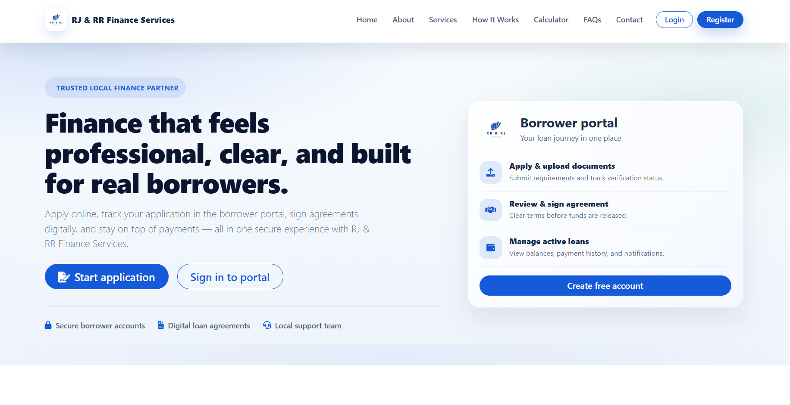
Figure 4.2
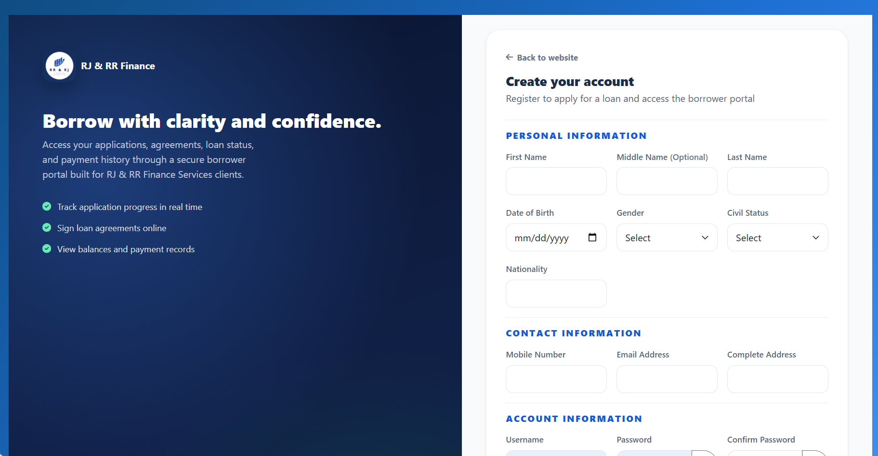
Borrower registration page

Figure 4.3
Borrower login and admin/staff login
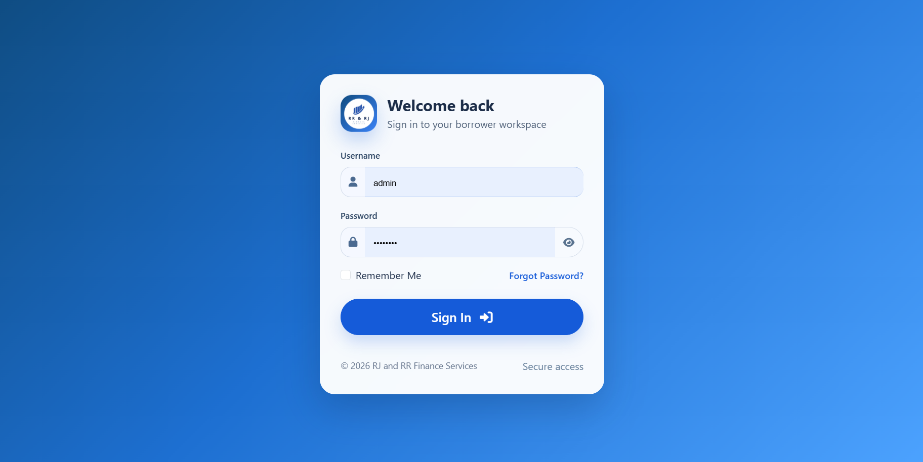
Admin/Staff Login Page
Borrower Login page

Figure 4.4
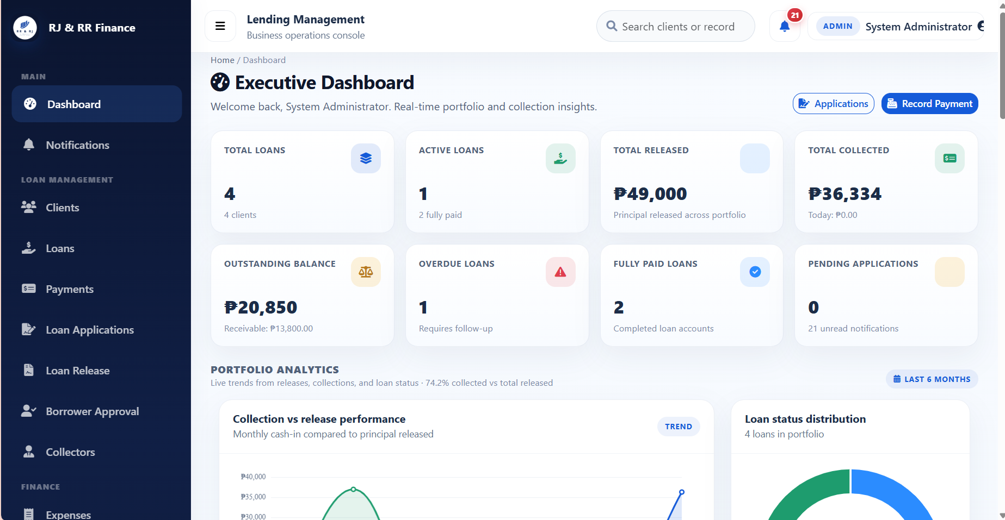
Administrator executive dashboard

Figure 4.5
Collector dashboard
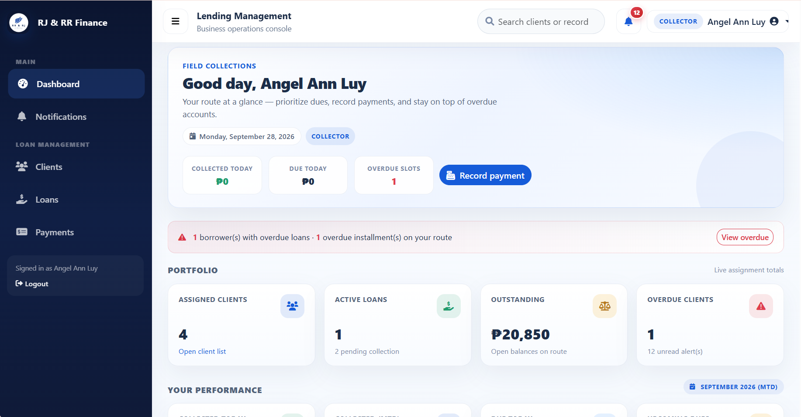

Figure 4.6
Borrower dashboard
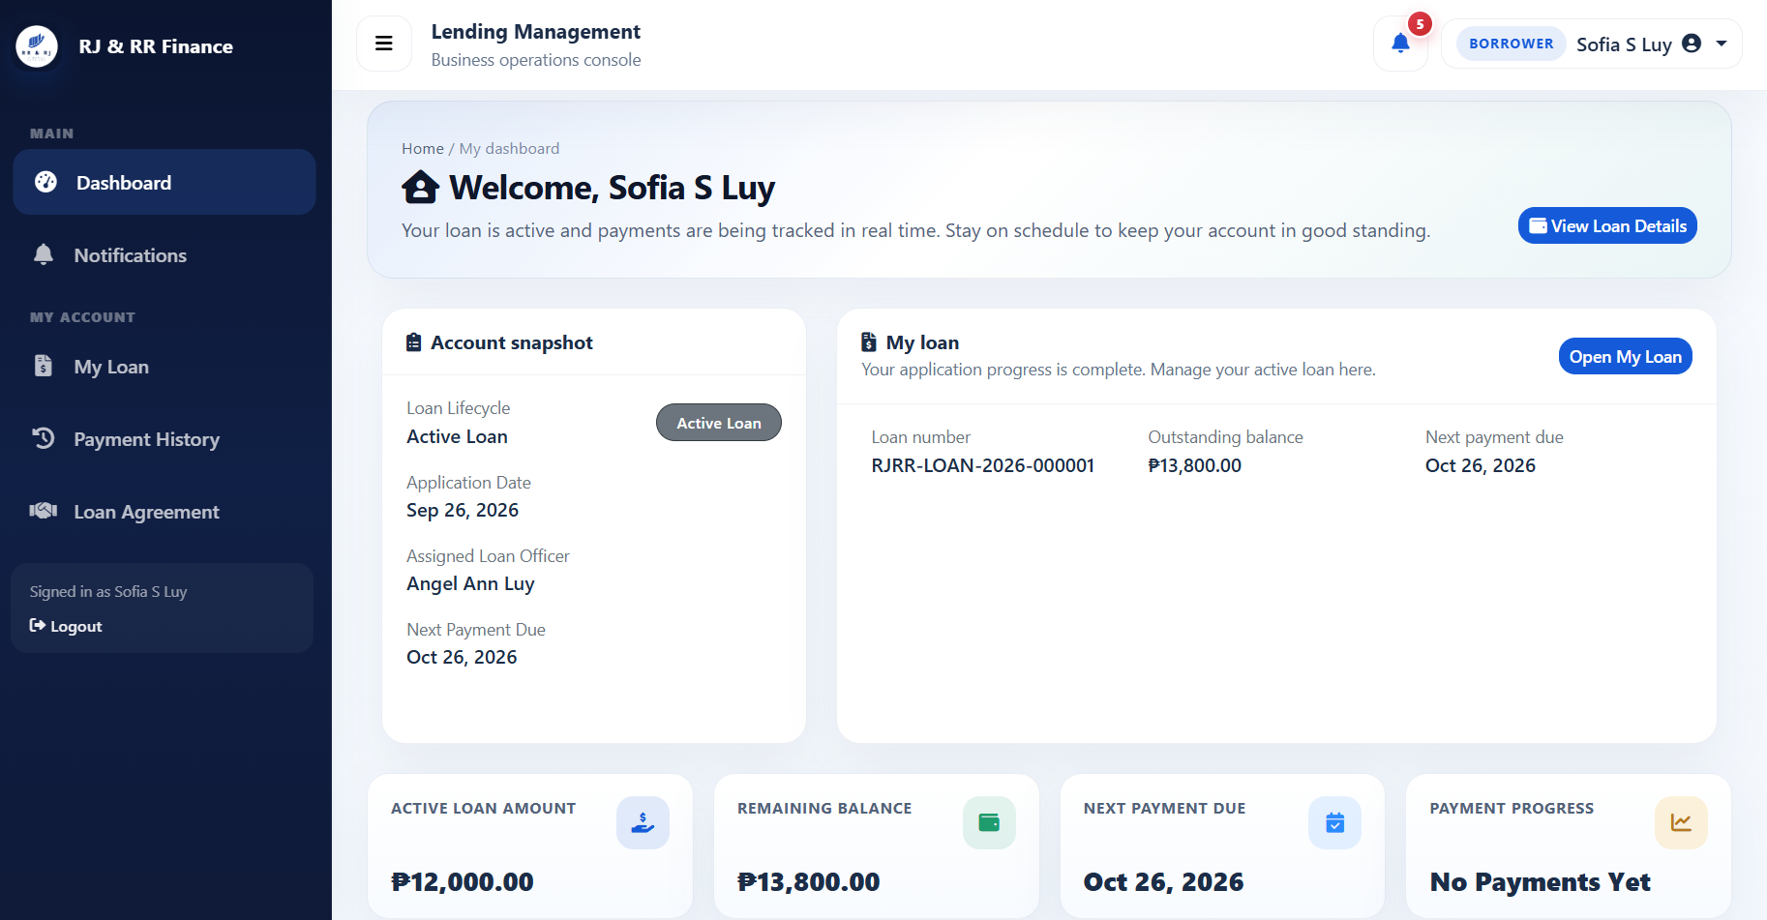

Figure 4.7
Borrower approval page
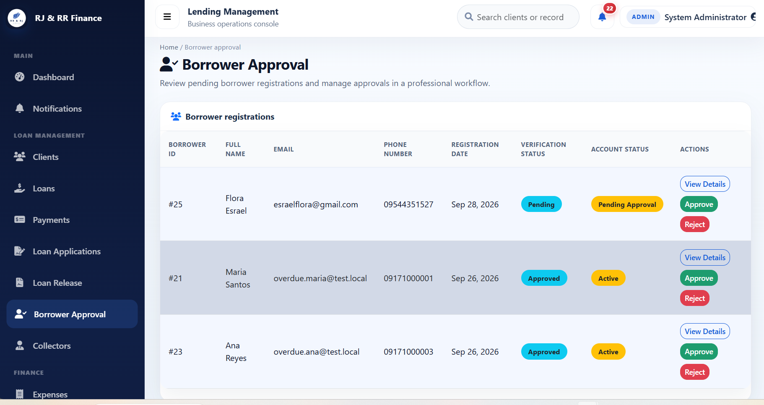

Figure 4.8
Loan application wizard
Step 1
Step 2
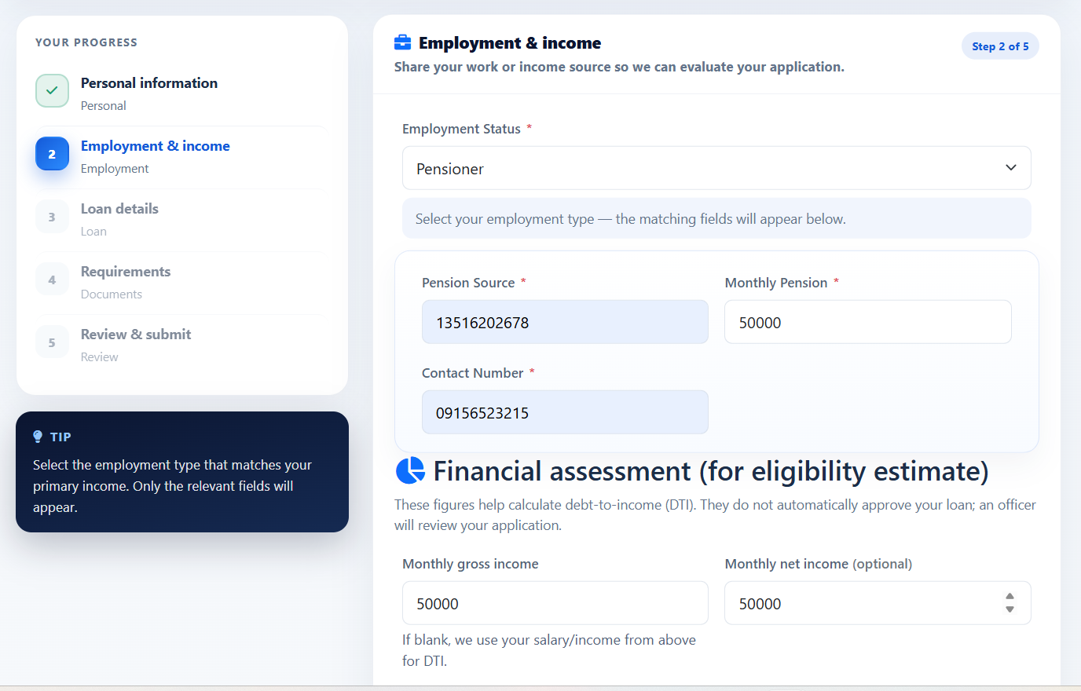

Step 3
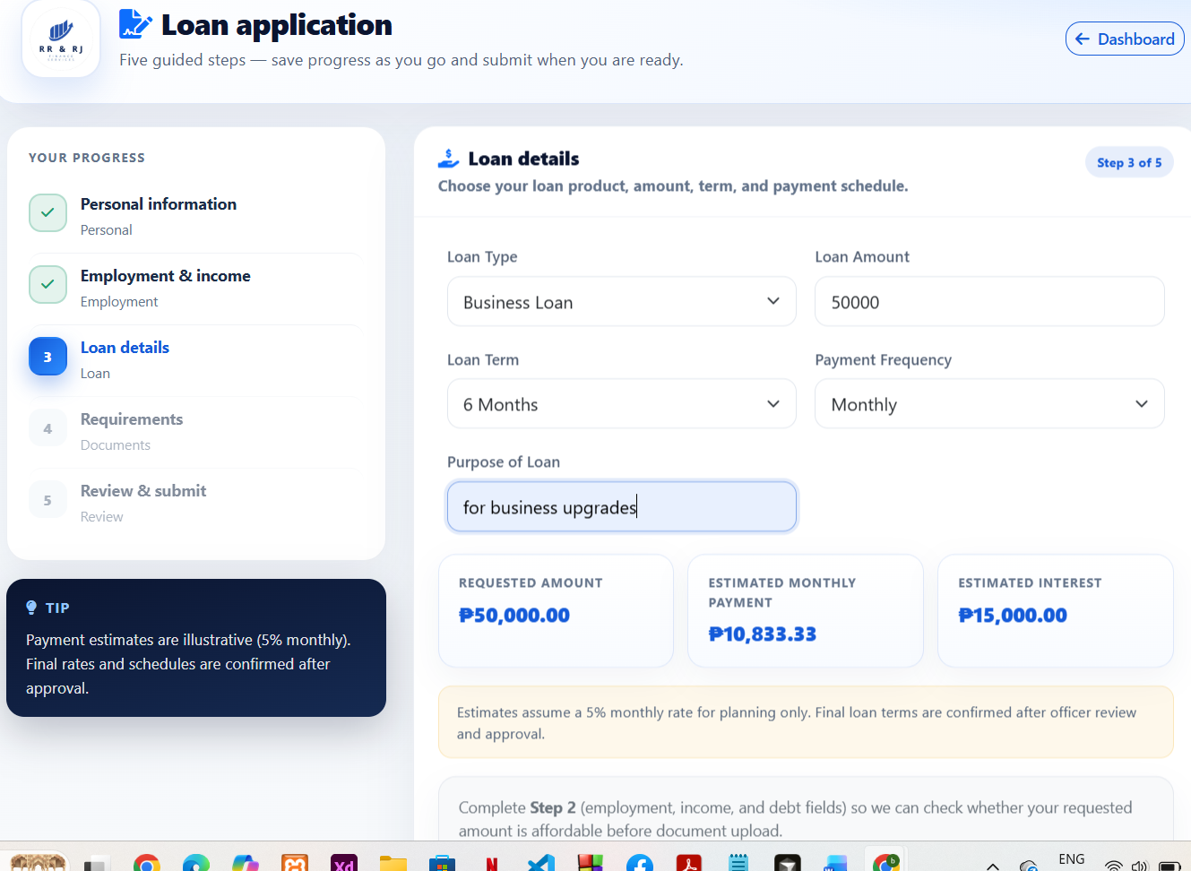
Step 4
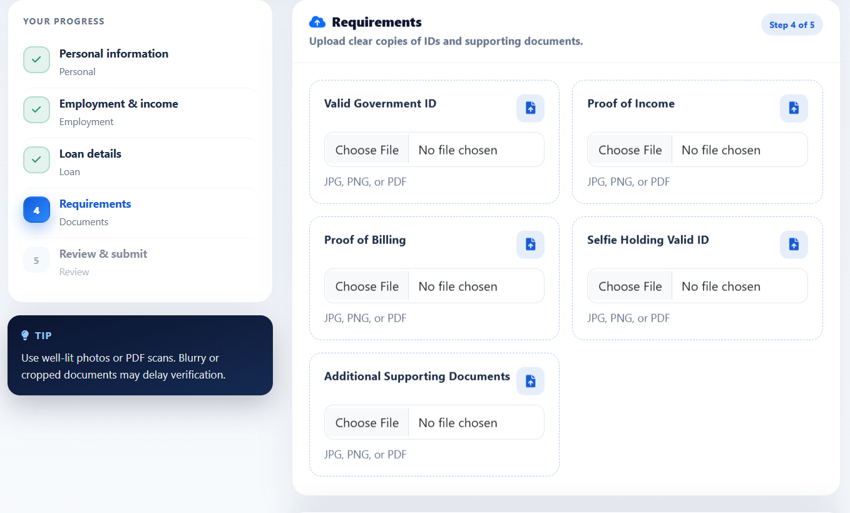

Step 5
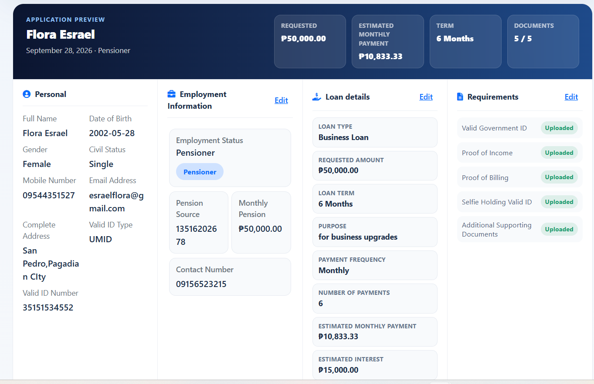

Figure 4.9
Eligibility estimate

Figure 4.10
Review of a loan application
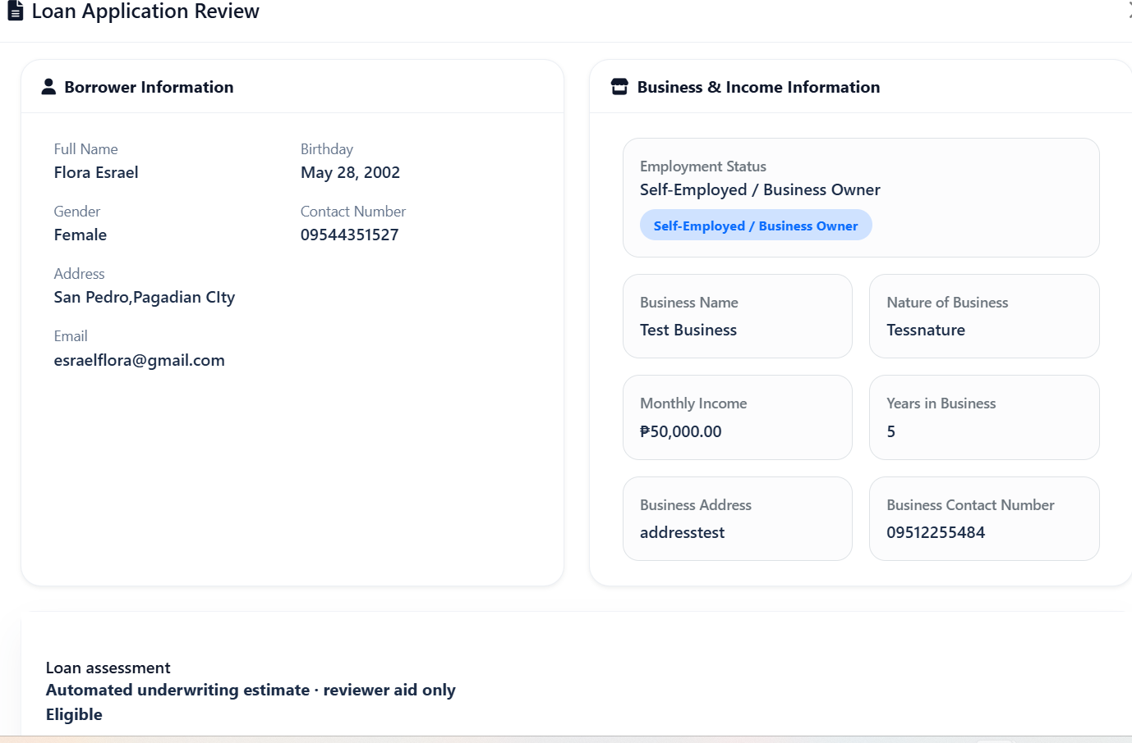
Figure 4.11
Loan agreement
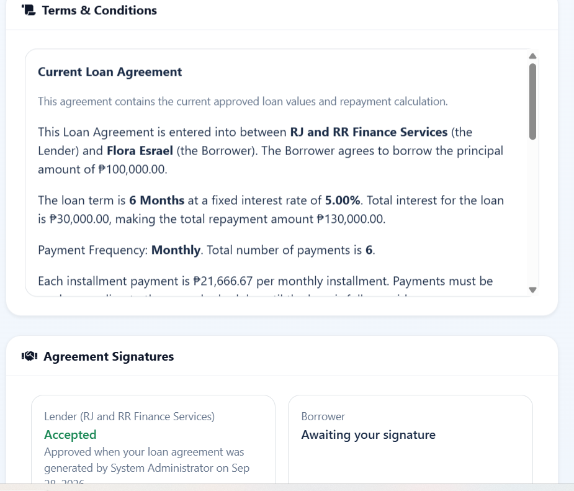

Figure 4.12
Loan release
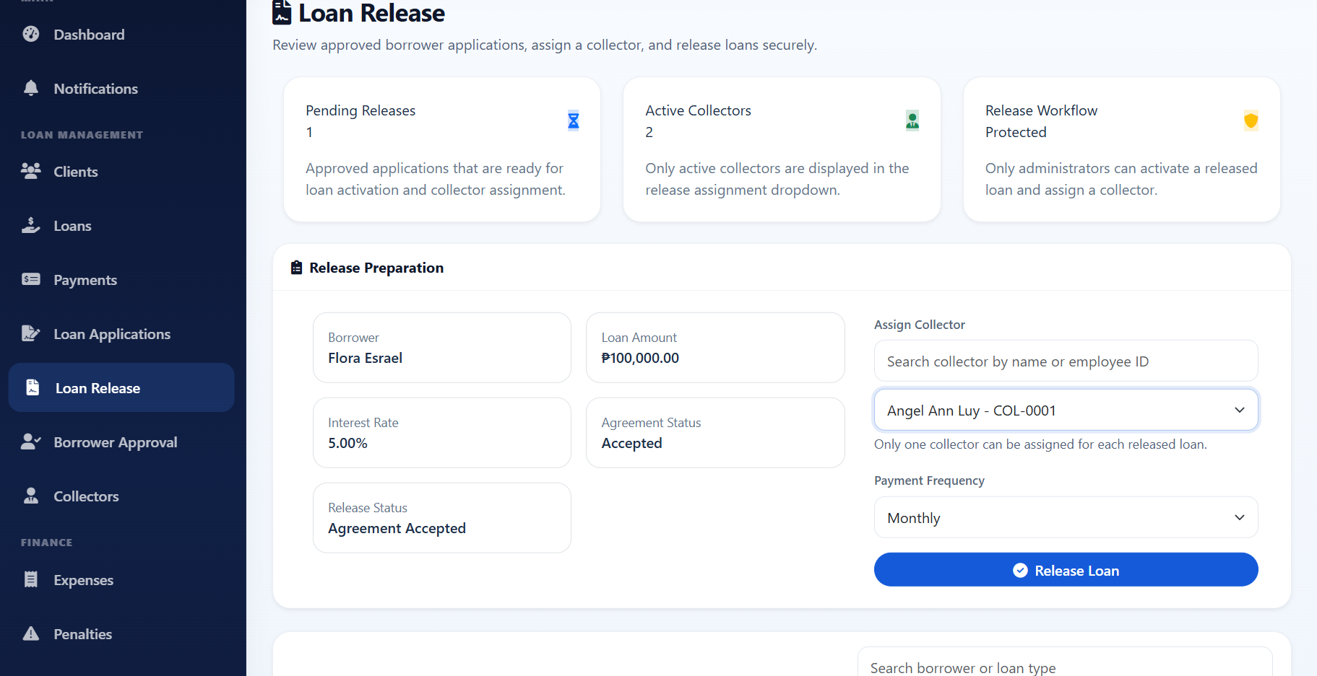
Figure 4.13
Loan details and installment schedule
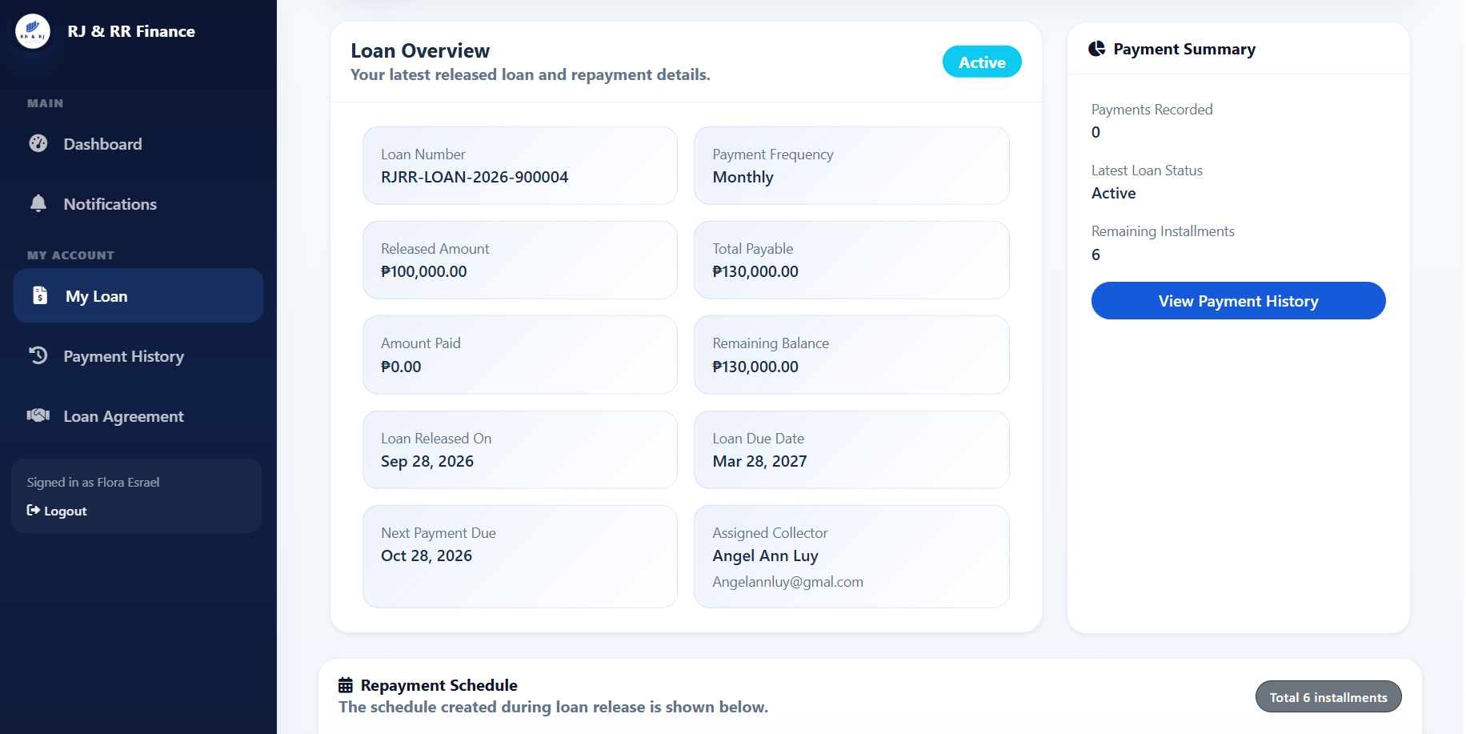

Figure 4.14
Payment recording
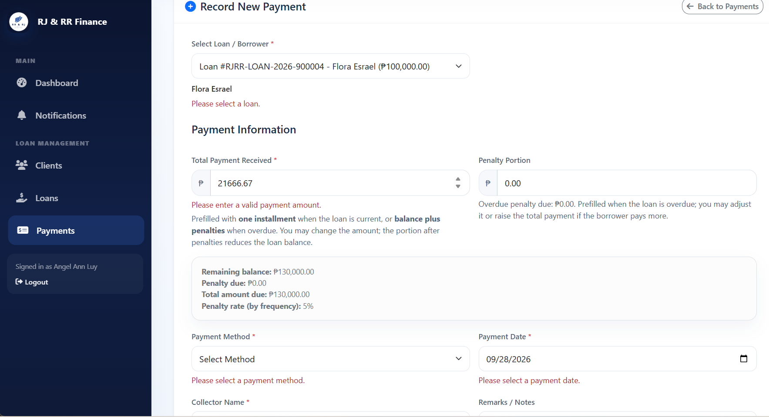

Figure 4.15
Penalty summary and reports
Figure 4.16
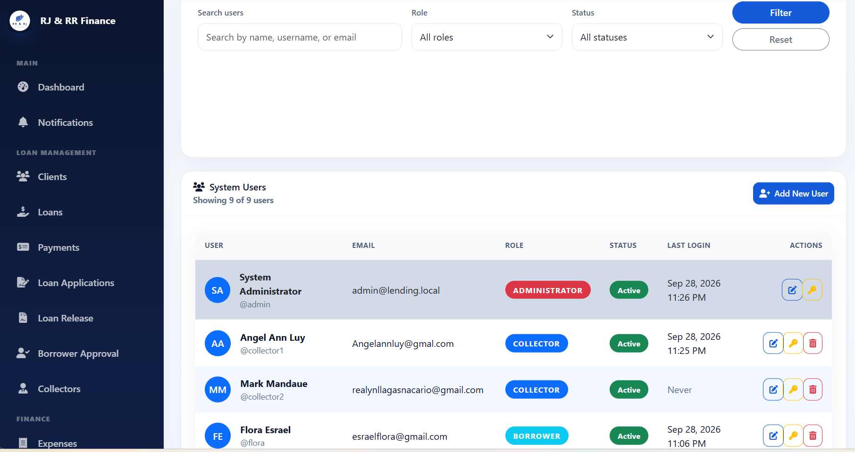
User management and notifications

The screenshots are evidence that the modules in Section 4.1.3 were built. They do not, by themselves, fill the actual-result columns in Tables 4.4 and 4.5. Chapter 5 can summarize these implementation and testing results, state the conclusions that the completed tables support, and list the recommendations that follow from the limits identified here.
CHAPTER V
SUMMARY, CONCLUSIONS, AND RECOMMENDATIONS
Summary of Findings
This study designed and developed the Financial Risk Assessment and Micro-Lending System (FRAMS) for RJ and RR Finance Services. The locally hosted web application uses PHP and MySQL to organize borrower registration, loan applications, eligibility assessment, agreements, loan release, installment schedules, payments, penalties, and administrative reports.
Borrowers can register and, after administrator approval, submit loan applications with the required supporting documents. The eligibility estimate uses declared income, existing financial obligations, the requested loan amount, the loan term, and configured lending criteria, including the debt-to-income limit. The estimate serves as a decision-support tool and does not automatically approve or reject a loan. The system also supports loan release, installment schedule generation, payment recording, and repayment monitoring. PayMongo QR Ph repayments should be treated as confirmed transactions only after Payment Intent status is succeeded and the paid amount matches, through polling on the open QR page or through staff-initiated Check with PayMongo.
The literature reviewed in Chapter II provides context for FRAMS through discussions of manual credit assessment, microfinance operations, and predictive scoring approaches. Unlike systems that use machine learning to predict default, FRAMS applies configured eligibility rules to assess borrower information and support the administrator's review. The system was evaluated through documented unit, integration, system, PayMongo integration, and penetration and security testing. The testing summary reports 48 of 48 documented official test cases as passed, comprising six unit tests, seven integration tests, twelve system tests, 11 PayMongo-related tests, and twelve penetration and security tests. These results apply to the specific test cases and conditions documented in Appendix B and do not establish that every possible workflow, security condition, or external payment scenario has been tested.
The User Acceptance Testing (UAT) response export contained 32 submissions, consisting of 30 borrowers, one administrator, and one collector. The evaluation instrument contained 20 statements grouped into five criteria: functionality, usability, reliability, security, and performance. Each criterion comprised four statements, resulting in 128 individual ratings per criterion and 640 individual ratings across the entire questionnaire.
The calculated weighted means were 4.56 for functionality, 4.54 for usability, 4.56 for reliability, 4.46 for security, and 4.52 for performance. The overall weighted mean was 4.53, interpreted as Strongly Agree under the five-point Likert scale adopted in Chapter III. These results indicate that the respondents generally expressed positive assessments of FRAMS across the five evaluation criteria.
Conclusions
In relation to the first specific objective, FRAMS provides a borrower management module that supports registration, administrator approval, client records, online loan applications, and supporting document submission and review.
In relation to the second specific objective, FRAMS computes a rule-based eligibility estimate from declared income, existing obligations, requested amount, loan term, and configured limits. The estimate is a decision-support result and does not automatically approve or reject a loan.
In relation to the third specific objective, FRAMS supports interest computation, installment schedules, loan agreement acceptance, collector assignment, loan release, payment recording, penalty computation, and repayment monitoring. PayMongo QR Ph repayments are recorded after Payment Intent confirmation through status polling on the open QR page or staff-initiated Check with PayMongo, not merely because a QR image was displayed.
In relation to the fourth specific objective, FRAMS sends in-application notifications for relevant application decisions, agreement updates, loan releases, and payment transactions, consistent with the notification functions available in the developed system.
In relation to the fifth specific objective, FRAMS generates financial reports that support monitoring of loan releases, collections, outstanding balances, overdue accounts, and related lending transactions.
In relation to the sixth specific objective, 32 intended users evaluated FRAMS. The supplied workbook contains 30 borrowers, one administrator, and one collector, each of whom answered 20 questionnaire items. The overall weighted mean was 4.53, interpreted as Strongly Agree. These ratings are user perceptions of acceptability and are not independent proof of security, loan accuracy, or measured performance.
The documented technical tests support the specific cases examined in their documented environments. Passing those cases does not establish that the entire system is free of defects. The documented PayMongo cases do not independently demonstrate a successful live PayMongo charge, Payment Intent polling, or staff-initiated Check with PayMongo.
The conclusions of this study are therefore limited to the system functions implemented, the documented technical tests, and the recorded user evaluation responses.
Recommendations
Based on the system’s current scope and the limitations identified in the study, the researchers recommend the following, in order of priority.
- 1. Establish a database backup and recovery procedure. Schedule regular MySQL backups of the production database and document how authorized personnel can restore a backup. Confirm the deployed database name before using it in any restore instructions.
- 2. Improve auditability by recording important actions—such as account approvals, loan releases, payment edits, and role changes—in a dedicated activity log.
- 3. Protect financial integrity by retaining the implemented payment-validation rules, Payment Intent confirmation for QR Ph collections, and the restriction against deleting a payment that is linked to a PayMongo QR Ph transaction. Reconcile pending QR attempts that remain open after the QR page is closed.
- 4. Keep the debt-to-income limit, minimum and maximum loan amounts, interest rate, and penalty rates in controlled configuration so approved policy changes do not require undocumented edits to application files.
- 5. Develop an administrator settings page, in a later enhancement, that allows authorized personnel to update loan limits and penalty rates, with validation and an audit trail. This page is not part of the current implementation.
6. SMS notifications may be added later if the lending office needs them and can support the cost. They are not implemented in the current system.

References
The following references are presented in APA 7th edition format.
Bazarbash, M., & Beaton, K. (2020). Filling the gap: Digital credit and financial inclusion (IMF Working Paper No. WP/20/150). International Monetary Fund. https://doi.org/10.5089/9781513552477.001
BlueOrchard. (2025, February 3). Microfinance outlook for 2025. https://www.blueorchard.com/microfinance-outlook-for-2025/
Campos, R. B., Jr. (2024). The impact of digitalization on credit risk management in microfinance institutions in Nueva Ecija, Philippines. Indian Journal of Information Sources and Services, 14(3). https://doi.org/10.51983/ijiss-2024.14.3.20
Chen, D., Ye, J., & Ye, W. (2023). Interpretable selective learning in credit risk. Research in International Business and Finance, 65, Article 101940. https://doi.org/10.1016/j.ribaf.2023.101940
Cornelli, G., Frost, J., Gambacorta, L., & Jagtiani, J. (2024). The impact of fintech lending on credit access for U.S. small businesses. Journal of Financial Stability, 73, Article 101290. https://doi.org/10.1016/j.jfs.2024.101290
Davis, F. D. (1989). Perceived usefulness, perceived ease of use, and user acceptance of information technology. MIS Quarterly, 13(3), 319–340. https://doi.org/10.2307/249008
DeLone, W. H., & McLean, E. R. (2003). The DeLone and McLean model of information systems success: A ten-year update. Journal of Management Information Systems, 19(4), 9–30. https://doi.org/10.1080/07421222.2003.11045748
Estrellado, G. E. (2024). Financial inclusion of lending institutions on sustainability of micro-businesses. United International Journal for Research & Technology, 5(7). https://uijrt.com/paper/financial-inclusion-lending-institutions-sustainability-micro-businesses
Guan, C., Suryanto, H., Mahidadia, A., Bain, M., & Compton, P. (2023). Responsible credit risk assessment with machine learning and knowledge acquisition. Human-Centric Intelligent Systems, 3(3), 232–243. https://doi.org/10.1007/s44230-023-00035-1
Huang, Y., Li, Z., Qiu, H., Sun, T., Wang, X., & Zhang, L. (2023). BigTech credit risk assessment for SMEs. China Economic Review, 81, Article 102016. https://doi.org/10.1016/j.chieco.2023.102016
International Organization for Standardization. (2011). Systems and software engineering—Systems and software Quality Requirements and Evaluation (SQuaRE)—System and software quality models (ISO/IEC 25010:2011).
Juventud, W. M., Matigas, E. A. O., Himongala, J., Galla, M. R., & Abiol, M. J. D. (2023). Perceived credit risk of micro finance loans among micro-enterprises business in Población Iligan City. International Journal of Multidisciplinary: Applied Business and Education Research, 4(10), 3697–3702. https://doi.org/10.11594/ijmaber.04.10.22
Khandani, A. E., Kim, A. J., & Lo, A. W. (2010). Consumer credit-risk models via machine-learning algorithms. Journal of Banking & Finance, 34(11), 2767–2787. https://doi.org/10.1016/j.jbankfin.2010.06.001
Kou, G. (2022). Editor’s introduction. Financial Innovation, 8, Article 71. https://doi.org/10.1186/s40854-022-00374-1
LendStack. (n.d.). Building the future of lending infrastructure. https://www.lendstack.in/
Mina, J. C. (2024). The credit risk management practices of lending companies in Nueva Ecija: Basis for risk mitigating plan. International Journal of Advanced and Applied Sciences, 11(9), 134–142. https://doi.org/10.21833/ijaas.2024.09.015
PayMongo. (n.d.). PayMongo API documentation. https://developers.paymongo.com/
Penaso, C. P., & Dagang, A. L. (2025). Loan management practices as key drivers for the operation efficiency of microfinance institutions in Northern Mindanao, Philippines. International Journal of Research and Scientific Innovation, 12(5), 1715–1724. https://doi.org/10.51244/ijrsi.2025.120500162
Ramirez, J. G. (2024). Establishment of gross loan portfolio risk-return questionnaire: Reliability and validity structure. Mindoro Journal of Social Sciences and Development Studies, 1(2), 18–26. https://journal.omsc.edu.ph/mjssds/article/view/11
Santos, A. R. (2023). The rise of digital payments: Transforming the financial landscape in the Philippines. International Journal of Applied Engineering and Technology, 5(2), 22–27. https://romanpub.com/resources/ijaet%20v5-2-2023-04.pdf
Shi, S., Tse, R., Luo, W., D’Addona, S., & Pau, G. (2022). Machine learning-driven credit risk: A systemic review. Neural Computing and Applications, 34(17), 14327–14339. https://doi.org/10.1007/s00521-022-07472-2
APPENDIX B
TEST CASE EVIDENCE AND USER ACCEPTANCE TESTING
Financial Risk Assessment and Micro-Lending System (FRAMS)
Purpose. This appendix organizes software test cases and user acceptance testing evidence for the Financial Risk Assessment and Micro-Lending System (FRAMS). It records the test scenario, expected result, actual observed result, status, and evidence reference. A case is considered passed only when its actual result and supporting evidence demonstrate that the expected result was met. Blank evidence locations or unexecuted tests are not evidence of a successful test.
A. UNIT TESTING
Unit testing was conducted to verify whether individual functions and components of FRAMS performed according to their intended specifications.
Table B1
Unit Testing Test Evidence of FRAMS
Test ID | Test Scenario | Expected Result | Actual Result | Status | Evidence Reference
UT-01 | Valid Login | The system authenticates the user and redirects them to the dashboard corresponding to their assigned role. | The valid login process opened the dashboard corresponding to the user's assigned role. | PASS | Figure B1
UT-02 | Incorrect Password or Inactive Account | The system denies access when the user enters an incorrect password or attempts to access an inactive account. | The system denied access to the invalid or inactive account. | PASS | Figure B2
UT-03 | Register a new borrower with complete and valid account details. | The borrower is listed on Borrower Approval with verification status Pending and account status Pending Approval. | Borrower #34, Honey Jane Comaling, appeared on Borrower Approval with verification status Pending and account status Pending Approval. | PASS | Figure B3
UT-04 | Loan Details Exceed DTI or Loan Limits | The system prevents the application from proceeding when the configured debt-to-income (DTI) or loan limits are exceeded. | The system blocked the application that exceeded the configured limit. | PASS | Figure B4
UT-05 | Valid JPG, PNG, and PDF selection | The requirements step accepts the selected JPG, PNG, and PDF files and shows each file as selected. | Step 4 showed a PDF, a JPG, and a PNG selected for the government ID, proof of income, proof of billing, and selfie. Each card was marked selected and labeled JPG, PNG, or PDF. | PASS | Figure B5
UT-06 | Invalid Payment Amount | The payment is rejected and is not stored. | The Record Payment page for loan RJRR-LOAN-2026-900008 showed “Payment amount cannot exceed the total amount due of ₱5,749.00 (balance + penalties).” The excess payment was not saved. | PASS | Figure B6

Screenshot Evidence for Unit Testing
Figure B1
Evidence for UT-01: Valid Login
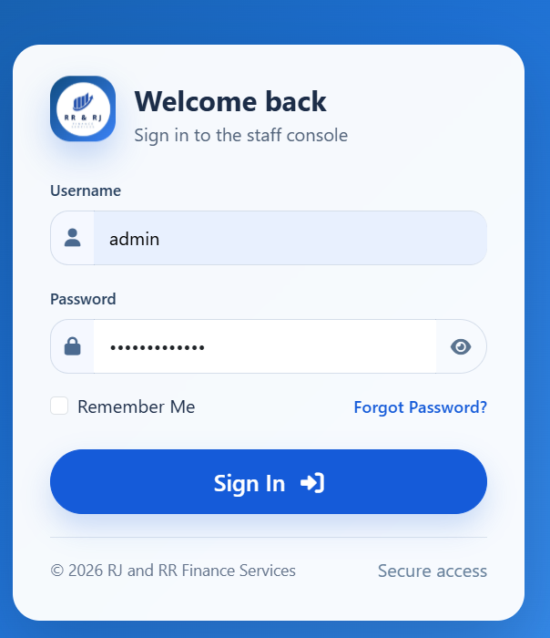
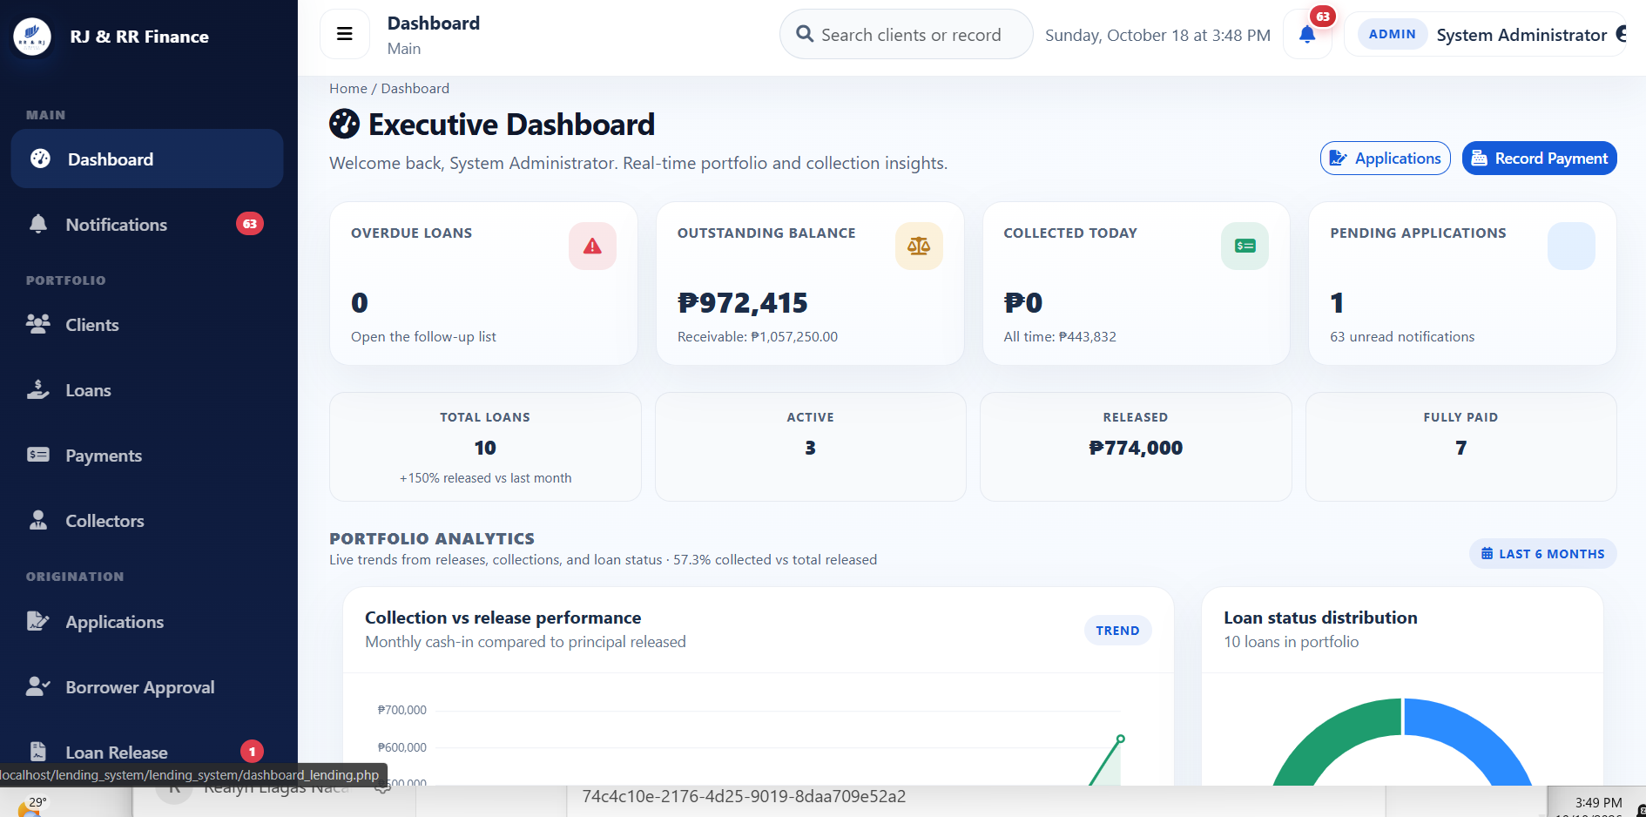
Figure B2
Evidence for UT-02: Incorrect Password or Inactive Account

Figure B3
Evidence for UT-03: Borrower Registration
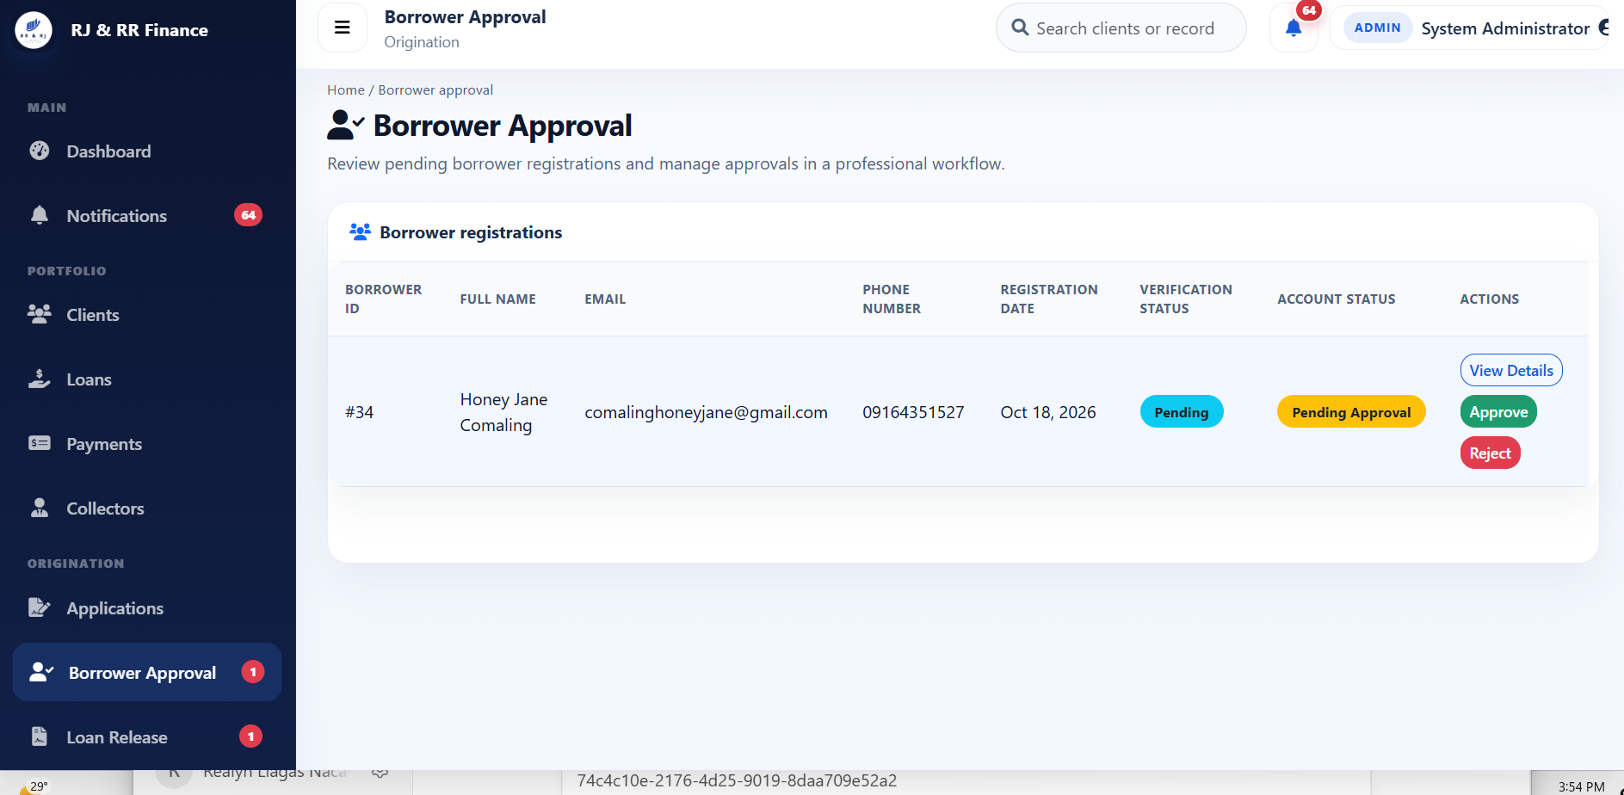
Figure B4
Evidence for UT-04: Loan Details Exceed DTI or Loan Limits
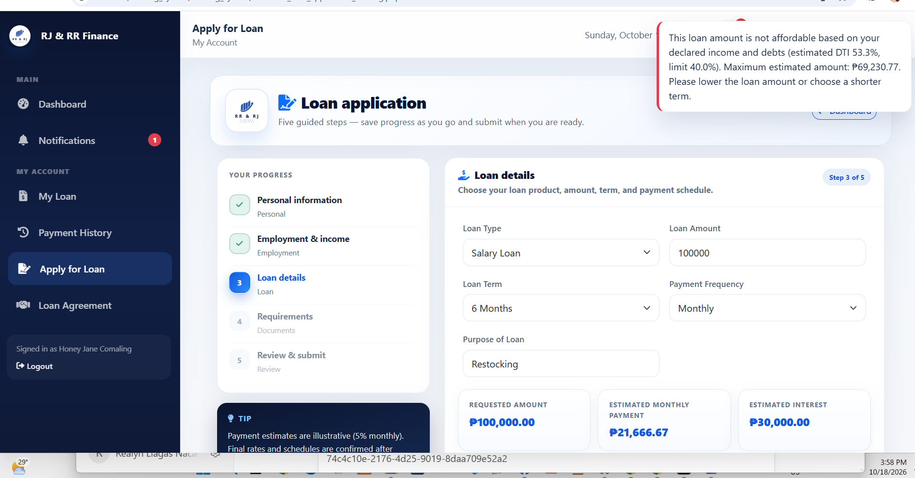

Figure B5
Evidence for UT-05: Valid JPG, PNG, and PDF selection
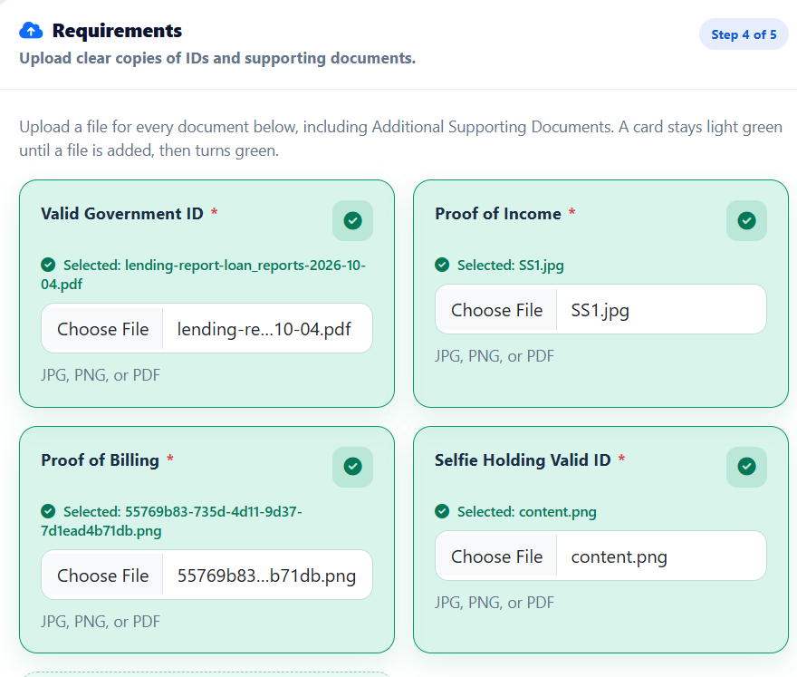Figure B6
Evidence for UT-06: Invalid Payment Amount
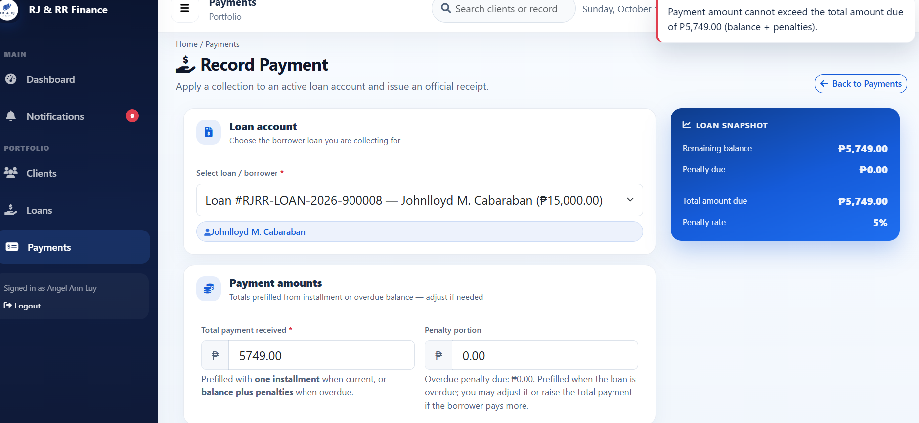
B. INTEGRATION TESTING
Integration testing was conducted to verify whether connected modules of FRAMS worked together correctly and maintained consistent records across the system.
Table B2
Integration Testing Test Evidence of FRAMS
Test ID | Test Scenario | Expected Result | Actual Result | Status | Evidence Reference
IT-01 | Registration, Account Approval, and Login | After approval, the borrower can sign in and the borrower's dashboard opens for that account. | The approval page showed “Borrower account approved successfully.” Honey Jane Comaling then opened the borrower dashboard. | PASS | Figure B7
IT-02 | After registration, locate the borrower before account approval. | The borrower appears with verification status Pending and account status Pending Approval. | Honey Jane Comaling, borrower #34, appeared with verification Pending and account status Pending Approval. | PASS | Figure B8
IT-03 | Submitted application and borrower record | The application is listed for that borrower with status Pending Review. | Application #33 for Honey Jane Comaling was listed as a Salary Loan for ₱20,000.00, with a 3-month term and status Pending Review. | PASS | Figure B9
IT-04 | Payment recording and remaining balance | The payment is saved, the covered installment is marked Paid, and the remaining balance decreases while the loan stays Active. | Receipt RJRR-20261018-000001 recorded cash of ₱7,666.67. Installment 1 was marked Paid, and loan RJRR-LOAN-2026-900009 stayed Active with ₱15,333.33 remaining. | PASS | Figure B22
IT-05 | Loan Application and Eligibility Assessment | The review shows the eligibility result, the requested amount, the maximum eligible amount, and the debt-to-income figure. | Application #33 for Honey Jane Comaling showed Eligible, ₱20,000.00 requested, ₱39,130.43 maximum eligible, estimated eligible ₱20,000.00, and DTI after loan of 25.33% against the 40.0% policy maximum. | PASS | Figure B11
IT-06 | Payment period and reports | The report views open for that period and show the collections total. | Reports & Analytics opened for October 2026 and showed collections of ₱371,718.67. The six views were Dashboard Analytics, Loan Reports, Payment Reports, Borrower Reports, Collector Performance, and Financial Summary. | PASS | Figure B12
IT-07 | Borrower username on the staff sign-in | The staff console does not open and no administrator records are shown. | Staff sign-in for the username honey stayed on the sign-in page and showed “Invalid username or password.” No administrator records were shown. | PASS | Figure B13

Screenshot Evidence for Integration Testing
Figure B7
Evidence for IT-01: Registration, Account Approval, and Login
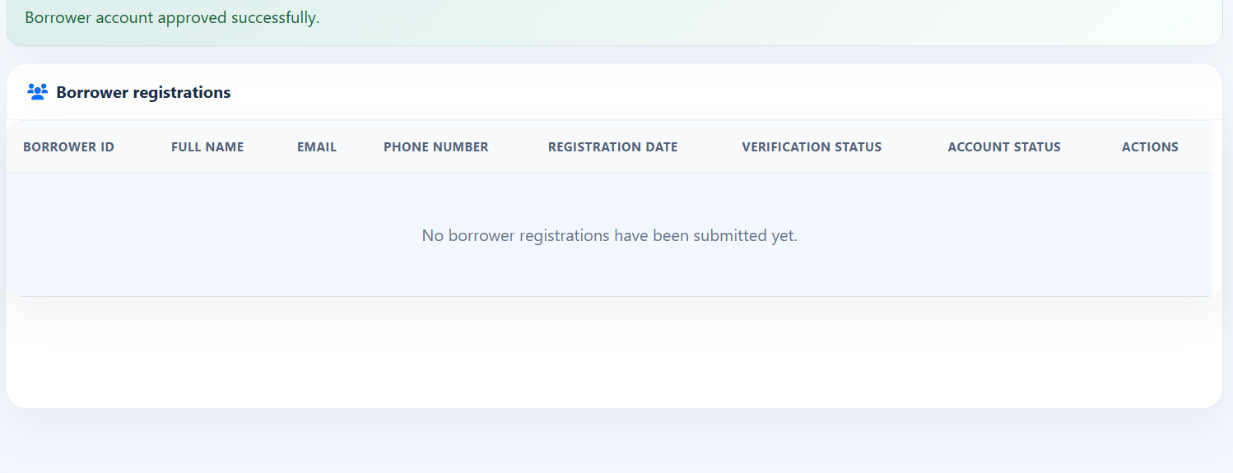
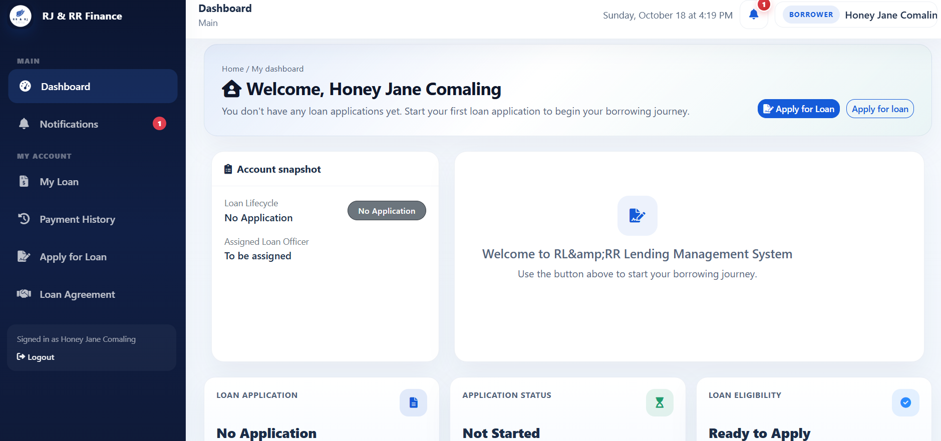
Figure B8
Evidence for IT-02: Registration and Borrower Records

Figure B9
Evidence for IT-03: Borrower Records and Loan Application
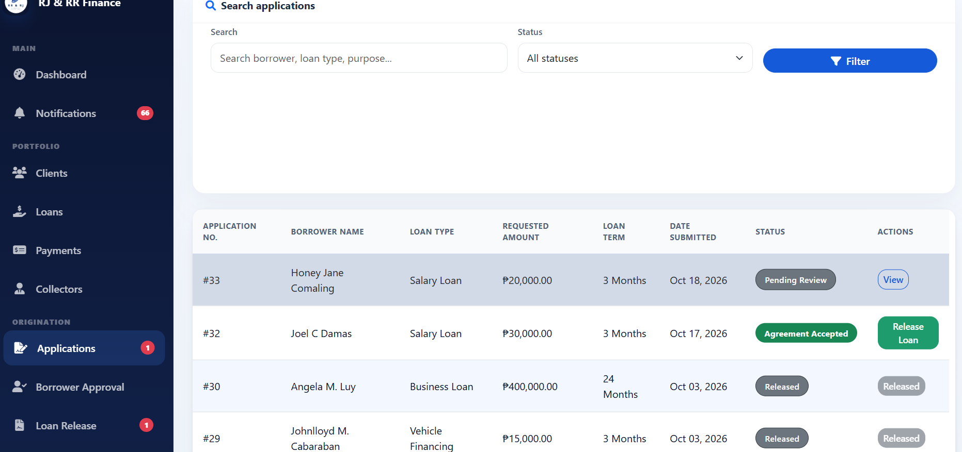
Figure B10
Evidence for IT-04: Payment Recording and Remaining Balance. The paid installment and remaining balance are shown in Figure B22.
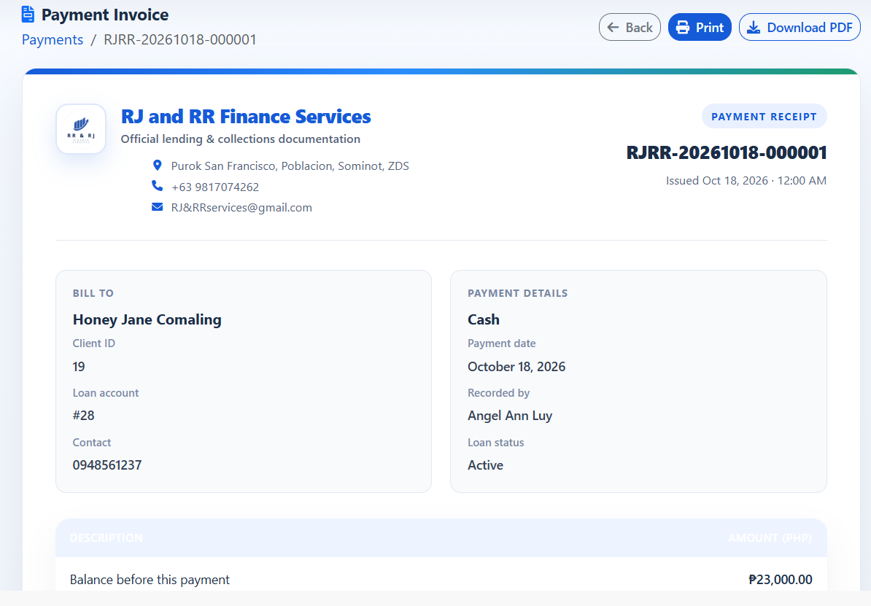
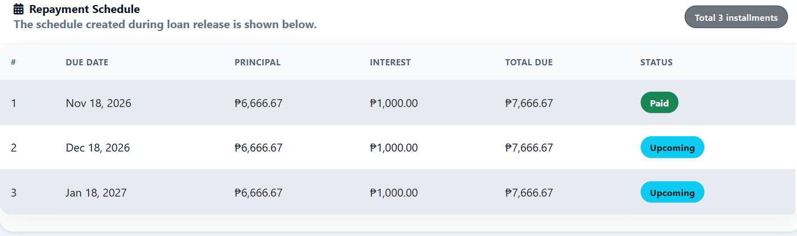

Figure B11
Evidence for IT-05: Loan Application and Eligibility Assessment
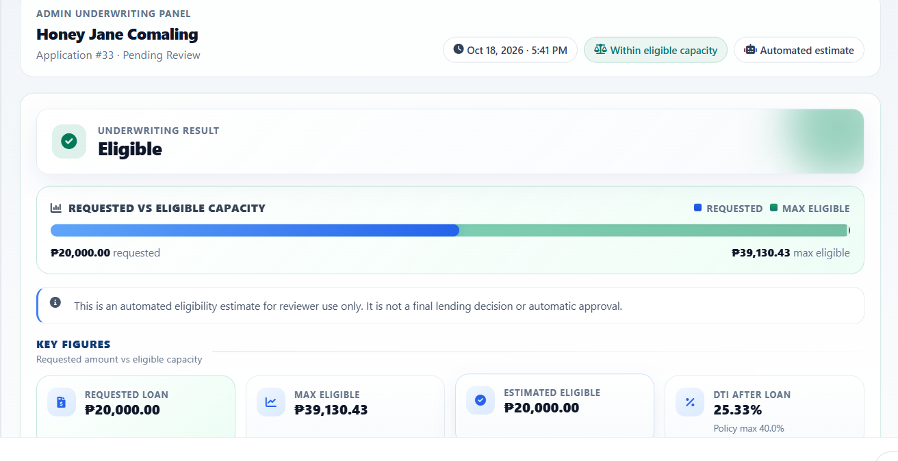
Figure B12
Evidence for IT-06: Reports for the Payment Period
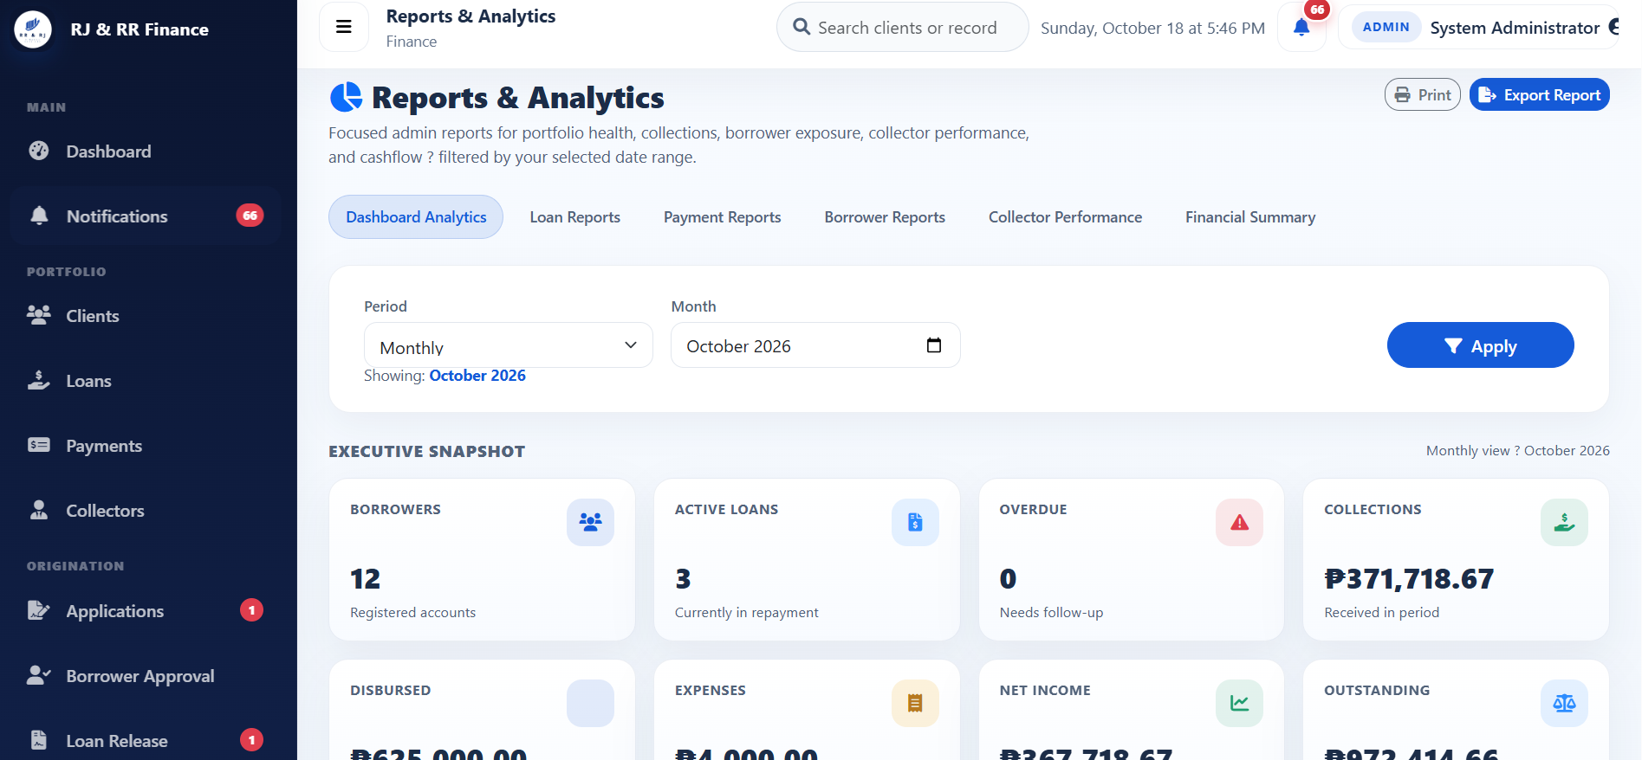
Figure B13
Evidence for IT-07: Borrower Username on the Staff Sign-In
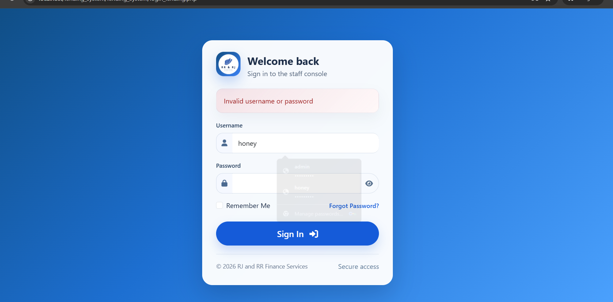

C. SYSTEM TESTING
System testing is documented here for borrower registration, loan application and release, payment processing, collector access, report generation, and notifications. All 12 system cases passed. The observed results match Figures B14–B25.
Test ID | Test Scenario | Expected Result | Actual Result | Status | Evidence Reference
ST-01 | Register a new borrower with the required account details. | The registration form accepts the borrower details, and the saved account appears as Pending Approval. | The registration form showed Honey Jane Comaling and the email address being entered. Borrower #34 then appeared on Borrower Approval with verification Pending and account status Pending Approval. | PASS | Figure B14
ST-02 | An administrator approves that registration, and the borrower signs in. | The pending registration is approved and the borrower dashboard opens for that account. | The approval page showed “Borrower account approved successfully.” and the pending list was cleared. Honey Jane Comaling then opened the borrower dashboard. | PASS | Figure B15
ST-03 | An approved borrower submits an application within the debt-to-income and loan limits, with the required JPG, PNG, or PDF documents. | The application is submitted and the borrower sees the submission confirmation. Submission does not release funds. | Honey Jane Comaling received “Your loan application has been successfully submitted.” Application #33 was then listed as Pending Review. | PASS | Figure B16
ST-04 | An administrator opens the underwriting review for the submitted application. | The review shows the borrower, employment or income, and loan details. | Loan Application #34 for Honey Jane Comaling opened in underwriting review and showed the borrower profile, pension income, and salary-loan details. | PASS | Figure B17
ST-05 | The borrower accepts the generated loan agreement. | The system confirms that the agreement has been accepted. | The borrower received “Agreement accepted” and the message that the loan agreement has been accepted. | PASS | Figure B18
ST-06 | An administrator releases the accepted loan to an active collector. | A loan number in the form RJRR-LOAN-year-###### is created and the release is assigned to an active collector. | Loan release invoice REL-000026 showed loan number RJRR-LOAN-2026-900009 for Honey Jane Comaling, assigned to collector Angel Ann Luy, with status Released on October 18, 2026. | PASS | Figure B19
ST-07 | The assigned collector records a cash payment within the amount due. | The payment is saved and a receipt number in the form RJRR-YYYYMMDD-###### is created. | Payment receipt RJRR-20261018-000001 was issued for Honey Jane Comaling as Cash, recorded by Angel Ann Luy on October 18, 2026. The loan remained Active. | PASS | Figure B20
ST-08 | The borrower who owns that payment opens the payment history. | The history shows that payment's receipt number, amount, and remaining balance. | Honey Jane Comaling's payment history listed receipt RJRR-20261018-000001, cash of ₱7,666.67, remaining balance ₱15,333.33, and collector Angel Ann Luy. | PASS | Figure B21
ST-09 | Open the loan after a partial payment that covers the first installment. | The covered installment is marked Paid, later installments remain Upcoming, and the loan stays Active while a balance remains. | Installment 1 of ₱7,666.67 was marked Paid. Installments 2 and 3 remained Upcoming. Loan RJRR-LOAN-2026-900009 stayed Active, with ₱7,666.67 paid and ₱15,333.33 remaining. | PASS | Figure B22
ST-10 | Sign in as a collector and open the dashboard and client list. | The collector sees the assigned portfolio, and the listed clients are assigned to that collector. | Angel Ann Luy's dashboard showed 8 assigned clients, 4 active loans, and ₱7,666.67 collected today. The client list showed only clients assigned to Angel Ann Luy, including Honey Jane Comaling. | PASS | Figure B23
ST-11 | An administrator opens the six report views for one period. | The six report views open for the selected period. | Reports & Analytics opened for October 2026 with Dashboard Analytics, Loan Reports, Payment Reports, Borrower Reports, Collector Performance, and Financial Summary. Dashboard Analytics showed 12 borrowers, 3 active loans, 0 overdue, and collections of ₱371,718.67. | PASS | Figure B24
ST-12 | The borrower opens the notification list after the agreement, release, and payment. | The intended borrower can see the notices for those actions on that borrower's loan. | The notification list showed 7 unread notices, including Loan Agreement Accepted, the release of RJRR-LOAN-2026-900009 assigned to Angel Ann Luy, and Payment Received for ₱7,666.67 on that loan. | PASS | Figure B25

Screenshot Evidence for System Testing
Figure B14
Evidence for ST-01: Borrower Registration
Figure B15
Evidence for ST-02: Account Approval and Login
Figure B16
Evidence for ST-03: Loan Application Submission
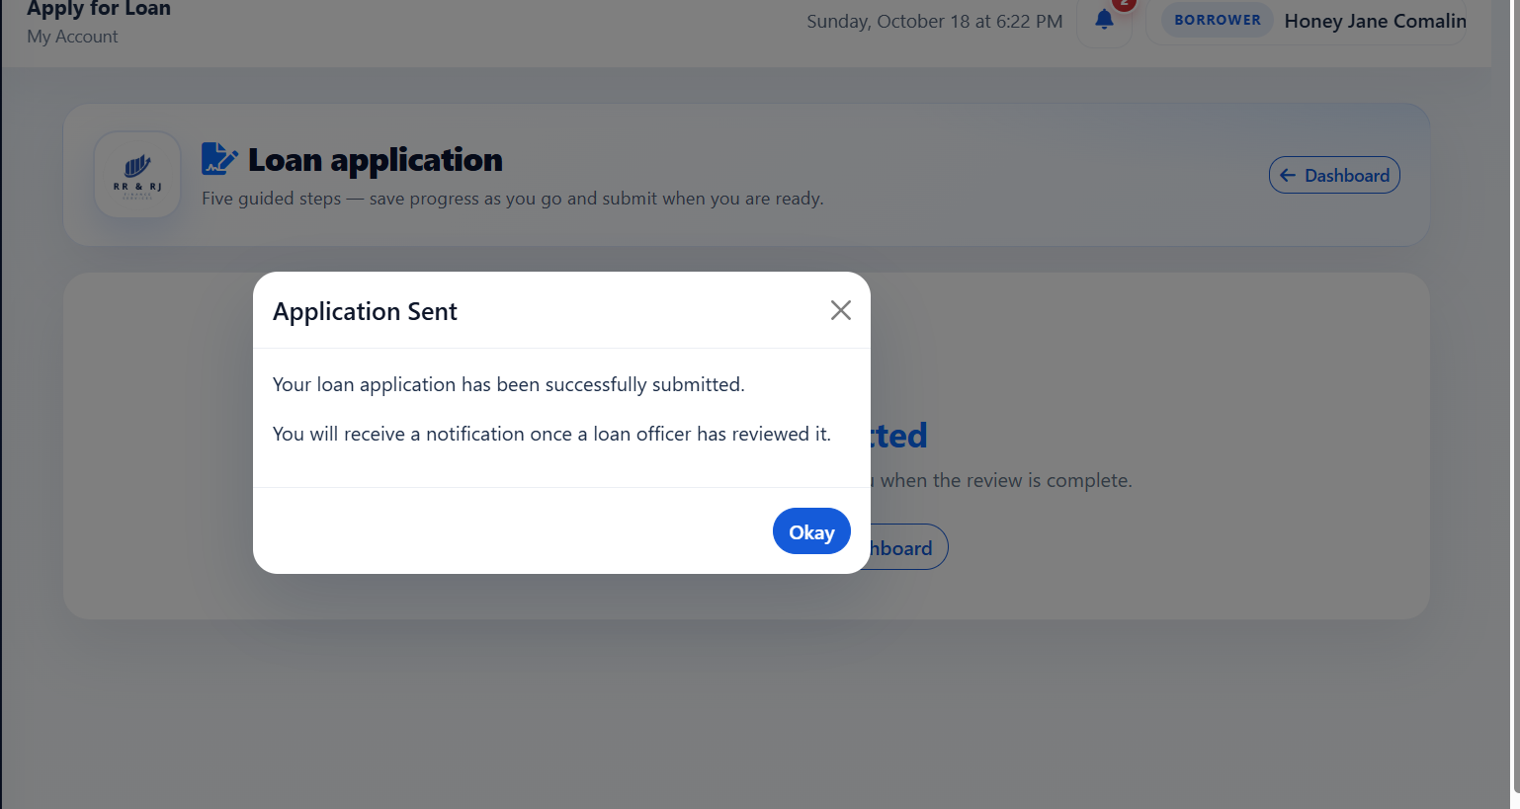
Figure B17
Evidence for ST-04: Loan Application Review
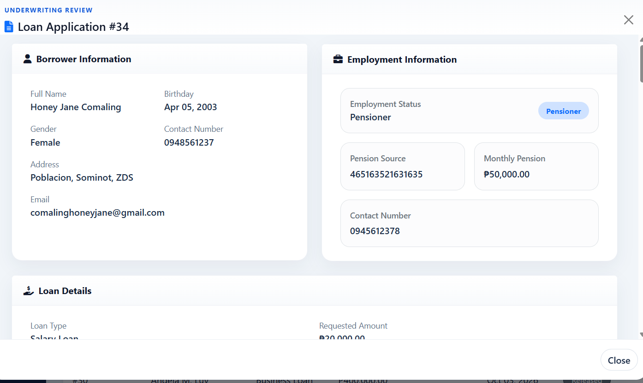

Figure B18
Evidence for ST-05: Loan Agreement Acceptance
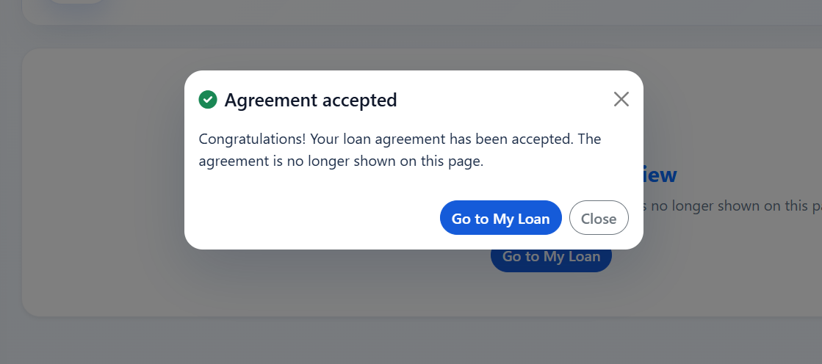
Figure B19
Evidence for ST-06: Loan Release
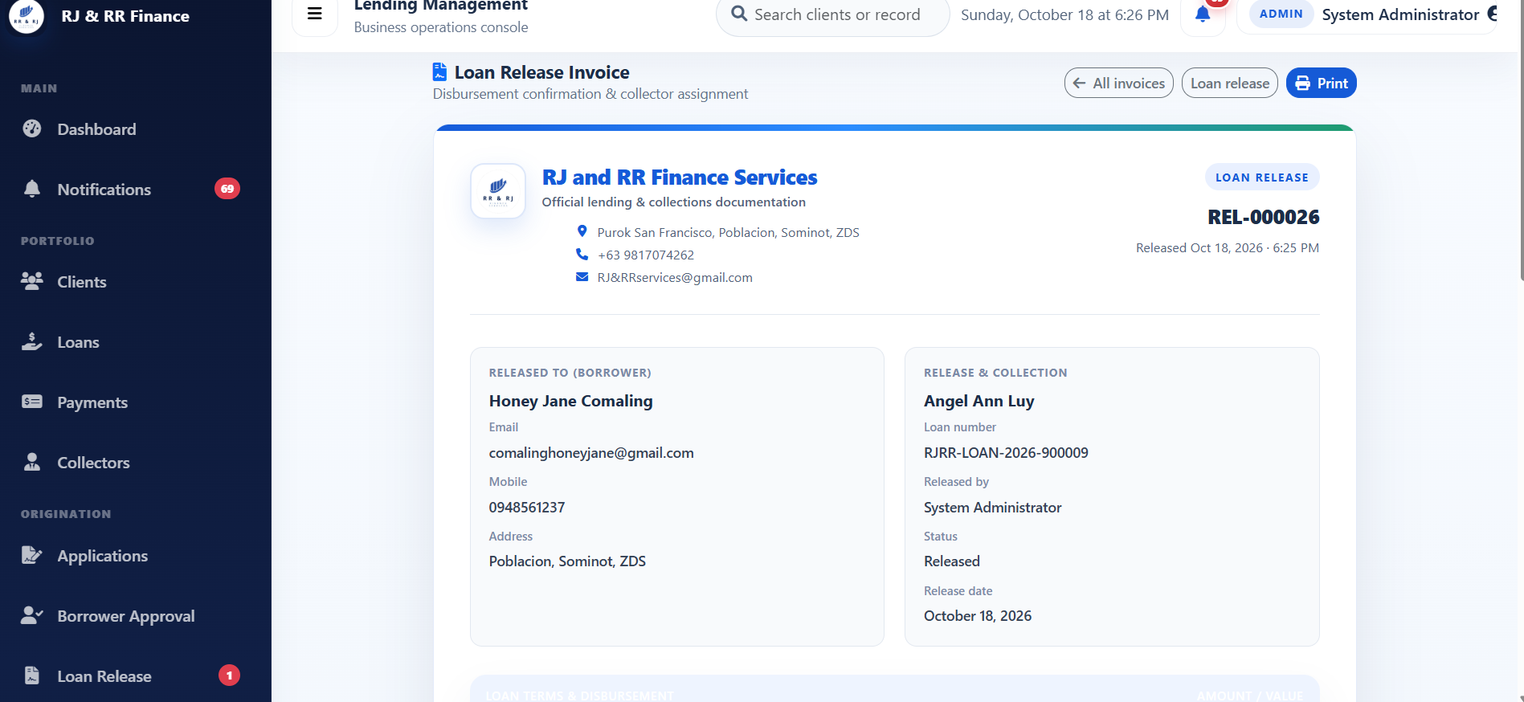

Figure B20
Evidence for ST-07: Cash Payment Recording
Figure B21
Evidence for ST-08: Borrower Payment History and Receipt
Figure B22
Evidence for ST-09: Loan and Installment Status Update

Figure B23
Evidence for ST-10: Collector Dashboard and Assigned Accounts
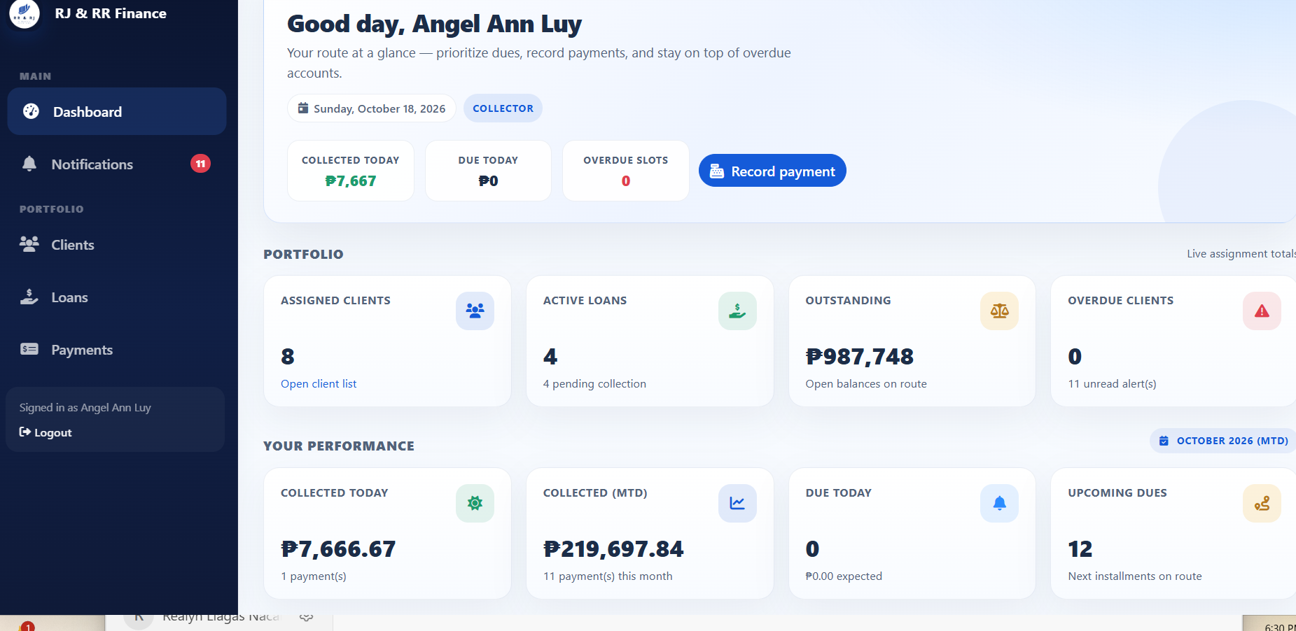
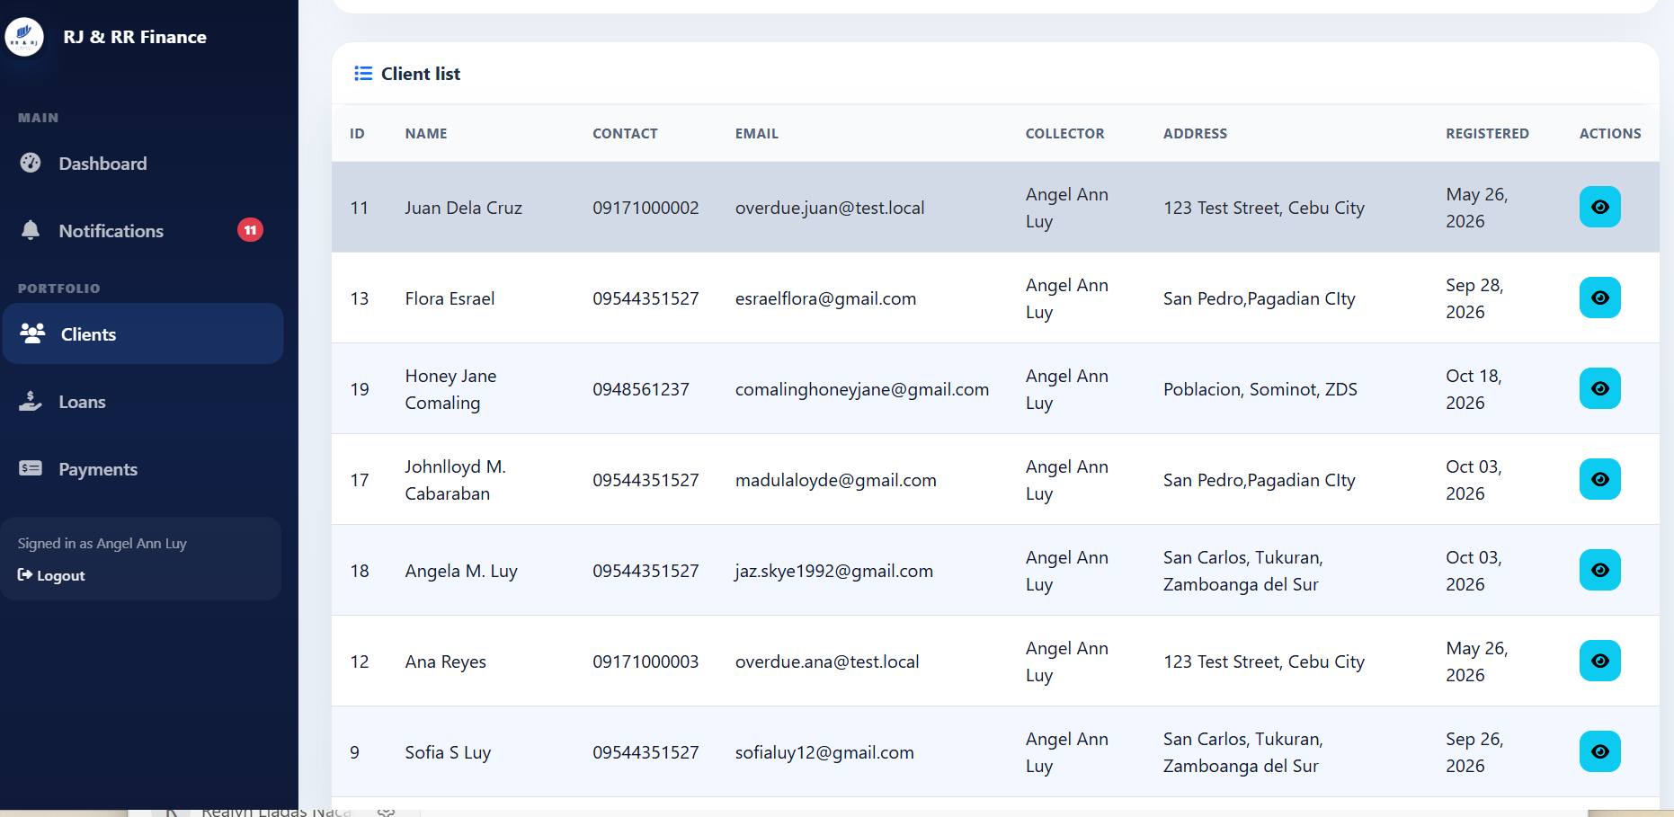

Figure B24
Evidence for ST-11: Administrative Reports
Figure B25
Evidence for ST-12: Notification Management
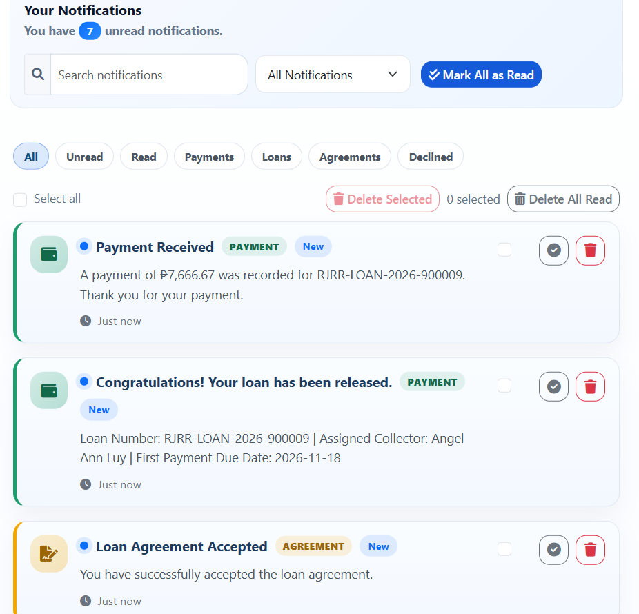
D. PAYMONGO TESTING
The official PayMongo evidence for PM-01 to PM-10 and PM-12 is attached as Figures B26–B35 and B37. The test descriptions and results below are aligned to the behaviors shown in the supplied evidence. PM-01 and PM-02 document safe failure handling with an isolated invalid test key. PM-09 documents receipt display for a recorded E-Wallet repayment in the isolated test environment; it does not establish Payment Intent polling, staff reconciliation, or a live PayMongo charge. Figure B36 is retained only as excluded local-endpoint evidence and is not counted.
Test Case ID | Description | Test Steps | Expected Result | Actual Result | Remarks
PM-01 | Verify safe handling when PayMongo rejects QR Ph creation. | 1. Open Record Payment. 2. Select FRAMS-DISP-01 and E-Wallet. 3. Submit the request and inspect the response. | If QR creation is rejected, FRAMS should show an error, display no QR code, and create no repayment. | PayMongo returned HTTP 401 for the isolated test key. The QR page did not open, no QR image was displayed, no repayment was created, and the loan remained Active. | PASSED — Figure B26 shows the rejected request and the safe-failure screen.
PM-02 | Verify the payment form after QR generation fails. | 1. Attempt E-Wallet QR creation for FRAMS-DISP-01. 2. Inspect the page after the failed request. | The form should remain available without QR details, and the loan balance should remain unchanged. | The Record Payment screen remained open without a QR image, QR amount, QR method block, or expiry. The displayed remaining balance stayed at PHP 3,150.00. | PASSED — Figure B27 shows the form after the failed QR request.
PM-03 | Verify QR creation controls when Cash is selected. | 1. Open Record Payment. 2. Select Cash. 3. Inspect the available actions. | The Create Dynamic QR Ph action should not be available for Cash payments. | With Cash selected, the Create Dynamic QR Ph button was hidden or disabled, while Cancel and Record Payment remained available. | PASSED — Figure B28 shows the Cash selection and available actions.
PM-04 | Verify validation of blank, zero, and nonnumeric payment amounts. | 1. Submit a blank amount. 2. Submit zero. 3. Submit a nonnumeric value. 4. Inspect each validation response. | Blank input should trigger required-field validation; zero and nonnumeric amounts should be rejected with validation messages. | Blank input was stopped by browser validation. Zero returned “Payment amount must be greater than zero.” The nonnumeric value returned “Enter a valid payment amount.” | PASSED — Figure B29(a) and B29(b) show zero and nonnumeric validation. The blank-input result is recorded in the test result.
PM-05 | Verify rejection of an amount exceeding the current total due. | 1. Open Record Payment for FRAMS-DISP-01. 2. Enter an amount greater than PHP 3,150.00. 3. Submit and inspect the response. | FRAMS should reject an amount greater than the current total amount due. | FRAMS displayed “Payment cannot exceed the current total amount due of ₱3,150.00.” | PASSED — Figure B30 shows the excessive-amount validation message.
PM-06 | Verify collector assignment restrictions for payment requests. | 1. Sign in as a collector. 2. Attempt a payment request for a loan assigned to another collector. 3. Inspect the response. | FRAMS should reject a collector’s request for a loan not assigned to that collector. | FRAMS displayed “You are not assigned to this loan.” The loan was not available in the displayed selection. | PASSED — Figure B31 shows the loan-assignment restriction message.
PM-07 | Verify authentication restrictions on the staff payment area. | 1. Sign out. 2. Attempt to open the protected staff payments page. 3. Observe the page shown. | An unauthenticated visitor should be redirected to the staff sign-in page. A signed-in borrower should be kept out of the staff payment form and sent to borrower payment history. | A signed-out request opened the staff sign-in page (Figure B32). The appendix test log also records that a signed-in borrower was redirected to Payment History, but that landing page is not shown in the remaining attached screenshot. The case does not demonstrate Payment Intent polling, staff Check with PayMongo, or a live PayMongo charge. | PASSED for the unauthenticated-access check supported by Figure B32 (staff sign-in). Borrower-history restriction is recorded in the test log but is not independently shown by the remaining embedded image. Not a polling, staff-reconciliation, or live-charge result.
PM-08 | Verify handling of an unresolved prior QR Ph attempt. | 1. Open Record Payment for FRAMS-TEST-A. 2. Select E-Wallet. 3. Attempt another QR Ph request while the earlier attempt cannot be confirmed. 4. Inspect the response and displayed balance. | FRAMS should refuse a new attempt when the previous QR Ph transaction cannot be confirmed. | FRAMS displayed “The previous PayMongo QR Ph attempt could not be confirmed with PayMongo. Try again in a moment or open the QR status page first.” The displayed balance was PHP 3,833.34. | PASSED — Figure B33 shows the blocked attempt and error message.
PM-09 | Verify the receipt details for a recorded E-Wallet repayment. | 1. Open the receipt for the recorded repayment. 2. Check receipt number, payment method, amount, and balances. | The receipt should display the recorded repayment details and the balance after payment. | The receipt showed RJRR-20261018-000004, E-Wallet, PHP 100.00 paid, PHP 3,150.00 before payment, and PHP 3,050.00 remaining. The recorded event was generated through a local simulation, not a live PayMongo charge. | PASSED — Figure B34 supports receipt display and repayment details; it does not prove receipt of live funds by PayMongo.
PM-10 | Verify that a recorded repayment appears in Payments Management. | 1. Open Payments Management. 2. Locate the displayed E-Wallet payment. 3. Check the payment ID, borrower, loan ID, amount, method, reference, and collector. | The payment list should display the recorded payment and its visible transaction details. | The screenshot showed Payment ID 46 for Synthetic Borrower A, Loan ID 31, PHP 100.00, E-Wallet, reference `pay_frams_pm09_once`, and FRAMS Test Collector. | PASSED as a recorded-list check in the test log. A Payments Management list screenshot is not embedded beside Figure B35 in this file. This does not demonstrate Payment Intent polling or staff-initiated Check with PayMongo, and it is not a live PayMongo charge.
PM-12 | Verify that the Payments Management page displays payment summaries and payment entries. | 1. Open Payments Management. 2. Review the selected period and summary cards. 3. Inspect the visible payment list and its transaction entry. | The page should display the selected reporting period, payment summary information, and recorded payment entries. | The screenshot showed October 2026, collected and all-time collection totals of PHP 10,516.66, four payments for the period, and Payment ID 46 for PHP 100.00 in the list. | PASSED as a summary-display check in the test log. A Payments Management summary screenshot is not embedded beside Figure B37 in this file. This does not test payment deletion restrictions, polling, staff Check with PayMongo, or a live charge.

Figure B26 — PM-01
Scenario: The assigned collector creates a QR Ph payment for a valid amount on a disposable unpaid loan.
Expected result: With the isolated invalid test key, PayMongo rejects QR creation. No QR page opens, no repayment is stored, and the loan balance stays unchanged. The attempt is saved as failed.
Actual result: The collector submitted E-Wallet for PHP 100.00 on FRAMS-DISP-01 while the balance was PHP 3,150.00. PayMongo returned HTTP 401 and rejected the isolated test key. The QR page did not open. The stored transaction status was failed, and it had no QR image. No repayment was created and the loan stayed Active. The provider text was redacted in the screenshot because it echoed part of the test key.
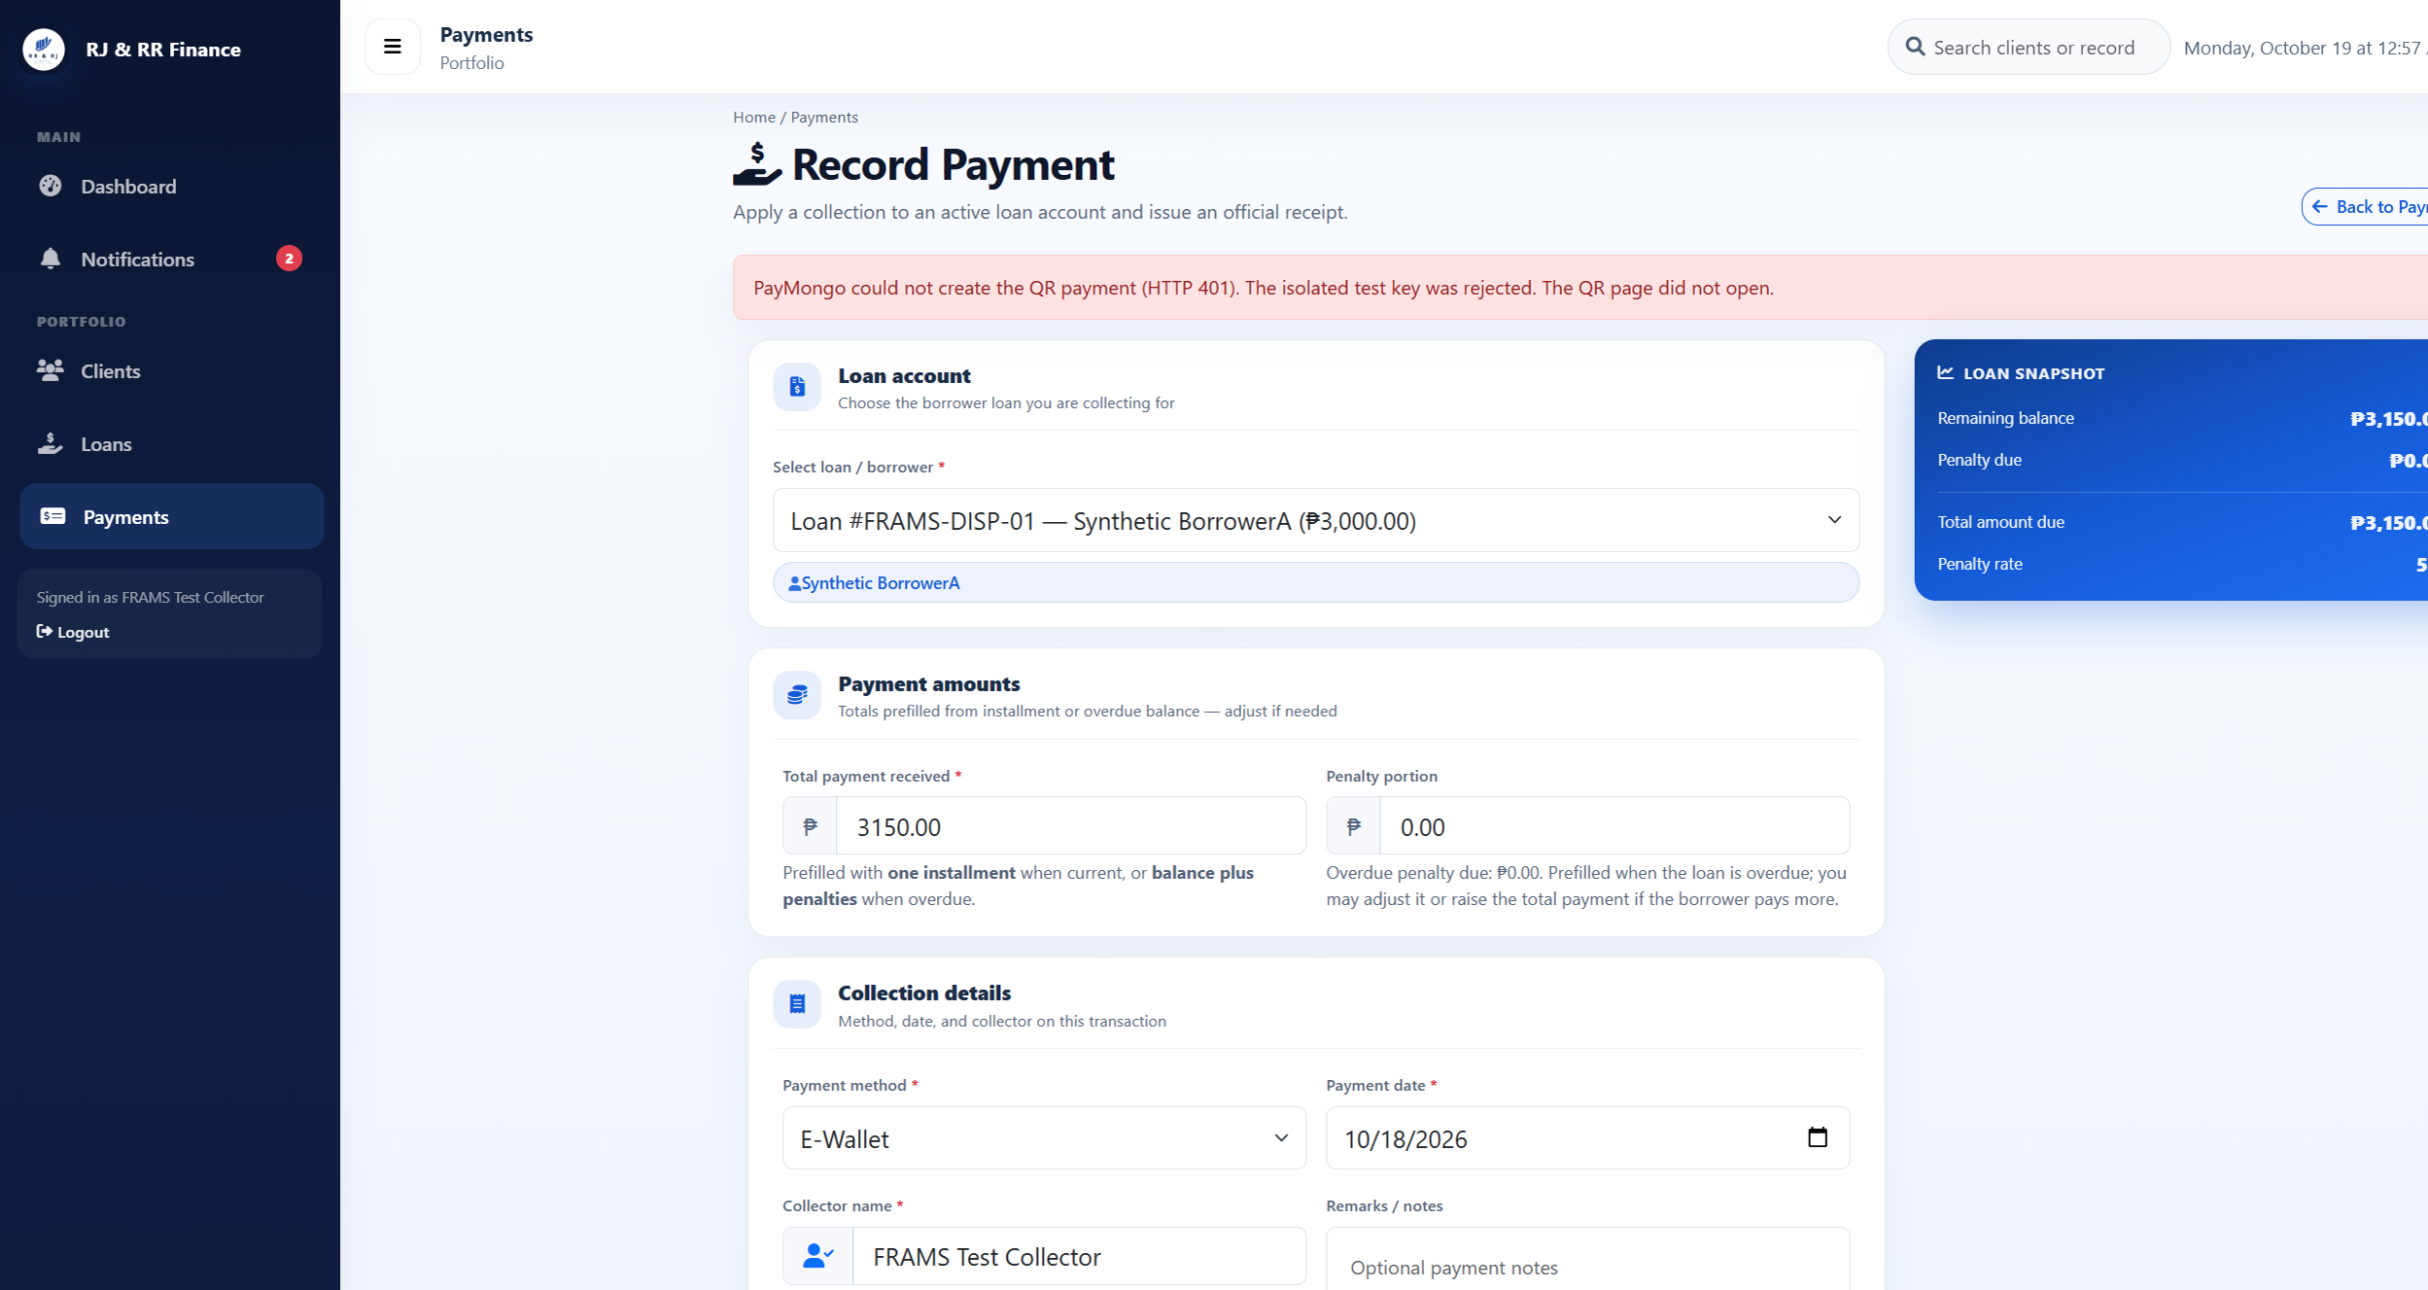
Figure B26 (B26_pm01_qr_rejected.png)

Figure B27 — PM-02
Scenario: The pending QR page is compared with the loan balance before payment.
Expected result: When QR creation is rejected, the payment form stays open. No QR, QR amount, method, or expiry is shown. The balance and loan status stay unchanged.
Actual result: The same screen as Figure B26 stayed on Record Payment. No QR image, QR amount, method block, or expiry was displayed. FRAMS-DISP-01 remained Active with remaining balance PHP 3,150.00.
Figure B27 (B26_pm01_qr_rejected.png)

Figure B28 — PM-03
Scenario: Cash is selected on the payment form.
Expected result: Create Dynamic QR Ph stays hidden. The ordinary cash payment action remains available.
Actual result: With Cash selected, the Create Dynamic QR Ph button was hidden and disabled. Cancel and Record Payment remained available. The loan and amount sections collapsed only so the action row fit in the capture.
Figure B28 (B28_pm03_cash_no_qr_button.png)

Figure B29 — PM-04
Scenario: Blank, zero, and nonnumeric QR amounts are submitted.
Expected result: No QR transaction is stored. A blank amount is stopped by the required field. Zero is rejected because the amount must be greater than zero. A nonnumeric value is also rejected.
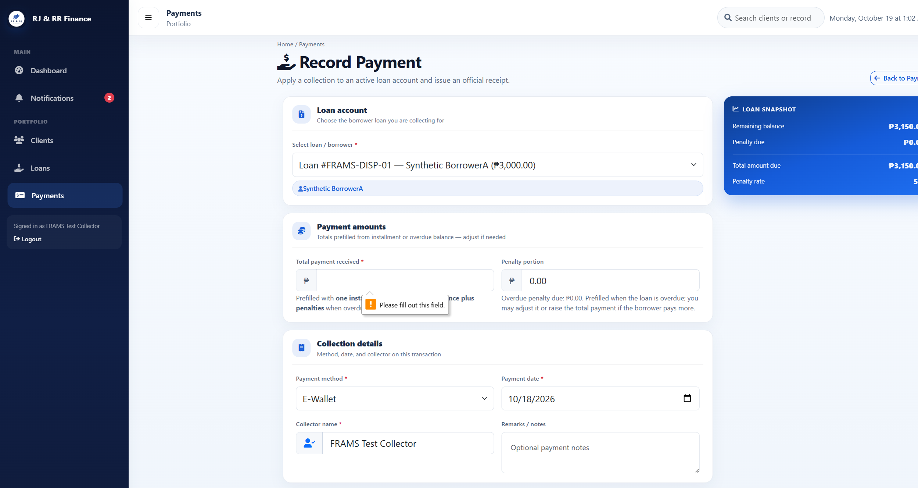
Actual result: Blank was stopped in the browser with "Please fill out this field." Zero reached the server and returned "Payment amount must be greater than zero." The nonnumeric value abc, after the number field was changed to text, returned "Enter a valid payment amount." None of the three created a QR image or a repayment.

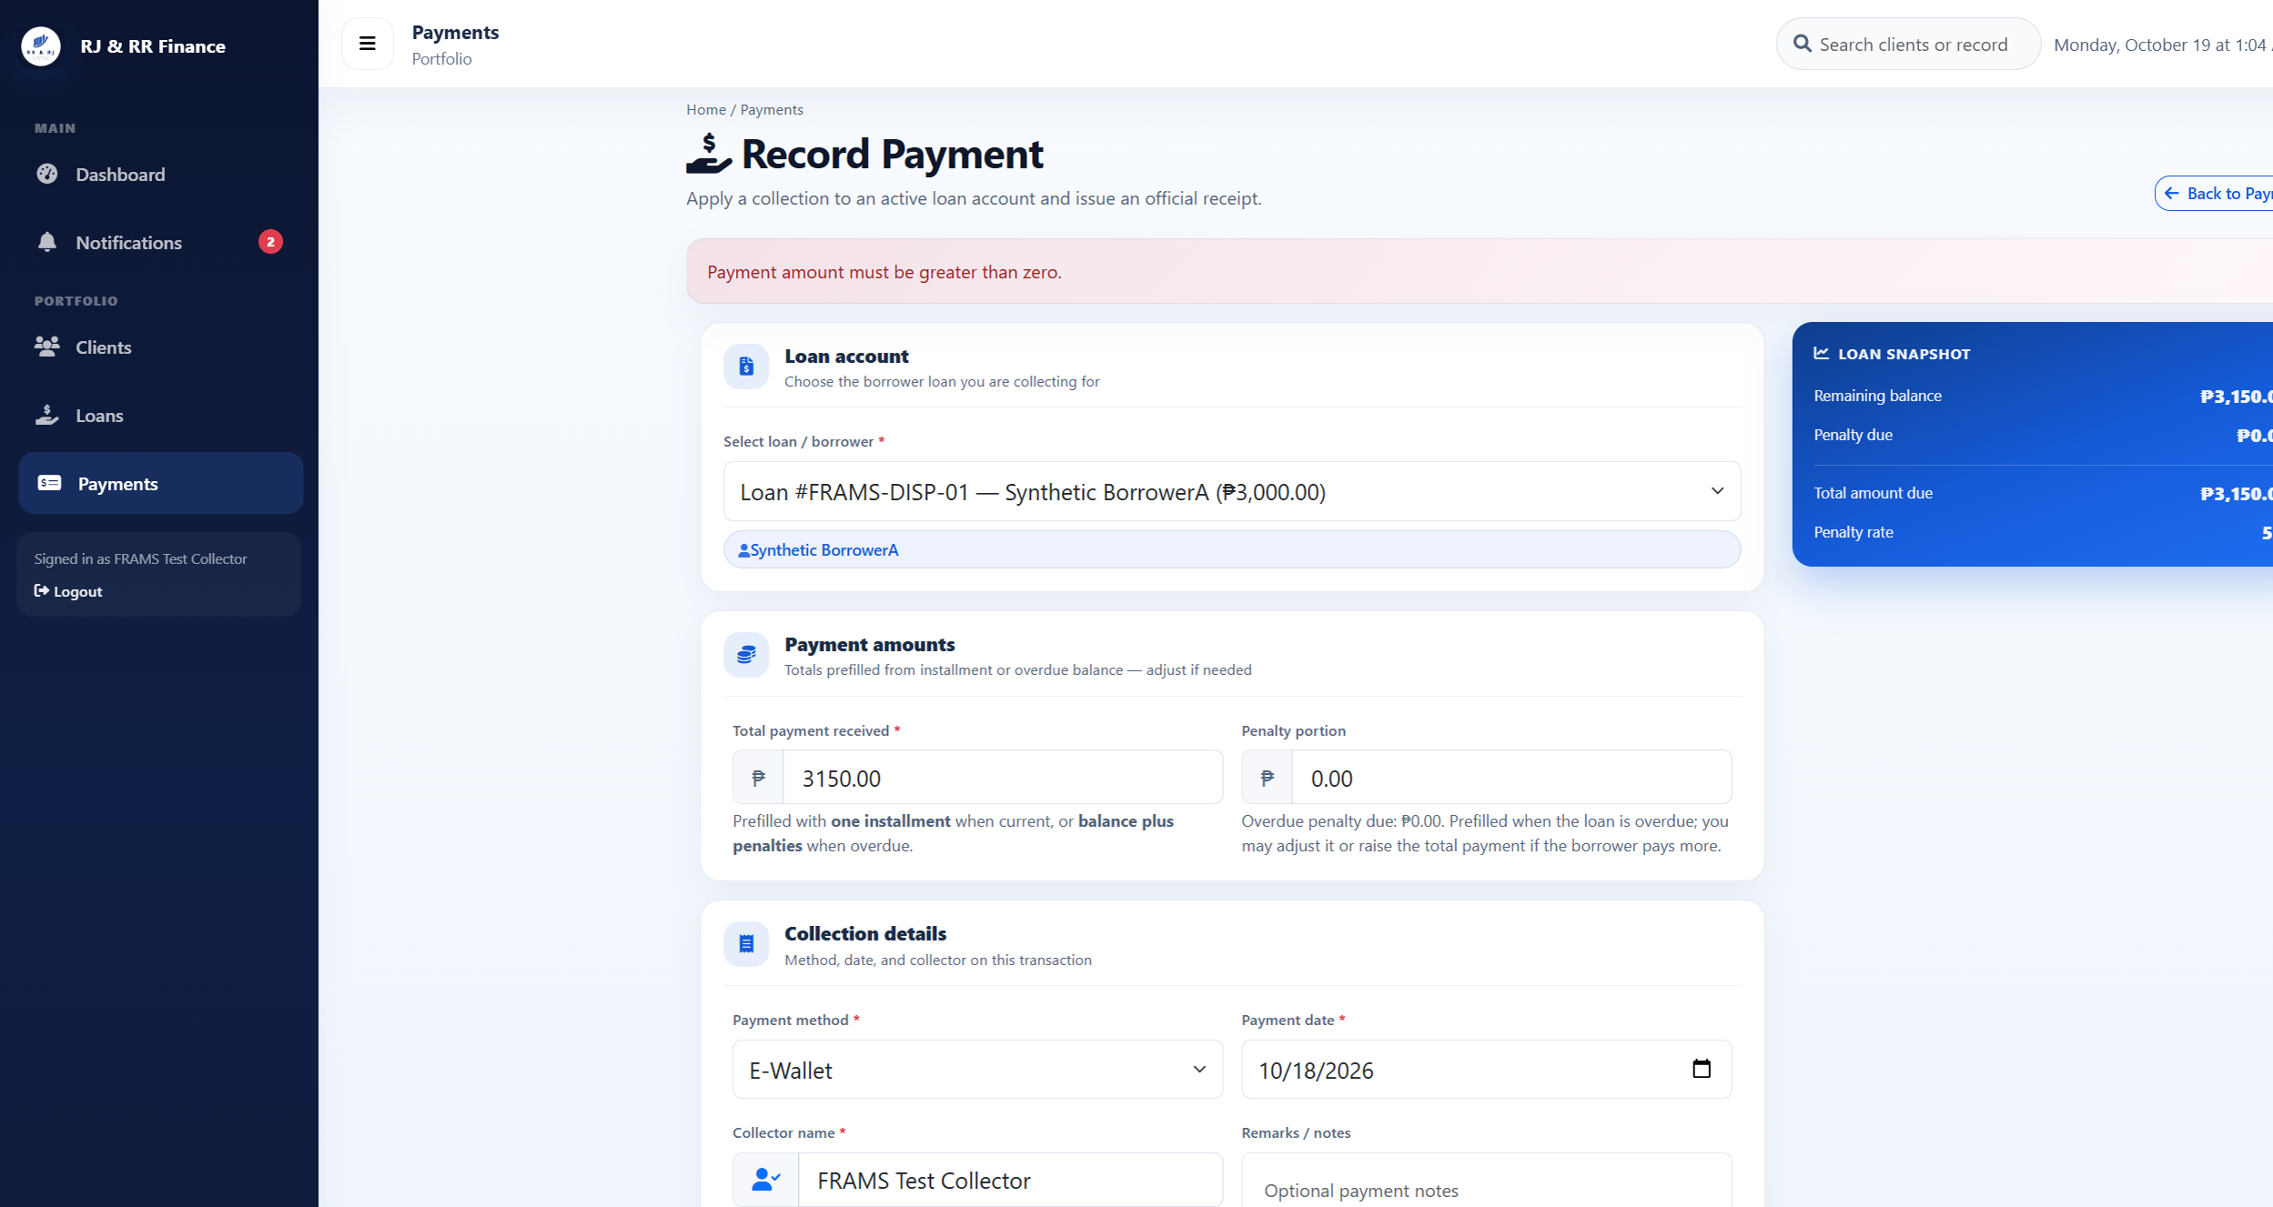
Figure B29(a) (B29_pm04_zero_amount.png)

Figure B29(b) (B29_pm04_nonnumeric.png)
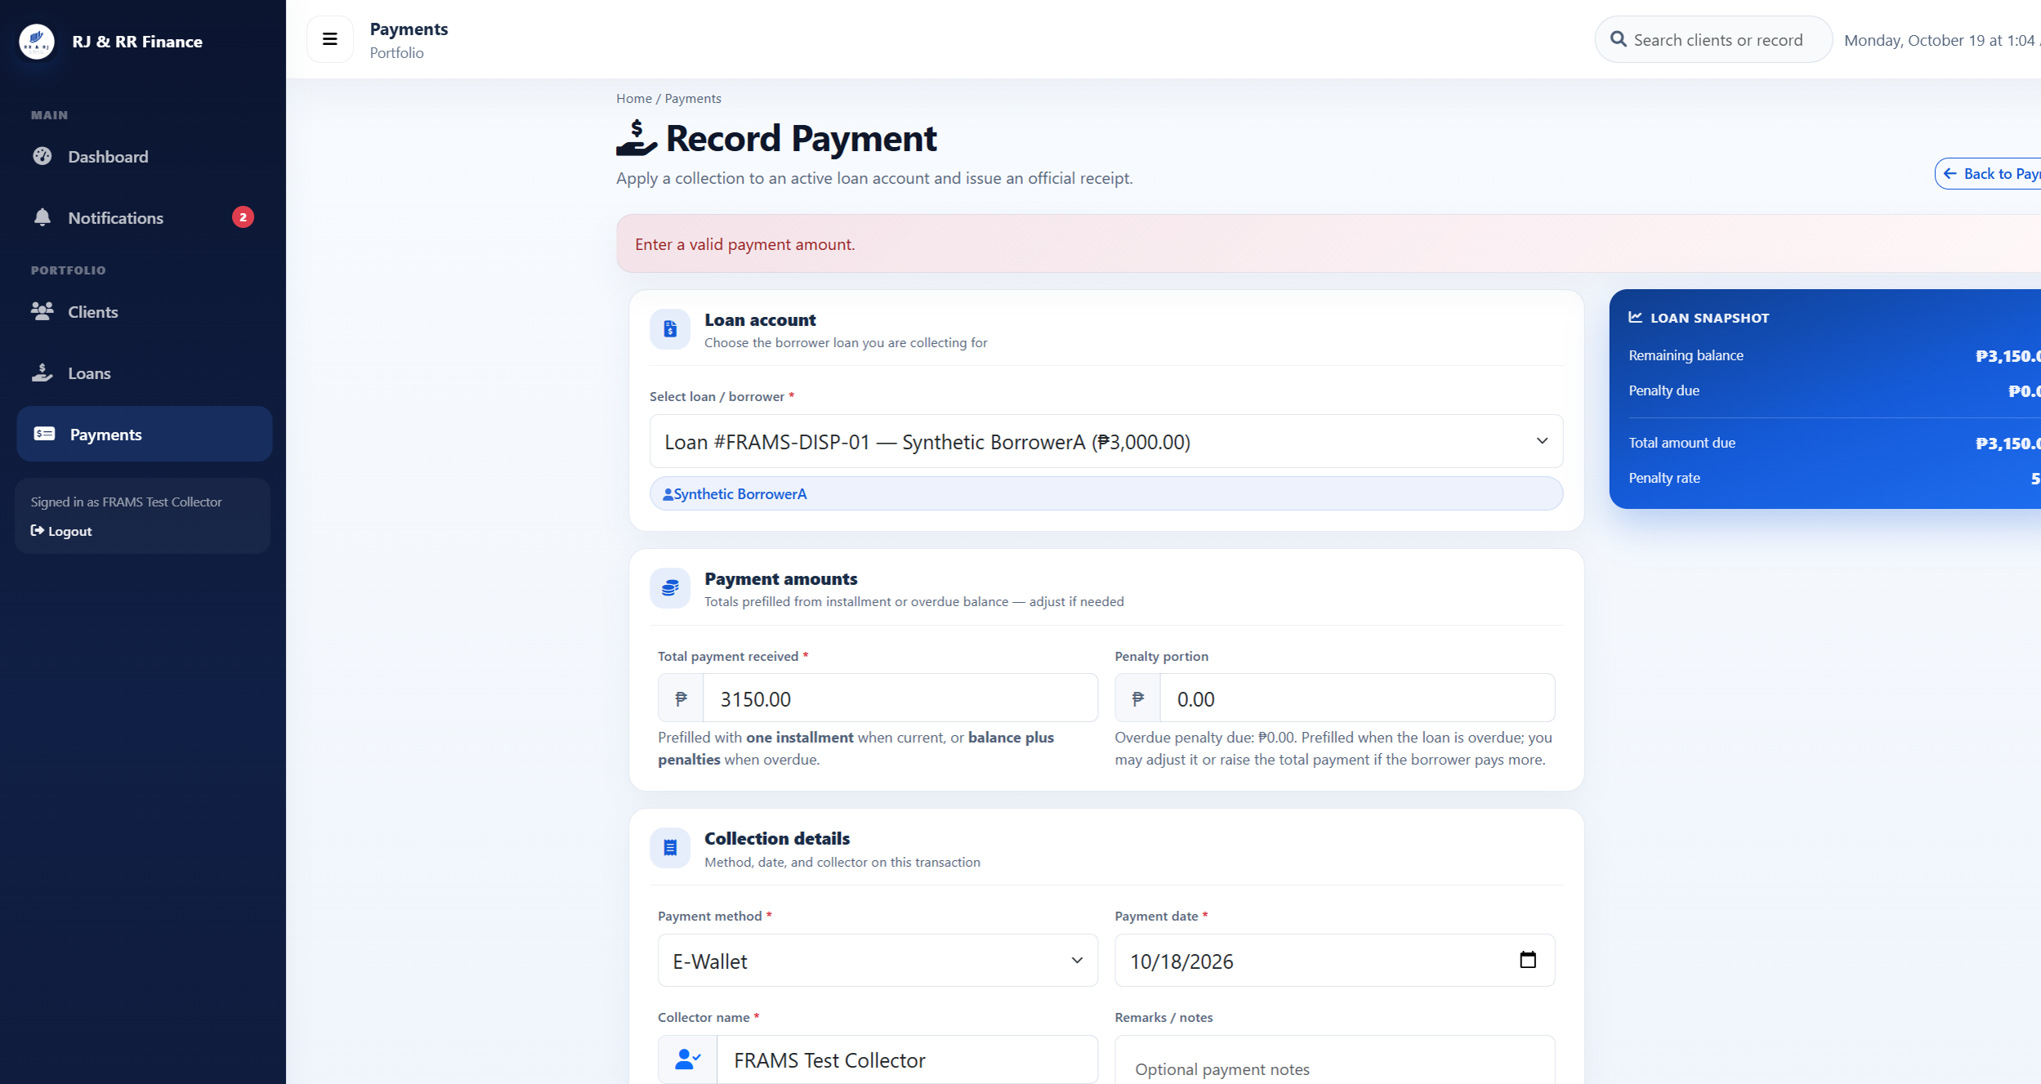

Figure B30 — PM-05
Scenario: The QR amount is greater than the current total due.
Expected result: The request is rejected and no QR transaction is stored.
Actual result: An amount of 4000.00 against a total due of PHP 3,150.00 was rejected: "Payment cannot exceed the current total amount due of PHP 3,150.00." No repayment was created.
Figure B30 (B30_pm05_amount_too_high.png)
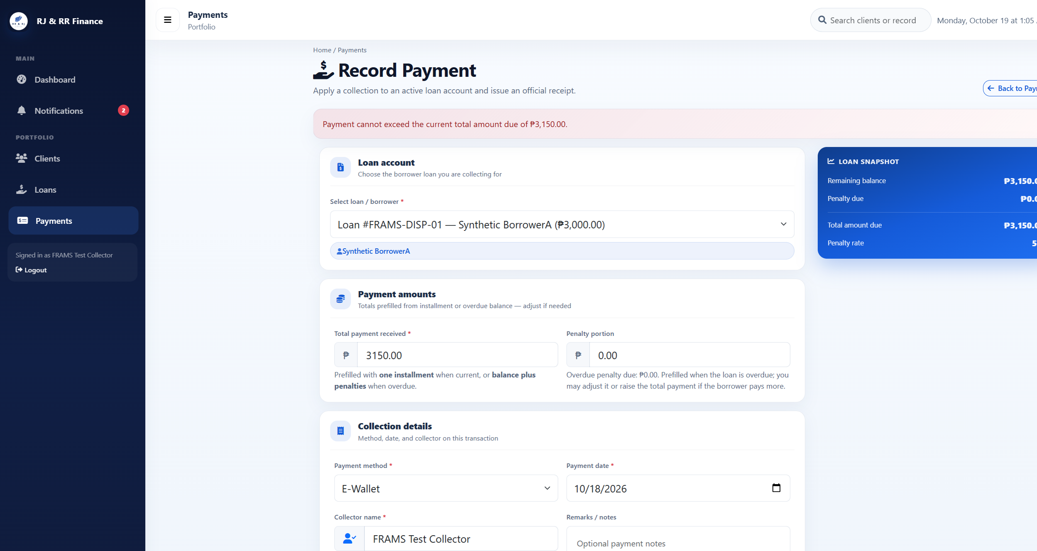

Figure B31 — PM-06
Scenario: A test collector submits a QR Ph request for a disposable loan assigned to another collector.
Expected result: The server rejects the request. No pending QR transaction and no repayment are created.
Actual result: Collector A submitted loan 30, which is assigned to Collector B. The server responded, "You are not assigned to this loan." The loan was not in Collector A's list, and no repayment was created.
Figure B31 (B31_pm06_other_collector.png)

Figure B32 — PM-07
Scenario: A signed-out visitor opens the payments page, and a borrower attempts to meet the collector QR request.
Expected result: The visitor is redirected to the staff sign-in page. The borrower is redirected to payment history and cannot start a QR payment.
Actual result: A signed-out request for the payments page opened the staff sign-in page. The signed-in borrower was redirected to Payment History. That page has no QR action. The borrower is turned away before the collector-only message is reached. The attached Figure B32 shows the staff sign-in page only; a borrower payment-history screenshot is not embedded in this file.

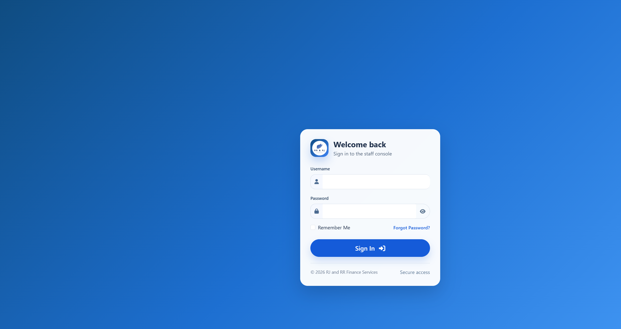
Figure B32. Staff sign-in page after a signed-out request for the staff payments page. The attached screenshot shows the staff console sign-in form. A separate borrower payment-history screenshot is not embedded in this file.

Figure B33 — PM-08
Scenario: A second QR Ph request is created while an earlier attempt for the same loan is unresolved.
Expected result: A second request is refused when a pending QR has not expired and PayMongo cannot confirm it.
Actual result: An unresolved pending attempt on FRAMS-TEST-A could not be confirmed with PayMongo. The second request was refused: "The previous PayMongo QR Ph attempt could not be confirmed with PayMongo." The pending row stayed pending, the balance stayed PHP 3,833.34, and no new repayment was created. The supersede path was not applicable because PayMongo could not confirm the open attempt.
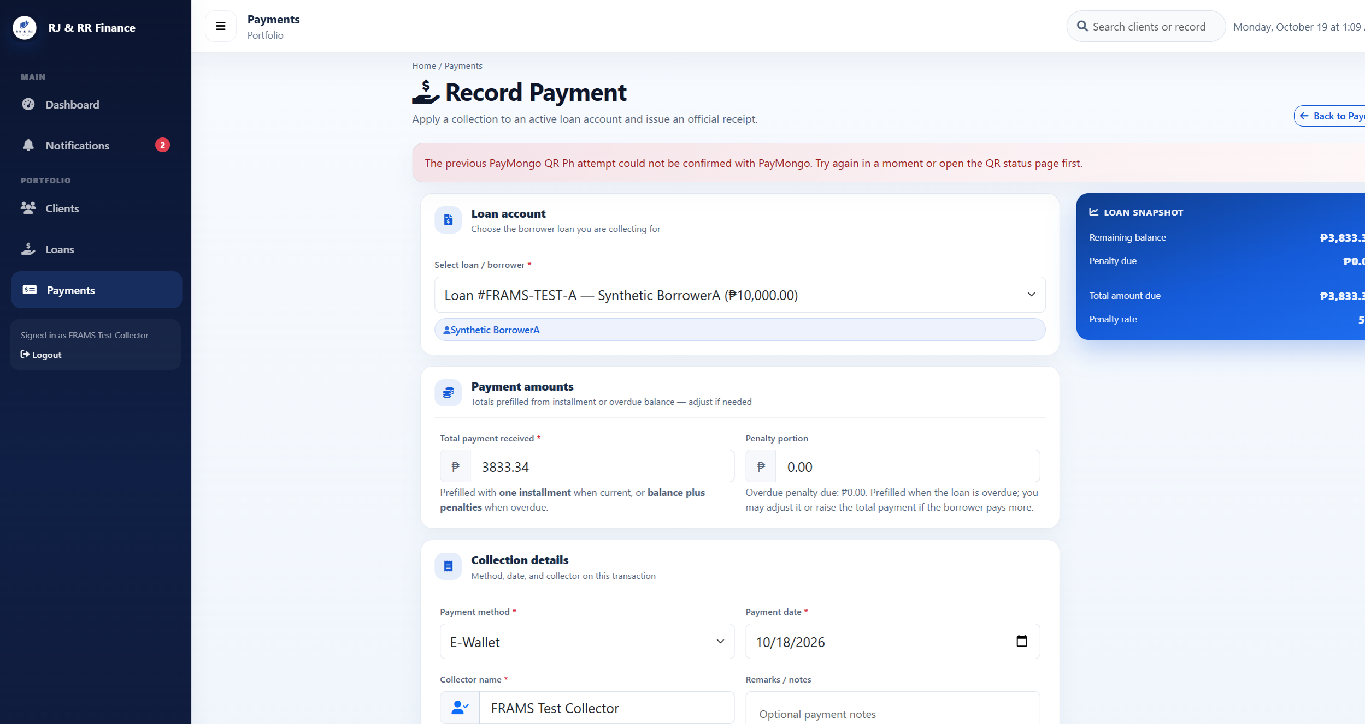
Figure B33 (B33_pm08_unconfirmed_pending_refused.png)

Figure B34 — PM-09
Scenario: An authorized user opens the receipt for a recorded E-Wallet repayment in the isolated test environment.
Expected result: The receipt should display the recorded repayment details and the remaining balance after payment.
Actual result: The receipt showed RJRR-20261018-000004, E-Wallet, PHP 100.00 paid, PHP 3,150.00 before payment, and PHP 3,050.00 remaining. This check confirms receipt contents for a stored record in the isolated test environment. It does not demonstrate Payment Intent polling, staff-initiated Check with PayMongo, or a live PayMongo charge.

Figure B34 (B34_pm09_receipt.png)
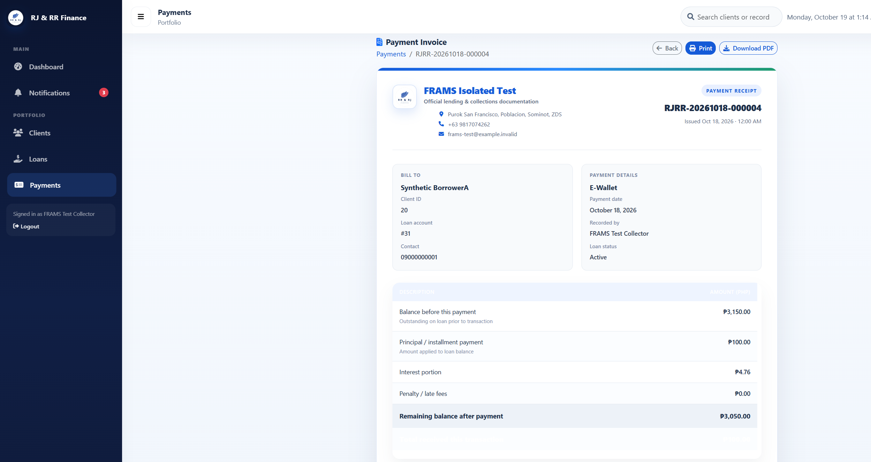

Figure B35 — PM-10
Scenario: An authorized staff member reviews the Payments Management page to verify that a recorded E-Wallet repayment appears in the payment list.
Expected result: The payment list should display the recorded repayment with its visible payment ID, date, borrower, loan ID, amount, payment method, reference number, and collector.
Actual result: The Payments Management screenshot displayed Payment ID 46 for Synthetic Borrower A, Loan ID 31, an amount of PHP 100.00, E-Wallet as the payment method, reference number pay_frams_pm09_once, and FRAMS Test Collector as the collector.

Figure B35 (Payments Management list screenshot). Note. No separate Payments Management list image is embedded beside this caption in the current file. The nearest attached PayMongo image is the PM-09 receipt (RJRR-20261018-000004). Do not treat that receipt as a payment-list screenshot.

Figure B36 — excluded from official PayMongo scope
Scope note: Figure B36 is excluded from the official PayMongo evaluation. It shows local endpoint responses and is not a Payment Intent polling test, not a staff Check with PayMongo test, and not a live charge.
This figure is not counted in Table 4.7.
The screenshot is retained in the appendix file only so that the excluded evidence is not silently discarded. It is not treated as a passed official test case.

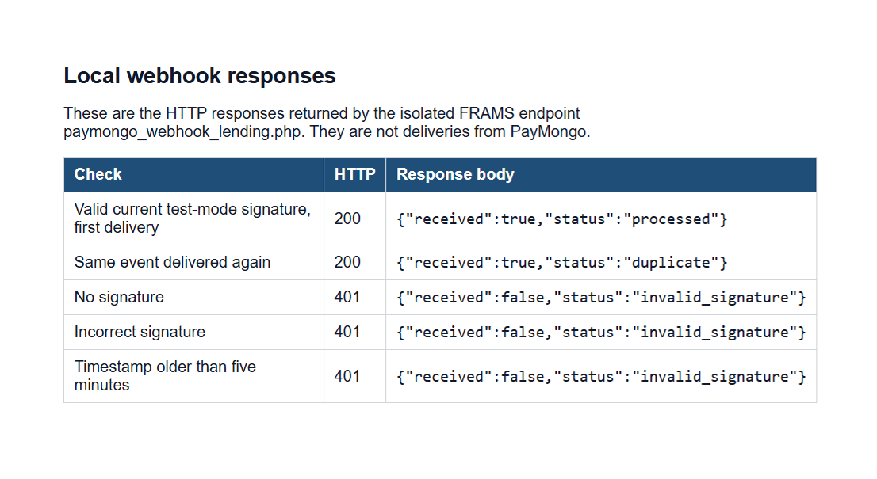Figure B36 (excluded from official PayMongo scope)

Figure B37 — PM-12
Scenario: An authorized staff member views the Payments Management page and reviews the displayed payment summaries and recorded payment entries.
Expected result: The page should display the selected reporting period, payment summary information, and recorded payment entries.
Actual result: The screenshot showed October 2026, collected and all-time collection totals of PHP 10,516.66, four payments for the period, and Payment ID 46 for PHP 100.00 in the payment list.
Remarks: The screenshot supports the display of summary cards and payment entries; it does not test payment deletion restrictions.

Figure B37 (Payments Management summary and payment list screenshot). Note. No separate Payments Management summary image is embedded beside this caption in the current file. This case is not treated as visual proof of payment deletion controls, polling, or a live PayMongo charge.
Table B5
Penetration Testing Test Evidence of FRAMS
Test Case ID | Description | Test Steps | Expected Result | Actual Result | Remarks / Evidence
PT-01 | To verify that protected staff and borrower pages cannot be accessed without authentication. | 1. Sign out. 2. Request the protected staff pages. 3. Request the protected borrower pages. 4. Check redirects and whether protected records appear. | Unauthenticated requests to protected staff pages should redirect to the staff login page. Requests to protected borrower pages should redirect to the borrower login page. Protected records should not be displayed. | Signed-out requests for dashboard_lending.php, collector_dashboard_lending.php, payments_lending.php, and reports_lending.php each returned HTTP 302 to login_lending.php. The browser showed the staff sign-in page and no loan, client, or user records. Signed-out requests for borrower_dashboard_lending.php, borrower_my_loan_lending.php, and borrower_payment_history_lending.php each returned HTTP 302 to borrower_login_lending.php. The browser showed the borrower sign-in page. | PASSED — Figure B38.
PT-02 | To verify that FRAMS rejects login attempts using an incorrect password or an inactive account. | 1. Submit a wrong password for the active test administrator. 2. Attempt sign-in with the inactive test account. 3. Check the messages and dashboard access. | FRAMS should reject both login attempts, display an appropriate authentication error, and prevent access to the dashboard. | frams_test_admin with a wrong password stayed on the staff sign-in page and showed "Invalid username or password." frams_test_inactive, whose users.status is Inactive, with the ordinary test password stayed on the same page and showed the same message. Neither attempt opened a dashboard. | PASSED — Figure B39.
PT-03 | To verify that a borrower cannot access staff-only pages and can view only their own payment history. | 1. Sign in as frams_test_borrower. 2. Request staff-only pages. 3. Open the staff payments page. 4. Inspect the borrower payment history. | Requests to staff-only pages should redirect the borrower to the borrower dashboard. The payment history should display only the signed-in borrower's records. | Signed in as frams_test_borrower. users_lending.php, reports_lending.php, loan_release_lending.php, and expenses_lending.php each returned HTTP 302 to borrower_dashboard_lending.php. The browser showed the borrower dashboard, not user administration, reports, loan release, or expenses. payments_lending.php returned HTTP 302 to borrower_payment_history_lending.php. That history listed only this borrower's receipt RJRR-20261018-000004. | PASSED — Figure B40.
PT-04 | To verify that a collector cannot access administrator-only user management, borrower approval, reporting, and loan-release pages. | 1. Sign in as frams_test_collector. 2. Request user management, reports, borrower approval, and loan release. 3. Check redirects and user count. | FRAMS should prevent the collector from accessing restricted administrative functions and redirect the collector to the collector dashboard. | Signed in as frams_test_collector. users_lending.php, reports_lending.php, borrower_approval_lending.php, and loan_release_lending.php each returned HTTP 302 to collector_dashboard_lending.php. The browser showed the collector dashboard. No user, approval, or release form was shown, and the user count stayed at 6. | PASSED — Figure B41.
PT-05 | To verify that FRAMS rejects selected form submissions made without the required security token. | 1. Submit registration, payment, expense, user-management, and loan-release requests without the required security token. 2. Check HTTP responses and record counts. | FRAMS should reject requests that lack the required security token and prevent unauthorized changes to the corresponding records. | Registration, payment recording, expense recording, user management, and loan release were each posted without the security token. Borrower approval was not used. All five responses were HTTP 419 with the heading "Invalid or expired session" and the text "Please refresh the page and try again." Users stayed at 6, payments at 4, expenses at 0, and loan releases at 3. The probe username was not created. | PASSED — Figure B42.
PT-06 | To verify that FRAMS safely handles SQL injection-style input in the staff login and user search functions. | 1. Enter the SQL-injection-style string in staff sign-in. 2. Enter the same string in user search. 3. Check authentication and search results. | FRAMS should reject the login attempt and handle the search input as ordinary user input. The test should not bypass authentication or expose user accounts. | The staff sign-in username frams_test_admin' OR '1'='1 was rejected with "Invalid username or password" and stayed on the sign-in page. The same quote in user search returned "Showing 0 of 0 users" and "No users found." It did not list the administrator, collector, or borrower accounts. | PASSED — Figure B43.
PT-07 | To verify that FRAMS safely displays search input containing HTML-like markup without rendering it as active HTML.  . | 1. Enter <b>pt07marker</b> in user search. 2. Inspect how the value is displayed in the page. | FRAMS should display the submitted markup as encoded text rather than interpreting it as HTML. The input should not be rendered as bold text or execute as active markup. | The user-search value <b>pt07marker</b> was returned in the page as encoded text. The search box showed the marker as ordinary characters, including the angle brackets. It was not rendered as bold text, and the search still listed 0 users. The payments flash message was not used. | PASSED — Figure B44.
PT-08 | To verify that a borrower cannot access another borrower's payment receipt or loan document. | 1. Sign in as frams_test_borrower. 2. Request another borrower's receipt. 3. Request a document not belonging to the borrower. 4. Inspect redirects and access response. | FRAMS should prevent access to another borrower's payment receipt and document. The borrower should see only their own payment history, and unauthorized document requests should be denied. | Signed in as frams_test_borrower. Requesting payments_lending.php?view=44, the receipt for Borrower B, returned HTTP 302 to borrower_payment_history_lending.php. The history still showed only RJRR-20261018-000004 and did not show RJRR-20261018-000002. Requesting download_loan_document_lending.php for a document path that does not belong to this borrower returned HTTP 403 and the text "Access denied." | PASSED — Figure B45.
PT-09 | To verify that a collector cannot view client, loan, or payment records that they are not authorized to access. | 1. Sign in as frams_test_collector. 2. Request Client 21, Loan 30, and Payment 44, which are outside the collector's assignments. 3. Check each response. | FRAMS should deny access to records outside the collector's authorized assignments and should not display the restricted information. | Signed in as frams_test_collector. Client 21, which is assigned to Collector B, returned HTTP 403: "You do not have permission to view this client." Loan 30, FRAMS-TEST-B, returned HTTP 403: "You do not have permission to view this loan." Payment 44 returned HTTP 403: "You do not have access to this receipt." None of the three records opened. | PASSED — Figure B46.
PT-10 | To verify that FRAMS rejects unsupported file types and files exceeding the permitted upload size during the loan application process. | 1. On loan-application Step 4, upload pt10-probe.txt. 2. Upload a file larger than 8 MB. 3. Inspect messages and document status. | FRAMS should reject unsupported file types and files larger than the 8 MB limit. Rejected files should not be saved in the document folder or marked as uploaded. | On loan-application step 4, pt10-probe.txt was checked and rejected with "Allowed file types: JPG, PNG, PDF." A file of 8,389,633 bytes was rejected with "File must be 8 MB or smaller." Neither file was written to the document folder. The wizard does not keep that sentence on screen: it stays on step 4 and shows "Required documents missing," with every document still marked "Not uploaded yet." | PASSED — Figure B47.
PT-11 | To verify that a collector cannot reopen a protected dashboard after signing out. | 1. Sign in as the test collector. 2. Sign out. 3. Reopen collector_dashboard_lending.php. 4. Check the redirect and displayed page. | After logout, FRAMS should require the collector to authenticate again before granting access to the protected dashboard. | The collector signed out, which opened the staff sign-in page. Opening collector_dashboard_lending.php again returned HTTP 302 to login_lending.php. The browser showed the staff sign-in page, so the protected dashboard required authentication again. | PASSED — Figure B48.
PT-12 | To verify the forgot-password process, including verification-code expiry, incorrect-code handling, attempt limits, and single-use behavior. | 1. Request a password-reset code. 2. Submit an incorrect code five times and try again. 3. Test an expired code. 4. Use a valid code, then try reusing it. 5. Restore the test password and inspect reset records. | FRAMS should issue a time-limited verification code, reject incorrect or expired codes, enforce the maximum number of incorrect attempts, and prevent a successfully used code from being reused. | The forgot-password page asks for a username and says it will email a 6-digit code. It does not offer a reset link. The code form says the code expires in 10 minutes. A new code record was measured at 600 seconds. An incorrect code returned "That code is incorrect or has expired." After five incorrect attempts, the next try returned "Too many incorrect codes. Request a new code." and the code record was removed. A code whose expiry was already past returned the incorrect-or-expired message. A correct code allowed one password change, and that same code was then rejected. The borrower test password was restored afterward, and no reset row remained. | PASSED — Figure B49.

Screenshot Evidence for Penetration Testing
Figure B38 — PT-01
Scenario: Open the administrator dashboard, collector dashboard, payments, reports, and borrower pages while signed out.
Expected result: Staff pages redirect to the staff sign-in page. Borrower pages redirect to the borrower sign-in page. No records are shown.
Actual result: Signed-out requests for dashboard_lending.php, collector_dashboard_lending.php, payments_lending.php, and reports_lending.php each returned HTTP 302 to login_lending.php. The browser showed the staff sign-in page and no loan, client, or user records. Signed-out requests for borrower_dashboard_lending.php, borrower_my_loan_lending.php, and borrower_payment_history_lending.php each returned HTTP 302 to borrower_login_lending.php. The browser showed the borrower sign-in page.
Figure B38. Staff sign-in after opening the administrator dashboard while signed out.
Figure B38. Borrower sign-in after opening the borrower dashboard while signed out.

Figure B39 — PT-02
Scenario: Sign in with a wrong password and with an inactive account.
Expected result: No protected page opens. The inactive trial uses the same staff message as a wrong password, and the account status supports that trial.
Actual result: frams_test_admin with a wrong password stayed on the staff sign-in page and showed "Invalid username or password." frams_test_inactive, whose users.status is Inactive, with the ordinary test password stayed on the same page and showed the same message. Neither attempt opened a dashboard.
Status: PASS
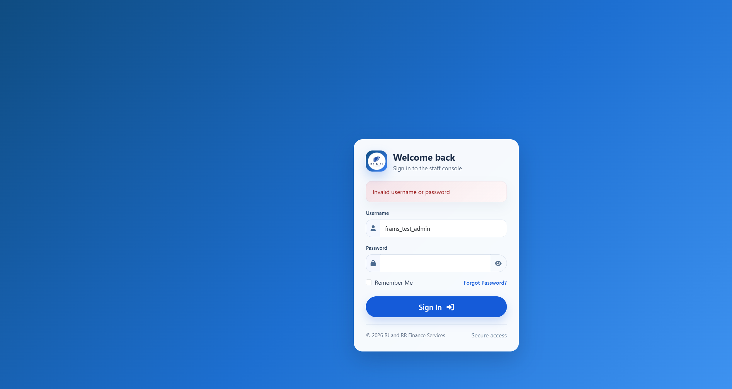
Figure B39. Wrong password for the active administrator.
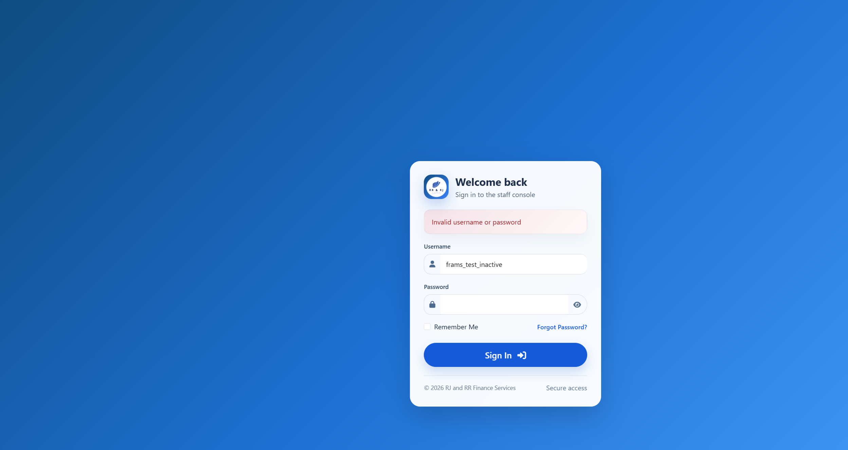
Figure B39. Inactive administrator. The message matches the wrong-password trial.

Figure B40 — PT-03
Scenario: A borrower opens the users, reports, loan-release, expenses, and payments pages.
Expected result: Users, reports, loan release, and expenses return the borrower to the borrower dashboard. The payments page returns the borrower to that borrower payment history.
Actual result: Signed in as frams_test_borrower. users_lending.php, reports_lending.php, loan_release_lending.php, and expenses_lending.php each returned HTTP 302 to borrower_dashboard_lending.php. The browser showed the borrower dashboard, not user administration, reports, loan release, or expenses. payments_lending.php returned HTTP 302 to borrower_payment_history_lending.php. That history listed only this borrower's receipt RJRR-20261018-000004.
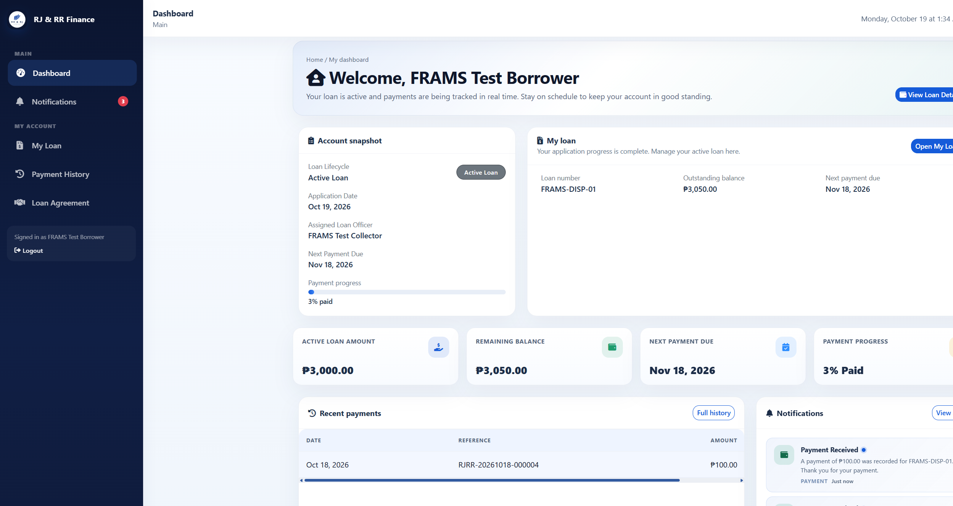
Figure B40. Borrower dashboard after requesting user management.
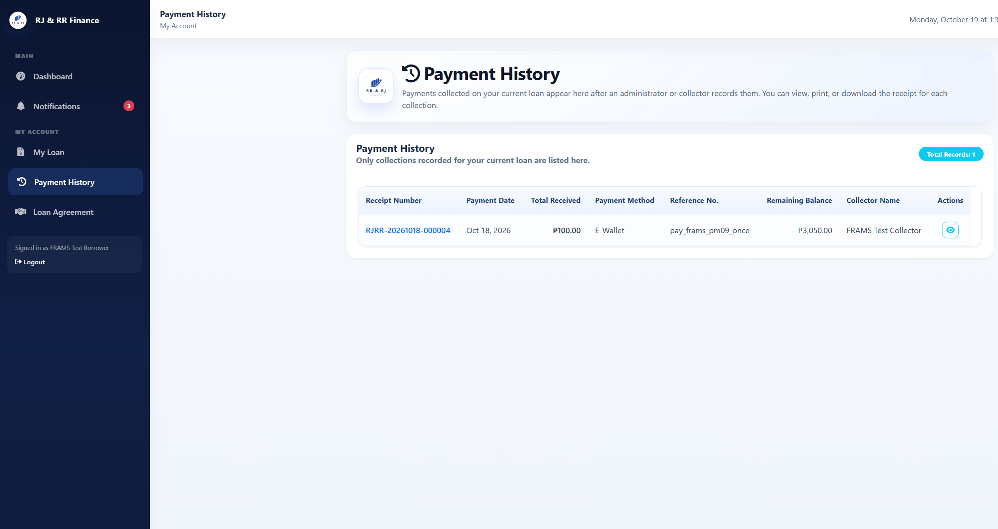
Figure B40. Borrower payment history after requesting the staff payments page.

Figure B41 — PT-04
Scenario: A collector opens users, reports, borrower approval, and loan release.
Expected result: Each request returns to the collector dashboard, and no administrator record is changed.
Actual result: Signed in as frams_test_collector. users_lending.php, reports_lending.php, borrower_approval_lending.php, and loan_release_lending.php each returned HTTP 302 to collector_dashboard_lending.php. The browser showed the collector dashboard. No user, approval, or release form was shown, and the user count stayed at 6.
Figure B41. Collector dashboard after requesting user management. Reports, borrower approval, and loan release returned to this same dashboard.

Figure B42 — PT-05
Scenario: Submit registration, payment recording, expense recording, user management, or loan release without the security token.
Expected result: The request ends with HTTP 419 and the message that the session is invalid or expired. No record is saved.
Actual result: Registration, payment recording, expense recording, user management, and loan release were each posted without the security token. Borrower approval was not used. All five responses were HTTP 419 with the heading "Invalid or expired session" and the text "Please refresh the page and try again." Users stayed at 6, payments at 4, expenses at 0, and loan releases at 3. The probe username was not created.
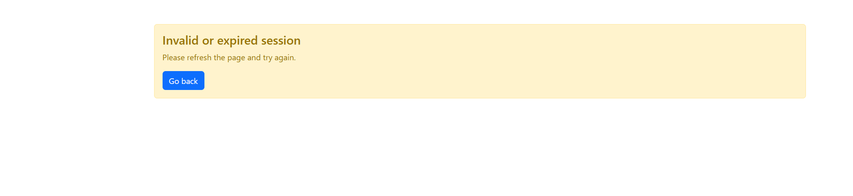
Figure B42. Registration submitted without the security token. The other four posts returned to this same page with HTTP 419.

Figure B43 — PT-06
Scenario: Enter a quote-style probe in sign-in and in a search box.
Expected result: Sign-in fails. Search does not reveal additional accounts, loans, or payments.
Actual result: The staff sign-in username frams_test_admin' OR '1'='1 was rejected with "Invalid username or password" and stayed on the sign-in page. The same quote in user search returned "Showing 0 of 0 users" and "No users found." It did not list the administrator, collector, or borrower accounts.
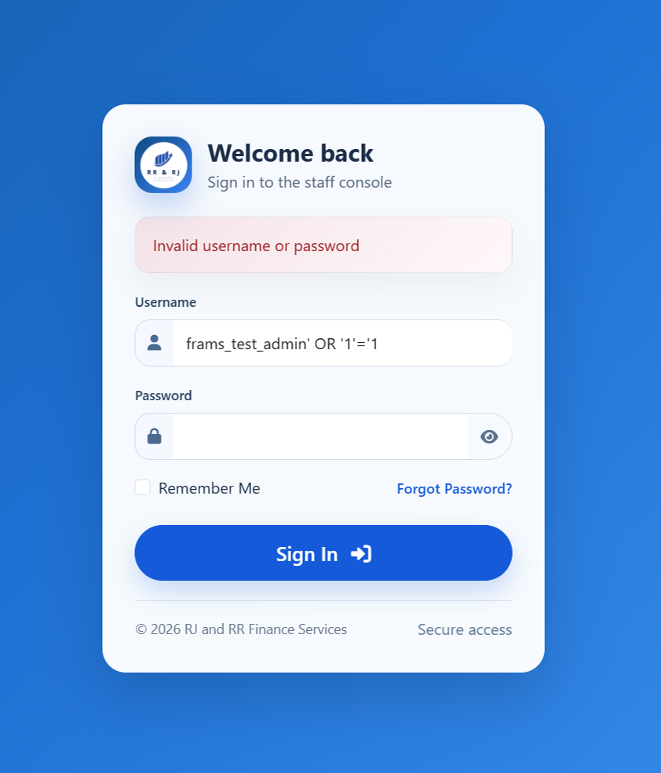
Figure B43. Quote-style sign-in probe rejected.
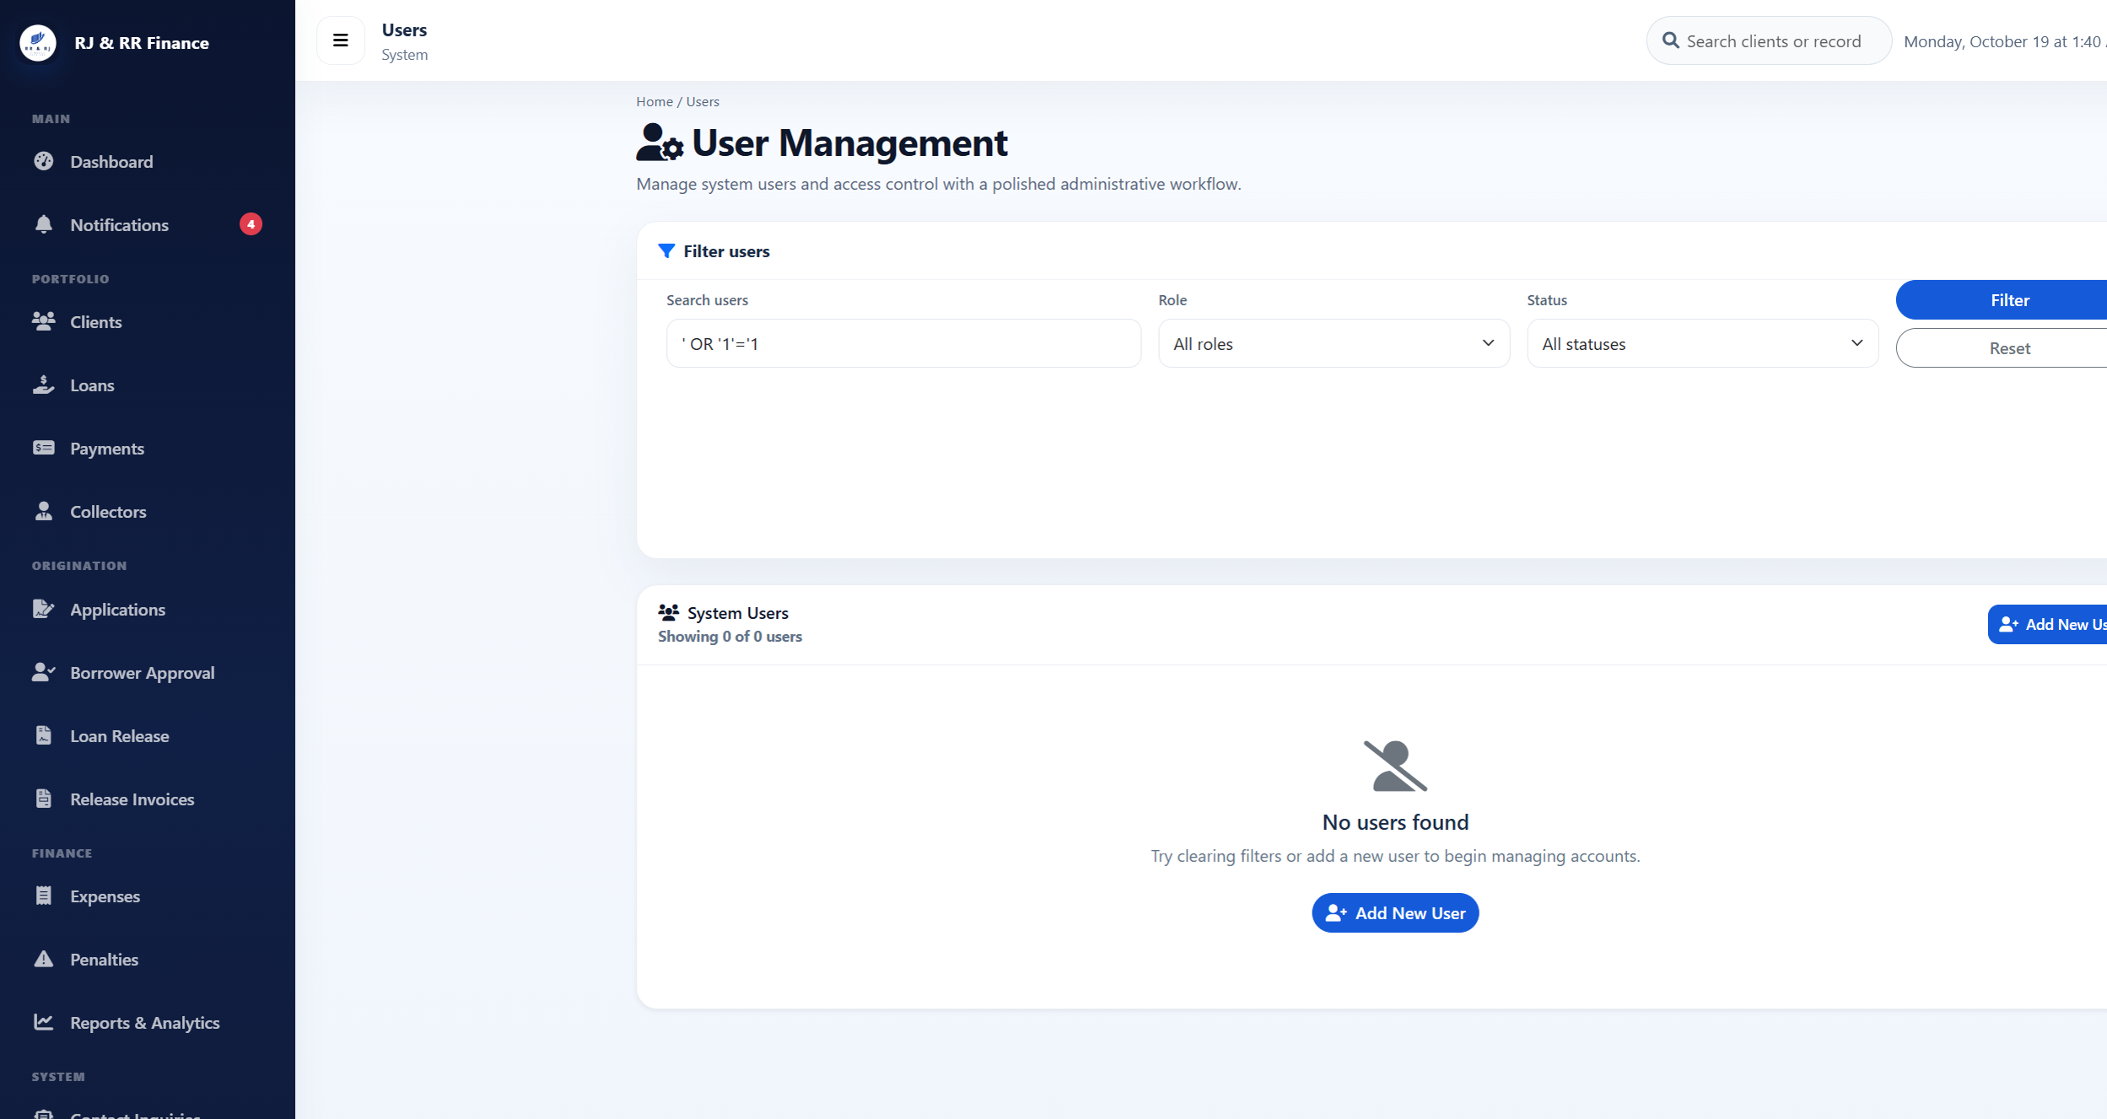
Figure B43. Quote-style user search returned no accounts.

Figure B44 — PT-07
Scenario: Enter a harmless markup marker in an encoded search field and display it.
Expected result: The marker is shown as ordinary text.
Actual result: The user-search value <b>pt07marker</b> was returned in the page as encoded text. The search box showed the marker as ordinary characters, including the angle brackets. It was not rendered as bold text, and the search still listed 0 users. The payments flash message was not used.
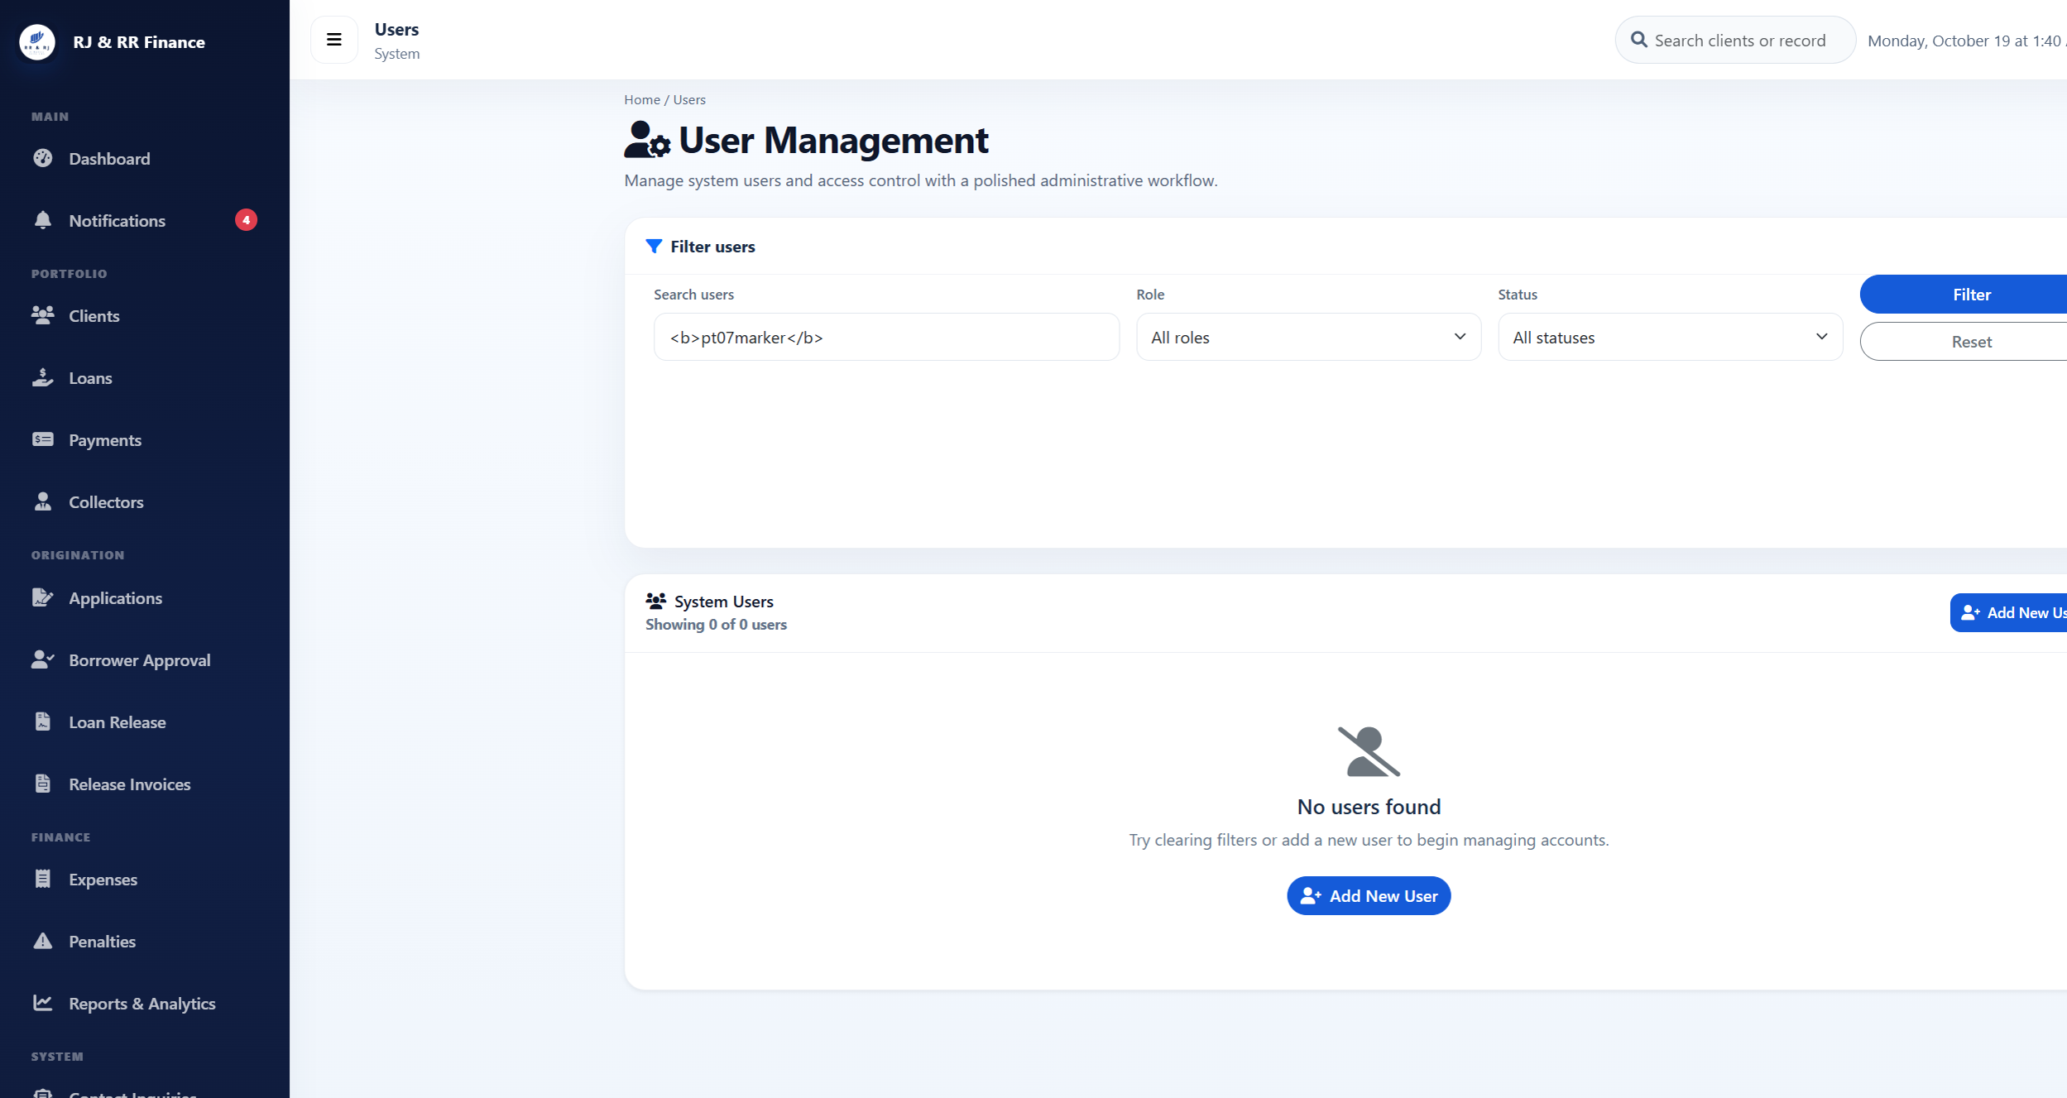
Figure B44. The markup marker remains visible as text in the search box.

Figure B45 — PT-08
Scenario: A borrower requests another borrower receipt address and document address.
Expected result: The receipt is refused or redirected, and the document request returns Access denied.
Actual result: Signed in as frams_test_borrower. Requesting payments_lending.php?view=44, the receipt for Borrower B, returned HTTP 302 to borrower_payment_history_lending.php. The history still showed only RJRR-20261018-000004 and did not show RJRR-20261018-000002. Requesting download_loan_document_lending.php for a document path that does not belong to this borrower returned HTTP 403 and the text "Access denied."
Figure B45. Other-borrower receipt request returned to this borrower's own payment history.
Figure B45. Other-borrower document request. The response text is Access denied.

Figure B46 — PT-09
Scenario: A collector opens a client, loan, or payment assigned to another collector.
Expected result: The unassigned record is not opened for collection.
Actual result: Signed in as frams_test_collector. Client 21, which is assigned to Collector B, returned HTTP 403: "You do not have permission to view this client." Loan 30, FRAMS-TEST-B, returned HTTP 403: "You do not have permission to view this loan." Payment 44 returned HTTP 403: "You do not have access to this receipt." None of the three records opened.
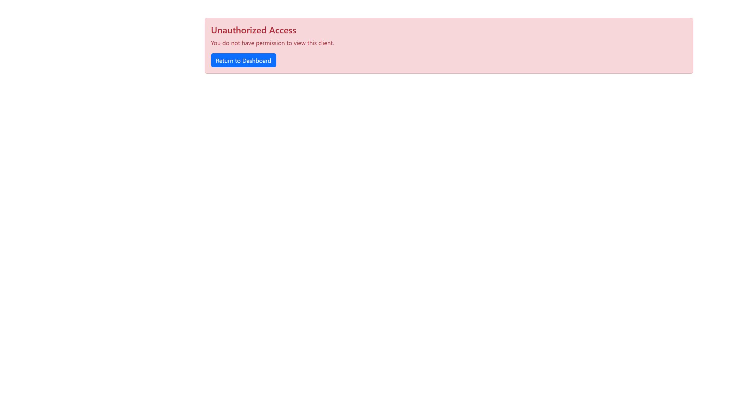
Figure B46. Collector A denied client 21.
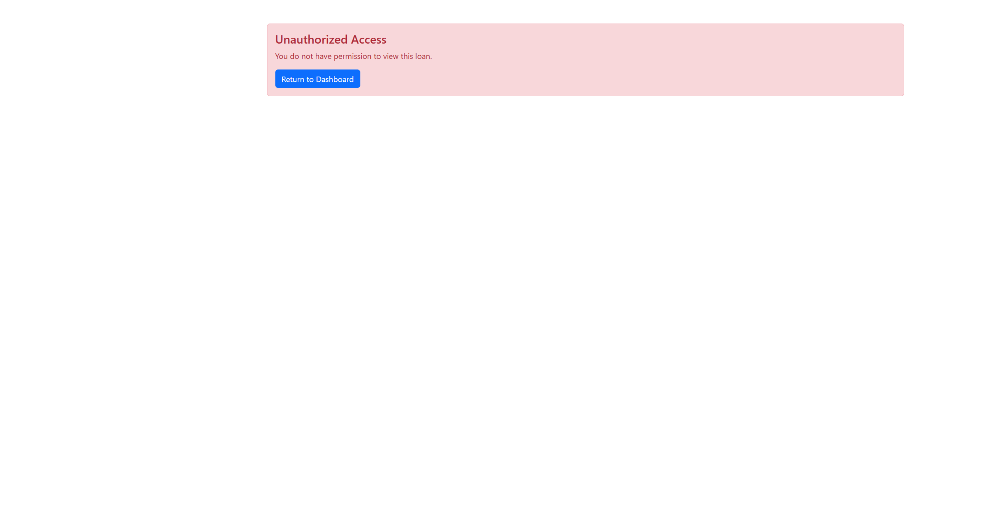
Figure B46. Collector A denied loan 30.
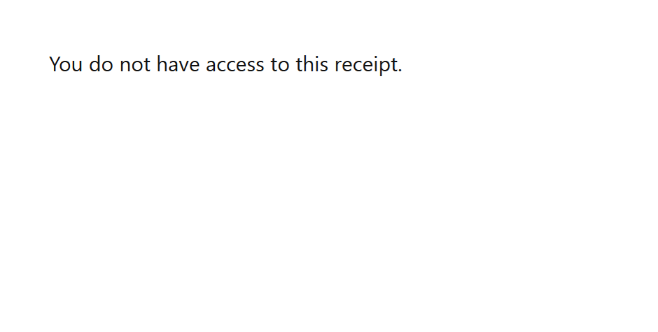
Figure B46. Collector A denied payment 44.

Figure B47 — PT-10
Scenario: Upload a file that is not JPG, PNG, or PDF, and a file larger than 8 MB.
Expected result: The file is rejected and is not stored. A PDF is an allowed file and was not used as the invalid sample.
Actual result: On loan-application step 4, pt10-probe.txt was checked and rejected with "Allowed file types: JPG, PNG, PDF." A file of 8,389,633 bytes was rejected with "File must be 8 MB or smaller." Neither file was written to the document folder. The wizard does not keep that sentence on screen: it stays on step 4 and shows "Required documents missing," with every document still marked "Not uploaded yet."
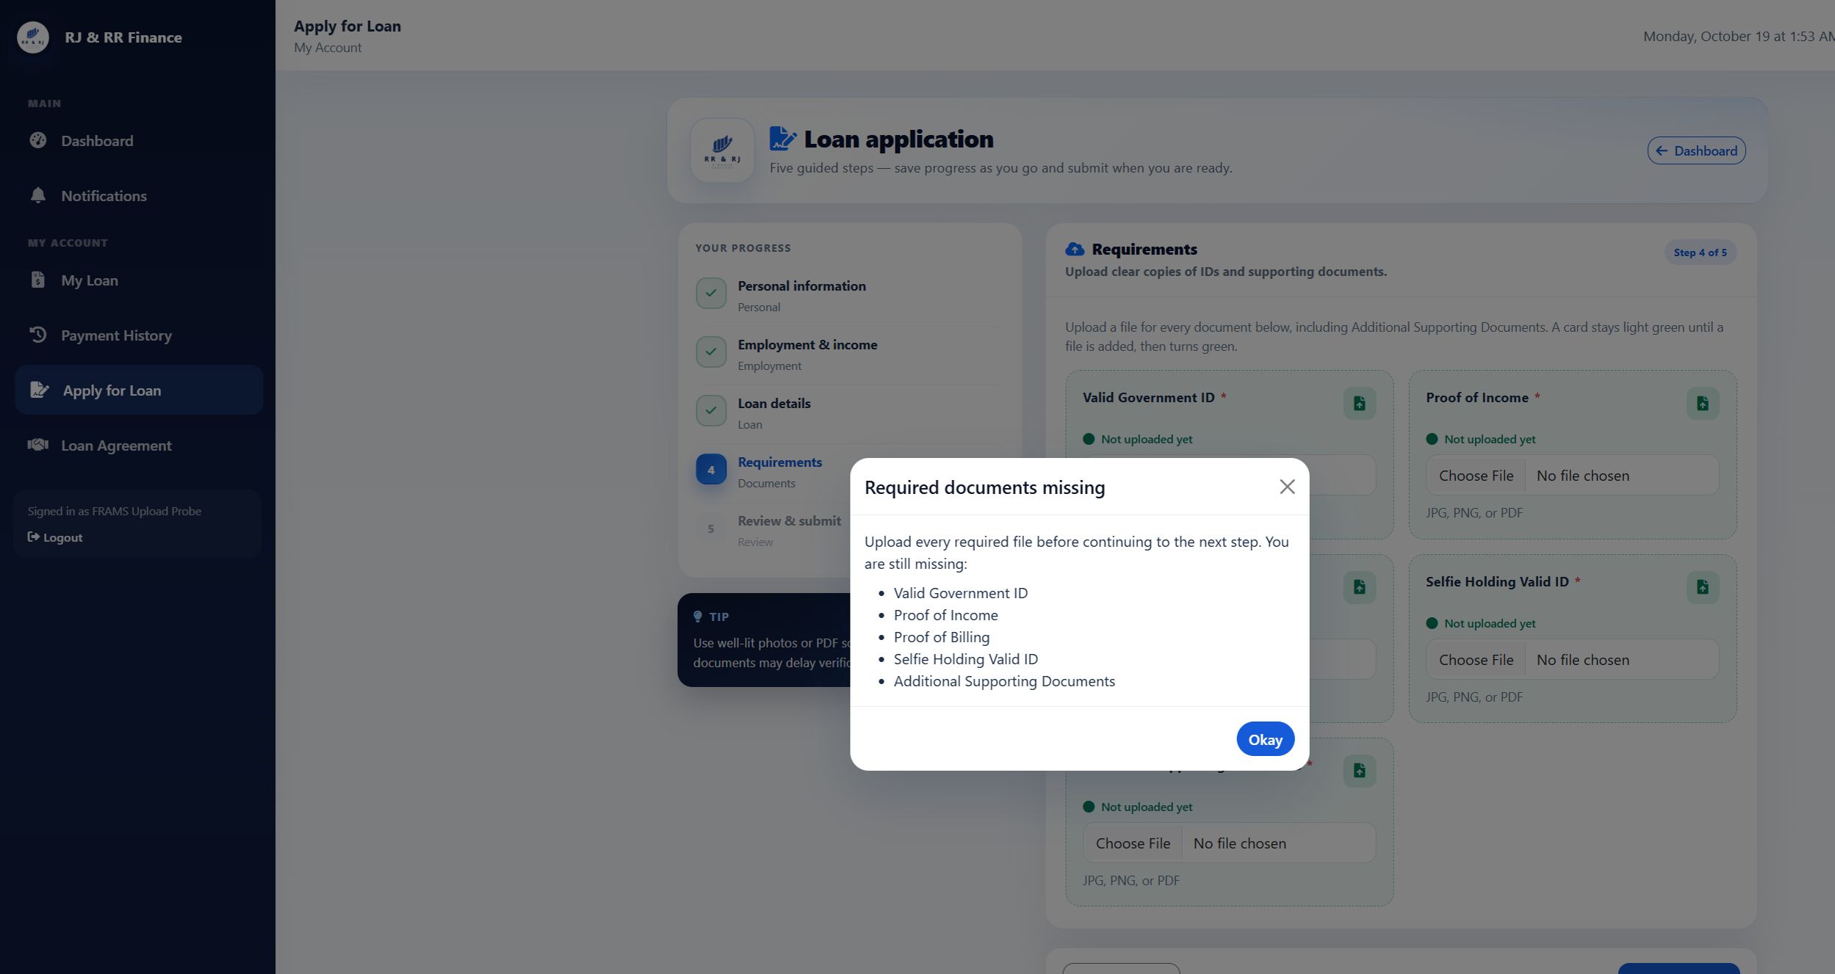
Figure B47. After the invalid uploads, step 4 still shows every document as not uploaded.

Figure B48 — PT-11
Scenario: After signing out, reload a protected page.
Expected result: The reloaded page redirects to the sign-in page.
Actual result: The collector signed out, which opened the staff sign-in page. Opening collector_dashboard_lending.php again returned HTTP 302 to login_lending.php. The browser showed the staff sign-in page, so the protected dashboard required authentication again.
Figure B48. Protected collector dashboard reloaded after sign-out.

Figure B49 — PT-12
Scenario: Submit an incorrect, expired, and already used six-digit password-reset code.
Expected result: The password is not changed by an invalid code. The live reset flow uses a six-digit code that expires after ten minutes, allows five incorrect attempts, and is removed after a successful change. It does not issue a reset link.
Actual result: The forgot-password page asks for a username and says it will email a 6-digit code. It does not offer a reset link. The code form says the code expires in 10 minutes. A new code record was measured at 600 seconds. An incorrect code returned "That code is incorrect or has expired." After five incorrect attempts, the next try returned "Too many incorrect codes. Request a new code." and the code record was removed. A code whose expiry was already past returned the incorrect-or-expired message. A correct code allowed one password change, and that same code was then rejected. The borrower test password was restored afterward, and no reset row remained.
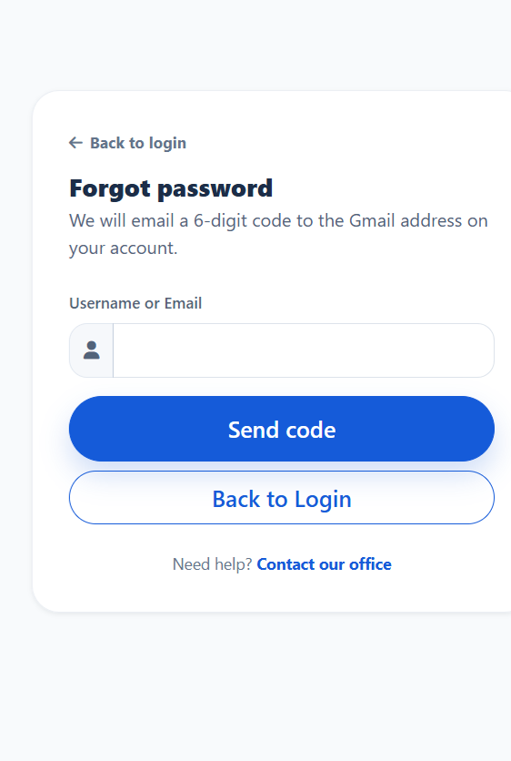
Figure B49. The reset page sends a 6-digit code and does not issue a link.
Figure B49. The code form states that the code expires in 10 minutes.
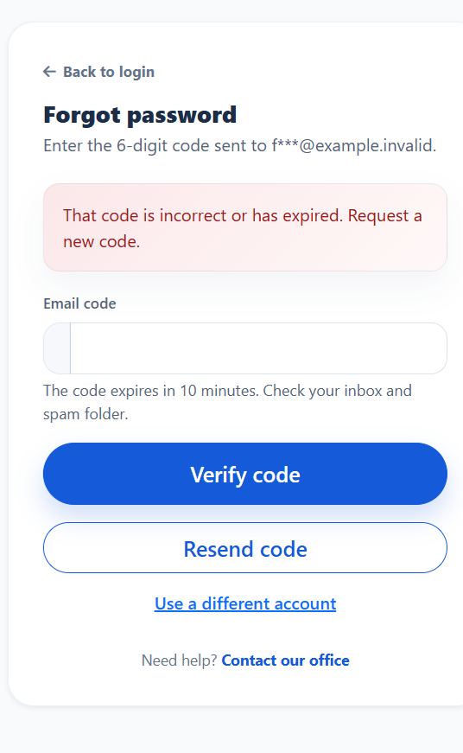
Figure B49. An incorrect code does not change the password.
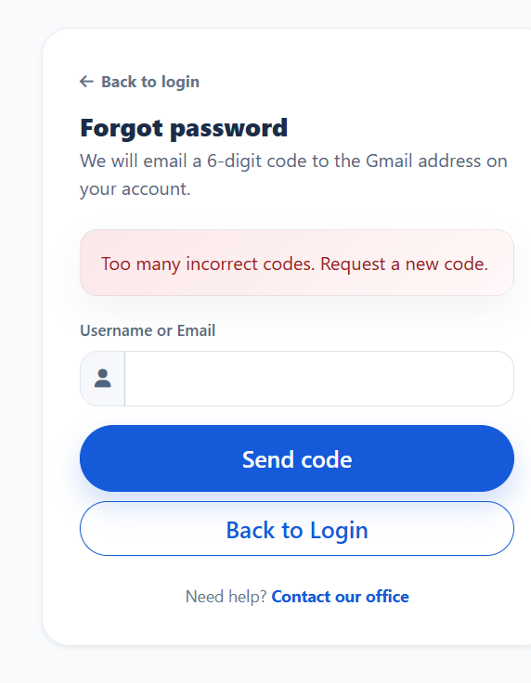
Figure B49. The attempt after five incorrect codes is refused.
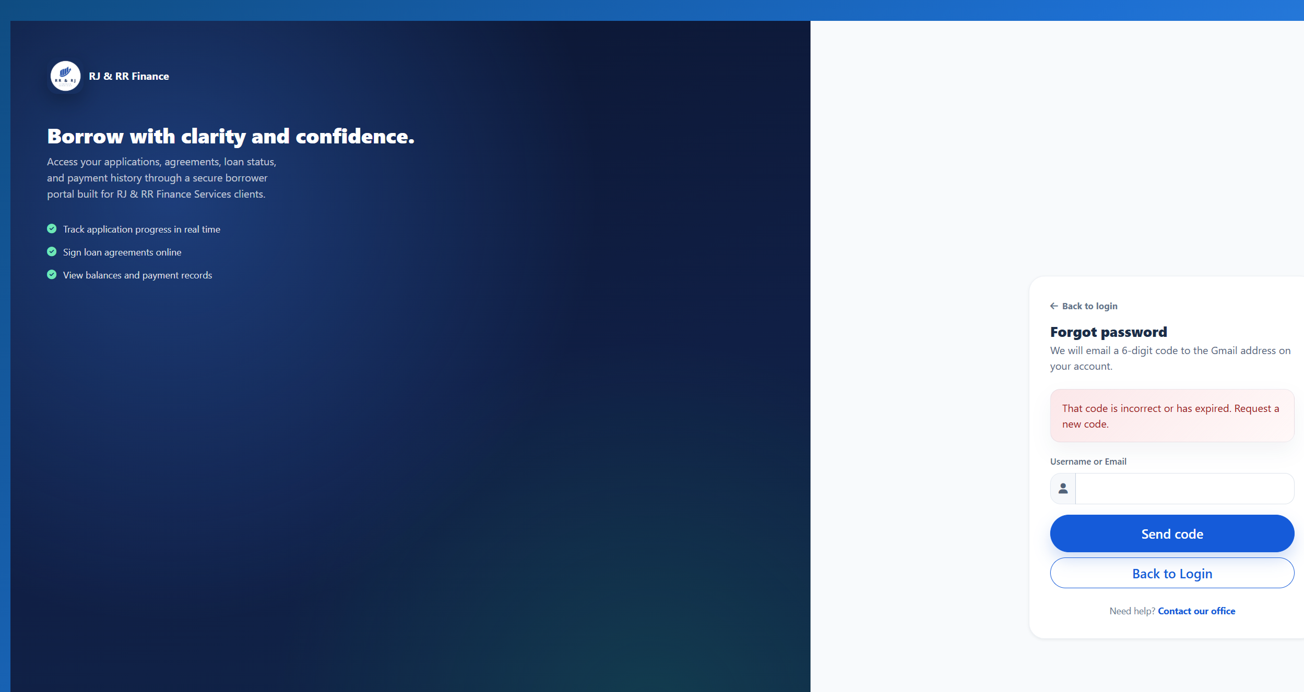
Figure B49. An expired code is refused.
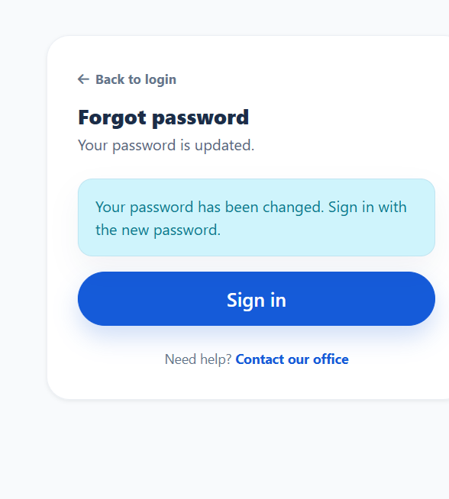
Figure B49. A valid code can be used once.
Figure B49. The same code is refused after the password change.
F. USER ACCEPTANCE TESTING
The supplied User Acceptance Testing (UAT) response export contains 32 submissions, consisting of 30 borrowers, one administrator, and one collector. The 20-item evaluation questionnaire covered five criteria: functionality, usability, reliability, security, and performance, with four statements assigned to each criterion.
The criterion-level weighted means are 4.56 for functionality, 4.54 for usability, 4.56 for reliability, 4.46 for security, and 4.52 for performance. The overall weighted mean across 640 individual ratings was 4.53, interpreted as Strongly Agree according to the five-point Likert scale used in the study.
The response export serves as the supporting source for the reported calculations. The original spreadsheet and administered questionnaire should be retained as research records. The blank questionnaire in Appendix I documents the instrument wording but is not a substitute for the completed responses.
Source of the tally. The frequencies and weighted means below were computed from the 20 individual item responses recorded for each of the 32 respondents in the supplied workbook. The blank questionnaire in Appendix I documents the instrument wording; it is not a completed response set.
The administered 20-item questionnaire is documented in Appendix I. The completed item-level answers and the recorded user-role field are retained in the supplied workbook. The respondent distribution used throughout this manuscript is 30 borrowers, one administrator, and one collector.
G. UAT TALLY AND WEIGHTED-MEAN COMPUTATION
The table below summarizes the response frequencies calculated from the supplied UAT response export. Each criterion includes four questionnaire statements answered by 32 respondents, producing 128 individual ratings per criterion. The overall results combine all 20 statements, producing 640 individual ratings.
The weighted mean was calculated using:
WM = [f(5) × 5 + f(4) × 4 + f(3) × 3 + f(2) × 2 + f(1) × 1] / N
where f represents the frequency of a response rating and N represents the total number of valid individual ratings.
Criterion | f(5) | f(4) | f(3) | f(2) | f(1) | N | Weighted Score | Weighted mean
Functionality | 72 | 56 | 0 | 0 | 0 | 128 | 584 | 4.5625
Usability | 70 | 57 | 1 | 0 | 0 | 128 | 581 | 4.5391
Reliability | 72 | 56 | 0 | 0 | 0 | 128 | 584 | 4.5625
Security | 59 | 69 | 0 | 0 | 0 | 128 | 571 | 4.4609
Performance | 68 | 59 | 1 | 0 | 0 | 128 | 579 | 4.5234
Overall | 341 | 297 | 2 | 0 | 0 | 640 | 2,899 | 4.5297

Note. The overall totals aggregate the response ratings across all 20 statements. Each criterion-level mean is based on 128 individual ratings, while the overall mean is based on 640 individual ratings.
The overall weighted score was calculated as follows:
(341 × 5) + (297 × 4) + (2 × 3) = 1,705 + 1,188 + 6 = 2,899.
The total number of individual ratings was 32 respondents × 20 statements = 640.
Therefore, the overall weighted mean was 2,899 ÷ 640 = 4.5297, rounded to 4.53 and interpreted as Strongly Agree.
H. SUMMARY OF TESTING RESULTS
The documented official functional test-case summary contains 48 cases: six unit tests, seven integration tests, twelve system tests, 11 PayMongo-related tests, and twelve penetration/security tests. The recorded official case summary reports 48 passed and 0 failed. These counts describe the listed official test cases and should not be interpreted as proof of exhaustive testing or as a count of every execution run.
Testing level | Documented cases | Passed | Failed | Not yet tested | Blocked / needs setup
Unit testing | 6 | 6 | 0 | 0 | 0
Integration testing | 7 | 7 | 0 | 0 | 0
System testing | 12 | 12 | 0 | 0 | 0
PayMongo testing | 11 | 11 | 0 | 0 | 0
Penetration testing | 12 | 12 | 0 | 0 | 0
Total | 48 | 48 | 0 | 0 | 0
The 48-case summary above remains the count of documented official cases listed in the test tables. A separate financial-computation and agreement-validation report records 53 test executions across three groups: 28 financial-computation checks, 8 term-validation checks, and 17 agreement/due-date/release checks, all reported as passed in the isolated test environment. These 53 executions are not asserted to be 53 unique test cases and are not added to the 49-case total. The report states that isolated test transactions were rolled back and that the production lending_management database was not modified. The browser based Confirm Release action was not clicked; therefore, this supplemental report does not establish that a loan release was completed through that browser step. The report is supplemental evidence and does not replace the detailed case tables.
The PayMongo and penetration/security evidence uses an isolated test server at 127.0.0.1:8099 and the frams_capstone_test database. The existing lending_management database was not modified, and no live PayMongo charge was created. PM-01 documents rejection of an isolated invalid test key. PM-09 and PM-10 document receipt and payment-list display for a stored E-Wallet record. These results support local validation, rejection handling, and record display. They do not prove Payment Intent polling, staff-initiated Check with PayMongo, or a successful end-to-end live charge. System tests ST-01 through ST-12 are recorded in Figures B14–B25.

APPENDIX I
FRAMS USER ACCEPTANCE TESTING (UAT)
20-ITEM EVALUATION QUESTIONNAIRE
Purpose: This form gathers feedback about the Financial Risk Assessment and Micro-Lending System (FRAMS) after the respondent has used the system. This is a blank questionnaire template. It must not be treated as a completed response form.
Respondent code (optional): ____________________ Date: ____________________
User role: ☐ Borrower ☐ Collector ☐ Administrator
Instructions: Based on your actual experience using FRAMS, mark exactly one response for each statement.
Table I1 FRAMS 20-Item User Acceptance Questionnaire
No. | Evaluation Statement | Strongly Agree | Agree | Neutral | Disagree | Strongly Disagree
 |  | 5 | 4 | 3 | 2 | 1
A. Functionality

1 | FRAMS allows authorized users to log in and access functions appropriate to their assigned roles. | ☐ | ☐ | ☐ | ☐ | ☐
2 | FRAMS allows borrowers to submit the information required for loan applications. | ☐ | ☐ | ☐ | ☐ | ☐
3 | FRAMS calculates loan interest and repayment amounts according to the system’s implemented formula. | ☐ | ☐ | ☐ | ☐ | ☐
4 | FRAMS allows authorized personnel to record and monitor loan payments. | ☐ | ☐ | ☐ | ☐ | ☐
B. Usability

5 | The FRAMS interface is organized and easy to understand. | ☐ | ☐ | ☐ | ☐ | ☐
6 | Menus and navigation help me find the functions needed for my role. | ☐ | ☐ | ☐ | ☐ | ☐
7 | Forms provide understandable instructions or validation messages when needed. | ☐ | ☐ | ☐ | ☐ | ☐
8 | I can complete the tasks relevant to my role without unnecessary difficulty. | ☐ | ☐ | ☐ | ☐ | ☐
C. Reliability

9 | FRAMS saves borrower, loan, and payment records consistently. | ☐ | ☐ | ☐ | ☐ | ☐
10 | Loan balances and installment schedules reflect the recorded transactions. | ☐ | ☐ | ☐ | ☐ | ☐
11 | FRAMS provides consistent information when I revisit a record or report. | ☐ | ☐ | ☐ | ☐ | ☐
12 | The system handles routine operations without unexpected interruption during my use. | ☐ | ☐ | ☐ | ☐ | ☐
D. Security

13 | FRAMS restricts pages and records according to the user’s assigned role. | ☐ | ☐ | ☐ | ☐ | ☐
14 | I can access only the information and functions permitted for my account. | ☐ | ☐ | ☐ | ☐ | ☐
15 | The system requires authentication before protected pages can be accessed. | ☐ | ☐ | ☐ | ☐ | ☐
16 | FRAMS provides appropriate protection for borrower and loan information during normal use. | ☐ | ☐ | ☐ | ☐ | ☐
E. Performance

17 | FRAMS loads the pages needed for my tasks within a reasonable time. | ☐ | ☐ | ☐ | ☐ | ☐
18 | The system processes routine forms and transactions within a reasonable time. | ☐ | ☐ | ☐ | ☐ | ☐
19 | FRAMS displays reports and loan information without excessive delay. | ☐ | ☐ | ☐ | ☐ | ☐
20 | The system remains responsive while I perform normal tasks. | ☐ | ☐ | ☐ | ☐ | ☐

Instrument and Evidence Note. The evaluation instrument contains 20 statements, with four statements assigned to each of the five evaluation criteria. The questionnaire included in this appendix documents the instrument wording and five-point response scale. The supplied UAT response export, FRAMS UAT Responses (1).xlsx, serves as the supporting source for the recorded respondent answers and weighted-mean calculations presented in Appendix J. The original response spreadsheet should be retained securely as part of the study's supporting research records. Personal identifiers should be protected in any copy circulated outside the research team.

APPENDIX J
USER ACCEPTANCE TESTING (UAT) EVIDENCE
Purpose and Source
This appendix presents the weighted-mean computations supporting the User Acceptance Testing results reported in Chapter IV. The calculations use the recorded response frequencies from the supplied UAT response export, FRAMS UAT Responses (1).xlsx.
The response export contains 32 submissions, consisting of 30 borrowers, one administrator, and one collector. The questionnaire contains 20 statements grouped into five criteria, with four statements assigned to each criterion. Therefore, each criterion comprises 128 individual ratings, while the overall computation includes 640 individual ratings.
Weighted Mean Formula
WM = Σ(f × x) / N
where f represents the frequency of each response rating, x represents the numerical Likert score, and N represents the total number of valid individual ratings included in the calculation.
Table J1
UAT Response Frequencies and Weighted-Mean Computation

Evaluation Criterion | f(5) | f(4) | f(3) | f(2) | f(1) | N | Weighted Score | Weighted mean
Functionality | 72 | 56 | 0 | 0 | 0 | 128 | 584 | 4.5625
Usability | 70 | 57 | 1 | 0 | 0 | 128 | 581 | 4.5391
Reliability | 72 | 56 | 0 | 0 | 0 | 128 | 584 | 4.5625
Security | 59 | 69 | 0 | 0 | 0 | 128 | 571 | 4.4609
Performance | 68 | 59 | 1 | 0 | 0 | 128 | 579 | 4.5234
Overall | 341 | 297 | 2 | 0 | 0 | 640 | 2,899 | 4.5297

Note. Each criterion-level result includes four statements answered by 32 respondents. The overall totals include the ratings for all 20 questionnaire statements.
Overall Weighted-Mean Computation
The response export contained 341 Strongly Agree ratings, 297 Agree ratings, two Neutral ratings, and no Disagree or Strongly Disagree ratings across all 20 statements.
The total weighted score was calculated as follows:
(341 × 5) + (297 × 4) + (2 × 3) = 1,705 + 1,188 + 6 = 2,899.
The total number of individual ratings was calculated as:
32 respondents × 20 statements = 640 ratings.
The overall weighted mean was:
2,899 ÷ 640 = 4.5297, rounded to 4.53.
According to the five-point Likert scale adopted in Chapter III, the overall result is interpreted as Strongly Agree.
Evidence Integrity and Record Handling
The supplied UAT response spreadsheet is the primary supporting record for the recorded responses and the calculations summarized in this appendix. The original workbook should be retained as part of the study's research records. The blank questionnaire in Appendix I documents the instrument wording but is not a completed response record.
The aggregate frequencies presented in Table J1 should not be used to reconstruct individual answers to specific statements. Any item-by-item frequency table added to the manuscript must be calculated directly from the original recorded responses. Personal identifiers should be protected in any copy circulated outside the research team.

APPENDIX K
FINANCIAL COMPUTATION VALIDATION AND RETEST RESULTS
The reported retest covers the flat-interest formula, public loan quote consistency, installment rounding, DTI boundaries, affordable-principal limits, payment allocation, outstanding balance, and invalid input handling. The configured rule uses 5% monthly flat interest. Eligibility is an estimate for decision support and does not constitute automatic loan approval.
Test ID | Validation area | Reported result | Evidence status
FC-01a–c | Flat-interest calculation | Expected and actual centavo values matched. | Passed in supplied automated report
FC-02a | Monthly installment schedule | Installments total 11,500.00; final installment 3,833.34. | Passed in supplied automated report
FC-02b | Weekly installment schedule | Installments total 11,500.00. | Passed in supplied automated report
FC-02c | Public calculator consistency | Flat-interest quote aligned with loan engine; 100,000.00 over 12 months shows regular installment 13,333.33, final installment 13,333.37, total payable 160,000.00. | Passed in supplied automated report; report notes browser evidence separately
FC-03–05c | Partial payment, penalty split, centavo allocation | Partial balance and penalty allocation matched expected values; monthly and weekly schedules total 11,500.00. | Passed in supplied automated report
FC-06a–c | DTI boundary | 40.00% and 38.67% were Eligible; 41.33% was Not Eligible. | Passed in supplied automated report
FC-07a–e / FC-08 | Affordability and requested principal limits | DTI-safe principal respected; requests above affordability were not treated as eligible; maximum principal capped at 500,000.00. | Passed in supplied automated report
FC-09 / FC-10a–b | Payment balance and payment validation | Partial and multiple payments updated balance; exact payoff set loan status to Paid; zero, negative, and over-limit payments were rejected. | Passed in supplied automated report
FC-10c–f | Invalid principal and loan term | Negative principal, zero-month term, and negative term rejected at calculation boundary; zero principal remains zero payable. | Passed in supplied automated report
FC-11 | Portfolio outstanding balance | Outstanding balance reflects total payable less recorded scheduled payments; paid loans show zero. | Passed in supplied automated report

Evidence references. The supplied fix report identifies testing/evidence/fc_validation_results.json and testing/reports/fc_computation_results.csv as automated outputs. The report also states that the public-calculator case was checked by the automated quote function and source inspection, with a separate browser section recording the same example. Keep the original machine-readable outputs and browser screenshots with the project testing artifacts so the results can be traced.
Frontend validation evidence. The screenshot below shows the loan amount field displaying “Value must be greater than or equal to 1000” when a negative amount is entered. This supports the presence of client-side form validation. By itself, the screenshot does not prove server-side rejection; that behavior should be supported by the automated calculation-boundary test and relevant server-side validation code.
Figure K1. Loan amount field validation for a negative input. Note. The message indicates that the entered value must be at least 1,000; this screenshot is frontend evidence only.
Interpretation and limitation. The supplied report describes the earlier defects and records the corresponding corrections and retest outcomes. The manuscript should not rely on the earlier six-failure summary as the current status without noting that a later fix report reports a successful 28-case retest. Conversely, “28 passed” should be attributed to the supplied automated report unless the CSV/JSON outputs and test environment are retained as auditable evidence. This appendix does not claim that every browser workflow, Payment Intent polling sequence, staff Check with PayMongo action, or live PayMongo charge was independently verified.
APPENDIX L
DATABASE SCHEMA AND INSTALLATION NOTES
This appendix supplies the reproducible database documentation requested for the operational FRAMS database. A structure-only dump of lending_management, without table-row data and without credentials, is saved as FRAMS_APPENDIX_L_Database_Schema.sql. The dump was generated from the local MariaDB instance used by the implemented system.
Installation procedure. Create an empty MySQL or MariaDB database named lending_management, or another name supplied in the application configuration. Import FRAMS_APPENDIX_L_Database_Schema.sql. Configure the host, database name, user, and password in the application environment. Place the application under the web server document root and open the staff or borrower login. After import, some feature columns continue to be added when the related page first runs. The PayMongo QR Ph tables are included in the dump and are also described by the SQL files in database/migrations/.
Declared relationships. The dump contains one foreign key: paymongo_qrph_webhook_events.transaction_id references paymongo_qrph_transactions.id with ON DELETE SET NULL. Relationships among users, clients, loans, releases, schedules, and payments are enforced in application queries. A deleted parent row is not stopped by a database foreign key on those core tables.
Required tables in the dump: users, clients, borrower_applications, loan_applications, loan_application_documents, loan_application_reviews, loan_agreements, loan_releases, loan_release_notifications, loans, loan_payment_schedules, payments, expenses, notifications, password_resets, contact_inquiries, contact_inquiry_replies, email_notifications, paymongo_qrph_transactions, and paymongo_qrph_webhook_events.
Initialization notes. AUTO_INCREMENT values in the dump reflect the source database at the time of export and are not required for a new empty installation. Passwords in a new installation must be created through the application so that they are stored as hashes. This appendix does not contain live API keys, secrets, or borrower records.

