

Financial Risk Assessment and Micro-Lending System (FRAMS):

A Capstone Project Presented to the Faculty of
College Department of
West Prime Horizon Institute, Inc.
Pagadian City

In Partial Fulfilment
of the Requirements in Capstone Project
for the Degree of Bachelor of Science in Information Technology
Academic Year 2025-2026

by:
Cabaraban, John Lloyd M.
Mandawe, Mark Rexben S.
Andulog, Joann R.
Luy, Angel Ann S.

Mr. Antonio Llagas Jr.
Adviser
October 15, 2026

CHAPTER I
INTRODUCTION
Background of Study
Many lending offices maintain borrower files, loan computations, and payment records using paper-based documents or separate spreadsheets. This practice makes it difficult to access and monitor essential information in one place, including borrower applications, declared income, existing financial obligations, loan amounts released, and outstanding balances. When these records are not properly integrated, lending offices may experience delays in processing transactions, inconsistencies in financial records, and difficulties monitoring overdue accounts and repayment activities.
Credit risk in micro-lending involves more than determining whether an individual qualifies for a loan. Local studies of lending institutions indicate that lending officers continue to rely on borrower interviews, business verification, and checks for existing unpaid loans when evaluating applications. These practices are particularly relevant because many micro-borrowers have limited income and little formal credit history (Mina, 2024; Juventud et al., 2023). Furthermore, studies on digital lending and microfinance indicate the growing role of web-based systems and structured risk assessment tools in improving lending operations (Santos, 2023; Campos, 2024). These studies, discussed in detail in Chapter 2, support the development of an integrated system that connects borrower information, loan processing, and financial risk assessment.
The system developed in this study is the Financial Risk Assessment and Micro-Lending System (FRAMS) for RJ and RR Finance Services, located at Purok San Francisco, Poblacion, Sominot, Zamboanga del Sur. The system registers borrowers, facilitates a five-step loan application process, and accepts supporting documents. It also computes an eligibility estimate based on the borrower's declared income, existing financial obligations, requested loan amount, loan term, and the lending office's configured limits. The final loan approval decision remains under the administrator's authority. Once the borrower accepts the loan agreement, the administrator assigns a collector and proceeds with the loan release. The system subsequently generates installment schedules, records repayments and applicable penalties, and produces financial reports to support monitoring and decision-making.

In addition to payments recorded at the lending office, FRAMS includes PayMongo Dynamic QR Ph. An administrator, or a collector assigned to the loan, starts PayMongo Dynamic QR Ph for bank transfer or e-wallet. The system creates a Payment Intent and shows the QR code. While that page stays open, it asks PayMongo for the Payment Intent immediately and then every five seconds. A repayment, receipt, and balance update are saved only when the retrieved intent matches the stored amount, PHP currency, and payment mode, the intent status is succeeded, and a nested QR Ph payment is paid. If the page is closed first, an administrator or the assigned collector can check that one pending transaction from the Payments page. The same checks are used. The receipt is available only after those checks post the repayment. A second confirmation of the same provider payment does not post another repayment. Showing the QR code, a local timer, or a report that an e-wallet was charged does not record the payment. Pending transactions are not checked in the background. Cash is recorded directly by authorized staff. Bank transfer and e-wallet may also be recorded directly, without a QR code, by an administrator or the assigned collector.

Therefore, this study focuses on developing a practical web-based system that integrates borrower management, loan application processing, eligibility assessment, loan approval, loan release, online and recorded payments, collection monitoring, and financial reporting for RJ and RR Finance Services. The eligibility estimate serves as a decision-support tool rather than an automatic loan approval mechanism or a machine-learning prediction of default. Through these integrated features, FRAMS aims to support more organized lending operations, improve the monitoring of financial transactions, and assist the lending office in making informed lending decisions.

Statement of the Problem
RJ and RR Finance Services currently face challenges in managing loan applications, borrower information, payment records, and loan assessment due to manual recording and the use of separate files. These processes can result in:
- Inefficient Loan Application and Borrower Data Management: The use of manual records and separate files makes it difficult to organize loan applications, update borrower information, and maintain complete and accurate records.
- Disorganized Payment and Loan Monitoring: The absence of a centralized system makes it challenging to track borrower payments, monitor outstanding balances, and identify overdue accounts accurately and on time.
- Disconnected Risk Assessment and Loan Records: The manual handling of borrower information and financial data makes it difficult to connect the information used for affordability and risk assessment with the corresponding loan application, which may result in delays, errors, and inconsistent evaluation.
The study seeks to answer the following questions:
• How can FRAMS improve the management of borrower and loan information?
• How can the system assist in assessing borrower risk from declared income, existing obligations, the requested loan, and the payment record, without treating the result as an automatic approval?
• How can the system improve the tracking of payments and overdue accounts?
• How can the system provide notifications about application decisions, agreements, releases, and payments?
• How can the system generate reports that support financial monitoring and management decisions?
• How acceptable is the developed system in terms of functionality, usability, reliability, security, and performance?

Objectives of the Study
The general objective of the study is to design and develop a secure web-based Financial Risk Assessment and Micro-Lending System that records lending transactions, supports an eligibility review, and provides reports for RJ and RR Finance Services.
Specifically, the study aims to:
• Develop borrower registration, administrator approval, client records, and an online loan application with document review.
• Implement an eligibility estimate based on debt-to-income, loan limits, and employment length, and present it to the reviewer as a guide rather than as a final decision.
• Compute the interest and installment schedule, record agreement acceptance, assign a collector, release the loan, record payments and penalties, and provide reports.

Scope and Limitations
This study covers the design, development, and evaluation of FRAMS. The included functions are the public portal, borrower registration and approval, client records, the five-step loan application, document verification, the eligibility estimate, loan agreement acceptance, loan release with collector assignment, installment schedules, payment recording, penalties, expenses, notifications, contact inquiries, user management, and administrator reports. The loan products presented on the public page are the salary loan, business loan, emergency loan, and vehicle financing. The users are the administrator, the collector, and the borrower.
The eligibility estimate uses monthly income, existing debt payments, other monthly obligations, employment or business length, the requested amount, the term, and the interest rate. The default limits in the program are a maximum debt-to-income ratio of 40%, a minimum loan of PHP 3,000, a maximum loan of PHP 500,000, and a minimum of 3 months of employment or business. Interest is a flat 5% per month on the original principal for each month of the term. Penalties on unpaid overdue installments are 1% for a daily loan, 2% for weekly, 3% for semi-monthly, and 5% for monthly. Evaluation uses the respondents and instruments described in Chapter 3. The results are presented in Chapter 4.
FRAMS includes PayMongo Dynamic QR Ph for bank transfer and e-wallet collection. An administrator, or a collector assigned to the loan, can start the QR code. A repayment is posted only after the server retrieves the Payment Intent and the amount, currency, mode, succeeded-intent, and paid QR Ph payment checks succeed. The integration uses the configured secret key, public key, and mode, which is test or live. Borrowers do not have a separate checkout page. The study does not include credit bureau integration, SMS integration, loan restructuring, deposits, savings, or investment accounts. Dependents and collateral notes may be stored, but they are not variables in the eligibility formula. The eligibility estimate remains rule-based and does not predict default. The study also does not establish that all recording errors have been eliminated or that the system has been deployed across multiple branches.

Significance of Study
Lending office. FRAMS gives RJ and RR Finance Services one application for applications, eligibility review, release, collection, and reports, in place of disconnected files.
Administrators. The system supports approval of borrowers, review of documents, release of loans, assignment of collectors, and reading of dashboards and period reports.
Collectors. The system limits collection work to assigned clients and loans and provides the schedule and payment form for those accounts.
Borrowers. An approved borrower can apply, upload requirements, accept or decline the agreement, and view the loan, the schedule, and the payment history.
Educational institutions. The project may be used in teaching systems analysis, database design, and web development.
Future researchers. The study may be a reference for later work on micro-lending systems and rule-based eligibility estimates.
The researchers. The project provides practice in analysis, web development, database design, and the implementation of a lending workflow.

Definition of Terms
Administrator. The staff role that approves borrowers, reviews applications, releases loans, manages users and collectors, and views expenses, penalties, and reports.
Borrower. The client who registers, applies after approval, responds to the agreement, and views that borrower’s own loan and payments.
Collector. The staff role that views assigned clients and loans and records payments for those accounts.
Debt-to-income ratio. Existing monthly obligations, with or without the proposed loan payment, divided by monthly gross income. FRAMS uses this ratio in the eligibility estimate.
Eligibility estimate. The result Eligible, Conditionally Eligible, or Not Eligible produced from income, obligations, the requested loan, the term, and the configured limits. It is not a final approval.
FRAMS. The Financial Risk Assessment and Micro-Lending System developed in this study.
Installment schedule. The due amounts created when a loan is released, with due date, principal, interest, and status.
Loan. The released amount recorded with its term, interest, schedule, and remaining balance.
Payment. An amount recorded against a loan, including date, method, collector, and any penalty portion.
Penalty. The amount computed on an unpaid installment whose due date has passed, using the rate for that loan’s payment frequency.
Role-based access. The restriction of pages and records according to the signed-in role.

CHAPTER II
REVIEW OF RELATED LITERATURE AND STUDIES

This chapter reviews the local and foreign literature and studies relevant to FRAMS. The discussion is organized into related literature, related studies, synthesis, and the theoretical and conceptual frameworks. It explains how previous work on credit-risk management, micro-lending, and information systems informs the requirements of FRAMS. The system developed in this study uses configured eligibility rules and does not implement the machine-learning models discussed in some of the reviewed studies.
Related Literature
Local Literature
Mina (2024) examined credit risk management practices of lending institutions in Nueva Ecija that offer microfinance loans. The institutions offered individual and group loans, with minimum and maximum amounts for first and later loans, and many loans were collected weekly. Officers obtained information mainly through interviews. The important checks were a credit review of the applicant, confirmation that the business existed, and confirmation that the borrower had no outstanding loan with another institution. Mina also reported weaknesses in these practices and proposed actions to reduce risks that cannot be avoided. The study used a descriptive design with four lending officers in San Isidro and Cabiao, Nueva Ecija.
Juventud, Matigas, Himongala, and Galla (2023) discussed credit risk in microfinance loans for micro-enterprises. They described microfinance as a means for low-income households to stabilize cash and as support during periods of reduced income. They noted that limited credit data, the absence of credit bureaus in many settings, and over-indebtedness increase credit risk, and that most micro-borrowers have restricted income and little credit history. Group lending and selected forms of collateral were identified as practices used to reduce that risk.
Estrellado (2024) studied the financial inclusion practices of lending institutions and the sustainability of micro-businesses in Sorsogon City for fiscal year 2024. The descriptive study involved 15 micro-business owners. It looked at years in operation, initial capital, loan amount, and daily sales, and it ranked strategies related to loan access, cash flow, profit and savings, repayment, and financial literacy. The common strategies included fewer loan requirements, use of the loan as capital, a choice of payment mode, and financial literacy education. Estrellado recommended credit information sharing, monitoring, need-based financial education, and better access to credit.
Juventud, Matigas, Himongala, Galla, and Abiol (2023) assessed perceived credit risk of microfinance loans among micro-enterprise owners in Barangay Población, Iligan City. Using a descriptive-correlational design and 75 business owners, they found that many respondents were 51 years old or older, that cafeteria businesses were common, and that many had used microfinance loans. They again noted limited income and limited credit history, and the use of group lending, collateral, and cash-flow assessment. Age, business type, prior loan use, and loan experience did not significantly explain perceptions of credit risk.

Foreign Literature
Kou et al. (2022) examined machine-learning models for financial risk assessment on digital lending platforms. They reported that real-time data and adaptive risk algorithms improved approval accuracy and reduced default risk, and they emphasized systems that adjust risk scores as borrower behavior changes. That finding is relevant as literature on automated assessment. FRAMS does not implement a machine-learning score. It implements a rule-based eligibility estimate that the administrator still reviews.
Bazarbash and Beaton (2022) studied fintech micro-lending in emerging economies. They reported that automated scoring with alternative data, such as transaction history and mobile use, can widen financial inclusion while holding risk at an acceptable level. The related point for this study is the value of a consistent assessment, not the use of mobile-use data, which FRAMS does not collect.
Ghosh et al. (2023) described a microfinance system that uses predictive analytics to monitor delinquency, identify high-risk borrowers early, and adjust repayment terms. Chen and Li (2023) examined artificial intelligence that reassesses risk during the life of the loan, not only at approval, and reported better repayment compliance. Frost et al. (2024), in World Bank–supported work, analyzed digital lending platforms that combine agile development with real-time risk analytics and reported gains in efficiency, transparency, and borrower trust. Rahman and Hasan (2025) emphasized modular design, rapid revision, and continuous monitoring of changing borrower profiles.
These foreign sources describe adaptive and predictive tools that are beyond the scope of FRAMS. They are retained because they show the direction of digital lending research. The present system answers a narrower need: one office application that computes an explainable eligibility estimate and keeps the loan and collection record in the same database.
Related Studies
Local Studies
Santos (2023) reported that digital payments and mobile banking have changed the financial landscape in the Philippines, and that a micro-lending service needs web or online access if it is to remain reachable and trusted beside fintech applications. That finding supports the borrower portal in FRAMS.
The Iligan City study of Juventud, Matigas, Himongala, Galla, and Abiol (2023), already cited as literature, is also a local empirical study. Its result, that many micro-borrowers lack a substantial credit history, supports the decision to base the FRAMS estimate on declared income and obligations rather than on a bureau score the office does not have.
Ramirez (2024) developed and validated a tool for assessing risk and return in the gross loan portfolio of microfinance institutions in Occidental Mindoro. The study showed the value of a structured instrument for portfolio decisions. Campos (2024) described credit analysis and collection practices of microfinance institutions in Nueva Ecija and the growing place of digital tools in credit risk management. Penaso and Dagang (2025) examined loan management and non-performing loans in microfinance institutions in Northern Mindanao and linked structured loan handling to operational control. Together, these studies support digital records, a stated assessment rule, and monitoring of loans after release, which are functions of FRAMS.
Foreign Studies
LendStack (2025) and BlueOrchard (2025) were cited in the researchers’ draft for the spread of cloud-based lending platforms and for reported reductions in infrastructure cost. Those reports describe an industry trend toward hosted software. FRAMS is developed for local hosting on Apache, PHP, and MySQL, so the related point is web-based access, not a claim that this project is a cloud service or that it reduces cost by a stated percent.
Khandani et al. (2018) reported that machine-learning models for consumer credit risk outperformed traditional scores. Batista and Montero (2020) studied a Brazilian digital micro-lending platform that combined automated scoring, borrower groups, and updates from repayment behavior, with higher approval for low-income borrowers and no increase in default. Chen et al. (2021) developed an early-warning monitor in China from transaction and behavior data. Juszczak et al. (2022) found that adaptive models which update risk from repayment behavior reduced defaults. Lopez and Martinez (2024), in OECD-supported work, pointed to modular architecture and continuous assessment as support for reliability.
These studies justify attention to repayment behavior after release. In FRAMS that attention is implemented as installment status, overdue penalties, payment history, and reports, not as a model that predicts default.
Synthesis
The local literature shows that microfinance lenders already practice credit checking, but much of it is manual, interview-based, and limited by the lack of a formal credit history (Mina, 2024; Juventud, Matigas, Himongala, & Galla, 2023; Juventud, Matigas, Himongala, Galla, & Abiol, 2023). Estrellado (2024) adds that access, repayment arrangements, and financial education matter to micro-business borrowers. Local studies then show the turn toward digital access and structured portfolio tools (Santos, 2023; Ramirez, 2024; Campos, 2024; Penaso & Dagang, 2025).
The foreign literature and studies go further. They describe machine learning, alternative data, and continuous reassessment (Kou et al., 2022; Bazarbash & Beaton, 2022; Ghosh et al., 2023; Chen & Li, 2023; Frost et al., 2024; Rahman & Hasan, 2025; Khandani et al., 2018; Batista & Montero, 2020; Chen et al., 2021; Juszczak et al., 2022; Lopez & Martinez, 2024). Those capabilities are a research direction. They are not features of the system built in this study.
The gap that FRAMS addresses is the absence of one web-based record that registers the borrower, stores the application and documents, applies a stated eligibility rule, releases the loan with a schedule, and tracks payments and penalties for a small lending office. FRAMS differ from the reviewed predictive systems because the eligibility result is explainable from income, debt, amount, term, and limits, and because the administrator remains the approving authority. Table 1 summarizes that comparison.

Area | Sources retained from the review | What those sources emphasize | What FRAMS implements
Credit checking | Mina (2024); Juventud et al. (2023) | Interviews, business checks, and limited credit history | Eligibility estimates from income, debt, amount, term, and limits
Financial inclusion | Estrellado (2024) | Loan access, repayment choice, and financial education | Online application and status viewing; no separate literacy module
Digital lending records | Santos (2023); Campos (2024); Penaso and Dagang (2025) | Web access and structured loan monitoring | Borrower portal, staff console, schedules, and reports
Portfolio tools | Ramirez (2024) | A structured risk-return instrument | Dashboard and period reports of loans, collections, and balances
Predictive scoring | Kou et al. (2022); Chen and Li (2023); Khandani et al. (2018) | Machine learning and continuous rescoring | Not implemented; the estimate is rule-based and is not an approval
Delinquency monitoring | Ghosh et al. (2023); Juszczak et al. (2022) | Early warning from behavior data | Overdue status, frequency-based penalties, and payment history

Table 1 Comparison of the reviewed focus and the FRAMS implementation

Conceptual Framework
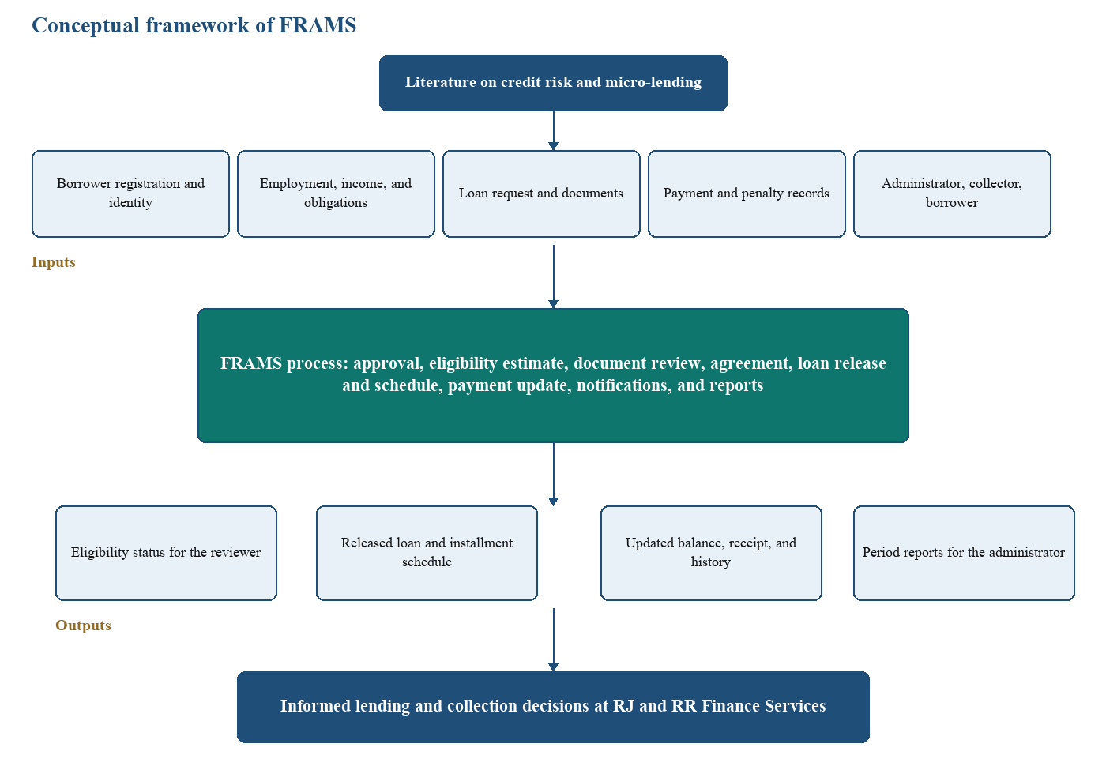
The conceptual framework of this study shows how FRAMS work. It explains how the system handles loan applications, loan release, and collection for RJ and RR Finance Services. The framework uses the Input–Process–Output (IPO) model, which shows how information flows from inputs, through the system, to outputs. The system takes information such as borrower registration and identity, employment, income, and obligations, the loan request and documents, and payment and penalty records from the administrator, collector, and borrower. FRAMS then uses this information to estimate eligibility, review documents, approve the loan, prepare the agreement, release the loan with a schedule, update payments, send notifications, and prepare reports. The outputs are the eligibility status for the reviewer, the released loan and installment schedule, the updated balance with its receipt and history, and period reports for the administrator. This helps the office make informed lending and collection decisions.
Figure 1 Conceptual framework of the FRAMS
Figure 1 presents the conceptual framework of the proposed FRAMS using the Input–Process–Output (IPO) model. The framework illustrates how data are collected as inputs, processed through the system, and transformed into meaningful outputs that support lending and collection. This framework is guided by literature on credit risk and micro-lending, which emphasizes the borrower’s identity, capacity to pay, supporting documents, and record of repayment.
The Input component consists of the necessary data and users required for system operation. These include borrower registration and identity, such as the borrower’s personal details and account information. Employment, income, and obligations describe the borrower’s work, earnings, existing debts, and other monthly obligations used in the eligibility estimate. The loan request and documents state the amount, term, and purpose of the loan and supply the files needed for review. Payment and penalty records show amounts collected, remaining balances, and overdue charges. The administrator, collector, and borrower are also part of the input, because they encode, review, release, collect, and pay through the system.
The Process component represents the operations performed by FRAMS. Approval covers the reviewer’s decision on the application. The eligibility estimate computes whether the requested loan fits the borrower’s income and existing obligations. Document review checks the files submitted with the application. The agreement records the approved terms accepted by the borrower. Loan release and schedule disburse the approved amount and set the installment plan. Payment update posts collections and penalty charges and refreshes the balance. Notifications inform the concerned users of application and payment events, and reports summarize lending and collection activity for a chosen period.
The Output component consists of the processed information generated by the system. These outputs include the eligibility status for the reviewer, the released loan and installment schedule, the updated balance together with the receipt and payment history, and period reports for the administrator. These outputs provide organized and timely information for reviewing applications, releasing loans, monitoring balances, and checking collections.
Overall, the conceptual framework demonstrates how FRAMS integrates input data, lending and collection processes, and informative outputs to support informed lending and collection decisions at RJ and RR Finance Services.
Theoretical Framework
The development of the Financial Risk Assessment and Micro-Lending System (FRAMS) is anchored on theories and models related to credit risk management, information system success, and technology acceptance. These foundations provide the basis for how FRAMS manages borrower information, evaluates loan requests, monitors repayment, and supports users in performing lending-related activities.
Credit Risk and Loan Management. Credit risk management focuses on identifying and managing the possibility that a borrower may be unable to fulfill loan obligations. In microfinance, creditworthiness appraisal, loan monitoring, risk handling, and loan recovery are important components of effective loan management. Penaso and Dagang (2025) examined these areas in microfinance institutions in Northern Mindanao and found that loan management practices are associated with operational efficiency, particularly in payment and recovery activities.
This concept is applied in FRAMS through the collection and evaluation of borrower information, income, existing obligations, requested loan amount, employment or business information, and supporting documents. The system provides an eligibility estimate based on defined lending criteria, such as the debt-to-income limit, minimum and maximum loan amount, and required employment or business duration. However, the system does not automatically reject applicants; the final decision remains with the authorized administrator. This allows FRAMS to function as a decision-support tool rather than replacing human judgment.
DeLone and McLean Information Systems Success Model. DeLone and McLean (2003) proposed an updated Information Systems Success Model that evaluates information systems through dimensions including system quality, information quality, service quality, use, user satisfaction, and net benefits.
The model is relevant to FRAMS because the system is designed to centralize loan and borrower information and make that information available for lending operations. In FRAMS, system quality is reflected in organized loan processing and monitoring functions, while information quality is supported by maintaining consistent borrower, loan, payment, and risk-assessment records. The resulting system is intended to improve the efficiency of loan processing, monitoring, reporting, and decision support.
Technology Acceptance Model. Davis (1989) introduced the Technology Acceptance Model (TAM), which identifies perceived usefulness and perceived ease of use as important factors influencing users' acceptance of information technology.
This model is applicable to FRAMS because the system must be usable by the personnel responsible for processing and managing loans. FRAMS provides centralized borrower records, loan applications, payment monitoring, notifications, and reports to reduce the need for separate manual records. Its usefulness is reflected in its ability to support lending activities, while its ease of use is addressed through organized interfaces and role-based functions for administrators and other authorized users.

CHAPTER III
DESIGN AND METHODOLOGY

Research Design
This study used a developmental research design to plan, develop, and refine the Financial Risk Assessment and Micro-Lending System (FRAMS). An iterative development approach was used because the lending workflow consists of related modules, including registration, loan application, eligibility assessment, agreement acceptance, loan release, payment recording, and reporting. The modules were developed and reviewed in stages so that issues identified during development could be addressed. Claims about testing or evaluation in this manuscript are limited to activities supported by actual records.
Respondents
The respondents were borrowers and personnel of RJ and RR Finance Services in Purok San Francisco, Poblacion, Sominot, Zamboanga del Sur. Purposive sampling was used because the study required feedback from people familiar with the lending operations addressed by FRAMS. The pre-development information-gathering activity and the post-development system evaluation are described separately; their respondent counts should not be assumed to be identical unless confirmed by the original records.
1. Survey Respondents (Before the Study)
The pre-development information-gathering activity was intended to identify issues in loan applications, borrower information management, eligibility review, and payment tracking. The number and roles of participants in this activity should be reported from the original survey and interview records. Do not use the post-development evaluation count as the pre-development respondent count unless the records confirm that they were the same participants.
2. Software Evaluation Respondents
After development, the system was evaluated by intended users to gather feedback on its functions and usability. The post-development evaluation is reported separately from the pre-development information-gathering activity. The evaluation findings should be based on the completed forms and the verified tally.
The post-development system evaluation is reported as involving one (1) administrator, one (1) collector, and thirty (30) borrowers, for a total of thirty-two (32) respondents. This count must be checked against the completed evaluation forms before final submission. If the forms show a different number of valid respondents, revise this paragraph and the related results consistently.
Sampling Technique
The study used purposive sampling to select respondents who were directly involved in or had experience with the lending operations addressed by the Financial Risk Assessment and Micro-Lending System (FRAMS). The respondents were selected based on their roles and their ability to provide relevant information about borrower registration, loan application processing, financial risk assessment, loan approval, loan release, payment collection, repayment monitoring, and report generation.
The post-development evaluation is reported as involving thirty (30) borrowers, one (1) administrator, and one (1) collector, for a total of thirty-two (32) respondents. Borrowers evaluated borrower-related functions, the administrator evaluated loan management and reporting functions, and the collector evaluated payment recording and repayment monitoring. Confirm the count and role breakdown against the completed forms before final submission.
Purposive sampling was appropriate because the study required feedback from individuals familiar with the lending process and the intended functions of FRAMS. Selecting respondents according to their roles enabled the researchers to obtain evaluations from the system's intended users and assess its acceptability.
Data-Gathering Instruments
The following instruments were identified for the study:
1. Survey Questionnaire
The survey questionnaire was prepared for the pre-development phase. It was intended to gather the problems in applications, credit assessment, and payment tracking, and to support the requirements of the system. Questionnaires were planned in printed and online form.
2. Interview Guide
The interview guide was prepared for lenders and administrators. Interviews were planned in person or online, to gather the current procedures for loan processing and payment tracking.
3. Observation
Observation was used to examine loan processing and payment tracking as they were being done.
4. User Evaluation Form
The user evaluation form was intended to gather respondents’ feedback after development on functionality, usability, reliability, security, and performance. The results reported in Chapter IV must be checked against the completed evaluation forms and the original tally before final submission.
5. Secondary Data Sources
Secondary sources consisted of the literature in Chapter II and the available lending records. These sources supplied additional information for the requirements and the design of FRAMS.
Data-Gathering Techniques
- Printed and online questionnaires given to the selected respondents.
- Interviews with lenders and administrators, in person or online.
- Observation of loan processing and payment tracking.
- Review of the literature in Chapter II and of available lending records.
Procedures
- Obtaining consent before gathering data.
- Conducting the interviews and distributing the questionnaires.
- Analyzing the responses to identify problems and requirements.
- Designing and developing FRAMS from those requirements.
- Testing the developed system.
- Revising the system from feedback.
Statistical Treatment of Data
Responses from the questionnaires and user evaluation form were analyzed using descriptive statistics. Weighted means were used to summarize respondents’ ratings of FRAMS in terms of functionality, usability, reliability, security, and performance. The results represent respondents’ perceptions and should not be treated as direct measurements of changes in lending performance, financial risk, or error rates.
The weighted mean was computed using the following formula:
$$\overline{x}=\frac{\sum{f}x}{N}$$
Where:
$\overline{x}$ = Weighted mean
$f$ = Frequency of responses for each rating
$x$ = Numerical value assigned to each rating
$N$ = Total number of respondents
The computed weighted means were interpreted using the five-point Likert scale adopted in the user evaluation form: 5 = Strongly Agree, 4 = Agree, 3 = Neutral, 2 = Disagree, and 1 = Strongly Disagree. The weighted means were interpreted as follows: 4.21–5.00, Strongly Agree; 3.41–4.20, Agree; 2.61–3.40, Neutral; 1.81–2.60, Disagree; and 1.00–1.80, Strongly Disagree.
Frequency counts and percentages were used to summarize respondent profiles and problems identified during the pre-development assessment. The post-development user evaluation used a five-point Likert scale to gather feedback on the system. The final analysis must use the actual completed forms and the verified tally.
The results were interpreted as measures of user perceptions and system acceptability. They were not treated as direct measurements of changes in lending performance, financial risk, or error rates before and after implementation.
Requirements Analysis
Functional and non-functional requirements were written from the objectives in Chapter I and from the lending workflow the office needs.
Functional Requirements
FRAMS is required to perform the following functions. Loan restructuring, a separate risk-analyst role, and machine-learning scores are outside this system and are not listed.
Borrower and application. The system registers a borrower, keeps the account pending until an administrator approves or rejects it, and stores client identity and contact information. An approved borrower submits personal details, employment and income, the loan product, amount, term, purpose, and payment frequency, and uploads five required files: a valid government ID, proof of income, proof of billing, a selfie holding the ID, and an additional supporting document. The system computes an eligibility estimate and blocks an unaffordable request before documents are accepted as the next step. The administrator verifies documents and approves, rejects, or asks for more documents. The borrower sees the application status.
Loan computation and release. The system computes total interest as the original principal multiplied by the monthly rate and by the term in months, and total payable as principal plus that interest. The standard rate in the program is 5 percent per month. It generates the installment count from the payment frequency, divides principal and interest across the installments, and sets the due dates. It stores the agreement, the borrower’s acceptance or decline, the assigned collector, the loan number, and the schedule. Loan status reflects active, overdue, and paid conditions from the balance and the due dates.
Payments and penalties. The system records a payment with amount, date, method, collector, optional reference, and a penalty portion. It rejects a payment that exceeds the remaining balance plus the penalty still due. It recomputes the balance and the installment status. For an unpaid installment past its due date, it computes a penalty of 1 percent, 2 percent, 3 percent, or 5 percent of the installment amount for daily, weekly, semi-monthly, and monthly loans. Cash, bank transfer, and e-wallet can be recorded at once by an administrator or the assigned collector. For bank transfer or e-wallet, an administrator or the assigned collector may instead start PayMongo Dynamic QR Ph. That repayment is stored only after the Payment Intent checks succeed. The same provider payment is not recorded twice.
Reports and notifications. The administrator dashboard summarizes loans, amounts released and collected, outstanding balance, and overdue loans. Reports cover loans, payments, borrowers, collector performance, and a financial summary for a daily, monthly, yearly, or custom period, with PDF export of the current view. The system stores a notification for the user who must act and shows the unread count.
Non-Functional Requirements
Security. Passwords are stored with a one-way hash. Pages require a session. The administrator, the collector, and the borrower reach only their own functions, and borrower and collector queries are limited to their own or assigned records. Forms that change data use a cross-site request token. Loan documents are limited to JPG, PNG, and PDF and to 8 MB.
Reliability. The eligibility result, the schedule, and the balance are computed by the shared functions rather than typed as finished totals, so that the review page, the borrower page, and the reports read the same stored figures.
Usability. Signed-in users share one sidebar and top bar. The application shows the step the borrower is on. A failed login, upload, eligibility check, or payment returns a message on the page.
Performance and availability. The system is intended for ordinary office use on the local network. The application is available when the local web server and database are running.
System Design Tools
The following system-design tools were used in the development of FRAMS.
Data Flow Diagram (DFD)
Figure 2 is the Level 1 data flow diagram, with processes 1.0 through 5.0. The borrower, the collector, and the administrator send data into those processes and receive the records that belong to their role. Process 4.0 is a payment recorded by the collector. An administrator can record cash, bank transfer, and e-wallet on the same payments store. A QR Ph repayment is written to that store only after the server confirms the Payment Intent. It is not drawn as a separate process on this figure.
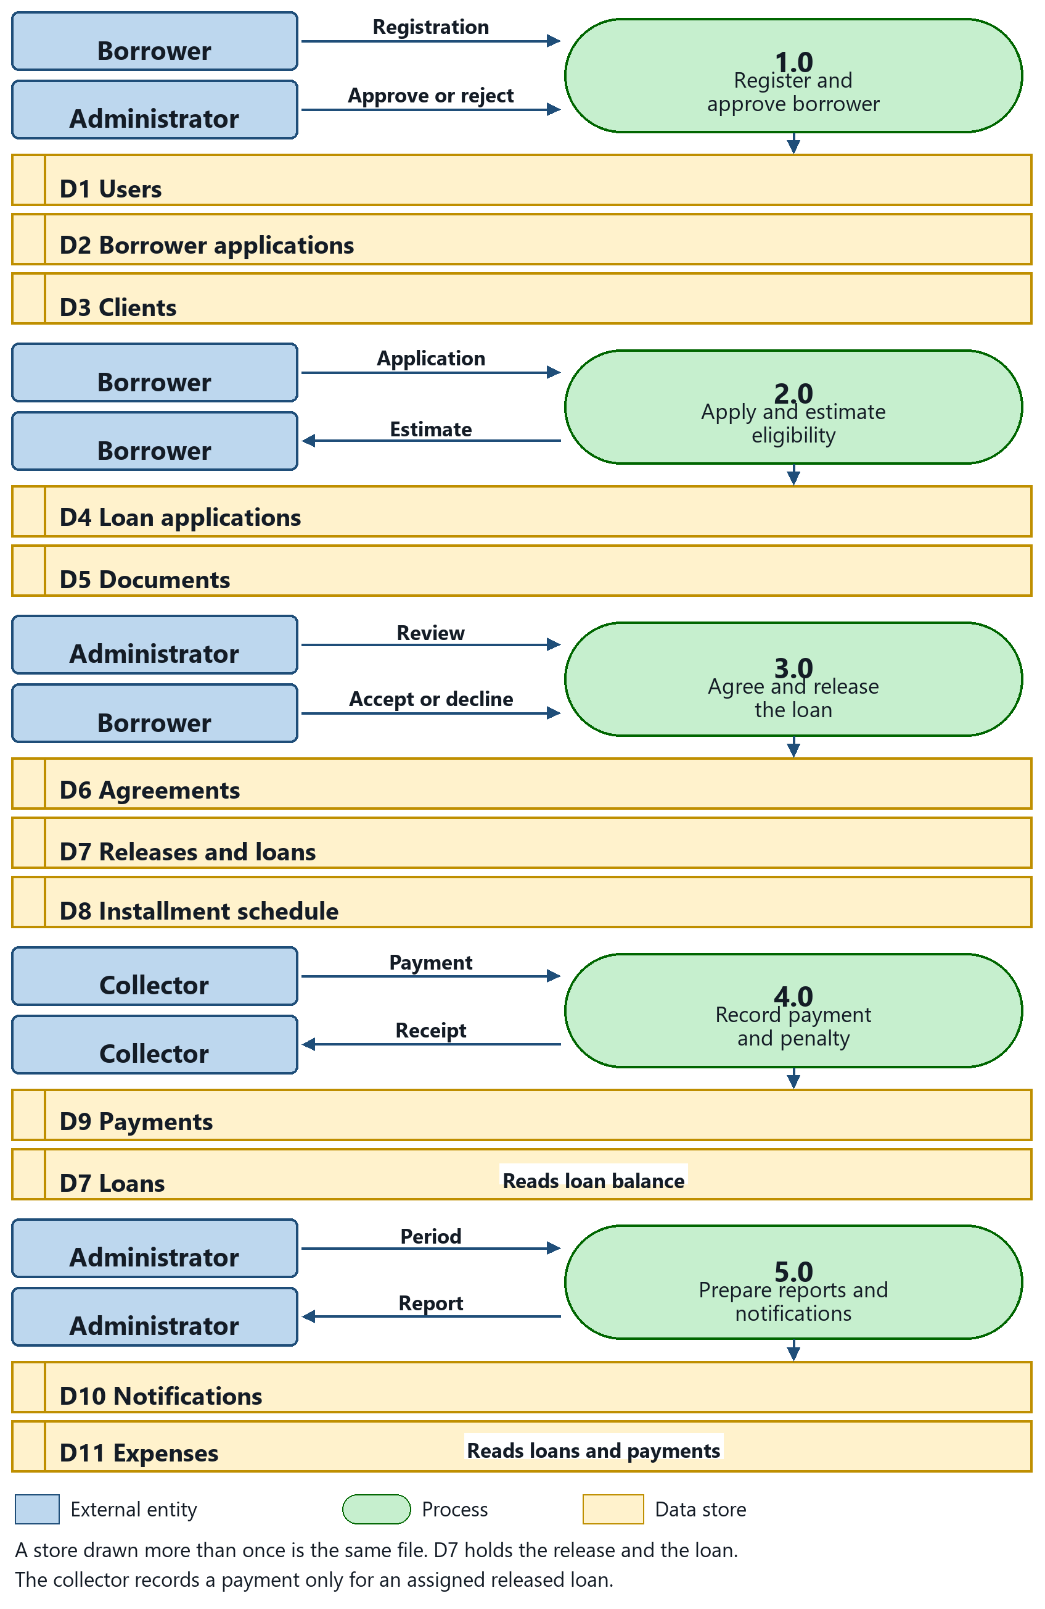

Figure 2 Level 1 Data Flow Diagram of FRAMS
Entity-Relationship Diagram (ERD)
Figure 3 is the entity-relationship diagram of FRAMS. A user account owns the borrower registration, the client record, password-reset tokens, and in-application notifications. A client is assigned to one collector through collector_id and may have many loans. A loan application belongs to the borrower's user account, stores the eligibility estimate, and links to its documents, reviews, one agreement, and one release. Releasing creates the loan and the installment rows. Installments are stored against the release through release_id. Payments belong to a loan. A PayMongo QR Ph attempt belongs to a loan and, after verification, to one payment. Contact messages from the public page are stored with their replies. Expenses and the email log are office records and are not required links to a loan.
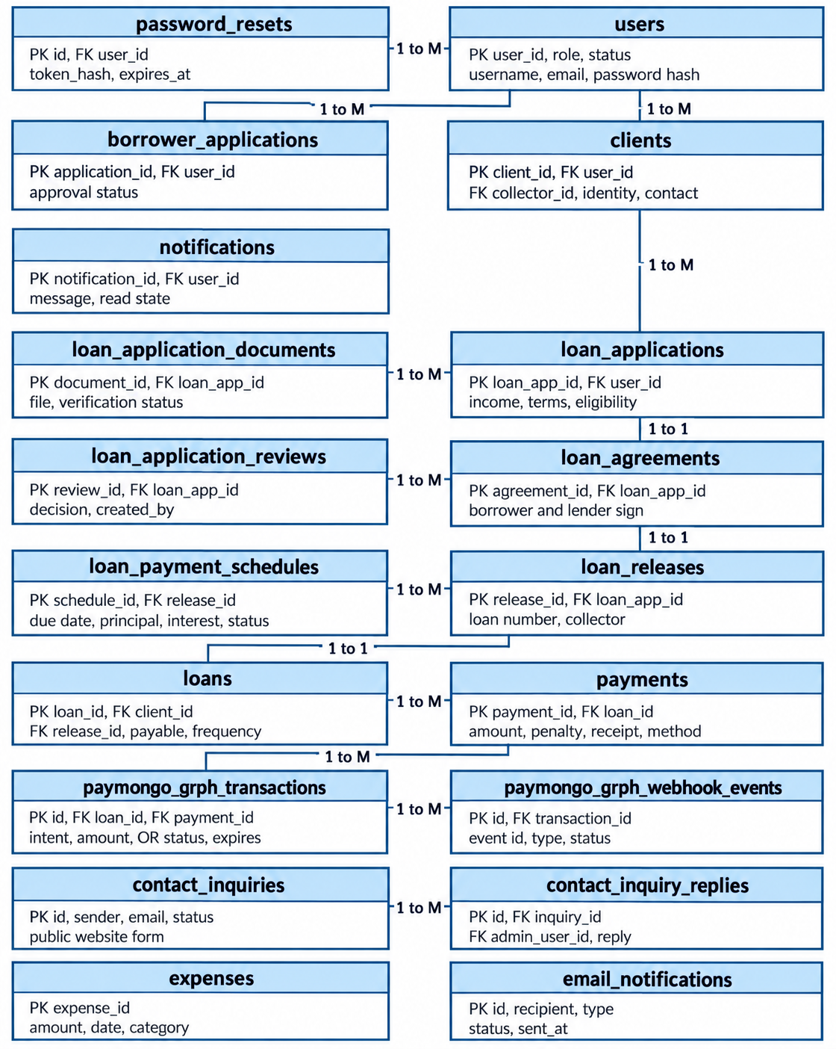
Figure 3 Entity-Relationship Diagram of FRAMS
users. Stores every account that can sign in. Each row holds the username, email, password hash, role (administrator, collector, or borrower), and account status. One user may be linked to many clients, borrower applications, and notifications.
borrower_applications. Stores a borrower’s request to open an account before that person becomes a client. It links to users through user_id and keeps the approval status of the registration.
clients. Stores the borrower profile used for lending. It links to the borrower’s user account and to the assigned collector through collector_id, and it keeps identity and contact details. One client may have many loans. Loan applications are stored on that borrower’s user account.
notifications. Stores messages sent to a user, such as application or payment updates. Each row links to users and records the message and whether it has been read.
loan_application_documents. Stores the files uploaded for a loan application, such as a valid ID, proof of income, proof of billing, a selfie holding the ID, and an additional supporting document. Each file links to loan_applications through application_id and keeps its verification status.
loan_applications. Stores a request for a loan. It links to the borrower’s user account through user_id and keeps the income, the requested terms, the eligibility status, and the assessment result. One application has many documents and, once approved, one agreement.
loan_agreements. Stores the borrower’s acceptance of the approved loan terms. It links one-to-one with loan_applications.
loan_releases. Stores the release of an approved loan, including the loan number. It links one-to-one with the agreement and with the loan record that follows.
loans. Stores the active loan after release. It links to the client and to loan_releases, and it keeps the total payable, payment frequency, and loan status. One loan has many schedule rows and many payments.
loan_payment_schedules. Stores each installment of a loan. A row links to the loan release through release_id and keeps the due date, principal, interest, amount due, and whether that installment is unpaid, paid, or overdue.
payments. Stores money collected for a loan. Each row links to loans and keeps the amount paid, any penalty included, the method, and the receipt number in the form RJRR-YYYYMMDD-######. A verified PayMongo QR Ph payment also stores the link to its QR Ph transaction.
expenses. Stores office expenses used in the financial report. Each row keeps the amount, date, and category. It is not linked to a borrower or a loan; it is read when the period report is prepared.
password_resets. Stores the expiring token used by the forgot-password page. Each row links to users.
email_notifications. Stores the result of selected email messages, including the recipient, message type, status, and send time. It is not required to link to a loan.
contact_inquiries. Stores the name, email, and message sent from the public page. An administrator reads and answers these records.
contact_inquiry_replies. Stores an administrator reply to one contact inquiry.
loan_application_reviews. Stores each administrator decision and review note for a loan application.
paymongo_qrph_transactions. Stores a collector-started Dynamic QR Ph attempt, including the loan, amount, payment-intent identifier, status, and expiry. A verified attempt links to one payment.
Process Design
The actors are the borrower, the collector, and the administrator. Figure 4 shows the activity those actors share. The borrower registers, applies, uploads documents, accepts or declines the agreement, and views the loan and receipts. The collector records payments for assigned loans. The administrator reviews, releases, assigns the collector, and opens users, expenses, penalties, and reports.
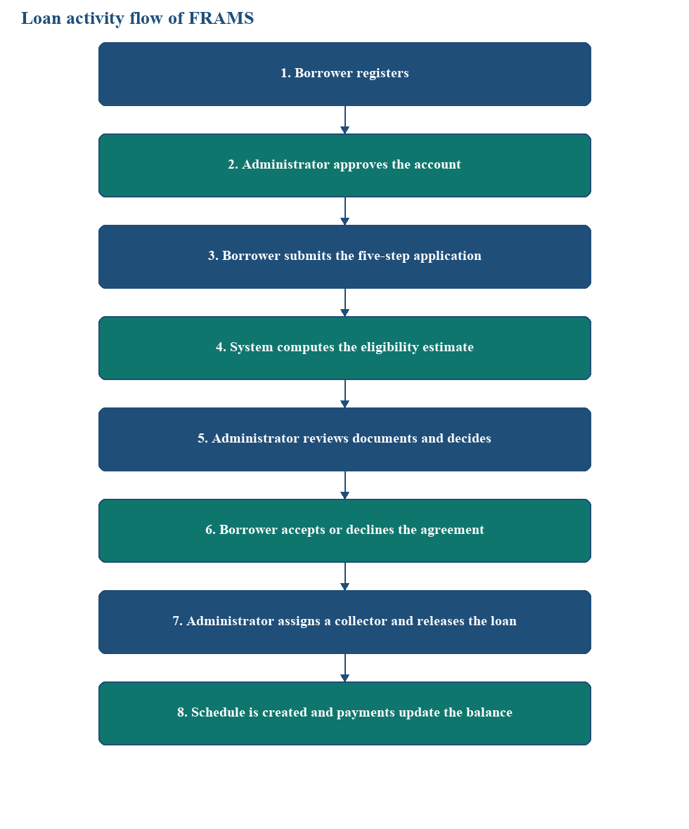
Figure 4 Loan activity flow of FRAMS
Figure 4 is the activity from registration through collection. The eligibility estimate sits before document review continues, and release sits only after the borrower accepts the agreement. Figure 5 is the sequence for that estimate. The borrower submits the figures, the application page calls the eligibility function, the result is saved, and the administrator reads the stored estimate on the review page. The administrator records the lending decision separately.

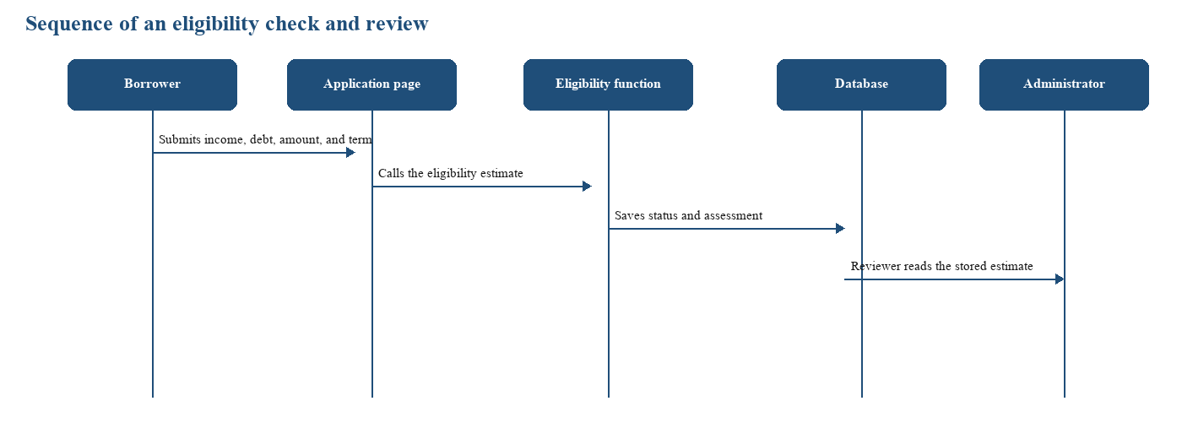
Figure 5 Sequence of an eligibility check and administrator review
System Process Flow
This section presents the operational flow of FRAMS with standard flowchart symbols. An oval marks the start or end. A rectangle marks a process. A diamond marks a decision, and its branches are labeled Yes and No. A parallelogram marks input or output. A cylinder marks a record read from or written to the database. A document symbol marks a file the system generates. Each chart follows the pages and rules in the implemented system.

Figure 5.1 presents the overall operational flow of FRAMS. The process begins when a user opens the staff login or borrower login page and enters a username or email address and password. FRAMS checks the credentials and account status. If access is denied, the system displays an appropriate message and returns the user to the login page. If authentication succeeds, the user is directed to the dashboard permitted by the assigned role.
Figure 5.1 illustrates the overall operational flow of FRAMS. The process begins when a user opens the staff login or the borrower login and enters a username or email and a password. FRAMS checks the password and whether the account is active. When access is withheld, the page shows an error or a pending-approval notice and returns to the login fields. When access is granted, the system opens the dashboard that belongs to the signed-in role. The user performs the tasks allowed for that role, the resulting records are saved in MySQL, and the system shows the page, receipt, or report produced by the task. The flow ends when the user logs out and the session is cleared.
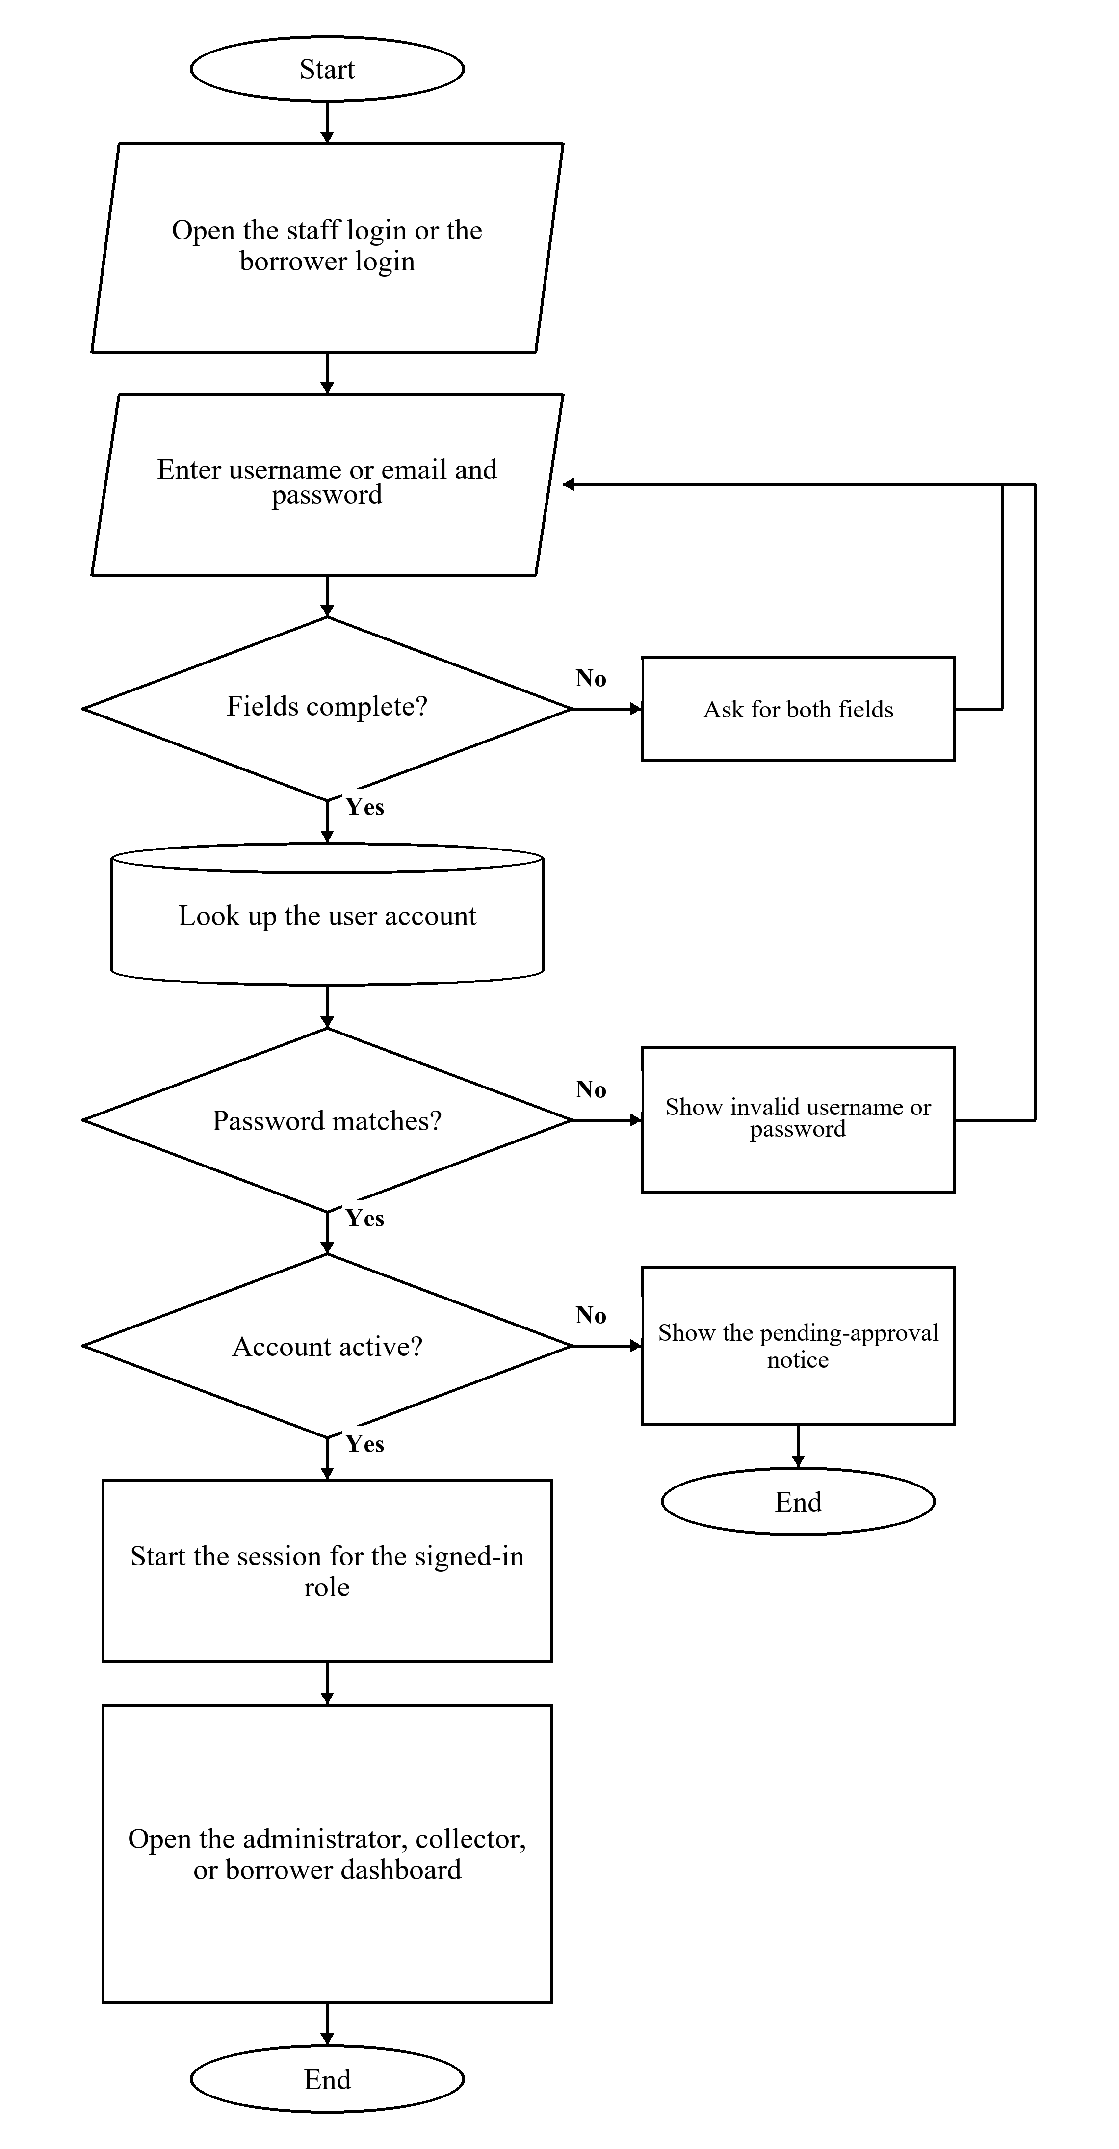
User Authentication Flow

Figure 5.2 FRAMS User Authentication Flowchart
Figure 5.2 shows how FRAMS authenticates a user. The process starts on the staff login page or the borrower login page. The user enters a username or email and password. If either field is empty, the page asks for both fields and returns to the form. If the fields are complete, FRAMS looks up the account. A password that does not match produces an invalid-login message and returns to the form. A matching password on an account that is not yet active, including a borrower registration that is still pending approval, produces a pending-approval notice and ends without a session. When the password matches and the account is active, FRAMS starts a session and opens the administrator dashboard, the collector dashboard, or the borrower dashboard according to the role.
Borrower Registration Flow
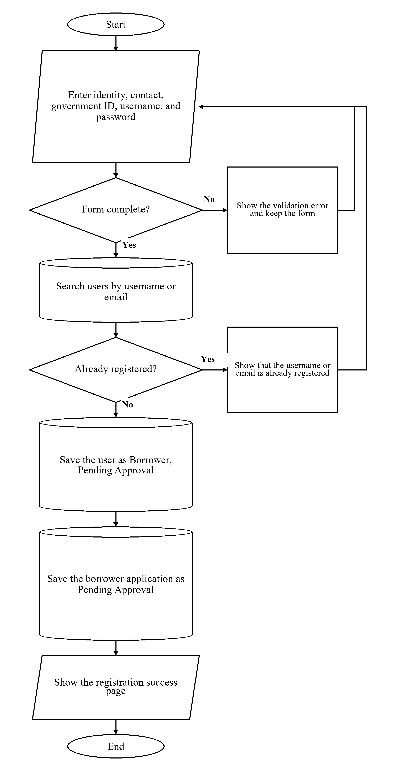

Figure 5.3 FRAMS Borrower Registration Flowchart
Figure 5.3 presents borrower registration. The applicant enters identity, contact, government identification, username, and password, and gives consent. If a required field is missing or the passwords do not match, the page shows a validation error and keeps the form. If the form is complete, FRAMS searches the user records by username or email. An existing username or email stops registration and shows that the account is already registered. When no matching record is found, the system stores the user with the role Borrower and the status Pending Approval and stores the borrower application with the same pending status. The registration success page is the result. The account can sign in after an administrator approves it.
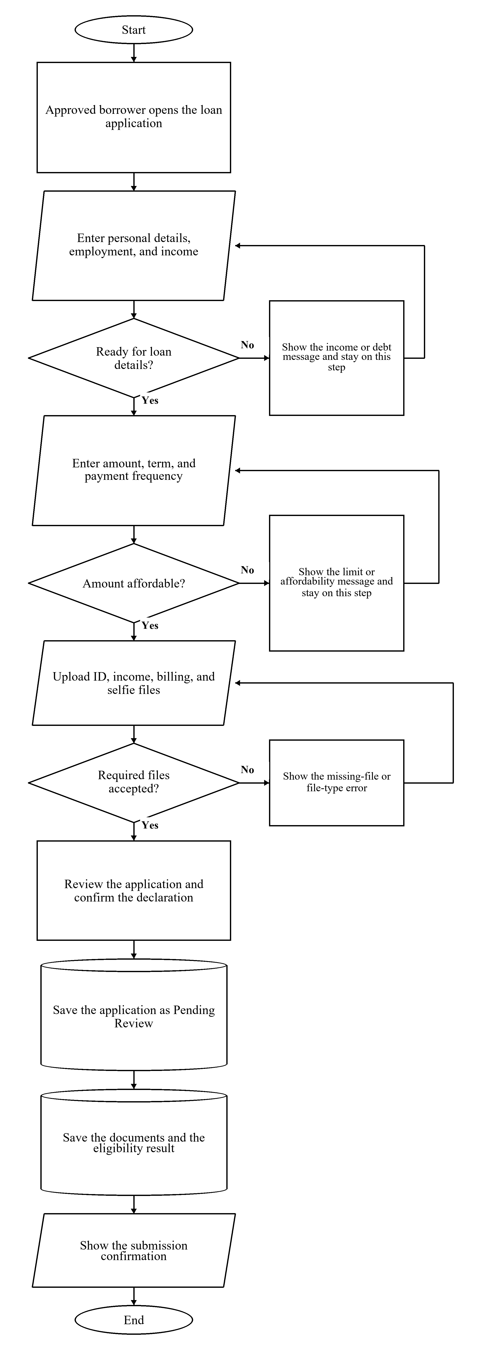
Loan Application Flow

Figure 5.4 FRAMS Loan Application Flowchart
Figure 5.4 traces the loan application completed by an approved borrower. The borrower enters personal details, employment, and income. FRAMS opens the loan-details step when employment status and income are present, existing debt is within the debt-to-income guidelines, and there is room for a new payment. Otherwise, the page shows the income or debt message and stays on that step. The borrower then enters the amount, term, and payment frequency. The wizard stays on that step when the amount is outside the configured loan limits, when debt-to-income after the proposed loan is over the limit, or when the requested amount is above the estimated affordable principal. The borrower uploads a valid government ID, proof of income, proof of billing, a selfie holding a valid ID, and an additional supporting document. All five files are required. Accepted files are JPG, PNG, or PDF and are limited to 8 MB. After the borrower reviews the application and confirms the declaration, FRAMS saves the application as Pending Review, saves the documents, and saves the eligibility result. The confirmation page is shown, and the application awaits administrator review.

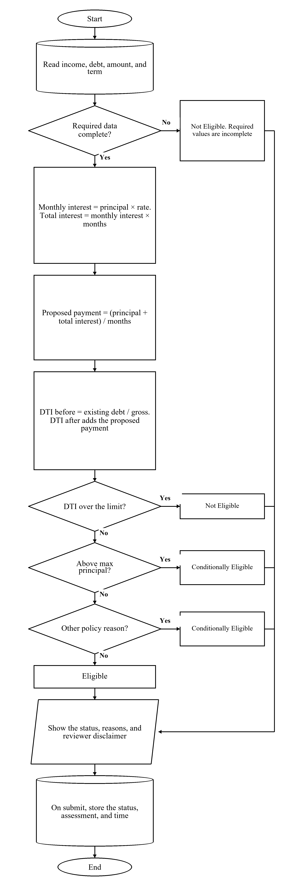

Figure 5.5 Financial Risk Assessment Flow
Figure 5.5 shows the eligibility estimate used during the application and again on the administrator review page. The process reads income, existing debt, the requested amount, and the term. If a required value is missing, the status is Not Eligible, and the page lists the missing information. When the data are complete, monthly interest equals the principal multiplied by the monthly rate, total interest equals that monthly interest multiplied by the term in months, and the proposed monthly payment equals the principal plus total interest, divided by the term. Debt-to-income before the loan is existing monthly debt divided by gross income. Debt-to-income after the loan adds the proposed payment. The maximum affordable payment is gross income multiplied by the configured debt-to-income limit, minus existing debt. The maximum principal is that affordable payment multiplied by the term, divided by one plus the rate multiplied by the term, and then kept within the minimum and maximum loan amounts. The configured defaults are a 40 percent debt-to-income limit, a loan range of 3,000 to 500,000 pesos, a minimum employment length of three months, and a monthly interest rate of 5 percent. Debt-to-income after the loan above the limit produces Not Eligible. A requested amount above the maximum principal, or another policy reason such as employment shorter than the minimum or net income greater than gross income, produces Conditionally Eligible. The remaining complete applications are Eligible. The page shows the status, the reasons, and the reviewer disclaimer. When the application is submitted, FRAMS stores the status, the assessment, and the time on the loan application. The administrator records the lending decision separately.

Loan Approval and Release Flow

Figure 5.6 FRAMS Loan Approval, Agreement, and Release Flowchart
Figure 5.6 shows administrator review through release of funds. The process starts when the administrator opens the application, the documents, and the stored eligibility estimate, and marks each document verified or rejected. If the application is not approved, the administrator rejects it and records the reason or requests more documents and sets the status to Documents Incomplete. In either case the borrower is notified and that branch ends. Approval sets the status to Waiting for Loan Agreement, saves or updates the client, and saves a loan marked Pending Release. FRAMS then generates the agreement and records the lender’s acceptance. The borrower reviews the agreement and either types a name to accept it or enters a reason to decline it. A decline is stored, both sides are notified, and release stops. Release continues when both acceptances are on record, an active collector is assigned, the loan amount is valid, and the application has not already been released. That step saves the loan number, the release record, and the installment schedule, and notifies the borrower that the loan has been released.

Payment and Collection Flow

Figure 5.7 FRAMS Payment and Collection Flowchart

Figure 5.7 shows how an administrator or the assigned collector records a cash, bank-transfer, or e-wallet payment on a released loan. A staff member selects the loan, and the page shows the remaining balance and the penalty due. Penalty due is computed from unpaid installments whose due date has passed, at 1 percent for a daily schedule, 2 percent for weekly, 3 percent for semi-monthly, and 5 percent for monthly, after penalty amounts already recorded on payments are applied. The staff member enters the amount received, the date, the method, and any penalty portion. The form is shown again when the amount is not greater than zero, when the penalty portion is larger than the amount received, or when the payment is larger than the remaining balance plus the penalty due. A valid payment is saved with a receipt number. The balance is recomputed from the total payable minus the payments on record, and the installment status is updated. The receipt can then be viewed, printed, or downloaded.
Figure 5.7 is the immediate recording path for cash, bank transfer, and e-wallet. An administrator or the assigned collector can save that payment as soon as the amount is valid. PayMongo Dynamic QR Ph waits for a later confirmation. The Create Dynamic QR Ph action is shown only for bank transfer or e-wallet. An administrator, or a collector assigned to the loan, can start it. The page stores a pending QR Ph transaction and shows the code. While the page is open, the server checks the Payment Intent every five seconds. The balance stays unchanged until the amount, currency, mode, succeeded-intent, and paid QR Ph payment checks succeed. If the page is closed, authorized staff can check that one pending transaction from the Payments page. A failed, expired, or mismatched attempt does not post a payment. A confirmed QR Ph payment remains on the receipt record and is not deleted.
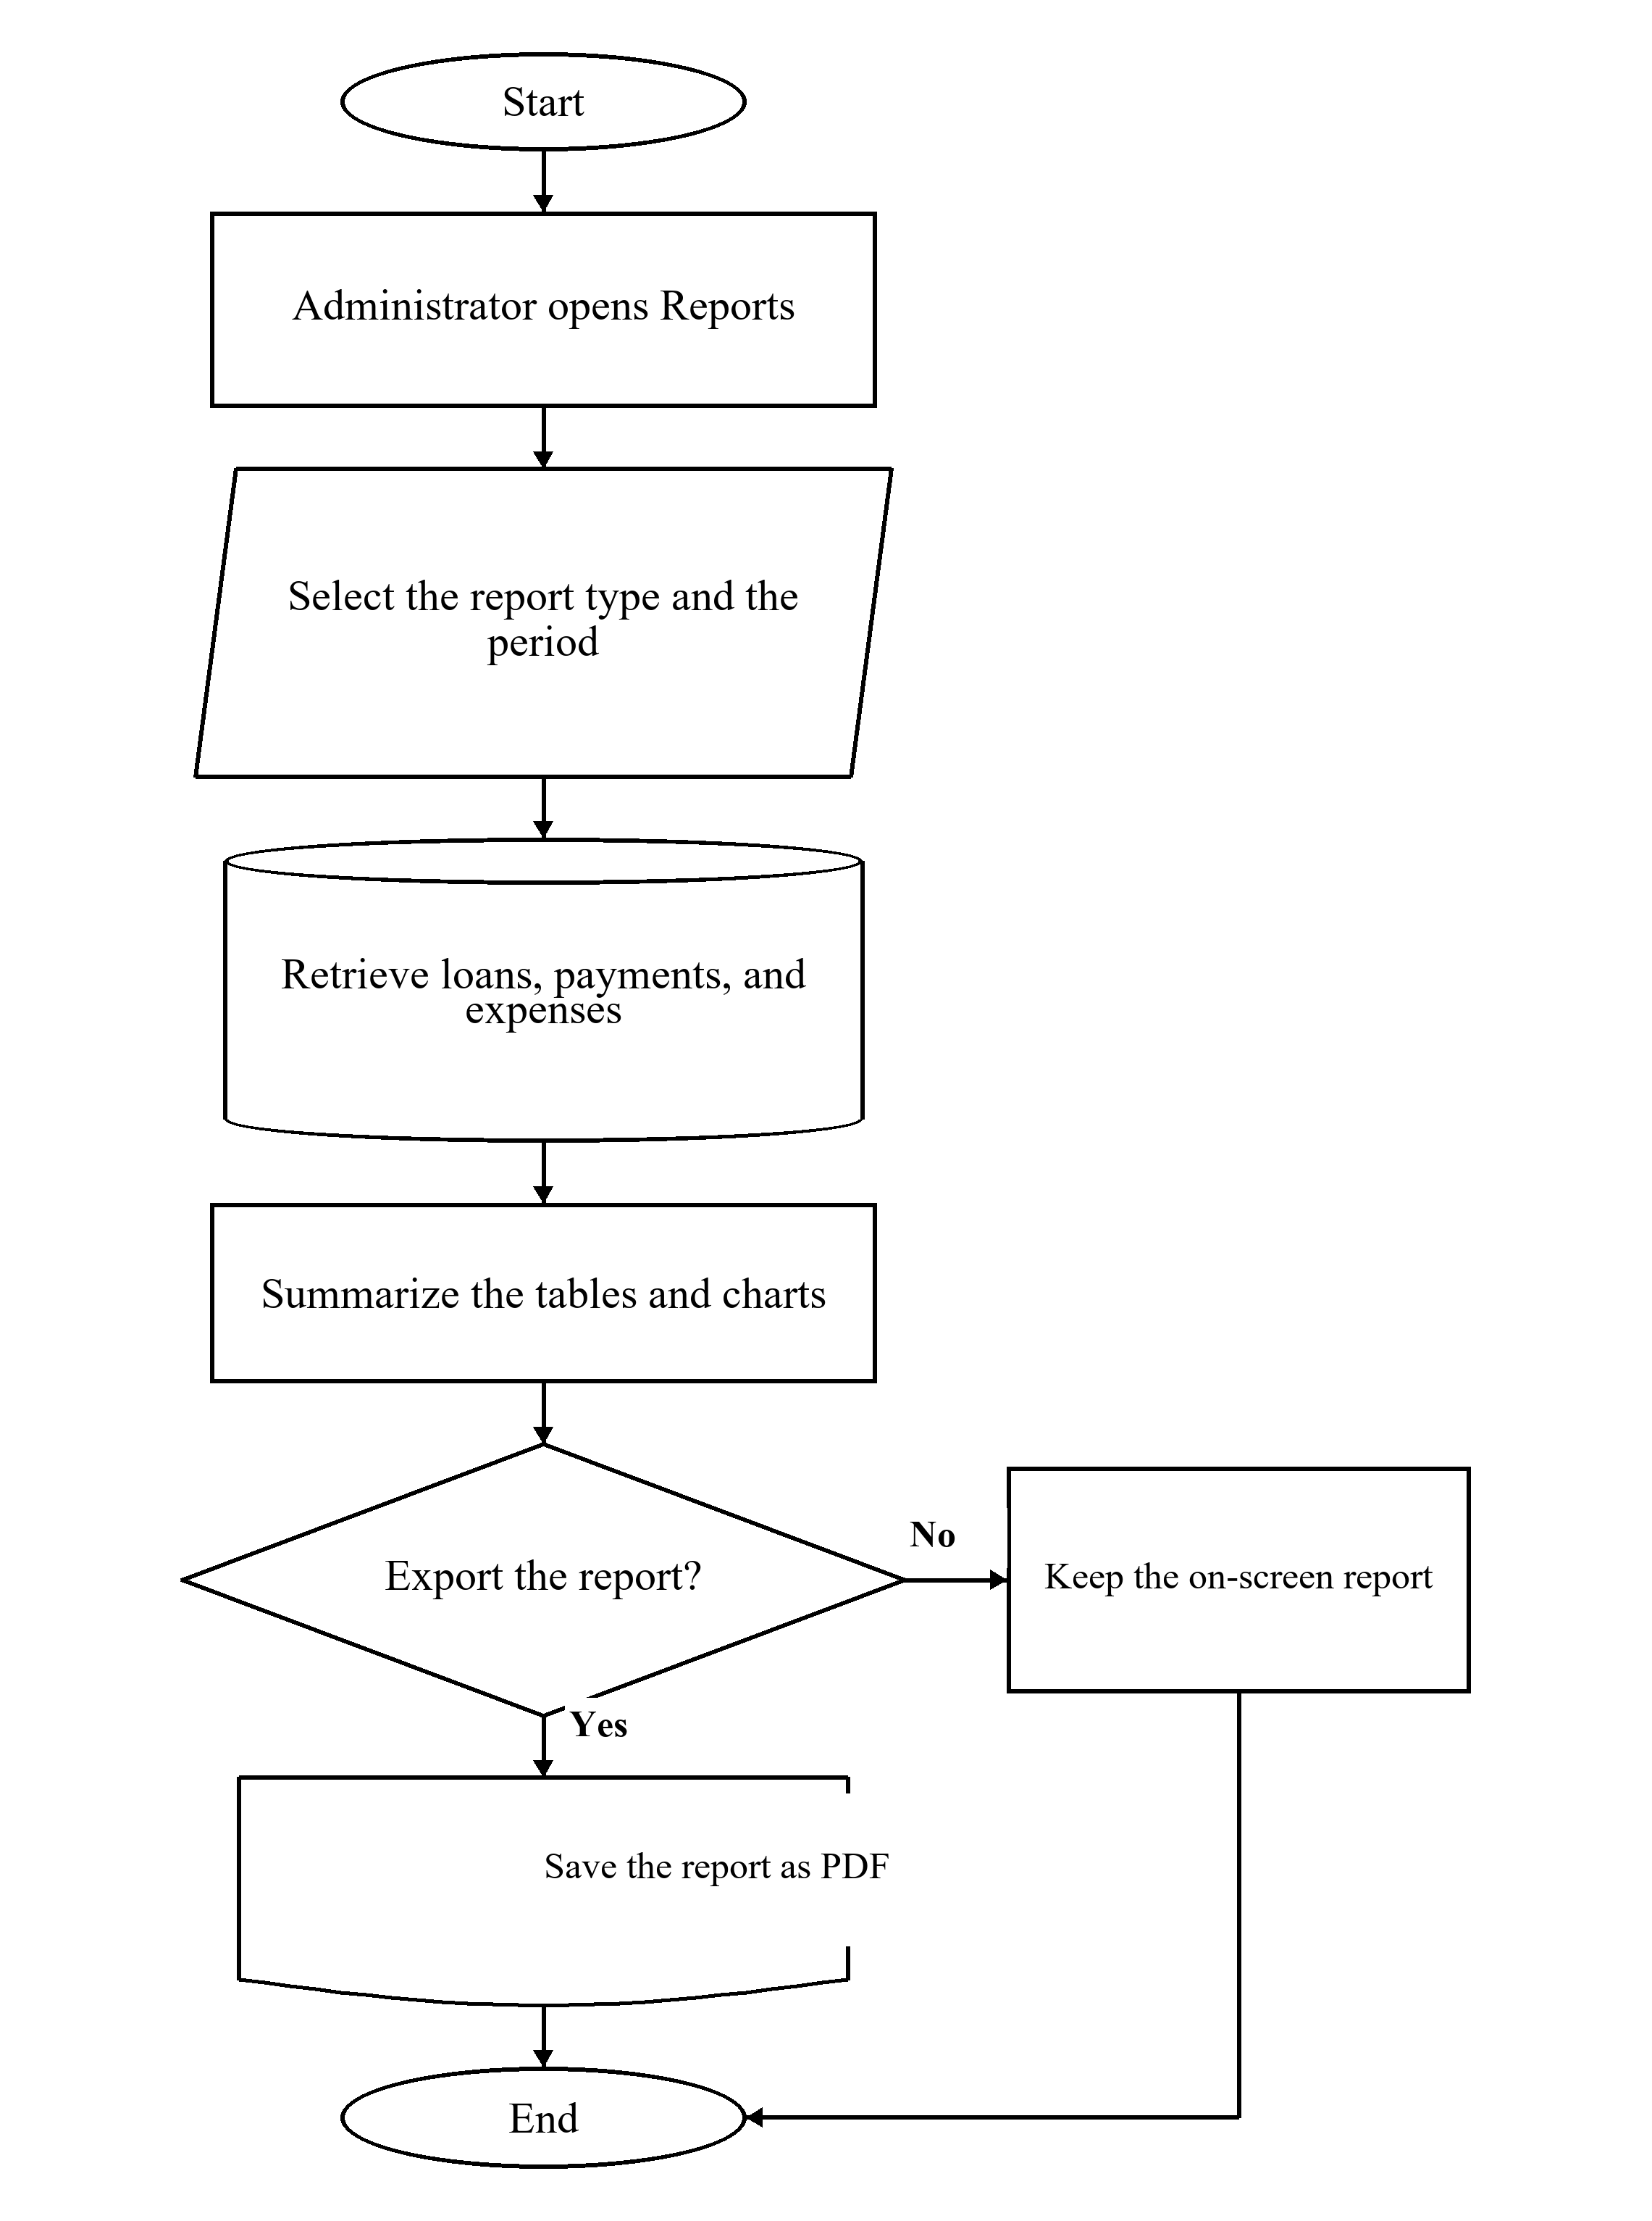
Report on Generation Flow

Figure 5.8 FRAMS Report Generation Flowchart
Figure 5.8 shows report generation, which is available to the administrator. The process starts when the administrator opens Reports and selects the report type and the period. The report types are dashboard analytics, loan reports, payment reports, borrower reports, collector performance, and the financial summary. The period may be daily, monthly, yearly, or a custom range. FRAMS retrieves the related loans, payments, and expenses and summarizes them as tables and charts. The administrator may keep the report on screen or export it. Exports are saved as PDF.

Technical Tools
Hardware Requirements
Equipment | Use
Computer running the local web server and MySQL | Hosts the application during development and office use
Staff computer with a current browser | Administrator and collector work
Borrower phone or computer with a browser | Registration, application, agreement, and loan viewing
Local network | Connects the browser to the office server

Table 2 Hardware used for FRAMS
Software Requirements
Component | Software
Server-side language | PHP 8.1 or newer
Database | MySQL through PDO
Web server | Apache; XAMPP is the documented local package
Browser interface | HTML, CSS, JavaScript, and Bootstrap
Charts and export | Chart.js for charts. The reports page exports the current view as PDF
Mail | PHPMailer for selected messages when mail is configured
Operating system | Windows for the development machine
Browsers | Google Chrome, Microsoft Edge, and Mozilla Firefox

Table 3 Software used for FRAMS
Development and Testing Environment
Development used a local XAMPP environment, MySQL, and a code editor, with the project files kept under version control. Testing follows the capstone requirement for unit testing, integration testing, and user acceptance testing.
Unit Testing
Unit testing evaluated individual functions and validation rules within FRAMS. The tests covered authentication, registration, loan eligibility validation, document uploads, and payment amount validation. Each function was assessed independently to determine whether it produced the expected result. The six test cases, identified as UT-01 to UT-06, are presented in Table 4.4.
Integration Testing
Integration testing evaluated whether connected modules worked together correctly. The tests covered the workflow from borrower approval and login to loan application submission, eligibility assessment, loan release, installment schedule generation, payment recording, balance updates, borrower payment history, and report generation. The seven integration test cases, identified as IT-01 to IT-07, are presented in Table 4.5.
System Testing
System testing evaluated FRAMS as a complete application. It examined whether the major features and workflows operated according to their intended requirements, including borrower management, loan processing, repayment monitoring, notifications, and report generation. The twelve system test cases, identified as ST-01 to ST-12, are presented in Table 4.6.
PayMongo QR Ph testing covered rejected QR creation with an isolated invalid test key, payment amount validation, cash-versus-QR controls, collector assignment, borrower and signed-out access restrictions, unresolved pending attempts, and protection of a QR-linked repayment from deletion. The test procedure used an isolated FRAMS test server and disposable test records. PM-01 and PM-02 document provider rejection, not a successful QR image. The retained cases and results are presented in Chapter IV and Figures B26–B34. Three earlier cases were removed from this official set because they are outside the implemented confirmation workflow.
PayMongo testing evaluated QR Ph validation, access control, an unresolved pending attempt, and protection of a linked repayment. The nine retained PayMongo test cases, identified as PM-01 to PM-09, are presented in Table 4.7. They do not include a successful QR image or a completed wallet payment.
Penetration and security testing used twelve controlled, non-destructive checks in the isolated FRAMS test environment. The checks covered signed-out access, wrong-password and inactive-account handling, borrower and collector role restrictions, missing security tokens, SQL-injection probes, output encoding, borrower-record ownership, collector assignment restrictions, file-upload validation, session behavior after logout, and password-reset-code controls. The results are limited to the specified cases and do not establish that the entire system is free of vulnerabilities. Detailed outcomes and screenshots are provided in Chapter IV and Figures B35–B46.
Penetration testing was intended to assess the security of FRAMS against potential vulnerabilities. Relevant areas may include authentication, role-based access control, session management, cross-site request forgery (CSRF), SQL injection, cross-site scripting (XSS), record ownership restrictions, file upload validation, and password-reset token validation. The twelve penetration test cases, identified as PT-01 to PT-12, are presented in Table 4.8.

CHAPTER IV
SYSTEM IMPLEMENTATION AND RESULTS
This chapter presents the actual implementation, testing, and results of the Financial Risk Assessment and Micro-Lending System (FRAMS) for RJ and RR Finance Services. In the running interface the organization is identified as RJ and RR Finance Services, and several page titles use the label Lending Management System. The discussion is limited to functions that exist in the source code. Test scores, respondent counts, and a declaration that every objective in Chapter 1 has been met are not supplied by the program files. Those items are identified in the testing tables so they can be completed from the approved Chapter 1, Chapter 3, and the recorded test sheets.
System Implementation
FRAMS was implemented as a browser-based application for a local Apache, PHP, and MySQL environment. The documented local setup is XAMPP, with the application placed under the web server document root. Authorized users open the pages in a web browser. The server renders each page, checks the signed-in role, reads and writes the database, and returns HTML. There is no separate mobile application and no separate public web service for the screens. The payments page uses two authenticated JSON lookups. One loads the selected loan and its remaining balance into the payment form. The other returns the status of a PayMongo QR Ph transaction after the server retrieves the Payment Intent. A QR Ph repayment is posted only after the amount, currency, mode, succeeded-intent, and paid QR Ph payment checks succeed.
The user interface uses HTML, CSS, and JavaScript, with Bootstrap, Font Awesome, and Bootstrap Icons stored in the application assets. Chart.js is used for dashboard and report charts. The reporting page provides PDF export. These descriptions should be retained only for functions present in the submitted version of the system.
Server-side processing is written in PHP. The user interface is HTML, CSS, and JavaScript, with Bootstrap, Font Awesome, and Bootstrap Icons stored in the application assets. Chart.js draws the dashboard and report charts. The reports page exports the current view as a PDF generated on the server. Chart.js draws the charts. The export control on that page saves a PDF. The project dependency file requires PHP 8.1 or newer and PHPMailer for selected email messages. MySQL, accessed through PHP Data Objects, stores the records.

Table 4.1
Technologies used in the implementation of FRAMS
Component | Tool or technology | Purpose in the implemented system
Server-side language | PHP | Processes forms, roles, loan computations, and page output
User interface | HTML, CSS, JavaScript, Bootstrap | Renders forms, navigation, tables, and messages
Database | MySQL through PDO | Stores users, applications, loans, schedules, and payments
Charts | Chart.js | Displays dashboard and report charts from query results
Mail | PHPMailer and the project mail helpers | Sends selected account, application, release, and payment messages when mail is configured
Local server | Apache with PHP and MySQL; XAMPP is the documented local setup | Hosts the application during development

The source is organized by responsibility. Each major screen is a PHP page. Shared files under the include directory handle the database connection, session and role checks, cross-site request tokens, loan interest and schedules, the eligibility estimate, navigation, mail, and document checks. Pages that change data call the token check before the update is saved. Text written back into a page has escaped in the templates that were inspected. Database statements that receive user input use prepared statements, with emulated preparations turned off. A failed database connection is written to the error log, and the user sees a short failure message rather than the connection details.
Authentication starts at a login page. Borrowers use the borrower login. Administrators and collectors use the staff login. The program looks up the account by username or email and checks the password with password_verify. New passwords are stored with password_hash. An account must be active. A borrower must also be approved before the borrower login continues. A successful login stores the user and role in the PHP session and opens the dashboard for that role. Logout destroys the session. Pages that require a signed-in user redirect an anonymous visitor to the staff login. Administrator-only pages stop a collector or a borrower. Borrower queries add the signed-in user. Collector queries add the assigned collector.
Loan amounts are calculated through shared functions rather than entered as precomputed totals. The standard monthly interest rate is 5%, subject to the configured rate used for a particular loan. FRAMS uses flat interest calculated against the original principal for each month of the loan term; it is not a declining-balance amortization method.
Formula 1. Monthly Interest
MI = P × (r / 100)

MI represents monthly interest, P is the original loan principal, and r is the monthly interest rate expressed as a percentage.

Formula 2. Total Interest
TI = MI × n

TI is total interest over the loan term, and n is the term in months.

Formula 3. Total Payable
TP = P + TI

TP is the scheduled total payable before separately assessed penalties.

For example, a principal of ₱10,000 at 5% monthly interest for six months produces monthly interest of ₱500, total interest of ₱3,000, and total payable of ₱13,000.

The installment count depends on payment frequency. When start and end dates are unavailable, the system uses the configured conventions shown below.

Formula 4. Number of Installments
Monthly: N = n | Semi-monthly: N = 2n
Weekly: N = 4n | Daily: N = 30n

N represents the number of installments and n is the term in months. The weekly and daily calculations use four weeks and thirty days per month, respectively, under the fallback rules described.

Formula 5. Principal Per Installment
PI = P / N

Formula 6. Interest Per Installment
II = TI / N

Formula 7. Scheduled Installment Amount
IA = PI + II = TP / N

PI is the principal portion, II is the interest portion, and IA is the scheduled installment amount. For example, ₱13,000 divided over six-monthly installments is approximately ₱2,166.67 per installment, subject to any rounding adjustment implemented by the system.
Due dates advance by one day for daily payments, seven days for weekly payments, fifteen days for semi-monthly payments, and one calendar month for monthly payments. The final due date is set to the release date plus the loan term in months.
Formula 8. Final Due Date
FD = RD + n months

FD represents the final due date, RD is the loan release date, and n is the term in months. The final due-date rule may cause the final interval to differ from the regular interval in some schedules.
Financial Risk Assessment and Eligibility

The financial risk function produces an eligibility estimate for reviewer use. It is not an approval and does not predict default. The function reads monthly gross income or an alternative monthly income field when gross income is missing, existing debt payments, other monthly obligations, employment status, employment or business duration, requested loan amount, loan term, and interest rate. Dependents and collateral notes are stored with the application but are not variables in the numerical formula described here. An empty credit-history note leaves the numeric result unchanged. A text note may be included as a reason concerning previous loans recorded in the system; an external credit-bureau report is outside the estimate. If required fields are missing, the status is Not Eligible, and the missing fields are listed rather than guessed.

Policy values are supplied through the environment or code defaults. The defaults described for the system are a maximum DTI of 40%, minimum loan amount of ₱3,000, maximum loan amount of ₱500,000, minimum employment or business duration of three months, and a standard monthly interest rate of 5%.

Formula 9. Existing Debt-to-Income Ratio
DTI_before = (E / I) × 100

E is existing monthly debt payments plus other monthly obligations, and I is monthly gross income.

Formula 10. Proposed Debt-to-Income Ratio
DTI_after = ((E + MP) / I) × 100

MP is the proposed monthly payment. The system description specifies that this payment is calculated as total payable divided by the loan term in months.

Formula 11. Proposed Monthly Payment
MP = TP / n

The proposed monthly payment is used for the monthly DTI comparison. It should not be confused with an individual weekly, daily, or semi-monthly installment.

Formula 12. Maximum Affordable New Payment
MAP = (I × (Dmax / 100)) − E

MAP is the maximum affordable new monthly payment, Dmax is the maximum DTI percentage (default 40%), I is monthly gross income, and E is existing monthly obligations.

Formula 13. Maximum Affordable Principal
Pmax = (MAP × n) / [1 + ((r / 100) × n)]

Pmax is the maximum affordable principal before applying the configured loan limits, n is the term in months, and r is the monthly interest rate expressed as a percentage. The result is limited by the configured minimum and maximum loan amounts: minimum ₱3,000 and maximum ₱500,000 by default.

The estimate assigns Not Eligible when required information is missing, proposed DTI exceeds the configured limit, or a blocking validation fails. It assigns Conditionally Eligible when the requested amount exceeds the maximum affordable amount or other policy reasons remain. It assigns Eligible when the affordability figures fall within the limits and no disqualifying policy reason remains. The application wizard blocks progression when existing debt already exceeds the limit or when the requested amount fails the minimum, maximum, or DTI validation. The administrator retains authority to approve, reject, or request additional documents. The stored disclaimer states that the estimate is for reviewer use and is not a final lending decision or automatic approval.

Payment Processing, Remaining Balance, and Penalties
The system validates payments before recording them. The payment must be greater than zero. A penalty cannot exceed the amount received. The amount received cannot exceed the remaining scheduled loan balance plus the penalty still due, and the installment portion cannot exceed the remaining scheduled balance.

Formula 14. Cumulative Amount Paid
AP = Σ Aᵢ, for i = 1 to m

AP is the sum of amounts recorded as paid toward the loan, Aᵢ is the amount for transaction i, and m is the number of payment transactions included in the sum.

Formula 15. Remaining Loan Balance
RB = TP − AP

RB is the remaining scheduled loan balance, TP is totally payable, and AP is the sum of amounts paid. For example, if TP is ₱13,000 and recorded payments total ₱5,000, the remaining balance is ₱8,000. This calculation assumes AP is the amount applied to the scheduled principal-and-interest payable and penalties are tracked separately.

An installment is overdue when its due date has passed and it remains unpaid. The described implementation calculates a penalty for an overdue unpaid installment by multiplying the installment total by a rate associated with the payment frequency.

Formula 16. Penalty Per Overdue Installment
PN = IA × (p / 100)

PN is the penalty for an overdue installment, IA is the scheduled installment amount, and p is the penalty percentage. The configured rates described are 1% for daily, 2% for weekly, 3% for semi-monthly, and 5% for monthly loans. For example, a ₱2,000 monthly installment at 5% produces a penalty of ₱100. These percentages should not be described as compounding daily rates unless the source code explicitly applies compounding.

Penalty amounts already recorded on payments are applied against installment penalties in schedule order.

Formula 17. Outstanding Penalty Per Installment
OPⱼ = max (0, PNⱼ − RPⱼ)

OPⱼ is the outstanding penalty for installment j, PNⱼ is the calculated penalty for that installment, and RPⱼ is the amount of previously recorded penalties applied to it.

Formula 18. Total Outstanding Penalties
OP_total = Σ OPⱼ, for j = 1 to k

OP_total is the sum of outstanding penalties across k installments with applicable penalties.

Formula 19. Total Outstanding Amount
OA = RB + OP_total

OA is the total outstanding amount. This formula is appropriate when RB excludes penalties and penalties are tracked separately; otherwise, the same penalty must not be counted twice.

Document Upload Validation
Uploaded requirements are limited to 8 MB and accepted formats are JPG, PNG, and PDF. The server checks the detected file type rather than relying only on the file extension.
Database Implementation
The operational database name in the connection file is lending_management, unless the environment supplies another name. The connection uses the host, database, user, and password from that configuration, with a local default. A single installation script that creates every table was not found in the repository. The PayMongo QR Ph tables are created from the SQL migration files. The pages expect core tables for users, clients, loans, and payments, and several other feature tables and columns are created or extended when the related page runs. Eligibility results are columns on the loan application, not a separate risk table. Passwords are stored as hashes. This section does not list credentials.
Table 4.2
Implemented database entities of FRAMS
Entity | Purpose
users | Accounts, roles, status, profile data, and the password hash
borrower_applications | Public registration and the approval decision
clients | Borrower records used for loans and collector assignment
loan_applications | Requested terms, income fields, status, remarks, and the saved eligibility estimate
loan_application_documents | Uploaded requirements and verification status
loan_application_reviews | Administrator decisions and review notes
loan_agreements | Agreement text, acceptance, signature name, and time
loan_releases | Loan number, released amount, borrower, collector, and terms
loan_payment_schedules | Installment due date, principal, interest, amount due, and status
loans | Operational loan, total payable, frequency, and status
payments | Amount, penalty portion, date, method, reference, collector, and receipt number
expenses | Office expense description, amount, date, and category
notifications | In-application messages and read state
password_resets | Password-reset token and expiry
contact_inquiries | Public contact-form messages and their status
contact_inquiry_replies | Administrator replies to a contact inquiry
email_notifications | Selected outbound email attempts, status, and send time
paymongo_qrph_transactions | Collector-started Dynamic QR Ph attempts, status, expiry, and the payment link after verification

The queries join these records in the lending order. A user links to a borrower application, a client, loan applications, notifications, and payments recorded by a collector. A client links loans and to an assigned collector. A loan application links to documents, reviews, an agreement, and a release. A release links to the loan and to the installment rows. A loan links to payments. Dashboard, report, and loan-detail pages follow those links. Contact messages from the public page are stored and answered through the inquiry helpers.

User Interface Design and System Modules
The signed-in interface uses a sidebar for navigation, a top bar for the page title, search where the role has a search target, the unread-notification count, and the user menu, and a content area for cards, forms, and tables. The sidebar changes with the role. Labels follow lending terms already used by the office: clients, loans, payments, loan applications, loan release, expenses, penalties, and reports. Required fields are marked on the forms that were inspected, and a failed validation returns a message on the same page. A separate settings screen was not implemented. Profile and password change are on the profile page. Policy limits for the eligibility estimate are environment values, not fields on a settings form.

Table 4.3
Implemented modules, purpose, and user access
Module | Purpose | Administrator | Collector | Borrower
Login and logout | Starts and ends the session for the correct role | Yes | Yes | Yes
Dashboard | Summarizes the records the role may see | Yes | Yes | Yes
Users and collectors | Creates and updates accounts, roles, and collector status | Yes | No | No
Borrower approval | Approves or rejects a public registration | Yes | No | No
Clients | Lists borrowers and assigns a collector | Yes | Assigned only | No
Loan application | Collects the request, documents, and eligibility estimate | Reviews | No | Submits
Agreement and release | Records acceptance and creates the loan and schedule | Releases | No | Accepts or declines
Loans | Shows terms, status, balance, and schedule | All loans | Assigned only | Own loan
Payments | Records a collection and updates the balance | Records cash, bank transfer, and e-wallet | Assigned loans; may start QR Ph | Own history only
Penalties and expenses | Shows overdue penalties and office expenses | Yes | No | No
Reports | Summarizes activity for a selected period and exports it | Yes | No | No
Notifications and profile | Lists events for the user and updates the password | Yes | Yes | Yes

Login interface. The borrower login and the staff login are separate pages. Each verifies the account, creates the session, and opens the matching dashboard. A borrower who is not yet approved does not enter the borrower pages. A forgotten-password page can send a time-limited reset when mail is configured.
Public portal and registration. The public page introduces RJ and RR Finance Services, and the loan products shown there: salary, business, emergency, and vehicle financing. Registration stores a pending account. A success page tells the applicant to wait for review. The contact form stores an inquiry that an administrator can answer.
Dashboard monitoring. After login, the administrator sees the executive dashboard: total loans, active loans, amount released, amount collected, outstanding balance, and overdue loans, with charts of collections, releases, loan status, and expenses. The collector dashboard is limited to assigned clients, loans, schedules, and pending collections. The borrower dashboard summarizes that borrower's own application or loan.
User, collector, and profile management. Administrators add and edit users, assign the administrator, collector, or borrower role, and set an account active or inactive. The collectors page creates, edits, activates, and deactivates collector accounts and can search by name, username, email, or employee identifier. The profile page lets the signed-in user review the account and change the password. Passwords entered on these pages are hashed before they are stored.
Borrower approval and client management. The approval page lists registrations and records approval or a rejection. Approval is what allows the borrower to login, and an approval email can be sent when mail is configured. The client list supports search. Client details show the borrower, loan history, and the assigned collector. The administrator search box in the top bar opens the client list.
Loan application management. An approved borrower who is allowed to apply completes five steps: personal information, employment and income, loan details, requirements, and review. Identity fields taken from registration stay locked. Address and mobile number can be updated. Required files are a valid government ID, proof of income, proof of billing, a selfie holding a valid ID, and an additional supporting document. Submission stores the application as pending review, stores the files, and saves the eligibility estimate. The administrator verifies or rejects each file and can approve the application, reject it, or ask for more documents. Remarks are stored. The borrower can open a loan-status page when a trackable application exists. Submission does not release funds.
Financial risk assessment display. The estimate appears on the loan details step and again on the administrator's review of the saved application. The panel shows the status, income, existing debt, both debt-to-income figures, the requested amount, the estimated eligible amount, the maximum eligible amount, the proposed payment, the term, the interest rate, the reasons, and any documents still requested. The status labels are Eligible, Conditionally Eligible, and Not Eligible. The same disclaimer shown in the calculation is printed on the panel.
Agreement, release, and loan monitoring. The administrator generates the agreement. The borrower accepts it by entering the borrower’s name or declines it. Acceptance stores the name and the date and time. Release requires an active collector. It creates a loan number in the form RJRR-LOAN, the year, and a six-digit sequence, together with the release record, the loan, and the installment rows. A release invoice can be opened. The loan list and loan details show the amount, term, frequency, status, balance, schedule, and payments. Status values used for loans include Active, Overdue, and Paid. The borrower sees only the released loan on My Loan.
Payment and collection management. The payments page lists collections and records a payment for an authorized loan. The form shows the borrower, the amount already paid, and the remaining balance. The fields stored are the amount, date, collector, method, optional reference number, and penalty portion. The receipt number uses the prefix RJRR, the date, and a numeric sequence. The borrower can view that borrower's payment history and download a receipt for that borrower's own payment. The collector works from assigned accounts. When the method is bank transfer or e-wallet, an administrator or the assigned collector can start PayMongo Dynamic QR Ph. The repayment, receipt, and balance change are saved only after the Payment Intent checks succeed. If the QR page has been closed, the Payments page lists that pending attempt and authorized staff can check it individually. An unverified, expired, or mismatched QR code does not post a payment, and a confirmed QR Ph payment is not deleted from the list. A payment that fails the amount checked in Section 4.1.1 is rejected. The same provider payment is not posted twice.
Penalties, expenses, and reports. The penalty page shows the outstanding penalty and the penalty amounts collected in the selected period. A collected penalty appears when the penalty portion was entered with the payment. Expenses store description, amount, date, and category. Reports are limited to the administrator and contain six views: dashboard analytics, loan reports, payment reports, borrower reports, collector performance, and financial summary. The period may be daily, monthly, yearly, or a custom range. The current view can be exported as a PDF.
Notifications. The notifications page lists messages for the signed-in user and can mark them read. The top bar shows the unread count. Events such as approval, an application decision, agreement action, and loan release create an in-application notice. Matching email functions exist for account approval and rejection, application submission and decision, agreement decision, release, payment received, and a fully paid loan. The application notice does not depend on mail delivery.

Testing Strategy
Testing is documented through unit, integration, system, PayMongo integration, and security test cases, with user acceptance testing reported separately. The final status of each test must be based on an actual execution record and supporting evidence. A test should be marked Passed only when its observed result matches the expected result. Failed, blocked, and not-yet-tested cases must remain separately identified until they are resolved or accurately reported as limitations.

Unit Testing
Unit testing examines whether a single function or page accepts valid input, rejects input that breaks its own rule, and shows or stores the intended result. The cases cover login, registration, the eligibility gate, document upload, and payment amount checks, because those rules are implemented as discrete checks.
After entering a valid username and password for an Active account, the user was redirected to the correct dashboard
Table 4.4
Unit test cases of FRAMS
Test Case ID | Description | Expected Result | Actual Result | Remarks
UT-01 | Sign in as an administrator, a collector, or a borrower with an active account and a matching password. | The session starts and the dashboard for that role opens. | After entering a valid username and password for an Active account, the user was redirected to the correct dashboard (administrator, collector, or borrower). | Pass
UT-02 | Sign in with a wrong password or with an inactive account. | The protected pages do not open. | With a wrong password or an inactive account, login failed. An error message was shown, and the administrator and borrower pages were not accessible without a valid session. | Pass
UT-03 | Register a new borrower with complete and valid account details. | The system stores the account and the borrower registration with the status Pending Approval, sets verification status to Pending, and displays the registration success page. Registration alone does not create a client record. | Record the observed result after execution. | Not Yet Tested
UT-04 | Enter loan details that exceed the debt-to-income limit or the loan limits. | The wizard stays on the loan-details step and states the limit that failed. | On Step 3, advancing to the next step was blocked when the debt-to-income or minimum or maximum loan rule failed. The message named the failed limit. | Pass
UT-05 | Upload a file that is not JPG, PNG, or PDF, or that is larger than 8 MB. | The file is refused and is not stored. | The upload was rejected. The file was not saved, and an error was shown. | Pass
UT-06 | Submit a payment greater than the remaining balance plus the penalty still due. | The payment is rejected and is not stored. | The payment was rejected. No payment row was saved, and a validation message was shown. | Pass

Integration Testing
Integration testing checks that connected modules use the same records. Registration must become an approved login. A submitted application must carry its documents and its saved eligibility estimate into the review page. Agreement acceptance and release must create the loan and the schedule that later appear on the borrower loan page. Payment must change the balance shown to the borrower and the totals available to reports. A penalty portion entered with a payment must appear on the penalty page.

Table 4.5
Integration test cases of FRAMS
Test Case ID | Description | Expected Result | Actual Result | Remarks
IT-01 | Register a new borrower, approve the account, then sign in at the borrower login. | After approval, the borrower can sign in and the borrower’s dashboard opens for that account. | After administrator approval, borrower login succeeded and the borrower dashboard opened with the correct account. | Pass
IT-02 | Submit a five-step loan application, then open it on the administrator review page. | The review page shows the uploaded documents, the application status, and the eligibility estimate. | The administrator review showed the uploaded documents, the application status, and the loan assessment or eligibility estimate. | Pass
IT-03 | Accept the loan agreement, then release the loan to an active collector. | A loan number is created, installment rows are stored, and the borrower can see the schedule. | A loan number was generated. Rows appeared in the loans and installment-schedule records, and the borrower loan page showed the schedule. | Pass
IT-04 | Record a payment that does not exceed the remaining balance and the penalty is still due. | The remaining balance decreases, and the same payment appears in the borrower’s history and the payments list. | The remaining balance on the loan details and the borrower loan page decreased. The same payment appeared in the borrower payment history and the payments list. | Pass
IT-05 | Record a payment with a penalty portion on an overdue loan, then open the penalties page. | The penalties page shows the penalty collected for that loan and period. | The penalties page showed the penalty collected for that loan and period, consistent with the payment record. | Pass
IT-06 | Open a report for a period that includes the payment date. | The report totals include the recorded payment for the selected period. | The report totals included the recorded payment amount for the selected period. | Pass
IT-07 | While signing in as a collector or a borrower, open an administrator page. | Access is denied, and administrator records are not shown. | Access was denied, the page did not load administrator data, or the user was redirected to that user's own dashboard. | Pass

Table 4.6
System test cases for FRAMS
Test Case ID | Description | Expected Result | Actual Result | Remarks
ST-01 | Register a new borrower with the required account details. | A pending account is stored, and the success page is shown. | The new borrower data was saved. The account status was Pending, and the registration success page was displayed. | Pass
ST-02 | Sign in as an administrator and approve pending borrower registration. | The borrower’s account becomes active, and the borrower can sign in. | The registration was approved and the account status became Active. The borrower was able to sign in to the borrower dashboard, and an approval notification was recorded. | Pass
ST-03 | Sign in as an approved borrower and submit a loan application with personal, income, and loan details, plus a JPG, PNG, or PDF document. | The application and the document are stored, and the borrower can see the application status. | The application was saved with the entered details and the uploaded document. The application status was available for the borrower to view. | Pass
ST-04 | Sign in as an administrator, verify the application documents, and approve the loan application. | The approval and review notes are stored, and the application status changes to approved. | The documents were marked verified, the approval was saved with the review notes, and the application status showed the approval. The borrower received a notification. | Pass
ST-05 | Generate the loan agreement and accept it as the borrower by entering the borrower’s name. | The acceptance, name, and time are stored, and the application can proceed to release. | The agreement was shown to the borrower. After the borrower’s name was entered, the acceptance and the time were saved, and the application was ready for release. | Pass
ST-06 | Sign in as an administrator, select an active collector, and release an accepted loan. | A loan number, a loan record, a release record, and the installment schedule are created, and the assigned users are notified. | The loan was released to the selected active collector. A loan number and an installment schedule were generated, and the assigned users received a notification. | Pass
ST-07 | Sign in as the assigned collector and record a cash payment that does not exceed the amount due. | The payment is saved, a receipt number is created, and the balance is reduced. | The cash payment was saved with the date, collector, and amount. A receipt number in the RJRR-YYYYMMDD-###### format was created, and the remaining balance was reduced. | Pass
ST-08 | Open the payment history as the borrower who owns the payment and download the receipt. | The borrower can view the payment and download the receipt for that payment. | The payment appeared in the borrower's payment history. The receipt downloaded for the owned payment and showed the recorded amount and receipt number. | Pass
ST-09 | Record payments against a released loan until the outstanding amount is fully covered. | The installment status and the loan status are recalculated from the payments and due dates. | Covered installments were updated from the amount paid. When the outstanding amount was fully paid, the loan status became Paid. | Pass
ST-10 | Sign in as a collector and open the collector dashboard, assigned clients, loans, and collection schedule. | Only clients and loans assigned to that collector are shown. | The dashboard listed the assigned clients, loans, pending collections, and schedule. Loans assigned to another collector were not listed for collection. | Pass
ST-11 | Sign in as an administrator and open the reports for borrowers, collectors, loan status, collections, expenses, disbursements, receivables, and collector performance. | The reports open, and the totals agree with the recorded loans, payments, and expenses. | The report pages opened for the administrator. The collection, expense, disbursement, receivable, and collector totals matched the records stored in the system. | Pass
ST-12 | Complete an action that sends a notification, then open the notification list as the intended user and mark the item as read. | The notification is visible only to the intended user, and its read state is saved. | The notification appeared for the intended user with an unread count. After it was opened, the item was marked read and the unread count decreased. | Pass

Table 4.7
PayMongo test cases of FRAMS
Test Case ID | Description | Expected Result | Actual Result | Remarks
PM-01 | Attempt QR Ph creation with the isolated invalid test key and verify safe failure handling. | With the isolated invalid test key, the provider rejects QR creation. No QR page opens, no repayment is stored, and the loan balance stays unchanged; the attempt is recorded as failed. | The collector submitted E-Wallet for PHP 100.00 on FRAMS-DISP-01 with a PHP 3,150.00 balance. PayMongo returned HTTP 401 because the isolated test key was invalid. No QR page or QR image opened; the transaction was stored as failed, no repayment was created, and the loan remained Active with the balance unchanged. | Pass
PM-02 | After QR creation is rejected, verify the payment form remains open and the loan balance is unchanged. | The payment form stays open. No QR image, amount, method, or expiry is shown, and the loan balance/status remain unchanged. | The Record Payment screen remained open after QR creation was rejected. No QR image, amount, payment-method block, or expiry was displayed. FRAMS-DISP-01 remained Active with a PHP 3,150.00 balance. | Pass
PM-03 | Select Cash and verify the Dynamic QR Ph action is unavailable. | The Create Dynamic QR Ph action is hidden or disabled for Cash; ordinary cash payment actions remain available. | With Cash selected, the Create Dynamic QR Ph button was hidden and disabled. Cancel and Record Payment remained available. | Pass
PM-04 | Submit blank, zero, and nonnumeric payment amounts. | Blank, zero, and nonnumeric values are rejected; no QR image or repayment is created. | A blank amount was blocked by browser validation; zero returned “Payment amount must be greater than zero”; and nonnumeric input returned “Enter a valid payment amount.” None created a QR image or repayment. | Pass
PM-05 | Submit a QR amount greater than the current total due. | The amount above the current total due is rejected and no repayment is created. | An amount of PHP 4,000.00 against a total due of PHP 3,150.00 was rejected with the amount-limit message. No repayment was created. | Pass
PM-06 | Attempt to create a QR payment for a loan assigned to another collector. | The request is rejected because the collector is not assigned to the loan; no QR transaction or repayment is created. | Collector A submitted a QR request for loan 30 assigned to Collector B. The server returned “You are not assigned to this loan.” No QR transaction or repayment was created. | Pass
PM-07 | Attempt to access the payments/QR workflow while signed out and as a borrower. | Signed-out visitors are redirected to staff sign-in; borrowers are redirected to payment history and cannot initiate QR payments. | A signed-out request for the payments page opened the staff sign-in page. A signed-in borrower was redirected to Payment History, which had no QR action. | Pass
PM-08 | Attempt a second QR request while an earlier payment attempt remains unresolved. | A second request is refused when the earlier attempt is unresolved and cannot be confirmed. The pending row and balance remain unchanged. | An unresolved pending attempt on FRAMS-TEST-A could not be confirmed with PayMongo. The second request was refused; the pending row and PHP 3,833.34 balance remained unchanged, and no repayment was created. | Pass
PM-09 | Attempt to delete a payment linked to a verified PayMongo QR Ph transaction. | A payment linked to a verified QR Ph transaction cannot be deleted through the tested operation. | The administrator payments screen showed View only, with no edit/delete control. A delete request for payment 46 was refused; the payment, receipt, and succeeded QR record remained, and the client and borrower were not deleted. | Pass
Table 4.8
Penetration test cases of FRAMS
Test Case ID | Description | Expected Result | Actual Result | Remarks
PT-01 | Open protected staff and borrower pages while signed out. | Staff pages redirect to staff sign-in and borrower pages redirect to borrower sign-in; no protected records are shown. | Signed-out requests for staff dashboard, collector dashboard, payments, and reports returned HTTP 302 to staff sign-in; borrower dashboard, loan, and payment-history pages returned HTTP 302 to borrower sign-in. No protected records were shown. | Pass
PT-02 | Attempt sign-in with a wrong password and with an inactive account. | Neither attempt opens a protected page; wrong-password and inactive-account responses are handled safely. | The active test administrator with a wrong password and the inactive account both stayed on the staff sign-in page and showed “Invalid username or password.” Neither opened a dashboard. | Pass
PT-03 | Attempt to open staff-only pages as a borrower. | The borrower cannot access staff-only functions or records and is redirected to an authorized borrower page. | The borrower was redirected to the borrower dashboard when requesting user administration, reports, loan release, and expenses. The payments request redirected to borrower payment history, which showed only the borrower’s own receipt. | Pass
PT-04 | Attempt to open administrator-only pages as a collector. | The collector cannot access administrator-only functions or records. | The collector was redirected to the collector dashboard when requesting user management, reports, borrower approval, and loan release. No restricted form appeared and the user count stayed at 6. | Pass
PT-05 | Submit selected state-changing requests without the security token. | Requests without the required security token are rejected and no record is created or changed. | Five POST operations without the security token returned HTTP 419 with “Invalid or expired session.” User count remained 6, payments 4, expenses 0, loan releases 3, and the probe username was not created. | Pass
PT-06 | Enter a quote-style SQL-injection probe in sign-in and user search. | Sign-in is not bypassed and the search probe does not reveal additional accounts or records. | The quote-style SQL-injection probe was rejected at sign-in. The same quote in user search returned zero users and did not reveal administrator, collector, or borrower accounts. | Pass
PT-07 | Enter a harmless markup marker in the user-search field and inspect output encoding. | The marker is displayed as encoded text and is not executed as markup. | The harmless <b>pt07marker</b> value was displayed as encoded text, not rendered as bold markup. The search returned zero users. | Pass
PT-08 | Attempt to access another borrower’s receipt and loan document. | The borrower cannot view another borrower’s receipt or document. | A borrower request for another borrower’s receipt redirected to the borrower’s own payment history and did not show the other receipt. A request for a document belonging to another borrower returned HTTP 403 “Access denied.” | Pass
PT-09 | Attempt to view client, loan, and payment records assigned to another collector. | The collector cannot access records assigned to another collector. | The collector received HTTP 403 for a client, loan, and payment assigned to another collector. None of the three records opened. | Pass
PT-10 | Attempt to upload a prohibited file type and a file larger than 8 MB. | Prohibited file types and files larger than 8 MB are rejected and not stored. | The .txt file was rejected with the allowed-file-types message. A 8,389,633-byte file was rejected because files must be 8 MB or smaller. Neither file was stored in the document folder. | Pass
PT-11 | Reload a protected dashboard after signing out. | The protected page requires authentication again after logout. | After sign-out, reopening the collector dashboard returned HTTP 302 to staff sign-in. The protected dashboard required authentication again. | Pass
PT-12 | Test incorrect, expired, throttled, valid, and reused password-reset codes. | Incorrect, expired, and reused codes are rejected; attempt throttling works and a valid code can be used only once. | The reset-code checks confirmed a 600-second expiry, rejection of incorrect and expired codes, throttling after five incorrect attempts, one successful password change, and rejection of code reuse. The test password was restored and no reset row remained. | Pass

User Acceptance Testing
User Acceptance Testing (UAT) was conducted to evaluate the acceptability of the Financial Risk Assessment and Micro-Lending System (FRAMS) based on the respondents' experience using the developed system. The evaluation involved thirty-two (32) respondents, consisting of thirty (30) borrowers, one (1) administrator, and one (1) collector. The respondents evaluated the system based on its functionality, usability, reliability, security, and performance.
After using FRAMS, the respondents completed the User Evaluation Form using a five-point Likert scale. The responses were analyzed using the weighted mean formula to determine the respondents' assessment of the system.
Formula for the Weighted Mean
$$\overline{x}=\frac{\sum{f}x}{N}$$

Where:
$\overline{x}$ = Weighted mean
$f$ = Frequency of responses for each rating
$x$ = Numerical value assigned to each rating
$N$ = Total number of responses included in the calculation

Presentation and Analysis of Results

Presentation of Testing Data
The results of unit, integration, system, PayMongo integration, and security testing are organized in Tables 4.4 to 4.8 and Appendix B. The attached PayMongo evidence (Figures B26–B34) documents 9 retained checks in the isolated test environment, including safe rejection when the isolated test key was invalid. PM-01 and PM-02 are not successful QR generation. The attached penetration evidence (Figures B35–B43) documents 12 passed controlled security checks. The 12 system test cases remain Not Yet Tested in this report. Unit and integration testing entries are retained without changes. On 23 October 2026 a separate command-line check exercised the same server decision used by the five-second status check and by the Payments page check. It did not create a QR code and did not call PayMongo. An unpaid intent stayed pending, a failed payment was not posted, and a wrong amount stayed in review. An administrator could check a loan, a collector could check only an assigned loan, and a borrower or signed-out session could not. One accepted decision posted a single repayment, and repeating that provider payment did not post another. A cash entry still inserted its own payment row. That database transaction was rolled back, so the payment count, loan status, and temporary QR row were unchanged. The five-second timer was confirmed in the page source. It was not observed in a signed-in browser. An unsigned status request was redirected to staff sign-in. A separate wrong-currency trial was not executed in that check.

Table 4.9
Summary of functional testing
Testing Level | Test Cases | Passed | Failed | Remarks
Unit testing | 6 | â€” | â€” | Retain a pass count only after Figures B1â€“B6 match the expected results, including Pending Approval for UT-03.
Integration testing | 7 | â€” | â€” | Retain a pass count only after Figures B7â€“B13 match the expected results, including the approval list for IT-02.
System Testing | 12 | — | — | 12 system cases remain Not Yet Tested; no completed system-test evidence was supplied.
PayMongo Testing | 9 | 9 | 0 | 9/9 retained cases passed in the isolated test environment. PM-01 and PM-02 verified safe rejection with an invalid test key, not successful QR generation. See Figures B26–B34.
Penetration Testing | 12 | 12 | 0 | 12/12 controlled security checks passed in the isolated test environment. See Figures B35–B46.
Total | 46 | 21* | 0* | *Verified counts in the retained PayMongo and penetration evidence only. Unit and integration entries remain unchanged; 12 system cases remain not yet tested. Do not interpret this as all 46 cases passed.

Table 4.10
User evaluation results of FRAMS
Criterion | Weighted mean | Interpretation
Functionality | 4.81 | Strongly Agree
Usability | 4.75 | Strongly Agree
Reliability | 4.78 | Strongly Agree
Security | 4.81 | Strongly Agree
Performance | 4.75 | Strongly Agree
Overall Mean | 4.78 | Strongly Agree

The verbal interpretation follows the scale adopted in Chapter III: 4.21–5.00 is interpreted as Strongly Agree. The criterion-level tally supplied for 32 respondents contains 26 Strongly Agree and 6 Agree ratings for functionality and security; 24 Strongly Agree and 8 Agree ratings for usability and performance; and 25 Strongly Agree and 7 Agree ratings for reliability. These yield means of 4.81, 4.75, 4.78, 4.81, and 4.75, respectively. The average of the five unrounded means is 4.78125, rounded to an overall mean of 4.78. These calculations verify the criterion-level scores supplied for this revision; they do not independently verify the underlying 20 item-level answers, which must be checked against the completed forms.

Analysis of Findings
The analysis of findings relates the implemented features and testing results of the Financial Risk Assessment and Micro-Lending System (FRAMS) to the objectives stated in Chapter I. It examines how the system supports borrower and loan information management, financial risk assessment, payment monitoring, notifications, and report generation. The eligibility assessment provides an estimate based on the borrower's financial information and applicable lending criteria; it is not a prediction of loan default and does not replace the administrator's authority to approve or reject an application. The analysis also considers the results of unit testing, integration testing, system testing, payment integration testing, security testing, and user acceptance testing to describe the system's functionality and acceptability based on the documented test results and user evaluations.
Functionality. The implemented modules provide one path from public registration and administrator approval, through a five-step application and document review, to an eligibility estimate, an accepted agreement, a released loan, an installment schedule, payment recording, penalties on overdue installments, and period reports. Borrower, collector, and administrator each receive the functions in Table 4.3. The eligibility status is Eligible, Conditionally Eligible, or Not Eligible, and the review page still requires an administrator action before a loan is released. Tables 4.4, 4.5, and 4.7 support the conclusion that the functional objectives in Chapter 1 were achieved on the prototype.

Usability. The signed-in pages use a shared sidebar, top bar, forms, and tables, and the loan application uses a five-step progress display. Validation messages are intended to appear when login details, eligibility rules, uploads, or payment amounts fail. The usability criterion received a reported weighted mean of 4.75, interpreted as Strongly Agree under the five-point Likert scale.

Reliability. Reliability in this project means that a saved application, release, or payment is the same record later shown on the related page. The integration cases in Table 4.5 are designed to confirm that the review page, the borrower loan page, the payment history, the penalty page, and the reports read the records written by the earlier step. Table 4.5 confirms that the related pages read the same stored records.

Security. The application includes controls such as separate login pages, hashed passwords, session checks, role separation, prepared statements, CSRF-token checks on relevant forms, and file-type and size checks for loan documents. Borrower and collector queries are intended to apply ownership or assignment restrictions. These controls should not be described as proof that the entire system is secure. Their effectiveness must be supported by executed security tests, and identified issues must be corrected or disclosed.

Performance. The application is built as a locally hosted lending office system. No measured response time, concurrent-user count, or load result was found in the project files. Performance findings, if the objectives require them, shall come from observation during the guided tasks and from the respondent ratings, not from an unmeasured benchmark.
In relation to the problem stated in Chapter 1, FRAMS places borrower registration, the loan request, the eligibility estimate, the agreement, the released loan, the schedule, and the payments in one database. Collectors see assigned accounts. Administrators see approval, release, expenses, penalties, and reports. The estimate supports the review by showing debt-to-income and the maximum amount implied by the configured limits, and the code states that it is not the approval itself. Whether this implementation satisfies each numbered objective remains a conclusion for Chapter 5, after the objective statements and the completed Tables 4.6 and 4.7 are read together.

Screenshots of the Working System
Figure 4.1
Public portal of RJ and RR Finance Services
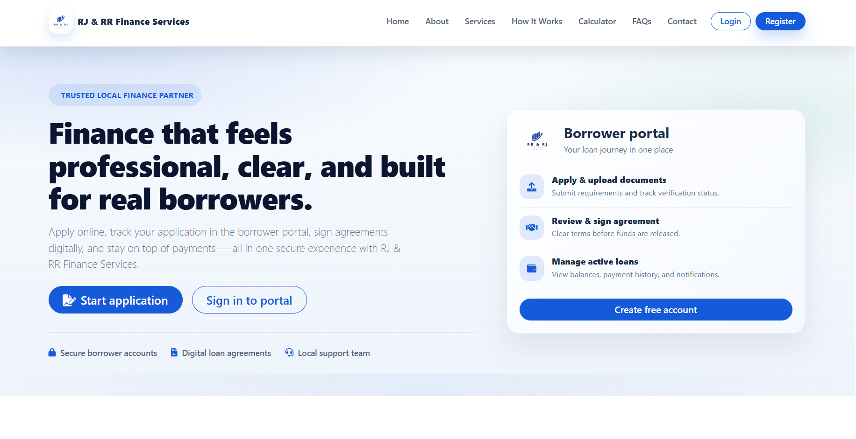

Figure 4.2
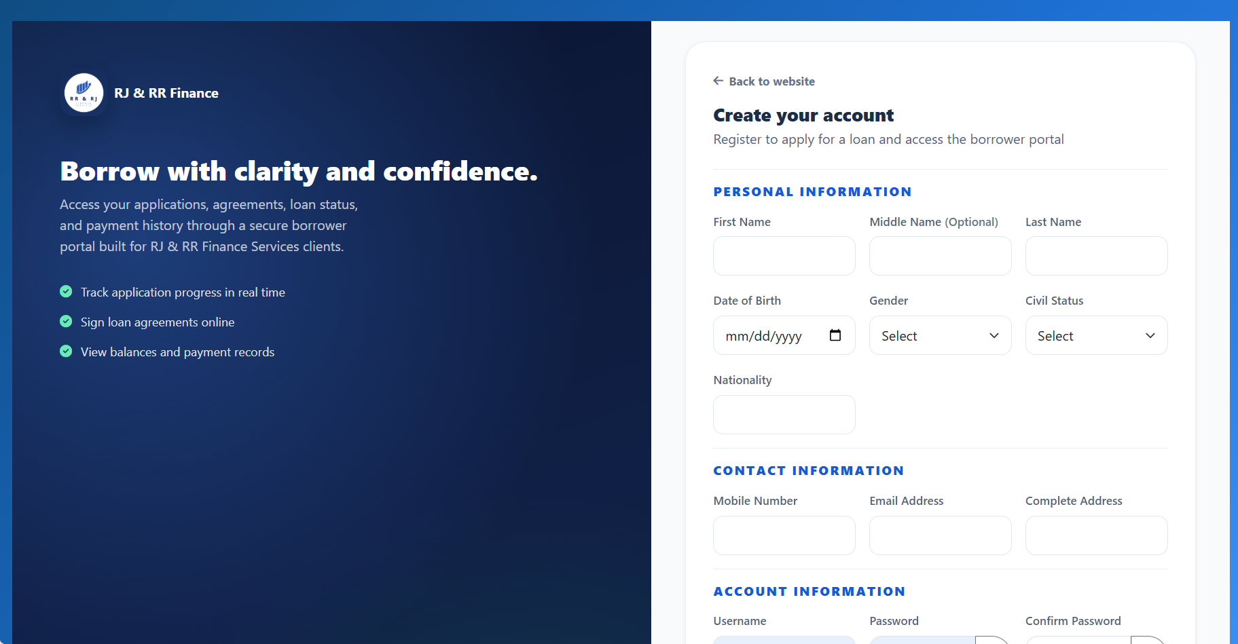
Borrower registration page

Figure 4.3
Borrower login and admin/staff login
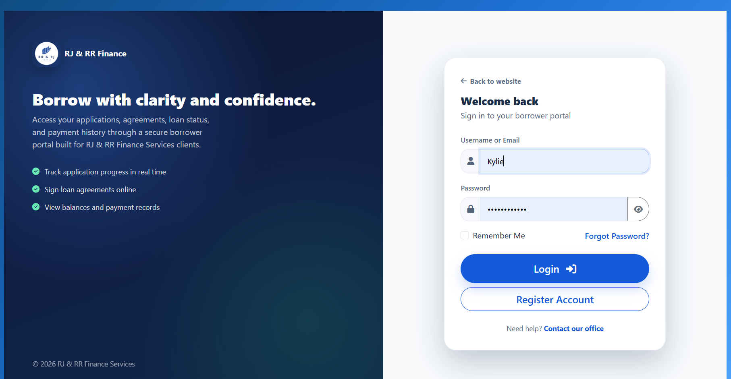
Borrower Login Page

Admin/Staff Login page

Figure 4.4
Administrator executive dashboard
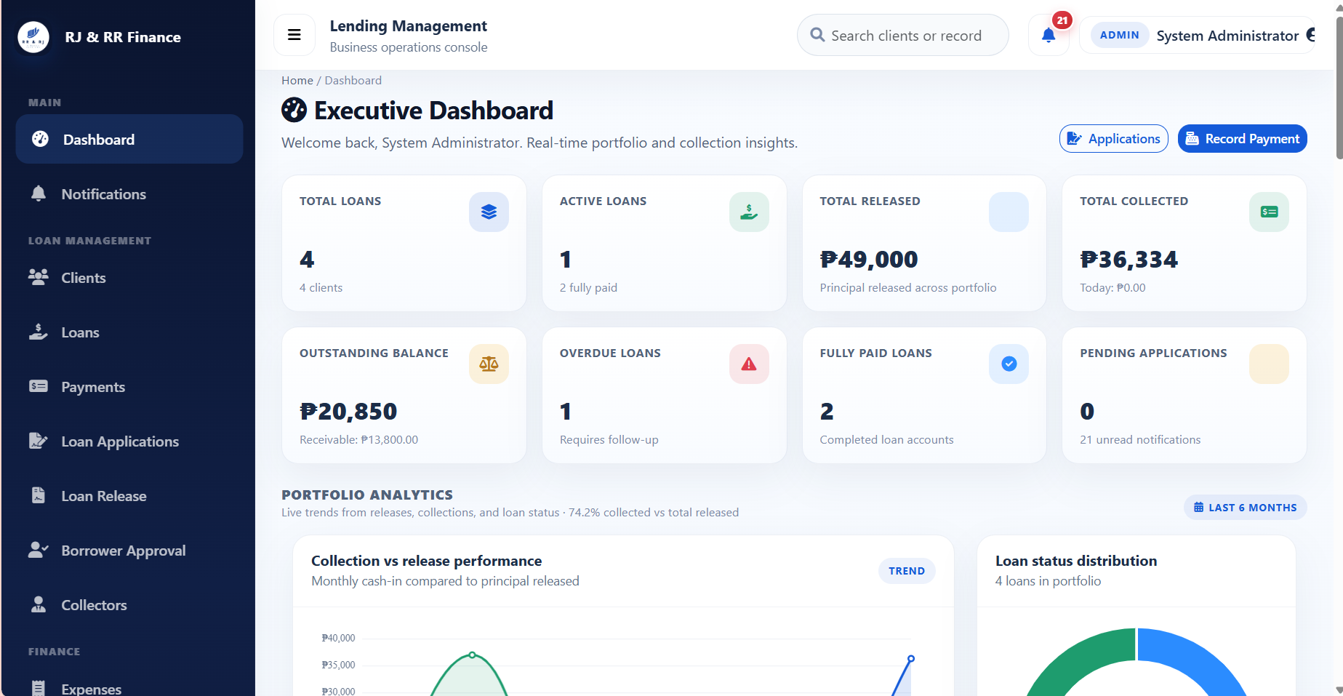

Figure 4.5
Collector dashboard
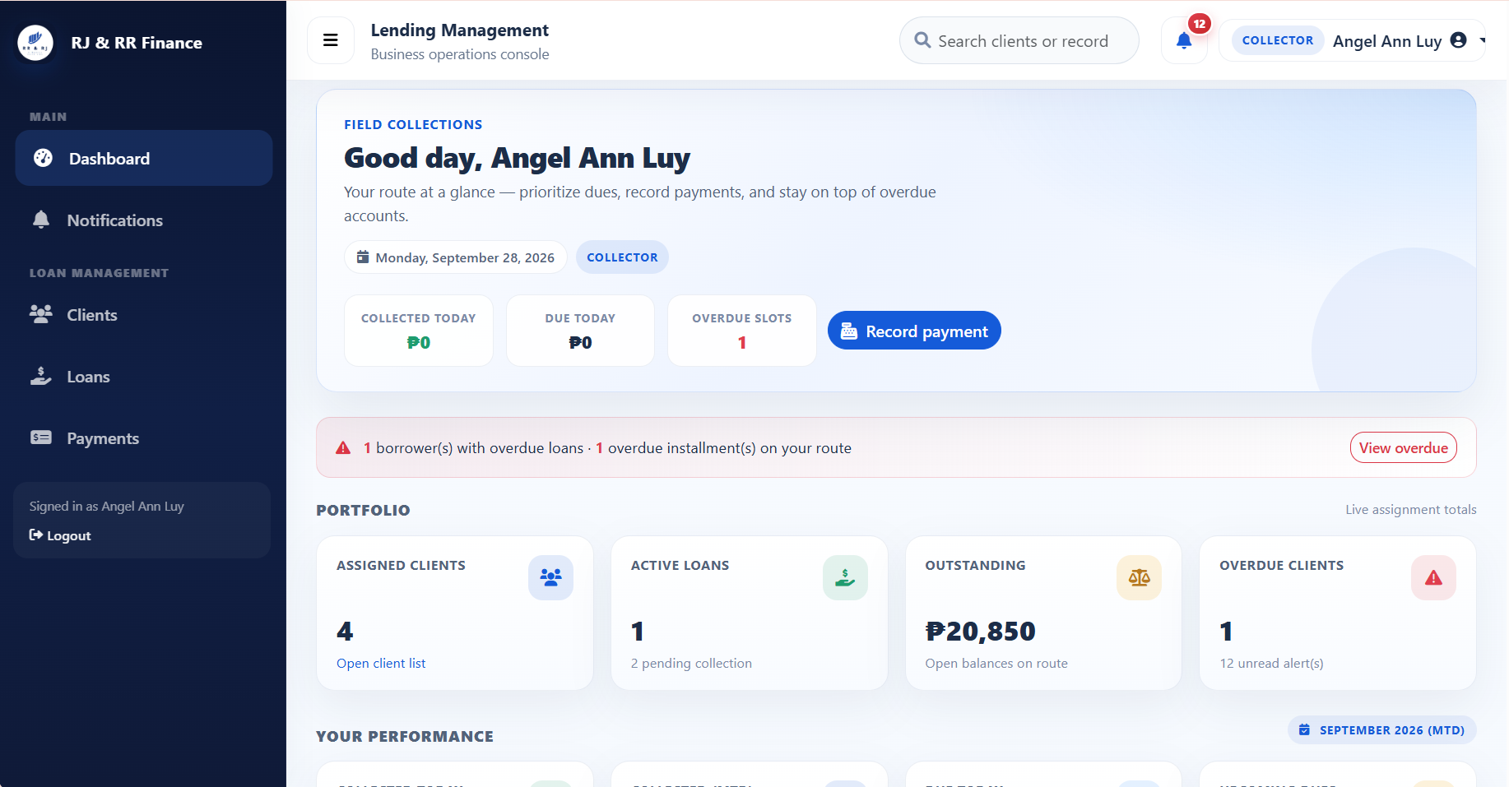

Figure 4.6
Borrower dashboard
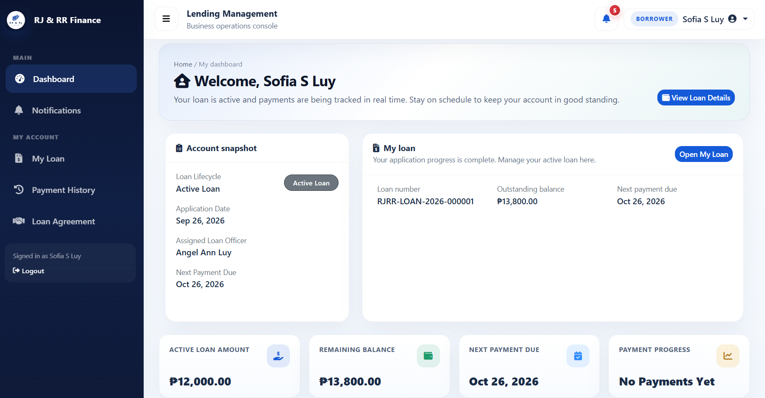

Figure 4.7
Borrower approval page
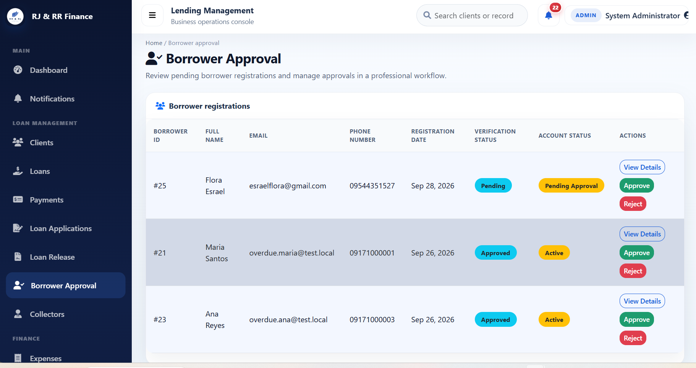
Figure 4.8
Loan application wizard
Step 1

Step 2
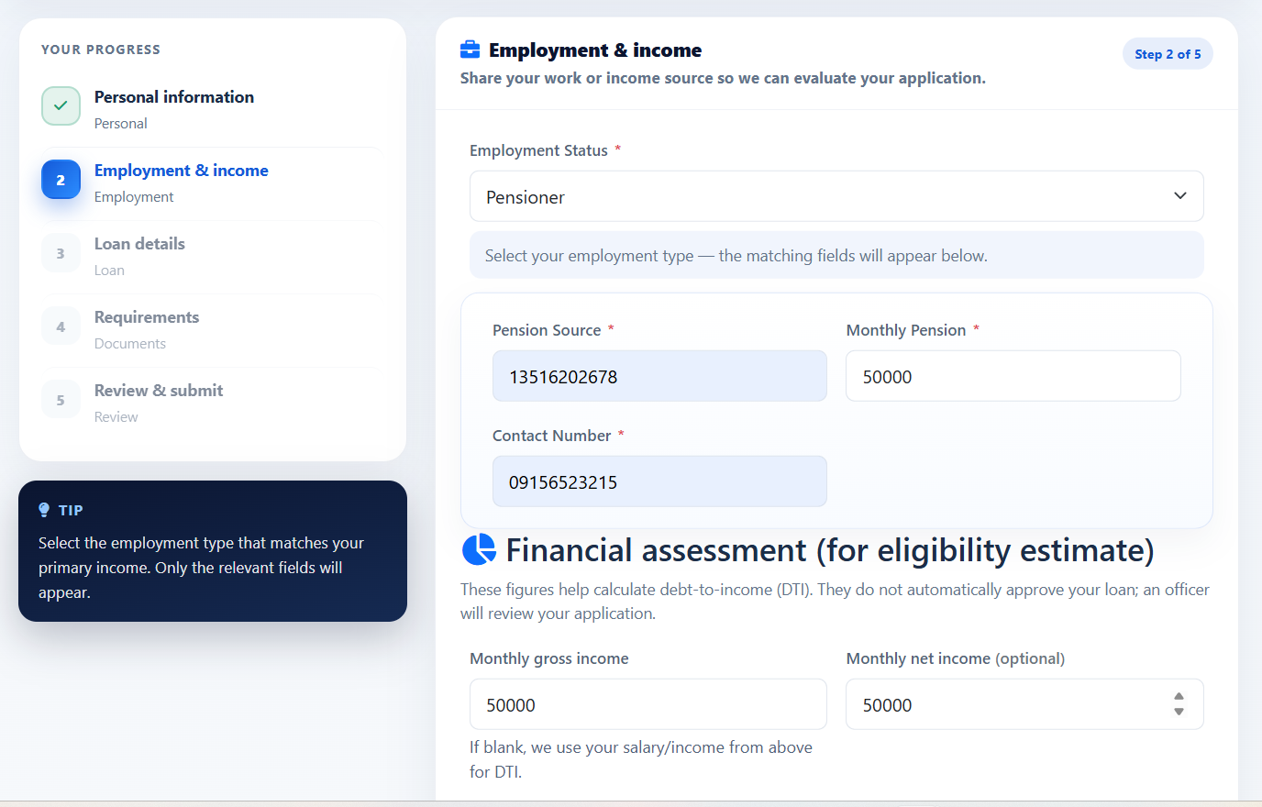

Step 3
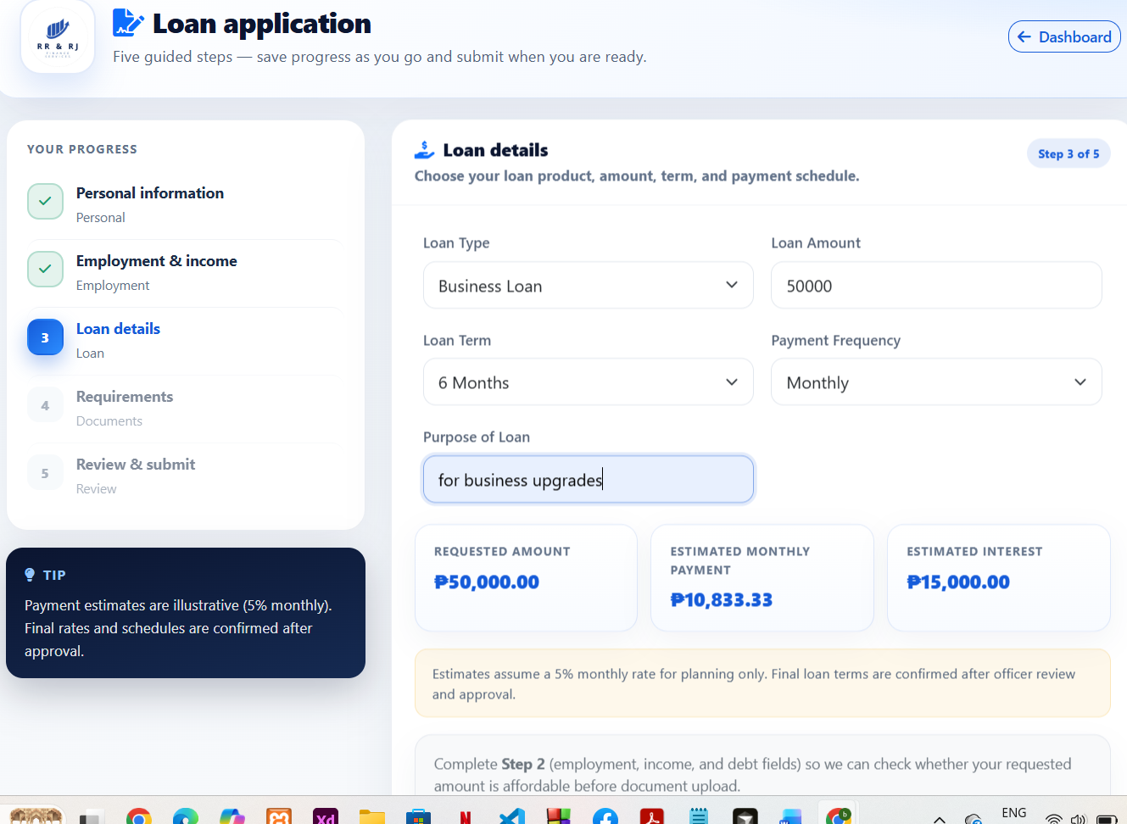

Step 4
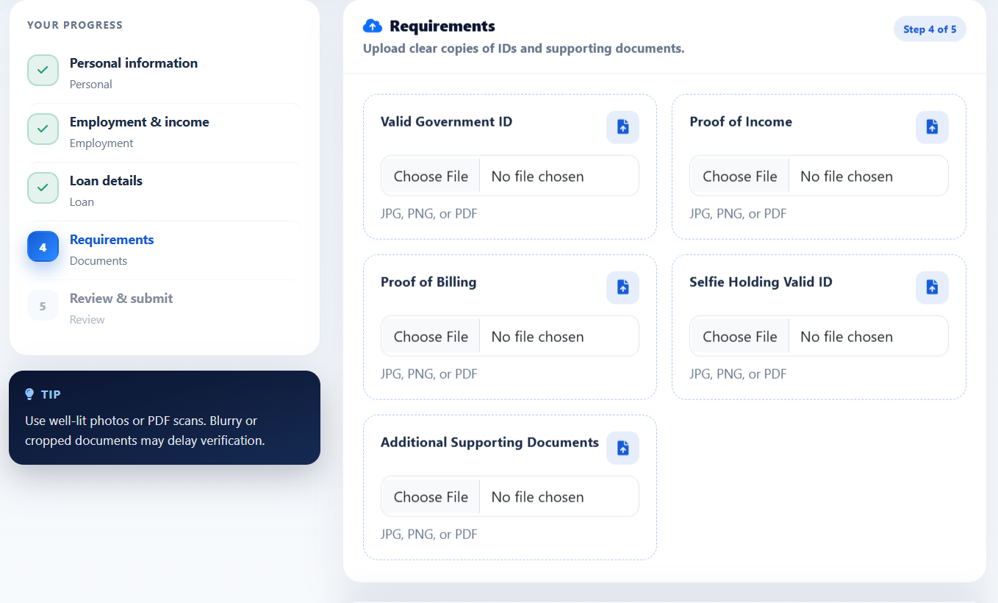
Step 5
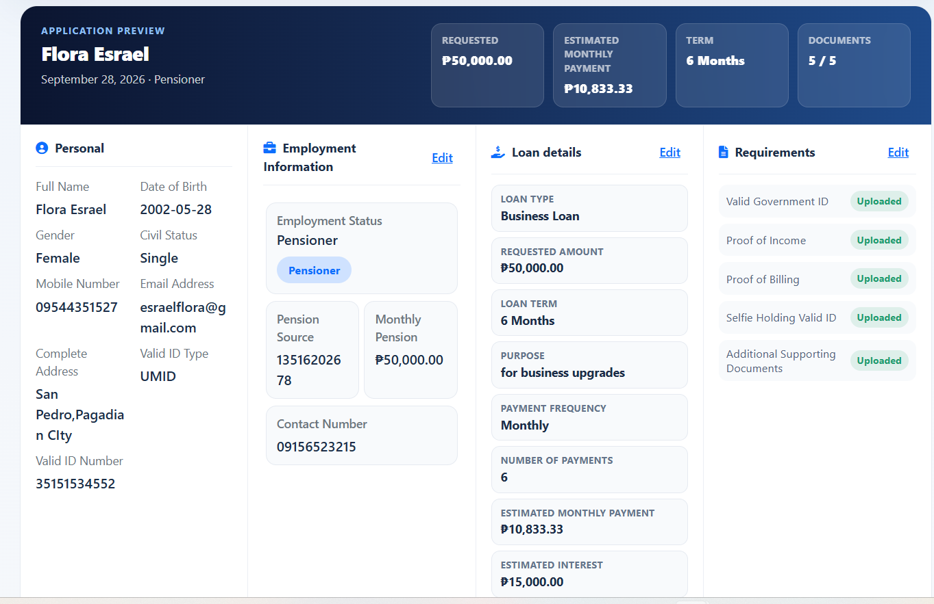

Figure 4.9
Eligibility estimate
Figure 4.10
Review of a loan application
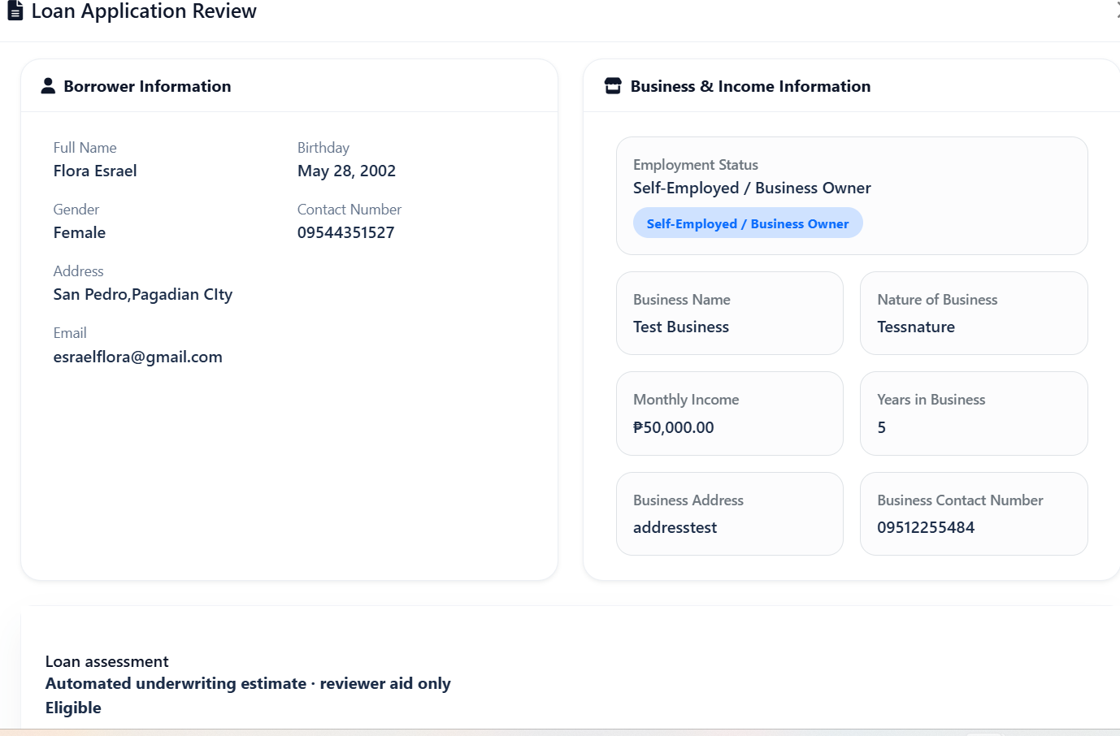
Figure 4.11
Loan agreement
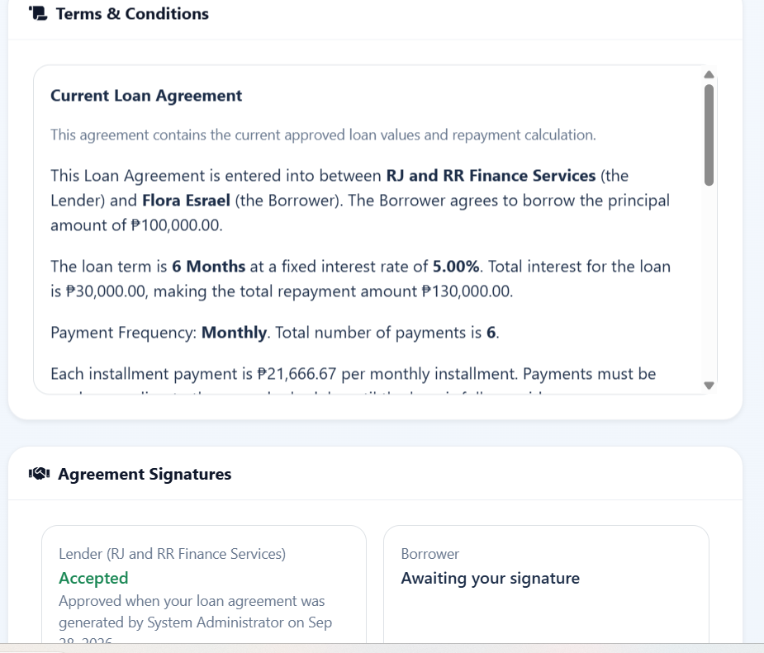
Figure 4.12
Loan release
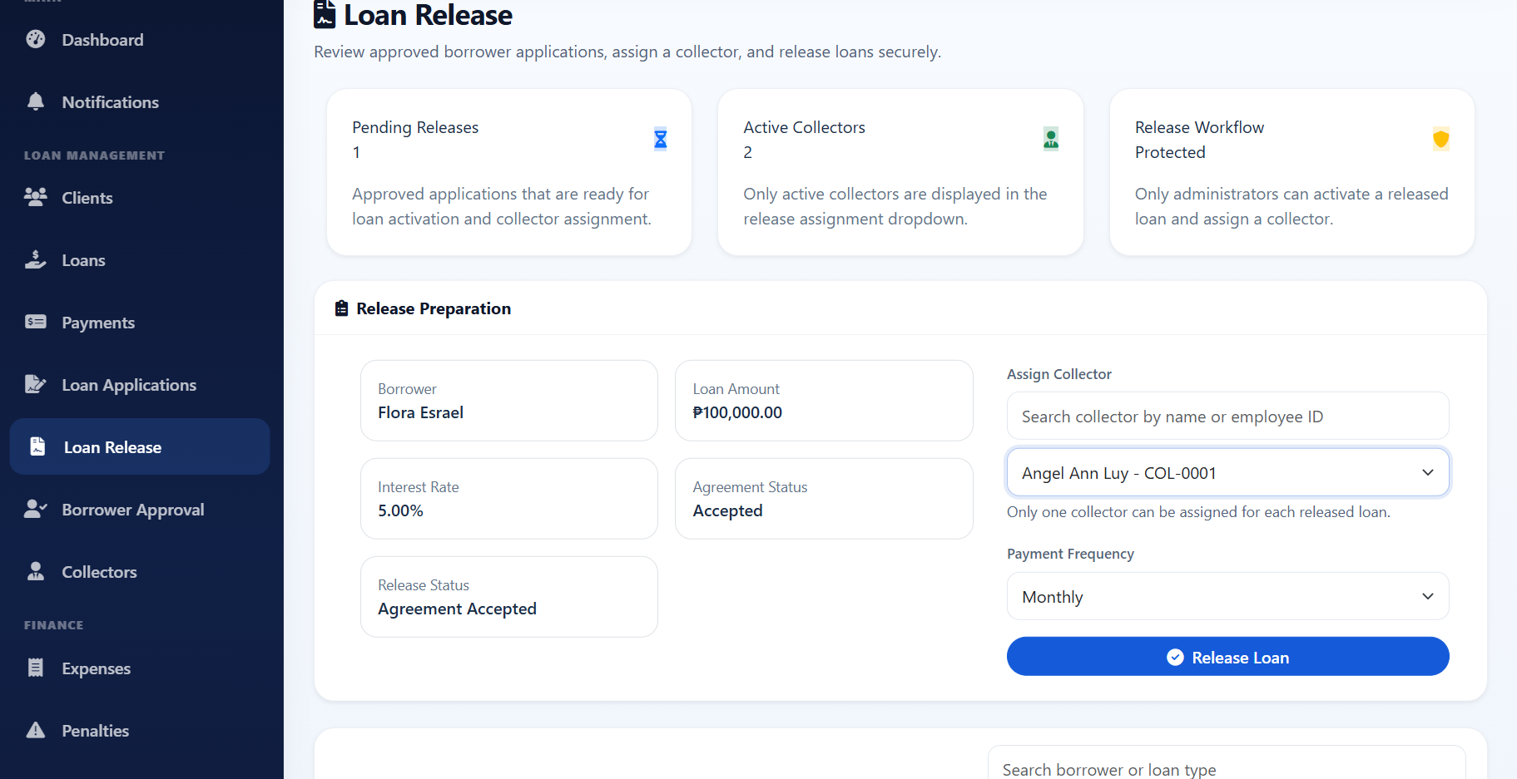

Figure 4.13
Loan details and installment schedule
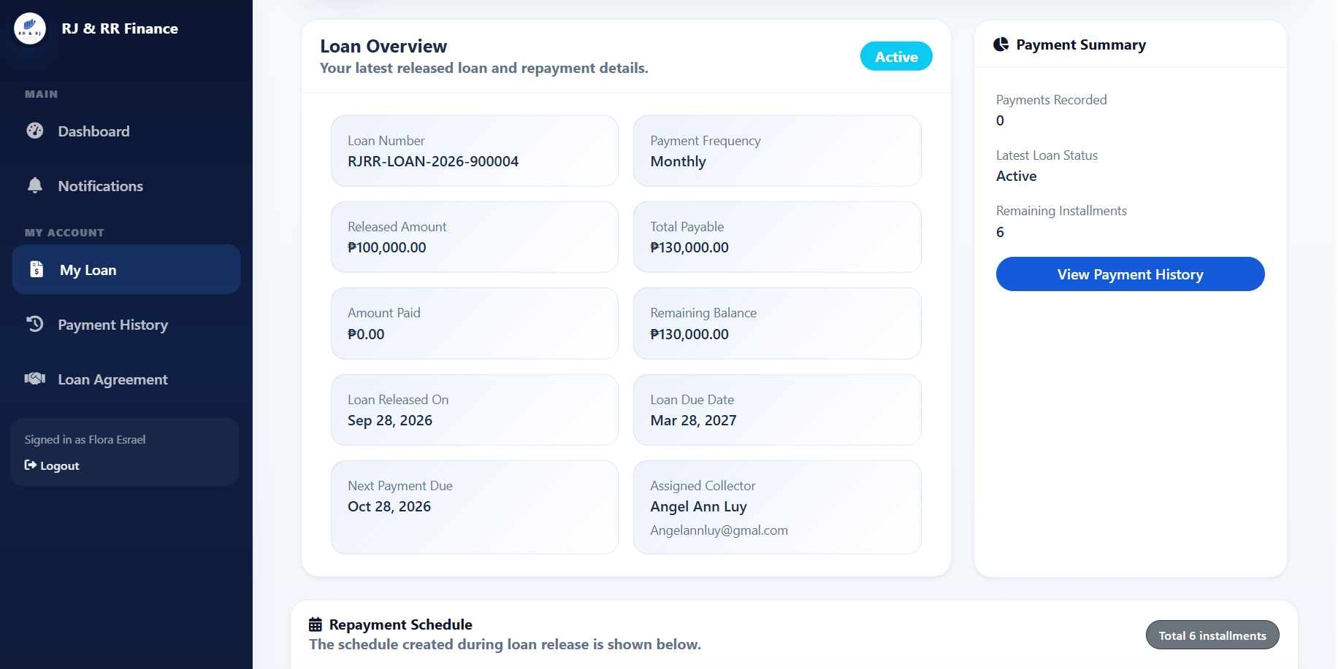

Figure 4.14
Payment recording
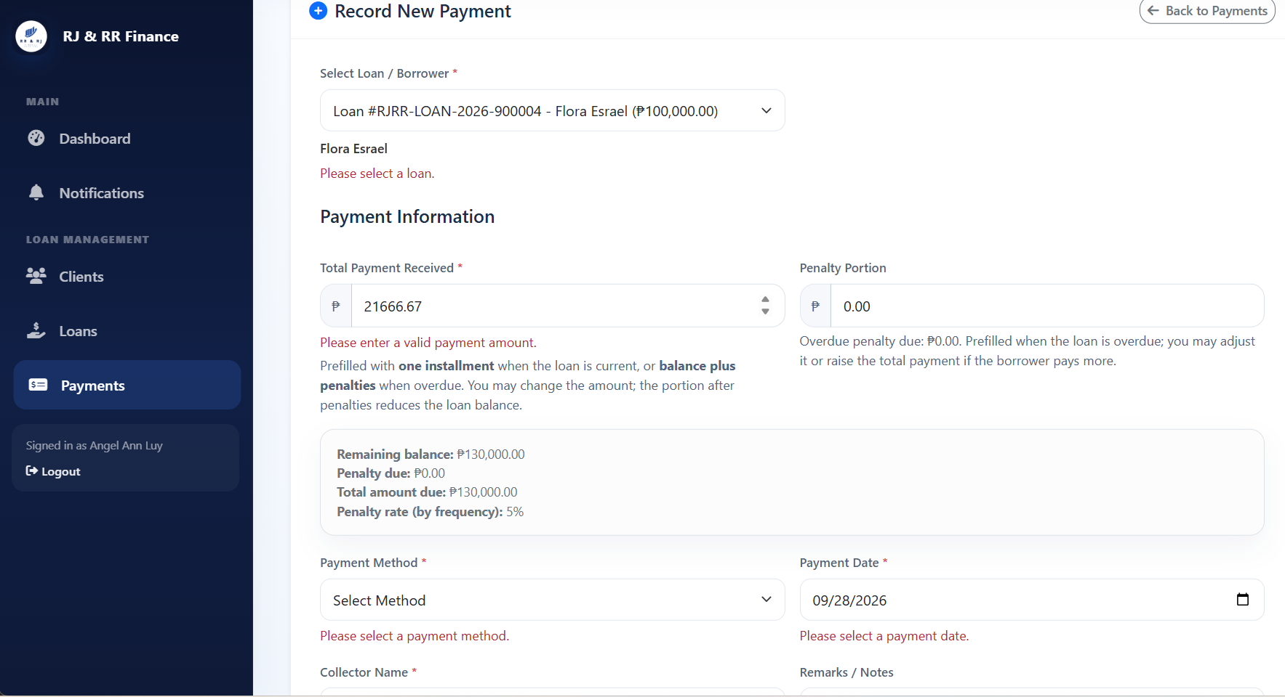

Figure 4.15
Penalty summary and reports
Figure 4.16
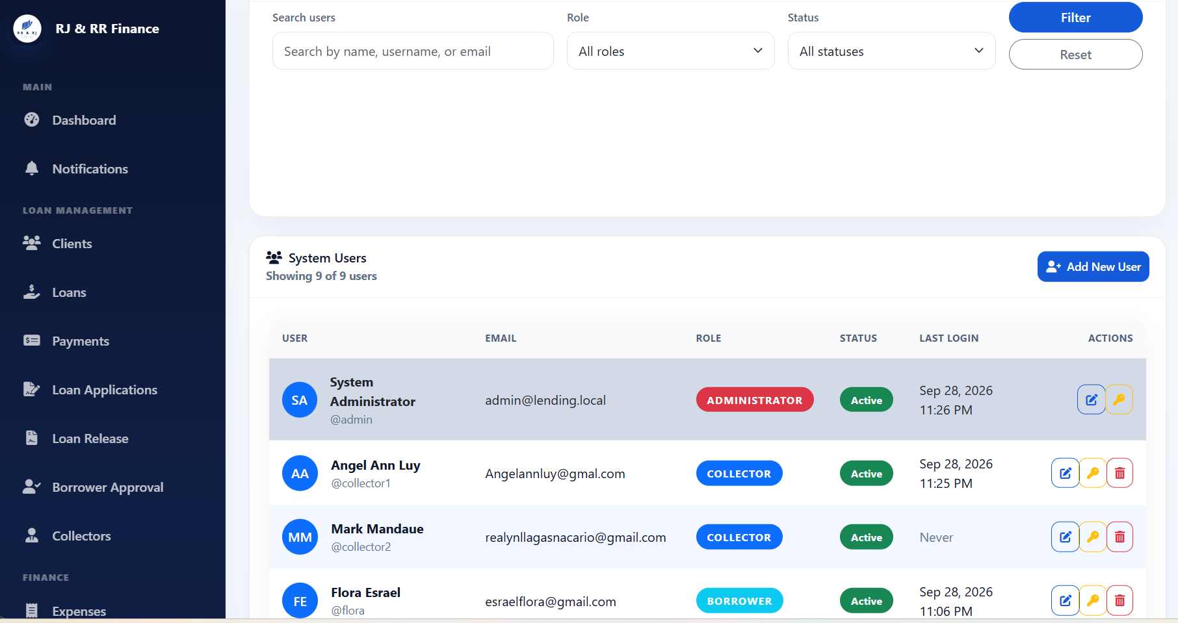
User management and notifications

The screenshots are evidence that the modules in Section 4.1.3 were built. They do not, by themselves, fill the actual-result columns in Tables 4.4 and 4.5. Chapter 5 can summarize these implementation and testing results, state the conclusions that the completed tables support, and list the recommendations that follow from the limits identified here.
CHAPTER V
SUMMARY, CONCLUSIONS, AND RECOMMENDATIONS
Summary of Findings
This study designed and developed the Financial Risk Assessment and Micro-Lending System (FRAMS) for RJ and RR Finance Services. The locally hosted web application uses PHP and MySQL to organize borrower registration, loan applications, eligibility assessment, agreements, loan release, installment schedules, payments, penalties, and administrative reports.
Borrowers can register and, after administrator approval, submit a loan application with the required documents. The eligibility estimate uses declared income, existing obligations, the requested amount, the loan term, and configured limits, including the stated debt-to-income ceiling. The result is intended to support review and does not automatically approve a loan. The system also supports loan release, installment scheduling, payment recording, and repayment monitoring. PayMongo QR Ph transactions should be described as confirmed repayments only when the required payment-confirmation process has been verified.
The literature reviewed in Chapter II places FRAMS alongside manual credit assessment and studies of predictive scoring. FRAMS uses configured eligibility rules and does not implement the machine-learning models discussed in some of the reviewed studies. The manuscript documents six unit test cases, seven integration test cases, twelve system test cases, nine PayMongo test cases, and twelve security test cases. These are documented cases, not proof that all forty-six cases passed. Final testing totals and user-evaluation means must be reconciled with the executed test records, evidence, and completed questionnaires in Appendix B.
Conclusions
FRAMS provides a centralized application for recording borrower information, processing loan applications, presenting a rule-based eligibility estimate, generating installment schedules, recording payments and penalties, and preparing reports. The eligibility estimate supports the administrator’s review and is not a final lending decision or a prediction of borrower default. The system’s overall effectiveness and security should be stated only to the extent supported by the verified test results and user-evaluation records.
The reported user-evaluation scores indicate positive ratings for functionality, usability, reliability, security, and performance; however, those figures must be recalculated from the completed evaluation forms before they are presented as final findings. The available draft does not establish that every documented system, PayMongo, or security test has passed. No measured response-time benchmark, concurrent-user test, or load test should be claimed unless such tests were actually conducted and recorded.
Recommendations
Based on the system’s current scope and the limitations identified in the study, the researchers recommend the following:
- SMS notifications. They may be added later if the lending office needs them and can support the cost.
- Establish a database backup and recovery procedure. Schedule regular MySQL backups of the actual production database and document how authorized personnel can restore a backup. Confirm the deployed database name before using it in any instructions.
- Centralize business rules in configuration. Keep the debt-to-income limit, minimum and maximum loan amounts, interest rate, and penalty rates in controlled configuration or administrator settings so approved policy changes do not require direct edits to PHP files.
- Develop an administrator settings page that allows authorized personnel to update loan limits and penalty rates, with validation and an audit trail.
- Improve audit visibility by recording important actions—such as account approvals, loan releases, payment edits, and role changes—in a dedicated activity log for accountability and troubleshooting.

References
Entries in A.1 follow APA 7th edition and were checked against the published work. Journal titles and volume numbers are italicized in the usual APA way. A hanging indent is used.
A.1 References matched to published works
Bazarbash, M., & Beaton, K. (2020). Filling the gap: Digital credit and financial inclusion (IMF Working Paper No. WP/20/150). International Monetary Fund. https://doi.org/10.5089/9781513552477.001
Campos, R. B., Jr. (2024). The impact of digitalization on credit risk management in microfinance institutions in Nueva Ecija, Philippines. Indian Journal of Information Sources and Services, 14(3). https://doi.org/10.51983/ijiss-2024.14.3.20
Davis, F. D. (1989). Perceived usefulness, perceived ease of use, and user acceptance of information technology. MIS Quarterly, 13(3), 319–340. https://doi.org/10.2307/249008
DeLone, W. H., & McLean, E. R. (2003). The DeLone and McLean model of information systems success: A ten-year update. Journal of Management Information Systems, 19(4), 9–30. https://doi.org/10.1080/07421222.2003.11045748
Estrellado, G. E. (2024). Financial inclusion of lending institutions on sustainability of micro-businesses. United International Journal for Research & Technology, 5(7). https://uijrt.com/paper/financial-inclusion-lending-institutions-sustainability-micro-businesses
International Organization for Standardization. (2011). Systems and software engineering—Systems and software Quality Requirements and Evaluation (SQuaRE)—System and software quality models (ISO/IEC 25010:2011).
Juventud, W. M., Matigas, E. A. O., Himongala, J., Galla, M. R., & Abiol, M. J. D. (2023). Perceived credit risk of micro finance loans among micro-enterprises business in Población Iligan City. International Journal of Multidisciplinary: Applied Business and Education Research, 4(10), 3697–3702. https://doi.org/10.11594/ijmaber.04.10.22

REFERENCES
Khandani, A. E., Kim, A. J., & Lo, A. W. (2010). Consumer credit-risk models via machine-learning algorithms. Journal of Banking & Finance, 34(11), 2767–2787. https://doi.org/10.1016/j.jbankfin.2010.06.001
Mina, J. C. (2024). The credit risk management practices of lending companies in Nueva Ecija: Basis for risk mitigating plan. International Journal of Advanced and Applied Sciences, 11(9), 134–142. https://doi.org/10.21833/ijaas.2024.09.015
PayMongo. (n.d.). PayMongo API documentation. https://developers.paymongo.com/
Penaso, C. P., & Dagang, A. L. (2025). Loan management practices as key drivers for the operation efficiency of microfinance institutions in Northern Mindanao, Philippines. International Journal of Research and Scientific Innovation, 12(5), 1715–1724. https://doi.org/10.51244/ijrsi.2025.120500162
Ramirez, J. G. (2024). Establishment of gross loan portfolio risk-return questionnaire: Reliability and validity structure. Mindoro Journal of Social Sciences and Development Studies, 1(2), 18–26. https://journal.omsc.edu.ph/mjssds/article/view/11

APPENDIX B
TEST CASE EVIDENCE AND USER ACCEPTANCE TESTING
Financial Risk Assessment and Micro-Lending System (FRAMS)
Purpose. This appendix organizes the software test cases and user acceptance testing evidence for the Financial Risk Assessment and Micro-Lending System (FRAMS). It records the test scenario, expected result, actual observed result, status, and evidence reference. All statuses and results must be checked against the actual execution records before final submission. Blank evidence locations and unresolved tests are not evidence of a successful test.
A. UNIT TESTING
Unit testing was conducted to verify whether individual functions and components of FRAMS performed according to their intended specifications.
Table B1
Unit Testing Test Evidence of FRAMS
Test ID | Test Scenario | Expected Result | Actual Result | Status | Evidence Reference
UT-01 | Valid Login | The system authenticates the user and redirects them to the dashboard corresponding to their assigned role. | The valid login process opened the dashboard corresponding to the user's assigned role. | PASS | Figure B1
UT-02 | Incorrect Password or Inactive Account | The system denies access when the user enters an incorrect password or attempts to access an inactive account. | The system denied access to the invalid or inactive account. | PASS | Figure B2
UT-03 | Register a new borrower with complete and valid account details. | The system stores the user and the borrower registration with the status Pending Approval, sets verification status to Pending, displays the registration success page, and lists the person on the borrower-approval page. Registration alone does not create a client record. | Record the observed result after execution. | Not Yet Tested | Figure B3
UT-04 | Loan Details Exceed DTI or Loan Limits | The system prevents the application from proceeding when the configured debt-to-income (DTI) or loan limits are exceeded. | The system blocked the application that exceeded the configured limit. | PASS | Figure B4
UT-05 | Invalid Document Upload | The system rejects prohibited document formats and displays an appropriate validation response. | The file selection window displayed the permitted JPG and PNG formats. Upload rejection should also be verified separately. | PASS/VERIFY | Figure B5
UT-06 | Invalid Payment Amount | The system rejects an invalid payment amount and prevents the invalid payment from being recorded. | The system rejected the invalid payment amount. | PASS | Figure B6

Screenshot Evidence for Unit Testing
Figure B1
Evidence for UT-01: Valid Login
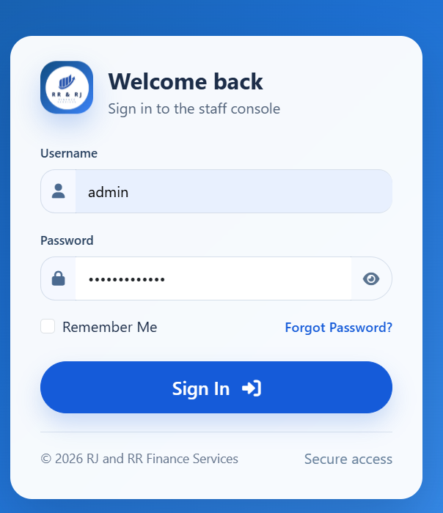

Figure B2
Evidence for UT-02: Incorrect Password or Inactive Account
Figure B3
Evidence for UT-03: Borrower Registration
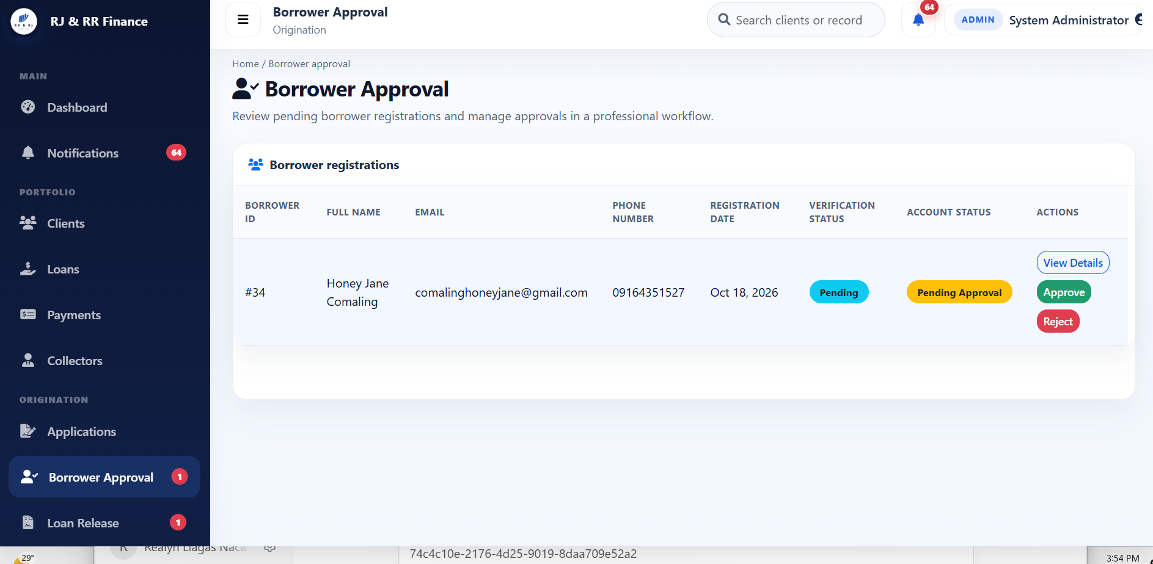

Figure B4
Evidence for UT-04: Loan Details Exceed DTI or Loan Limits
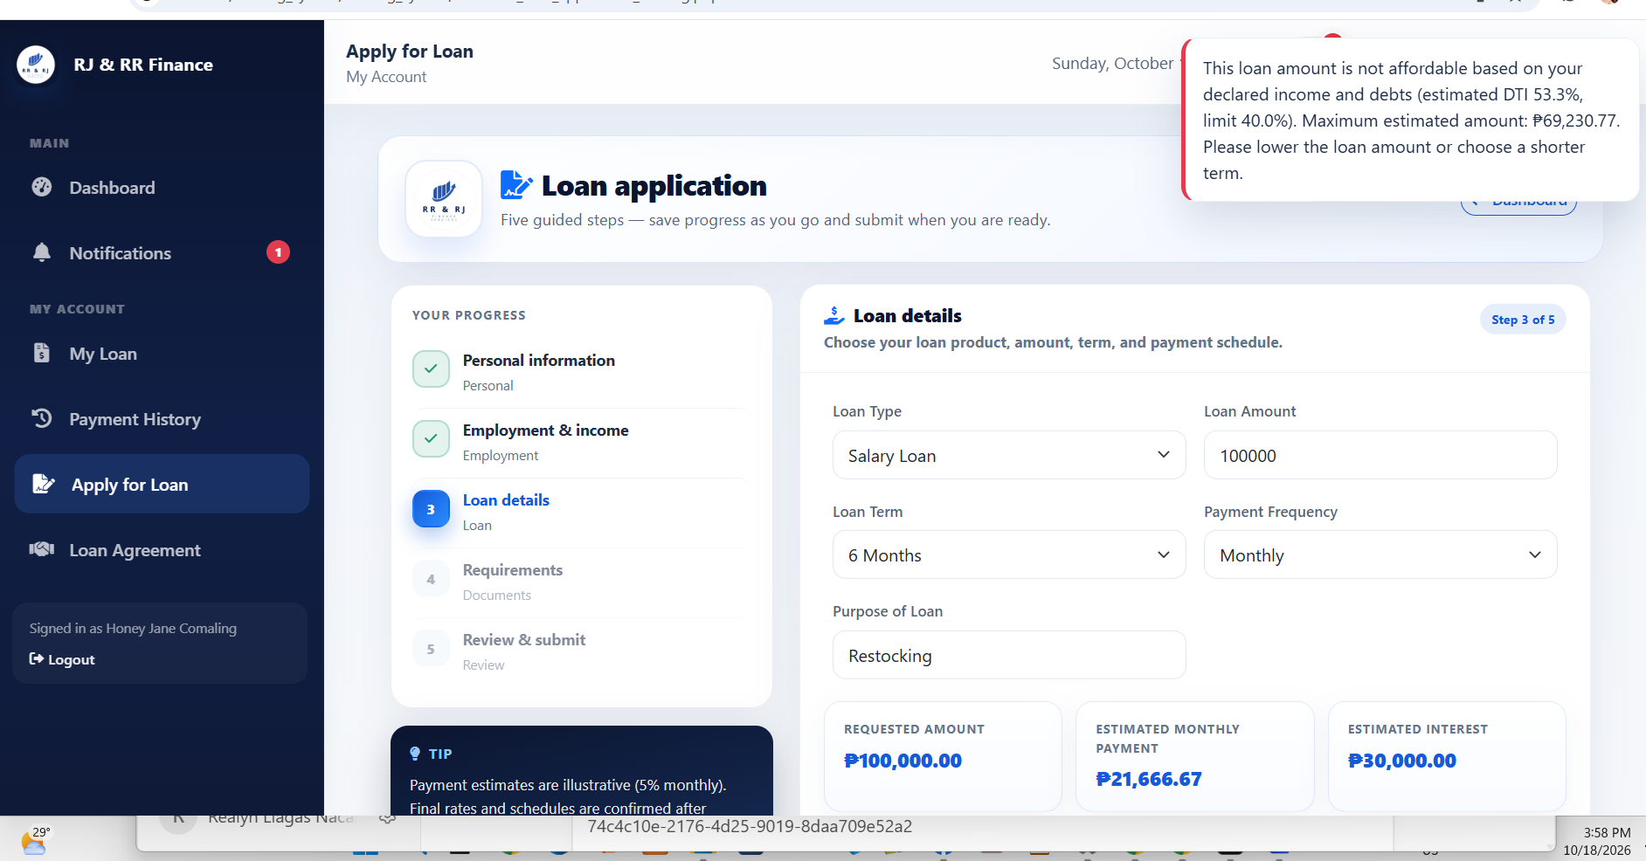

Figure B5
Evidence for UT-05: Invalid Document Upload
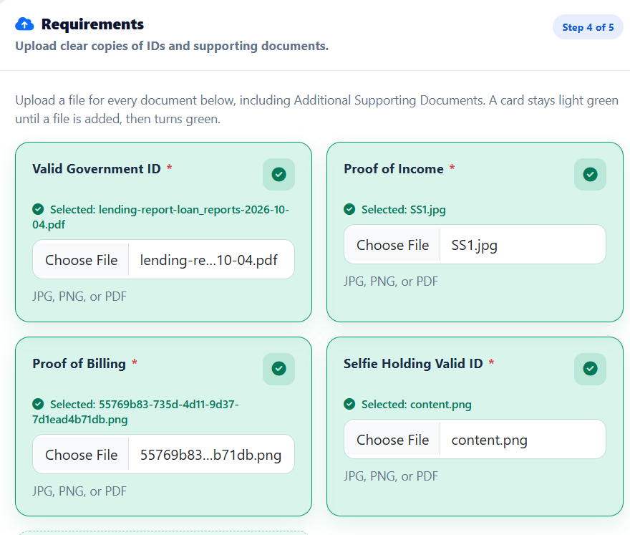Note. The screenshot may show the permitted file types displayed in the file selection window or the system's validation message when an invalid file is submitted.
Figure B6
Evidence for UT-06: Invalid Payment Amount
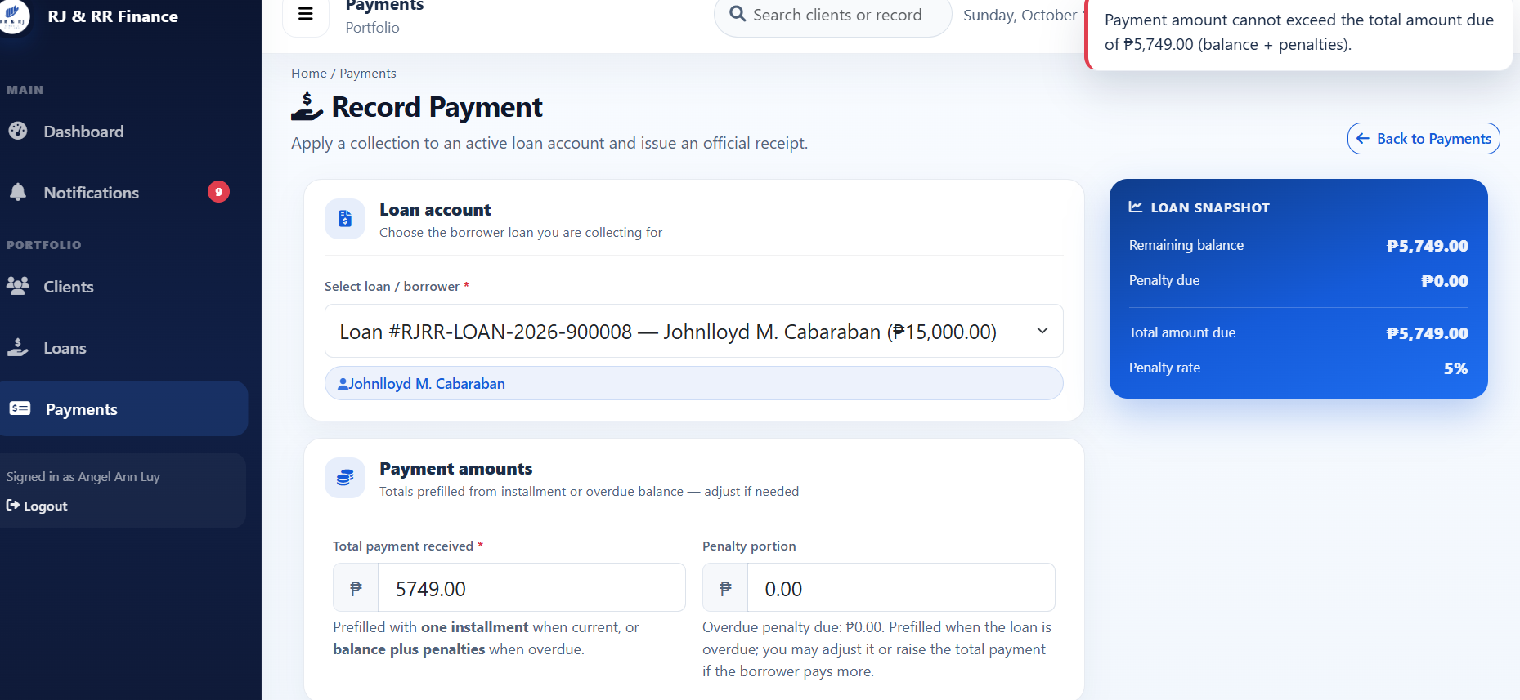
B. INTEGRATION TESTING
Integration testing was conducted to verify whether connected modules of FRAMS worked together correctly and maintained consistent records across the system.
Table B2
Integration Testing Test Evidence of FRAMS
Test ID | Test Scenario | Expected Result | Actual Result | Status | Evidence Reference
IT-01 | Registration, Account Approval, and Login | The user's access follows the account approval and login process. | The system followed the registration, approval, and login workflow. | PASS | Figure B7
IT-02 | After registration, locate the borrower before loan release. | The borrower appears in the administrator approval list with the status Pending Approval. The same person does not yet appear in the client list. A client record is created later when an administrator adds the client or when an accepted loan is released. | Record the observed result after execution. | Not Yet Tested | Figure B8
IT-03 | Borrower Records and Loan Application | The loan application is associated with the selected borrower. | The application was associated with the selected borrower. | PASS | Figure B9
IT-04 | Loan Application and Eligibility Assessment | The system displays an eligibility estimate based on the configured assessment rules. | The eligibility estimate was displayed based on the configured rules. | PASS | Figure B10
IT-05 | Payment Recording and Penalty Records | The penalties page displays the penalty collected for the relevant loan and period. | The penalties page displayed the penalty collected for the loan and period, consistent with the payment record. | PASS | Figure B11
IT-06 | Payment Records and Reports | The report includes the recorded payment in the selected reporting period. | The report totals included the recorded payment for the selected period. | PASS | Figure B12
IT-07 | Role-Based Access Restriction | Borrowers and collectors cannot access administrator pages or view administrator records. | Access was denied, administrator data did not load, or the user was redirected to their own dashboard. | PASS | Figure B13

Screenshot Evidence for Integration Testing
Figure B7
Evidence for IT-01: Registration, Account Approval, and Login
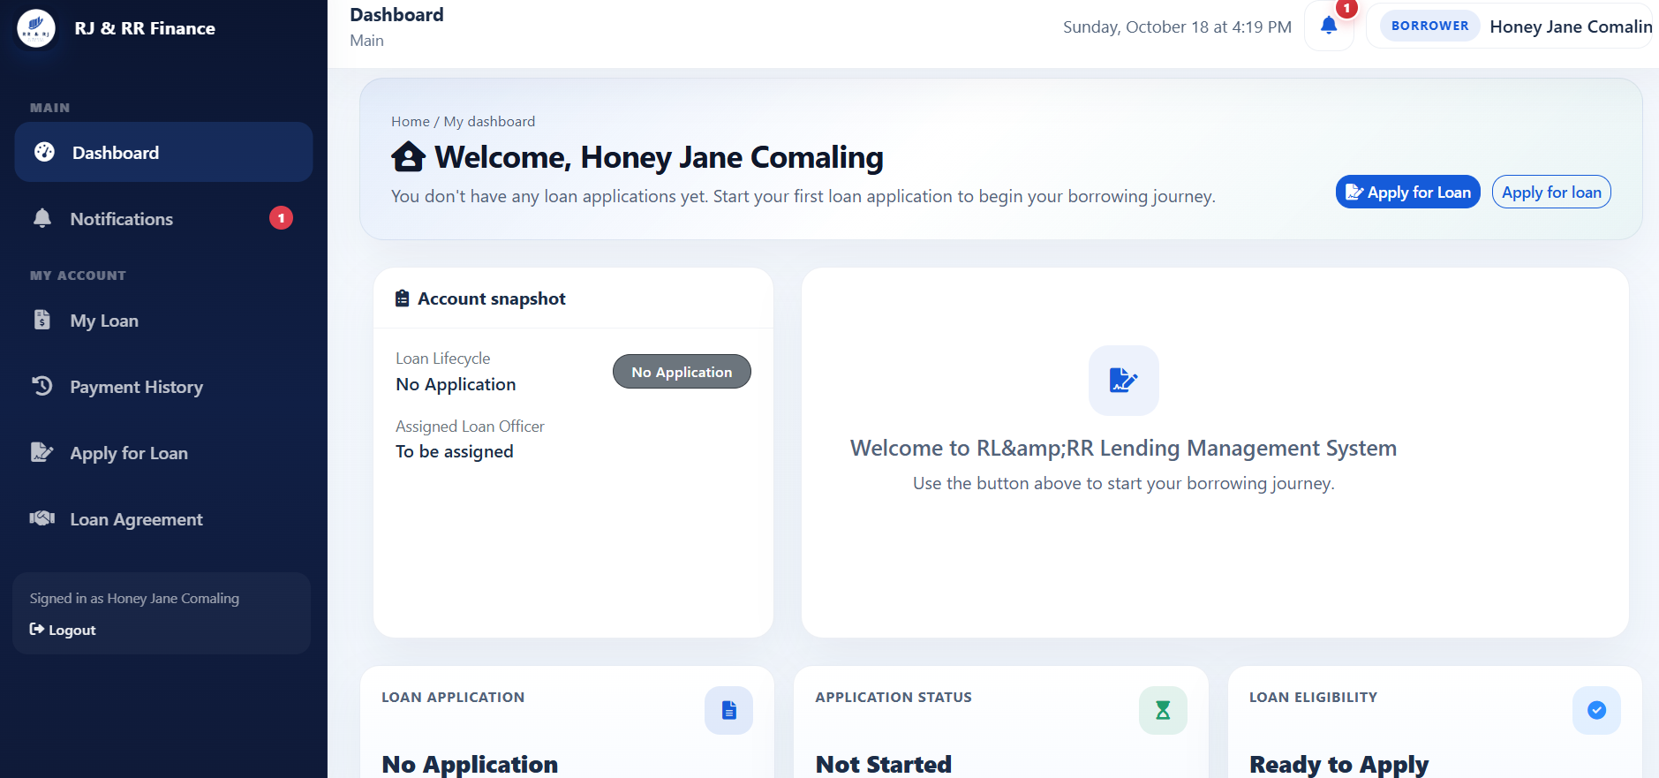
Figure B8
Evidence for IT-02: Registration and Borrower Records
Figure B9
Evidence for IT-03: Borrower Records and Loan Application
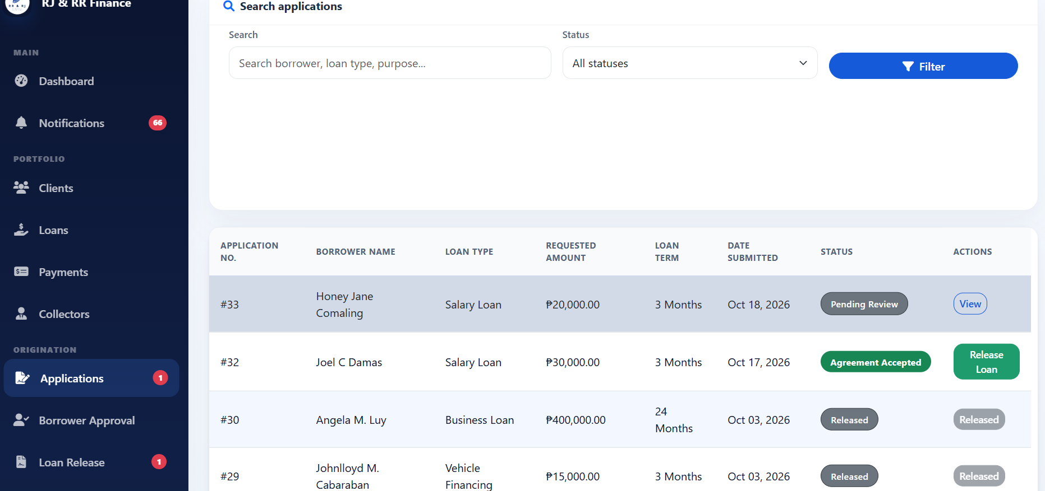
Figure B10
Evidence for IT-04: Loan Application and Eligibility Assessment
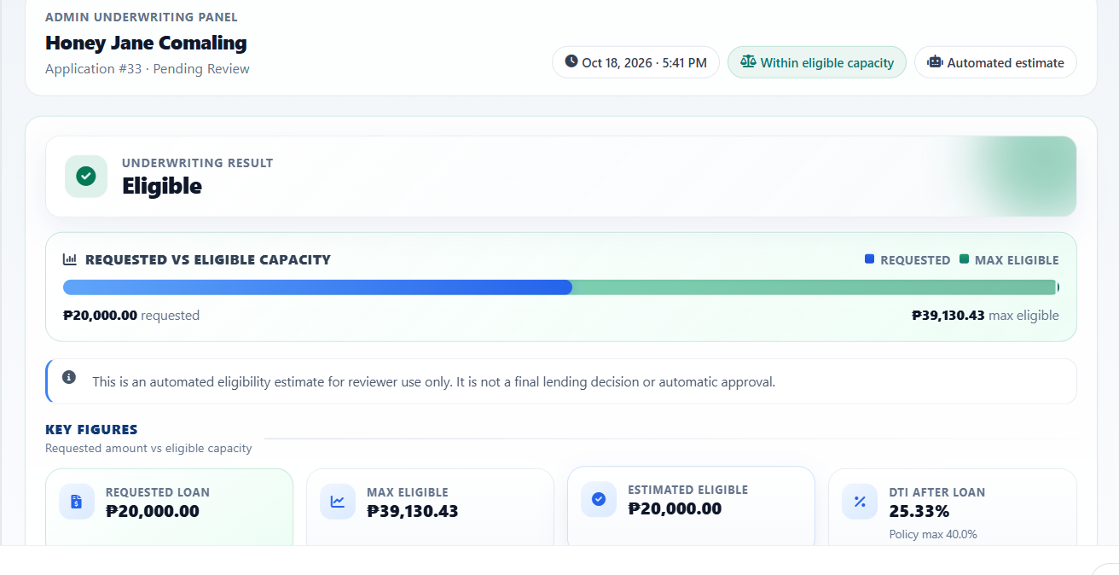Figure B11
Evidence for IT-05: Payment Recording and Penalty Records
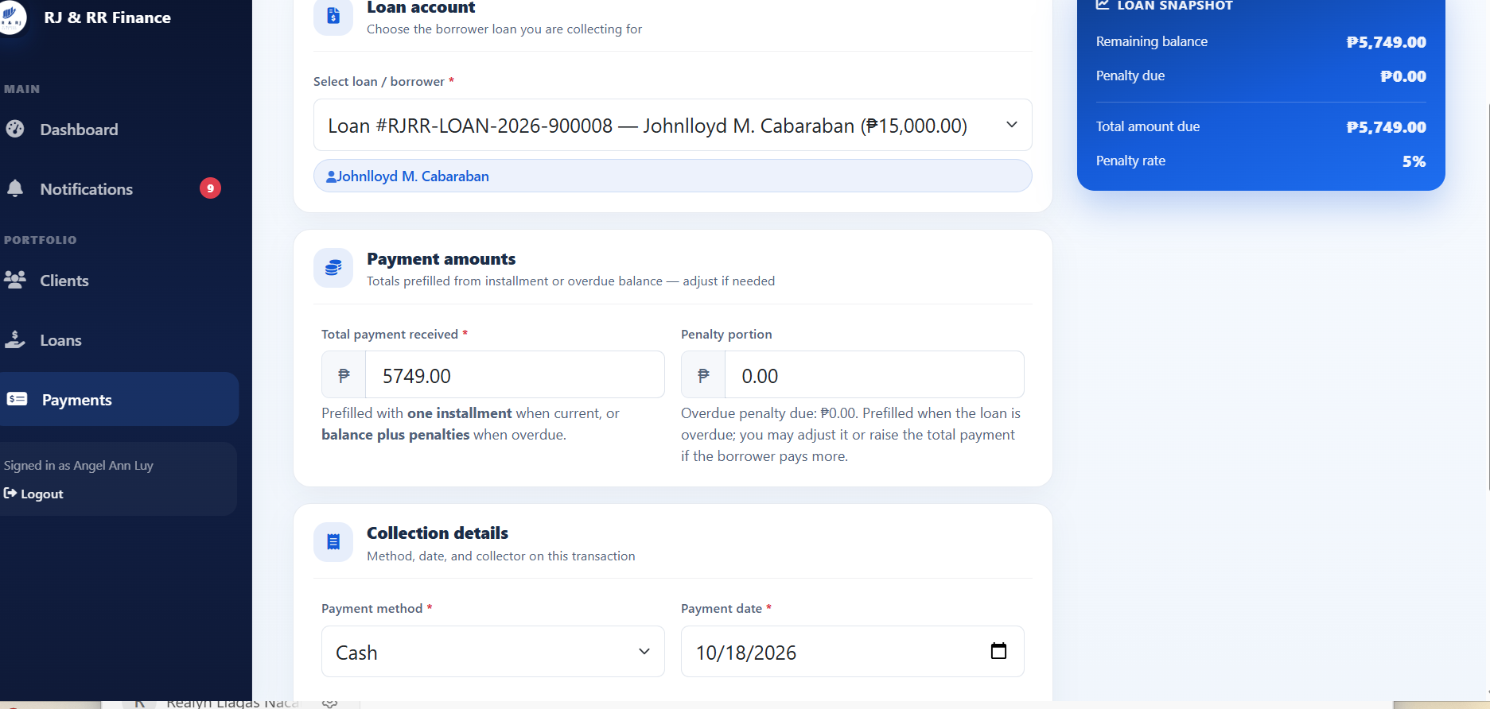Figure B12
Evidence for IT-06: Payment Records and Reports
Figure B13
Evidence for IT-07: Role-Based Access Restriction
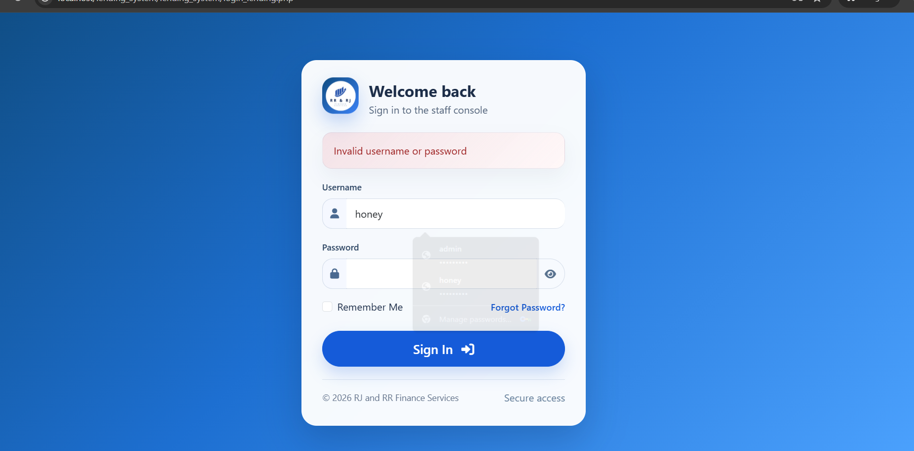
C. SYSTEM TESTING
System testing is documented here for borrower registration, loan application and release, payment processing, collector access, report generation, and notifications. These cases are not marked passed until each test is executed and its figure is inserted. Use disposable test loans for payment tests.
Test ID | Test Scenario | Expected Result | Actual Result | Status | Evidence Reference
ST-01 | Register a new borrower with the required account details. | The account is stored as Pending Approval and the success page is shown. | Record the observed result after execution. | Not Yet Tested | Figure B14
ST-02 | An administrator approves that registration, and the borrower signs in. | The account becomes Active, the borrower dashboard opens, and an approval notice is recorded. | Record the observed result after execution. | Not Yet Tested | Figure B15
ST-03 | An approved borrower submits an application within the debt-to-income and loan limits, with the required JPG, PNG, or PDF documents. | The application and documents are stored, and the borrower can view the status. Funds are not released. | Record the observed result after execution. | Not Yet Tested | Figure B16
ST-04 | An administrator verifies the documents and approves the application. | Verification, approval, and review notes are stored, and the borrower receives a notice. | Record the observed result after execution. | Not Yet Tested | Figure B17
ST-05 | An administrator generates the agreement, and the borrower accepts it by typing the borrower name. | The typed name, acceptance, and time are stored, and the application can proceed to release. | Record the observed result after execution. | Not Yet Tested | Figure B18
ST-06 | An administrator releases the accepted loan to an active collector. | A loan number in the form RJRR-LOAN-year-######, a release record, a loan record, and installment rows are created. | Record the observed result after execution. | Not Yet Tested | Figure B19
ST-07 | The assigned collector records a cash payment within the amount due on a disposable test loan. | The payment is saved, a receipt number in the form RJRR-YYYYMMDD-###### is created, and the balance is reduced. | Record the observed result after execution. | Not Yet Tested | Figure B20
ST-08 | The borrower who owns that payment opens the payment history and receipt. | The payment and receipt show the recorded amount and receipt number. | Record the observed result after execution. | Not Yet Tested | Figure B21
ST-09 | Payments are recorded on a disposable test loan until the outstanding amount is covered. | Covered installments become Paid. When the payable amount is covered, the loan status becomes Paid. | Record the observed result after execution. | Not Yet Tested | Figure B22
ST-10 | Two collectors open their dashboards, clients, loans, and schedules. | Each collector sees only accounts assigned through the client or the loan. | Record the observed result after execution. | Not Yet Tested | Figure B23
ST-11 | An administrator opens the six report views for one period. | The views open, and one checked total agrees with the related loan, payment, or expense list. | Record the observed result after execution. | Not Yet Tested | Figure B24
ST-12 | The intended user opens a notice and marks it read. Another user checks the same notice. | The notice is visible to the intended user, the read state is saved, and the other user does not see it. | Record the observed result after execution. | Not Yet Tested | Figure B25
Screenshot Evidence for System Testing
Figure B14
Evidence for ST-01: Borrower Registration
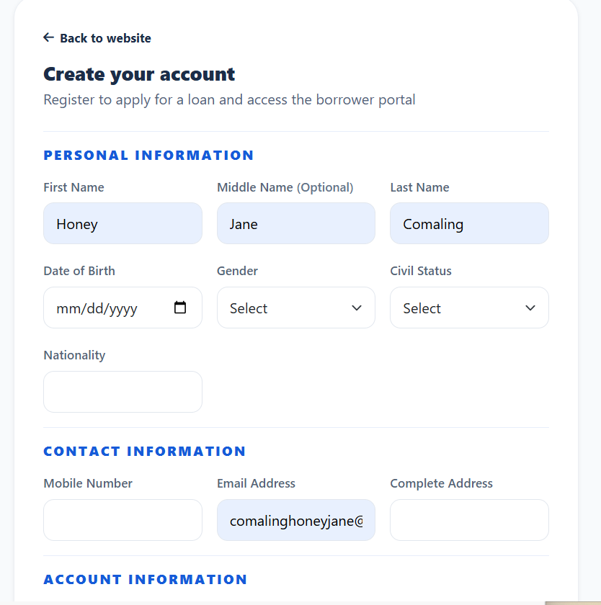
Figure B15
Evidence for ST-02: Account Approval and Login
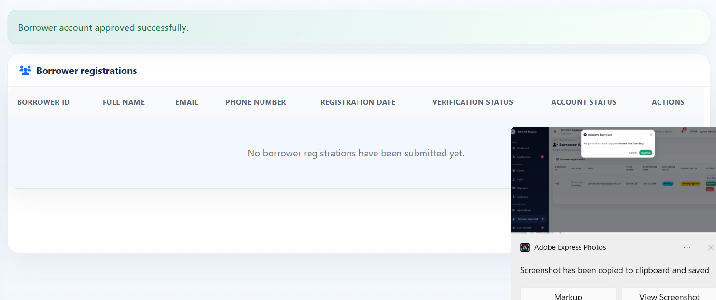
Figure B16
Evidence for ST-03: Loan Application Submission
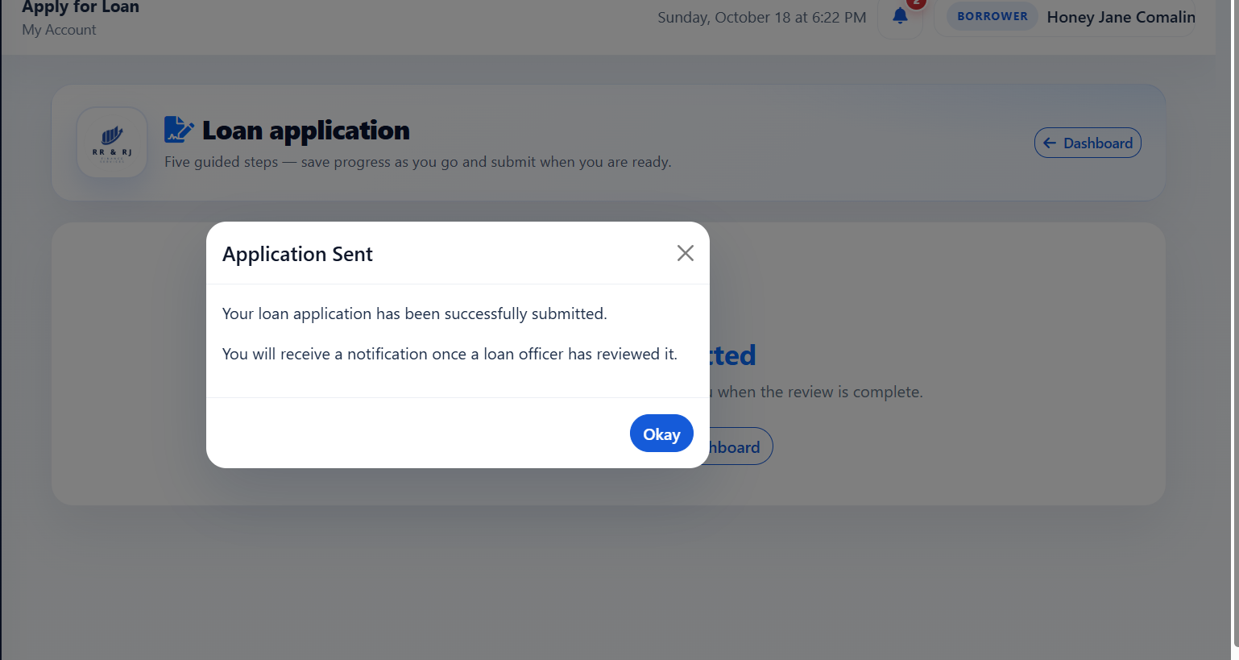
Figure B17
Evidence for ST-04: Loan Application Review
Figure B18
Evidence for ST-05: Loan Agreement Acceptance
Figure B19
Evidence for ST-06: Loan Release
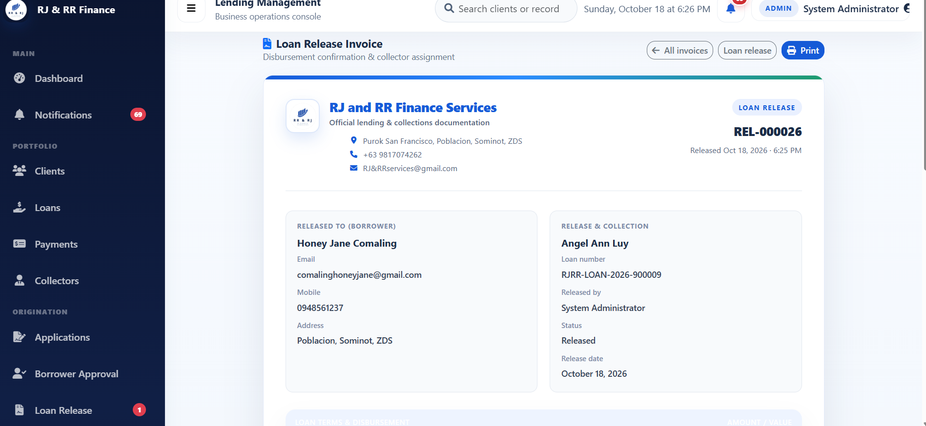

Figure B20
Evidence for ST-07: Cash Payment Recording
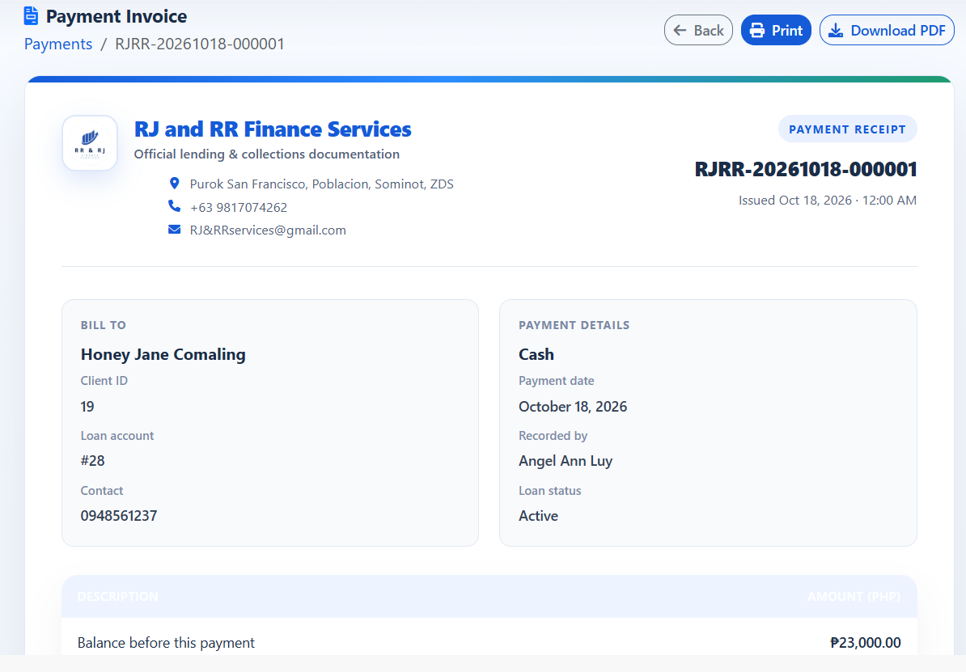
Figure B21
Evidence for ST-08: Borrower Payment History and Receipt
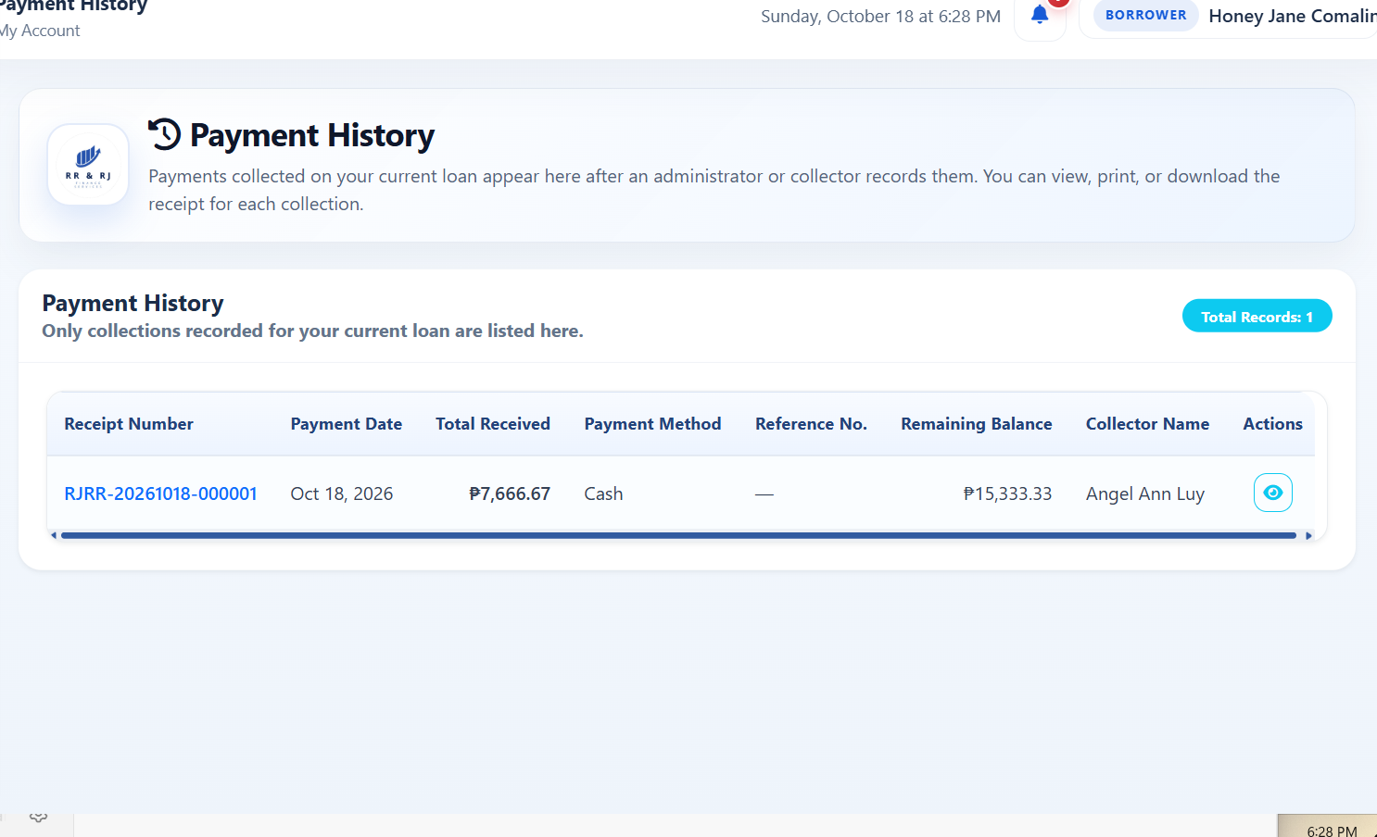
Figure B22
Evidence for ST-09: Loan and Installment Status Update

Figure B23
Evidence for ST-10: Collector Dashboard and Assigned Accounts
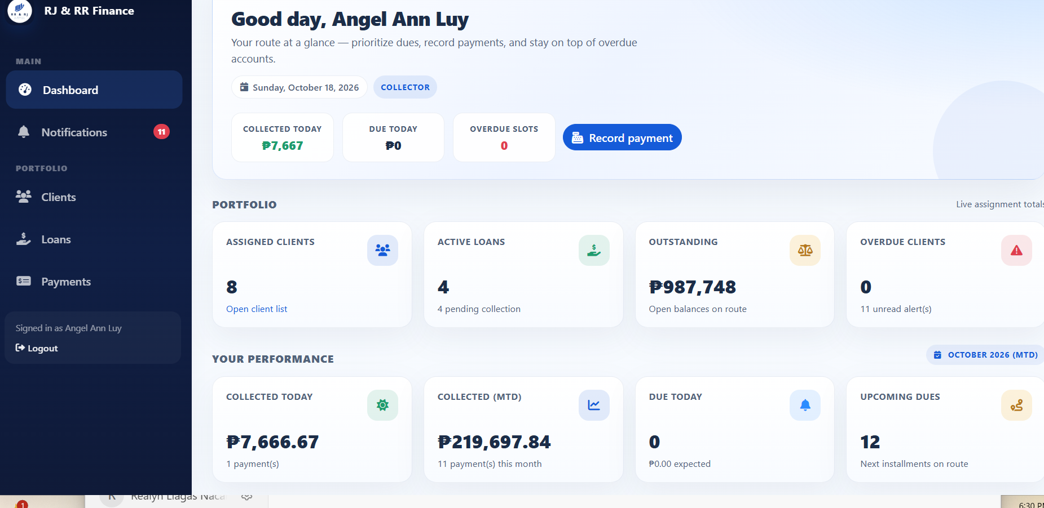
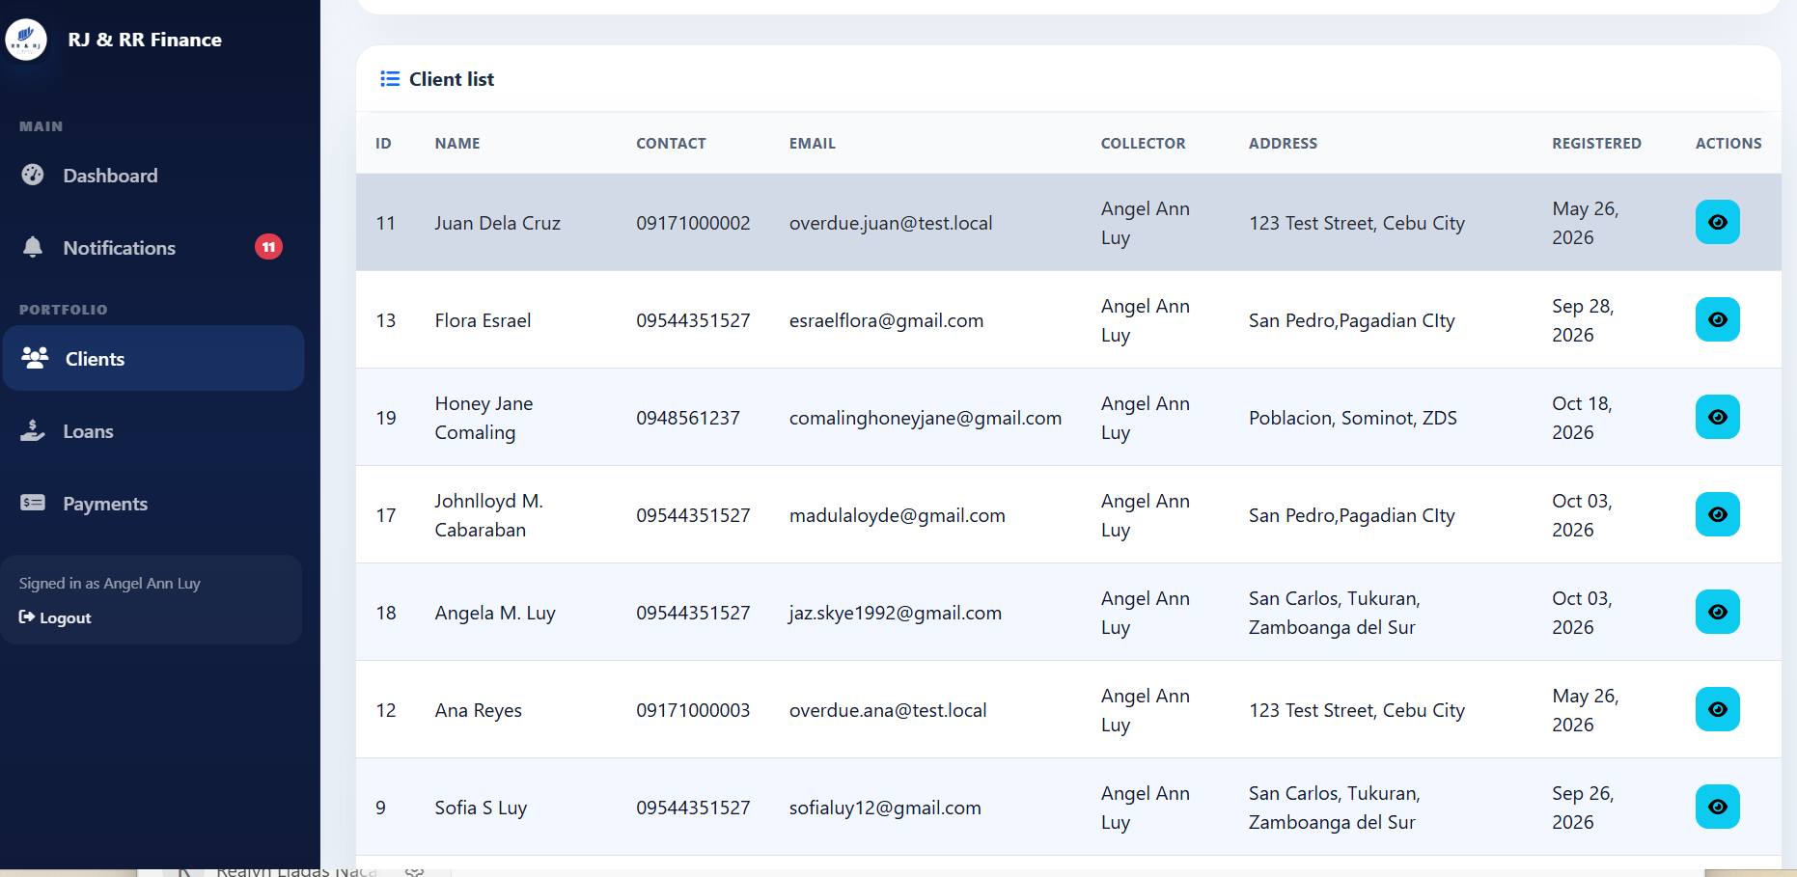

Figure B24
Evidence for ST-11: Administrative Reports
Figure B25
Evidence for ST-12: Notification Management
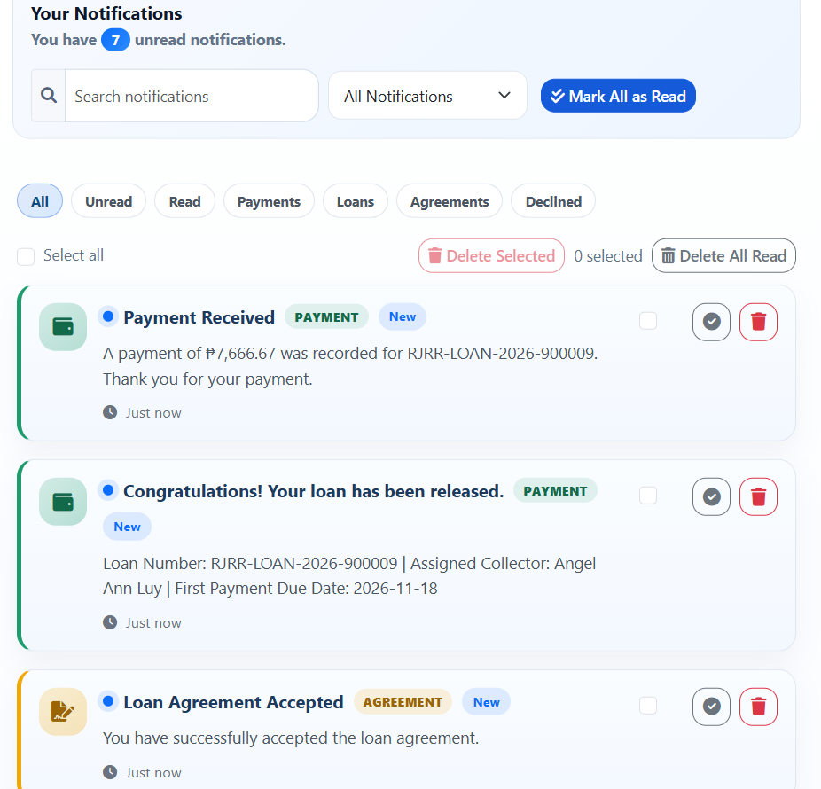

D. PAYMONGO TESTING
The PayMongo evidence for PM-01 to PM-09 is attached after the main manuscript appendix as Figures B26–B34. All 9 retained checks passed in the isolated FRAMS test environment. PM-01 and PM-02 document safe failure handling with an isolated invalid test key, not successful QR generation. Provider messages and sensitive test-key material are redacted. This set does not show a completed wallet payment.
Test ID | Figure | Status | Actual result
PM-01 | Figure B26 | PASS | The collector submitted E-Wallet for PHP 100.00 on FRAMS-DISP-01 while the balance was PHP 3,150.00. PayMongo returned HTTP 401 and rejected the isolated test key. The QR page did not open. The stored transaction status was failed, and it had no QR image. No repayment was created and the loan stayed Active. The provider text was redacted in the screenshot because it echoed part of the test key.
PM-02 | Figure B27 | PASS | The same screen as Figure B26 stayed on Record Payment. No QR image, QR amount, method block, or expiry was displayed. FRAMS-DISP-01 remained Active with remaining balance PHP 3,150.00.
PM-03 | Figure B28 | PASS | With Cash selected, the Create Dynamic QR Ph button was hidden and disabled. Cancel and Record Payment remained available. The loan and amount sections were collapsed only so the action row fit in the capture.
PM-04 | Figure B29 | PASS | Blank was stopped in the browser with "Please fill out this field." Zero reached the server and returned "Payment amount must be greater than zero." The nonnumeric value abc, after the number field was changed to text, returned "Enter a valid payment amount." None of the three created a QR image or a repayment.
PM-05 | Figure B30 | PASS | An amount of 4000.00 against a total due of PHP 3,150.00 was rejected: "Payment cannot exceed the current total amount due of PHP 3,150.00." No repayment was created.
PM-06 | Figure B31 | PASS | Collector A submitted loan 30, which is assigned to Collector B. The server responded "You are not assigned to this loan." The loan was not in Collector A's list, and no repayment was created.
PM-07 | Figure B32 | PASS | A signed-out request for the payments page opened the staff sign-in page. The signed-in borrower was redirected to Payment History. That page has no QR action. The borrower is turned away before the collector-only message is reached.
PM-08 | Figure B33 | PASS | An unresolved pending attempt on FRAMS-TEST-A could not be confirmed with PayMongo. The second request was refused: "The previous PayMongo QR Ph attempt could not be confirmed with PayMongo." The pending row stayed pending, the balance stayed PHP 3,833.34, and no new repayment was created. The supersede path was not applicable because PayMongo could not confirm the open attempt.
PM-09 | Figure B34 | PASS | The administrator payments screen shows View only. There is no edit or delete control. A delete request for payment 46 returned the refusal that a payment linked to a verified PayMongo QR Ph transaction was not deleted. Payment 46, receipt RJRR-20261018-000004, and the succeeded QR record remained. The client and borrower were not deleted.

Figure B26 — PM-01
Scenario: The assigned collector creates a QR Ph payment for a valid amount on a disposable unpaid loan.
Expected result: With the isolated invalid test key, PayMongo rejects QR creation. No QR page opens, no repayment is stored, and the loan balance stays unchanged. The attempt is saved as failed.
Actual result: The collector submitted E-Wallet for PHP 100.00 on FRAMS-DISP-01 while the balance was PHP 3,150.00. PayMongo returned HTTP 401 and rejected the isolated test key. The QR page did not open. The stored transaction status was failed, and it had no QR image. No repayment was created and the loan stayed Active. The provider text was redacted in the screenshot because it echoed part of the test key.
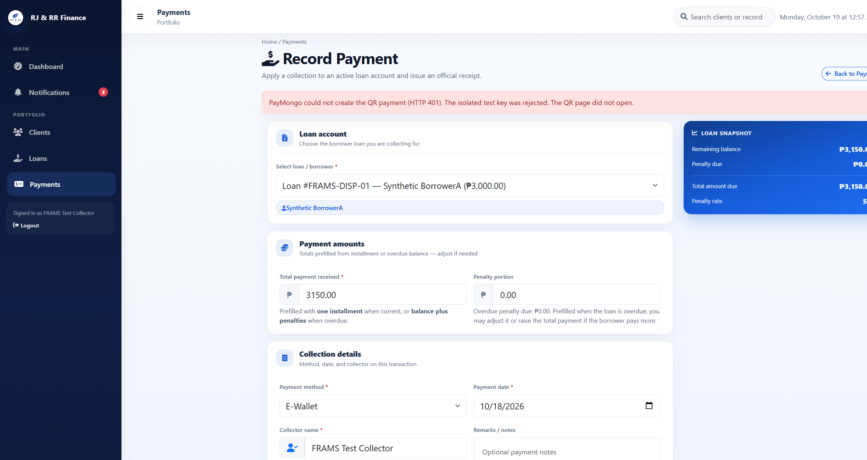
Status: PASS

Figure B26 (B26_pm01_qr_rejected.png)

Figure B27 — PM-02
Scenario: The pending QR page is compared with the loan balance before payment.
Expected result: When QR creation is rejected, the payment form stays open. No QR, QR amount, method, or expiry is shown. The balance and loan status stay unchanged.
Actual result: The same screen as Figure B26 stayed on Record Payment. No QR image, QR amount, method block, or expiry was displayed. FRAMS-DISP-01 remained Active with remaining balance PHP 3,150.00.
Status: PASS

Figure B27 (B26_pm01_qr_rejected.png)

Figure B28 — PM-03
Scenario: Cash is selected on the payment form.
Expected result: Create Dynamic QR Ph stays hidden. The ordinary cash payment action remains available.
Actual result: With Cash selected, the Create Dynamic QR Ph button was hidden and disabled. Cancel and Record Payment remained available. The loan and amount sections were collapsed only so the action row fit in the capture.
Status: PASS
Figure B28 (B28_pm03_cash_no_qr_button.png)

Figure B29 — PM-04
Scenario: Blank, zero, and nonnumeric QR amounts are submitted.
Expected result: No QR transaction is stored. A blank amount is stopped by the required field. Zero is rejected because the amount must be greater than zero. A nonnumeric value is also rejected.
Actual result: Blank was stopped in the browser with "Please fill out this field." Zero reached the server and returned "Payment amount must be greater than zero." The nonnumeric value abc, after the number field was changed to text, returned "Enter a valid payment amount." None of the three created a QR image or a repayment.
Status: PASS
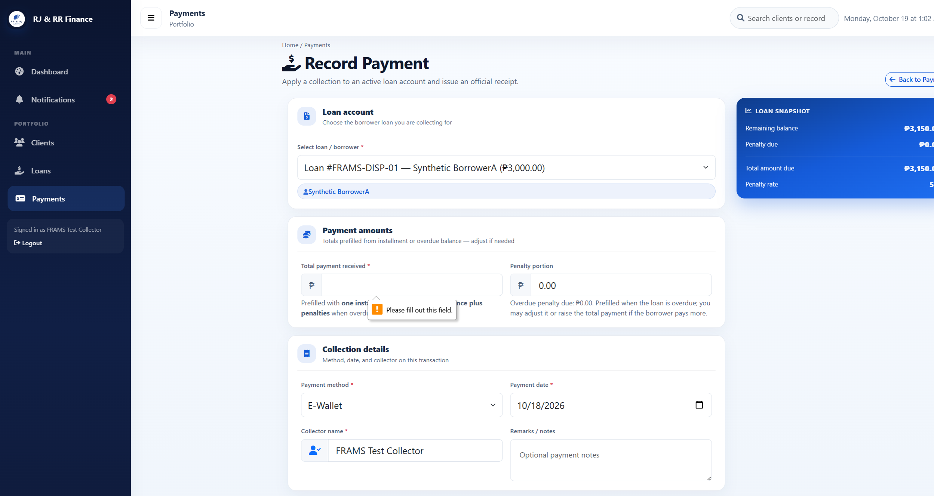
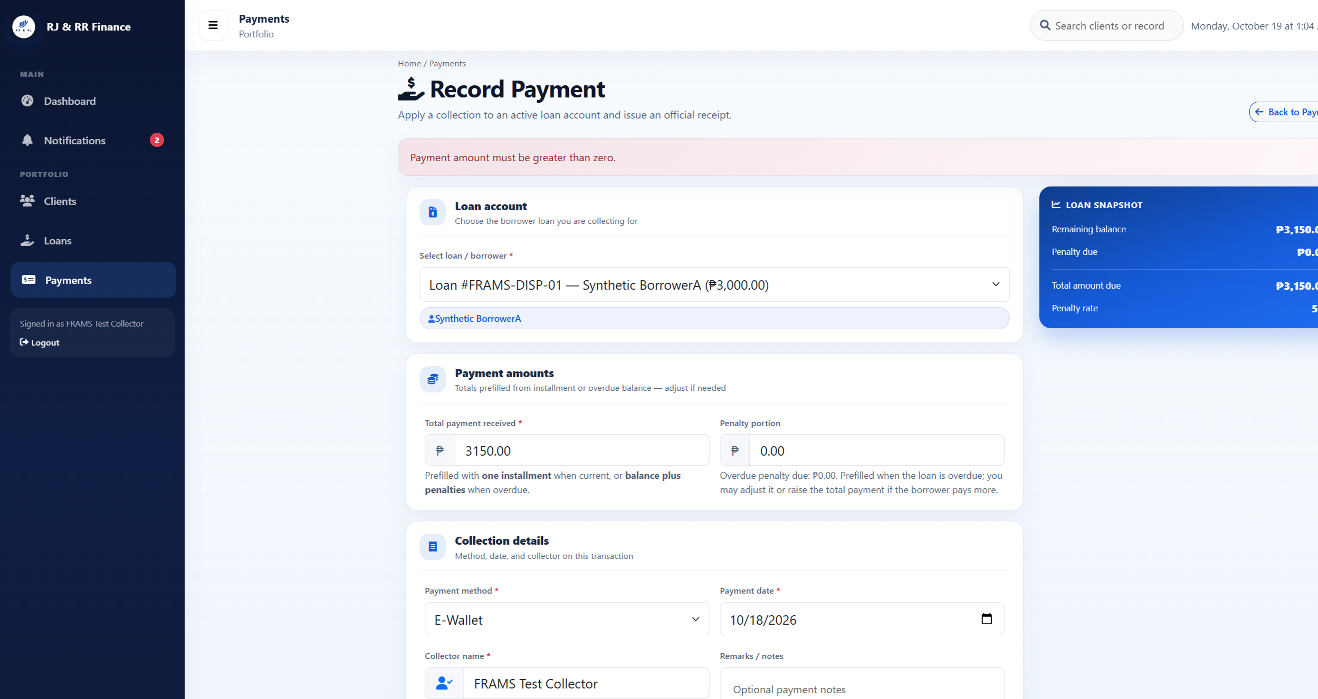
Figure B29 (B29_pm04_blank_amount.png)

Figure B29 (B29_pm04_zero_amount.png)
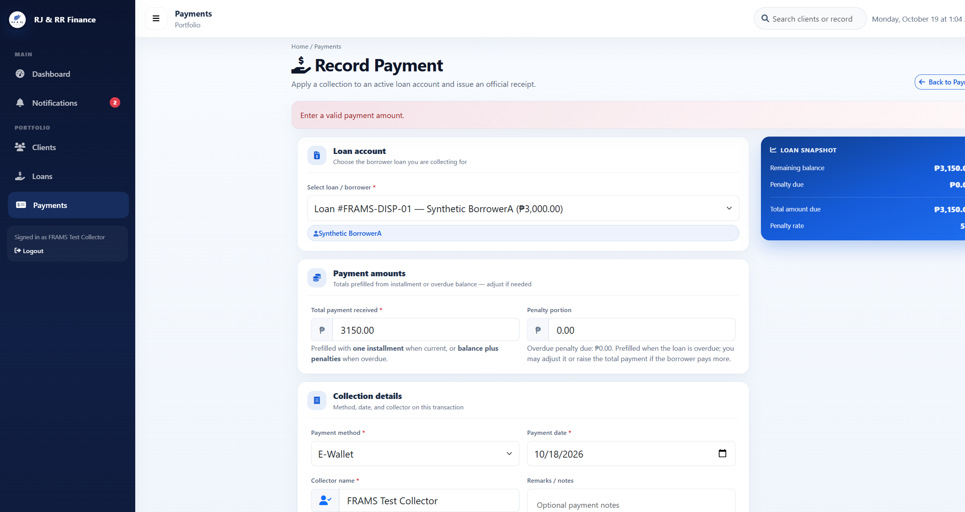
Figure B29 (B29_pm04_nonnumeric.png)

Figure B30 — PM-05
Scenario: The QR amount is greater than the current total due.
Expected result: The request is rejected and no QR transaction is stored.
Actual result: An amount of 4000.00 against a total due of PHP 3,150.00 was rejected: "Payment cannot exceed the current total amount due of PHP 3,150.00." No repayment was created.
Status: PASS
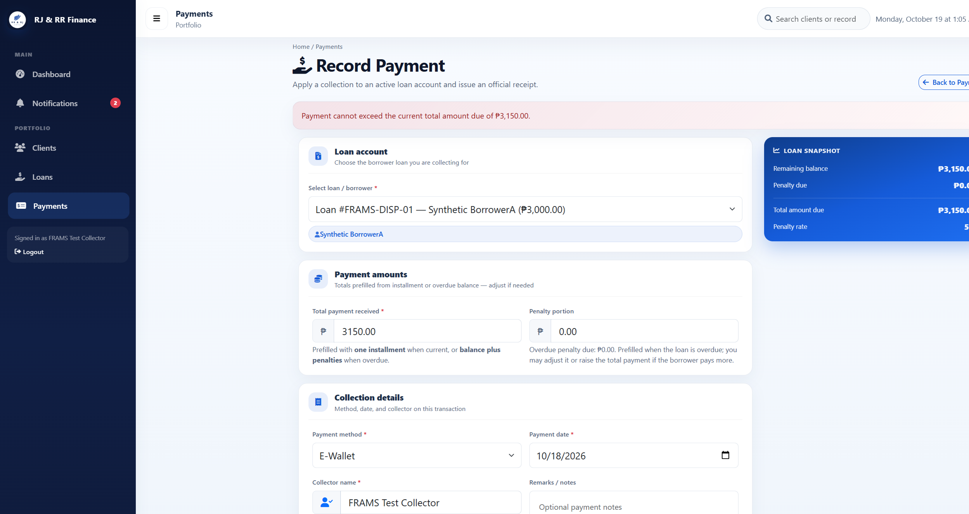
Figure B30 (B30_pm05_amount_too_high.png)

Figure B31 — PM-06
Scenario: A test collector submits a QR Ph request for a disposable loan assigned to another collector.
Expected result: The server rejects the request. No pending QR transaction and no repayment are created.
Actual result: Collector A submitted loan 30, which is assigned to Collector B. The server responded "You are not assigned to this loan." The loan was not in Collector A's list, and no repayment was created.
Status: PASS
Figure B31 (B31_pm06_other_collector.png)

Figure B32 — PM-07
Scenario: A signed-out visitor opens the payments page, and a borrower attempts the collector QR request.
Expected result: The visitor is redirected to the staff sign-in page. The borrower is redirected to payment history and cannot start a QR payment.
Actual result: A signed-out request for the payments page opened the staff sign-in page. The signed-in borrower was redirected to Payment History. That page has no QR action. The borrower is turned away before the collector-only message is reached.
Status: PASS
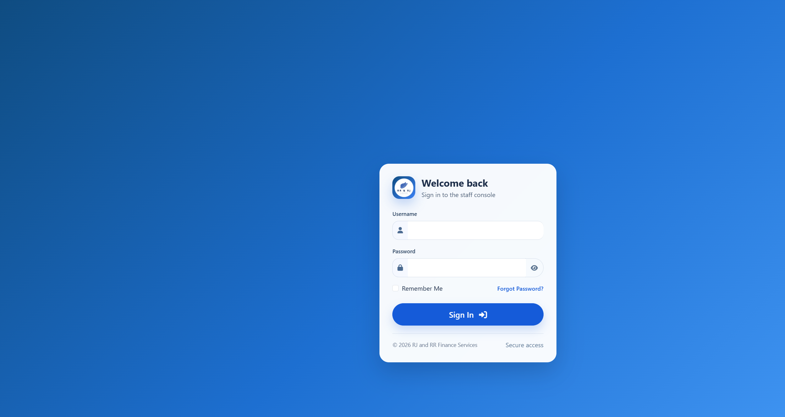
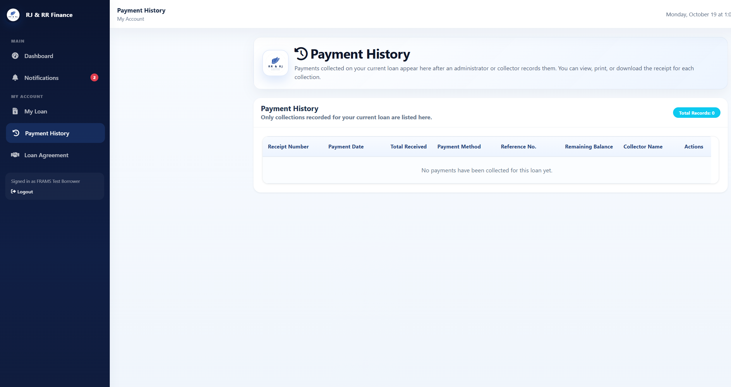
Figure B32 (B32_pm07_signed_out_redirect.png)

Figure B32 (B32_pm07_borrower_history.png)

Figure B33 — PM-08
Scenario: A second QR Ph request is created while an earlier attempt for the same loan is unresolved.
Expected result: A second request is refused when a pending QR has not expired and PayMongo cannot confirm it.
Actual result: An unresolved pending attempt on FRAMS-TEST-A could not be confirmed with PayMongo. The second request was refused: "The previous PayMongo QR Ph attempt could not be confirmed with PayMongo." The pending row stayed pending, the balance stayed PHP 3,833.34, and no new repayment was created. The supersede path was not applicable because PayMongo could not confirm the open attempt.
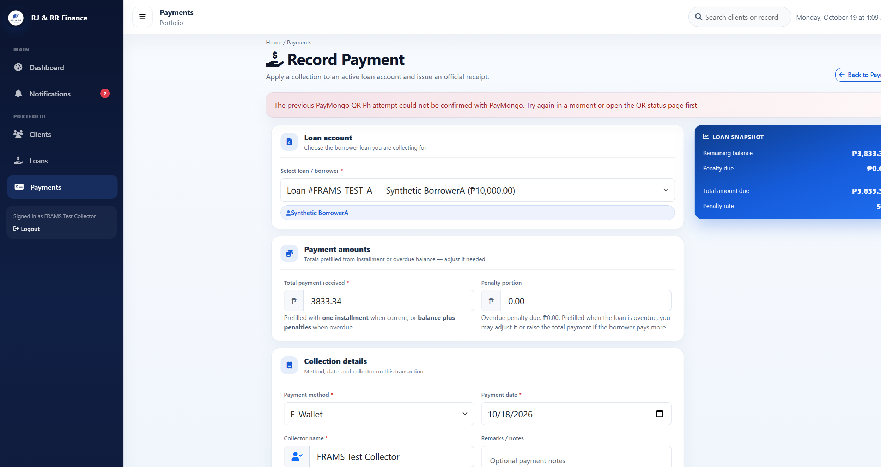
Status: PASS

Figure B33 (B33_pm08_unconfirmed_pending_refused.png)

Figure B34 — PM-09
Scenario: An administrator submits deletion of a disposable repayment linked to a verified QR Ph transaction.
Expected result: The payments screen has no edit or delete control. The delete request is refused, and the payment, receipt, and QR record remain.
Actual result: The administrator’s payments screen shows View only. There is no edit or delete control. A delete request for payment 46 returned the refusal that a payment linked to a verified PayMongo QR Ph transaction was not deleted. Payment 46, receipt RJRR-20261018-000004, and the succeeded QR record remained. The client and borrower were not deleted.
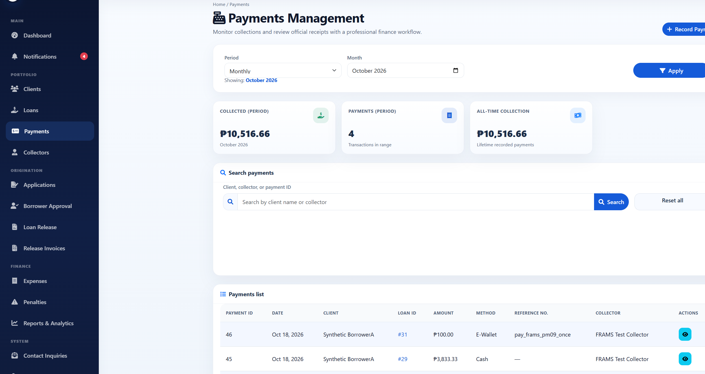
Status: PASS

Figure B34 (B34_pm12_no_delete_control.png)

Penetration testing is documented as a limited set of non-destructive checks. A control observed in the source code is not recorded as a passed test. The whole system is not described as secure on the basis of this section.
Table B5
Penetration Testing Test Evidence of FRAMS
Test ID | Figure | Status | Actual result
PT-01 | Figure B35 | PASS | Signed-out requests for dashboard_lending.php, collector_dashboard_lending.php, payments_lending.php, and reports_lending.php each returned HTTP 302 to login_lending.php. The browser showed the staff sign-in page and no loan, client, or user records. Signed-out requests for borrower_dashboard_lending.php, borrower_my_loan_lending.php, and borrower_payment_history_lending.php each returned HTTP 302 to borrower_login_lending.php. The browser showed the borrower sign-in page.
PT-02 | Figure B36 | PASS | frams_test_admin with a wrong password stayed on the staff sign-in page and showed "Invalid username or password." frams_test_inactive, whose users.status is Inactive, with the ordinary test password stayed on the same page and showed the same message. Neither attempt opened a dashboard.
PT-03 | Figure B37 | PASS | Signed in as frams_test_borrower. users_lending.php, reports_lending.php, loan_release_lending.php, and expenses_lending.php each returned HTTP 302 to borrower_dashboard_lending.php. The browser showed the borrower dashboard, not user administration, reports, loan release, or expenses. payments_lending.php returned HTTP 302 to borrower_payment_history_lending.php. That history listed only this borrower's receipt RJRR-20261018-000004.
PT-04 | Figure B38 | PASS | Signed in as frams_test_collector. users_lending.php, reports_lending.php, borrower_approval_lending.php, and loan_release_lending.php each returned HTTP 302 to collector_dashboard_lending.php. The browser showed the collector dashboard. No user, approval, or release form was shown, and the user count stayed at 6.
PT-05 | Figure B39 | PASS | Registration, payment recording, expense recording, user management, and loan release were each posted without the security token. Borrower approval was not used. All five responses were HTTP 419 with the heading "Invalid or expired session" and the text "Please refresh the page and try again." Users stayed at 6, payments at 4, expenses at 0, and loan releases at 3. The probe username was not created.
PT-06 | Figure B40 | PASS | The staff sign-in username frams_test_admin' OR '1'='1 was rejected with "Invalid username or password" and stayed on the sign-in page. The same quote in user search returned "Showing 0 of 0 users" and "No users found." It did not list the administrator, collector, or borrower accounts.
PT-07 | Figure B41 | PASS | The user-search value <b>pt07marker</b> was returned in the page as encoded text. The search box showed the marker as ordinary characters, including the angle brackets. It was not rendered as bold text, and the search still listed 0 users. The payments flash message was not used.
PT-08 | Figure B42 | PASS | Signed in as frams_test_borrower. Requesting payments_lending.php?view=44, the receipt for Borrower B, returned HTTP 302 to borrower_payment_history_lending.php. The history still showed only RJRR-20261018-000004 and did not show RJRR-20261018-000002. Requesting download_loan_document_lending.php for a document path that does not belong to this borrower returned HTTP 403 and the text "Access denied."
PT-09 | Figure B43 | PASS | Signed in as frams_test_collector. Client 21, which is assigned to Collector B, returned HTTP 403: "You do not have permission to view this client." Loan 30, FRAMS-TEST-B, returned HTTP 403: "You do not have permission to view this loan." Payment 44 returned HTTP 403: "You do not have access to this receipt." None of the three records opened.
PT-10 | Figure B44 | PASS | On loan-application step 4, pt10-probe.txt was checked and rejected with "Allowed file types: JPG, PNG, PDF." A file of 8,389,633 bytes was rejected with "File must be 8 MB or smaller." Neither file was written to the document folder. The wizard does not keep that sentence on screen: it stays on step 4 and shows "Required documents missing," with every document still marked "Not uploaded yet."
PT-11 | Figure B45 | PASS | The collector signed out, which opened the staff sign-in page. Opening collector_dashboard_lending.php again returned HTTP 302 to login_lending.php. The browser showed the staff sign-in page, so the protected dashboard required authentication again.
PT-12 | Figure B46 | PASS | The forgot-password page asks for a username and says it will email a 6-digit code. It does not offer a reset link. The code form says the code expires in 10 minutes. A new code record was measured at 600 seconds. An incorrect code returned "That code is incorrect or has expired." After five incorrect attempts, the next try returned "Too many incorrect codes. Request a new code." and the code record was removed. A code whose expiry was already past returned the incorrect-or-expired message. A correct code allowed one password change, and that same code was then rejected. The borrower test password was restored afterward, and no reset row remained.

Screenshot Evidence for Penetration Testing

Figure B35 — PT-01
Scenario: Open the administrator dashboard, collector dashboard, payments, reports, and borrower pages while signed out.
Expected result: Staff pages redirect to the staff sign-in page. Borrower pages redirect to the borrower sign-in page. No records are shown.
Actual result: Signed-out requests for dashboard_lending.php, collector_dashboard_lending.php, payments_lending.php, and reports_lending.php each returned HTTP 302 to login_lending.php. The browser showed the staff sign-in page and no loan, client, or user records. Signed-out requests for borrower_dashboard_lending.php, borrower_my_loan_lending.php, and borrower_payment_history_lending.php each returned HTTP 302 to borrower_login_lending.php. The browser showed the borrower sign-in page.
Status: PASS
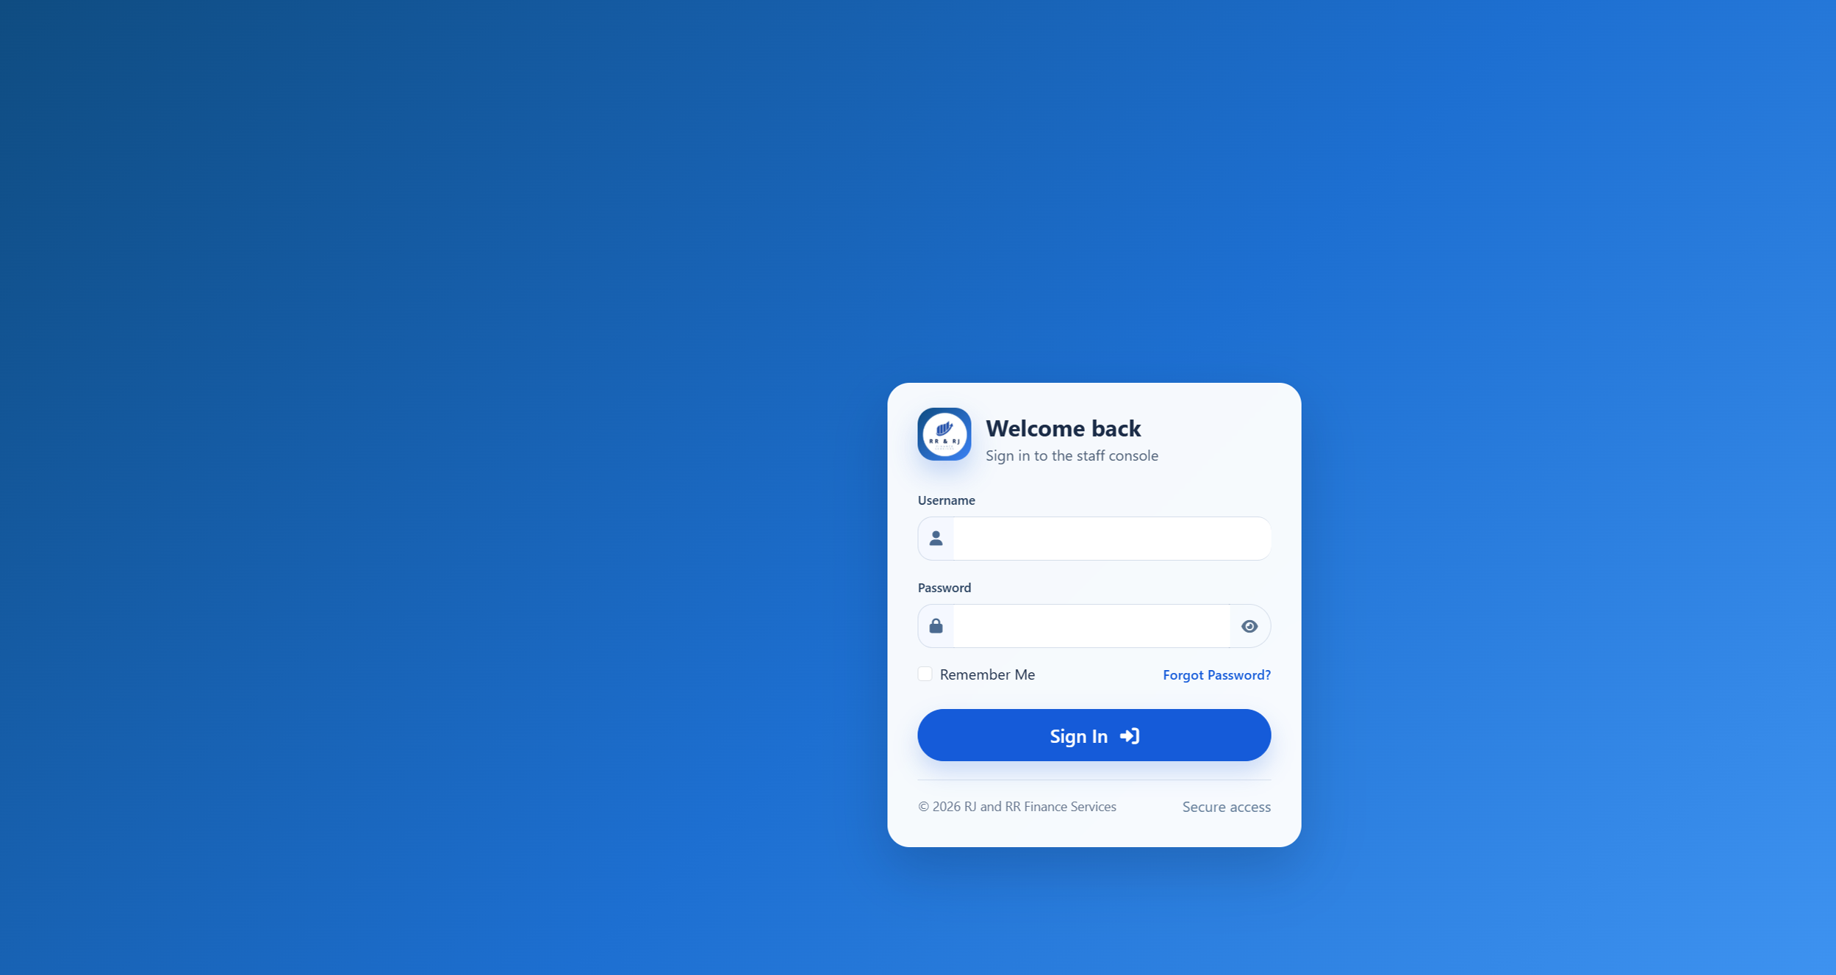
Figure B35. Staff sign-in after opening the administrator dashboard while signed out.
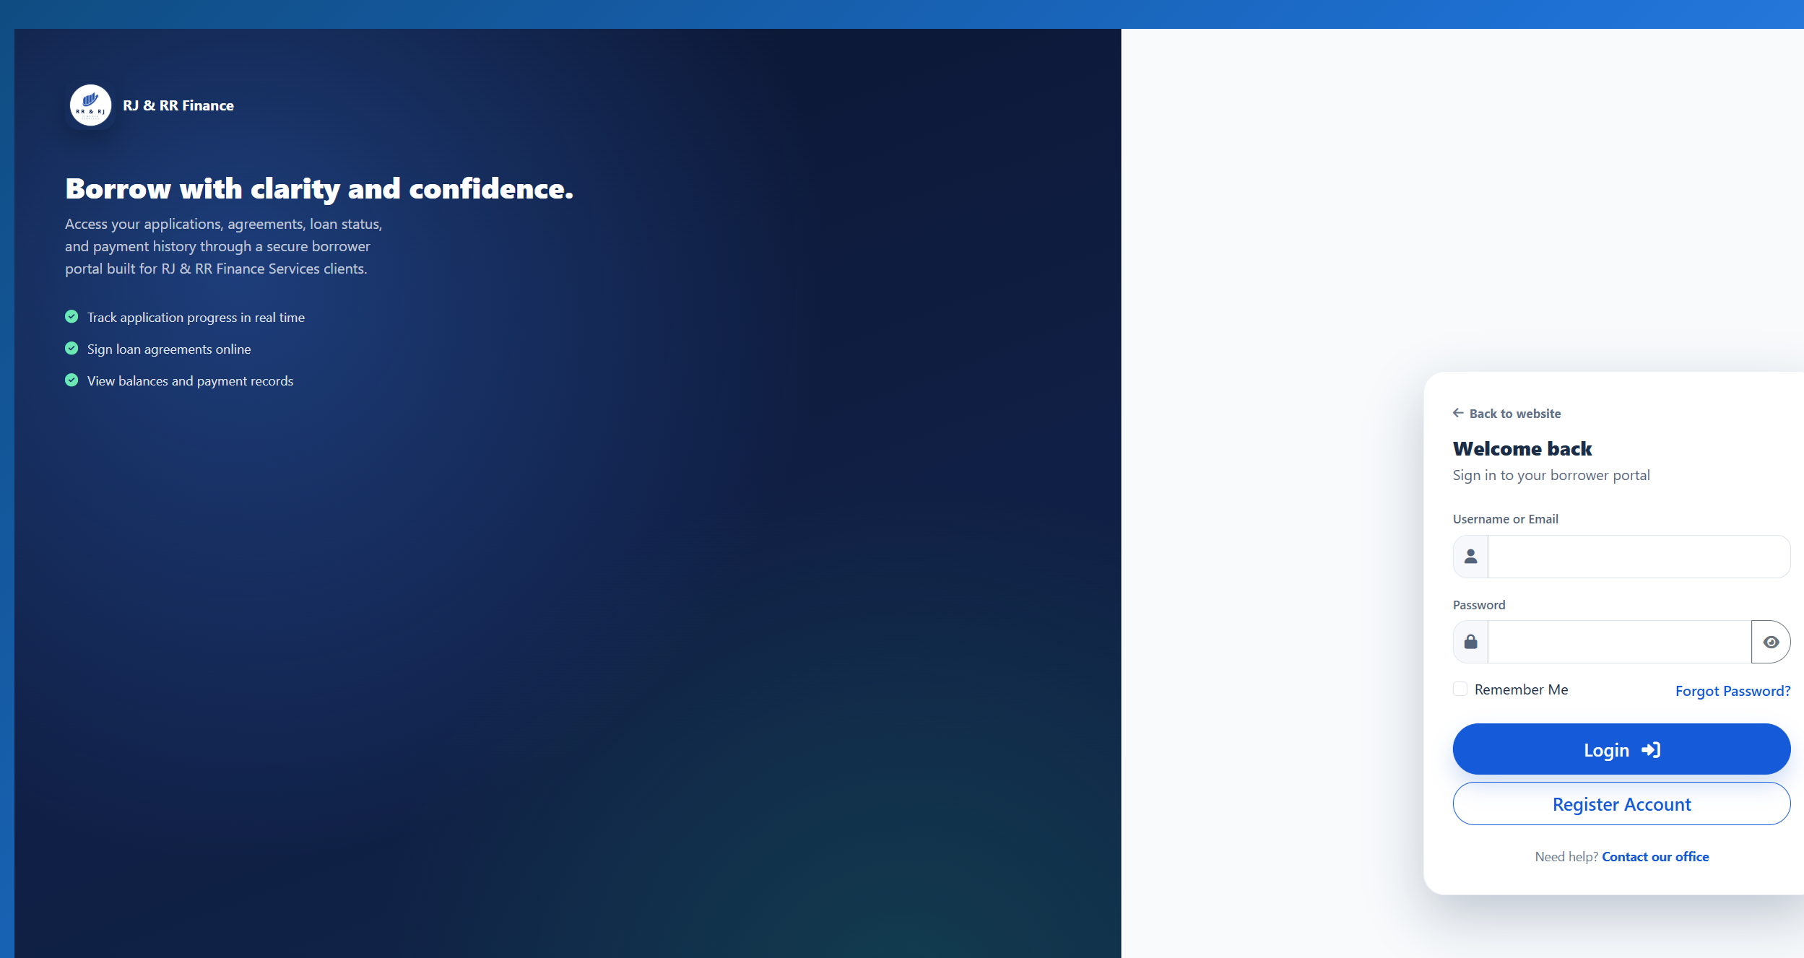
Figure B35. Borrower sign-in after opening the borrower dashboard while signed out.

Figure B36 — PT-02
Scenario: Sign in with a wrong password and with an inactive account.
Expected result: No protected page opens. The inactive trial uses the same staff message as a wrong password, and the account status supports that trial.
Actual result: frams_test_admin with a wrong password stayed on the staff sign-in page and showed "Invalid username or password." frams_test_inactive, whose users.status is Inactive, with the ordinary test password stayed on the same page and showed the same message. Neither attempt opened a dashboard.
Status: PASS
Figure B36. Wrong password for the active administrator.
Figure B36. Inactive administrator. The message matches the wrong-password trial.

Figure B37 — PT-03
Scenario: A borrower opens the users, reports, loan-release, expenses, and payments pages.
Expected result: Users, reports, loan release, and expenses return the borrower to the borrower dashboard. The payments page returns the borrower to that borrower payment history.
Actual result: Signed in as frams_test_borrower. users_lending.php, reports_lending.php, loan_release_lending.php, and expenses_lending.php each returned HTTP 302 to borrower_dashboard_lending.php. The browser showed the borrower dashboard, not user administration, reports, loan release, or expenses. payments_lending.php returned HTTP 302 to borrower_payment_history_lending.php. That history listed only this borrower's receipt RJRR-20261018-000004.
Status: PASS
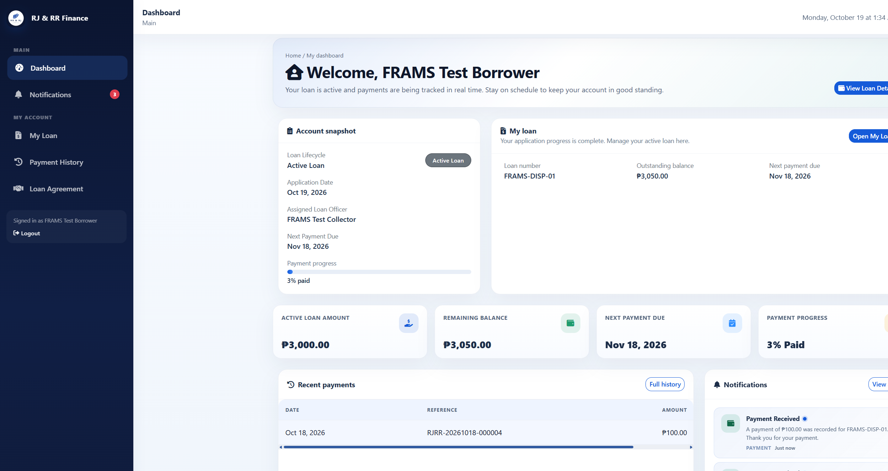
Figure B37. Borrower dashboard after requesting user management.
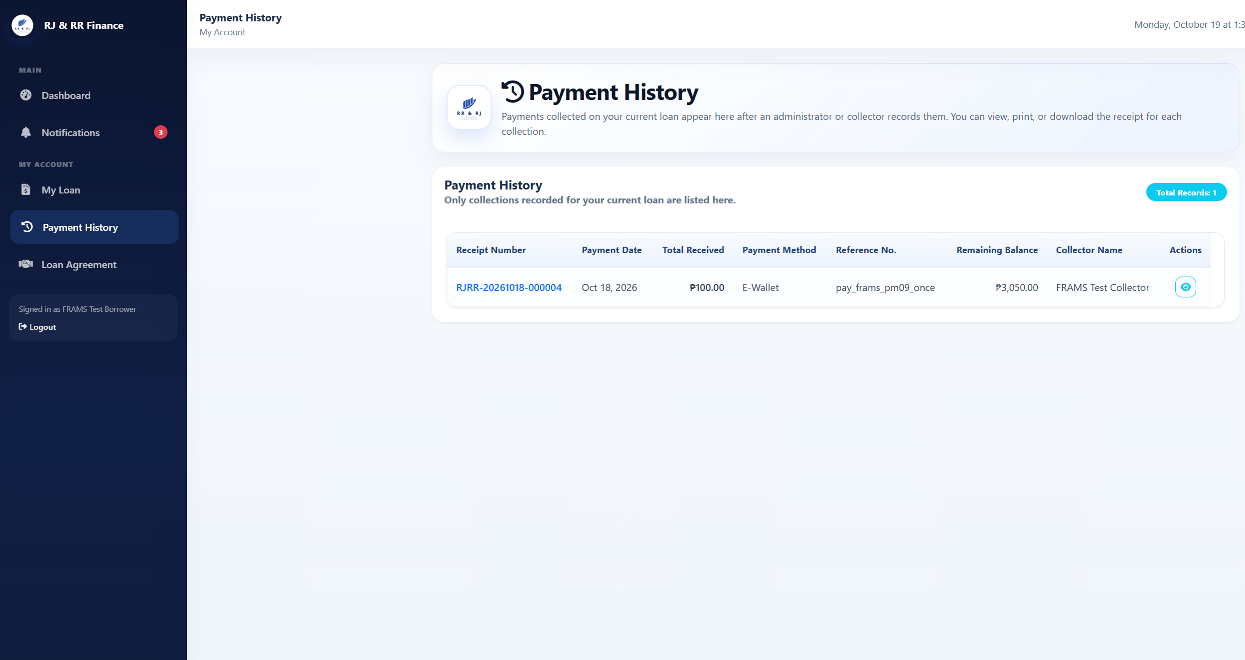
Figure B37. Borrower payment history after requesting the staff payments page.

Figure B38 — PT-04
Scenario: A collector opens users, reports, borrower approval, and loan release.
Expected result: Each request returns to the collector dashboard, and no administrator record is changed.
Actual result: Signed in as frams_test_collector. users_lending.php, reports_lending.php, borrower_approval_lending.php, and loan_release_lending.php each returned HTTP 302 to collector_dashboard_lending.php. The browser showed the collector dashboard. No user, approval, or release form was shown, and the user count stayed at 6.
Status: PASS
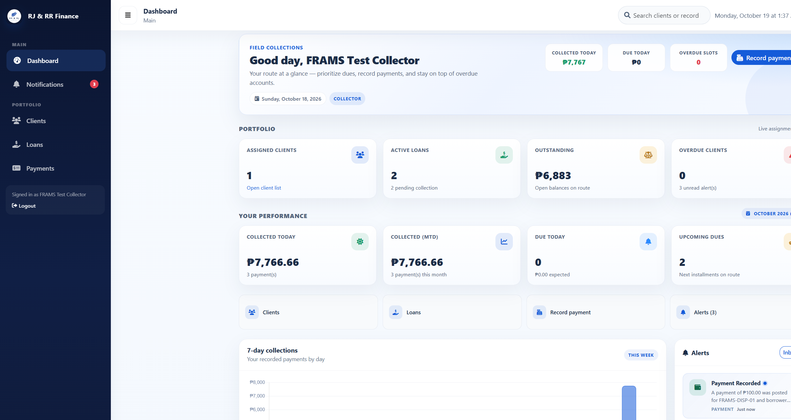
Figure B38. Collector dashboard after requesting user management. Reports, borrower approval, and loan release returned to this same dashboard.

Figure B39 — PT-05
Scenario: Submit registration, payment recording, expense recording, user management, or loan release without the security token.
Expected result: The request ends with HTTP 419 and the message that the session is invalid or expired. No record is saved.
Actual result: Registration, payment recording, expense recording, user management, and loan release were each posted without the security token. Borrower approval was not used. All five responses were HTTP 419 with the heading "Invalid or expired session" and the text "Please refresh the page and try again." Users stayed at 6, payments at 4, expenses at 0, and loan releases at 3. The probe username was not created.
Status: PASS
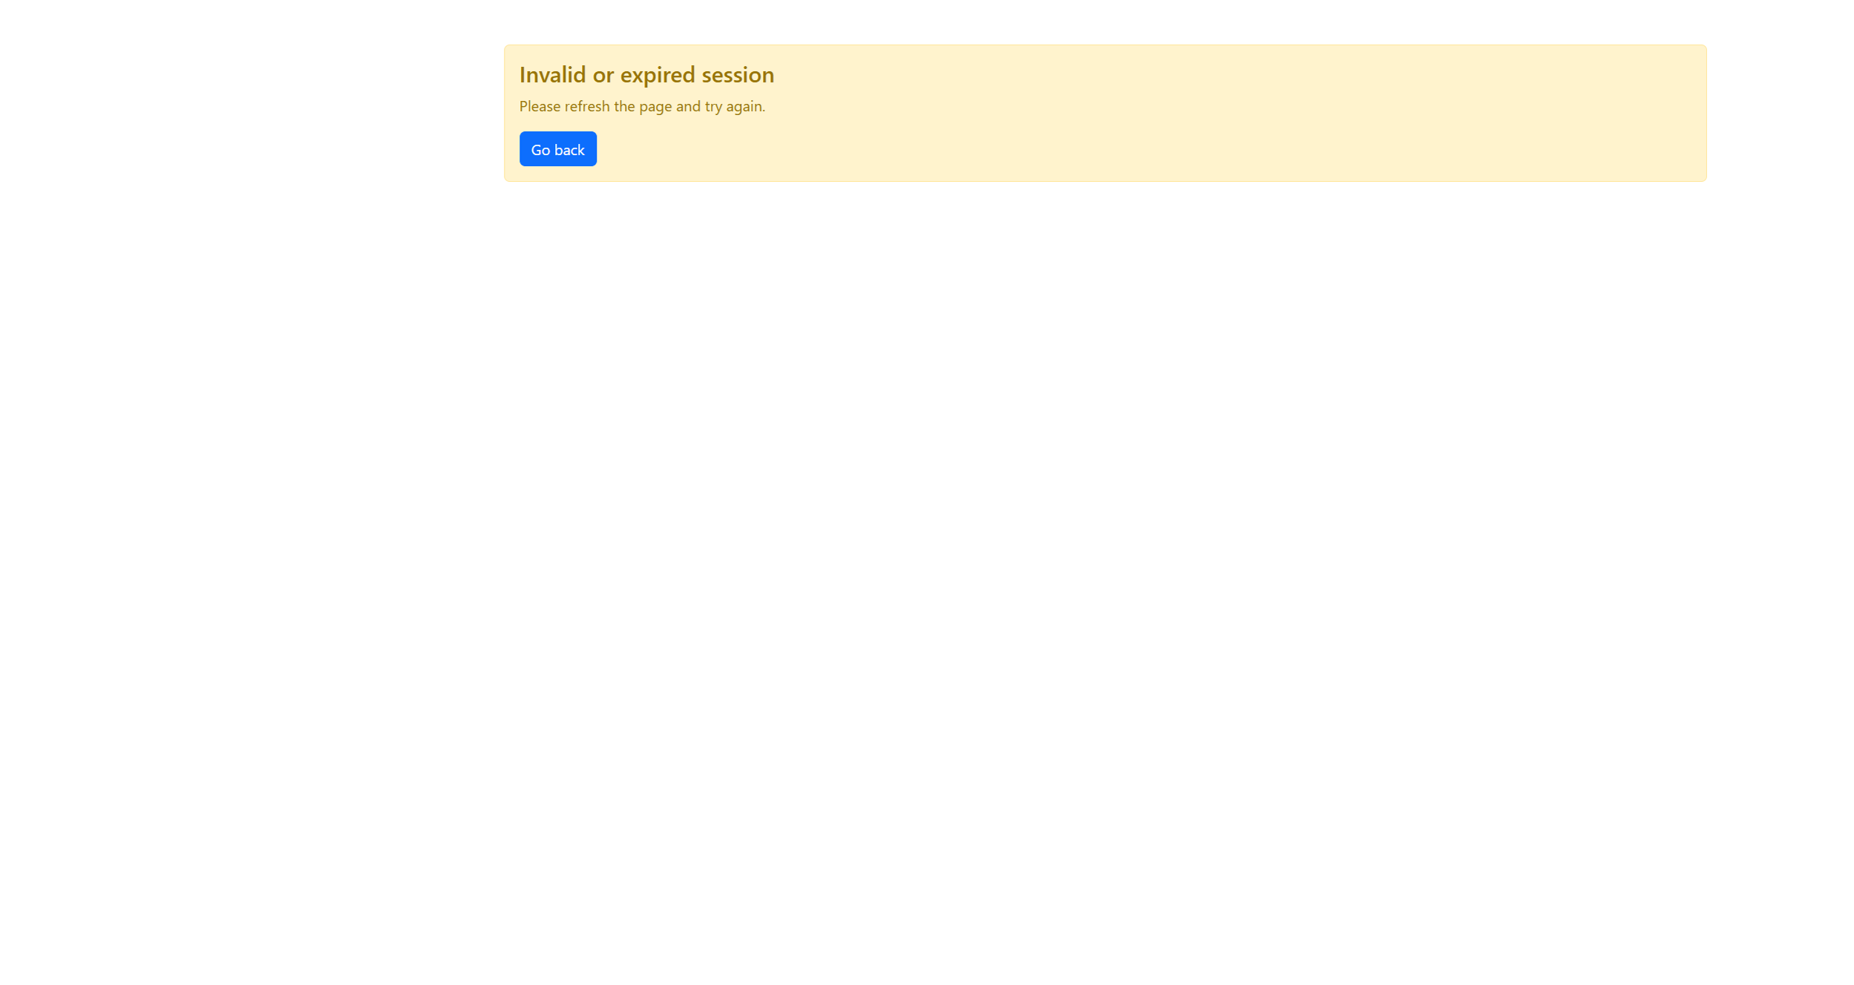
Figure B39. Registration submitted without the security token. The other four posts returned this same page with HTTP 419.

Figure B40 — PT-06
Scenario: Enter a quote-style probe in sign-in and in a search box.
Expected result: Sign-in fails. Search does not reveal additional accounts, loans, or payments.
Actual result: The staff sign-in username frams_test_admin' OR '1'='1 was rejected with "Invalid username or password" and stayed on the sign-in page. The same quote in user search returned "Showing 0 of 0 users" and "No users found." It did not list the administrator, collector, or borrower accounts.
Status: PASS
Figure B40. Quote-style sign-in probe rejected.
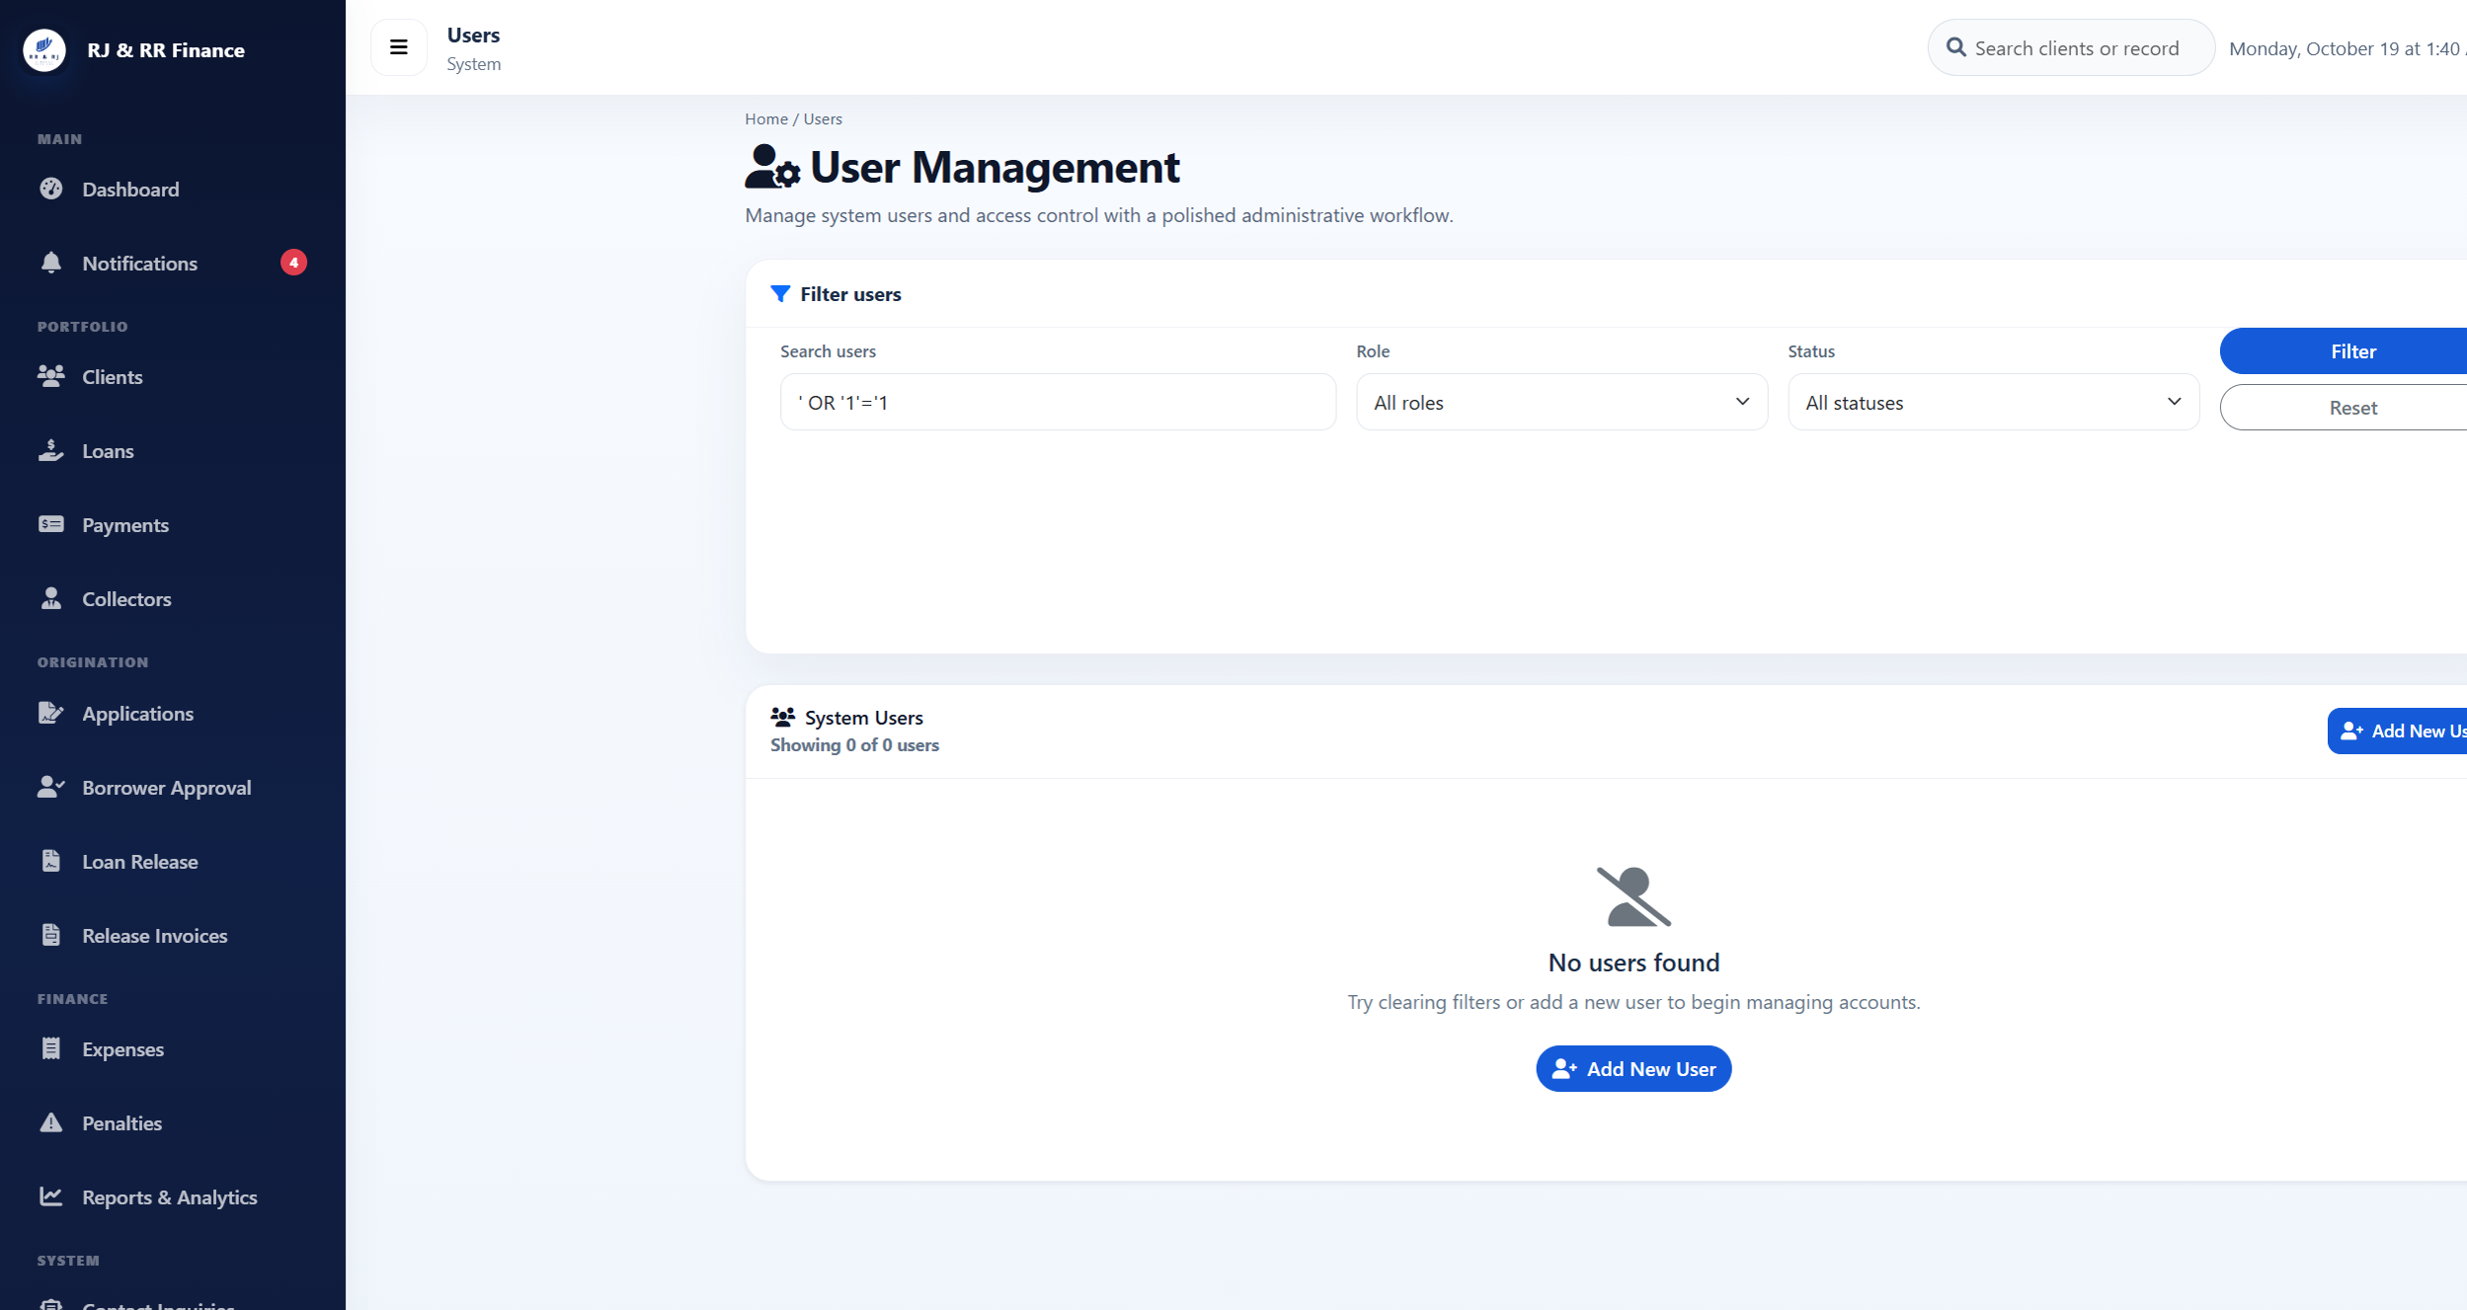
Figure B40. Quote-style user search returned no accounts.

Figure B41 — PT-07
Scenario: Enter a harmless markup marker in an encoded search field and display it.
Expected result: The marker is shown as ordinary text.
Actual result: The user-search value <b>pt07marker</b> was returned in the page as encoded text. The search box showed the marker as ordinary characters, including the angle brackets. It was not rendered as bold text, and the search still listed 0 users. The payments flash message was not used.
Status: PASS
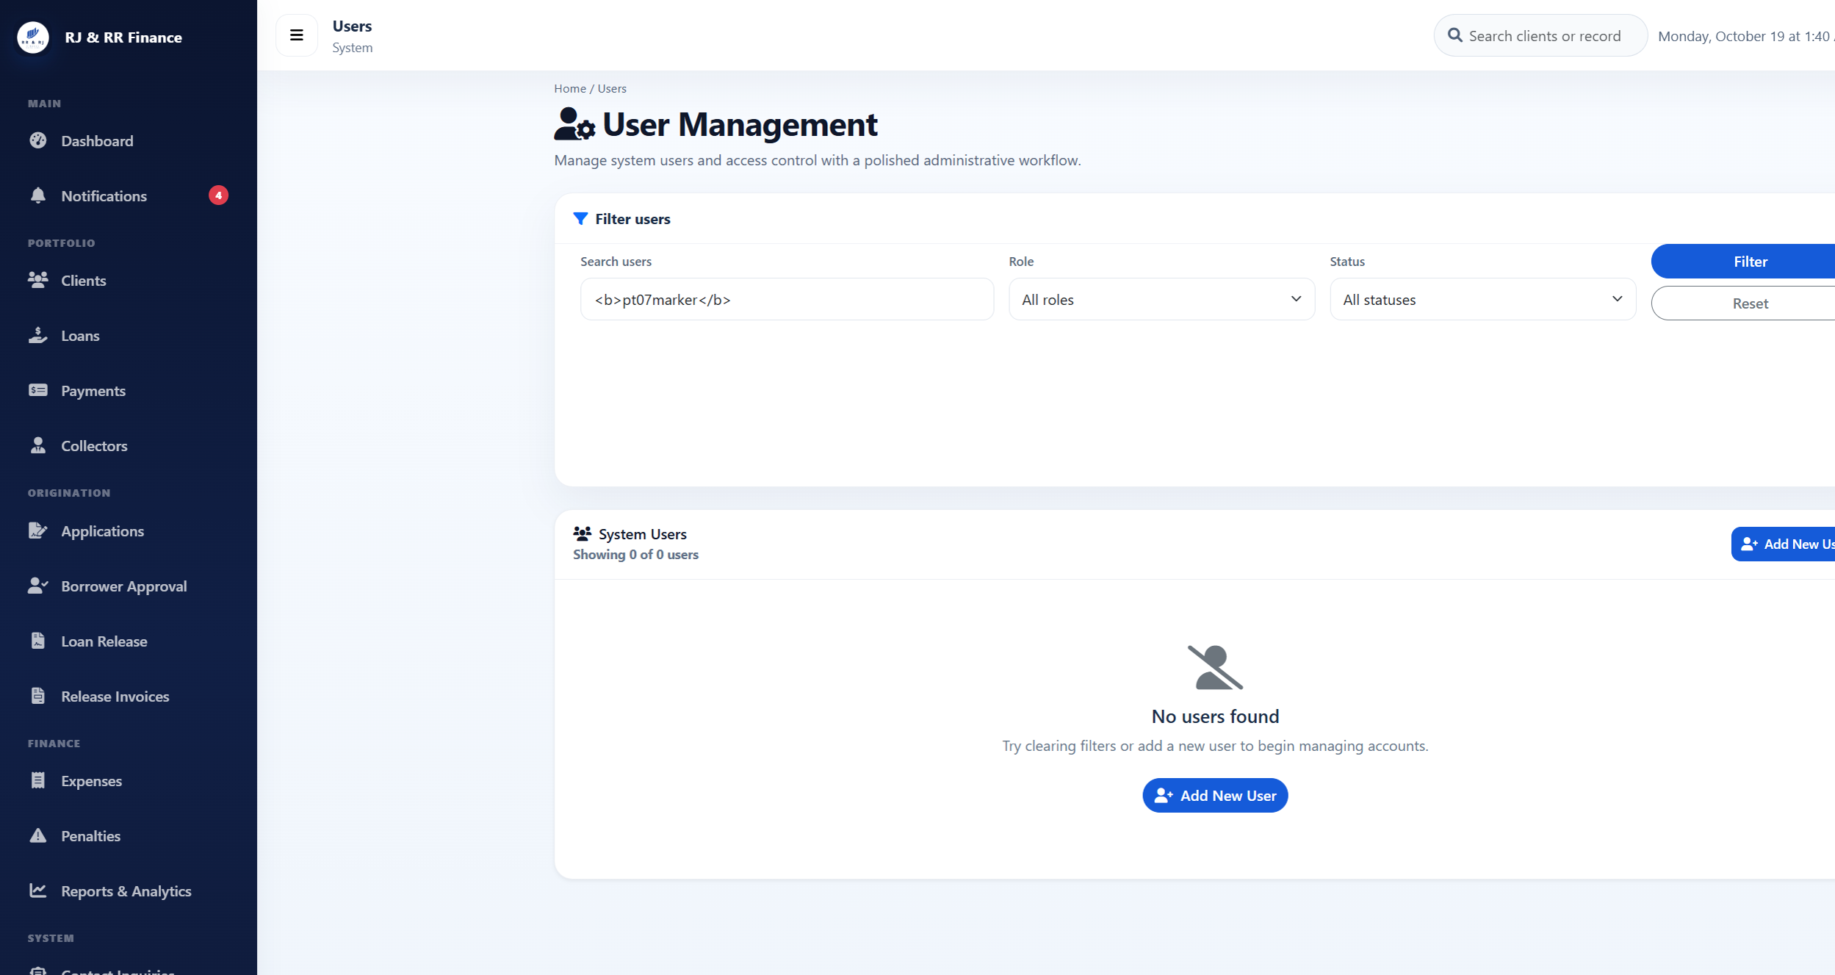
Figure B41. The markup marker remains visible as text in the search box.

Figure B42 — PT-08
Scenario: A borrower requests another borrower receipt address and document address.
Expected result: The receipt is refused or redirected, and the document request returns Access denied.
Actual result: Signed in as frams_test_borrower. Requesting payments_lending.php?view=44, the receipt for Borrower B, returned HTTP 302 to borrower_payment_history_lending.php. The history still showed only RJRR-20261018-000004 and did not show RJRR-20261018-000002. Requesting download_loan_document_lending.php for a document path that does not belong to this borrower returned HTTP 403 and the text "Access denied."
Status: PASS
Figure B42. Other-borrower receipt request returned to this borrower's own payment history.

Figure B42. Other-borrower document request. The response text is Access denied.

Figure B43 — PT-09
Scenario: A collector opens a client, loan, or payment assigned to another collector.
Expected result: The unassigned record is not opened for collection.
Actual result: Signed in as frams_test_collector. Client 21, which is assigned to Collector B, returned HTTP 403: "You do not have permission to view this client." Loan 30, FRAMS-TEST-B, returned HTTP 403: "You do not have permission to view this loan." Payment 44 returned HTTP 403: "You do not have access to this receipt." None of the three records opened.
Status: PASS
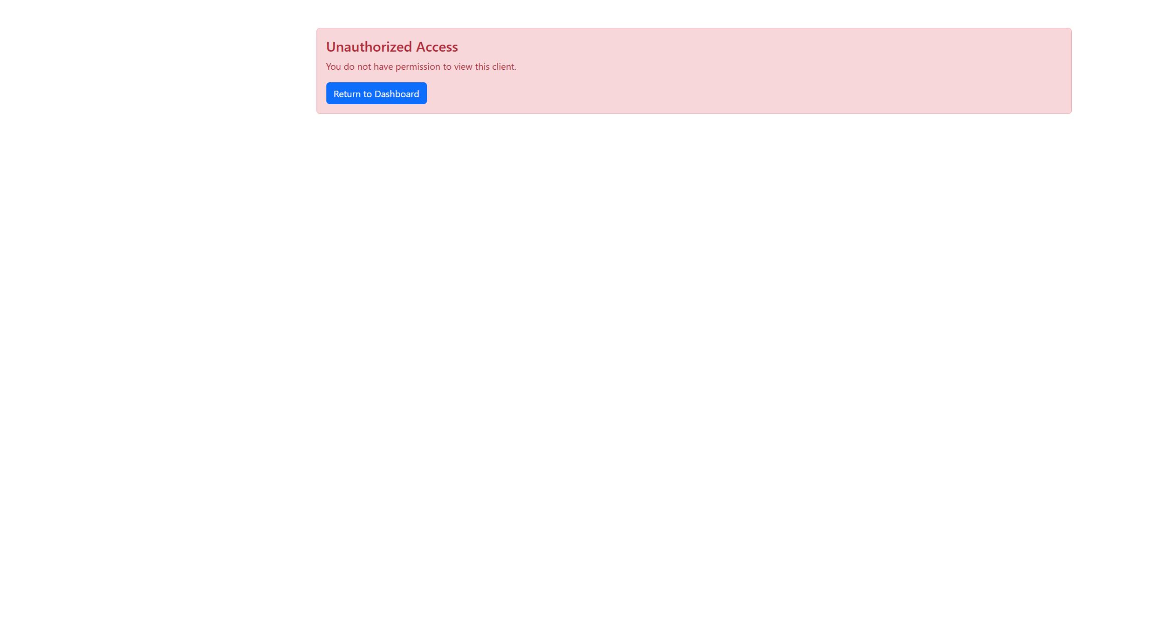
Figure B43. Collector A denied client 21.
Figure B43. Collector A denied loan 30.
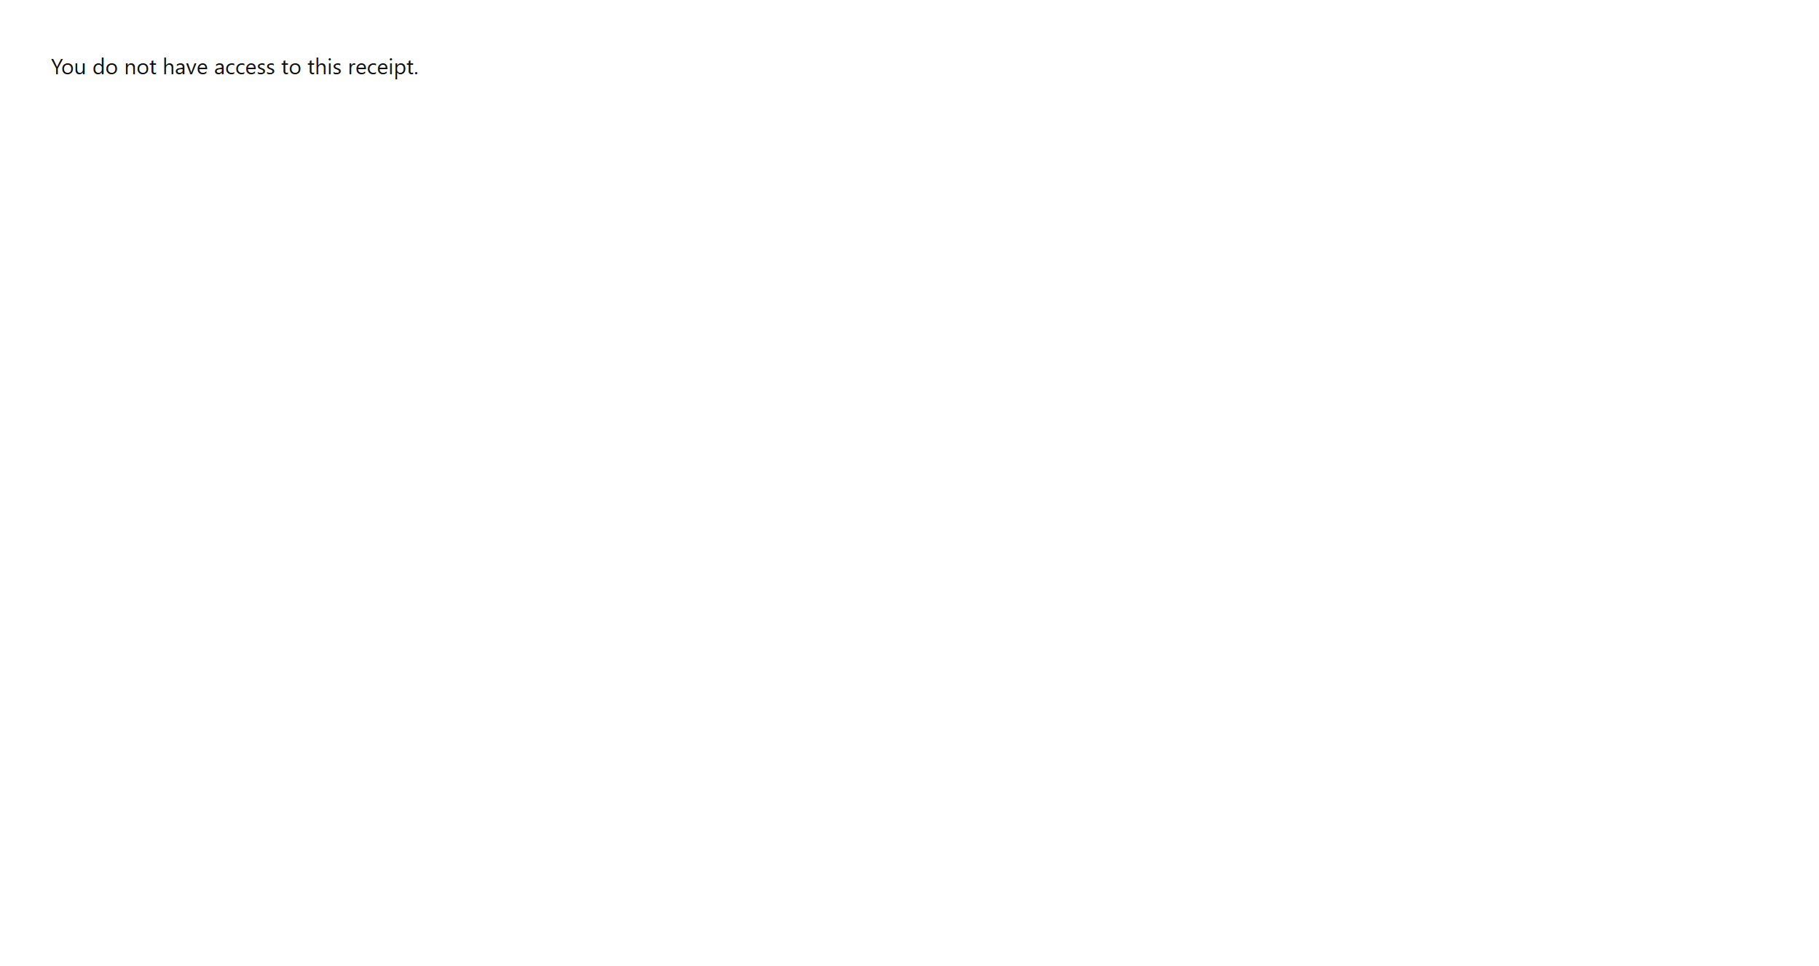
Figure B43. Collector A denied payment 44.

Figure B44 — PT-10
Scenario: Upload a file that is not JPG, PNG, or PDF, and a file larger than 8 MB.
Expected result: The file is rejected and is not stored. A PDF is an allowed file and was not used as the invalid sample.
Actual result: On loan-application step 4, pt10-probe.txt was checked and rejected with "Allowed file types: JPG, PNG, PDF." A file of 8,389,633 bytes was rejected with "File must be 8 MB or smaller." Neither file was written to the document folder. The wizard does not keep that sentence on screen: it stays on step 4 and shows "Required documents missing," with every document still marked "Not uploaded yet."
Status: PASS
Figure B44. After the invalid uploads, step 4 still shows every document as not uploaded.

Figure B45 — PT-11
Scenario: After signing out, reload a protected page.
Expected result: The reloaded page redirects to the sign-in page.
Actual result: The collector signed out, which opened the staff sign-in page. Opening collector_dashboard_lending.php again returned HTTP 302 to login_lending.php. The browser showed the staff sign-in page, so the protected dashboard required authentication again.
Status: PASS
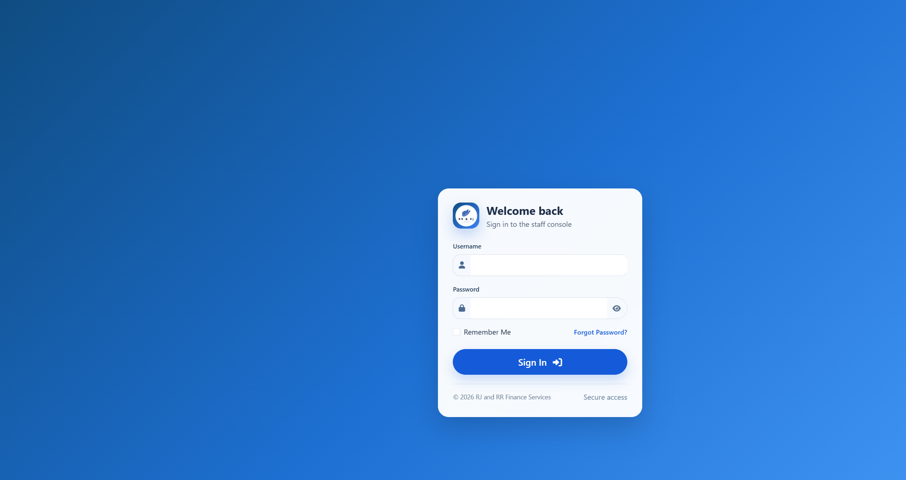
Figure B45. Protected collector dashboard reloaded after sign-out.

Figure B46 — PT-12
Scenario: Submit an incorrect, expired, and already used six-digit password-reset code.
Expected result: The password is not changed by an invalid code. The live reset flow uses a six-digit code that expires after ten minutes, allows five incorrect attempts, and is removed after a successful change. It does not issue a reset link.
Actual result: The forgot-password page asks for a username and says it will email a 6-digit code. It does not offer a reset link. The code form says the code expires in 10 minutes. A new code record was measured at 600 seconds. An incorrect code returned "That code is incorrect or has expired." After five incorrect attempts, the next try returned "Too many incorrect codes. Request a new code." and the code record was removed. A code whose expiry was already past returned the incorrect-or-expired message. A correct code allowed one password change, and that same code was then rejected. The borrower test password was restored afterward, and no reset row remained.
Status: PASS
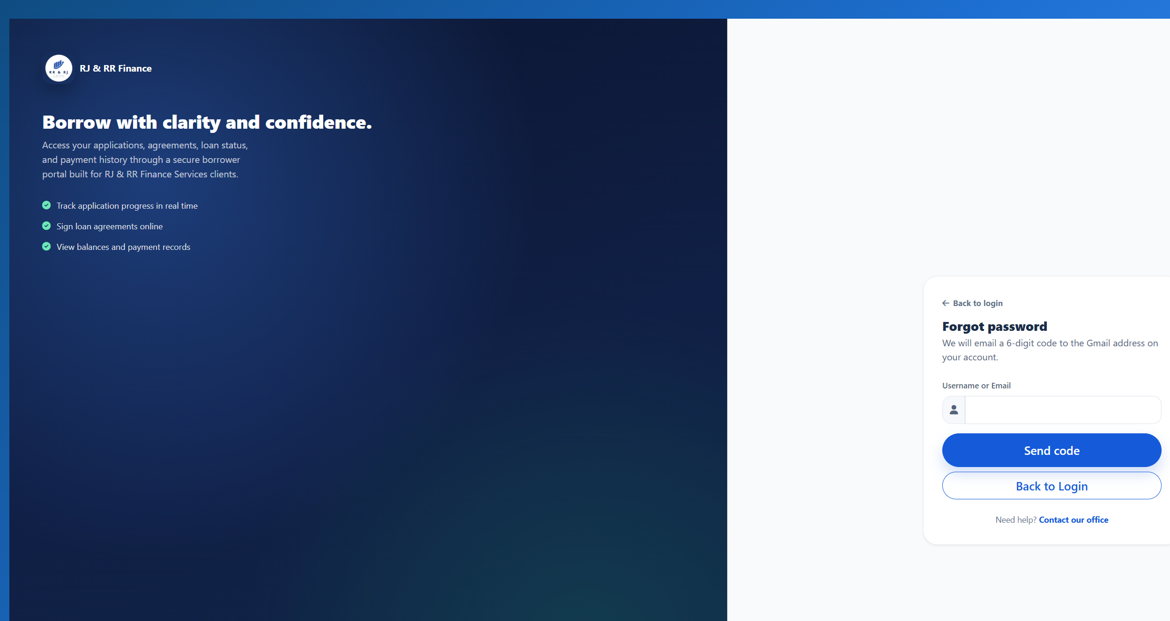
Figure B46. The reset page sends a 6-digit code and does not issue a link.
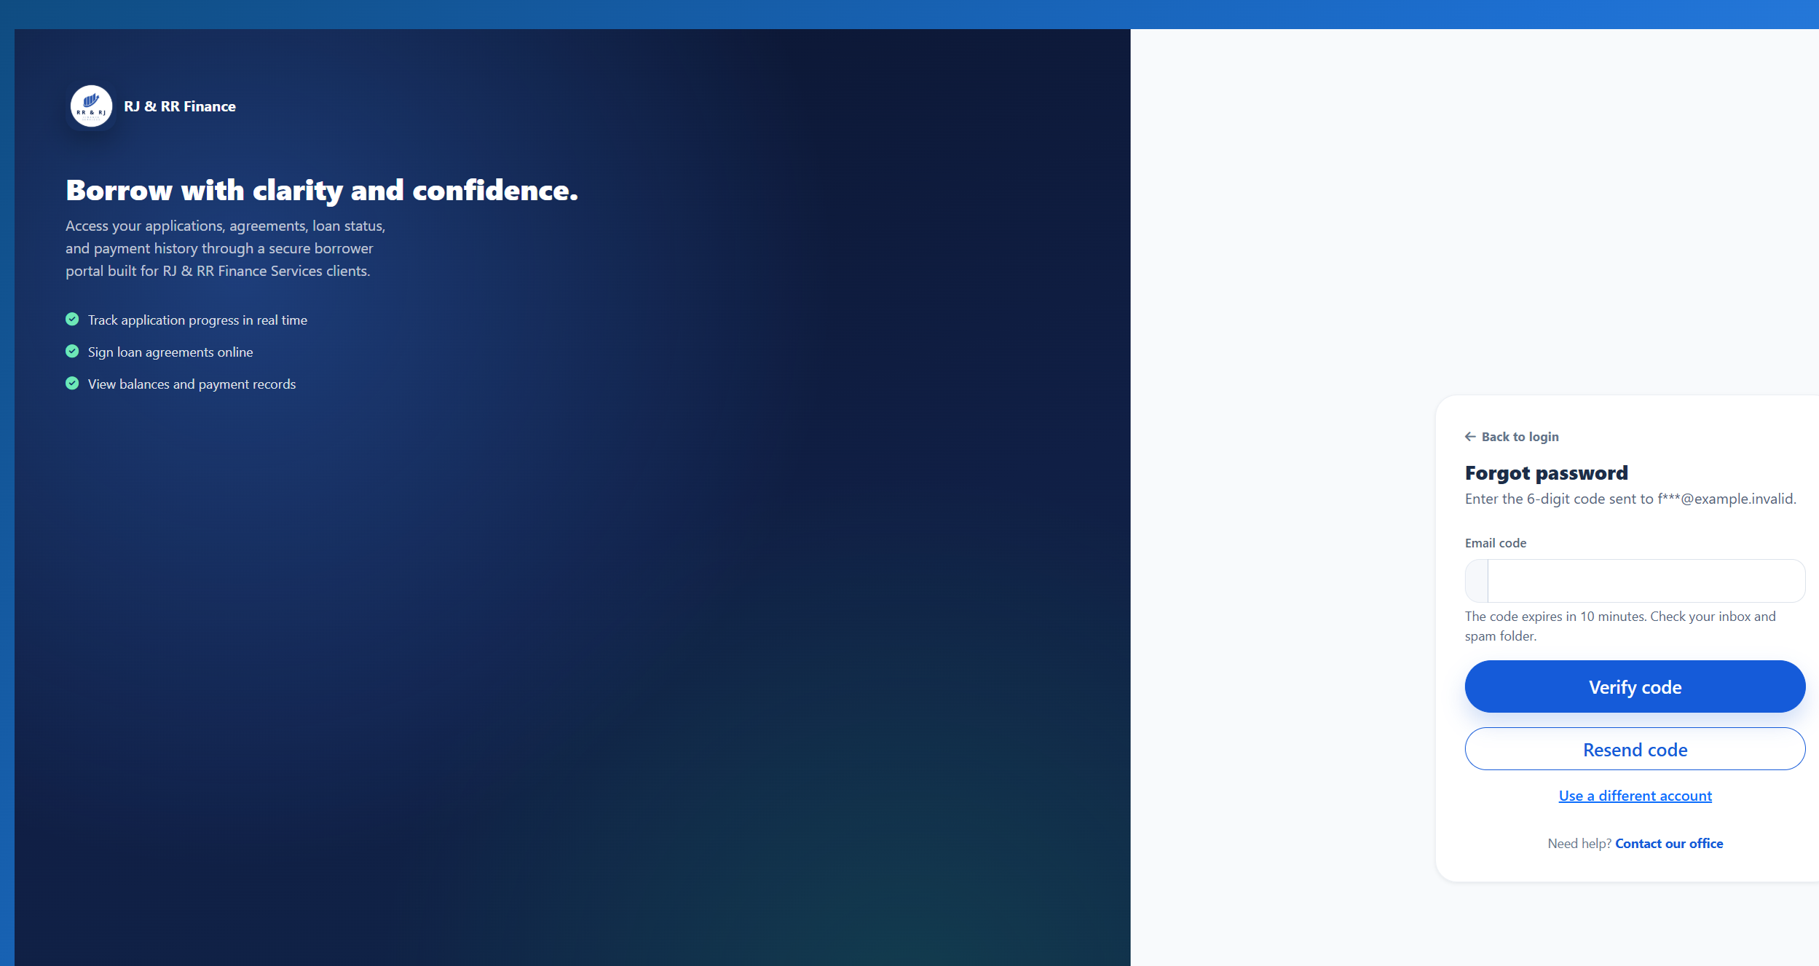
Figure B46. The code form states that the code expires in 10 minutes.
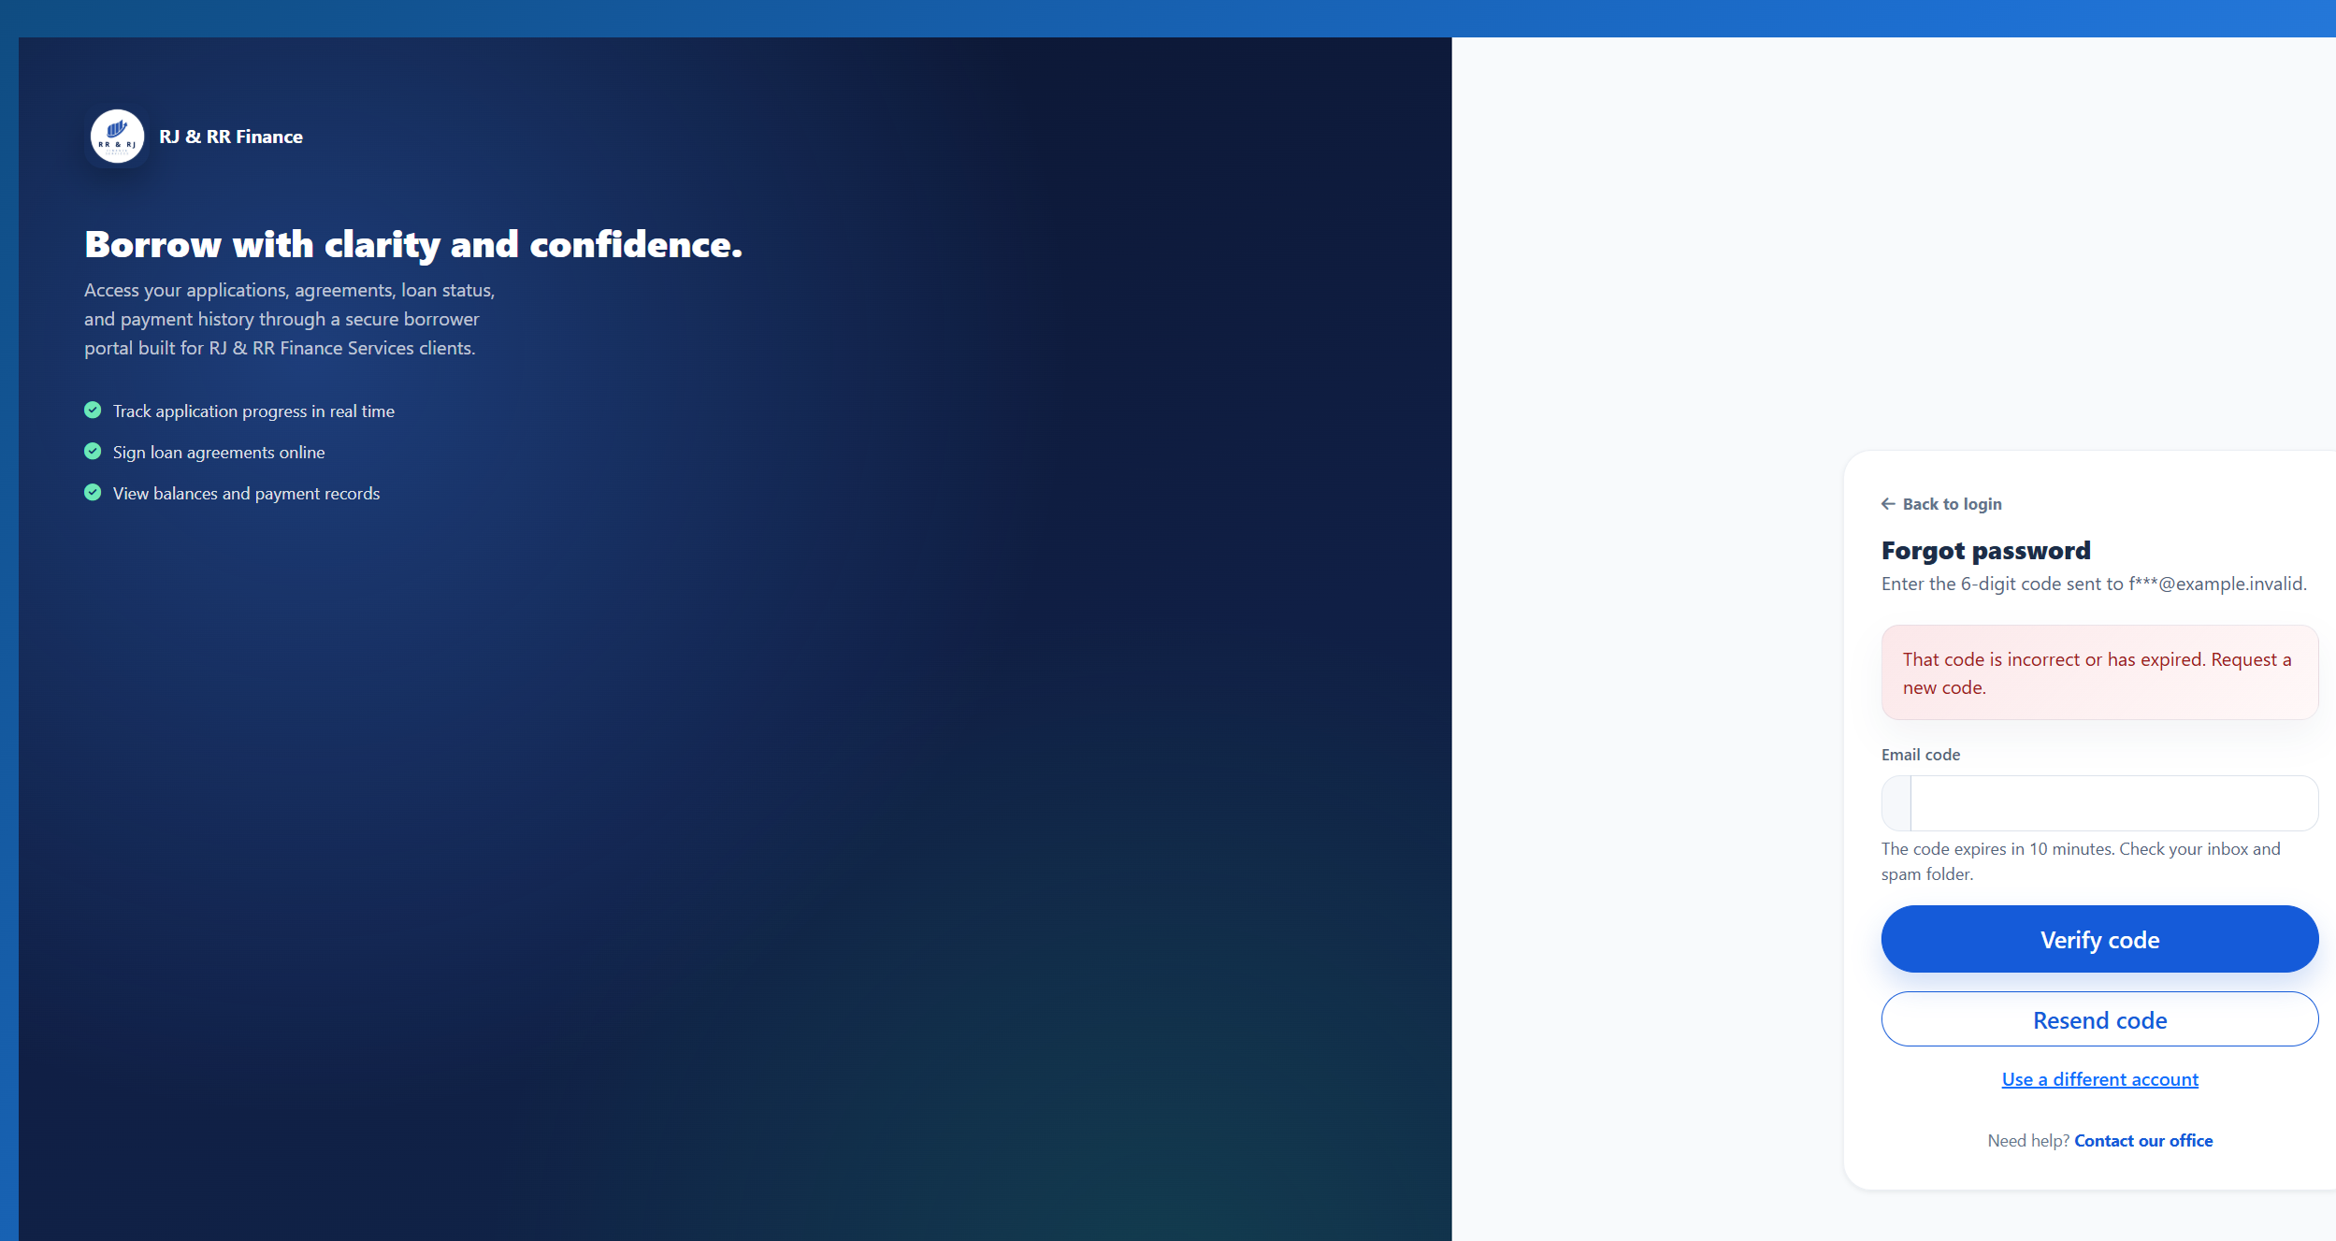
Figure B46. An incorrect code does not change the password.
Figure B46. The attempt after five incorrect codes is refused.
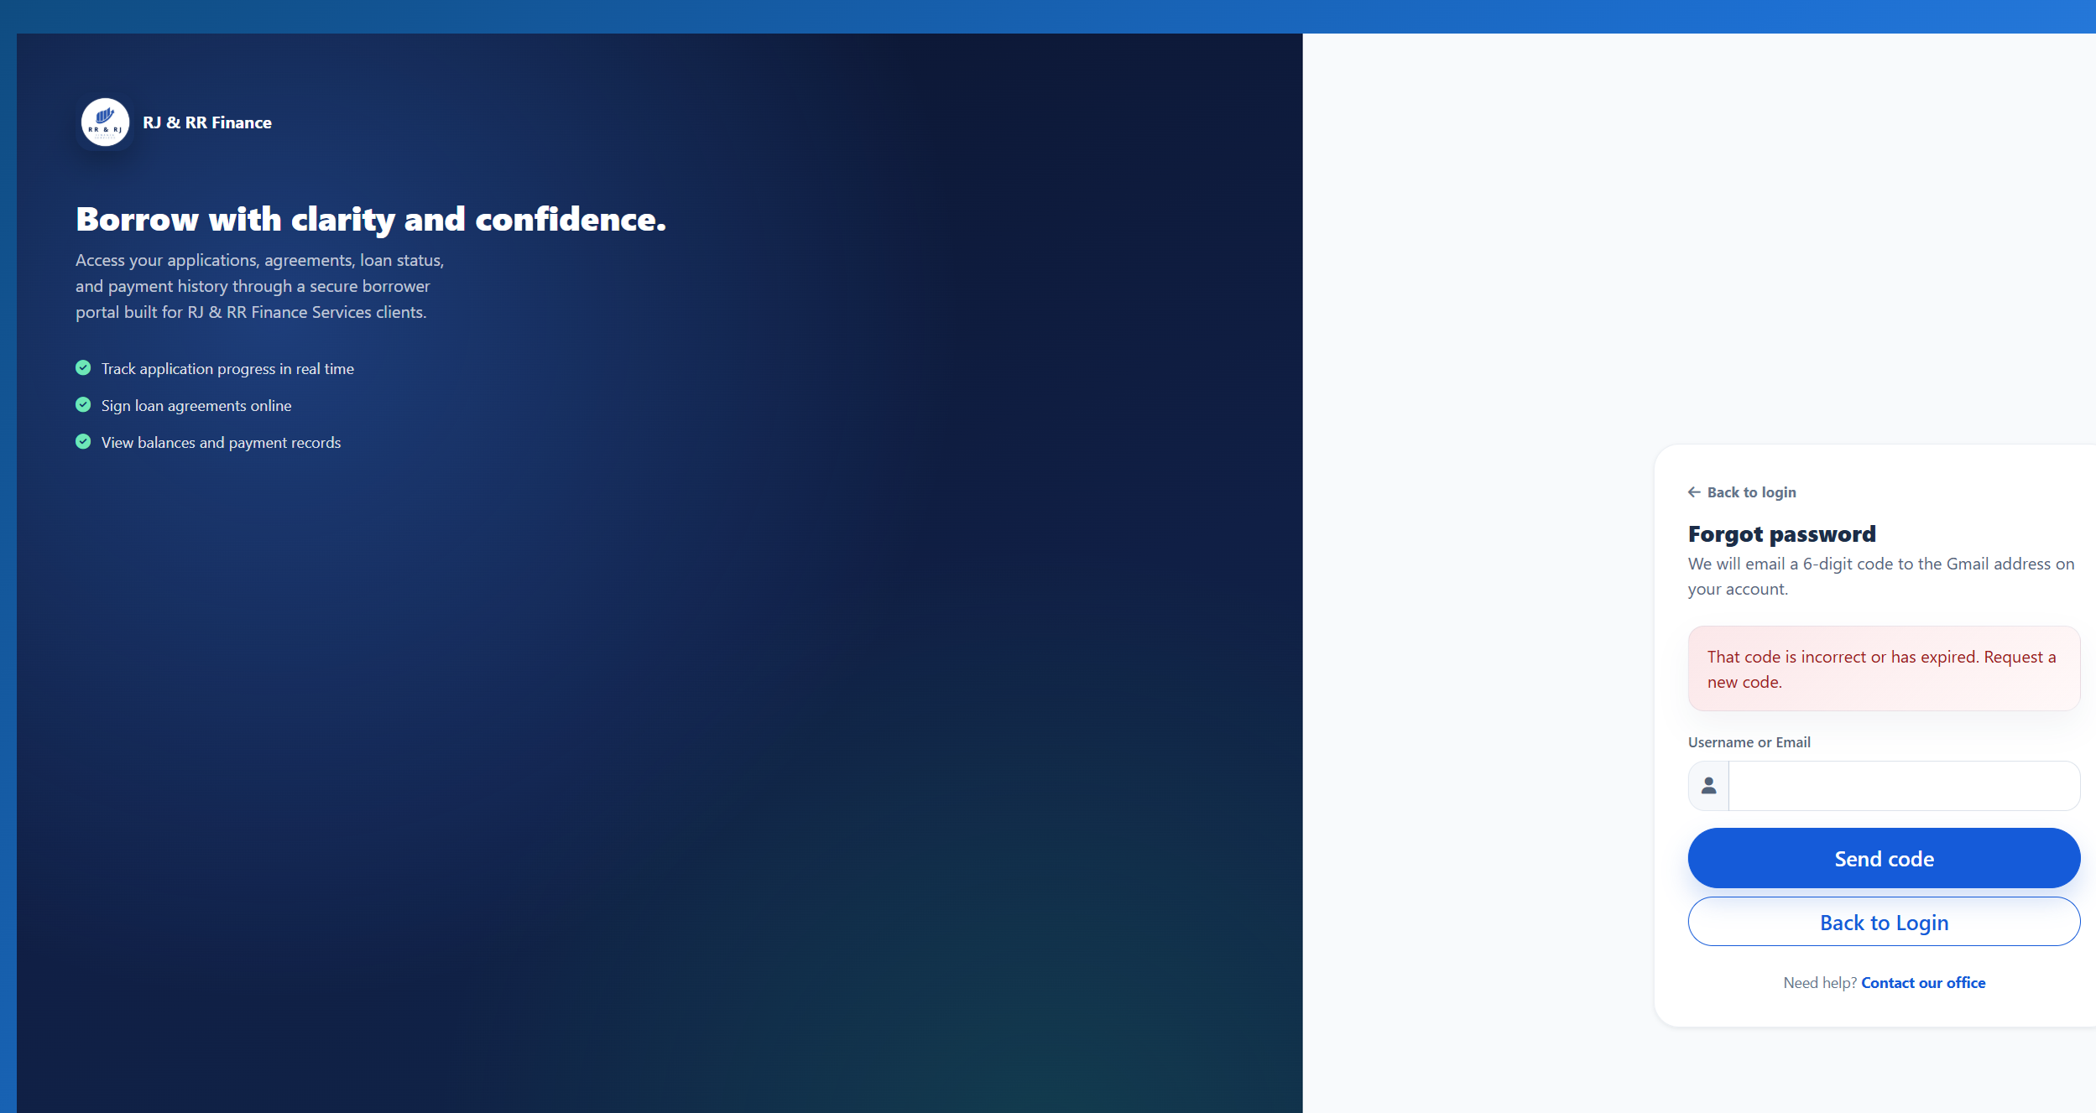
Figure B46. An expired code is refused.
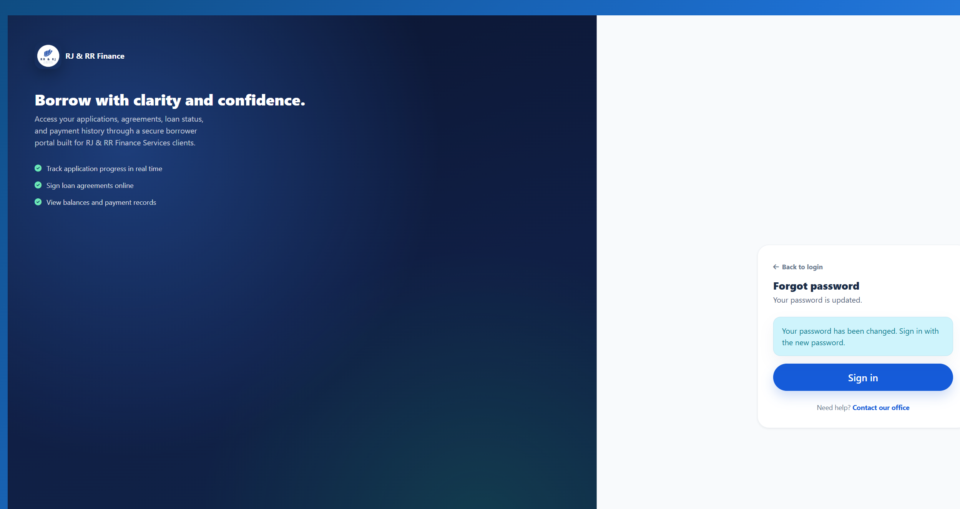
Figure B46. A valid code can be used once.
Figure B46. The same code is refused after the password change.

F. USER ACCEPTANCE TESTING
The manuscript reports 32 post-development evaluation respondents: 30 borrowers, one administrator, and one collector. The reported criterion means are 4.81 for functionality, 4.75 for usability, 4.78 for reliability, 4.81 for security, and 4.75 for performance, with an overall mean of 4.78. Under the Chapter III interpretation scale, each criterion and the overall mean fall within 4.21–5.00 (Strongly Agree).
Evidence limitation: the tally below is computed from the supplied respondent-level criterion scores (one rating per respondent for each of the five criteria). It verifies the stated criterion means from those scores, but it is not a transcription of all 20 individual questionnaire-item responses. The questionnaire added in Appendix I is a blank instrument template, not a completed response set.
Supporting records to retain: the questionnaire instrument administered, the 32 completed evaluation forms with personal information masked where appropriate, the respondent-role tally, and the original calculation sheet.
G. UAT TALLY AND WEIGHTED-MEAN COMPUTATION
The table reports the criterion-level frequency counts supplied for the 32 respondents. For each criterion, WM = [f(5)×5 + f(4)×4 + f(3)×3 + f(2)×2 + f(1)×1] / N. The overall mean is the average of the five unrounded criterion means. The 160 overall ratings are 32 respondents × 5 criteria; they are not 160 separate respondents.
Criterion | f(5) | f(4) | f(3) | f(2) | f(1) | N | Weighted mean
Functionality | 26 | 6 | 0 | 0 | 0 | 32 | 4.8125 ≈ 4.81
Usability | 24 | 8 | 0 | 0 | 0 | 32 | 4.7500 = 4.75
Reliability | 25 | 7 | 0 | 0 | 0 | 32 | 4.78125 ≈ 4.78
Security | 26 | 6 | 0 | 0 | 0 | 32 | 4.8125 ≈ 4.81
Performance | 24 | 8 | 0 | 0 | 0 | 32 | 4.7500 = 4.75
Overall | 125 | 35 | 0 | 0 | 0 | 160 ratings | 4.78125 ≈ 4.78
H. SUMMARY OF TESTING RESULTS
The retained PayMongo evidence is 9 passed cases, and the penetration evidence is 12 passed cases. Unit and integration counts are unchanged and are not restated here as newly executed passes. The 12 system cases remain not yet tested. This paragraph does not claim that all 46 documented cases passed, and it does not claim that QR generation or a live payment passed.
Testing level | Documented cases | Passed | Failed | Not yet tested | Blocked / needs setup
Unit testing | 6
Integration testing | 7
System testing | 12 | 0 | 0 | 12 | 0
PayMongo testing | 9 | 9 | 0 | 0 | 0
Penetration testing | 12 | 12 | 0 | 0 | 0
Total | 46 | 21* | 0* | 12* | 0*
The summary counts in this table show the retained PayMongo and penetration outcomes and the existing not-yet-tested count for system testing. The total row marked with an asterisk covers only these updated categories; the Unit and Integration rows remain as previously documented and are not recalculated here. Therefore, this table must not be read as a claim that all 46 test cases passed.
The attached PayMongo and penetration evidence documents are dated 19 October 2026 and use the isolated test server at 127.0.0.1:8099 with database frams_capstone_test. The existing lending_management database was not modified. No live PayMongo charge was created. System tests ST-01 through ST-12 still require execution and evidence before they can be reported as passed.

ATTACHED PAYMONGO QR PH TEST EVIDENCE — FIGURES B26–B34

FRAMS QR Ph test figures
Figures B26 to B34
Execution date: 19 October 2026. Environment: isolated FRAMS test server at http://127.0.0.1:8099 and database frams_capstone_test. The existing lending_management database was not modified. No live PayMongo charge was created.
PM-01 and PM-02 record the behavior available with the isolated invalid test key: PayMongo rejects creation, the QR page does not open, and the balance does not change. They do not show a PayMongo QR image.
Results: 12 passed, 0 failed, 0 blocked, 0 not executed.
Test ID | Figure | Status | Actual result
PM-01 | Figure B26 | PASS | The collector submitted E-Wallet for PHP 100.00 on FRAMS-DISP-01 while the balance was PHP 3,150.00. PayMongo returned HTTP 401 and rejected the isolated test key. The QR page did not open. The stored transaction status was failed, and it had no QR image. No repayment was created and the loan stayed Active. The provider text was redacted in the screenshot because it echoed part of the test key.
PM-02 | Figure B27 | PASS | The same screen as Figure B26 stayed on Record Payment. No QR image, QR amount, method block, or expiry was displayed. FRAMS-DISP-01 remained Active with remaining balance PHP 3,150.00.
PM-03 | Figure B28 | PASS | With Cash selected, the Create Dynamic QR Ph button was hidden and disabled. Cancel and Record Payment remained available. The loan and amount sections were collapsed only so the action row fit in the capture.
PM-04 | Figure B29 | PASS | Blank was stopped in the browser with "Please fill out this field." Zero reached the server and returned "Payment amount must be greater than zero." The nonnumeric value abc, after the number field was changed to text, returned "Enter a valid payment amount." None of the three created a QR image or a repayment.
PM-05 | Figure B30 | PASS | An amount of 4000.00 against a total due of PHP 3,150.00 was rejected: "Payment cannot exceed the current total amount due of PHP 3,150.00." No repayment was created.
PM-06 | Figure B31 | PASS | Collector A submitted loan 30, which is assigned to Collector B. The server responded "You are not assigned to this loan." The loan was not in Collector A's list, and no repayment was created.
PM-07 | Figure B32 | PASS | A signed-out request for the payments page opened the staff sign-in page. The signed-in borrower was redirected to Payment History. That page has no QR action. The borrower is turned away before the collector-only message is reached.
PM-08 | Figure B33 | PASS | An unresolved pending attempt on FRAMS-TEST-A could not be confirmed with PayMongo. The second request was refused: "The previous PayMongo QR Ph attempt could not be confirmed with PayMongo." The pending row stayed pending, the balance stayed PHP 3,833.34, and no new repayment was created. The supersede path was not applicable because PayMongo could not confirm the open attempt.
PM-09 | Figure B34 | PASS | The administrator payments screen shows View only. There is no edit or delete control. A delete request for payment 46 returned the refusal that a payment linked to a verified PayMongo QR Ph transaction was not deleted. Payment 46, receipt RJRR-20261018-000004, and the succeeded QR record remained. The client and borrower were not deleted.

Figure B26 — PM-01
Scenario: The assigned collector creates a QR Ph payment for a valid amount on a disposable unpaid loan.
Expected result: With the isolated invalid test key, PayMongo rejects QR creation. No QR page opens, no repayment is stored, and the loan balance stays unchanged. The attempt is saved as failed.
Actual result: The collector submitted E-Wallet for PHP 100.00 on FRAMS-DISP-01 while the balance was PHP 3,150.00. PayMongo returned HTTP 401 and rejected the isolated test key. The QR page did not open. The stored transaction status was failed, and it had no QR image. No repayment was created and the loan stayed Active. The provider text was redacted in the screenshot because it echoed part of the test key.
Status: PASS
Figure B26 (B26_pm01_qr_rejected.png)

Figure B27 — PM-02
Scenario: The pending QR page is compared with the loan balance before payment.
Expected result: When QR creation is rejected, the payment form stays open. No QR, QR amount, method, or expiry is shown. The balance and loan status stay unchanged.
Actual result: The same screen as Figure B26 stayed on Record Payment. No QR image, QR amount, method block, or expiry was displayed. FRAMS-DISP-01 remained Active with remaining balance PHP 3,150.00.
Status: PASS
Figure B27 (B26_pm01_qr_rejected.png)

Figure B28 — PM-03
Scenario: Cash is selected on the payment form.
Expected result: Create Dynamic QR Ph stays hidden. The ordinary cash payment action remains available.
Actual result: With Cash selected, the Create Dynamic QR Ph button was hidden and disabled. Cancel and Record Payment remained available. The loan and amount sections were collapsed only so the action row fit in the capture.
Status: PASS
Figure B28 (B28_pm03_cash_no_qr_button.png)

Figure B29 — PM-04
Scenario: Blank, zero, and nonnumeric QR amounts are submitted.
Expected result: No QR transaction is stored. A blank amount is stopped by the required field. Zero is rejected because the amount must be greater than zero. A nonnumeric value is also rejected.
Actual result: Blank was stopped in the browser with "Please fill out this field." Zero reached the server and returned "Payment amount must be greater than zero." The nonnumeric value abc, after the number field was changed to text, returned "Enter a valid payment amount." None of the three created a QR image or a repayment.
Status: PASS
Figure B29 (B29_pm04_blank_amount.png)
Figure B29 (B29_pm04_zero_amount.png)
Figure B29 (B29_pm04_nonnumeric.png)

Figure B30 — PM-05
Scenario: The QR amount is greater than the current total due.
Expected result: The request is rejected and no QR transaction is stored.
Actual result: An amount of 4000.00 against a total due of PHP 3,150.00 was rejected: "Payment cannot exceed the current total amount due of PHP 3,150.00." No repayment was created.
Status: PASS
Figure B30 (B30_pm05_amount_too_high.png)

Figure B31 — PM-06
Scenario: A test collector submits a QR Ph request for a disposable loan assigned to another collector.
Expected result: The server rejects the request. No pending QR transaction and no repayment are created.
Actual result: Collector A submitted loan 30, which is assigned to Collector B. The server responded "You are not assigned to this loan." The loan was not in Collector A's list, and no repayment was created.
Status: PASS
Figure B31 (B31_pm06_other_collector.png)

Figure B32 — PM-07
Scenario: A signed-out visitor opens the payments page, and a borrower attempts the collector QR request.
Expected result: The visitor is redirected to the staff sign-in page. The borrower is redirected to payment history and cannot start a QR payment.
Actual result: A signed-out request for the payments page opened the staff sign-in page. The signed-in borrower was redirected to Payment History. That page has no QR action. The borrower is turned away before the collector-only message is reached.
Status: PASS
Figure B32 (B32_pm07_signed_out_redirect.png)
Figure B32 (B32_pm07_borrower_history.png)

Figure B33 — PM-08
Scenario: A second QR Ph request is created while an earlier attempt for the same loan is unresolved.
Expected result: A second request is refused when a pending QR has not expired and PayMongo cannot confirm it.
Actual result: An unresolved pending attempt on FRAMS-TEST-A could not be confirmed with PayMongo. The second request was refused: "The previous PayMongo QR Ph attempt could not be confirmed with PayMongo." The pending row stayed pending, the balance stayed PHP 3,833.34, and no new repayment was created. The supersede path was not applicable because PayMongo could not confirm the open attempt.
Status: PASS
Figure B33 (B33_pm08_unconfirmed_pending_refused.png)

Figure B34 — PM-09
Scenario: An administrator submits deletion of a disposable repayment linked to a verified QR Ph transaction.
Expected result: The payments screen has no edit or delete control. The delete request is refused, and the payment, receipt, and QR record remain.
Actual result: The administrator payments screen shows View only. There is no edit or delete control. A delete request for payment 46 returned the refusal that a payment linked to a verified PayMongo QR Ph transaction was not deleted. Payment 46, receipt RJRR-20261018-000004, and the succeeded QR record remained. The client and borrower were not deleted.
Status: PASS
Figure B34 (B34_pm12_no_delete_control.png)

ATTACHED PENETRATION TEST EVIDENCE — FIGURES B35–B46

FRAMS penetration test figures
Figures B35 to B46
Execution date: 19 October 2026. Environment: isolated FRAMS test server at http://127.0.0.1:8099 and database frams_capstone_test. The existing lending_management database was not modified.
Results: 12 passed, 0 failed, 0 blocked, 0 not executed.
Test ID | Figure | Status | Actual result
PT-01 | Figure B35 | PASS | Signed-out requests for dashboard_lending.php, collector_dashboard_lending.php, payments_lending.php, and reports_lending.php each returned HTTP 302 to login_lending.php. The browser showed the staff sign-in page and no loan, client, or user records. Signed-out requests for borrower_dashboard_lending.php, borrower_my_loan_lending.php, and borrower_payment_history_lending.php each returned HTTP 302 to borrower_login_lending.php. The browser showed the borrower sign-in page.
PT-02 | Figure B36 | PASS | frams_test_admin with a wrong password stayed on the staff sign-in page and showed "Invalid username or password." frams_test_inactive, whose users.status is Inactive, with the ordinary test password stayed on the same page and showed the same message. Neither attempt opened a dashboard.
PT-03 | Figure B37 | PASS | Signed in as frams_test_borrower. users_lending.php, reports_lending.php, loan_release_lending.php, and expenses_lending.php each returned HTTP 302 to borrower_dashboard_lending.php. The browser showed the borrower dashboard, not user administration, reports, loan release, or expenses. payments_lending.php returned HTTP 302 to borrower_payment_history_lending.php. That history listed only this borrower's receipt RJRR-20261018-000004.
PT-04 | Figure B38 | PASS | Signed in as frams_test_collector. users_lending.php, reports_lending.php, borrower_approval_lending.php, and loan_release_lending.php each returned HTTP 302 to collector_dashboard_lending.php. The browser showed the collector dashboard. No user, approval, or release form was shown, and the user count stayed at 6.
PT-05 | Figure B39 | PASS | Registration, payment recording, expense recording, user management, and loan release were each posted without the security token. Borrower approval was not used. All five responses were HTTP 419 with the heading "Invalid or expired session" and the text "Please refresh the page and try again." Users stayed at 6, payments at 4, expenses at 0, and loan releases at 3. The probe username was not created.
PT-06 | Figure B40 | PASS | The staff sign-in username frams_test_admin' OR '1'='1 was rejected with "Invalid username or password" and stayed on the sign-in page. The same quote in user search returned "Showing 0 of 0 users" and "No users found." It did not list the administrator, collector, or borrower accounts.
PT-07 | Figure B41 | PASS | The user-search value <b>pt07marker</b> was returned in the page as encoded text. The search box showed the marker as ordinary characters, including the angle brackets. It was not rendered as bold text, and the search still listed 0 users. The payments flash message was not used.
PT-08 | Figure B42 | PASS | Signed in as frams_test_borrower. Requesting payments_lending.php?view=44, the receipt for Borrower B, returned HTTP 302 to borrower_payment_history_lending.php. The history still showed only RJRR-20261018-000004 and did not show RJRR-20261018-000002. Requesting download_loan_document_lending.php for a document path that does not belong to this borrower returned HTTP 403 and the text "Access denied."
PT-09 | Figure B43 | PASS | Signed in as frams_test_collector. Client 21, which is assigned to Collector B, returned HTTP 403: "You do not have permission to view this client." Loan 30, FRAMS-TEST-B, returned HTTP 403: "You do not have permission to view this loan." Payment 44 returned HTTP 403: "You do not have access to this receipt." None of the three records opened.
PT-10 | Figure B44 | PASS | On loan-application step 4, pt10-probe.txt was checked and rejected with "Allowed file types: JPG, PNG, PDF." A file of 8,389,633 bytes was rejected with "File must be 8 MB or smaller." Neither file was written to the document folder. The wizard does not keep that sentence on screen: it stays on step 4 and shows "Required documents missing," with every document still marked "Not uploaded yet."
PT-11 | Figure B45 | PASS | The collector signed out, which opened the staff sign-in page. Opening collector_dashboard_lending.php again returned HTTP 302 to login_lending.php. The browser showed the staff sign-in page, so the protected dashboard required authentication again.
PT-12 | Figure B46 | PASS | The forgot-password page asks for a username and says it will email a 6-digit code. It does not offer a reset link. The code form says the code expires in 10 minutes. A new code record was measured at 600 seconds. An incorrect code returned "That code is incorrect or has expired." After five incorrect attempts, the next try returned "Too many incorrect codes. Request a new code." and the code record was removed. A code whose expiry was already past returned the incorrect-or-expired message. A correct code allowed one password change, and that same code was then rejected. The borrower test password was restored afterward, and no reset row remained.

Figure B35 — PT-01
Scenario: Open the administrator dashboard, collector dashboard, payments, reports, and borrower pages while signed out.
Expected result: Staff pages redirect to the staff sign-in page. Borrower pages redirect to the borrower sign-in page. No records are shown.
Actual result: Signed-out requests for dashboard_lending.php, collector_dashboard_lending.php, payments_lending.php, and reports_lending.php each returned HTTP 302 to login_lending.php. The browser showed the staff sign-in page and no loan, client, or user records. Signed-out requests for borrower_dashboard_lending.php, borrower_my_loan_lending.php, and borrower_payment_history_lending.php each returned HTTP 302 to borrower_login_lending.php. The browser showed the borrower sign-in page.
Status: PASS
Figure B35. Staff sign-in after opening the administrator dashboard while signed out.
Figure B35. Borrower sign-in after opening the borrower dashboard while signed out.

Figure B36 — PT-02
Scenario: Sign in with a wrong password and with an inactive account.
Expected result: No protected page opens. The inactive trial uses the same staff message as a wrong password, and the account status supports that trial.
Actual result: frams_test_admin with a wrong password stayed on the staff sign-in page and showed "Invalid username or password." frams_test_inactive, whose users.status is Inactive, with the ordinary test password stayed on the same page and showed the same message. Neither attempt opened a dashboard.
Status: PASS
Figure B36. Wrong password for the active administrator.
Figure B36. Inactive administrator. The message matches the wrong-password trial.

Figure B37 — PT-03
Scenario: A borrower opens the users, reports, loan-release, expenses, and payments pages.
Expected result: Users, reports, loan release, and expenses return the borrower to the borrower dashboard. The payments page returns the borrower to that borrower payment history.
Actual result: Signed in as frams_test_borrower. users_lending.php, reports_lending.php, loan_release_lending.php, and expenses_lending.php each returned HTTP 302 to borrower_dashboard_lending.php. The browser showed the borrower dashboard, not user administration, reports, loan release, or expenses. payments_lending.php returned HTTP 302 to borrower_payment_history_lending.php. That history listed only this borrower's receipt RJRR-20261018-000004.
Status: PASS
Figure B37. Borrower dashboard after requesting user management.
Figure B37. Borrower payment history after requesting the staff payments page.

Figure B38 — PT-04
Scenario: A collector opens users, reports, borrower approval, and loan release.
Expected result: Each request returns to the collector dashboard, and no administrator record is changed.
Actual result: Signed in as frams_test_collector. users_lending.php, reports_lending.php, borrower_approval_lending.php, and loan_release_lending.php each returned HTTP 302 to collector_dashboard_lending.php. The browser showed the collector dashboard. No user, approval, or release form was shown, and the user count stayed at 6.
Status: PASS
Figure B38. Collector dashboard after requesting user management. Reports, borrower approval, and loan release returned to this same dashboard.

Figure B39 — PT-05
Scenario: Submit registration, payment recording, expense recording, user management, or loan release without the security token.
Expected result: The request ends with HTTP 419 and the message that the session is invalid or expired. No record is saved.
Actual result: Registration, payment recording, expense recording, user management, and loan release were each posted without the security token. Borrower approval was not used. All five responses were HTTP 419 with the heading "Invalid or expired session" and the text "Please refresh the page and try again." Users stayed at 6, payments at 4, expenses at 0, and loan releases at 3. The probe username was not created.
Status: PASS
Figure B39. Registration submitted without the security token. The other four posts returned this same page with HTTP 419.

Figure B40 — PT-06
Scenario: Enter a quote-style probe in sign-in and in a search box.
Expected result: Sign-in fails. Search does not reveal additional accounts, loans, or payments.
Actual result: The staff sign-in username frams_test_admin' OR '1'='1 was rejected with "Invalid username or password" and stayed on the sign-in page. The same quote in user search returned "Showing 0 of 0 users" and "No users found." It did not list the administrator, collector, or borrower accounts.
Status: PASS
Figure B40. Quote-style sign-in probe rejected.
Figure B40. Quote-style user search returned no accounts.

Figure B41 — PT-07
Scenario: Enter a harmless markup marker in an encoded search field and display it.
Expected result: The marker is shown as ordinary text.
Actual result: The user-search value <b>pt07marker</b> was returned in the page as encoded text. The search box showed the marker as ordinary characters, including the angle brackets. It was not rendered as bold text, and the search still listed 0 users. The payments flash message was not used.
Status: PASS
Figure B41. The markup marker remains visible as text in the search box.

Figure B42 — PT-08
Scenario: A borrower requests another borrower receipt address and document address.
Expected result: The receipt is refused or redirected, and the document request returns Access denied.
Actual result: Signed in as frams_test_borrower. Requesting payments_lending.php?view=44, the receipt for Borrower B, returned HTTP 302 to borrower_payment_history_lending.php. The history still showed only RJRR-20261018-000004 and did not show RJRR-20261018-000002. Requesting download_loan_document_lending.php for a document path that does not belong to this borrower returned HTTP 403 and the text "Access denied."
Status: PASS
Figure B42. Other-borrower receipt request returned to this borrower's own payment history.
Figure B42. Other-borrower document request. The response text is Access denied.

Figure B43 — PT-09
Scenario: A collector opens a client, loan, or payment assigned to another collector.
Expected result: The unassigned record is not opened for collection.
Actual result: Signed in as frams_test_collector. Client 21, which is assigned to Collector B, returned HTTP 403: "You do not have permission to view this client." Loan 30, FRAMS-TEST-B, returned HTTP 403: "You do not have permission to view this loan." Payment 44 returned HTTP 403: "You do not have access to this receipt." None of the three records opened.
Status: PASS
Figure B43. Collector A denied client 21.
Figure B43. Collector A denied loan 30.
Figure B43. Collector A denied payment 44.

Figure B44 — PT-10
Scenario: Upload a file that is not JPG, PNG, or PDF, and a file larger than 8 MB.
Expected result: The file is rejected and is not stored. A PDF is an allowed file and was not used as the invalid sample.
Actual result: On loan-application step 4, pt10-probe.txt was checked and rejected with "Allowed file types: JPG, PNG, PDF." A file of 8,389,633 bytes was rejected with "File must be 8 MB or smaller." Neither file was written to the document folder. The wizard does not keep that sentence on screen: it stays on step 4 and shows "Required documents missing," with every document still marked "Not uploaded yet."
Status: PASS
Figure B44. After the invalid uploads, step 4 still shows every document as not uploaded.

Figure B45 — PT-11
Scenario: After signing out, reload a protected page.
Expected result: The reloaded page redirects to the sign-in page.
Actual result: The collector signed out, which opened the staff sign-in page. Opening collector_dashboard_lending.php again returned HTTP 302 to login_lending.php. The browser showed the staff sign-in page, so the protected dashboard required authentication again.
Status: PASS
Figure B45. Protected collector dashboard reloaded after sign-out.

Figure B46 — PT-12
Scenario: Submit an incorrect, expired, and already used six-digit password-reset code.
Expected result: The password is not changed by an invalid code. The live reset flow uses a six-digit code that expires after ten minutes, allows five incorrect attempts, and is removed after a successful change. It does not issue a reset link.
Actual result: The forgot-password page asks for a username and says it will email a 6-digit code. It does not offer a reset link. The code form says the code expires in 10 minutes. A new code record was measured at 600 seconds. An incorrect code returned "That code is incorrect or has expired." After five incorrect attempts, the next try returned "Too many incorrect codes. Request a new code." and the code record was removed. A code whose expiry was already past returned the incorrect-or-expired message. A correct code allowed one password change, and that same code was then rejected. The borrower test password was restored afterward, and no reset row remained.
Status: PASS
Figure B46. The reset page sends a 6-digit code and does not issue a link.
Figure B46. The code form states that the code expires in 10 minutes.
Figure B46. An incorrect code does not change the password.
Figure B46. The attempt after five incorrect codes is refused.
Figure B46. An expired code is refused.
Figure B46. A valid code can be used once.
Figure B46. The same code is refused after the password change.

APPENDIX I
FRAMS USER ACCEPTANCE TESTING (UAT)
20-ITEM EVALUATION QUESTIONNAIRE
Purpose: This form gathers feedback about the Financial Risk Assessment and Micro-Lending System (FRAMS) after the respondent has used the system. This is a blank questionnaire template. It must not be treated as a completed response form.
Respondent code (optional): ____________________ Date: ____________________
User role: ☐ Borrower ☐ Collector ☐ Administrator
Instructions: Based on your actual experience using FRAMS, mark exactly one response for each statement.
Strongly Agree |  | Agree |  | Neutral |  |  | Disagree |  | Strongly Disagree
5 |  | 4 |  | 3 |  |  | 2 |  | 1
No. | Evaluation Statement |  | SA (5) |  | A (4) | N (3) |  | D (2) |  | SD (1)
A. Functionality
1 | FRAMS allows authorized users to log in and access functions appropriate to their assigned roles. |  | ☐ |  | ☐ | ☐ |  | ☐ |  | ☐
2 | FRAMS allows borrowers to submit the information required for loan applications. |  | ☐ |  | ☐ | ☐ |  | ☐ |  | ☐
3 | FRAMS calculates loan interest and repayment amounts according to the system’s implemented formula. |  | ☐ |  | ☐ | ☐ |  | ☐ |  | ☐
4 | FRAMS allows authorized personnel to record and monitor loan payments. |  | ☐ |  | ☐ | ☐ |  | ☐ |  | ☐
B. Usability
5 | The FRAMS interface is organized and easy to understand. |  | ☐ |  | ☐ | ☐ |  | ☐ |  | ☐
6 | Menus and navigation help me find the functions needed for my role. |  | ☐ |  | ☐ | ☐ |  | ☐ |  | ☐
7 | Forms provide understandable instructions or validation messages when needed. |  | ☐ |  | ☐ | ☐ |  | ☐ |  | ☐
8 | I can complete the tasks relevant to my role without unnecessary difficulty. |  | ☐ |  | ☐ | ☐ |  | ☐ |  | ☐
C. Reliability
9 | FRAMS saves borrower, loan, and payment records consistently. |  | ☐ |  | ☐ | ☐ |  | ☐ |  | ☐
10 | Loan balances and installment schedules reflect the recorded transactions. |  | ☐ |  | ☐ | ☐ |  | ☐ |  | ☐
11 | FRAMS provides consistent information when I revisit a record or report. |  | ☐ |  | ☐ | ☐ |  | ☐ |  | ☐
12 | The system handles routine operations without unexpected interruption during my use. |  | ☐ |  | ☐ | ☐ |  | ☐ |  | ☐
D. Security
13 | FRAMS restricts pages and records according to the user’s assigned role. |  | ☐ |  | ☐ | ☐ |  | ☐ |  | ☐
14 | I can access only the information and functions permitted for my account. |  | ☐ |  | ☐ | ☐ |  | ☐ |  | ☐
15 | The system requires authentication before protected pages can be accessed. |  | ☐ |  | ☐ | ☐ |  | ☐ |  | ☐
16 | FRAMS provides appropriate protection for borrower and loan information during normal use. |  | ☐ |  | ☐ | ☐ |  | ☐ |  | ☐
E. Performance
17 | FRAMS loads the pages needed for my tasks within a reasonable time. |  | ☐ |  | ☐ | ☐ |  | ☐ |  | ☐
18 | The system processes routine forms and transactions within a reasonable time. |  | ☐ |  | ☐ | ☐ |  | ☐ |  | ☐
19 | FRAMS displays reports and loan information without excessive delay. |  | ☐ |  | ☐ | ☐ |  | ☐ |  | ☐
20 | The system remains responsive while I perform normal tasks. |  | ☐ |  | ☐ | ☐ |  | ☐ |  | ☐
Instrument and evidence note. The five criteria and five-point response scale align with Chapter III and Table 4.10. This instrument contains 20 statements (four per criterion). The criterion-level tally reported in Appendix G is a summary of the supplied criterion ratings; it cannot be used to reconstruct or claim the individual answers to these 20 statements. Use the actual completed forms to verify item-level frequencies before submitting the manuscript.

APPENDIX J
USER ACCEPTANCE TESTING (UAT) EVIDENCE
Purpose. This appendix records the calculation evidence supporting the UAT weighted means reported in Chapter IV. The computation is based on the supplied criterion-level ratings for 32 respondents. It is not a substitute for the original completed questionnaires.
Respondent profile reported in the manuscript: 30 borrowers, 1 administrator, and 1 collector (32 respondents total). Rating scale: 5 = Strongly Agree, 4 = Agree, 3 = Neutral, 2 = Disagree, and 1 = Strongly Disagree.
Weighted Mean Formula
WM = Σ(f × x) / N
Where f is the frequency for a rating, x is the numerical rating, and N is the number of valid ratings for that criterion.
Criterion | f(5) | f(4) | f(3) | f(2) | f(1) | N | Weighted Mean
Functionality | 26 | 6 | 0 | 0 | 0 | 32 | (26×5 + 6×4)/32 = 4.81
Usability | 24 | 8 | 0 | 0 | 0 | 32 | (24×5 + 8×4)/32 = 4.75
Reliability | 25 | 7 | 0 | 0 | 0 | 32 | (25×5 + 7×4)/32 = 4.78
Security | 26 | 6 | 0 | 0 | 0 | 32 | (26×5 + 6×4)/32 = 4.81
Performance | 24 | 8 | 0 | 0 | 0 | 32 | (24×5 + 8×4)/32 = 4.75
Overall | 125 | 35 | 0 | 0 | 0 | 160 ratings | 765/160 = 4.78
Step-by-step overall computation. Strongly Agree total = 26 + 24 + 25 + 26 + 24 = 125. Agree total = 6 + 8 + 7 + 6 + 8 = 35. Weighted score = (125×5) + (35×4) = 625 + 140 = 765. Total criterion-level ratings = 32 respondents × 5 criteria = 160. Overall weighted mean = 765 ÷ 160 = 4.78125, rounded to 4.78.
Evidence integrity and verification. The counts above are based on the supplied respondent-level criterion ratings. They confirm the arithmetic of the five criterion means but do not reveal each respondent’s answer to each of the 20 questionnaire items. Attach or retain the actual completed forms and original tally sheet, with personal information masked where appropriate, and verify that their counts match before final submission. The blank questionnaire in Appendix I is the instrument template, not evidence of completed responses.
UAT evidence checklist
☐ Blank 20-item questionnaire used as the evaluation instrument.
☐ Thirty-two completed forms retained securely; redact personal identifiers in manuscript copies.
☐ Respondent profile tally confirms 30 borrowers, 1 administrator, and 1 collector.
☐ Original item-level tally checked against the criterion-level counts in this appendix.
☐ Excel calculation workbook retained as supporting computation evidence.

