FRAMS penetration test figures
Figures B38 to B49
Execution date: 19 October 2026. Environment: isolated FRAMS test server at http://127.0.0.1:8099 and database frams_capstone_test. The existing lending_management database was not modified.
Results: 12 passed, 0 failed, 0 blocked, 0 not executed.
Test ID | Figure | Status | Actual result
PT-01 | Figure B38 | PASS | Signed-out requests for dashboard_lending.php, collector_dashboard_lending.php, payments_lending.php, and reports_lending.php each returned HTTP 302 to login_lending.php. The browser showed the staff sign-in page and no loan, client, or user records. Signed-out requests for borrower_dashboard_lending.php, borrower_my_loan_lending.php, and borrower_payment_history_lending.php each returned HTTP 302 to borrower_login_lending.php. The browser showed the borrower sign-in page.
PT-02 | Figure B39 | PASS | frams_test_admin with a wrong password stayed on the staff sign-in page and showed "Invalid username or password." frams_test_inactive, whose users.status is Inactive, with the ordinary test password stayed on the same page and showed the same message. Neither attempt opened a dashboard.
PT-03 | Figure B40 | PASS | Signed in as frams_test_borrower. users_lending.php, reports_lending.php, loan_release_lending.php, and expenses_lending.php each returned HTTP 302 to borrower_dashboard_lending.php. The browser showed the borrower dashboard, not user administration, reports, loan release, or expenses. payments_lending.php returned HTTP 302 to borrower_payment_history_lending.php. That history listed only this borrower's receipt RJRR-20261018-000004.
PT-04 | Figure B41 | PASS | Signed in as frams_test_collector. users_lending.php, reports_lending.php, borrower_approval_lending.php, and loan_release_lending.php each returned HTTP 302 to collector_dashboard_lending.php. The browser showed the collector dashboard. No user, approval, or release form was shown, and the user count stayed at 6.
PT-05 | Figure B42 | PASS | Registration, payment recording, expense recording, user management, and loan release were each posted without the security token. Borrower approval was not used. All five responses were HTTP 419 with the heading "Invalid or expired session" and the text "Please refresh the page and try again." Users stayed at 6, payments at 4, expenses at 0, and loan releases at 3. The probe username was not created.
PT-06 | Figure B43 | PASS | The staff sign-in username frams_test_admin' OR '1'='1 was rejected with "Invalid username or password" and stayed on the sign-in page. The same quote in user search returned "Showing 0 of 0 users" and "No users found." It did not list the administrator, collector, or borrower accounts.
PT-07 | Figure B44 | PASS | The user-search value <b>pt07marker</b> was returned in the page as encoded text. The search box showed the marker as ordinary characters, including the angle brackets. It was not rendered as bold text, and the search still listed 0 users. The payments flash message was not used.
PT-08 | Figure B45 | PASS | Signed in as frams_test_borrower. Requesting payments_lending.php?view=44, the receipt for Borrower B, returned HTTP 302 to borrower_payment_history_lending.php. The history still showed only RJRR-20261018-000004 and did not show RJRR-20261018-000002. Requesting download_loan_document_lending.php for a document path that does not belong to this borrower returned HTTP 403 and the text "Access denied."
PT-09 | Figure B46 | PASS | Signed in as frams_test_collector. Client 21, which is assigned to Collector B, returned HTTP 403: "You do not have permission to view this client." Loan 30, FRAMS-TEST-B, returned HTTP 403: "You do not have permission to view this loan." Payment 44 returned HTTP 403: "You do not have access to this receipt." None of the three records opened.
PT-10 | Figure B47 | PASS | On loan-application step 4, pt10-probe.txt was checked and rejected with "Allowed file types: JPG, PNG, PDF." A file of 8,389,633 bytes was rejected with "File must be 8 MB or smaller." Neither file was written to the document folder. The wizard does not keep that sentence on screen: it stays on step 4 and shows "Required documents missing," with every document still marked "Not uploaded yet."
PT-11 | Figure B48 | PASS | The collector signed out, which opened the staff sign-in page. Opening collector_dashboard_lending.php again returned HTTP 302 to login_lending.php. The browser showed the staff sign-in page, so the protected dashboard required authentication again.
PT-12 | Figure B49 | PASS | The forgot-password page asks for a username and says it will email a 6-digit code. It does not offer a reset link. The code form says the code expires in 10 minutes. A new code record was measured at 600 seconds. An incorrect code returned "That code is incorrect or has expired." After five incorrect attempts, the next try returned "Too many incorrect codes. Request a new code." and the code record was removed. A code whose expiry was already past returned the incorrect-or-expired message. A correct code allowed one password change, and that same code was then rejected. The borrower test password was restored afterward, and no reset row remained.

Figure B38 — PT-01
Scenario: Open the administrator dashboard, collector dashboard, payments, reports, and borrower pages while signed out.
Expected result: Staff pages redirect to the staff sign-in page. Borrower pages redirect to the borrower sign-in page. No records are shown.
Actual result: Signed-out requests for dashboard_lending.php, collector_dashboard_lending.php, payments_lending.php, and reports_lending.php each returned HTTP 302 to login_lending.php. The browser showed the staff sign-in page and no loan, client, or user records. Signed-out requests for borrower_dashboard_lending.php, borrower_my_loan_lending.php, and borrower_payment_history_lending.php each returned HTTP 302 to borrower_login_lending.php. The browser showed the borrower sign-in page.
Status: PASS
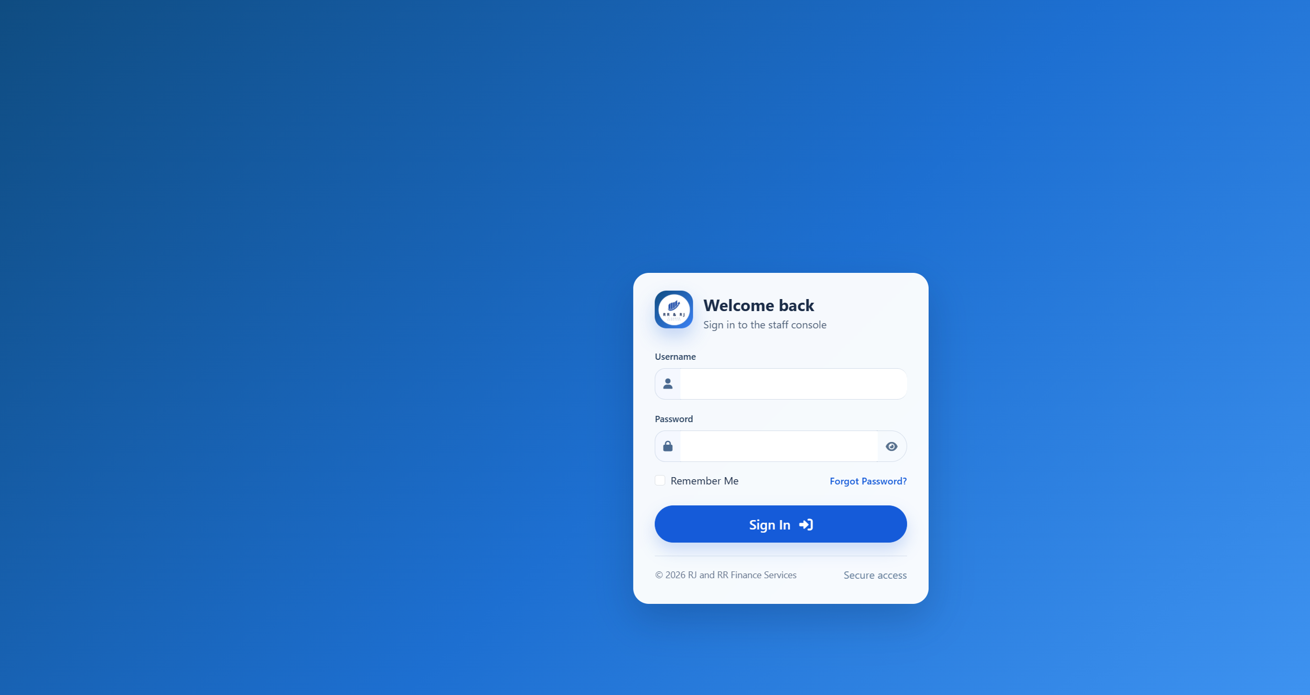
Figure B38. Staff sign-in after opening the administrator dashboard while signed out.
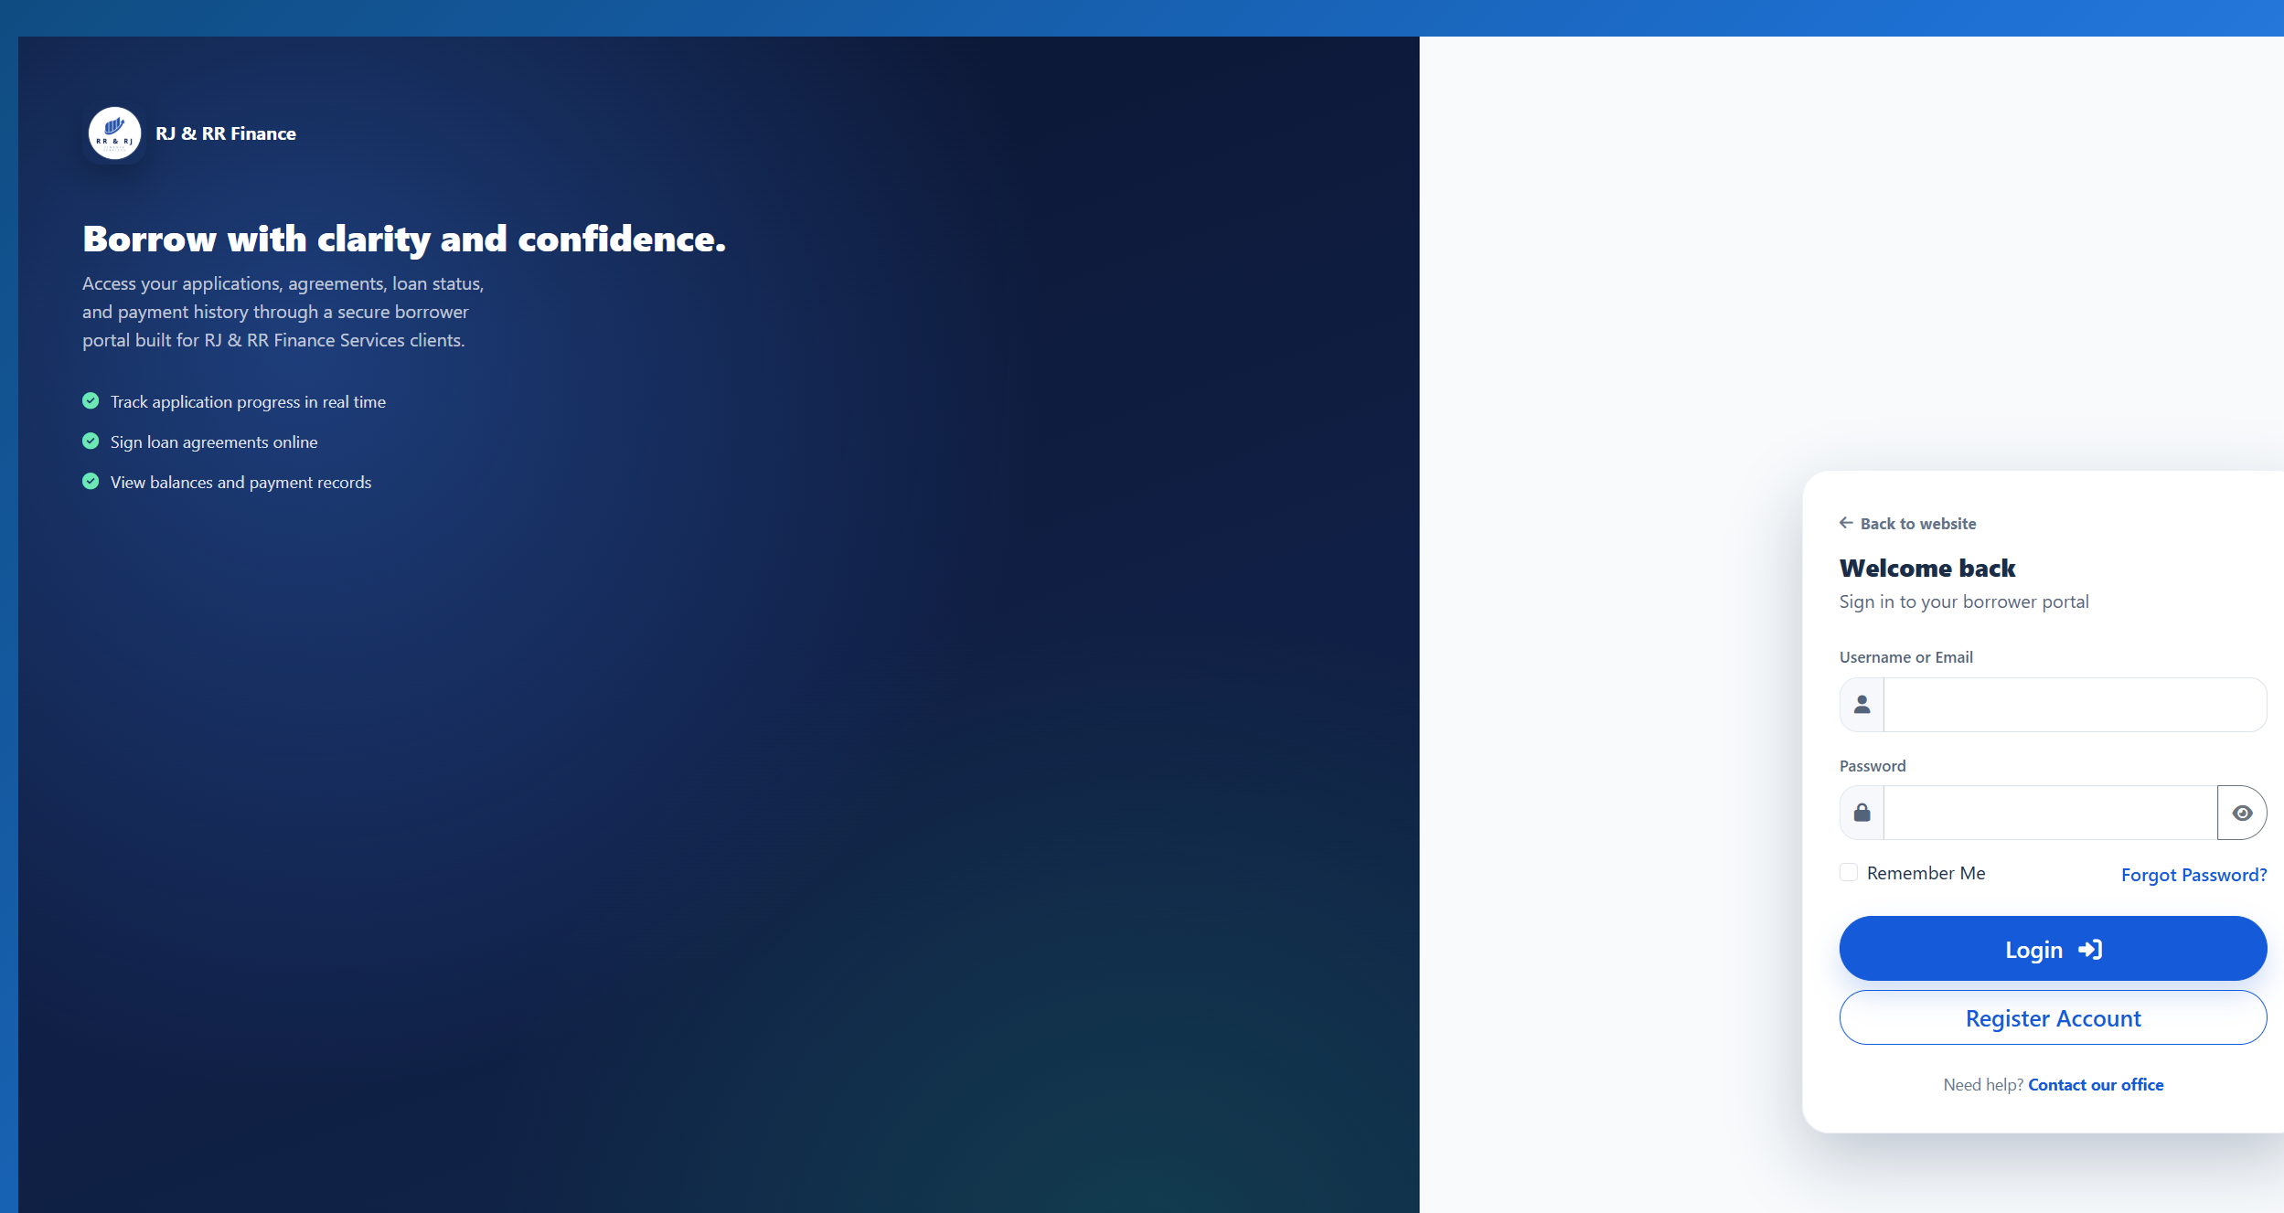
Figure B38. Borrower sign-in after opening the borrower dashboard while signed out.

Figure B39 — PT-02
Scenario: Sign in with a wrong password and with an inactive account.
Expected result: No protected page opens. The inactive trial uses the same staff message as a wrong password, and the account status supports that trial.
Actual result: frams_test_admin with a wrong password stayed on the staff sign-in page and showed "Invalid username or password." frams_test_inactive, whose users.status is Inactive, with the ordinary test password stayed on the same page and showed the same message. Neither attempt opened a dashboard.
Status: PASS
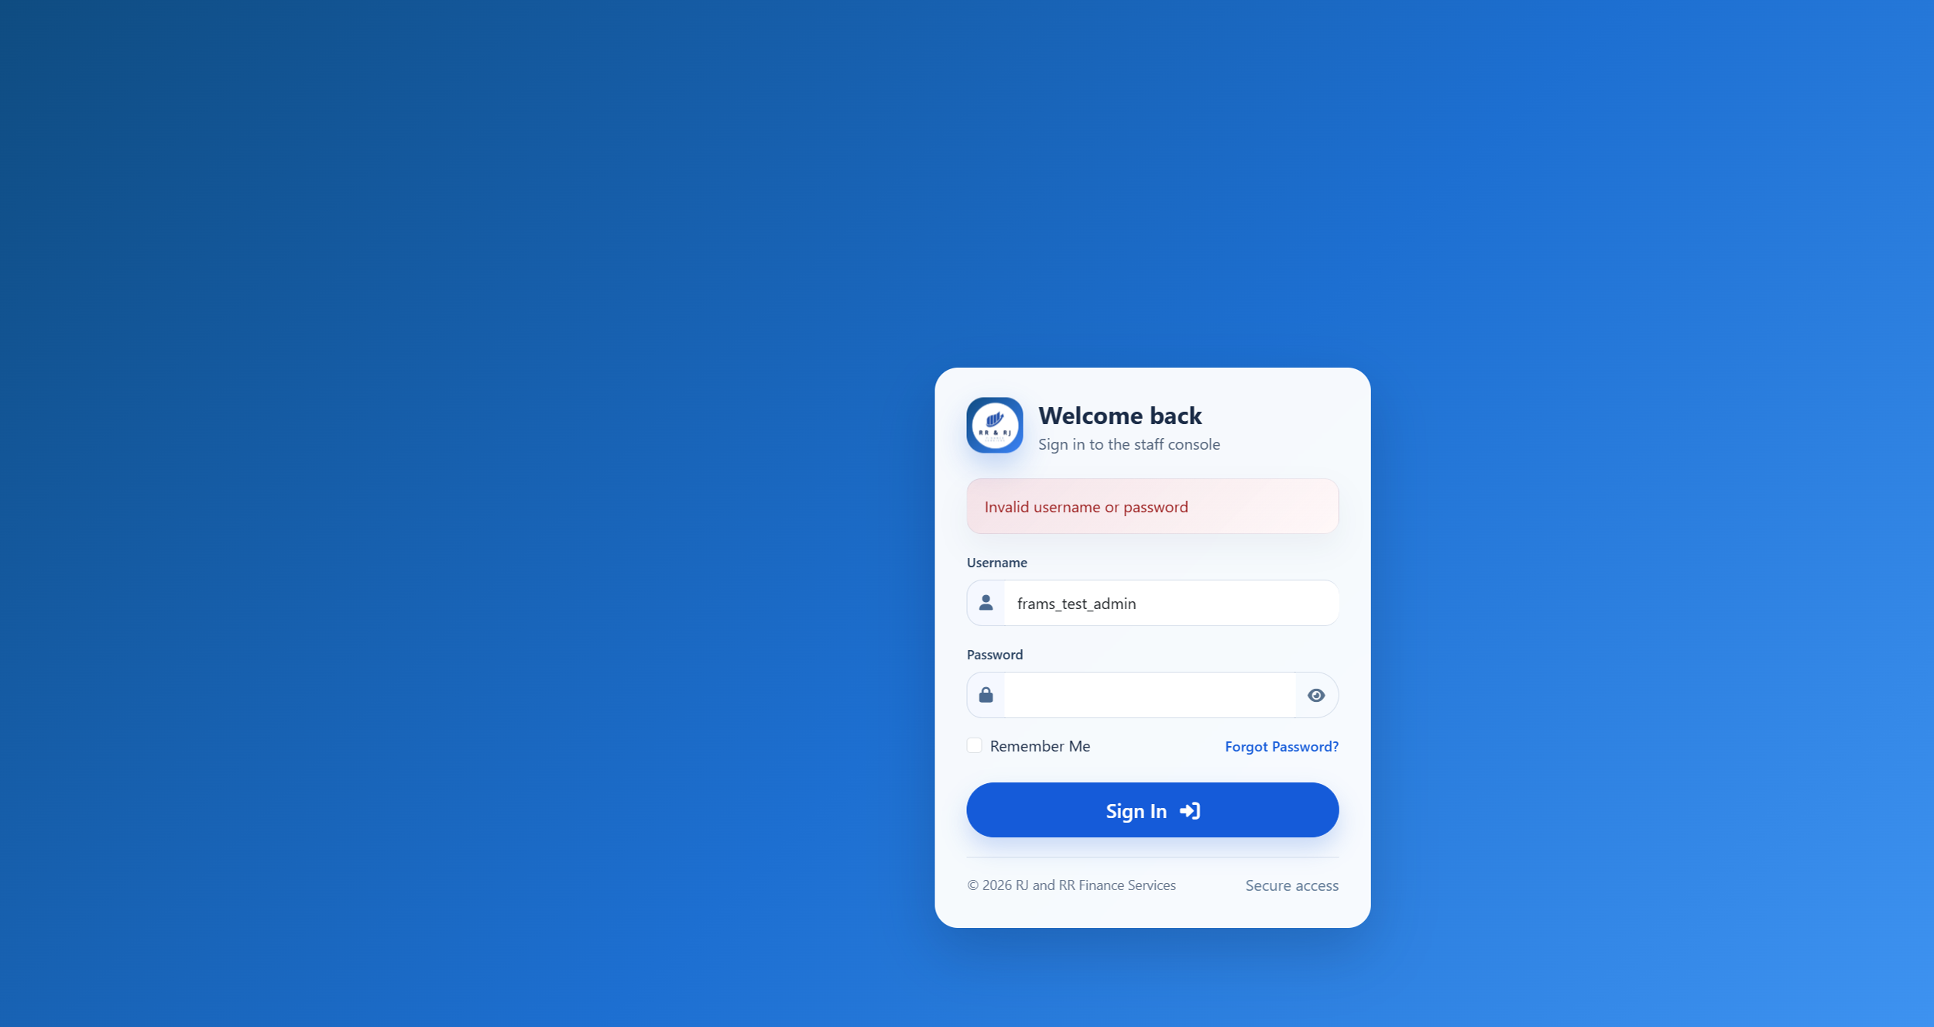
Figure B39. Wrong password for the active administrator.
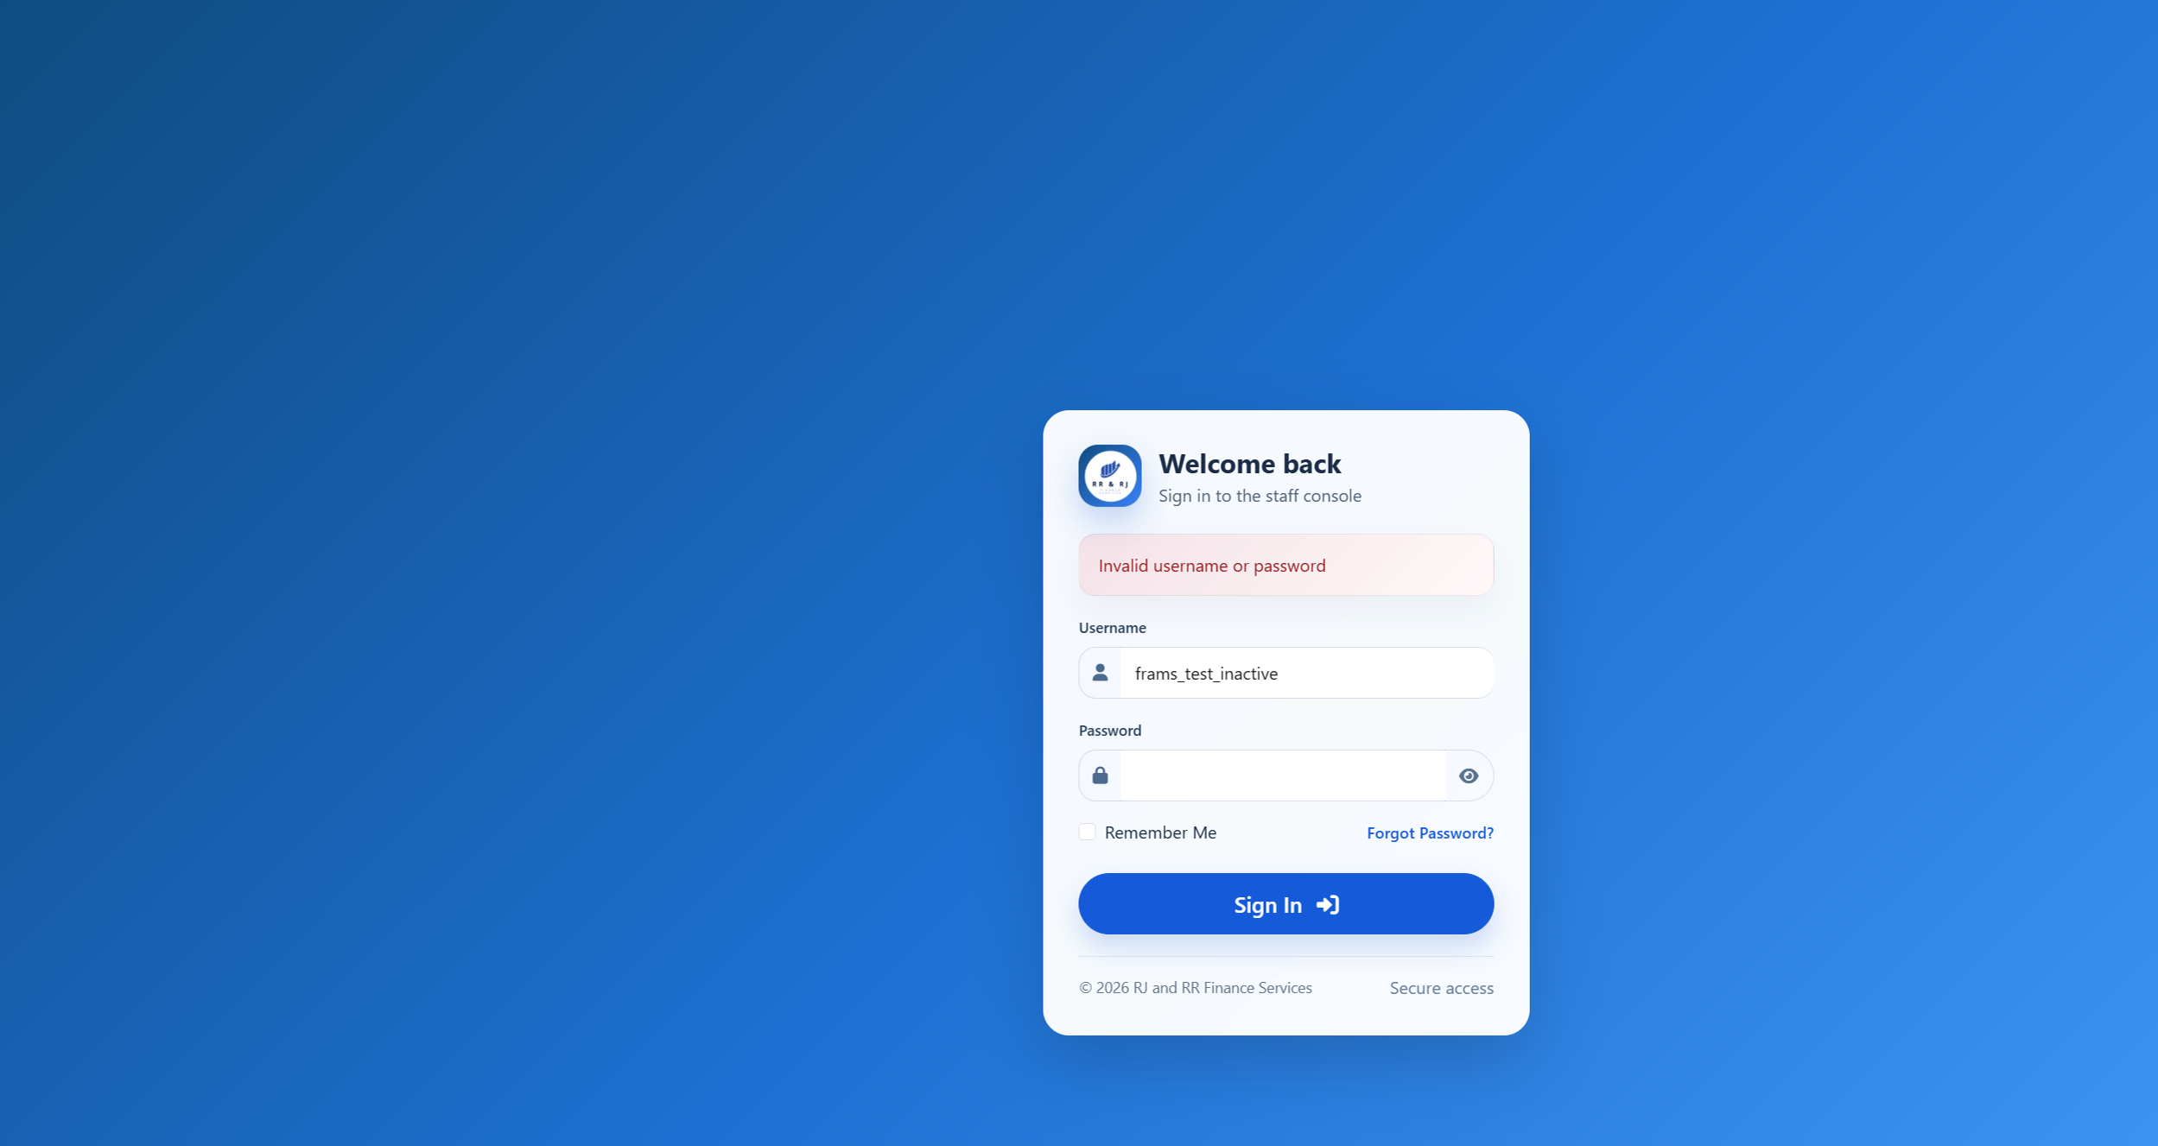
Figure B39. Inactive administrator. The message matches the wrong-password trial.

Figure B40 — PT-03
Scenario: A borrower opens the users, reports, loan-release, expenses, and payments pages.
Expected result: Users, reports, loan release, and expenses return the borrower to the borrower dashboard. The payments page returns the borrower to that borrower payment history.
Actual result: Signed in as frams_test_borrower. users_lending.php, reports_lending.php, loan_release_lending.php, and expenses_lending.php each returned HTTP 302 to borrower_dashboard_lending.php. The browser showed the borrower dashboard, not user administration, reports, loan release, or expenses. payments_lending.php returned HTTP 302 to borrower_payment_history_lending.php. That history listed only this borrower's receipt RJRR-20261018-000004.
Status: PASS
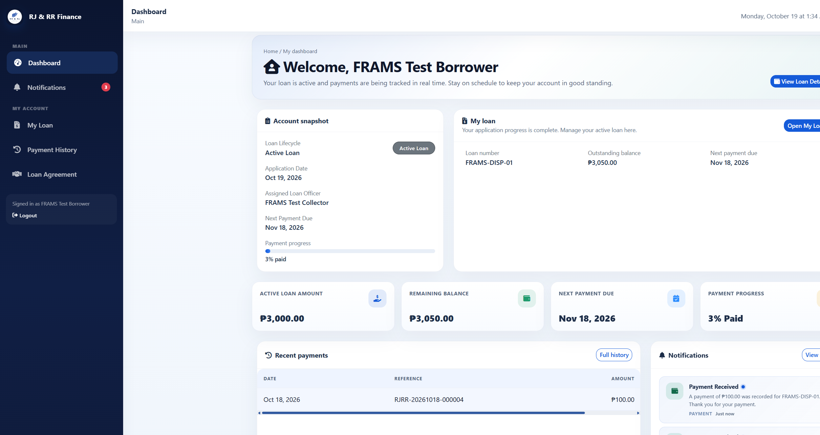
Figure B40. Borrower dashboard after requesting user management.
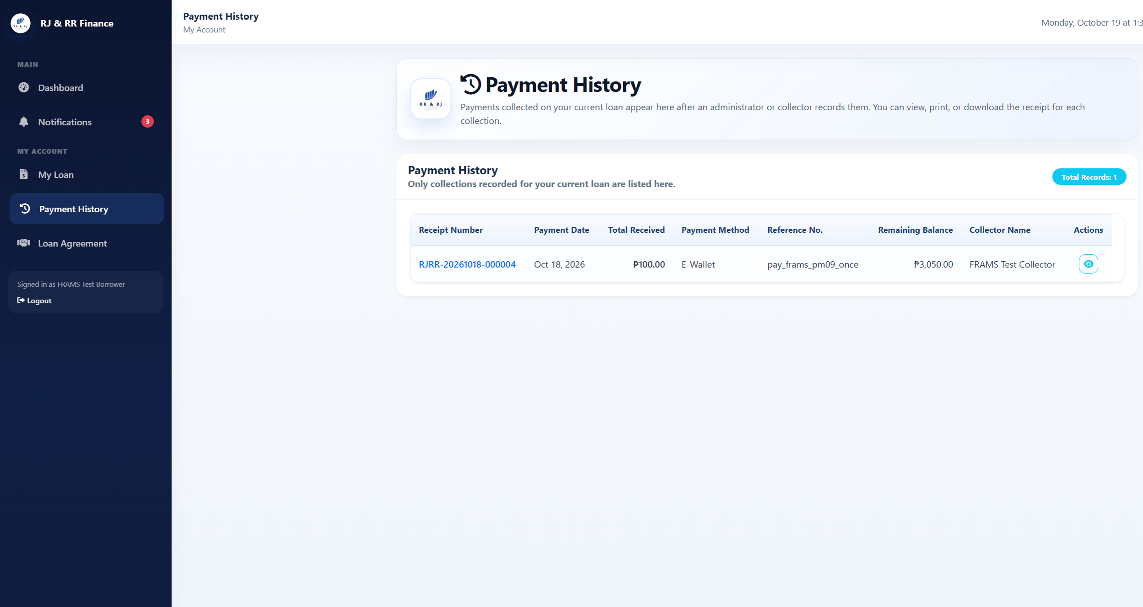
Figure B40. Borrower payment history after requesting the staff payments page.

Figure B41 — PT-04
Scenario: A collector opens users, reports, borrower approval, and loan release.
Expected result: Each request returns to the collector dashboard, and no administrator record is changed.
Actual result: Signed in as frams_test_collector. users_lending.php, reports_lending.php, borrower_approval_lending.php, and loan_release_lending.php each returned HTTP 302 to collector_dashboard_lending.php. The browser showed the collector dashboard. No user, approval, or release form was shown, and the user count stayed at 6.
Status: PASS
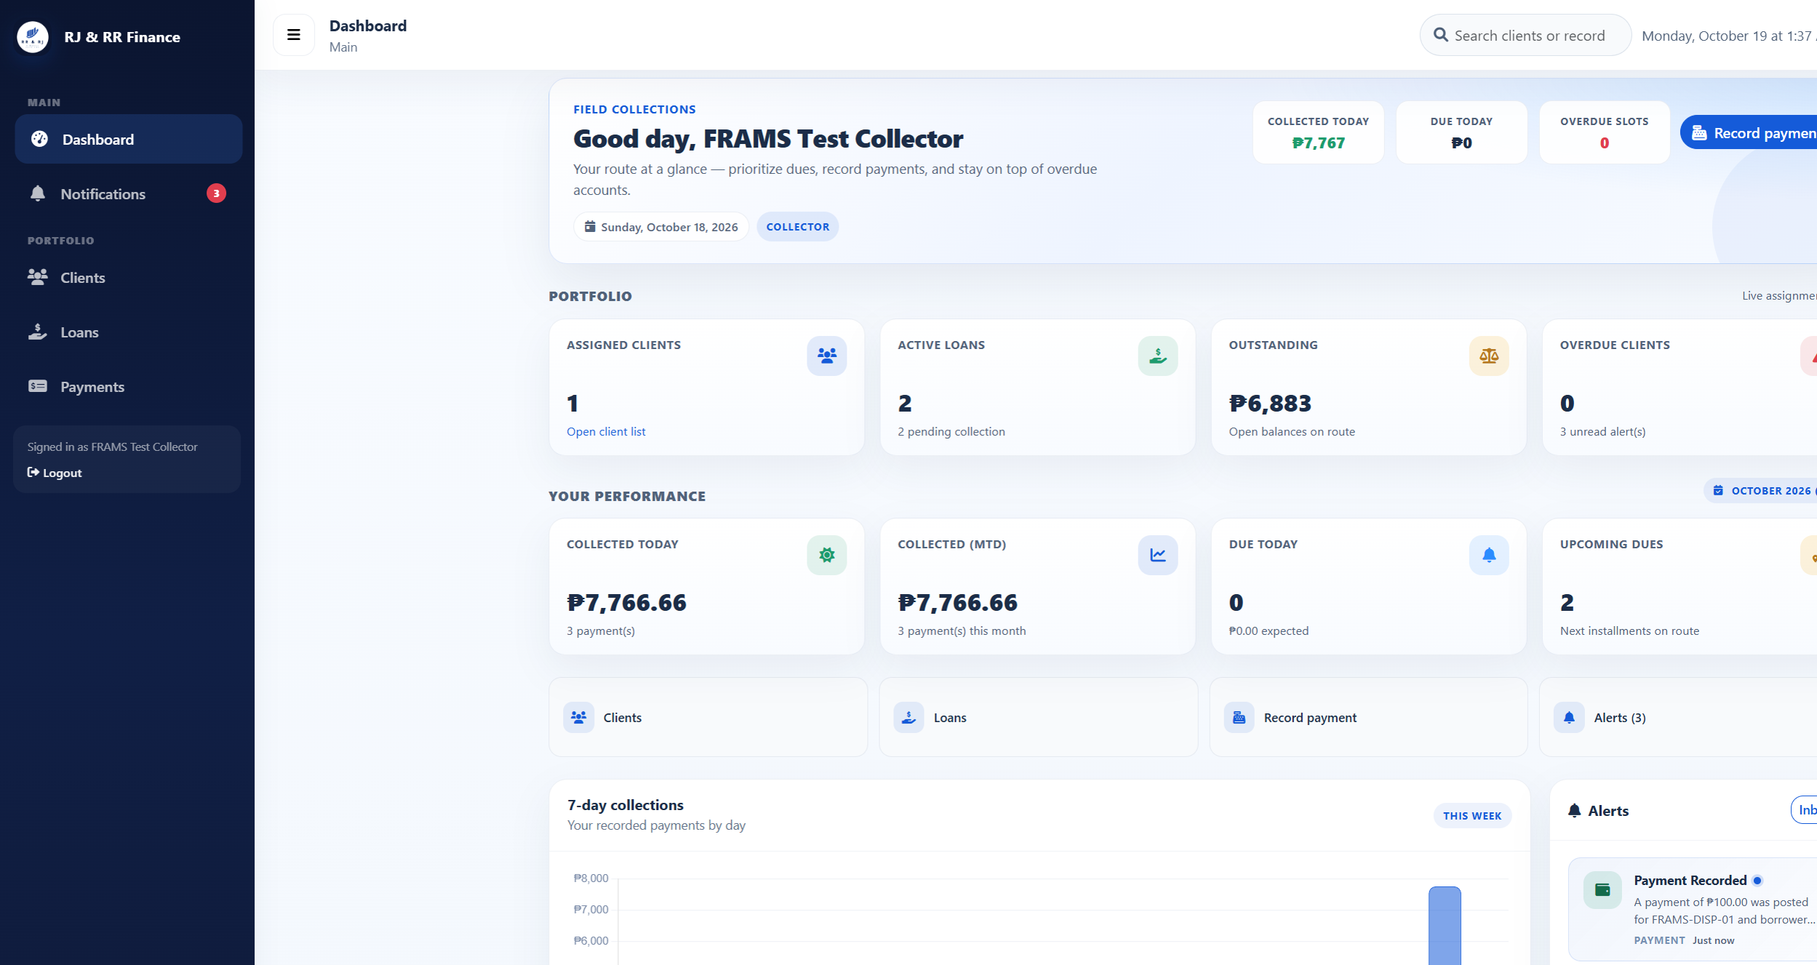
Figure B41. Collector dashboard after requesting user management. Reports, borrower approval, and loan release returned to this same dashboard.

Figure B42 — PT-05
Scenario: Submit registration, payment recording, expense recording, user management, or loan release without the security token.
Expected result: The request ends with HTTP 419 and the message that the session is invalid or expired. No record is saved.
Actual result: Registration, payment recording, expense recording, user management, and loan release were each posted without the security token. Borrower approval was not used. All five responses were HTTP 419 with the heading "Invalid or expired session" and the text "Please refresh the page and try again." Users stayed at 6, payments at 4, expenses at 0, and loan releases at 3. The probe username was not created.
Status: PASS
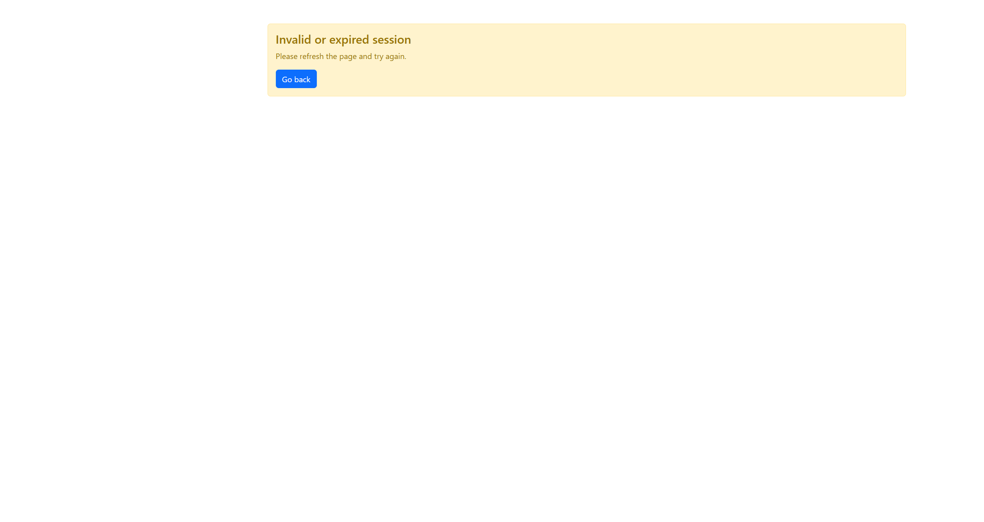
Figure B42. Registration submitted without the security token. The other four posts returned this same page with HTTP 419.

Figure B43 — PT-06
Scenario: Enter a quote-style probe in sign-in and in a search box.
Expected result: Sign-in fails. Search does not reveal additional accounts, loans, or payments.
Actual result: The staff sign-in username frams_test_admin' OR '1'='1 was rejected with "Invalid username or password" and stayed on the sign-in page. The same quote in user search returned "Showing 0 of 0 users" and "No users found." It did not list the administrator, collector, or borrower accounts.
Status: PASS
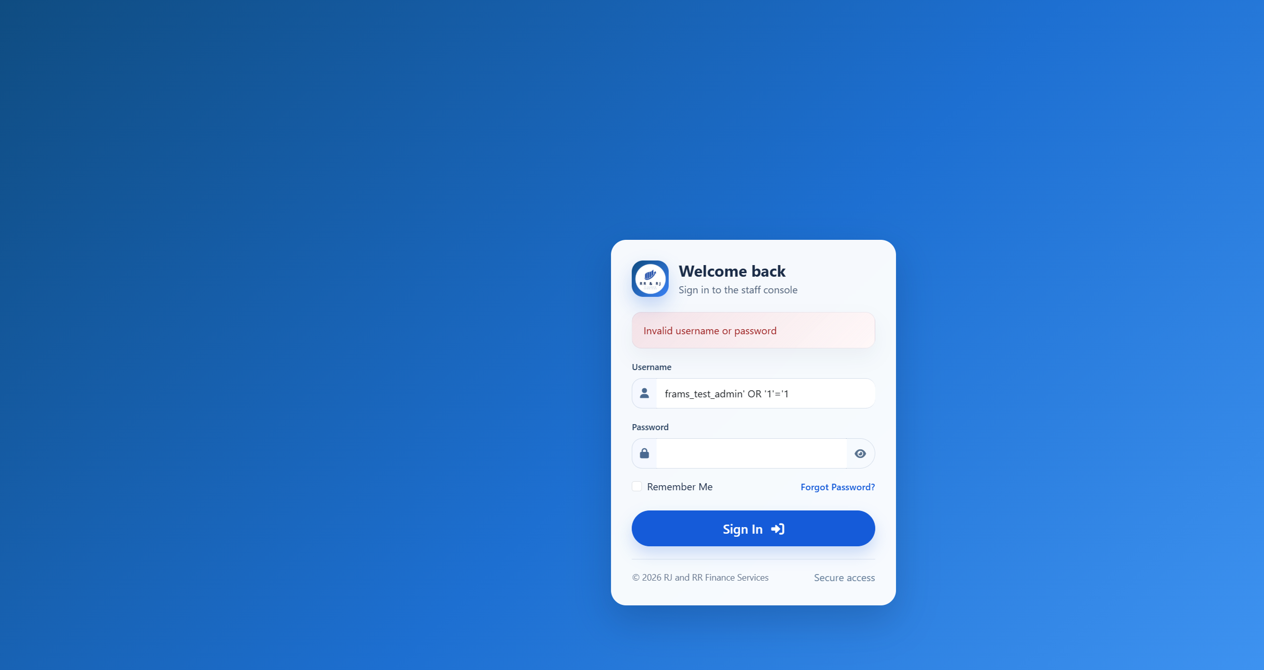
Figure B43. Quote-style sign-in probe rejected.
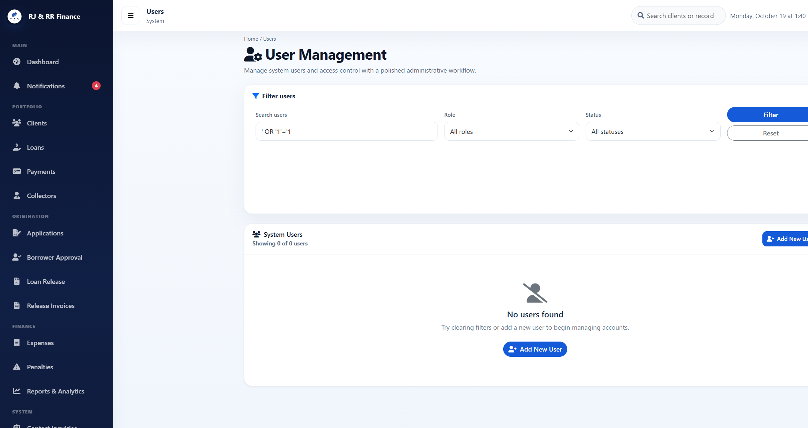
Figure B43. Quote-style user search returned no accounts.

Figure B44 — PT-07
Scenario: Enter a harmless markup marker in an encoded search field and display it.
Expected result: The marker is shown as ordinary text.
Actual result: The user-search value <b>pt07marker</b> was returned in the page as encoded text. The search box showed the marker as ordinary characters, including the angle brackets. It was not rendered as bold text, and the search still listed 0 users. The payments flash message was not used.
Status: PASS
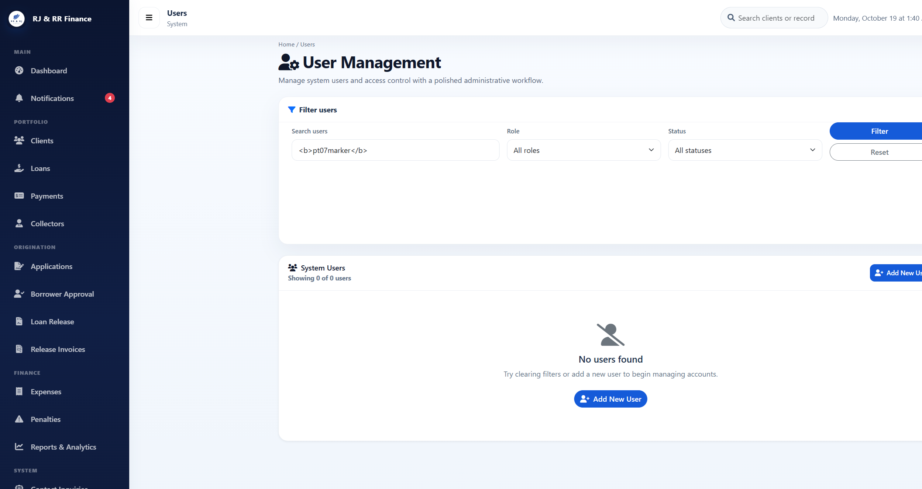
Figure B44. The markup marker remains visible as text in the search box.

Figure B45 — PT-08
Scenario: A borrower requests another borrower receipt address and document address.
Expected result: The receipt is refused or redirected, and the document request returns Access denied.
Actual result: Signed in as frams_test_borrower. Requesting payments_lending.php?view=44, the receipt for Borrower B, returned HTTP 302 to borrower_payment_history_lending.php. The history still showed only RJRR-20261018-000004 and did not show RJRR-20261018-000002. Requesting download_loan_document_lending.php for a document path that does not belong to this borrower returned HTTP 403 and the text "Access denied."
Status: PASS
Figure B45. Other-borrower receipt request returned to this borrower's own payment history.

Figure B45. Other-borrower document request. The response text is Access denied.

Figure B46 — PT-09
Scenario: A collector opens a client, loan, or payment assigned to another collector.
Expected result: The unassigned record is not opened for collection.
Actual result: Signed in as frams_test_collector. Client 21, which is assigned to Collector B, returned HTTP 403: "You do not have permission to view this client." Loan 30, FRAMS-TEST-B, returned HTTP 403: "You do not have permission to view this loan." Payment 44 returned HTTP 403: "You do not have access to this receipt." None of the three records opened.
Status: PASS
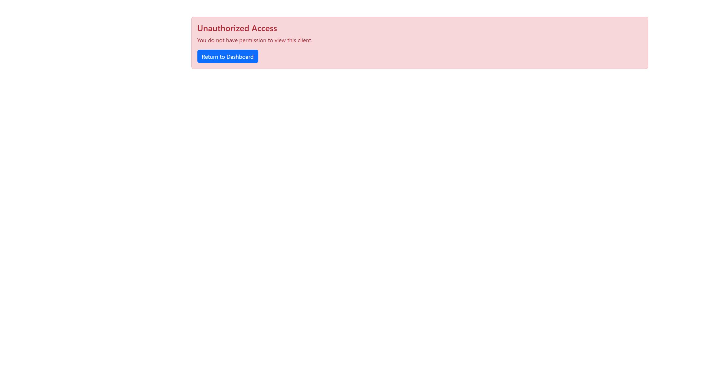
Figure B46. Collector A denied client 21.
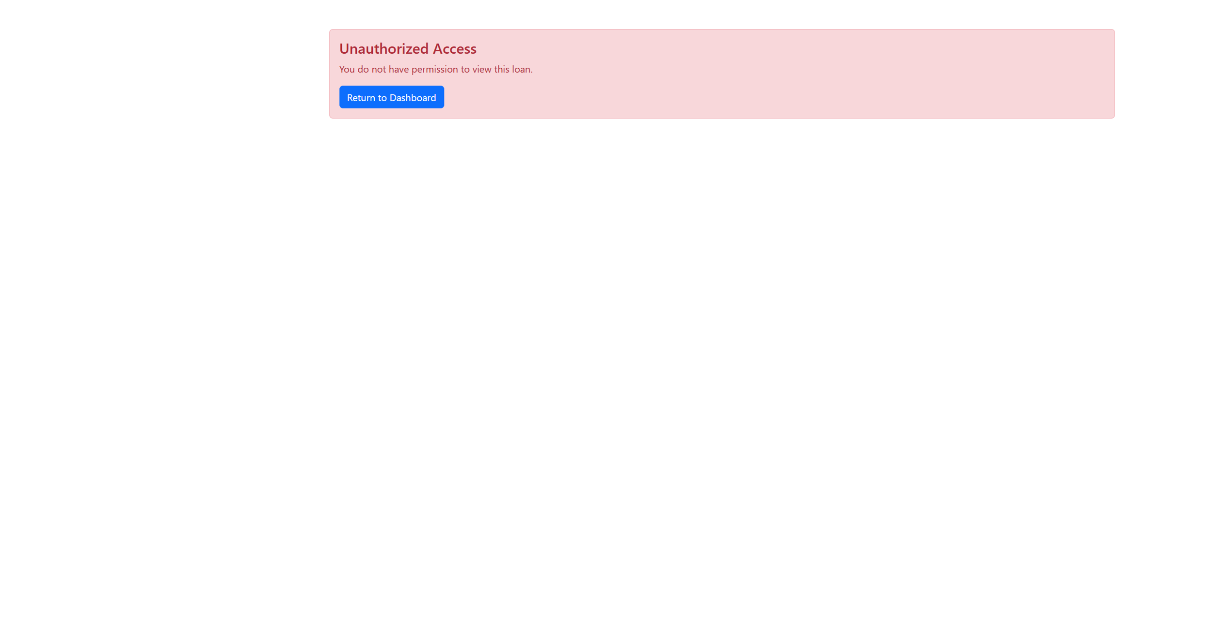
Figure B46. Collector A denied loan 30.

Figure B46. Collector A denied payment 44.

Figure B47 — PT-10
Scenario: Upload a file that is not JPG, PNG, or PDF, and a file larger than 8 MB.
Expected result: The file is rejected and is not stored. A PDF is an allowed file and was not used as the invalid sample.
Actual result: On loan-application step 4, pt10-probe.txt was checked and rejected with "Allowed file types: JPG, PNG, PDF." A file of 8,389,633 bytes was rejected with "File must be 8 MB or smaller." Neither file was written to the document folder. The wizard does not keep that sentence on screen: it stays on step 4 and shows "Required documents missing," with every document still marked "Not uploaded yet."
Status: PASS
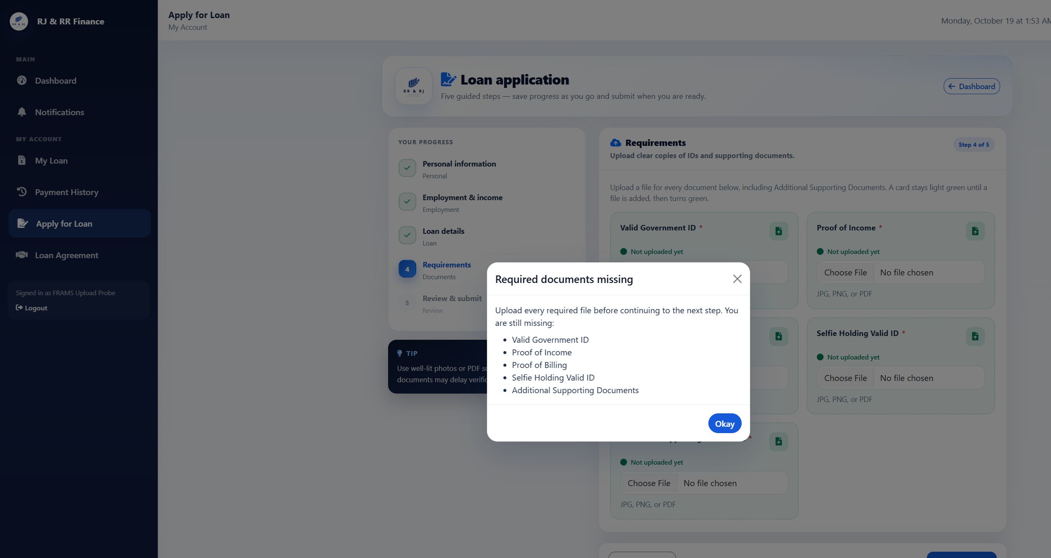
Figure B47. After the invalid uploads, step 4 still shows every document as not uploaded.

Figure B48 — PT-11
Scenario: After signing out, reload a protected page.
Expected result: The reloaded page redirects to the sign-in page.
Actual result: The collector signed out, which opened the staff sign-in page. Opening collector_dashboard_lending.php again returned HTTP 302 to login_lending.php. The browser showed the staff sign-in page, so the protected dashboard required authentication again.
Status: PASS
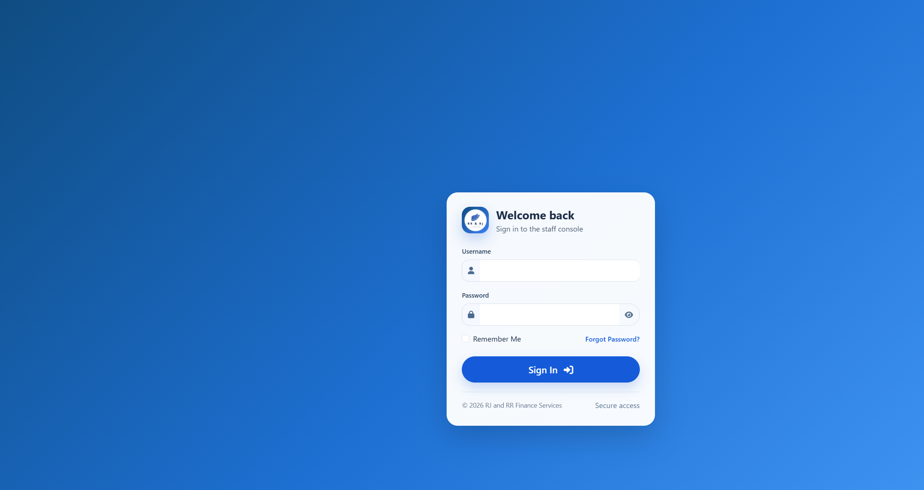
Figure B48. Protected collector dashboard reloaded after sign-out.

Figure B49 — PT-12
Scenario: Submit an incorrect, expired, and already used six-digit password-reset code.
Expected result: The password is not changed by an invalid code. The live reset flow uses a six-digit code that expires after ten minutes, allows five incorrect attempts, and is removed after a successful change. It does not issue a reset link.
Actual result: The forgot-password page asks for a username and says it will email a 6-digit code. It does not offer a reset link. The code form says the code expires in 10 minutes. A new code record was measured at 600 seconds. An incorrect code returned "That code is incorrect or has expired." After five incorrect attempts, the next try returned "Too many incorrect codes. Request a new code." and the code record was removed. A code whose expiry was already past returned the incorrect-or-expired message. A correct code allowed one password change, and that same code was then rejected. The borrower test password was restored afterward, and no reset row remained.
Status: PASS
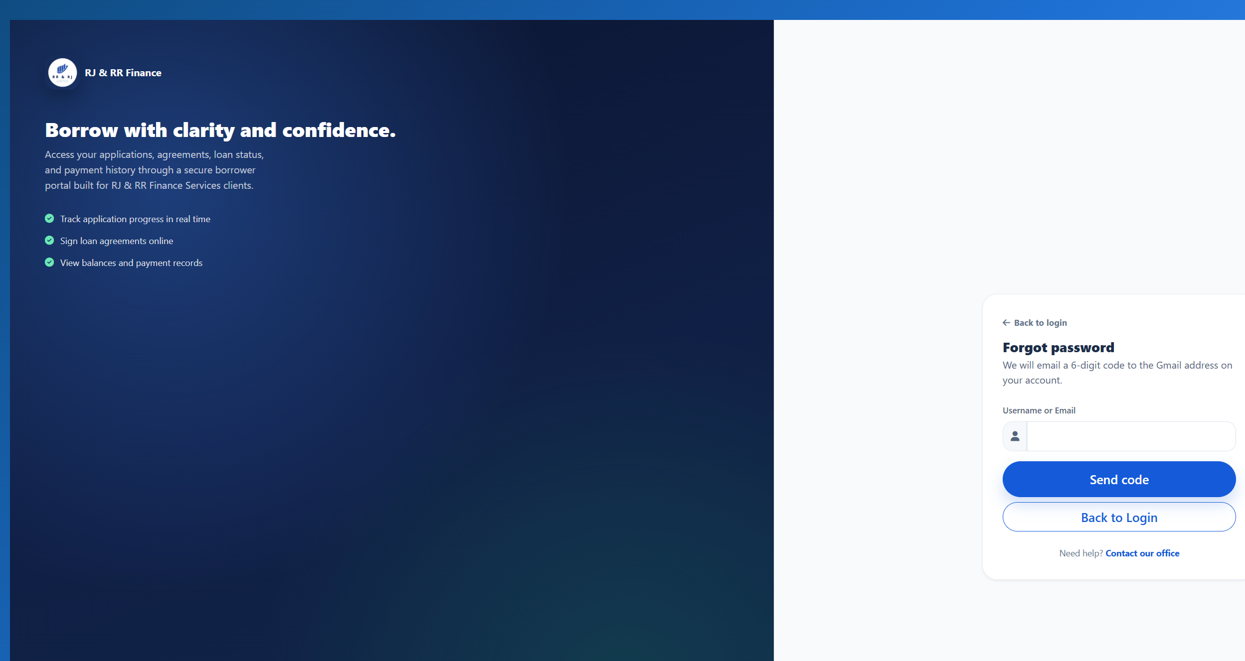
Figure B49. The reset page sends a 6-digit code and does not issue a link.
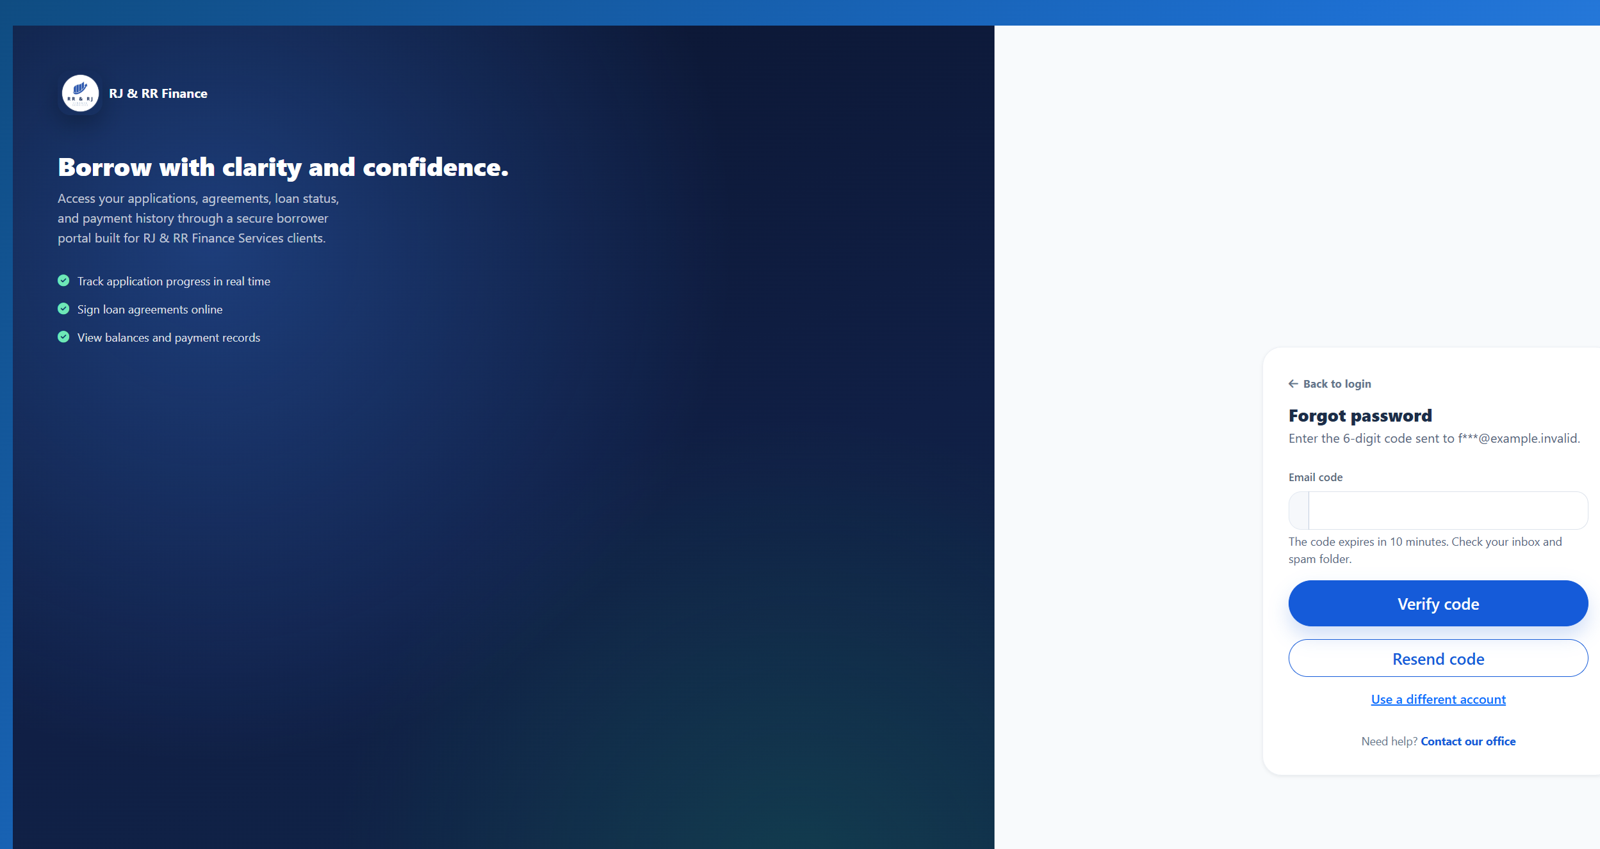
Figure B49. The code form states that the code expires in 10 minutes.
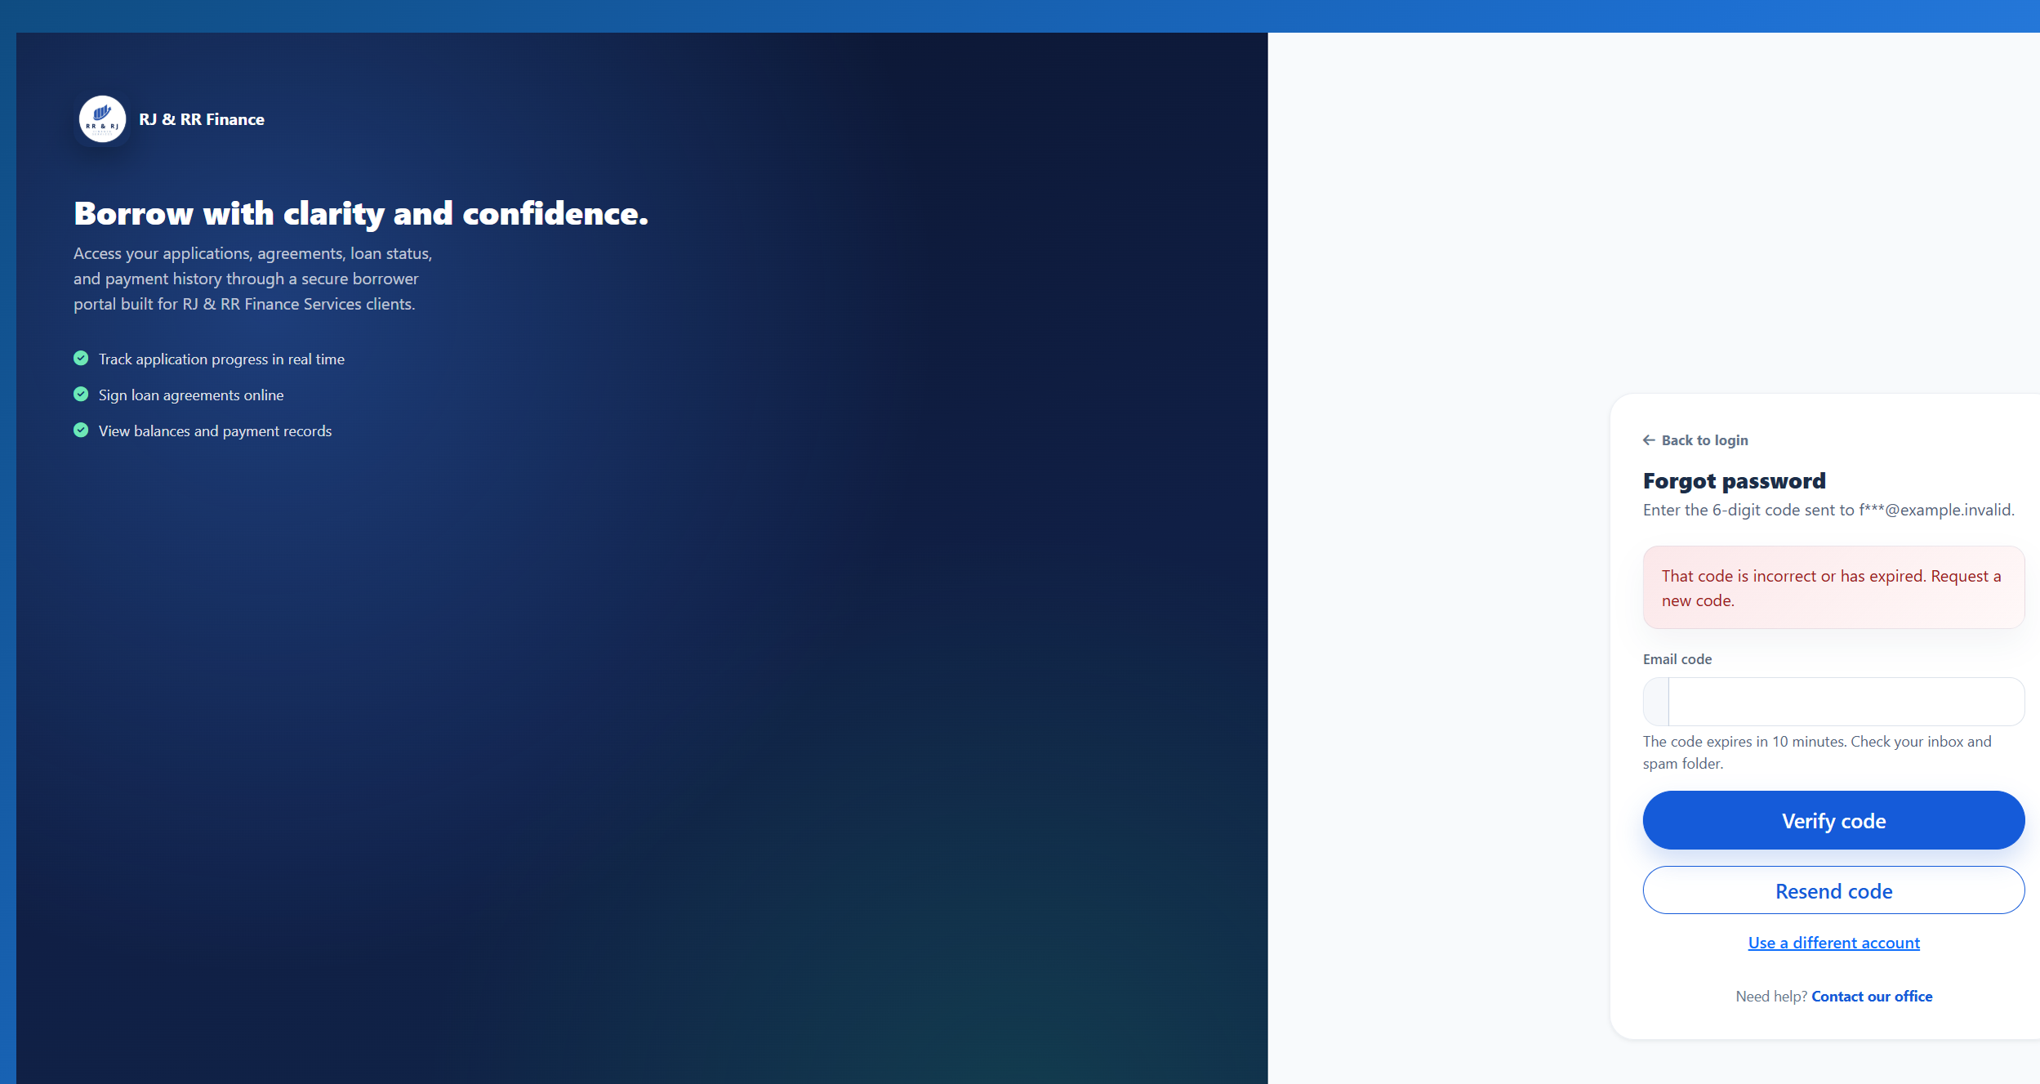
Figure B49. An incorrect code does not change the password.
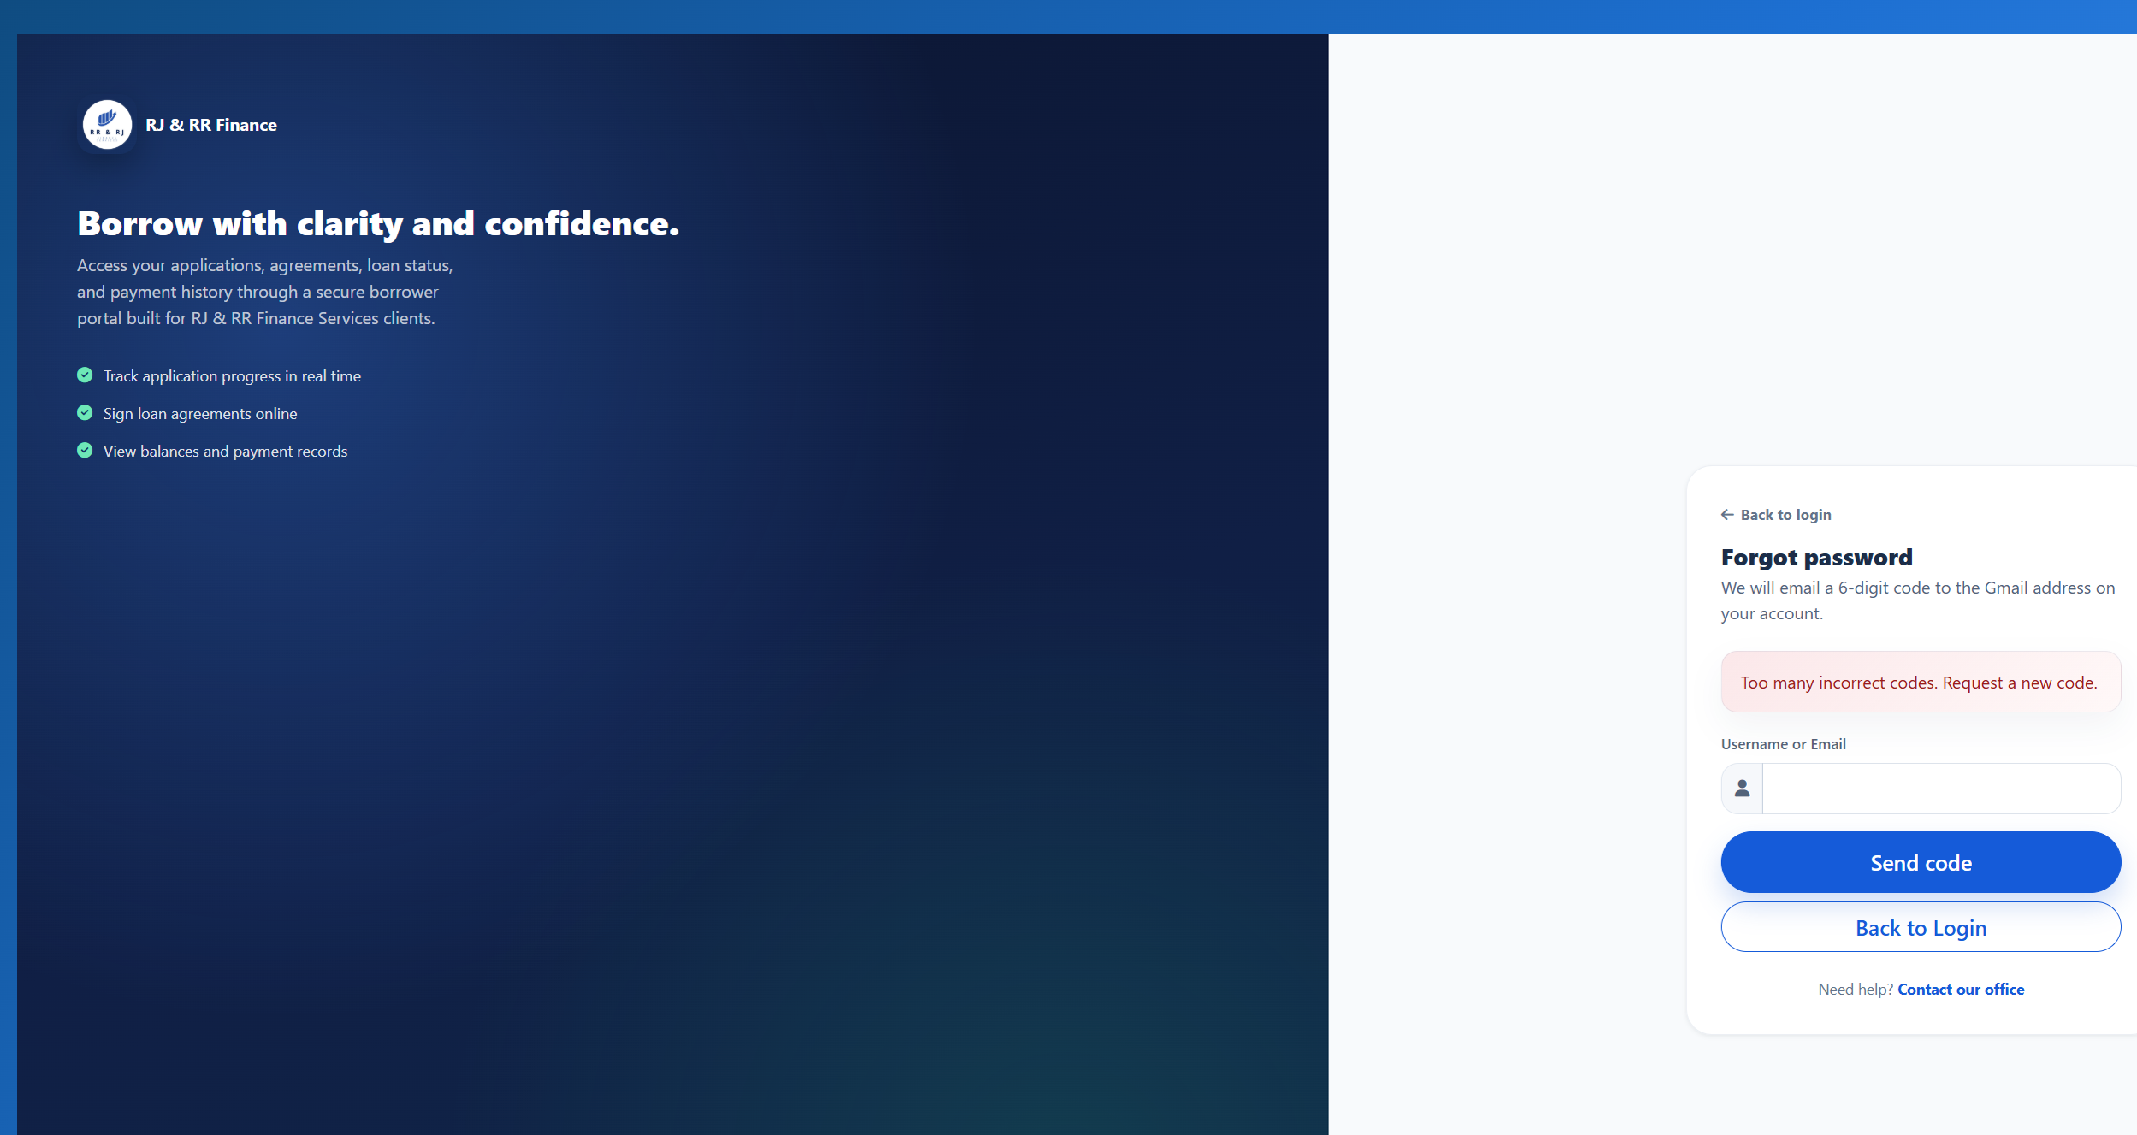
Figure B49. The attempt after five incorrect codes is refused.
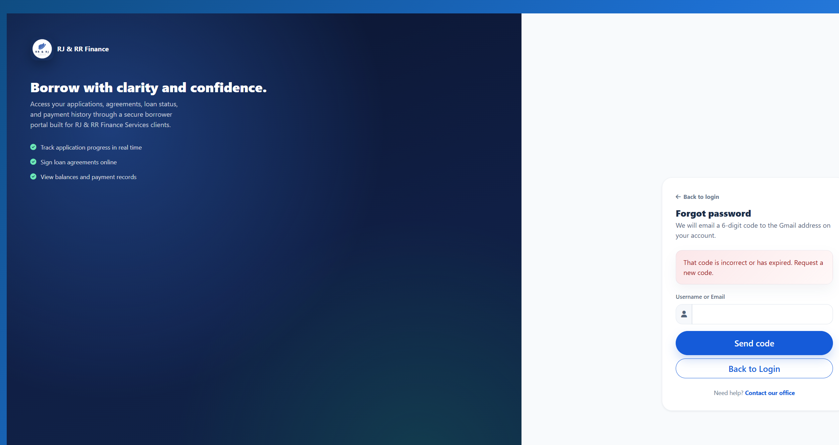
Figure B49. An expired code is refused.
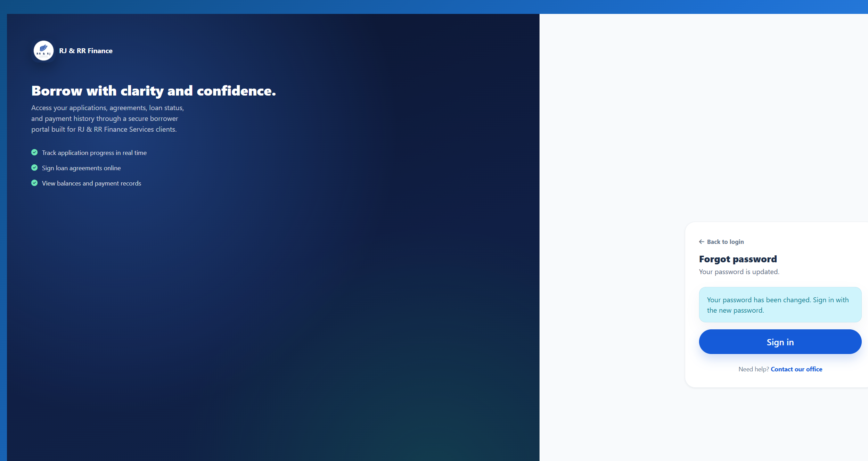
Figure B49. A valid code can be used once.
Figure B49. The same code is refused after the password change.

