FRAMS QR Ph test figures
Figures B26 to B37
Execution date: 19 October 2026. Environment: isolated FRAMS test server at http://127.0.0.1:8099 and database frams_capstone_test. The existing lending_management database was not modified. No live PayMongo charge was created.
PM-01 and PM-02 record the behavior available with the isolated invalid test key: PayMongo rejects creation, the QR page does not open, and the balance does not change. They do not show a PayMongo QR image. PM-09 and PM-10 completed through a local webhook simulation. That simulation is not a payment delivered by PayMongo.
Results: 12 passed, 0 failed, 0 blocked, 0 not executed.
Test ID | Figure | Status | Actual result
PM-01 | Figure B26 | PASS | The collector submitted E-Wallet for PHP 100.00 on FRAMS-DISP-01 while the balance was PHP 3,150.00. PayMongo returned HTTP 401 and rejected the isolated test key. The QR page did not open. The stored transaction status was failed, and it had no QR image. No repayment was created and the loan stayed Active. The provider text was redacted in the screenshot because it echoed part of the test key.
PM-02 | Figure B27 | PASS | The same screen as Figure B26 stayed on Record Payment. No QR image, QR amount, method block, or expiry was displayed. FRAMS-DISP-01 remained Active with remaining balance PHP 3,150.00.
PM-03 | Figure B28 | PASS | With Cash selected, the Create Dynamic QR Ph button was hidden and disabled. Cancel and Record Payment remained available. The loan and amount sections were collapsed only so the action row fit in the capture.
PM-04 | Figure B29 | PASS | Blank was stopped in the browser with "Please fill out this field." Zero reached the server and returned "Payment amount must be greater than zero." The nonnumeric value abc, after the number field was changed to text, returned "Enter a valid payment amount." None of the three created a QR image or a repayment.
PM-05 | Figure B30 | PASS | An amount of 4000.00 against a total due of PHP 3,150.00 was rejected: "Payment cannot exceed the current total amount due of PHP 3,150.00." No repayment was created.
PM-06 | Figure B31 | PASS | Collector A submitted loan 30, which is assigned to Collector B. The server responded "You are not assigned to this loan." The loan was not in Collector A's list, and no repayment was created.
PM-07 | Figure B32 | PASS | A signed-out request for the payments page opened the staff sign-in page. The signed-in borrower was redirected to Payment History. That page has no QR action. The borrower is turned away before the collector-only message is reached.
PM-08 | Figure B33 | PASS | An unresolved pending attempt on FRAMS-TEST-A could not be confirmed with PayMongo. The second request was refused: "The previous PayMongo QR Ph attempt could not be confirmed with PayMongo." The pending row stayed pending, the balance stayed PHP 3,833.34, and no new repayment was created. The supersede path was not applicable because PayMongo could not confirm the open attempt.
PM-09 | Figure B34 | PASS | This was a local signed webhook simulation, not a PayMongo delivery and not a live charge. The pending transaction changed to succeeded. One E-Wallet repayment of PHP 100.00 was stored with receipt RJRR-20261018-000004 and reference pay_frams_pm09_once. The receipt shows PHP 3,150.00 before payment and PHP 3,050.00 after payment.
PM-10 | Figure B35 | PASS | The first local webhook returned HTTP 200 with status processed. The same event returned HTTP 200 with status duplicate. Loan FRAMS-DISP-01 still has one PHP 100.00 repayment. This was a local simulation, not an external PayMongo delivery.
PM-11 | Figure B36 | PASS | All three requests returned HTTP 401 with status invalid_signature. The repayment count for the disposable loan stayed at one, and the succeeded transaction was not changed. These were local requests to the FRAMS webhook endpoint.
PM-12 | Figure B37 | PASS | The administrator payments screen shows View only. There is no edit or delete control. A delete request for payment 46 returned the refusal that a payment linked to a verified PayMongo QR Ph transaction was not deleted. Payment 46, receipt RJRR-20261018-000004, and the succeeded QR record remained. The client and borrower were not deleted.

Figure B26 — PM-01
Scenario: The assigned collector creates a QR Ph payment for a valid amount on a disposable unpaid loan.
Expected result: With the isolated invalid test key, PayMongo rejects QR creation. No QR page opens, no repayment is stored, and the loan balance stays unchanged. The attempt is saved as failed.
Actual result: The collector submitted E-Wallet for PHP 100.00 on FRAMS-DISP-01 while the balance was PHP 3,150.00. PayMongo returned HTTP 401 and rejected the isolated test key. The QR page did not open. The stored transaction status was failed, and it had no QR image. No repayment was created and the loan stayed Active. The provider text was redacted in the screenshot because it echoed part of the test key.
Status: PASS
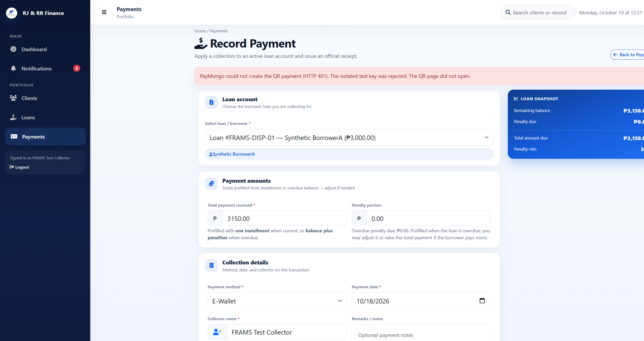
Figure B26 (B26_pm01_qr_rejected.png)

Figure B27 — PM-02
Scenario: The pending QR page is compared with the loan balance before payment.
Expected result: When QR creation is rejected, the payment form stays open. No QR, QR amount, method, or expiry is shown. The balance and loan status stay unchanged.
Actual result: The same screen as Figure B26 stayed on Record Payment. No QR image, QR amount, method block, or expiry was displayed. FRAMS-DISP-01 remained Active with remaining balance PHP 3,150.00.
Status: PASS
Figure B27 (B26_pm01_qr_rejected.png)

Figure B28 — PM-03
Scenario: Cash is selected on the payment form.
Expected result: Create Dynamic QR Ph stays hidden. The ordinary cash payment action remains available.
Actual result: With Cash selected, the Create Dynamic QR Ph button was hidden and disabled. Cancel and Record Payment remained available. The loan and amount sections were collapsed only so the action row fit in the capture.
Status: PASS
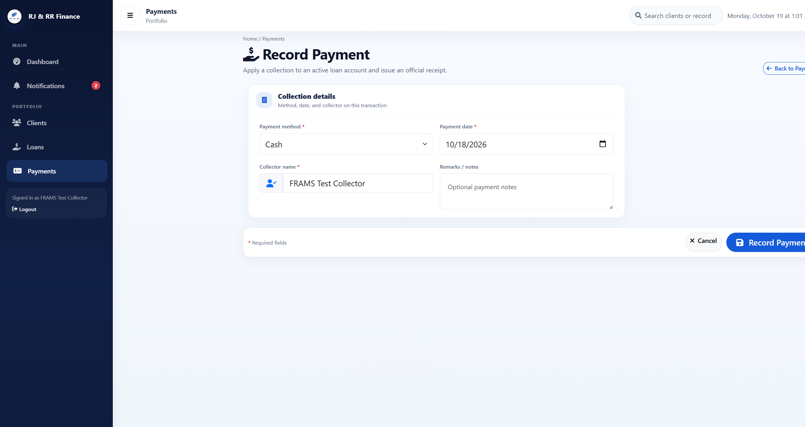
Figure B28 (B28_pm03_cash_no_qr_button.png)

Figure B29 — PM-04
Scenario: Blank, zero, and nonnumeric QR amounts are submitted.
Expected result: No QR transaction is stored. A blank amount is stopped by the required field. Zero is rejected because the amount must be greater than zero. A nonnumeric value is also rejected.
Actual result: Blank was stopped in the browser with "Please fill out this field." Zero reached the server and returned "Payment amount must be greater than zero." The nonnumeric value abc, after the number field was changed to text, returned "Enter a valid payment amount." None of the three created a QR image or a repayment.
Status: PASS
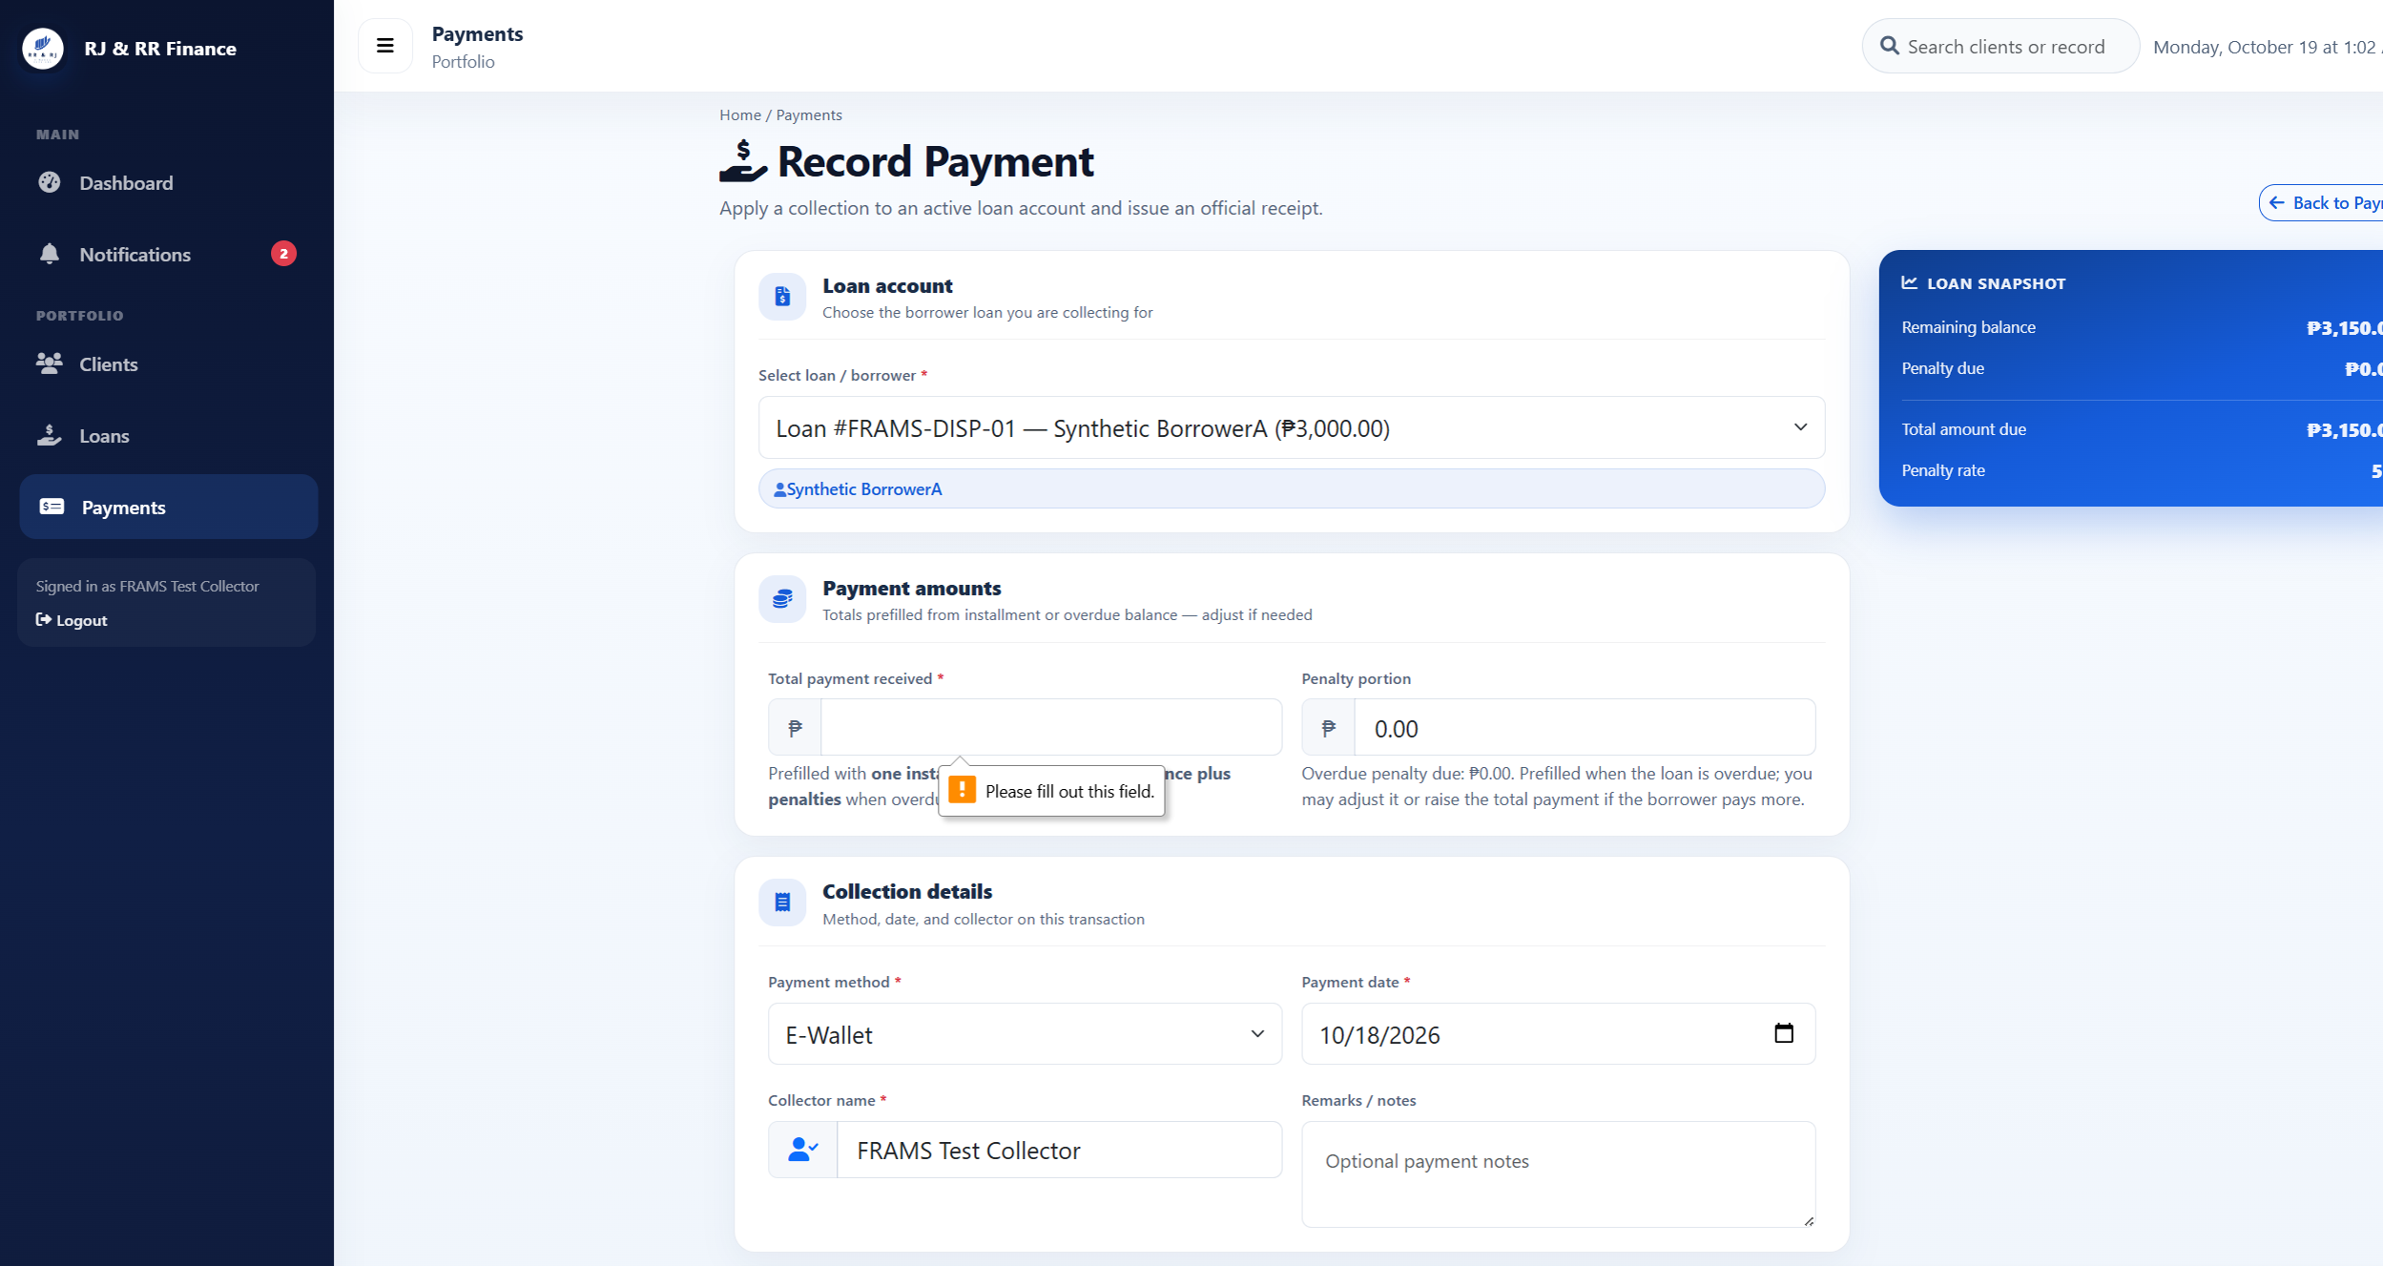
Figure B29 (B29_pm04_blank_amount.png)
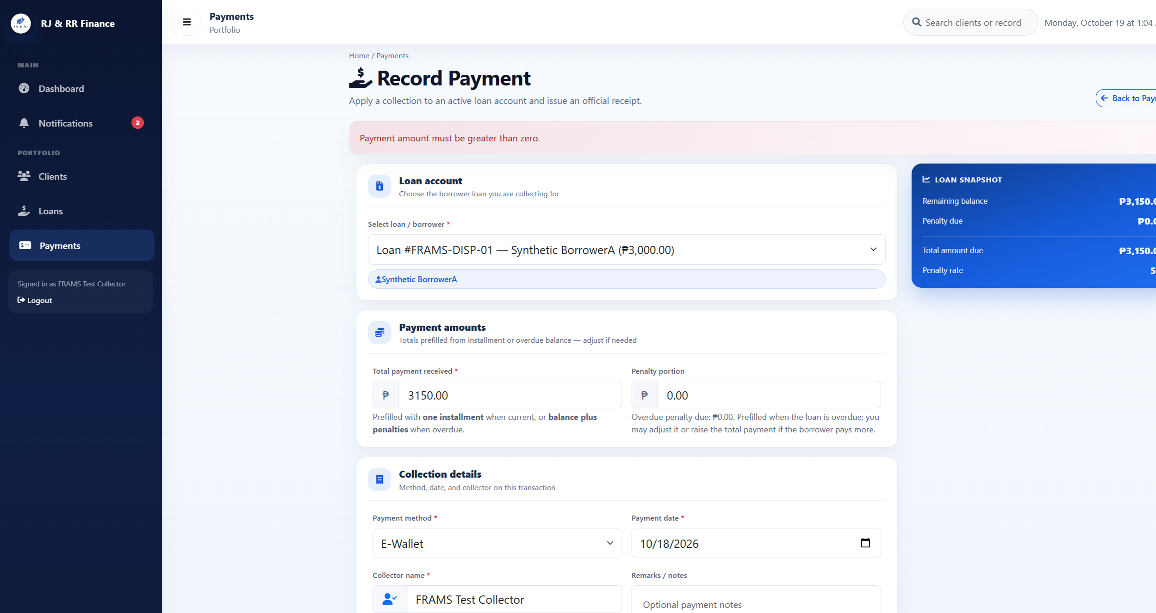
Figure B29 (B29_pm04_zero_amount.png)
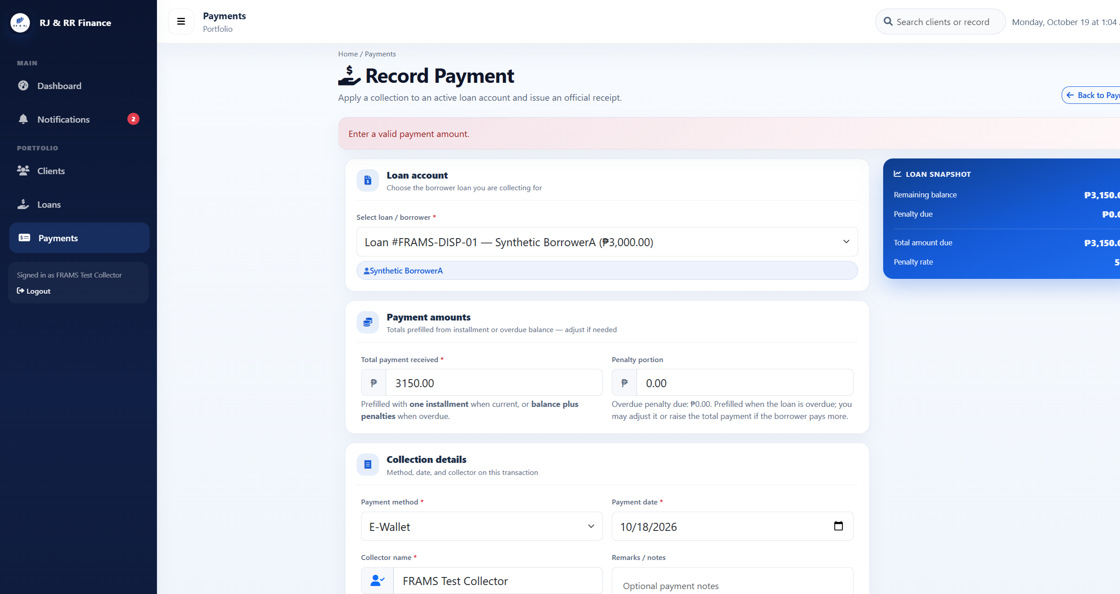
Figure B29 (B29_pm04_nonnumeric.png)

Figure B30 — PM-05
Scenario: The QR amount is greater than the current total due.
Expected result: The request is rejected and no QR transaction is stored.
Actual result: An amount of 4000.00 against a total due of PHP 3,150.00 was rejected: "Payment cannot exceed the current total amount due of PHP 3,150.00." No repayment was created.
Status: PASS
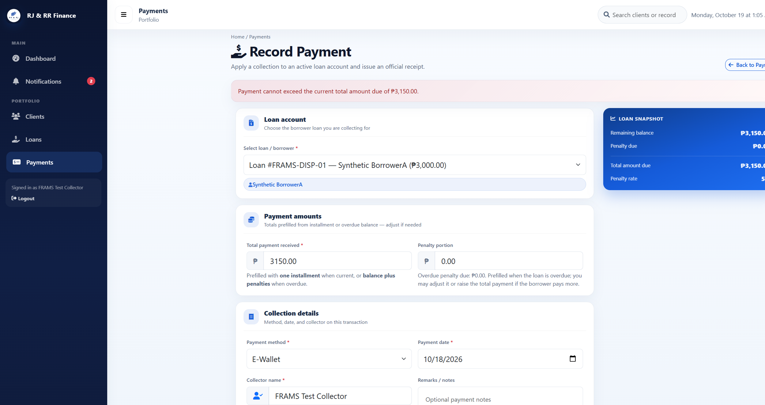
Figure B30 (B30_pm05_amount_too_high.png)

Figure B31 — PM-06
Scenario: A test collector submits a QR Ph request for a disposable loan assigned to another collector.
Expected result: The server rejects the request. No pending QR transaction and no repayment are created.
Actual result: Collector A submitted loan 30, which is assigned to Collector B. The server responded "You are not assigned to this loan." The loan was not in Collector A's list, and no repayment was created.
Status: PASS
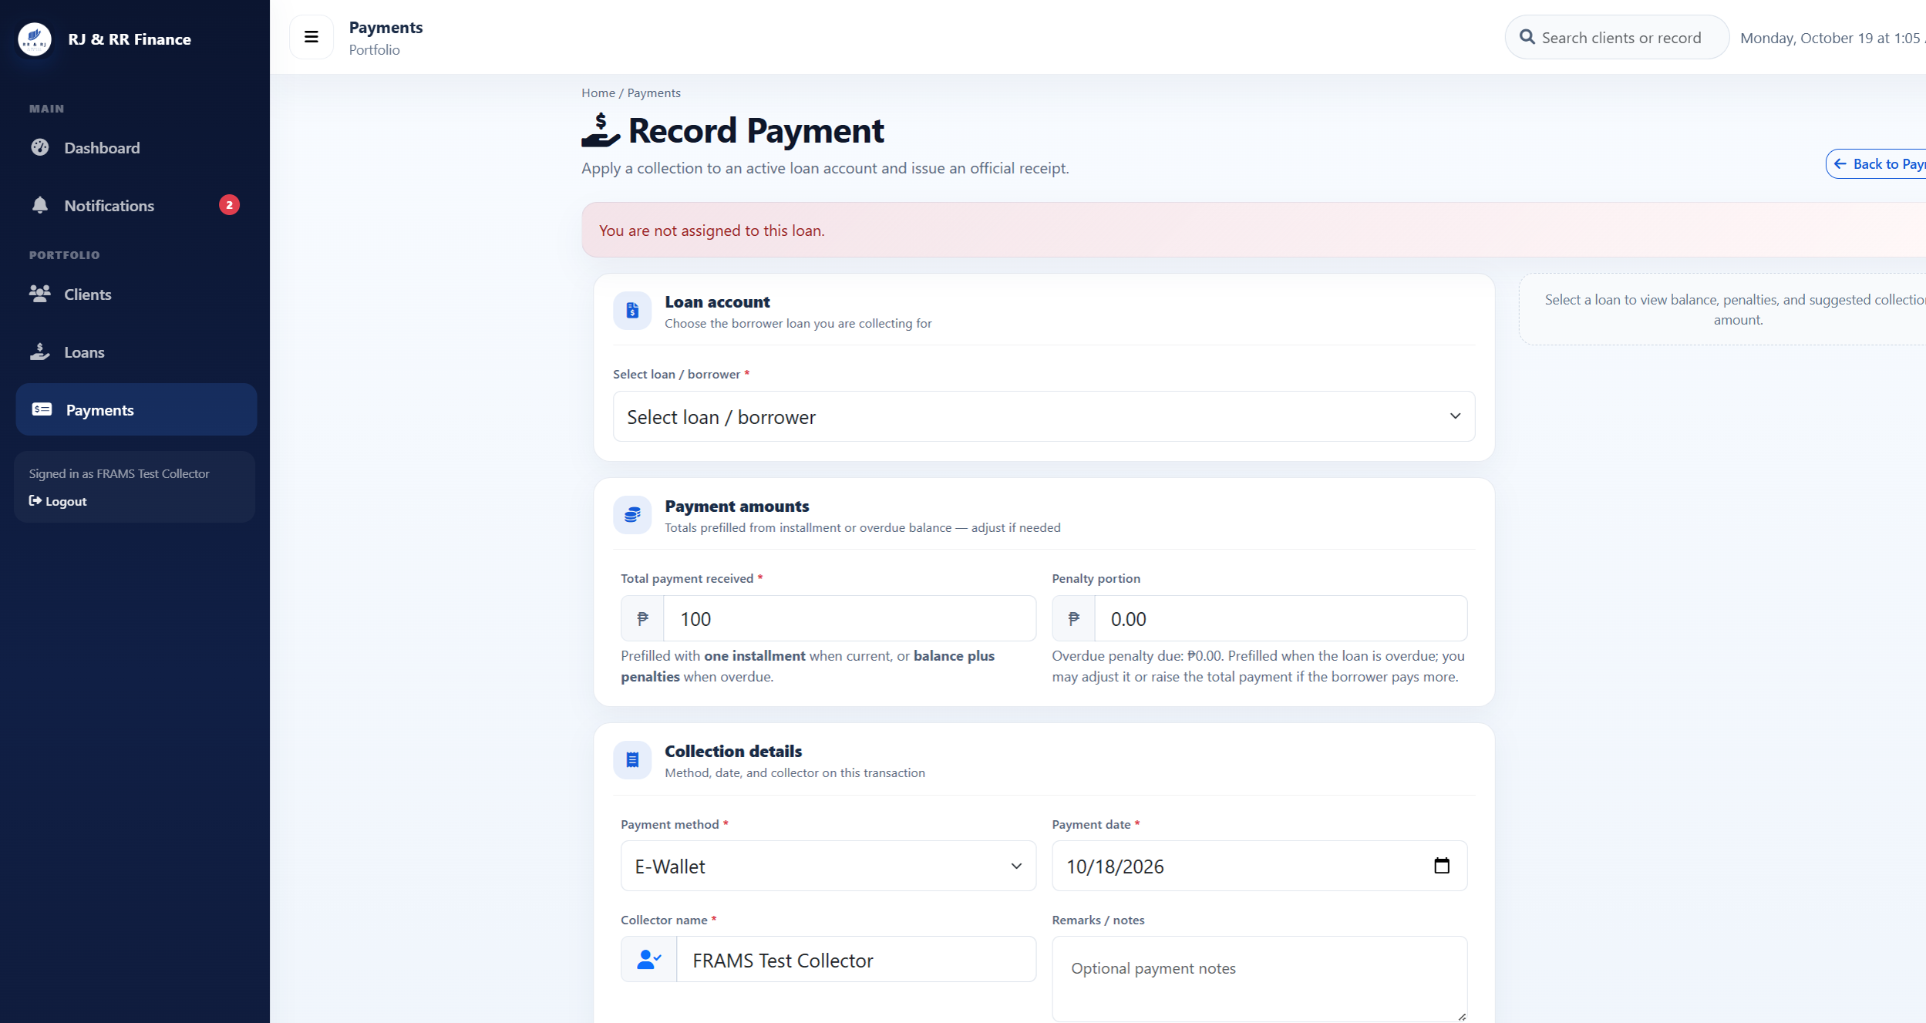
Figure B31 (B31_pm06_other_collector.png)

Figure B32 — PM-07
Scenario: A signed-out visitor opens the payments page, and a borrower attempts the collector QR request.
Expected result: The visitor is redirected to the staff sign-in page. The borrower is redirected to payment history and cannot start a QR payment.
Actual result: A signed-out request for the payments page opened the staff sign-in page. The signed-in borrower was redirected to Payment History. That page has no QR action. The borrower is turned away before the collector-only message is reached.
Status: PASS
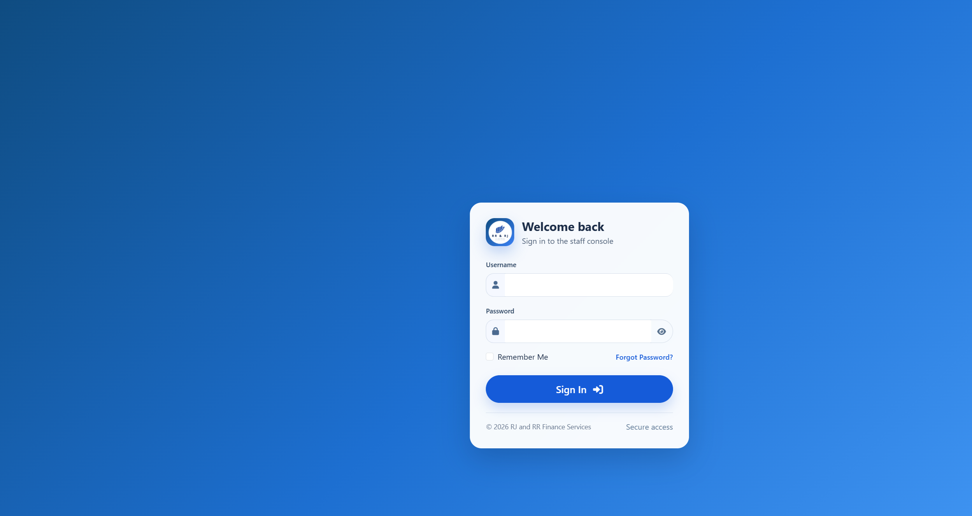
Figure B32 (B32_pm07_signed_out_redirect.png)
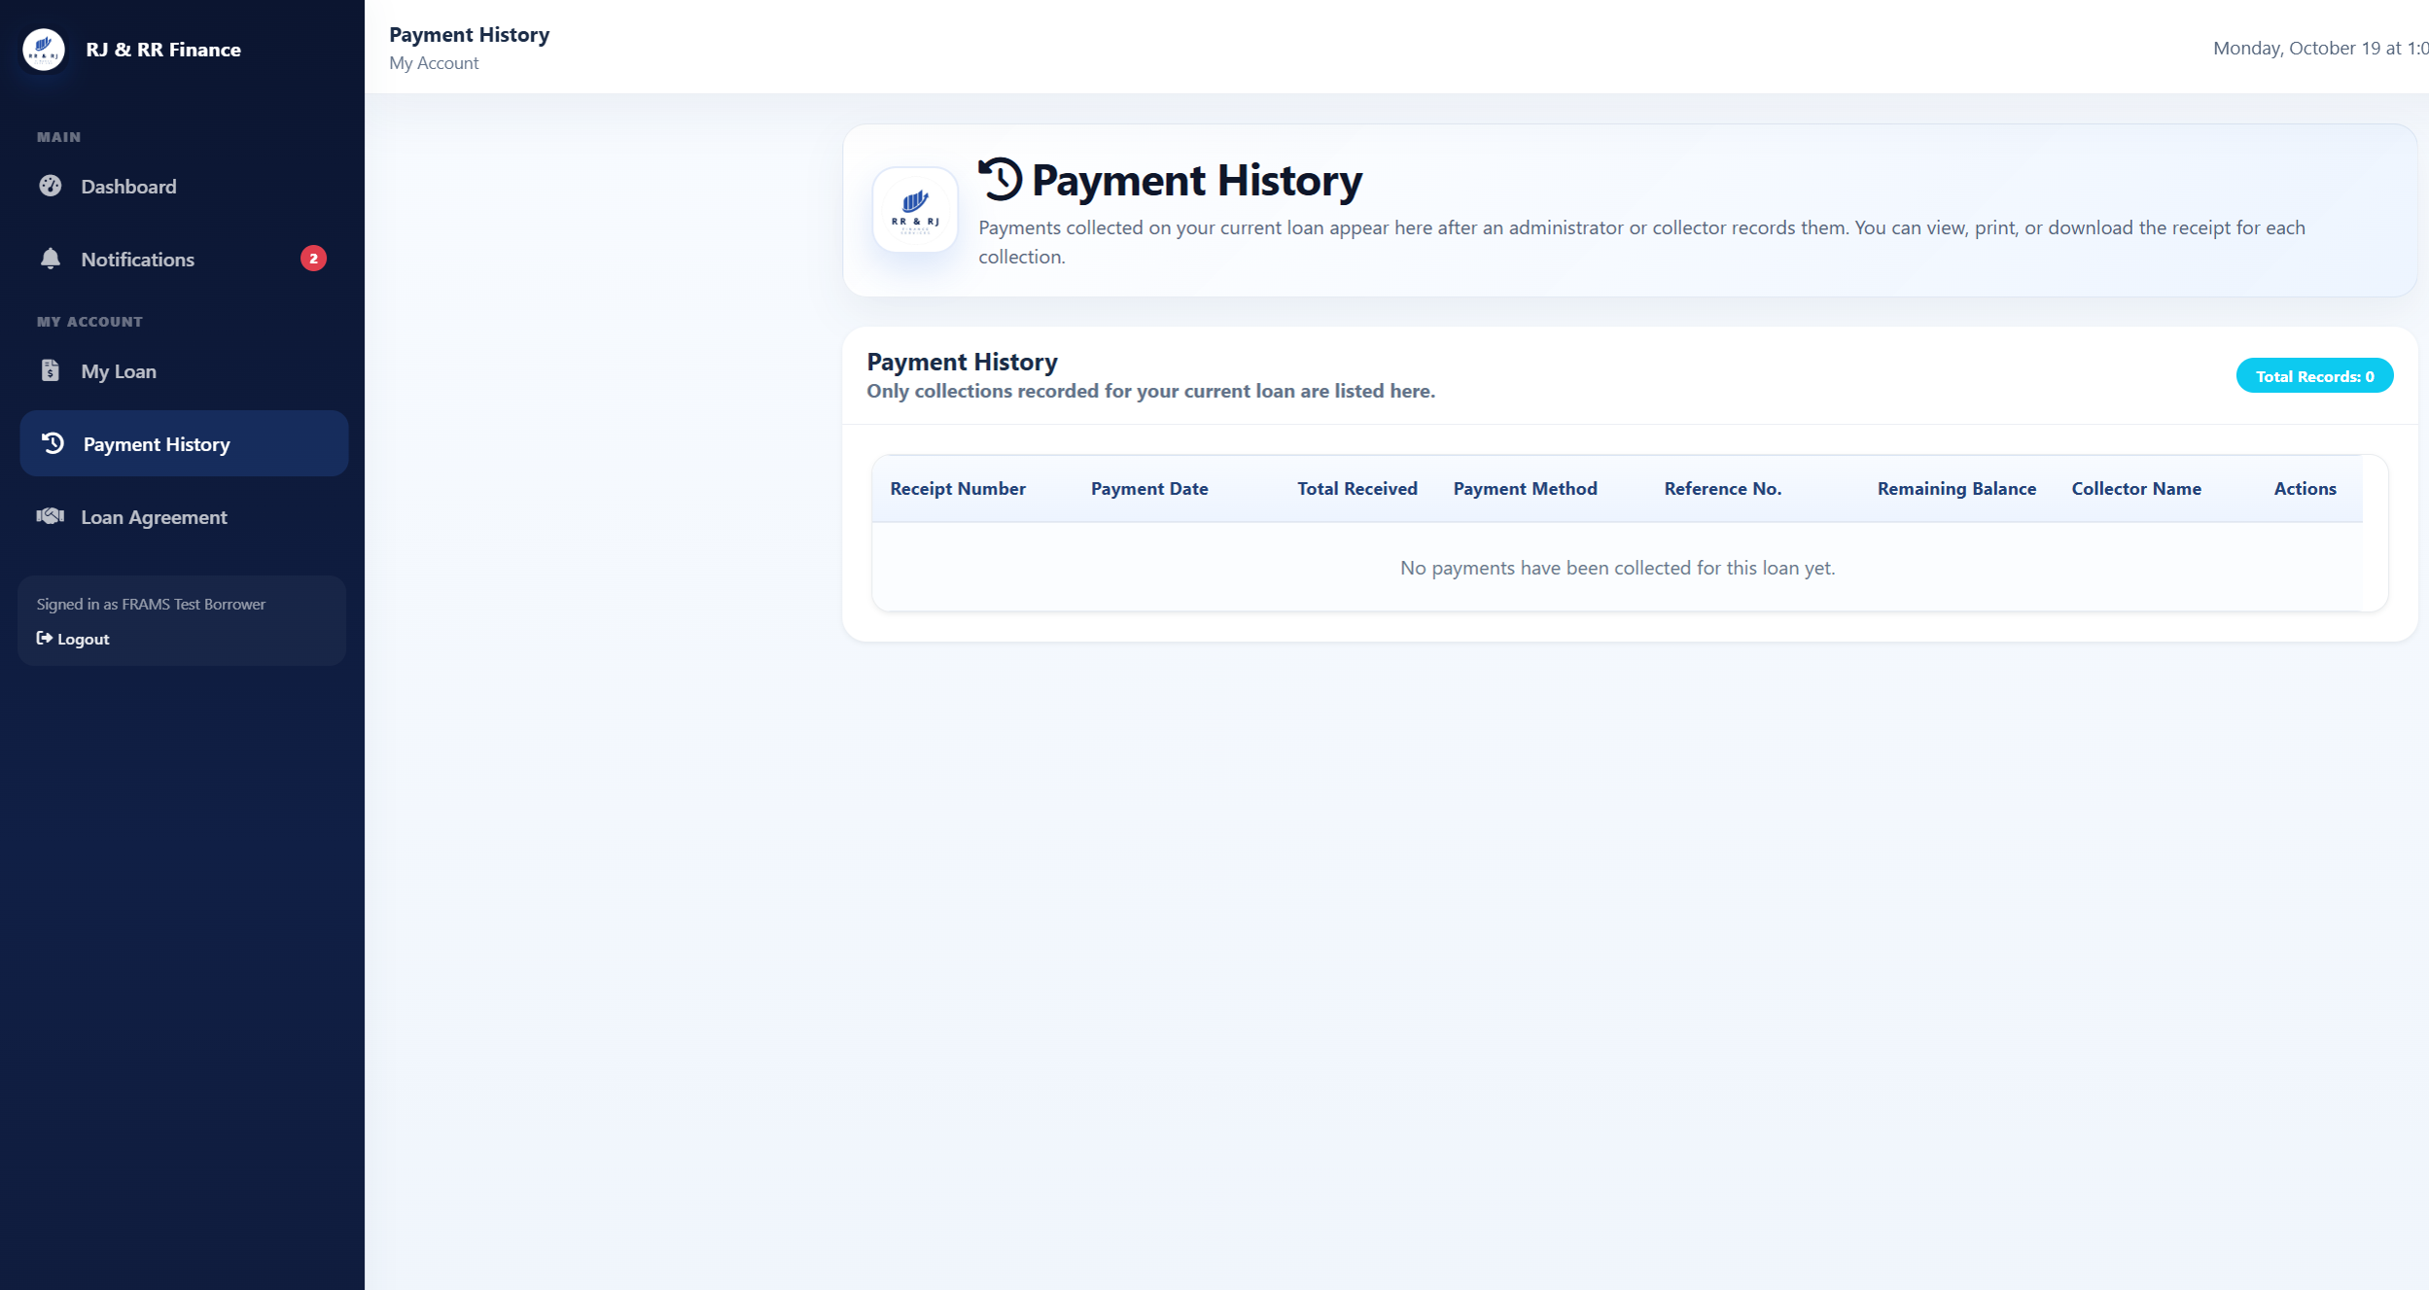
Figure B32 (B32_pm07_borrower_history.png)

Figure B33 — PM-08
Scenario: A second QR Ph request is created while an earlier attempt for the same loan is unresolved.
Expected result: A second request is refused when a pending QR has not expired and PayMongo cannot confirm it.
Actual result: An unresolved pending attempt on FRAMS-TEST-A could not be confirmed with PayMongo. The second request was refused: "The previous PayMongo QR Ph attempt could not be confirmed with PayMongo." The pending row stayed pending, the balance stayed PHP 3,833.34, and no new repayment was created. The supersede path was not applicable because PayMongo could not confirm the open attempt.
Status: PASS
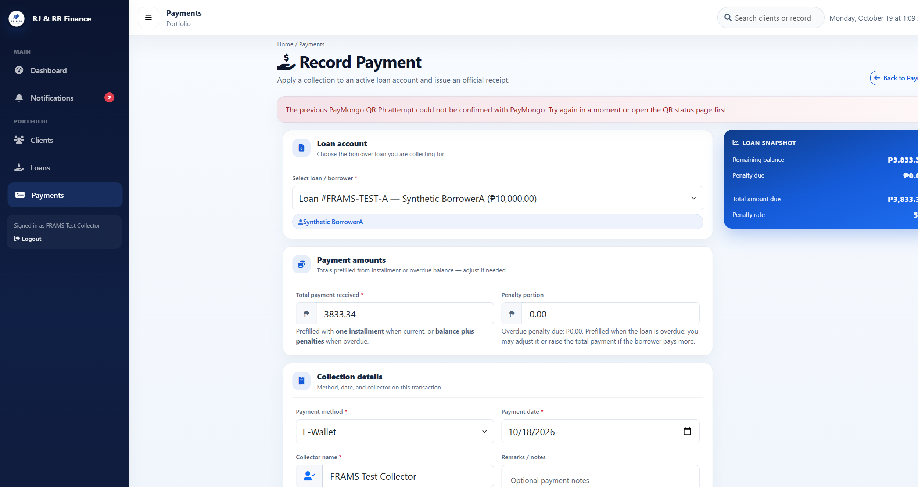
Figure B33 (B33_pm08_unconfirmed_pending_refused.png)

Figure B34 — PM-09
Scenario: A test-mode simulation completes one pending QR on a disposable loan.
Expected result: The transaction changes from pending to paid, one repayment and one receipt are stored, and the balance changes only after confirmation.
Actual result: This was a local signed webhook simulation, not a PayMongo delivery and not a live charge. The pending transaction changed to succeeded. One E-Wallet repayment of PHP 100.00 was stored with receipt RJRR-20261018-000004 and reference pay_frams_pm09_once. The receipt shows PHP 3,150.00 before payment and PHP 3,050.00 after payment.
Status: PASS
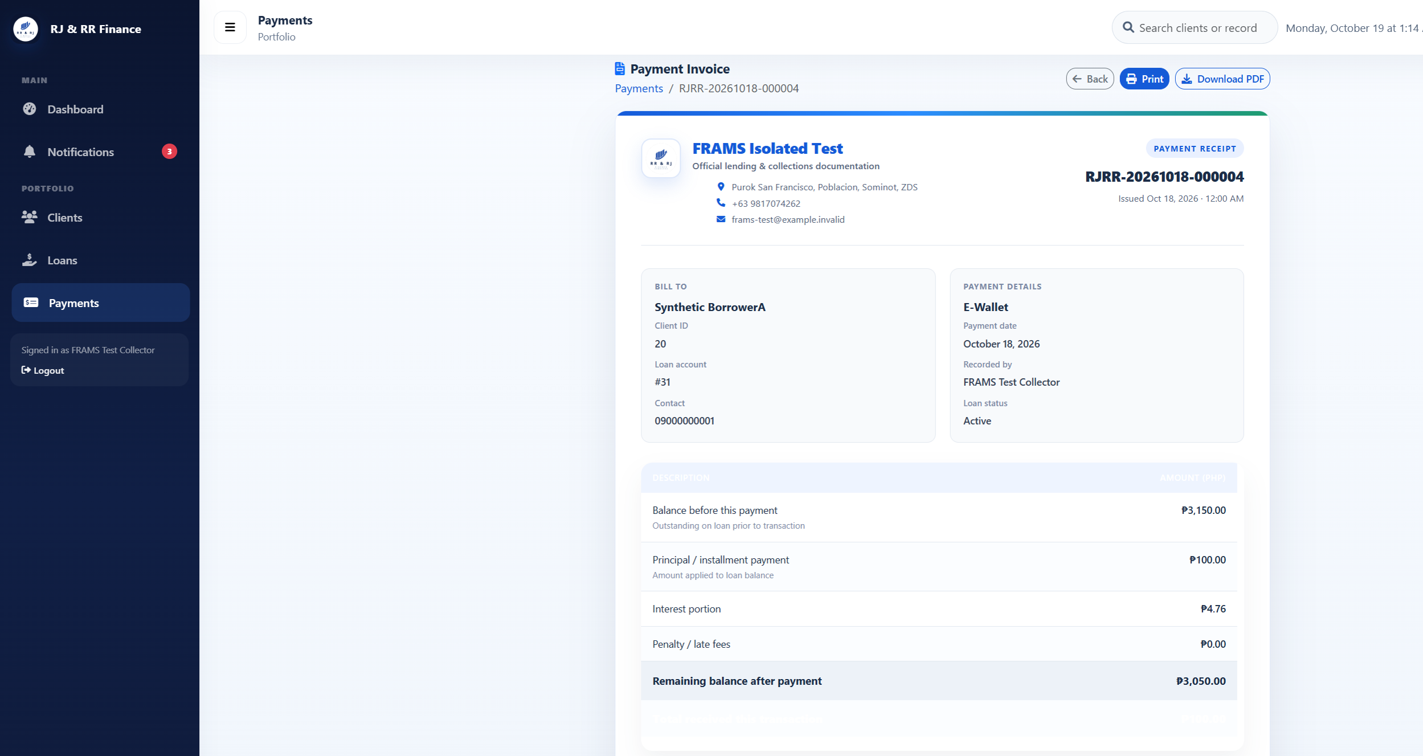
Figure B34 (B34_pm09_receipt.png)
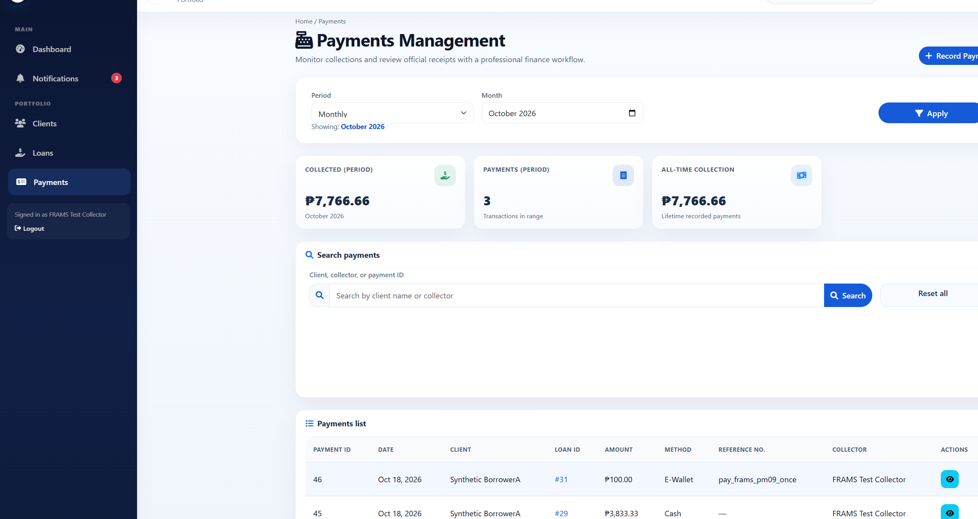
Figure B34 (B34_pm09_simulated_payment_list.png)

Figure B35 — PM-10
Scenario: A valid webhook is delivered once and then the same event is delivered again.
Expected result: The first accepted event records one repayment. The repeated event does not record a second repayment.
Actual result: The first local webhook returned HTTP 200 with status processed. The same event returned HTTP 200 with status duplicate. Loan FRAMS-DISP-01 still has one PHP 100.00 repayment. This was a local simulation, not an external PayMongo delivery.
Status: PASS
Figure B35 (B34_pm09_simulated_payment_list.png)
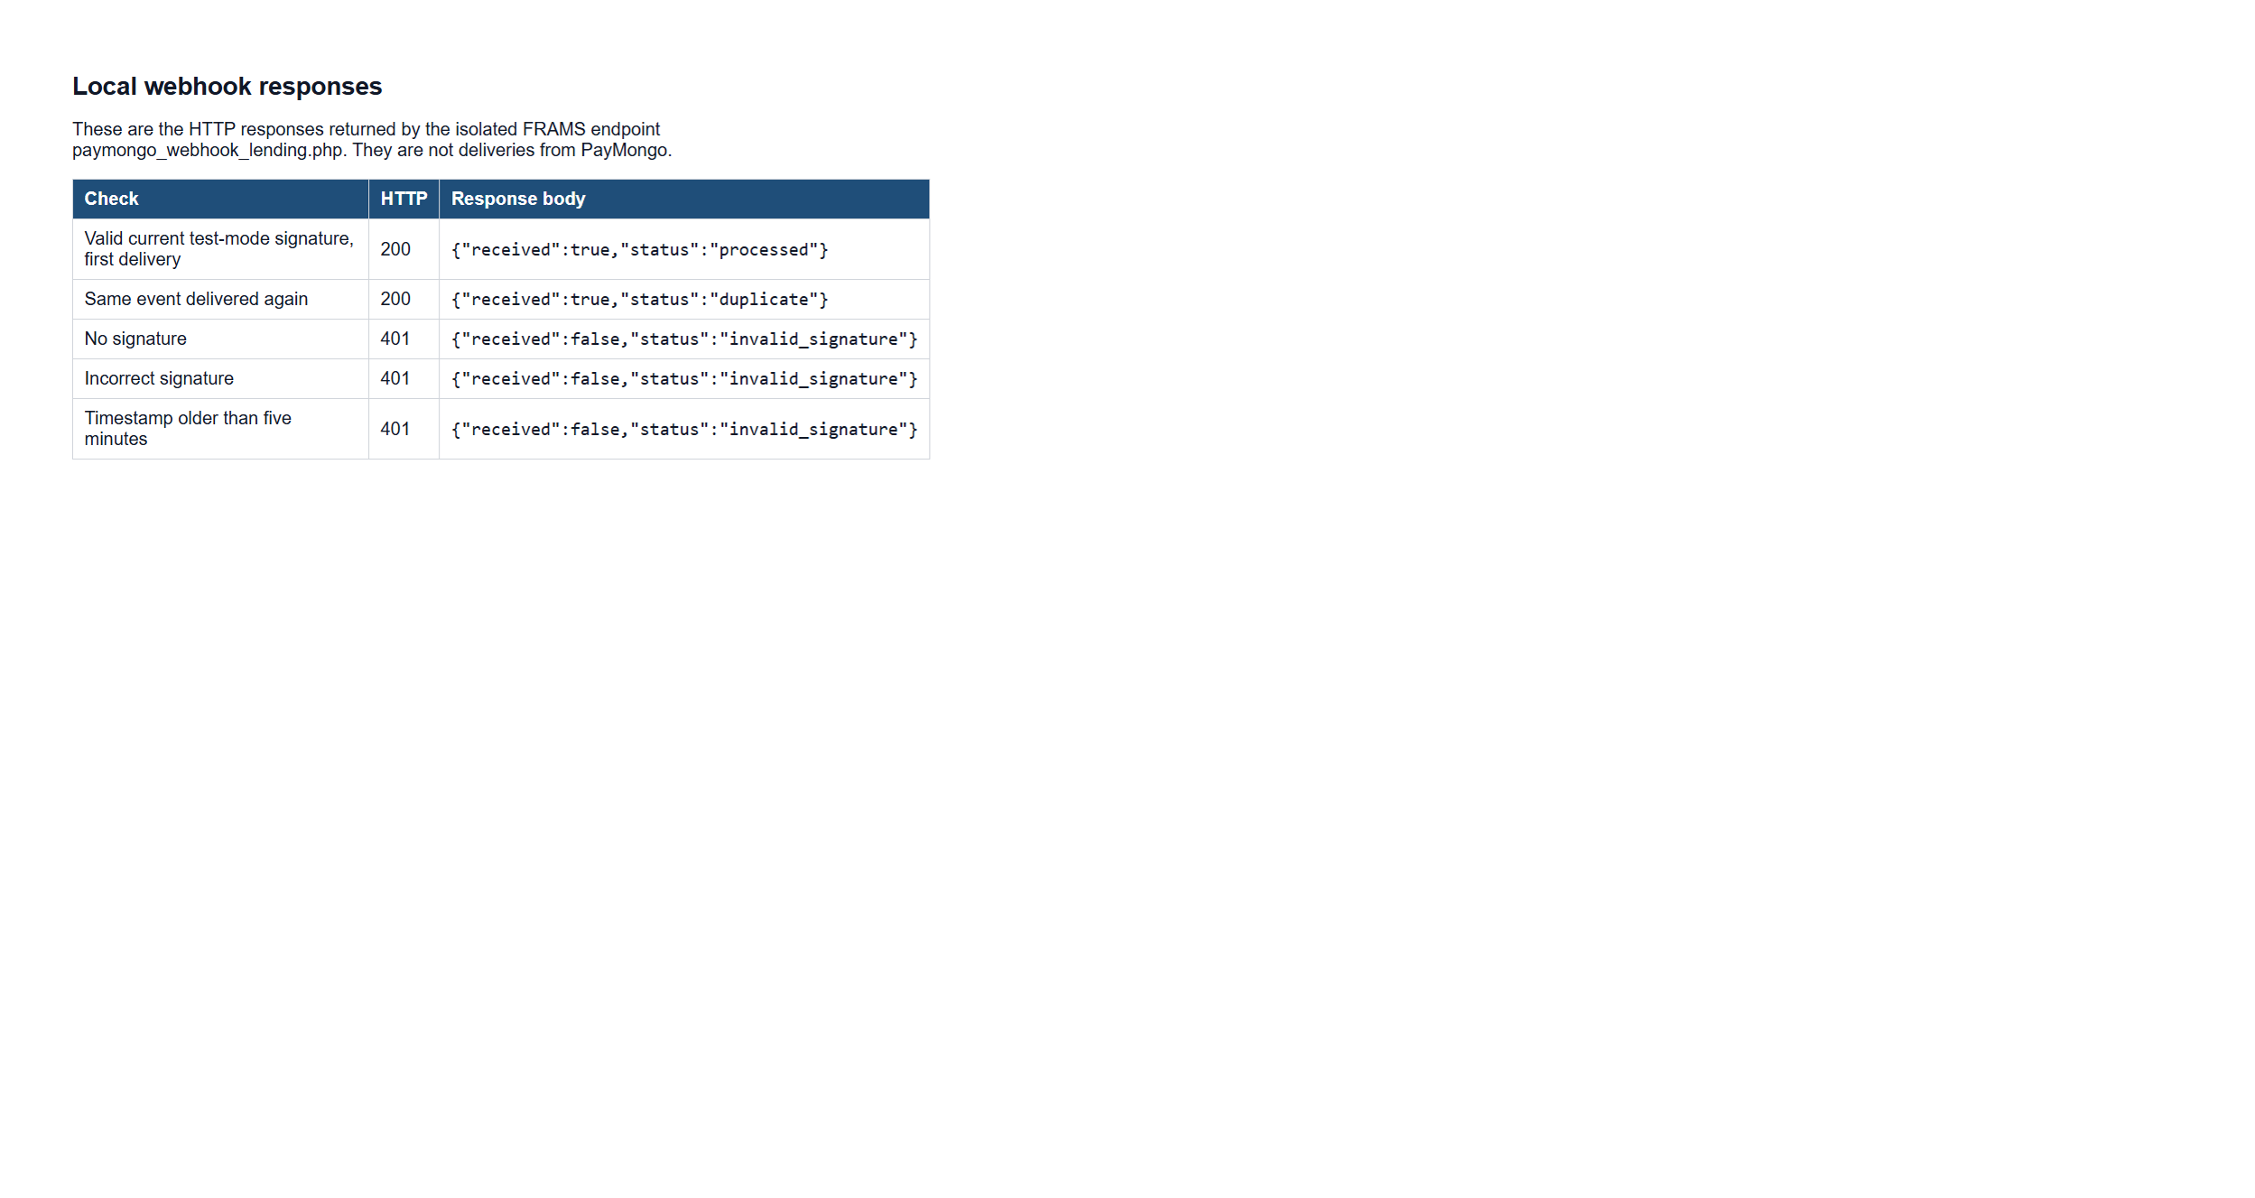
Figure B35 (B36_pm11_webhook_responses.png)

Figure B36 — PM-11
Scenario: A webhook is sent with no signature, an incorrect signature, or a timestamp older than five minutes.
Expected result: Each request is rejected and the pending QR and payment count remain unchanged.
Actual result: All three requests returned HTTP 401 with status invalid_signature. The repayment count for the disposable loan stayed at one, and the succeeded transaction was not changed. These were local requests to the FRAMS webhook endpoint.
Status: PASS
Figure B36 (B36_pm11_webhook_responses.png)

Figure B37 — PM-12
Scenario: An administrator submits deletion of a disposable repayment linked to a verified QR Ph transaction.
Expected result: The payments screen has no edit or delete control. The delete request is refused, and the payment, receipt, and QR record remain.
Actual result: The administrator payments screen shows View only. There is no edit or delete control. A delete request for payment 46 returned the refusal that a payment linked to a verified PayMongo QR Ph transaction was not deleted. Payment 46, receipt RJRR-20261018-000004, and the succeeded QR record remained. The client and borrower were not deleted.
Status: PASS
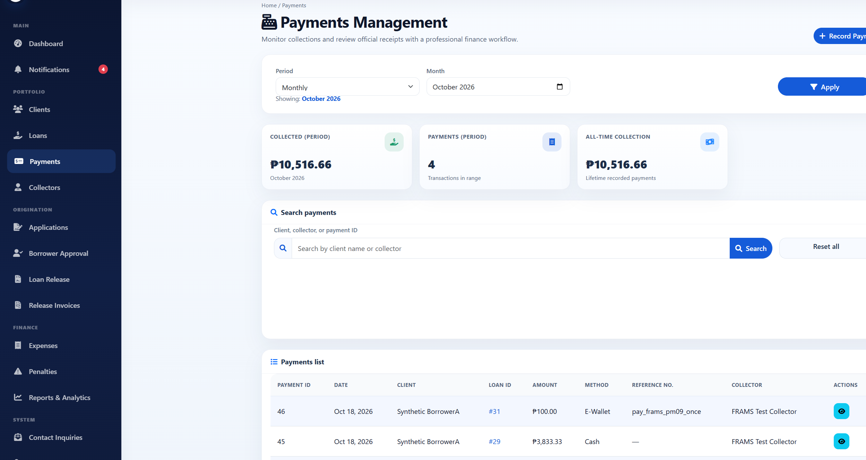
Figure B37 (B37_pm12_no_delete_control.png)

