Phase 3: Architectural Design

3.1 Analyze Architectural Styles
This section presents a general analysis of different architectural styles that can be applied to the Online Course Registration Management System.
3.1.1 Client–Server Architecture:
The Client–Server architectural style divides the system into two main components: clients and servers. Clients are responsible for sending requests, while the server processes these requests and returns responses. This style is commonly used in web-based systems where multiple users access centralized services. It supports data consistency and centralized control, but may become less flexible as system complexity increases.
3.1.2 Three-Tier Architecture:
The Three-Tier architectural style extends the client–server model by separating the system into three distinct layers: presentation, business logic, and data. The presentation layer handles user interaction, the business logic layer processes system rules and workflows, and the data layer manages persistent storage. This separation improves maintainability, scalability, and security, making it suitable for complex systems with multiple user roles and business rules.
3.1.3: Model–View–Controller (MVC) Architecture:
The Model–View–Controller (MVC) architectural style separates the application into three interconnected components. The Model represents the system data and business rules, the View handles the user interface, and the Controller manages user input and coordinates interactions between the Model and the View. MVC improves code organization and simplifies user interface development, but may introduce additional complexity for large-scale systems.

3.2 Select & Justify Suitable Architectural Style:
Based on the analysis of architectural styles, the Three-Tier Architecture is selected as the most suitable style for the Online Course Registration Management System. This architecture divides the system into three distinct layers: presentation, business logic, and data.
The separation of concerns provided by the Three-Tier Architecture improves system maintainability and simplifies future modifications. The presentation layer allows students, academic advisors, and administrators to interact with the system through user-friendly interfaces. The business logic layer handles course registration rules, prerequisite validation, seat availability checks, and advisor approvals. The data layer securely manages student records, course information, registration requests, and academic history.
Additionally, this architectural style enhances system security by isolating direct data access and supports scalability, making it suitable for a university environment with a large number of users and concurrent registration requests.

3.3 Map Design for Three-Tier Architecture:
In the Three-Tier Architecture, the Online Course Registration Management System is organized into three main layers, each responsible for a specific set of functions.
Presentation Layer:
The presentation layer represents the user interface through which users interact with the system. It includes interfaces for students to log in, view available courses, and submit registration requests. It also provides interfaces for academic advisors to review and approve registrations, and for administrators to manage courses and system configurations. This layer focuses on displaying information and collecting user input.
Business Logic Layer:
The business logic layer contains the core functionality of the system. It handles validation of student credentials, prerequisite checking, seat availability verification, registration request processing, academic advisor approval workflows, and notification generation. This layer ensures that all academic and administrative rules defined in the system are correctly applied.
Data Layer:
The data layer is responsible for managing persistent data storage. It includes databases that store student information, course details, registration records, academic history, and system configurations. This layer ensures data consistency, integrity, and secure access by the business logic layer.

3.4 Create Architecture Diagram & Reasoning:
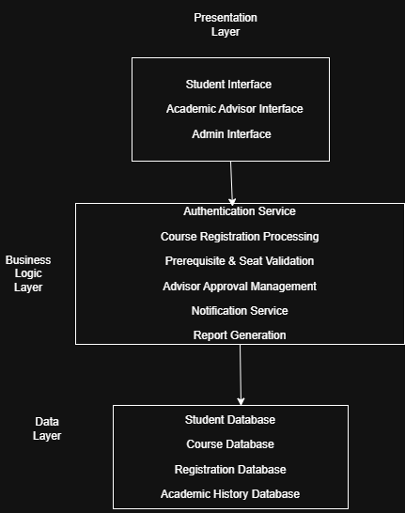
The architecture diagram illustrates the adoption of the Three-Tier Architecture for the Online Course Registration Management System. The presentation layer provides user interfaces for students, academic advisors, and administrators. The business logic layer processes registration rules, validations, approvals, notifications, and reporting functionalities. The data layer manages persistent storage of student records, course details, and registration information. This layered structure enhances system maintainability, security, and scalability by clearly separating responsibilities across the system.

