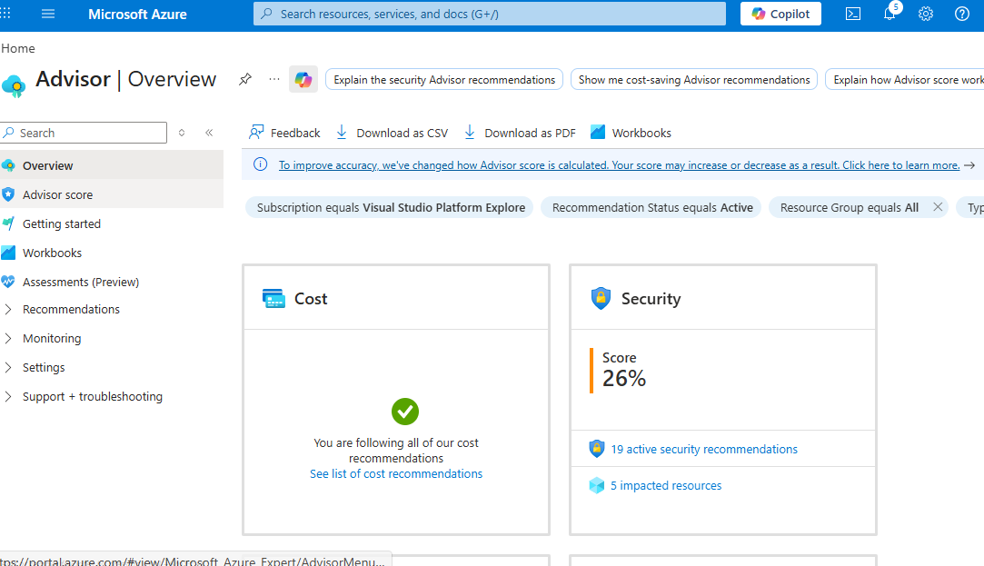

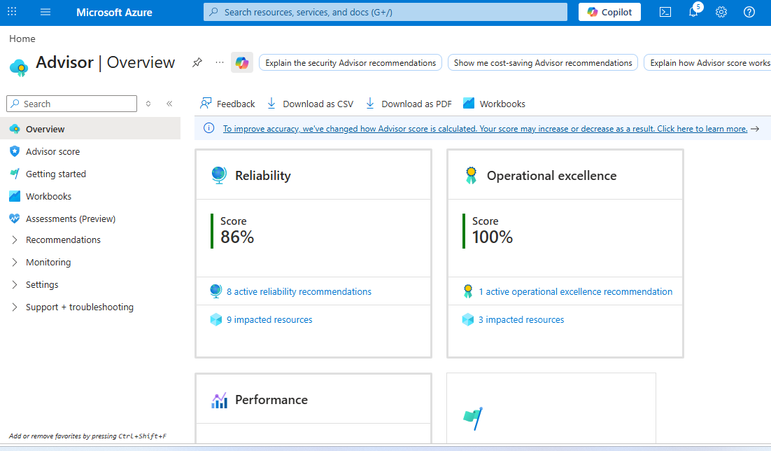

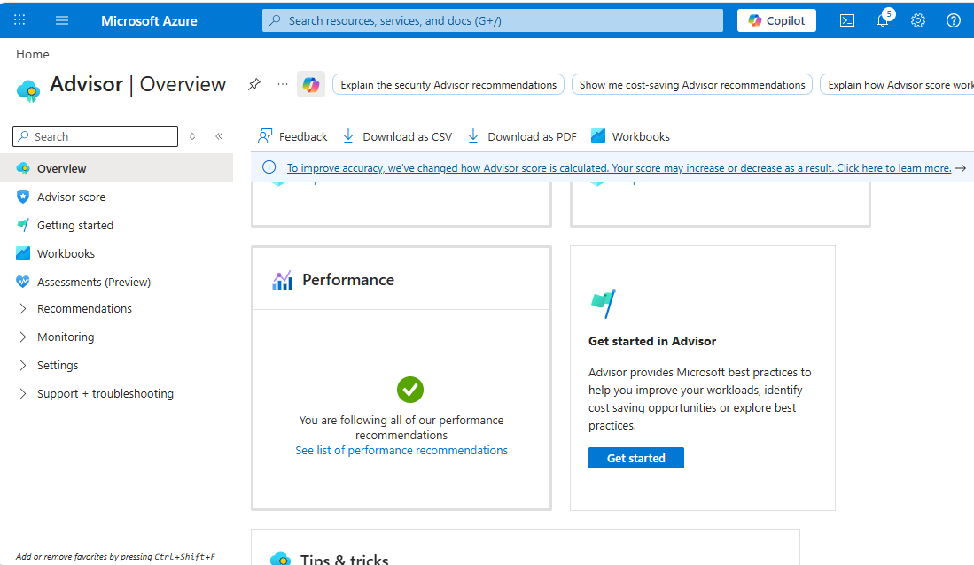

Answer the following questions in your thought-process.md file:
- Why is the DataSubnet NSG configured to deny all internet traffic? What types of resources would go in this subnet and why shouldn't they be internet-accessible?
Answer: The DataSubnet NSG denies internet traffic to protect sensitive, backend resources that should never be exposed publicly.
The resources should only be accessed internally, not by the public internet.

- What would happen if the Storage Account allowed public blob access instead of private? Describe a real-world scenario where this could cause a data breach.
Answer: If a Storage Account allows public blob access, anyone on the internet can read the data in those containers. That turns the storage from “locked down” into something closer to a public website.
Allowing public blob access exposes stored data to anyone on the internet. In a real-world scenario, this could lead to unauthorized access to sensitive files such as database backups or employee records, resulting in a serious data breach, financial loss, and reputational damage. Keeping blob containers private ensures that only authorized users and services can access the data.
- What is your Azure Advisor score? What specific improvements does it suggest? Would you implement all of them — why or why not?
Answer: From the Azure Advisor dashboard, my scores are as follows:
- Reliability: 86%
- Security: 26%
- Operational Excellence: 100%
- Cost: 100%
- Performance: 100%
The overall observation is that while cost, performance, and operational excellence are well optimized, security has a very low score and reliability needs improvement.
Recommendations
Azure Advisor suggests several improvements:
- 19 active security recommendations affecting 5 resources
- 8 reliability recommendations affecting 9 resources
- 1 operational excellence recommendation affecting 3 resources
The key areas needing attention are:
Security:
- Improve security configurations (likely NSGs, public access, or missing protections)
- Apply security best practices to reduce vulnerabilities
Reliability:
- Enable backups for resources
- Improve fault tolerance and availability configurations
Operational Excellence:
- Minor improvements related to resource management or monitoring
Would I implement all recommendations?
I would not implement all recommendations automatically. Instead, I would evaluate them based on necessity and impact.
For example:
- Security recommendations should be prioritized and mostly implemented because they protect against threats and data breaches.
- Reliability improvements such as backups are important and should be implemented to prevent data loss.
- Cost and performance recommendations may not always be necessary if the current setup already meets requirements.
- Some recommendations might increase cost or complexity without significant benefit, especially in a test or development environment.
Therefore, I would implement critical security and reliability recommendations first, while carefully reviewing others based on business needs and cost implications.

- Your VM currently has a public IP and SSH (port 22) open. In a production environment, what would you do differently?
Answer: In a production environment, leaving a VM with a public IP and port 22 (SSH) open to the internet is not considered secure. It increases the attack surface and exposes the VM to unauthorized access.
In a production environment, I would not expose a virtual machine directly to the internet with a public IP and open SSH port. Instead, I would place the VM in a private subnet without a public IP. If SSH access is required, I would restrict it to specific trusted IP addresses using NSG rules and enforce SSH key-based authentication. These measures reduce the attack surface and protect the VM from unauthorized access and brute-force attacks.
- You chose LRS for the Storage Account. A manager asks: "What happens if the entire datacenter goes down?" How do you respond?
Answer: LRS is more cost-effective and sufficient for non-critical or test workloads, but it does not provide protection against datacenter-level failures.

If the entire datacenter goes down (for example, due to a power outage, natural disaster, or major network failure), the data would become unavailable because all replicas are stored in that same location.

To handle this risk in a production environment, a higher redundancy option such as Zone-Redundant Storage (ZRS) or Geo-Redundant Storage (GRS) would be used. These options replicate data across multiple availability zones or regions, ensuring continued availability even if one datacenter fails.

