

**送货清单**

客户名称：{zb_company}

收货人：{consignee_name1}

电话：{consignee_phone1}

手机：{consignee_mobie1}

收货地址：{consignee_address1}

--------------------------------

<**

|  |  |  |  |
| --- | --- | --- | --- |
| **名称** | **数量** | **单价** | **小计** |
| {pro_name} | {send_sl} | {pro_price_hszh} | {pro_price_hszh1} |

-------------------------------

数量合计：{send_sl_all}

总价合计：{pro_price_zj3}**>

-------------------------------

签字：

\*\*\*\*\*\*\*\***欢迎再次订购**\*\*\*\*\*\*\*\*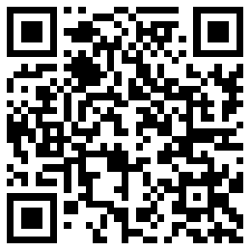

联系电话：010-XXXXXXXX