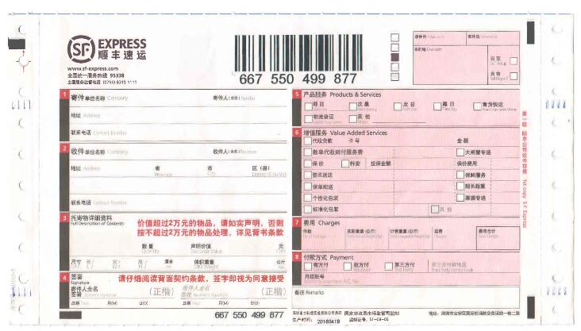

|  |  |  |  |  |  |  |
| --- | --- | --- | --- | --- | --- | --- |
|  |  |  |  |  |  |  |
|  |  |  |  |  |  |  |
|  |  | |  |  |  |  |
|  |  | |  | **{person_name}** |  |  |
|  |  | | | |  |  |
|  |  |  | | |  |  |
|  | **{zb_company}** | |  | **{consignee_name1}** |  |  |
|  | **{consignee_address1}** | | | |  | **.** |
|  |  | **{consignee_mobie1}** | | |  |  |
|  |  |  |  |  |  |  |
|  |  | | |  |  |  |
|  |  |  |