Introducing LabPortal
Fully Automated Veterinary Laboratory Information Management System(VLIS)
LabPortal is an automated Laboratory Information Management System (LIS) developed specifically for veterinary laboratories to simplify their complex operations. LabPortal is the ultimate solution to improve workflow and ensure the accuracy of results.
It serves as a centralized platform for managing and automating various laboratory operations, including receiving orders, sample tracking, data management, modality testing, result reporting, quality control, inventory management, communication with referring hospitals or clinics, etc.
The main Benefits of LabPortal are:
- Improved workflow efficiency
- Electronic Lab Notebook (ELN) for efficient experiment planning and documentation
- Laboratory Information Management System (LIS) for improved sample tracking and inventory management with low-stock notifications
- Efficient information management
- Automate all processes of testing and producing results to reduce human error.
- Seamless communication with referring hospitals
- Elevated customer experience
- Regulatory compliance support to ensure data integrity and accreditation requirements

Market Need
In today's competitive veterinary healthcare industry, laboratories require efficient and user-friendly solutions to manage increasing caseloads, streamline workflows, and maintain accurate results. The market demands tailored LIS to meet the unique needs of veterinary Laboratories without sacrificing efficiency or accuracy, all while remaining scalable and adaptable.
Key Market Needs
- Efficient lab management for growing veterinary cases
- Accurate and prompt diagnostics
- Robust data management
- Streamlined workflows
- Seamless communication with referring hospitals
- Scalable and adaptable LIS solution for all lab sizes
- Robust Security
- Advanced Inventory Management

Our Top Competitors

Name | Link
Orchard Software | https://www.orchardsoft.com/solutions/veterinary-labs/
Zendolims | https://www.zendolims.com/en/features-zendolims-vet.html
LabVantage Medical Suite | https://www.labvantageclinical.com/laboratory-disciplines/veterinary/

The Features We Want To Implement Are
Streamlined workflow management, from patient registration to result delivery.
- Cloud-based Access: Secure cloud storage and accessibility allows for real-time data updates and remote access for lab personnel.
- Eliminate Manual Data Entry: Minimize manual input and reduce errors with automated data collection and entry.
- Seamless Integration: Easily integrate veterinary lab modalities such as Biochemistry analyzer, Hematology analyzer, and Hormone analyzer, with Hospital Information systems(HIS) for a cohesive user experience.
- Comprehensive Reporting: Generate custom reports and analytics for performance evaluation, trend analysis, and decision-making.
- Quality Control and Compliance: Track quality control processes and maintain compliance with industry regulations and standards.
- Secure Data Management: Robust security features to protect sensitive patient and diagnostic information from unauthorized access and breaches.
- Real-time Notifications(IoT): By leveraging IoT technology, you can enjoy seamless connectivity and instant alerts for important updates, pending tasks, or critical issues requiring immediate attention.
- Sample Tracking: Barcode scanning and sample tracking capabilities to ensure accurate identification and processing of lab specimens.
- Inventory Management: Efficient tracking and monitoring of lab consumables, equipment, and reagent usage lead to cost savings and reduced waste

Target Customers for LabPortal
Veterinary Diagnostic Laboratories:
Independent veterinary diagnostic labs provide testing and diagnostic services for animal health.
In-house diagnostic labs within veterinary clinics, hospitals, or research institutions.
Research Laboratories:
Veterinary research laboratories conduct studies on animal diseases, genetics, or pharmaceutical development.
Veterinary Hospitals and Clinics:
Hospitals and clinics with in-house laboratory facilities require streamlined lab management and result reporting.
Animal Research Facilities:
Institutions engaged in animal research require efficient lab management solutions for sample tracking and data management.
Biotechnology and Pharmaceutical Companies:
Biotech and pharmaceutical companies focusing on veterinary therapeutics and diagnostics, need lab management systems to support their research and development activities.
Veterinary Schools and Universities:
Educational institutions offering veterinary programs that require effective lab management and result reporting tools.
Veterinary Pathology Centers:
Specialized veterinary pathology centers are involved in diagnosing and managing animal diseases.
Veterinary Reference Laboratories:
Reference laboratories provide specialized veterinary testing services to other veterinary practices or hospitals.

Roles In The App
- Service Provider
- Hospital
- Veterinary laboratory
- Owner
- Pet Patient

Revenue Model
LabPortal will be offered to the manufacturers and distributors of Veterinary Lab Analyzers. e.g., FujiFilm or JF. The license will have two separate options.
- App Functionalities
- API Connectivity

Modalities
- Biochemistry analyzer
- Hematology analyzer
- Hormone analyzer

Functionalities
Actors: The following kind of Actors will be present in the System:
Service Provider | Hospital | Lab with Modality devices
JF | Hos A | Lab
Supplier of Modality Devices | Creates an order | Analyze the samples with their modality devices.

LabPortal Workflow
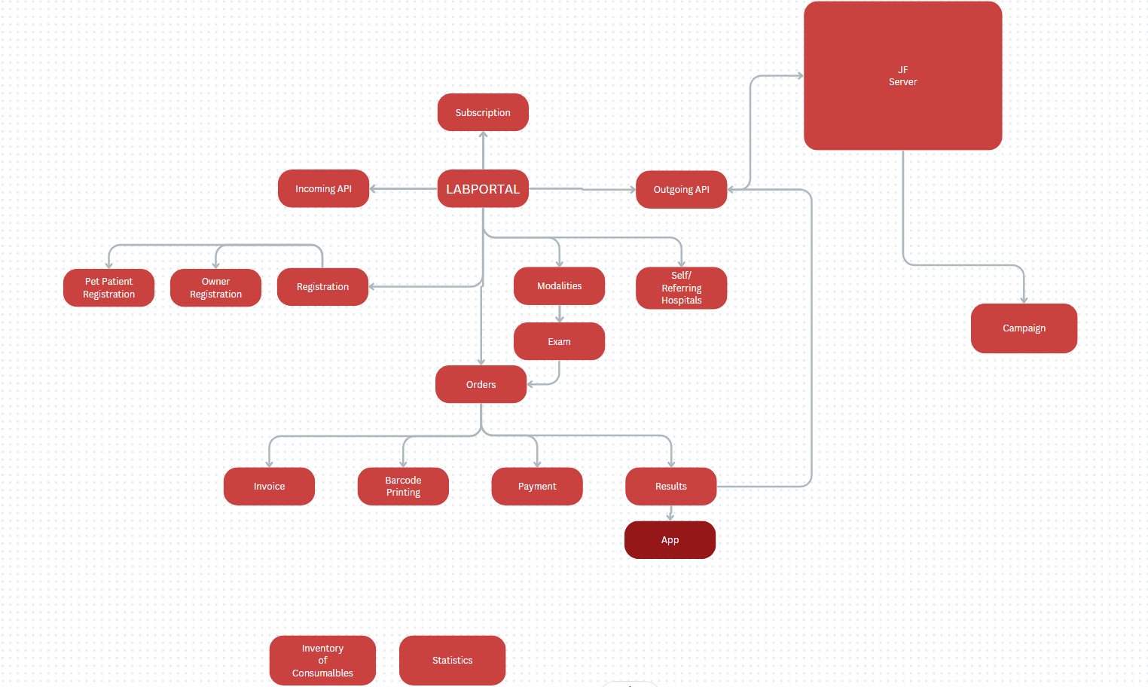

Incoming API - Data is received from the Hospital Information System (HIS) through an incoming API.
Order Creation - Orders can be created based on the incoming API data, specifying the requested exams, and procedures. Orders can also be created manually.
Invoice Generation - An invoice is generated based on the selected exams. The pricing is determined based on the selected exam and associated tube settings.
Barcode Printing - Barcodes are printed for each sample or test tube based on the specific tube settings associated with the selected exam.
Reporting - The samples are processed, the relevant tests or procedures are performed in the laboratory, and returns a report with preferred consumables which can be found in our LabPortal system.
Result Transmission - The results can be sent to the client's HIS system, their own server, or a third-party server using outgoing API. This can involve both sending and receiving data to ensure seamless integration between systems.
Payment - The client is notified of the invoice and makes the necessary payment for the services rendered.
Analytics - LabPortal generates robust analytics, including data analysis, performance monitoring, quality control, resource optimization, visualization, and continuous improvement for hospitals and laboratories. Enhancing efficiency, accuracy, and decision-making in veterinary lab operations.

Hardware Requirements
- Computer with a stable Internet connection

