Nucleus
Documentation

Document Version No- 1.1.2

Last update Datetime-19/07/2022

Last update by-Wasiur Rahman

Applicable Software no-0.1.0

Flowchart

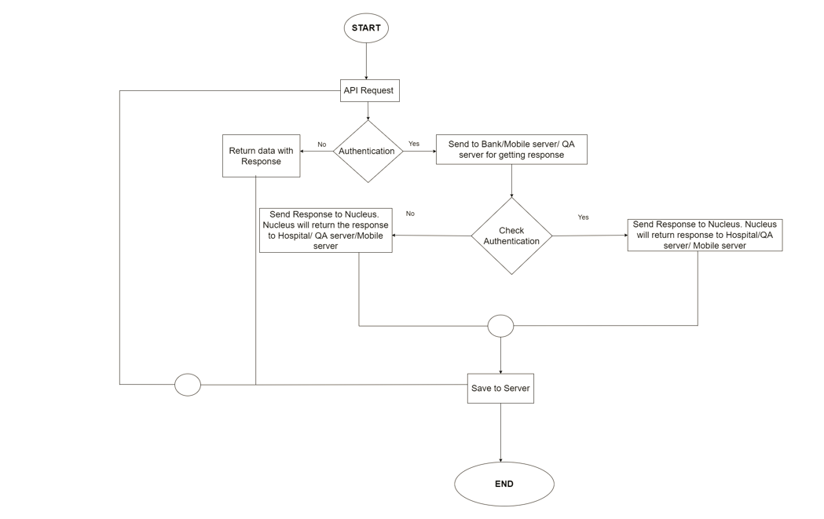

Nucleus software connects the backend systems. The Nucleus software helps to connect multiple API requests.
Nucleus is a middleware app. The API first requests the software, and then the software checks the API's authentication. If the API request is authenticated, the software returns the response to the third party and saves that response to the existing server. There are four servers hospital, bank, QA, and Mobile server. They can all provide the API request through this software. They can all provide the API request through this software. The software has to check the security of the API request.

We see the Nucleus software as a service. Nucleus software makes the software work seamlessly. Nucleus software helps improve the software's interoperability, scalability, manageability, and flexibility. It brings different systems together as a single platform.

