Overview of OAuth2 (via IdentityServer4)
OAuth 2.0 is an open standard authorization protocol that allows applications to obtain limited access to user resources on an HTTP service, typically via access tokens, without exposing the user's credentials. It is designed to enable secure delegated access, where a user can authorize a third-party application to act on their behalf for specific resources.
IdentityServer4 is an open-source framework for ASP.NET Core that implements both the OAuth 2.0 and OpenID Connect (OIDC) protocols. It serves as a centralized authentication and authorization server (also known as a Security Token Service or STS), issuing security tokens (such as JWTs) to clients (applications) after authenticating users.
How OAuth2 Works (with IdentityServer4)
- Roles in OAuth2:
  - Resource Owner: The user who owns the data or resource.
  - Client: The application requesting access to the resource.
  - Resource Server: The API that holds the protected data.
  - Authorization Server: The service (e.g., IdentityServer4) that authenticates the user and issues tokens.

- Typical Flow:
  - The client application redirects the user to the authorization server (IdentityServer4) for authentication and consent.
  - Upon successful authentication and authorization, IdentityServer4 issues an access token (and optionally a refresh token and ID token if using OIDC).
  - The client uses the access token to access protected resources from the API on behalf of the user.
- OAuth2 Grant Types (Flows):
  - Authorization Code: Most secure, uses both front and back channels; suitable for web and mobile apps.
  - Implicit: For browser-based apps, less secure, now discouraged.
  - Resource Owner Password Credentials: For legacy or trusted apps, rarely recommended.
  - Client Credentials: For service-to-service communication2.

IdentityServer4’s Role
- Implements OAuth2 and OIDC: IdentityServer4 provides all the necessary endpoints and logic to handle OAuth2 flows and OIDC authentication, including issuing, validating, and revoking tokens.
- Centralized Security: It acts as a single point for authentication and authorization across multiple applications and APIs, reducing duplication and improving security5.
- Token Types Issued:
  - Access Token: Used by clients to access APIs.
  - ID Token: (OIDC) Contains user identity information.
  - Refresh Token: Used to obtain new tokens without re-authenticating4.
- Endpoints Provided:
  - /authorize: Initiates authentication and authorization.
  - /token: Issues tokens.
  - /userinfo: (OIDC) Returns user claims.
  - /revocation: Revokes tokens.
  - /.well-known/openid-configuration: Discovery document for client auto-configuration.
- Summary
- OAuth2 (via IdentityServer4) is a robust approach for securing APIs and applications. IdentityServer4 acts as an authorization server, implementing OAuth2 and OIDC protocols, handling user authentication, issuing tokens, and centralizing security for modern web, mobile, and microservices architectures. This enables secure, scalable, and standards-compliant authentication and authorization across multiple applications.

Feature | OAuth2 (via IdentityServer4) | OpenID Connect (via IdentityServer4)
Token Type | Access Token | ID Token (plus Access Token)
Purpose | API authorization | User authentication + API authorization
Required Scope | Defined per API | OpenID (plus profile, email, etc.)
Client Registration | Yes | Yes
User Info Endpoint | Optional | Standardized in OIDC
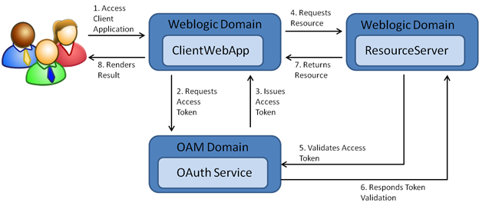

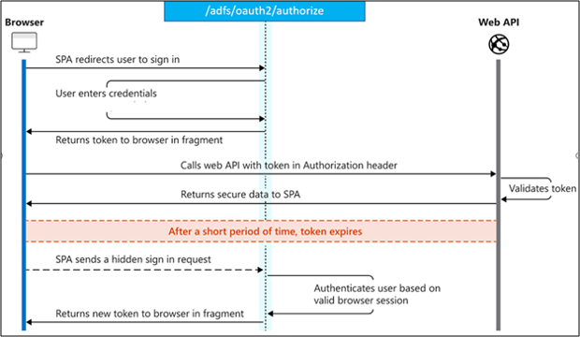
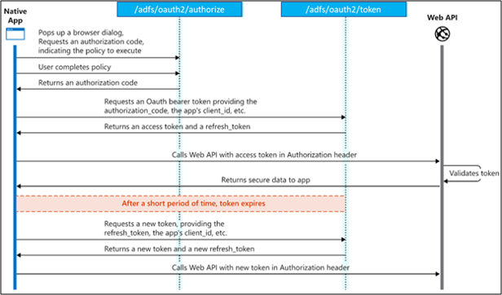

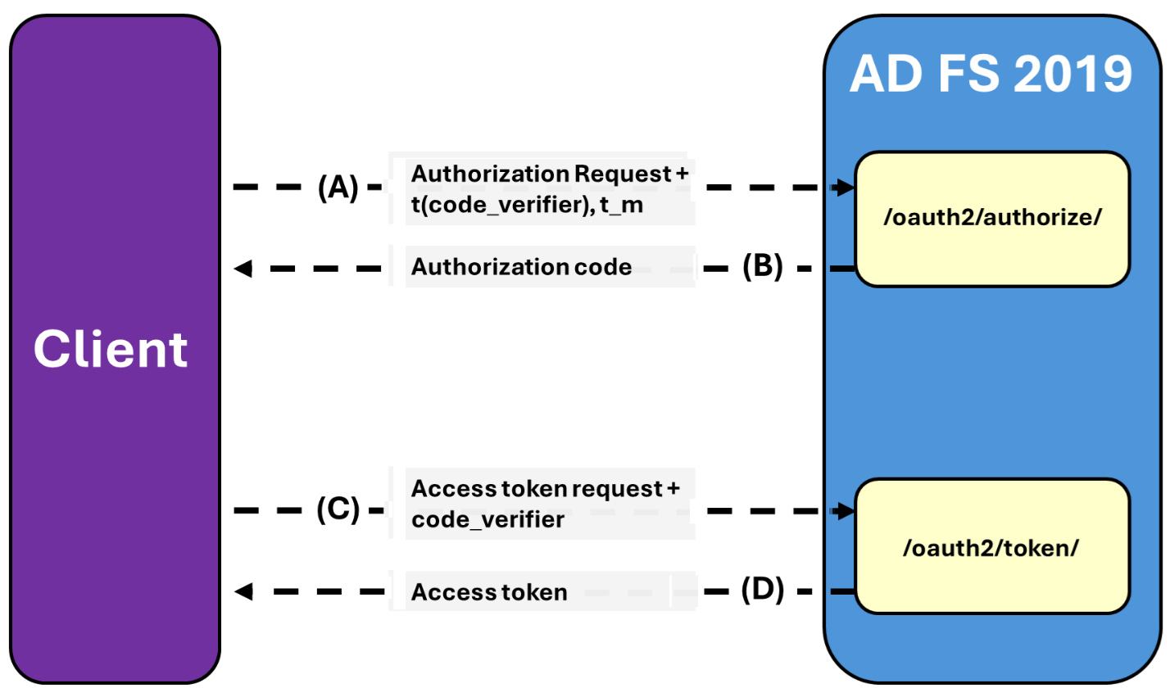
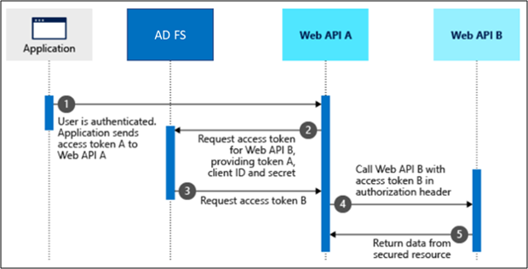

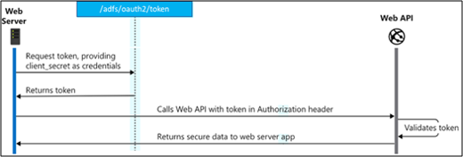
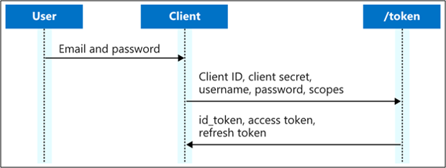
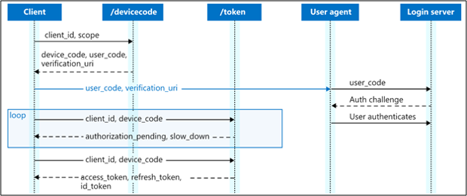

Ref: https://learn.microsoft.com/en-us/windows-server/identity/ad-fs/overview/ad-fs-openid-connect-oauth-flows-scenarios

