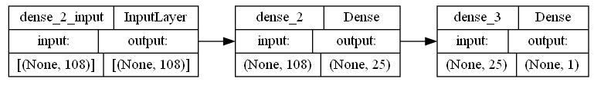

…

Input Layer

108 nodes

…

Hidden Layer

25 nodes

Output Layer

1 node

Income Predicated Probability

Age

demogweight

education-num

capital-loss

capital-gain

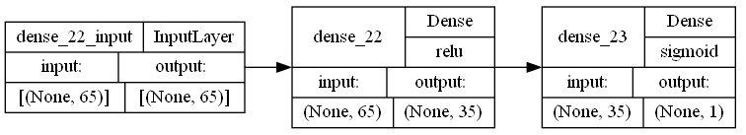

…

Input Layer

65 nodes

…

Hidden Layer

35 nodes

Output Layer

1 node

Income Predicated Probability

Age

demogweight

capital-loss

capital-gain

sex_Male