[1]

Report for Speed Sensor System project(2022)

Thien V. Dang, *Fellow*, and Hoa Tran, Dr., *Member*

***Abstract*—This document provides an overview and details of this project.**

# I. Introduction

T

HIS project design and write two programs in C++ with proper functions and data structure to simulate a speed

sensor mounted on a DC motor with the following specification:

* Measurement range: 0 ÷ 3000 rpm (revolution per minutes);
* Resolution: 0.2 rpm.

The design for this project is a simple and easy to grasp which allows the users to satisfy their inquisitiveness.

Our programing will run via command line interface, user may input parameters to customize the result.

Project structure:

* Task 1: Includes speed_sim.cpp and speed_sim.exe (compiled from speed_sim.cpp file) files.
* Task 2: Includes some test files, speed_process.cpp and speed_process.exe (compiled from speed_process.cpp file) files.

# II. Design

Each task, we will show the design of the whole program and each function. The flowcharts of the main program and important functions and brief description of this flow chart.

## Task 1

### Design

* void output_error(int error_code): print error to the screen and write to file at the same time with *error_code*; this function is not return value.
* bool assign_value(bool &has_set, int &variable, string value, int error_code): set an int *variable* with *value* as string; if this *variable* *has_set* or *value* is not a number or *value* exceed integer range then *ouput_error* and returns false, otherwise returns true.
* bool process_command_line(int argc, char *argv[]): this function iterate through argv array, that is parameter from user command line pass by main, then check each pair of element to *assign_value*. During the process, if invalid parameters are encountered, a log file corresponding to that error will be written (using the *output_error* function) and return false. This function returns a bool.
* string conver_to_string(time_t time): converts a time to HH:mm:ss format – the result is a string.
* int main(int argc, char *argv[]): main function of the program (entrypoint), used to call the function *process_command_line* which argc and argv is parameter from user command line. If *process_command_line* is true, this function writes generated values to csv file.

### Flowchart

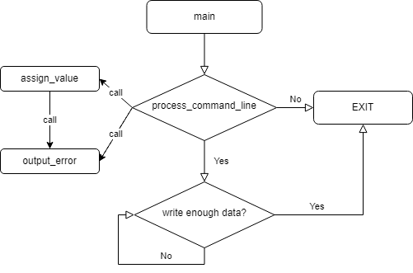

Figure .. Relationship of functions

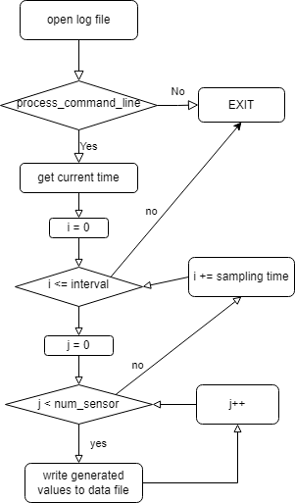

Figure .. Flowchart of the main program

## Task 2

### Design

### Flowchart

# III. Results

The program runs correctly according to the requirements of the given topic, has checked the happy cases such as the user miss some parameters and bad cases such as the user enters the parameter in the wrong format or number out of range (-n -st, -n -6).

Almost error about file accessing is handled.

Optional task 2.4 and Additional requirements 3 also implemented.

Although the project was successful, there are areas that could be improved on. Unfortunately, there was no time to complete the extra parts of the project.

# IV. Conclusion

Overall, this is a small project conducted individually so flaws are inevitable in designs, through some evaluations and examinations it is concluded that it still need to be improved and needed to be more comprehensive. With regard to this, there would need enhancement in the coding method and add some features to the project in the future.

Some of a few ideas that we have come up with can be listed below:

* Adding more commands.
* Looking for more bugs to fix so that the program can run smoothly as users will.
* Defining more errors if there are any.

# V. Task allocations

## Member 1

### Task 1

### Task 2

## Member 2

### Task 1

### Task 2

# VI. References

*Basic format for electronic documents (when available online):*

Issuing Organization. (year, month day). *Title*. [Type of medium]. Available: site/path/file

*Example:*

1. U.S. House. 102nd Congress, 1st Session. (1991, Jan. 11). *H. Con. Res. 1, Sense of the Congress on Approval of Military Action*. [Online]. Available: LEXIS Library: GENFED File: BILLS
2. **First A. Author** (Fellow, IEEE) and all authors may include biographies if the publication allows. Biographies are often not included in conference-related papers. Please check the Information for Authors to confirm. Author photos should be current, professional images of the head and shoulders. The first paragraph may contain a place and/or date of birth (list place, then date). Next, the author’s educational background is listed. The degrees should be listed with the type of degree in what field, which institution, city, state, and country, and year the degree was earned. The author’s major field of study should be lowercase. 

The second paragraph uses the preferred third person pronoun (he, she, they, etc.) and not the author’s last name. It lists military and work experience, including summer and fellowship jobs. Job titles are capitalized. The current job must have a location; previous positions may be listed without one. Information concerning previous publications may be included. The format for listing publishers of a book within the biography is: *Title of Book* (publisher name, year) similar to a reference. Current and previous research interests end the paragraph.

The third paragraph begins with the author’s preferred title and last name (e.g., Dr. Smith, Prof. Jones, Mr. Kajor, Ms. Hunter, Mx. Riley). List any memberships in professional societies other than the IEEE. Finally, list any awards and work for IEEE committees and publications.

**Second B. Author**, photograph and biography not available at the time of publication.

**Third C. Author, Jr.** (Member, IEEE), photograph and biography not available at the time of publication.

1. 07/11/2022

   Thien V. Dang was with the University of Transport and Communication, Ha Noi, Viet Nam (e-mail: author@ boulder.nist.gov).

   Hoa Tran is with the University of Transport and Communication, Ha Noi, Viet Nam (e-mail: author@ boulder.nist.gov).