#Try the following steps to compile, run, and test the Rust program.

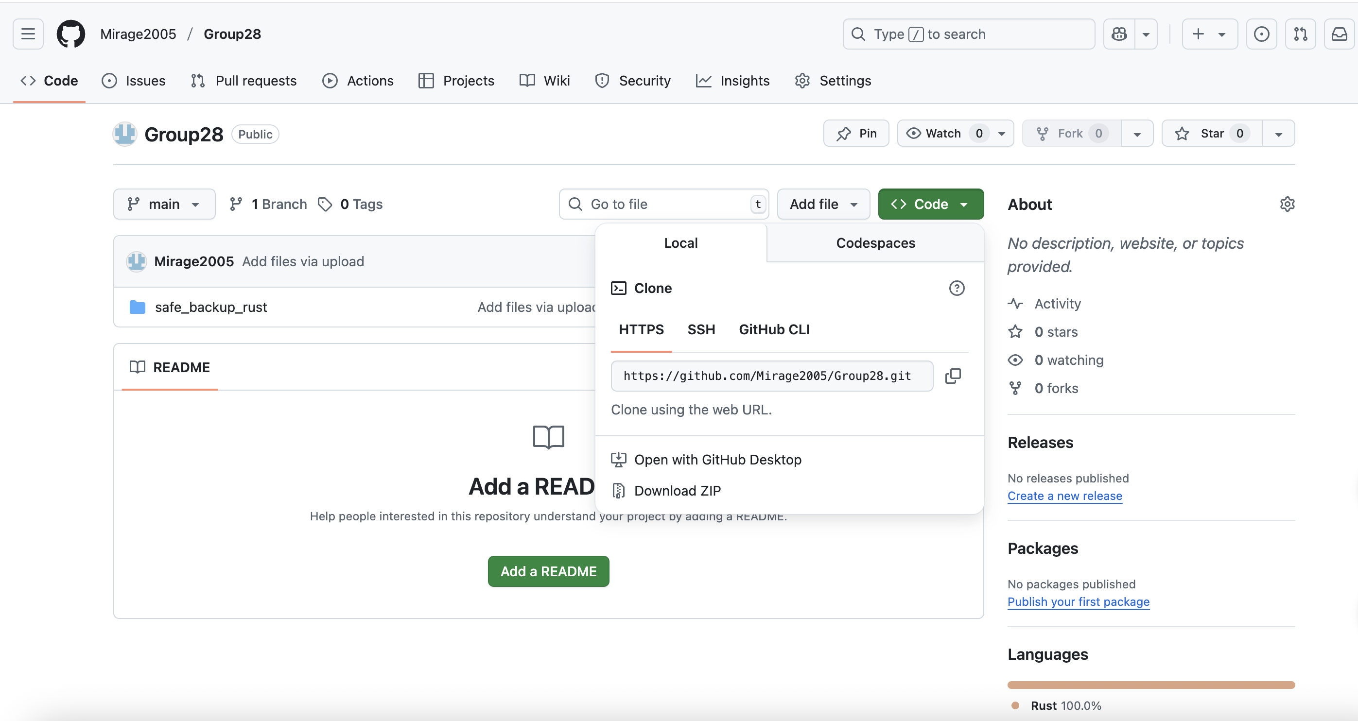

1. When you click on the link given on the top of the report, click on the green box written code.

2. Then click on download zip.

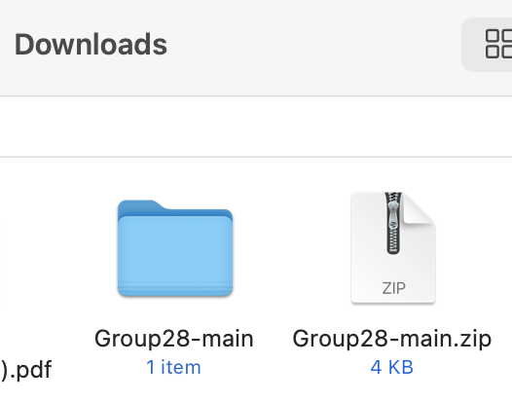

3. Then you will get a zip folder.

4. After extract that zip and you will get the folder named Group28-main.

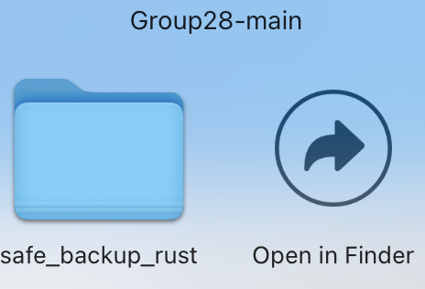

5. When you open that folder, you will see another folder named safe_backup_rust.

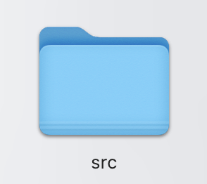

6. when you open that folder you will see this folder along with other files.

7. Click on this folder and you will find main.rs file which has the code.

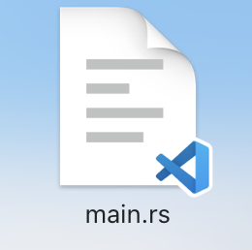

8. Open the file and you will see the code given below.

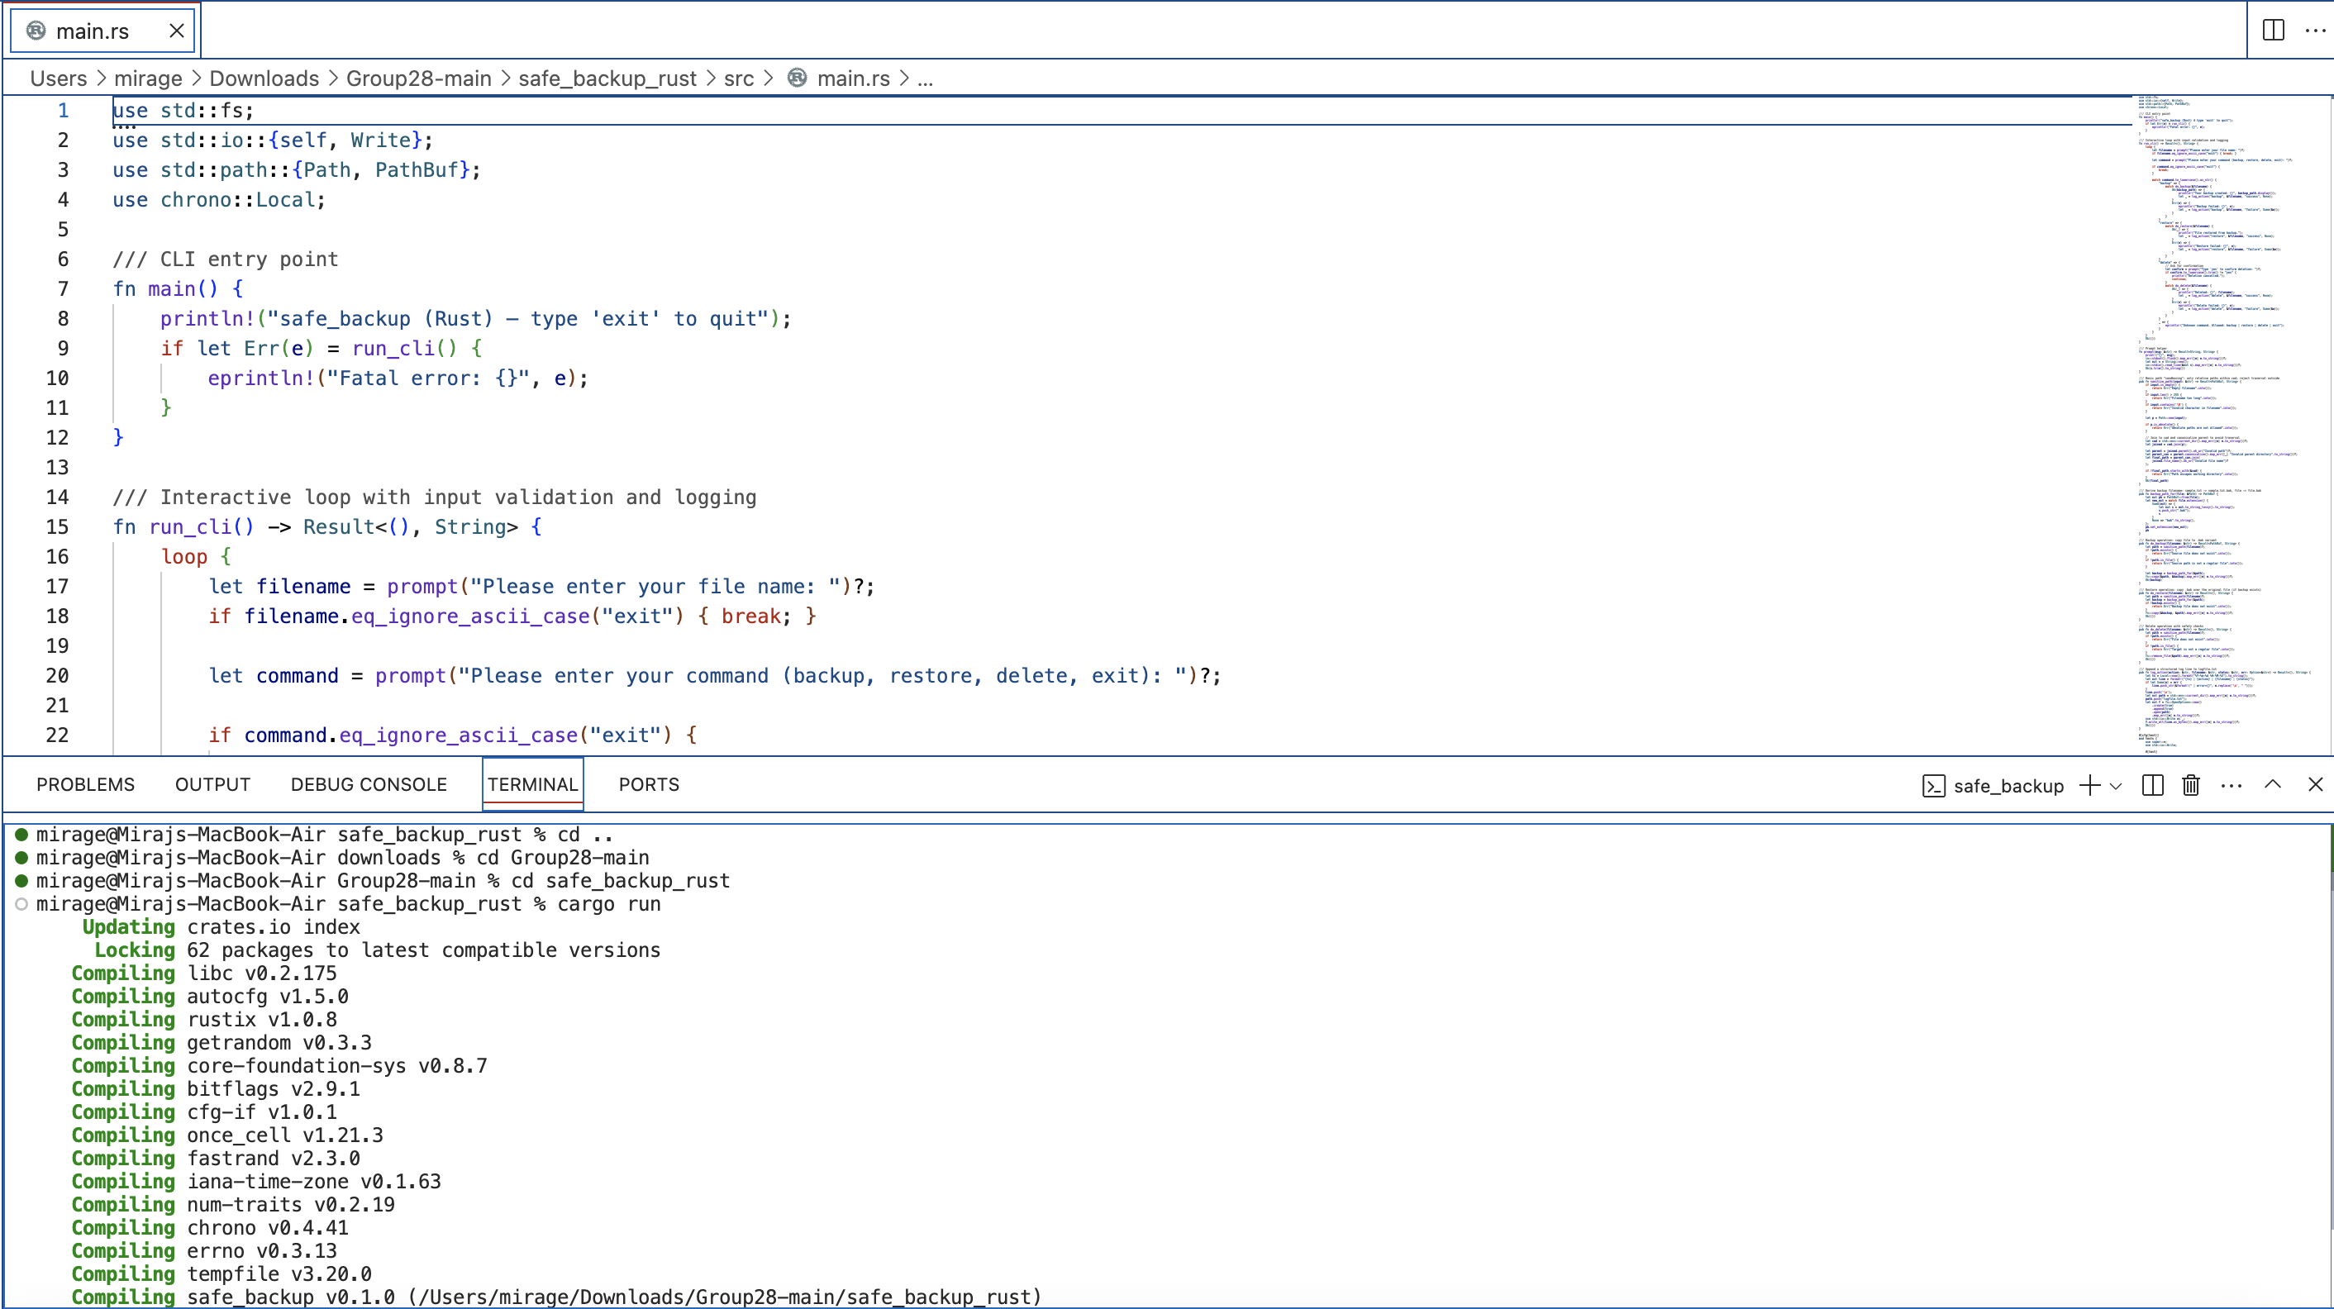

9. Use cd (……file path one by one where all the files are)

10. Once you reach and get inside the safe_backup_rust file type cargo run and enter.



11. When you run the code it asks to enter the file name.

12. We have only two files sample.txt and data.txt on the safe_backup_rust folder to perform the tests. So, if you put any other file name it will pop an error and won’t work further.



13. Once you enter the file name it will ask you to either backup, restore and delete the file or exit from the runnning code.

#Note: Only delete the file once you backup the file because once you delete the file you won’t be able to restore the file.

14. when you type backup and enter it will backup the file and new file named data.txt.bak file gets generated.

15. Now it again asks whether what you want to do with the files.

16. We have already backup the file so, now we can delete the file with no risk.

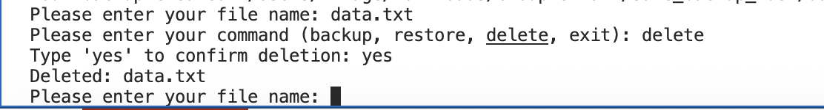

17. When you put the file and type delete and enter, it will ask you to confirm whether you really want to delete the file or not. After confirming yes, we can get our file deleted from the folder and it will disappear.

18. Now, we have to restore the file so, we will do:

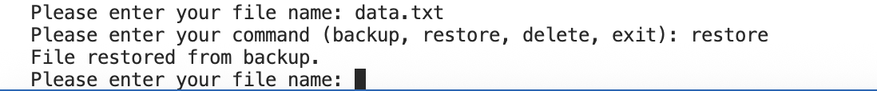

19. By this way the file will be restored back to the folder.

20. Now, you can type random name in the file name press enter and then again type exit press enter and then you will be out of the program.

