**Project Documentation**

This work focused on an exploratory analysis and time series analysis of climate change trends for the period between 1961 and 2022. Available data to drive the analysis came from international organizations including NASA and linked climate variables like surface temperature, atmospheric CO2 levels, mean sea level, and ocean heat content. The objective was to reveal the trends, determine the areas that are most affected, and analyze the interaction of these values.

The studies of global temperature change and related indicators are essential for developing strategies to decrease the level of climate change. This project is aimed at analysing and comparing various climate indicators in order to capture patterns and find out relationships for the use by policy makers and researchers.

1. **Global Temperature Change**

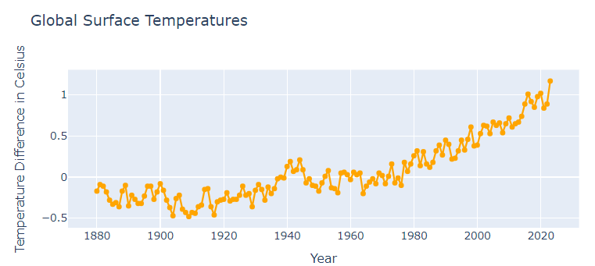

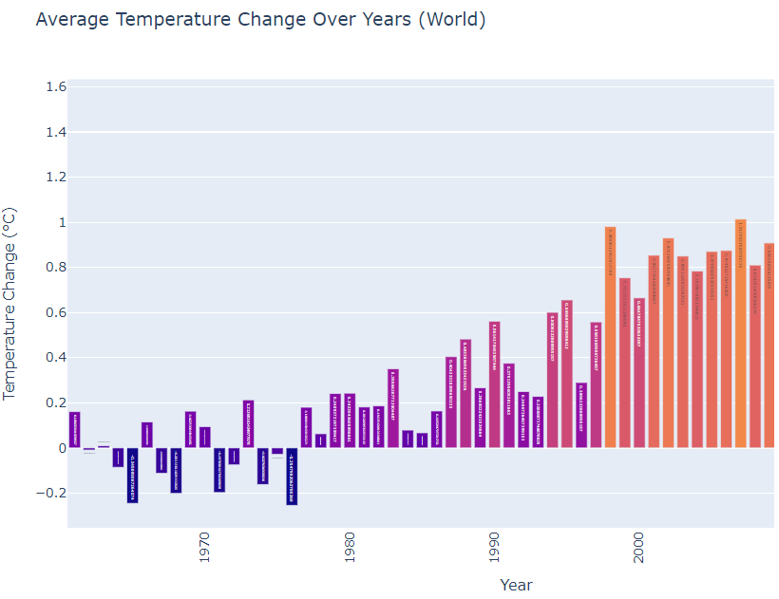

• These graphs refer to the average temperature fluctuations on Earth over the period 1961-2022.

• Over this period there is clear trends of rise meaning there is a marked increase in average temperatures.

• Most important is that increasing of temperature has accelerated in activity since the 1980s, where the recent years recording the highest degree of temperature rise.

Global temperatures in general have risen and are on the rise globally and especially so in the later years of the twentieth century and the first decade of the twenty first century, and rising average global temperatures directly affect glaciers. This also during summer when glaciers undergo faster melting resulting to decrease in both mass and area. This melting contributes to rise in the sea level since the water formed melts glaciers carry water into the seas.

1. **CO2 Emission**

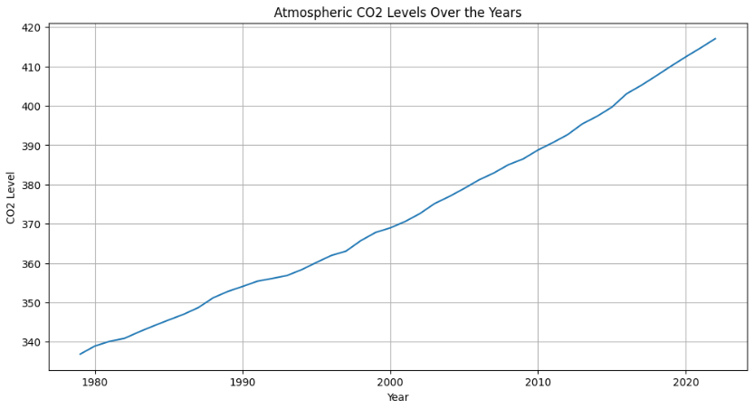

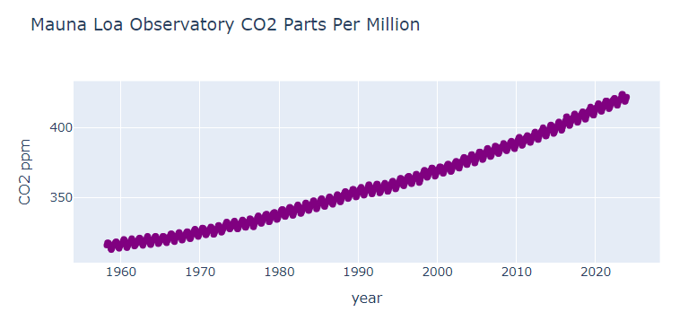

The trend of the atmospheric CO2 concentration with the years signifies a linear increase. Depending on the source the CO2 levels have been around 340 ppm in 1980 and have risen well over 415 ppm in the year 2022, and the graph also gives a clear indication of an upward trend. I do agree with this upward trend when bearing in mind the fact that greenhouse gas emissions continue to increase thus adding to the increase in global warming and climate change.

The rising straight-line curve in the figure reflects the increase in atmospheric CO2 levels and global warming. More amounts of gases in the atmosphere enable the greenhouse effect to trap more heat in the atmosphere. This heat increases the pace at which glaciers in various parts of the world; and notably in polar zones where ice is known to succumb easily to heat.

1. **Sea level**

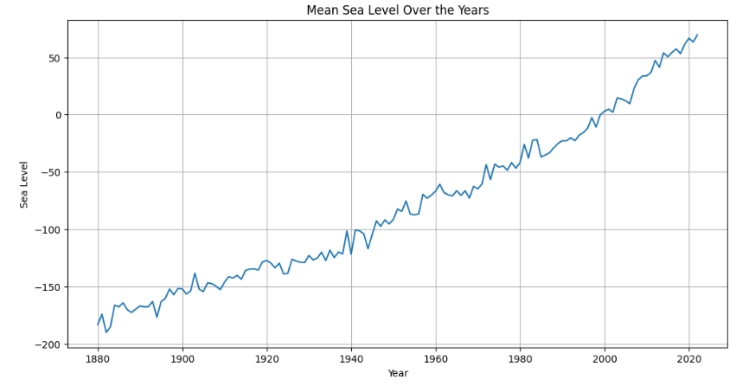

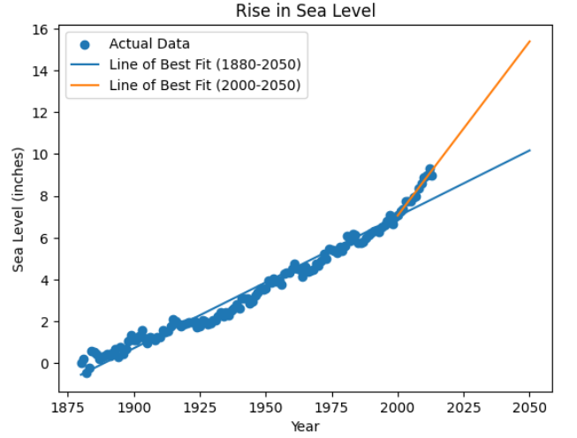

The changes in the mean sea levels over the years shows a clear and linear trend. In case of sea levels, the general average from 1993 to 2008 was stimulated from -175mm in 1880 to over 60mm by 2022. It has been rising steadily, thereby proving the effect of global warming especially through the melting of ice caps in the polar region and the thermal expansion of sea water, exerting a great effect on the human developments.

Increasing mean temperatures are also the reason for continued increase in sea level due to expansion of water because of heat expansion and through melting of glaciers and caps. It also notes that as glaciers melt, so does do the global sea levels which are dangerous to coast and marine related ecosystems. This is because the cutting down of glaciers also leads to a low supply of fresh water into rivers especially when it is warm, a factor that affects millions of humans.

1. **Ocean Heat Anomaly**

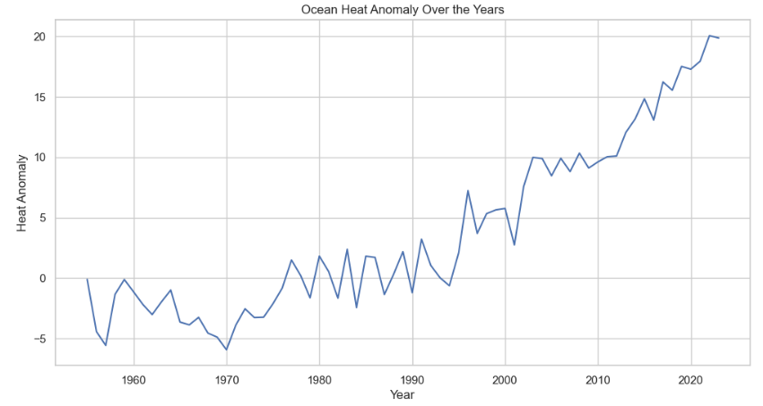

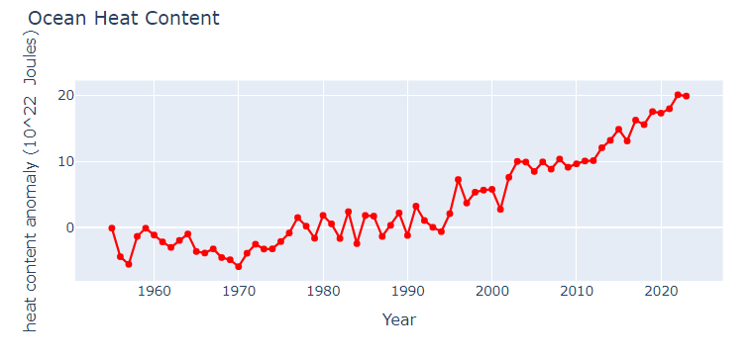

• 1955-1990: The ocean heat anomaly was also measured because it changed little over the given period and distributed between 5 to -5 x 10 ^{22} Joules. This period shows a fairly balanced partition of heat all through the oceans.

• 1990-2022: Perhaps the most dramatic change took place after 1990, and was manifested by the sharp rise in the ocean heat anomaly. This rise trend increased over the years to reach an anomaly of about 20 x 10^22 Joules in 2022.

This suggests the inevitable buildup of heat in the ocean especially signaling what may be new climate change processes and changes in heat circulation.

They also point out that since 1990, the increase in near-surface ocean heat content implies that oceans are carrying most of the excess heat from global warming. Higher temperatures in water may cause high degree of glacier calving where glaciers meet the sea particularly in Greenland and Antarctica. This melting can in turn destabilize ice sheets and lead to fast rates of ice loss.

1. **Correlation Matrix**

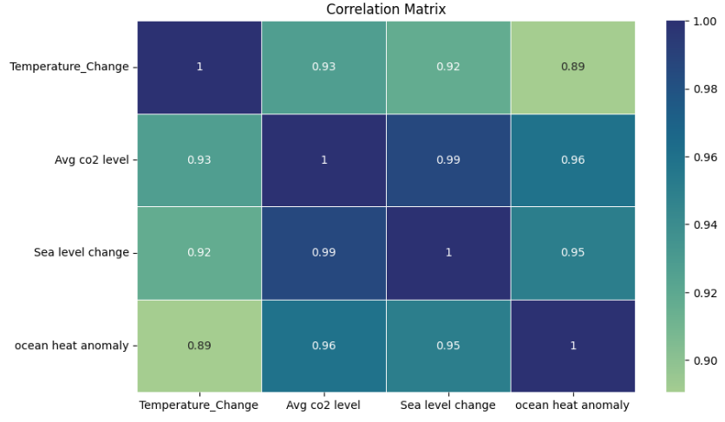

• The correlation matrix heatmap also shows these relationships quantitatively where higher intensity of blue means higher positive correlation.

• The highest coefficient of determination is 0.93 between Temperature Change and Avg CO2 Level which indicates toward positive relationship as compared to the results given in the pair plot.

• Sea Level Change and Ocean Heat Anomaly have very high positive correlations with Temperature Change; they both are equal to 0.92 and 0.89 respectively.

• As with the other paired variables (Avg CO2 Level, Sea Leve Change, and Ocean Heat Anomaly), the correlation coefficients are positive and close to one, with values ranging from 0.92 to 0.96.

These results indicate that the different climate change indicators are correlated and their changes exhibit similar trends, whereby as global temperatures increase, so does CO2 concentration in the atmosphere, sea level and ocean heat content.

1. **Temperature change forecasting**

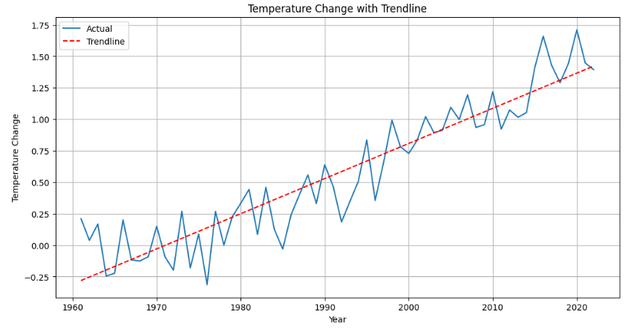

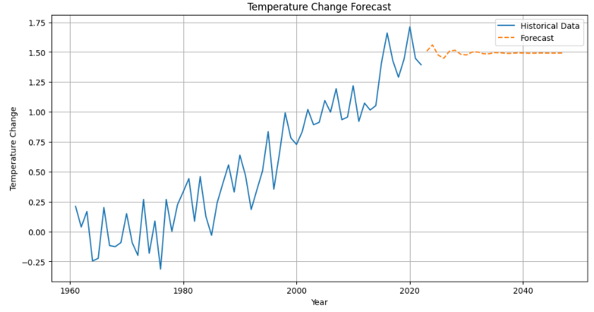

The first graph, which is clearly visible as the blue line, illustrates the change of temperature in the past years, while the second one, the orange dashed line, shows the predicted tendency of change in the following 25 years.

The lines of forecast state that the temperature condition will remain in a high and low oscillation. Nevertheless, the trend depicted here indicates that there is general tendency of an increase in the temperature over the next 25 years perhaps as a result of emission of greenhouse gases and change in climate.

We need to know that any forecast model always contains more or less uncertainties, and therefore the changes in the future temperatures might vary with the forecasted data due to such factors as shifts in climate policies, advancement in technologies and other unpredictable factors.

**Real-Life Scenario:**

They also show that climate change is moving with increasing speed and has profound impacts on human and natural systems in the northern Hemisphere.

Higher sea levels are expected to cause flooding and erosion of coastal areas; this will also reduce the area of habitable coastal land.

**Influence of Indicators:**

Present atmospheric CO2 levels are high and are proportional to the rise in world temperatures and sea levels, implying the need to curb emissions of greenhouse gases.

Warming of oceans results to extreme weather conditions that impact on sea and other activities reliant on ocean products.

Altogether this project aims at giving a detailed description of the climate change indicators and significant relationship and trends between them. The outcomes identified here highlight the evidence to support calls for climate change response and adaptation, especially in the areas that are most sensitive to warming. Knowledge of these trends is crucial for the formation of further actions against climate change and for preservation of endangered ecosystems and populations.