Advanced Computer Networks – PCS223
Assignment 3
Name – Mira Gurung
Subgroup – CS2
Roll No. – 8025320113
- Connected one PC with another PC
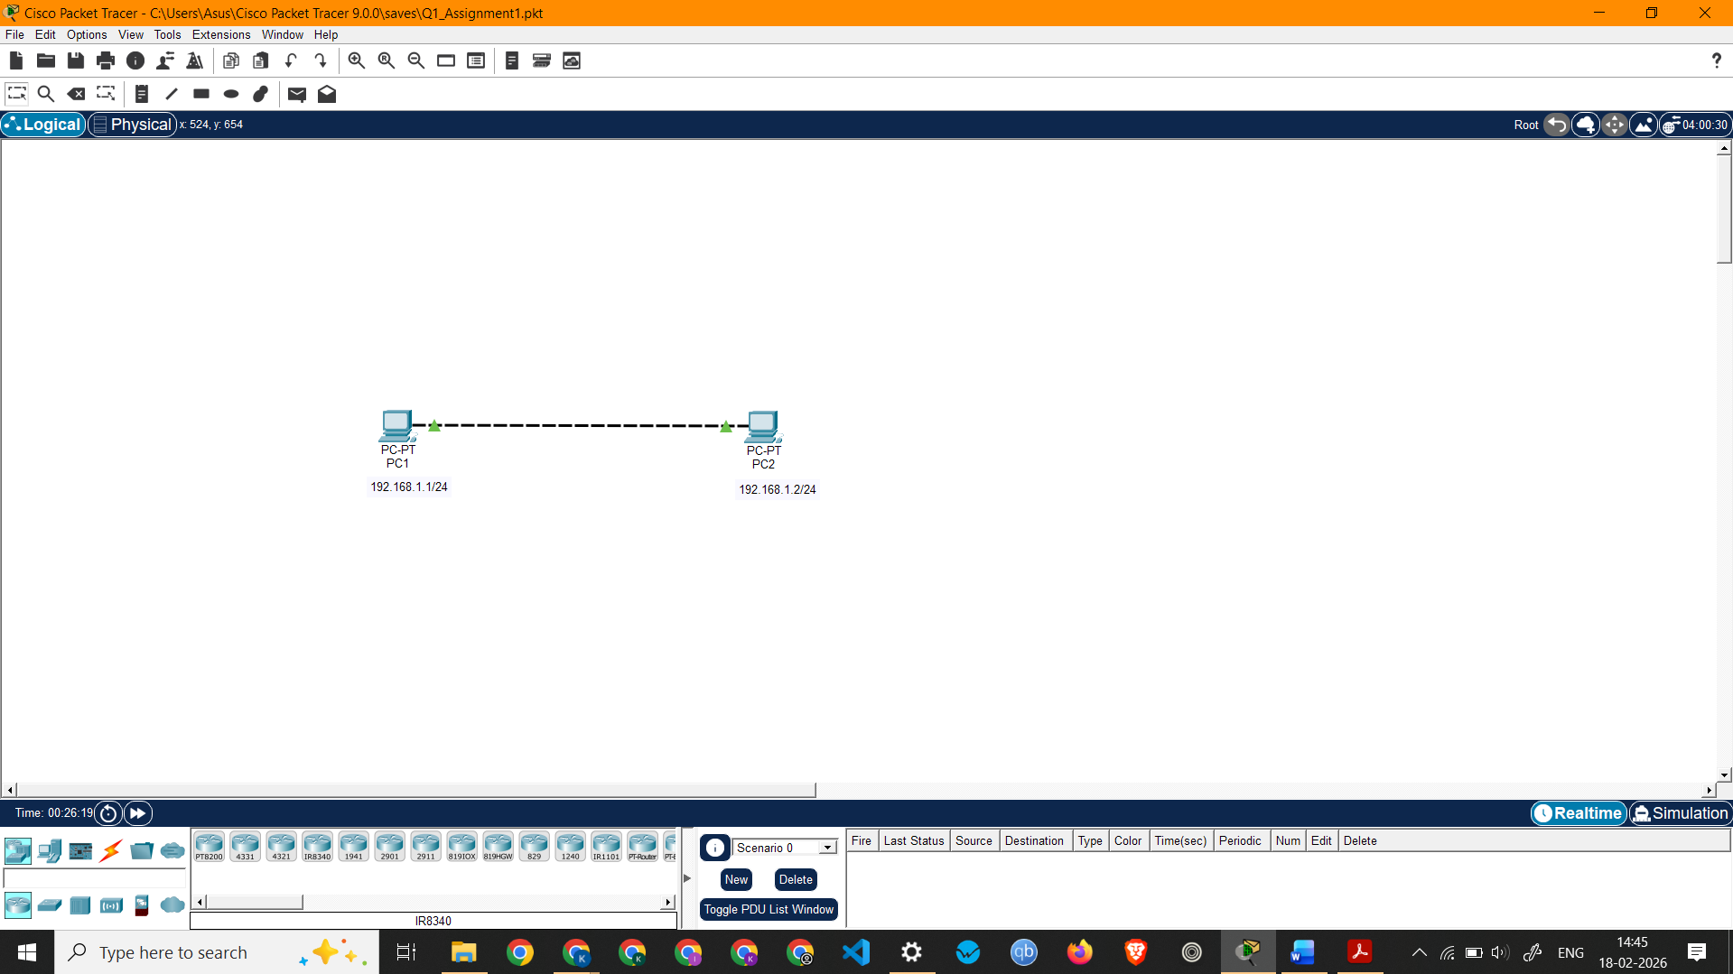
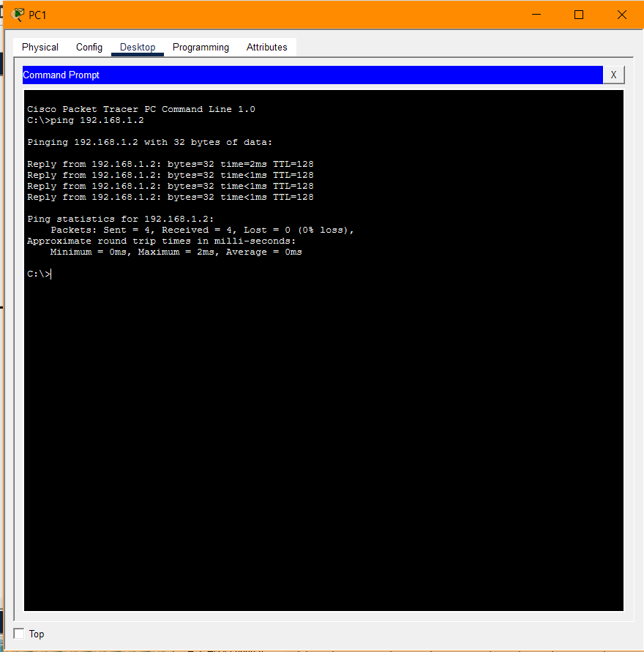

- Connect a PC with Router Ethernet port as shown below.
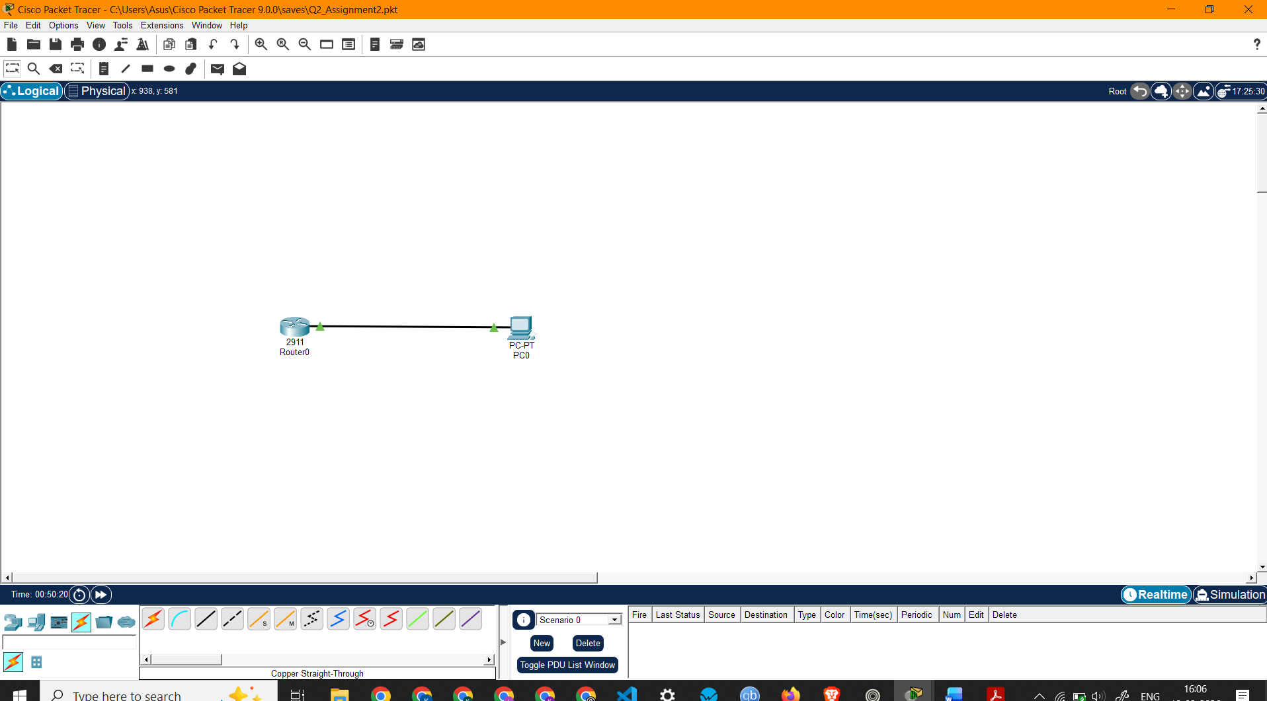

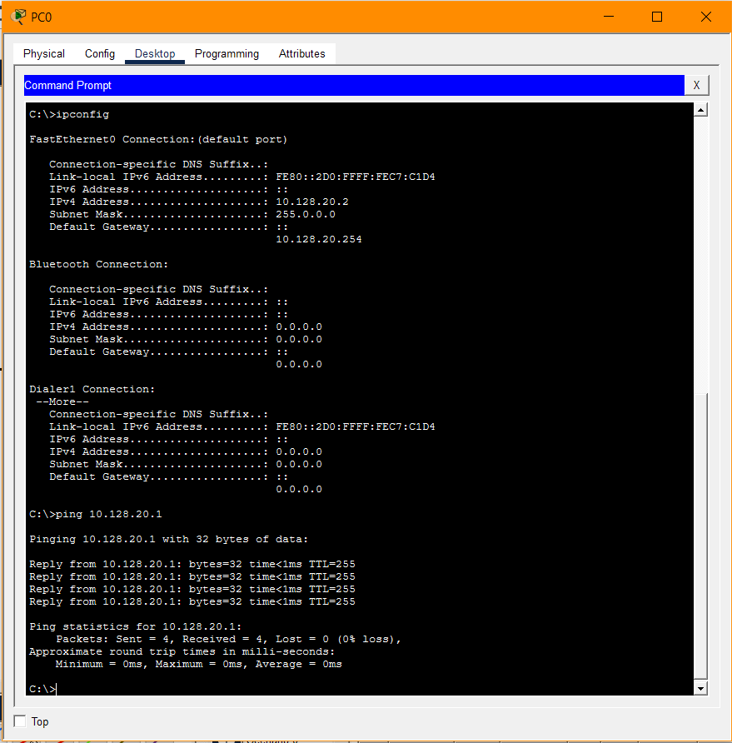
- Create a network of 2 PCs as below.
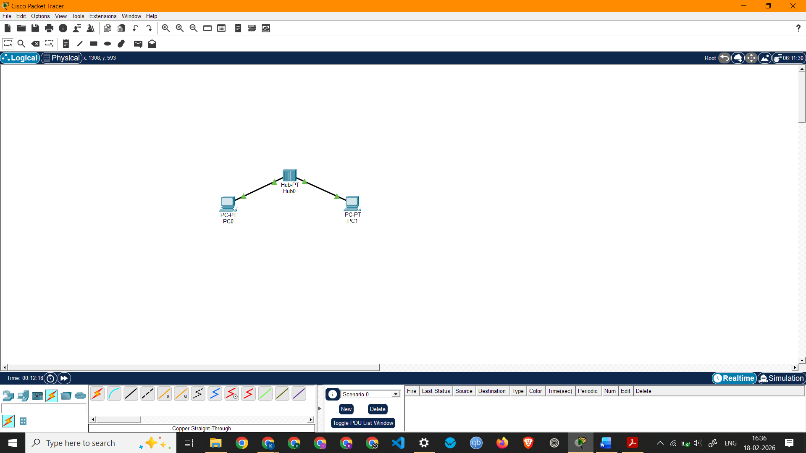

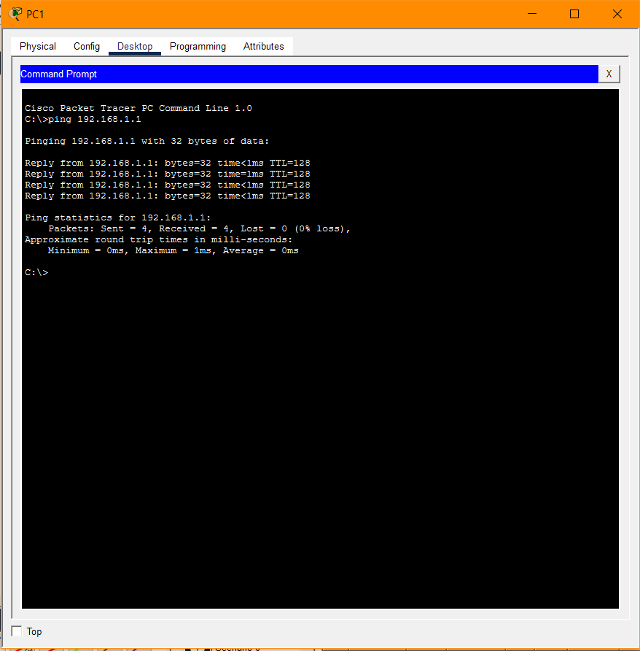

- Connect 2 PCs with a Switch below.
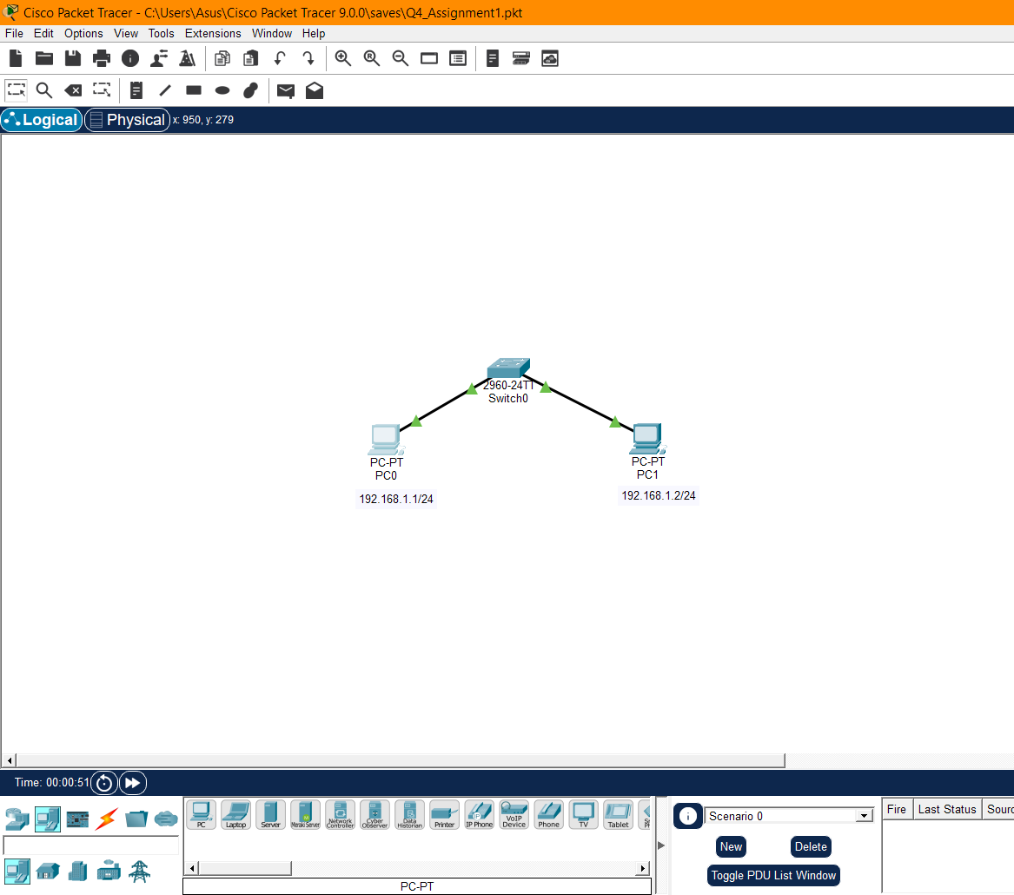

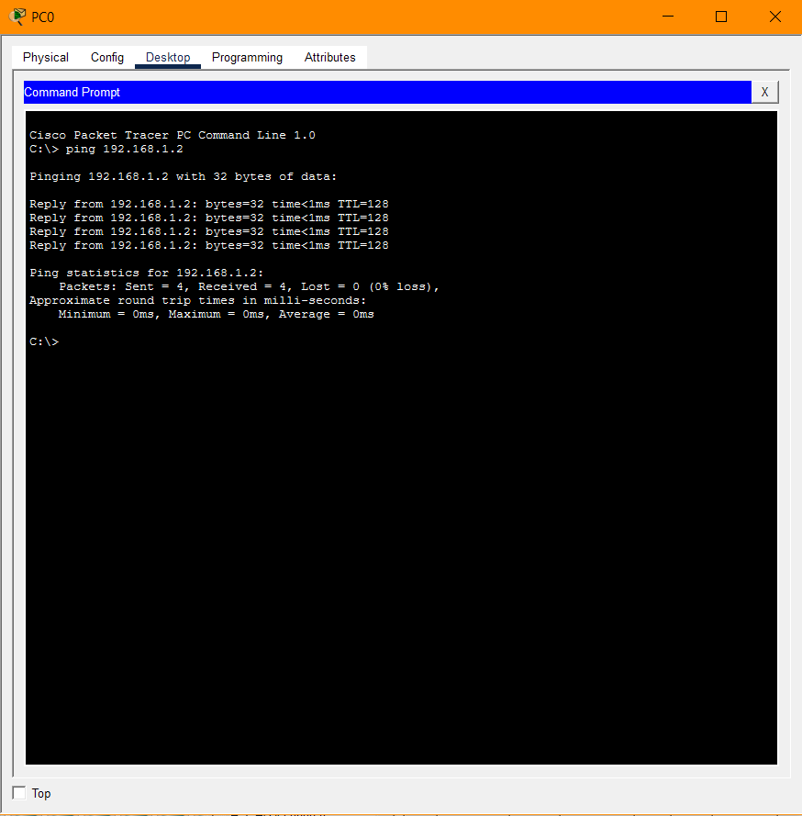

- Create BUS topologies as below.
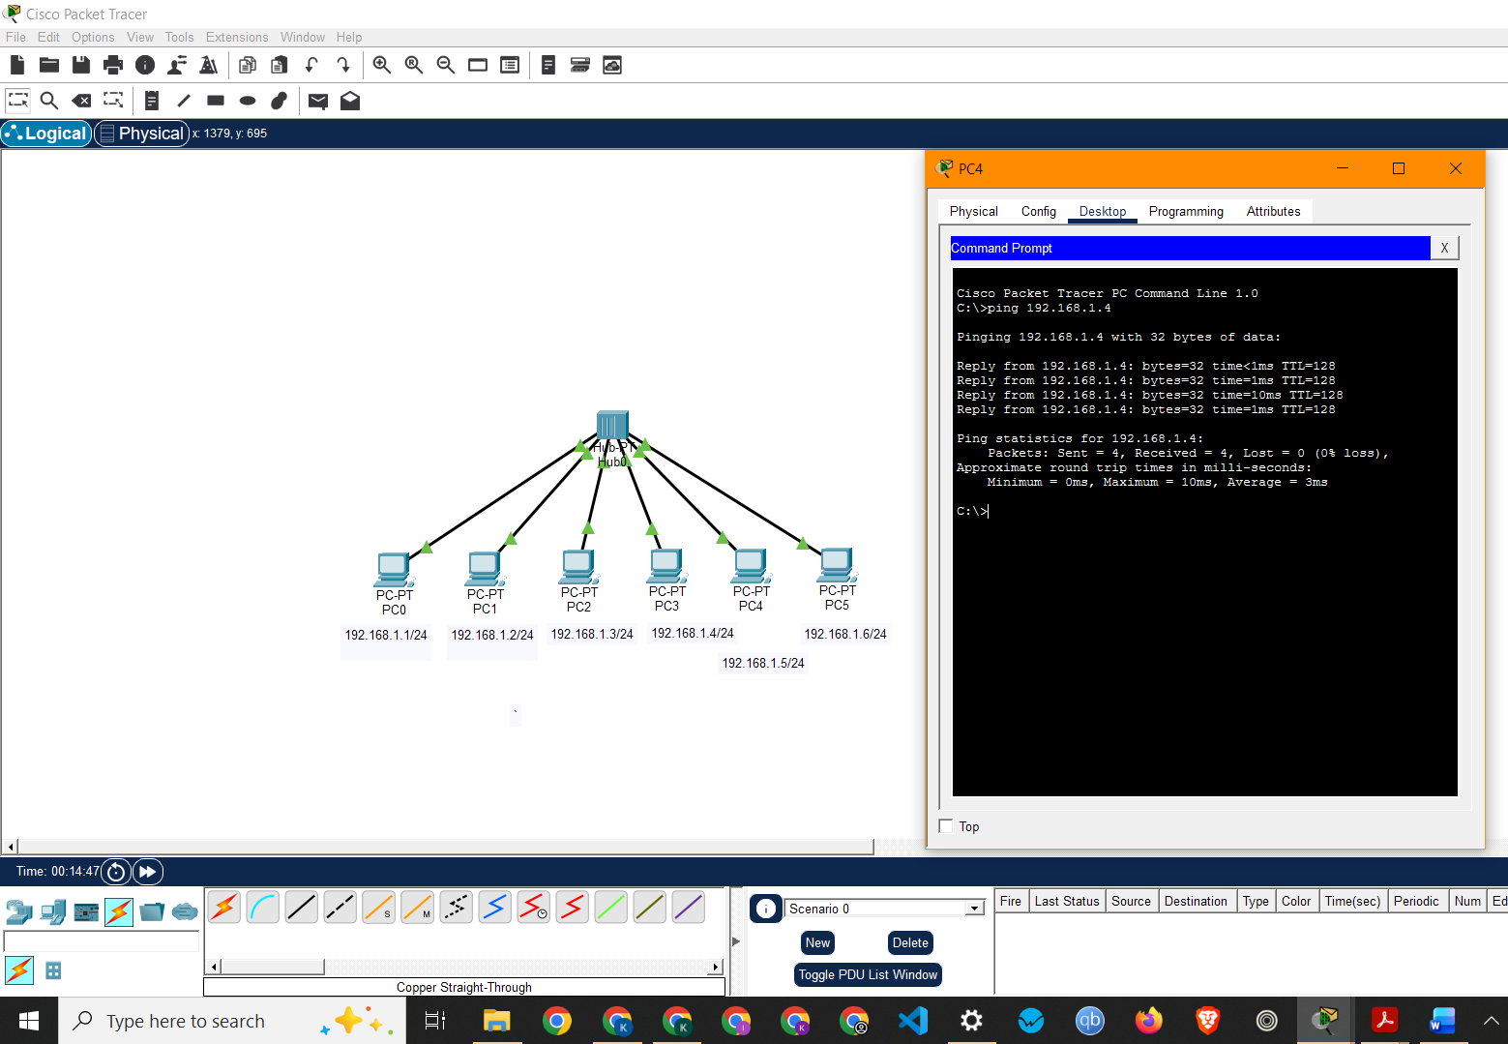
(a)

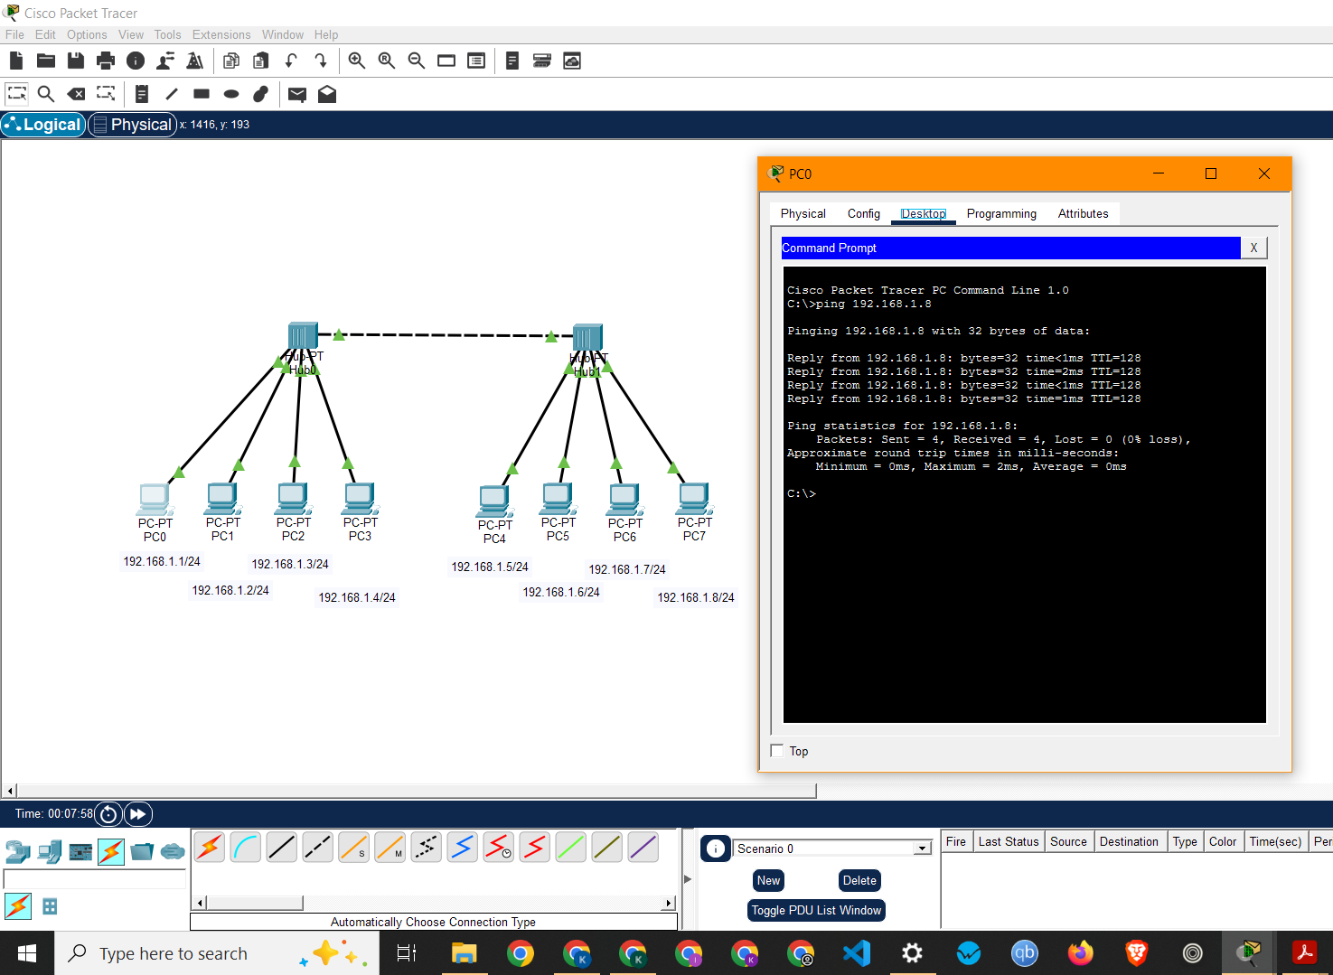
(b)

- Create the following ring topology
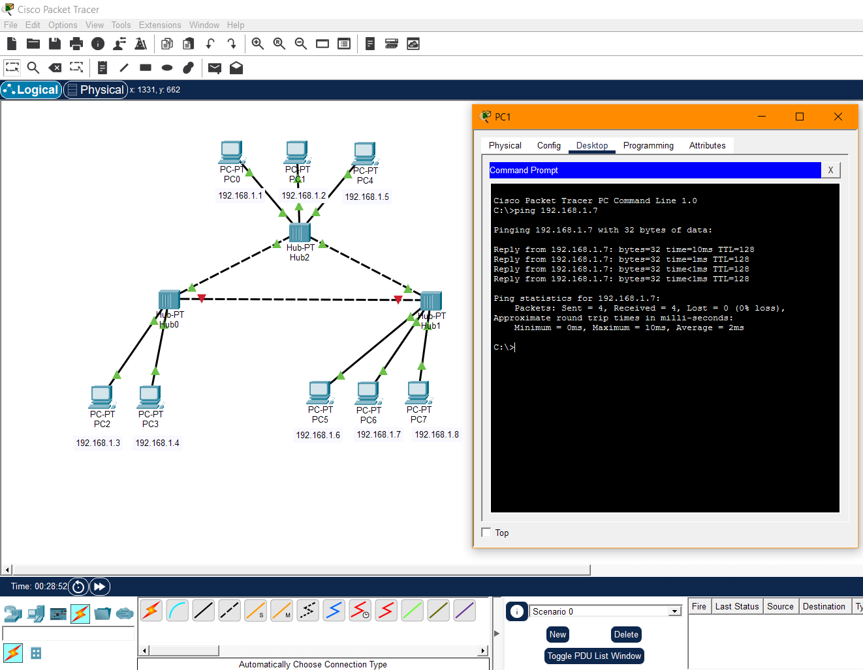

- Create the following ring topology

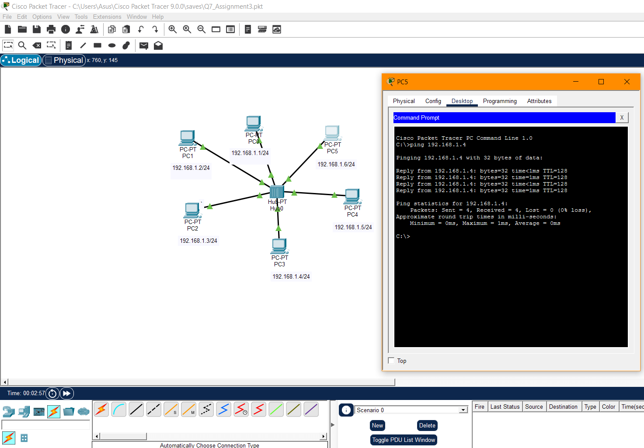

- Create the following ring topology

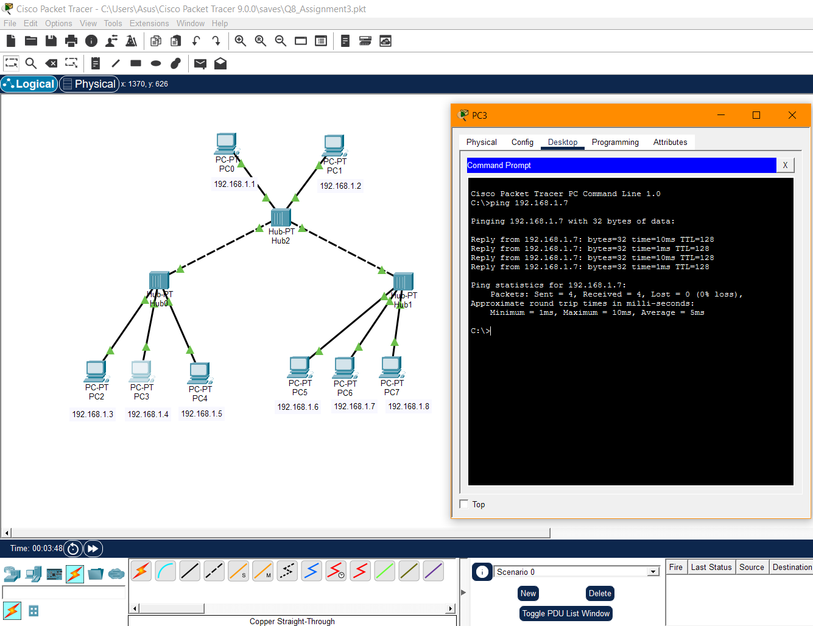

4. To capture and analyze DNS query and response packets
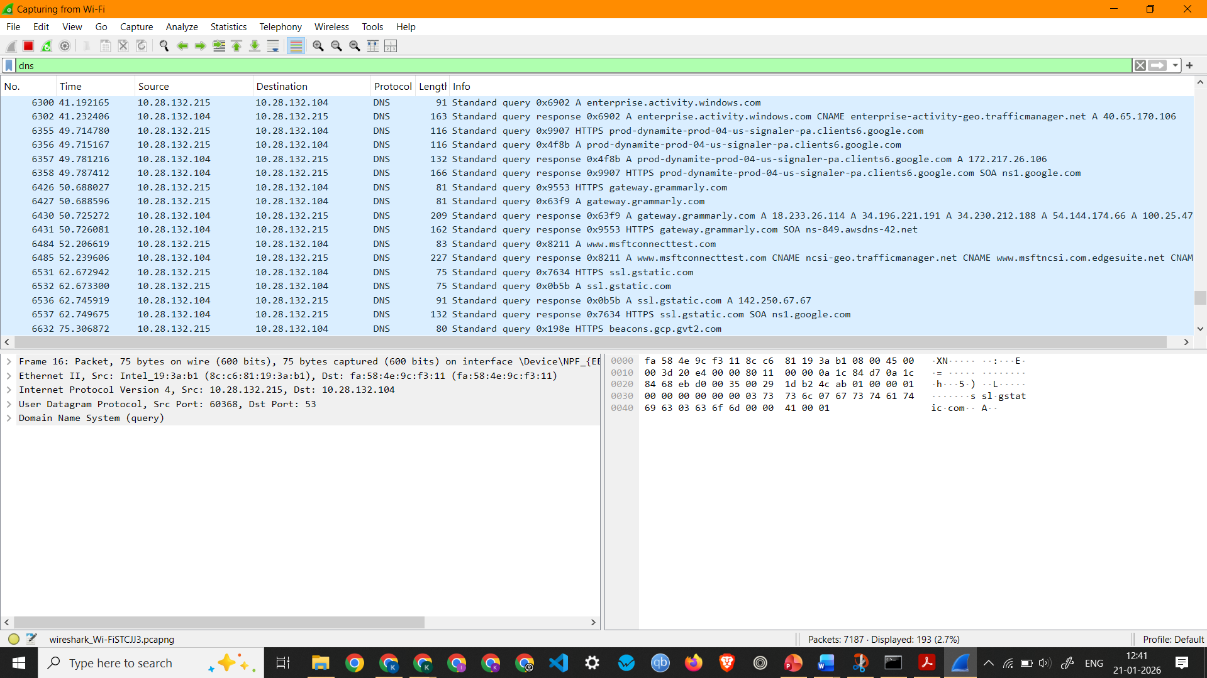
Screenshot showing DNS Packets Capture
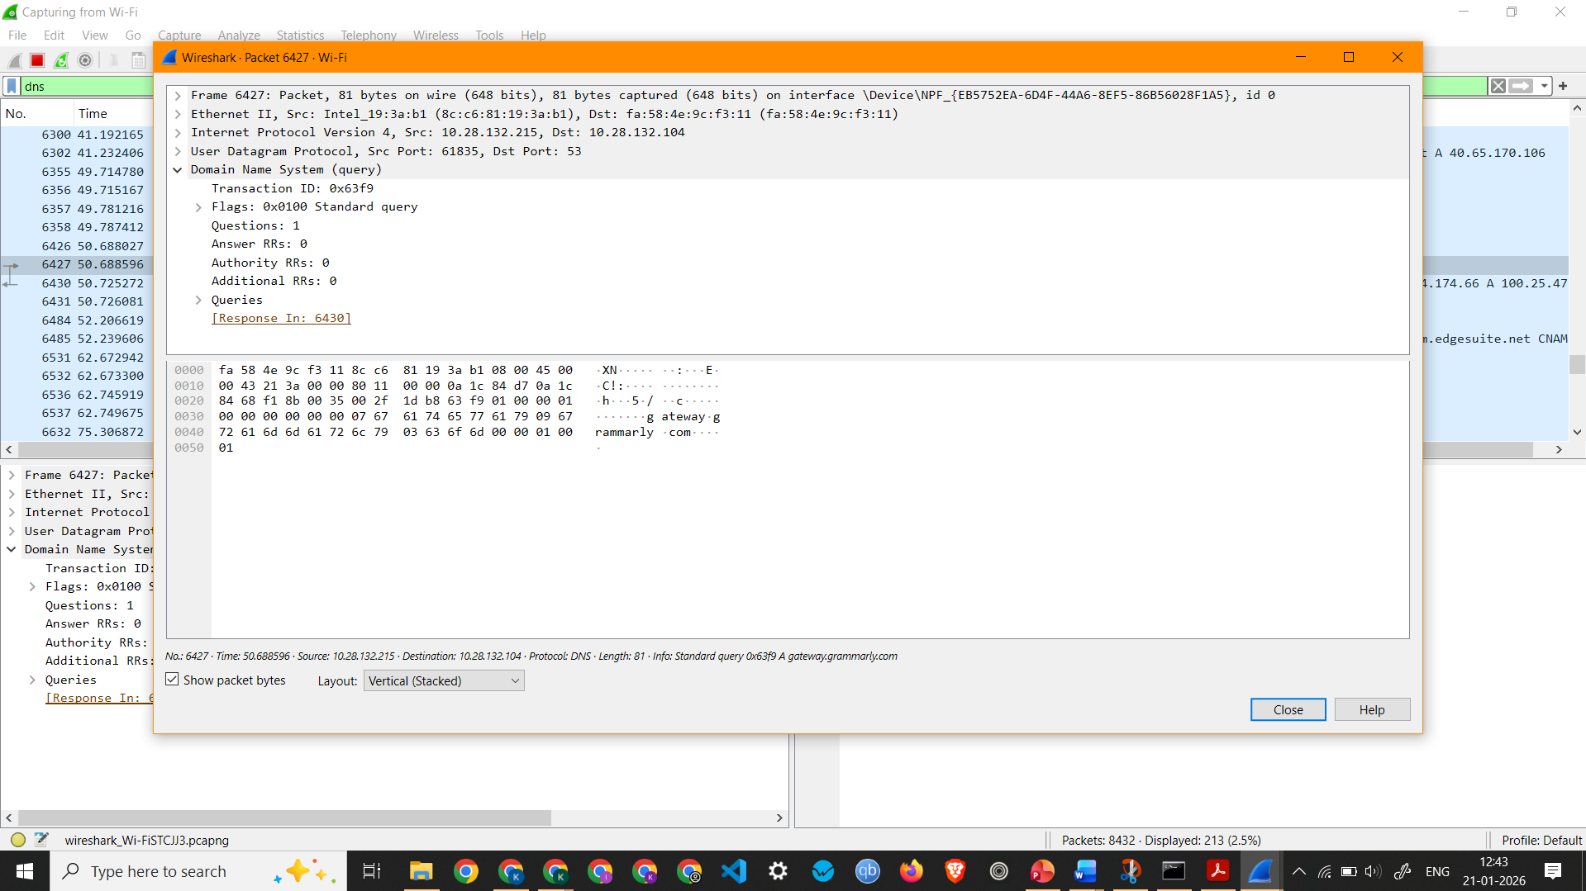
Screenshot showing details of a DNS Packet 6427 (Standard query request)

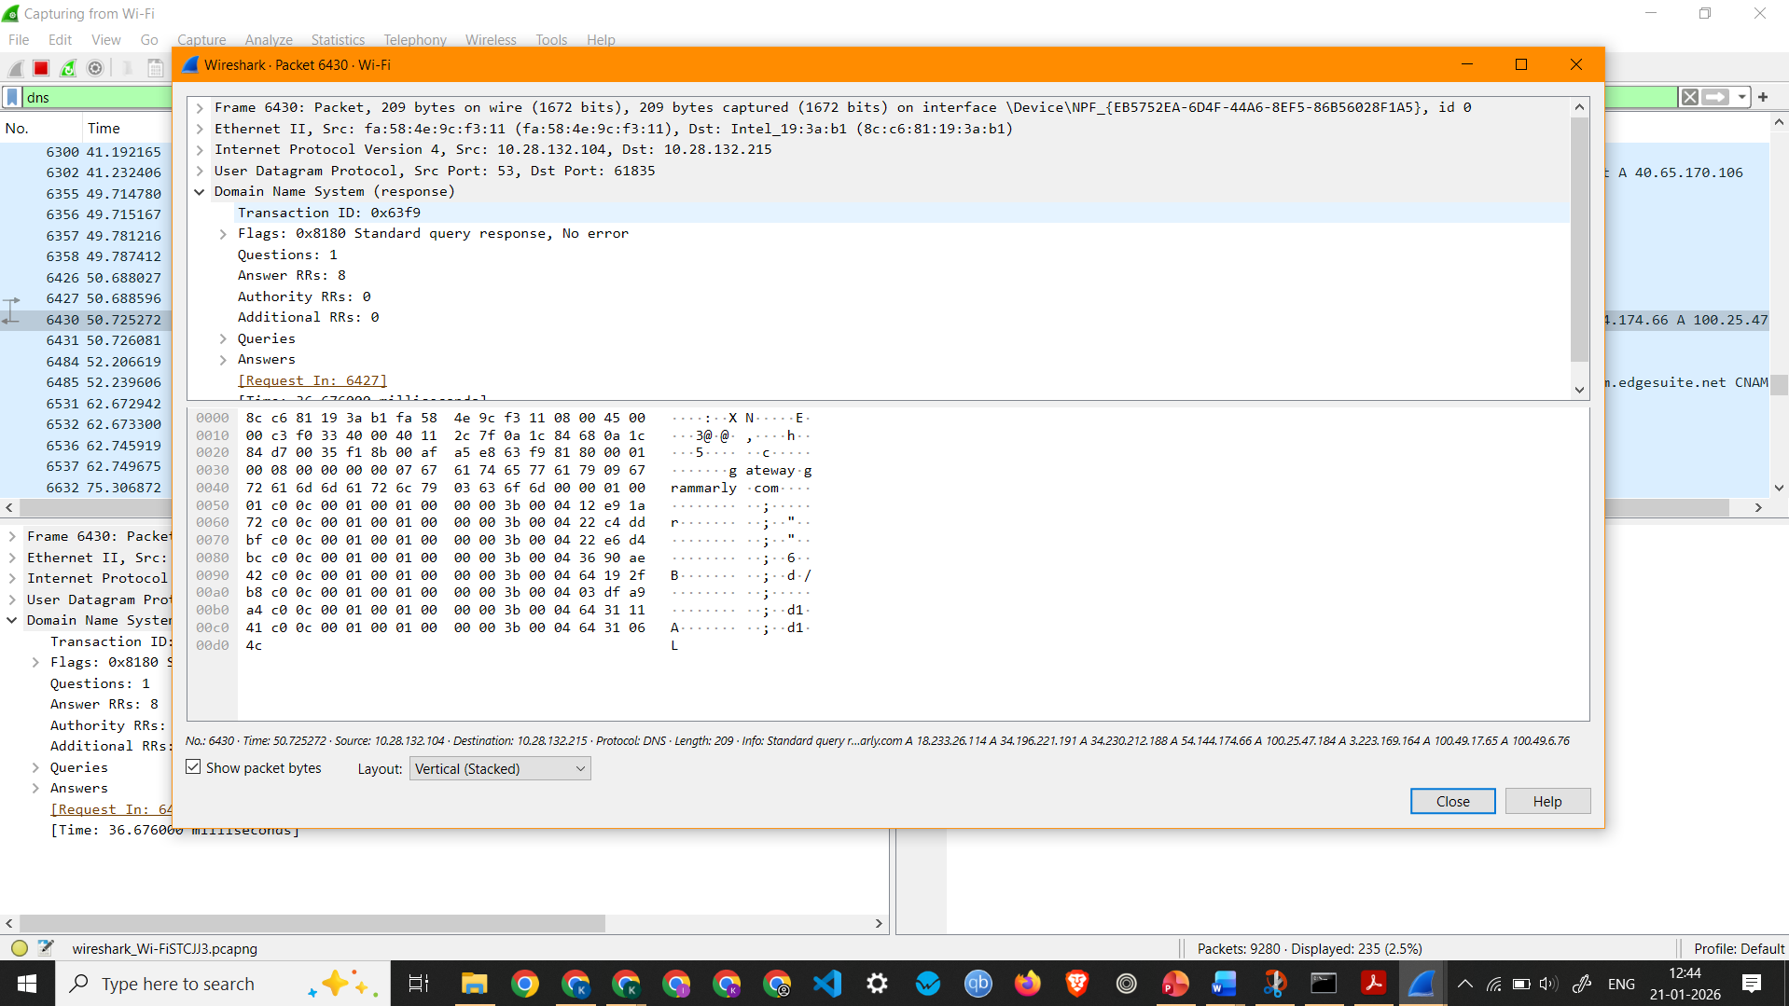
Screenshot showing details of a DNS Packet 6430 (Standard query response)

Observation: DNS Packet 6427 –
  - Interface Used: Wi-Fi
  - Protocols Observed: Ethernet II, Internet Protocol Version 4, and User Datagram Protocol
  - Source IP Address: 10.28.132.215
  - Destination IP Address: 10.28.132.104
  - Packet Length: 81 Bytes
  - Queries - gateway.grammarly.com: type A, class IN

Observation: DNS Packet 6430 –
  - Interface Used: Wi-Fi
  - Protocols Observed: Ethernet II, Internet Protocol Version 4, and User Datagram Protocol
  - Source IP Address: 10.28.132.104
  - Destination IP Address: 10.28.132.215
  - Packet Length: 209 Bytes

5. To capture and analyze HTTP packets
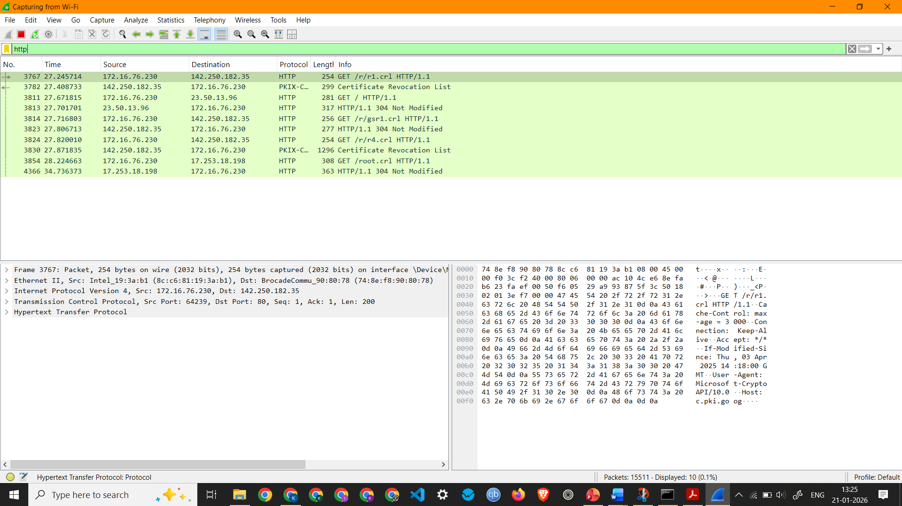
Screenshot showing HTTP Packets Capture
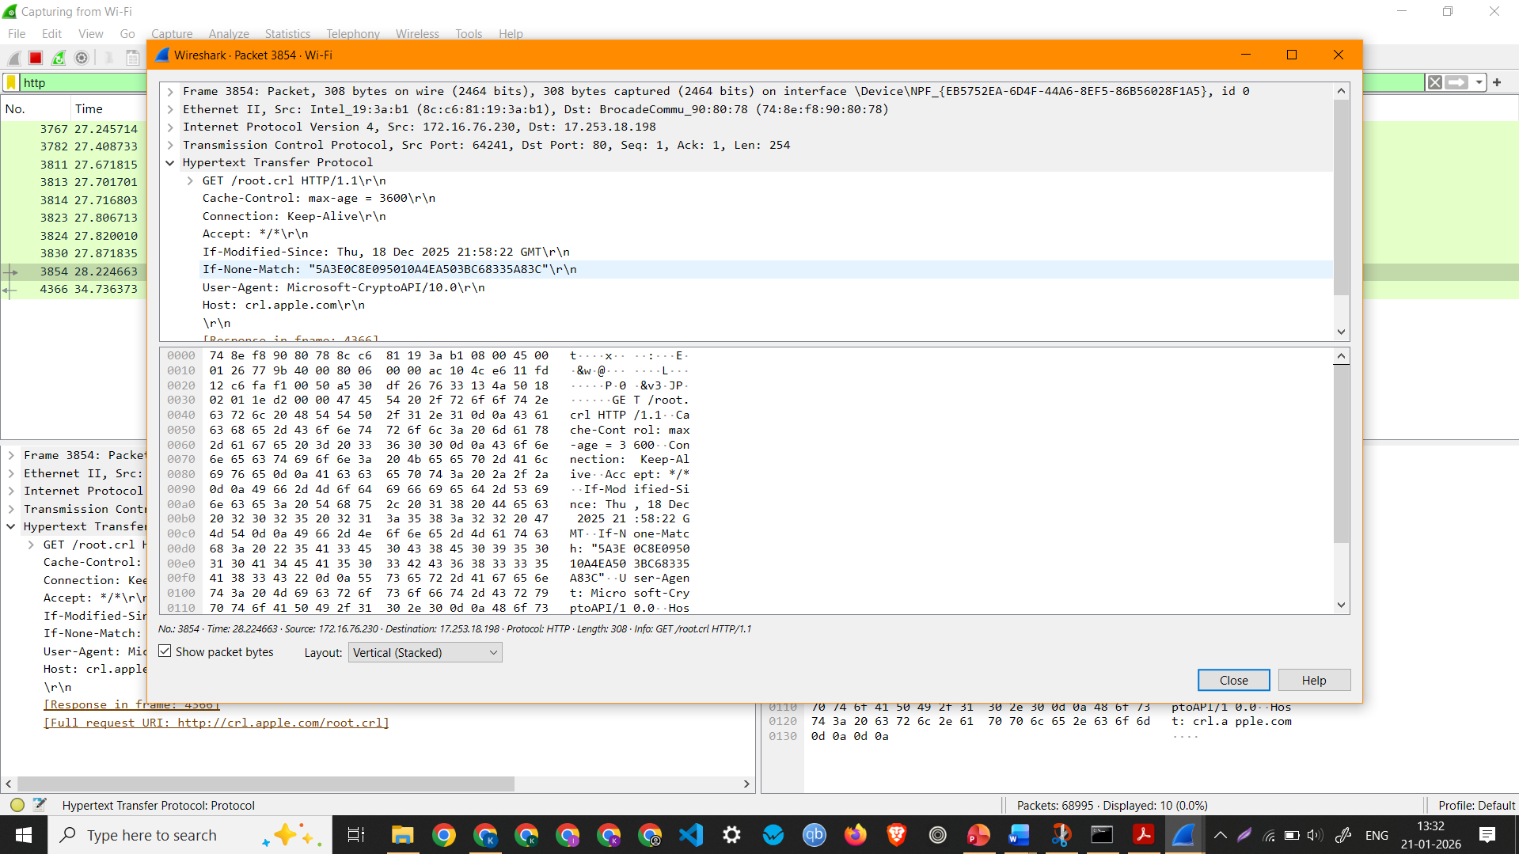
Screenshot showing details of a HTTP Packet (HTTP Request)
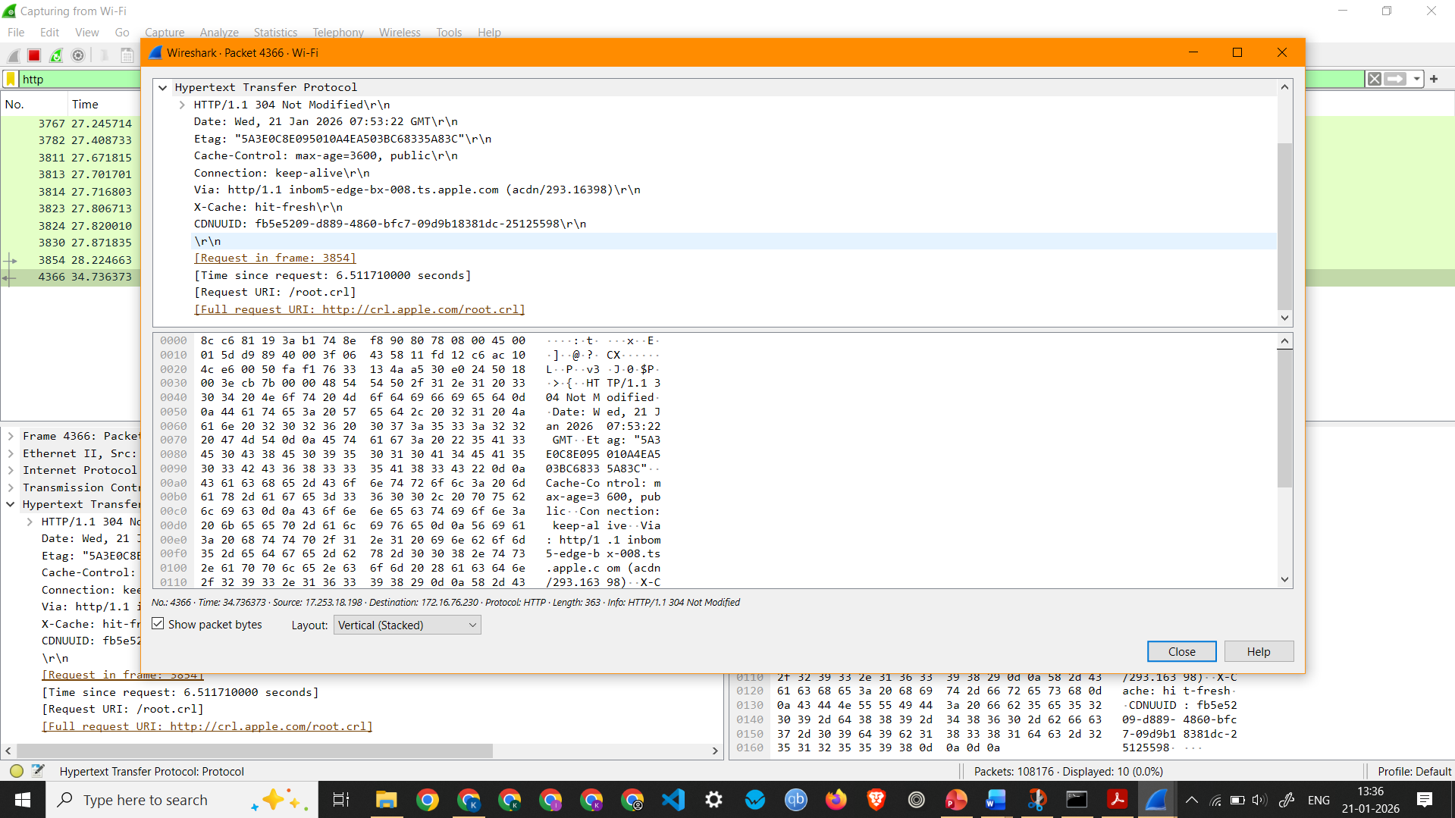
Screenshot showing details of a HTTP Packet (HTTP Response)

Observation: HTTP Request 3854 –
  - Interface Used: Wi-Fi
  - Protocols Observed: Ethernet II, Internet Protocol Version 4, Transmission Control Protocol, Hypertext Transfer Protocol
  - Source IP Address: 172.16.76.230
  - Destination IP Address: 17.253.18.198
  - Packet Length: 308 Bytes
Observation: HTTP Response 4366 –
  - Interface Used: Wi-Fi
  - Protocols Observed: Ethernet II, Internet Protocol Version 4, Transmission Control Protocol, Hypertext Transfer Protocol
  - Source IP Address: 17.253.18.198
  - Destination IP Address: 172.16.76.230
  - Packet Length: 363 Bytes

3. To capture and analyze UDP packets
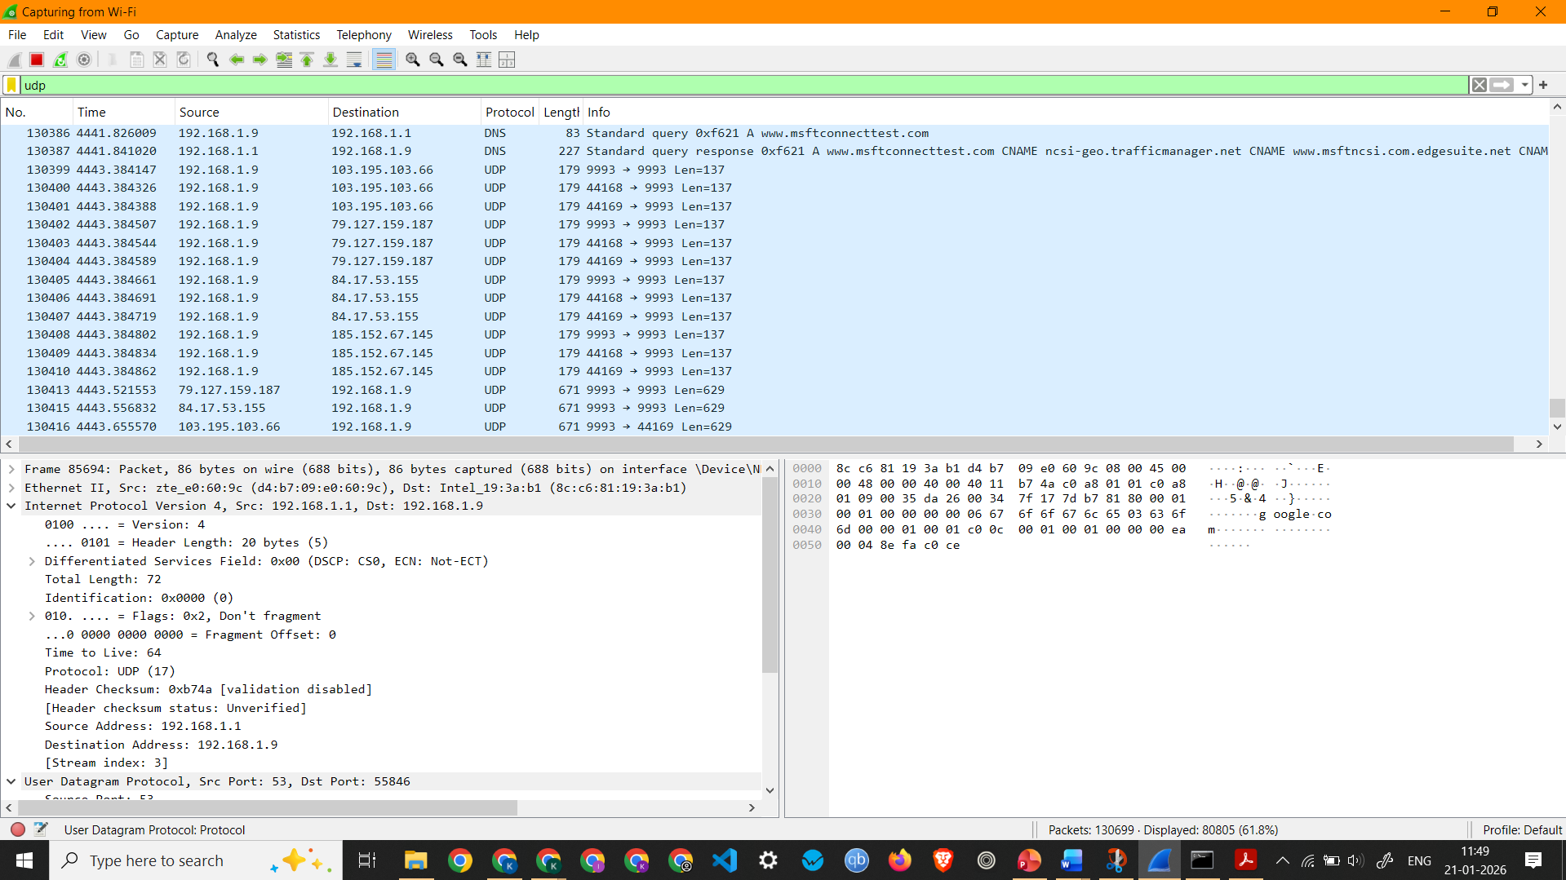
Screenshot showing UDP Packets Capture
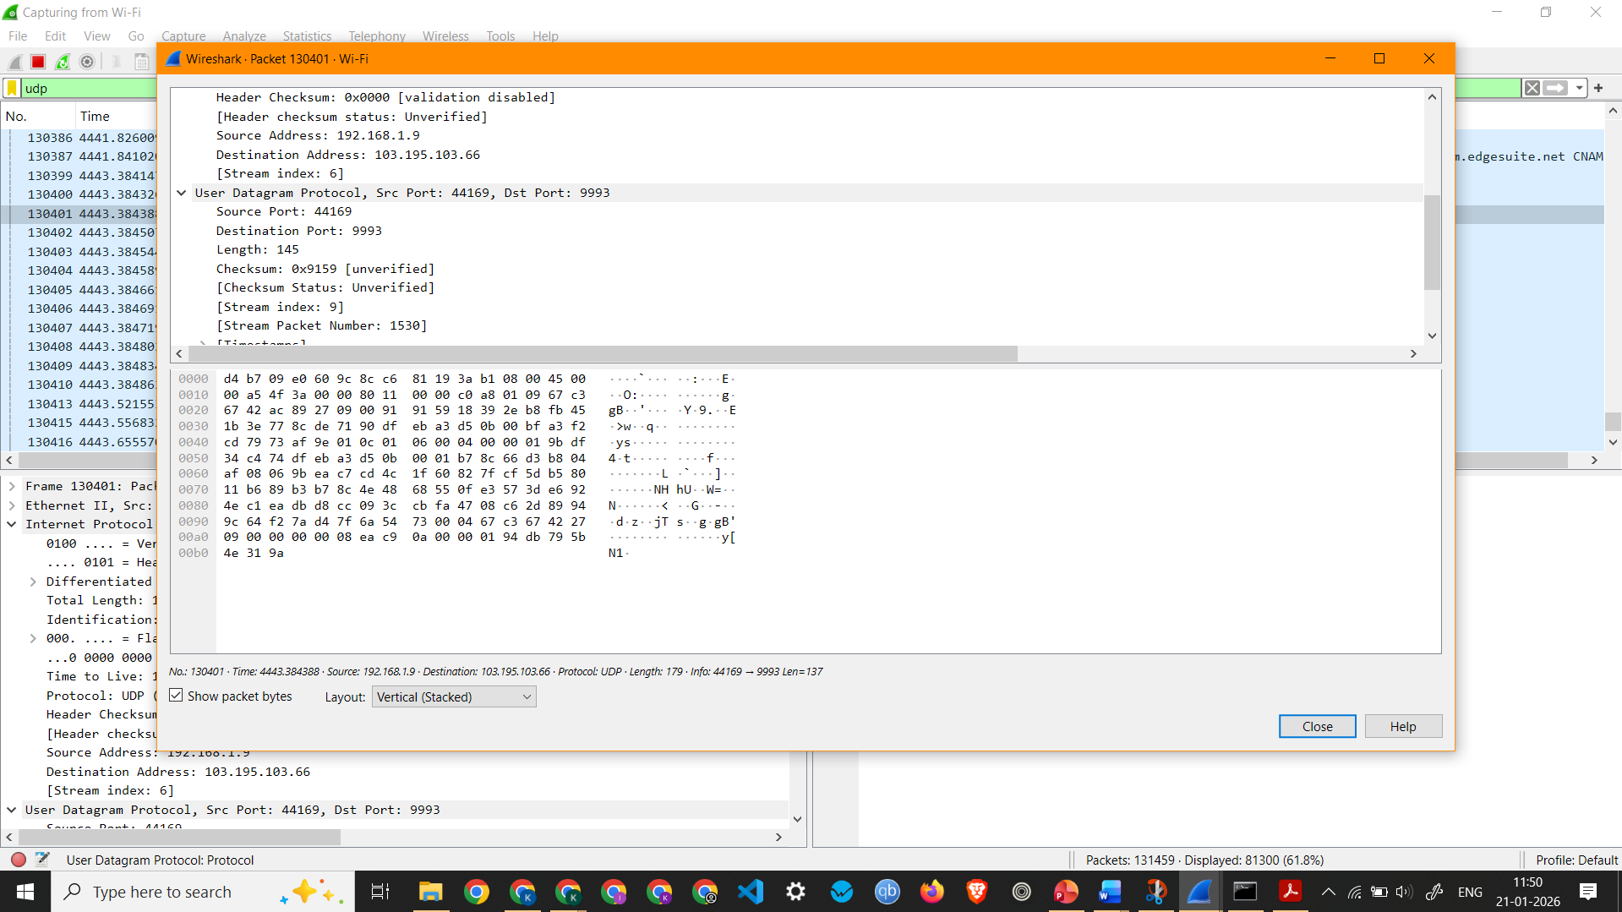
Screenshot showing details of a UDP Packet

Observation: UDP Packet 130401 –
  - Interface Used: Wi-Fi
  - Protocols Observed: Ethernet II, Internet Protocol Version 4, and User Datagram Protocol
  - Source IP Address: 192.168.1.9
  - Destination IP Address: 103.195.103.66
  - Packet Length: 179 Bytes

3. To capture and analyze UDP packets

Screenshot showing UDP Packets Capture

Screenshot showing details of a UDP Packet

Observation: UDP Packet 130401 –
  - Interface Used: Wi-Fi
  - Protocols Observed: Ethernet II, Internet Protocol Version 4, and User Datagram Protocol
  - Source IP Address: 192.168.1.9
  - Destination IP Address: 103.195.103.66
  - Packet Length: 179 Bytes
3. To capture and analyze UDP packets

Screenshot showing UDP Packets Capture

Screenshot showing details of a UDP Packet

Observation: UDP Packet 130401 –
  - Interface Used: Wi-Fi
  - Protocols Observed: Ethernet II, Internet Protocol Version 4, and User Datagram Protocol
  - Source IP Address: 192.168.1.9
  - Destination IP Address: 103.195.103.66
  - Packet Length: 179 Bytes

3. To capture and analyze UDP packets

Screenshot showing UDP Packets Capture

Screenshot showing details of a UDP Packet

Observation: UDP Packet 130401 –
  - Interface Used: Wi-Fi
  - Protocols Observed: Ethernet II, Internet Protocol Version 4, and User Datagram Protocol
  - Source IP Address: 192.168.1.9
  - Destination IP Address: 103.195.103.66
  - Packet Length: 179 Bytes

