Advanced Computer Networks – PCS223
Assignment 2
Name – Mira Gurung
Subgroup – CS2
Roll No. – 8025320113

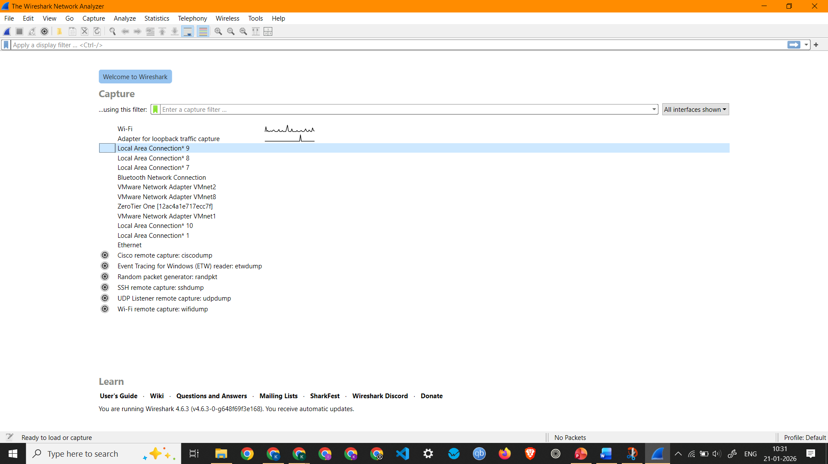
Screenshot showing all interfaces and the active interface (Wi-Fi)

1. To capture and analyze ICMP packets (Ping request and reply)
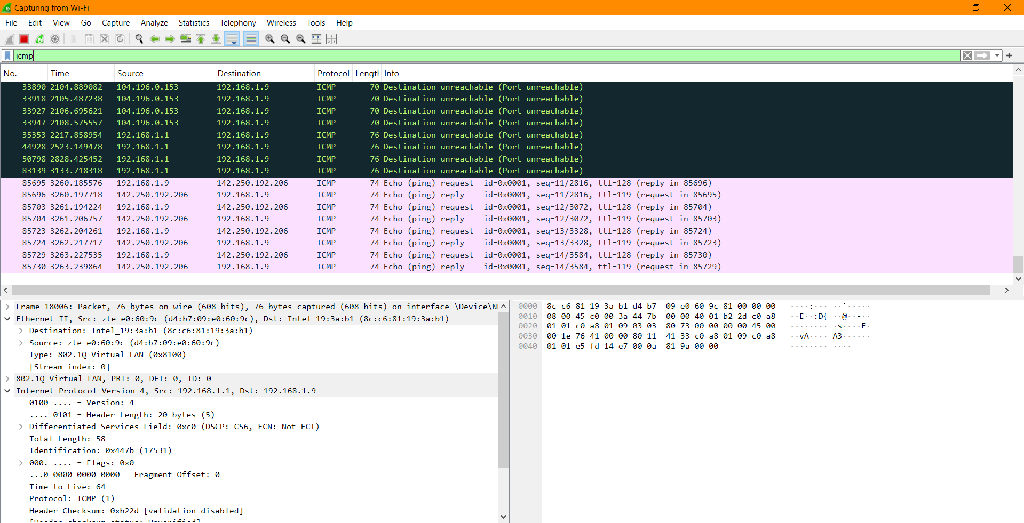
Screenshot showing ICMP Packets Captured by pinging google.com
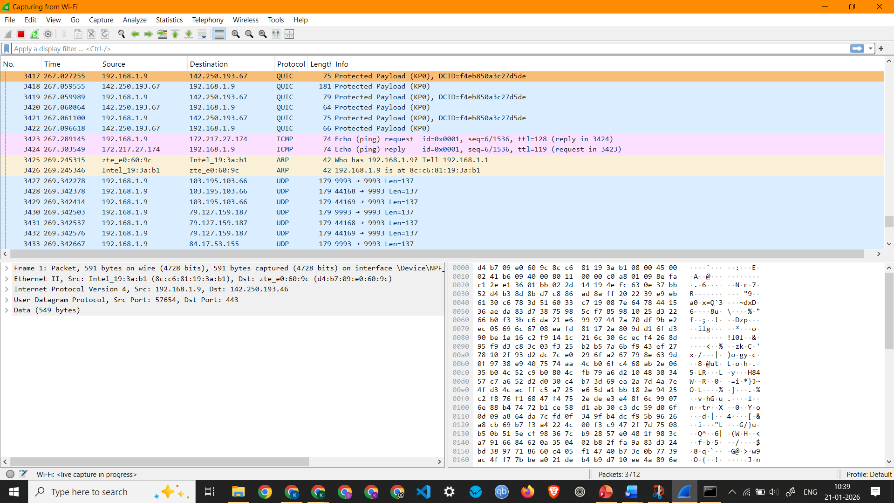
Screenshot showing ICMP Packets Captured by pinging google.com

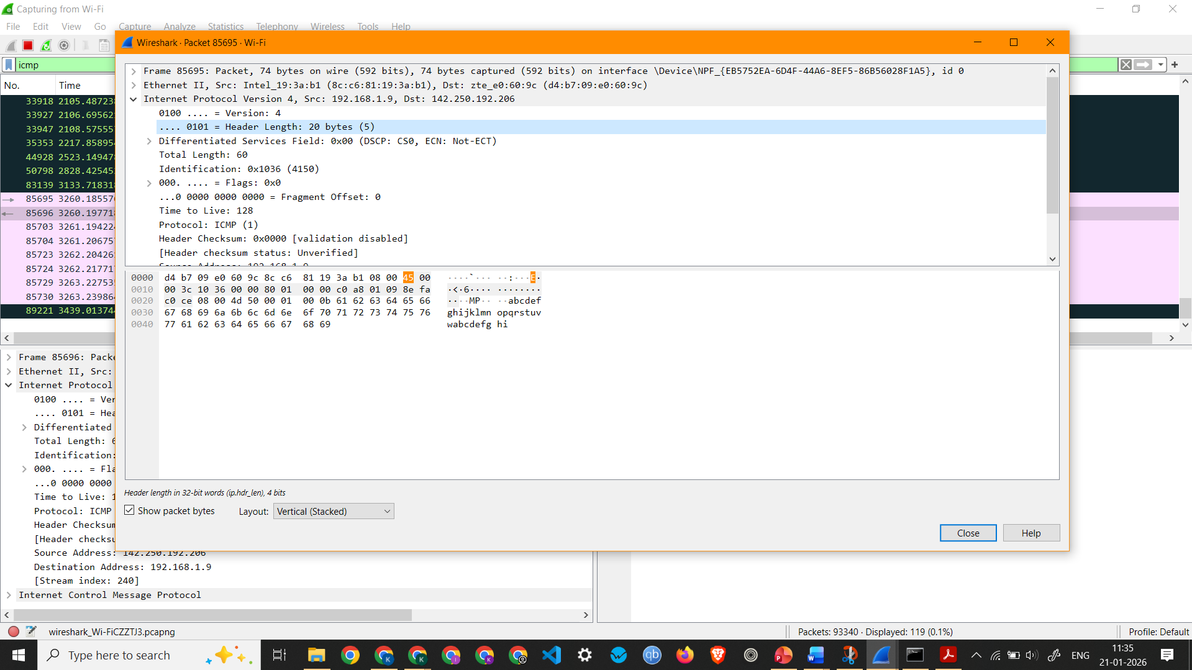
Screenshot showing ICMP Packet 85695 details (Ping Request)
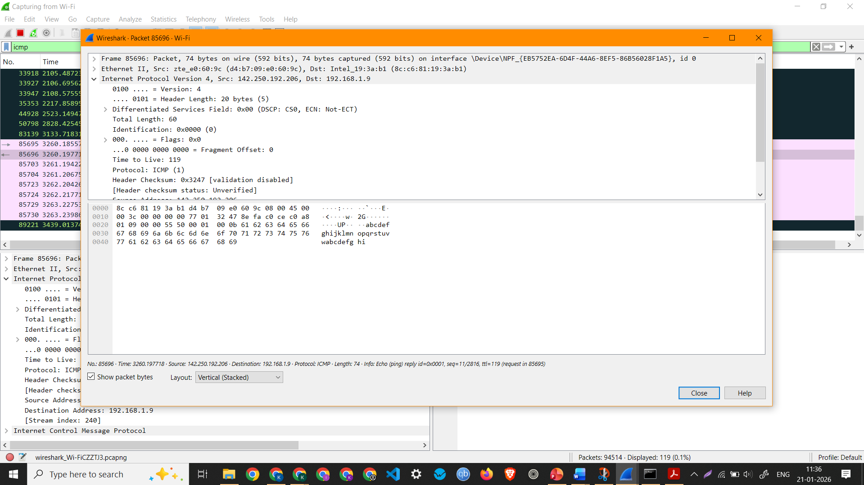
Screenshot showing ICMP Packet 85696 details (Ping Reply)

Observation and Analysis of ICMP Packet 85695 -
  - Interface Used: Wi-Fi
  - Protocols Observed: Ethernet II, Internet Protocol Version 4, and Internet Control Message Protocol
  - Source IP Address: 192.168.1.9
  - Destination IP Address: 142.250.192.206
  - Packet Length: 74 Bytes

Observation and Analysis of ICMP Packet 85696 -
  - Interface Used: Wi-Fi
  - Protocols Observed: Ethernet II, Internet Protocol Version 4, and Internet Control Message Protocol
  - Source IP Address: 142.250.192.206
  - Destination IP Address: 192.168.1.9
  - Packet Length: 74 Bytes

2. To analyze TCP packets and observe the TCP three-way handshake
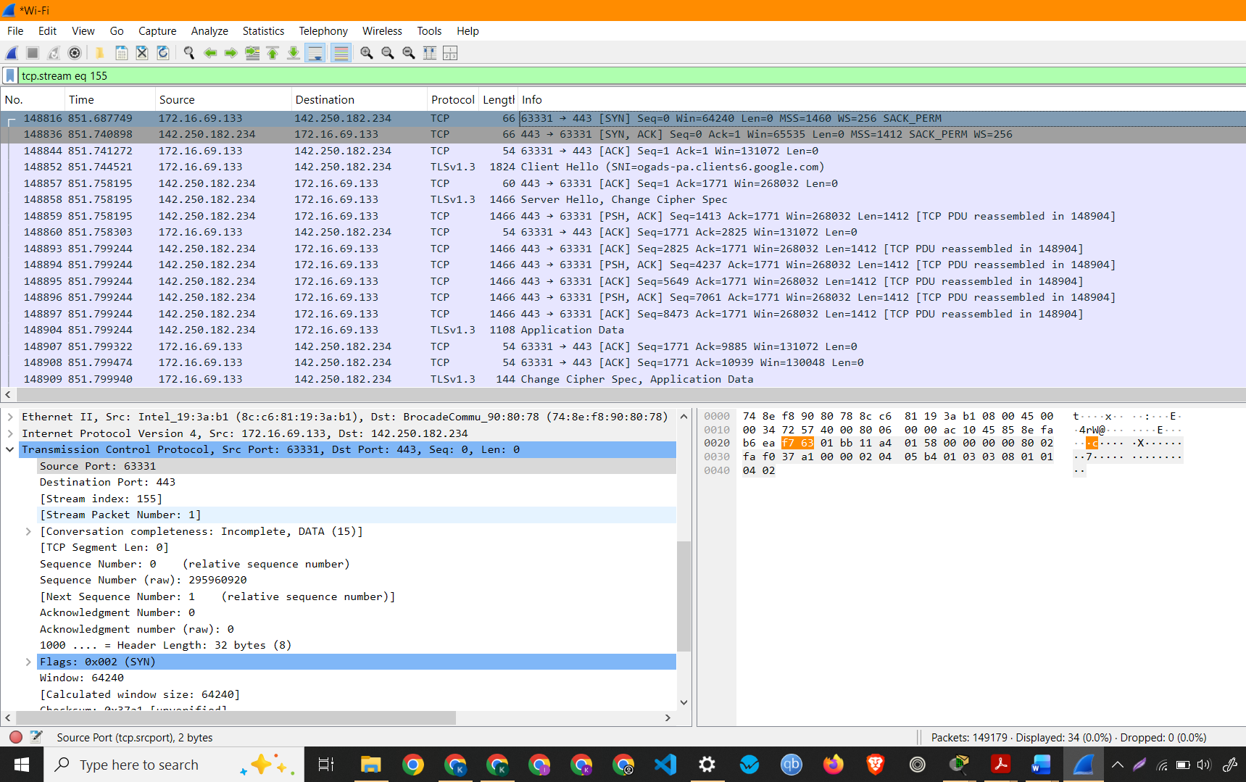
Screenshot showing TCP Packet (SYN)
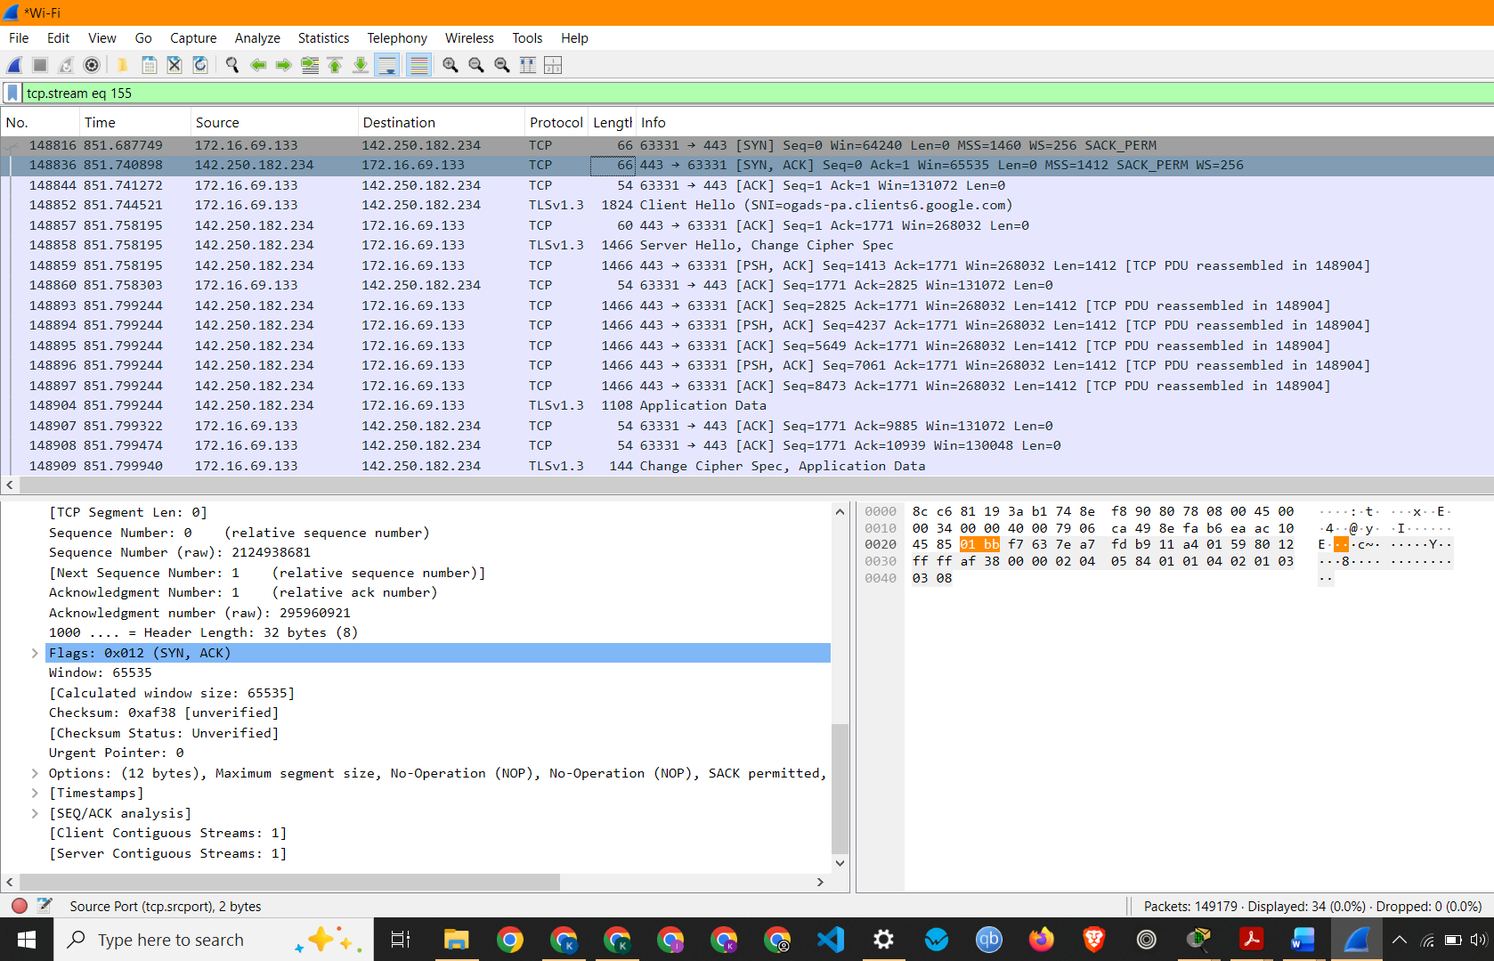
Screenshot showing TCP Packet (SYN, ACK)

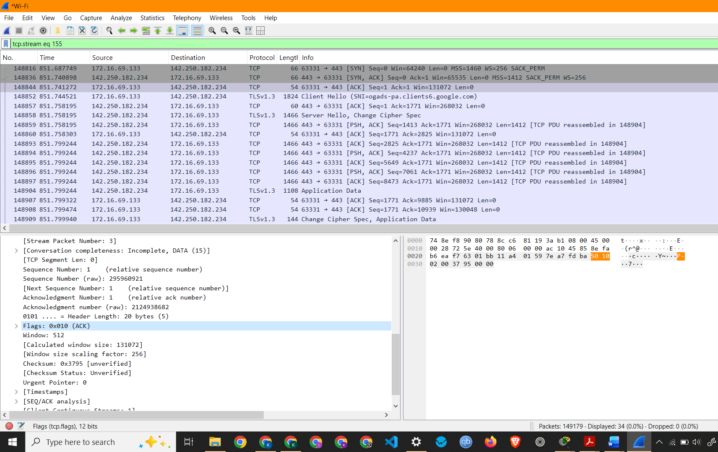
Screenshot showing TCP Packet (ACK)

3. To capture and analyze UDP packets
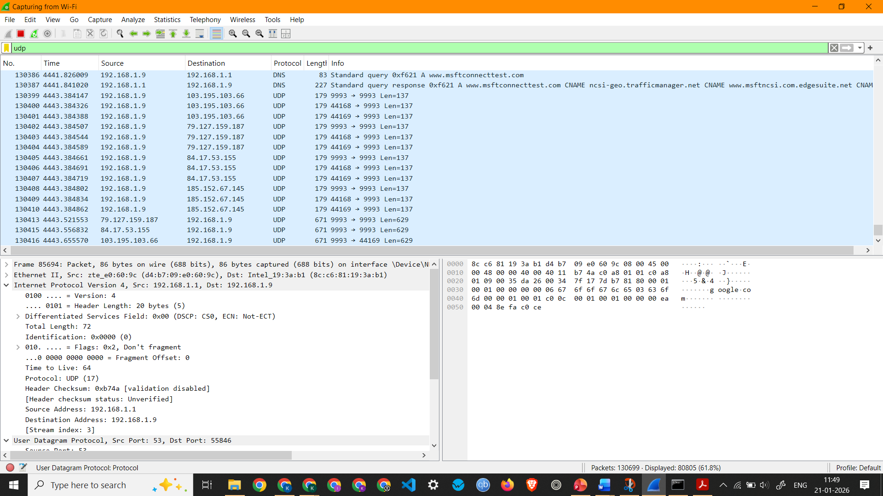
Screenshot showing UDP Packets Capture
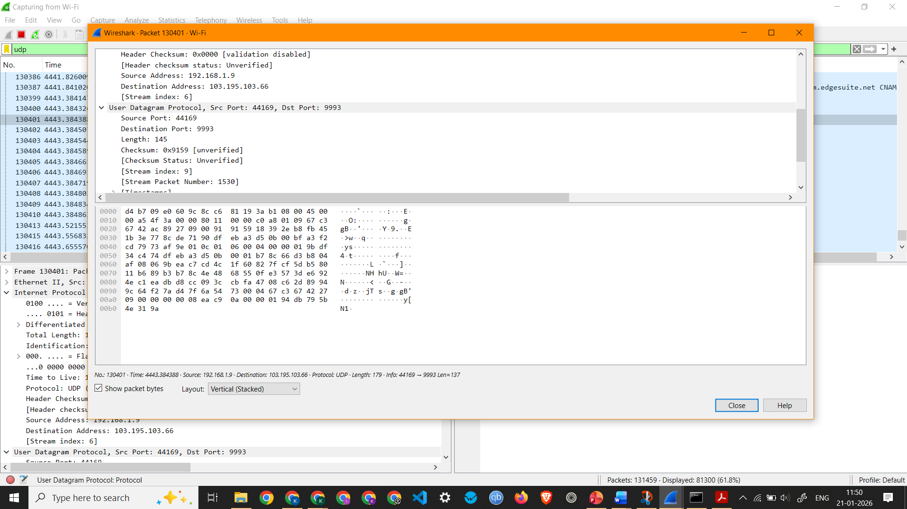

Screenshot showing details of a UDP Packet

Observation: UDP Packet 130401 –
  - Interface Used: Wi-Fi
  - Protocols Observed: Ethernet II, Internet Protocol Version 4, and User Datagram Protocol
  - Source IP Address: 192.168.1.9
  - Destination IP Address: 103.195.103.66
  - Packet Length: 179 Bytes
4. To capture and analyze DNS query and response packets
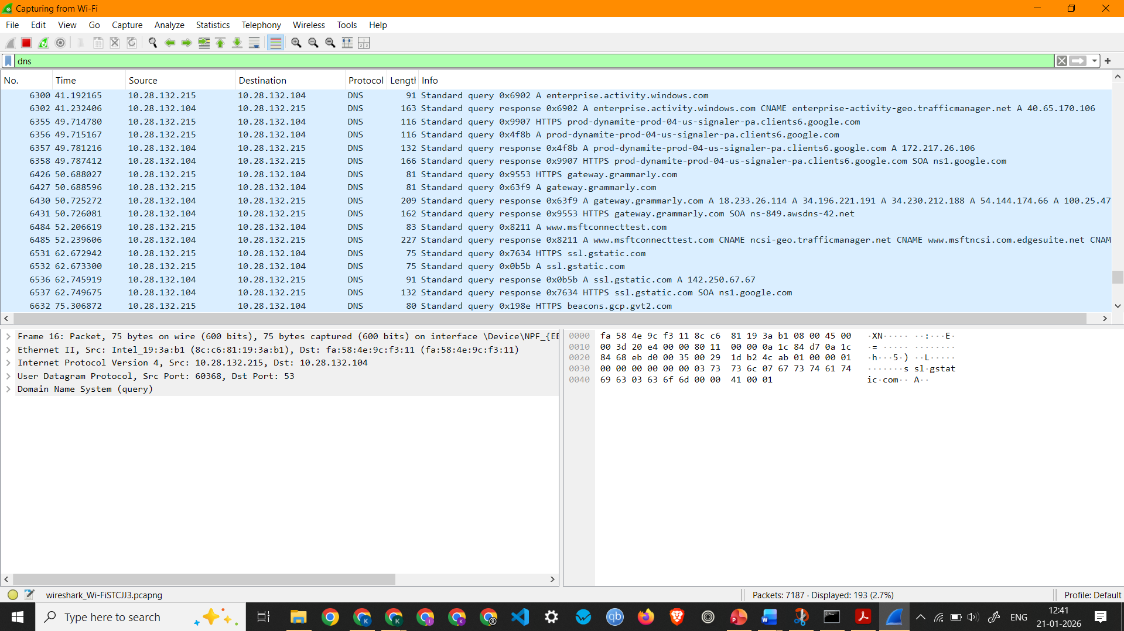
Screenshot showing DNS Packets Capture
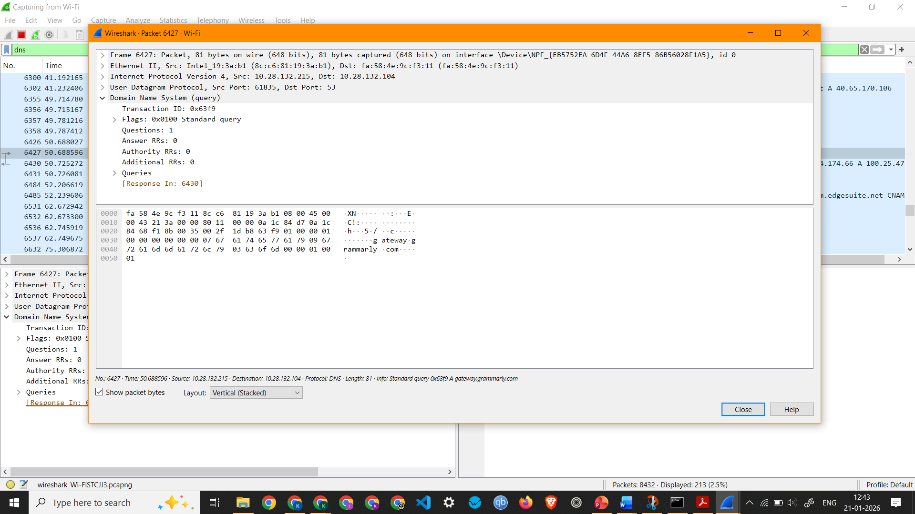
Screenshot showing details of a DNS Packet 6427 (Standard query request)

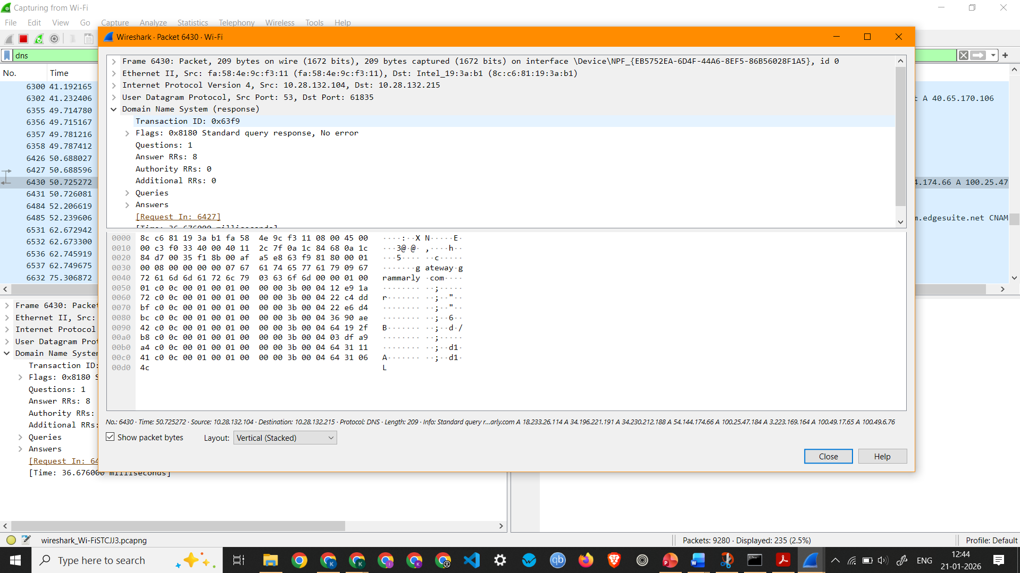
Screenshot showing details of a DNS Packet 6430 (Standard query response)

Observation: DNS Packet 6427 –
  - Interface Used: Wi-Fi
  - Protocols Observed: Ethernet II, Internet Protocol Version 4, and User Datagram Protocol
  - Source IP Address: 10.28.132.215
  - Destination IP Address: 10.28.132.104
  - Packet Length: 81 Bytes
  - Queries - gateway.grammarly.com: type A, class IN

Observation: DNS Packet 6430 –
  - Interface Used: Wi-Fi
  - Protocols Observed: Ethernet II, Internet Protocol Version 4, and User Datagram Protocol
  - Source IP Address: 10.28.132.104
  - Destination IP Address: 10.28.132.215
  - Packet Length: 209 Bytes

5. To capture and analyze HTTP packets
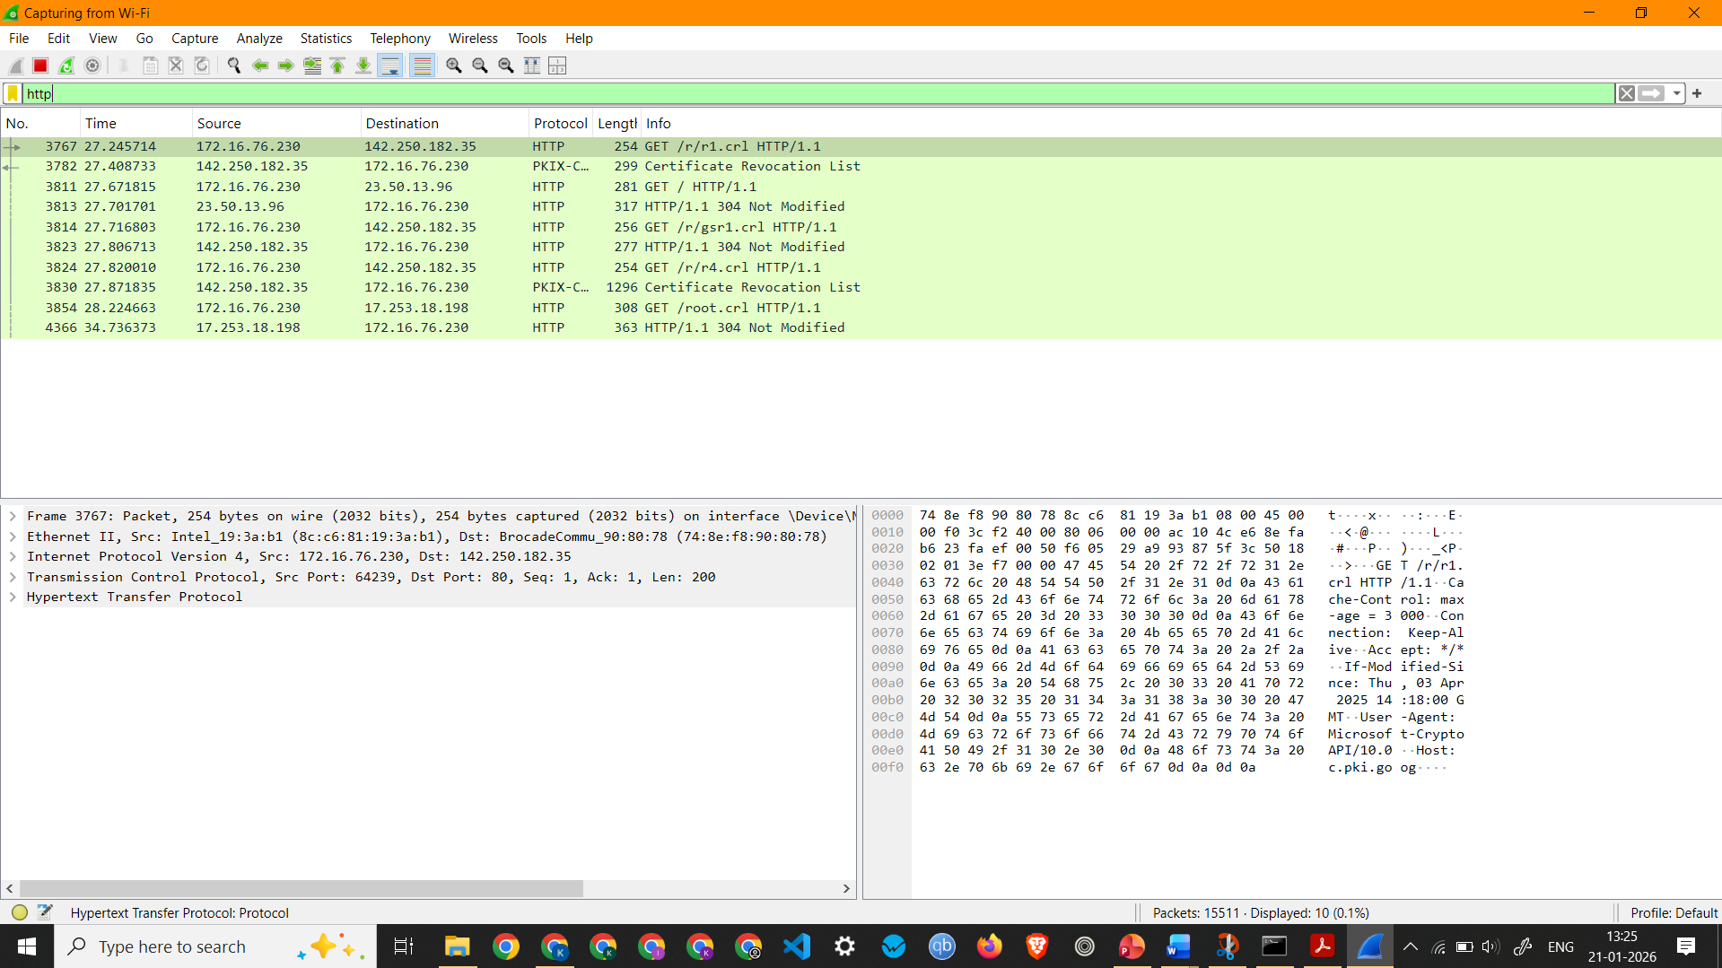
Screenshot showing HTTP Packets Capture
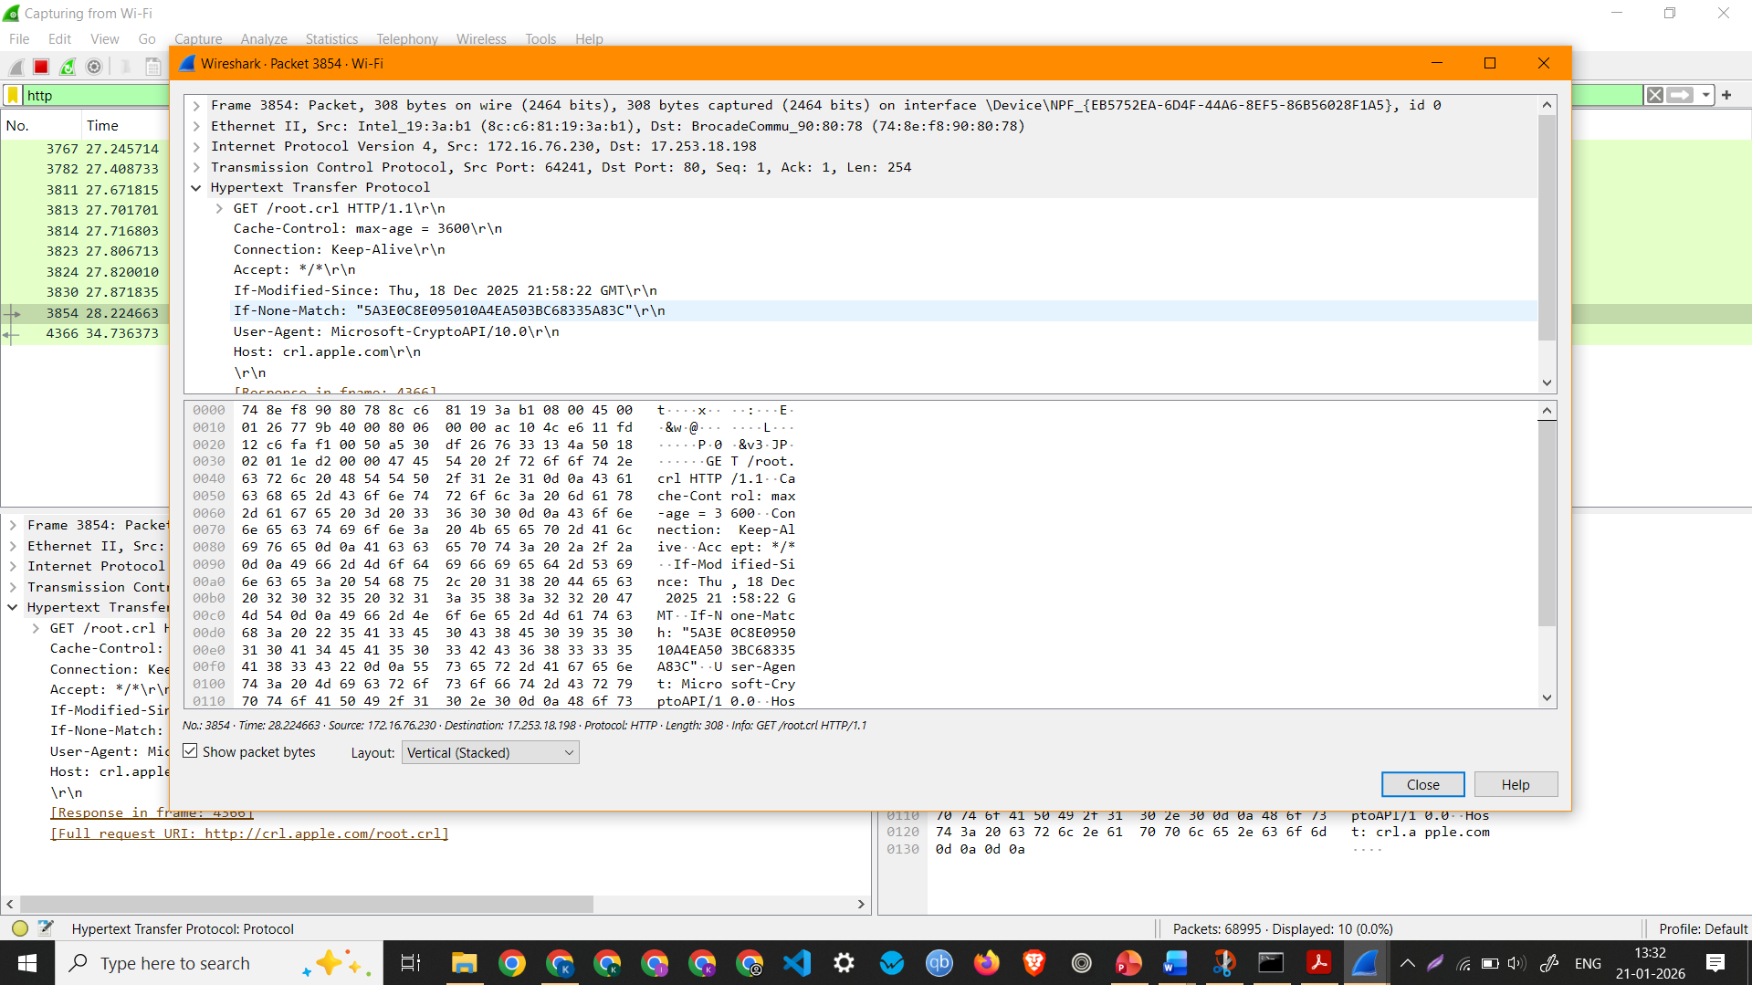

Screenshot showing details of a HTTP Packet (HTTP Request)

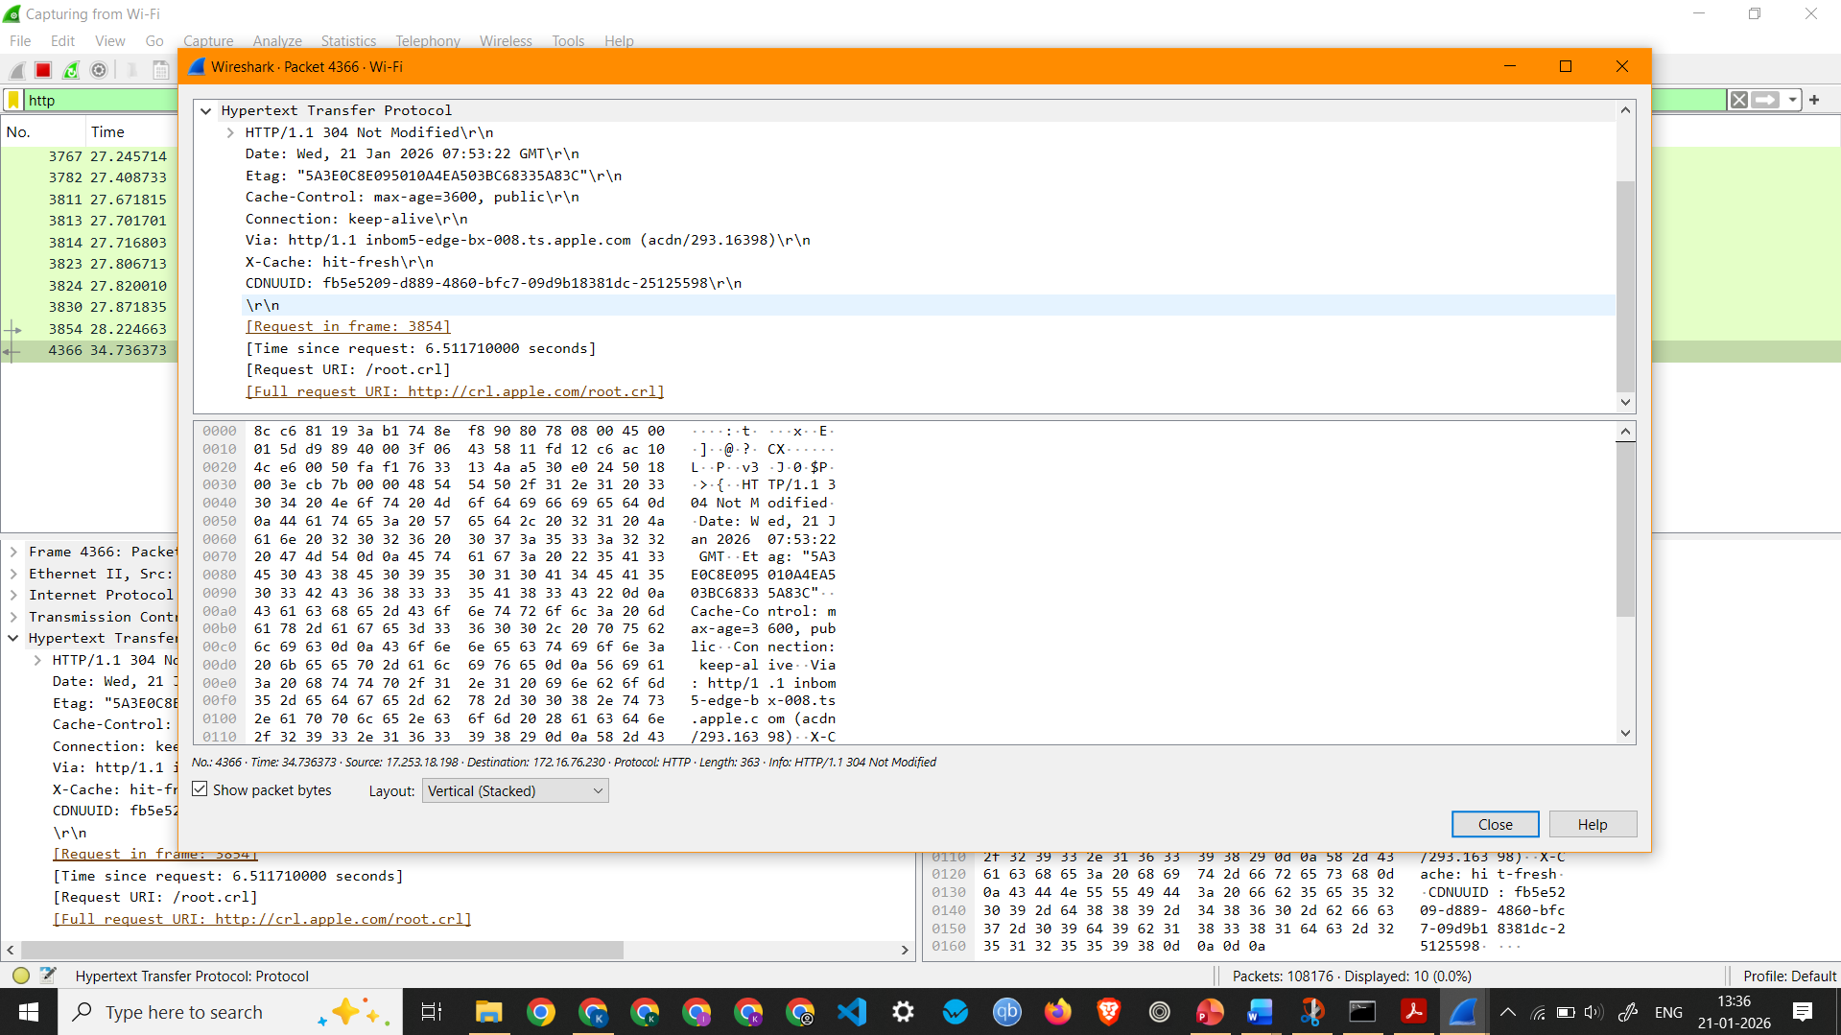
Screenshot showing details of a HTTP Packet (HTTP Response)

Observation: HTTP Request 3854 –
  - Interface Used: Wi-Fi
  - Protocols Observed: Ethernet II, Internet Protocol Version 4, Transmission Control Protocol, Hypertext Transfer Protocol
  - Source IP Address: 172.16.76.230
  - Destination IP Address: 17.253.18.198
  - Packet Length: 308 Bytes
Observation: HTTP Response 4366 –
  - Interface Used: Wi-Fi
  - Protocols Observed: Ethernet II, Internet Protocol Version 4, Transmission Control Protocol, Hypertext Transfer Protocol
  - Source IP Address: 17.253.18.198
  - Destination IP Address: 172.16.76.230
  - Packet Length: 363 Bytes

6. To analyze ARP request and reply packets
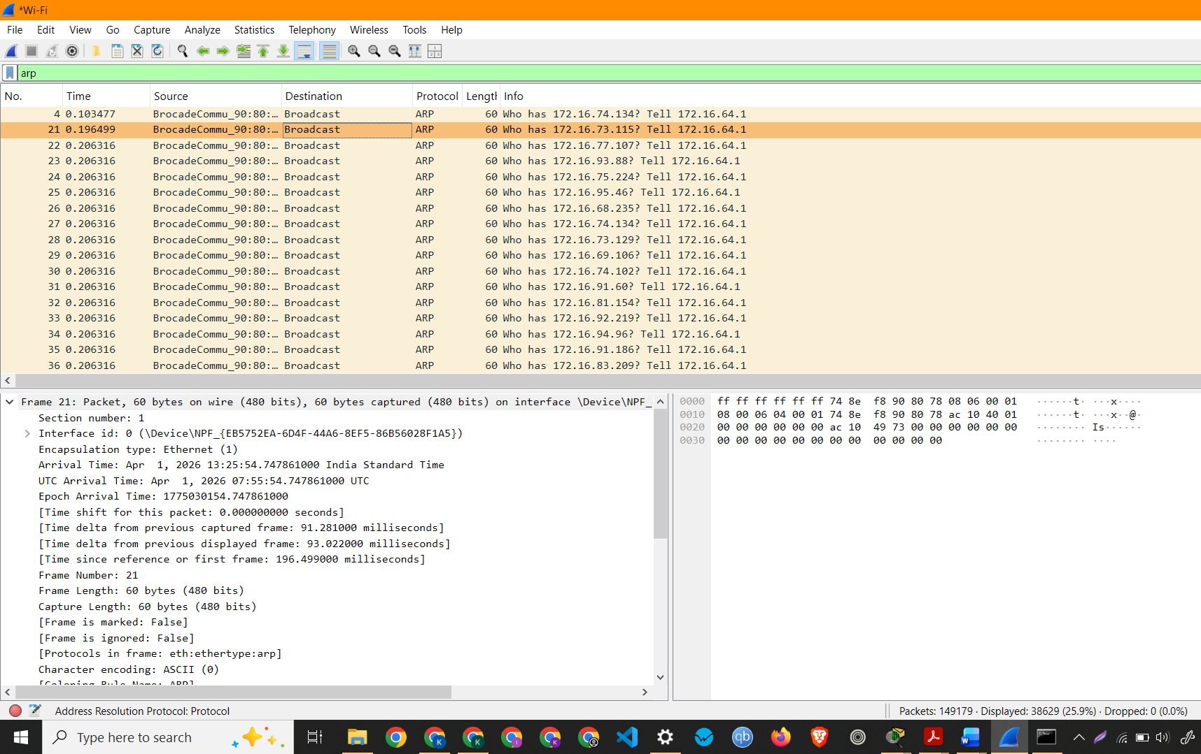
Screenshot showing ARP Packets Capture

7. To identify source and destination MAC and IP addresses in captured
packets
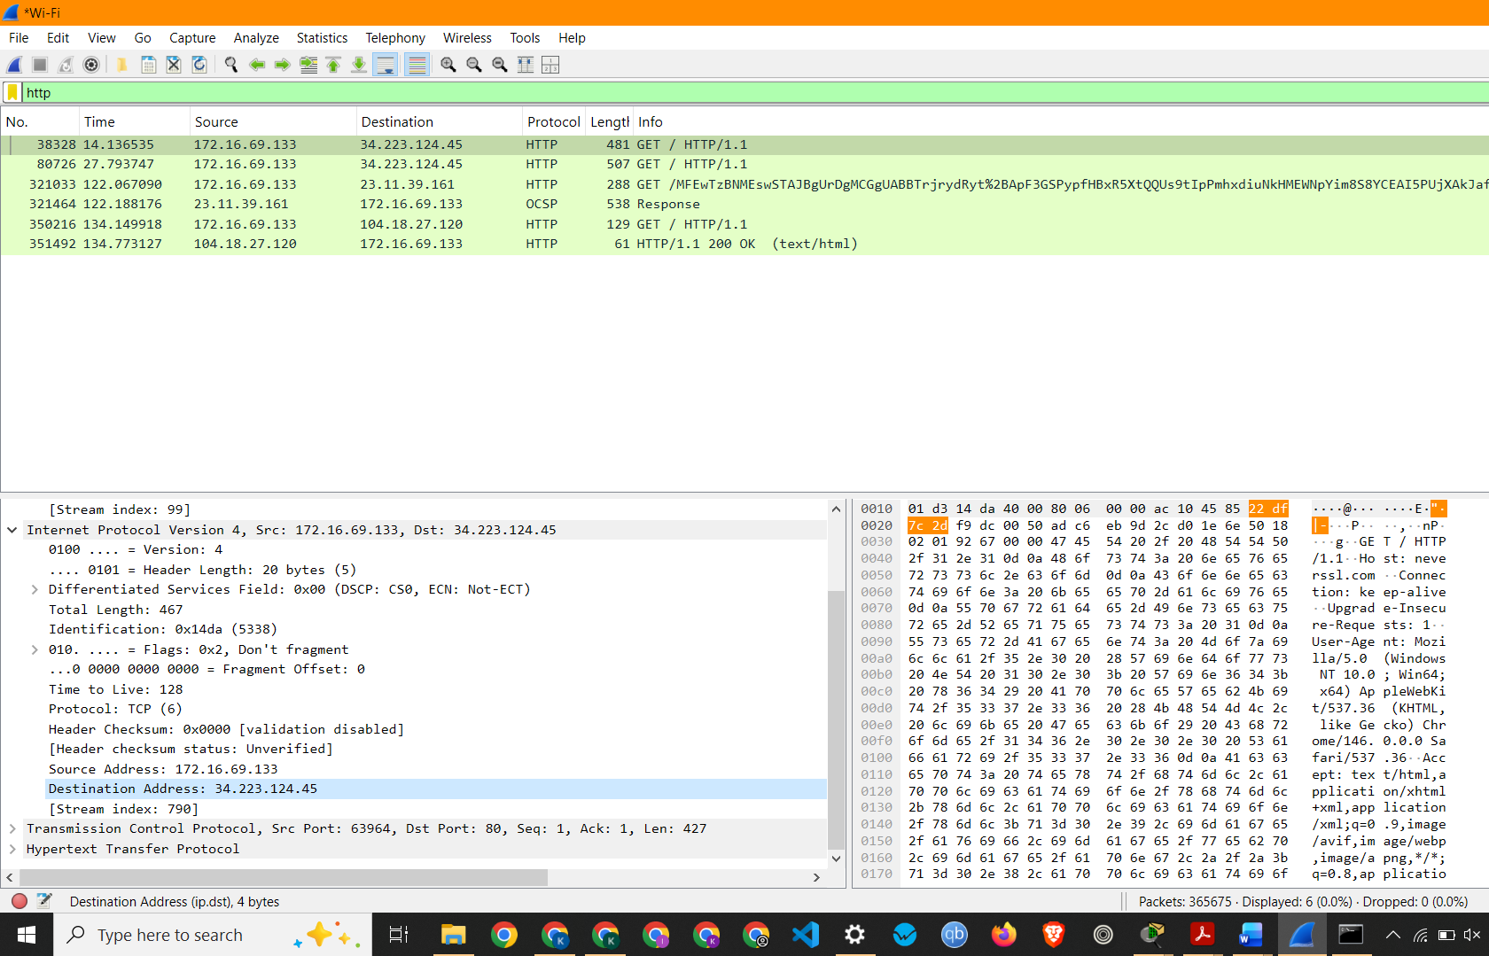

Screenshot showing Source and Destination IP Address of a HTTP
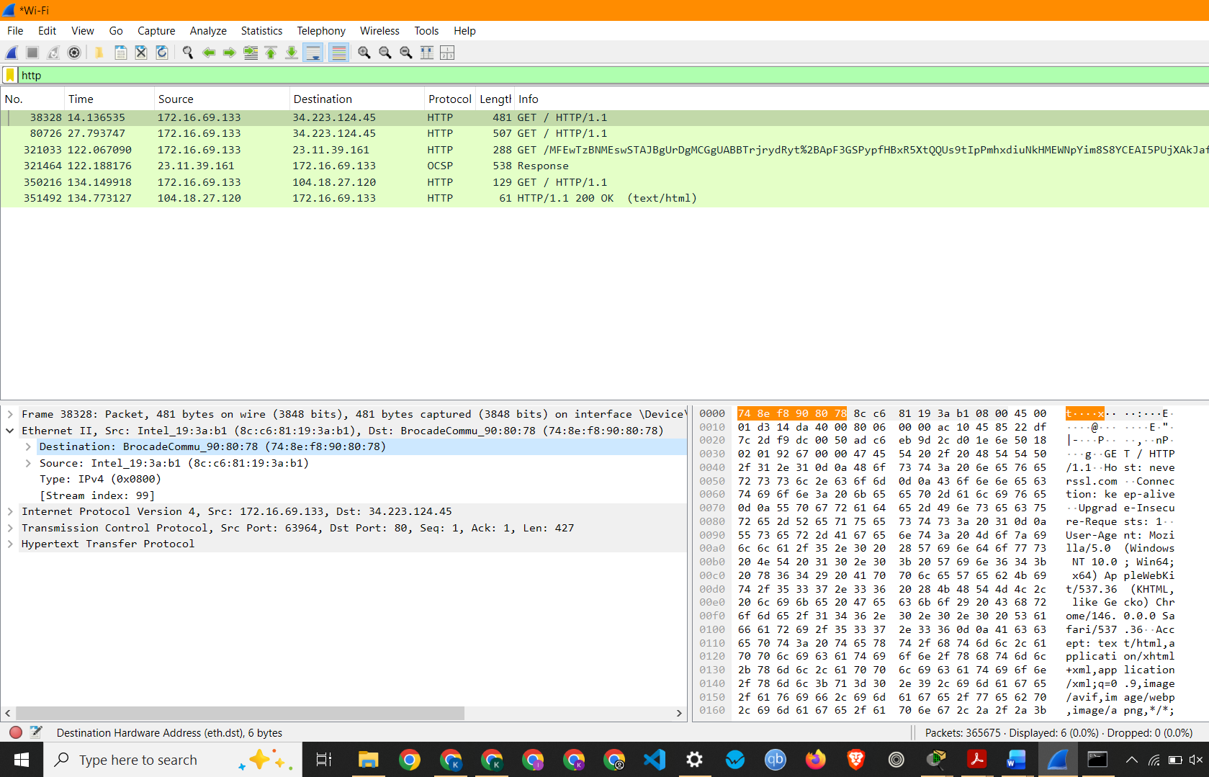
Screenshot showing Source and Destination MAC Address of a HTTP Packet

Observation: HTTP Packet 38328 –
  - Interface Used: Wi-Fi
  - Protocols Observed: Ethernet II, Internet Protocol Version 4, Transmission Control Protocol, Hypertext Transfer Protocol
  - Source IP Address: 172.16.69.133
  - Destination IP Address: 34.223.124.45
  - Source MAC Address: 8c:c6:81:19:3a:b1
  - Destination MAC Address: 74:8e:f8:90:80:78
  - Packet Length: 481 Bytes

