B11156040 邵云希

1. for i in range(10):

    print(" "\*(10-i)+"\*"\*(2\*i-1))

for i in range(10,0,-1):

    print(" "\*(10-i)+"\*"\*(2\*i-1))

結果:

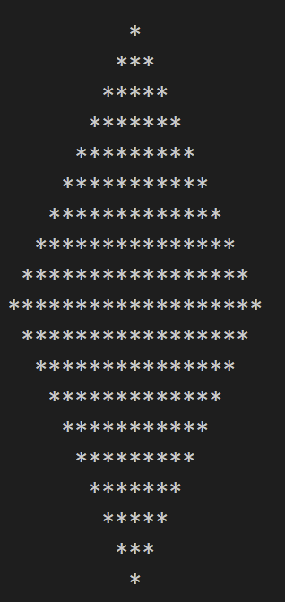

2. i = ['strawberry','apple','guava','pear','grape']

i.append('papaya'), i.insert(3,'franchfries'), i.extend(['happy','ice']), i.pop(4)

print(i)

['strawberry','apple','guava','pear','grape']

結果:

3. fruit = {'apple':65, 'strawberry':37, 'grape':18}

fruit.setdefault('guava',89), fruit.update({'pear':73, 'peach':24})

del fruit['apple']

print(fruit)

結果:

刪除value:

fruit = {'apple':65, 'strawberry':37, 'grape':18}

fruit.clear()

print(fruit)

結果: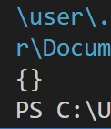

修改字典:

fruit = {'apple':65, 'strawberry':37, 'grape':18}

fruit['strawberry']="94"

print(fruit)

結果:

複製字典:

fruit = {'apple':65, 'strawberry':37, 'grape':18}

fruit2=fruit.copy()

print(fruit)

結果:

4. a=[50, 37, 94, 11, 78, 65, 44, 26]

def test(a):

    for i in range(len(a)-1,-1,-1):

        for j in range(i):

            if a[j]>a[j+1]:

                a[j],a[j+1]=a[j+1],a[j]

test (a)

print(a)

結果: