# 第一題

def triangle(layer):

    b = layer-1

    c = 1

    for i in range(0, layer):

        print(" "*b, "*"*c)

        c += 2

        b -= 1

def square(layer):

    for i in range(0, layer):

        for j in range(0, layer):

            print("*", end=' ')

        print()

def diamond(layer):

    b = layer-1

    c = 1

    for i in range(0, layer-1):

        print(" "*b, "*"*c)

        c += 2

        b -= 1

    b = 0

    for i in range(0, layer):

        print(" "*b, "*"*(layer*2-1))

        layer -= 1

        b += 1

def hourglass(layer):

    a = layer

    b = 0

    for i in range(0, layer):

        print(" "*b, "*"*(layer*2-1))

        layer -= 1

        b += 1

    b = a-1

    c = 1

    for i in range(0, a):

        print(" "*b, "*"*c)

        c += 2

        b -= 1

def triangle_upsidedown_mid(layer):

    b = 0

    for i in range(0, layer):

        print(" "*b, "*"*(layer*2-1))

        a -= 1

        b += 1

a = int(input('1三角形, 2正方形, 3菱形, 4漏斗, 5奇怪的形狀'))

if a == 1:

    layers = int(input('請輸入層數'))

    square(layers)

elif a == 2:

    layers = int(input('請輸入層數'))

    square(layers)

elif a == 3:

    layers = int(input('請輸入層數'))

    diamond(layers)

elif a == 4:

    layers = int(input('請輸入層數'))

    hourglass(layers)

elif a == 5:

    layers = int(input('請輸入層數'))

    triangle_upsidedown_mid(layers)

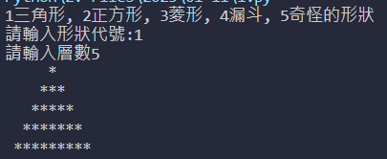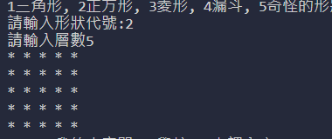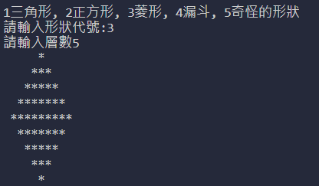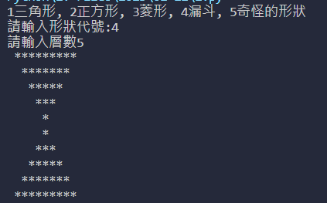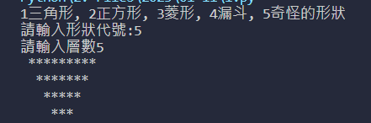

#第二題

menu = []

while True:

    a = int(input('1新增項目至菜單, 2新增菜單到特定位置, 3新增多個項目至菜單, 4刪除菜單最後一項, 5結束\n請輸入模式:'))

    if a == 1:

        thing = input('請輸入想新增的項目')

        menu.append(thing)

        print(menu)

    elif a == 2:

        target = int(input('請輸入想新增的位置'))

        thing = input('請輸入想新增的項目')

        menu.insert(target, thing)

        print(menu)

    elif a == 3:

        thing = list(input('請輸入想新增的項目').split(' '))

        menu.extend(thing)

        print(menu)

    elif a == 4:

        menu.pop()

        print(menu)

    elif a == 5:

        break

print(menu)

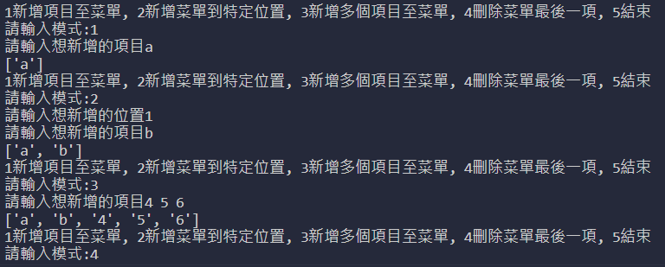

#第三題

data = {}

data2 = {'B': 'banana', 'C': 'cherry'}

data.setdefault('A', 'apple')  # *.setdefault()*

print(data)

data.update(data2)  # *.updata()*

print(data)

del data['A']  # *del*

print(data)

data.clear()  # *刪除、清除字典內所有的鍵*

print(data)

data = {'D': 'drinks', 'E': 'elephant'}  # *修改、更改字典*

data['D'] = "drunk"

print(data)

data2 = data.copy()  # *複製字典的內容到另一字典*

print(data)

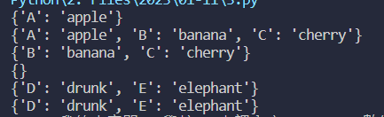

#第四題

import random

List = [1, 28, 95, 63, 47, 10, 9, 5]

random.shuffle(List)

def a(arr):

    n = len(arr)

    while n > 1:  # *確定長度有沒有超過一個字*

        n -= 1  # *要減掉一個才能跑回圈*

        for i in range(n):

            if arr[i] > arr[i+1]:

                arr[i], arr[i+1] = arr[i+1], arr[i]

    return arr

print(a(List))



第五題

import random

a = ['a1', 'a2', 'a3', 'a4', 'a5', 'a6', 'a7', 'a8', 'a9', 'a10']

b = ['b1', 'b2', 'b3', 'b4', 'b5', 'b6', 'b7', 'b8', 'b9', 'b10']

c = ['c1', 'c2', 'c3', 'c4', 'c5', 'c6', 'c7', 'c8', 'c9', 'c10']

d = ['d1', 'd2', 'd3', 'd4', 'd5', 'd6', 'd7', 'd8', 'd9', 'd10']

storehouses = [a, b, c, d]

sell = []

for i in range(10):

    store = random.choice(storehouses)

    x = random.sample(store, 1)

    sell.append(x)

    store.remove(x[0])

for j in range(0, 10):

    print("第{}位客人買了{}商品\n".format(j+1, sell[j]))

for l in range(4):

    print("{}倉庫庫存剩下{}".format(

        [k for k, v in locals().items() if v == storehouses[l]][0], storehouses[l]))

