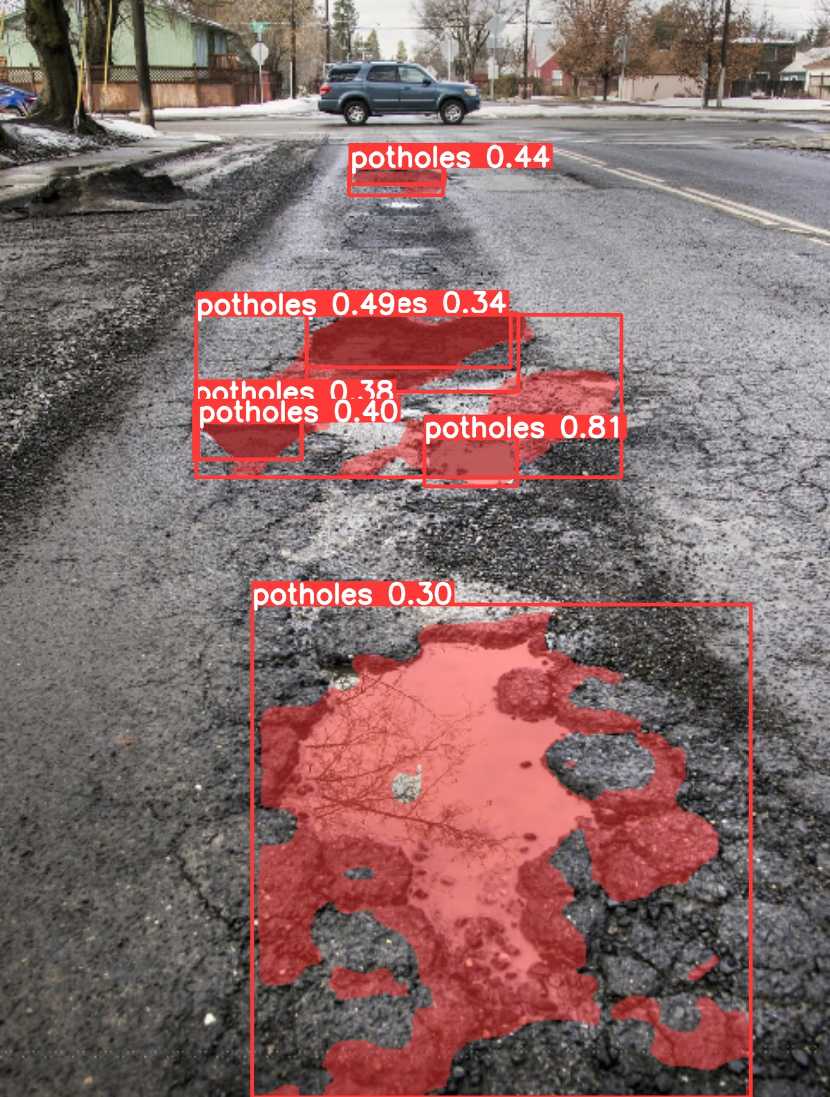 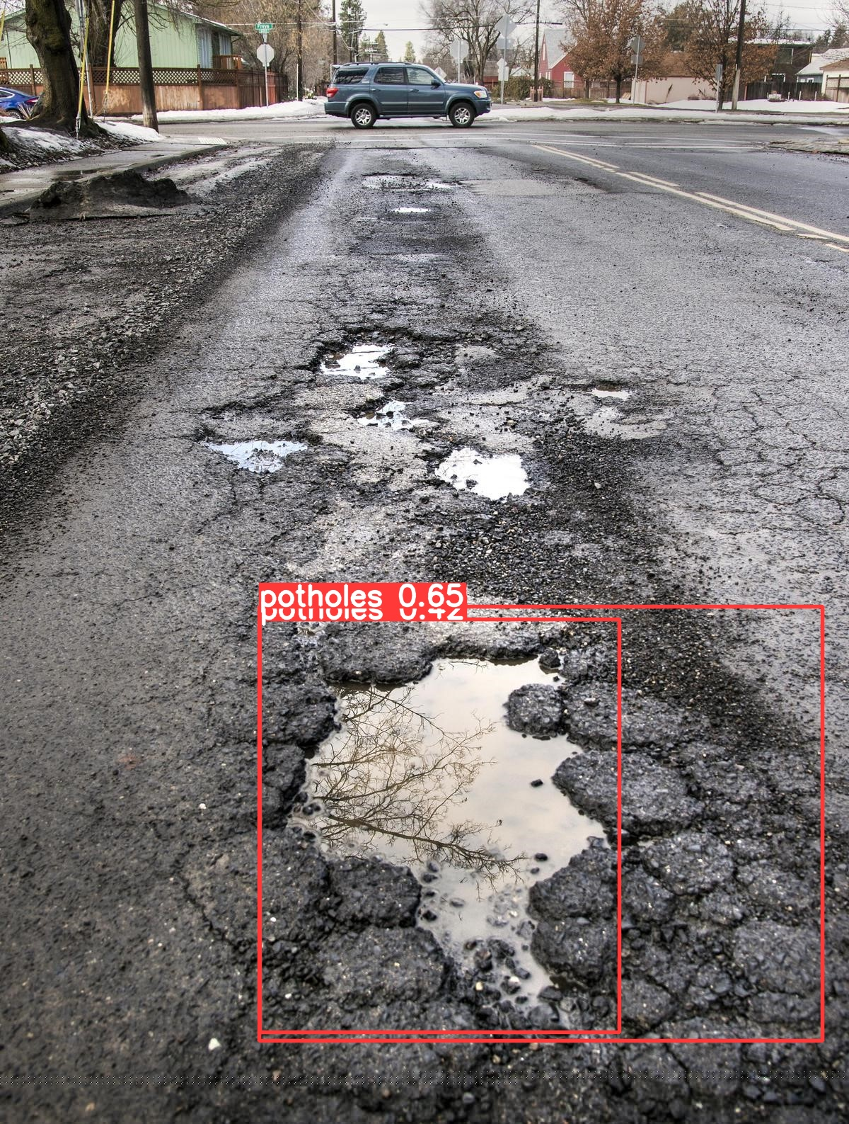

(a)YOLOv8s-Segment (b)YOLOv8n-Detect