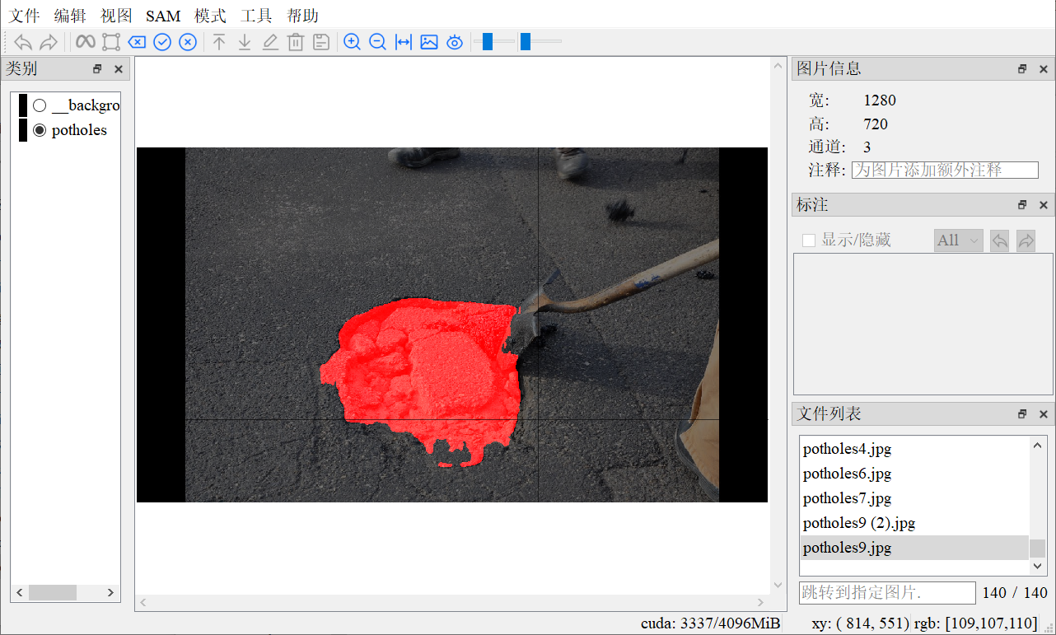 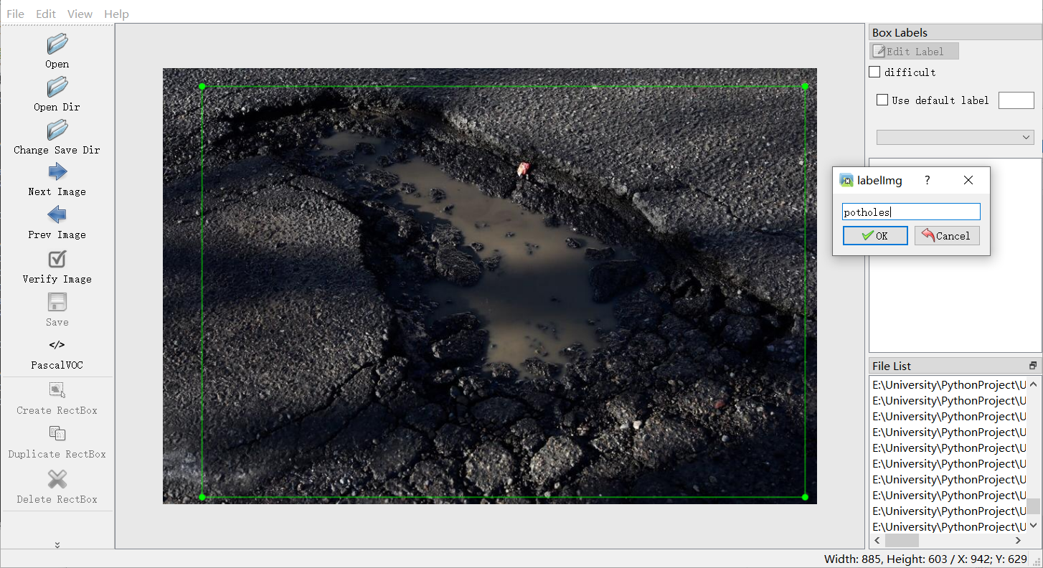

(b) Labelimg

(a) ISAT-SAM [sam_hq_vit_tiny.pth]