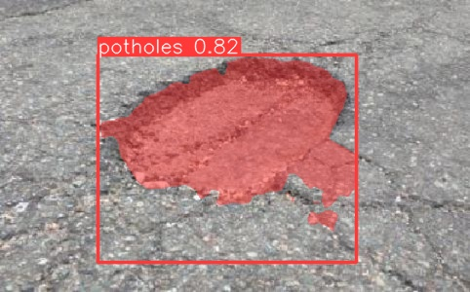 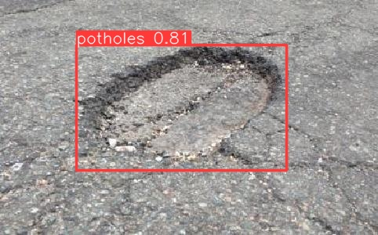

(a) YOLOv8s-Segment (b) YOLOv8n-Detect