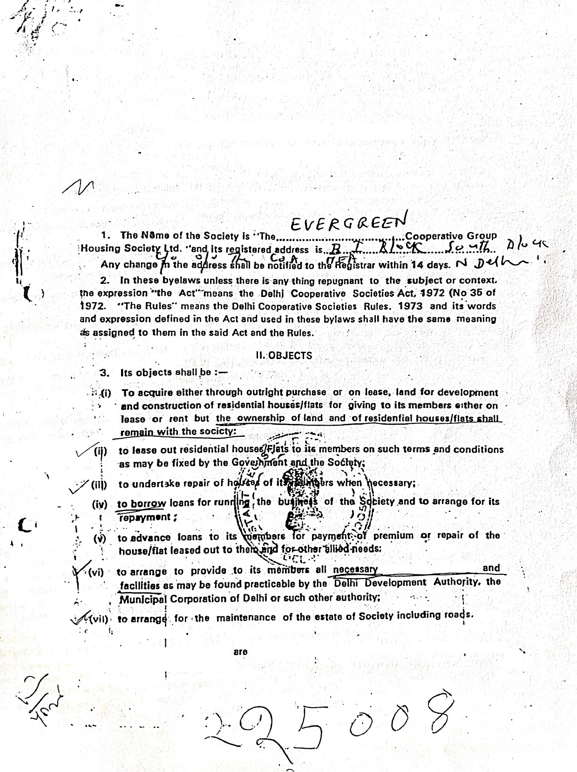

THE BYE-LAWS

Cooperative Group Howing
Society Ltd.

I. PRELIMINARY

common amenities

lanes
end parks etc
(viii) to do all Such things as incidental or conducive to the attainment of any or
all of ihe'above objects. >


¡II. MEMDERSHIP

- 4. The membef9 shall consist of :
  - persona yy jç}ip in th e application fOf f6g' 8tÏOn'_ ’
dmitted in £lccordance With thèse Öÿ’ä-Ï8W/@and

- percons ä
t a laid down in RuÏe

- Nomin»! ç} asSoCiste members subject to cO/ ! S S
26.
{j. (¡) Afjy p£traC/Ft shall be eligible to be a fTf0mber of 6s 1Ogiety ptoVid6d '—

He Is domiciled in Delhi/NeWD^l/I/DBlhI Cantonme”n“, ”
  - His'written appltcazion foi”"m mbeFg”hJ :Üaé b+ ’! PPP ++ Y à +Ï l!Y of the Msnagins Committee; •
  - Hís age is mare than 18 years. except .in the case Of f¥iinor heÍF Of a
deceased membefj


(d} He is not a member of any other hous6 BUl)z zfialGroup I-housing societ
(e) He or his wife (she or her housband, in case of a woman or any of hi her dependents does not own a dwelllñg kouse or plot for building
house in Dalhi/New Delhi/Delhi Cantonmen


d{$g¿tlsr nr •- {, ‹, y ‹ its u e¿ $jOt |jgg[ iTt @UyC§¥$gg.B O7 SB)@ OF YOUS@g//]4 g
or land for construction of house/flats either himself or throngh any of
his dependents;

(g) He has carried out the provisions of these byw3aws. •
The society rñay admit }o/nt members prov'dad they make a declaration in writting that the parson whose name stand first fñ the share certificate Shall have the right to vote snd all the liabilities will be bdrne jointly snd severally by them ss prbvided in the Ast. Rules and byelaws-


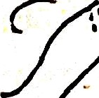

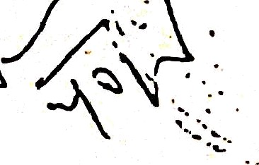


(iii) In accordancé with the prcedure laid down in the byelaws and the Rules for admission of any member, the society may admit minors and persons of unsound mind inheriting share or interest of deceased mpmbers as its mem- béirs”through their lagal repre4entatlves . or guardians respectively. The membeís.sO pclmittled will srjoy auch rights and t•- i!itie es era iuiò,down In thasa bYa{•'. s a r›ú wi›ich are consistent with the Act and Rules.
.• (iv) ersori úeektng membership of the Society shah sign a declaration to" Ï@i$“t 6Ct tha{ hb ór his wif6 (She or her hUsband)”zsr any of hic/her depen- dént¥’• does not town a dwalling house or plat k› Oelhi/New DelhllDelhi
.ntonments”dnd"that heiS#à I T'! I B Member of any other co-operative
’èusebuíldfn G”roup HouSirig 8uciety. He sha|! also be rcquired to" submit



a declaràtion to tlle effect that ho shah abide
.,’sdciety sat out in annexure” ’.
*the regulacions ' of th6






'' s(i)
( n) ho is domicilcd in DClhi/New Delhi/Dclhi Cantt. fu :gç
vidsd thœt this condition will notapply to a Dcntrel i
° rvan4s(including officers of All Indic Scrviccs)/xc*
crsonncl/Employccs of Publis UndcrtiPings

- Ever member on admission shsll pay Re- 10/- as admission fee which shall not be refunded In any case.
 When a person's application has been accepted. by the Committee and he
.has paid his admlSSiOfi f9é 3!1d shar•. money. he shall bn deemed to have
acquired all the rights and incuiied all the obligations and liabilities of a member of the society as laid down in the Act, the Rules made there under and these byelaws.

  - Application for admission as member and lot allotment of chares shall be made to the Secretary in the form, prescribed by the society for the purpose. Every such application shall be disposed off by tAe Managing Committee who shnll have power to grant admission or to refuse in after recording reasons for such rafusal.
  - Any person whose application has 6een refused by tha Managing Committee may p efer an appeal to the Registrar. Co-opcrz•tive Socie- ties within thirty days from the date of communication of ‹he decision of refusal by registered AO. letter acknowedgement due. The decision of ”the Registrar shall be final.
- (a) The provisions of byelaw S (i) (b) shall not apply to the original members of the Society.
(b) The sociaty shaft noi admit memöers wïthin one month prior to the data of the meeting of: the general bcdy.
- A member of the society may be expelled by a vote of the General Meeting :—
  - if he ”makes default in the paYmenl of instalments of his shares: or land and construction money
(2J He has applied to be adjudicated as insolvent oi is an undischarged in
solvent; or
- .He” has been sentenced for any offence other than an offence of a Po!'t c»! characrer or an offence involving moral turpitude and dishonesty; or

- He undsrtakes any profession similar to •he objeçts of the society; or W(5) He Intentionalty does any act likely to iajgre the cfggit pl the . 6oCi8tÿ OU
fails to observe groper”discipline in rejjîÎfd o the “Larg, gh.e socie ; al


•: . - - .


,(6! For any action which m8'ÿ' b8 held by .thä Mansg,i}g -Committee
C›pr
the

! General Meeting to be dishone«t of contrary society or to the interest of coeperation; or
stated ob}ects)Of the

- incurs any of th e disqualifications as contained.in RU!« 2>;

A Opportunity sha ll be given to a member before
expUlsion from mem-






bership to represer.t his case tö the General bôdy and e xpulsion SllälÎ not be effective.unIess it is approverl b\' lhe Registra‹-
- A person ceases to be a membet : -- . '
- on death OF


4
(¡¡) for lack of con(irmstion Of membership as per byelaw fi (*>) *•
(ííl) when his ràsignation is accepted bg’ the MaQaglng Committee; or

n exulsion under b elaw 7:of
- ,ceasing to hold the mioi.mum number of
byelaws: or .
shares pr«scrïbsd ‹n these

- on withdrewa| efter 3.monihs notic6 in wr¡ting to the society, provided
that the member wjthdrawinç/does not owè anyt mig to the so•:»tyand is
not a surety for an‘unpaid d0bt; Of


on undertaking the businacs éf purchase and sale ”ef
hóuses“” or Íand for



construction of . houàes e!ther dir6ctly or indirectlY • ”@f} ] 0$rchas)fÏg a house or a plot or land for”construction of house‹t elther in hls own name br in the nama of any of his dependents througfi anà“ "other source and the mambat shall. 'within ”one month of his undertaking the said business of purchase of a hbiJse or 8tpl6t or land shall inf»‹m the Society about this.
Under such”dircuizisiences, lease of rent deed executed will aut matical!v

beccme ineffective.'
{J) A member or the nominee or successor of an ex-member M8y transfer hi6 shares to another member or applicant qualified under byelaw 5 and appro- ved bY tha Committee or to a share transfer fund created by the Society out of. its proflts and shah then'bunsp d h r ny sum due ,from him to tche Society. No transfer ,of share or interest shpll,
how ever, be made unlesc a member has held such shares ror not less than “
one yaar but ”the condition of byelaw 6 will not be applicable to the n o- minee or legal heir of the decease member.
- The value of the sbars shah in no case be more than the sum receivad by the Society in eaymsnt theteof.







(3} A member on withdrawal, whether voluntarily or through the action of the sdci•ty shall subject howerver, to the rules of the Society have no claim on the provident fund or any other funds or property of Society of any Lind.
CAPITAL
10. The capital shah composed of :—
(a)
(b)
(c)
an“urdeteftúTried ómber:of sharas of the value of Rs 100/- each. loans•and <Ieposits from rúembers and non-members;
donations anti
.” •”. ., • ’• “° “ " /, ”.
"
”
contf‹tjution
ï“ €9’
the c ttÓt housas, lands, maintenance of roads,
drain's and part etc.
(ej oral unds :•
(f) reaB ed’ profi
z•
f'"deposits and loans from nom-
subject to any restriction phich«/re'Reól
embers shah be
“


5


, 11. {a) The capital of the society shall ge used in earring out its objec'ts. SurDlus funds of the society not likely to be Immediately required. shall be inves- ted in accordatance with section 49
(b) Every member shall purchase at least sharec an no member shall hold share of which the nominal value exceeds R '. 20,0001 or 115th of the total share subscribed whichever is less. If any member by otherwise becomes possesed of morc than thc maximum holding permited by this i ule the Nianaging L*ommittee shall have power to sell tbs excess number
or buy them on behalf of the society and to hold the proceeds at its disposal. A member shall not be entitled to pay towards bis second and subsequent share uñtill the first or previous one has been paid in full.
  - (a) Shares shall be paid up in a single payment.
r
(b) A share certificate shall be issued under the seal of the society after the full amount of share money in respect of his shares has 6sen paid. Share certificate shall be signed by the President,. Secretary and one of the““ member of the ohm t ae authorisedooh purposes
  - If a share certificate is lost or destroyed. a duplicate shall be issued on pay-
ment of Rs. 2/-- ,
  - Shares shall not be withdrawn or repaid or transferred otherwise than as provi-
ded in byelaw u.
"US. Every member may nominate a person or persons to wbom on death his shares
shall be transferred but no member may nominate more lhan one nersne. •• -c ':*-
- c -• t be Unit iu quail nominees; whether by way of whole shares or by fixed pro- portion of the amount available for transfer. as the case may be is duyl specified wbsn the norrjinee is appointed and he shall attest the nomination by putting his signature or thumb impression in the register of members. If not admitted to membership the nominee or
nozoinees shall , be paid the value of the shares or interest subject to the provision of
byelaw 9 If any deduction has to be made from the shares of the deceased and there are more than one nominee, the azoount to be deducted shall be set off against the amount due to each nominee in proportion to his interest.
- The society shall have tha right to set off any money due on any account horn

the society to a member or past member or person
any sum which he owes to the society. or for w
claiming \through him in payment of lie stands rdR•. • “” '/


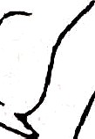



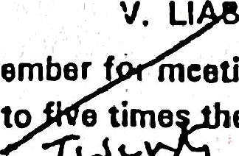



- The libility of the member meeting any <Ieficit1fi e assets• of,- the society
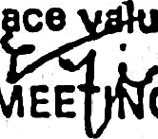
on liquidation shall be limited to e tima e I C6 e.af ttigir subscribed shares.
VG GENE L MEE " G
- The first general meeting of the members shall have the same powers as are herein given to the annual meeting.
  - The preliminary general meeting shall be called with in a oeriod of not less than one month and not more than three months from the dat• of its registra- tion. In this meeeiing the follow,ing business shall be discussed and decided.

Approval af aliotmant of shares, amount coII•«t•d af3d Øf¥gOUßt Gpent
connection with the registration of the socie ty before registration;
Election, if anv. of the members of the Committee othet than nominate
members, subject to țhe provisions of section 31 (1):

Consideration of the Piogramme for ensuing year

  - The annual general meeting shell be called within a eriod of the close of Coopera A special General Meeting may be celled at” an time by the in committee and shall be calied b
ooh f u n f b of
the Registrar, Co operative Societies or any percon author
In case of the Annual General Meeting date. time and pl the meeting shall be nnou d t Ie st 14 davs clearly In advance end in ca
General Meeting at leas - s 4n-edv.anae, by a. written notice publishe on the notice oard of the society and"crculated to the members. Thø election shall be by show an unless otherwjse decided by the general meeting.
- The agenda proposed for the Annual General Me
Mëeting'shall be despatched to al) ztiember 14 days and days recpø before the date of the meeting, giving áate. time and pfaco of meeting.

- The presence the 1l3rd of the total number of"the members szzbsisting as h o the date of Notice of the meeting subject to a minimum of 10.m•m- shal fOF the disposal of . any business at the General Meeting Each member shal have one vote irrespective oÎ thb shares held bv
him. The Chairman/president shall have a casting vote in additions
shall be allowed and no member shall be allowed to vote who is in arrear
with his s

th

ting is not held by society within the
;" tënd8d periods. if any, gfanted by the Registrar, he er any person autho- ùay call such meeting in the manner prescrtf›ed Bid that deemed to be a general meeting duly called by tÑ8 SOCÏ6t'/
1’. and the Reg.í,s. tr.,ar m,ay order'that the expenditure incurred in calling such
a meeting șha*!•be paid out o/ the funds of the society or bÿ

”whe, in the-śpiriío»
of the Registrar. were responsible fOf

failure to convene the general meeting.
- -- • S
” (iii) If within an hour for the tipje.-appointed fOF the meetifîg. ä 9U ”” '

presept, the me,eting .
ha.il. stand adjourn ed to the same diy in the next

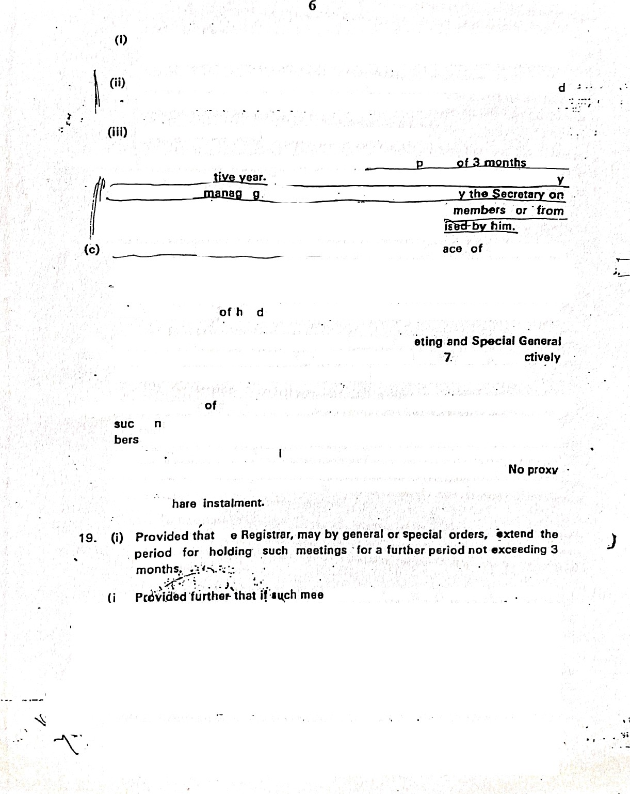











week at the ŠaMØ UMA
and place and İf the
meeting is called
upon ”the ”

7
reqdisition of the members (not the Registrar) it shall stand dissolved pro- vided that at the adjourned meeting, no quorum shall be necessary.

- If at any time during the meeting sufficient number of members is not @£6S nt IO fOfM a quorum. the Chairman/President of meating on his own motion or on his attention batng drawn to this fact shall. adjourn the meeting at such convenient time, date and place as he thinks fit arid ti•e business to be transacted at ihe adjourned meeting shall be transacted in the usual manner even.if no quoium is present.
- No matter shall be discussed at any meeting which has not been included in the agenda of the meeting provided that the chairman may in case of emergency premit the discussion of such ‘matter when. the majority of mcmbers present so desire.
- The President or the Vice-President or in their sbsence one of the other member slected for the purpose shall preside.
- The duties and pr›wers of the General Meeting are :
  - to e!«* •••°? c°› ”u‹ i •move members of the Managing Committee, includ- ing a President and one or more Vice-Presidents and if the number of members in the society exceeds 20 ”to elect a committee of control;
f2) to tecsvie from the Committee a report of'l the” preceding Y6»r“s or/i*lg - of the society together with a statement showing the recetpts”éñd expen- diure;.sssets and liabiliti9S“@nd profit and loss for the year;

” "“ ”” ”” (3 To consider the audit'note, inspection note of the Registrar. or financing institution and any other communication from the Registrar;
- To dicpose off profits in accordance with the Act, Rules made thereunder
and these byelaws;
- To discharge any membet of the fdañaging Committee”on the recommen- dation o( the Committee of Control which may for this purpose call a general meeting at any time; - ‹
- To consider the reports of the Committee of Control togmizer -wilh com- ments. if any of Managing Committee thereon and the action to be taken on the recommendation contained and, in regard to anv matter emerging
from that report:
- To fix the maximum credit limit for each member pfovided thot such maXi- mum limit sl›aIl noi ba mora than that laid down in the Registrar's insttuc- tion on the subject but this may be exceeded with the special sanction ! the Registrar to be abtained In each case:'
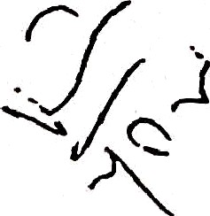
(8} To lix subject to the approval of tha RegiStraE the mäXÏmtJrn iiabiiitr ‹o be
incurred during the (ollowing year, in loans or deposits fruM non-menzö•s•
- To amend the byelaws. SUbject to the sanction_of the I-tegist‹a‹:
- To expel members subject to the approv -I of regi I ar

8
 To fix th• terms and rat•• «t whiCh penal interest shall be ch@Ëg0d by the

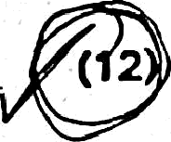
managing Committee on overdue Instalments øț excead 3% P•A over normal rate of Interest.
( 2
loans. which shall not

To fix rate of contribution to be made by the member for US Maintenance
Of the estate of the society:
13) To decide the manner in which d0Velopment and construction work wiIł be carried out by the society:
(14) To decide the terms and conditions on which th8 houses/hat» will be leased to the members:
(1B) To frame the rules of business subject to the app•«YØl of th8 R8gistrar: and

(16) To consider eny other business brought}forward.
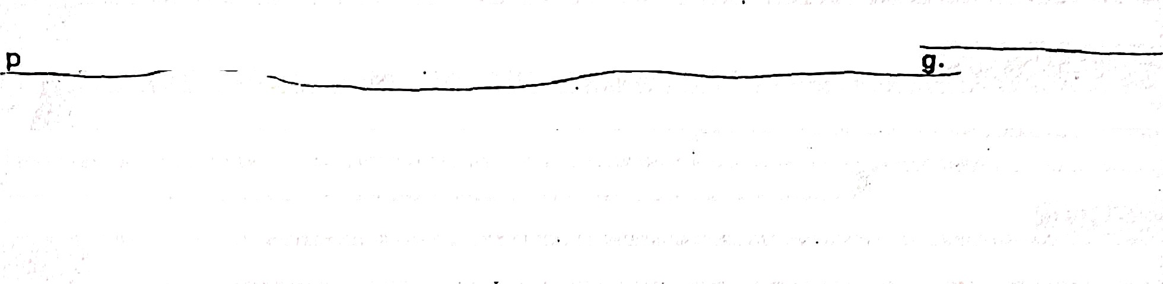

- All business discussed or decided at a General Meeting shall be !*CO7däÖ in a
roceędings book which shall be signed by the Chairman of the meetin
- Amendments to the bye-laws shall only be carried out by a majority of not less than two third Of the members present in a General Meeting in which dUØ fŁOtİCØOf the intention to disCUSs such amendments has been given and Shall ó^ forwärded to the Registrar for registration withìn a periods oS 3 months from the date of meeóng.
I
Ah other questions before the General Meeting shell bø decided by th@ m@jøp¡țy pt

(a} If it appears to the Registrar that an amendment . of a bye-laws of a co- operative society is necessary or desirable in the interest of cuch cOoPBrative society, he may call upon the cooperative society to make the amendment,
(b) The Registrar may by Serving a notice inform/call upon a society to make an amendment within a period not exceeding 60 days.
 After the eXpi£'ÿ’ Of ths period specified in the notice under sub-rute (2) and if the society fails tô. ma @ Ò hDÓM£îflt+ tÈi6 R6ØłStf8t ØÎtØf' ØłVİłł@ @j yç}ç}țj
. .’

rative societY
dp,ğàrtutiity T being heard, may register the amendment and

Issue to th£t
.@-.o@i’8tive“ äoctetÿ. a copy of such amendment certified by him

(d)'

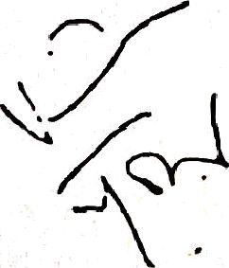
with ã certifiC•t@"Sign,ed by him. With effect from date of Registration, the amendment is binding ăn the cooperative society and its members subject to
appeal, if any..
All amandmants of the"bye-laws relating to the same cooperative society when registered by • the Registrar shall be assigned a consecutive number in chronological order and shall be noted in Index to the bye-laws to be main- tained by the cooperative society in the registration file.
VII MANAGING COMMITEE
(i) The Managing Committee shall con¥ißt of Icebers of the society

and not more than 15 over the age of 21 years including run  and
one or more Vice•P‹eSident. Tнe President or Vice-President or in their
absence any’ Other membar ejected for purpose shall presid0. Each mem- bar of the committee shall have one vote btJț thä Chairman shall hãVØ 6 casting vote. in addition.



- Committee members shall be elected ‘ahd- hold officene th a d shall be eligible for re-election. but no member shal! be eJigi6le for holding the offiC6 OI the President. Vice President, Chairman. Vice•Chairman.
Managing Director, Secretary. Joint Secretary and Treasurer o
two consecutive terms whe er full or part. These oNice bearers shall also not be eligible to hold such offices on.a Committee of another co- operative society a( the same type or on the Committees of more than
three t1ifferent types of the Societies. 1/3 members of the Committee
shall retire evary year by rotation through draw of lets.
 Tho election of the Menaging Committee shell be bY show of hands in the manner given in schedule III of the Delhi Cooperatives Societies Rules 1973 unless a poll is demanded by members in which case It shall be held by secret ballot. In case the membership of the society exceeds five hundred, the election shall be held by secret ballot In the manner given in
Schedule 11 of the Delhi Cooperative Societies Rules, 1B73.

(¡v)
Tha meeting of the Committee shall be held when necessary and shall be called by the Secretary on receipi of “a requisition from three or 1/3rd m be s he Mana n ee whichevor ls zzzore or Ime Registrar. Cooperative Societies, or on/‘ person autfforčsed by him. The Managing Ccrnmittee shall cause minutes of all proceedings of its meet-
.ings to be entered in the book“for the purpose in hand written at the spot in the presence Of members .present .and voting. Ttze minutes of each meeting shall contain the names of the members, if any. dissenting from or not concurring to anY resolution. At the end of tfse minutes. each member present and voting shall sign them." if”the mlfxztes are not made an”d recorded in this manner, they shall not be considered valid and it shall be deemed that no such meeting was duly cs1Ied as»d held.

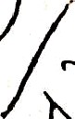



fb) The meeting shall be held as often ss required but ¿ti a be he d
I t oT?c6 i eve f*
- A me”mber of the Committee shall cease to hold office if he :—
  - ceases to be a member of the society: or
  - applies for insoilvency or is declared insolvent: or
  - becomes of unsound mind: or
  - is convicted of any offence involvina dishonesty or moral turoitude: or
(^*) accepts any office of profits under the society or receives any honourarium: or
) carries on business on his own account similai that as spauified inbye law 3 [i]: ‘(7} resigns and his resignation is accepted by the Committee: or

” 25
8’
The
d t e
’ ’
ee'sh I
o d
ntc s
et
the eo

the society except those

rer ervgd for the General Meeting subject to any regulations or resrrictfons laid down by the society in a General Me•ting or in the bye- laws and in partictzta• shall have the following powers andduties :—
(1) 1o observe in all their transaction. the Act. the No ified Rules d these bylaws:
(1 \ to maintain true and accurate accounts of all monev «cet e , expanded.
- to keep register of members correct a nd uptodate:

- to keep true acco••i of assets and iiabiiitieso( the society• profit anJ loss

- to prepare and lay bef‹›re th• Genoral occount and 8udited Balance sheet:
/\/ÏeOtji,g tl•e n"u"!

(ti) .to +
amine the accounts, aanction contingent allà other expenditUr6 dFld
the maintenance of the perSCribad fe@ÍstarS•

SLlper\fisa
- to consider tf›e inspection notes of the '.RàBlstrar and
- - . -
pl nny Otha‹ person g instítution and to take

authorised by the RegÏSt7ä¢ IO
necessary action:
inspect Jr financin

- to eloct new meizibe‹s and issue new shares and transfe‹ old shar8S:
- to srrange for the recovery of dues”of thet soc etY:
- to summon General Meetings-in accordanca with ths byelaws 18.
- to coñtract loans subject to any restriction imposed by the Regisuar or General Meetings and to make necessary arrangements for its repayments.
- to decide tho tarms on and the period (or which loans are to be given. to approve or rejact the security, to arrange for the recovery of loans and interest and to impose. and recover penal interest on ove‹ due instalments as laid down bY the General Meeting nnd to sanction, renews loan when necessary:
(t3) to decide the terms on the pefiod for and the rbt”e'oi interest at which deposits are to be received and to arcangc lot the payment of such deposited
(14a to waích thailhelozns ateappÜed to theapproved puipose.for which ihey
were made:

(15) to assist in tha inspection of the books, óther

sóciety by any"person authorlsed to see them;
documents and papers of the

(10) to appoint, suspend, nish and dísmiss employeessubjeGt to the provisions of these byelaws and to’fjx their remuneration;
(h,) through y wembor
speclall authorised, to cónduct, defend, compfolT›ise, refer to arbitration or
abandof gtjai proceedings by or against the society Committee or the officer or emploYees concerning tha a(fairs of the society:
- to acquire on behall of the society. shares in other registered co-ogetative
- to fix the rate of interest on loans to members aubjeci’to bye-laws:
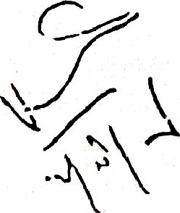
- to arrange (or the custody of books and to appoint one of its f¥\Pmb8rs or one of 1he officer ol the society resident in the area of op_{e}rat¡On to take chatge of all the registeis and papers prescribed III these by•Iaws:
- to invest tha surplus funds of the Sf3C'6ty In accordance with section 49 of the Act:
- to acquire and hold p‹opoity and to entar into contracts ‹on • bahalJ of the
SOCI6 ty: .

- to fix the maximum,r edit IiMİt of each membar in accordance With the ins tructions of the Registro . subject to the approval of the General Meeting. This  be fixed only wh0f› a member filed a declaration giving the amount off his debts secured end unsecured with the tate of interest The proposal
for maximum credit limit of a member of the Committee chall be brought
before the General Meeting In a separate detailed rosolution and shall no: b
included in the proposal for maximum credit limits of other œ-embers:
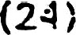 to decide tl:: near.:-•‹• of «xecL:tion of • ork зnd its allotment to members ar›d employees:
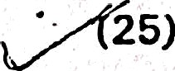 to appoint a treasurer to keep the money o( the society and to requiro him to a!•e such security as it may deem su(ficiønt:
- to elect the Secretary out of Managing Committee members
- to distribute the duties batween1he Secretary and manager. if necessarÿ:
(28y to carry out the development, construction work in the manner as may be dec i- ded by the General meeting and allotment of ” house flat to members in accor- dance with the rules framuo by the Society with the approval of the Registrar:

(29}

(30}
to appoint a custodian of the property of Society and to keep ït in good state
of affairs:
To coopt, m°mbers against the vacancy caused by the resignation or disquali-
fication of anY member of the managing committee: and

(g1'} generally to carry on the business of the Society. :

- In the conduct of the business uf.society. the Committee şhalł exćrcise the prudence and diligence of ordinary men ol business and shall be fęspo/jsible for.oriy loss sustained through dCtS contrary to the Aci, the Rules made therec er and" these óye-laws.
- No member oJ the Contmittea shall receive any remu- ”tión for his work as a mf2mber.of UE? Committee. No member of the Com.wìttee shall vote in ar•y application for a loan in whićh he himself is interested as a borrower. he sháll not stand surety for a new loan to another member of the committee.
- All business discUSSP•d r de cided at a meeting of the Committee shall бe
recorded in book which shall b« signed by the Chairman of the meeting and all members
of the committee present.
- The Committee may appoint from amongst its own members a sub committee
and may delegate to it or any officer of such ol its own powers as it may consider
desirable for the better conduct ef the Society's affairs. The sub-committee or officers,

Shall ìFï
the discharge of the functiofl eFltrusted to them. confirm in all respects to tnese
ns given by the Managing Coinmittee.

bye-laws and to the instructio
VIII SECRETARY AND/OR MANAGER

” . The co shall : —

mlTl
ittee of the sosiety shall sgecif y' whiCh of the of ficers Of a society

- keep th0 books of accounts,

- keep other books and registers; 

- prepare re turn s and sI otemen ts.
. o. Provided .hat a person charged with the keapins accounts shoIl not be the- ” in charg e o( cash.
If the COiTtfTtittae of a cooperative society has not spacified the of ficers required to specified in sub-rule (1) notwithstanding anything contained in the bye-laws of the society. the followirig officers shaI| ba responsible for keeping accounts, record eic. indicated against each. nameiy :
{a) Treasurer
he shall keep or cause to be kept all the books of accounts and vouchers and shall prepare or causa to be prepared annual profit and loss account, receipt and disbursement account and the balance sheet. Whosoever may’ be writing
t these books of accounts. they shah I s o
I possession. power end control. ” He shall be raslzofisible for their safe delivery

- to his successor after making a list of documents handéd an4 taken over.

he shall keap or cause to be kept all other racords of the society and shall be responsible for preparation and submission of’ various returns to tho Registrar.
Whosoever may be keeping these records sha!! •!ways be deemed to be in his custody, possession. power and control. He shall be responsible for making
over the charge of this rerord to gis successor under proper charge report to be signed by the relieving and relieved offlcers.
  - Casb :
Cash balance in hand shall always remain in the hands of e Treasurer a o h ice ppo nte om e
    - Every cooperative Society tslfall learn-“tirr\e to time determina in a meeting or the Committee; !“ mini utn- members“.”off paid staff required for the business.




The emoluments.
shall gragcr)be their qualifications and experience and Com l{te0.•. shall be competent to appoint, dismiss or

remove any pa staff. ’. :“
    - The minimum id staff for ay Cooperative bank and any cooperative society with working Capital ora ”Tal transaction of rupeas five lakhs or over shall be : — -
(ij One SecretarY or Manager :
      - One Accountant ; and
      - One Cashi0f.

IX”REGISTERS
    - The following registers and papers shall be maintained and shall be open for inspection of any one interested in its funds, except that no ona shall be allowed to sea the deposi t account of any parson, without that person“s consent in writing :

- _{it} _{f'}egister of members showing the name, address and occupation of every member, the number of shares held by him, date of his admission to member- ships' date of termination of! membership ,ah,d the nominee .appo‹nted under
x“
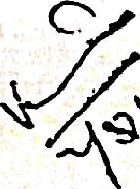
' bye-laws 15: ° • °”- "“ ”“ ° - '

i I .

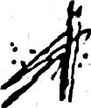
- a caslt book showing tl›o income. expendlture and balance on each day on which business is done: ' ' •.' •• •
.
lflt0l'0St.
3) a ledger account (or each member, depositor and creditor, miscellaneous and contingent Income and expenditure;
(4) a ‹•gister showing tha maximum cradit of each member: 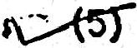 on account showing mon\hly depoclts and contribution;
) a register showing all the properties purchased and disposed/Ieas•d out by the society:
(7) a register showing the monthly instalments for payment of loans;
(0) a register showing the monthly instalments for payment a I loans;IDeposits
{9) a pass book for each members and depositor;
- a book of bonds for all loans ”Issued;
- the register of application for membership containing the name and address of..the applicant the date of receipt of application. the number of shales applied for and in case of refucal, the date of communication of the deci-
sion refusing admission to the applicant; and (1 2) any other register prescribcd by the Registrsr,
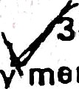




4. Copies of the bye-laws and balance sheet stîall be suppliad Free on demand to an mOfTÏb@r. The last balance sheat shall e opan to public inspection during office hours. ., ,
ih

;gg. The c•wmittee shall appoint o.n at the s ciety tOtäk6 hold and keep in safe custody all 33 and other papers in use of the Society. . *
- COMPULSOBY;,DEPOSITS
or <ine of the officer of prescribed in bye-laws.

g6, (1) Ev•‹y member shall subsCtibe to" ïîeposits fôr specific objects•
(2) such deposits Shall be governed by rules to be framed by the Society stJbject tO ägproval of the General Meeting of the Society.
(0) With the sanction of the Committee, a membor may be exempted
from the obligatiOn to deposit for any period during which his circzI• mstances donot permit Ofsûch payments.
- LOANS
, g7. No loan ahall bs advonced bY the society save for payment of premium or
repair of house/flatsleased out io the members and other allied needs. {, :y -. ,,1.. _,-
- . - be granted within the maximum credit limit of a rnember àt

38. Al{ loans shall
the discre}io» o/ the Committe
- such loans shall not exceed 60ºe of.the premium paid
mortgaged to the 8OCI4‘.ty. In addition to

pr payab)8 tu th• üovernment of the prooa tY
tangjbÎ€fsecu ty, the borrower shall ftJrnish at
lsast two personal sureties whO fTiL!St

th e
be members o( the S
ociety. SUCh {OanS SI all be
nditions Which may be
granted subject further to any g^0^F+!

imposed by the Registrar from tiM8 IO

{gr _{S}p cial restr ictions Of co
d before
payment of lOäF?

‹iw• Theyborrower shall
_{E}x_{é}cute a ban



14
as. Loan shall be payable in equal monthIy instalments spraad Over five years.

The CommittB€i may suspend repayments
. , _ Sufficient cause being shown and may period not execeeding six years.
of any- instalment for one or more months on thereby extend the time of tOtal payment by a

- 40. The property given by a borroWing member as surety shall remain under first mortgaçte with the society iill the borrower Pay off the whole dues.
Such mortagages shall always be in addition to pcrsonnol sureties who must be member of the society provided that the amt, for which a member stand surety shall not t exceed the balance of his maximum credit limit. after deducting the amount he himself
'“ owes on“a morteage.
- House given in security shall be insured • against fire for their full value. The insurance premium shall be paid by the borrower. failing which the Society will pay the premium and debit the amount to the member's account.
- If țhe Committee finds that the security Igor an outstanding loan has be- coma insufficient or that the borrower's material position has weakened. they shall call on the borrower to provide satis(actory secu‹ily and in default shall calf in the loan at once. Tfie loan shall also be recalled.if the Committee find that it has not been appl ed to the purpose for which it was taken.,
- A mamber's commitments es surety shall not execeed an additional amount equal to his maximum credit limit. Unavalled portion of member's credit limit may be ”’ added to increase the limit upto whleh he may stand as surety. When a member has stoôd surety for an additional amount owi•ø to his maximum credit limit not being fully drawn, he may not draw further his maximum credit limit, until his liability as surety has been correspondingly decreased.
Permanent sureities may be taken subject to rules and regulation is approved by


the Registrar. but the provis'ion mentioned above shall not aPply
regarding unavailed portion of maximum credit limit ats

The limit to which a,membar ,«Ïan- stand as' surety in accordance with this bye-

r i aaso 44.
bte needed at thà discr n of the Committee in case where collateral sacu-


  - *
Interest on loans țÔ'members shall be charged at a rates to be fixed by the

Committee provided that the margin between the borrowing and lending rate is of at- least 2% per annum. In case of default. penal rate may bg prescribed by the General
Meeting under bye-!aw 20 (11). subject to a maximum of 3% P.A.
- All documents creating a charge or obligation on the society shall be sig- " ned by the President or Vice-President snd by other members of the Managing COMfTlİttOO appointed for the purpose provided that in the case of receipts and cheque .upt9 Rs..2ü0/- and receipt for deposits and repayments of loan the, Presidenl or secretary..aNd

Tréesurer rńay üignl ÄII important ’docúinents of the Society shall..;b,e
seated. Ith 4he ., •

śô“ččé" ”š seal. Th e seal shall be kept in ”the custody of th e Secretary•or zny other officer
: ör‹offićë’bBarer of the Society authoriśed for the purpose. üi :.•f! č-••“ø›"•

15
- Society shal) not allott any py perty- including ] ty houses or flags tgy
person excapt to its own membefs. NO fTlember shall be alloted on laase or rent more
than one plot or house or flat by the society.

- AUDIT
47f The accounts of the Society shall be audited atleast once a year by an Auditor appointed by the I\egistrar. Tho Society shall pay such Audit fee as may from time to time fixed by the Registrar, Cs-op r8tive Societies Delhi.

* ^ XIII. DISTRIBUTION OF PROFITS

4g. (a)
The following shall be first charges on profits:
- any loss undergone by the society :
- necessary deduction for depreciation of machinery, building. etc. (iii} all insurance charges:
- all payments of salaries. provident 'fund and working. expenses:
- interest on debentures, Iosns deposits, etc.

  - contributions to audit fee as may be fixed from time to time by the
Registrar.
(b) The balance shali be the nettpgofjt of t s ciety.

(j )
Flo.t less than 25 per cent of”the nat gr it shall be. oarried to the Reserve Fund which shallttbe indivision and no roëizibers shall be entitled to any share in it. ' ’”

(2) The society ”shail credit a sum“calculàÏed at two oer nt of its net profit subject to a maximum of -Rs. J.50o“- every year for contribu- tion to the COO/›arativa Eduction"Fund to be . administered by the
Registrar. The Registrar may frame regulation for the utilisation and ahe administr iion of the Fund. This fund shall be kept with the
State Bank of India Any such amount payable by tke society. shall ba " a charge on the funds of the society.
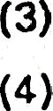
Dividend on shares may be paid not exceading 10s› par annum.
Not more than 20' of the balance shall be distributed as bonus to ali employees whether-members of the Society or not... '"
 :Tha. remaining amount. if any. may be allowed to ”any or ah oi the pur- pos'es detailed below or may be carried over to :— - •
(a) .bad debt fund: -- -”•---
. (b) rebate on goods purchased bY the members:
- common goods fund according to section 47 of the Act:
- dividend equalisation fund;
{e) share transfer fund; and
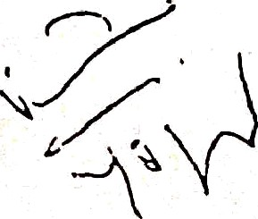
(f) anv o ther funrl r•quired for the business ôf the Socieby,


49. ‘ I f no dividend is claimed fa PB£İOd o f three years from the da te of the declare
ation. a notice shall be issued bÿ th e Societysat the registered addf6SS O f the me'mber at
his cost calling upon hint to take the an oUFlt vyith in one month of the receipt of the
notice. If the dividend İS hot claimed during this period it shall be credited to the Reserve Fund.
50 Bonus shall be paid. according to the rules approved by the General Meetíne
- "and subject to any restriction imposed by the Registrar.
  - No bonus in addition to the uividend shall be distributed on chares of the
members.
- Dividend shall not be paid while any Claim du8 from the Society to a depositor'
or creditor remains un-satisfied. ' '

- Allocation and distribution of profits shall be made only gfțer tha annual audit. Membars shall have no right to the dii/idend unless declarećl and approved by the General
.- ’‘Body. The dividend shall be paid to all members within three monih of thø approval by the General Body.










XIV. RESERVE FUND .

- The Róserve Fund is indivisible and no iziember is entitled-to cłàim a cpecified share. It shall be invested in Government Securities or otherwise as diremed by Regis- trar unüer section 49 of the Act. .

XV. DISPUTES “'

čî5. If any dispure touching the constituÿon or busiùess of the Society arises bet- ween members or past membečs of the”Sociaty or person claïminØ through a member or past member of the Society (pașt or presentj -or ğetĘeen the soçietY or its Committee and
any officer. member or servant of t.hue Socipty {țiast qr present) it shall be referred to thø Registrar as provided in.the Act an the Rules made thereunder.

- AU matters not speci ,fly provided pr6“to be decided in accordance with the
c operaitvo sociațies Act antźúÊe Rules”madd thereunder.
- The Managing Committee with the approval of the General Meeting may frame Rules of business "for carrying on the woik of the society and may maks-additions or
.t alteration in them frolTl tífTle tO time'.

XVII LIQUIDATION '*
- “(1) The Society'. shall be wound up and dissolved on)y by an Òrder of tha ?-
Rsg'strar under section 63 of the Delel Coop. Societìts Act | 1972 | and Rules made | }”
thereunder. |  | - | -•
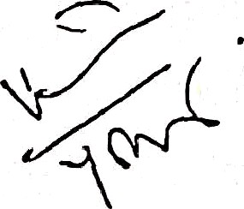

- (2) ÂÎtØ‹ meeting the Iíabiliti«, including

assets, if any. S It ȚÏOt be divided amo ng
thØ
the paid-ug 6hate capital. the surplus

anY object of public utiiÎtÿ determined
ftiember8, but
•*•!! be utilised toward

thre8 months of the dete Registrar lTløv with the
by th€Ï General of the fìnal liquidation
Meeting of the Society within and approved бy the Reelstrar

SUrg1us on
®Î8DfOVä[ Of the General bleating of ihe SOCi9ty, place the said
deposit with the Delhi Stzt• co-opärati

» Cİät'ÿ’ wİth BİMİlar conditions is regi
ve Bank Ltd.. until such time a new
si łd who With the consent of thø Registrar such

0UrP,lUș may be credited to.the Pese•ve FUn€l Of such new society or assign the surplus 
either vzholiÿ or in p• t to an object of public utility of local interest ”or a charitable
purpose as defined in section 2 of Charitable Endowments Act. 1890 (6 of 1990}.

AI\INUXURE
REGULATIONS RELATING THE HOUSESIF1*T6 LEASED OUT OUT BY GROUP HOUSlNa sociETY TO łTS MEMBERS

1. Residential houses will be allotted by the society to its member who fulfil the pres- cribed conditionsbayned a e bid




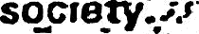


2.
The residential houses shall be allotted by the society to its members by draw of
.
.
‹. •..,-
- ..,:,.'..‹
3 " - tEach sub-leas-ee shall .be required to excută ap ağraement
Government as may be hound necessary beforețenterîng
t, house
wt}-z•”-1he
No sub-leasøø shall
at any’”time, quarry any -'F - ”
”
ctøne, dig ound
.. .° •'
Acwthich mav be harmful țo the building or źhe esiæt of the
5.
No sub-leaséa shall make ariy alteration in or addition? to house alJoted to him with- oUt the ağproval of the Committee in wrítting and subject to the Municipal bye-laws
6. Each sub- leasee hall be required to get ihø ,house insured against fire or damage
•nd sha!! be liable to annual premium regularly. If for any reason the sum leasee fails
to pay the premium in time, it shall be paid by the society, which “will be debited” to the account of the Sub-leaseø concørnșd and shall bø ’recovered from him in “ãccor-” “, dance with provisions of the Oelhi CooperøiivŚ Societies Ačt. 1972 as applicable to
-"the Union Territory” of Delhi. the rules made thereunder end the bye-laws of the
society.
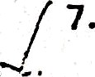
Each sub-leasae shall pay % t an n hi h ha ous h b n
- scg_rtucted, calculatedby the -Society and Approved . by ttiø General Meeting as
each sub-leasee shall y groundregt as a fixad by the General Meeting of

h e
a nce h
by(G veÏnment idditibn h n
ida

8. Each sub-leasae shall be responsible for the internal repairs of tha how-e alloted to h‹m. T e ut hie ashi and t er no e s s
Society.

