a

MINI PORJECt REPORT

ON

“Library management system”
FOR PARTIAL FULFILLMENT
OF THE REQUIREMENTS FOR THE
Database Managaement
oF T.E. E&TC – 2019 Course, SPPU, Pune

By
Pratik Mirajkar 32442
Sayika Pirjade 32453
Saee Shendge 32462

GUIDE
Prof. S. L. Dhende

Department Of
Electronics and TELECommunication ENGINEERING
PUNE INSTITUTE OF COMPUTER TECHNOLOGY
PUNE – 43

ACADEMIC YEAR: 2021 - 2022

Department of Electronics and Telecommunication Engineering
Pune Institute of Computer Technology, Pune – 43

CERTIFICATE

This is to certify that the Mini Project Report entitled
Library management system has been successfully completed by

Pratik Mirajkar 32442
Sayika Pirjade 32453
Saee Shendge 32462

Is a bona fide work carried out by them under the supervision of Prof. S. L. Dhende and it is approved for the partial fulfillment of the requirements for the Employability skills and Mini Project and Seminar Subject of T.E. E&TC – 2019 Course of the Savitribai Phule Pune University, Pune.

Prof.S.L.Dhende Dr. Sandeep Gaikwad
Project Guide HOD, E&TC Dept. of E&TC

Place: Pune
Date : 05/12/21

ACKNOWLEDGEMENT

It takes immense pleasure in completing and submitting the final project report.
I would like to express my gratitude to our respected, HOD Dr. Sandeep Gaikwad and PROF. S.L.Dhende my project guide for their continuous encouragement, valuable guidance and the help for completing the project work.

Last but not the least, I am thankful to all the college staff, friends for helping me directly or indirectly in my project.

Pratik Mirajkar 32442
Sayika Pirjade 32453
Saee Shendge 32462

ABSTRACT
Online Library Management System is a system which maintains the information about the books present in the library, their authors, the members of library to whom books are issued, library staff and all. This is very difficult to organize manually. Maintenance of all this information manually is a very complex task. Owing to the advancement of technology, organization of an Online Library becomes much simple. The Online Library Management has been designed to computerize and automate the operations performed over the information about the members, book issues and returns and all other operations. This computerization of library helps in many instances of its maintenances. It reduces the workload of management as most of the manual work done is reduced
Pratik Mirajkar 32442
Sayika Pirjade 32453
Saee Shendge 32462

CONTENTS

 | Abstract |  |  |  | i
 | List of Figures |  |  |  | ii
1 | Introduction |  |  |  | 1-10
 | 1.1 |  | Back ground and Context |  | 1
 | 1.2 |  | Relevance |  | 1
 | 1.3 |  | Literature Survey |  | 1-2
 | 1.4 |  | Motivation |  | 2
 | 1.5 |  | Aim of the Project |  | 2
 | 1.6 |  | Scope and Objectives |  | 2-3
 | 1.7 |  | Technical Approach |  | 3-5
2 | Functional Requirement |  |  |  | 6-8
 | 2.1 |  | Introduction |  | 6
 | 2.2 |  | Block Diagram |  | 6
 | 2.3 |  | Normal User |  | 7-8
3 | Connectivity and System Design |  |  |  | 9-12
 | 3.1 | Introduction
4 | Results and discussion
 |  |  |  | System Implementation | 13-18
 |  |  |  | Conclusion and future Scope | 18-19
 | References |  |  |  | 20

CHAPTER 1

Introduction

  - Background

Library Management system helps in maintaining data of books issued to learners and books available in the library. This helps librarians to spot any particular book at any given time in the library. The ERP for library management systems can be easily customized as per individuals’ requirements. It’s easy to use interface and immediate reporting makes things easier for the school library staff and It is also convenient for students of K12 and higher education. Unlike higher education schools needs more cautions and highly smart software to manage the library as school’s students are not that careful with the books. The best school library management system simplifies that for staff by keeping records of every log, payment details, book details, student information in a highly effective way.

  - Relevance

LMS (library Management System):
In this project we used MySQL and phpMyAdmin for the backend and designed the website using CSS (Cascading Style Sheet) and html (hypertext markup language). Also used the XAMMP server for connectivity and for the server process.
Library Management System is a computerized system which helps user(librarian) to manage the library daily activity in electronic format. It reduces the risk of paper work such as file lost, file damaged and time consuming. It can help user to manage the transaction or record more effectively and time saving.

  - Literature Survey

Early days Libraries are managed manually. It required lot of time to record or to retrieve the details. The employees who have to record the details must perform their job very carefully. Even a small mistake would create a lot of problems. Security of information is very less. Report generations of all the information is very tough task. ν Maintenance of Library catalogue and arrangement of the books to the catalogue is very complex task. In addition to its maintenance of member details, issue dates and return dates etc. manually is a complex task. ν All the operations must be performed in perfect manner for the maintenance of the library with out any degradation which may finally result in the failure of the entire system.

  - Motivation

This project is important where we can’t keep all the records manually so it’s quite easy to use this website and user friendly. Sometimes it’s LMS can’t have the books the user wants this is one of the limitations. We can use the direct messages to inform the particular user for the availability of the book or via email. Also we can add genres.

  - Aim of the Project

LMS (library Management System):
- Issue Date
- Return Date
- Number of books available
- Request A book
- Login and Sign-Up page (for new users)
- We can also change the password of our account
- We also have different account for admin who can see the book requests.

  - Scope and Objectives

To recognize the need for information. To access information from appropriate sources, develop skills in using information technologies, critically analyse and evaluate information, organize and process information, apply information for effective and creative decision making, understand and respect the ethical and legal aspects of information.
Librarian is able to search record by using few clicks of mouse and few search keywords thus saving his valuable time, After computerized system is implemented less human force will be required to maintain the library thus reducing the overall cost.

Technical Approach:

- PHP
PHP is a server-side scripting language designed for web development but also used as a general-purpose programming language. Originally created by Rasmus Lerdorf in 1994, the PHP reference implementation is now produced by The PHP Group. PHP originally stood for Personal Home Page, but it now stands for the recursive backronym PHP: Hypertext Preprocessor.
PHP code may be embedded into HTML code, or it can be used in combination with various web template systems, web content management system and web frameworks. PHP code is usually processed by a PHP interpreter implemented as a module in the web server or as a Common Gateway Interface (CGI) executable. The web server combines the results of the interpreted and executed PHP code, which may be any type of data, including images, with the generated web page. PHP code may also be executed with a command-line interface (CLI) and can be used to implement standalone graphical applications.
The standard PHP interpreter, powered by the Zend Engine, is free software released under the PHP License. PHP has been widely ported and can be deployed on most web servers on almost every operating system and platform, free of charge.
The PHP language evolved without a written formal specification or standard until 2014, leaving the canonical PHP interpreter as a de facto standard. Since 2014 work has gone on to create a formal PHP specification.
- MySQL
SQL stands for Structured Query Language. The MySQL development project has made its source code available under the terms of the GNU General Public License, as well as under a variety of proprietary agreements. MySQL was owned and sponsored by a single for-profit firm, the Swedish company MySQL AB, now owned by Oracle Corporation. For proprietary use, several paid editions are available, and offer additional functionality.
MySQL is a fast, easy-to-use RDBMS being used for many small and big businesses. MySQL is developed, marketed, and supported by MySQL AB, which is a Swedish company. MySQL is becoming so popular because of many good reasons:
MySQL is released under an open-source license. So you have nothing to pay to use it. MySQL is a very powerful program in its own right. It handles a large subset of the functionality of the most expensive and powerful database packages. MySQL uses a standard form of the well-known SQL data language. MySQL works on many operating systems and with many languages including PHP, PERL, C, C++, JAVA, etc. MySQL works very quickly and works well even with large data sets. MySQL is very friendly to PHP, the most appreciated language for web development. MySQL supports large databases, up to 50 million rows or more in a table. The default file size limit for a table is 4GB, but you can increase this (if your operating system can handle it) to a theoretical limit of 8 million terabytes (TB). MySQL is customizable. The open-source GPL license allows programmers to modify the MySQL software to fit their own specific environments.
- HTML
HyperText Markup Language, commonly abbreviated as HTML, is the standard markup language used to create web pages. Along with CSS, and JavaScript, HTML is a cornerstone technology used to create web pages, as well as to create user interfaces for mobile and web applications. Web browsers can read HTML files and render them into visible or audible web pages. HTML describes the structure of a website semantically and, before the advent of Cascading Style Sheets (CSS), included cues for the presentation or appearance of the document (web page), making it a markup language, rather than a programming language.
HTML elements form the building blocks of HTML pages. HTML allows images and other objects to be embedded and it can be used to create interactive forms. It provides a means to create structured documents by denoting structural semantics for text such as headings, paragraphs, lists, links, quotes and other items. HTML elements are delineated by tags, written using angle brackets. Tags such as <img /> and <input /> introduce content into the page directly. Others such as <p>...</p> surround and provide information about document text and may include other tags as sub-elements. Browsers do not display the HTML tags, but use them to interpret the content of the page.
HTML can embed scripts written in languages such as JavaScript which affect the behavior of HTML web pages. HTML markup can also refer the browser to Cascading Style Sheets (CSS) to define the look and layout of text and other material. The World Wide Web Consortium (W3C), maintainer of both the HTML and the CSS standards, has encouraged the use of CSS over explicit presentational HTML since 1997.

- APACHE HTTP SERVER (Used by installing XAMMP)
The Apache HTTP Server, colloquially called Apache. It is the world's most used web server software. Apache played a key role in the initial growth of the World Wide Web.
Apache is developed and maintained by an open community of developers under the auspices of the Apache Software Foundation. Most commonly used on a Unix-like system (usually Linux), the software is available for a wide variety of operating systems besides Unix, including eComStation, Microsoft Windows, NetWare, OpenVMS, OS/2, and TPF. Released under the Apache License, Apache is free and open-source software.
As of November 2015, Apache was estimated to serve 50% of all active websites and 37% of the top servers across all domains.

- XAMPP

XAMPP is free and open-source cross-platform web server solution.
It has stack package developed by Apache Friends, consisting mainly of the Apache HTTP server, MariaDB database and interpreters for scripts written in PHP and Pearl programming languages.
Since, most actual web server deployment use the same components as XAMPP, it makes transitioning from a local test server to live server possible.

CHAPTER 2

Functional Requirements

2.1 Introduction
A Library Management System (LMS) is a tool to help any libraries which are still using the old way to manage their library. The old way like searching for a book using manual work is hassle, fast report generation is not possible, information about issue/return of the books are not properly maintained, no central database can be created as information is not available in database. But by using the LMS, user can overcome all the problems mentioned above. This system can manage all the happenings of the library. Book transactions including book searching, availability of the book, details and appearance of the book, personal book borrowing history and etc. can be very easily handled by this system. This system is suitable for small to big libraries including medical and legal libraries, colleges, schools, universities, corporate houses and other academic resource centres. However, I would like to focus on LMS for colleges or universities.

  - Block diagram
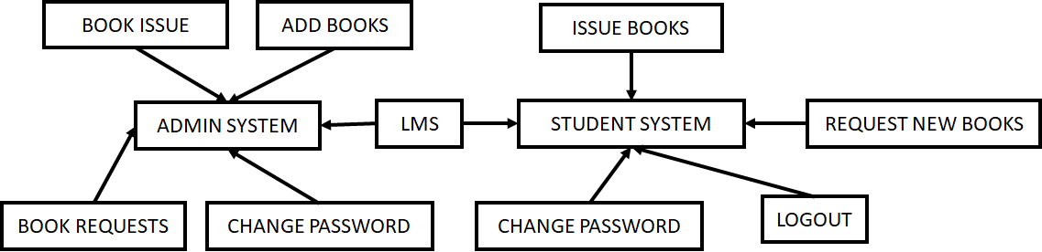
2.3 NORMAL USER
2.3.1 USER LOGIN:
Description of feature This feature used by the user to login into system. They are required to enter user id and password before they are allowed to enter the system. The user id and password will be verified and if invalid id is there user is allowed to not enter the system. Functional requirements -user id is provided when they register -The system must only allow user with valid id and password to enter the system -The system performs authorization process which decides what user level can access to. -The user must be able to logout after they finished using system.

2.3.2 REGISTER NEW USER:
This feature can be performed by all users to register new user to create account. Functional requirements -System must be able to verify information -System must be able to delete information if information is wrong

2.3.3 REGISTER NEW BOOK:
This feature allows to add new books to the library Functional requirements -System must be able to verify information -System must be able to enter number of copies into table. - System must be able to not allow two books having same book id.

2.3.4 SEARCH BOOK:
This feature is found in book maintenance part . we can search book based on book id, book name , publication or by author name.

2.3.5 ADMIN LOGIN:
We can use this feature to add books, also can see the book requests and issued books also we can add or delete student’s registration through localhost which we used phymyAdmin.

SOFTWARE REQUIREMENTS

- Operating system- Windows 7 is used as the operating system as it is stable and supports more features and is more user friendly
- Database MYSQL-MYSQL is used as database as it easy to maintain and retrieve records by simple queries which are in English language which are easy to understand and easy to write.
- Development tools and Programming language- HTML is used to write the whole code and develop webpages with css, java script for styling work and php for sever side scripting

CHAPTER 3
Connectivity and System Design
3.1 Introduction:
In this section we are briefing about connectivity and the system Design. How we used PHP amd MySQL for backend with server (XAMMP).
3.1.1
Database Connectivity:
Database is a popular technology used widely in the business world and their importance, popularity and success have already grown. However, in spite of the extensive development that took place in the world of databases, one area has not been fully researched upon. We are talking about the connection of middleware or user-interface with the back-end database of the application. Some technologies are present that connect the user interface with the database at the backend. Some systems are basically front-end combined with levels of middleware and database back-ends. Along with that, there are multi-tier models that allow mix and match of various technologies according to their system goals. One critical aspect of the mechanism for connecting the middleware to the database backend is the design of the system. We will discuss several popular approaches to database connectivity available through an application-programming interface (API) in this blog. We will understand the issue of database connectivity and compare the technologies and methodologies available. The blog will follow an easy approach and the ultimate goal is to make the user understand the connectivity methods available and hence make a knowledgeable and informed decision, next time you work on an application
as a developer and especially implementing a database solution. While discussing database connectivity, we will also explore the most common data access technologies while offering a case study of major database vendors like Oracle and Java. This will demonstrate how a database vendor complies, implements and supports data access standards.

System Design:
XAMPP Server:
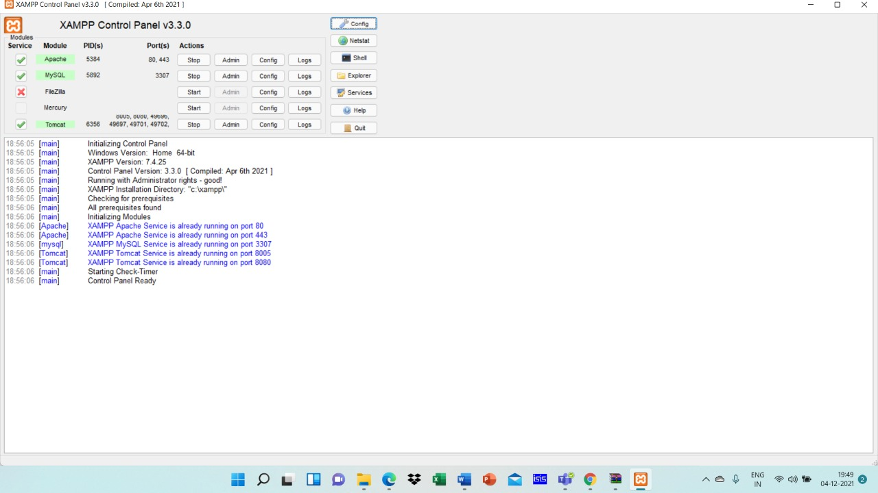

PhpMyAdmin:

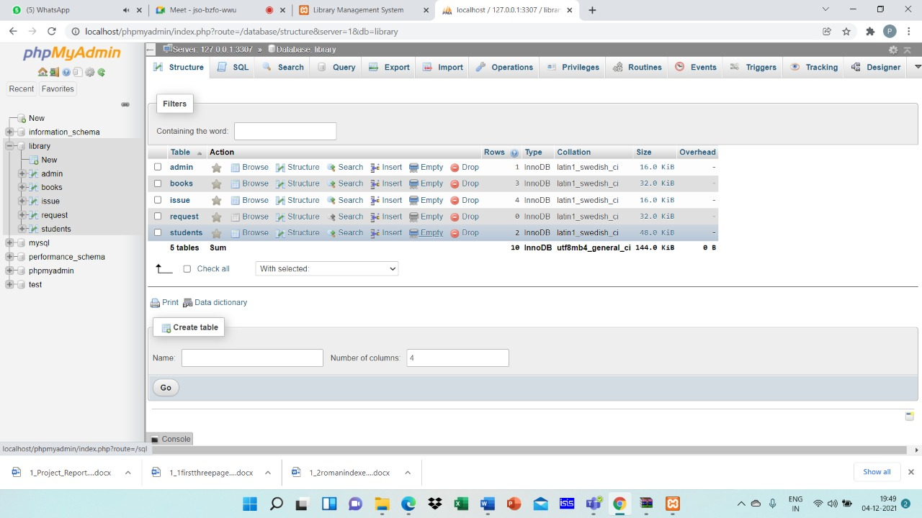
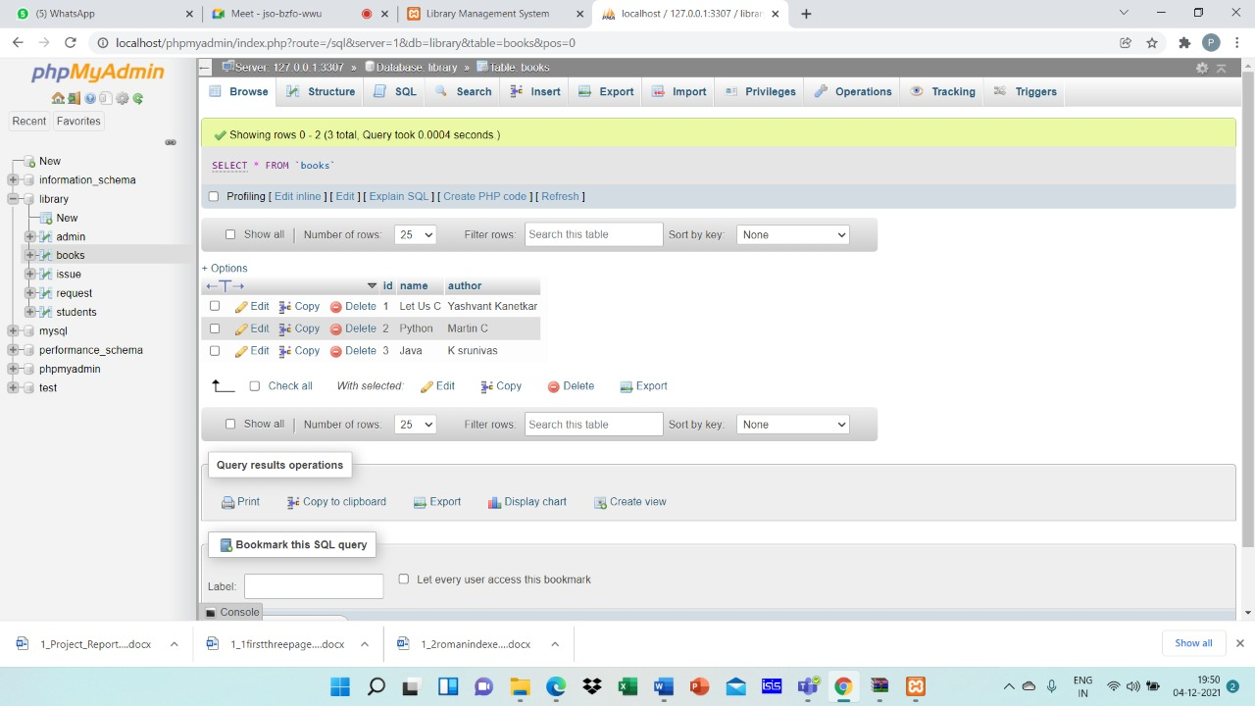

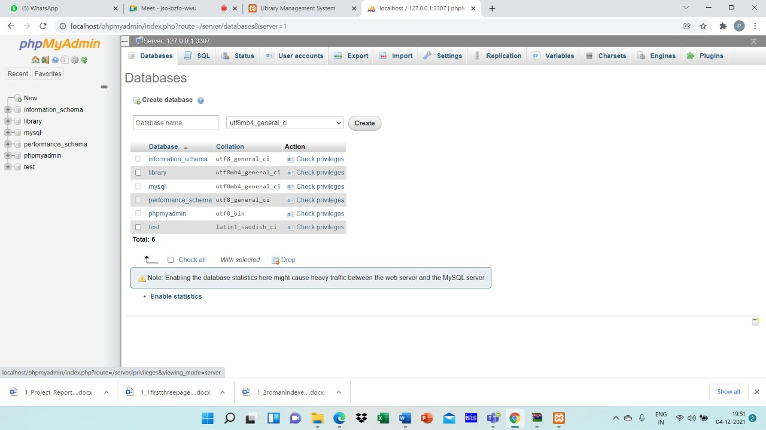

Same tables in MySQL Line-Client:
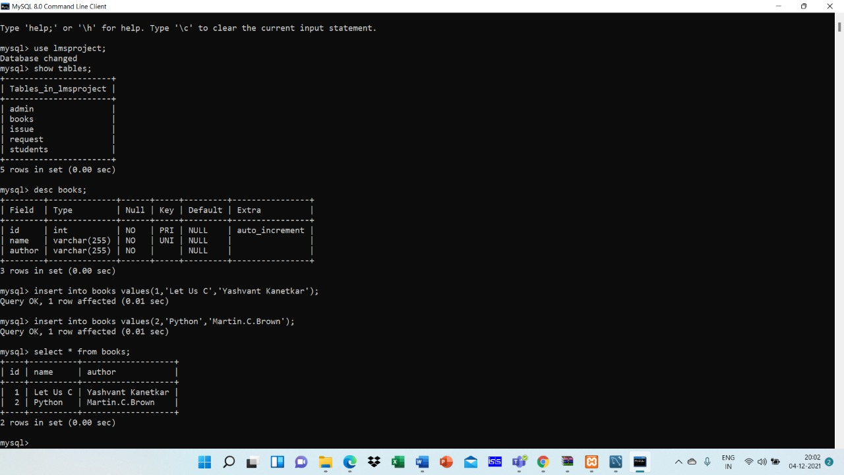

CHAPTER 4

Results and Discussion

System Implementation:
Sign -in Page:
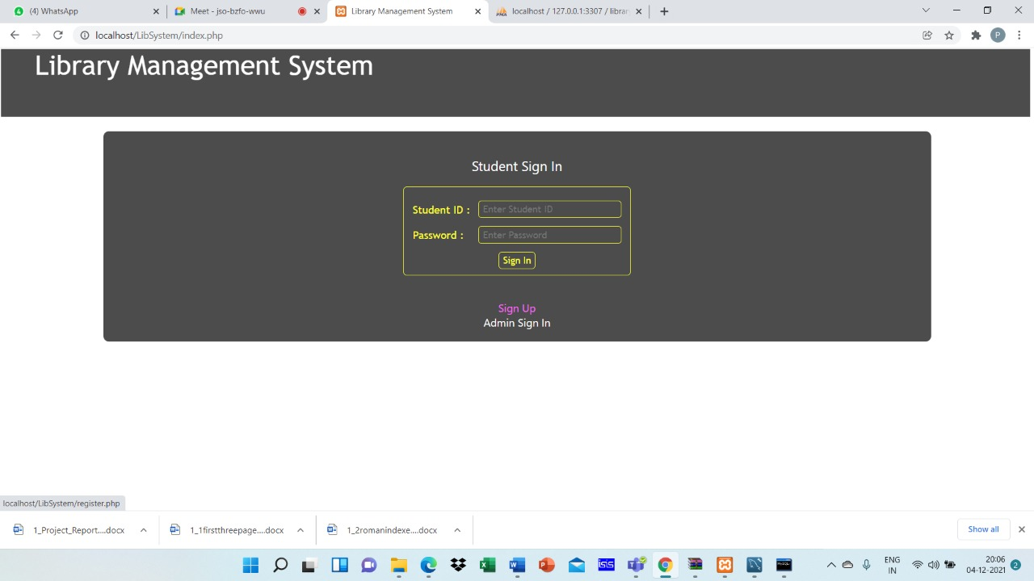
Sign- Up Page:
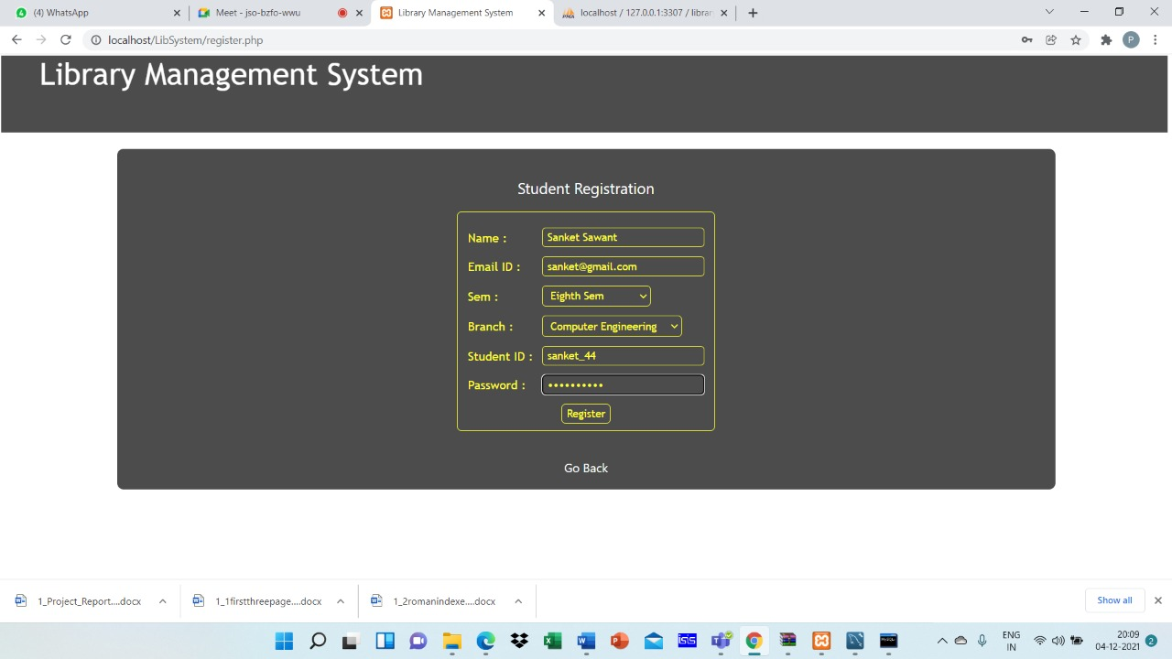
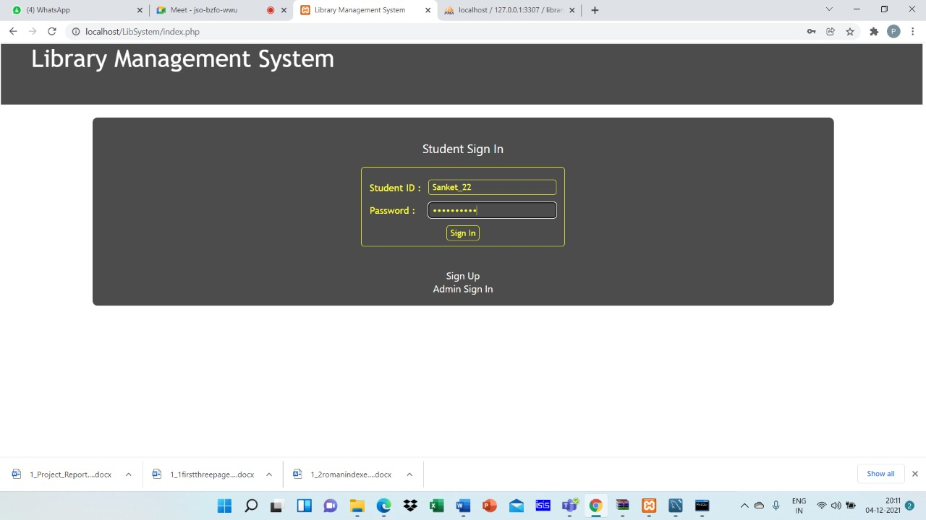
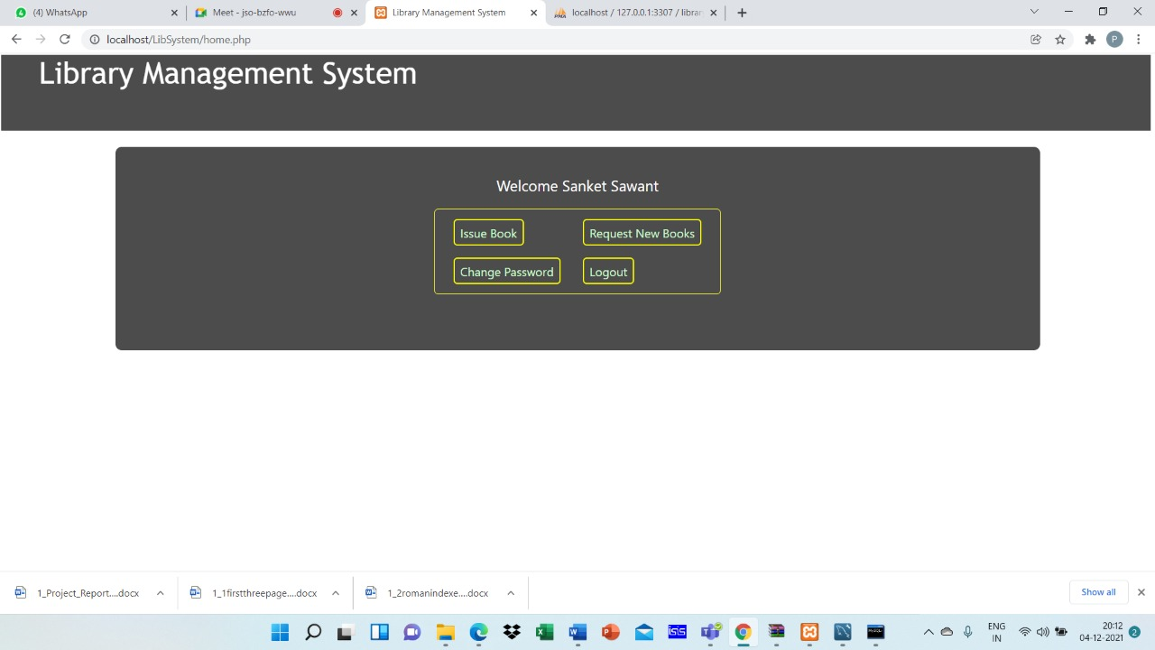
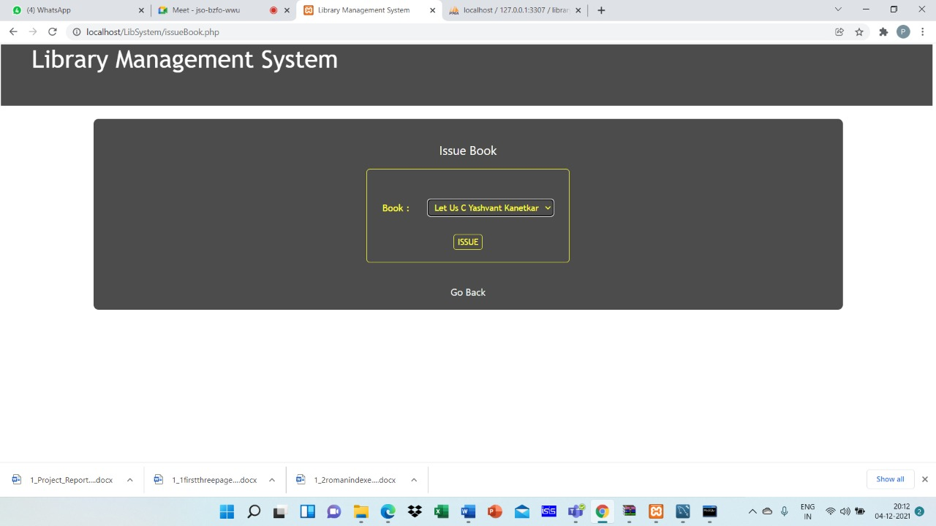

Request For Unavailable Book:

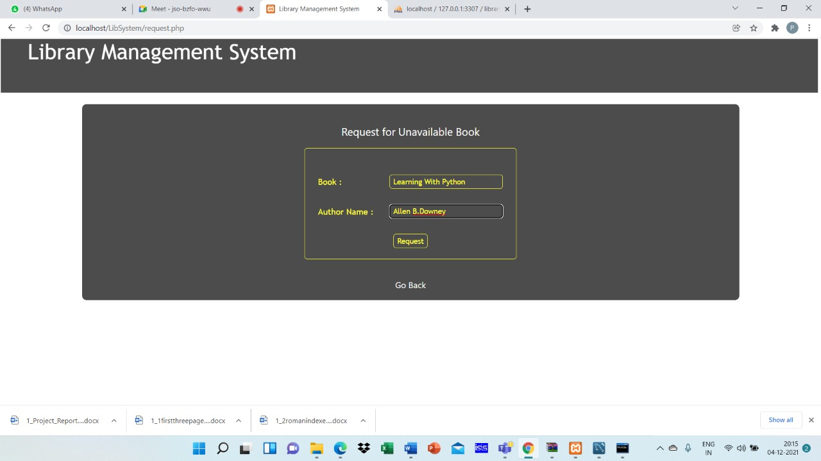

Admin Sign-In:
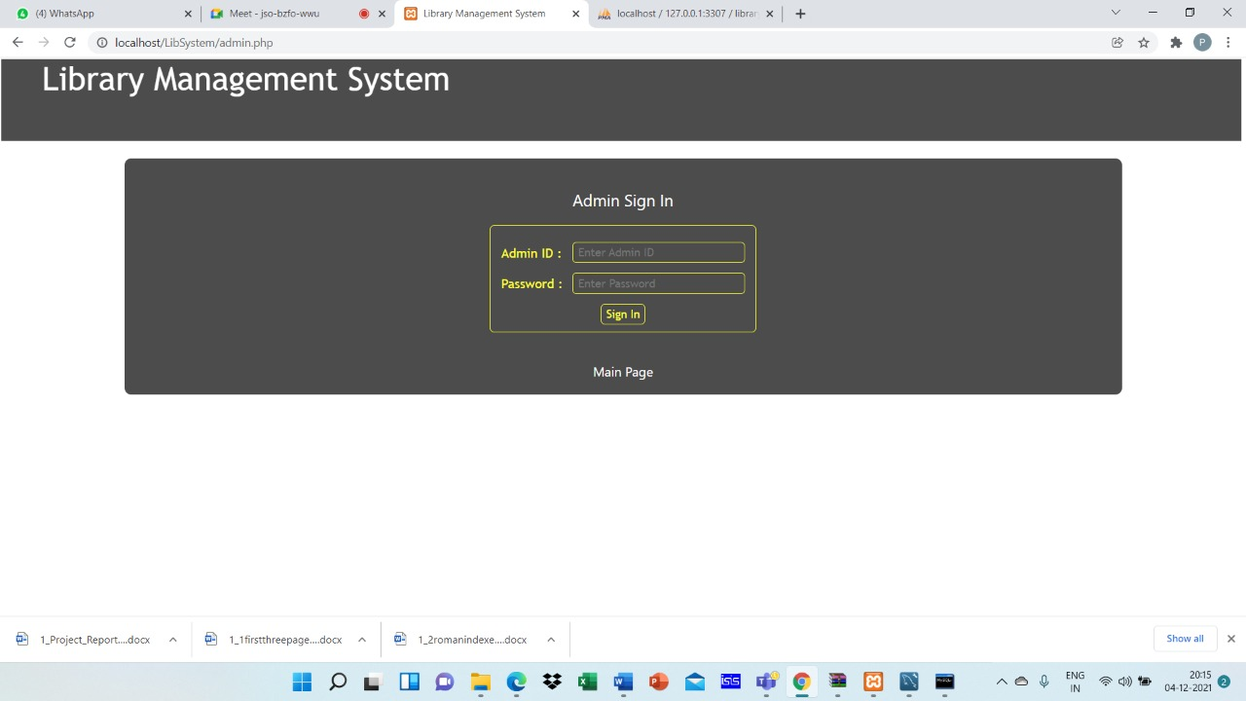

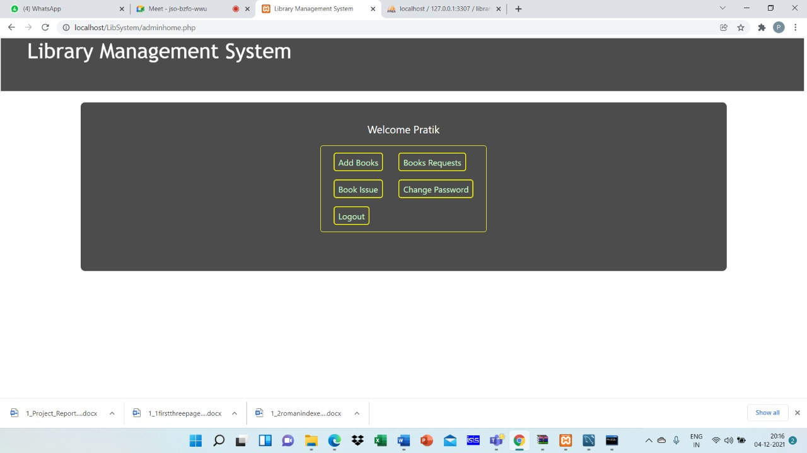
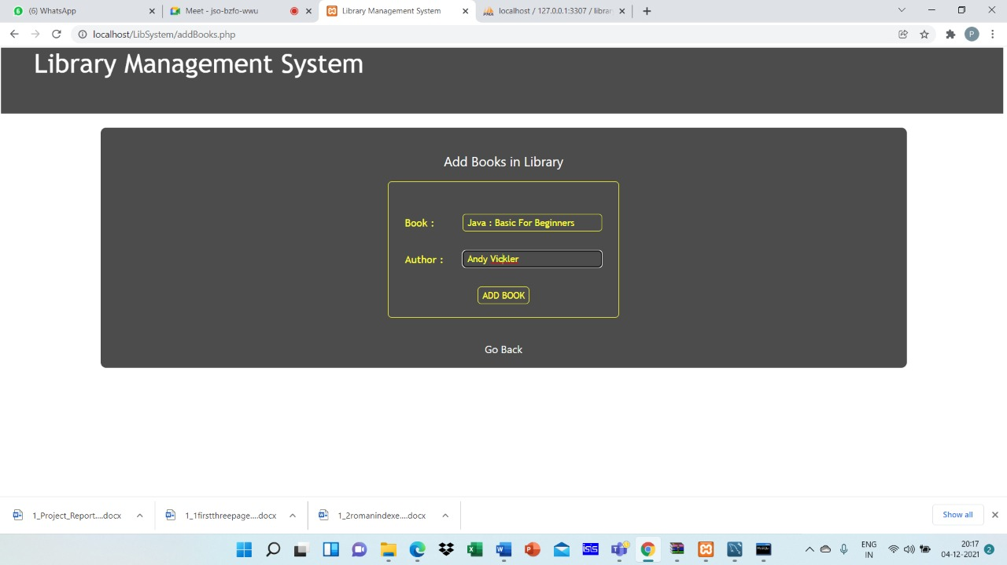

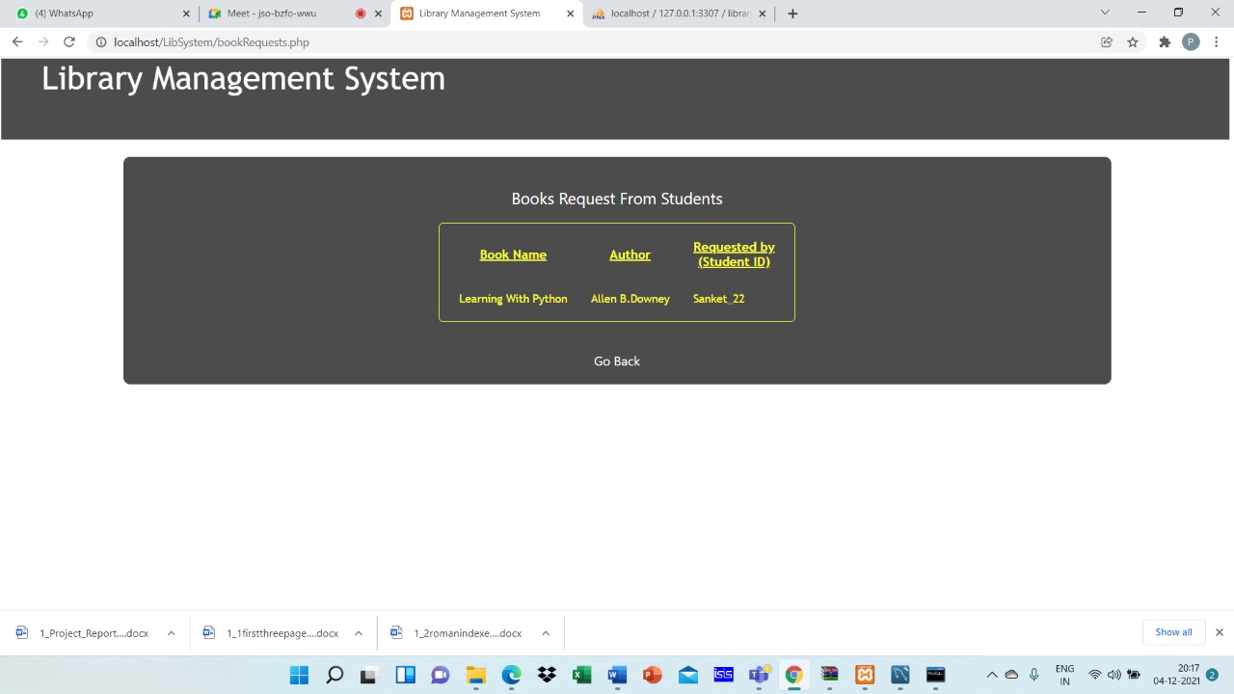
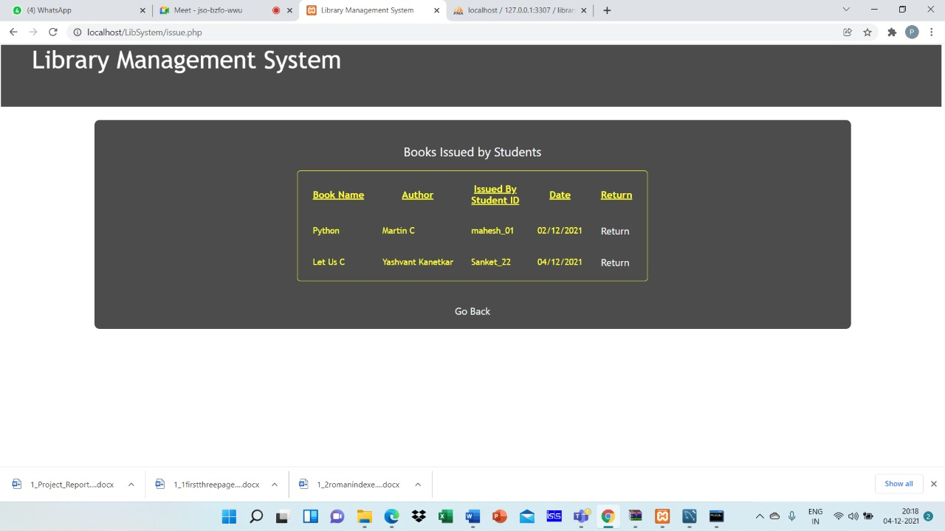
Features:
Features of Library Manager Software:
- It can keep complete records of a document; it can be a book, registers, files of any type etc.
- Existing records can be edited only by an authorized person.
- Authorized person/administrator has to change the password at any time to prevent people who want to hack the password.
- New members can only be registered by the library administrator or authorized person.
- Member’s ID and Password can be included and may be verified at the time of issuing any document.
- The software can give the following information at finger tips:
- Issue/return records of any document
- Issue/return records of a member
- Details of all documents issued from the library on date

Conclusions

This website provides a computerized version of library management system which will benefit the students as well as the staff of the library. It makes entire process online where student can search books, staff can generate reports and do book transactions. It also has a facility for student login where student can login and can see status of books issued as well request for book or give some suggestions. It has a facility of teacher’s login where teachers can add lectures notes and also give necessary suggestion to library and also add info about workshops or events happening in our college or nearby college in the online notice board.

Future Scope

There is a future scope of this facility that many more features such as online lectures video tutorials can be added by teachers as well as online assignments submission facility , a feature Of group chat where students can discuss various issues of engineering can be added to this project thus making it more interactive more user friendly and project which fulfills each users need in the best way possible.

References

- http://www.w3schools.com/html/html_intro.asp
- www.wikipedia.com

