**WIA- Presentation**

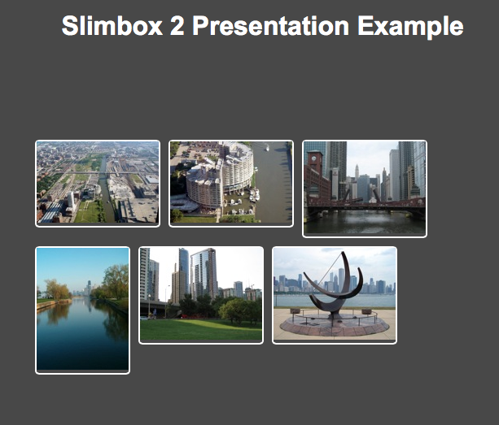

I created an image gallery using the jquery plugin slimbox 2. I decided to create this gallery because it is something I I’ve wanted to learn now to do for some years now. This knowledge will give me a much better understanding of many of the image plugins that I’ve used while building websites using Wordpress.

This slimbox 2 plugin is one of the best image gallery plugins to use because it is light, easy to use and it also has an API that, you can use to expand it if needed. There are a lot of possibilities with this plugin and it has been one of my favorites for a long time.