Dataset:-

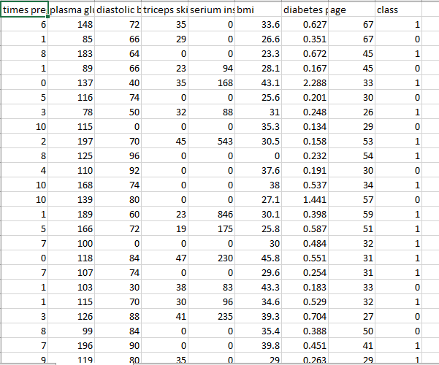

Code:--

import pandas as pd

import numpy as np

from sklearn.naive_bayes import BernoulliNB

#import seaborn as sns

#import matplotlib.pyplot as plt

#% matplotlib inline

data=pd.read_csv("DiabetesData.csv")

print(data.head(10))

print("# no of passenger in the data set:", +(len(data)))

##Analysis data

#sns.countplot(x="diastolic bp",data=data)

#sns.countplot(x="diastolic bp",hue="age", data=data)

#plt.show()

# sns.countplot(x="loans",hue="homeowner",data=bank_data)

# plt.show()

#data["age"].plot.hist()

#plt.show()

#

## TRAIN MY DATASET

x=data.drop("class",axis=1)

y=data["class"]

from sklearn.model_selection import train_test_split

x_train,x_test,y_train,y_test=train_test_split(x,y,test_size=0.2,random_state=1)

from sklearn.linear_model import LogisticRegression

logmodel=LogisticRegression()

print(logmodel.fit(x_train,y_train))

predictions=logmodel.predict(x_test)

from sklearn.metrics import classification_report

print(classification_report(y_test,predictions)) #generate classification report

##generate accrucy

from sklearn.metrics import confusion_matrix

print(confusion_matrix(y_test,predictions))

from sklearn.metrics import accuracy_score

print( "The Accuracy of the Logistic Regression prediction is: ",accuracy_score(y_test,predictions))

x_train, x_test, y_train, y_test = train_test_split(x, y, test_size=0.2, random_state=1)

from sklearn.tree import DecisionTreeClassifier

classifier = DecisionTreeClassifier()

classifier.fit(x_train, y_train)

y_pred = classifier.predict(x_test)

from sklearn.metrics import classification_report, confusion_matrix

print(confusion_matrix(y_test, y_pred))

print(classification_report(y_test, y_pred))

from sklearn.metrics import accuracy_score

print("\n======================================================================================")

print( "The Accuracy of the prediction using Decision Tree is: ", accuracy_score(y_test, y_pred))

x_train, x_test, y_train, y_test = train_test_split(x, y, test_size=0.35,random_state=1)

BernNB = BernoulliNB(binarize= 0.1)

BernNB.fit(x_train,y_train)

print(BernNB)

y_expt = y_test

y_pred = BernNB.predict(x_test)

print("\n======================================================================================")

print("The Accuracy using Naive Bayes is: ",accuracy_score(y_expt, y_pred))

OutPut:-

