Custom Tensorflow layers

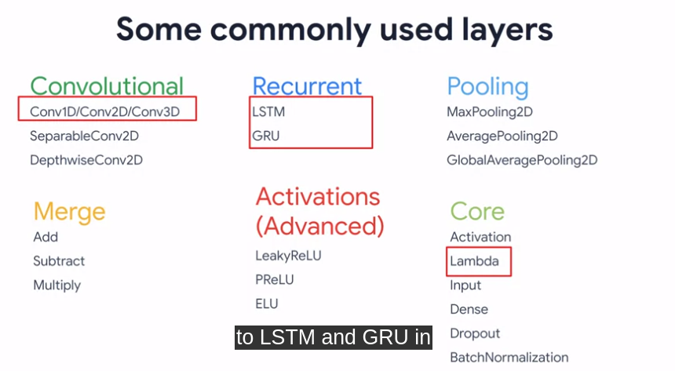

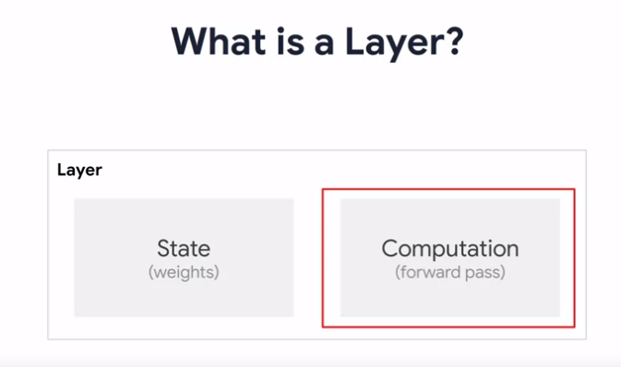

A layer is a class that collects parameters that are encapsulate state and computation to achieve the layers purpose in a neural network. Whether use Sequential or Function API, every model architecture design item is a layer.

The state can be considered as a variable, something that makes a particular instance of a layer unique. These variables can be trainable where during model.fit, tensorflow can tweek their values to test for better performance or they can be non-trainable, where they might be used for some other feature.

Computation is a meaning of transforming a batch of inputs into a batch of outputs, it’s typically called the forward pass in neural networks, where a calculation is made and then pass to the next layer.

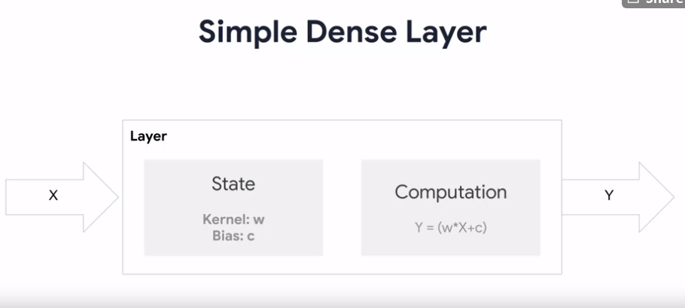

Take the simple dense layer as an example, the state includes weights and bias

