**Marsh Detection/Mapping Method**

**Study area:** Virginia coastal areas

**Data acquisition:**

**Images**

* Sentinel-2 MSI: 2015 – present (all year round should be included for classification)
* Resolution: 10 m (RGB/NIR), 20 m (5,6,7,8A band: designed for vegetation characterization, SWIR 11&12 band: evaluating vegetation moisture stress), 60m (1, 9, 10: atmospheric correction and cloud screen).
* How to get data?
  + Python code retrieve the raw data from santinelsat
  + Google earth engine to retrieve the images from study area

**Areas:**

* **National estuarine research reserve system**: <https://cdmo.baruch.sc.edu/get/gis_index.cfm>

**Labels**

* **Virginia shoreline inventory:**
  + Presence of marshes
  + Marshes types and high/low distribution
* National wetland inventory (NWI): <https://www.fws.gov/program/national-wetlands-inventory/wetlands-data>
  + Virginia NWI Data downloaded from NWI website on 06/21/2022, saved in the raw data folder. This dataset includes the polygons of wetland types in the entire Virginia, not just coastal areas, so a spatial file that represents the coastal Virginia is needed to create the study area. The NWI wetland types include the below categories. (The marsh detection paper in SC uses the areas marked as estuarine and marine wetland as study area to map)

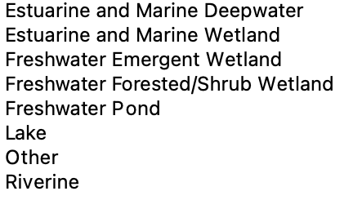

* Chesapeake land cover data type:
  + 1-meter resolution landcover type includes 13 classes derived from NAIP (?)
  + Hydro, impervious (extracted), impervious (local dataset), barron, **forest**, tree, scrub/shrub, harvested, turfgrass, pasture, cropland**, woody wetland and emergent wetland.**
* NOAA Coastal Change Analysis Program (C-CAP): Starting 1996 and updated every 5 years, lack of marsh details and remain high uncertainties: <https://coast.noaa.gov/digitalcoast/data/>
  + <https://www.fisheries.noaa.gov/inport/item/48336>
* Collaborating with local agencies and universities, NOAA National Estuarine Research Reserve Systems (NERR) have been providing long-term monitoring with detailed information concerning coastal habitat conditions over the 26 designated estuaries on the U.S. coasts.
* **Virginia shoreline inventory (VSI):** marsh boundaries with the type of marshes
* National landcover database (NLCD): 2016 was downloaded
* Virginia landcover dataset: <https://vgin.vdem.virginia.gov/apps/virginia-land-cover-dataset/explore>
  + <https://gismaps.vdem.virginia.gov/Download/Land_Cover/> Parent folder
  + <https://gismaps.vdem.virginia.gov/Download/Land_Cover/Bay_Area_1/>
  + <https://gismaps.vdem.virginia.gov/Download/Land_Cover/Bay_Area_2/>
  + <https://gismaps.vdem.virginia.gov/Download/Land_Cover/Bay_Area_3/>
  + The Wetlands is from NWI (National Wetland Inventory)

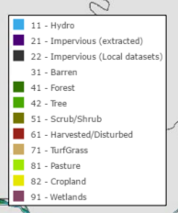

Understand the different types of marshes that coded in this database, and differentiate into high marsh and low marsh.

**DATA PROCESSING**

Label processing:

* TMI_2011_2019.shp received on March, 2022 was used to create the label layer.
* Marshes size 500>square meters, and all marsh types are included.

Image processing:

* 2017 sentinel imagery that covers the TMI areas are downloaded, with cloud less than 10% between June 01, 2017 – Sep 30, 2017. Each band was mosaic into separate .tiff.
* For each polygon in the filtered marsh polygons, get the centroid point of the polygon, and extract a 512X512 image patch.