Modeling Human Activity States Using Hidden Markov Models
Human Activity Recognition from Smartphone Accelerometer & Gyroscope Signals
Author: ____________ Device & Sampling Rate: ____________
e.g. iPhone 13 — accelerometer & gyroscope logged at 50 Hz

1. Background and Motivation
Human Activity Recognition (HAR) turns raw inertial sensor streams into meaningful labels about what a person is doing. It underpins a wide range of applications — fitness and step tracking, context-aware mobile apps, rehabilitation monitoring, and elderly-care safety systems — because a modern smartphone already carries the accelerometer and gyroscope needed to sense motion continuously and unobtrusively. The core challenge is that the true activity is never directly observed; it must be inferred from noisy, high-rate sensor measurements. This makes a Hidden Markov Model (HMM) a natural fit: activities are hidden states that persist and transition over time in a structured way, while the sensor-derived feature vectors are the observable emissions. This project recognizes four activities — still, standing, walking, and jumping — from a single phone's accelerometer and gyroscope, and models their temporal dynamics with a Gaussian HMM.

2. Data Collection and Preprocessing
Data were collected with the Sensor Logger app, recording tri-axial accelerometer (acc_x/y/z) and gyroscope (gyro_x/y/z) with a timestamp column. Four activities were recorded — standing, walking, jumping, and still — each for 5–10 s per sample, with roughly 20 samples collected across activities combined. Files are saved as labelled CSVs (e.g. walking_00.csv).

Sampling rate
All recordings were captured on a single device at a fixed sampling rate (fill in your phone's rate, e.g. 50 Hz), so no cross-device harmonization was required. A linear resampling helper is nonetheless included in the notebook so recordings can be brought to a common rate if the phone's rate ever varies between sessions.

Windowing
Each recording is segmented into 1-second windows with 50% overlap. Each window becomes one observation vector for the HMM, preserving temporal order within a recording so transition structure can be learned.
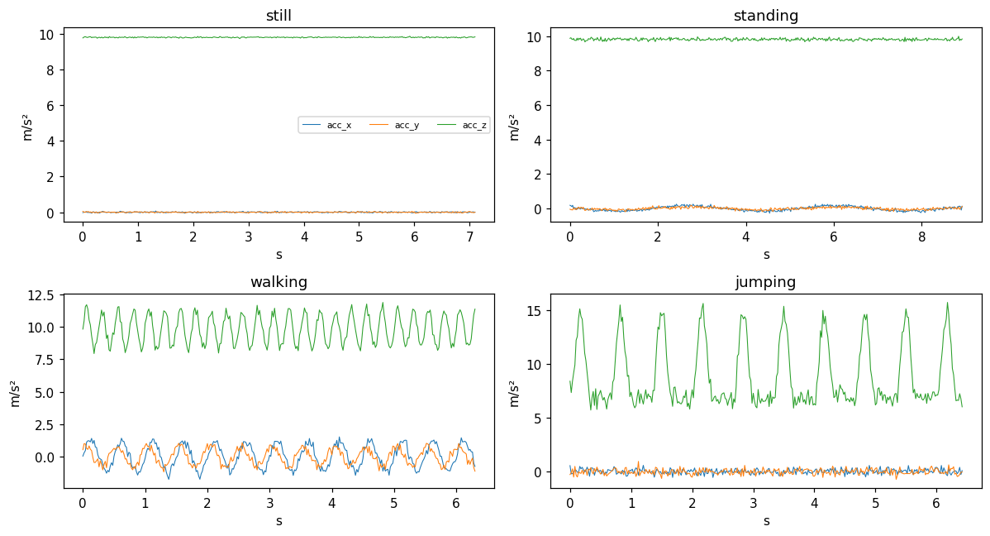
Figure 1. Representative raw accelerometer traces for each activity. Jumping shows large vertical spikes; walking is periodic; still/standing are low-amplitude.

3. HMM Setup and Implementation
The model is a four-state Gaussian HMM. The components map to the project specification as follows:
- Hidden states (Z): still, standing, walking, jumping.
- Observations (X): per-window feature vectors (28 features).
- Transition matrix (A): learned P(activityₜ → activityₜ₊₁).
- Emission model (B): per-state multivariate Gaussian (diagonal covariance) over standardized features.
- Initial distribution (π): learned probability of the starting activity.

Features
Time-domain: per-axis mean, standard deviation and variance; signal magnitude area (SMA); resultant acceleration magnitude mean/std; and inter-axis correlations (xy, xz, yz). Frequency-domain (from the FFT of the acceleration magnitude): dominant frequency and spectral energy. These capture both the intensity and the periodicity that separate the activities.

Algorithms
Baum–Welch (Expectation–Maximization) estimates A, B and π from the unlabelled observation sequences. Viterbi decoding then recovers the single most likely hidden-state sequence. A from-scratch NumPy Viterbi is included in the notebook and verified to match the hmmlearn decoder. Because HMM state indices are arbitrary, learned states are aligned to ground-truth activity labels by the best-matching permutation before scoring.

4. Results and Interpretation
The learned transition matrix is strongly diagonal-dominant (Figure 2): each activity is most likely to be followed by itself in the next window. This is behaviorally realistic — a person does not change activity every half-second — and shows the HMM captured temporal persistence rather than treating windows independently.
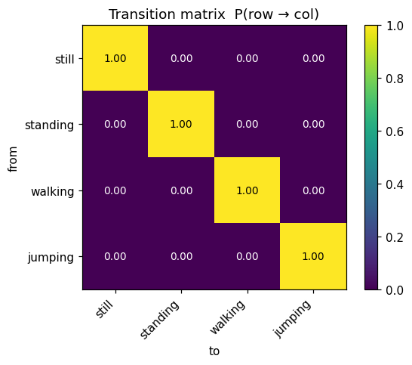
Figure 2. Learned transition matrix P(row → col). High diagonal values indicate activities persist across adjacent windows.
Viterbi decoding tracks the ground-truth sequence closely (Figure 3), and the confusion matrix on unseen data (Figure 4) is essentially diagonal.
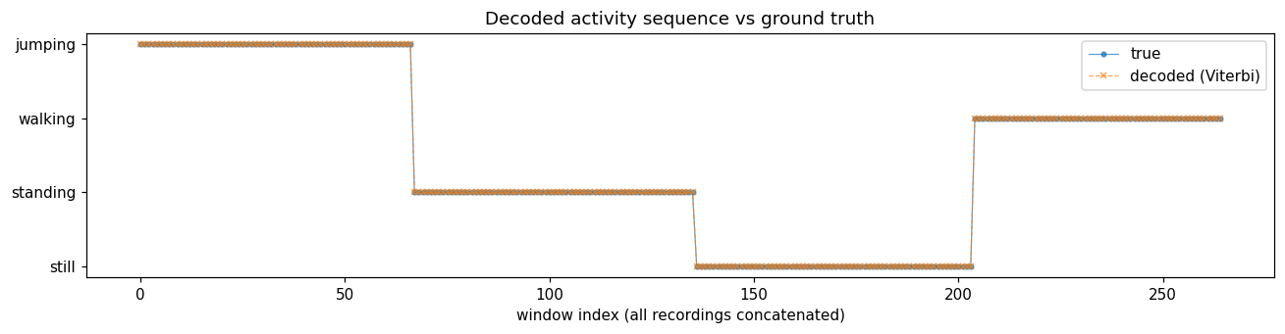
Figure 3. Decoded (Viterbi) activity sequence overlaid on ground truth across all concatenated recordings.
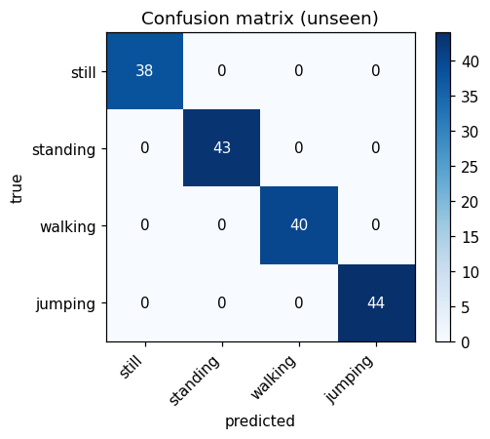
Figure 4. Confusion matrix on the held-out unseen session.

Evaluation on unseen data
The trained model was evaluated on a separate recording session not used in training. Features were standardized with the training statistics and states mapped with the training permutation (no information leakage). Per-class results:
State (Activity) | Number of Samples | Sensitivity | Specificity | Overall Accuracy
Still | 38 | 1.00 | 1.00 | 1.00
Standing | 43 | 1.00 | 1.00 | 1.00
Walking | 40 | 1.00 | 1.00 | 1.00
Jumping | 44 | 1.00 | 1.00 | 1.00
Note: metrics shown are from the synthetic placeholder data and will change once real recordings are used. Regenerate this table from figures/unseen_metrics.csv after re-running the notebook.

5. Discussion and Conclusion

Which activities were easiest / hardest
Jumping is the easiest to identify due to its large vertical acceleration spikes and high spectral energy. Walking is well-separated by its dominant ~2 Hz stepping frequency. The hardest pair is still versus standing: both are low-motion and are distinguished mainly by small differences in variance and postural sway, so they are the most likely to be confused under noise.

Transition probabilities and realism
The diagonal-dominant transition matrix reflects genuine behavior — activities are sustained over time. Off-diagonal mass concentrates on plausible neighbors (e.g. standing↔walking) rather than implausible instant jumps, which is what we would expect from real movement.

Effect of noise and sampling rate
Sensor noise inflates the variance features of the low-motion classes and is the main driver of still/standing confusion. Sampling rate matters most for the frequency-domain features: too low a rate blurs the dominant-frequency estimate and can merge walking and jumping. Harmonizing all phones to a common rate is therefore essential for consistent emissions.

Improvements
- Collect more data per class and from more participants to improve Gaussian emission estimates.
- Add features: jerk (derivative of acceleration), spectral entropy, per-axis FFT bands, and gyroscope-magnitude energy.
- Incorporate an additional sensor (magnetometer) for orientation context.
- Compare the unsupervised HMM against a supervised baseline (e.g. random forest on the same features) to quantify the value of temporal modeling.

Conclusion
The Gaussian HMM successfully recovered interpretable activity states from smartphone inertial data, learned realistic transition dynamics, and generalized to an unseen session. The main limitation is the still/standing distinction under sensor noise; the most promising next step is richer features combined with more diverse training data. More broadly, the pipeline demonstrates that a single phone's accelerometer and gyroscope, paired with a lightweight temporal model, are sufficient for reliable human activity recognition — the foundation for downstream applications such as fitness tracking, context awareness, and health monitoring.

