Photo Essay — Introduction to Photography
Poverty Trap
Five photographs on how people fall, and stay, in poverty — with notes on craft
HUM2112: Introduction to Photography — University of Liberal Arts Bangladesh
Md. Miraz Hossain (233012010) — all photographs by the author, December 2024

About this essay
This is the final project for Introduction to Photography: five photographs made to the assigned theme “Poverty Trap,” each shot manually and explained on its technique and intention. The photographs and the technical notes are my own work from the original submission, lightly edited for the portfolio. I have added a short curator’s introduction below.
A word on the theme. The brief asked for images of the “poverty trap,” and the captions name a single trigger for each frame — debt, low-wage work, addiction, family size, child labour. I would now read these less as causes I am diagnosing and more as fragments of a condition I was trying to photograph honestly: the texture of precarity in Dhaka, caught in a card reader, a tea tray, a child’s face over a food stall at night. The interest, for me, is less in the sociological label than in whether the light and the frame tell the truth about the moment.

On shooting the series
Four of these five frames were made in low light, and that was the technical thread that ran through the project. Poverty in a city is mostly photographed in daylight; I was drawn to the dim interiors and night streets where a lot of the actual economy of getting by happens — the late shift, the after-hours drink, the food cart lit by a single bulb. Working dark forced a consistent set of choices: a wide aperture held near f/1.4 to gather light and throw the background out of focus, a high ISO when the shutter could not drop any further, and a lot of the mood recovered afterwards in the edit. The one daylight frame, the family outside their dwelling, is deliberately the odd one out — the only photograph that pulls back to show an environment rather than isolating a subject.
One choice I want to flag, because it matters more than the exposure settings. In the first frame, of a contactless card payment, I shot the angle so that only the Visa logo showed, and then in editing I deliberately reduced the texture on the card to obscure its details “to make it invisible even when zoomed in.” That instinct — protecting an identifiable person’s private financial data even in a class exercise — is the same reflex I bring to journalism, and it is the part of this project I am most pleased with. Craft and ethics are not separate skills.

PLATE 1 Credit card debt and the cycle that does not end
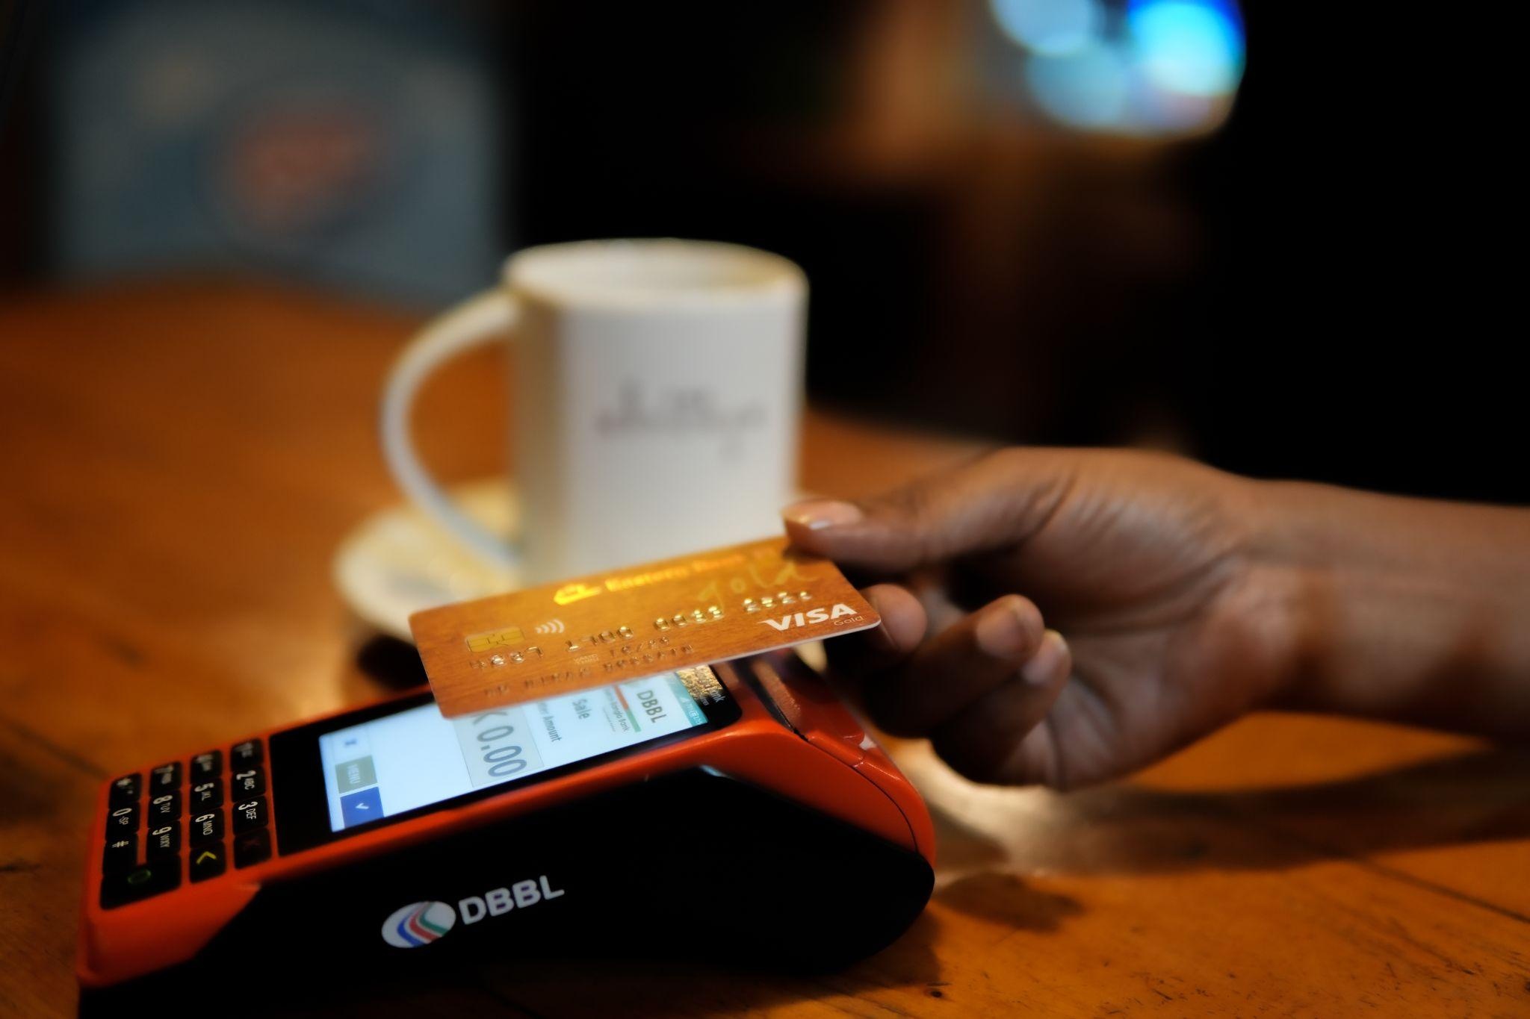
f/1.4 · ISO 1600 · 1/125 · soft indoor fill light
Technique. Shot at f/1.4, ISO 1600, 1/125, with a shallow depth of field to blur the background and a white element (a coffee mug) behind the card to push contrast. Composed on the rule of thirds, balanced rather than tight. In the edit I deepened the shadows fully and pulled texture down to roughly minus forty.
Intention. In a dim setting the wide aperture and high ISO maximised available light while the moderate shutter held steady, since there was little movement. The shallow depth of field puts all the attention on the moment of payment. I framed so that only the “Visa” mark was legible, hiding personal details, and in post I reduced shadows and texture specifically to obscure the card number so it stays unreadable even at full zoom.

PLATE 2 Part-time work that holds growth back
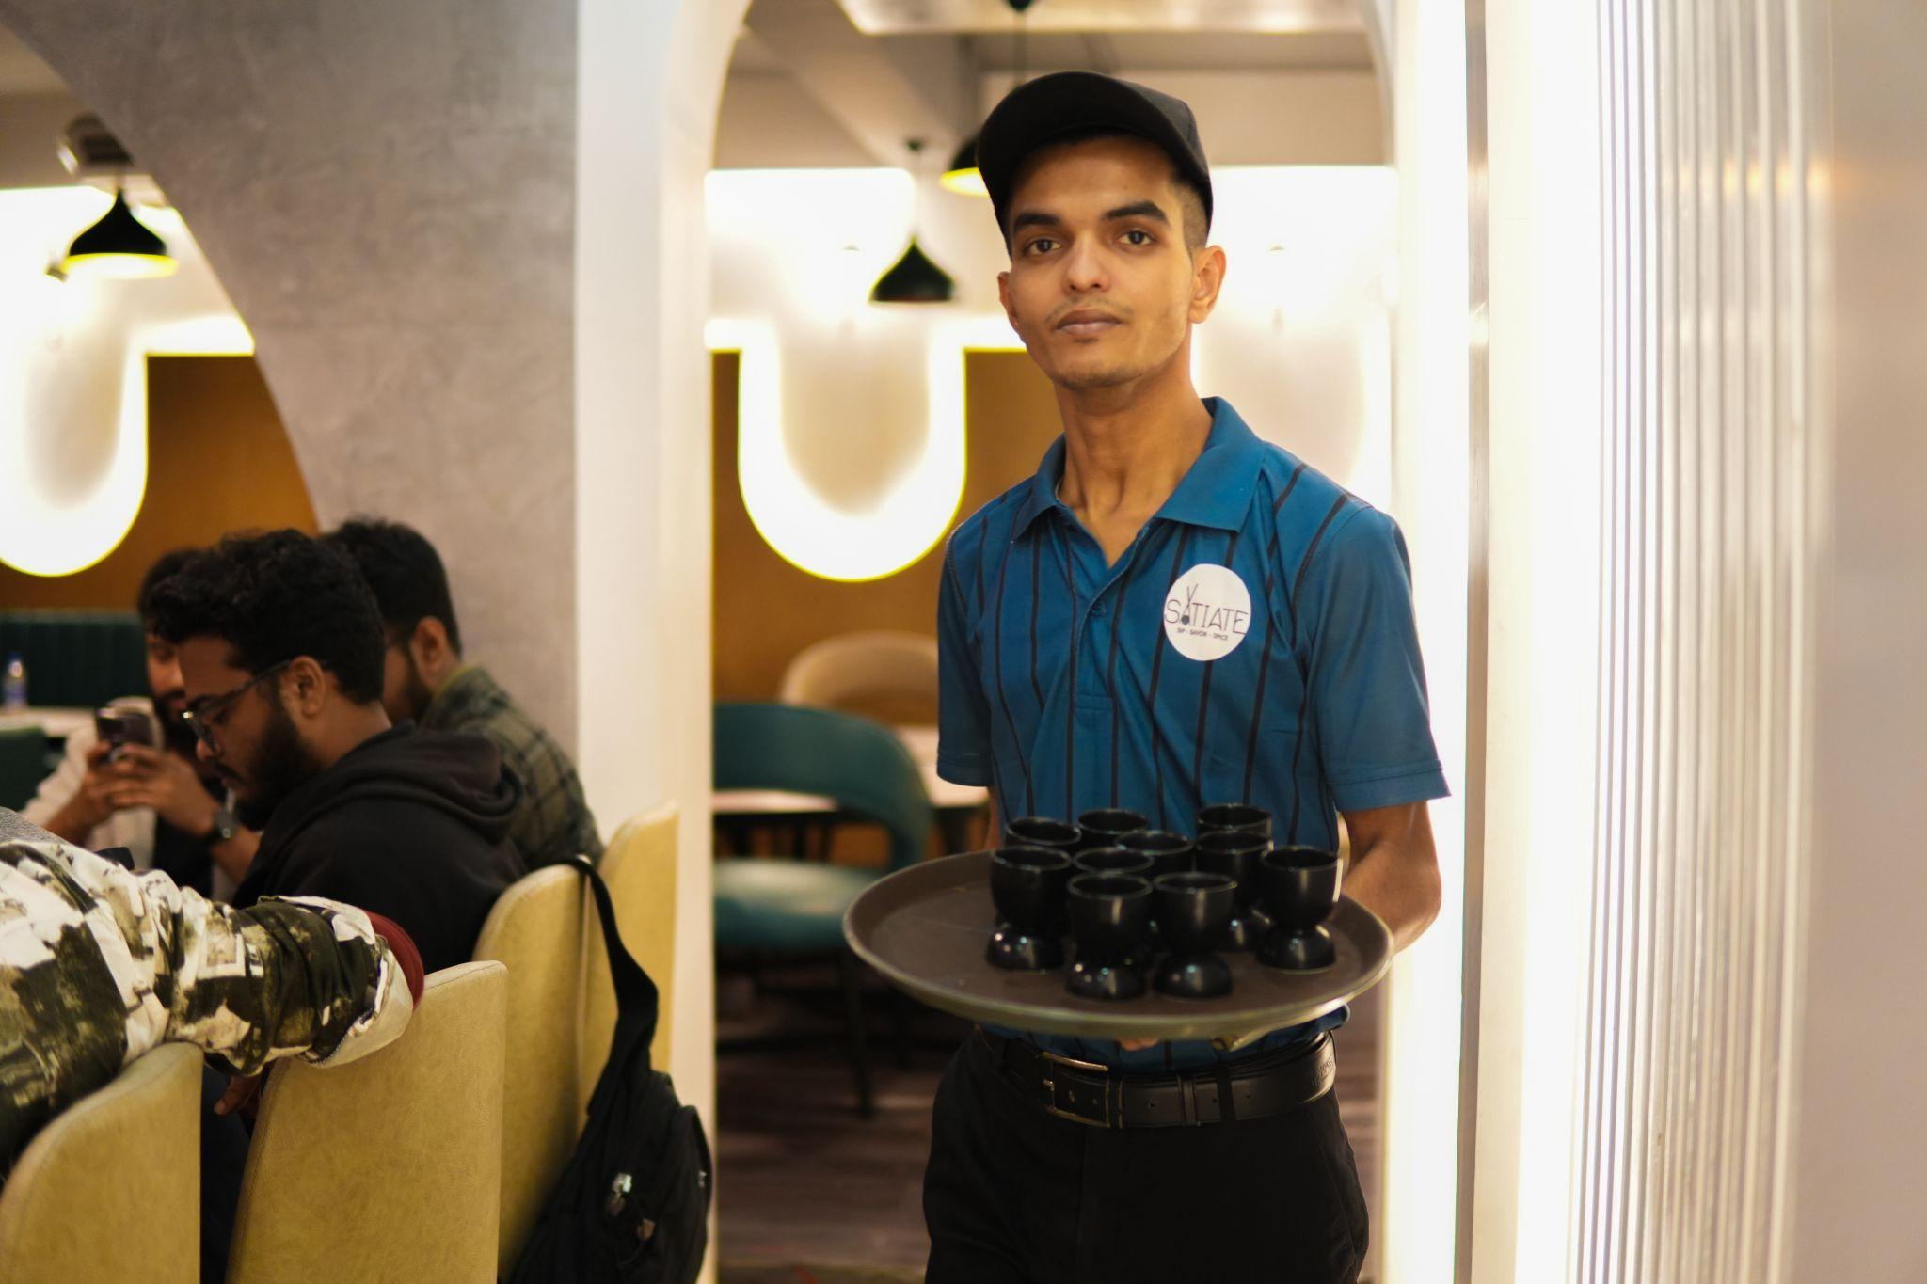
f/1.4 · ISO 800 · 1/160 · diffused fill light
Technique. ISO 800, f/1.4, 1/160 for balanced exposure in a dim room, with diffused fill light for a soft ambience. Shallow depth of field to isolate the subject from background noise. I kept the vertical lines straight and aligned the arch behind him to end exactly at the corner of the frame. In the edit I raised contrast, brought exposure and highlights down, dropped the shadows slightly, and lifted vibrancy.
Intention. The f/1.4 focuses on the subject and softens the background; the diffused light gives the figure a calm, even quality. I centred him to make him prominent and squared the verticals, pushing the arch into the frame’s corner for a sense of stability. The original read as overexposed, too much white, so I reduced exposure and highlights to soften the bright areas and then boosted vibrancy to correct the skin tone while keeping the other lights saturated.

PLATE 3 Addiction draining what little there is
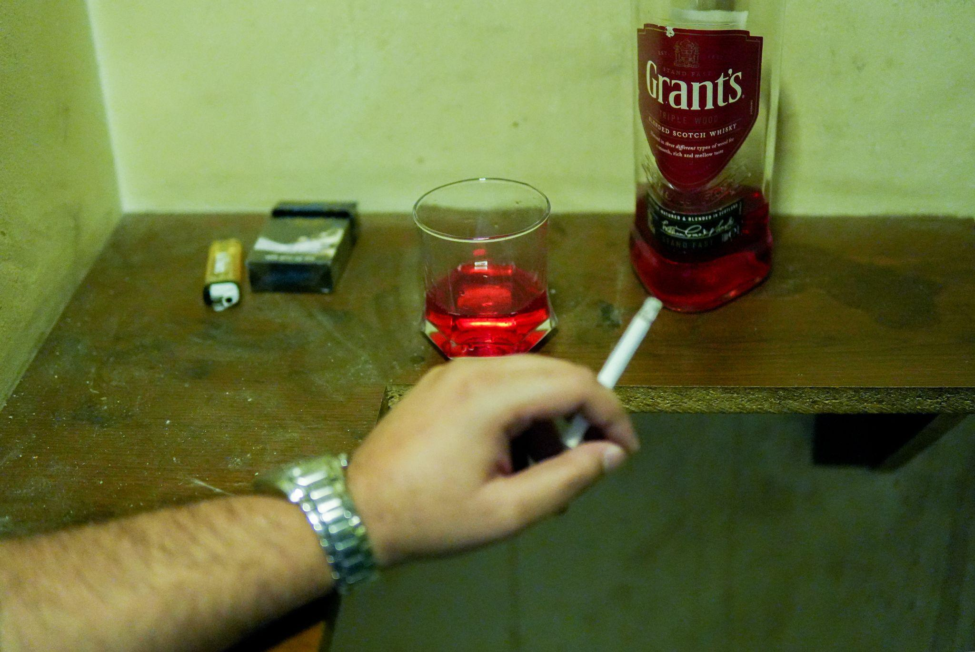
f/1.4 · ISO 5000 · 1/320 · very low ambient light
Technique. Low light at ISO 5000, 1/320, f/1.4. The composition runs a horizontal line through the elements of addiction — cigarette packet, bottle, glass — placed on the rule-of-thirds points, with a shallow depth of field holding focus on the glass. In the edit I cooled the temperature, lifted tint, raised exposure and contrast, and crushed the blacks.
Intention. I wanted a sombre, reflective mood, so I shot in very low light. Because the subject’s hand moved often I had to raise the shutter speed, which darkened the frame, so I compensated with high ISO and the widest aperture. The horizontal arrangement works as a leading line connecting the packet, bottle and glass. In post I adjusted temperature and tint to drain the yellow-green cast, lifted exposure for legibility, and pushed contrast and blacks for weight.

PLATE 4 A large family and limited resources
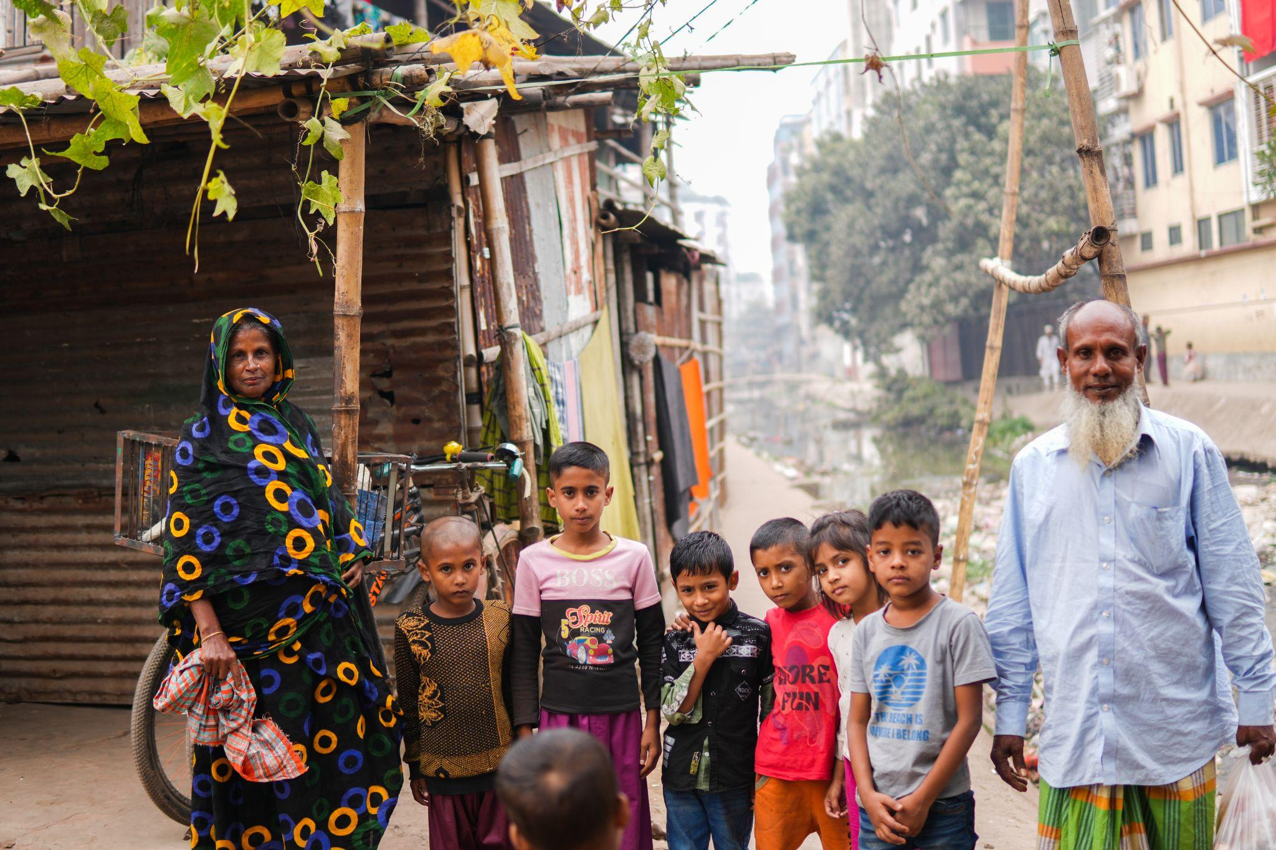
f/2.8 · ISO 400 · natural morning light
Technique. The one daylight frame. A wider aperture at f/2.8 with ISO 400 for clean brightness, and a moderate depth of field that keeps some of the environment legible. The subjects are arranged in a line leading the eye left to right, with the surrounding setting kept in to give context. Edited with raised exposure and contrast, highlights pulled fully down, blacks lifted.
Intention. I used a moderate depth of field to emphasise the people while keeping enough of the background to carry the context, and held space with the rule of thirds, lining the figures left to right as a leading line. The frame came out slightly underexposed, so in the edit I raised exposure to brighten the whole image, added contrast for definition, reduced highlights to protect detail in the bright areas, and lifted the blacks for richer dark tones.

PLATE 5 Child labour and the next generation
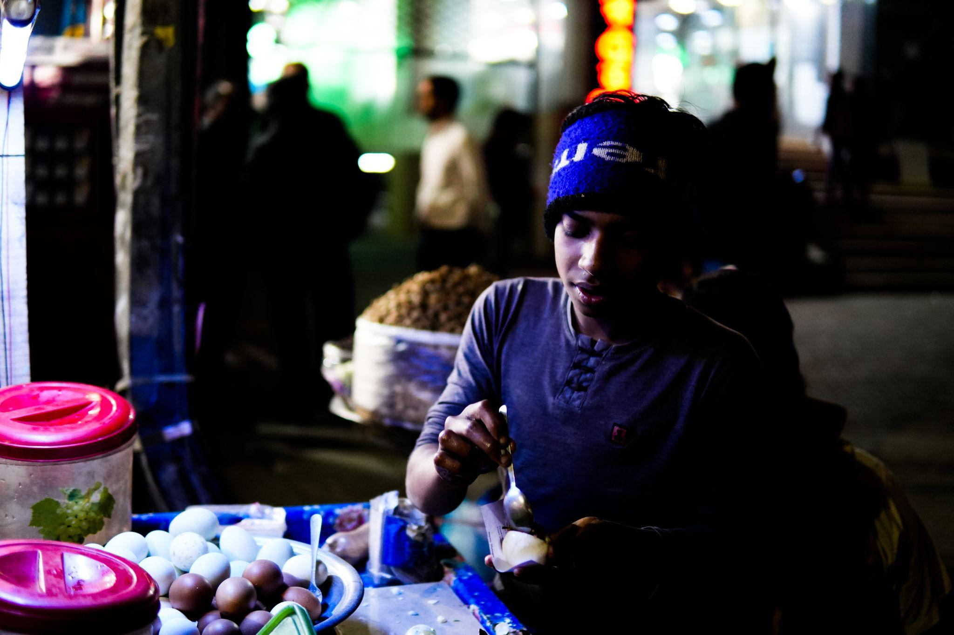
f/1.4 · ISO 1600 · 1/200 · side / back light
Technique. A backlit night frame at ISO 1600, f/1.4, 1/200. Shallow depth of field for subject focus, shutter kept high enough to freeze hand movement. In post I pushed contrast hard, dropped blacks and shadows to separate the figure from the dark surround.
Intention. The shallow depth of field isolates the subject and blurs the background; the slightly higher shutter freezes the working hands. My main aim was the backlight, which I got about halfway in camera and finished in the edit. The high ISO and wide aperture carried the low-light ambience. Raising contrast distanced the whites and blacks to lift the subject’s partly lit face out of the backlight, and I darkened blacks and shadows further to hold the mood.

What the series taught me
The recurring lesson across the five frames was that exposure is a negotiation, not a setting. Almost every photograph here involved a trade — raise the shutter to freeze a moving hand and lose light, open the aperture to recover it and lose depth, push ISO to compensate and gain noise — and learning to make those trades quickly, in bad light, with a real person in front of me, is the actual skill. The edit is where intention gets finished, but the frame is where it has to be earned. And the strongest single decision in the set was not a camera setting at all; it was choosing to make a real person’s card number unreadable. That is the instinct I most want to keep.

