Data Journalism Final Project
The Bachelor Economy:
The Cost of Living Solo in Dhaka
Md. Miraz Hossain — MSJ3253: Data Journalism — Fall 2025
Submitted to: Dewan Shahnoor Alam Sourav, Lecturer, School of Social Sciences
Date of submission: 22 December 2025

Dhaka’s Bachelor Penalty
Sharing a room is not a lifestyle choice. It is the safety net that makes the rent calculation possible at all.
At 6:30 AM, before the sun has cleared the smog over Farmgate, Tanvir Ahmed, 25, is already awake. Not to an alarm — to the pressure cooker whistling in a kitchen three feet from his head. His bedroom is a plywood-partitioned cabin in the corner of a flat’s dining room. Forty-two square feet. A single bed, a folding table, a plastic clothes rack, no window. For this slice of Dhaka, he pays Tk 5,500 a month.
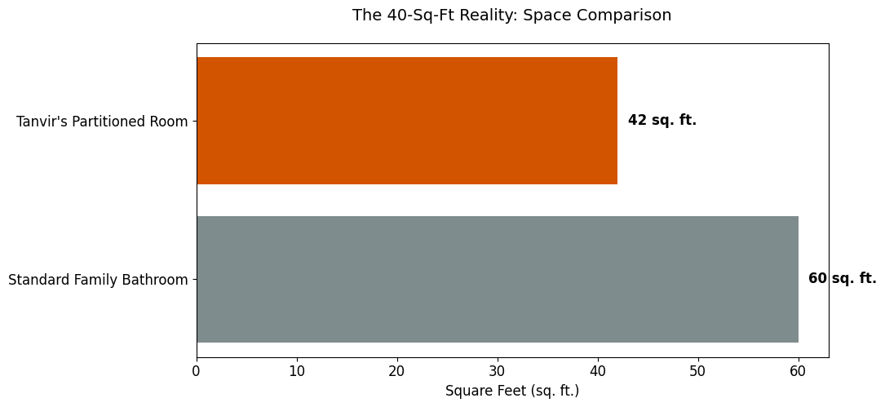
Fig. 1. Tanvir’s partitioned room (42 sq ft) compared against a standard family bathroom (60 sq ft). The space he sleeps in is smaller than what most Dhaka apartments allocate to a bathroom.
Tanvir is not poor. He is a junior executive at a logistics firm with a university degree. He lives in conditions urban planners would classify as a slum because his application for a standard one-bedroom flat does not survive the first question landlords ask: are you married? ‘The moment I say I am unmarried, the conversation ends,’ he says. ‘Landlords look at me like I am a security threat.’
Tanvir’s experience is not unusual. It is the standard entry condition for young single professionals arriving in Dhaka. Raihan, who moved from Chittagong hoping to make a life in the capital, ended up in Shajahanpur paying Tk 5,000 a month for a share of an apartment that houses four men in space designed for one family. They are both subjects of what this investigation calls Dhaka’s Bachelor Economy: an unregulated rental market in which single men pay a substantial price premium for substantially worse housing, and in which that premium is normalised as a fact of urban life rather than recognised as a form of discrimination.
A comparison of rental listings from December 2020 and December 2025 — scraped from public Facebook groups, the dominant marketplace for shared housing in Dhaka — indicates that families renting standard apartments pay roughly Tk 22 per square foot, while bachelors in mess arrangements pay upward of Tk 90 per square foot. The ratio is the central finding of this investigation. Everything else follows from it.
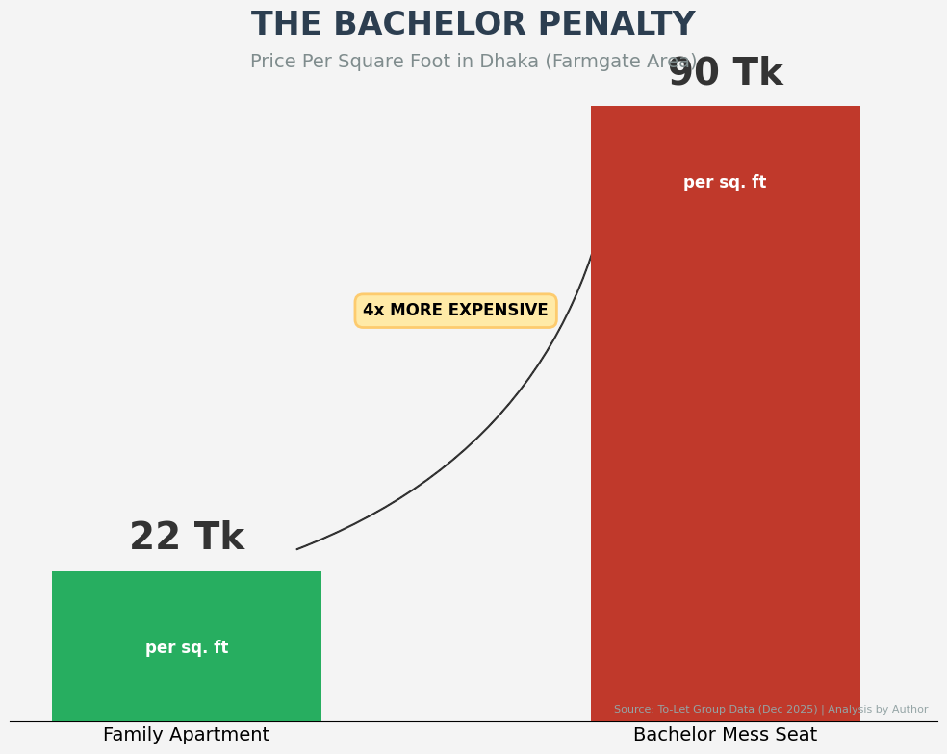
Fig. 2. Per-square-foot cost in Dhaka’s Farmgate area, December 2025. Bachelors in mess arrangements pay approximately 4x the rate families pay for the same physical space. Source: To-Let group listings, analysis by author.

The Mathematics of the Penalty
The price gap is not produced by random landlord behaviour. It is produced by an arithmetic that landlords have worked out and that the market has learned to accept. A standard 1,200 square foot apartment in East Rajabazar rents to a family for around Tk 26,000 a month. The same flat, converted into a bachelor mess, becomes a different financial object.
The drawing room takes two beds at Tk 4,000 each. The master bedroom fits three students at Tk 3,500 each. By the time every room is partitioned and every partition occupied, the flat houses ten people who collectively pay Tk 45,000 — a 73 percent revenue uplift on the same physical space. The bachelors absorb a higher unit price; the landlord captures the difference. The per-square-foot figure is what falls out of the arithmetic, not what causes it.

Configuration | Occupants | Monthly rent | Per occupant | Tk per sq ft
Family tenancy | 1 family (4–5) | Tk 26,000 | n/a | Tk 21.6
Bachelor mess (East Rajabazar) | 10 men | Tk 45,000 | Tk 4,000–4,500 | Tk 90+
Bachelor mess (Mirpur) | 12 men | Tk 60,000 | Tk 5,000 | Tk 60–70
Indicative configurations drawn from listings in three Dhaka neighbourhoods, December 2025.

“By failing to regulate the rental market for single individuals, we are essentially allowing a shadow market to thrive.”
— Adil Mohammed Khan, President, Bangladesh Institute of Planners
Adil Mohammed Khan, President of the Bangladesh Institute of Planners, argues that the Bachelor Economy is the predictable outcome of a regulatory absence rather than a market failure. The Revised Detailed Area Plan recently raised population density limits in central Dhaka from 250 to 300 persons per acre — a change Khan describes as ‘reckless,’ and which he warns will turn parts of the city into ‘vertical slums.’ The Bachelor Economy is what the slum looks like in advance: not the unfinished construction but the partitioned drawing room.

Meal-Rate Inflation
Rent is the visible cost. The Meal Rate is the harder one. Bachelor messes operate a shared-kitchen system in which residents pool a fixed monthly contribution — the Mill or Meal Rate — and split the cost of the meals it produces. The Meal Rate is the closest thing the informal bachelor economy has to a consumer price index for food. Watching it move tells you what is happening to disposable income in real time.
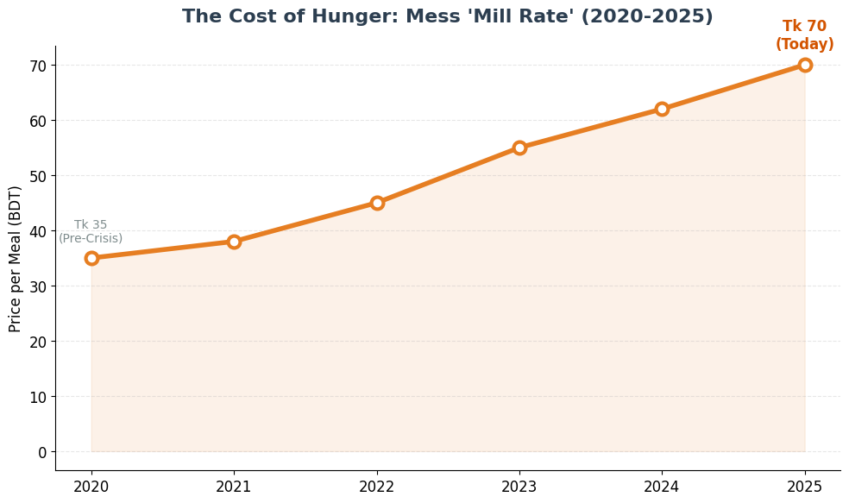
Fig. 3. Mess ‘Mill Rate’ in Farmgate, 2020–2025. The cost of a single meal has doubled in five years, from Tk 35 in 2020 to Tk 70 in 2025. Source: Crowd-sourced data from university residents.
In Farmgate in 2020, the average Mill Rate was Tk 35 per meal. By 2025, it sits at Tk 70 — a 100 percent increase in five years, well in excess of headline inflation, concentrated on a category of spending that cannot be deferred. Rafsan Mahmud Hoque, a trainee assistant manager at City Bank, describes the practical consequence: ‘Renting can be a pain alone if you have unexpected expenses. The meal system is increasingly volatile because of inflation.’ The doubling of meal costs is what makes flatmates a financial necessity rather than a social preference. Solo living against a doubled Meal Rate on a stagnant entry-level salary is mathematically impossible.

A Broken ROI on Education
Mess rents in surveyed Dhaka neighbourhoods have risen approximately 28 percent since 2021. Entry-level salaries for general officer positions have, by contrast, remained almost flat — hovering in the Tk 20,000 to Tk 25,000 range throughout the period. The gap between the two is where the Bachelor Penalty lives.
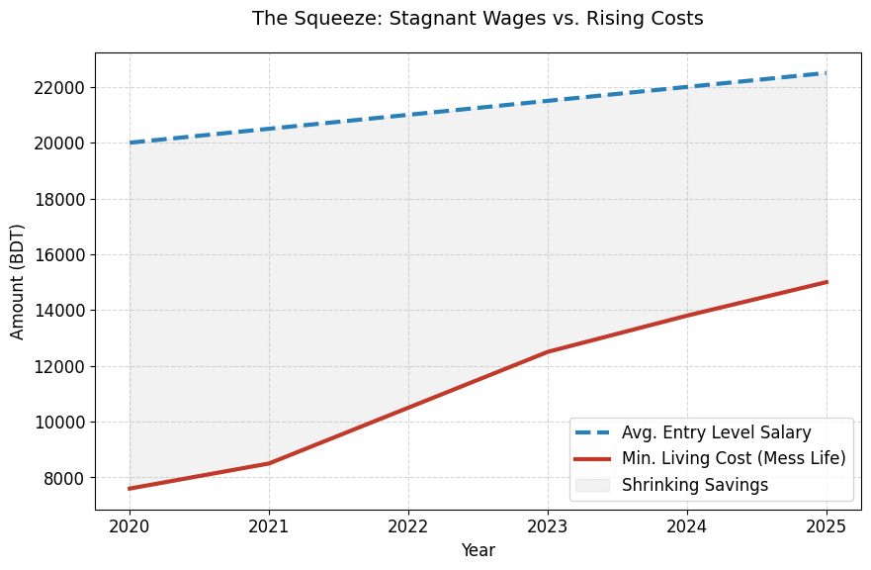
Fig. 4. Entry-level salary trajectory (2020–2025) against minimum mess living costs. The shaded area between the lines represents the diminishing margin available for everything else — savings, healthcare, family support, professional development.
“This reflects a harsh reality. There is not adequate investment for job creation.”
— Dr. Fahmida Khatun, Executive Director, Centre for Policy Dialogue
Dr. Fahmida Khatun, Executive Director of the Centre for Policy Dialogue, describes the resulting financial position as a ‘savings vacuum’: an income structure in which graduates earn enough to survive in shared accommodation but not enough to accumulate any cushion against future cost increases or to leave the shared accommodation arrangement that the costs require.
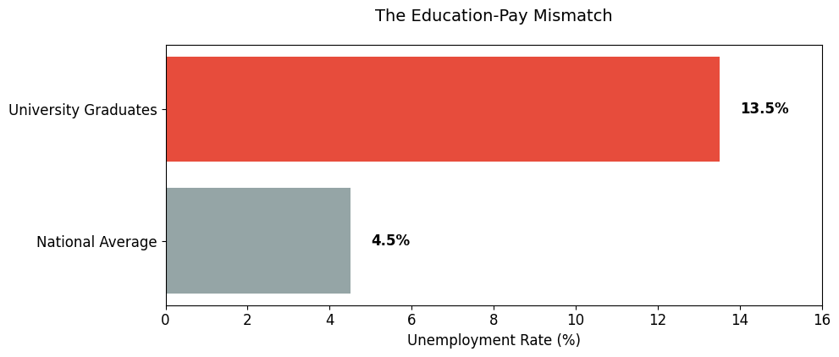
Fig. 5. Unemployment rate among university graduates (13.5%) against the national average (4.5%). The graduate rate is three times the national figure. Source: CPD economic reports, 2024.
According to CPD figures cited in 2024, approximately 8.85 lakh university graduates in Bangladesh are unemployed — representing a 13.5 percent unemployment rate among those with tertiary education, substantially above the national figure of 4.5 percent. The graduates who do find work frequently take roles below their qualification level. The market is, in Khatun’s phrase, a ‘skills-pay mismatch.’
The downstream consequence is what Rafsan describes from the inside: a job market that feels ‘ultra-competitive’ and ‘running thin.’ With nine hundred thousand other graduates competing for the same positions, salary expectations get marked down to whatever the market will clear at. The investment in education — ‘thousands or millions of taka,’ in Rafsan’s words — returns a starting salary that does not cover its own carrying cost once Dhaka rent and meal rates are factored in. That is the Bachelor Economy’s most quietly damaging feature: it makes the educational investment that produced the graduate look, in retrospect, like a bad bet.

The Bua Economy: The Informal Labour Behind the Numbers
The most overlooked component of the bachelor cost stack is also the most structurally interesting. Mess life depends on an entire informal labour economy that does not appear in any rental listing: the Bua (domestic worker) who cooks and cleans, the garbage collector who handles disposal, the building security guard who admits residents after 11 PM. None of these workers are formally employed by anyone. All of them are essential to mess life being viable at all. And all of them charge bachelors more than they charge families for equivalent work.
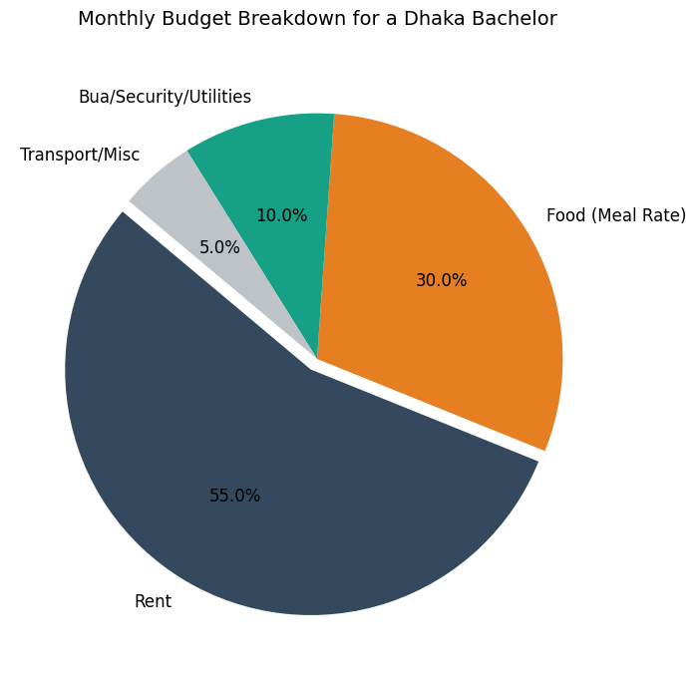
Fig. 6. Typical monthly budget breakdown for a Dhaka bachelor. Rent (55%) and food (30%) dominate, but the 10% spent on Bua services, security, and utilities flows entirely through the informal economy and is unregulated.
In a typical mess of eight to ten residents, hiring a Bua to cook two meals a day and clean shared spaces costs between Tk 5,000 and Tk 10,000 a month — split across residents at Tk 800 to Tk 1,200 each. The total is comparable to what a family might pay a full-time domestic worker, but the per-occupant arithmetic differs in an important way: the bachelor’s share is a fixed monthly deduction with no flexibility for the months when income is tight. The garbage collector charges a premium because the mess generates more waste than a family flat. The security guard, as Tanvir puts it, ‘expects a bachelor tip to let us back in after 11 PM.’ None of this is written down. All of it is non-negotiable.
What makes the Bua Economy worth naming as a distinct phenomenon is what it reveals about the formal-informal interaction. Bachelors are paid through the formal economy — taxed salaries from registered employers — but every cost layer below their rent is informal, cash-only, and unregulated. They pay formal-economy taxes against informal-economy expenses. The Bua Economy is the membrane through which formal income flows out into the informal sector that actually keeps the city running. It is also, by virtue of being undocumented, the part of the bachelor cost stack that is most resistant to policy intervention. You can regulate rent. You cannot easily regulate the tip the security guard expects.

The Geography of the Penalty
The Bachelor Penalty is not flat across the city. It varies by neighbourhood in patterns that map onto Dhaka’s broader social geography. The more affluent the area, the higher the barrier to bachelor entry — but the mechanism producing the barrier shifts depending on where you are.
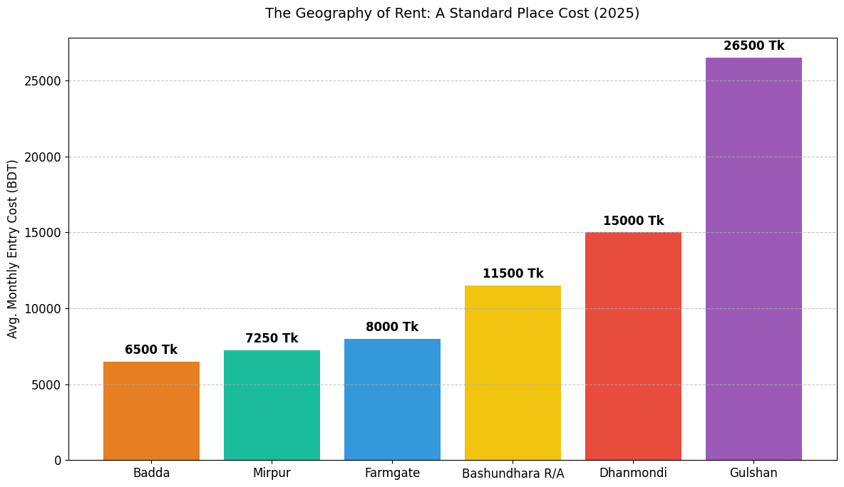
Fig. 7. Average monthly entry cost for a bachelor across six Dhaka neighbourhoods, December 2025. The fourfold gap between Badda (Tk 6,500) and Gulshan (Tk 26,500) reflects two different penalty mechanisms operating in the same city.
In Mirpur, the dominant lung for Dhaka’s bachelor population, the penalty operates through density. With the arrival of the Metro Rail, rents in Mirpur 10 and 11 have risen 15 to 20 percent. The area remains accessible to bachelors only because landlords compensate for higher rates by accommodating more occupants per flat. A 1,000 square foot apartment housing twelve bachelors at Tk 5,000 each produces Tk 60,000 in monthly revenue against a Tk 22,000 family rate — a 173 percent uplift. The landlord captures the difference; the bachelors absorb the spatial cost. The arithmetic is the same as East Rajabazar, scaled up.
In Gulshan, the mechanism inverts. There, the penalty operates as prestige gatekeeping. Md. Wahiduzzaman, President of REHAB, the developers’ association, notes that high construction and land costs make small-unit affordable housing unviable for developers in upmarket neighbourhoods. The few bachelor spaces that exist in Gulshan are high-end sublets where a single room can cost more than a full three-bedroom apartment in Mirpur. The Bachelor Penalty in Gulshan is not about extracting maximum revenue from dense occupation. It is about keeping bachelors out at a price point that maintains the neighbourhood’s family-oriented social register.
The result, as Rafsan describes from inside the market, is forced migration toward whatever pockets of affordability still exist near commercial centres. Thousands of young professionals competing for a small number of viable spots produces exactly the ‘ultra-competitive’ dynamic he describes — and ensures that whether in a Mirpur mess or a Gulshan sublet, the bachelor pays the highest unit price for the smallest slice of the city.

The Super Hostel: A Premium Version of the Same Problem
The market has responded to the Bachelor Economy crisis by producing a more expensive version of it. Corporate Super Hostels — facilities in Shahbagh, Uttara, and Mirpur that rebrand the mess experience with tiered membership packages — now offer Economy, Cozy, and VIP tiers that scale by privacy rather than by space.
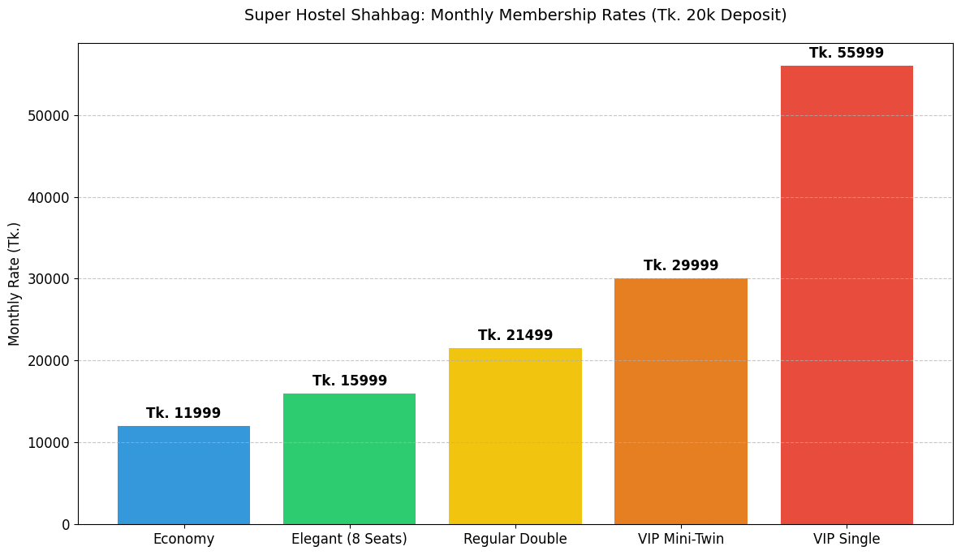
Fig. 8. Super Hostel Shahbagh monthly membership rates by tier, with a Tk 20,000 deposit. The VIP Single tier (Tk 55,999) costs more than a three-bedroom apartment in Mirpur.
An Economy bed starts at approximately Tk 11,999 plus a Tk 999 utility surcharge. A VIP Single can reach Tk 55,999 a month. The pricing structure is not a solution to the Bachelor Economy. It is a gentrified expression of it. The same dynamic — single professionals paying disproportionate premiums for sub-standard space — is repackaged as a premium service, with the basic amenities of shared living (Wi-Fi, laundry, cleaning) priced individually rather than absorbed communally. The professionalisation makes the arrangement legible to a corporate sensibility but does not change its underlying economics. A graduate paying Tk 25,000 a month for a Super Hostel bed is not in a meaningfully different financial position than a graduate paying Tk 5,000 for a mess bed. Both are spending a disproportionate share of their income to maintain a place to sleep in a city that has no other plan for them.
“Construction costs jumped by 20 percent in 2024. Middle-class families are finding it increasingly difficult to afford or access housing.”
— Md. Wahiduzzaman, President, REHAB
Wahiduzzaman attributes the absence of genuinely affordable solo housing to construction cost increases, rigid land-use rules, and high registration costs that make small-unit developments commercially unattractive. His association has proposed reducing registration fees and introducing studio apartment incentives. The proposals are sensible. They do not exist in policy yet.

Breaking the Bachelor Penalty
The Bachelor Penalty is more than a housing problem. It is a structural drag on the economic transition of an entire generation of educated workers — a system that taxes the people least able to bear it, on behalf of the people least dependent on the tax. Three distinct interventions are required, and they operate at different levels of the system.
The first is legal. Adil Mohammed Khan of BIP argues that the foundation of the problem is the absence of any prohibition on landlord discrimination by marital status. ‘The state must mandate non-discriminatory renting practices,’ he says. ‘We need a legal framework that prohibits landlords from rejecting tenants based solely on marital status. Until housing is viewed as a basic right rather than a tool for social profiling, bachelors will continue to be marginalised into sub-standard, high-cost spaces.’ This is not a radical proposal. Most jurisdictions with developed housing markets have some version of it. Bangladesh does not.
The second is structural. Wahiduzzaman of REHAB argues for supply-side intervention: studio apartment incentives — significant tax breaks and lower registration fees for small-unit developments — to make affordable solo housing commercially viable for developers. ‘Developers have the capacity to build, but the current math does not favour the single professional,’ he says. ‘By reducing entry barriers for developers, we can foster a professional studio culture that provides dignity and affordability to young workers.’ The proposal addresses the supply problem that the legal intervention alone cannot solve. Non-discrimination law does not produce housing units. It only changes how the existing units can be allocated.
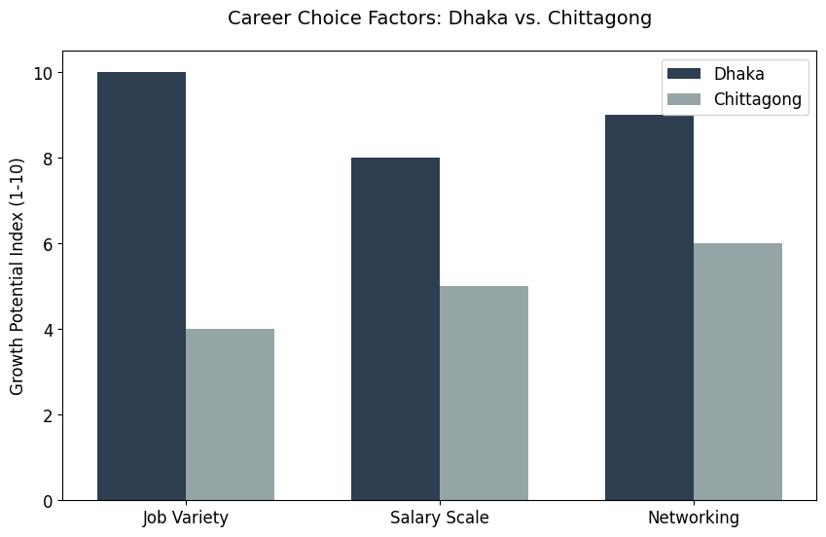
Fig. 9. Career factor comparison: Dhaka vs. Chittagong, indexed 1–10. Dhaka’s dominance in job variety, salary scale, and professional networking explains why decentralisation policy alone cannot relieve pressure on the capital.
The third intervention is geographic. Dr. Fahmida Khatun of CPD frames the longer-term solution as decentralisation: improving the quality of education and creating job hubs outside Dhaka so that single professionals are not forced into a single overheated rental market in the first place. ‘We must improve the quality of education all over the country so that students do not have to come to Dhaka. And we must create job hubs in cities like Chittagong and Rajshahi where the job market currently lags despite a better quality of life,’ she says. Rafsan, asked about this, agreed that cities like Chittagong are ‘calmer’ and offer better social connections. He also said the ‘vastly superior choice of jobs’ in Dhaka remains an inescapable pull. Decentralisation as a policy goal cannot succeed without a sustained programme of job creation in secondary cities. That is a multi-decade project, not a regulatory tweak.
Without intervention at all three levels, the Bachelor Penalty will continue to function as an effective and quietly punishing tax on the educated workers Bangladesh most needs to retain. It is not a small problem. It is the daily condition of a substantial fraction of the country’s graduate workforce.

Methodology and Data
This investigation drew on four sources of evidence. First, rental listings scraped from two major public Facebook groups (‘To-Let Dhaka’ and ‘Bachelor Mess Dhaka’) for December 2020 and December 2025, providing the comparative base for the per-square-foot rate calculations. Per-square-foot figures were derived from listed rents against typical apartment dimensions; they are indicative rather than census-grade and the calculation methodology is documented in the accompanying notebook for replication.
Second, primary interviews with Tanvir Ahmed, Rafsan Mahmud Hoque, and Raihan, all of whom agreed to speak with their names used. Each consented to the use of their account in published form.
Third, expert interviews with three institutional sources: Adil Mohammed Khan (President, Bangladesh Institute of Planners), Dr. Fahmida Khatun (Executive Director, Centre for Policy Dialogue), and Md. Wahiduzzaman (President, REHAB). Their quotations are taken from direct interviews conducted by the project team between October and December 2025.
Fourth, crowd-sourced Meal Rate data from university seniors across multiple neighbourhoods, used to triangulate the 2020 vs 2025 cost comparison. Super Hostel pricing was obtained directly from facility operators.
All data analysis and visualisations were produced in Python (matplotlib) within a documented Google Colab notebook. The notebook is publicly accessible and includes the source code for every figure in this report:
Colab notebook: bachelor.ipynb — https://colab.research.google.com/drive/1DZ6ME236wp_ryulQozl5yMP5I-0rQCab

AI Acknowledgement
AI tools were used during the project for specific, documented tasks: brainstorming the story outline, generating Excel formulas for data cleaning, and supporting visual production in the Colab notebook. All interviews were conducted by the project team. All data verification, quotation checks, and final writing were the work of the team. The use of AI for any task in this project is acknowledged in the interest of methodological transparency, in line with the standards applied by major academic and journalistic publications.

