PROIECT SISTEME DE GESTIUNE A BAZELOR DE DATE
ADMINISTRAREA UNUI LANT DE SALI DE FITNESS
234 PETCU MIRCEA

1.Prezentați pe scurt bazade date (utilitatea ei).
Proiectul are ca scop administrare unui lant de sali de fitness ce inglobeaza tot ce tine de acest domeniu: clienti, instructori,aparatura etc. Utilitatea acestei baze de date o reprezinta o adiministrare mult mai facila si mai rapida a salilor de fintness aflate in conglomerat ajutand, astfel, la cresterea profitului dar si a satisfactiei clientilor si urmareste dezvoltarea afacerii. Dintr-un lant fac parte mai multe sali aflate in diferite locatii. Aceste sali, pentru a functiona au nevoie de angajati (intructori, receptioneri,manageri oameni pentru curatenie etc.), de aparatura(de cardio, de fitness etc.), alte produse pentru vanzare (suplimente) si nu in ultimul rand, de clienti. Clientii isi fac abonamnete ce sunt de mai multe tipuri(standard sau premium) ce duce la cresterea incasarilor dar si capacitate mai mare de clienti pe care o sala le are este direct proportionala cu cheltuielile salii. Capacitate unei sali nu este oferita doar de locurile disponibile din vestiar ci si de numarul de aparate disponibile in sala, de numarul de intructori si de suprafata efectiva a salii. Pretul abonamentului depinde direct si doar de id-ul abonamentului deoare acesta poate fi personalizat. O sala poate avea mai multe game de aparate sau suplimente de la diferite firme.

2.Realizați diagrama entitate-relație (ERD).

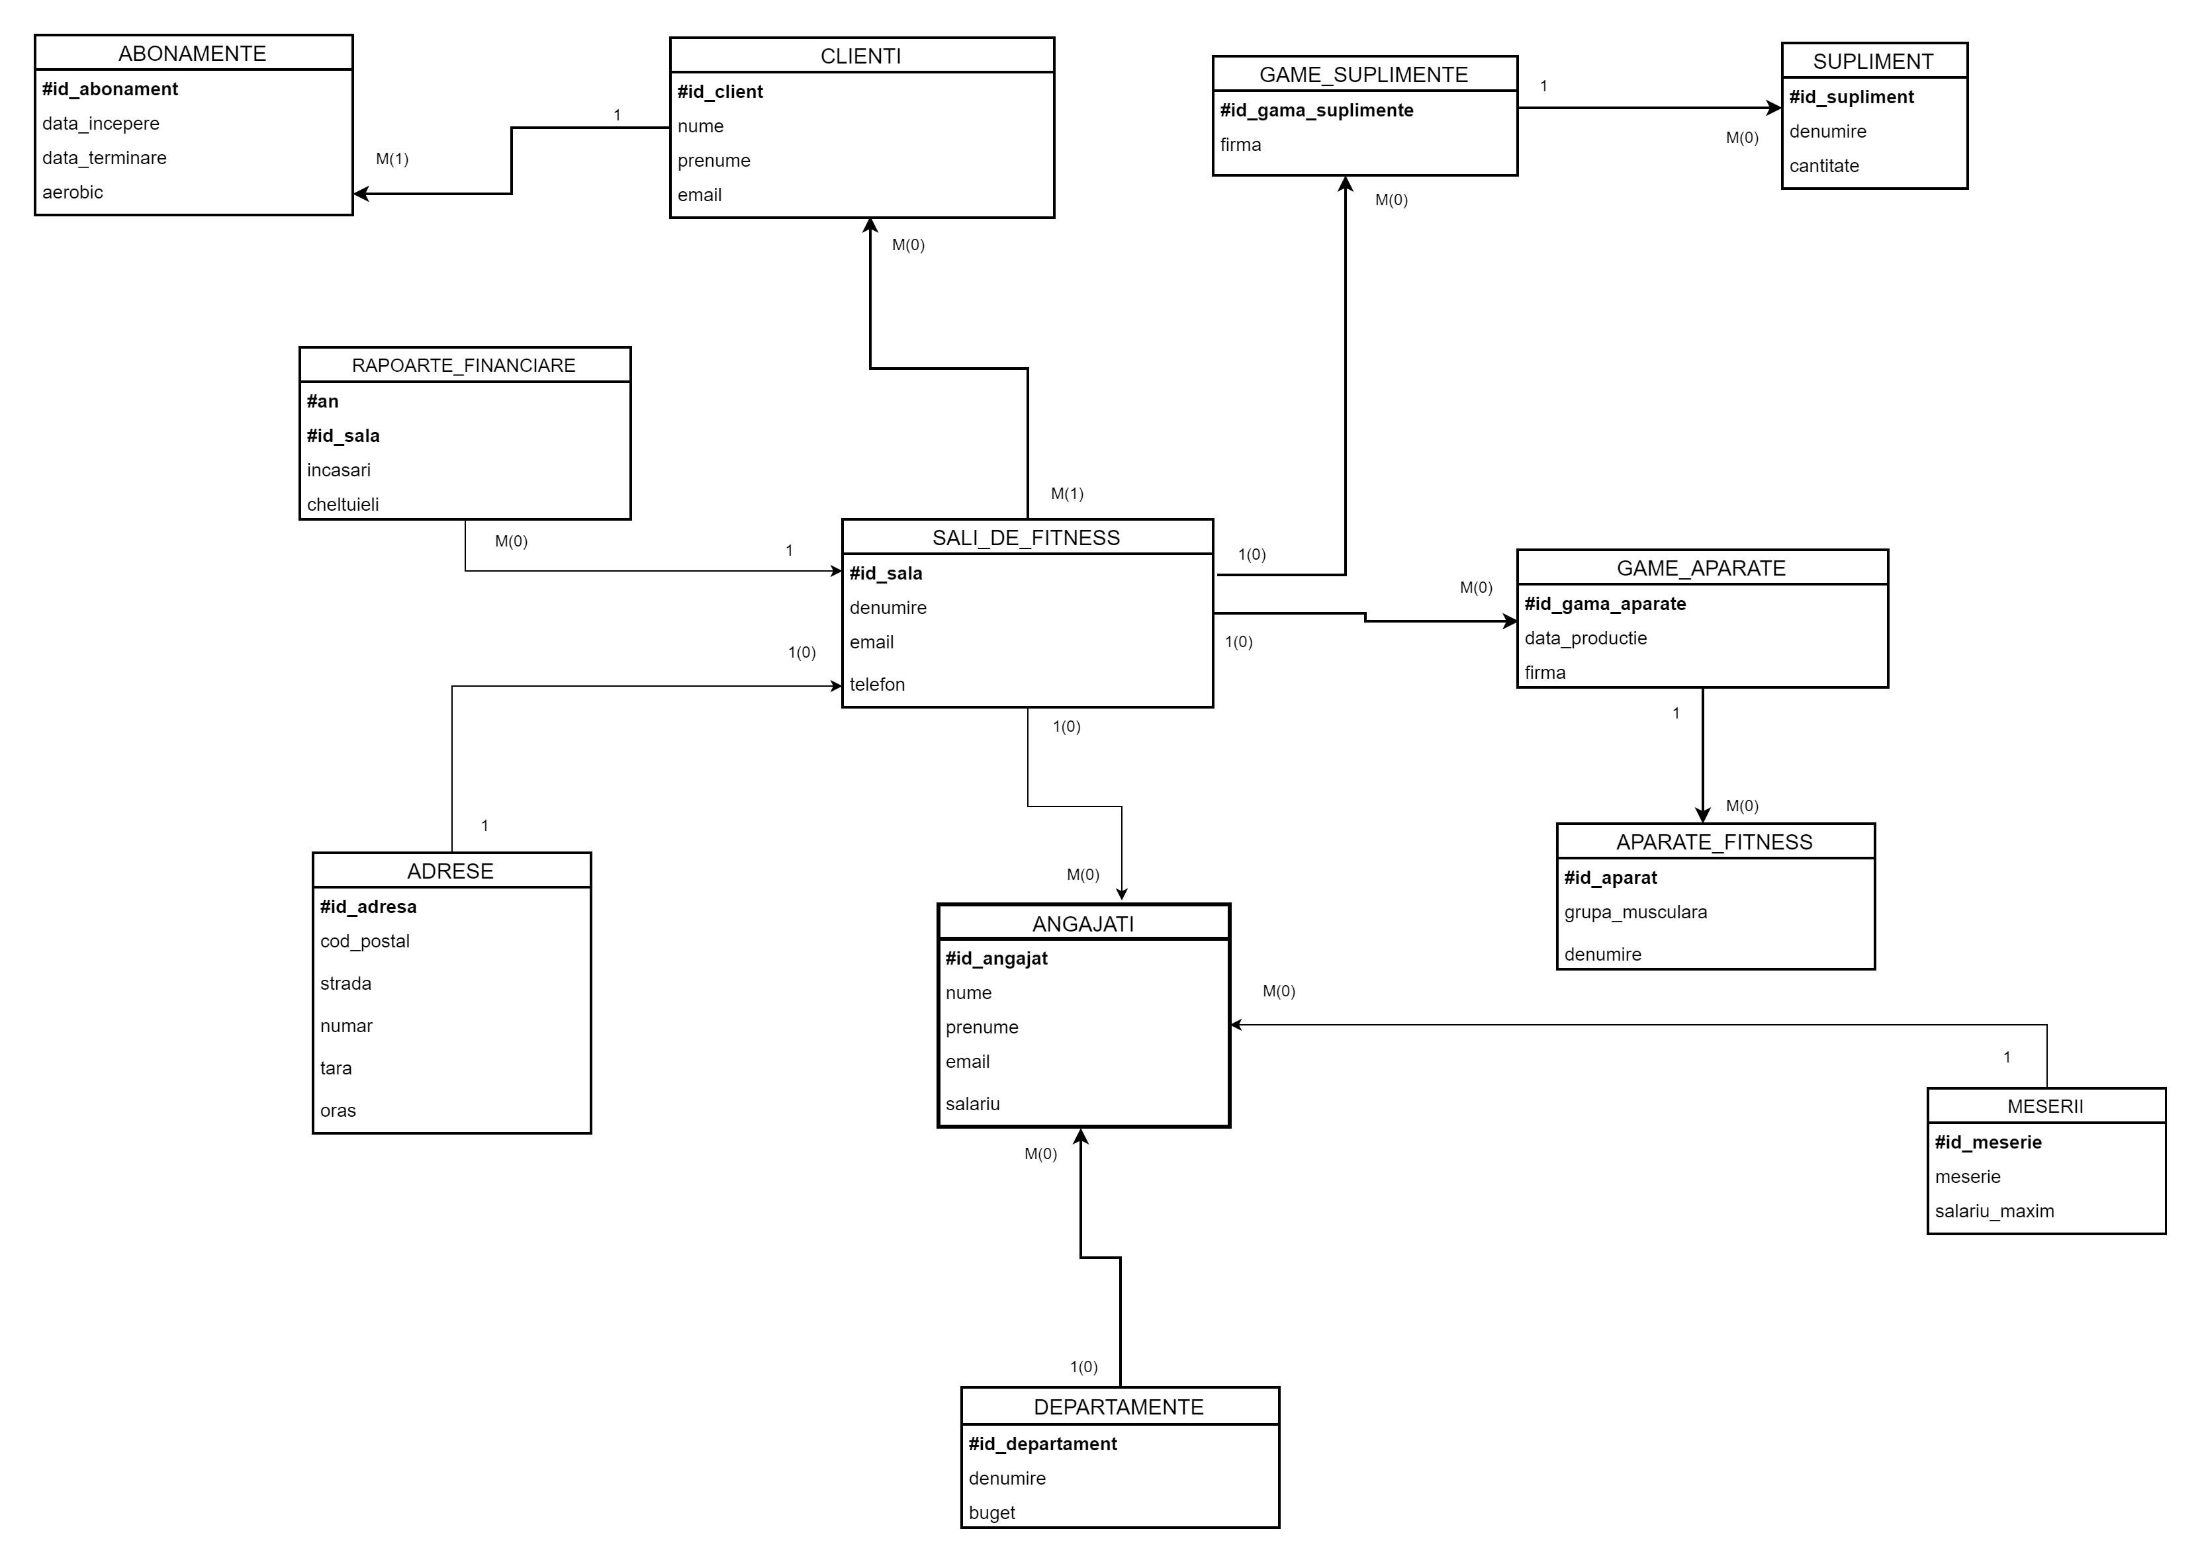

3.Pornind de la diagrama entitate-relație realizațidiagramaconceptualăa modelului propus, integrând toate atributele necesare.
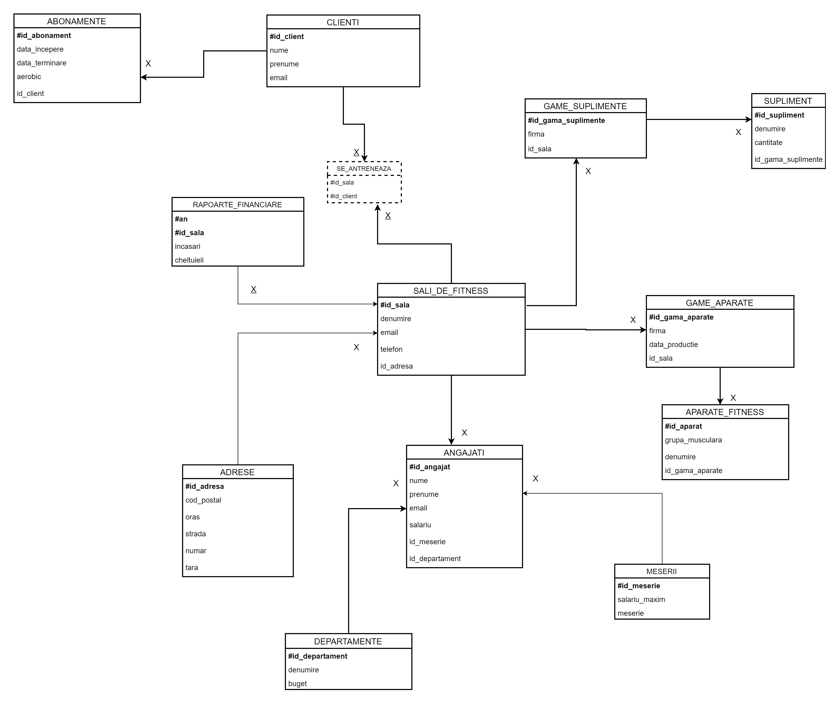
4.Implementați în Oracle diagrama conceptuală realizată: definiți toate tabelele, implementând toate constrângerile de integritate necesare (chei primare, cheile externe etc).

create sequence sala_fitness_seq
increment by 1
start with 10;
drop sequence sala_fitness_seq;
--creare tabele
create table ADRESE
(
id_adresa number(6)
constraint pk_adresa primary key,
cod_postal varchar2(10),
strada varchar2(40),
numar varchar2(5),
oras varchar2(50),
tara varchar2(50)
);
create table SALI_DE_FITNESS
(
id_sala number(6)
constraint pk_sala primary key,
denumire varchar2(50),
email varchar2(50)
constraint nn_sala_email not null,
telefon varchar2(10)
constraint unq_sala_tel unique,
id_adresa number(6),
constraint fk_sali_locatii foreign key (id_adresa)
references ADRESE (id_adresa) on delete cascade,
constraint unq_sali_email unique (email)
);
create table DEPARTAMENTE
(
id_departament number(6)
constraint pk_dep primary key,
denumire varchar2(50)
);
alter table DEPARTAMENTE
add buget number(10, 2);
create table MESERII
(
id_meserie number(6)
constraint pk_meserie primary key,
meserie varchar2(50),
constraint unq_meserii unique (meserie)
);
alter table MESERII
add salariu_maxim number(10);
create table ANGAJATI
(
id_angajat number(6)
constraint pk_ang primary key,
nume varchar2(50)
constraint nn_ang_nume not null,
prenume varchar2(50),
email varchar2(50)
constraint nn_ang_email not null,
salariu number(7) default 1500,
id_departament number(6),
id_meserie number(6),
id_sala number(6),
constraint fk_ang_dep foreign key (id_departament)
references DEPARTAMENTE (id_departament) on delete cascade,
constraint unq_ang_email unique (email),
constraint chk_ang_sal check ( salariu > 1399 ),
constraint fk_ang_meserii foreign key (id_meserie)
references MESERII (id_meserie) on delete cascade,
constraint fk_ang_sali foreign key (id_sala)
references SALI_DE_FITNESS (id_sala) on delete cascade
);
create table GAME_APARATE
(
id_gama_aparate number(6)
constraint pk_game_aparate primary key,
firma varchar2(50),
data_productie date,
id_sala number(6),
constraint fk_game_aparate_sali foreign key (id_sala)
references SALI_DE_FITNESS (id_sala) on delete cascade
);
create table GAME_SUPLIMENTE
(
id_gama_suplimente number(6)
constraint pk_game_suplimente primary key,
firma varchar2(50),
id_sala number(6),
constraint fk_game_suplimente_sali foreign key (id_sala)
references SALI_DE_FITNESS (id_sala) on delete cascade
);
create table APARATE_FITNESS
(
id_aparat number(6)
constraint pk_aparate primary key,
grupa_musculara varchar2(50),
denumire varchar2(50),
id_gama_aparate number(6),
constraint fk_aparate_fitness_sali foreign key (id_gama_aparate)
references GAME_APARATE (id_gama_aparate) on delete cascade
);
create table SUPLIMENTE
(
id_supliment number(6)
constraint pk_suplimente primary key,
denumire varchar2(50),
id_gama_suplimente number(6),
constraint fk_suplimente_sali foreign key (id_gama_suplimente)
references GAME_SUPLIMENTE (id_gama_suplimente) on delete cascade
);
create table CLIENTI
(
id_client number(6)
constraint pk_clienti primary key,
nume varchar2(50)
constraint nn_nume_clienti not null,
prenume varchar2(50),
email varchar2(50)
constraint nn_email_clienti not null,
constraint unq_email_clienti unique (email)
);
create table ABONAMENTE
(
id_abonament number(6)
constraint pk_abonamente primary key,
data_incepere date
constraint nn_incepre not null,
data_terminare date
constraint nn_terminare not null,
aerobic varchar2(2),
id_client number(6)
constraint nn_id_client not null,
constraint fk_abonamente_clienti foreign key (id_client)
references CLIENTI (id_client) on delete cascade
);
create table SE_ANTRENEAZA
(
id_client number(6),
id_sala number(6),
constraint pk_se_antreneaza primary key (id_client, id_sala),
constraint fk_se_antreneaza_1 foreign key (id_client)
references CLIENTI (id_client) on delete cascade,
constraint fk_se_antreneaza_2 foreign key (id_sala)
references SALI_DE_FITNESS (id_sala) on delete cascade
);
create table RAPOARTE_FINANCIARE
(
id_sala number(6),
an number(4),
incasari number(10, 2),
cheltuieli number(10, 2),
constraint pk_rap primary key (an, id_sala),
constraint fk_rap_sala foreign key (id_sala)
references SALI_DE_FITNESS (id_sala) on delete cascade
);

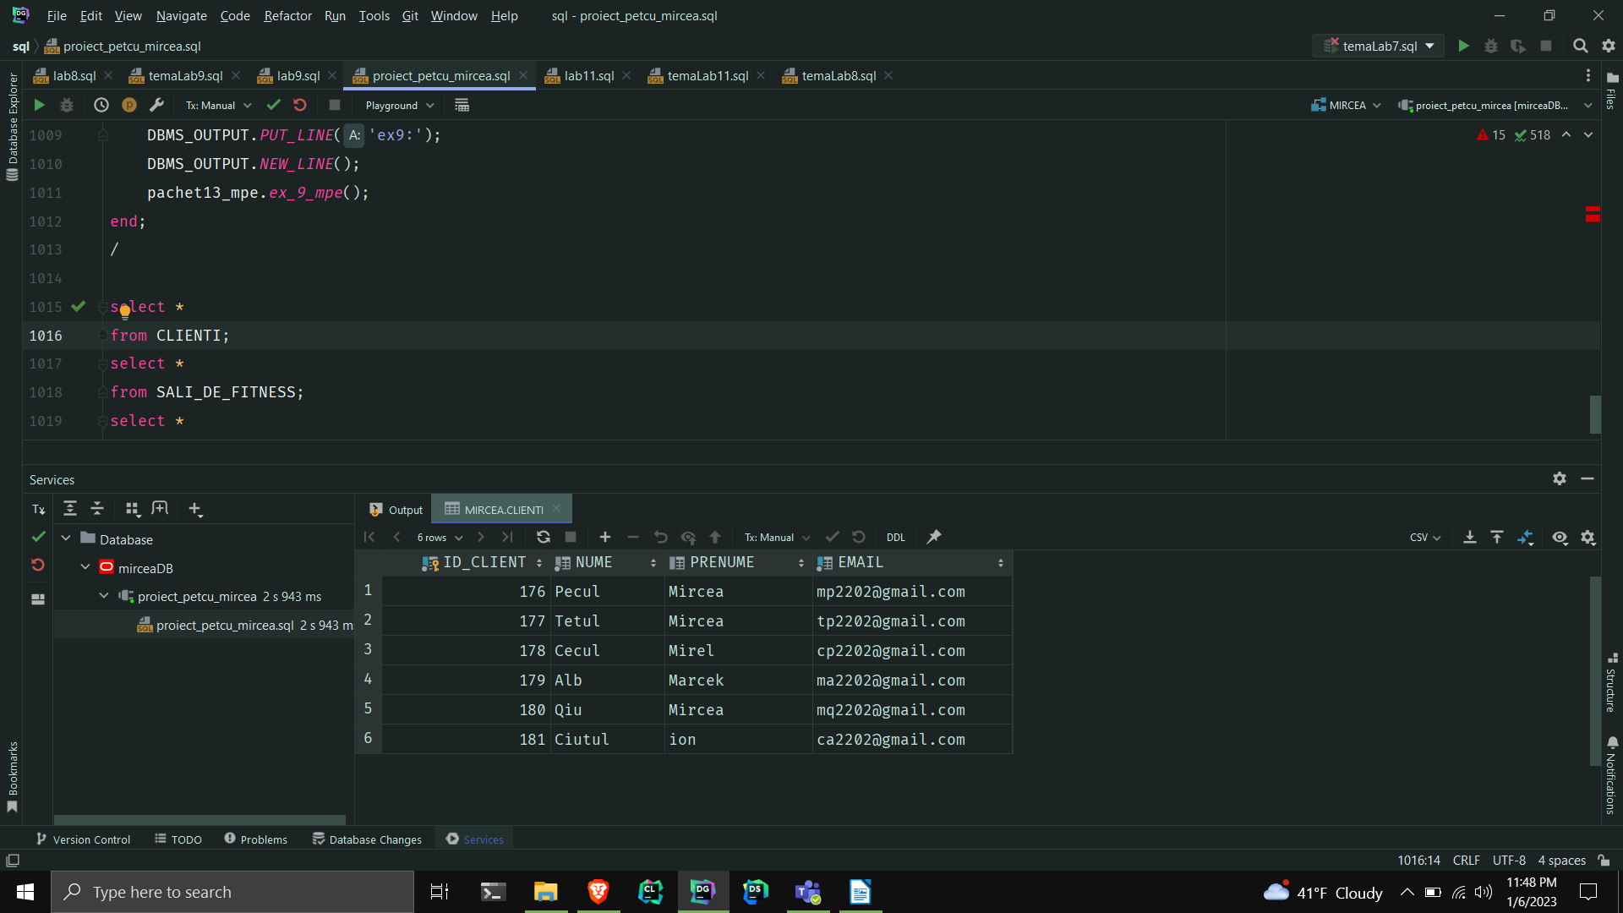
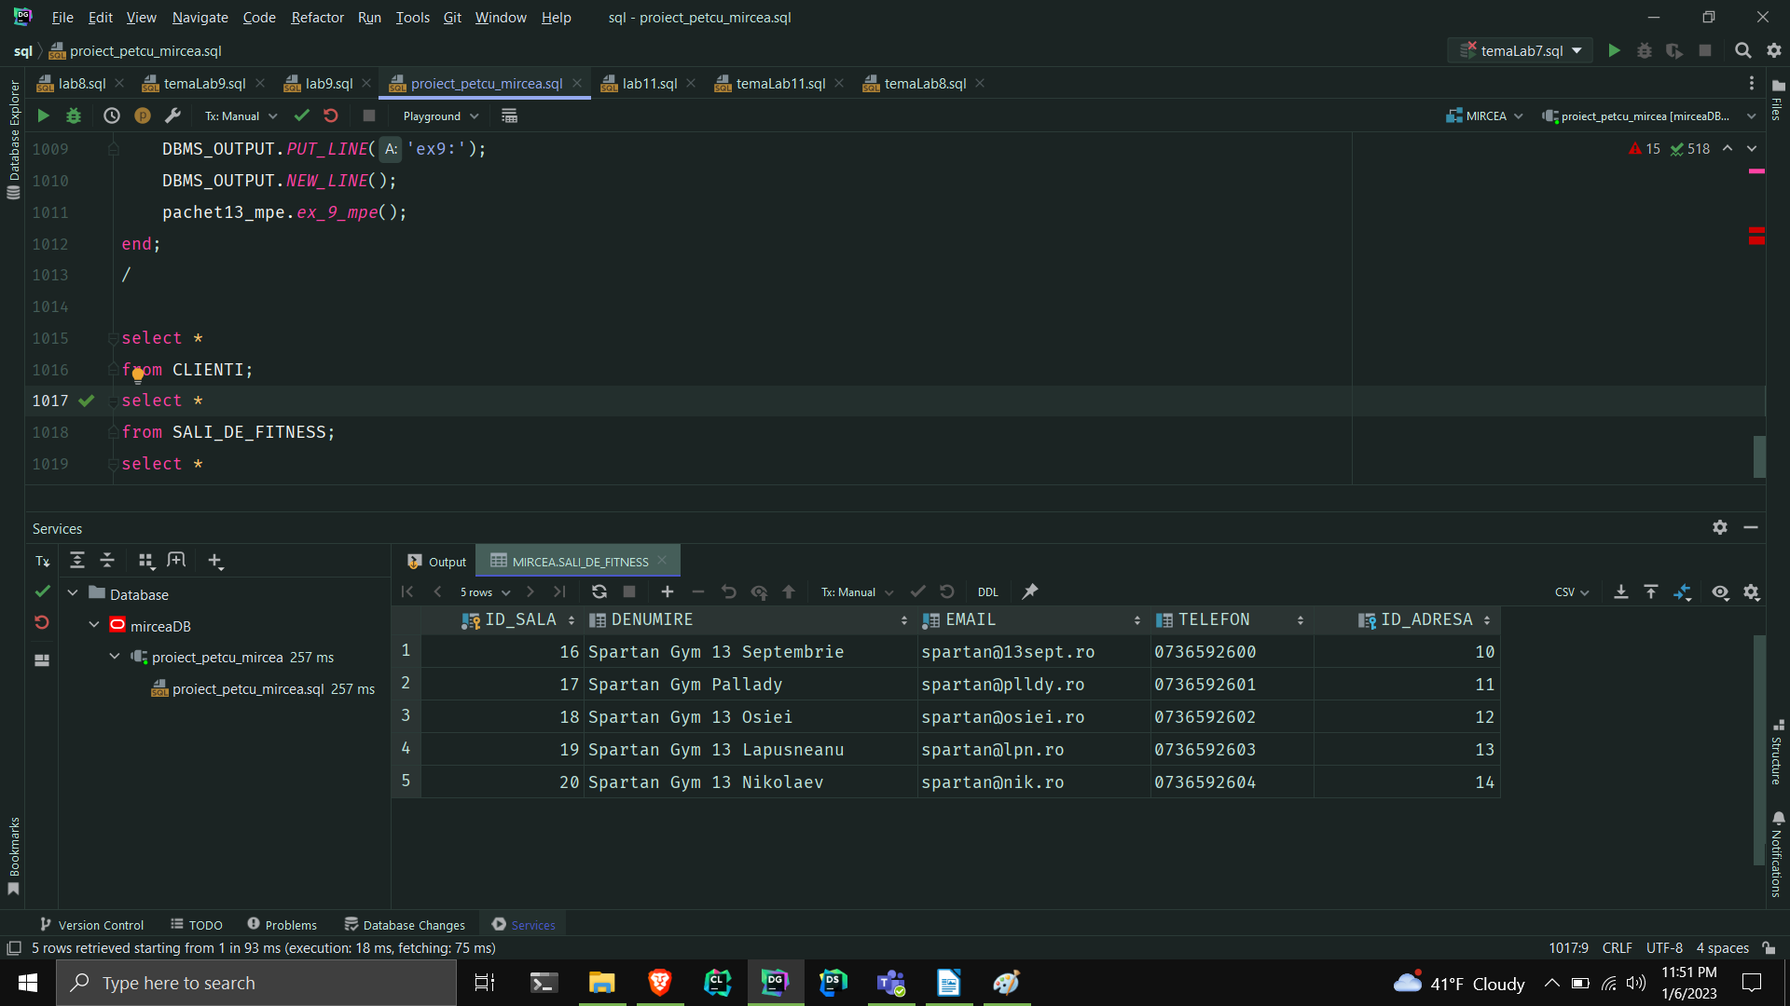
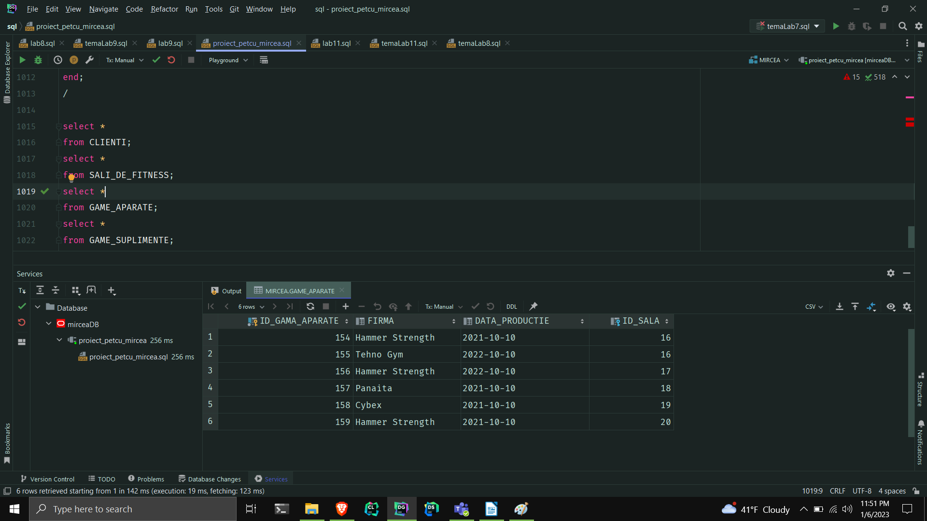
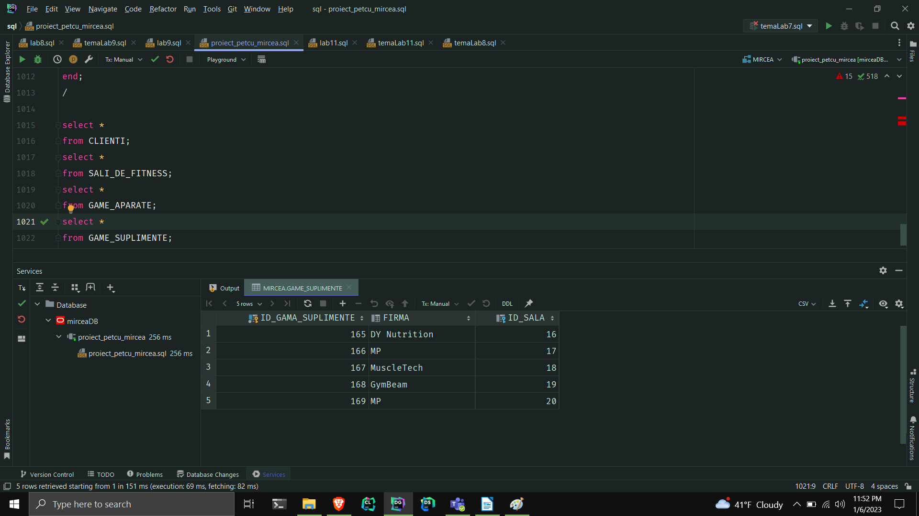
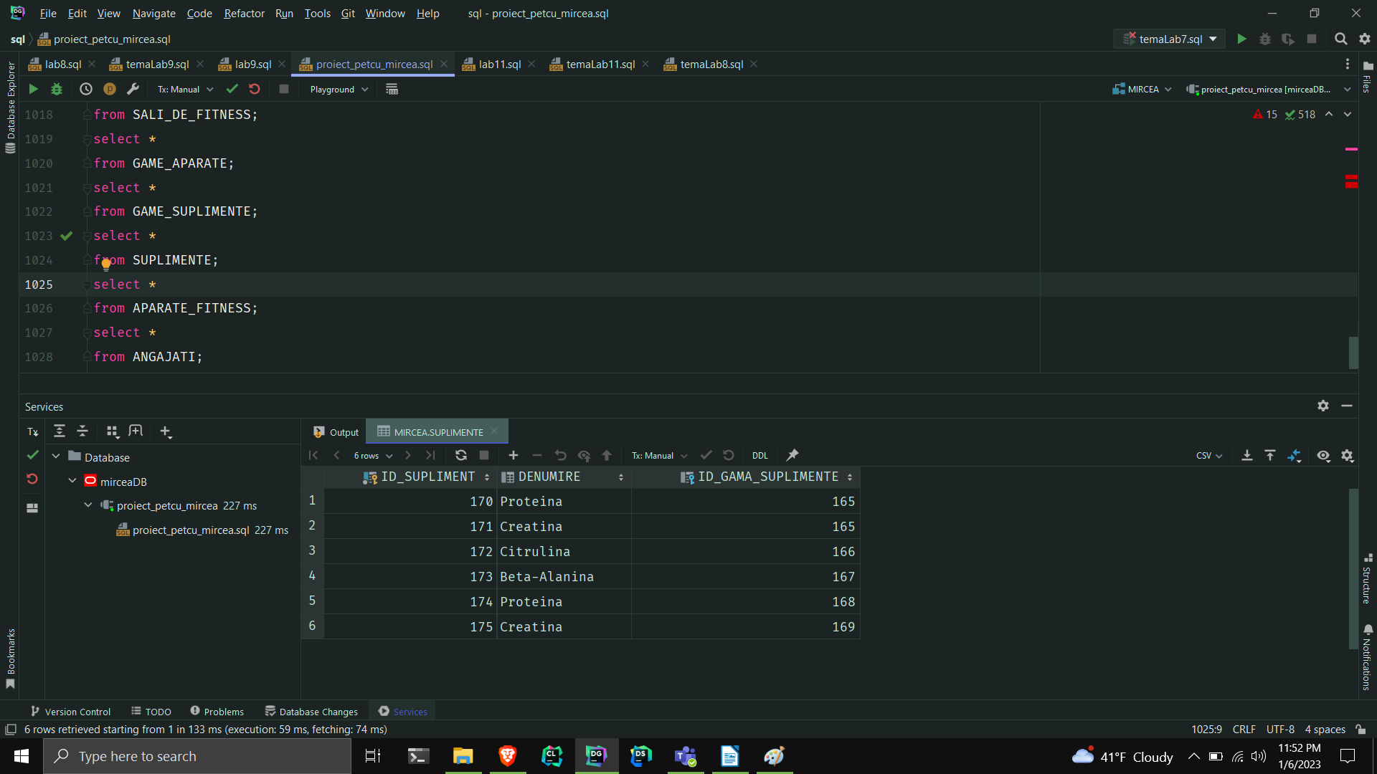
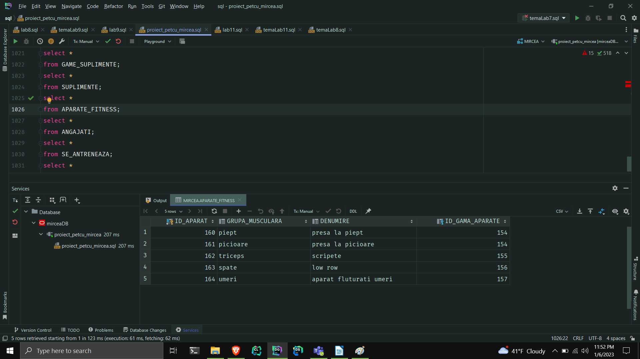
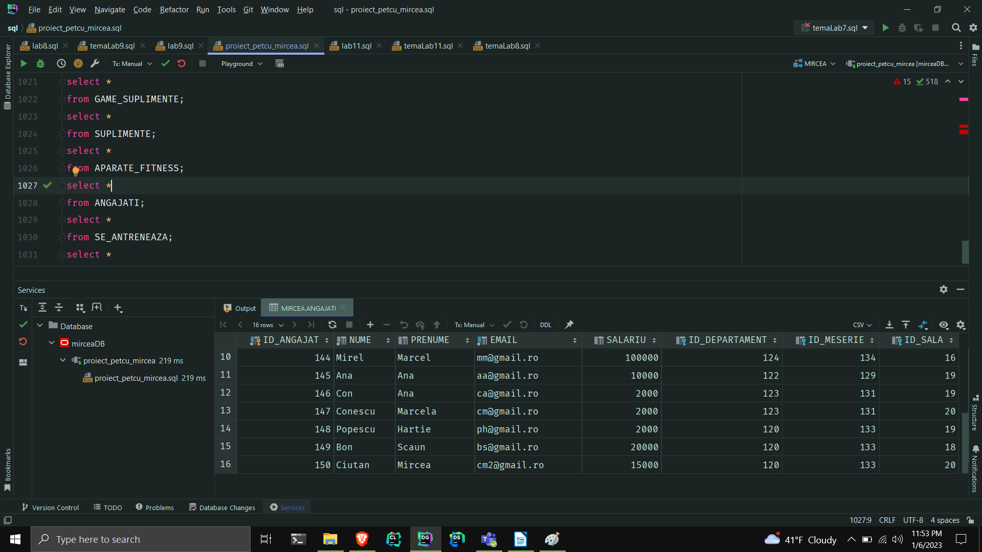
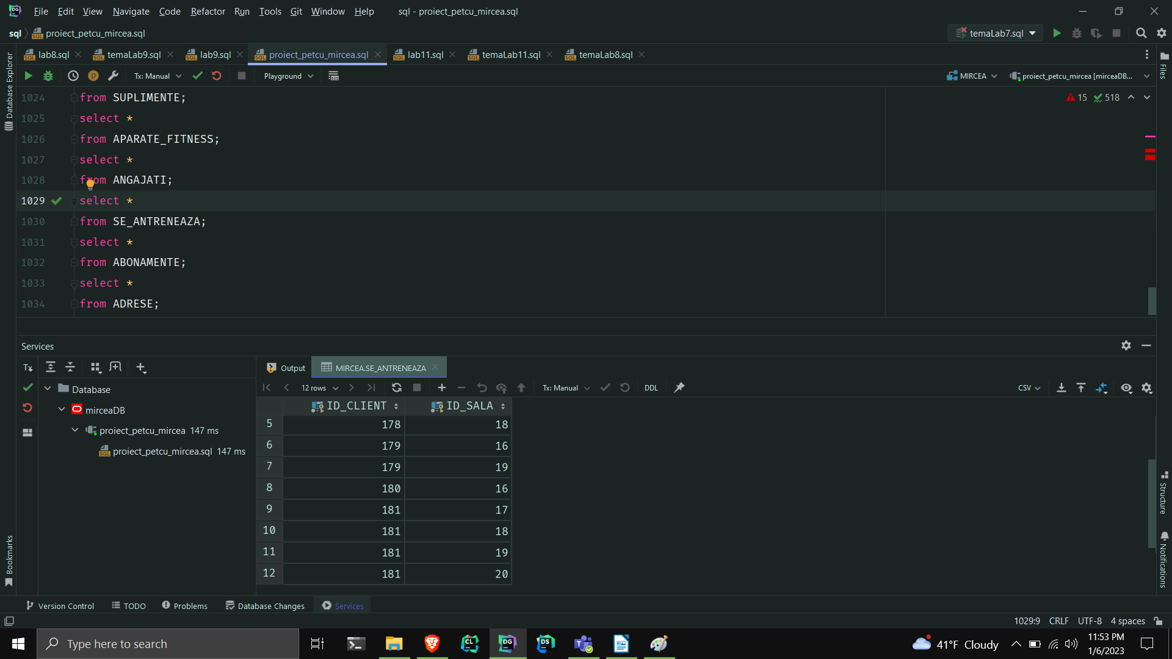
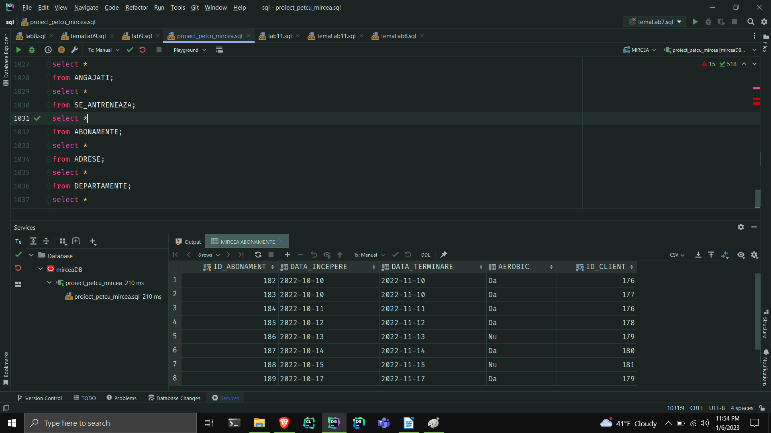
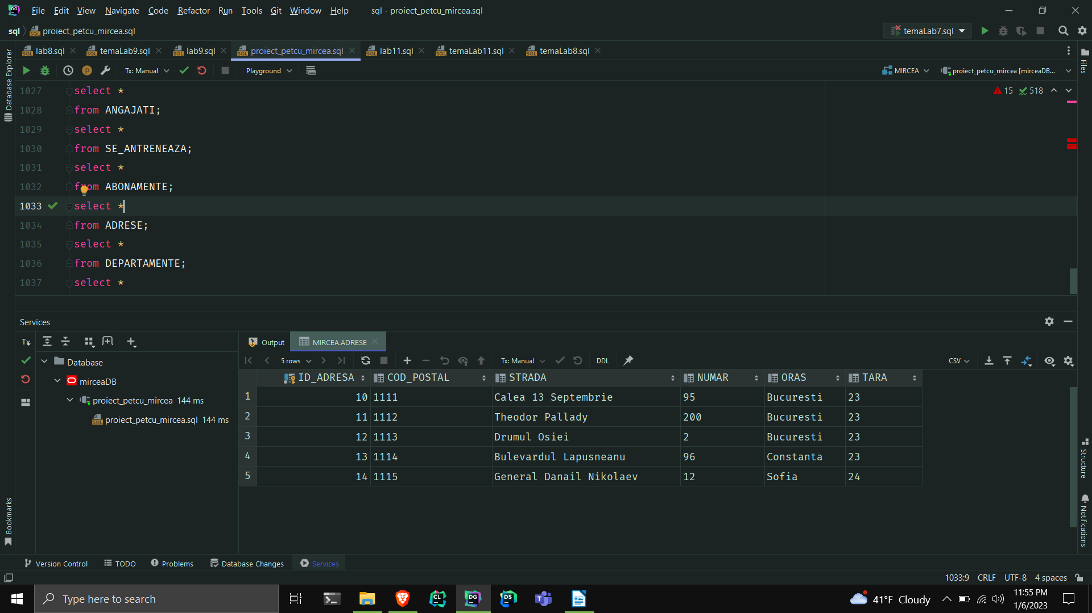
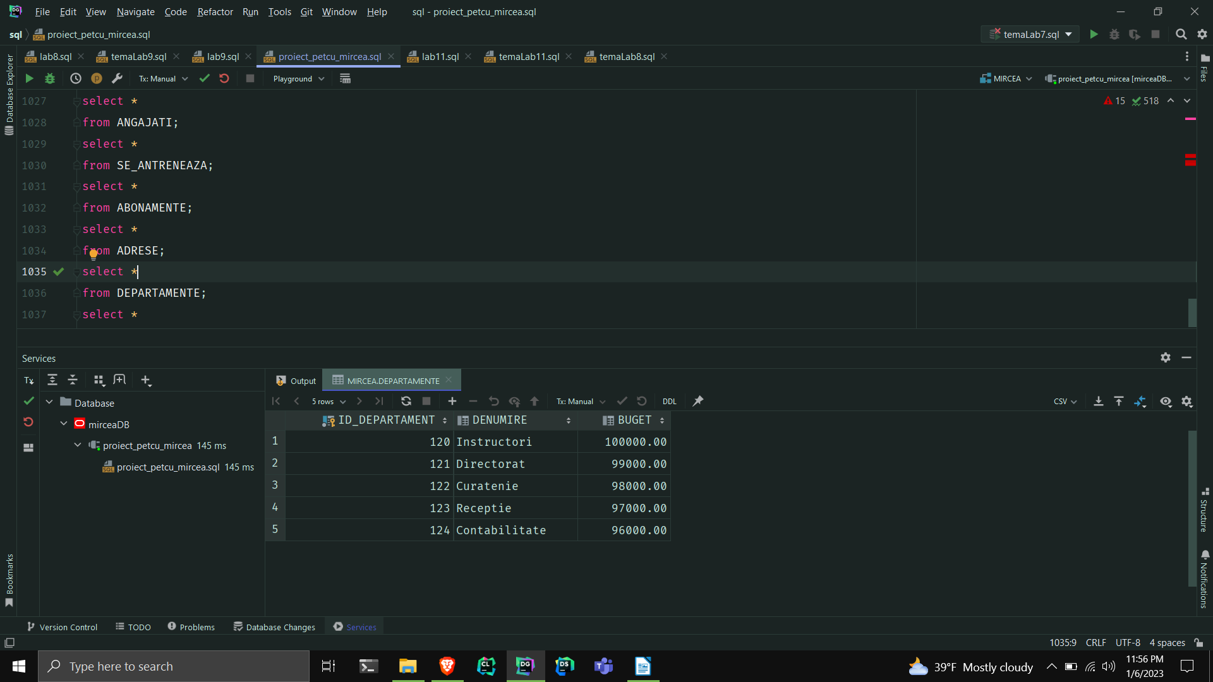
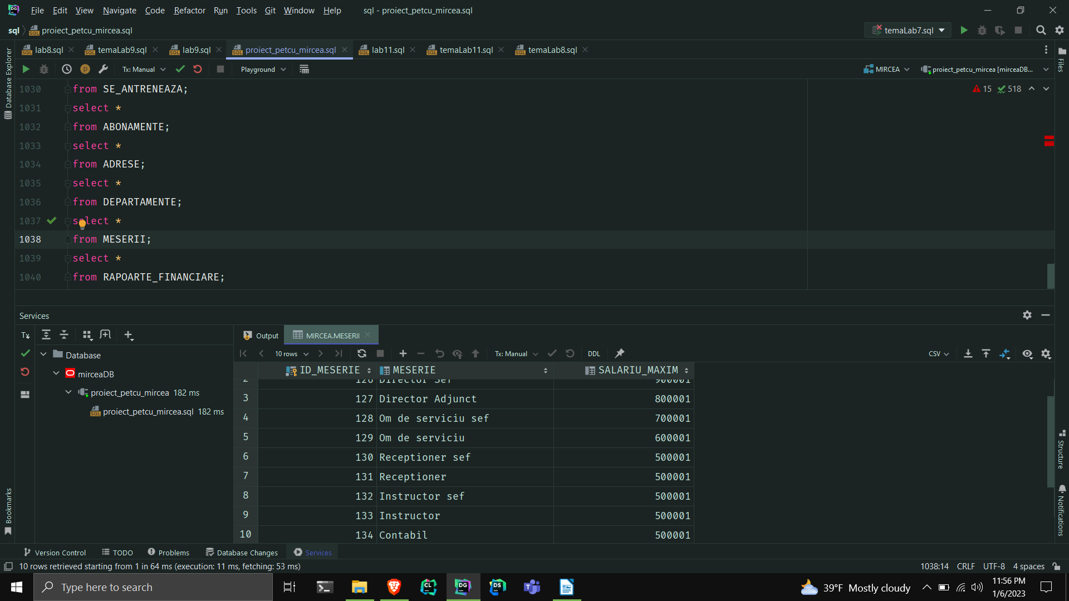
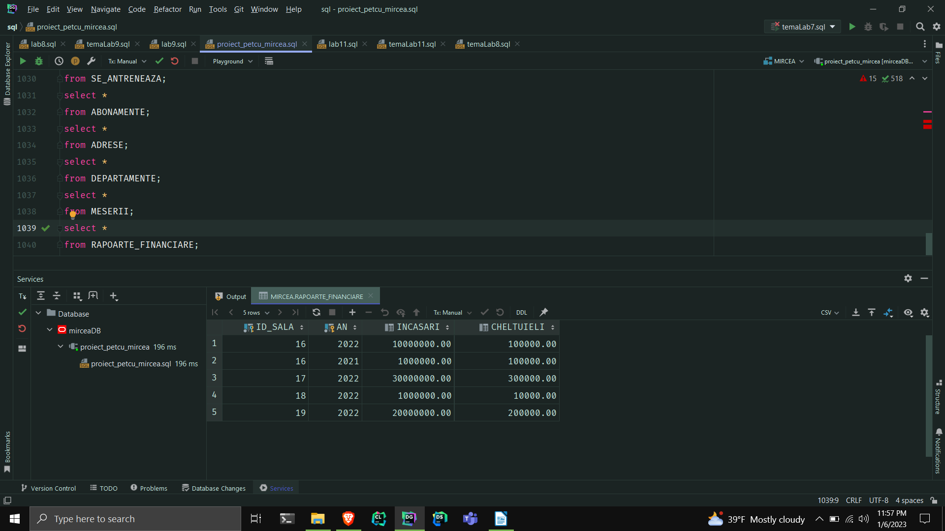
5.Adăugați informații coerente în tabelele create (minim 5 înregistrări pentru fiecare entitate independentă; minim 10 înregistrări pentru tabela asociativă).

--inserare in tabele
------------------------adrese------------------------------
insert into ADRESE
values (sala_fitness_seq.nextval, '1111', 'Calea 13 Septembrie', '95', 'Bucuresti', 23);
insert into ADRESE
values (sala_fitness_seq.nextval, '1112', 'Theodor Pallady', '200', 'Bucuresti', 23);
insert into ADRESE
values (sala_fitness_seq.nextval, '1113', 'Drumul Osiei', '2', 'Bucuresti', 23);
insert into ADRESE
values (sala_fitness_seq.nextval, '1114', 'Bulevardul Lapusneanu', '96', 'Constanta', 23);
insert into ADRESE
values (sala_fitness_seq.nextval, '1115', 'General Danail Nikolaev', '12', 'Sofia', 24);
select *
from ADRESE;
------------------------sali_de_fitness---------------------------------
insert into SALI_DE_FITNESS
values (sala_fitness_seq.nextval, 'Spartan Gym 13 Septembrie', 'spartan@13sept.ro', '0736592600', 10);
insert into SALI_DE_FITNESS
values (sala_fitness_seq.nextval, 'Spartan Gym Pallady', 'spartan@plldy.ro', '0736592601', 11);
insert into SALI_DE_FITNESS
values (sala_fitness_seq.nextval, 'Spartan Gym 13 Osiei', 'spartan@osiei.ro', '0736592602', 12);
insert into SALI_DE_FITNESS
values (sala_fitness_seq.nextval, 'Spartan Gym 13 Lapusneanu', 'spartan@lpn.ro', '0736592603', 13);
insert into SALI_DE_FITNESS
values (sala_fitness_seq.nextval, 'Spartan Gym 13 Nikolaev', 'spartan@nik.ro', '0736592604', 14);
select *
from SALI_DE_FITNESS;
--------------------------departamente----------------------
insert into DEPARTAMENTE
values (sala_fitness_seq.nextval, 'Instructori');
insert into DEPARTAMENTE
values (sala_fitness_seq.nextval, 'Directorat');
insert into DEPARTAMENTE
values (sala_fitness_seq.nextval, 'Curatenie');
insert into DEPARTAMENTE
values (sala_fitness_seq.nextval, 'Receptie');
insert into DEPARTAMENTE
values (sala_fitness_seq.nextval, 'Contabilitate');
select *
from DEPARTAMENTE;
declare
nr number := 100000;
ordine number := 120;
begin
while ordine < 125
loop
update DEPARTAMENTE
set buget = nr
where id_departament = ordine;
ordine := ordine + 1;
nr := nr - 1000;
end loop;
end;
---------------meserii------------------------
insert into MESERII
values (sala_fitness_seq.nextval, 'Director Sef Principal');
insert into MESERII
values (sala_fitness_seq.nextval, 'Director Sef');
insert into MESERII
values (sala_fitness_seq.nextval, 'Director Adjunct');
insert into MESERII
values (sala_fitness_seq.nextval, 'Om de serviciu sef');
insert into MESERII
values (sala_fitness_seq.nextval, 'Om de serviciu');
insert into MESERII
values (sala_fitness_seq.nextval, 'Receptioner sef');
insert into MESERII
values (sala_fitness_seq.nextval, 'Receptioner');
insert into MESERII
values (sala_fitness_seq.nextval, 'Instructor sef');
insert into MESERII
values (sala_fitness_seq.nextval, 'Instructor');
insert into MESERII
values (sala_fitness_seq.nextval, 'Contabil');
alter table MESERII
drop column salariu_maxim;
select *
from MESERII;
declare
ordine number := 125;
nr number := 1000001;
begin
while ordine < 135
loop
update MESERII
set salariu_maxim = nr
where id_meserie = ordine;
if ordine < 130 then
nr := nr - 100000;
end if;
ordine := ordine + 1;
end loop;
end;
/
---------------angajati-----------------------
insert into ANGAJATI
values (sala_fitness_seq.nextval, 'Petcu', 'Mircea', 'mp2002@gmail.com', 1000000, 121, 125, 16);
insert into ANGAJATI
values (sala_fitness_seq.nextval, 'Ionescu', 'Marcel', 'im@gmail.ro', 100000, 121, 127, 16);
insert into ANGAJATI
values (sala_fitness_seq.nextval, 'Ion', 'Ana', 'ia@gmail.ro', 10000, 122, 128, 16);
insert into ANGAJATI
values (sala_fitness_seq.nextval, 'Bon', 'Ana', 'ba2@gmail.ro', 2000, 122, 129, 17);
insert into ANGAJATI
values (sala_fitness_seq.nextval, 'Bonescu', 'Marcela', 'bm@gmail.ro', 2000, 123, 130, 16);
insert into ANGAJATI
values (sala_fitness_seq.nextval, 'Pop', 'Ana', 'pa@gmail.ro', 2000, 123, 133, 18);
insert into ANGAJATI
values (sala_fitness_seq.nextval, 'Ion', 'Scaun', 'is@gmail.ro', 20000, 124, 132, 16);
insert into ANGAJATI
values (sala_fitness_seq.nextval, 'Scarlet', 'Mircea', 'sm@gmail.ro', 15000, 124, 133, 16);
insert into ANGAJATI
values (sala_fitness_seq.nextval, 'Pletos ', 'Ion', 'pi@gmail.com', 200000, 121, 126, 17);
insert into ANGAJATI
values (sala_fitness_seq.nextval, 'Mirel', 'Marcel', 'mm@gmail.ro', 100000, 124, 134, 16);
insert into ANGAJATI
values (sala_fitness_seq.nextval, 'Ana', 'Ana', 'aa@gmail.ro', 10000, 122, 129, 19);
insert into ANGAJATI
values (sala_fitness_seq.nextval, 'Con', 'Ana', 'ca@gmail.ro', 2000, 123, 131, 19);
insert into ANGAJATI
values (sala_fitness_seq.nextval, 'Conescu', 'Marcela', 'cm@gmail.ro', 2000, 123, 131, 20);
insert into ANGAJATI
values (sala_fitness_seq.nextval, 'Popescu', 'Hartie', 'ph@gmail.ro', 2000, 120, 133, 19);
insert into ANGAJATI
values (sala_fitness_seq.nextval, 'Bon', 'Scaun', 'bs@gmail.ro', 20000, 120, 133, 18);
insert into ANGAJATI
values (sala_fitness_seq.nextval, 'Ciutan', 'Mircea', 'cm2@gmail.ro', 15000, 120, 133, 20);
----------------------------rapoarte_financiare-------------------------------
select *
from SALI_DE_FITNESS;
insert into RAPOARTE_FINANCIARE
values (16, 2022, 10000000, 100000);
insert into RAPOARTE_FINANCIARE
values (16, 2021, 1000000, 100000);
insert into RAPOARTE_FINANCIARE
values (17, 2022, 30000000, 300000);
insert into RAPOARTE_FINANCIARE
values (18, 2022, 1000000, 10000);
insert into RAPOARTE_FINANCIARE
values (19, 2022, 20000000, 200000);
select *
from RAPOARTE_FINANCIARE;
----------------------------gama_aparate---------------------------------------
insert into GAME_APARATE
values (sala_fitness_seq.nextval, 'Hammer Strength', to_date('10-10-2021', 'DD-MM-YYYY'), 16);
insert into GAME_APARATE
values (sala_fitness_seq.nextval, 'Tehno Gym', to_date('10-10-2022', 'DD-MM-YYYY'), 16);
insert into GAME_APARATE
values (sala_fitness_seq.nextval, 'Hammer Strength', to_date('10-10-2022', 'DD-MM-YYYY'), 17);
insert into GAME_APARATE
values (sala_fitness_seq.nextval, 'Panaita', to_date('10-10-2021', 'DD-MM-YYYY'), 18);
insert into GAME_APARATE
values (sala_fitness_seq.nextval, 'Cybex', to_date('10-10-2021', 'DD-MM-YYYY'), 19);
insert into GAME_APARATE
values (sala_fitness_seq.nextval, 'Hammer Strength', to_date('10-10-2021', 'DD-MM-YYYY'), 20);
----------------------------aparate_fitness------------------------------------
insert into APARATE_FITNESS
values (sala_fitness_seq.nextval, 'piept', 'presa la piept', 154);
insert into APARATE_FITNESS
values (sala_fitness_seq.nextval, 'picioare', 'presa la picioare', 154);
insert into APARATE_FITNESS
values (sala_fitness_seq.nextval, 'triceps', 'scripete', 155);
insert into APARATE_FITNESS
values (sala_fitness_seq.nextval, 'spate', 'low row', 156);
insert into APARATE_FITNESS
values (sala_fitness_seq.nextval, 'umeri', 'aparat fluturati umeri', 157);
----------------------------gama_suplimente---------------------------------------
insert into GAME_SUPLIMENTE
values (sala_fitness_seq.nextval, 'DY Nutrition', 16);
insert into GAME_SUPLIMENTE
values (sala_fitness_seq.nextval, 'MP', 17);
insert into GAME_SUPLIMENTE
values (sala_fitness_seq.nextval, 'MuscleTech', 18);
insert into GAME_SUPLIMENTE
values (sala_fitness_seq.nextval, 'GymBeam', 19);
insert into GAME_SUPLIMENTE
values (sala_fitness_seq.nextval, 'MP', 20);
select *
from GAME_SUPLIMENTE;
---------------------------------------suplimente--------------------------------
insert into SUPLIMENTE
values (sala_fitness_seq.nextval, 'Proteina', 165);
insert into SUPLIMENTE
values (sala_fitness_seq.nextval, 'Creatina', 165);
insert into SUPLIMENTE
values (sala_fitness_seq.nextval, 'Citrulina', 166);
insert into SUPLIMENTE
values (sala_fitness_seq.nextval, 'Beta-Alanina', 167);
insert into SUPLIMENTE
values (sala_fitness_seq.nextval, 'Proteina', 168);
insert into SUPLIMENTE
values (sala_fitness_seq.nextval, 'Creatina', 169);
-----------------------------clienti-------------------------------------
insert into CLIENTI
values (sala_fitness_seq.nextval, 'Pecul', 'Mircea', 'mp2202@gmail.com');
insert into CLIENTI
values (sala_fitness_seq.nextval, 'Tetul', 'Mircea', 'tp2202@gmail.com');
insert into CLIENTI
values (sala_fitness_seq.nextval, 'Cecul', 'Mirel', 'cp2202@gmail.com');
insert into CLIENTI
values (sala_fitness_seq.nextval, 'Alb', 'Marcek', 'ma2202@gmail.com');
insert into CLIENTI
values (sala_fitness_seq.nextval, 'Qiu', 'Mircea', 'mq2202@gmail.com');
insert into CLIENTI
values (sala_fitness_seq.nextval, 'Ciutul', 'Andrei', 'ca2202@gmail.com');
select *
from CLIENTI
where id_client = 176;
-----------------------se_antreneaza----------------------------------
insert into SE_ANTRENEAZA
values (176, 16);
insert into SE_ANTRENEAZA
values (176, 17);
insert into SE_ANTRENEAZA
values (177, 17);
insert into SE_ANTRENEAZA
values (178, 18);
insert into SE_ANTRENEAZA
values (179, 19);
insert into SE_ANTRENEAZA
values (180, 16);
insert into SE_ANTRENEAZA
values (179, 16);
insert into SE_ANTRENEAZA
values (177, 19);
insert into SE_ANTRENEAZA
values (181, 20);
insert into SE_ANTRENEAZA
values (181, 18);
insert into SE_ANTRENEAZA
values (181, 19);
select *
from SE_ANTRENEAZA;
------------------------abonamente------------------------------
insert into ABONAMENTE
values (sala_fitness_seq.nextval, to_date('10-10-2022', 'dd-mm-yyyy'), to_date('10-11-2022', 'dd-mm-yyyy'), 'Da', 176);
insert into ABONAMENTE
values (sala_fitness_seq.nextval, to_date('10-10-2022', 'dd-mm-yyyy'), to_date('10-11-2022', 'dd-mm-yyyy'), 'Da', 177);
insert into ABONAMENTE
values (sala_fitness_seq.nextval, to_date('11-10-2022', 'dd-mm-yyyy'), to_date('11-11-2022', 'dd-mm-yyyy'), 'Da', 176);
insert into ABONAMENTE
values (sala_fitness_seq.nextval, to_date('12-10-2022', 'dd-mm-yyyy'), to_date('12-11-2022', 'dd-mm-yyyy'), 'Da', 178);
insert into ABONAMENTE
values (sala_fitness_seq.nextval, to_date('13-10-2022', 'dd-mm-yyyy'), to_date('13-11-2022', 'dd-mm-yyyy'), 'Nu', 179);
insert into ABONAMENTE
values (sala_fitness_seq.nextval, to_date('14-10-2022', 'dd-mm-yyyy'), to_date('14-11-2022', 'dd-mm-yyyy'), 'Da', 180);
insert into ABONAMENTE
values (sala_fitness_seq.nextval, to_date('15-10-2022', 'dd-mm-yyyy'), to_date('15-11-2022', 'dd-mm-yyyy'), 'Nu', 181);
insert into ABONAMENTE
values (sala_fitness_seq.nextval, to_date('17-10-2022', 'dd-mm-yyyy'), to_date('17-11-2022', 'dd-mm-yyyy'), 'Da', 179);

6.Formulați în limbaj natural o problemă pe care să o rezolvați folosind un subprogram stocat independent care să utilizeze două tipuri diferite de colecții studiate. Apelați subprogramul.
-- 6.Formulați în limbaj natural o problemă pe care să orezolvați
-- folosind unsubprogram stocatindependent care să utilizeze douătipuridiferite
-- de colecțiistudiate. Apelați subprogramul.
-- Enunt: Mentineti intr-o colectie toti clientii al caror email se termina cu '.com'. In alta colectie mentineti abonamentel fiecarui dintre ei. Afisati
-- pentru fiecare client abonamentele sale, si nr de abonamente avute sub forma clientul si abonamentele.
create or replace procedure ex_6_mpe
is
type tab_index is table of CLIENTI%rowtype index by pls_integer;
t tab_index;
type arr is varray(100) of ABONAMENTE%rowtype;
v arr := arr();
nr number := 0;
begin
select * bulk collect
into t
from CLIENTI
where email like ('%.com');
for i in t.first..t.LAST
loop
DBMS_OUTPUT.PUT_LINE('clientul cu id-ul : ' || t(i).id_client || ' cu numele si prenumele: ' || t(i).nume ||
' ' || t(i).prenume || ' si emailul: ' || t(i).email);
DBMS_OUTPUT.PUT_LINE('A avut/are abonamentele: ');
DBMS_OUTPUT.NEW_LINE();
select * bulk collect
into v
from ABONAMENTE
where id_client = t(i).id_client;
for i in v.first..v.last
loop
DBMS_OUTPUT.PUT_LINE('abonamentul cu id-ul: ' || v(i).id_abonament || ' data incepere :' ||
v(i).data_incepere || ' data terminare :' || v(i).data_terminare ||
' are aerobic: ' || v(i).aerobic);
end loop;
select count(*)
into nr
from ABONAMENTE
where id_client = t(i).id_client;
DBMS_OUTPUT.PUT_LINE('A avut: ' || nr || ' abonamente.');
DBMS_OUTPUT.NEW_LINE();
end loop;
end ex_6_mpe;
/
-- begin
-- DBMS_OUTPUT.ENABLE();
-- end;
begin
ex_6_mpe(179);
end;
/
select *
from CLIENTI;
select *
from ABONAMENTE;
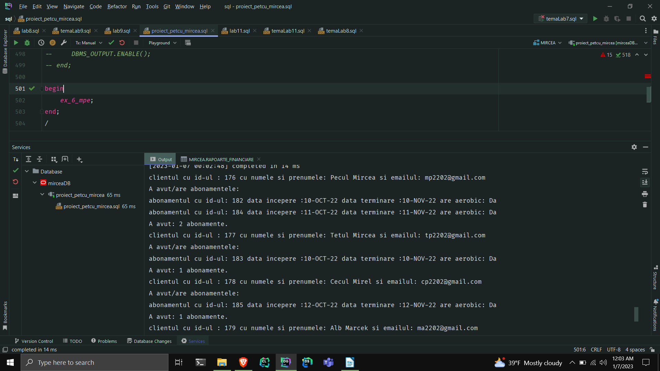
7.Formulați în limbaj natural o problemă pe care să o rezolvați folosind un subprogram stocat independent care să utilizeze 2 tipuri diferite de cursoare studiate, unul dintre acestea fiind cursor parametrizat. Apelați subprogramul.
-- 7. Formulați în limbaj natural o problemă pe care să o rezolvați folosind un subprogram stocat
-- independent care să utilizeze 2 tipuri diferite de cursoare studiate, unul dintre acestea
-- fiind cursor parametrizat. Apelați subprogramul.
-- Enunt: Pentru fiecare sala de fitness ce se afla in Bucuresti gasiti gamele de aparate. Iar pentru fiecare gama
-- de aparate afisati aparatele de fitness(denumirea). Daca nu exista aparate in gama respectiva afisati mesajul: "Din
-- pacate nu are aparate din gama asta." .
create or replace procedure ex7_mpe
is
cursor c(id_gama GAME_APARATE.id_gama_aparate%type) is
select denumire
from APARATE_FITNESS
where id_gama_aparate = id_gama;
type t_denumiri is table of GAME_APARATE.firma%type;
tden t_denumiri;
begin
for i in (select distinct s.id_sala, s.denumire
from SALI_DE_FITNESS s,
ADRESE a
where s.id_adresa = a.id_adresa
and a.oras = 'Bucuresti')
loop
DBMS_OUTPUT.PUT_LINE('Sala cu id-ul: ' || i.id_sala || '; si denumirea: ' || i.denumire ||
'; are urmatoarele game de aparate: ');
for k in (select id_gama_aparate, firma, data_productie
from GAME_APARATE
where id_sala = i.id_sala)
loop
DBMS_OUTPUT.PUT_LINE('id: ' || k.id_gama_aparate || '; firma: ' || k.firma ||
'; data productie: ' || k.data_productie ||
'; cu aparatele urmatoare: ');
open c(k.id_gama_aparate);
fetch c bulk collect into tden;
loop
if tden.COUNT = 0 then
DBMS_OUTPUT.PUT_LINE('Din pacate nu are aparate din gama asta.');
else
for j in tden.FIRST..tden.LAST
loop
DBMS_OUTPUT.PUT_LINE(' Aparat: ' || tden(j));
end loop;
end if;
exit when c%notfound;
end loop;
close c;
end loop;
end loop;
end ex7_mpe;
/
begin
ex7_mpe;
end;
/

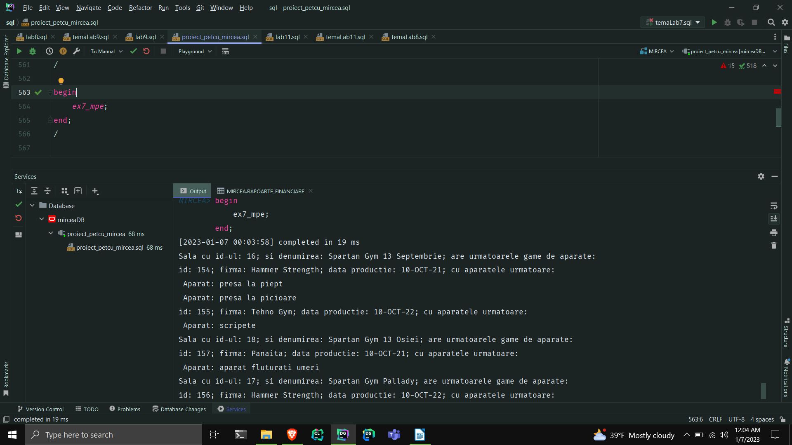
8.Formulați în limbaj natural o problemă pe care să o rezolvați folosind un subprogram stocat independent de tip funcție care să utilizeze într-o singură comandă SQL 3 dintre tabelele definite. Definiți minim 2 excepții. Apelați subprogramul astfel încât să evidențiați toate cazurile tratate.
-- 8.Formulați în limbaj natural o problemă pe care să o rezolvați folosind un subprogram stocat
-- independent de tip funcție care să utilizeze într-o singură comandă SQL 3 dintre tabelele definite.
-- Definiți minim 2 excepții. Apelați subprogramul astfel încât să evidențiați toate cazurile tratate.
-- Enunt: Pentru clientul cu numele dat ca parametru afisati o sala in care se antreneaza. Tratati erorile no_data_found, too_many_rows plus cazul in
-- in care numele nu se da(' ') sau daca numele este 'mircea'.
create or replace function ex8_mpe(nume2 CLIENTI.nume%type)
return varchar2
is
nume_invalid exception ;
nume_interzis exception ;
denumire SALI_DE_FITNESS.denumire%type;
begin
if nume2 = ' ' then
raise nume_invalid;
end if;
if lower(nume2) = 'mircea' then
raise nume_interzis;
end if;
select *
into denumire
from (select s.denumire
from CLIENTI c,
SE_ANTRENEAZA sa,
SALI_DE_FITNESS s
where c.id_client = sa.id_client
and sa.id_sala = s.id_sala
and lower(c.nume) = lower(nume2))
where ROWNUM < 2;
return denumire;
exception
when nume_invalid then
RAISE_APPLICATION_ERROR(-20003,
'Numele este invalid.');
return '';
when nume_interzis then
RAISE_APPLICATION_ERROR(-20004,
'Numele este interzis.');
return '';
WHEN NO_DATA_FOUND THEN
RAISE_APPLICATION_ERROR(-20000,
'Nu exista un client cu numele acesta sau nu merge la nicio sala.');
return '';
WHEN TOO_MANY_ROWS THEN
RAISE_APPLICATION_ERROR(-20001,
'Confuzie. Sunt mai multi clienti cu acelasi nume.');
return '';
WHEN OTHERS THEN
RAISE_APPLICATION_ERROR(-20002, 'Alta eroare!');
return '';
end ex8_mpe;
/
begin
for i in (select nume from CLIENTI)
loop
DBMS_OUTPUT.PUT_LINE('Nume: ' || i.nume || '; Sala: ' || ex8_mpe(i.nume));
end loop;
end;/
begin
DBMS_OUTPUT.PUT_LINE('Nume: Ionescu; Sala: ' || ex8_mpe('Ionescu'));
end;/
begin
DBMS_OUTPUT.PUT_LINE('Nume: ; Sala: ' || ex8_mpe(' '));
end;/
begin
DBMS_OUTPUT.PUT_LINE('Nume: mircea; Sala: ' || ex8_mpe('mircea'));
end;
/

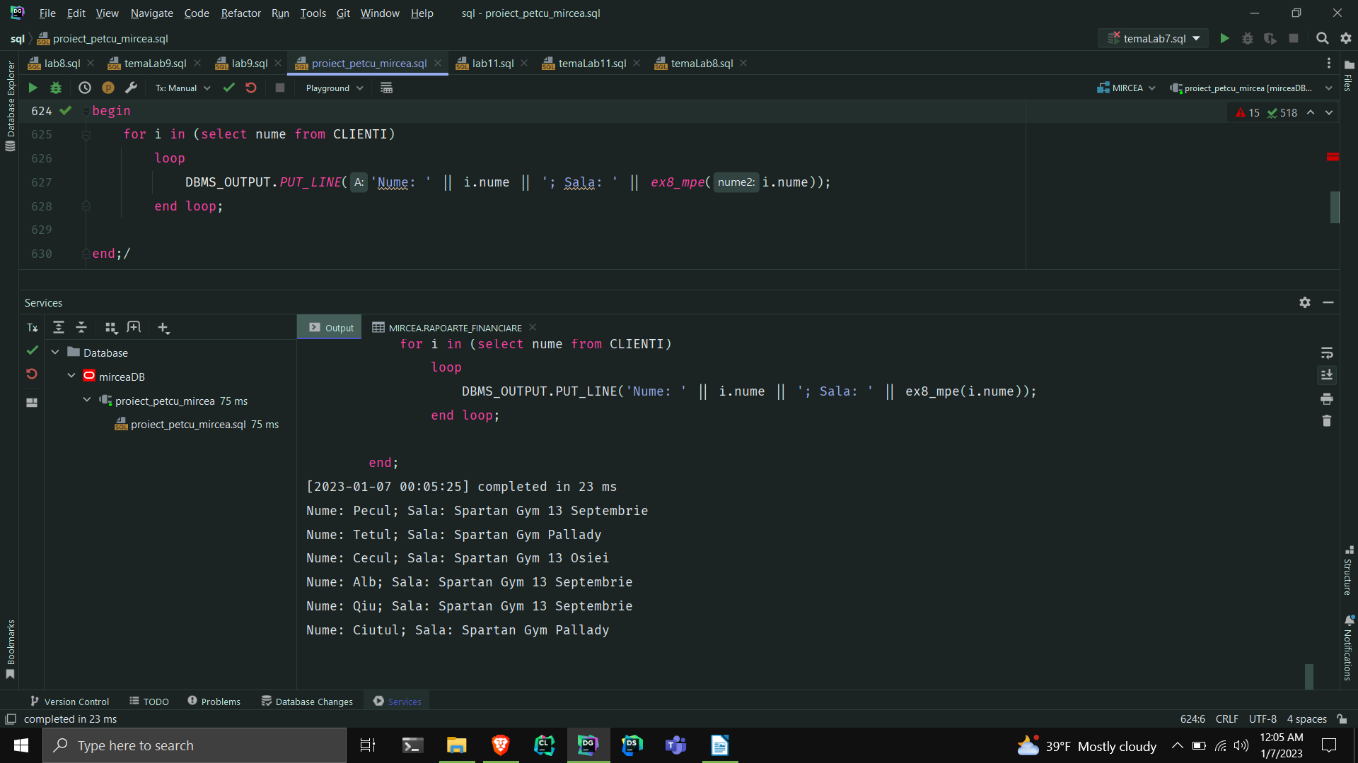
9.Formulați în limbaj natural o problemă pe care să o rezolvați folosind un subprogram stocat independent de tip procedură care să utilizeze într-o singură comandă SQL 5 dintre tabelele definite. Tratați toate excepțiile care pot apărea, incluzând excepțiile NO_DATA_FOUND și TOO_MANY_ROWS. Apelați subprogramul astfel încât să evidențiați toate cazurile tratate.

-- 9.Formulați în limbaj natural o problemă pe care să o rezolvați folosind un subprogram stocat independent
-- de tip procedură care să utilizeze într-o singură comandă SQL 5 dintre tabelele definite. Tratați toate
-- excepțiile care pot apărea, incluzând excepțiile NO_DATA_FOUND și TOO_MANY_ROWS. Apelați subprogramul
-- astfel încât să evidențiați toate cazurile tratate.
--Enunt: Afisati numele, meseria si salariul angajatului cu cel mai mare salariu din departamentul de directorat
-- (daca exista) care lucreaza intr-o sala din Bucuresti. Tratati si cazul cand sunt mai multi angajati ce indeplinesc
-- conditiile date.
create or replace procedure ex_9_mpe
is
mes MESERII.meserie%type;
name ANGAJATI.nume%type;
salary ANGAJATI.salariu%type;
begin
select ag.nume, m.meserie, ag.salariu
into name,mes,salary
from ADRESE a,
SALI_DE_FITNESS s,
ANGAJATI ag,
DEPARTAMENTE d,
MESERII m
where a.id_adresa = s.id_adresa
and s.id_sala = ag.id_sala
and ag.id_departament = d.id_departament
and ag.id_meserie = m.id_meserie
and lower(d.denumire) = 'directorat'
and lower(a.oras) = 'bucuresti'
and ag.salariu = (select max(salariu)
from ANGAJATI,
DEPARTAMENTE
where ANGAJATI.id_departament = DEPARTAMENTE.id_departament
and lower(DEPARTAMENTE.denumire) = 'directorat');
DBMS_OUTPUT.PUT_LINE(name || ' ' || mes || ' ' || salary);
exception
WHEN NO_DATA_FOUND THEN
RAISE_APPLICATION_ERROR(-20000, 'Nu exista angajat care sa indeplineasca conditiile cerute.');
WHEN TOO_MANY_ROWS THEN
RAISE_APPLICATION_ERROR(-20001, 'Sunt mai mult de un angajat care sa indeplineasca conditiile cerute.');
WHEN OTHERS THEN
RAISE_APPLICATION_ERROR(-20002, 'Alta eroare!');
end ex_9_mpe;
/
commit;
begin
ex_9_mpe;
end;
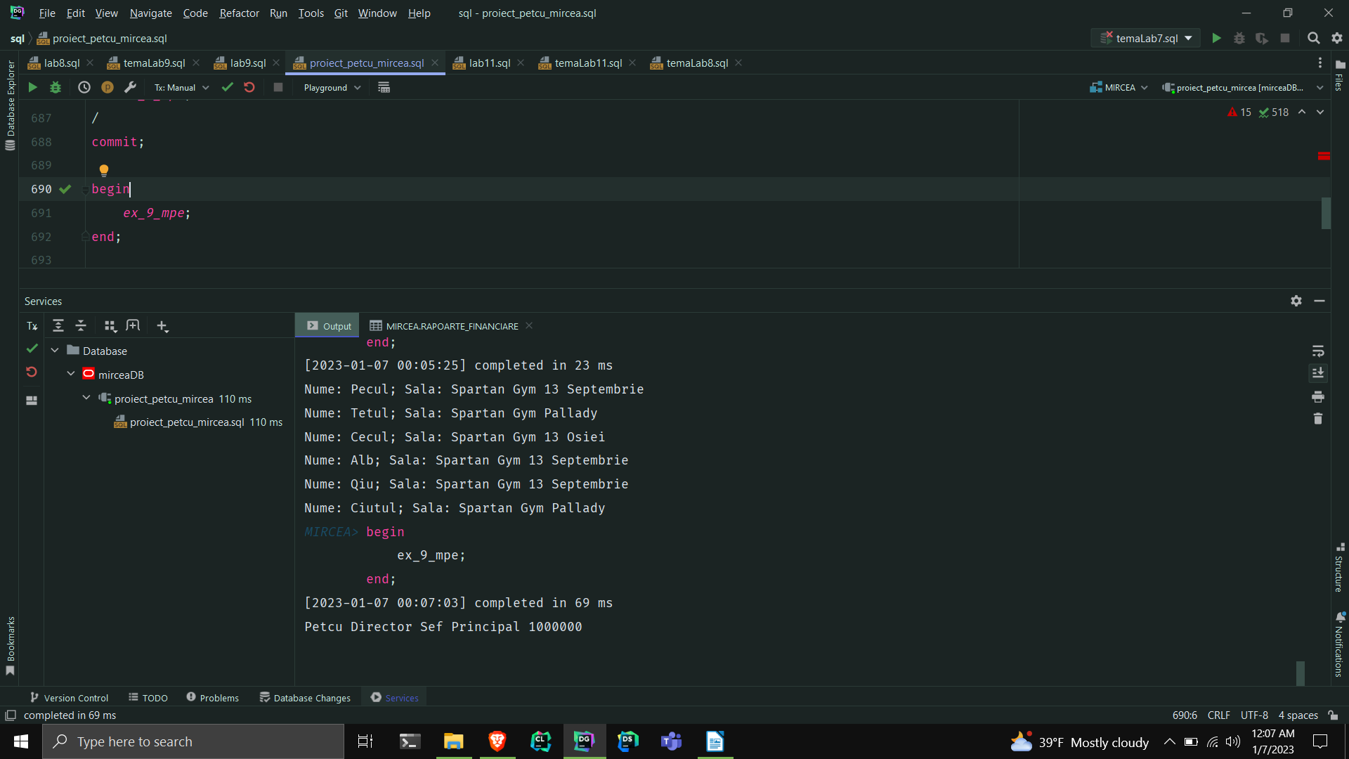
10.Definiți un triggerde tip LMD la nivel de comandă. Declanșați trigger-ul.
-- 10.Definiți un triggerd e tip LMD la nivel de comandă. Declanșați trigger-ul.
-- nu te lasa sa faci update sau sa stergi o sala daca toate salile sunt pe profit in anul curent
create or replace trigger trigger10_mpe
before update or delete
on SALI_DE_FITNESS
declare
type v_profit is varray(100) of number;
vp v_profit;
eroare number := 0;
triger_exception exception ;
begin
select incasari - cheltuieli bulk collect
into vp
from RAPOARTE_FINANCIARE,
SALI_DE_FITNESS s
where s.id_sala = RAPOARTE_FINANCIARE.id_sala
and RAPOARTE_FINANCIARE.an = extract(year from sysdate);
for i in vp.first..vp.LAST
loop
if vp(i) < 0 then
eroare := 1;
end if;
end loop;
if eroare = 0 then
raise triger_exception;
end if;
exception
when triger_exception then
raise_application_error(-20001,
'Tabelul nu poate fi actualizat sau sters din el deoarece toate salile sunt pe profit in anul curent.');
end;
/
update SALI_DE_FITNESS
set denumire = 'Spartan Gym Osiei'
where id_sala =18;
select *
from SALI_DE_FITNESS;

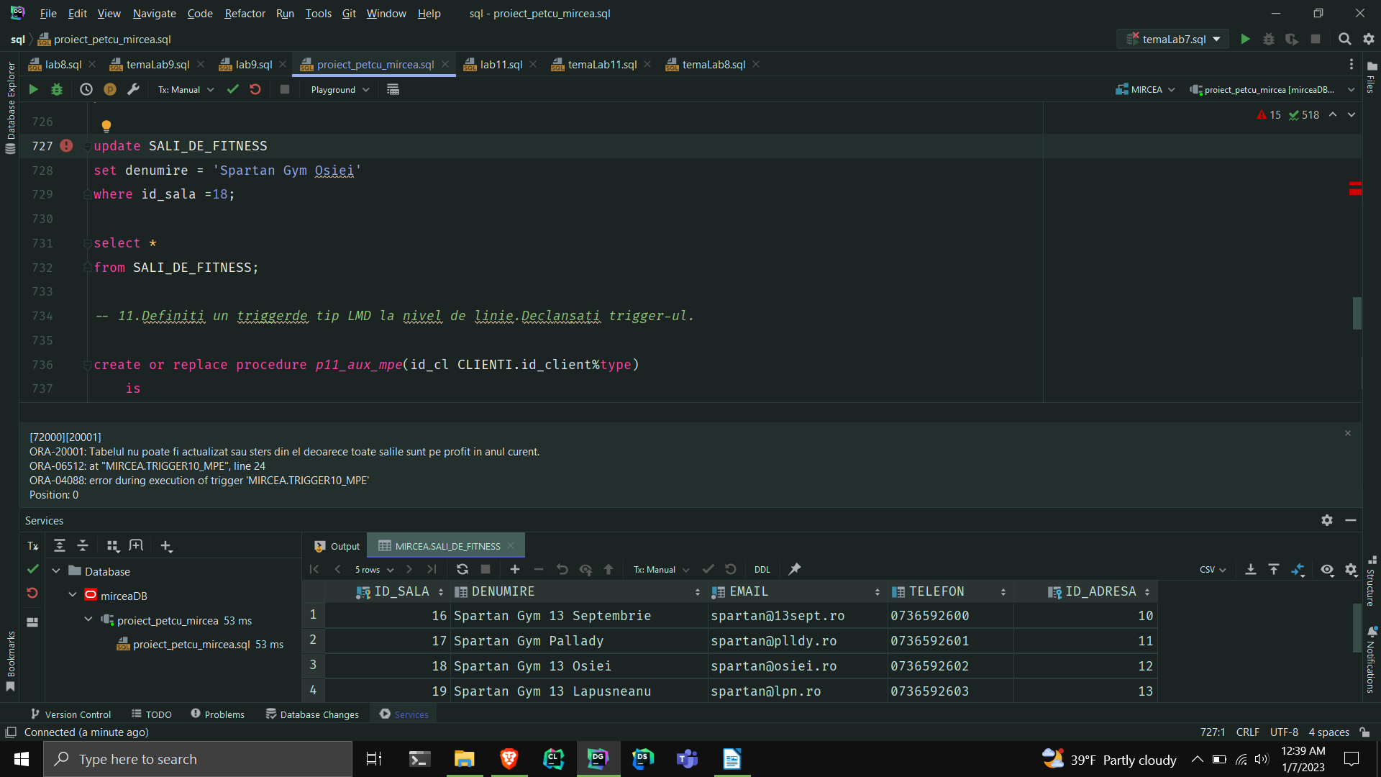
11.Definiți un trigger de tip LMD la nivel de linie. Declanșați trigger-ul.

-- 11.Definiți un triggerde tip LMD la nivel de linie.Declanșați trigger-ul.
--dupa fiecare update pentru prenume, fiecare rand se apeleaza triggerul ce nu te lasa sa-i schimbi prenumele clientului in 'mircea' sau sa fie schimbat in numele clientului.
--altfel ii va prelungi abonamentul automat ,cu ajutorul procedurii, cu o luna.
create or replace procedure p11_aux_mpe(id_cl CLIENTI.id_client%type)
is
begin
update ABONAMENTE
set data_terminare = data_terminare + 30
where id_client = id_cl;
end;
create or replace trigger trigger11_mpe
after update of prenume
on CLIENTI
for each row
declare
ex1 exception ;
begin
if lower(:NEW.prenume) = 'mircea'
then
raise ex1;
end if;
if lower(:NEW.prenume) = lower(:OLD.nume) then
raise_application_error(-20002, 'prenumele nou este acelasi cu numele vechi.');
end if;
if updating then
p11_aux_mpe(:OLD.id_client);
end if;
exception
when ex1 then
raise_application_error(-20001, 'prenumele nu poate fi schimbat.');
end;
/
update CLIENTI
set prenume = 'ionut'
where id_client in (181,180);
rollback;
select *
from CLIENTI;
select *
from ABONAMENTE;

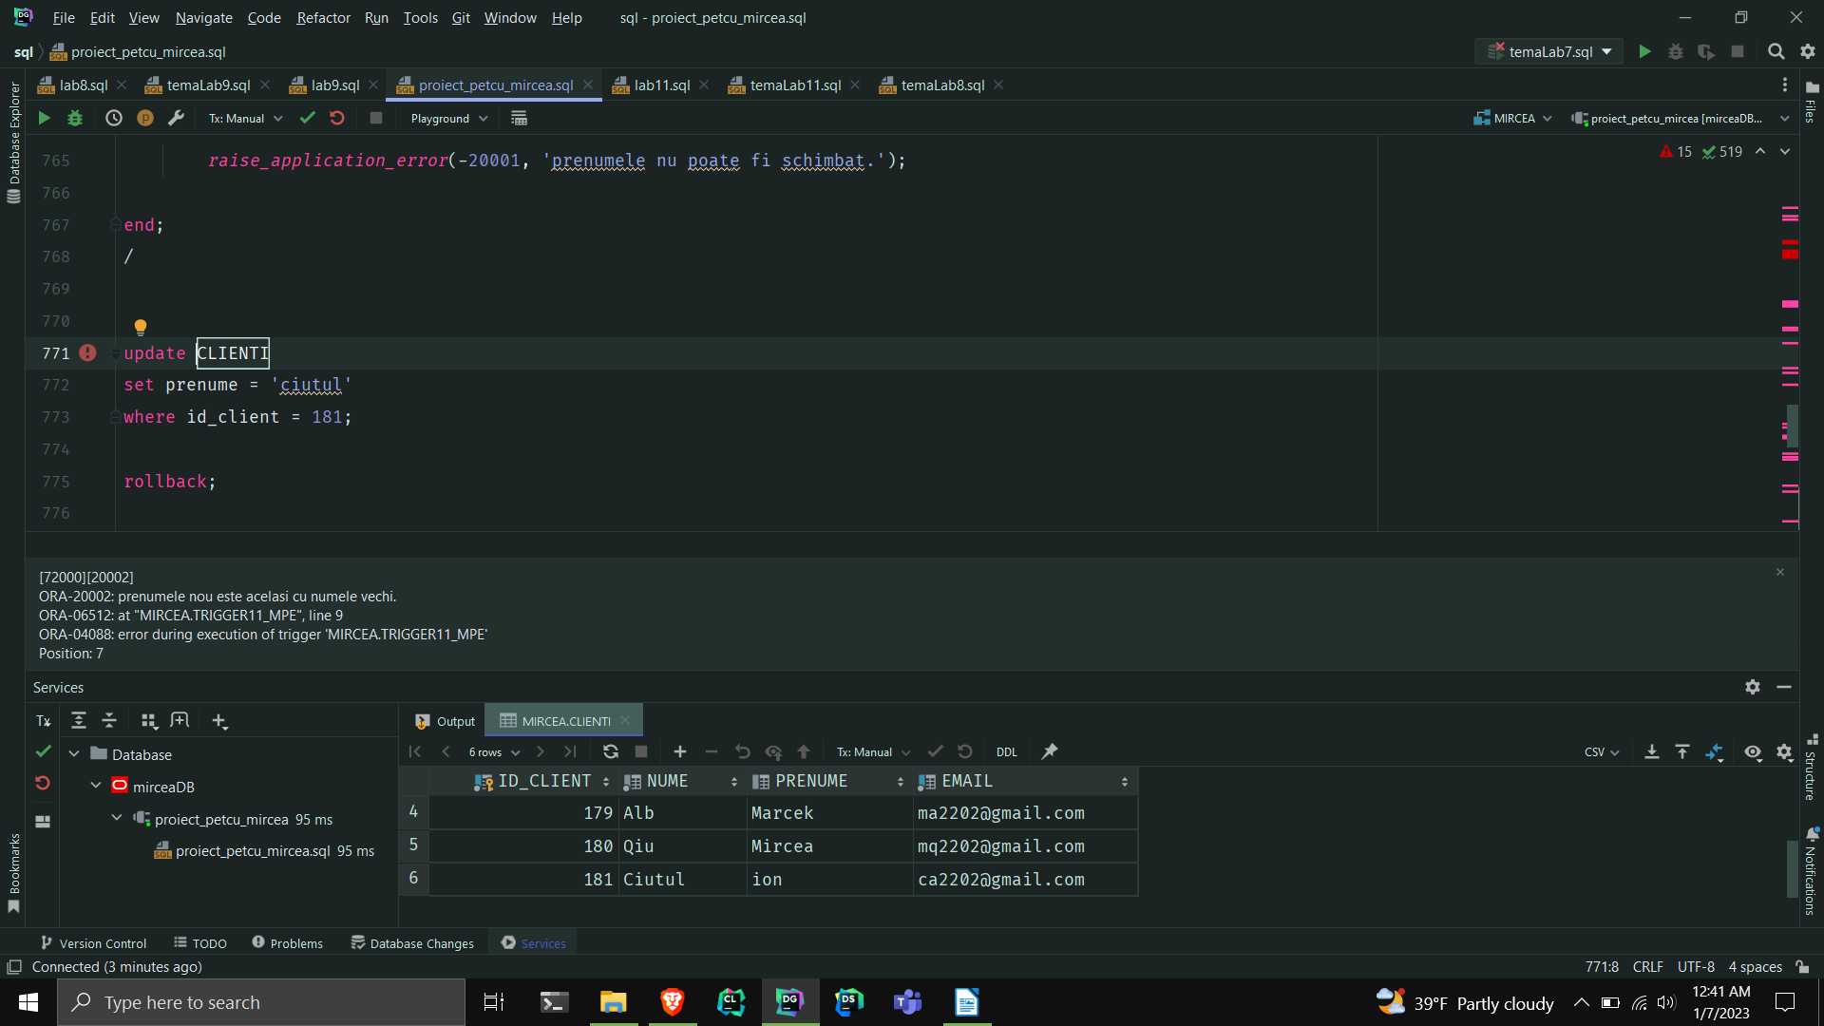
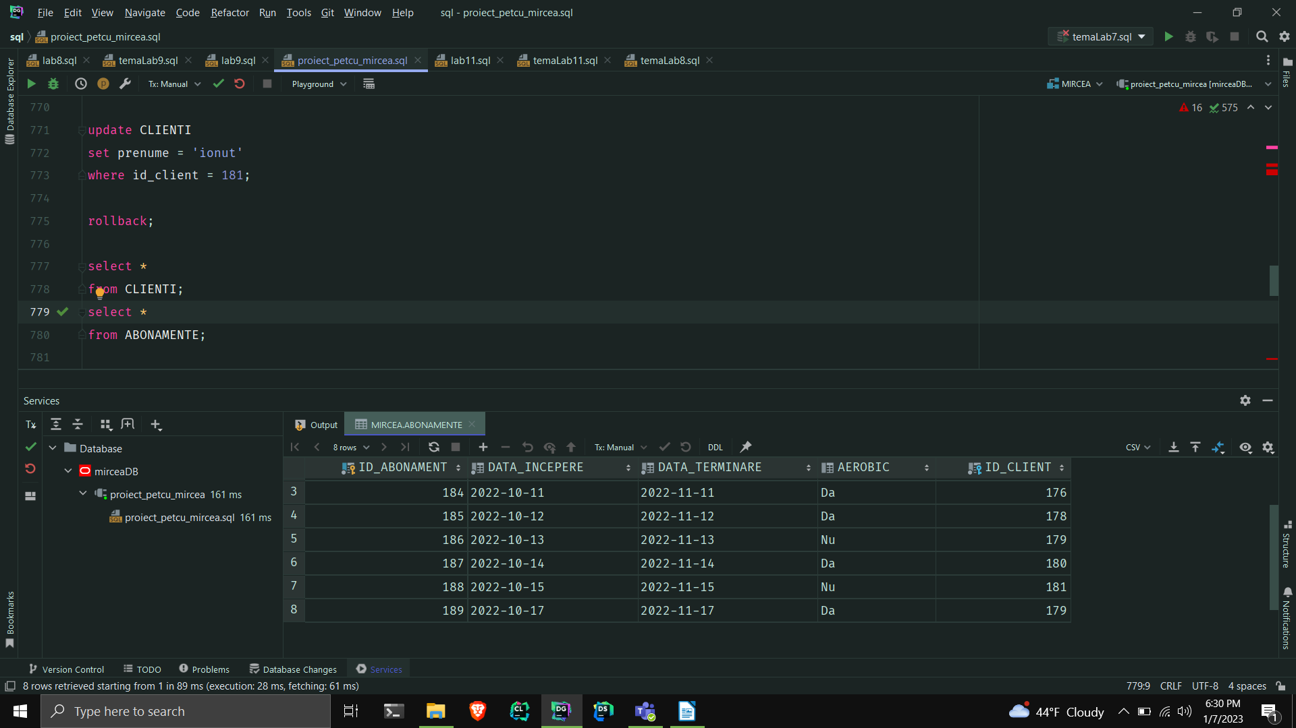
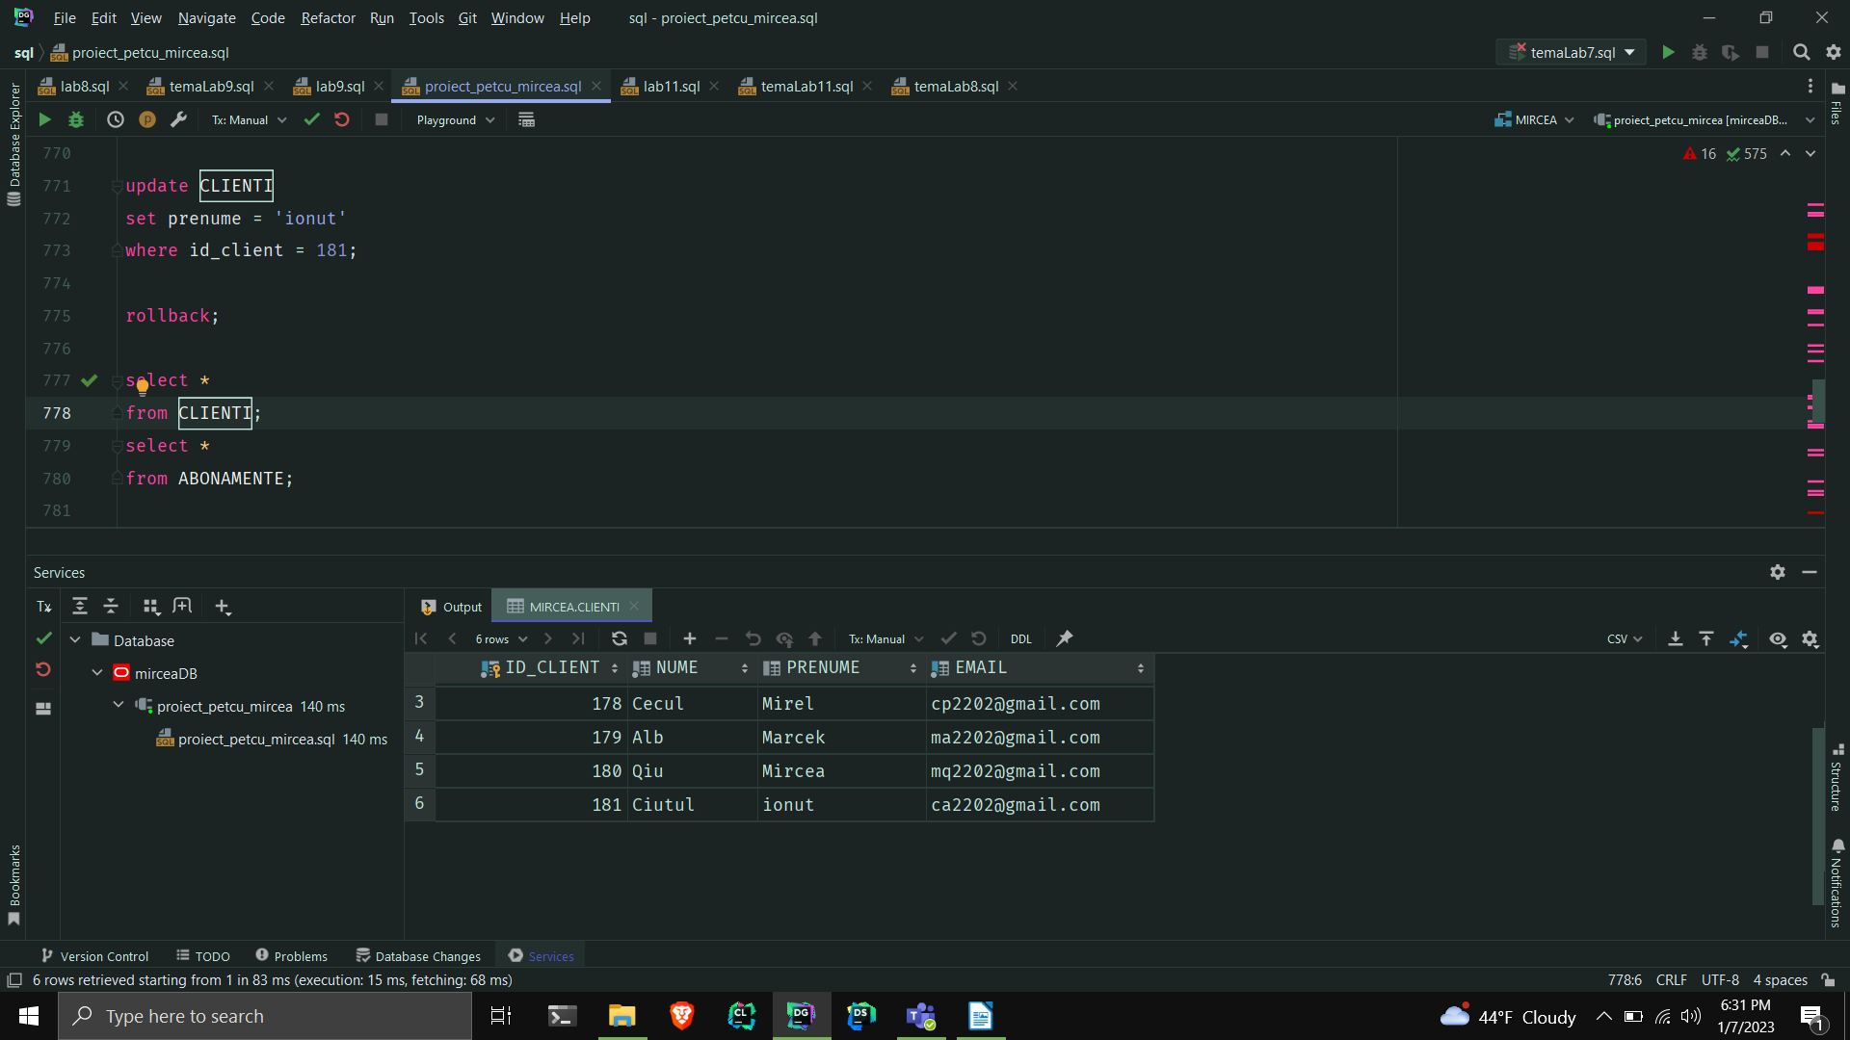
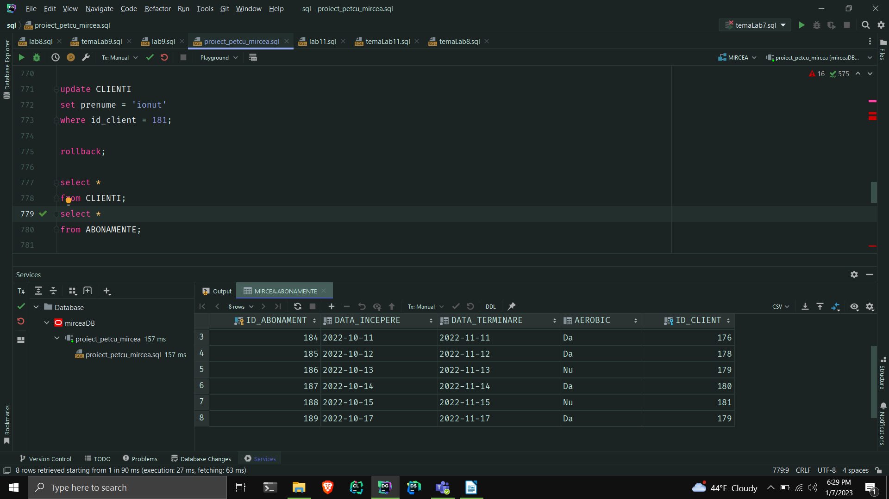
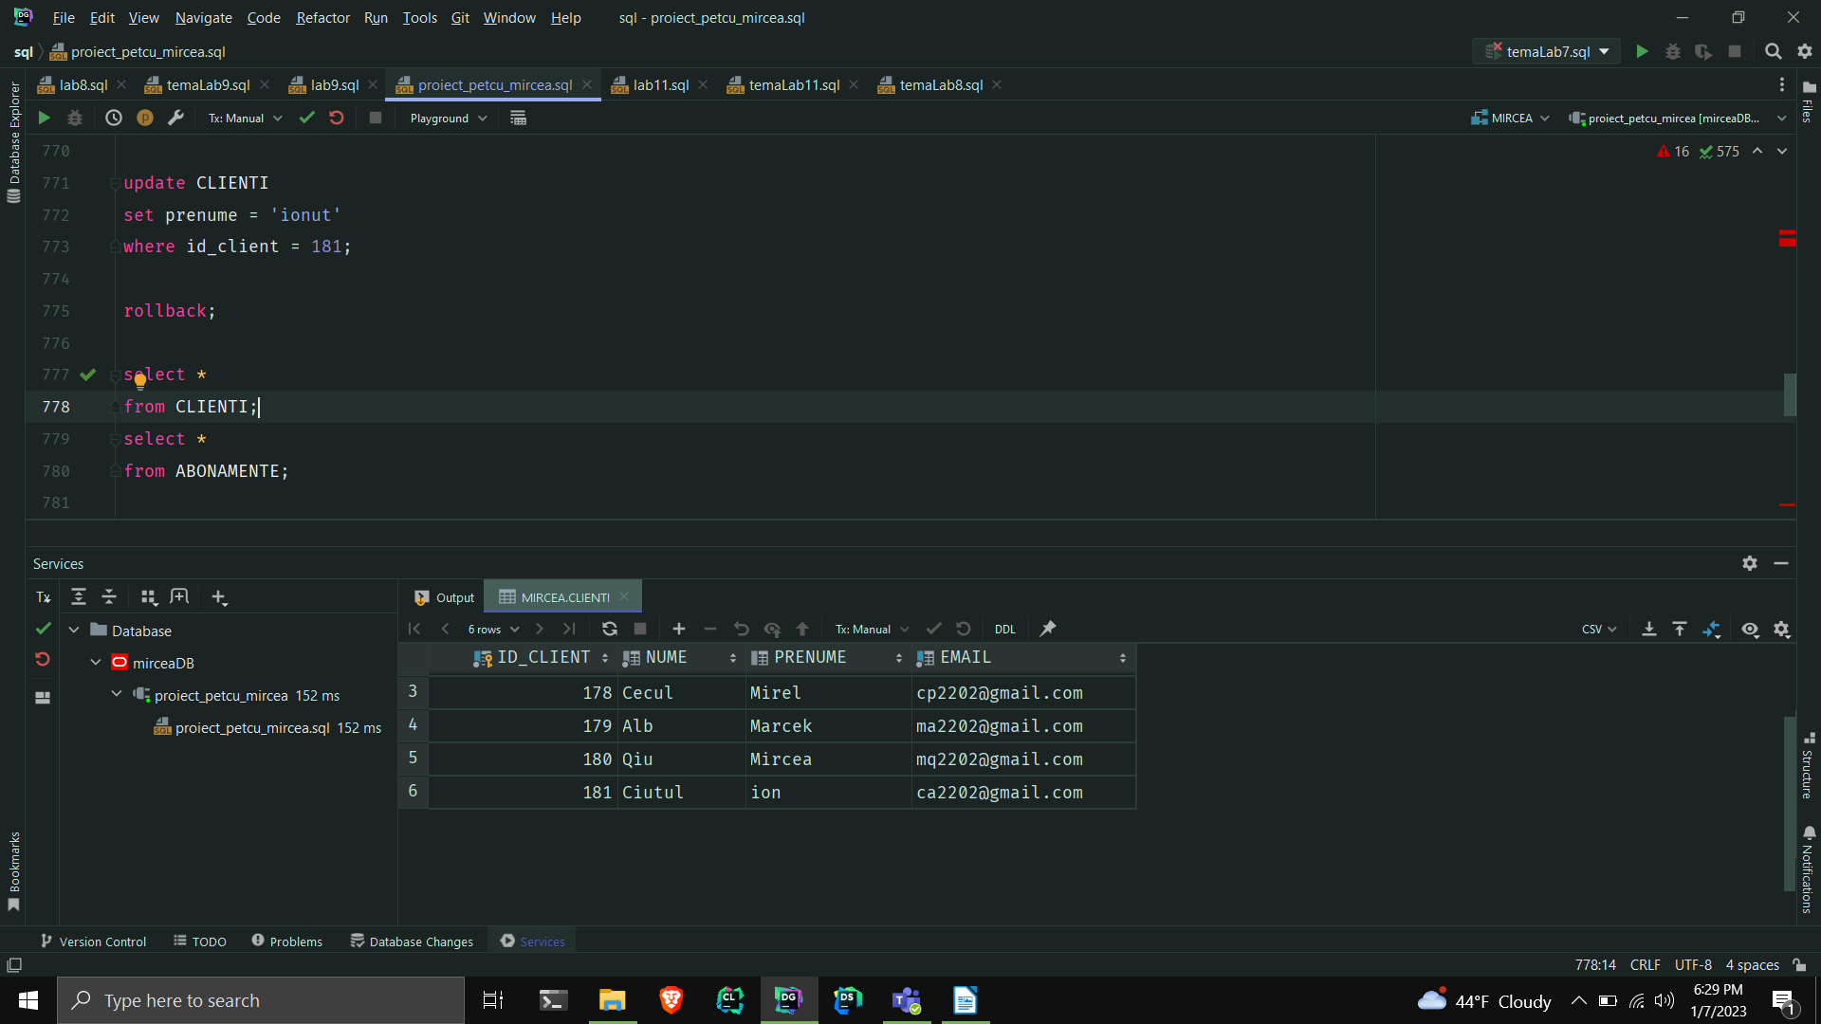
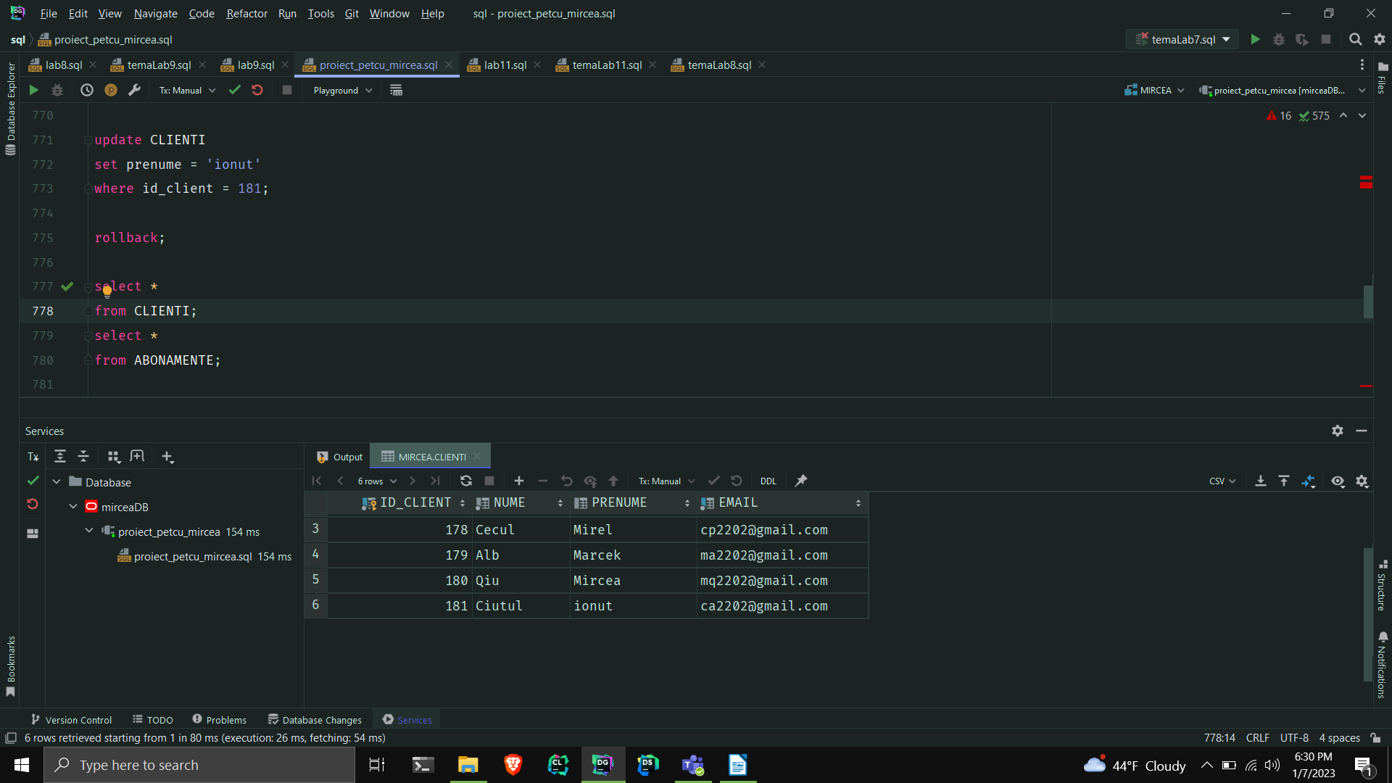
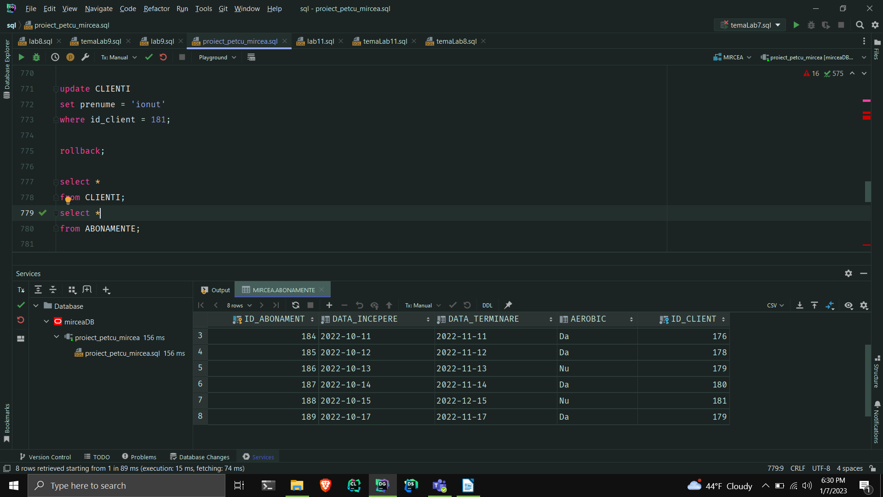
12.Definiți un trigger de tip LDD. Declanșați trigger-ul.
-- 12.Definiți un triggerde tip LDD. Declanșați trigger-ul.
--insereaza in tabelul creat actiuni_ulterioare ,de fiecare data cand se face o operatie LDD, utilizatorul, numele bazei de date, comanda si data actiunii
create table actiuni_ulterioare
(
id_actiune number(6)
constraint pk_1 primary key,
utilizator varchar2(50),
baza_de_date varchar2(50),
eveniment varchar2(50),
data_actiune date
);
create or replace trigger trigger12_mpe
before create or drop or alter
on database
begin
insert into actiuni_ulterioare
values (sala_fitness_seq.nextval, (select user from dual), Sys.DATABASE_NAME, sys.SYSEVENT, sysdate);
DBMS_OUTPUT.PUT_LINE('Utilizatorul norocos: ' || USER);
end;
/
create table mir
(
id_mir number
);
drop table mir;
select *
from actiuni_ulterioare;
commit;

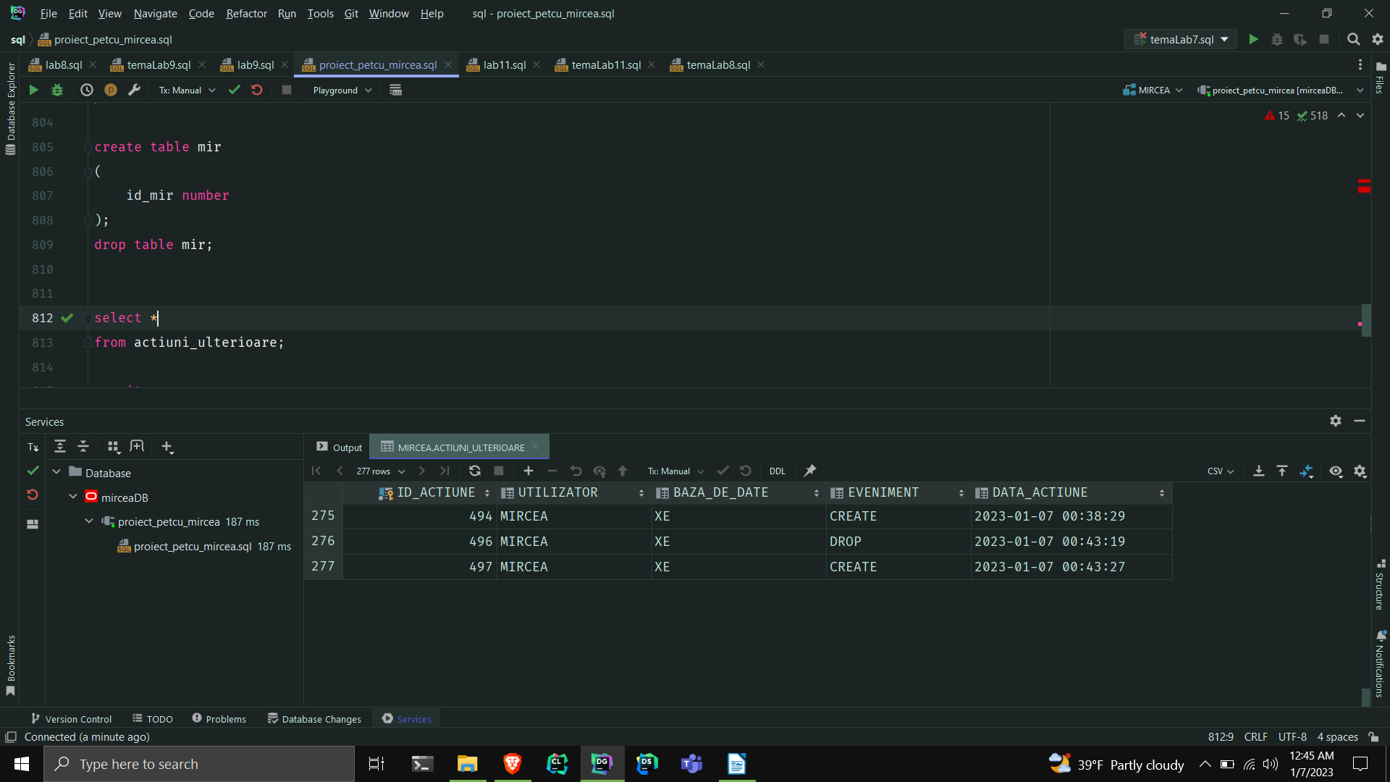
13.Definiți un pachet care să conțină toate obiectele definite în cadrul proiectului.

-- 13.Definiți un pachet care să conțină toate obiectele definite în cadrul proiectului.
create or replace package pachet13_mpe as
procedure ex_6_mpe;
procedure ex7_mpe;
function ex8_mpe(nume2 CLIENTI.nume%type) return varchar2;
procedure ex_9_mpe;
end pachet13_mpe;
------------------------------------------------------
------------------------------------------------------
create or replace package body pachet13_mpe as
procedure ex_6_mpe
is
type tab_index is table of CLIENTI%rowtype index by pls_integer;
t tab_index;
type arr is varray(100) of ABONAMENTE%rowtype;
v arr := arr();
nr number := 0;
begin
select * bulk collect
into t
from CLIENTI
where email like ('%.com');
for i in t.first..t.LAST
loop
DBMS_OUTPUT.PUT_LINE('clientul cu id-ul : ' || t(i).id_client || ' cu numele si prenumele: ' ||
t(i).nume ||
' ' || t(i).prenume || ' si emailul: ' || t(i).email);
DBMS_OUTPUT.PUT_LINE('A avut/are abonamentele: ');
DBMS_OUTPUT.NEW_LINE();
select * bulk collect
into v
from ABONAMENTE
where id_client = t(i).id_client;
for i in v.first..v.last
loop
DBMS_OUTPUT.PUT_LINE('abonamentul cu id-ul: ' || v(i).id_abonament || ' data incepere :' ||
v(i).data_incepere || ' data terminare :' || v(i).data_terminare ||
' are aerobic: ' || v(i).aerobic);
end loop;
select count(*)
into nr
from ABONAMENTE
where id_client = t(i).id_client;
DBMS_OUTPUT.PUT_LINE('A avut: ' || nr || ' abonamente.');
DBMS_OUTPUT.NEW_LINE();
end loop;
end ex_6_mpe;
----------------------------------------------------------------------------
procedure ex7_mpe
is
cursor c(id_gama GAME_APARATE.id_gama_aparate%type) is
select denumire
from APARATE_FITNESS
where id_gama_aparate = id_gama;
type t_denumiri is table of GAME_APARATE.firma%type;
tden t_denumiri;
begin
for i in (select distinct s.id_sala, s.denumire
from SALI_DE_FITNESS s,
ADRESE a
where s.id_adresa = a.id_adresa
and a.oras = 'Bucuresti')
loop
DBMS_OUTPUT.PUT_LINE('Sala cu id-ul: ' || i.id_sala || '; si denumirea: ' || i.denumire ||
'; are urmatoarele game de aparate: ');
for k in (select id_gama_aparate, firma, data_productie
from GAME_APARATE
where id_sala = i.id_sala)
loop
DBMS_OUTPUT.PUT_LINE('id: ' || k.id_gama_aparate || '; firma: ' || k.firma ||
'; data productie: ' || k.data_productie ||
'; cu aparatele urmatoare: ');
open c(k.id_gama_aparate);
fetch c bulk collect into tden;
loop
if tden.COUNT = 0 then
DBMS_OUTPUT.PUT_LINE('Din pacate nu are aparate din gama asta.');
else
for j in tden.FIRST..tden.LAST
loop
DBMS_OUTPUT.PUT_LINE(' Aparat: ' || tden(j));
end loop;
end if;
exit when c%notfound;
end loop;
close c;
end loop;
end loop;
end ex7_mpe;
-------------------------------------------------------------------------------------------
function ex8_mpe(nume2 CLIENTI.nume%type)
return varchar2
is
nume_invalid exception ;
nume_interzis exception ;
denumire SALI_DE_FITNESS.denumire%type;
begin
if nume2 = ' ' then
raise nume_invalid;
end if;
if lower(nume2) = 'mircea' then
raise nume_interzis;
end if;
select *
into denumire
from (select s.denumire
from CLIENTI c,
SE_ANTRENEAZA sa,
SALI_DE_FITNESS s
where c.id_client = sa.id_client
and sa.id_sala = s.id_sala
and lower(c.nume) = lower(nume2))
where ROWNUM < 2;
return denumire;
exception
when nume_invalid then
RAISE_APPLICATION_ERROR(-20003,
'Numele este invalid.');
return '';
when nume_interzis then
RAISE_APPLICATION_ERROR(-20004,
'Numele este interzis.');
return '';
WHEN NO_DATA_FOUND THEN
RAISE_APPLICATION_ERROR(-20000,
'Nu exista un client cu numele acesta sau nu merge la nicio sala.');
return '';
WHEN TOO_MANY_ROWS THEN
RAISE_APPLICATION_ERROR(-20001,
'Confuzie. Sunt mai multi clienti cu acelasi nume.');
return '';
WHEN OTHERS THEN
RAISE_APPLICATION_ERROR(-20002, 'Alta eroare!');
return '';
end ex8_mpe;
------------------------------------------------------------------------------------------------
procedure ex_9_mpe
is
mes MESERII.meserie%type;
name ANGAJATI.nume%type;
salary ANGAJATI.salariu%type;
begin
select ag.nume, m.meserie, ag.salariu
into name,mes,salary
from ADRESE a,
SALI_DE_FITNESS s,
ANGAJATI ag,
DEPARTAMENTE d,
MESERII m
where a.id_adresa = s.id_adresa
and s.id_sala = ag.id_sala
and ag.id_departament = d.id_departament
and ag.id_meserie = m.id_meserie
and lower(d.denumire) = 'directorat'
and lower(a.oras) = 'bucuresti'
and ag.salariu = (select max(salariu)
from ANGAJATI,
DEPARTAMENTE
where ANGAJATI.id_departament = DEPARTAMENTE.id_departament
and lower(DEPARTAMENTE.denumire) = 'directorat');
DBMS_OUTPUT.PUT_LINE(name || ' ' || mes || ' ' || salary);
exception
WHEN NO_DATA_FOUND THEN
RAISE_APPLICATION_ERROR(-20000, 'Nu exista angajat care sa indeplineasca conditiile cerute.');
WHEN TOO_MANY_ROWS THEN
RAISE_APPLICATION_ERROR(-20001, 'Sunt mai mult de un angajat care sa indeplineasca conditiile cerute.');
WHEN OTHERS THEN
RAISE_APPLICATION_ERROR(-20002, 'Alta eroare!');
end ex_9_mpe;
----------------------------------------------------------
end pachet13_mpe;
-------------------------------
begin
DBMS_OUTPUT.PUT_LINE('ex6:');
DBMS_OUTPUT.NEW_LINE();
pachet13_mpe.ex_6_mpe;
DBMS_OUTPUT.PUT_LINE('ex7:');
DBMS_OUTPUT.NEW_LINE();
pachet13_mpe.ex7_mpe;
DBMS_OUTPUT.PUT_LINE('ex8:');
DBMS_OUTPUT.NEW_LINE();
DBMS_OUTPUT.PUT_LINE('Sala: '||pachet13_mpe.ex8_mpe('Ciutul'));
DBMS_OUTPUT.PUT_LINE('ex9:');
DBMS_OUTPUT.NEW_LINE();
pachet13_mpe.ex_9_mpe();
end;
/

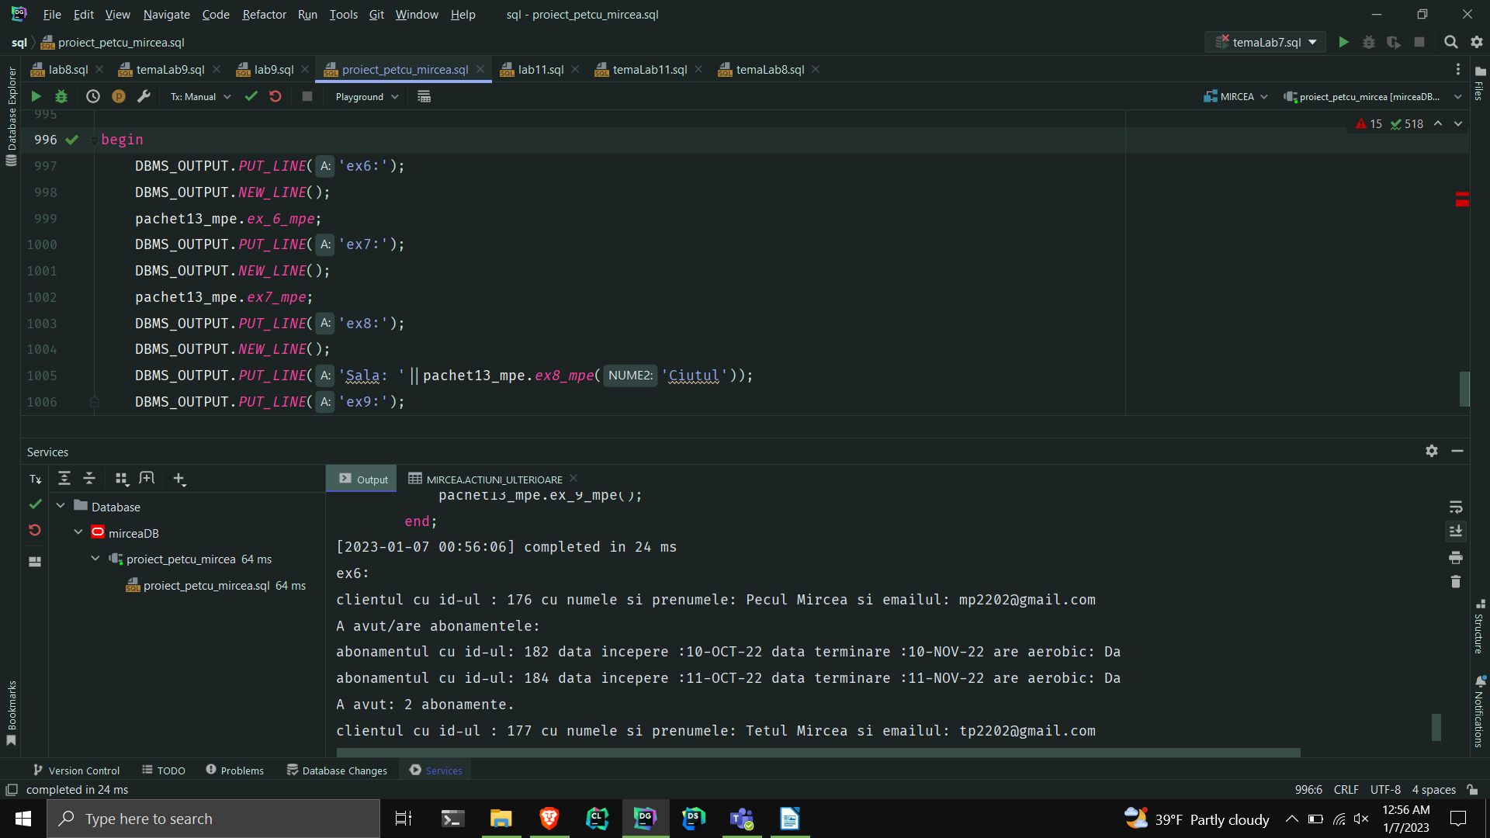
14.Definiți un pachet care să includă tipuri de date complexe și obiecte necesare unui flux deacțiuni integrate, specifice bazei de date definite (minim 2 tipuri de date, minim 2 funcții, minim 2 proceduri).
-- 14.Definiți un pachet care să includă tipuri de date complexe și obiecte necesare unui flux
-- de acțiuni integrate, specifice bazei de date definite (minim 2 tipuri de date, minim 2funcții,
-- minim 2 proceduri).
create or replace package pachet14_mpe is
type t_clienti_sala is table of clienti.nume%type;
type v_top5angajati is varray(5) of angajati.id_angajat%type;
--returneaza ce profit a avut sala primita ca parametru in anul dat ca parametru, daca exista un raport
function f1_14_mpe(sala_id SALI_DE_FITNESS.id_sala%type, anul RAPOARTE_FINANCIARE.an%type)
return number;
--returneaza numarul de clienti ai salii date ca parametru
function f2_14_mpe(sala SALI_DE_FITNESS.id_sala%type) return number;
--afisesaza toti instructorii salii dati ca parametru
procedure p1_14_mpe(sala SALI_DE_FITNESS.id_sala%type);
--afiseaza daca angajatul dat ca parametru castiga mai mult sau nu decat bugetul maxim pentru departamentul sau
procedure p2_14_mpe(angajat ANGAJATI.id_angajat%type);
--afiseaza top 5(daca exista cei mai bine platiti angajati)
procedure p3_14_mpe(sala SALI_DE_FITNESS.id_sala%type);
--afiseaza numele clientilor salii date ca parametru
procedure p4_14_mpe(sala SALI_DE_FITNESS.id_sala%type);
end pachet14_mpe;
create or replace package body pachet14_mpe is
top5angajati v_top5angajati := v_top5angajati();
clienti_sala t_clienti_sala := t_clienti_sala();
procedure p4_14_mpe(sala SALI_DE_FITNESS.id_sala%type) is
begin
select c.nume bulk collect
into clienti_sala
from SE_ANTRENEAZA sa,
SALI_DE_FITNESS s,
CLIENTI c
where sa.id_client = c.id_client
and sa.id_sala = s.id_sala
and s.id_sala = sala;
for i in clienti_sala.first..clienti_sala.LAST
loop
DBMS_OUTPUT.PUT_LINE(clienti_sala(i));
end loop;
exception
when no_data_found then
raise_application_error(-20008, 'Niciun angajat!');
end p4_14_mpe;
procedure p3_14_mpe(sala SALI_DE_FITNESS.id_sala%type)
as
sal ANGAJATI.salariu%type;
begin
select * bulk collect
into top5angajati
from (select ANGAJATI.id_angajat
from ANGAJATI,
SALI_DE_FITNESS
where ANGAJATI.id_sala = SALI_DE_FITNESS.id_sala
and ANGAJATI.id_sala = sala
order by salariu desc)
where ROWNUM <= 5;
for i in top5angajati.first..top5angajati.LAST
loop
select salariu
into sal
from ANGAJATI
where id_angajat = top5angajati(i);
DBMS_OUTPUT.PUT_LINE('Angajatul cu id-ul: ' || top5angajati(i) || ' cu salariul: ' || sal);
end loop;
exception
when no_data_found then
raise_application_error(-20009, 'Niciun angajat!');
end p3_14_mpe;
function f1_14_mpe(sala_id SALI_DE_FITNESS.id_sala%type, anul RAPOARTE_FINANCIARE.an%type)
return number is
profit number := 0;
begin
select (incasari - RAPOARTE_FINANCIARE.cheltuieli)
into profit
from RAPOARTE_FINANCIARE
where id_sala = sala_id
and an = anul;
if profit >= 0 then
return 1;
else
return 0;
end if;
exception
when no_data_found then
raise_application_error(-200001, 'Nu exista un raport pentru sala respectiva in anul respectiv.');
return -1;
end f1_14_mpe;
procedure p2_14_mpe(angajat ANGAJATI.id_angajat%type)
is
nr number := 0;
begin
select (salariu - d.BUGET)
into nr
from ANGAJATI,
DEPARTAMENTE d
where ANGAJATI.id_departament = d.id_departament
and angajat = id_angajat;
if nr < 0 then
DBMS_OUTPUT.PUT_LINE('ANGAJATUL CASTIGA PREA MULT');
else
DBMS_OUTPUT.PUT_LINE('ANGAJATUL CASTIGA CAT TREBUIE');
end if;
end p2_14_mpe;
procedure p1_14_mpe(sala SALI_DE_FITNESS.id_sala%type) is
type instructori is table of Angajati.id_angajat%type;
instr instructori := instructori();
n ANGAJATI.nume%type;
p ANGAJATI.prenume%type;
cursor c(ang ANGAJATI.id_angajat%type) is
select nume, prenume
from ANGAJATI
where id_angajat = ang;
begin
select a.id_angajat bulk collect
into instr
from ANGAJATI a,
MESERII m
where a.id_sala = sala
and a.id_meserie = m.id_meserie
and lower(m.meserie) = lower('instructor');
if instr.COUNT <> 0 then
DBMS_OUTPUT.PUT_LINE('Instructori: ');
for i in instr.FIRST..instr.LAST
loop
open c(instr(i));
fetch c into n,p;
DBMS_OUTPUT.PUT_LINE(n || ' ' || p);
exit when c%notfound;
close c;
end loop;
else
DBMS_OUTPUT.PUT_LINE('Nu exista instructori la sala respectiva');
end if;
end p1_14_mpe;
function
f2_14_mpe(sala SALI_DE_FITNESS.id_sala%type)
return number
is
nr_clienti number := 0;
nume_sala SALI_DE_FITNESS.denumire%type;
begin
select count(*)
into nr_clienti
from SE_ANTRENEAZA
where id_sala = sala;
select denumire
into nume_sala
from SALI_DE_FITNESS
where id_sala = sala;
DBMS_OUTPUT.PUT_LINE('Sala ' || nume_sala || ' are ' || nr_clienti || ' clienti');
return nr_clienti;
end f2_14_mpe;
end pachet14_mpe;


